Benefits of environmental water - Spawning of Golden Perch in the lower Goulburn River
Fact sheet 4 – Spawning success of Golden Perch
Investigating how to use environmental water to protect and restore environmental values within rivers, floodplains, wetlands and estuaries.

Background
Golden Perch (Macquaria ambigua) naturally occur in lowland rivers in the Murray-Darling Basin, primarily in warm, flowing rivers. Although widespread, they have declined in some areas, due largely to weirs that have turned flowing rivers into static pools and barriers which block their movements. Golden Perch are classified as Near Threatened in Victoria.
Golden Perch make extensive upstream and downstream movements and regularly move hundreds of kilometres. They lay their semi-buoyant eggs in flowing water and the eggs/larvae drift downstream, sometimes hundreds of kilometres.
Recent monitoring of environmental flow events in New South Wales and Victoria has shown there is a close link between free flowing water (i.e. average of 0.3 metres/second in the river channel) over large spatial scales (e.g. 500 km) and strong recruitment and survival of young fish. In static weir pools the water velocity is much less (<0.07 m/s) and there is little recruitment of young fish. The science indicates that there are now great opportunities to deliver flowing water environments to ensure Golden Perch can complete their life cycle.

Managing environmental water releases
Many agencies work together to develop and implement environmental watering programs in Victoria. These include the Department of Environment, Land, Water and Planning (DELWP), the Victorian Environmental Water Holder (VEWH), Catchment Management Authorities (CMAs), land managers and water authorities, the Commonwealth Environmental Water Office (CEWO) and the Murray-Darling Basin Authority (MDBA).
The Seasonal Watering Plan for the Goulburn River includes delivery of within-channel spring pulses (known as ‘freshes’) to trigger Golden Perch movement and spawning. The next stage of the Watering Plan is to deliver flows to support survival and dispersal of young fish.
Environmental water is critical for Golden Perch as they require specific flows to survive and complete their life cycle.

Monitoring spawning responses to flow
From 2003 to 2015, the Arthur Rylah Institute (ARI) investigated the effects of flows on spawning of Golden Perch in the Goulburn River. This represents a valuable long-term dataset for analysing flow patterns and the ecology of Golden Perch.
Eggs and larvae of Golden Perch have been collected at sites on the Goulburn and Murray rivers since 2003, between September and January.
To study spawning success in relation to flow, scientists measured flow, water velocity and temperature at the time of fish spawning. The concentration of eggs and larvae in the water (called an “index of spawning intensity”) was assessed for the different flow conditions and water temperatures over time.

Key findings
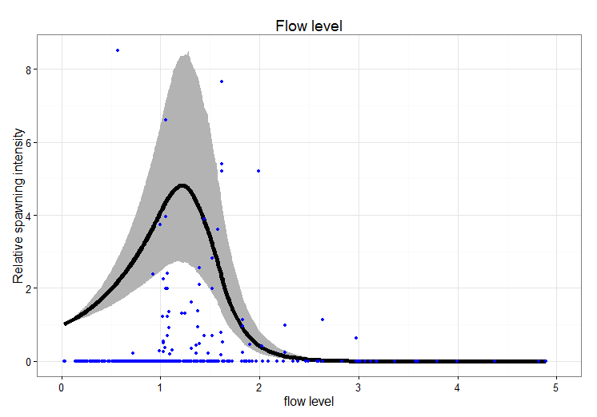
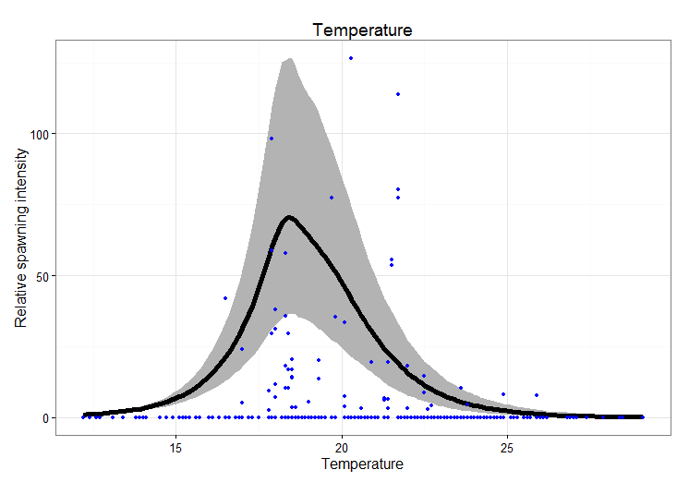
- Golden Perch spawned in response to within-channel pulses (‘freshes’) and natural bankfull flows in late spring with water temperatures between 18-22ºC.
Figure: Expected spawning intensity (density of eggs/larvae) as a function of flow level and water temperature on the day of sampling. Flow level is standardized by the overall mean level (i.e. 1 = long term mean flow level for a site). Blue dots are actual counts, rescaled to the y-axis range.
- Spawning was greatest after several days of increasing flow and water temperature.
- Golden Perch spawned in flowing water environments and eggs and larvae then drifted downstream into the lower Goulburn and Murray rivers.

What does this mean for management?
These results highlight the need for coupling rises in water height and velocity with appropriate water temperatures to achieve Golden Perch spawning.
To enhance Golden Perch reproduction and survival in regulated rivers, there is a need to restore key components of the natural flow regime, such as spring freshes and flowing water over large spatial scales.
Data from this research will be used to fine-tune the delivery of environmental flows to maximise the benefits for native fish.
The insights gained from this work can enable both:
- efficient use and delivery of environmental water, and
- successful outcomes for Golden Perch populations with knowledge that can be transferred to other rivers.
Future directions should investigate provision of summer flows to enhance dispersal of juvenile Golden Perch.

Contact: Wayne.Koster@delwp.vic.gov.au
Funding: These surveys were funded by Recreational Fishing Licence (2003-5), Goulburn-Broken Catchment Management Authority (2003-2015) and Commonwealth Environmental Water Office (2015) (Short-term Intervention Monitoring program, led by the University of Melbourne).

