|  |
| --- |
| Macquarie Perch –  captive breeding strategy, Snowy 2.0 |
| J. Lyon, H. Ho, B. Ingram, D. Gilligan, A. Pavlova,  A. Moyles and Z. Tonkin |
| December 2022 |



Arthur Rylah Institute for Environmental Research   
Published Client Report

|  |
| --- |
| Arthur Rylah Institute for Environmental Research Department of Environment, Land, Water and Planning PO Box 137 Heidelberg, Victoria 3084 Phone (03) 9450 8600 Website: [www.ari.vic.gov.au](http://www.ari.vic.gov.au)  **Citation**: Lyon, J. Ho, H., Ingram. B, Gilligan, D., Pavlova, A., Moyles, A. and Tonkin, Z. (2022). Macquarie Perch – captive breeding strategy, Snowy 2.0. Published client report for Snowy Hydro Ltd, Cooma. Arthur Rylah Institute for Environmental Research, Department of Environment, Land, Water and Planning, Heidelberg, Victoria.  **Front cover photo**: (clockwise from top) Murrumbidgee River at junction with Tantangara Creek; Macquarie Perch; alpine plain in snow; Stocky Galaxias (Images: Tarmo A. Raadik).  Logo© The State of Victoria Department of Environment, Land, Water and Planning 2022    This work is licensed under a Creative Commons Attribution 3.0 Australia licence. You are free to re-use the work under that licence, on the condition that you credit the State of Victoria as author. The licence does not apply to any images, photographs or branding, including the Victorian Coat of Arms, the Victorian Government logo, the Department of Environment, Land, Water and Planning logo and the Arthur Rylah Institute logo. To view a copy of this licence, visit <http://creativecommons.org/licenses/by/3.0/au/deed.en>  **Edited by** David Meagher, Zymurgy SPS.  **ISBN** 978-1-76136-200-2 **(pdf/online/MS word)**  **Disclaimer** This publication may be of assistance to you but the State of Victoria and its employees do not guarantee that the publication is without flaw of any kind or is wholly appropriate for your particular purposes and therefore disclaims all liability for any error, loss or other consequence which may arise from you relying on any information in this publication.  Accessibility  If you would like to receive this publication in an alternative format, please telephone the DELWP Customer Service Centre on 136 186, email [customer.service@delwp.vic.gov.au](mailto:customer.service@delwp.vic.gov.au) or contact us via the National Relay Service on 133 677 or [www.relayservice.com.au](http://www.relayservice.com.au). This document is also available on the internet at [www.delwp.vic.gov.au](http://www.delwp.vic.gov.au) |

|  |
| --- |
| Acknowledgment  We acknowledge and respect Victorian Traditional Owners as the original custodians of Victoria's land and waters, their unique ability to care for Country and deep spiritual connection to it. We honour Elders past and present whose knowledge and wisdom has ensured the continuation of culture and traditional practices.  We are committed to genuinely partner, and meaningfully engage, with Victoria's Traditional Owners and Aboriginal communities to support the protection of Country, the maintenance of spiritual and cultural practices and their broader aspirations in the 21st century and beyond. |

**Macquarie Perch – captive breeding strategy, Snowy 2.0**

**Jarod Lyon1, Huiking Ho2, Brett Ingram2, Dean Gilligan3, Alexandra Pavlova4, Adele Moyles2 and Zeb Tonkin1**

1 Arthur Rylah Institute for Environmental Research   
 123 Brown Street, Heidelberg, Victoria 3084

2 Victorian Fisheries Authority  
 Spring Street, Melbourne, Victoria 3000

3 New South Wales DPI – Fisheries  
Batemans Bay Fisheries Office, cnr Beach Road & Orient Street, Batemans Bay, NSW 2536

4 Monash University  
 Clayton, Victoria.

**Caveat:** This report was completed in September 2021 and consequently does not contain more recent information which may have become available.

Arthur Rylah Institute for Environmental Research  
**Published Client Report for Snowy Hydro Ltd, Cooma,  
Department of Environment, Land, Water and Planning**

# Acknowledgements

We thank Joanne Sharley and Tarmo Raadik (DELWP-ARI), Lizzie Pope (Snowy Hydro) and Lachlan Barnes (SLR), for providing comments on earlier drafts of this report. Lindy Lumsden (ARI) provided invaluable additional comments on the final draft of this document.

Contents

Acknowledgements ii

1 Introduction 1

2 Aim and objectives 2

3 Details of a captive breeding and requirements for Macquarie Perch 3

4 Techniques and infrastructure requirements for successful captive breeding 4

4.1 Wild broodstock collection, husbandry and spawning 4

4.1.1 Broodstock collection 4

4.1.2 Hatchery acclimation 5

4.1.3 Inducement to ovulate 5

4.1.4 Artificial fertilisation 5

4.2 Captive-held broodfish and spontaneous spawning 6

4.2.1 Fish maintenance 6

4.2.2 Hormone treatment 6

4.3 Egg incubation 7

4.4 Larval rearing 9

4.5 Pond harvest and stocking 9

5 Genetic augmentation of the Upper Murrumbidgee Macquarie Perch population 11

6 The way forward 14

7 References 15

Figures

Figure 1. Spawning Macquarie Perch in a tributary of Lake Dartmouth (image: Jonathon Dower). 4

Figure 2. After fertilisation, Macquarie Perch eggs are transferred to incubators for water-hardening (image: Victorian Fisheries Authority). 5

Figure 3. Netted 0.18 ha earthen pond and associated artificial stream used to maintain broodfish at the Narrandera Fisheries Centre (image: NSW DPI). 6

Figure 4. Incubators provide a gentle continuous flow of water that allows eggs to ‘tumble’ without sinking to the bottom of the jar or sticking/smothering others (image: Victorian Fisheries Authority). 8

Figure 5. Larvae develop fully while in incubators until hatched and able to swim freely. They are siphoned out of incubators and transferred to larval rearing tanks (image: Victorian Fisheries Authority). 8

Figure 6. Larval culture in cylindrical rearing tanks until their yolk sac is consumed, at which point they are ready for live food (image: Victorian Fisheries Authority). 9

Figure 7. Removing fingerlings from a plankton pond (image: Victorian Fisheries Authority). 10

Figure 8. Macquarie Perch fingerlings ready for release (image: Victorian Fisheries Authority) 10

Figure 9. Estimates of genetic diversity for Macquarie Perch populations 11

Figure 10. Phylogenetic similarity network between mitochondrial haplotypes (= circles) for Macquarie Perch individuals from different populations (indicated by different colours). 12

1. Introduction

Snowy Hydro Limited received approval in 2020 to construct a new large-scale pumped hydro-electric storage and generation scheme (Snowy 2.0), to increase hydro-electric capacity within the existing Snowy Mountains Hydro-electric Scheme. This will involve the connection of the existing Talbingo and Tantangara reservoirs via a series of underground pipes and an underground power generation station. Water will be transferred in both directions between the reservoirs, which are in separate river catchments.

The Arthur Rylah Institute for Environmental Research has been engaged by Snowy Hydro to provide specialist advice that can inform the selection of options and preparation of various aquatic Management Plans required as part of the NSW and Commonwealth approvals for the Snowy 2.0 project.

This report details the current approach to Macquarie Perch (*Macquaria australasica*) captive husbandry, outlines knowledge gaps, and provides options for consideration. The current report has significant compatibility with the Translocation Strategy. It outlines the known requirements for captive breeding of Macquarie Perch, identifies the limitations of existing techniques, details current research and sets out key considerations for the procurement of captive breed fish for a stocking program in the mid-Murrumbidgee River. Given the long-term nature of such an endeavour, the value and relevance of this strategy will extend beyond the Snowy 2.0 Management Plans.

* 1. **Relevance to priority conservation actions**

Whilst captive breeding does not specifically align with any of the recommended management/research actions for Macquarie Perch (NSW DPI 2015), it is related to the following recommended actions:

* Conduct research to evaluate the effectiveness of translocation of adult fish compared to stocking of juveniles to inform future conservation actions (High priority).
* Develop an emergency response policy to guide the collection and captive husbandry of Macquarie Perch. The policy should address the circumstances in which wild individuals may be collected, held and re-released, and identify holding facilities, potential funding sources and legal requirements (Low priority).

The following activities from the 2018 National Recovery Plan for Macquarie Perch are relevant to captive breeding:

1d. Restore Macquarie Perch population connectivity by conducting regular assisted gene flow (i.e. translocations) to decrease inbreeding, prevent further loss of genetic diversity by drift and improve adaptive potential (consistent with EPBC Act requirements).

1e. Develop an emergency management response plan for rescue translocations (consistent with EPBC Act requirements).

4a. Refine and improve captive breeding techniques for Macquarie Perch.

4b. Undertake a conservation stocking program for Macquarie Perch.

1. Aim and objectives

The aim of a captive breeding program for Macquarie Perch in the mid-Murrumbidgee River would be as follows:

* Improve the resilience of the population by increasing the number of individuals through the captive production and stocking of viable offspring with evolutionary potential.

The specific objectives of this captive breeding strategy for Macquarie Perch are as follows:

* Detail the current approach for captive breeding of Macquarie Perch.
* Outline existing knowledge gaps, known limitations of existing techniques, and current research.
* Set out the steps to procure and stock Macquarie Perch in the mid-Murrumbidgee River.

1. Details of a captive breeding and requirements for Macquarie Perch

Macquarie Perch was once an abundant fish in midland and upland streams of the Murray–Darling Basin. Today the abundance of this species has declined. The likely causes of this decline in abundance are changes to habitat including (Cadwallader 1978, Cadwallader 1981, Ingram et al. 1990):

* Alteration to stream flows.
* Barriers to fish movement.
* Changes to temperature regime.
* Impact of introduced fish.

These changes have reduced the ability of Macquarie Perch to successfully breed in affected waterways. Macquarie Perch is listed as Endangered under the under Australian Government and ACT, NSW and Victoria State/Territory Government legislation (Moore et al. 2010).

Over the past two‐decades Macquarie Perch have been successfully bred at several government (including Snobs Creek and Narrandera Fisheries Centre) and private hatcheries (e.g. Native Fish Australia) (Gooley 1986, Gooley and McDonald 1988, Ingram et al. 1994, Ingram and Gooley 1996, Trueman 2007, Ingram 2008, Ho and Ingram 2013). Currently, breeding of Macquarie Perch in hatcheries requires:

* The acquisition and immediate use of sexually mature broodstock from wild populations during the spawning season.
* The use of an ‘artificial stream’ environment to induce gonad maturation of long-term captive-held broodstock.
* The use of hormones to induce and spawning in the wild caught or captive held broodfish.

Methods to rear Macquarie Perch larvae and fry have been developed (Ingram and De Silva 2007; Ingram 2008, 2009). Currently the production of Macquarie Perch is hampered by the difficulty of spawning Macquarie Perch broodstock maintained in captivity. Although captive fish have been induced to spawn in the last 10 years in both Victoria and NSW, large-scale production of fingerlings still relies on collection of running-ripe fish from the wild. Reasons for this have been attributed to several factors that may affect proper conditioning and maturation of captive broodstock. These include:

* Environmental conditions.
* Broodstock management and husbandry techniques.
* Nutritional requirements of broodstock for successful final oocyte maturation (FOM).
* Hormonal factors influencing FOM.

1. Techniques and infrastructure requirements for successful captive breeding

Two production systems have been used to produce Macquarie Perch fingerlings. The more traditional methods used to spawn Macquarie Perch from wild-collected spawning fish are relatively well established (see Gooley and McDonald 1988; Ingram et al. 1994; Ingram and Gooley 1996; Ho and Ingram 2013). The Snobs Creek Hatchery in Victoria was able to produce a small number of fingerlings in 2012 from captive held fish, and furthermore, the NSW government is in the process of refining a production system utilising captive-held broodfish and spontaneous spawning within hatchery tanks and/or pond systems (Dean Gilligan, pers. comm.).

Below we present a summary of the well-established captive breeding techniques and infrastructure, sourced largely from Ho and Ingram (2013).

* 1. Wild broodstock collection, husbandry and spawning
     1. Broodstock collection

Field teams collect running ripe fish from spawning locations. In Victoria, this is mainly Lake Dartmouth (Figure 1), where the population is large enough to sustain a small take of adult fish, based on population modelling. These fish are then transferred to the Snobs Creek hatchery following a prescribed method of transport to minimise stress and injury.

Figure 1. Spawning Macquarie Perch in a tributary of Lake Dartmouth (image: Jonathon Dower).

* + 1. Hatchery acclimation

Following wild collection, adult Macquarie Perch arrive on site at the hatchery and are acclimatised to system water over 1–2 hours. Fish are then placed into holding tanks, quarantined, and observed for illness or disease, and treated if required. Fish are then held until required for spawning.

* + 1. Inducement to ovulate

To induce ovulation, female fish are injected with one of the selected hormones (Chorulon (HCG)) or Ovaprim), and male and female fish are then held in separate tanks. Commencing 36 hours after injection, females are monitored for signs of ovulation, which include an increase in the redness and swelling of the vent region, which usually occurs 39–64 hr (mean 42 hr) after injection. At ovulation, eggs begin to flow freely from the vent with only slight pressure to the abdomen, and eggs are clear with predominantly one large oil globule. Eggs are examined using microscopy to ensure they are at the correct stage of development.

* + 1. Artificial fertilisation

Fish that are ovulating are anaesthetised and eggs are hand‐stripped into a clean, dry bowl. Milt (up to 1 mL), freshly stripped from a male, is then mixed into the eggs by swirling. Wild-caught males do not require injection and produce milt when slight pressure is applied to the abdomen. A small amount (up to 10% by volume) of fertilising solution (0.4% sodium chloride and 0.3% urea) is also added to:

* Facilitate sperm activation.
* Facilitate clearing of the micropyle of the egg.
* Facilitate mix of eggs and sperm.
* Prevent the eggs from sticking together.

After 5–7 minutes the fertilised eggs (Figure 2) are rinsed with fertilising solution, then spread into an EWOS trough for water-hardening (Figure 2).

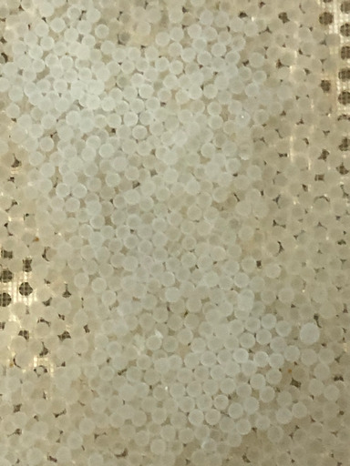

Figure 2. After fertilisation, Macquarie Perch eggs are transferred to incubators for water-hardening (image: Victorian Fisheries Authority).

* 1. Captive-held broodfish and spontaneous spawning

Fish captured as sub-adults are reared in outdoor earthen ponds until they reach sexual maturity. The density of fish held at Narrandera Fisheries Centre (NFC) is 50–100 per 0.18 hectares (Figure 3). Ponds are netted to limit bird predation, and supplementary feeding is not required.

In August–September a purpose-built artificial stream adjacent to the broodfish pond is activated by raising the pond’s water level to inundate a linear channel excavated to exit and re-enter the pond at opposite ends. The channel has a gravel-cobble substratum, boulder and timber habitats for cover, a series of four raised cobble riffles, and overhanging riparian vegetation. Flow within the artificial stream is achieved through a series of paddle wheels at the channel entrance and at intervals throughout, and a 6-inch (150 mm) electric pump at the channel entrance. The combine flow and habitat features simulate more-or-less natural lotic mesohabitats.

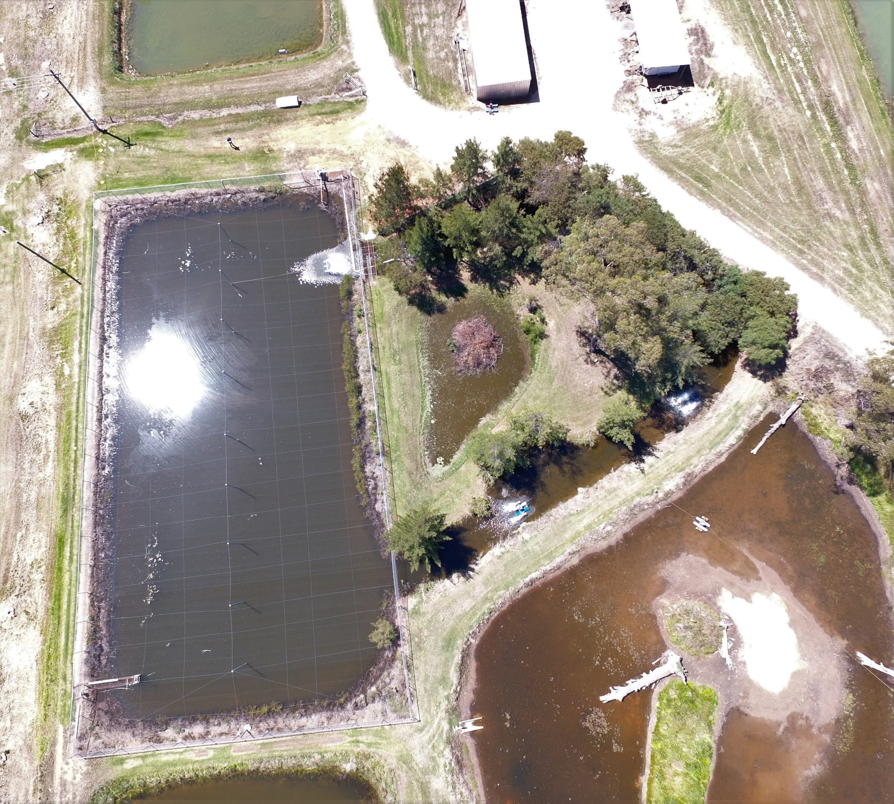

Figure 3. Netted 0.18 ha earthen pond and associated artificial stream used to maintain broodfish at the Narrandera Fisheries Centre (image: NSW DPI).

* + 1. Fish maintenance

Water levels and flow are maintained in the artificial stream for 8–10-weeks prior to the spawning season. Despite achieving gonad maturation in broodfish held within this system, natural spontaneous spawning has not been achieved without the hormone treatment of broodfish.

* + 1. Hormone treatment

Once daily maximum water temperatures in the pond exceed 17 °C (mid-October at Narrandera), the pond and artificial stream are drained and broodfish are recovered for hormone treatment.

Several treatments have been trialled over several years (refer to section 4.1), with inconsistent results. However, a current project with the Genecology Lab at the University of Sunshine Coast is investigating novel hormone therapies. Preliminary data from a single spawning season suggests that a custom-made GnRHa induces ovulation in 100% of treated females.

Each female is implanted with a hormone pellet at a target dosage of 150 µg/kg. Implanted females are held in groups of five with an equal number of untreated male broodfish in 2500 L hatchery tanks supplied with flow-through at 20 °C. Females spawned spontaneously within the hatchery tanks and eggs were naturally fertilised by the males. Latency period between treatment and spontaneous spawning was 67 ± 23 hours in the initial trials.

An additional treatment group involved implanting females with the same hormone dosage, and then returning them and a male group to the artificial stream. These fish also spawning spontaneously and produced an equal to greater number of fingerlings to the hatchery spawned fish.

Following fertilisation, eggs were harvested from the tanks and transferred to McDonald jars for incubation.

The same hormone treatment method was applied to a single group of wild-caught broodfish at the Snobs Creek hatchery in November 2020. Although treated females ovulated, the same spontaneous spawning outcome was not observed.

Further development and refinement of hormone treatments and spontaneous spawning strategies is being trialled at the Narrandera Fisheries Centre in the 2021 and 2022 spawning seasons.

* 1. Egg incubation

Fertilised eggs are relocated to upwelling incubators for hatching, with two types of incubators used:

* Mini‐incubators (Aquatic Ecosystem, USA).
* McDonald egg incubators.

Mini‐incubators are configured with an overflow pipe from the incubators leading into a 160 L fibreglass tank, to collect any larvae hatching overnight (see Ho and Ingram 2013). Upwelling (McDonald) incubators are supplied with a constant flow of water which is adjusted regularly to ensure eggs are gently turning over in the incubators (Figure 4 and Figure 5).

Flow rates within both styles of incubator must be adjusted frequently throughout the incubation period to account for changes in buoyancy as embryos develop. Infertile and dead eggs are removed daily to prevent fungal infections. Water temperature is maintained at 18–21 °C.

Eggs from each spawning are maintained in separate incubators so that fertilisation rate and hatch rate could be estimated for each spawning. Once hatching commences, spawnings are transferred to separate Ewos baskets. Once hatching is complete, larvae are transferred to 160 L fibreglass tanks for rearing.

On average the volume of eggs from a single female suits one McDonald jar incubator. The gently tumbling incubator allows hatched larvae to be removed and transferred to larval rearing tanks. At least two technical staff are required to maintain and check eggs during incubation and transfer hatched larvae, and carry out disease prevention treatments.

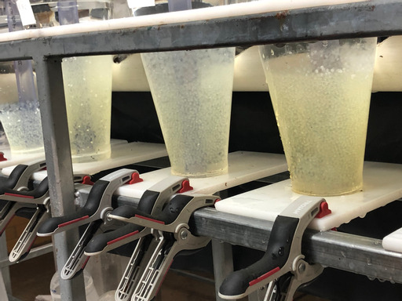

Figure 4. Incubators provide a gentle continuous flow of water that allows eggs to ‘tumble’ without sinking to the bottom of the jar or sticking/smothering others (image: Victorian Fisheries Authority).

This system passively removes unfertilised eggs or empty shells that are negatively buoyant, floating to the outlet at the top of the incubator and into the overflow

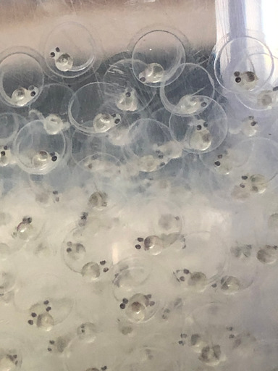

Figure 5. Larvae develop fully while in incubators until hatched and able to swim freely. They are siphoned out of incubators and transferred to larval rearing tanks (image: Victorian Fisheries Authority).

* 1. Larval rearing

Newly hatched larvae are maintained in 160 L fibreglass tanks supplied with a constant flow of water maintained at 18–21oC and aerated (Figure 6). Once the yolk sac has been absorbed (3–5 days after hatching) larvae are fed with zooplankton (collected from fry rearing ponds), or newly hatched (instar 1) brine shrimp (Artemia) nauplii for up to one month, before being transferred, depending on weather conditions, pond plankton stage etc., to fry ponds for on‐growing (Ho and Ingram 2003). Fry are on‐grown to a fingerling size in fertilised fry rearing ponds as described in Ingram (2009).

At least two technical staff are required to maintain, check and feed larvae, including the preparation of live food.

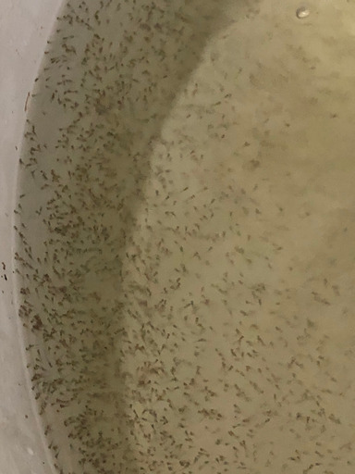

Figure 6. Larval culture in cylindrical rearing tanks until their yolk sac is consumed, at which point they are ready for live food (image: Victorian Fisheries Authority).

* 1. Pond harvest and stocking

Plankton ponds are prepared in advance and fertilised to encourage a bloom of diverse zooplankton. Aeration is provided to ponds with electric paddle wheels, and a single plankton pond can support 50–150,000 Macquarie Perch larvae, depending on stock-out size. Fry are allowed to grow in the plankton ponds and are monitored over 30–60 days before harvest.

Two technical staff are required to transfer stock to ponds, and four staff, at a minimum, are required for pond harvest of fish (Figure 7) and transfer to hatchery quarantine. After harvest, fingerlings are assessed and undergo precautionary treatment for disease or parasites. To reduce transport/handling stress, they are maintained in quarantine and monitored for a minimum of 24–48 hours prior to stocking into waterways (Figure 8).

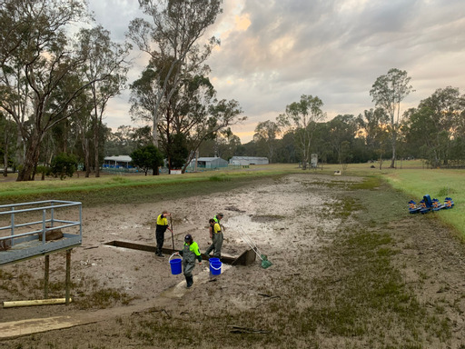

Figure 7. Removing fingerlings from a plankton pond (image: Victorian Fisheries Authority).

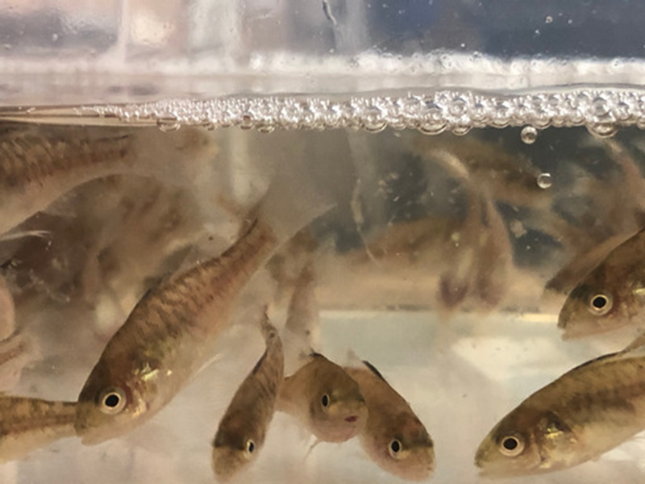

Figure 8. Macquarie Perch fingerlings ready for release (image: Victorian Fisheries Authority)

1. Genetic augmentation of the Upper Murrumbidgee Macquarie Perch population

Genetic diversity underpins phenotypic diversity, and thus the ability of populations to persist and adapt to environmental changes. In particular, the ability of organisms and populations to fight diseases depends on a high genetic diversity of immune genes. Small and isolated populations rapidly lose genetic diversity. This leads to reduced fitness, lower disease resistance, and low ability to adapt to novel threats. Additionally, small populations are susceptible to inbreeding and its harmful effects on fitness. Assisted gene flow (via stocking and translocations) can reverse these trends and supplement declining populations with diverse novel genetic variants.

A genetic study comparing levels of genetic diversity across the range of Macquarie Perch showed that the Murrumbidgee population has the lowest level of genetic diversity of all Murray–Darling Basin populations (Figure 9; Pavlova et al. 2017). Simulations showed that without assisted gene flow, this population is likely to go extinct within a few decades, but regular small-scale translocations will rescue it from inbreeding depression and increase its adaptive potential through genetic restoration.

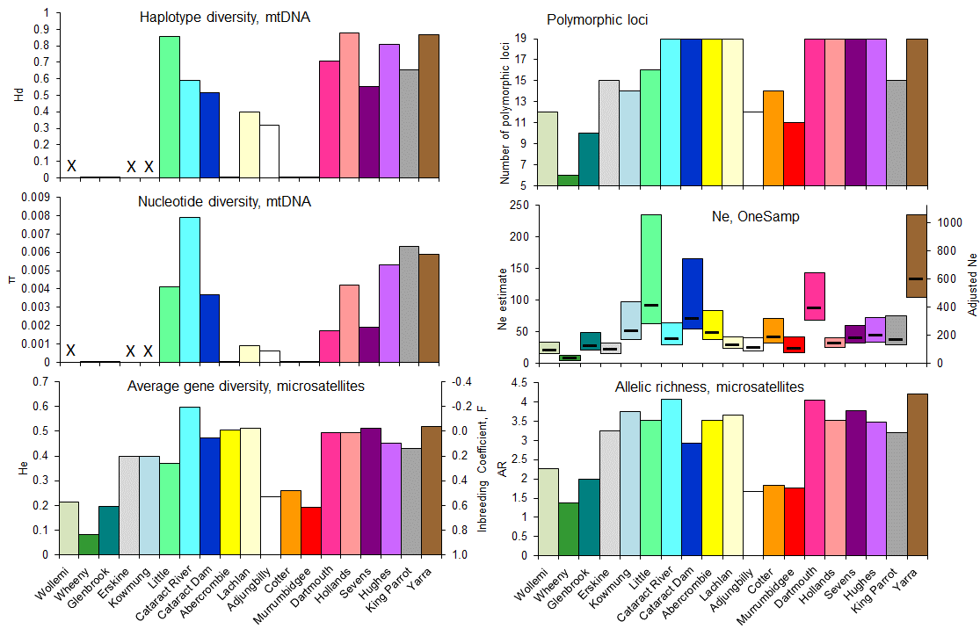

Figure 9. Estimates of genetic diversity for Macquarie Perch populations

The Murrumbidgee population (red bar) had the lowest estimates for all four parameters of genetic diversity:

* π – nucleotide diversity of the mitochondrial control region (X indicates missing data).
* Ne – effective population size (from OneSamp; black horizontal bar = mean, coloured bars = lower and upped 95% confidence limits).
* He – average gene diversity.
* AR – allelic richness.

Ne, He and AR were estimated based on variation at 19 microsatellite loci (from Pavlova et al. 2017). Supplementing genetic diversity of the Murrumbidgee population may help promote population growth and strengthen resistance to threatening processes such as novel pathogens introduced by alien fish.

Genetic admixture, using multiple source populations, was applied during the restoration of the Ovens River (Victoria) Macquarie Perch population. Specifically, two source populations were used for translocations and captive breeding (and stocking): the genetically diverse Yarra population and the moderately diverse Dartmouth population (Lutz et al. 2021). For captive breeding, same-population and different-population parents were used during hatchery production. The genetic analysis of survival, reproduction, and growth showed that:

1. Fish translocated from the river had higher survival and reproduction compared to fish translocated from the lake.
2. Stocked offspring of river origin and those of mixed origin had a higher chance of survival compared to the offspring of pure lake origin.
3. Offspring with two river parents grew faster than offspring of two lake fish or two-population ancestry.

Based on these results, combining compatible broodstock is likely to benefit restoration of other wildlife populations, and mixing river and lake fish will produce fitter offspring than using two lake parents.

Using more genetically diverse, compatible sources is predicted to provide more benefit to population fitness during genetic supplementation. Available genetic data (Figure 10; Pavlova et al. 2017) suggest that any Macquarie Perch population in the Murray River and Murrumbidgee River catchments should provide a compatible source for the Murrumbidgee population. These translocations will emulate the effect of historical gene flow and improve population persistence through a decrease in demographic and genetic stochasticity. The Cataract Dam population in coastal NSW, originally sourced from the Murrumbidgee River, and Yarra River population established from multiple tributaries of the Murray River, represent the best sources for translocation, as they are genetically diverse (Figure 9). There is no evidence that populations of the Lachlan River catchment are in any way incompatible with the Murrumbidgee population. In fact, offspring of parents from different catchments may display hybrid vigour and have been recommended, initially under controlled conditions.

Figure 10. Phylogenetic similarity network between mitochondrial haplotypes (= circles) for Macquarie Perch individuals from different populations (indicated by different colours).

From Pavlova et al. (2017). The size of each circle is proportional to the haplotype frequency, pie segments indicate haplotype sharing among populations (i.e. shared ancestry across populations). Haplotype sharing indicates historical connectivity of populations. The Murrumbidgee population (red circle) appears closely related to many populations of the Murray catchment (including Yarra) and the Cataract Dam population (dark blue), which was originally sourced from the Murrumbidgee River. In turn, close relationships between Cataract Dam, Cotter River, and Adjungbilly populations suggest that migrants to Murrumbidgee could be safely sourced from any population of the Murray or Murrumbidgee catchments, as well as the Yarra River and the Cataract Dam. Unlike populations of the Murray and Murrumbidgee catchments, which appear to have exchanged genes relatively recently, populations of the Lachlan catchment (yellow) appear to have diverged from other MDB populations since the last glacial maximum, about 27,000 years ago (Pavlova et al. 2017).

Although translocating fish directly from the rivers appears to be the most appealing option, remaining river populations (including the Yarra River) yielded low numbers of adults during recent surveys and could be rapidly depleted by intensive harvesting. Translocations from the lakes (such as Cataract Dam) could rapidly increase the number of adults in the Murrumbidgee River, but the Ovens River Macquarie Perch restoration study suggests that lake fish could have low fitness in rivers (Lutz et al. 2021). Therefore, stocking with offspring of crosses between lake and river fish appears to be the most promising option for augmenting the Murrumbidgee population.

We suggest the following sources for broodstock fish:

* Cataract Dam and Dartmouth Dam are the best lake sources.
* Murrumbidgee River and Yarra River are the best river sources.
* Additional options include Cotter Reservoir, the Lachlan/Abercrombie River and the Mongarlowe River, but the latter two will need additional studies.

Prior to selecting the Lachlan or Abercrombie River as a source location, consideration should be given to comparing the early fitness (e.g. fertilisation and hatching success) of offspring of Lachlan/Abercrombie River fish with offspring of fish from other catchments to ensure a lack of increased mortality before stocking. Genetic assessment of Mongarlowe River fish to confirm their MDB ancestry, infer original source catchment and estimate their genetic diversity, should be undertaken prior to use of fish from this catchment.

Additional considerations for stocking include:

1. Sourcing broodstock from multiple populations for each breading season, so none of the sources are rapidly depleted.
2. Replacing broodstock regularly to ensure the population is not swamped by genetic variation of few parents.
3. Returning used broodstock to the source of origin or releasing them to the Murrumbidgee population, to ensure no adult Macquarie Perch is wasted.
4. Fertilising the eggs of the same female with milt of multiple males (fertilisation should occur in separate containers to prevent sperm competition).
5. The way forward

Fisheries and conservation agencies within south-eastern Australia have long looked upon closing the breeding cycle of captive-held Macquarie Perch as the ‘holy grail’ in hatchery methodology. Recently there has been a renewed interest in this process, driven largely by the impacts of threatening processes such as drought and bushfire on remnant Macquarie Perch populations. For the species to persist into the future, there is an inevitability that production, utilising captive-held animals, is achieved.

Production at the Narrandera Fisheries Centre between 2010 and 2013 and Ho and Ingram (2013) have demonstrated that captive held Macquarie Perch broodstock can be induced to spawn, and that offspring from such spawnings are viable. Furthermore, the current research collaboration between NSW DPI and the University of the Sunshine Coast has produced promising results. However, there is still much to be done. As outlined in Ho and Ingram (2013), considerable research and development needs to be undertaken to:

* Validate and refine the techniques and develop reliable methods for conditioning and spawning broodstock.
* Investigate broodstock nutrition and nutritional supplements.
* Investigate type, timing, and dosage of hormone induction to refine the optimal treatment protocol for stimulating FOM and maximising spawning success.

However, while there is much will, there remains a lack of investment from key partners in developing this breeding technology. As such, ARI and the Victorian Fisheries Authority will be co-hosting an investment workshop in early 2022, to bring together organisations with an interest in solving this problem. The workshop will bring subject matter experts (with skills in fish nutrition and husbandry, fish stocking, conservation genetics, fish ecology and hormone induction) together with investors, with the aim of developing a collaborative program to allow for captive held fish to be bred in commercial quantities, for both conservation and recreational outcomes.

Activities to enable the stocking of Macquarie Perch in the mid-Murrumbidgee catchment include:

* Indication of interest in acquiring fish for stocking in the upper Murrumbidgee catchment to potential suppliers (NSW DPI and Victorian Fisheries Authority). This should include information relating to the preferred origin of broodfish (as outlined in the document above) and the number of fingerlings required.
* Confirmation of translocation sites via a catchment survey (Lintermans et al. 2022) and subsequent Translocation Strategy (Tonkin et al. 2022).
* Undertake a targeted stocking (should fingerlings be available) or translocation program to supplement populations/create new populations. Translocations should be aligned with genetic protocols outlined in this document, and in the Translocation Strategy (Tonkin et al. 2022).

In addition to improved management of waterways within the Upper Murrumbidgee Catchment, it is generally accepted that Macquarie Perch populations, across their range, will require supplementation with stocked or translocated fish to ensure species persistence, particularly in response to impacts of climate change such as increased drought and wildfire. The preferred way for this supplementation to occur into the future is by being able to reliably spawn Macquarie Perch in captivity. One option to assist in improving captive spawning techniques includes investment in the strategic research partnership being led by the Victorian Fisheries Authority.

1. References

Cadwallader, P.L. (1978). Some causes of decline in range and abundance of native fishes in the Murray–Darling River system. *The Proceedings of the Royal Society of Victoria* **90**, 211–224.

Cadwallader, P.L. (1981). Past and present distributions and translocations of Macquarie Perch *Macquaria australasica*, with particular reference to Victoria. *The Proceedings of the Royal Society of Victoria* **93**, 23–30.

Gooley, G.J. (1986). Culture methods for Macquarie perch at Lake Dartmouth, Victoria. *Australian Fisheries* **45**(9), 18–20.

Gooley, G.J. and McDonald, G.L. (1988). *Preliminary study on the hormone-induced spawning of Macquarie perch,* Macquaria australasica *(Cuvier) (Percichthyidae), from Lake Dartmouth, Victoria.* Arthur Rylah Institute for Environmental Research Technical Report Series No. 80.

Ho, H.K. and Ingram, B.A. (2013). *Creating an enhanced Macquarie Perch fishery: Breeding Program 2009 to 2012.* Fisheries Victoria Research Report Series No. 56, Department of Primary Industries, Melbourne.

Ingram, B.A. (2008). ‘Macquarie perch hatchery production– DPI SnobsCreek’. In ‘Creating an Enhanced Macquarie Perch Fishery. Cross‐jurisdiction Workshop’. Fisheries Victoria,Melbourne.

Ingram, B.A. (2009).Culture of juvenile Murray cod, trout cod and Macquarie perch (Percichthyidae) infertilised earthen ponds. *Aquaculture* **287**, 98–106.

Ingram, B.A., Barlow, C.G., Burchmore, J.J., Gooley, G.J., Rowland, S.J. and Sanger, A.C. (1990). Threatened native freshwater fishes in Australia – some case histories. *Journal of Fish Biology* **37** (Supplement A), 175–182.

Ingram, B.A. and De Silva, S.S. (2007). Diet composition and preference of juvenile Murray cod, trout cod and Macquarie perch (Percichthyidae) reared in fertilised earthern ponds. *Aquaculture* **271**, 260–270.

Ingram, B.A., Rimmer, M.A. and Rowland, S.J. (1994). Induced spawning trials with captive Macquarie perch, *Macquaria australasica* (Percichthyidae). *Proceedings of the Linnaean Society of New South Wales* **114**, 109–116.

Ingram, B. and Gooley, G. (1996). ‘Hormone‐induced spawning of the threatened Macquarie perch (*Macquaria australasica*): an Australian native freshwater fish’. In: Hancock,D.A. and Beumer,J.P. (Eds.) *Developing and Sustaining World Fisheries Resources: The State of Science and Management*, pp 97, Proceedings Volume1.

Lintermans, M., Lyon, J. and Tonkin, Z. (2022). *Macquarie Perch – catchment survey, Snowy 2.0*. Published client report for Snowy Hydro Ltd, Cooma. Arthur Rylah Institute for Environmental Research, Department of Environment, Land, Water and Planning, Heidelberg, Victoria.

Lutz, M.L., Tonkin, Z., Yen, J.D.L., Johnson, G., Ingram, B.A., Sharley, J., Lyon, J., Chapple, D.G., Sunnucks, P. and Pavlova, A. (2021). Using multiple sources during reintroduction of a locally extinct population benefits survival and reproduction of an endangered freshwater fish. *Evolutionary Applications* **14**(4), 950–964.

Moore, A., Ingram, B.A., Friend, S., King Ho, H., Robinson, N., McCormack, R., Coughran, J. and Hayes, B. (2010). *Management of genetic resources for fish and crustaceans in the Murray-Darling Basin.* Bureau of Rural Sciences, Canberra

NSW DPI (2015). *Priorities Action Statement – Actions for Macquarie Perch*. Available at: <https://www.dpi.nsw.gov.au/fishing/species-protection/what-current/endangered-species2/macquarie-perch/priorities-action-statement-actions-for-macquarie-perch> (accessed July 2021)

Pavlova, A., Beheregaray, L.B., Coleman, R., Gilligan, D., Harrisson, K.A., Ingram, B.A., Kearns, J., Lamb, A.M., Lintermans, M., Lyon, J., Nguyen, T.T.T., Sasaki, M., Tonkin, Z., Yen, J.D.L., and Sunnucks, P. (2017). Severe consequences of habitat fragmentation on genetic diversity of an endangered Australian freshwater fish: A call for assisted gene flow. *Evolutionary Applications* **10**(6), 531–550.

Tonkin, Z., Lintermans, M., Gilligan, D. and Lyon, J. (2022). *Macquarie Perch – translocation strategy, Snowy 2.0*. Published client report for Snowy Hydro Ltd, Cooma. Arthur Rylah Institute for Environmental Research, Department of Environment, Land, Water and Planning, Heidelberg, Victoria.

Trueman, W.T. (2007). ‘A review of attempts at the artificial propagation of the Macquarie perch Macquaria australasica with recommendations for future action’. *Native Fish Australia Technical Report* 2. Native Fish Australia (Victoria), Doncaster.

[www.delwp.vic.gov.au](http://www.delwp.vic.gov.au)

www.ari.vic.gov.au