Abundance and population genetics of Hog deer

(Axis porcinus) in Victoria

D.S.L. Ramsey, C. Pacioni, L. White,

E. Hill, N. Murphy and J.G. Cally

November 2023
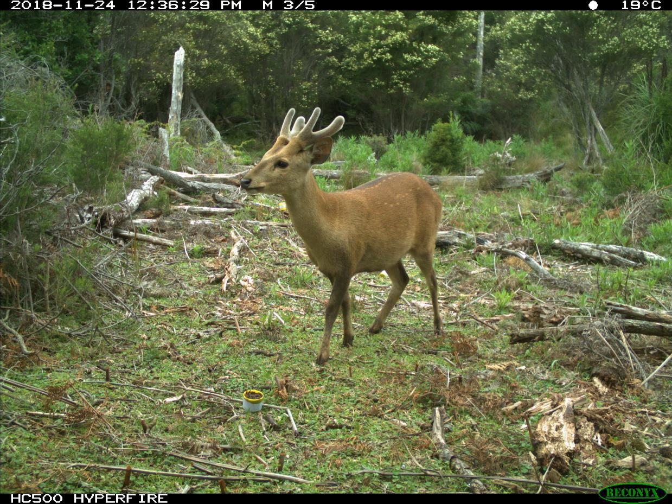

Arthur Rylah Institute for Environmental Research
Technical Report Series No. 372





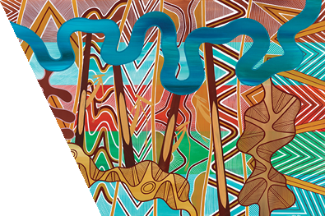
Acknowledgment
We acknowledge and respect Victorian Traditional Owners as the original custodians of Victoria's land and waters, their unique ability to care for Country and deep spiritual connection to it. We honour Elders past and present whose knowledge and wisdom has ensured the continuation of culture and traditional practices.
We are committed to genuinely partner, and meaningfully engage, with Victoria's Traditional Owners and Aboriginal communities to support the protection of Country, the maintenance of spiritual and cultural practices and their broader aspirations in the 21st century and beyond.

Arthur Rylah Institute for Environmental Research
Department of Energy, Environment and Climate Action
PO Box 137
Heidelberg, Victoria 3084
Phone (03) 9450 8600
Website: www.ari.vic.gov.au
Citation: Ramsey, D.S.L., Pacioni, C., White, L., Hill, E., Murphy, N., and Cally, J.G. (2023). Abundance and population genetics of Hog deer (Axis porcinus) in Victoria. Arthur Rylah Institute for Environmental Research Technical Report Series No. 372. Department of Energy, Environment and Climate Action, Heidelberg, Victoria.
Front cover photo: Hog deer in Wilsons Promontory (source: Arthur Rylah Institute).

© The State of Victoria Department of Energy, Environment and Climate Action 2023

This work is licensed under a Creative Commons Attribution 3.0 Australia licence. You are free to re-use the work under that licence, on the condition that you credit the State of Victoria as author. The licence does not apply to any images, photographs or branding, including the Victorian Coat of Arms, the Victorian Government logo, the Department of Energy, Environment and Climate Action logo and the Arthur Rylah Institute logo. To view a copy of this licence, visit http://creativecommons.org/licenses/by/3.0/au/deed.en

Edited by Fox Writing Services
ISSN 1835-3835 (pdf))
ISBN 978-1-76136-531-7 (pdf/online MS word)

Disclaimer
This publication may be of assistance to you but the State of Victoria and its employees do not guarantee that the publication is without flaw of any kind or is wholly appropriate for your particular purposes and therefore disclaims all liability for any error, loss or other consequence which may arise from you relying on any information in this publication.

Accessibility
If you would like to receive this publication in an alternative format, please telephone the DEECA Customer Service Centre on 136 186, email customer.service@delwp.vic.gov.au or contact us via the National Relay Service on 133 677 or www.relayservice.com.au. This document is also available on the internet at www.deeca.vic.gov.au

Abundance and population genetics of Hog deer (Axis porcinus) in Victoria

David S.L. Ramsey¹, Carlo Pacioni¹, Lauren White¹, Erin Hill², Nick Murphy² and Justin G. Cally¹

In partnership with

¹Arthur Rylah Institute for Environmental Research
123 Brown Street, Heidelberg, Victoria 3084
²La Trobe University, Plenty Road, Bundoora, Victoria, 3086

Date

Arthur Rylah Institute for Environmental Research
Technical Report Series No. 372

Acknowledgements
We would like to thank Tom Schneider (ARI) for his help and expertise in processing and classifying the camera images produced from this study. The assistance of Octavian Manescu, Game Management Authority (GMA), in coordinating the Hog deer checking station samples was greatly appreciated. The work detailed in this report was funded by the Game Management Authority. We thank Simon Toop, Jason Flesch and Chris Davies (GMA) as well as Michael Scroggie and Jian Yen (ARI) for helpful comments on a draft of this report.

Contents
Acknowledgements ii
Summary 1
1 Introduction 3
2 Methods 4
2.1 Hog deer abundance and density estimates 4
2.1.1 Monitoring 4
2.1.2 Density and abundance estimates 4
2.1.3 Abundance process from camera trap counts 6
2.1.4 Predictions of Hog deer abundance 7
2.1.5 Hog deer distribution 7
2.2 Population genetics 8
2.2.1 Sample collection and genotyping 8
2.2.2 Population structure 9
2.2.3 Dispersal 9
2.2.4 Genetic diversity and effective population size 10
3 Results 11
3.1 Hog deer abundance and density 11
3.1.1 Detection of deer 11
3.1.2 Distance sampling 11
3.1.3 Drivers of abundance 12
3.1.4 Hog deer distribution 15
3.2 Population genetics of Hog deer 16
3.2.1 Sample collection and genotyping 16
3.2.2 Population structure 16
3.2.3 Dispersal 18
3.2.4 Genetic diversity and effective population size 21
4 Discussion 22
4.1 Hog deer genetics 22
4.2 Conclusions 25
5 References 26
Appendix 30

Tables
Table 1. Descriptions of the covariates used to model deer density. 8
Table 2. Model selection table for deer detection. 11
Table 3. Model-based estimates of Hog deer abundance (N) on public land in the Gippsland region of Victoria. SD – standard deviation, CV – coefficient of variation, 5%, 95% – lower and upper limits of the 90% credible interval (CI). Density – average density (deer/km²). 13
Table 4. Pairwise FST statistic between clusters. P values are above the diagonal. 18
Table 5. Distance between pairs of individuals of different relatedness classes. SD – standard deviation. 19
Table 6. Diversity statistics. Ne: effective population size including 95% confidence intervals in parentheses, Ho: observed SNP heterozygosity, He expected SNP heterozygosity, FIS: inbreeding coefficient, aHo: observed autosomal heterozygosity, aHe: expected autosomal heterozygosity. 21
Table A1. Filtering steps undertaken on the single nucleotide polymorphism (SNP) dataset. 31

Figures
Figure 1. The Gippsland region of eastern Victoria and its bioregions. Points show the site locations monitored as part of the Hog deer survey or statewide deer survey. 5
Figure 2. Detections of Hog deer recorded at each camera site in the Gippsland region. Coloured polygons refer to the bioregions given in Table 1. 11
Figure 3. Distance-sampling detection process for Hog deer (group size = 1). Bars indicate the frequency distribution of expected distances, and the line indicates the detection function for the average herbaceous understorey cover (50%). 12
Figure 4. Conditional effects of five covariates used to model the spatial distribution of abundance for Hog deer. The y-axis shows the relative contribution to abundance (log-scale), and the x-axis shows the untransformed covariate values. All parameters were scaled for use within the model with square-root transformations for bare soil, nitrogen, and forest edge. Distance to pastural land was rounded up to the nearest 100 m and log transformed. 50% and 90% confidence bands are shown with dark and light purple shading. 13
Figure 5. Distribution of Hog deer density (deer/km²) on public land within the Gippsland region. 14
Figure 6. Estimate of the occupied range for Hog deer within the Gippsland region of Victoria. LCI and UCI refer to the bootstrapped 90% confidence intervals for the predicted range that minimised false positive and negative rates. 15
Figure 7. Broad sampling locations of 272 Hog deer samples successfully genotyped. Locations are coloured to match the PCA plot (Figure 8), by longitude for the Mainland samples (red-yellow), latitude for Wilsons Promontory (light-dark blue) or island (pink and green for Snake and Sunday Island, respectively). Particular sampling locations mentioned in the main text are labelled. 17
Figure 8. PCA plots of the first two principal components (PC) (which explain 10.3% of the variance in the dataset). Each point represents a sample, coloured to reflect sample location as displayed in Figure 1. Location of points in this plot reflect genetic similarity, so that points that are placed closer together are more genetically similar. 17
Figure 9. fastSTRUCTURE results. Each bar represents an individual, grouped by the location at which they were sampled. Wilsons Promontory samples are ordered by latitude, and Mainland samples are ordered by longitude. Colours represent the estimated proportional ancestry from each cluster. 18
Figure 10. Close-kin connections. Points represent sampling locations, curved lines indicate distances between first- and second-degree relatives (excluding those that were < 5 km apart). Blue lines indicate second-degree relatives, red lines indicate first-degree relatives. 19
Figure 11. Spatial autocorrelation. Top row plots (A and B) show the results for female-female pairs, while bottom row plots (C and D) show the results for male-male pairs. On the left (A and C) are plots of geographic vs genetic distance data, each point represents a pair of individuals. This data was used to build the correlograms on the right (B and D). Each point on the correlograms represents a distance class for which a Mantel test was run, and the y axis represents the Mantel correlation coefficient, r. Points are sized by how many pairs of individuals were found in that distance class and coloured by the log p-value. Significantly positive (p<0.05) values of r indicate a positive relationship between genetic and geographic distance as expected under isolation-by-distance 20
Figure 12. Spatial autocorrelation. A) analysis of Wilsons Promontory samples only, and B) analysis of Mainland samples only. Each point on the correlograms represents a distance class for which a Mantel test was run, and the y axis represents the Mantel correlation coefficient, r. Points are sized by how many pairs of individuals were found in that distance class and coloured by the log p-value. Significantly positive (p<0.05) values of r indicate a positive relationship between genetic and geographic distance as expected under isolation-by-distance. 21
Figure A1. Posterior predictive checks comparing summary statistics (T) of the predicted counts of deer from snapshot moments during camera trap distance sampling (CTDS), with the observed counts at each site. Summary statistics are the proportion of plots with zero counts, the mean total count, the standard deviation of the total count, and the maximum total count. Pale-blue histograms give the distribution of the summary statistic predicted by the model $T(yrep)$ and dark-blue bars give the summary statistic for the observed counts $T(y)$. 30
Figure A2. PCA results before filtering on PC2 loadings. Each point represents a sample, coloured to reflect sample location as displayed in Figure 1. Location of points in this plot reflect genetic similarity, so that points that are placed closer together are more similar. 32
Figure A3. PCA results after filtering on PC2 loadings (87 single nucleotide polymorphisms (SNPs) removed). Each point represents a sample, coloured to reflect sample location as displayed in Figure 1. Location of points in this plot reflect genetic similarity, so that points that are placed closer together are more similar. 32

Summary
Context:
Hog deer (Axis porcinus) were introduced into Victoria in the 1860s, but are currently largely confined to the coastal areas of south and east Gippsland. The Hog deer is a highly valued games species, and because of their relative rarity there is concern among some stakeholders that the Hog deer population is in decline due to factors such as illegal hunting and loss of habitat. In contrast, Hog deer are being actively controlled within Wilsons Promontory with the aim to eradicate all deer from the National Park to protect biodiversity values.
Aims:
This study aimed to (1) estimate the abundance and distribution of Hog deer across their range; and (2) investigate the genetics of the Hog deer population to examine genetic diversity, population structure and connectivity between local populations as well as effective population size. The study updates recent estimates of the abundance, distribution and genetics of Hog deer undertaken in 2018 (Ramsey et al. 2019).
Methods:
The abundance and density of Hog deer was estimated using data from camera traps set at 64 sites across the species’ coastal Gippsland range in the area originally monitored in 2018 between September and December 2022. Data from these sites were supplemented by additional camera traps set at 89 sites across the wider Gippsland region as part of a related project between October 2021 and May 2023. Monitoring was undertaken predominately on public land such as State Forests and Reserves, Conservation areas, state game reserves and National Parks, and therefore did not include areas of private land managed for Hog deer recreational hunting. Four distance markers were placed in each camera’s field of view and used to estimate the distance between each deer and the camera location. Abundance ($N$) and density of deer were estimated using camera trap distance sampling (CTDS) methods.
An updated analysis of Hog deer population genetics was undertaken to re-assess estimates of population structuring, dispersal and genetic diversity of Hog deer. The current assessment used a larger, higher resolution single nucleotide polymorphism (SNP) dataset extracted from tissue samples collected from Hog deer between 2015 and 2023. Tissue samples were collected from shot Hog deer at checking stations during the April hunting season, as well as from culls undertaken by Parks Victoria in Wilsons Promontory and by Para Park Co-operative from Sunday Island. Population structure was investigated using spatially explicit and non-spatial Bayesian clustering analysis, and sex-biased dispersal patterns of Hog deer were investigated using spatial autocorrelation analysis. The number of breeders contributing to the genetic pool of the population in each generation (effective population size–$N_{e}$) was also estimated using linkage disequilibrium-based approaches. In addition, descriptive statistics of genetic diversity were also calculated.
Results:
Hog deer were recorded from 22 of the 153 sites in the Gippsland region. No Hog deer were recorded from cameras east of Lakes Entrance or further inland from the area originally sampled in 2018. Total Hog deer abundance was estimated as 4,252 (90% credible interval (CrI): 2,571–6,490) with the majority occurring within the Gippsland Plains bioregion (2,290 Hog deer), which had an average density of 1.6 deer/km². However, highest densities of Hog deer were found within the Wilsons Promontory bioregion (4.1 deer/km²), with a total abundance of 1,670 Hog deer.
Genetic analysis was undertaken on 272 individual Hog deer that were successfully genotyped from tissue samples. Results from the Bayesian clustering analysis identified the presence of three genetic clusters (subpopulations), centred on Wilsons Promontory, the Gippsland Plains and Sunday Island. Analysis of measures of heterozygosity revealed that the Victorian Hog deer population generally contained low genetic variability, confirming previous analyses, with the subpopulation on Sunday Island having the lowest genetic diversity and effective population size. However, in contrast to previous findings, the Snake Island subpopulation was found to have relatively high genetic diversity containing ancestry from all three subpopulations. Maximum dispersal distances were found to be around 40 km for females and 60 km for males. However, most natal dispersal events occurred over relatively short (< 5 km) distances.
Conclusions and implications:
The Hog deer population inhabiting two core bioregions on public land in coastal Gippsland between Lower Tarwin and Lakes Entrance was predicted to be higher than the estimate from 2018 (i.e. 3,000 Hog deer). However, much of this difference can be attributed to the larger area sampled, which included sites further inland from the coastal breeding range originally sampled by Ramsey et al. (2019), which were predicted to be suitable for Hog deer. As was the case in that study, the monitoring design for the current study did not include areas of private land, including some that are specifically managed for Hog deer recreational hunting (e.g. Sunday Island and some mainland private properties), so our estimates of abundance may have underestimated the total population of Hog deer in this region. Importantly, models of Hog deer abundance suggested that Hog deer may reside in suitable habitat in areas of Stradbroke Flora and Fauna Reserve, Mullungdung Nature Conservation Reserve and Holey Plains State Park, despite no Hog deer being detected on cameras in these areas. However, more intensive monitoring would be required to confirm Hog deer presence or absence in these areas.
Our findings revealed that the Victorian Hog deer population exhibited limited genetic diversity, consisting of three primary genetic clusters (subpopulations). Analysis of distances between close kin indicated predominantly short average natal dispersal distances (< 5 km), with infrequent long-distance dispersal events. While there was evidence of mixing between the two mainland clusters, the migration between these regions is low most likely due to barriers created by agricultural and urban development. The reason for the low genetic diversity of the Sunday Island population, relative to other clusters, is unknown but suggests that natural migration of Hog deer from the mainland to the island is unlikely. In contrast, the relatively high genetic diversity and mixed ancestry of the Snake Island population suggest that Hog deer on the island have been influenced by immigration from surrounding areas and translocations from, or to, other subpopulations. This result contrasts starkly with previous genetic work, which indicated much lower genetic diversity of the Snake Island subpopulation (Ramsey et al. 2019). Consequently, the result from the current analyses should be investigated further and confirmed through additional sampling. The generally low genetic diversity suggests that the Hog deer population in Gippsland may be susceptible to risks such as inbreeding and loss of adaptive capacity, which would be exacerbated by over-harvesting, disease and habitat loss (e.g. through intensive bushfires).
Recommendations
- In light of the updated estimates of population abundance and distribution, continue to monitor Hog deer populations periodically to determine population trends in the Gippsland Plains and Wilsons Promontory bioregions.
- Conduct more intensive monitoring in areas of suitable habitat within Stradbroke Flora and Fauna Reserve, Mullungdung Nature Conservation Reserve and Holey Plains State Park to confirm the presence (or absence) of Hog deer in these regions.
- Conduct an analysis of additional samples from Hog deer on Snake Island to confirm the genetic analysis suggesting the population on the island has mixed genetic ancestry.

- Introduction
The Hog deer (Axis porcinus) is a small (30–50 kg) species of deer native to southern Asia. It was introduced into the Gippsland region of Victoria in the 1860s and 1870s, and by the 1940s had spread from the initial release sites near Port Welshpool and Sale to colonise the coastal strip between the Tarwin River and Lakes Entrance (Mayze and Moore 1990; Menkhorst 1995). Recent investigations examining locations of Hog deer sightings from various sources have concluded that the breeding range of Hog deer encompasses a 2336 km² coastal strip between the Tarwin River and Point Hicks. Although Hog deer have been seen outside these areas, notably as far east as Mallacoota and as far west as the Otway Ranges, none of these areas currently support breeding populations (Forsyth et al. 2016).
Hog deer commonly inhabit coastal shrublands and swamps, including Manna Gum and Banksia woodlands and Leptospermum, Melaleuca and Acacia scrub (Menkhorst 1995). Although their diet in their native range consists primarily of grasses, in Victoria their diet consists predominantly of dicots, including both forbs and shrubs (Davis et al. 2008). Adult Hog deer are mainly solitary, but females may be accompanied by subadult offspring, and aggregations may sometimes occur where food is plentiful (Menkhorst 1995; Odden and Wegge 2007). In Victoria, breeding occurs mainly in December and January, and births peak in August and September following a gestation period of approximately 240 days. Females may breed in their first year and produce an average of 1.2–1.4 young per year; males develop their first set of antlers at around 10 months of age (Mayze and Moore 1990; Menkhorst 1995).
Because of its relative rarity, the Hog deer is a highly valued game species in Victoria. Hunting of Hog deer is highly regulated: licensed hunters are allowed to take one male and one female deer during April, and the current harvest is around 150 animals per year (Moloney and Turnbull 2018). While Hog deer are appreciated for their aesthetics and are a valued hunting resource, they can have a negative impact on biodiversity and may pose problems for private landholders (Côté et al. 2004; Davis et al. 2016). There is also some concern among hunters that the Hog deer population is declining as a result of various factors such as habitat degradation and illegal hunting (Slee 1985). Extensive areas of suitable Hog deer habitat (e.g. wetlands/marshes and coastal scrub) that once existed between Westernport Bay and the Gippsland lakes have been progressively lost or degraded through agricultural development. This loss of habitat is thought to have restricted movements of Hog deer, resulting in increasingly fragmented populations, which have become more vulnerable to other impacts such as hunting (Mayze and Moore 1990).
Among the various population parameters, population size is arguably one of the most important, because knowledge about how abundance or density varies across the landscape can provide important information about prevailing trends (e.g. increasing, stable or declining) as well as whether management actions are effective. In addition to abundance, information on other aspects of population dynamics such as sex-specific dispersal patterns and ‘effective’ population size obtained from molecular data can provide important insights into the connectivity, sustainability and genetic condition of populations.
A previous survey to estimate the abundance of Hog deer across their range as well as their population genetic structure was undertaken in 2018 (Ramsey et al. 2019). That study used remote infrared cameras to detect the presence of Hog deer at 50 sites located within the Hog deer breeding range, with the total population size on public land estimated to be 3,000 (95% CI; 1,858–4,845) (Ramsey et al. 2019). Analysis of genetic data extracted from tissue samples revealed the presence of three genetic subpopulations of Hog deer, with each sub-population exhibiting low genetic diversity (Ramsey et al. 2019).
Here we report on a study to update the estimates of the abundance and population genetics of Hog deer. In doing so we take advantage of data collected from a related study investigating the abundance of deer across all public land in Victoria (Cally and Ramsey 2023) by combining monitoring data from that study with new monitoring data targeting the Hog deer range. We also report on an updated analysis of Hog deer population genetics in which we re-assess population structuring, dispersal characteristics and genetic diversity of the Victorian Hog deer population.

- Methods
  - Hog deer abundance and density estimates
    - Monitoring
Monitoring to assess the abundance and density of Hog deer was undertaken at 64 sites located across the range of the species in coastal Gippsland, from Lower Tarwin to Point Hicks. Sites selected for monitoring were based on the 50 sites sampled in 2018, which were randomly selected from the pool of sites calculated by dividing up the area of public land within the Hog deer range into 2 × 2 km cells (Ramsey et al. 2019). The remaining 14 sites were selected ensuring spatial balance was achieved between these sites and the original 50 sites (Foster et al. 2017) (Figure 1). For various reasons, a number of the original 50 sites were inaccessible, and these were shifted to the nearest accessible 2 x 2 km cell. In addition to these 64 sites, a further 253 sites were also monitored as part of a larger project to estimate the abundance of deer across Victorian public land (statewide deer project) (Cally and Ramsey 2023). Including these sites resulted in a total of 317 sampled sites across Victoria. However, for the purposes of estimating the abundance of Hog deer, we focused on the subset of 153 sites sampled within the Gippsland region (Figure 1).
At each site selected for monitoring, a single heat-in-motion camera (Reconyx HF2X Hyperfire 2) was deployed at the approximate centroid of the cell at least 150 m from the nearest vehicle access point. The cameras were secured to a tree 1 m above the ground and were set for quick and continuous shooting to maximise footage of animals when they were in the frame. Cameras were situated at locations where the field of view (out to 15 m) was not overly obscured by vegetation to ensure good visibility of deer. Four plastic markers were placed in the midline of the field of view of each camera at 2.5, 5, 7.5, and 10 metres from the camera location, which were used to classify images of deer into distance classes from the camera. Reflective tape was applied to each marker to ensure good visibility at night. The distance measurements of Hog deer from the camera were then used to estimate deer density using camera trap distance sampling (CTDS) methods (Howe et al. 2017; Corlatti et al. 2020; Mason et al. 2022; Delisle et al. 2023). In addition, we also assessed the amount of herbaceous (non-woody) understory vegetation cover (< 2.2 m in height) in front of the camera. The percentage cover was visually assessed in a quadrant covering the camera field of view. Cameras were set out during October and November 2022 and left in place for approximately six weeks. Cameras set out as part of the statewide deer project used similar methods with camera monitoring occurring between October 2021 and March 2023. Camera images were tagged with several metadata tags: species, number of individuals in the photo, distance of closest individual from the camera and any un-natural behaviour (e.g., interaction with markers or camera), as these may bias density estimates (Henrich et al. 2022). Data were tagged in DigiKam (https://digikam.org) or Lightroom Classic (https://adobe.com), with metadata extracted using the camtrapR R package (Niedballa et al. 2016).
    - Density and abundance estimates
Images of deer from each camera were classified into species, and also sex and age class (juvenile/adult) if possible. For each deer image, the distance class was also recorded using the plastic markers as distance guides. We used a hierarchical CTDS model (e.g. Delisle et al. 2023) to estimate the densities of Hog deer at each camera location and then used these to estimate the population abundance of Hog deer. Briefly, this method assumes that cameras are deployed independently of animal locations at a location $k$ for a period of time $T_{k}$ and captures images for as long as an individual is present to trigger the camera. Images are then obtained at a predetermined set of instants, $t$ units of time apart. Temporal effort at each camera is then calculated as $T_{k}⁄t$. Howe et al. (2017) suggested that a useful range for $t$ is 0.25 to 3 seconds, with values at the lower end being more suitable for fast-moving or rarer species. If the camera covers a horizontal angle of view of $θ$ radians, then the fraction of the circle observed by the camera field of view is $θ⁄2π$. Hence, the data consist of a series of snapshot instants taken $t$ units of time apart, with overall sampling effort at each location $k$ equal to $(θT_{k})/2πt$ (Howe et al. 2017). Estimates of density (${\hat{D}}_{k}$) followed standard point-transect methods (Buckland et al. 2015),
$\begin{aligned}\begin{aligned}{\hat{D}}_{i}=\frac{C_{i}}{πw^{2} e_{i}{\hat{p}}_{i}\hat{A}}\end{aligned}\#1\end{aligned}$

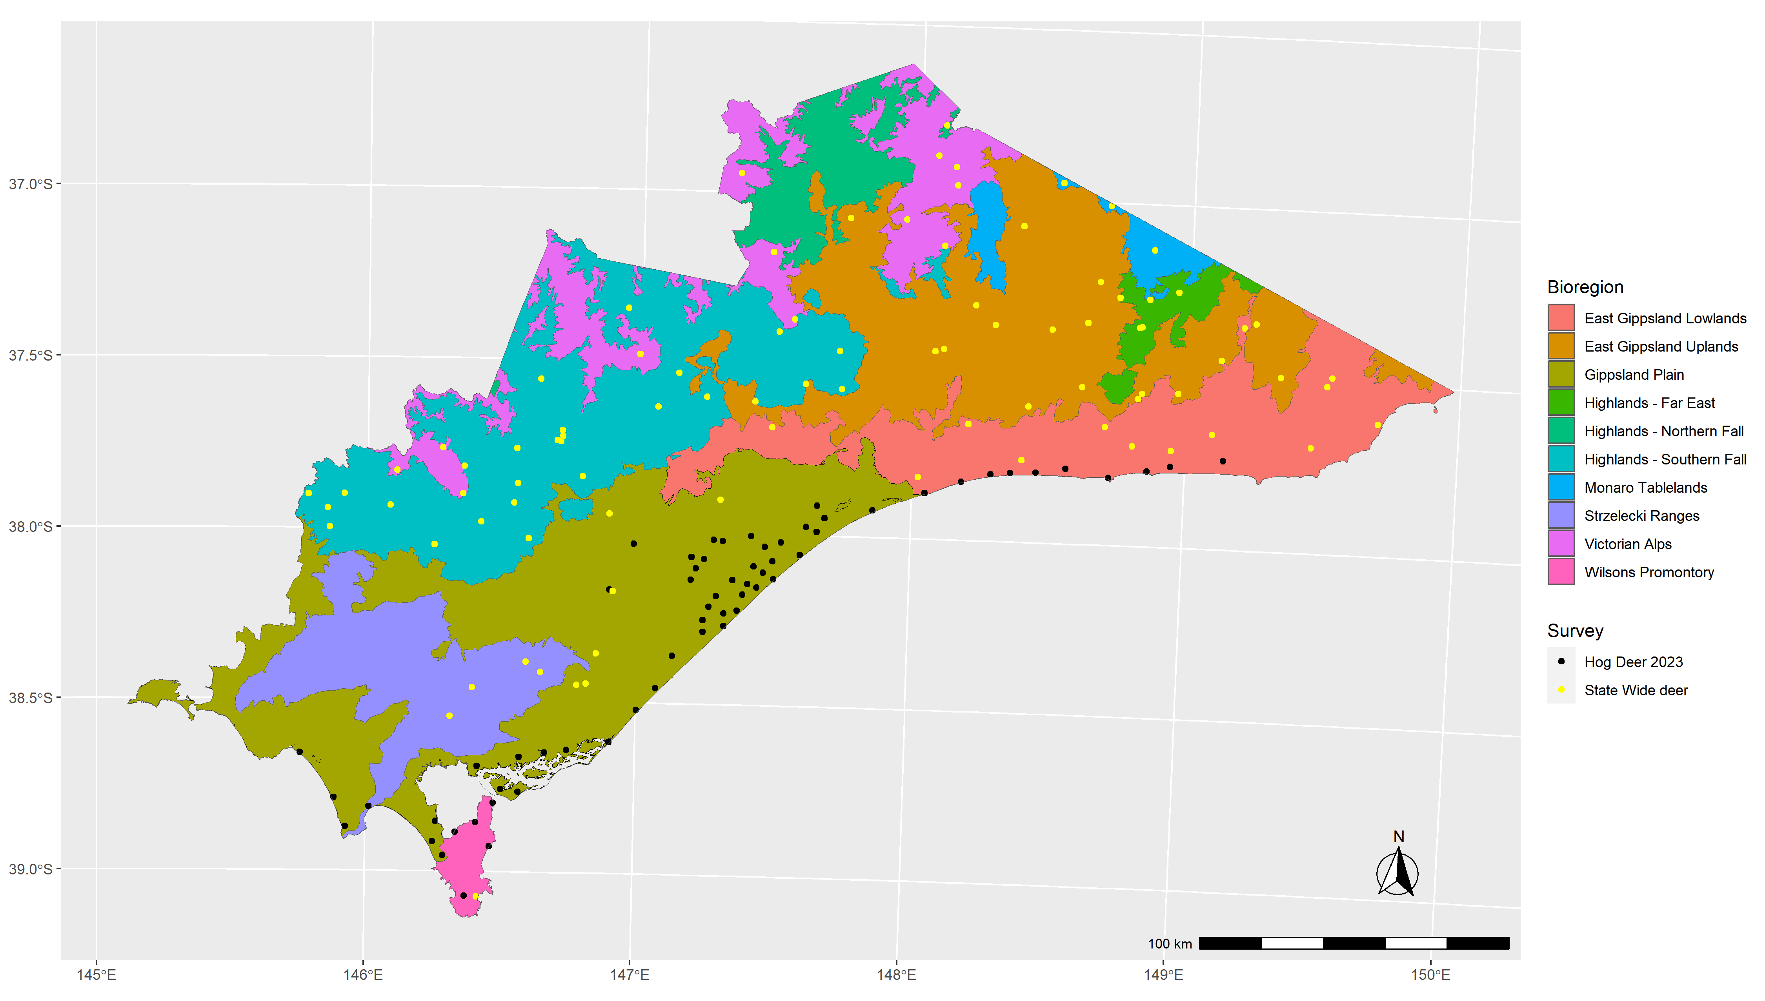
Figure 1. The Gippsland region of eastern Victoria and its bioregions. Points show the site locations monitored as part of the Hog deer survey or statewide deer survey.

where $C_{i}$ represented the counts of deer observations at site $i$, $w$ was the maximum observation distance from the camera (truncation distance – here set to 12.5 m), $p_{i}$ was the probability of detecting an individual that was within $w$ distance from the camera, $A$was an estimate of relative animal activity and $e_{i}$ was the overall sampling effort $(θT_{i})/2πt$.
An underlying assumption about CTDS is that the probability a deer will be available for detection at any given point location within the camera field of view is proportional to the total area of each distance bin, which increases at further distance bins (Buckland et al. 2015). However, in this study we implemented a novel method that considered group size of the detected species in the availability calculations. For larger groups, CTDS should account for the availability of the closest individual rather than the availability of all individuals (e.g. Cally and Ramsey 2023). This modification in approach was due to our assumption that it is the individual within a group that is closest to the camera that will trigger the camera trap. It follows that as group size increases, the distance between the camera and the closest individual is likely to decrease. If we assume that the triggering of the camera is dependent upon the closest individual within a group then we must adjust our estimated availability to account for variable group sizes. If we don’t adjust for group size and only use the distance to the closest individual for our distance sampling models, then we will likely underestimate the detection rate. Alternatively, if we record distances to multiple individuals in the same photo and take an average or model them independently, we will likely overestimate detection probability because individuals at further distances are only recorded because a closer individual has triggered the camera trap.
In this study, we investigated two possible detection functions (half-normal and hazard rate) that may explain how detection rates decline with increasing distances from the camera (Buckland et al. 2015). We also examined possible heterogeneity in detection rates among sites by incorporating herbaceous understorey cover as a covariate as a possible explanatory variable. We compared detection functions using AIC (Burnham and Anderson 2002) in the ‘Distance’ R package (Thomas et al. 2010) and used the detection function most supported by the data in our Bayesian hierarchical model for abundance.
For each site, the average estimated detection probability $p_{i}$ (up to 12.5m) was then included in the model to account for imperfect detection of individual deer in the camera counts.
    - Abundance process from camera trap counts
The count of the number of snapshot moments of deer images at a site was modelled as a function of explanatory variables describing spatial variation in density, relative frequency of group sizes, distance-sampling detection probability, survey effort (area in front of camera multiplied by the snapshot moments the camera was deployed for) and proportion of time within a 24-hour cycle that deer were active (Equation 2). We accounted for overdispersion in the counts of Hog deer by adopting a zero-inflated Poisson $(ZIP$) model. Our model for estimating the counts ($C$) for site ($i$), and group size ($j$) was therefore:
$$\begin{aligned}C_{ij} \sim ZIP\left(λ_{i}∙p_{i}∙A∙g_{ij}∙e_{i}, ϕ_{i}\right)\#2\end{aligned}$$
Where $λ_{i}$ was the true mean density at a site (dependent on explanatory variables), $p_{i}$ was the probability of detection, $e_{i}$ was the overall sampling effort, and $A$ was the estimate of Hog deer activity. This mean density parameter $\left(λ_{i}\right)$ was dependent on a log-linear model:
$$\begin{aligned}λ_{i}=\text{exp}\left(X_{i}β\right)\#3\end{aligned}$$
$$\begin{aligned}ϕ_{i}= {\left(1+\text{exp}\left(-b_{i}α\right)\right)}^{-1}\#4\end{aligned}$$
where $X_{i}$ were the covariates describing spatial variation in density, derived from climatic, environmental, topographic, and soil-based variables (Table 1) and $β$ were the parameter estimates. The zero-inflation parameter $ϕ_{i}$ allowed for a type of overdispersion due to excess zero observations that were inconsistent with the underlying Poisson distribution. Here the probability that site $i$ had a count of zero was modelled using a single predictor bioregion $b$ with $α$ being the vector of parameters (Equation 4).
The values for the spatial variables at a camera site were estimated as the mean of the values extracted from the camera location including a 1 km buffer. The $g_{ij}$ were the estimated proportions for each of the $J$ group sizes ($j=1…J$) at site $i$, where $\sum_{j=1}^{J}{g_{ij}}=1.$We assumed that group size proportions could vary between sites and accounted for this by modelling group size with a group level intercept ($ζ_{j}$) and site-group-size level random effect (${ϵsite}_{ij}$):
$${ϵpsi}_{ij}=exp\left(ζ_{j}+{ϵsite}_{ij}\right)$$
The proportional group size $j$at a given site $i$ was therefore given by:
$$\begin{aligned}g_{ij}= \frac{{ϵpsi}_{ij}}{sum\left({ϵpsi}_{ij}\right)}\#5\end{aligned}$$
The parameter $A$ was the estimate of Hog deer activity, defined as the proportion of a 24-hour day that animals were active. Estimation of this parameter is required to account for availability bias, where individuals may temporarily be unavailable for detection due to changes in animal behaviour (e.g., resting) (Corlatti et al. 2020). We estimated the proportion of a 24h day that individual deer were active by fitting a kernel density estimate to the image capture times from each deer image (with time expressed in radians to reflect the daily activity cycle). The area under the kernel density estimate was used as the estimate of $A$ (Rowcliffe et al. 2014). Additionally, we removed snapshot moments where deer were involved in behaviour that might bias density estimates (e.g. interaction with camera/markers). Since CTDS estimates of animal density are based on encounter rates of individuals in cameras at each snapshot moment, changes in animal behaviour that affect movement rates can cause bias in density estimates (Henrich et al. 2022).
    - Predictions of Hog deer abundance
Following selection of the detection function with the most support, we fitted models describing the spatial variation in Hog deer abundance. A total of six models were fitted that varied in their combination of fixed and random effects. All models included covariates (or a subset) that we deemed to potentially be informative in predicting spatial variation in Hog deer distribution and abundance (Table 1). Comparisons of the predictive performance of these models were conducted using approximate leave-one-out cross validation (loo-CV) (Vehtari et al. 2020). Based on the relative values of loo-CV for each of these models and the results of a range of posterior predictive checks, we chose a single model to predict Hog deer abundance across the Gippsland region. The relative fit of the best model was summarised using an estimate of R² for Bayesian models (Gelman et al. 2019), which is a measure of the proportion of the variance in the data explained by the model.
We restricted our predictions of Hog deer abundance to public land (excluding water bodies and publicly tenured land used for services and utilities). The total area of public land we generate abundance predictions for was 25,926 km², which represented around 60% of the land area in the Gippsland region. This differed from the predictions given in Ramsey et al. (2019), which restricted predictions to the 1,762 km² area of public land within the Hog deer breeding range. The different areas reflect the much greater spatial range of sampling that occurred with the current survey. Predictions used covariate data at a 1 km² grid cell spatial resolution offset by the amount of public land in the grid cell and therefore reflected the estimated abundance of deer on public land within that grid cell. Grid cells were then summed within a region and any subregions (e.g. bioregions) to generate abundance estimates.
    - Hog deer distribution
Using mean model predictions of Hog deer abundance, we created binary predictions of occupied and unoccupied grid cells. To do this, we calculated an optimal abundance/density ($λ_{i}$) threshold, which was closest to perfect sensitivity and specificity (Perkins and Schisterman 2006; Robin et al. 2011). We generated 90% confidence intervals for this threshold value using 2,000 bootstrapped iterations (Robin et al. 2011). From these values, we were able to assign areas across 25,926 km² of public land in the Gippsland region as being occupied/unoccupied based on median thresholds, as well as lower and upper bound thresholds.

Table 1. Descriptions of the covariates used to model deer density.
Covariate | Description
Bioregion | A landscape-scale classification of areas in Victoria based on their climate, geomorphology, geology, soils, and vegetation (Department of Energy Environment and Climate Action 2019).
Bare soil (%) | Fractional cover of bare soil estimated from remote sensing (MODIS Nadir BRDF-Adjusted Reflectance product: MCD43A4). The combined sum of bare soil, photosynthetic vegetation and non-photosynthetic vegetation is 100% (Guerschman 2014).
Nitrogen (%) | Mass fraction of nitrogen in the topsoil (0–15 cm) by weight (O’Brien 2021).
Distance to pastural land (m) | Distance to nearest area of land that is classed as being under pastural use. Catchment scale land use data for Australia (CLUM) using The Australian Land Use and Management (ALUM) classification system was used to classify pastural areas (ABARES 2021). The following land use classes were considered as pasture:  2.1.0 Grazing native vegetation  3.2.0 Grazing modified pastures  3.2.1 Native/exotic pasture mosaic  3.2.2 Woody fodder plants  3.2.3 Pasture legumes  3.2.4 Pasture legume/grass mixtures  3.2.5 Sown grasses  4.2.0 Grazing irrigated modified pastures  4.2.1 Irrigated woody fodder plants  4.2.2 Irrigated pasture legumes  4.2.3 Irrigated legume/grass mixtures  4.2.4 Irrigated sown grasses.
Precipitation seasonality | The coefficient of variation of precipitation across the year. That is, the standard deviation of the monthly precipitation estimates expressed as a percentage of the mean of those estimates (i.e. the annual mean). This broadly reflects how much rainfall varies throughout the year (Karger et al. 2017).
Forest edge per km² (m) | Length of forest edge within a 1 km² area. Forest cover is estimated from structural vegetation data (DEECA 2021). With forest classed as a type of open forest or woodland vegetation form.

  - Population genetics
    - Sample collection and genotyping
Samples were collected in two batches. The first batch, which was genotyped in 2018 as part of a previous study (Hill et al. 2022), was collected between 2015 and 2017 from Wilsons Promontory National Park (NP), Yanakie, Boole Poole, Snake Island and Sunday Island. The second batch, which was genotyped as part of the current study, was collected in 2023 from Wilsons Promontory NP, and across the Hog deer range from Tarwin to Kalmina in the Gippsland Lakes. We refer to four broad sampling locations when describing samples: ‘Snake Island’, ‘Sunday Island’, ‘Wilsons Promontory’, which includes all samples from Wilsons Promontory NP and around the nearby town of Yanakie, and finally ‘Mainland’ samples, which refers to multiple locations across the mainland coastal Gippsland Plains bioregion. Tissue samples were collected in tissue sampling units (Allflex) or 80% ethanol by contractors undertaking deer control in Wilsons Promontory NP, or Game Management Authority (GMA) staff during routine hunting audits of deer shot by recreational hunters at checking stations.
Tissue samples from 2023 were sent to Diversity Array Technology (DArT) and were processed in the same manner as the 2018 batch, using DArT’s genome-complexity reduction method. Data from the 2018 and 2023 batch were co-analysed by DArT to produce a unified Single Nucleotide Polymorphism (SNP) dataset. The SNP dataset was imported into R (R Development Core Team 2020) and filtered using the dartR package (Mijangos et al. 2022) (Table A1 - Appendix). Briefly, we removed untyped SNPs, SNPs with a reproducibility score of less than 0.99, SNPs that were genotyped in fewer than 95% of individuals and that were called based on fewer than five or more than 300 reads per allele. We then removed individuals that had >20% missing data across all SNPs. We next pruned the dataset by removing one of each pair of SNPs, which occurred on the same read (i.e. secondaries; the SNP with the lowest reproducibility score was removed). We then removed invariant (i.e. monomorphic) and low frequency SNPs (minor allele frequency <0.01). Initial principal components analysis (PCA) indicated a strong batch effect (Figure A2 - Appendix). We therefore further filtered the dataset by removing outlier SNPs with very high PC2 loadings (above 0.07), which removed the batch effect (Figure A3 - Appendix).
Finally, initial relatedness analysis (see the section 2.2.3 below for details) revealed two pairs of 2023 individuals with genetic relatedness >0.99, indicating either instances of twins in the population, or sample mix-ups. All four individuals were males sampled from multiple locations in the eastern Gippsland Plains region (Woodside, Perry Bridge and Loch Sport). As we were unable to distinguish between twins and sample mix-ups, we conservatively removed one, randomly chosen individual from each pair from the dataset. Unless otherwise stated, all analyses of SNP data were conducted in the R programming language using the package dartR (Mijangos et al. 2022).
    - Population structure
We first used the SNP dataset to characterize population structure across the Hog deer range using PCA and fastSTRUCTURE (Raj et al. 2014). Population structure refers to levels of genetic similarity and differences between sampled individuals and can reflect the level of connectivity across a landscape. For example, when two populations are exchanging migrants and interbreeding often, genetic similarity will be higher. Conversely, when two populations are isolated or gene flow is low, they will accumulate genetic differences over time.
PCA is a statistical technique for exploring datasets with large numbers of measurements by reducing those measurements to a few ‘principal components’ (PCs), which explain the main patterns and can be easily visualized. The program fastSTRUCTURE is used to define clusters based on theoretical expectations of allele frequencies within populations and estimates the proportion of each individual’s genome that is derived from each of these clusters. We chose the optimal number of clusters (K) based on the number that maximised the likelihood of the model.
The genetic differentiation between clusters was calculated using the fixation index (FST) using the gl.fst.pop function of dartR.
    - Dispersal
We assessed the dispersal patterns in our SNP dataset in two ways: 1. by characterising the distances between close kin and 2. by examining patterns of isolation-by-distance. To determine the average distance between close kin, we estimated genetic relatedness between all pairs of individuals in our dataset using the related R package (Pew et al. 2015) and the Queller and Goodnight method (Queller and Goodnight 1989). Genetic relatedness refers to the proportion of two individual’s genomes that are identical due to recent common ancestry. For example, first-degree relatives (i.e. parent-offspring and full siblings) share, on average, 50% of their genome and therefore are expected to have a genetic relatedness of ~0.5. Second-degree relatives (e.g. half-siblings, grandparent-grandchild and niece/nephew-aunt/uncle) share, on average, 25% of their genome, and are expected to have a genetic relatedness value of ~0.25. We expect variation in our estimates of relatedness from these expected values due to variability in mendelian inheritance and sampling limitations. For our purposes, we therefore define first-degree relatives as pairs of individuals with estimated relatedness > 0.4, and second-degree relatives as pairs of individuals with estimated relatedness > 0.2 and $≤$ 0.4. Pairs of individuals with estimated relatedness > 0.05 and $≤$ 0.2 are considered distantly related and pairs with estimated relatedness < 0.05 are considered unrelated. Using the above groupings (first-degree, second-degree, distantly related and unrelated), we then calculated the average, the minimum and the maximum distance between kin of each relatedness-class. We then mapped the distances between first and second-degree relatives that were > 5 km apart to visualize maximum dispersal distances across the Hog deer range.
We then ran a spatial auto-correlation analysis to describe the extent and scale of isolation-by-distance in our dataset. Isolation-by-distance is a term that refers to the phenomenon in which limited dispersal leads to correlations in genetic dissimilarity with geographic distance between individuals or populations. Examining these patterns can give an indication of maximal dispersal distances and average neighbourhood sizes (i.e. spatial scale over which individuals interact and exchange genes). We used dartR to calculate genetic dissimilarity (scaled Euclidean distance) and the package geosphere (Hijmans 2022) to calculate the geographic distance between all pairs of individuals. We then used the R package ecodist (Goslee and Urban 2007) to conduct Mantel tests and construct a correlogram. Mantel tests assess the correlation (r) between two matrices (here genetic and geographic distance) (Sokal 1979). We constructed a correlogram by dividing the geographic distances into 10 km distance classes and calculating the Mantel correlation coefficient for each bin, allowing the decay in isolation-by-distance to be visualized (Diniz-Filho et al. 2013). We ran this analysis excluding individuals from Snake and Sunday Island (as we expected minimal natural dispersal from islands to the mainland) and for male-male and female-female pairs separately to reveal any patterns of sex-biased dispersal (Banks and Peakall 2012). We also ran the analysis separately for the Gippsland Plains and Wilsons Promontory individuals to assess whether dispersal patterns varied across these regions. For Wilsons Promontory, we used 2 km distance classes due to the smaller spatial scale of this sampling location.
    - Genetic diversity and effective population size
We calculated the genetic diversity measures, observed and expected SNP heterozygosity (Ho and He), as well as the inbreeding coefficient (FIS) for each cluster in the dataset. Although SNP heterozygosity is the most commonly reported genetic diversity measure, recent work has shown that this standard statistic can be biased by sample size and may not be comparable across datasets and species (Schmidt et al. 2021). We therefore also estimated autosomal heterozygosity (aHo and aHe), which considers invariant sites when calculating these measures and is expected to be considerably lower than SNP heterozygosity. To do so, we used the gl.report.secondaries function of dartR to estimate the number of invariant sites in the dataset prior to removing secondaries. We then passed this number to the function gl.report.heterozygosity to calculate autosomal heterozygosity. This functionality in dartR is still in development stage, and therefore the results should be considered preliminary.
The effective population size (Ne) of each cluster was calculated using the program NeEstimator and the linkage disequilibrium method (Waples and Do 2008; Do et al. 2014). The effective population size (Ne) is an estimate of the number of breeders that contribute to the gene pool at each generation, and is an important measure of a populations genetic health, as the rate of inbreeding and diversity loss is inversely related to Ne.

- Results
  - Hog deer abundance and density
    - Detection of deer
Cameras were left in place for an average of 53 days (range 35–248 days). All images were tagged for species and group size, as well as any behavioural interaction with either the distance markers or camera. Following tagging, Hog deer were detected at 22 of the 153 camera sites within the Gippsland region (Figure 2).
    - Distance sampling
We compared the relative fit of four detection models (restricting to group size = 1) and found that the top performing model (according to AIC) was a hazard function with herbaceous understorey as a predictor of the scale parameter (Table 2). When this hazard function was incorporated into a Bayesian model it provided an average detection rate for the area in front of the camera of 0.225, for an average cover of herbaceous understorey and group size = 1 (Figure 3). For group sizes of two and three deer, the detection probability increased to an average of 0.33 and 0.40, respectively.

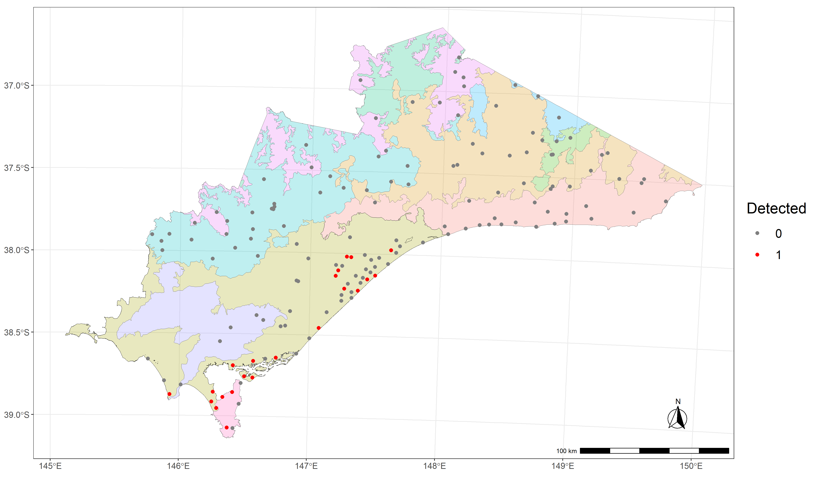
Figure 2. Detections of Hog deer recorded at each camera site in the Gippsland region. Coloured polygons refer to the bioregions given in Table 1.

Table 2. Model selection table for deer detection.
Model | Key function | Formula | $$ΔAIC$$
hr1 | Hazard-rate | ~Herbaceous understory cover | 0.000
hr0 | Hazard-rate | ~1 | 3.759
hn0 | Half-normal | ~1 | 186.719
hn1 | Half-normal | ~Herbaceous understory cover | 187.700
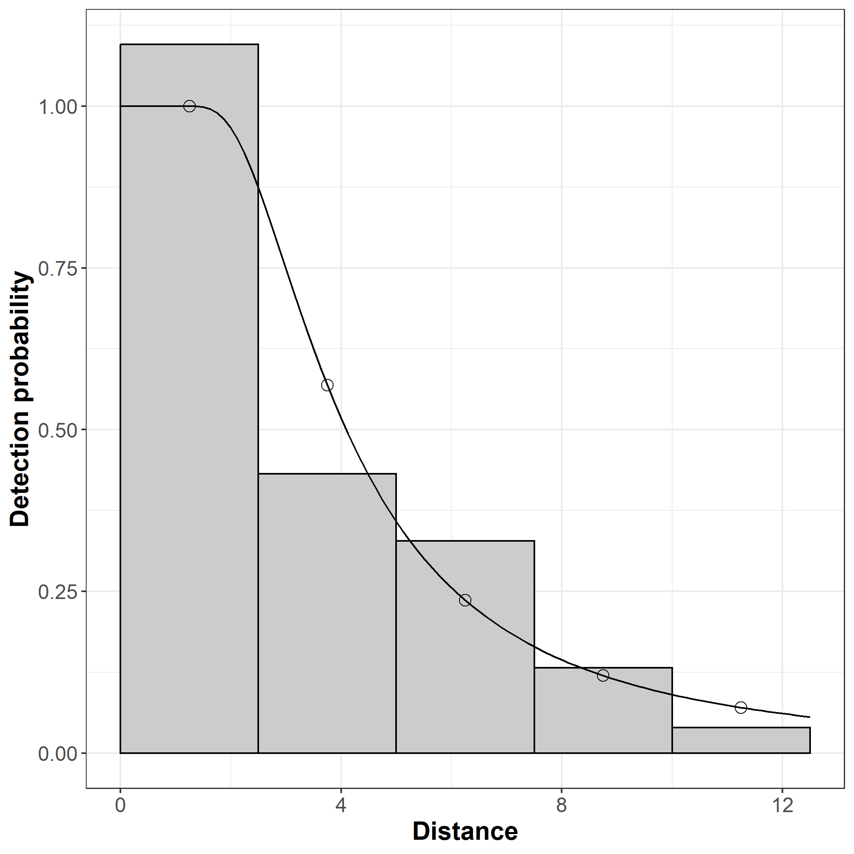
Figure 3. Distance-sampling detection process for Hog deer (group size = 1). Bars indicate the frequency distribution of expected distances, and the line indicates the detection function for the average herbaceous understorey cover (50%).

    - Drivers of abundance
A total of six covariates were used to model spatial variation in Hog deer abundance (Table 1). The zero-inflation parameter was modelled using bioregion as the sole effect, with Hog deer only detected in two bioregions, Gippsland Plains and Wilsons Promontory (Figure 2). The model for Hog deer abundance contained five fixed-effect covariates including bare soil (estimated by remote sensing at a broad spatial scale), soil nitrogen, distance to pastural land, precipitation seasonality, and amount of forest edge within a site. Bare soil and nitrogen had negative effects on Hog deer abundance (Figure 4). Distance to pasture had a relatively weak negative effect on Hog deer abundance, with abundance decreasing when the distance to pasture was beyond around 10 km (Figure 4). Hog deer also showed a strong positive relationship between precipitation seasonality as well as the amount of forest edge in the landscape (Figure 4). The model was a reasonable fit to the data, as judged by posterior predictive checks of the predicted and observed counts of deer on the cameras (Figure A1 – Appendix). While the model was a good fit to the proportion of sites with zero counts, as well as the mean and maximum count, it slightly underestimated the standard deviation of the counts (Figure A1 – Appendix). Overall, the model explained 60% of the variance in the camera counts (Bayesian R² = 0.598).

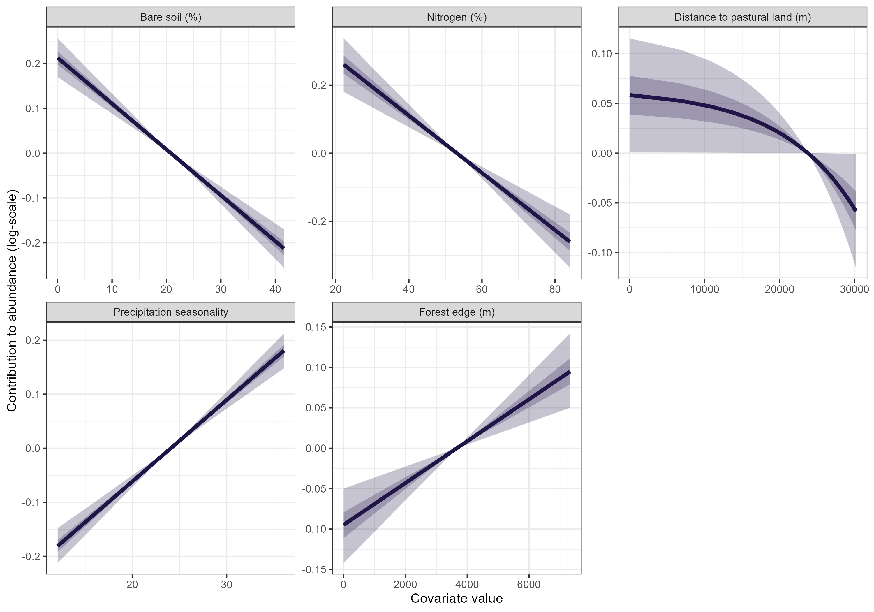
Figure 4. Conditional effects of five covariates used to model the spatial distribution of abundance for Hog deer. The y-axis shows the relative contribution to abundance (log-scale), and the x-axis shows the untransformed covariate values. All parameters were scaled for use within the model with square-root transformations for bare soil, nitrogen, and forest edge. Distance to pastural land was rounded up to the nearest 100 m and log transformed. 50% and 90% confidence bands are shown with dark and light purple shading.

Prediction of Hog deer abundance was made for public land within the Gippsland region as well as for the two main bioregions that encompassed the distribution of Hog deer, the Gippsland Plains and Wilsons Promontory (Table 3). Total Hog deer abundance was estimated as 4,252 (90% CrI: 2,571–6,490), with the majority occurring within the Gippsland Plains bioregion, which included areas such Stradbroke Flora and Fauna Reserve, Mullungdung Nature Conservation Reserve and Holey Plains State Park (Figure 5). However, highest densities of Hog deer were found within the Wilsons Promontory bioregion (4.1 deer/km²) (Table 3, Figure 5).

Table 3. Model-based estimates of Hog deer abundance (N) on public land in the Gippsland region of Victoria. SD – standard deviation, CV – coefficient of variation, 5%, 95% – lower and upper limits of the 90% credible interval (CrI). Density – average density (deer/km²).
Bioregion | N | SD | CV | 5% | 95% | Area km² | Density (90% CI)
Gippsland plains | 2,290 | 478 | 0.21 | 1450 | 3331 | 1,453 | 1.59 (0.97, 2.29)
Wilsons Promontory | 1,670 | 661 | 0.40 | 480 | 2975 | 414 | 4.06 (1.09, 7.20)
Total | 4,252 | 1,035 | 0.24 | 2,571 | 6490 | 25,211 | 0.17 (0.10, 0.26)

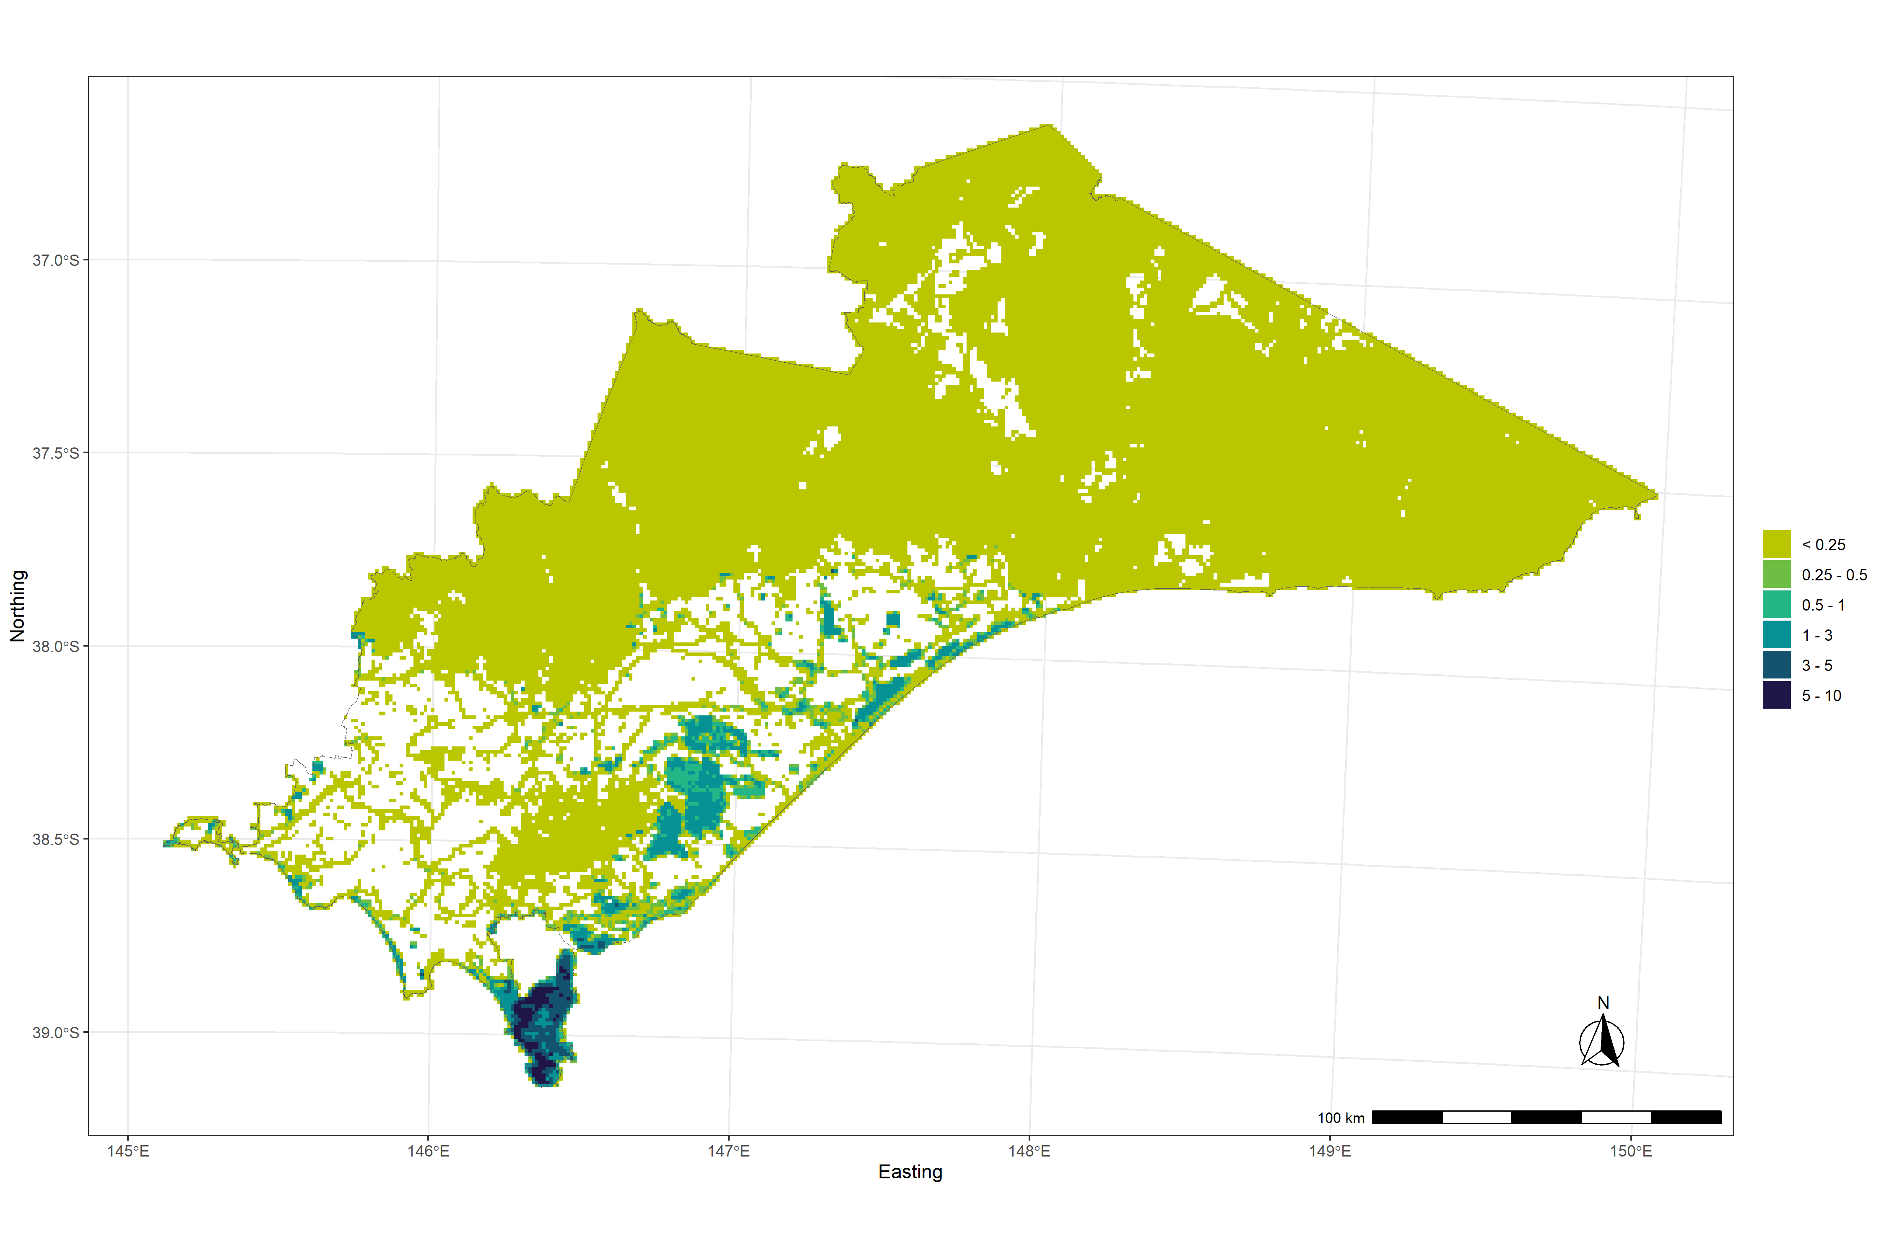
Figure 5. Distribution of Hog deer density (deer/km²) on public land within the Gippsland region.
    - Hog deer distribution
We obtained a threshold distribution based on the predicted mean abundance values for each grid cell. Our estimate of the distribution of Hog deer suggested a Hog deer range of 1,836 km² [95% CI: 1,610–2,187] across public land in the Gippsland region (Figure 6). This is slightly larger than the area of the Hog deer breeding range examined by Ramsey et al. (2019).

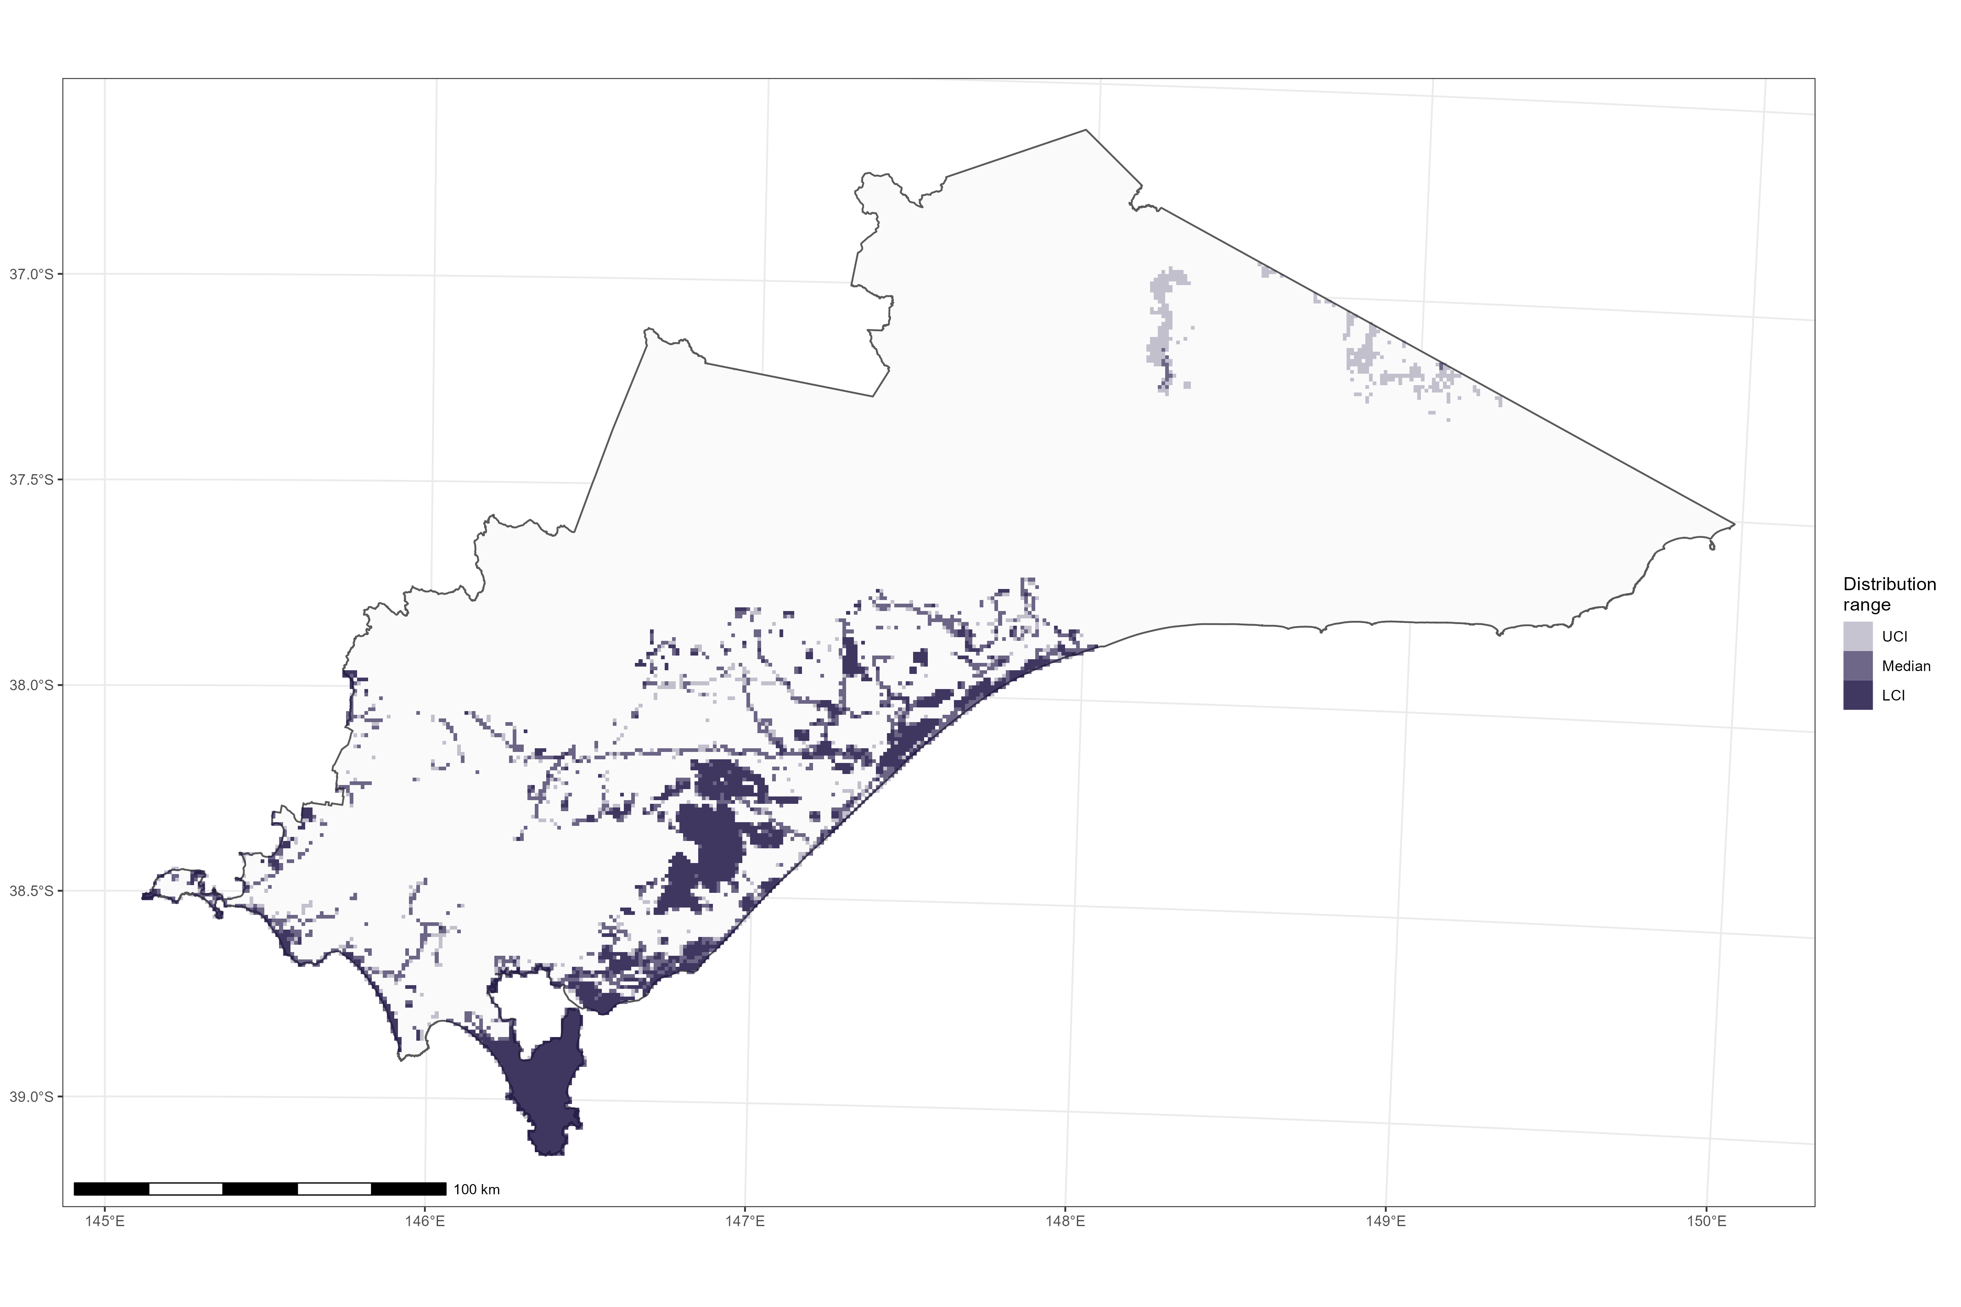
Figure 6. Estimate of the occupied range for Hog deer within the Gippsland region of Victoria. LCI and UCI refer to the bootstrapped 90% confidence intervals (CI) for the predicted range that minimised false positive and negative rates.

  - Population genetics of Hog deer
    - Sample collection and genotyping
After filtering, our dataset consisted of 6,277 SNPs from 276 individuals. This included 91 samples genotyped in 2018 and 185 samples genotyped in 2023. We successfully genotyped 111 samples from Wilsons Promontory, 14 samples from Snake Island, 12 samples from Sunday Island, and 129 samples from across the Mainland (Figure 7). A further 10 samples did not have recorded locations and were therefore excluded from analyses of dispersal and genetic diversity. Sample locations were recorded as the closest geographical feature (town, reserve or check station), and are consequently only indicative of the general area. Of the 276 successfully genotyped individuals, six were recorded as juveniles (< 1.5 years), 104 were adults and 166 did not have age data recorded. We expected most Mainland, Snake Island and Sunday Island individuals to be adults as recreational shooters typically avoid young deer. All deer sampled from Wilsons Promontory were culled as part of the deer eradication effort, which did not discriminate based on age, and therefore may have led to more juveniles being sampled from this location.
    - Population structure
The PCA plot revealed that samples were broadly organized by geographic location (Figure 8). The proportion of variation explained by the first two principal components (PCs) was 8% and 2.3%, indicating that the strength of population structuring was low to moderate. The first PC mainly separated the two edges of the Hog deer’s mainland range, from Wilsons Promontory NP in the west, to the Gippsland Lakes region in the east. Samples from the region between these two locations mirrored their geography on the PCA and fell between the two main clusters. Sunday Island samples separated from the other samples on the second PC and samples from Snake Island fell intermediately between the other three main clusters (Mainland, Sunday Island and Wilsons Promontory). A number of samples from the eastern Mainland region, specifically Blond Bay, also tended more towards Sunday Island (Figure 8). One individual from Yarram strongly grouped with the Wilsons Promontory samples (Figure 8). The other three samples from Yarram grouped with the pattern from the general area. Samples without recorded sampling locations grouped with the eastern Mainland samples.
The fastSTRUCTURE results indicated that the optimal number of clusters in the dataset was three, which broadly represented Wilsons Promontory, Sunday Island, and the Mainland (Figure 9). Snake Island individuals were found to have ancestry from all three of these clusters, approximately half from the Sunday Island cluster and a quarter from both the Wilsons Promontory and Mainland clusters. Many individuals from the Mainland also had a significant amount of ancestry from the Wilsons Promontory and/or Sunday Island clusters. Individuals further west generally had a larger proportion of their genome attributable to the Wilsons Promontory cluster. Additionally, all six samples from Blond Bay had a higher-than-average proportion of ancestry (40–50%) from the Sunday Island cluster compared to other samples from the Mainland. Similar to the PCA, a single individual from Yarram strongly clustered with Wilsons Promontory samples in the fastSTRUCTURE results, and all individuals from unknown sampling locations grouped with the eastern Mainland individuals.
Differentiation (based on FST statistic) between clusters was low, but significantly larger than zero (p<0.01) for all comparisons (Table 4).
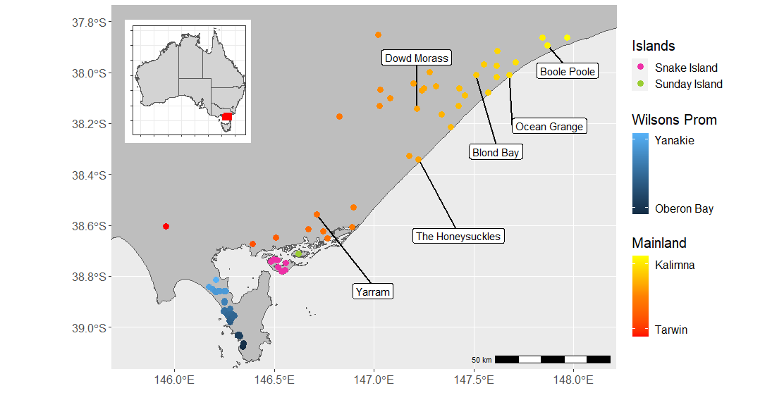
Figure 7. Broad sampling locations of 272 Hog deer samples successfully genotyped. Locations are coloured to match the PCA plot (Figure 8), by longitude for the Mainland samples (red-yellow), latitude for Wilsons Promontory (light-dark blue) or island (pink and green for Snake and Sunday Island, respectively). Particular sampling locations mentioned in the main text are labelled.

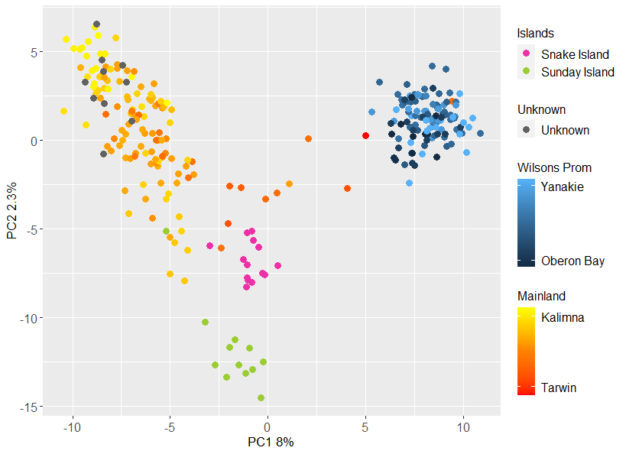
Figure 8. PCA plots of the first two principal components (PC) (which explain 10.3% of the variance in the dataset). Each point represents a sample, coloured to reflect sample location as displayed in Figure 1. Location of points in this plot reflect genetic similarity, so that points that are placed closer together are more genetically similar.

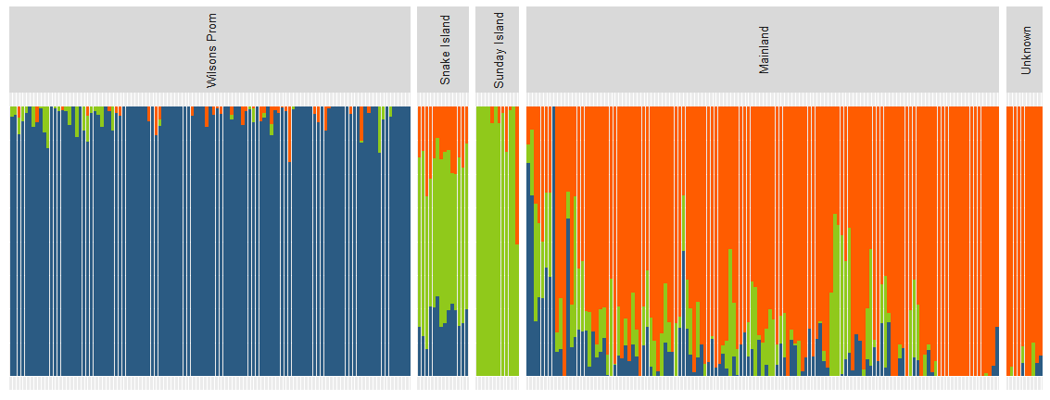
Figure 9. fastSTRUCTURE results. Each bar represents an individual, grouped by the location at which they were sampled. Wilsons Promontory samples are ordered by latitude, and Mainland samples are ordered by longitude. Colours represent the estimated proportional ancestry from each cluster.

Table 4. Pairwise FST statistic between clusters. P values are above the diagonal.
 | Mainland | Wilsons Promontory | Snake Island | Sunday Island
Mainland |  | <0.01 | <0.01 | <0.01
Wilsons Promontory | 0.082 |  | <0.01 | <0.01
Snake Island | 0.053 | 0.077 |  | <0.01
Sunday Island | 0.076 | 0.110 | 0.052

    - Dispersal
The majority of close kin (first- and second-degree relatives) were sampled very close together. The average distance between first-degree relatives was only 3.7 km, while the average distance between second-degree relatives was only 7.7 km (Table 5). There were, however, a number of close kin sampled much further apart, potentially indicating dispersal events or deliberate translocations. For example, of the 25 pairs of first-degree relatives, the longest distance between a pair was 43.4 km, between a male sampled at Ocean Grange and a female sampled at Dowd Morass, both in the eastern Mainland area. Another five first-degree relatives were > 5 km apart (Figure 10)
Of the 486 second-degree relatives identified, 212 were sampled > 5 km apart (Figure 10). Most of these were found either within the eastern Lakes region of the Mainland, or across Wilsons Promontory (Figure 10). The two most distantly separated second-degree relatives were found 75 km apart, with one individual sampled at Boole Poole, with the other sampled at The Honeysuckles. Ten individuals from Wilsons Promontory also had connections to the Yarram location via a single individual who had a large number of close kin in Wilsons Promontory (Figure 10).
We found strongly positive spatial autocorrelation in genetic similarity up to 40 km for females and 60 km for males, after which the correlation plateaued (Figure 11). While results for the Mainland were similar to the overall results, with significantly positive correlations found up to 40 km, results for Wilsons Promontory showed positive correlations between genetic and geographic distance only up to 8 km (Figure 12).

Table 5. Distance between pairs of individuals of different relatedness classes. SD – standard deviation.
Relatedness-class | Pairs | Mean distance (km) | SD. | Min. distance (km) | Max. distance (km)
First-degree | 25 | 3.7 | 9.1 | 0.0 | 43.4
Second-degree | 486 | 7.7 | 12.0 | 0.0 | 75.4
Distantly related | 9,842 | 24.9 | 26.0 | 0.0 | 163.6
Unrelated | 24,892 | 100.6 | 53.0 | 0.0 | 195.7
All | 35,245 | 78.1 | 58.3 | 0.0 | 195.7

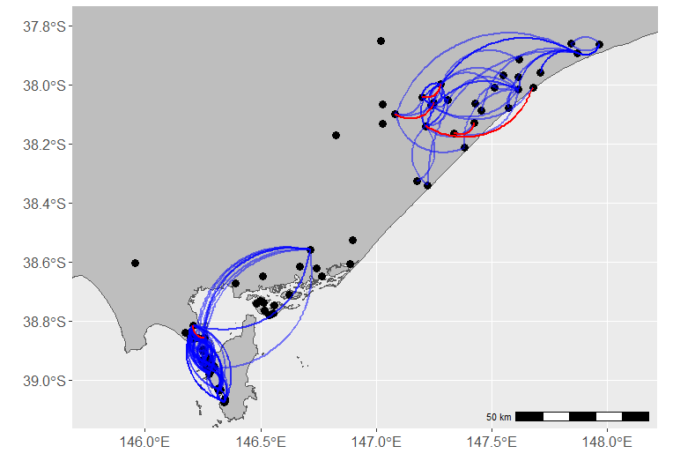
Figure 10. Close-kin connections. Points represent sampling locations, curved lines indicate distances between first- and second-degree relatives (excluding those that were < 5 km apart). Blue lines indicate second-degree relatives, red lines indicate first-degree relatives.
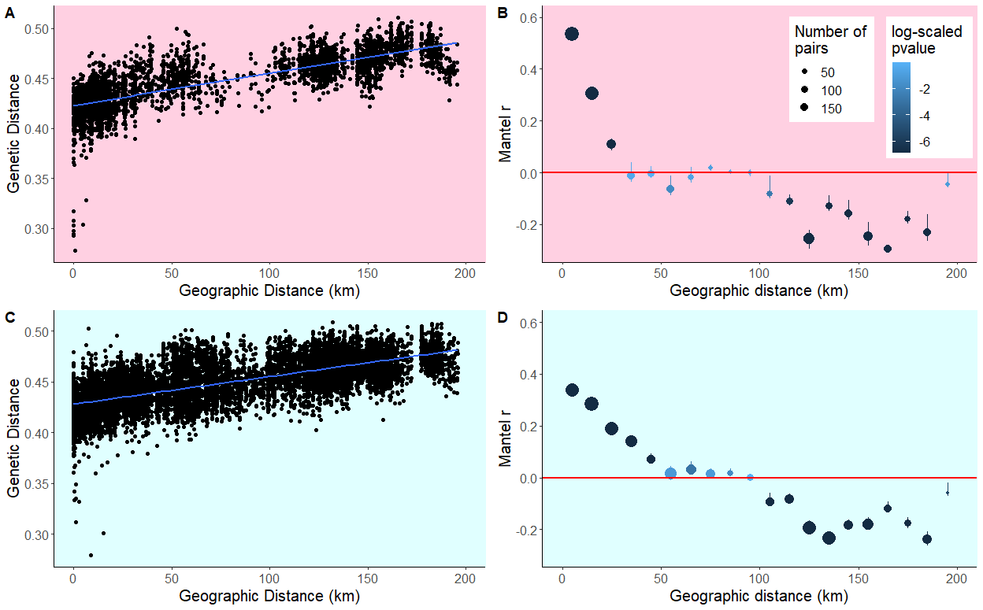
Figure 11. Spatial autocorrelation. Top row plots (A and B) show the results for female-female pairs, while bottom row plots (C and D) show the results for male-male pairs. On the left (A and C) are plots of geographic vs genetic distance data, each point represents a pair of individuals. This data was used to build the correlograms on the right (B and D). Each point on the correlograms represents a distance class for which a Mantel test was run, and the y axis represents the Mantel correlation coefficient, r. Points are sized by how many pairs of individuals were found in that distance class and coloured by the log p-value. Significantly positive (p<0.05) values of r indicate a positive relationship between genetic and geographic distance as expected under isolation-by-distance.

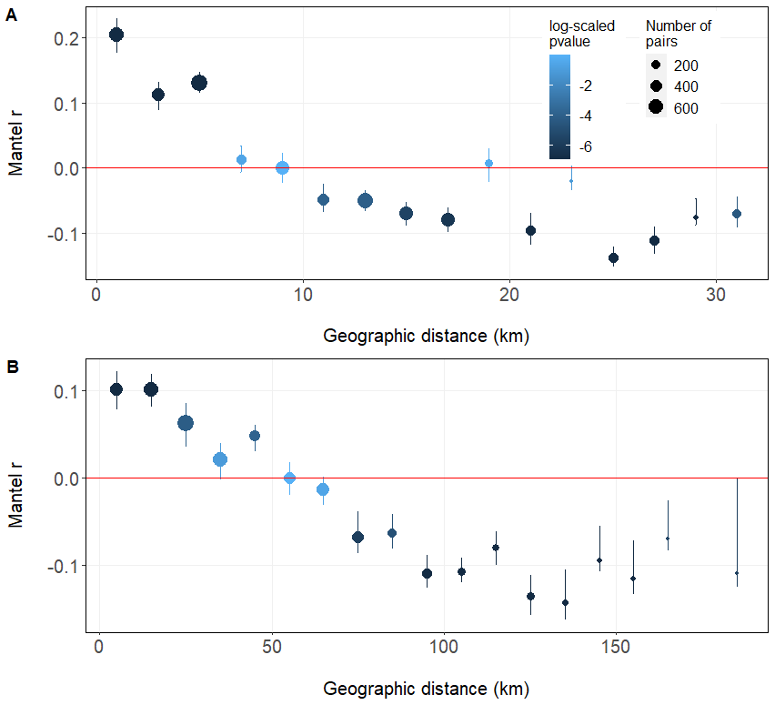
Figure 12. Spatial autocorrelation. A) analysis of Wilsons Promontory samples only, and B) analysis of Mainland samples only. Each point on the correlograms represents a distance class for which a Mantel test was run, and the y axis represents the Mantel correlation coefficient, r. Points are sized by how many pairs of individuals were found in that distance class and coloured by the log p-value. Significantly positive (p<0.05) values of r indicate a positive relationship between genetic and geographic distance as expected under isolation-by-distance.

    - Genetic diversity and effective population size
SNP heterozygosity was moderate across all four clusters, with Ho ranging from 0.32 at Sunday Island, to 0.37 at Snake Island and He ranging from 0.34–0.37 (Table 6). The close values of Ho and He were reflected in the inbreeding coefficient which was, in all cases, near zero (0.03–0.06; Table 6), suggesting that further within group clustering was not occurring. As expected, autosomal heterozygosity estimates were substantially lower than SNP heterozygosity and were similarly small across all four clusters (0.0001–0.00012; Table 6).

Table 6. Diversity statistics. Ne: effective population size including 95% confidence intervals in parentheses, Ho: observed SNP heterozygosity, He expected SNP heterozygosity, FIS: inbreeding coefficient, aHo: observed autosomal heterozygosity, aHe: expected autosomal heterozygosity.
Location | N | Ne (95% CI) | Ho | He | FIS | aHo | aHe
Mainland | 131 | 127.5 (112.7–145.8) | 0.35 | 0.37 | 0.06 | 0.000110 | 0.000116
Wilsons Promontory | 111 | 99.7 (84.9–118.9) | 0.34 | 0.35 | 0.04 | 0.000107 | 0.000110
Snake Island | 14 | 159.1 (106.1–310.3) | 0.37 | 0.37 | 0.03 | 0.000116 | 0.000115
Sunday Island | 12 | 24.2 (13.1–75.1) | 0.32 | 0.34 | 0.06 | 0.000102 | 0.000104
- Discussion
Estimates of Hog deer abundance on public land within the Gippsland region indicated that the population was relatively small, at around 4,250 individuals, with the highest abundance estimated for the Gippsland Plains bioregion (2,290 deer) at an average density of 1.6 deer km². However, the highest densities of Hog deer occurred in Wilsons Promontory, with an estimate of 4.1 deer/km² and an abundance estimate of 1,670 deer. The abundance estimate for the current study was higher than was reported in the earlier study of Ramsey et al. (2019) (3,000). Recent studies have shown that CTDS estimates need to account for variation in activity levels (i.e. the proportion of a 24 h day when animals are active), because encounter rates with cameras are likely to vary with activity (Rowcliffe et al. 2014). Failure to account for activity using CTDS will result in underestimates of population abundance (Corlatti et al. 2020). In addition, behavioural interactions of animals with camera traps or distance markers may also cause bias in density estimates (Houa et al. 2022). Consequently, animal reactivity to camera traps must also be accounted for in any analysis to avoid such bias. While the current analysis accounted for both Hog deer activity and behavioural interactions with cameras and distance markers, the study by Ramsey et al. (2019) did not account for these effects, which was likely to have resulted in abundance being underestimated. Although the current estimate for the Hog deer population is higher than that given in Ramsey et al. (2019), this difference can at least in part be attributed to the larger area sampled, which included 153 sites on public land within the entire Gippsland region. In contrast, the study by Ramsey et al. (2019) only sampled sites within the coastal Gippsland area.
We found several bioclimatic and landscape variables to be informative in predicting spatial variation in Hog deer abundance. Notably, edge/ecotone effects were found to be informative for predicting abundance, with Hog deer more likely to be found in closer proximity to pasture as well as areas with higher amounts of forest edge habitat. Proximity to pasture and grasslands may support higher densities of deer, because those areas likely provide an abundance of preferred food sources. Our study also found effects of soil composition (bare soil and nitrogen %) and climate (precipitation seasonality), which had variable effects on Hog deer abundance. Determining whether these relationships reflect underlying habitat preferences or correlations of these habitat attributes with other processes influencing Hog deer density (e.g., hunting pressure/control) would require more detailed investigation.
Despite sampling of 153 locations throughout the Gippsland region, Hog deer were not detected east of Lakes Entrance, consistent with the results reported by Ramsey et al. (2019). Despite the more extensive sampling undertaken during the current survey, Hog deer were only detected at a similar number of sites and locations to those where Hog deer were detected in 2018. Estimates of the area occupied by Hog deer (1,610–2,187 km²) suggest that the Hog deer range is still largely confined to the coastal area between Lower Tarwin and Lakes Entrance. However, the current study also suggested the possibility that Hog deer may occupy areas of Stradbroke Flora and Fauna Reserve, Mullungdung Nature Conservation Reserve and Holey Plains State Park, despite no Hog deer being detected on cameras in these areas. More intensive monitoring would be required to confirm Hog deer presence or absence in these areas.
  - Hog deer genetics
Our results show that the Victorian Hog deer population has low genetic variability, is composed of three main clusters, and shows characteristics of small average dispersal distances with rare long-distance dispersal. These results largely support the findings of Ramsey et al. (2019). However, the use of SNPs and an increased sample size has allowed an analysis with a much finer resolution than was possible using the microsatellite analysis employed by Ramsey et al. (2019).
Population structure
The eastern Lakes region of the Mainland and the Wilsons Promontory area in the west represent two separate genetic clusters. However, our results suggest that while movement between these two regions is probably lower than within them, it is not completely absent. Although we only detected a small number of first- or second-degree relatives connected across these two regions (between Yarram and Wilsons Promontory, discussed further below), FST, PCA and fastSTRUCTURE analysis indicate that there is some mixing between the two groups: differentiation between the two clusters was low and many individuals collected in the intermediate regions between the two range extremes show joint ancestry from the two main clusters. More specifically, individuals in the intermediate region showed some ancestry with the Wilsons Promontory cluster, but individuals from Wilsons Promontory showed very limited ancestry with the eastern Mainland group. This suggests that Wilsons Promontory NP is acting as a source population from which deer are dispersing, but that deer from outside the peninsula are unlikely to be migrating into the National Park. Furthermore, these results indicate that Hog deer find it difficult, but not impossible, to move across the landscape between the Wilsons Promontory NP and the Lakes NP, possibly reflecting increased agricultural development (Ramsey et al. 2019). The possibility also exists that some dispersal events are actually due to human assisted translocation of Hog deer.
Sunday Island represented a third cluster in the dataset. This island population also had the lowest diversity and smallest effective population size. These results likely reflect the insularity of the Hog deer population at this site, which is a privately owned game reserve. This insularity has likely increased the rate of divergence, diversity loss and inbreeding compared to that at other sites. Genetic ancestry from the Sunday Island cluster was also evident at some mainland sites, which may reflect historic translocations from the islands. For example, deer from Sunday Island were translocated to Blond Bay in the 1980s, and this connection is still evident in the genetic data today.
Our results from Snake Island support the conclusion that it is genetically intermediate between the other three clusters (Sunday Island, eastern Mainland and Wilsons Promontory). This result could reflect movement of individuals out of Snake Island to the other clusters, movement of individuals from the other clusters into Snake Island, or both. The initial release of Hog deer in Victoria occurred at Port Welshpool, the closest mainland site to Snake Island, in 1865, and more deer were released onto Snake Island itself in 1867 (Mayze and Moore 1990). As an introduced population’s range expands, the edges of the range expansion tend to have lower diversity than the initial release site/core range. Indeed, we found that Snake Island has the highest diversity and effective population size of all sampled locations (but see below for a discussion of differences in this result to previous work). However, high diversity can also reflect recent gene flow from differentiated populations into a site. Additionally, we know that 90 individuals from Snake Island were translocated to Dutson Downs, in the Lakes region, in the 1970s (Mayze and Moore 1990) and a previous genetic study found close-kin connections between Snake Island and the mainland site of Loch Sport, suggesting recent movement (Hill et al. 2022). Since the population on Sunday Island is genetically distinct from the other subpopulations, natural migration from/to the mainland appears to be unlikely. Consequently, the relatively high genetic variability of Hog deer on Snake Island is most probably due to human assisted translocation of individuals.
Dispersal
Our spatial auto-correlation analysis indicated the “neighbourhood-size’ for genetic connectivity of Hog deer was ~40 km for females and ~60 km for males. These can also be interpreted as maximum dispersal distances, although shorter, sequential, multi-generation dispersals can also lead to this result. These results agree well with the results of our relatedness analysis, which found average distances between first- and second-degree relatives of 3.3 km and 7.7, respectively, but maximum distances of 43.4 km and 75.4 km. These results indicate that Hog deer mostly disperse only a short distance from their natal range, with long distance dispersal occurring occasionally. As an evolutionary strategy, this may be expected as long-distance dispersal tends to be a risky strategy with uncertain pay-offs (Shaw et al. 2014).
The different patterns found for female-female and male-male pairs indicate that dispersal is male biased, as is the case for most mammal species (Pusey 1987). This was also shown during tracking of translocated individuals in the 1970s, where females typically dispersed < 30 km, but males displayed more varied dispersal including some long-distance movements (Mayze and Moore 1990).
When we examined the Mainland and Wilsons Promontory samples separately, we found that the neighbourhood size at Wilsons Promontory was significantly smaller than the other subpopulations, at just 8 km. This was also reflected in the relatedness analysis, as a large number of second-degree relatives were detected within this location. This might reflect restricted movement opportunities within Wilsons Promontory, which has a geographically diverse landscape. Alternatively, it may reflect a preference for shorter dispersal distances when habitat is relatively continuous. Wilsons Promontory is a large national park, in contrast to the other mainland sites, which have a significant amount of agricultural and urban development fragmenting suitable Hog deer habitat. Finally, it may reflect a difference in age structure of samples from Wilsons Promontory compared to that at other locations. Unlike other regions where hunting is strictly regulated to maintain the Hog deer population, efforts are underway at Wilsons Promontory to eradicate deer from the peninsula. Therefore, we may expect more juvenile deer, which have not yet dispersed from their natal range, in the sample-set from this region. All dispersal analyses need to be interpreted with some caution due to the known inaccuracies of the location data and the limitations of using straight-line distances when dealing with discontinuous habitat, which may include habitat with varying permeability to dispersing animals. Human mediated translocations of individuals may also affect conclusions about natural dispersal distances of Hog deer in these areas.
Genetic diversity and effective population size
SNP heterozygosity measures were moderate (0.32–0.37). However, previous microsatellite genotyping found much lower diversity (relative to microsatellite-based estimates of other species) across the Victorian Hog deer population (Ramsey et al. 2019). This difference is likely due to the known upward bias of SNP heterozygosity estimates (Schmidt et al. 2021). To overcome this, we used newly developed functions of dartR to estimate autosomal heterozygosity, which, as expected, was substantially lower than SNP heterozygosity (0.0001–0.00012).
A benefit of the autosomal heterozygosity method is the ability to compare across studies and species. However, SNP heterozygosity has been the most common diversity statistic presented in population genetics studies for nearly a decade, and autosomal heterozygosity has, as yet rarely been reported. Consequently, comparisons with other taxa with known conservation status are limited. Regardless, from a limited number of comparisons, our results from Hog deer are around an order of magnitude lower than that reported for other species. For example, a threatened grasshopper species (Keyacris scurra) was shown to have aHo values of 0.00179–0.00355 (Schmidt et al. 2021), and a mean value of 0.00187 was calculated from the genome of stickleback fish Gasterosteus aculeatus (Davey et al. 2011). A larger comparative dataset of autosomal heterozygosity is needed to better understand relative patterns of diversity (Willi et al. 2022). Additionally, we emphasise that the Hog deer aHo results are preliminary, as we used functionality of the dartR package that is still under development. Regardless, from the limited comparisons available, and in agreement with previous microsatellite-based work, we find that the genetic diversity of Victorian Hog deer is very low. This corresponds with our estimates of effective population size, which were also small (24.2–159.1).
Low diversity and effective population size is to be expected in the Victorian Hog deer population given the small number of founders released over 150 years ago, and the small census population size that has been maintained since. Strong bottlenecks during founder events and small, long-term population size will both lead to rapid loss of genetic diversity, which is common among many introduced species (Schrieber and Lachmuth 2017). The rate at which a population will lose genetic diversity is inversely related to effective population size. Therefore, a population with low effective population size is expected to lose diversity faster, and experience negative impacts of inbreeding sooner, than one with a larger effective population size. In a wildlife conservation context, estimates of effective population size less than 100 are considered inadequate to avoid inbreeding depression in the next five generations (Frankham et al. 2014). Our results indicate that Sunday Island Hog deer are the most at risk of inbreeding depression and diversity loss in the future.
Comparisons with previous work
Victorian Hog deer population structure, dispersal characteristics and genetic diversity have previously been investigated using microsatellites (Ramsey et al. 2019; Hill et al. 2022) and SNPs (Hill et al. 2023). The majority of our results in this new study are in agreement with previous work. For example, previous SNP-based examination of dispersal characteristics found small neighbourhood sizes and high rates of relatedness among Wilsons Promontory individuals and low rates of long-distance dispersal (Hill et al. 2023). Previous microsatellite-based analyses also found low differentiation between clusters and similar patterns of isolation-by-distance and spatial autocorrelation, and also showed connection between the two extreme-ends of the Hog deer’s mainland range (Wilsons Promontory vs the eastern Lakes region; Ramsey et al. 2019; Hill et al. 2022), which our analysis has confirmed. We also found similarly small effective population size and low diversity across the Hog deer range, comparable with previous work.
Small differences in results from the current study and previous work are likely due to differences in sampling distribution, choice of genetic marker analysed, and slight differences in the spatial delineation of genetic clusters. The major point of difference with previous studies centres on Snake Island. Two previous microsatellite-based studies identified this island population as differentiated from all other groups, and one of these found that this population had the lowest diversity of all sites (although the second found diversity levels at Snake Island were comparable to Wilsons Promontory (Ramsey et al. 2019; Hill et al. 2022). While we found that Snake Island did form an identifiable cluster on the PCA, it was equally similar to the other three clusters in the dataset (Sunday Island, Wilsons Promontory and the eastern Mainland). This was reflected in the fastSTRUCTURE results, which indicated Snake Island Hog deer had ancestry from all three other clusters. Additionally, our results indicated that Snake Island had the highest diversity and effective population size of all sites. This may be due to the limited sample size we evaluated (14 individuals compared to 25–30 in the microsatellite studies), the wider sampling distribution we achieved in this study compared to the previous work, or the complex population history of founding and translocation from and to Snake Island. Complex demographic histories are known to produce difficult-to-interpret results from clustering algorithms such as STRUCTURE (Lombaert et al. 2018). Increased sampling from Snake Island may resolve some of these conflicts, but analysis of historic samples may be required to better resolve the complexities around founder effects and translocations.
  - Conclusions
Monitoring of the Hog deer population using a more extensive array of sites throughout the Gippsland region has not revealed significant changes to either the abundance or distribution of Hog deer, compared to the previous analyses in 2018. Therefore, the Hog deer population remains comparatively small, and geographically isolated when compared with the other deer species in Victoria (e.g. Sambar, Fallow, Red) (Cally and Ramsey 2023). Modelling of the current distribution did suggest that Hog deer may potentially occupy areas outside of their current known range including Stradbroke Flora and Fauna Reserve, Mullungdung Nature Conservation Reserve and Holey Plains State Park, despite no Hog deer being detected on cameras in these areas. More intensive monitoring would be required to confirm Hog deer presence or absence in these areas.
The current genetic analyses of Hog deer revealed limited genetic diversity, three primary subpopulations, and short average dispersal distances with occasional long-distance dispersal events. There was evidence of limited migration between the Wilsons Promontory and Mainland clusters, possibly due to barriers caused by agricultural and urban development. The Sunday Island population, isolated from the mainland, exhibits the lowest genetic diversity and effective population size. In contrast, Snake Island stands out with the highest genetic diversity, contrary to previous findings, suggesting a history of translocations of Hog deer from/to the Island. Overall, the low genetic diversity suggests that the population is at a higher risk from inbreeding and loss of adaptive capacity, especially given threats like hunting, control efforts, disease, and habitat loss (e.g. high intensity bushfires).
Recommendations
- In light of the updated estimates of population abundance and distribution, continue to monitor Hog deer populations periodically to determine population trends in the Gippsland Plains and Wilsons Promontory bioregions.
- Conduct more intensive monitoring in areas of suitable habitat within Stradbroke Flora and Fauna reserve, Mullungdung Nature Conservation reserve and Holey Plains State Park to confirm the presence (or absence) of Hog deer in these regions.
- Conduct an analysis of additional samples from Hog deer on Snake Island to confirm the genetic analysis suggesting the population on the island is derived from mixed genetic ancestry.
- References
ABARES. (2021). Catchment scale land use of Australia – Update December 2020. Australian Bureau of Agricultural and Resource Economics and Sciences, Canberra, ACT.
Banks, S. C. and Peakall, R. (2012). Genetic spatial autocorrelation can readily detect sex-biased dispersal. Molecular Ecology 21, 2092–2105 doi:10.1111/j.1365-294X.2012.05485.x
Buckland, S. T., Rexstad, E. A., Marques, T. A., Oedekoven, C. S., others (2015). Distance sampling: Methods and applications. Springer, Cham, Switzerland.
Burnham, K. P. and Anderson, D. R. (2002). Model selection and multimodel inference. Springer-Verlag, New York, USA.
Cally, J. G. and Ramsey D. S. L. (2023). Abundance of deer in Victoria: Regional and statewide estimates of deer density and their impact on vegetation. Arthur Rylah Institute for Environmental Research Technical Report Series No. 368. Department of Energy, Environment and Climate Action, Heidelberg, Victoria.
Corlatti, L., Sivieri, S., Sudolska, B., Giacomelli, S. and Pedrotti, L. (2020). A field test of unconventional camera trap distance sampling to estimate abundance of marmot populations. Wildlife Biology 2020, 1–11 doi:10.2981/wlb.00652
Côté, S. D., Rooney, T. P., Tremblay, J-P., Dussault, C. and Waller, D. M. (2004). Ecological impacts of deer overabundance. Annual Review of Ecology, Evolution, and Systematics 35, 113–147.
Davey, J. W., Hohenlohe, P. A., Etter, P. D., Boone, J. Q., Catchen, J. M. and Blaxter, M. L. (2011). Genome-wide genetic marker discovery and genotyping using next-generation sequencing. Nature Reviews Genetics 12, 499–510 http://dx.doi.org/10.1038/nrg3012
Davis, N. E., Bennett, A., Forsyth, D. M., Bowman, D. M. J. S. J. S., Lefroy, E. C., Wood, S. W., Woolnough, A. P., West, P., Hampton, J. O. and Johnson, C. N. (2016). A systematic review of the impacts and management of introduced deer (family Cervidae) in Australia. Wildlife Research 43, 515–532.
Davis, N. E., Coulson, G. and Forsyth, D. M. (2008). Diets of native and introduced mammalian herbivores in shrub-encroached grassy woodland, south-eastern Australia. Wildlife Research 35, 684–694.
DEECA (2021). Structural vegetation (1995). https://metashare.maps.vic.gov.au/geonetwork/srv/api/records/d433599e-e517-5b5b-a75b-45bb95ad1b85/formatters/sdm-html?root=html&output=html
Delisle, Z. J., Miller, D. L. and Swihart, R. K. (2023). Modelling density surfaces of intraspecific classes using camera trap distance sampling. Methods in Ecology and Evolution, 1287–1298 doi:10.1111/2041-210X.14093
Department of Energy Environment and Climate Action. (2019). Native Vegetation - Modelled 2005 Ecological Vegetation Classes (with Bioregional Conservation Status). https://metashare.maps.vic.gov.au/geonetwork/srv/api/records/a502df15-7b90-5e96-b1a0-ba29e95558b2/formatters/sdm-html?root=html&output=html
Diniz-Filho, J .A. F., Soares, T. N., Lima, J. S., Dobrovolski, R., Landeiro, V. L., de Campos Telles, M. P., Rangel, T. F. and Bini, L. M. (2013). Mantel test in population genetics. Genetics and Molecular Biology 36, 475–485 doi:10.1590/S1415-47572013000400002
Do, C., Waples, R. S., Peel, D., Macbeth, G. M., Tillett, B. J. and Ovenden, J. R. (2014). NeEstimator v2: re-implementation of software for the estimation of contemporary effective population size (Ne) from genetic data. Molecular Ecology Resources 14, 209–214 doi:10.1111/1755-0998.12157
Forsyth, D. M., Stamation, K. and Woodford, L. (2016). Distributions of Fallow Deer, Red Deer, Hog Deer and Chital Deer in Victoria. Unpublished Client Report for the Biosecurity Branch, Department of Economic Development, Jobs, Transport and Resources. Arthur Rylah Institute for Environmental Research, Department of Environment, Land, Water and Planning, Heidelberg, Victoria.
Foster, S. D., Hosack, G. R., Lawrence, E., Przeslawski, R., Hedge, P., Caley. M. J., Barrett, N. S., Williams, A., Li. J., Lynch, T., Dambacher, J. M., Sweatman, H. P. A. and Hayes, K. R. (2017). Spatially-balanced designs that incorporate legacy sites. Methods in Ecology and Evolution 8, 1433–1442.
Frankham, R., Bradshaw, C. J. A. and Brook, B. W. (2014). Genetics in conservation management: Revised recommendations for the 50/500 rules, Red List criteria and population viability analyses. Biological Conservation 170, 56–63 doi:https://doi.org/10.1016/j.biocon.2013.12.036
Gelman, A., Goodrich, B., Gabry, J. and Vehtari, A. (2019). R-squared for Bayesian Regression Models. The American Statistician 73, 307–309 doi:10.1080/00031305.2018.1549100
Goslee, S. C. and Urban, D. L. (2007). The Ecodist Package for Dissimilarity-based Analysis of Ecological Data. Journal of Statistical Software 022, 1–19 https://ideas.repec.org//a/jss/jstsof/v022i07.html
Guerschman, J. (2014). Fractional cover—MODIS. CSIRO algorithm. V2. CSIRO, Data Collection. http://hdl. Handle. Net/102.100 100, 42094.
Henrich, M., Hartig, F., Dormann, C. F., Kühl, H. S., Peters, W., Franke, F., Peterka, T., Šustr, P. and Heurich, M. (2022). Deer behavior affects density estimates with camera traps, but is outweighed by spatial variability. Frontiers in Ecology and Evolution 10, 1–17 doi:10.3389/fevo.2022.881502
Hijmans, R. J. (2022). Geosphere: Spherical Trigonometry. https://CRAN.R-project.org/package=geosphere
Hill, E., Murphy, N., Linacre, A., Toop, S., Strugnell, J. M., Hill, E., Murphy, N., Linacre, A., Toop, S. and Strugnell, J. M. (2023). Kinship analysis reveals low dispersal in a hog deer (Axis porcinus) population in Wilsons Promontory National Park, Australia. Wildlife Research 50, 746–756 doi:10.1071/WR22098
Hill, E., Murphy, N., Toop, S., Linacre, A. and Strugnell, J. M. (2022). Genetic analysis of hog deer (Axis porcinus) in Victoria, Australia, and its applications to invasive species and game management. European Journal of Wildlife Research 68, 45 doi:10.1007/s10344-022-01592-9
Houa, N. A., Cappelle, N., Bitty, E. A., Normand, E., Kablan, Y. A. and Boesch, C. (2022). Animal reactivity to camera traps and its effects on abundance estimate using distance sampling in the Taï National Park, Côte d’Ivoire. PeerJ doi:10.7717/peerj.13510
Howe, E. J., Buckland, S. T., Després-Einspenner, M-L. and Kühl, H. S. (2017). Distance sampling with camera traps. Methods in Ecology and Evolution 8, 1558–1565.
Karger, D. N., Conrad, O., Böhner, J., Kawohl, T., Kreft, H., Soria-Auza. R. W., Zimmermann, N. E., Linder, H. P. and Kessler, M. (2017). Climatologies at high resolution for the earth’s land surface areas. Scientific data 4, 1–20.
Lombaert, E., Guillemaud. T. and Deleury, E. (2018). Biases of STRUCTURE software when exploring introduction routes of invasive species. Heredity 120, 485–499.
Mason, S. S., Hill, R. A., Whittingham, M. J., Cokill, J., Smith, G.C. and Stephens, P. A. (2022). Camera trap distance sampling for mammal population monitoring: Lessons learnt from a UK case study. Remote Sensing in Ecology and Conservation, 1–14 doi:10.1002/rse2.272
Mayze, R. J. and Moore, G. I. (1990). The Hog Deer. Australian Deer Research Foundation, Melbourne, Victoria.
Menkhorst, P. W. (1995). Mammals of Victoria: Distribution, ecology and conservation. Oxford University Press, Melbourne, Victoria.
Mijangos, J. L., Gruber, B., Berry, O., Pacioni, C. and Georges, A. (2022). dartR v2: An accessible genetic analysis platform for conservation, ecology and agriculture. Methods in Ecology and Evolution 13, 2150–2158 doi:10.1111/2041-210X.13918
Moloney, P. D. and Turnbull, J. D. (2018). Estimates of the 2017 deer harvest in Victoria. Unpublished Client Report for the Game Management Authority. Arthur Rylah Institute for Environmental Research, Department of Environment, Land, Water and Planning: Heidelberg, Victoria
Niedballa, J., Sollmann, R., Courtiol, A. and Wilting, A. (2016). camtrapR: an R package for efficient camera trap data management. Methods in Ecology and Evolution 7, 1457–1462.
O’Brien, L. (2021). slga: Data access tools for the Soil and Landscape Grid of Australia. Available at: https://github.com/obrl-soil/slga
Odden, M. and Wegge, P. (2007). Predicting spacing behavior and mating systems of solitary cervids: A study of hog deer and Indian muntjac. Zoology 110, 261–270.
Perkins, N. J. and Schisterman, E. F. (2006). The inconsistency of ‘optimal’ cutpoints obtained using two criteria based on the Receiver Operating Characteristic Curve. American Journal of Epidemiology 163, 670–675 doi:10.1093/aje/kwj063
Pew, J., Muir, P. H., Wang, J., and Frasier, T. R. (2015). related: an R package for analysing pairwise relatedness from codominant molecular markers. Molecular Ecology Resources 15, 557–561 doi:10.1111/1755-0998.12323
Pusey, A. E. (1987). Sex-biased dispersal and inbreeding avoidance in birds and mammals. Trends in Ecology and Evolution 2, 295–299 doi:10.1016/0169-5347(87)90081-4
Queller, D. C. and Goodnight, K. F. (1989). Estimating relatedness using genetic markers. Evolution 43, 258–275 doi:10.1111/j.1558-5646.1989.tb04226.x
R Development Core Team (2020). R: A language and environment for statistical computing. http://www.r-project.org
Raj, A., Stephens, M. and Pritchard, J. K. (2014). fastSTRUCTURE: Variational inference of population Structure in large SNP data sets. Genetics 197, 573–589 doi:10.1534/genetics.114.164350
Ramsey, D. S. L., Pacioni, C. and Hill, E. (2019). Abundance and population genetics of Hog Deer (Axis porcinus) in Victoria. Arthur Rylah Institute for Environmental Research Technical Report Series No. 303, Department of Environment, Land, Water and Planning: Heidelberg, Victoria.
Robin, X., Turck, N., Hainard, A., Tiberti, N., Lisacek, F., Sanchez, J-C. and Müller, M. (2011). pROC: An open-source package for R and S+ to analyze and compare ROC curves. BMC bioinformatics 12, 1–8.
Rowcliffe, J. M., Kays, R., Kranstauber, B., Carbone, C. and Jansen, P. A. (2014). Quantifying levels of animal activity using camera trap data Ed D Fisher. Methods in Ecology and Evolution 5, 1170–1179 doi:10.1111/2041-210X.12278
Schmidt, T. L., Jasper, M-E., Weeks, A. R. and Hoffmann, A. A. (2021). Unbiased population heterozygosity estimates from genome-wide sequence data. Methods in Ecology and Evolution 12, 1888–1898 doi:10.1111/2041-210X.13659
Schrieber, K. and Lachmuth, S. (2017). The Genetic Paradox of Invasions revisited: The potential role of inbreeding × environment interactions in invasion success. Biological Reviews 92, 939–952 doi:10.1111/brv.12263
Shaw, A. K., Jalasvuori, M. and Kokko, H. (2014). Population-level consequences of risky dispersal. Oikos 123, 1003–1013 doi:10.1111/oik.01229
Slee, K. J. (1985). 1985 Hog Deer habitat survey. A report prepared for the Australian Deer Association, Melbourne, Victoria.
Sokal, R. R. (1979). Testing statistical significance of geographic variation patterns. Systematic Zoology 28, 227–232 doi:10.2307/2412528
Thomas, L., Buckland, S. T., Rexstad, E. A., Laake, J. L., Strindberg, S., Hedley, S. L., Bishop, J. R. B., Marques, T. A. and Burnham, K. P. (2010). Distance software: Design and analysis of distance sampling surveys for estimating population size. Journal of Applied Ecology 47, 5–14 doi:https://doi.org/10.1111/j.1365-2664.2009.01737.x
Vehtari, A., Gabry, J., Magnusson, M., Yao, Y., Bürkner, P-C., Paananen, T. and Gelman, A. (2020). loo: Efficient leave-one-out cross-validation and WAIC for Bayesian models. https://mc-stan.org/loo/
Waples, R. S. and Do, C. (2008). ldne: A program for estimating effective population size from data on linkage disequilibrium. Molecular Ecology Resources 8, 753–756 doi:10.1111/j.1755-0998.2007.02061.x
Willi, Y., Kristensen, T. N., Sgrò, C. M., Weeks, A. R., Ørsted, M. and Hoffmann, A. A. (2022). Conservation genetics as a management tool: The five best-supported paradigms to assist the management of threatened species. Proceedings of the National Academy of Sciences 119, e2105076119 doi:10.1073/pnas.2105076119

Appendix
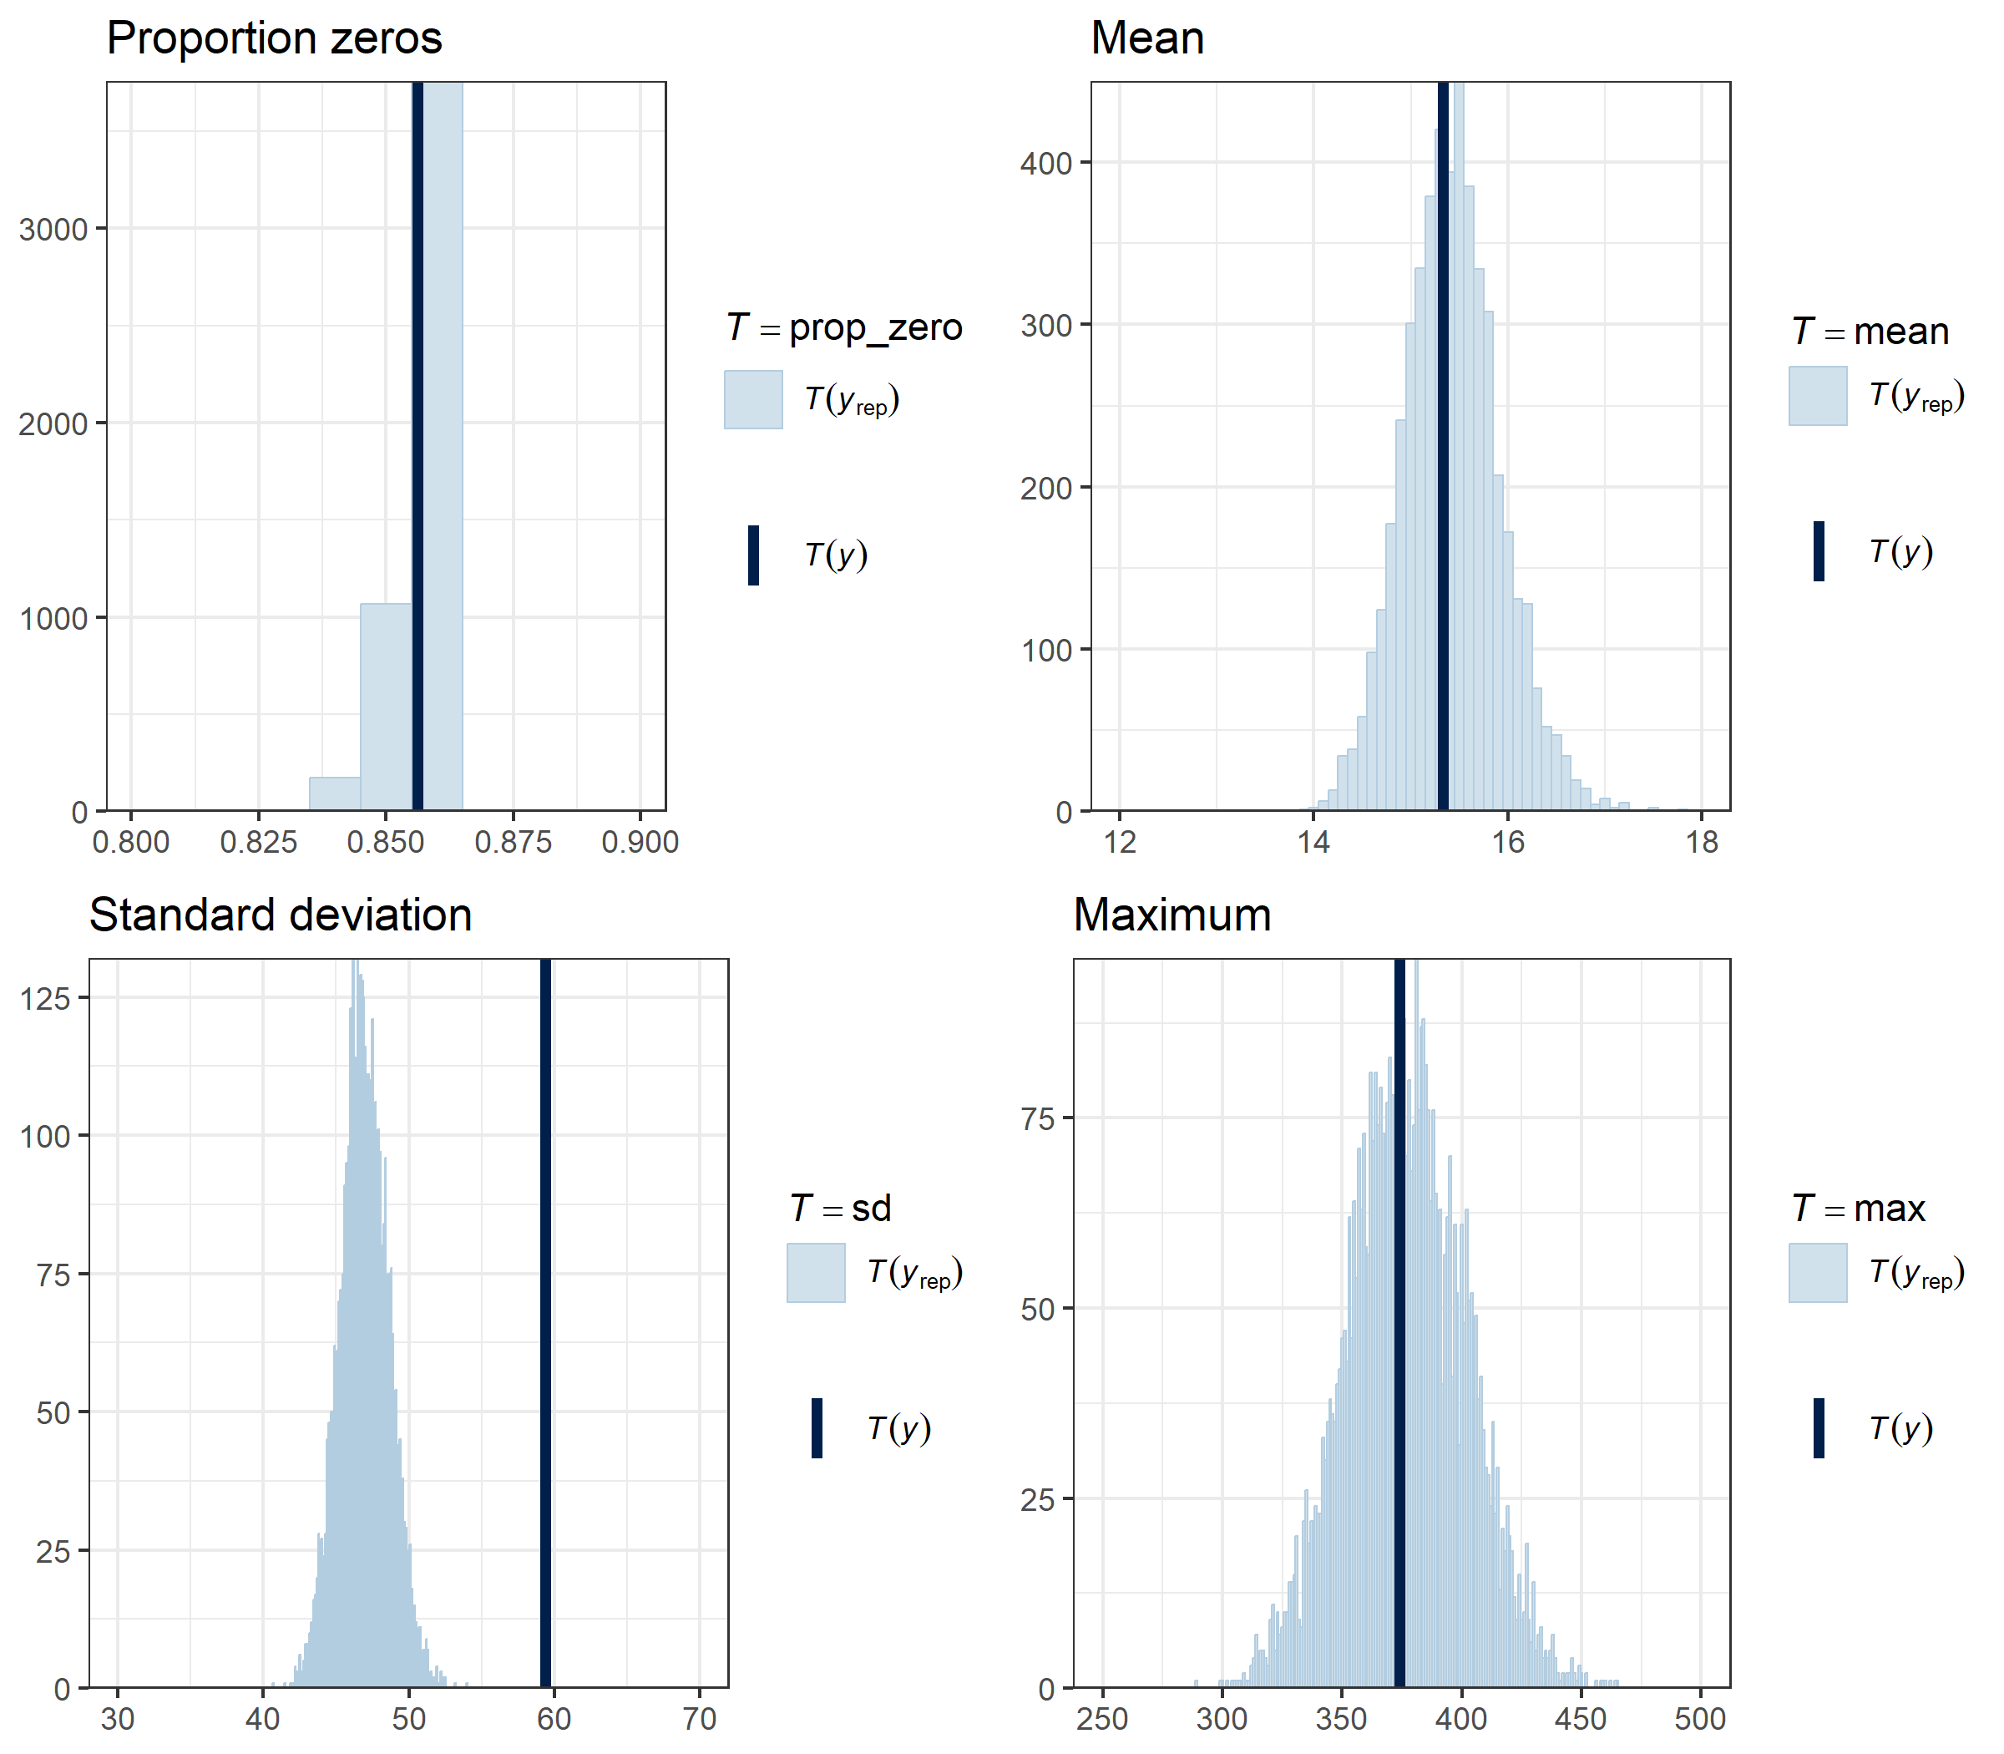

Figure A1. Posterior predictive checks comparing summary statistics (T) of the predicted counts of deer from snapshot moments during camera trap distance sampling (CTDS), with the observed counts at each site. Summary statistics are the proportion of plots with zero counts, the mean total count, the standard deviation of the total count, and the maximum total count. Pale-blue histograms give the distribution of the summary statistic predicted by the model $T(y_{rep})$ and dark-blue bars give the summary statistic for the observed counts $T(y)$.

Table A1. Filtering steps undertaken on the single nucleotide polymorphism (SNP) dataset.
Filtering step | SNPs remaining | Individuals remaining
Raw data | 15616 | 282
Remove untyped SNPs and failed samples | 15616 | 278
Reproducibility score < 0.99 | 10267 | 278
SNPs with more than 20% missing data | 7782 | 278
SNPs with < 5 or > 300 reads per allele | 6825 | 278
Individuals with more than 20% missing data | 6825 | 278
SNPs on the same locus | 6754 | 278
Monomorphic SNPs | 6754 | 278
SNPs with MAF < 0.01 | 6364 | 278
PC2 Loading > 0.07 | 6277 | 278
Excluding genetically identical pairs | 6277 | 276

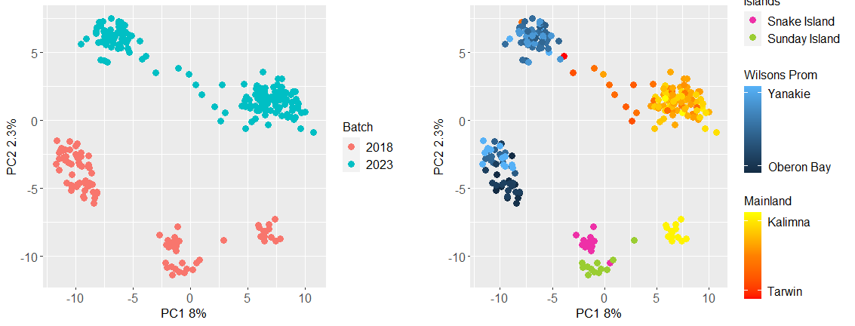
Figure A2. PCA results before filtering on PC2 loadings. Each point represents a sample, coloured to reflect sample location as displayed in Figure 1. Location of points in this plot reflect genetic similarity, so that points that are placed closer together are more similar.

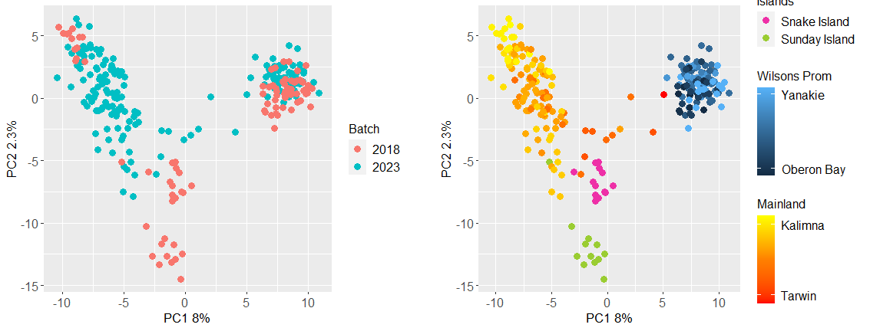
Figure A3. PCA results after filtering on PC2 loadings (87 single nucleotide polymorphisms (SNPs) removed). Each point represents a sample, coloured to reflect sample location as displayed in Figure 1. Location of points in this plot reflect genetic similarity, so that points that are placed closer together are more similar.

www.deeca.vic.gov.au

www.ari.vic.gov.au

