

Arthur Rylah Institute for Environmental Research Technical Report Series No. 385
State-wide abundance of kangaroos in Victoria, 2024
Results from the 2024 aerial survey
M.P. Scroggie and P.D. Moloney
December 2024



Arthur Rylah Institute for Environmental Research
Department of Energy, Environment and Climate Action
PO Box 137, Heidelberg, Victoria 3084
Phone (03) 9450 8600
Website: www.ari.vic.gov.au
Citation: Scroggie, M.P. and Moloney, P.D. (2024). State-wide abundance of kangaroos in Victoria, 2024. Arthur Rylah Institute for Environmental Research Technical Report Series No. 385. Department of Energy, Environment and Climate Action, Heidelberg, Victoria.
Front cover photo: Eastern Grey Kangaroo (Justin Cally)

ISSN 1835-3835 (pdf))
ISBN 978-1-76176-028-0 (pdf)


We acknowledge and respect Victorian Traditional Owners as the original custodians of Victoria’s land and waters, their unique ability to care for Country and deep spiritual connection to it.
We honour Elders past and present whose knowledge and wisdom
has ensured the continuation of culture and traditional practices.
DEECA is committed to genuinely partnering with Victorian Traditional Owners and Victoria’s Aboriginal community to progress their aspirations.
© The State of Victoria Department of Energy, Environment and Climate Action December 2024.
Creative Commons
This work is licensed under a Creative Commons Attribution 4.0 International licence, visit the Creative Commons website (http://creativecommons.org/licenses/by/4.0/).
You are free to re-use the work under that licence, on the condition that you credit the State of Victoria as author. The licence does not apply to any images, photographs or branding, including the Victorian Coat of Arms, and the Victorian Government, the Department and the ARI logos.
Disclaimer
This publication may be of assistance to you, but the State of Victoria and its employees do not guarantee that the publication is without flaw of any kind or is wholly appropriate for your particular purposes and therefore disclaims all liability for any error, loss or other consequence which may arise from you relying on any information in this publication.
Accessibility
To receive this document in an alternative format, phone the Customer Service Centre on 136 186, email customer.service@deeca.vic.gov.au, or contact National Relay Service on 133 677. Available at DEECA website (www.deeca.vic.gov.au).

State-wide abundance of kangaroos in Victoria, 2024

Results from the 2024 aerial survey

Michael P. Scroggie and Paul D. Moloney

Arthur Rylah Institute for Environmental Research
Department of Energy, Environment and Climate Action
123 Brown Street, Heidelberg, Victoria 3084

Date

Arthur Rylah Institute for Environmental Research
Technical Report Series No.385

Acknowledgements
This work was funded by the Biodiversity Division, Department of Energy, Environment and Climate Action, Victoria.
We thank Bali Forbes, Vural Yazgin and Darcy Shilling-Walsh for their help throughout the project and for the provision of data, suggestions and advice. The aerial survey and ground survey data on which the kangaroo abundance estimates are based was collected by EcoKnowledge Pty Ltd and Macropus Consulting respectively. We thank Mark Lethbridge and Graeme Coulson for their work in planning and executing the collection of the field data. Bali Forbes, Vural Yazgin and Darcy Shilling-Walsh (DEECA, Biodiversity Division) and Jenny Nelson, Jemma Cripps, Carlo Pacioni and Justin Cally (ARI) provided helpful comments on drafts of this report and advice and support during its preparation.

Contents
Acknowledgements ii
Summary 4
1 Introduction 6
2 Methods 8
2.1 Species distribution, study area and stratification 8
2.2 Aerial surveys 8
2.3 Estimating the proportions of Eastern and Western Grey Kangaroos in the overlap zone 8
2.4 Analysis of aerial survey data 9
2.4.1 Distance sampling analysis 9
2.4.2 Model-based analysis of spatial variation in kangaroo density 9
2.4.3 Model-based estimates of abundance 10
2.4.4 Design-based estimates of abundance 10
3 Results 11
3.1 Spatial modelling of grey kangaroo overlap zone 11
3.2 Analysis of aerial survey data 11
3.2.1 Analysis of distance data 12
3.2.2 Spatial modelling of grey kangaroo abundance 14
3.2.3 Model-based estimates of density and abundance 16
3.2.4 Model-based estimates of abundance within harvest zones 17
3.2.5 Design-based estimates of abundance for grey kangaroos 21
3.2.6 Estimates of abundance for Red Kangaroos 21
4 Discussion 23
4.1 Recommendations 24
References 25
Appendix: design-based abundance estimates 28
4.1.1 Background 28
4.1.2 Design-based estimates of abundance for grey Kangaroos for 2022 and 2024 28
4.1.3 Comparison of model-based and design-based estimates of abundance for grey kangaroos. 32

Summary
Context:
In Victoria, commercial kangaroo harvesting through the Kangaroo Harvesting Program (KHP) is authorised under the Kangaroo Harvest Management Plan 2024-2028 (KHMP) (DEECA 2023). The KHMP allows ecologically sustainable commercial harvesting of wild grey kangaroo populations (Eastern Grey Kangaroos, Macropus giganteus and Western Grey Kangaroos, Macropus fuliginosus). In addition, both species can be legally culled by landholders under the Authority to Control Wildlife (ATCW) provisions of the Wildlife Act 1975. To determine appropriate total harvest rates for these species, the Victorian Government conducts periodic state-wide aerial population surveys for both grey kangaroo species, along with opportunistic, simultaneous collection of survey data on Red Kangaroo, Osphranter rufus populations. Although not subject to commercial harvesting, this latter species is nevertheless subject to lethal control under the ATCW provisions of the Wildlife Act 1975.
Aims:
To provide updated estimates of the abundance of Eastern and Western Grey Kangaroos across the non-forested parts of Victoria, and within each of the harvest zones.
Methods:
Aerial (helicopter) surveys were conducted across the non-forested parts of Victoria using the established survey methodology. These surveys were methodologically identical to those undertaken previously, with some substitution of transects to address logistic and safety concerns associated with operations of the aircraft. As Eastern and Western Grey Kangaroos cannot be reliably distinguished from aerial surveys, the relative proportions of these two species within areas of Victoria where they overlap was estimated using a spatial model for the relative proportions of each species, based on ground survey data and biodiversity atlas records.
Total and zone-level abundances were estimated from the data using a model-based distance sampling approach, which has now superseded the design-based approach to abundance estimation that was used to interpret the data from previous aerial surveys. This approach relates the density of grey kangaroos to habitat covariates using a regression model and can generally be expected to provide more precise estimates of abundance. Furthermore, changes to the harvest zone boundaries were incorporated into the analytical results to provide both state-wide and zone-level estimates of abundance for the two grey kangaroo species within the boundaries of the new harvest zones. For comparative purposes, we also computed estimates of grey kangaroo abundance for 2022 using the new model-based approach, as well as estimates for both years using the old design-based approach.
Abundances of Red Kangaroos (which have a limited geographic distribution in Victoria) for 2024 were estimated using the previous design-based approach as the amount of survey data for this species was inadequate for model-based estimation of abundance.
Results:
Based on the model-based analysis of the survey data, the total population of grey kangaroos in the non- heavily forested areas of the state was estimated to be approximately 2.3 million. After applying the spatial model to apportion the total between the two species, the estimated total numbers of Eastern and Western Grey Kangaroos were 2.09 million (95% CI 1.76 – 2.55 million) and 212,000 (95% CI 156,000-281,000) respectively (Table S1). Eastern Grey Kangaroos comprised the vast majority (~83 %) of the Victorian grey kangaroo population. The design-based estimate of abundance for Red Kangaroos for 2024 was 39,000 (95 % CI 22,000-68,000).

Table S1. Estimated abundances of Eastern and Western Grey Kangaroos determined from the 2024 aerial survey. Estimates are given for each of the five harvest zones, and for the 10 LGAs recently added to the exclusion zone around Melbourne, which together make up the entire survey area.
(The estimates are rounded to the nearest 1000 kangaroos. No estimate for WGK is provided for zones where Western Greys are absent (Gippsland, Hume, 10 LGAs within Exclusion Zone).
Zone | Species | Estimate | SE | LCL | UCL
Barwon South-West | EGK | 249,000 | 43,423 | 180,000 | 337,000
 | WGK | 12,000 | 3,189 | 7,000 | 19,000
Grampians | EGK | 273,000 | 41,936 | 204,000 | 366,000
 | WGK | 112,000 | 22,983 | 75,000 | 164,000
Loddon Mallee | EGK | 408,000 | 75,486 | 286,000 | 572,000
 | WGK | 87,000 | 16,186 | 59,000 | 123,000
Hume | EGK | 771,000 | 104,702 | 583,000 | 993,000
 | WGK | - | - | - | -
Gippsland | EGK | 166,000 | 29,300 | 116,000 | 226,000
 | WGK | - | - | - | -
TOTAL (less exclusion zone) | EGK | 1,866,000 | 168,853 | 1,568,000 | 2,222,000
 | WGK | 212,000 | 32,514 | 156,000 | 281,000
Ten LGAs now part of the Exclusion Zone | EGK | 228,000 | 69,188 | 135,000 | 393,000
 | WGK | - | - | - | -
TOTAL (entire survey area which includes ten LGAs no longer part of the KHP) | EGK | 2,094,000 | 199,547 | 1,758,000 | 2,545,000
 | WGK | 212,000 | 32,514 | 156,000 | 281,000

Conclusions and Implications:
Comparison of estimates of abundance for 2022 and 2024 (both derived using the new, model-based methodology), points to a change in abundance (across the entire survey area) of EGK from 1.76 million to 2.09 million between 2022 and 2024. This represents an increase of approximately 18%. In comparison, the number of WGK decreased slightly, from 227 thousand to 212 thousand, a decline of approximately 7%. For both grey kangaroo species, there was substantial overlap between the confidence intervals of the 2022 and 2024 population estimates, meaning certainty in the actual percentage changes in abundance was low.
Changes within zones between 2022 and 2024 varied markedly across the state for both model and design-based estimates, and there were a few cases where there was substantial disagreement between the population trends inferred from the model-based and design-based population estimates.
In nearly all cases, the model-based approach to abundance estimation met the objective of obtaining coefficients of variation (CV) of less than 20%, with model-based CVs being substantially smaller than equivalent design-based estimates. This shows the inherent superiority of the model-based approach in meeting the objective of obtaining precise estimates of abundance from the survey data.
Recommendations:
- Continue the current practice of repeating the aerial survey every two years.
- Given the lack of change in the locations of GKOZ, we recommend that the ground surveys be repeated every four years and supplemented with biodiversity atlas data.
- Model-based approaches deliver superior precision and allow more flexible insights into spatial variation in kangaroo density. However, we recommend the continued calculation of design-based abundance estimates to provide an adjunct to the model-based estimates that relies on fewer ecological or statistical assumptions.
- Introduction
In Victoria, there are two regulatory mechanisms that allow for culling of wild kangaroos. The first mechanism is the Authority to Control Wildlife (ATCW) provisions of the Wildlife Act 1975. These provisions allow landholders to seek permission to cull wildlife, including three species of kangaroos with widespread distributions in Victoria – the Eastern Grey Kangaroo (Macropus giganteus, EGK), Western Grey Kangaroo (Macropus fuliginosus, WGK) and Red Kangaroo (Osphranter rufus, RK). The second mechanism is via commercial harvesting of EGK and WGK only, which is regulated under a Kangaroo Harvest Management Plan (KHMP) (DEECA 2023), where annually determined quotas allow for ecologically sustainable harvesting of these two species and commercial utilization of the meat and skins.
The Victorian government regulates commercial harvesting via Kangaroo Harvest Management Plans (DELWP 2020; DEECA 2023) which set out actions and indicators for the Kangaroo Harvesting Program (KHP) and specify the manner in which the annual quotas will form commercial harvesting will be set. In particular, the KHMPs have specified that the total population offtake (ATCW permits + commercial harvest) should be limited to a total of 10% of the population of each species within each of a set of harvest zones across the state.
To determine the appropriate total quota, it is necessary to know the abundance of each species, both at a state-wide level and within each harvest zone. To this end, the Victorian government undertakes aerial surveys every two years with the aim of obtaining accurate and precise estimates of kangaroo abundance.
Aerial surveys have been widely used across Australia to assess kangaroo populations, with a history going back to the 1960s (Caughley et al. 1987; Finch et al. 2021). Line-transect methods, with the resulting data analysed using various distance sampling models (Buckland et al. 1993) are the typical methodology. These approaches allow the estimation of abundances at large geographic scales, while accounting for undercounting due to decreasing sightability of kangaroos with increasing distance from the aircraft (Fewster and Pople 2008). Since 2017, aerial line-transect methods have been used to survey kangaroos across the non-forested parts of Victoria, with successive surveys being conducted in 2017, 2018, 2020 and 2022 (Moloney et al. 2017; Moloney et al. 2018b; Moloney et al. 2021; Moloney et al. 2023). These earlier surveys used classical, design-based distance sampling methodologies (Buckland et al. 1993) which rely on the selection of representative samples of transect lines which are then surveyed for abundance of kangaroos according to a stratified random sampling design. The resulting zone-based estimates of abundance are then calculated based on the average densities observed on the transects within each zone. The survey strata in previous surveys coincided with the seven harvest zones that were at the time used to manage the quota-setting process for the Victorian commercial kangaroo harvest, under the Kangaroo Harvest Management Plan 2021-2023 (DELWP 2020). Under the KHMP 2024-2028, the harvest zone boundaries will change from 2025, and an additional 10 local government areas (LGAs) on the periphery of the Melbourne metropolitan area will be removed from the commercial harvest program. Lethal control under ATCW remains possible in these areas, and the LGAs in question are still included in the aerial survey program (Figure 1).
More recent research work (Scroggie et al. in press) has led to the adoption of a more sophisticated approach to the estimation of kangaroo abundance in Victoria, using model-based distance sampling analysis of the aerial survey data (Miller et al. 2013; Buckland et al. 2016). This approach to analysis and interpretation of the aerial survey data is adopted to provide the abundance estimates used for quota-setting for the first time this year. Details of the methodology are given in Scroggie et al. (in press). In brief, the model-based approach relates the local, transect-level estimates of abundance to a series of habitat covariates of known or likely significance to kangaroos using a statistical model. The model is then used to predict abundances at larger spatial scales, while simultaneously accounting for undercounting biases using a distance-sampling model together with the uncertainty in the parameters of the habitat-abundance and distance-detection components of the model.
The move to a model-based approach has several advantages. Firstly, the model-based inferences of abundance are often more precise than equivalent design-based estimates, as they can rely on information inherent in the ecological relationship between kangaroo abundances along the transect and the habitat covariates (Miller et al. 2013; Scroggie et al. in press). Secondly, model-based approaches result in a predictive map of kangaroo density across the area of interest rather than simple average densities for a zone or stratum. This feature of the model-based approach allows inference regarding the likely population size within any arbitrary areas of interest, such as local government areas, harvest zones or bioregions. This feature of the new modelling approach is of particular utility here, given the impending changes to the kangaroo harvest zones in Victoria under the new KHMP (DEECA 2023).
One general disadvantage of aerial surveys is the difficulty experienced in accurately distinguishing morphologically similar species. In the case of Eastern and Western Grey Kangaroos, it has long been recognised that these two species cannot be reliably distinguished from the air. Accordingly, in Victoria, a process has been adopted for determining how the relative proportions of the two species (which overlap substantially in the west of the state) varies in space and time by fitting a spatial model to ground survey data which is supplemented by data obtained from government biodiversity atlas databases. The spatial model can then be used to apportion the estimated total grey kangaroo abundance between the two species both in aggregate for the entire survey area, but also for areas of interest, notably the harvest zones. By combining spatial predictions of EGK:WGK ratios obtained from the ground surveys with the spatial models of kangaroo abundance obtained from the aerial survey data, it is possible to obtain integrated predictions of the abundance of each grey kangaroo species across any region of management interest, including each of the harvest zones.
In this report, we present the results of the fifth state-wide aerial survey of kangaroo populations in Victoria, based on aerial surveys that were conducted during September 2024. We provide updated abundance estimates and associated measures of uncertainty for both species across the entire study area using the model-based approach for each harvest zone. These estimates will be referred to by policy-makers when setting kangaroo harvest quotas for 2025, with recommended quotas being specified in an associated, separate report (Scroggie and Moloney 2024)
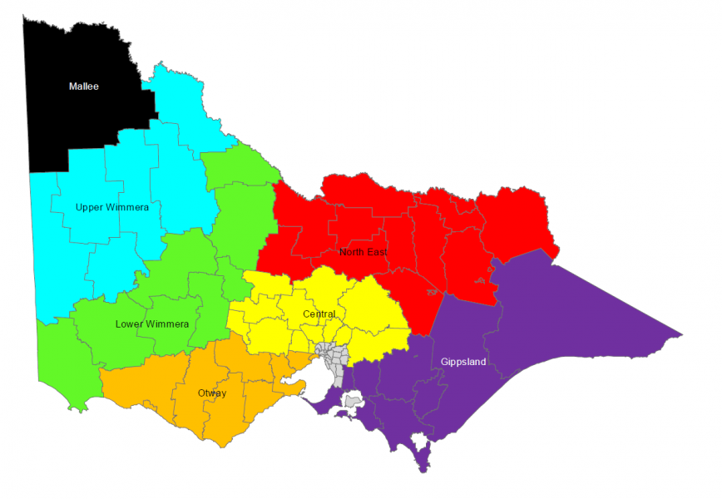
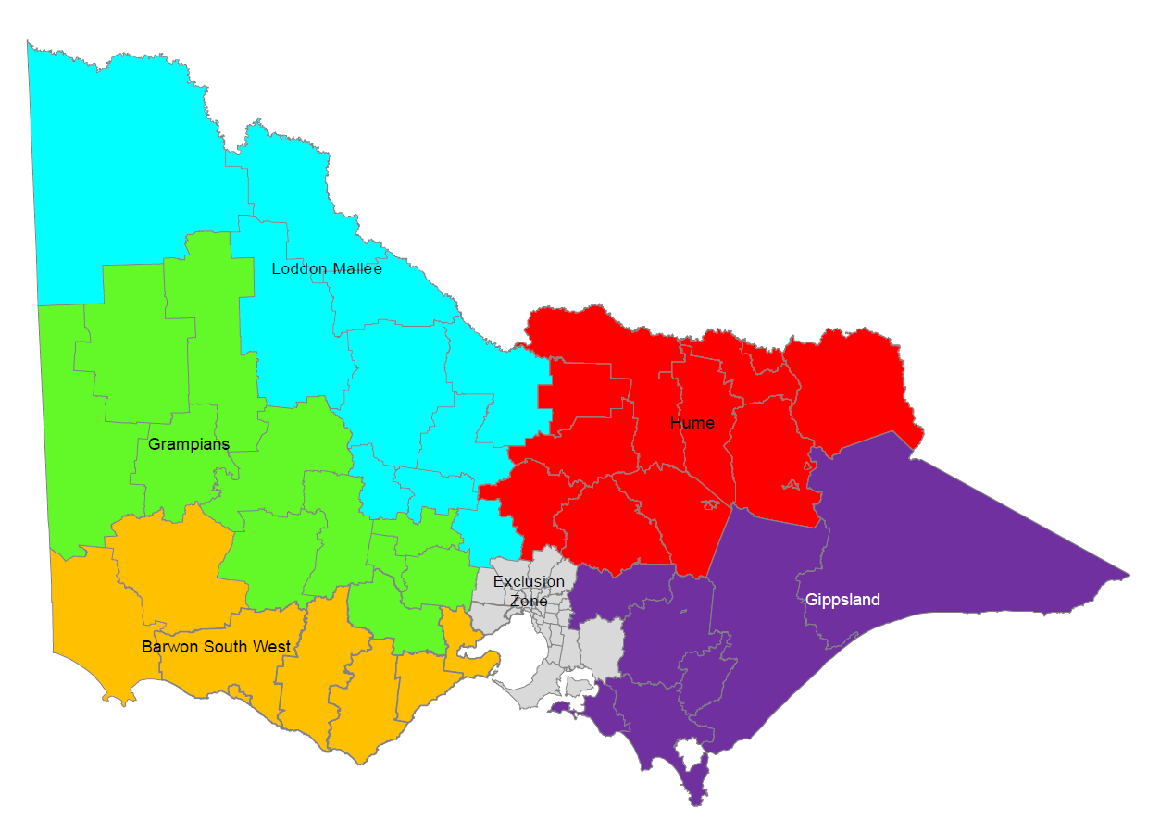

Figure 1. Map showing the old (top) and new (bottom) harvest zones for grey kangaroos in Victoria.
From 2025 onwards, commercial quota-setting will be based around the new zoning system.

- Methods
  - Species distribution, study area and stratification
Two species of grey kangaroos (Eastern Grey Kangaroo, Macropus giganteus and Western Grey Kangaroo, M. fuliginosus) occur in Victoria, with Western Greys being confined to western and north western Victoria. There is a broad overlap in the geographic ranges of the two species in Western Victoria, with the area where the species are in broad sympatry being referred to as the Grey Kangaroo Overlap Zone (GKOZ, Caughley et al. 1984). Our survey spanned the Victorian geographic ranges of both species and was intended to provide separate estimates of abundance for both species. The data and statistical methodology for apportioning the total abundance estimates (both grey kangaroo species combined) derived from the aerial surveys between the two species is described in Section 2.3 below.
Aerial surveys, using the methods outlined in Moloney et al. (2018a) were conducted during September 2024. A total of 147 transects were flown across the state. Transects were typically 25 km in length (with some being shortened for operational reasons), resulting in a total of 3090 km of aerial transect effort (an average length of 21.0 km). The stratification of the surveys followed the old harvest zoning scheme (seven harvest zones) as in previous years of the survey. There were a small number of transects that were flown in 2022 that were not available or safe to fly during 2024. These were substituted for another nearby transect from within the same (old) harvest zone.
  - Aerial surveys
The aerial surveys used line-transect distance sampling, with the distance band for each sighted group of kangaroos being recorded to allow for the fitting of distance sampling models (Buckland et al. 1993) to the data. Aerial surveys were conducted using a Bell LongRanger helicopter, with a single observer on each side of the aircraft. Transects were flown during daylight hours within three hours of sunrise or sunset, with the helicopter flying away from rising or setting sun to avoid the effects of solar glare on the pilot and observers. Transects were flown at an altitude of 200 feet (~60 m) and an airspeed of 50 knots (~90 km/h). A five-zone survey pole was fixed to each side of the aircraft and allowed classification of sighted kangaroos into one of five distance categories (0-20, 20-40, 40-70, 70-100 and 100-150m from the transect line). The species, group size, and distance class at the time of the first observation of each group of kangaroos were recorded. Because EGK and WGK cannot be reliably distinguished from the air, groups of kangaroos were classified as either Red Kangaroos (RK) or grey kangaroos combined (GK). Coordination and execution of the aerial survey was undertaken by EcoKnowledge Pty Ltd under the direction of Dr Mark Lethbridge. Further details of the aerial survey methodology are given in Lethbridge et al. (2019).
  - Estimating the proportions of Eastern and Western Grey Kangaroos in the overlap zone
Ground surveys were undertaken during the Spring of 2024 on road transects that spanned the width of the Grey Kangaroo Overlap Zone (GKOZ, Caughley et al. 1984) in Western Victorian and adjacent parts of South Australia and New South Wales. These surveys were undertaken under contract by Dr Graeme Coulson (Macropus Consulting). Dr Coulson also kindly contributed additional records of the two species collected during his private travel in the same area. Full details of the transects and surveys are given in Coulson (2024). The data from the 2024 ground surveys, together with data from similar surveys undertaken in previous years (Coulson 2018; Coulson 2020), provided a large number of spatially referenced records of EGK and WGK across the GKOZ. Collectively, these provide information on the location and width of the GKOZ and therefore provide detailed information on the relative proportions of EGK and WGK at locations across the GKOZ.
The data from the ground surveys was supplemented with additional records of EGK and WGK across south eastern Australia obtained from the Atlas of Living Australia database (Belbin et al. 2021). The large volume of available records for the two species was thinned by removing records with low spatial accuracy, and by eliminating occasional likely erroneous records of the two species at locations outside their established geographic ranges. We also applied spatial thinning to the data such that only a single record was allowed from a given location or it’s 100 m radius in any given year. This removed large accumulations of data from single locations and prevented these spatial clusters of data from unduly influencing the results of the spatial modelling of the GKOZ.
The resulting sub-sample of spatially and temporally referenced records of EGK and WGK from across south eastern Australia provides a picture of the location of the GKOZ in time and space, allowing tracking of possible changes in the location and width of the zone over time. We used the dataset to build a spatiotemporal model which predicts the expected proportion of EGK at each year and location as a function of latitude, longitude and time. These quantities were modelled using a spatio-temporal Generalized Additive Model (GAM, Wood 2017) with the expected proportion of EGK as the response variable. The GAM had a Bernoulli error distribution and the spatio-temporal pattern was modelled using a tri-variate thin-plate regression spline (Wood 2003) with latitude, longitude and time (Year) as the covariates.
The GAM was fitted to the data using the R package mgcv (Wood 2017). The fitted model was then used to predict the proportions of the two GK species in space and time across the study area. Uncertainty in this quantity was inferred using a parametric bootstrap approach (Wood 2017), where a sample was drawn from the inferred multivariate normal posterior distribution of the model’s parameters and used to generate a set of replicate predictions of the proportion of EGK at each location and year. This allowed uncertainty in the fitted model to be combined with uncertainty in the prevailing density of GK (both species combined) that was inferred from the aerial data (see below).
  - Analysis of aerial survey data
    - Distance sampling analysis
Standard conventional and multi-covariate distance sampling models (Buckland et al. 1993; Marques et al. 2007) were fitted to the data using Distance in R (Miller et al. 2019). We compared alternative models using Akaike’s Information Criterion (AIC) and assessed goodness of fit using a chi-squared test and a Q-Q plot to assess the distribution of the residuals (Buckland et al. 1993). To maximise the precision of the fitted distance models we also included data from previous aerial surveys, while evaluating the effects of year and observer (identities of observers varied between years) using covariates. Results were essentially the same as those obtained from fitting the models to distance data from a single year.
Alternative distance models considered included half-normal, uniform and hazard-rate key functions with effects of kangaroo group size, year, observer, time-of-day (morning or afternoon) and vegetation type (open or wooded). For models without covariates, we considered cosine, polynomial and Hermite adjustment terms (Buckland 2007) of increasing order, added to the key functions with selection of the appropriate order by minimising the AIC of the fitted model.
    - Model-based analysis of spatial variation in kangaroo density
The model-based analysis of abundance was undertaken by constructing a density surface model (DSM) using package dsm in R (Miller et al. 2013). We fitted separate models to the data from the 2022 and 2024 aerial surveys to allow valid comparison of abundance estimates from those two years (estimates for 2022 and other previous years had used design-based inference, see Moloney et al. 2023).
Transects (usually 25 km long) are segmented into 5km sub-transects. Kangaroo sightings were assigned to the segments based on proximity. Abundance on each segment was related to the spatial habitat covariates (measured at a 5 km grid cell scale) using a Generalized Additive Model (Wood 2017), with additive, thin-plate spline terms. Spatial effects were considered by including a bivariate (latitude, longitude) Duchon spline term within the structure of the model (Duchon 1977). We considered alternative Poisson, negative-binomial and Tweedie error distributions for the model, with the selection of the appropriate error term being based on AIC and goodness of fit via a Q-Q plot to determine the most appropriate error distribution (Miller et al. 2013).
The habitat covariates considered for inclusion in the model were raster-based and mapped at 5 km grid cell scale. These included longitude and latitude (spatial smoothing), long-term mean rainfall, and the normalized difference vegetation index (NDVI, Pettorelli et al. 2011), which is a remote-sensed measure of vegetation greenness. NDVI measurements (from the MODIS observation program, Didan 2021) were median values for September of 2022 and 2024, to coincide with the time of the aerial surveys. Fine-scale (25 m) land use data for Victoria (White et al. 2020) was obtained and aggregated to a 5 km scale to provide information on the proportion of each cell that was covered by crop, open, woody and urban land-uses. Furthermore, a Sobel filter analysis (Sun 2014) of the woody vegetation data was used to infer the amount of ecotonal woodland/forest to grassland habitat within each cell, given kangaroos’ need for shade (Roberts et al. 2016) and utilization of wooded vegetation (including edges of wooded areas) as refuge and shelter.
The basic spatial model (longitude and latitude effects only) was added to by including the above covariates. Pairs of covariates with either high linear (collinearity) or non-linear (concurvity, Siems et al. 2023) relationships were identified and eliminated to simplify the model, and non-influential covariates were progressively removed from the model until there was no further improvement in AIC. More thorough comparisons of alternative models or testing of additional habitat covariates to improve the ecological realism of the model was not explored here but could be considered in future analyses.
    - Model-based estimates of abundance
The finally selected DSM was used to predict grey kangaroo density and abundance across the entire survey area. The abundance in each grid cell was simply the predicted density (from the DSM), multiplied by the area of the cell. We subtracted from the area of each cell the amount of area that was identified as urban or wetland land use in the fine-scale land use dataset of (White et al. 2020).
By summing up the predicted abundances of grid cells within the entire study area (or within particular harvest zones or other areas of interest) it is possible to estimate the total population of grey kangaroos. Furthermore, by multiplying each cells’ estimated abundance by the estimated proportions that were Eastern and Western Grey Kangaroos (see Section 2.3 above), it is possible to obtain population estimates for each species for any defined geographic area within the study area. We did this for both the entire survey area, as well as each of the harvest zones.
Uncertainty in these population estimates was assessed by combining parametric bootstrap samples from the fitted DSM and the spatial model of the GKOZ, and taking summary statistics (mean, standard deviation, coefficient of variation, lower and upper 95% confidence intervals) for the calculated abundances from each bootstrap sample.
    - Design-based estimates of abundance
As in previous kangaroo abundance reports, we also provide here estimates of population size derived using design-based analysis of the distance sampling data (Buckland et al. 1993), as well as the new model-based methodology (see above). The design-based approach to the analysis of distance sampling data has been explained in previous reports, and essentially involves estimating density of grey kangaroos on randomly selected transects within each harvest zone (stratum) and using the resulting estimate of mean density to extrapolate across the entire harvest zone. This approach is simple and makes fewer assumptions than the model-based approach but is less flexible and cannot take advantage of the information provided by ecologically relevant habitat-abundance relationships. Accordingly, design-based approaches typically result in less precise estimates of abundance (Miller et al. 2013; Buckland et al. 2016; Scroggie et al. in press). As future quota setting will be based on the model-based approach, the design-based estimates are presented in the Appendix.

- Results
  - Spatial modelling of grey kangaroo overlap zone
A total of 245 records of EGK and 207 spatially referenced records of WGK were obtained during the 2024 ground surveys of the GKOZ (Coulson 2024). These were supplemented with an additional 812 records (463 EGK and 349 WGK) from previous ground surveys (Coulson 2018; Coulson 2020), as well as a spatially-thinned sample of 19,071 EGK records and 5,087 WGK records from south eastern Australia obtained from the Atlas of Living Australia (Belbin et al. 2021).
The space-time GAM fitted to the data was used to infer the current position of the GKOZ in Western Victoria. The fine (5 km) grid of inferences (including a parametric bootstrap sample to characterise the uncertainty in the proportion of EGK in each grid cell) were then used to partition the estimated total population sizes of grey kangaroos between the two species (Figure 2).
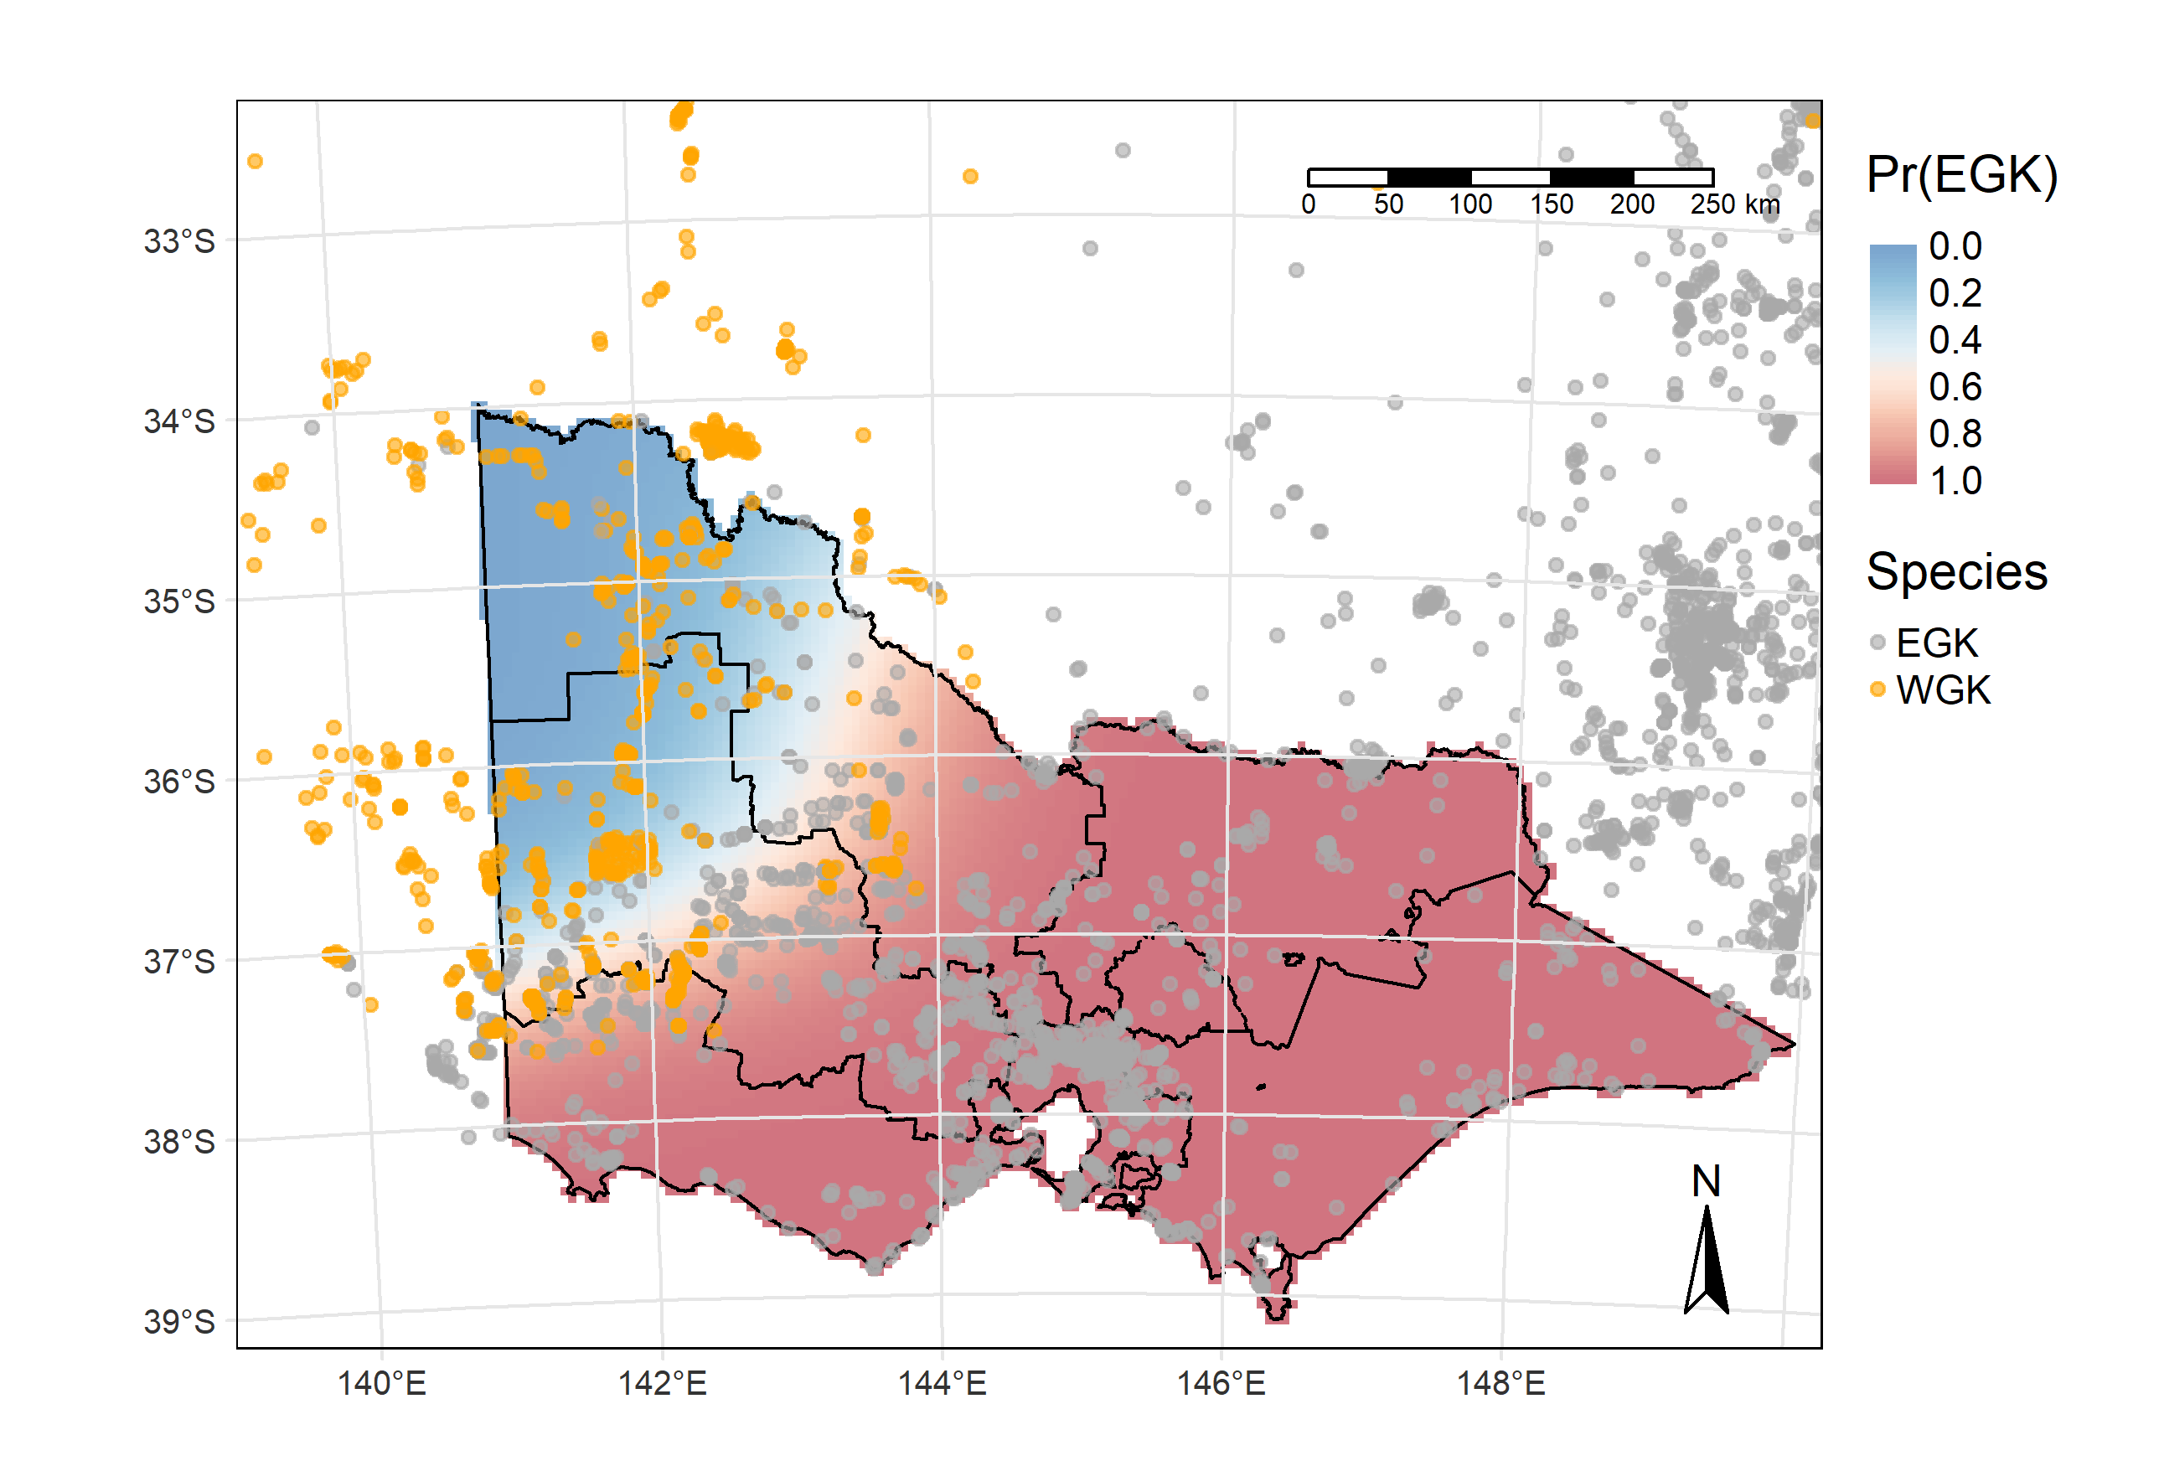
Figure 2. Map showing the predicted proportion of grey kangaroos that are Eastern Greys across the state.
The predictions are for the year 2024 and are derived from the space-time GAM that was fitted to the combined ground survey and atlas records for the two grey kangaroo species. The overlaid dots are the locations of recent EGK (grey) and WGK (orange) records used as input for the spatial model. Internal boundaries on the map are the new harvest zones.
  - Analysis of aerial survey data
A total of 3090 km of helicopter transects were flown with 1893 distinct groups of grey kangaroos being sighted, comprising 8948 individual grey kangaroos in total. This represents an average of 2.9 kangaroos per km of transect.
The spatial arrangement of the transects flown in 2024 is shown in Figure 3. For comparative purposes, we also re-analysed aerial survey data collected in 2022 using the model-based approach. Details of the 2022 aerial survey transects and sighting data can be found in Moloney et al. (2023).

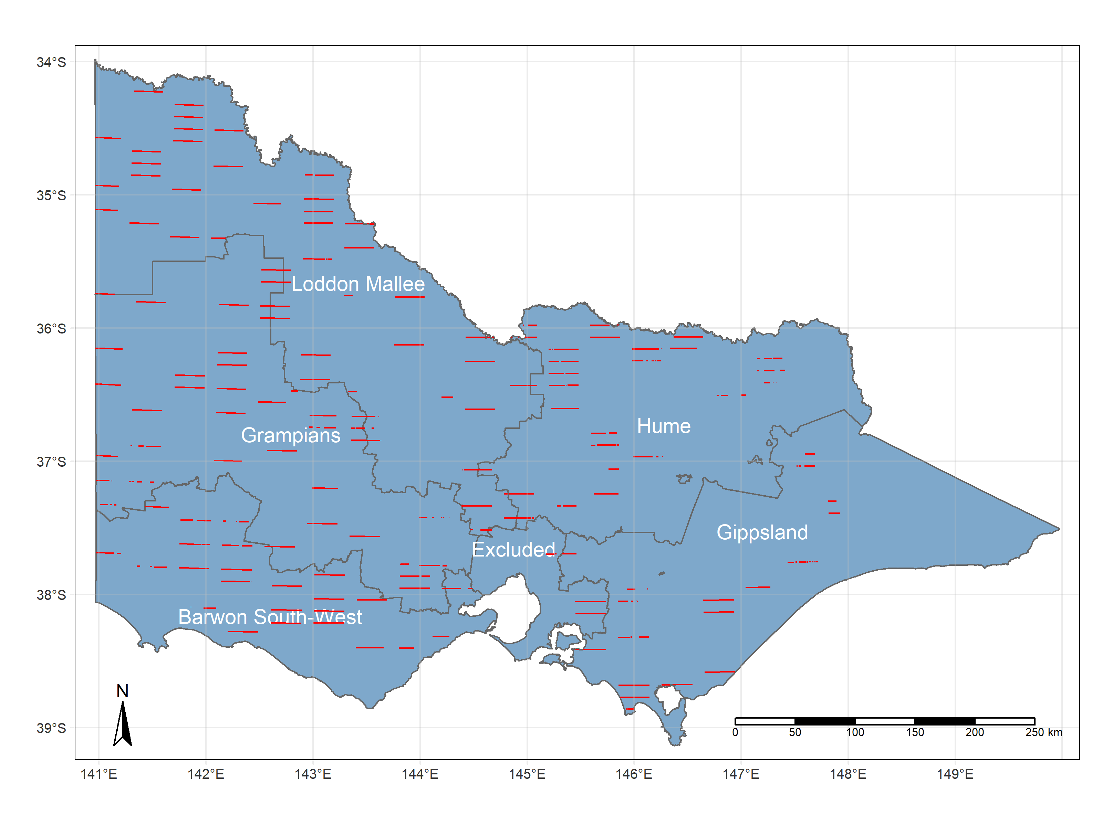
Figure 3. Map showing the locations of the transects (red lines) that were flown during the 2024 aerial survey
Internal boundaries on the map are the new harvest zones along with the exclusion zone around Melbourne where no commercial kangaroo harvest is permitted.

    - Analysis of distance data
To estimate detectability of groups of kangaroos on the survey transects, a range of conventional distance models (See Methods) with and without covariates were fitted to the data with summary statistics given in Table 1. For brevity, only top ten best-supported models are included in the table. There was overwhelming support for a single model (w>0.999): a hazard-rate model with covariates for year and group size. An average detection probability of $\hat{p}$ = 0.596 (SE=0.022) for kangaroos out to 150 m from the transect line was inferred for the 2024 sighting data. The fitted distance curves, along with histograms of the observed distance counts are given in Figure 4, along with the estimates of average detection probability, which varied moderately between years and was estimated with excellent precision (small standard error) due to the large number of kangaroo sightings that were used to fit the models.

Table 1. Model selection for distance sampling data form aerial survey data from the 2017, 2018, 2020, 2022 and 2024 surveys.
Only the top ten best models (based on AIC) are included. df- degrees of freedom, AIC – Akaike’s Information Criterion, w- model selection weights.
Key function | Adjustment | Covariates | df | AIC | w
Hazard rate | - | Group Size, Year | 7 | 22319 | >0.999
Hazard rate | - | Year | 6 | 22335 | <0.001
Half-normal | - | Group Size, Year | 6 | 22343 | <0.001
Hazard rate | - | Observer | 7 | 22344 | <0.001
Half-normal | - | Habitat | 4 | 22354 | <0.001
Hazard rate | - | Habitat | 5 | 22359 | <0.001
Half-normal | Cosine | - | 4 | 22370 | <0.001
Uniform | Cosine | - | 4 | 22372 | <0.001
Uniform | Polynomial | - | 4 | 22375 | <0.001
Half-normal | Polynomial | - | 3 | 22378 | <0.001

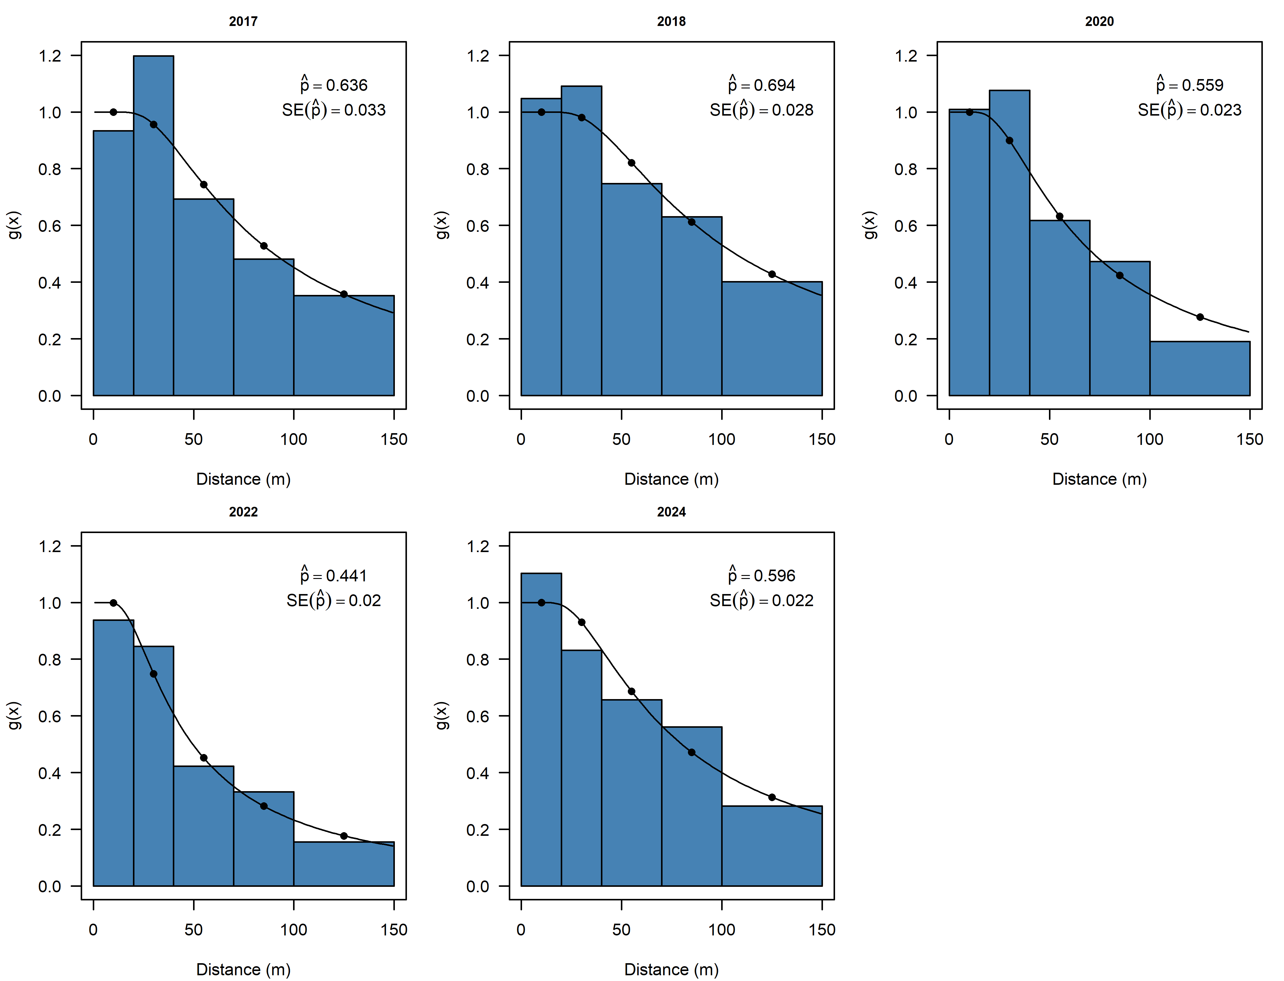
Figure 4. Fitted distance-detection curves for the combined aerial survey data for the years 2017-2024.
The blue histograms are the observed counts within each of the five distance bands. The black curves are the inferred relationships between distance from the transect line and probability of detection for grey kangaroos under average covariates values. The numerical values on each panel are the estimated mean detection probabilities, $\hat{p}$ and the associated standard error (SE).
    - Spatial modelling of grey kangaroo abundance
Initial exploration of the spatial abundance data using a series of simple density surface models (DSM) led to selection of Tweedie error distribution for further modelling, even though the Negative Binomial model was more parsimonious based on AIC. The latter model had poor goodness-of-fit and led to severe and implausible overestimation of abundance in certain parts of the state. None of these problems were apparent in the Tweedie model, so this error distribution was selected for further model development.
After elimination of covariates with high collinearity and concurvity (see Methods), the finally selected models included covariates for crop cover, woody vegetation cover, NDVI and a bivariate latitude/longitude spatial smoothing term. Separate, but structurally identical models were fitted to the 2022 and 2024 survey data to allow comparison of kangaroo abundance between years based on analyses with a common statistical methodology. Summary statistics for the two models can be found in Table 2.
Table 2. Summary statistics for the Tweedie distributed density surface models fitted to the 2022 and 2024 aerial survey data for grey kangaroos.
edf- effective degrees of freedom, p– p-values for each model term.
Year | Smoothing term | Spline basis | edf | p | Deviance explained (%)
2022 | s(longitude, latitude) | Duchon | 32.212 | <0.001 | 49.1 %
 | s(crop) | thin-plate | 2.943 | <0.001
 | s(woody) | thin-plate | 2.634 | <0.001
 | s(NDVI) | thin-plate | 1.723 | 0.001
2024 | s(longitude, latitude) | Duchon | 36.5 | <0.001 | 55.3 %
 | s(crop) | thin-plate | 2.829 | 0.002
 | s(woody) | thin-plate | 3.195 | <0.001
 | s(NDVI) | thin-plate | 0.947 | <0.001

The fitted covariate relationships for the 2022 and 2024 models are given in Figure 5. Somewhat different covariate relationships are inferred in the two years; however, it is important to note that this likely reflects differences in the extent to which the observed variation in grey kangaroo density is explained by the bivariate spatial smoothing component of the model (Figure 6), versus the habitat covariates. This is essentially a matter of confounding between spatial and habitat covariates and is of little consequence for a model where the purpose is to account for spatial variation in density rather than to derive causal relationships between habitat variables and kangaroo abundance.

2022 | 2024
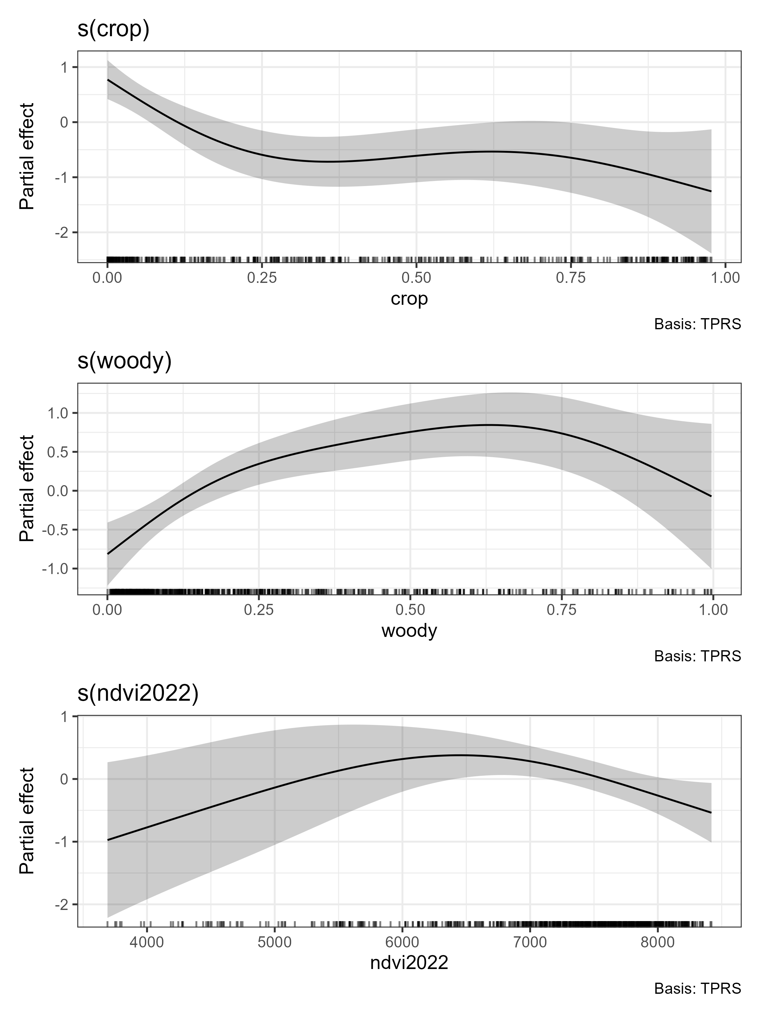 | 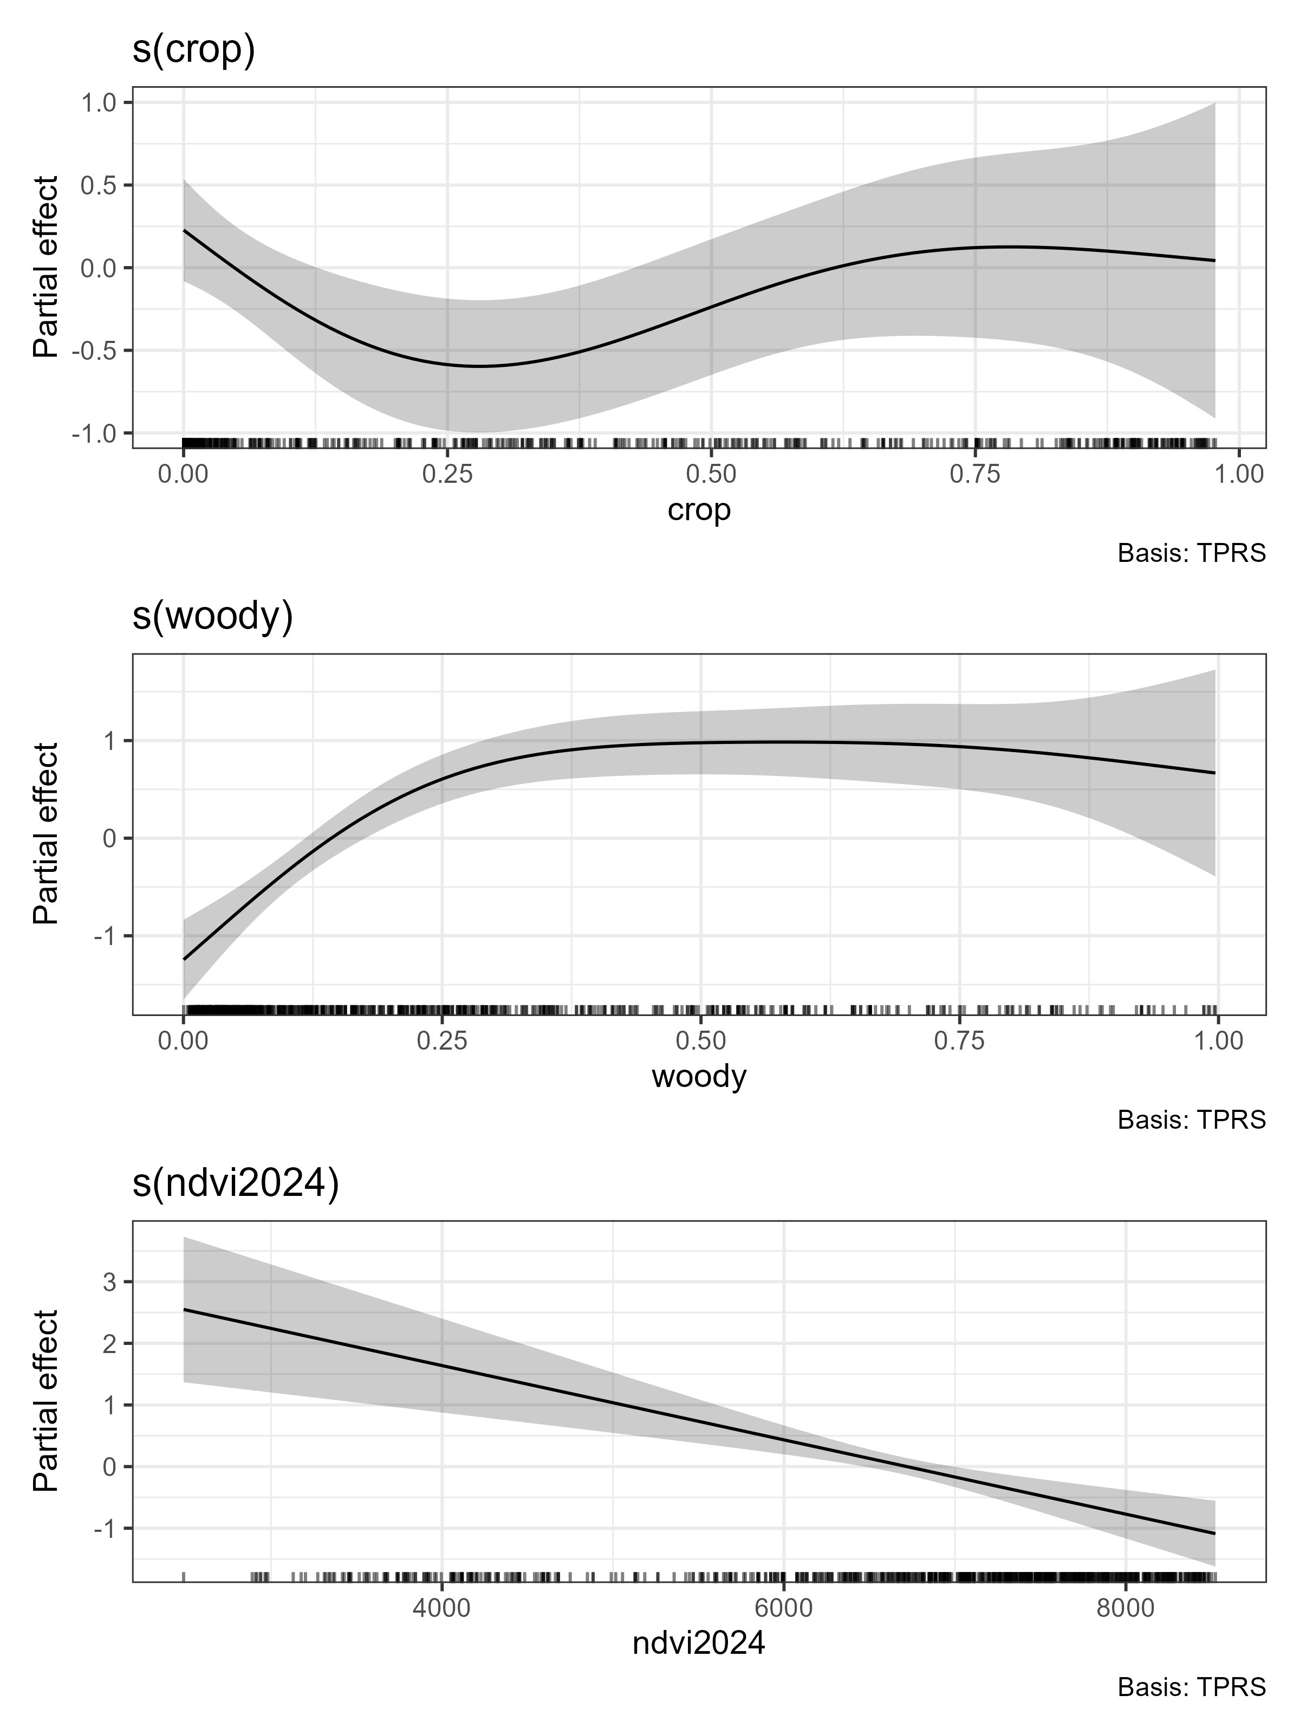
Figure 5. Fitted covariate relationships for the Tweedie density-surface models fitted to aerial survey data from 2022 and 2024. Both models also included a separate, bivariate spatial smoothing term.
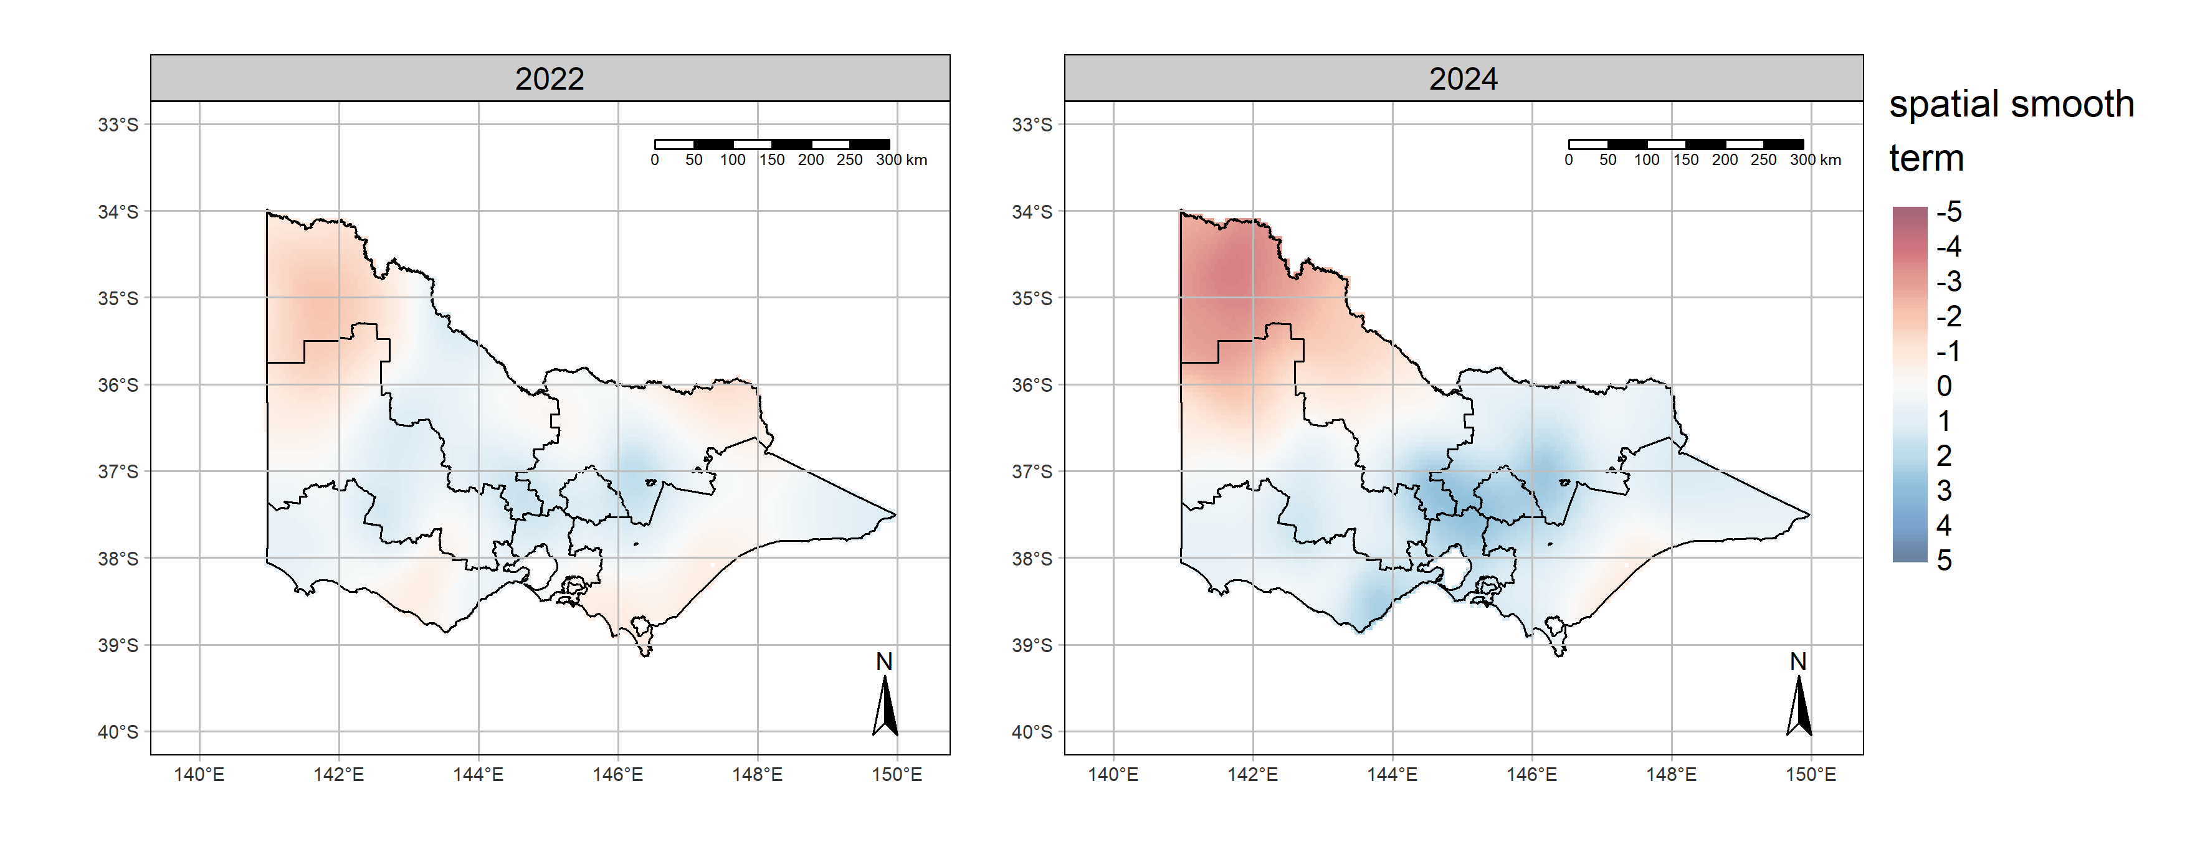
Figure 6. Spatial smoothing components (bivariate Duchon spline) of the Tweedie density-surface models fitted to aerial survey data from 2022 and 2024.
Red/blue colours indicate areas with lower/higher grey kangaroo abundance (on a logarithmic scale) than would be expected based solely on the fitted relationships between kangaroo density and the habitat covariates (Figure 5). The boundaries of the new harvest zones (including the exclusion zone around Melbourne) are overlaid.

    - Model-based estimates of density and abundance
The predicted densities of grey kangaroos based on the density surface models fitted to the 2022 and 2024 aerial survey data are given in Figures 7 and 8 below, along with maps of spatial variation in an associated measure of uncertainty, the coefficient of variation (CV). These maps illustrate area of high and low grey kangaroo density in each year and allow statistical comparisons between the densities of grey kangaroo in the two years. White areas are grid cells that were entirely excluded from the survey area.
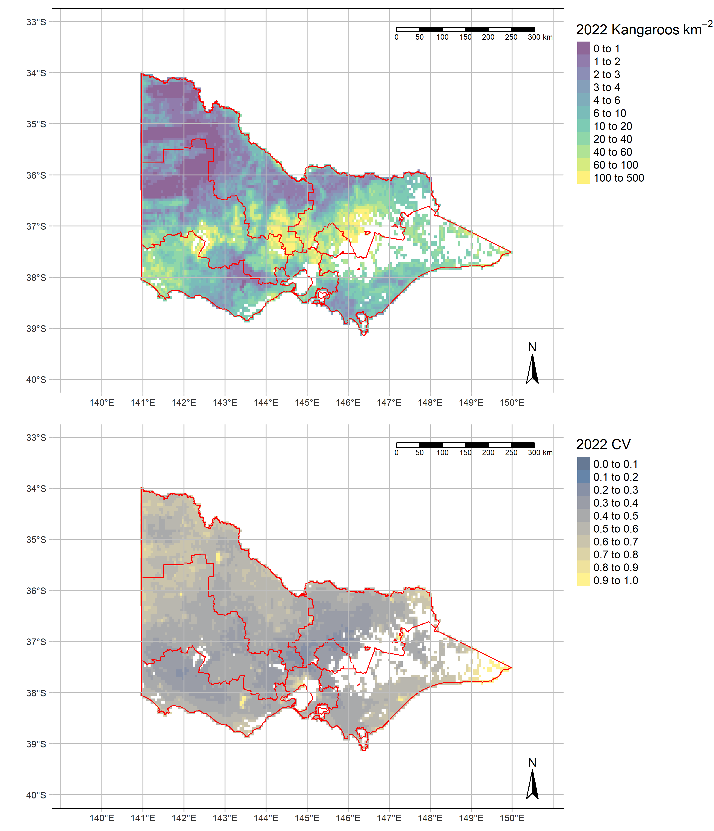
Figure 7. Predicted grey kangaroo density across Victoria during 2022, along with the associated coefficient of variation (a measure of uncertainty in the density).
Internal boundaries are the new harvest zones. Predicted densities apply only to non-forested habitat within each 5km grid cell.

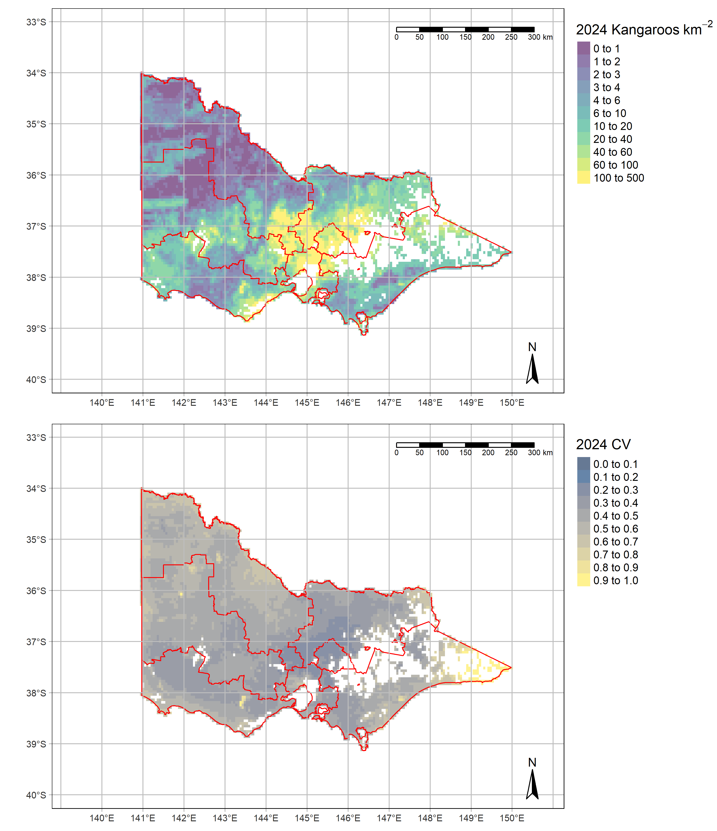
Figure 8. Predicted grey kangaroo density across Victoria during 2024, along with the associated coefficient of variation (a measure of uncertainty in the density).
Internal boundaries (red) are the new harvest zones. Predicted densities apply only to non-forested habitat within each 5km grid cell.

    - Model-based estimates of abundance within harvest zones
The estimated abundances of Eastern and Western Grey Kangaroos for each of the five new harvest zones during 2022 and 2024 are given in Tables 3 and 4 below, along with associated measures of uncertainty (standard errors and 95% confidence intervals). Equivalent model-based estimates for the seven old harvest zones (used in the previous KHMP) are given in Tables 5 and 6.
Table 3. Model-based abundance estimates for two species of grey kangaroos for the five harvest zones, and ten LGAs within the harvest exclusion zone that surrounds the Melbourne metropolitan area which together make up the entire survey area. These estimates are for the year 2022.
SE – standard error, LCL, UCL – lower and upper 95% confidence internals of the estimates. The estimates are rounded to the nearest 1000 kangaroos. No estimates for WGK are provided for zones where Western Greys are absent (Gippsland, Hume, 10 LGAs within Exclusion Zone).
Zone | Species | Estimate | SE | LCL | UCL
Barwon South-West | EGK | 330,000 | 62,718 | 241,000 | 488,000
 | WGK | 24,000 | 6,449 | 15,000 | 40,000
Grampians | EGK | 313,000 | 58,410 | 224,000 | 447,000
 | WGK | 109,000 | 21,346 | 75,000 | 156,000
Loddon Mallee | EGK | 344,000 | 79472 | 218,000 | 553,000
 | WGK | 93,000 | 18371 | 62,000 | 133,000
Hume | EGK | 815,000 | 76775 | 388,000 | 671,000
 | WGK | - | - | - | -
Gippsland | EGK | 172,000 | 37683 | 111,000 | 250,000
 | WGK | - | - | - | -
TOTAL (less exclusion zone) | EGK | 1,676,000 | 171,694 | 1,348,000 | 2,042,000
 | WGK | 227,000 | 31,000 | 177,000 | 291,000
Ten LGAs now part of the Exclusion Zone | EGK | 91,000 | 28,973 | 50,000 | 155,000
 | WGK | - | - | - | -
TOTAL (entire survey area which includes ten LGAs no longer part of the KHP) | EGK | 1,767,000 | 180,620 | 1,425,000 | 2,132,000
 | WGK | 227,000 | 31,000 | 177,000 | 291,000

Table 4. Model-based abundance estimates for two species of grey kangaroos for the five harvest zones, and ten LGAs within the harvest exclusion zone that surrounds the Melbourne metropolitan area, which together make up the entire survey area. These estimates are for the year 2024.
SE – standard error, LCL, UCL – lower and upper 95% confidence internals of the estimates. The estimates are rounded to the nearest 1000 kangaroos. No estimates for WGK are provided for zones where Western Greys are absent (Gippsland, Hume, 10 LGAs within Exclusion Zone).
Zone | Species | Estimate | SE | LCL | UCL
Barwon South-West | EGK | 249,000 | 43,423 | 180,000 | 337,000
 | WGK | 12,000 | 3,189 | 7,000 | 19,000
Grampians | EGK | 273,000 | 41,936 | 204,000 | 366,000
 | WGK | 112,000 | 22,983 | 75,000 | 164,000
Loddon Mallee | EGK | 408,000 | 75,486 | 286,000 | 572,000
 | WGK | 87,000 | 16,186 | 59,000 | 123,000
Hume | EGK | 771,000 | 104,702 | 583,000 | 993,000
 | WGK | - | - | - | -
Gippsland | EGK | 166,000 | 29,300 | 116,000 | 226,000
 | WGK | - | - | - | -
TOTAL (less exclusion zone) | EGK | 1,866,000 | 168,853 | 1,568,000 | 2,222,000
 | WGK | 212,000 | 32,514 | 156,000 | 281,000
Ten LGAs now part of the Exclusion Zone | EGK | 228,000 | 69,188 | 135,000 | 393,000
 | WGK | - | - | - | -
TOTAL (entire survey area which includes ten LGAs no longer part of the KHP) | EGK | 2,094,000 | 199,547 | 1,758,000 | 2,545,000
 | WGK | 212,000 | 32,514 | 156,000 | 281,000

Table 5. Model-based abundance estimates for two species of grey kangaroos for the seven old harvest zones for the year 2022.
Abundances were estimated from aerial surveys undertaken during 2024 with ground surveys used to apportion the abundance estimates between Eastern and Western Greys. SE – standard error, LCL, UCL – lower and upper 95% confidence internals of the estimates. The estimates are rounded to the nearest 1000 kangaroos. No estimate for WGK is provided for zones where Western Greys are absent (Otway, Central, Northeast, Gippsland).
Zone | Species | Estimate | SE | LCL | UCL
Mallee | EGK | 3,000 | 1,127 | 1,000 | 5,000
 | WGK | 51,000 | 15.257 | 28,000 | 87,000
Upper Wimmera | EGK | 70,000 | 12.312 | 48,000 | 95,000
 | WGK | 103,000 | 20.255 | 71,000 | 148,000
Lower Wimmera | EGK | 444,000 | 71.710 | 323,000 | 596,000
 | WGK | 66,000 | 13.149 | 44,000 | 97,000
Otway | EGK | 131,000 | 28.839 | 88,000 | 200,000
 | WGK | - | - | - | -
Central | EGK | 549,000 | 95.796 | 389,000 | 762,000
 | WGK | - | - | - | -
Northeast | EGK | 395,000 | 65.777 | 284,000 | 532,000
 | WGK | - | - | - | -
Gippsland | EGK | 176,000 | 38.030 | 109,000 | 250,000
 | WGK | - | - | - | -
TOTAL | EGK | 1,768,000 | 180,676 | 1,425,000 | 2,133,000
 | WGK | 227,000 | 30,970 | 177,000 | 291,000

Table 6. Model-based abundance estimates for two species of grey kangaroos for the seven old harvest zones for the year 2024.
Abundances were estimated from aerial surveys undertaken during 2024 with ground surveys used to apportion the abundance estimates between Eastern and Western Greys. SE – standard error, LCL, UCL – lower and upper 95% confidence internals of the estimates. The estimates are rounded to the nearest 1000 kangaroos. No estimate for WGK is provided for zones where Western Greys are absent (Otway, Central, Northeast, Gippsland).
Zone | Species | Estimate | SE | LCL | UCL
Mallee | EGK | 4,000 | 1,455 | 2,000 | 8,000
 | WGK | 58,000 | 13,456 | 37,000 | 87,000
Upper Wimmera | EGK | 48,000 | 9511 | 32,000 | 69,000
 | WGK | 105,000 | 22,040 | 67,000 | 156,000
Lower Wimmera | EGK | 260,000 | 44,449 | 191,000 | 356,000
 | WGK | 41,000 | 8,432 | 28,000 | 60,000
Otway | EGK | 195,000 | 39,731 | 132,000 | 287,000
 | WGK | - | - | - | -
Central | EGK | 895,000 | 120,957 | 694,000 | 1,152,000
 | WGK | - | - | - | -
Northeast | EGK | 519,000 | 72,6219 | 403,000 | 678,000
 | WGK | - | - | - | -
Gippsland | EGK | 173,000 | 31,267 | 122,000 | 238,000
 | WGK | - | - | - | -
TOTAL | EGK | 2,095,000 | 199,620 | 1,759,000 | 2,546,000
 | WGK | 212,000 | 32,516 | 156,000 | 281,000

    - Design-based estimates of abundance for grey kangaroos
Abundance estimates for both grey kangaroo species obtained using the old design-based methodology, under both the new and old zoning schemes are given in the Appendix, along with some comparisons and discussion of the comparative strengths and weaknesses of these two alternative approaches to inferring the abundance of grey kangaroos.
    - Estimates of abundance for Red Kangaroos
For Red Kangaroos, only design-based estimates of abundance were made from the aerial survey data as we have not tried to construct a density surface model (dsm) for this species. The small geographic range and relatively small number of sightings of Red Kangaroos within the survey area would make a model-based approach to estimation difficult to achieve in practice. Appreciable numbers of Red Kangaroos are only found in two of the old harvest zones, which roughly delimit this species’ limited distribution within Victoria. Accordingly, we only report estimated abundances for these two zones. The new zoning system does not provide a useful framework for design-based assessment of the abundance of Red Kangaroos due to its lack of alignment with the species’ geographic range within the north west of the state. Design-based estimates of Red Kangaroo abundance are given in Table 7 below.

Table 7. Design-based estimates of abundances for red kangaroos for the two old harvest zones to which this species is confined.
Red kangaroos are only present in appreciable numbers in Mallee and Upper Wimmera, so the total population is estimated based on those zones only. No Red Kangaroos were sighted during surveys in the Upper Wimmera zone during 2022, so no design-based estimate for this zone/year is possible.
Zone | Year | Estimate | SE | LCL | UCL
Mallee | 2022 | 54,000 | 19,945 | 25,000 | 114,000
 | 2024 | 36,000 | 11,117 | 19,000 | 68,000
Upper Wimmera | 2022* | - | - | - | -
 | 2024 | 3000 | 2163 | 1,000 | 11,000
Total | 2022 | 54,000 | 19,945 | 25,000 | 114,000
 | 2024 | 39,000 | 11,326 | 22,000 | 68,000
*while Red Kangaroos are known to occur in small numbers in the Upper Wimmera harvest zone, none were detected in this zone during the 2022 aerial survey. Accordingly, the design-based estimation of abundance for this zone/year is zero and it is not possible to estimate a standard error or confidence limit.

- Discussion
The 2024 aerial survey has preceded the shift to a new zoning system for the commercial harvest of grey kangaroos in Victoria that will apply from 2025 onwards (DEECA 2023). The Victorian aerial survey program for kangaroos, which has been conducted in Victoria since 2017, was designed around the previous scheme of seven harvest zones which coincided with the design strata for the aerial surveys. Alignment between the harvest and survey zoning allowed relatively straightforward estimation of grey kangaroo abundance within each zone by treating the aerial transects as a random (and hence representative) sample from the distribution of prevailing kangaroo densities within each zone. In turn, this enabled statistical extrapolation from the densities observed on the transects within each zone to the entire zone when estimating abundances at the zone and state level using standard stratified sampling theory and a Horvitz-Thompson type estimator (Buckland et al. 1993; Thompson 2012).
With the changing of the zone boundaries, it has become necessary to reconsider this basis for inference. The simplest approach is to simply reallocate the existing transects to the new harvest zones in which they are now located using a similar design-based approach to estimation. We have calculated abundances under this design-based approach for the new zoning as well as design-based abundances under the old zoning scheme (see Appendix). While simple design-based approaches to the estimation of wildlife abundance (including macropods) from aerial survey data are widely used and relatively simple to implement (Buckland et al. 1993; Finch et al. 2021), these approaches are limited in their utility as they provide only limited information on spatial variation in population density. In contrast, model-based approaches allow information on ecologically driven habitat-abundance relationships to enter the analytical framework and provide insight into the processes driving abundance at scales smaller than a survey stratum. Recent research on methods for inferring kangaroo abundances in Victoria from aerial survey data has proven the utility of such model-based method of population estimation (Scroggie et al. in press).
The model-based approach has several advantages over the design-based method. Most notably, model-based approaches often lead to more precise estimates of abundance (i.e. narrower confidence intervals). Model-based inference allows estimation of kangaroo density at each location across the study area by extrapolation from inferred habitat-abundance relationships. This ability to predict abundance at any location, and to aggregate these predictions for any given geographic region of interest is particularly useful for management of Victorian grey kangaroo populations, where kangaroo densities vary markedly across the state, and harvest quotas are set based on geographically defined harvest zones. The model-based approach allows abundance estimates to be easily derived for any subset of the study area, meaning that it is possible to infer abundances for any area of management interest.
Due to the better precision and flexibility of the model-based approach, this approach to abundance estimation has been adopted as the preferred method for interpreting current and future aerial kangaroo surveys in Victoria and will be used for setting harvest quotas from 2025 onwards as specified in the new Kangaroo Harvest Management Plan 2024-2028 (DEECA 2023).
The new model-based approach yielded estimates of the total populations for 2024 (across the entire aerial study area) of 2,094,000 (CI 1,758,000 - 2,545,000) Eastern Grey Kangaroos and 212,000 (CI 156,000 - 281,000) Western Grey Kangaroos. This represents an increase on equivalent model-based estimates derived from the previous (2022) survey for Eastern Grey Kangaroos 1,767,000 (CI 1,425,000 – 2,132,000) and a small decrease from the 2022 model-based estimate of 227,000 (CI 177,000 - 291,000) Western Grey Kangaroos. In both species there was substantial overlap in the confidence intervals of the estimates from the two years, meaning that the data may plausibly have represented small to moderate increases or decreases in the abundance of both species. As this is the first year in which the model-based approach has been used operationally, it is important to note that the model-based estimates for 2022 were computed retrospectively. Design-based estimates were used for quota setting in all previous years of the program.
Regarding the precision of the model-based estimates, for the 2024 survey coefficients of variation of less than the target value of 0.2 were obtained for all new harvest zones for Eastern Grey Kangaroos (Figure A5). For Western Grey Kangaroos, the CV was only less than 0.2 for a single zone (Loddon Mallee), with somewhat higher than target values of 0.205 and 0.266 being obtained for the Grampians and Barwon South West harvest zones. While neither of these latter two CVs were substantially greater than the target value of 0.2, this relative imprecision in the estimation of Western Grey Kangaroo populations may need to be addressed in future aerial surveys to bring the precision below the target value of 0.2. Several actions could help meet this aim. Firstly, surveying more transects within the Barwon South West and Grampians Zones will improve the overall precision with which the abundance of grey kangaroos is estimated within these zones. Secondly, ongoing improvement to the spatial model of the GKOZ will allow more precise apportionment of the total grey kangaroo population estimate between the two species. Finally, improvements to the habitat-abundance component of the density surface model (by identifying additional covariates that lead to more accurate predictions of kangaroo abundance at small scale) could help to improve the overall predictive performance of this model component, which will flow through into better precision of model-based estimates of abundance for both species and all harvest zones.
Spatial predictions of grey kangaroo (both species) density are a useful side-effect of the model-based approach to abundance estimation and are given in Figures 7 and 8 for the years 2022 and 2024 respectively. Both maps point to similar broad spatial patterns in the density of grey kangaroos across the state. In both years, the models predict high densities of grey kangaroos in central Victoria, with somewhat lower, but varying densities across the pastoral, agricultural and arid parts of the states west and north, and in Gippsland. When the maps for the two years are compared, there is an apparently uneven pattern of change in abundance over time, with substantial increases and decreases being noted in different regions of the state (Figure 8). Being based on only two time points (2022 and 2024), it is important not to over-interpret this result. However, it will be very useful at the time of the next survey (planned for 2026) to undertake additional modelling to determine whether these apparent trends in abundance have continued or not.
Overall, the pattern discerned from the model-based estimates is one of stability in total abundance, but with apparent large changes in abundance in certain parts of the state (Figures A3 and A4). The ecological processes driving this outcome are unknown and cannot be determined directly from presently available data. Without data on specific population processes (mortality and reproductive rates), it is not possible to distinguish amongst the many possible explanations for population change.
Evidence of apparent large increases and decreases in grey kangaroo abundance in some zones should prompt careful re-consideration of population trends at the time of next aerial survey (scheduled for 2026). Future aerial surveys and subsequent analyses should aim determine if apparent regional declines and increases noted between 2022 and 2024 have continued to occur.
The limited available data collected on Red Kangaroos during the 2024 survey led to a design-based estimate of a total population of 39,000 with 95% CI of 22,000-68,000. The point estimate was somewhat less than the previous (2022) estimate of 54,000 Red Kangaroos (95% CI 25,000-114,000), however both estimates were relatively imprecise with substantial overlap between the confidence intervals, meaning that the actual trend in abundance of Red Kangaroos over this period was highly uncertain. This uncertainty is complicated by the fact that Red Kangaroos were only detected in the (old) Upper Wimmera harvest zone during 2024, with nil sightings in this zone during 2022. This complicates interpretation of the total population estimates, as no valid estimate for the Upper Wimmera zone was possible for the year 2022. Model-based estimation of Red Kangaroo abundance has not been pursued at this time but would potentially be feasible. However, the relatively small number of sightings and limited geographic range may place a limit on the capacity for model-based inference to improve the precision of the abundance estimates.
  - Recommendations
- We recommend continuation of the aerial survey program every two years to allow assessment of trends in the abundance of both grey kangaroo species across the state. Continued collection of survey data and calculation of design-based abundance estimates for Red Kangaroos is also recommended, as this can be done within minimal additional resources and provides valuable information for monitoring and managing the Victorian population of this iconic species.
- Given the lack of evidence of any shifts in the locations of the overlap zone between the two grey kangaroo species, the current practice of repeating the ground surveys every four years and updating the spatial model at the same intervals should provide adequate understanding of the distributions and relative abundance of the two grey kangaroo species. Accordingly, we recommend that the grounds survey be repeated and the spatial model of the GKOZ be next updated in 2028.
- Model-based approaches clearly deliver superior precision and allow more flexible insights into spatial variation in kangaroo density. However, continued calculation of design-based abundance estimates provides a useful adjunct to the model-based estimates that makes fewer ecological or statistical assumptions. We, therefore, recommend that these estimates are also derived and presented alongside the model-based estimates of abundance that result from future aerial surveys.

References
Belbin L, Wallis E, Hobern D, Zerger A (2021). The Atlas of Living Australia: History, current state and future directions. Biodiversity Data Journal 9, e65023. doi:10.3897/BDJ.9.e65023
Buckland ST (Ed.) (2007). ‘Advanced distance sampling: estimating abundance of biological populations’ 1st publ. in paperback. (Oxford Univ. Press: New York, NY)
Buckland ST, Anderson DR, Burnham KP, Laake JL (1993). ‘Distance sampling: estimating abundance of biological populations’. (Springer: New York)
Buckland ST, Oedekoven CS, Borchers DL (2016). Model-based distance sampling. Journal of Agricultural, Biological, and Environmental Statistics 21, 58–75. doi:10.1007/s13253-015-0220-7
Caughley G, Brown B, Dostine P, Grice D (1984). The grey kangaroo overlap zone. Wildlife Research 11, 1. doi:10.1071/WR9840001
Caughley G, Short J, Shepherd N (Eds.) (1987). ‘Kangaroos, their ecology and management in the sheep rangelands of Australia’. (Cambridge University Press: Cambridge) doi:10.1017/CBO9780511898082
Coulson G (2024). Ground survey of grey kangaroos in Victoria - Spring 2024. Report to the Department of Environment, Energy and Climate Action. Macropus Consulting.
Coulson G (2018). Ground survey of grey kangaroos in Victoria, Spring 2018. Report to Department of Environment, Land, Water and Planning. Macropus Consulting.
Coulson G (2020). Ground survey of grey kangaroos in Victoria, Spring 2020. Report to Department of Environment, Land, Water and Planning. Macropus Consulting.
DEECA (2023). Victorian Kangaroo Harvest Management Plan 2024-2028. Department of Energy, Environment and Climate Action, East Melbourne. Available at: https://www.wildlife.vic.gov.au/__data/assets/pdf_file/0030/718167/Victorian-Kangaroo-Harvest-Management-Plan-2024-2028.pdf [accessed 27 November 2024]
DELWP (2020). Victorian Kangaroo Harvest Management Plan 2021-2023. Department of Environment, Land, Water and Planning, East Melbourne. Available at: http://agriculture.vic.gov.au/__data/assets/pdf_file/0011/495029/Kangaroo-harvest-management-plan-2020.pdf [accessed 12 June 2020]
Didan K (2021). MODIS/Terra Vegetation Indices 16-Day L3 Global 1km SIN Grid V061. doi:10.5067/MODIS/MOD13A2.061
Duchon J (1977). Splines minimizing rotation-invariant semi-norms in Sobolev spaces. In ‘Constructive Theory of Functions of Several Variables’. (Eds W Schempp, K Zeller.) Lecture Notes in Mathematics. pp. 85–100. (Springer: Berlin, Heidelberg) doi:10.1007/BFb0086566
Fewster RM, Pople AR (2008). A comparison of mark-recapture distance-sampling methods applied to aerial surveys of eastern grey kangaroos. Wildlife Research 35, 320. doi:10.1071/WR07078
Finch N, Pople A, McLeod SR, Wallace G (2021). Advances in aerial survey methods for macropods in New South Wales and Queensland. Ecological Management & Restoration 22, 99–105. doi:10.1111/emr.12486
Lethbridge M, Stead M, Wells C (2019). Estimating kangaroo density by aerial survey: a comparison of thermal cameras with human observers. Wildlife Research 46, 639. doi:10.1071/WR18122
Marques TA, Thomas L, Fancy SG, Buckland ST (2007). Improving estimates of bird density using multiple- covariate distance sampling. The Auk 124, 1229–1243. doi:10.1093/auk/124.4.1229
Miller DL, Burt ML, Rexstad EA, Thomas L (2013). Spatial models for distance sampling data: recent developments and future directions. Methods in Ecology and Evolution 4, 1001–1010. doi:10.1111/2041-210X.12105
Miller DL, Rexstad E, Thomas L, Marshall L, Laake JL (2019). Distance sampling in R. Journal of Statistical Software 89, 1–28. doi:10.18637/jss.v089.i01
Moloney P, Scroggie M, Ramsey D (2018a). Revisiting the Victorian kangaroo aerial survey design. Unpublished Client Report. Arthur Rylah Institute for Environmental Research, Heidelberg.
Moloney PD, Ramsey DSL, Scroggie MP (2017). A state-wide aerial survey of kangaroos in Victoria. Arthur Rylah Institute for Environment Research Technical Report Series No. 268. Arthur Rylah Institute for Environmental Research, Heidelberg. Available at: https://www.ari.vic.gov.au/__data/assets/pdf_file/0007/122011/ARI-Technical-Report-286-A-state-wide-aerial-survey-of-kangaroos-in-Victoria.pdf [accessed 26 August 2019]
Moloney PD, Ramsey DSL, Scroggie MP (2023). State-wide abundance of kangaroos in Victoria, 2022. Results from the 2022 aerial survey. Arthur Rylah Institute for Environment Research Technical Report Series No. 356. Arthur Rylah Institute for Environmental Research, Department of Energy, Environment and Climate Action, Heidelberg.
Moloney PD, Ramsey DSL, Scroggie MP (2018b). State-wide abundance of kangaroos in Victoria: results from the 2018 aerial survey. Arthur Rylah Institute for Environment Research Technical Report Series No. 296. Arthur Rylah Institute for Environmental Research, Heidelberg. Available at: https://www.wildlife.vic.gov.au/__data/assets/pdf_file/0030/415596/Statewide_kangaroo_report_2018_FINAL.pdf [accessed 26 August 2019]
Moloney PD, Ramsey DSL, Scroggie MP (2021). State-wide abundance of kangaroos in Victoria: results from the 2020 aerial survey. Arthur Rylah Institute for Environment Research Technical Report Series No. 324. Arthur Rylah Institute for Environmental Research, Heidelberg.
Pettorelli N, Ryan S, Mueller T, Bunnefeld N, Jędrzejewska B, Lima M, Kausrud K (2011). The Normalized Difference Vegetation Index (NDVI): unforeseen successes in animal ecology. Climate Research 46, 15–27. doi:10.3354/cr00936
Roberts JA, Coulson G, Munn AJ, Kearney MR (2016). A continent-wide analysis of the shade requirements of red and western grey kangaroos. Temperature 3, 340–353. doi:10.1080/23328940.2016.1163452
Scroggie MP, Moloney PD (2024). Kangaroo harvest quotas for Victoria, 2025. Arthur Rylah Institute for Environment Research Technical Report Series No. 384. Arthur Rylah Institute for Environmental Research, Heidelberg.
Scroggie MP, Moloney PD, Ramsey DSL (in press). Spatio-temporal trends in the abundance of grey kangaroos in Victoria, Australia. Wildlife Research.
Siems J, Ditschuneit K, Ripken W, Lindborg A, Schambach M, Otterbach JS, Genzel M (2023). Curve Your Enthusiasm: Concurvity Regularization in Differentiable Generalized Additive Models. doi:10.48550/arXiv.2305.11475
Sun J (2014). Exploring edge complexity in remote-sensing vegetation index imageries. Journal of Land Use Science 9, 165–177. doi:10.1080/1747423X.2012.756071
Thompson SK (2012). ‘Sampling’. (John Wiley & Sons: Hoboken, N.J.) Available at: http://public.eblib.com/EBLPublic/PublicView.do?ptiID=818503 [accessed 14 July 2014]
White M, Griffioen P, Newell G (2020). Multi-temporal land cover and native vegetation extent for Victoria. Arthur Rylah Institute for Environment Research Technical Report Series No. 311. Arthur Rylah Institute for Environmental Research, Heidelberg.
Wood SN (2017). ‘Generalized Additive Models: An Introduction with R’ 2nd ed. (Chapman and Hall/CRC: New York)
Wood SN (2003). Thin plate regression splines. Journal of the Royal Statistical Society Series B: Statistical Methodology 65, 95–114. doi:10.1111/1467-9868.00374

Appendix: design-based abundance estimates
    - Background
While current and future aerial surveys of kangaroo abundance in Victoria will be conducted using the model-based approach developed by Scroggie et al. (in press), it is useful to also compute and present equivalent design-based estimates using the methodology that was previously used for estimation of kangaroo abundance in Victoria (Moloney et al. 2017; Moloney et al. 2018b; Moloney et al. 2021; Moloney et al. 2023). These estimates are presented here for the 2022 and 2024 surveys under both the new and old zoning schemes to serve as a point of comparison with the model-based estimates presented in the body of the report. We also provide a brief discussion of the merits of the two statistical methods and a comparison of the zone-level estimates obtained using the two approaches.
    - Design-based estimates of abundance for grey Kangaroos for 2022 and 2024
Design-based estimates of abundance for Eastern and Western Grey Kangaroos for the years 2022 and 2024, under both the new and old harvest-zoning are given in Tables A1 to A4, along with associated measures of uncertainty (standard errors and 95% confidence intervals). Under the new zoning scheme (Tables A1 and A2), the design-based results suggest a slight decline in the population of Eastern Greys between 2022 and 2024 (1.96 million to 1.89 million), and a larger proportional decrease in the abundance Western Greys, from 615 thousand to 473 thousand. These results stand in contrast to the design-based results calculated under the old zoning system, which suggest an increase in abundance of Eastern Grey Kangaroos from 2.02 million – 2.21 million and a decrease in abundance of Western Grey Kangaroos from 207 thousand to 168 thousand over the same period.
The discrepancy in the estimates of Western Grey Kangaroos between design-based estimates under the two zoning schemes is especially marked, suggesting that the estimation of abundance can be strongly affected by the stratification approach that is employed when interpreting the data. We explore some possible reasons for these discrepancies below.
Table A1. Estimated design-based abundances of grey kangaroos for the five new harvest zones for the year 2022.
Abundances were estimated from aerial surveys undertaken during 2022 with ground surveys used to apportion the abundance estimates between Eastern and Western Greys. SE – standard error, LCL, UCL – lower and upper 95% confidence internals of the estimates. The estimates are rounded to the nearest 1000 kangaroos. No estimate for WGK is provided for zones where Western Greys are absent (Hume, Gippsland).
Zone | Species | Estimate | SE | LCL | UCL
Barwon South-West | EGK | 548,000 | 143,499 | 336,000 | 896,000
 | WGK | 26,000 | 8,089 | 15,000 | 46,000
Grampians | EGK | 196,000 | 38,884 | 136,000 | 286,000
 | WGK | 194,000 | 38,703 | 135,000 | 285,000
Loddon Mallee | EGK | 299,000 | 122,824 | 144,000 | 622,000
 | WGK | 395,000 | 160,595 | 191,000 | 813,000
Hume | EGK | 628,000 | 190,718 | 340,000 | 1,160,000
 | WGK | - | - | - | -
Gippsland | EGK | 217,000 | 62,785 | 119,000 | 396,000
 | WGK | - | - | - | -
TOTAL (less exclusion zone) | EGK | 1,887,000 | 278,397 | 1,416,000 | 2,516,000
 | WGK | 615,000 | 165,391 | 367,000 | 1,032,000
Ten LGAs now part of the Exclusion Zone | EGK | NA | NA | NA | NA
 | WGK | - | - | - | -
TOTAL (entire survey area which includes ten LGAs no longer part of the KHP) | EGK | 1,967,000 | 278,414 | 1,492,000 | 2,592,000
 | WGK | 615,000 | 165,391 | 367,000 | 1,032,000

Table A2. Estimated design-based abundances of grey kangaroos for the five new harvest zones for the year 2024.
Abundances were estimated from aerial surveys undertaken during 2024 with ground surveys used to apportion the abundance estimates between Eastern and Western Greys. SE – standard error, LCL, UCL – lower and upper 95% confidence internals of the estimates. The estimates are rounded to the nearest 1000 kangaroos. No estimate for WGK is provided for zones where Western Greys are absent (Hume, Gippsland).
Zone | Species | Estimate | SE | LCL | UCL
Barwon South-West | EGK | 325,000 | 94,022 | 191,000 | 559,000
 | WGK | 16,000 | 5,115 | 8,000 | 28,000
Grampians | EGK | 142,000 | 28,336 | 97,000 | 207,000
 | WGK | 141,000 | 27,889 | 96,000 | 205,000
Loddon Mallee | EGK | 240,000 | 120,996 | 102,000 | 561,000
 | WGK | 317,000 | 159,585 | 135,000 | 743,000
Hume | EGK | 838,000 | 229,334 | 482,000 | 1,457,000
 | WGK | - | - | - | -
Gippsland | EGK | 246,000 | 99,138 | 109,000 | 557,000
 | WGK | - | - | - | -
TOTAL (less exclusion zone) | EGK | 1,791,000 | 294,458 | 1,301,000 | 2,467,000
 | WGK | 473,000 | 162,085 | 246,000 | 909,000
Ten LGAs now part of the Exclusion Zone | EGK | NA | NA | NA | NA
 | WGK | - | - | - | -
TOTAL (entire survey area which includes ten LGAs no longer part of the KHP) | EGK | 1,894,000 | 311,896 | 1,375,000 | 2,610,000
 | WGK | 473,000 | 162,085 | 246,000 | 909,000

Table A3. Estimated design-based abundances of grey kangaroos for the seven old harvest zones for the year 2022.
Abundances were estimated from aerial surveys undertaken during 2022 with ground surveys used to apportion the abundance estimates between Eastern and Western Greys. SE – standard error, LCL, UCL – lower and upper 95% confidence internals of the estimates. The estimates are rounded to the nearest 1000 kangaroos. No estimate for WGK is provided for zones where Western Greys are absent (Otway, Central, Northeast, Gippsland).
Zone | Species | Estimate | SE | LCL | UCL
Mallee | EGK | 7,000 | 2,704 | 3,000 | 14,000
 | WGK | 49,000 | 12,322 | 30,000 | 77,000
Upper Wimmera | EGK | 97,000 | 33,988 | 51,000 | 184,000
 | WGK | 108,000 | 37,426 | 57,000 | 201,000
Lower Wimmera | EGK | 488,000 | 128,601 | 296,000 | 799,000
 | WGK | 50,000 | 17,782 | 25,000 | 95,000
Otway | EGK | 175,000 | 75,263 | 73,000 | 421,000
 | WGK | - | - | - | -
Central | EGK | 761,000 | 106,600 | 559,000 | 1,036,000
 | WGK | - | - | - | -
Northeast | EGK | 337,000 | 154,873 | 137,000 | 830,000
 | WGK | - | - | - | -
Gippsland | EGK | 158,000 | 38,860 | 95,000 | 263,000
 | WGK | - | - | - | -
TOTAL | EGK | 2,023,000 | 245,407 | 1,596,000 | 2,564,000
 | WGK | 207,000 | 43,229 | 138,000 | 310,000

Table A4. Estimated design-based abundances of grey kangaroos for the seven old harvest zones for the year 2024.
Abundances were estimated from aerial surveys undertaken during 2024 with ground surveys used to apportion the abundance estimates between Eastern and Western Greys. SE – standard error, LCL, UCL – lower and upper 95% confidence internals of the estimates. The estimates are rounded to the nearest 1000 kangaroos. No estimate for WGK is provided for zones where Western Greys are absent (Otway, Central, Northeast, Gippsland).
Zone | Species | Estimate | SE | LCL | UCL
Mallee | EGK | 4,000 | 1,324 | 2,000 | 7,000
 | WGK | 53,000 | 14,004 | 32,000 | 86,000
Upper Wimmera | EGK | 30,000 | 7,932 | 19,000 | 49,000
 | WGK | 66,000 | 16,673 | 41,000 | 106,000
Lower Wimmera | EGK | 273,000 | 51,453 | 189,000 | 392,000
 | WGK | 49,000 | 10,773 | 32,000 | 74,000
Otway | EGK | 225,000 | 87,933 | 102,000 | 500,000
 | WGK | - | - | - | -
Central | EGK | 1,065,000 | 157,828 | 770,000 | 1,474,000
 | WGK | - | - | - | -
Northeast | EGK | 427,000 | 155,597 | 207,000 | 883,000
 | WGK | - | - | - | -
Gippsland | EGK | 182,000 | 59,224 | 93,000 | 354,000
 | WGK | - | - | - | -
TOTAL | EGK | 2,207,000 | 251,141 | 1,767,000 | 2,756,000
 | WGK | 168,000 | 24,293 | 127,000 | 223,000

    - Comparison of model-based and design-based estimates of abundance for grey kangaroos.
It is instructive to compare the model-based and design-based estimates of abundance for each zone as a way of exploring the different inferences that are drawn from these two statistical approaches. Figures A1 and A2 provide this information for both the new and old zoning schemes. It is immediately noticeable that in all cases, the 95% confidence intervals for the model-based inferences are narrower than the equivalent design-based inferences, meaning that the model-based inferences are more precise. In most cases, the confidence intervals for the two types of inferences are overlapping, with no consistent tendency toward higher or lower estimates for one method or the other.

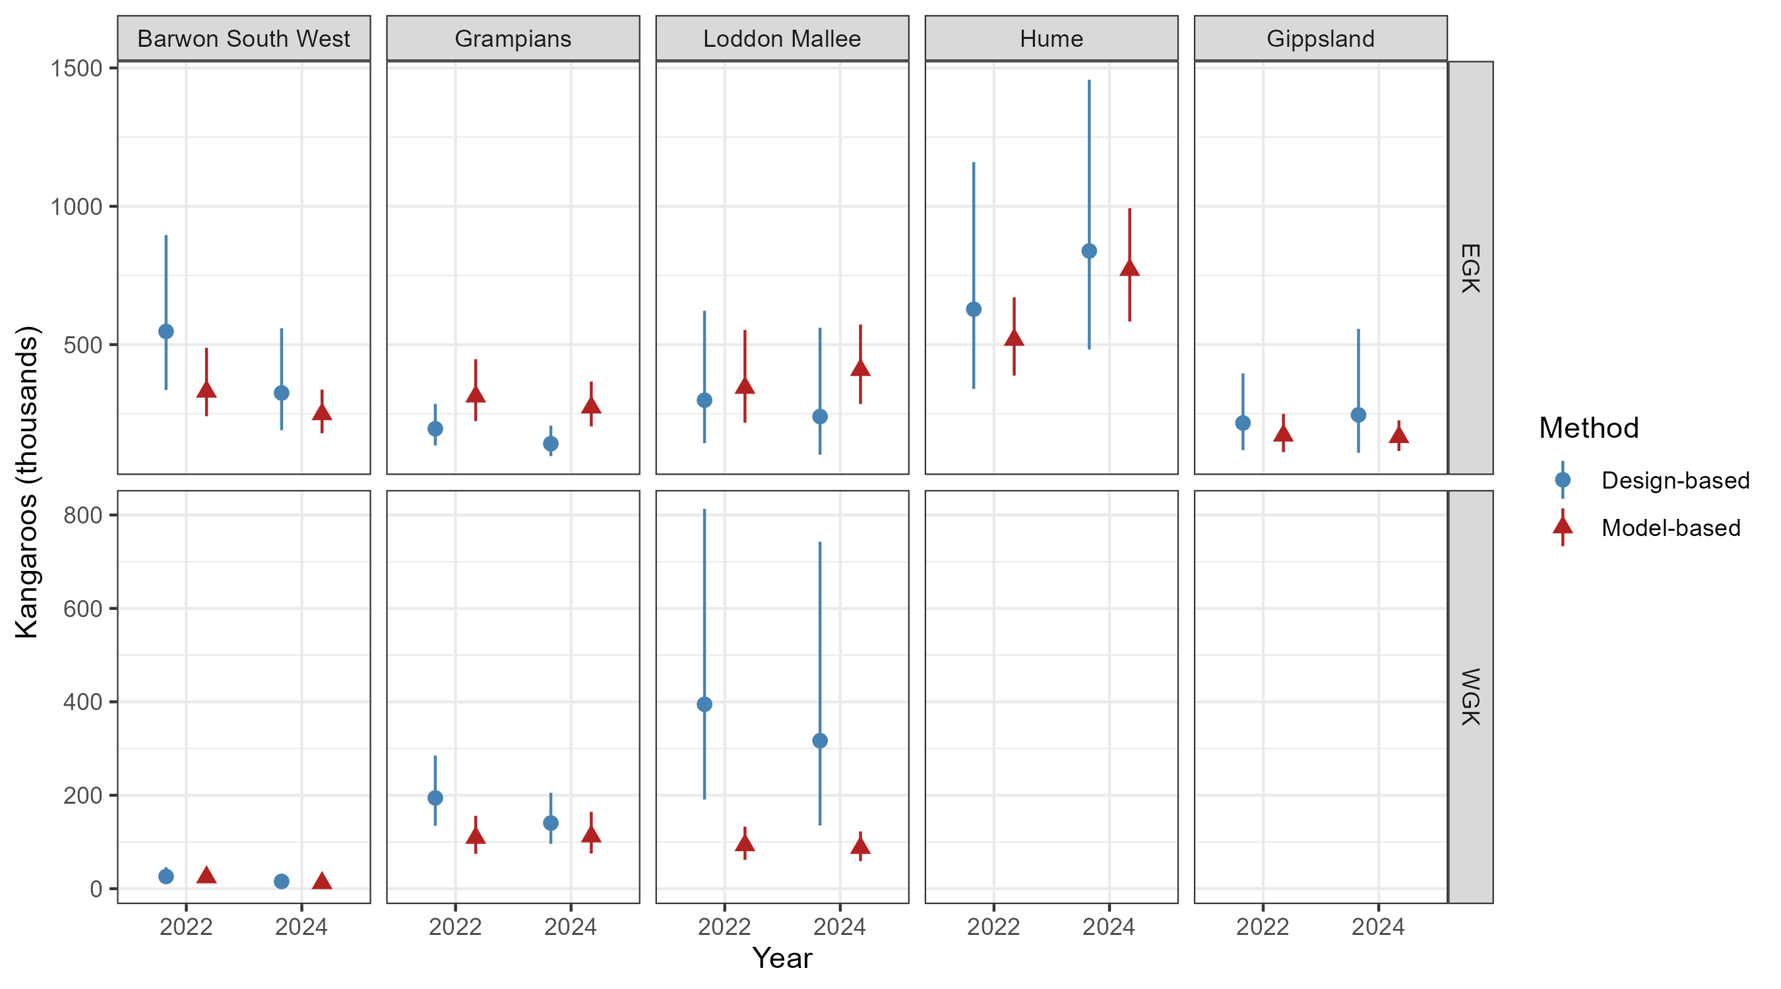
Figure A1. Comparison of model-based and design-based estimates of abundance for each of the new harvest zones for the years 2022 and 2024. Separate plots are made for each of the two grey kangaroo species. Error bars are 95% confidence intervals.

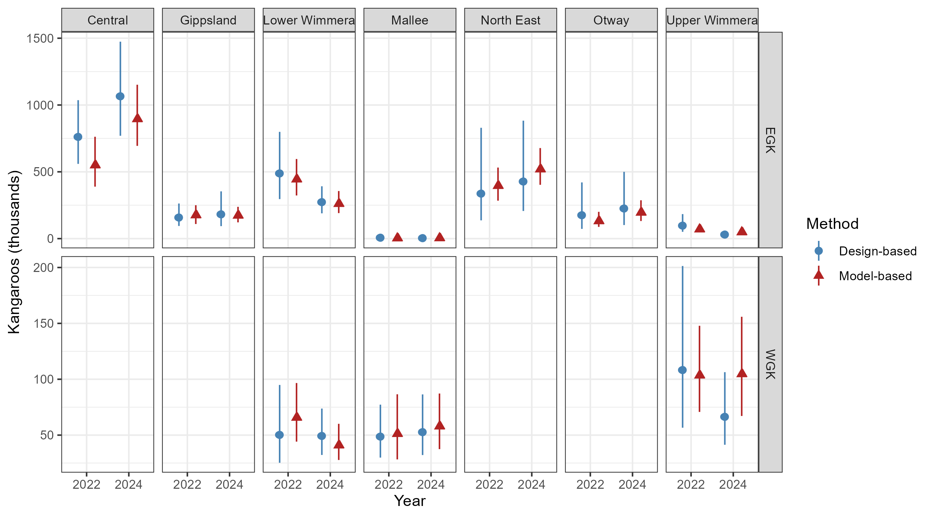
Figure A2. Comparison of model-based and design-based estimates of abundance for each of the old harvest zones for the years 2022 and 2024. Separate plots are made for each of the two grey kangaroo species. Error bars are 95% confidence intervals.

Figure A3 provides a clearer picture of this comparison by plotting the design- and model-based estimates for each zone/year against each other. If the pairs of estimates were exactly equal, then we would expect them all to be located on the diagonal dashed line on Figure 10. While there is some variability around this line, there is no clear tendency for points to be located above or below the line, which might indicate some consistent bias of one of the methods. Perhaps the most notable discrepancies between model-based and design-based estimates can be found amongst Western Grey Kangaroos in the new Loddon Mallee region, where the design-based estimates are markedly higher (and more uncertain) than the equivalent model-based estimates.
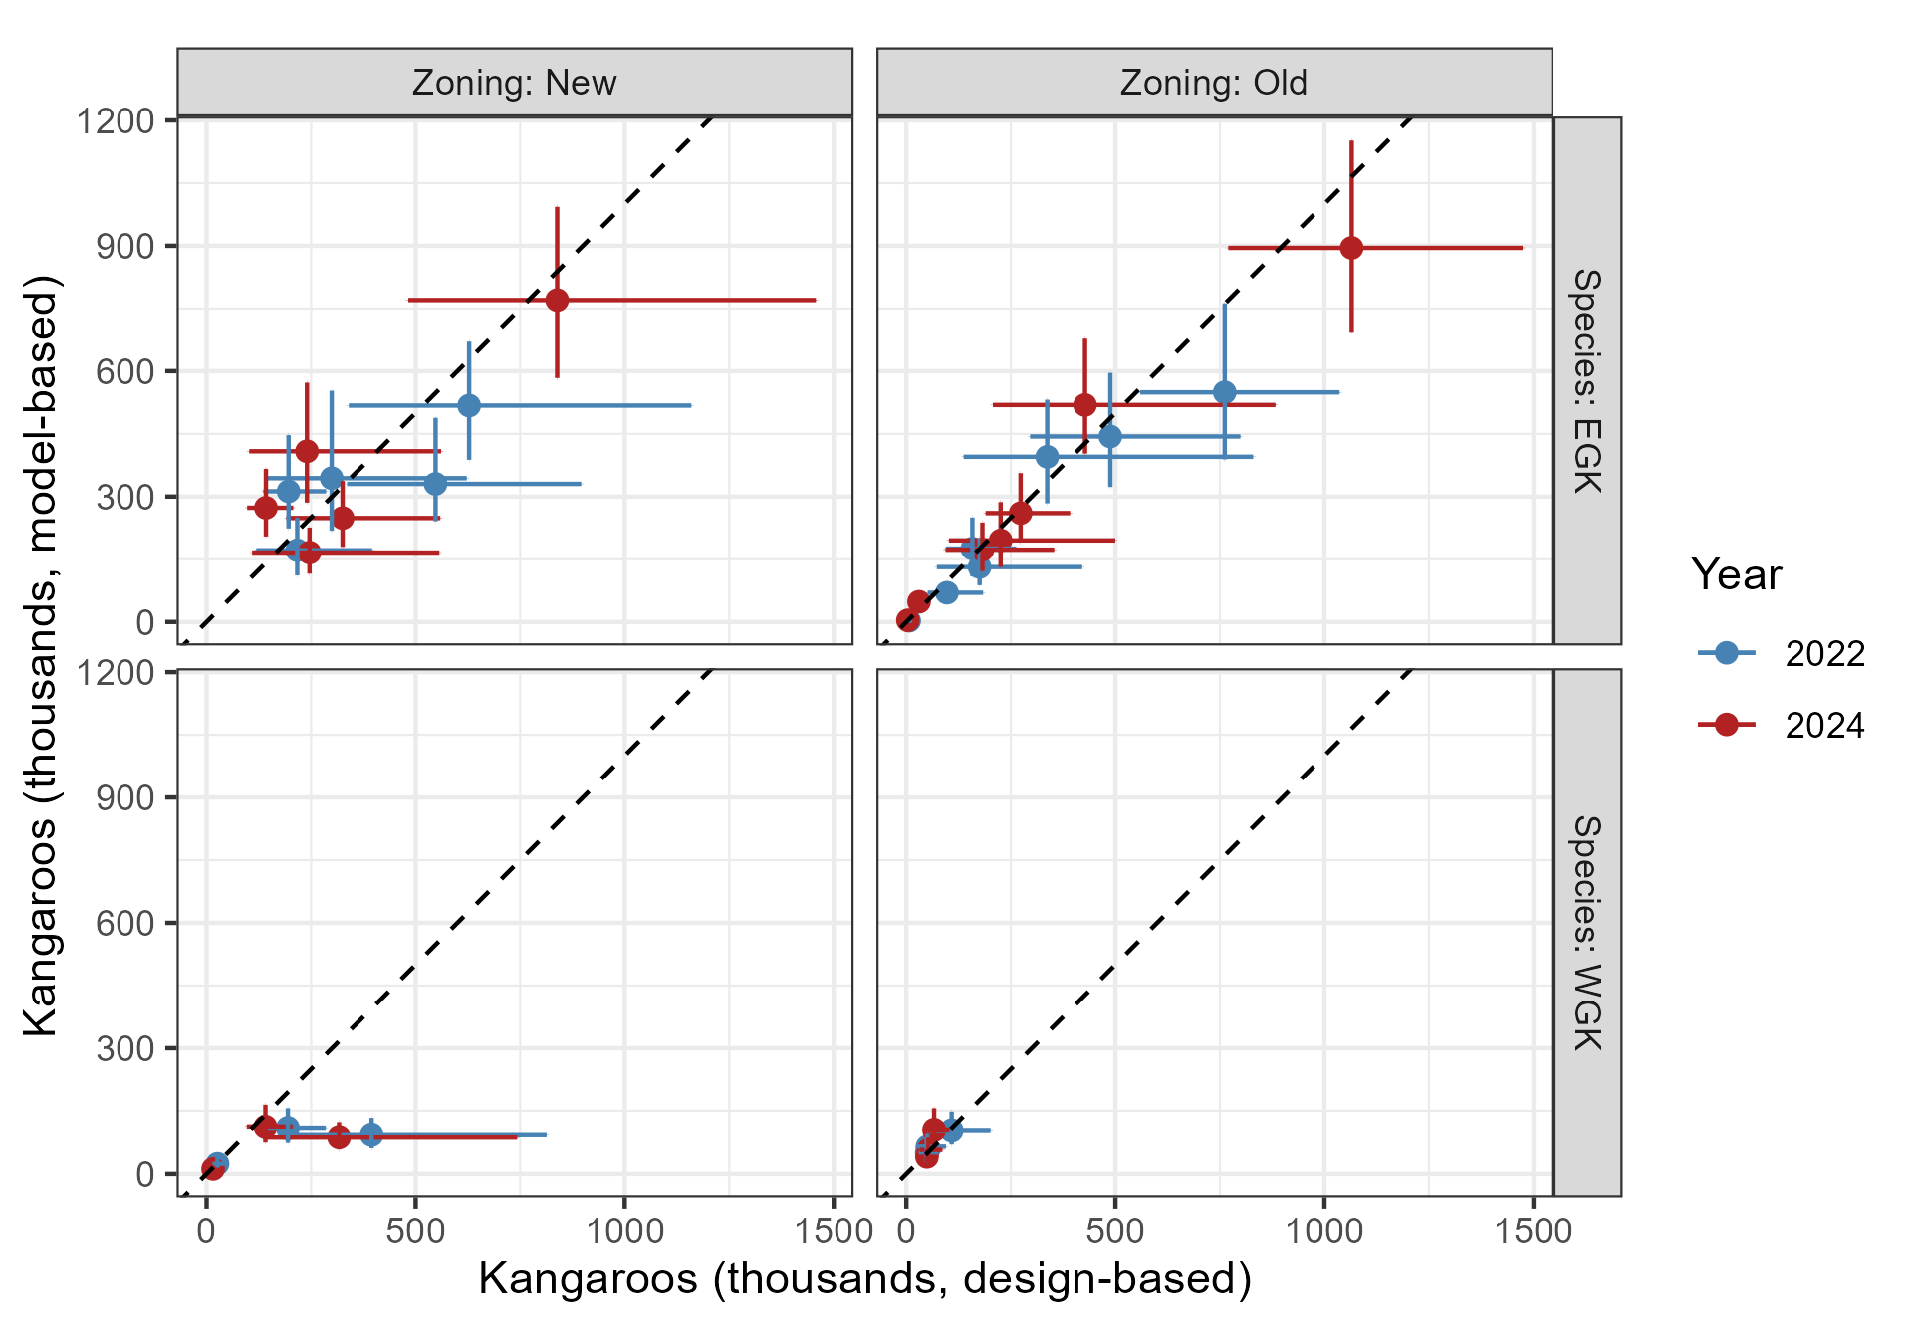
Figure A3. Relationship between model-based and design-based estimates of abundance for both new and old zoning schemes. Where the two methods of estimation are equal, they will lie on the diagonal dashed line. Error bars are 95% confidence intervals for the population estimates.

The estimated percentage changes in abundance for each zone between 2022 and 2024, derived using model-based and design-based inferences of abundance are given in Figure A4. In general, there was broad agreement between the inferred percentage changes for the two statistical methods, but also some notable discrepancies, with uncertainty as to whether populations in a few zones had actually increased or decreased (for example, Eastern Grey Kangaroos in the new Loddon Mallee zone) or cases where a larger change was inferred from one method versus another (for example, both Eastern and Western Grey Kangaroos in the old Upper Wimmera Zone).
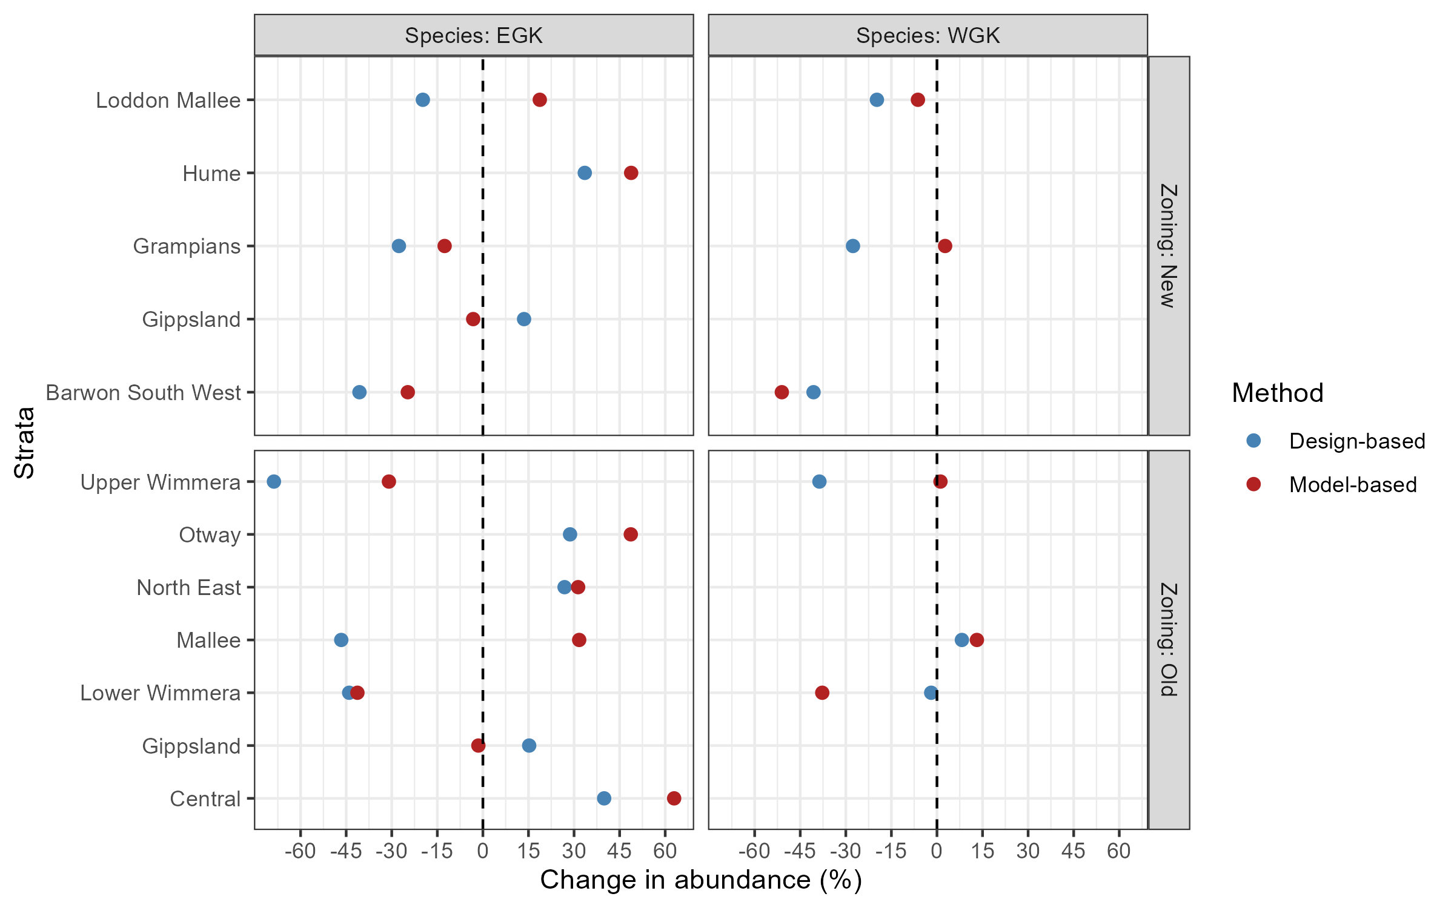
Figure A4. Implied percentage population changes between 2022 and 2024 for EGK and WGK in each old and new harvest zone based on model-based and design-based estimates of abundance. The vertical dashed line implies no change in abundance.

Precision (expressed as the coefficient of variation, CVs) for each of the zone-level estimates of abundance are shown in Figure A5. It is apparent that in every case, model-based estimates have smaller CVs (and hence better precision) than equivalent design-based estimates for the same zone or year. A target of CV=0.2 or better for each harvest zone has been articulated as an aim for the aerial survey program. For the year 2024, under the new zoning scheme (third panel of Fig A5), all model-based estimates for Eastern Grey Kangaroos had CVs that were clearly less than the target value of 0.2. For Western Grey Kangaroos, a CV less than 0.2 was only obtained in the Loddon-Mallee harvest zone, with CVs of 0.205 and 0.266 respectively in the Grampians and Barwon South West Zones.
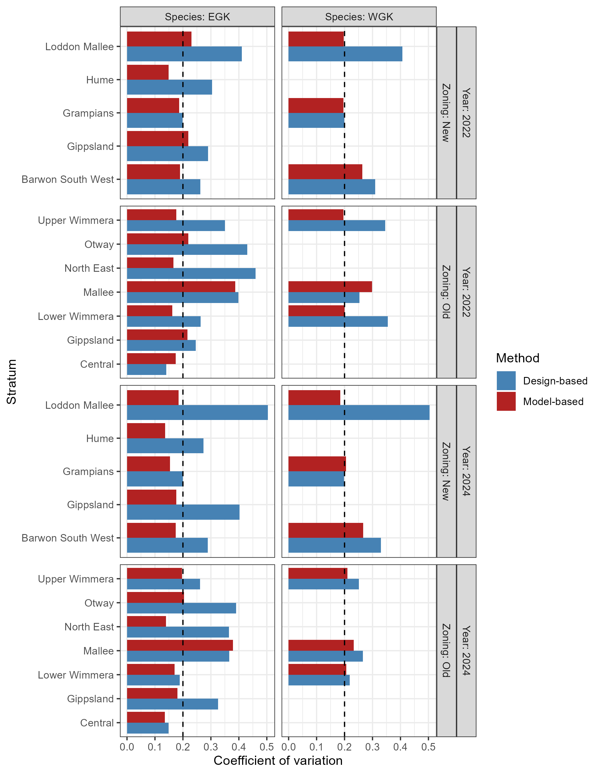
Figure A5. Precision (expressed as the coefficient of variation) of model-based and design-based estimates of abundance for each old and new harvest zone for the years 2022 and 2024. The vertical line is the target CV of 0.2.

Apparent large discrepancies between model-based and design-based estimates of abundance in some zones should be the subject of further investigation. It is notable that the largest discrepancies occurred under the new zoning system, which consists of a smaller number of zones which are each more ecologically and climatically diverse. For example, the new Loddon-Mallee zone covers an area including the semi-arid Mallee at one extremity, to more temperate parts of central Victoria at the other. If (as the model-based approach has shown, see Figures 7 and 8) kangaroo density covaries strongly with vegetational or climatic gradients, then the new zones will have far more within-zone variation in kangaroo density that the old zones, which were on average smaller in area, and more ecologically and climatically homogenous. This effect will likely contribute to the higher uncertainty (expressed as coefficients of variation) in overall (both species combined) abundance estimates for the new zones under a design-based approach, as transect-level observations of density within a zone will be expected to be highly variable due to the underlying strong gradients in kangaroo density. As the model-based approach benefits from inferred relationships between habitat, climate and kangaroo density it is not directly affected by within-zone heterogeneity. This effect adds to the strength of the argument for employing the model-based approach, as model-based estimates.
There is an additional disadvantage of the design-based approach to estimation which flows from the need to apportion the overall total estimates of grey kangaroo abundance between the two species using the spatial model illustrated in Figure 2. Because two of the new zones (Grampians and Loddon Mallee) span both strong ecological and rainfall gradients, as well as a coinciding gradient in the proportion of grey kangaroos which are Eastern Grey Kangaroos, there is an inherent confounding between kangaroo density and the proportional breakdown between the two species within different parts of the zone. This means that the simple approach of multiplying the overall design-based mean density estimates for grey kangaroos by the average proportions of Eastern and Western Grey kangaroos within each zone may produce biased estimates of the total numbers of each species in the zone. This was far less of a problem under the old zoning system, where the zones containing most of the state’s population of Western Greys was limited to three zones (Mallee, Upper Wimmera and Lower Wimmera), and kangaroo habitat (and in turn, density) within each of these zones was comparatively homogeneous in terms of rainfall and vegetation. This in turn mean that within-zone gradients in the ratio of Eastern to Western Greys did not apparently closely coincide with gradients in Grey Kangaroo abundance.
Fortunately, the model-based approach is essentially immune to biases that may flow from the combination of large within-zone heterogeneity in grey kangaroo density and confounding of within-zone gradients in kangaroo density with the relative proportions of Eastern and Western Greys. When apportioning between Eastern and Western Greys, the model-based approach does so on a grid-cell basis, rather than considering the zone as a whole in a single step. This means that any correlation between kangaroo density and the ratio of Eastern to Western Greys is correctly accounted for in the estimates. Elimination of this potential source of bias is an important reason for preferring the model-based inferences in general but is particularly important under the new zoning scheme, where within some zones, the gradients in kangaroo density and the proportions of the two species are closely correlated.

www.deeca.vic.gov.au

www.ari.vic.gov.au

