The Abundance of Dingoes in Victoria
Analysis from statewide camera trap surveys across public land between 2021 and 2025







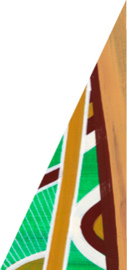



Arthur Rylah Institute for Environmental Research
March 2026
D.S.L Ramsey, J.G. Cally, L.P. Woodford and T.J. Schneider
deeca.vic.gov.au

Project summary
Camera-trap monitoring conducted between 2021 and 2025 on public land in the Big Desert and Wyperfeld National Park (Big Desert) and the Hume and Gippsland regions in Eastern Victoria was used to assess dingo (Canis familiaris dingo) abundance across Victoria. Using 645 camera deployments at 445 sites, with 200 locations resurveyed across years, the study estimated dingo population abundance using camera-trap distance sampling methods and Bayesian inference.
Between 2023 and 2025, dingo numbers remained unchanged in the Big Desert, with an estimate of 121 (90% CI: 56–216) and 122 (90% CI: 58–214), in 2023 and 2025, respectively. In Eastern Victoria, there was some evidence for an increase in abundance from 4,547 (90% CI: 3,322–5,993) to 5,349 (90% CI: 3,924–7,069) over the same period, representing an average 18% increase (90% CI: 7 – 30%). While the results indicate higher dingo abundance in Eastern Victoria in 2025, with only two survey periods it is not possible to infer whether this represents an increasing trend in abundance: differences in abundance between periods may just reflect natural variation in dingo populations. Future monitoring is recommended to identify long-term trends, particularly to assess the impacts of ongoing lethal control in Eastern Victoria, and the cessation of lethal control in the Big Desert.

Background
The Dingo (Canis familiaris dingo) is listed as ‘Vulnerable in Victoria’ under the state’s Flora and Fauna Guarantee Act 1988. Despite this, dingoes are subject to lethal control in eastern Victoria as part of a Governor in Council order, which declares dingoes to be unprotected wildlife within 3 km of private land boundaries. A smaller and more isolated population of dingoes also reside in the west of the state in the Big Desert Wilderness Park and Wyperfeld National Park (hereafter referred to as the Big Desert population). Lethal control of dingoes in the Big Desert population ceased in March 2024 following the overturning of the unprotection order for that population. This was based on previous research that indicated this population had low levels of genetic diversity (i.e. high levels of inbreeding) (Weeks et al. 2025) coupled with a small population size of 110 individuals (90% CI: 40 – 230) (Ramsey and Cally 2024). An independent study also estimated the abundance of dingoes within the Big Desert was similarly small: 77 dingoes (95% CI = 64–94) (Cascio et al. 2025). In contrast, the dingo population for eastern Victoria was estimated at 4,900 (90% CI: 2,640 – 8,880) (Ramsey and Cally 2024).
In this study we use camera trap monitoring data collected across the dingo range in Victoria between 2021 – 2025 to estimate dingo density and abundance in the Big Desert and Eastern Victoria during Spring 2023 (cf. Ramsey and Cally 2024) and obtain new estimates for Spring 2025 and compare changes in abundance over this time.

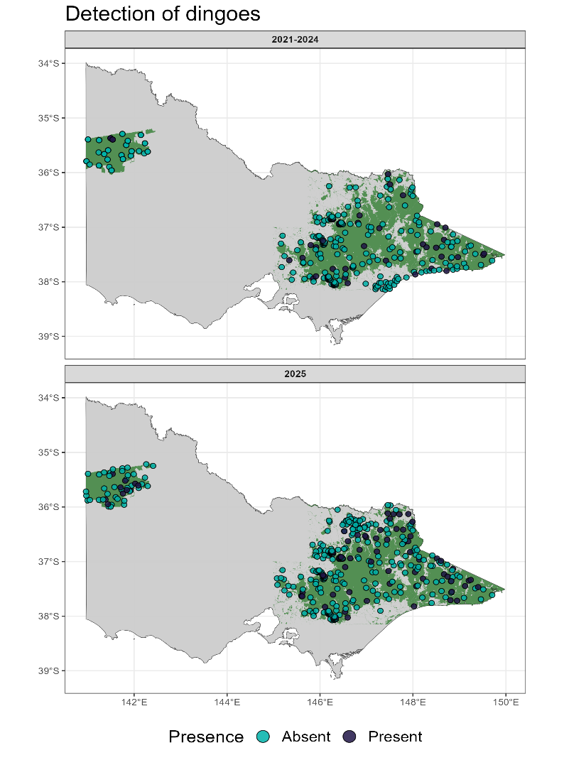
Approach
Within public land in the Big Desert and Eastern Victorian regions, we deployed 645 cameras using camera trap distance sampling (CTDS) methods (Howe et al. 2017) between 2021 and 2025. These cameras were deployed at 445 unique locations with 200 locations being monitored in both 2023 and 2025. Camera locations were primarily determined using spatially-balanced, random sampling techniques (Foster et al. 2017). Additional camera data was also sourced from other, smaller scale studies. The resulting spatial clustering of cameras in some parts of the study area was accounted for using a spatial random effect and spatially structured covariates, which explicitly models autocorrelation between neighbouring locations (see below).
Cameras were deployed for an average of 59 days (41 – 110 days) at a height of 1m above the ground with no bait or lures used, as these would strongly bias density estimates. All cameras deployed were Reconyx HF2X models set to “High” sensitivity, operating without delay or quiet periods and continually triggering (i.e. “rapidfire”). To determine the distance of an individual dingo from the camera we used distance markers set at 2.5 m, 5 m, 7.5 m and 10 m from the camera. From 2023 onwards we replaced the use of distance markers with reference images at the same distances (Henrich et al. 2022; Delisle et al. 2023a) to minimise animal interaction with distance markers.
Figure 1. Detections of dingoes across Victoria, grouped according to the survey years (2021 – 2024) and 2025.
The analysis of the camera trap data implemented CTDS by adopting a hierarchical framework, which separates the population process (abundance) from the observation process (detection probability) (Delisle et al. 2023b). Here, we modelled the density of dingoes at camera sites as a function of the number of dingo encounters at pre-determined time points (i.e. snapshot moments) during the period of camera deployment, which were set at every second. We also accounted for the proportional time within a 24-hour cycle dingoes were active (and hence, available to be detected) as well as the detection probability in front of the camera (as modelled by a detection function). Dingo density at a site was modelled using a zero-inflated Poisson (ZIP) distribution that better accounts for the proportion of cameras that did not detect dingoes. The ZIP model was dependent upon several covariates and a spatial-random effect (Gaussian process) driving baseline occupancy patterns. Covariates influencing dingo density included variables describing the climate, vegetation and topography at each site as well as the change in density across the period of camera deployment between 2021 – 2025.
From our fitted model, we predicted abundance to 1km² grid cells across the Big Desert and Eastern Victoria. Predictions were restricted to and offset by the amount of public land in each grid cell. This led to predictions across 6,941 km² across the Big Desert region and 41,062 km² in the Eastern Victoria region. Predictions were made specific to two time-points: September 1st 2023 and September 1st 2025.

Key findings
Dingoes were detected on 133 out of the 645 (20%) camera deployments (Figure 1). From the most recent round of surveys in August 2025 – January 2026, 55 out of the 197 (28%) cameras detected dingoes, with 10 out of the 48 cameras deployed in the Big Desert recording dingo presence. From the 200 sites that had surveys across multiple years, more sites had detections of dingoes during the second deployment. Specifically, 41 cameras (21%) detected dingoes during the initial deployment while 55 cameras (28%) detected dingoes during the second deployment in 2025.

Density Estimates
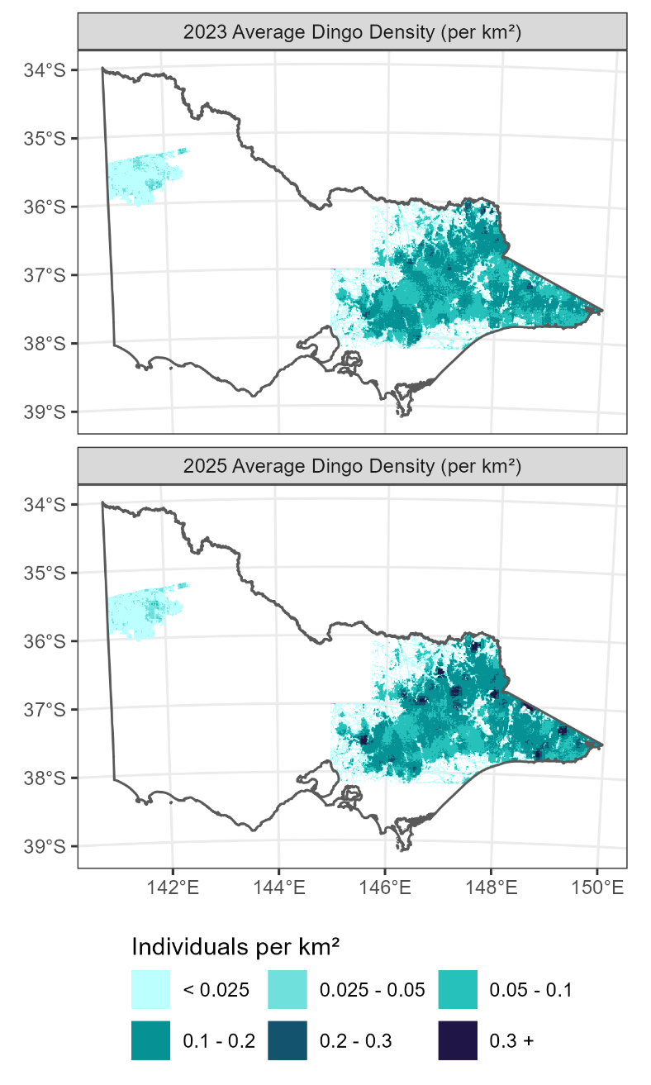
Across the 645 camera deployments we obtained a mean density estimate of 0.11 (90% CI: 0.007 – 0.35) dingoes per km². Model predictions for all public land in the Big Desert and Eastern Victoria provided total population estimates for each region in September 2023 and September 2025. We found no evidence for a change in dingo population size in the Big Desert with estimates of 121 (90% CI: 56 – 216) and 122 (90% CI: 58 – 213) in 2023 and 2025, respectively (Table 1). In Eastern Victoria, there was evidence for an increase in population size from 4,547 (90% CI: 3,322 – 5,993) to 5,349 (90% CI: 3,924 – 7,069) over the same period, representing an 18% increase (90% CI: 7 – 30%).
It should be acknowledged that the 2023 estimates presented here are statistically indifferent from the estimates previously reported in Ramsey and Cally (2024). The minor differences in abundance estimates reflect model refinement to estimate spatial and temporal population change between the two periods. These changes have also led to improved precision of estimates compared with Ramsey and Cally (2024), as evidenced by the lower coefficient of variation (CV) (Table 1).
In the Big Desert we found that dingoes were at highest densities in the eastern areas of the park dominated by lake beds and drainage lines as well as areas surrounding park borders or forest edge. Dingoes were at variable densities across eastern Victoria with some of the higher density areas found within remote, topographically complex and heavily forested areas such as Mount Lawson, Yarra Ranges, Falls Creek, Whitfield and East Gippsland.
Figure 2. Spatial variation in dingo densities across Victoria during 2023 and 2025

Table 1. Estimated mean dingo abundance in two regions in Victoria, across two time periods. SD – standard deviation, CV – coefficient of variation. LCL - lower 90% credible limit, UCL – upper 90% credible limit.
Region | Time period | Abundance | SD | CV | LCL | UCL | Density  (90% CI)
Big Desert  (6,941 km²) | 2023 | 121 | 50 | 0.41 | 56 | 216 | 0.02 (0.01, 0.03)
Big Desert  (6,941 km²) | 2025 | 122 | 49 | 0.40 | 58 | 213 | 0.02 (0.01, 0.03)
Eastern Victoria  (41,062 km²) | 2023 | 4,547 | 827 | 0.18 | 3,322 | 5,993 | 0.11 (0.08, 0.15)
Eastern Victoria  (41,062 km²) | 2025 | 5,349 | 953 | 0.18 | 3,924 | 7,069 | 0.13 (0.10, 0.17)

Abundance of dingoes on country
In addition to the abundance of dingoes on public land in Eastern Victoria and the Big Desert, we also estimated the abundance of dingoes on Country within the boundaries of various Registered Aboriginal Party (RAP) lands. These are provided in Table 2. Highest abundances of dingoes were found on the lands of the Gunaikurnai Land and Waters Aboriginal Corporation with only a small number of dingoes found on the lands of the Yorta Yorta and Bunurong (Table 2, Figure 3).

Table 2. The abundance of dingoes on Country administered by various Registered Aboriginal Parties (RAPs). Values in brackets provide the 90% credible interval of the estimated population size.
RAP area | RAP area (km²) | Estimated population (September 2023) | Estimated population (September 2025)
Barengi Gadjin Land Council Aboriginal Corporation | 37,120 | 121 (55–215) | 122 (58–212)
Bunurong Land Council Aboriginal Corporation | 8,174 | 26 (11–46) | 28 (11–51)
Gunaikurnai Land and Waters Aboriginal Corporation | 25,771 | 1,331 (931–1,818) | 1,335 (926–1,827)
No Registered Aboriginal Party | 24,810 | 2,090 (1,520–2,779) | 2,741 (1,999–3,618)
Taungurung Land and Waters Council Aboriginal Corporation | 20,221 | 856 (605–1,154) | 981 (688–1,340)
Wurundjeri Woi Wurrung Cultural Heritage Aboriginal Corporation | 7,091 | 210 (127–314) | 227 (140–336)
Yorta Yorta Nation Aboriginal Corporation | 13,202 | 30 (11–57) | 32 (12–60)

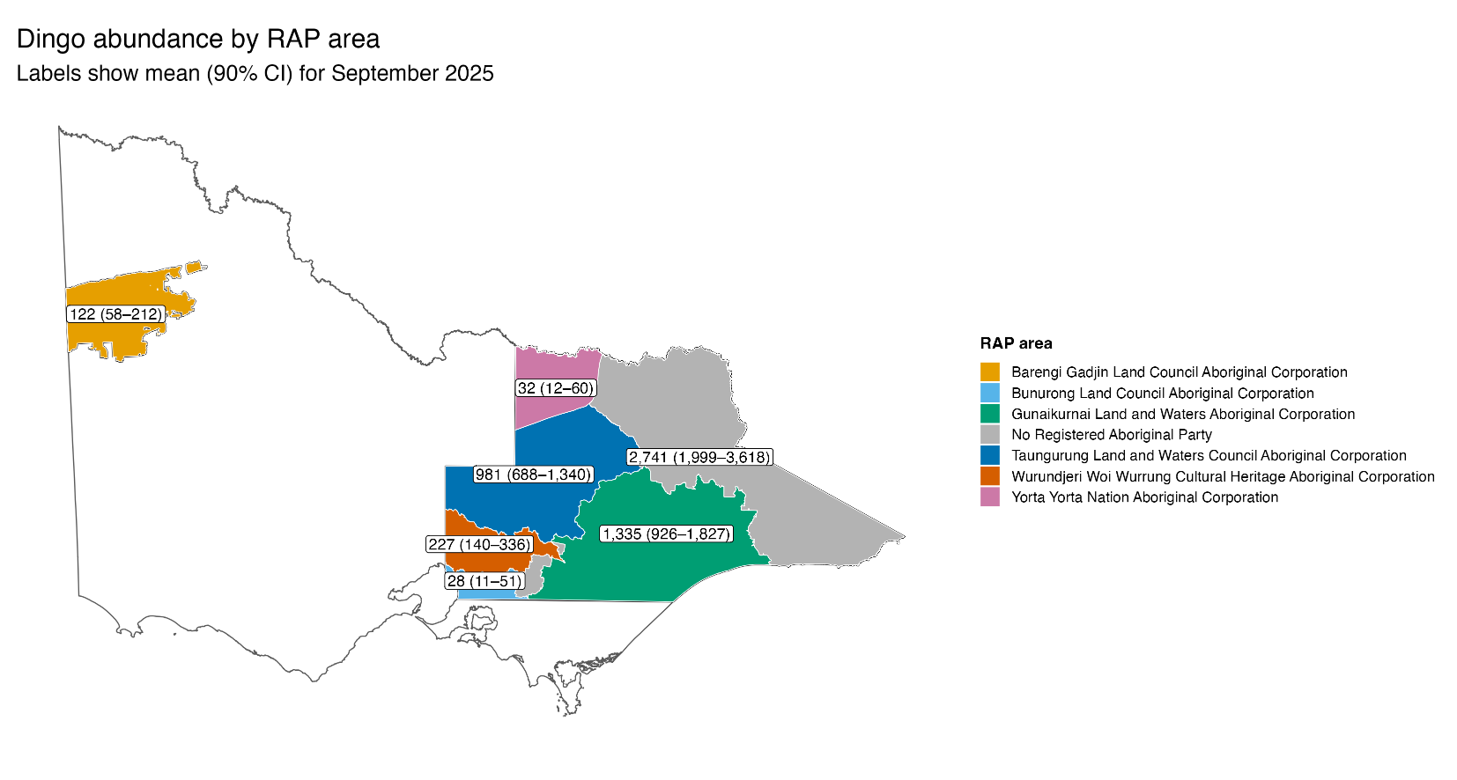
Figure 3. Map showing the abundance of dingoes as of September 2025 within areas administered by various Registered Aboriginal Parties (RAPs).

Drivers of Dingo Abundance, Occupancy, Detectability and Activity
We found that the abundance of dingoes across Victoria to be driven mainly by random spatiotemporal processes with relatively weaker effects from climate and habitat variables (Table A1 – Appendix). Among the stronger effects, covariates including effects from topography, amount of forest edge habitat and degree of non-photosynthetic vegetation indicating dingoes in eastern Victoria preferred heavily forested areas in more rugged terrain. However, these effects were less influential in the Big Desert. It should be noted that these relationships do not imply that dingo abundance is directly influenced by these variables. Indeed, these relationships could be due to correlations with other variables not included in the model, such as the abundance of dingo prey.
Dingoes in the Big Desert were more likely to be detected in camera traps, likely due to less dense obscuring vegetation that was more common in heavily forested areas of Eastern Victoria. The average probability of detection for a single dingo that was within 15 m of the camera was 0.18 in Eastern Victoria and 0.49 in the Big Desert. Additionally, we found that dingoes were active for around half the day (i.e. 12 hours), with peak activity times in the morning and evening.

Recommendations for management/policy
We have obtained updated estimates on the abundance of dingoes in Victoria which builds on the initial estimates given in Ramsey and Cally (2024). In the Big Desert region, the abundance of dingoes was estimated to be unchanged in 2025 compared with 2023, with some evidence for an increase in abundance in Eastern Victoria. However, we caution against any interpretation of these differences as indicating a trend. With only a maximum of two surveys at sites any abundance changes may just reflect normal variation due to natural population dynamics. Dingoes are estimated to have a high underlying annual rate of increase (Hone et al. 2010) and thus can have rapid changes in abundance and density.
Several management challenges remain for dingoes within the Big Desert. Firstly, inbreeding and low genetic diversity are an ongoing threat to this population (Weeks et al. 2025). Secondly, dingo populations appear to be relatively restricted to certain areas of the Big Desert, thus raising questions about the carrying capacity of dingoes in this environment. In Eastern Victoria, dingo abundance has shown a modest increase despite ongoing lethal control programs in this region. Several environmental factors might have contributed to changes in abundance in the east. Firstly, since 2019-20 dingo populations were likely impacted by fires that affected 15,000 km² of possible dingo habitat in Eastern Victoria. Previous research suggested that occupancy of dingoes decreased after these fires in East Gippsland (Robley et al. 2022). The abundance increase seen here may in part be explained by a population recovery and recolonisation process in the areas that were burnt in 2019-20.

Next steps
Future population monitoring should be undertaken to elucidate the trends in dingo abundance in both regions. In addition to camera-based monitoring methods, other methods that utilise genetic information obtained from captured individuals during dingo management programs, such as Close-Kin Mark-Recapture (Bravington et al. 2016), could also be considered to provide population trend estimates. Additional monitoring data should help better understand the impacts of continued lethal control in eastern Victoria and ceased lethal control in the Big Desert. As previously noted, the impact of fires on dingo populations across Victoria may be significant but remain largely unstudied; there is some evidence that dingoes may prefer recently burnt habitat (Geary et al. 2018), but other research suggests that occupancy declines according to fire severity (Robley et al. 2022).

References
Bravington MV, Skaug HJ and Anderson EC (2016). Close-kin mark-recapture. Statistical Science 31, 259–274. doi:10.1214/16-STS552
Cascio AL, Martion E, Ramsey DSL, Mason R, Pestell A, Geary WL, Sowersby W and Ritchie EG (2025). Landscape drivers of population density of a vulnerable apex predator (Wilkerr/dingo). EcoEvoRxiv. doi:https://doi.org/10.32942/X2MD3G
Delisle ZJ, McGovern PG, Dillman BG and Swihart RK (2023a). Imperfect detection and wildlife density estimation using aerial surveys with infrared and visible sensors. Remote Sensing in Ecology and Conservation 9, 222–234. doi:10.1002/rse2.305
Delisle ZJ, Miller DL and Swihart RK (2023b). Modelling density surfaces of intraspecific classes using camera trap distance sampling. Methods in Ecology and Evolution. doi:10.1111/2041-210X.14093
Foster SD, Hosack GR, Lawrence E, Przeslawski R, Hedge P, Caley MJ, Barrett NS, Williams A, Li J, Lynch T, Dambacher JM, Sweatman HPA and Hayes KR (2017). Spatially-balanced designs that incorporate legacy sites. Methods in Ecology and Evolution 8, 1433–1442.
Geary WL, Ritchie EG, Lawton JA, Healey TR and Nimmo DG (2018). Incorporating disturbance into trophic ecology: fire history shapes mesopredator suppression by an apex predator. Journal of Applied Ecology 55, 1594–1603.
Henrich M, Hartig F, Dormann CF, Kühl HS, Peters W, Franke F, Peterka T, Šustr P and Heurich M (2022). Deer Behavior Affects Density Estimates With Camera Traps, but Is Outweighed by Spatial Variability. Frontiers in Ecology and Evolution 10. doi:10.3389/fevo.2022.881502
Hone J, Duncan RP and Forsyth DM (2010). Estimates of maximum annual population growth rates (rm) of mammals and their application in wildlife management. Journal of Applied Ecology 47, 507–514. doi:10.1111/j.1365-2664.2010.01812.x
Howe EJ, Buckland ST, Després-Einspenner ML and Kühl HS (2017). Distance sampling with camera traps. Methods in Ecology and Evolution 8, 1558–1565. doi:10.1111/2041-210X.12790
Ramsey DSL and Cally JG (2024). The abundance of dingoes Canis familiaris (Dingo) in Victoria: Results from a statewide survey. Arthur Rylah Institute for Environmental Research Technical Report Series No. 382. Department of Energy, Environment and Climate Action, Heidelberg, Victoria.
Robley A, Cally JG, Murray A, Bluff L, Collyer A, Borg N and Phillips L (2022). The response of native species to the 2019–20 bushfires and introduced predators in far East Gippsland. Technical Report Series No. 329.
Weeks AR, Kriesner P, Bartonicek N, Van Rooyen A, Cairns KM and Ahrens CW (2025). Genetic structure and common ancestry expose the dingo-dog hybrid myth. Evolution Letters 9, 1–12. doi:10.1093/evlett/qrae057

Appendix

Table A1. Model parameter estimates from the ZIP model for dingo abundance.
Process | Component | Parameter | Mean | 5% | 95% | SD
Abundance | Covariate | Intercept | -1.08 | -2.39 | 0.21 | 0.79
Abundance | Covariate | Zone: Eastern Victoria | -0.28 | -1.56 | 1.03 | 0.78
Abundance | Covariate | MRVBF (square-root) | -0.43 | -0.93 | 0.09 | 0.31
Abundance | Covariate | Slope (square-root) | 0.18 | -0.07 | 0.42 | 0.15
Abundance | Covariate | Forest edge (square-root) | -0.07 | -0.32 | 0.19 | 0.16
Abundance | Covariate | Nitrogen | -0.02 | -0.14 | 0.10 | 0.07
Abundance | Covariate | Non-photosynthetic Vegetation | -0.61 | -1.24 | 0.02 | 0.38
Abundance | Covariate | TWIND | 0.20 | -0.63 | 1.05 | 0.51
Abundance | Covariate | Zone: Eastern Victoria X MRVBF (square-root) | 0.20 | -0.48 | 0.87 | 0.41
Abundance | Covariate | Zone: Eastern Victoria X Forest edge (square-root) | 0.17 | -0.10 | 0.45 | 0.17
Abundance | Covariate | Zone: Eastern Victoria X Non-photosynthetic Vegetation | 0.63 | -0.03 | 1.28 | 0.40
Abundance | Covariate | Zone: Eastern Victoria X TWIND | 0.01 | -0.90 | 0.92 | 0.56
Abundance | Time effect | Time slope (Big Desert) | 0.00 | -0.08 | 0.08 | 0.05
Abundance | Time effect | Time slope (Eastern Victoria) | 0.06 | -0.01 | 0.13 | 0.04
Zero-inflation | Covariate | Intercept | -1.78 | -2.14 | -1.48 | 0.20
Zero-inflation | Covariate | BIO18: Precipitation in driest month | 1.10 | -0.05 | 2.27 | 0.69
Zero-inflation | Covariate | BIO14: Precipitation in driest quarter | -0.56 | -1.81 | 0.65 | 0.75
Zero-inflation | Covariate | BIO15: Precipitation Seasonality | 0.10 | -0.41 | 0.60 | 0.31
Zero-inflation | Covariate | Distance to water (log) | 0.03 | -0.36 | 0.40 | 0.23
Zero-inflation | Covariate | Effort | 0.67 | 0.36 | 1.00 | 0.19
Zero-inflation | GP spatial time-slope field | GP length-scale (time-slope field) | 1.32 | 1.14 | 1.52 | 0.12
Zero-inflation | GP spatial time-slope field | GP sigma (time-slope field) | 0.62 | 0.57 | 0.67 | 0.03

© The State of Victoria Department of Energy, Environment and Climate Action February 2026
Citation: Ramsey, D.S.L., Cally, J.G., Woodford, L.P., and Schneider, T.J. (2026). The abundance of dingoes in Victoria: analysis from statewide camera trap surveys across public land between 2021 and 2025. Arthur Rylah Institute for Environmental Research. Department of Energy, Environment and Climate Action, Heidelberg, Victoria.
This work is licensed under a Creative Commons Attribution 4.0 International licence, visit the Creative Commons website (http://creativecommons.org/licenses/by/4.0/).
ISBN 978-1-76176-944-3 (pdf/online/MS word)

We acknowledge Victorian Traditional Owners and their Elders past and present as the original custodians of Victoria’s land and waters and commit to genuinely partnering with them and Victoria’s Aboriginal community to progress their aspirations.

