

VEFMAP Stage 6

Part B: Program design and monitoring methods

October 2017

Arthur Rylah Institute for Environmental Research

and

Integrated Water and Catchments Division, DELWP

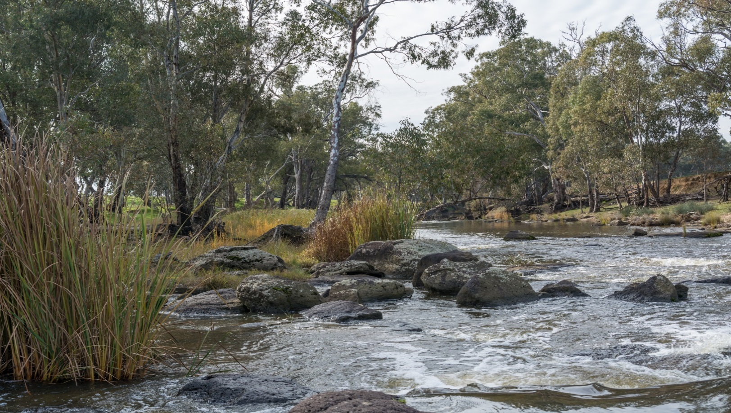

**Report produced by:** Arthur Rylah Institute for Environmental Research  
Department of Environment, Land, Water and Planning  
PO Box 137  
Heidelberg, Victoria 3084

and

Integrated Water and Catchments Division  
Department of Environment, Land, Water and Planning  
8 Nicholson Street, East Melbourne, Victoria 3002

Website: [www.delwp.vic.gov.au](http://www.delwp.vic.gov.au)

With assistance from

Peter Cottingham, Peter Cottingham and Associates

**Citation**: DELWP (2017) VEFMAP Stage 6 Part B: Program design and monitoring methods. A report by Arthur Rylah Institute for Environmental Research and Integrated Water and Catchments Division, Department of Environment, Land, Water and Planning, Victoria.

|  |
| --- |
| © The State of Victoria Department of Environment, Land, Water and Planning 2017  LogoThis work is licensed under a Creative Commons Attribution 4.0 International licence. You are free to re-use the work under that licence, on the condition that you credit the State of Victoria as author. The licence does not apply to any images, photographs or branding, including the Victorian Coat of Arms, the Victorian Government logo and the Department of Environment, Land, Water and Planning (DELWP) logo. To view a copy of this licence, visit <http://creativecommons.org/licenses/by/4.0/>  ISBN 978-1-76047-924-4 (print)  ISBN 978-1-76047-925-1 (pdf)  **Disclaimer**  This publication may be of assistance to you but the State of Victoria and its employees do not guarantee that the publication is without flaw of any kind or is wholly appropriate for your particular purposes and therefore disclaims all liability for any error, loss or other consequence which may arise from you relying on any information in this publication.  **Accessibility**  If you would like to receive this publication in an alternative format, please telephone the DELWP Customer Service Centre on 136186, email [customer.service@delwp.vic.gov.au](mailto:customer.service@delwp.vic.gov.au), or via the National Relay Service on 133 677 [www.relayservice.com.au](http://www.relayservice.com.au). This document is also available on the internet at [www.delwp.vic.gov.au](http://www.delwp.vic.gov.au). |

Contents

Summary 1

1 Introduction 2

1.1 VEFMAP Stage 6 objectives 2

1.2 Purpose and approach of this document 2

1.3 Context and rationale 3

1.4 Environmental water delivery – planning 3

1.5 VEFMAP site locations 3

1.6 Pilot studies 4

2 Native Fish Theme 5

2.1 Key Evaluation Question 1 6

Do environmental flows promote immigration by diadromous fishes in southern Victorian coastal rivers? 6

2.1.1 Study design 7

2.1.2 Survey locations 7

2.1.3 Sampling methods 8

2.1.4 Evaluation and statistical analysis 9

2.1.5 Reporting 9

2.1.6 Key partnerships and in-kind contributions 10

2.2 Key Evaluation Question 2 11

Do environmental flows enhance dispersal, distribution and recruitment of diadromous fishes in southern Victorian coastal rivers? 11

2.2.1 Study design 12

2.2.2 Survey locations 13

2.2.3 Sampling methods 13

2.2.4 Evaluation and statistical analysis 15

2.2.5 Reporting 15

2.2.6 Key partnerships and in-kind contributions 15

2.3 Key Evaluation Question 3 16

Do environmental flows promote migration of native fish into, and dispersal throughout, northern Victorian rivers? 16

2.3.1 Study design 17

2.3.2 Survey locations 18

2.3.3 Sampling methods 18

2.3.4 Evaluation and statistical analysis 20

2.3.5 Reporting 20

2.3.6 Key partnerships and in-kind contributions 20

2.4 Key Evaluation Question 4 22

Does environmental flow management used for native large-bodied fish species enhance: (i) survival and recruitment, (ii) abundance, and (iii) distribution? 22

2.4.1 Study design 23

2.4.2 Survey locations 23

2.4.3 Sampling methods 24

2.4.4 Evaluation and statistical analysis 27

2.4.5 Reporting 28

2.4.6 Key partnerships and in-kind contributions 28

3 Aquatic and River Bank Vegetation Theme 30

Monitoring vegetation responses to environmental flow delivery in Victoria 30

3.1 Objectives 30

3.2 Key Evaluation Questions 30

3.3 Survey locations 32

3.4 Methods 32

3.5 Filling important knowledge gaps 38

3.6 Approach to analysis and evaluation 40

➢ Other sources of potential data 41

3.7 Key partnerships 41

4 References 42

**Figures**

Figure 1: Conceptual model of initiation of diadromous fish migration into lower freshwater river reaches. 7

Figure 2: Conceptualisation of diadromous fish distribution response to environmental flows. Dotted vertical lines represent potential sampling events.. 12

Figure 3: Conceptual model of links between flow conditions and movement of golden perch and silver perch between main stem and tributary locations. 16

Figure 4: Conceptual representation of how river flows and other modifiers link to fish life-history processes and population demography. 22

Figure 5: A hypothetical example of mapped patches of vegetation types along the Wimmera River. Different colours indicate different vegetation types or species. Some patches may be mapped as polygons (red/green), while very small patches or individual plants mapped as point locations (blue/yellow). 34

Figure 6: Example of a targeted, fine-scale survey method for VEFMAP Stage 6. The data do not aim to characterise a particular site, but rather record changes in existing vegetation patches and vegetation recruitment. 35

Figure 7: Example of a canopy cover photo from standard digital camera. Image can be post-processed to measure foliage projective cover (excluding major branches) 37

Figure 8: Schematic diagram of soil moisture probe layout for environmental flow data collection 39

**Tables**

Table 1: The key vegetation responses associated with the five KEQs for vegetation and the monitoring approaches that will be used to observe and understand them …………………31

**Summary**

The Department of Environment, Land, Water and Planning (DELWP) established the Victorian Environmental Flows Monitoring and Assessment Program (VEFMAP) in 2005 and Stages 1-5 were completed in mid-2016. VEFMAP Stage 6 includes a refocus on ‘intervention’ or ‘flow-event’ style questions to help demonstrate the ecological value of water for the environment at catchment, regional and state-wide scales.

The scope and detail of Stage 6 has been compiled into two parts:

* Part A: Program context and rationale
* Part B: Program design and monitoring methods.

Part A outlines the scope for VEFMAP Stage 6 and should be consulted for information on program context, learnings from previous VEFMAP stages, program governance, approaches to reporting and evaluation, QA/QC and adaptive management.

Part B (this volume) details the project design and monitoring methods for VEFMAP Stage 6, which will include three years of monitoring from 2016/17 until 2019/20, followed by analysis in 2020.

VEFMAP Stage 6 has been designed to meet objectives and answer key evaluation questions (KEQs) related to two ecological themes: (i) native fish, and (ii) aquatic and river bank vegetation. The sampling design for each theme is based on:

* learnings gained through previous VEFMAP stages;
* conceptual understanding of the role of flow in driving ecological response;
* environmental water delivery plans (Seasonal Watering Plans, Environmental Water Management Plans, Long-term Watering Plans);
* response indicators related to the key evaluation questions; and
* sampling techniques best suited to generating indicator data.

Within this document, information presented for each key evaluation theme includes a summary of study design considerations and potential evaluation approaches. Key partnerships and reporting mechanisms are also summarised.

# **Introduction**

The Department of Environment, Land, Water and Planning (DELWP) established the Victorian Environmental Flows Monitoring and Assessment Program (VEFMAP) in 2005 and Stages 1-5 were completed in mid-2016. VEFMAP Stage 6 includes a refocus on ‘intervention’ or ‘flow-event’ style questions to help demonstrate the ecological value of environmental water at catchment, regional and state-wide scales.

The scope and detail of Stage 6 has been compiled into two parts:

* Part A: Program context and rationale
* Part B: Program design and monitoring methods.

Part B (this volume) details the project design and monitoring methods to be implemented as part of VEFMAP Stage 6, which will include three years of monitoring and evaluation from 2016/17 to 2019/20, followed by analysis and evaluation in 2020.

VEFMAP Stage 6 has been designed to meet objectives and answer key evaluation questions (KEQs) related to two ecological themes: (i) native fish, and (ii) aquatic and river bank vegetation. The focus on these attributes was proposed following a review at the end of VEFMAP Stage 4, given that native fish and riparian vegetation are key ecosystem components and of direct interest to environmental water managers (see section 3.2, *VEFMAP Stage 6 Part A: Program context and rationale,* DELWP 2017).

## **VEFMAP Stage 6 objectives**

1. Enable DELWP and its water delivery partners to clearly demonstrate the ecological value of environmental water management to the community and water industry stakeholders.
2. Fill knowledge gaps to improve planning, delivery and evaluation of environmental water management in rivers and wetlands across Victoria.
3. Identify ecosystem outcomes form environmental water to help meet Victoria’s obligations under the Murray-Darling Basin Plan (Schedule 12, Matter 8).

## **Purpose and approach of this document**

This document has been compiled for the following purposes:

* To provide an Independent Review Panel (IRP) and internal reviewers from DELWP with adequate information to assess the suitability of the proposed program design for meeting the stated program objectives.
* To provide a record of the design and methods for VEFMAP Stage 6 for use by the program delivery partner - Arthur Rylah Institute (ARI) and for Victorian Catchment Management Authorities (CMAs).
* To provide a source and summary of information for use in briefing DELWP Managers, Directors, Executive Directors and the Minister, Water.
* To provide a source and summary of information for use in preparing contracts to complete the monitoring.

Section 2 of this document focusses on the native fish theme for VEFMAP Stage 6. Project design and sampling methods are presented separately for each KEQ.

Section 3 of this document focusses on the aquatic and river bank vegetation theme. Proposed monitoring methods are broadly relevant to all the vegetation KEQs and will provide multiple lines of evidence for KEQ evaluation. Therefore, methods are outlined together, in one section (3.4).

## **Context and rationale**

*VEFMAP Stage 6 Part A: Program context and rationale* (DELWP 2017) outlines the scope for VEFMAP Stage 6 and should be consulted for information on program context and rationale, learnings from previous VEFMAP stages, program governance, approaches to reporting and evaluation, QA/QC and adaptive management.

## **Environmental water delivery – planning**

The intervention monitoring approach of Stage 6 requires a focus on rivers and sites that receive environmental flows. Annual Seasonal Watering Plans released by the Victorian Environmental Water Holder (VEWH) will be used to identify rivers scheduled to receive environmental water releases each year. The volume and timing of their environmental water releases in specific rivers will be confirmed at the beginning of each water year, and throughout the year the VEFMAP project team will coordinate sampling efforts with CMAs and the VEWH to ensure environmental flows and sampling efforts are timed appropriately.

## **VEFMAP site locations**

Where appropriate, Stage 6 monitoring will be conducted at existing VEFMAP rivers and in existing VEFMAP survey locations (particularly for vegetation monitoring); this will allow existing data to be built upon to explore long-term trends.

Existing VEFMAP rivers include:

* Goulburn River
* Broken River
* Broken Creek
* Loddon River
* Campaspe River
* Glenelg River
* Macalister River
* MacKenzie River
* Thomson River
* Wimmera River
* Yarra River

Additional rivers and site locations will be included where there is a greater likelihood of detecting an ecological response to an environmental watering regime (due to factors such as existing long-term monitoring data, adequate sample sizes and wider ranging environmental covariates). Additional rivers for monitoring in VEFMAP Stage 6 may include:

* Murray River
* Ovens River
* Barwon River
* Werribee River
* Wimmera tributaries
* Tarwin River
* Bunyip River
* Cardinia Creek

Not all VEFMAP rivers will be surveyed each year, although it is a priority to include as many rivers as possible over the course of Stage 6. The specific survey locations will be discussed with the relevant CMAs prior to sampling. Water operators and managers will be consulted regarding variations in environmental flow delivery (i.e. timing and magnitude of releases). Rivers not receiving an intervention may be surveyed to address questions of change in the absence of environmental flow deliveries.

## **Pilot** studies

The methods designed to assess native fish and aquatic and river bank vegetation responses to environmental watering were trialled through a series of pilot studies undertaken in the first year of VEFMAP Stage 6 (2016/17). The pilot studies included surveys in a sub-sample of rivers planned for VEFMAP Stage 6, and the information obtained contributed to the evaluation and refinement of sampling methods and data collection/collation processes for the full program. The information obtained was presented to the program governance bodies as part of this process (Independent Review Panel and Steering Committee).

# **Native Fish Theme**

Numerous life history processes including spawning, recruitment and dispersal drive the population dynamics of Australian native fish species. River flow is thought to play an important role in regulating many of these processes; however, infrastructure development of many of Australia's riverine systems has resulted in changes to natural stream flow patterns and reduced connectivity, creating a fundamental impediment to dispersal processes.

Environmental watering can play a role in mitigating the detrimental impacts caused by changes to natural flow regimes, although quantitative links between fish life history processes and flow are not always clear (Arthington 2012). Scrutiny of environmental watering outcomes demands that there are clear links between watering, life history processes and, ultimately, improvements to fish populations.

The native fish theme for VEFMAP Stage 6 addresses two broad objectives that relate to the influence of environmental watering on native fish life history processes.

Broadly, objectives for native fish monitoring in VEFMAP Stage 6 focus on:

(i) the importance of environmental flows to promote immigration, dispersal and subsequent recruitment of diadromous fish in Victorian coastal rivers, and

(ii) the importance of environmental flows to promote population growth via immigration, dispersal, recruitment and survival in northern Victorian rivers.

The two objectives differ predominately with respect to their region and multiple KEQs have been selected to monitor and assess each objective (below).

|  |  |  |
| --- | --- | --- |
| **Coastal Catchments** | **KEQ 1** | Do environmental flows promote immigration by diadromous fishes in southern Victorian coastal rivers? |
|  | **KEQ 2** | Do environmental flows enhance dispersal, distribution and recruitment of diadromous fishes in southern Victorian coastal rivers? |
| **Northern Catchments** | **KEQ 3** | Do environmental flows support immigration of native fish into, and dispersal throughout, northern Victorian rivers? |
|  | **KEQ 4** | Does environmental flow management used for large-bodied species enhance: (i) survival and recruitment, (ii) abundance, and (iii) distribution? |

For the remainder of Section 2, project design and monitoring methods are presented separately for each KEQ.

## Key Evaluation Question 1

### Do environmental flows promote immigration by diadromous fishes in southern Victorian coastal rivers?

Seventy percent of fish species inhabiting coastal freshwater rivers of Victoria are diadromous, requiring movement between fresh and marine waters for part of their life cycle (Harris 1984). Current evidence suggests that river discharge plays a role in attracting diadromous fishes into rivers and that low flow conditions, resulting from drought or water regulation, lead to reduced fish abundance and diversity (Amtstaetter *et al*. 2016). As a result, Victorian Seasonal Watering Plans for both the central and western regions include the provision of environmental water releases to attract diadromous fishes into rivers and to protect and increase native fish populations (VEWH 2016).

To support this management action, it is important to understand the relationship between discharge and fish colonisation, and to evaluate the effectiveness of environmental flow releases in promoting migration from marine/estuarine habitats into coastal rivers. This can then allow waterway managers to refine the management of environmental flow delivery to provide better outcomes (e.g. to optimise the timing, magnitude and duration of releases).

To this end, the purpose of this project is to examine links between environmental flow releases, natural flow variability, and the movement of native Australian diadromous fish species from marine waters into southern Victorian coastal rivers. Specific species of interest in this study include tupong *Pseudaphritis urvillii*, Australian grayling *Prototroctes maraena*, several galaxiid species *Galaxias* spp., short-headed lamprey *Mordacia mordax*, pouched lamprey *Geotria australias*, and short-finned eel *Anguilla australis*.

Based on existing evidence, the expectation is that increases in river discharge attract juvenile diadromous fish into rivers (Amtstaetter *et al*. 2016). KEQ 1 will test whether increases in spring flows (as a result of environmental flow releases or natural fluctuations) result in higher abundances of the target fish populations entering the lower freshwater reaches of coastal rivers (Figure 1).

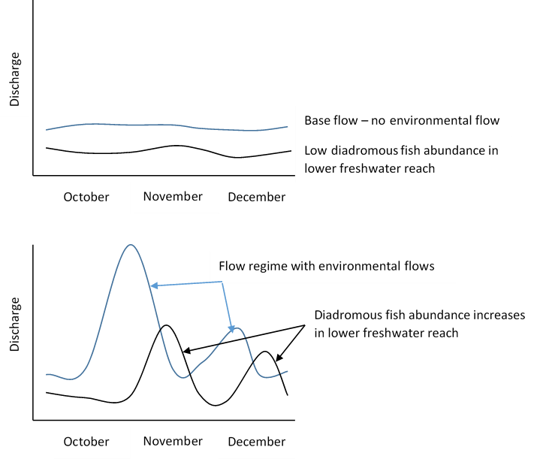

Figure 1: Conceptual model of initiation of diadromous fish migration into lower freshwater river reaches.

Addressing KEQ 1 will focus on event-based monitoring of the migration of diadromous fishes from marine/estuarine environments into freshwater reaches from spring to early summer.

### Study design

To address KEQ 1, intervention monitoring will be undertaken weekly from spring to early summer to coincide with the peak upstream migration period for many juvenile diadromous species. This level of sampling is proposed to be repeated over the three-year sampling period to provide sufficient data on the response variable under a variety of flow (including environmental flow events), temperature and temporal conditions. With enough data and variation in conditions, we can better guide how to deliver environmental water. Sampling will predominately occur in regulated rivers that receive environmental water deliveries; however, sampling unregulated systems that do not receive environmental water, but have high natural flow fluctuations, will greatly increase the program’s ability to determine the response of diadromous fish to a variety of flow events.

### Survey locations

To maximise the ability to monitor the response of fish to a broad variety of flow conditions, a minimum of five rivers need to be sampled in each of the three years of the project. Final river and site selection have been governed by one or a combination of:

* the availability (and scheduling) of environmental flows;
* the systems contain appropriate fish species in sufficient abundance, relevant to the sampling design;
* the likelihood of a dynamic flow regime;
* the ability to efficiently monitor the response variable (diadromous fish presence and abundance) within available timeframes, budget and sampling methods; and
* potential additional funding and available resources.

Based on these criteria, the rivers suitable for monitoring KEQ 1 are:

* Barwon River
* Werribee River
* Bunyip/Tarago River
* Glenelg River
* Tarwin River
* Cardinia Creek.

Of the six rivers/systems included in this study, four are regulated (Barwon, Werribee, Bunyip/Tarago and Glenelg rivers), one is unregulated (Tarwin River), and one is semi-regulated (Cardinia Creek; receives passing flows).

The regulated rivers will provide response data to environmental flow releases during spring, as well as response data to natural fluctuations in flow.

The inclusion of the unregulated Tarwin River, and the semi-regulated Cardinia Creek, will provide additional response data to a broader range of flow conditions (particularly flow variability), which may not be captured in the regulated systems during the time frames of the program. This will maximise the ability to monitor the response of fish to a broad variety of flow conditions, to help guide environmental water deliveries aimed at increasing the abundance of diadromous fish entering the lower freshwater reaches of coastal rivers.

The Bunyip, Barwon, Glenelg and Werribee rivers all have environmental water delivery plans and fish objectives relevant to this research question (see 2016/17 and 2017/18 Seasonal Watering Plan, VEWH 2016, 2017).

### Sampling methods

In order to answer KEQ 1, sampling will consist of one or a combination of:

* fyke net sampling, and
* fishway trapping.

The indicators that will be monitored to address KEQ 1 in coastal rivers during Stage 6 include those related to:

* river and environmental flow hydrology (i.e. daily discharge and height time series); and
* diadromous fish presence and abundance.

Sampling will consist of fyke net sampling or fishway (trap) sampling within the lower freshwater reach of each river (as close to the estuarine reach as possible). To provide the best catch rate, rivers where a large proportion of the river width can be netted, and rivers with fishways where all fish must swim through a restricted area to migrate upstream, have been selected.

The following methods are indicative for the first full year of Stage 6 monitoring, and may be updated in subsequent years. VEFMAP Stage 6 is an adaptive program and sites and methods may be refined following outcomes of the monitoring projects through to 2019.

All diadromous fish species will be targeted, but it is expected that the common galaxias (*Galaxias maculatus*), based on their abundance in all study rivers, will provide the best response data. We may also observe a response by other diadromous species (e.g. the threatened Australian grayling and tupong) in the Barwon and Bunyip rivers where young-of-year individuals have previously been captured migrating upstream).

**Frequency and timing of sampling**

* Sampling of each river/creek will be undertaken weekly during spring and early summer (approximately 9 weeks through October, November, December).
* Nets or traps will be set in the morning, checked later in the day and emptied and removed the following day resulting in a total set time of 24 h.

**Fish sampling technique**

* Netting will be used in the lower freshwater reaches to measure the abundance of juvenile diadromous fishes entering rivers.
* Rivers where a large proportion of the river width can be netted or rivers with fishways, where all fish must swim through a restricted area to migrate upstream, should provide the best catch rates for this investigation.
* The Werribee, Tarwin, Bunyip, Glenelg and Cardinia creek will be sampled using custom-made fine mesh (4 mm), 1.5 m tall, double wing fyke nets. The dimensions of the nets (wing length and net length) and the design (net entrance and funnel) will be determined by the dimensions of each river, to provide effective sampling at varying water depths. These nets will be used for the life of the program. The net entrance and funnels have been designed in a way that provides for effective sampling at varying water depths (e.g. 0.2 to 1.0 m). The fyke nets will be set with the cod end toward the current so that the wings and net opening face downstream, and so that fish migrating upstream can be captured.
* The Barwon River fishway will be sampled using a pre-existing, custom built trap that fits into the vertical-slot fishway; this has been used during previous sampling events at this location. Data should not be used if collected during flow events that are known to influence the effectiveness of the fishway (generally extreme high flow events).

**Sampling effort**

* Up to 50 individuals per site/trip will be collected, identified, counted and measured for length (mm; caudal fork length (FL) for species with forked caudal fin, total length (TL) for all other fish).
* For highly abundant species such as Galaxiids, batch weights (comprising of at least 100 individuals) and total bulk weight (comprising all individuals) will be measured to enable an estimate of their total abundance to be made.

### Evaluation and statistical analysis

Annual data sets will be explored using descriptive statistics to examine within-year patterns in fish presence/absence, abundance, and diversity in relation to environmental covariates (e.g. temperature, time of year and different attributes of flow). This data will then feed into statistical models at the end of VEFMAP Stage 6 (2019/20), which will be used to assess the effects of environmental flows on the abundance of juvenile diadromous fish entering the lower freshwater reaches of coastal rivers.

The study design is best suited to frequentist techniques for analysis and evaluation. General additive models (GAMs) and ANOVAs can be used to answer whether or not diadromous fish have moved into freshwater reaches. Summary data can be presented as year-class histograms and catch-per-unit effort (CPUE) to examine the distribution of fish species and how this might change over the period of the project.

### Reporting

Timely communication of key findings and photos/videos will be delivered to relevant CMAs and stakeholders in conjunction with each field sampling trip.

Important outputs will include annual activity reports for each of the first two years of the program. This reporting will provide stakeholders with key information on the project, and will provide regionally-specific results for CMAs and the VEWH, which are both timely and consistent with the messaging of the VEFMAP program as a whole. Presentations and updates will be given at events such as EWRO meetings and the annual VEFMAP stakeholder meeting, to facilitate sharing of collected information.

A final report will be provided at the completion of the final year of the project, which will incorporate in-depth analyses and provide clear outputs relevant to the overarching question relating fish migration into rivers in response to environmental water delivery. Results will be analysed (and presented) in a way that allows outcomes to be as transferable as possible to other systems across the region with similar hydrology and/or species composition.

### Key partnerships and in-kind contributions

The program will involve a strong partnership between the DELWP Environmental Water team, ARI, VEWH, Melbourne Water and the Glenelg-Hopkins, Corangamite and West Gippsland CMAs.

In-kind contributions will include sampling of the Bunyip River by Melbourne Water.

Previous fish data collected by ARI for Cardinia Creek (2011 and 2012) and the Barwon River (2014 and 2015) will be used in the analyses, where appropriate, to provide additional statistical power.

## Key Evaluation Question 2

### Do environmental flows enhance dispersal, distribution and recruitment of diadromous fishes in southern Victorian coastal rivers?

Hydrology is a major factor affecting the life history of diadromous fishes and anecdotal evidence suggests numerous diadromous species in coastal Victorian rivers require increases in discharge to trigger upstream dispersal (e.g. Australian grayling in the Thomson River; Koster *et al*. 2009, Webb *et al.* 2017).

Previous VEFMAP data (collected in stages 1-4, Miller *et al*. 2014) indicated that the dispersal of tupong in the Glenelg and Thompson rivers can be positively influenced by environmental watering events (see Stage 5; Webb *et al*. 2017 for details). In view of this, an overarching objective of environmental watering for fish in the Glenelg system is to protect and increase populations of native fish and cue fish movement and spawning to increase the recruitment of species such as the short-finned eel, black bream, estuary perch and tupong(2017-18 Victorian Seasonal Watering Plan, VEWH 2017). Similar fish objectives exist for 9 of the 10 other regulated Victorian coastal rivers.

With KEQ 1 focusing on the process of immigration of diadromous fish to the lower freshwater reaches of coastal rivers, KEQ 2 has been established to look at the subsequent dispersal, distribution and survival that follow, and how this is influenced by flow. It is expected that the distribution of diadromous fish within river systems will vary spatially and temporally depending on the nature and timing of environmental flow releases and other natural flow events. Figure 2 identifies potential flow hydrographs that might apply during VEFMAP Stage 6, along with conceptual responses by diadromous fishes that might ensue. The distribution of diadromous fishes following an environmental flow is expected to be greater than the distribution that would occur in the absence of an environmental flow (see Figure 2: Year 1 vs Years 2 and 3). Further, an environmental flow delivered during spring might result in a greater distribution of fish through a river system, compared to a flow delivered in early summer (see Figure 2: Year 2 vs Year 3). Additionally, the role of flows in maintaining adequate habitat and water quality critical for fish survival is also expected to influence population demography such as distribution, recruitment and abundance. This will be further tested using patterns in long-term data (abundance and distribution) collected in past VEFMAP surveys. Collection of long-term abundance and distribution data will continue for the next three years in the Thompson and Glenelg rivers.

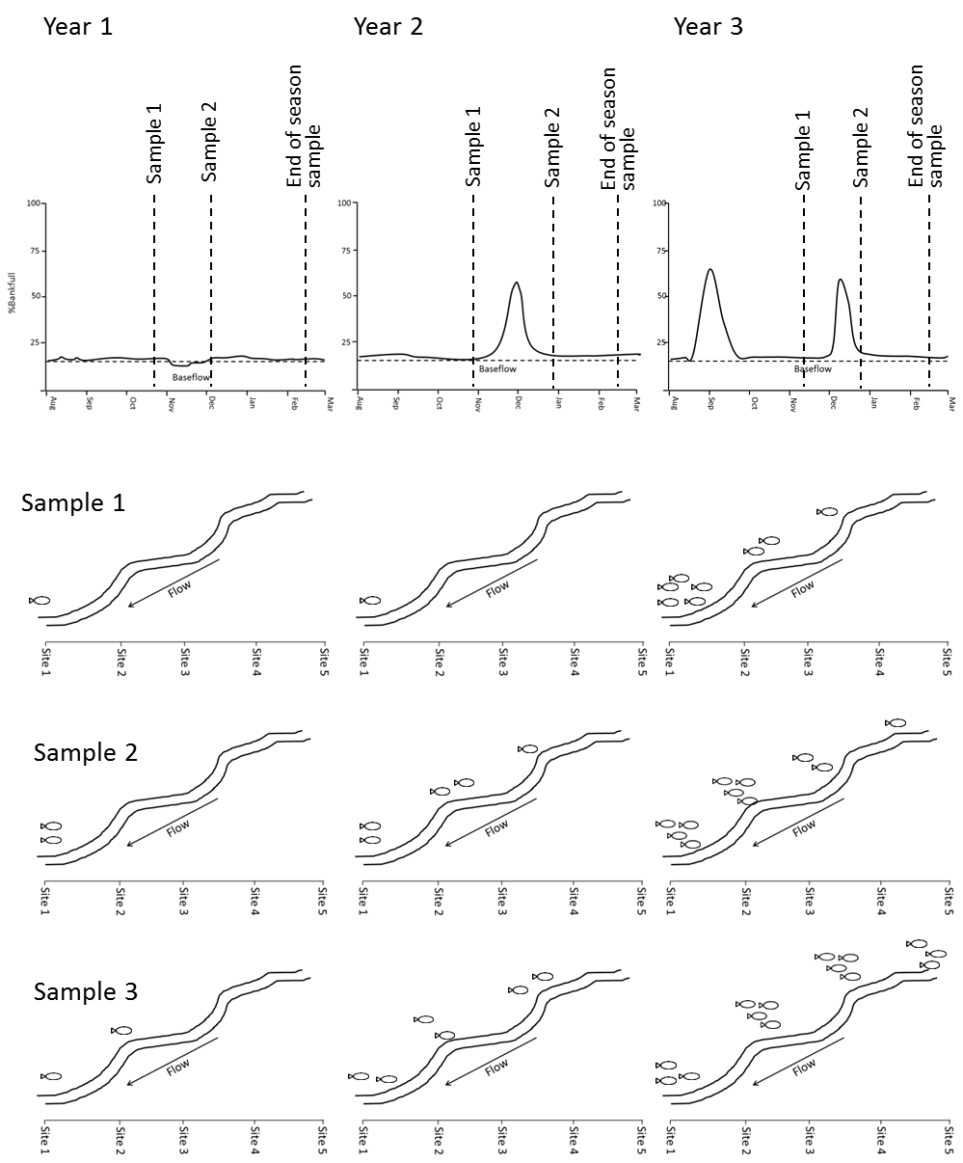

Figure 2: Conceptualisation of diadromous fish distribution response to environmental flows. Dotted vertical lines represent proposed sampling events. Note: Sampling is to occur before, during and after the delivery of environmental flows so that the response by diadromous fish to environmental watering can be isolated from other natural flow pulses.

### Study design

To address KEQ 2, intervention monitoring will be undertaken to collect before-, during- and after-intervention (environmental flow) data (Figure 2). Sampling will predominately occur at regulated rivers that receive environmental water deliveries, and potentially at an unregulated river that does not receive environmental water, but has natural flow fluctuations that have been shown to attract diadromous fish migrations upstream. Like KEQ 1, the inclusion of an unregulated river will greatly increase our ability to assign the response of diadromous fish directly to environmental watering.

KEQ 2 encompasses an end-of-season condition survey to assess whether changes to fish migrations resulting from environmental flows delivered during spring and summer persist throughout autumn. The collection of end-of-season data will also make it possible to build on the condition monitoring approach of previous VEFMAP stages to assess trends in fish populations over time.

### Survey locations

To maximise the ability to monitor the response of fish to a broad variety of flow conditions, several rivers will need to be sampled in each of the three years of the project. River and site selection will be governed by one or a combination of:

* the availability (and scheduling) of environmental flows;
* the systems contain appropriate fish species in sufficient abundance, relevant to the sampling design;
* the likelihood of a dynamic flow regime;
* the ability to efficiently monitor the response variable (diadromous fish dispersal and distribution) within available timeframes, budget and sampling methods; and
* potential additional funding, complementary monitoring data (particularly long-term demography) and available resources.

Based on these criteria, rivers well suited to the monitoring design of KEQ 2 include:

* Glenelg River
* Thomson River
* Werribee River
* Bunyip River
* Moorabool River.

All these rivers are regulated and will provide response data to environmental flow releases as well as response data to natural fluctuations in flow. All rivers have environmental water delivery plans and fish objectives relevant to this research question (see Seasonal Watering Plan, VEWH 2016, 2017).

### Sampling methods

In order to answer KEQ 2, sampling will consist of one or a combination of:

* event-based netting, and
* end-of-season electrofishing (population demographics).

The study design (including methods) may be refined over time, following annual outcomes of the monitoring.

[Note: Acoustic telemetry was trialed as a method to assess movement of juvenile tupong in the Glenelg River in the 2016/17 pilot study. Whilst the method provided encouraging information on downstream migration responses of adult fish to flow, suitably sized juvenile fish of most relevance to the KEQ were difficult to locate and as such a decision was made to discontinue the method (Tonkin *et al*. 2017a).]

The indicators that will be monitored to address KEQ 2 in coastal rivers during Stage 6 include those related to:

* river and environmental flow hydrology (i.e. daily flow time series);
* diadromous fish presence and abundance;
* diadromous fish distribution;
* diadromous fish movement (e.g. dispersal and/or range shift); and
* diadromous fish species size structure.

#### **Event-based netting**

Netting will occur at numerous sites, including control sites, over three nights prior to an environmental flow release and then again during the peak period of an environmental flow release.

**Frequency and timing of sampling**

* Netting will occur for three nights before and during a spring or summer environmental flow release (usually fresh release).
* Nets will be set in the morning, checked later in the day and emptied and removed the following day resulting in a total set time of 24 h.

**Fish sampling technique**

* Rivers will be sampled using double wing fyke nets 0.75 m high with 4 mm mesh to capture fish moving in an upstream direction.
* The net entrance and funnels have been designed in a way that provides for effective sampling at varying water depths (e.g. 0.2 to 1.0 m). The fyke nets will be set with the cod end toward the current so that the wings and net opening face downstream, and so that fish migrating upstream can be captured.
* Captured fish will be identified to species, counted and a sub-sample (20 per species) measured for length (FL or TL, depending on species, in mm).

**Sampling effort**

* Up to nine sites will be surveyed in each river
* For each ‘treatment’ river, six sites will extend upstream from the lower to mid-freshwater reach (impact sites; distance upstream being river dependent). Three sites will be surveyed in a control tributary (e.g. Stokes River for the Glenelg River).

#### **End-of-season electrofishing**

End of season electrofishing will be used to assess trends in population demographics (size structure, abundance and distribution) in the Glenelg and Thomson rivers. Observed trends will be linked with outcomes of the migratory assessments revealed through event-based netting. Up to 15 previously sampled VEFMAP sites will be electrofished (using VEFMAP Stage 3 methods) to obtain information on trends in diadromous fish distribution. Depending on available resources and complementary monitoring projects, sampling effort may be expanded to additional rivers (particularly those investigated in KEQ 1).

**Frequency and timing of sampling**

* Electrofishing in each river will be conducted over a five-day period in February or March, to continue a portion of the data series collected during previous years of VEFMAP (for the Thomson and Glenelg rivers, 2005 to 2016).

**Fish sampling technique**

* Sampling at each site will target wadeable habitats using a Smith–Root® model 7.5 GPP bank–mounted electrofishing unit.
* Sites from previous VEFMAP stages will be sampled using established techniques, which apply 10 x 150 second electrofishing shots (see Sustainable Rivers Audit protocols for details: MDBC 2004). Additional sites and effort will be applied where required to increase the sample size for specific rivers, thus enhancing the ability to generate accurate measures of population demography.
* For additional sites, the total time during which electrical current is applied to the water will be recorded.
* The length of river sampled at each site will be 100-200 metres.
* Shallow habitat types, where target species are typically captured between the georeferenced start and finish points, will be sampled.
* All captured fish will be identified to species, counted and a sub-sample (50 per species) measured for length (FL or TL, depending on species, to mm).
* The weight of large-bodied species and all tupong will be measured in grams.

**Sampling effort**

* For each river, electrofishing will be completed over a five-day period at 9-14 sites (river dependent).
* The total time electrical current is applied to the water will be recorded for each site and used to determine CPUE to standardise results.
* Site locations will be determined based on previous survey locations, as well as historic, current and potential distribution of diadromous fish species within each river.

### Evaluation and statistical analysis

The event-based fyke netting and population demographic data (all years) will be explored using descriptive statistics. This data will also feed into statistical models at the end of VEFMAP Stage 6 (2019/20).

The study design is best suited to general additive models (GAMs) and ANOVAs to answer whether or not diadromous fish dispersal throughout freshwater reaches is linked to environmental flows. Summary data can be presented as year-class histograms and CPUE to examine the distribution of fish species and how this might change over the period of the project. Fish movement data can be analysed using GAMs with binomial distribution (detection probability and probability of range shift).

Continuation of the end-of-season monitoring may also allow a Bayesian approach to be re-applied to the long-term condition monitoring data collected during VEFMAP Stage 3. Alternative approaches to analyse population demographics will also be explored.

### Reporting

Timely communication of key findings and photos/videos will be delivered to relevant CMAs and stakeholders in conjunction with each field sampling trip.

Important outputs will include annual activity reports for each of the first two years of the program. This reporting will provide stakeholders with key information on the project, and will provide regionally-specific results for CMAs and the VEWH that are both timely and consistent with the messaging of the VEFMAP program as a whole. Presentations and updates will be given at events such as EWRO meetings, to facilitate sharing of collected information.

A final report will be provided at the completion of the final year of the project, which will incorporate in-depth analyses that provide clear outputs relevant to the overarching question relating environmental water delivery to fish survival, recruitment and population trends. Results will be analysed (and presented) in such a way that outcomes are as transferable as possible to systems of similar hydrology and/or species composition.

### Key partnerships and in-kind contributions

The program will involve a strong partnership between the DELWP Environmental Water team, ARI, VEWH, Melbourne Water and the Glenelg-Hopkins, Corangamite and West Gippsland CMAs.

In-kind contributions may include sampling of the Bunyip River by Melbourne Water.

Previous fish data collected by ARI in the Glenelg and Thomson rivers (2014 and 2015) will be used to provide additional statistical power, where appropriate.

## Key Evaluation Question 3

### Do environmental flows promote migration of native fish into, and dispersal throughout, northern Victorian rivers?

Riverine fishes are among the most threatened fauna in the world, in part due to the disconnection of key movement corridors. As utilisation and development of freshwater resources increases, there are opportunities to restore the long-term viability of native riverine fish populations through targeted management actions such as environmental flow delivery. This will support critical life cycle events and allow fishes to perform other ecologically important functions. Understanding the key locations, timing and magnitude of fish movements at various life stages, and the abiotic drivers including movement responses to managed flow events such as environmental water delivery, represents a critical knowledge requirement for effective population recovery.

Golden perch and silver perch are two important fish species found in lowland rivers in the Murray-Darling Basin, with various aspects of their life history linked to flow. Recent research suggests that golden perch and silver perch can move over 100s–1000s km relative to patterns of hydrology, including among river systems, and that immigration can be a main source of populations in tributaries (Lyon *et al*. 2014, Koster *et al.* 2014, Zampatti *et al.* 2015, Thiem *et al.* 2017). As such, it has been hypothesised that within-channel freshes occurring in tributaries between spring and autumn will trigger movement of fish such as golden perch and silver perch from the Murray River into and throughout tributaries, contributing to re-colonisation and dispersal (Sharpe 2011, Koster *et al.* 2014, O'Connor *et al.* 2005, Stuart and Sharpe 2015) (Figure 3).

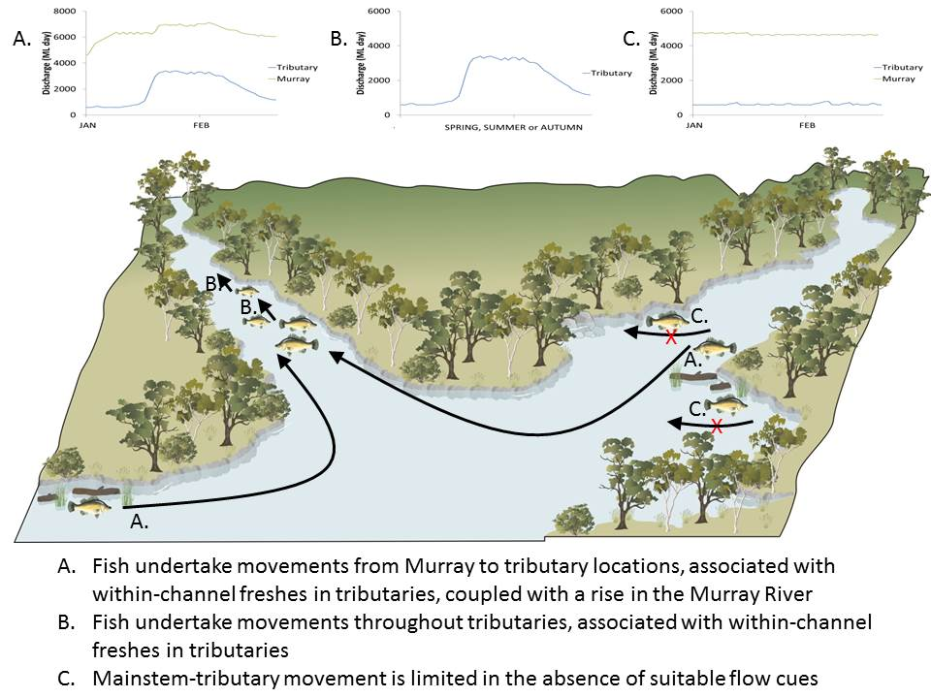

Figure 3: Conceptual model of links between flow conditions and movement of golden perch and silver perch between Murray main stem and tributary locations.

There is also evidence to show that migration is an important process governing population dynamics for species that display strong site fidelity (e.g. Murray cod *Maccullochella peelii,* Lyon *et al*. 2014) or even small bodied species (e.g. Murray River rainbowfish *Melanotaenia fluviatilis* and unspecked hardyhead *Craterocephalus stercusmuscarum,* Tonkin *et al*. 2017b).

This project will investigate links between environmental flows and immigration and dispersal of native fish (particularly golden perch and silver perch), throughout northern Victorian tributary streams. This includes testing whether colonisation and dispersal can be elicited using targeted managed environmental flows. This information is needed to improve our understanding of the movement ecology of these species, particularly the effects of flows on their movement, and to ensure environmental water entitlements are used to achieve the best environmental outcome with the water that is available. Ultimately, the use of co-ordinated environmental flows is expected to lead to increased recruitment of native fish across broad spatial scales (Koster *et al*. 2014, Sharpe 2011, Stuart and Sharpe 2015).

Assessing dispersal of native fish into, and throughout, northern Victorian tributary streams in response to environmental flows is based on a strong conceptual understanding of the role of flow in the life history stages and habitat requirements of key large-bodied native fish species (Murray cod, golden perch, silver perch; see Appendix 3, *VEFMAP Stage 6 Part A: Program context and rationale,* DELWP 2017, for detailed information).

It is expected that within-channel freshes between spring and autumn in tributaries of the Murray River will facilitate movement (i.e. serve as an attractant to promote immigration) of fish such as golden perch and silver perch from the Murray River (Sharpe 2011, Koster *et al.* 2014, Stuart and Sharpe 2015) (Figure 3). For such tributaries as the Goulburn River, a desired hydrograph (as developed in consultation with the GBCMA), may include a within-channel fresh comprising a water level rise of at least 20 cm above ‘normal’ summer/autumn level of 10+ days duration, timed to coincide with a rise in water level in the Murray River. For the Murray River, the desired hydrograph might involve a rise of at least 20 cm above ‘normal’ level each day for several days, followed by a rise of 5 cm each day for 5 days, then variations (rise or fall) of 5 cm each day for 1 week (Mallen-Cooper *et al.* 1996). The initial proof-of-concept for managing flows in this manner has been demonstrated in the Gunbower and Pyramid creeks systems (Sharpe and Tranter 2012, Stuart and Sharpe 2015).

### Study design

KEQ 3 will be examined using an intervention design, monitoring responses to specific flow events. The project is divided into two project components:

1. Project Component 1 – Murray mainstem-to-tributary movement (immigration)

This component will investigate migration of golden perch and silver perch from the Murray mainstem into its tributaries (see Figure 3, A) and whether hydrology or other factors influence the occurrence or frequency of Murray mainstem-to-tributary movements.

1. Project Component 2 – Within-tributary movement (dispersal)

This component will investigate the influence of flows on within-tributary movement (i.e. dispersal) over broad spatial scales (10s-100s of km) (see Figure 3, B). Given the conceptual models and fish tagging being undertaken as part of component 1, golden perch and silver perch will be used as our indicator species when using the acoustic telemetry method for project component 2 (see s 2.3.3). The monitoring of fishways, however, catches the full size structure of the entire fish community. As such, fishway monitoring will record data for all species (size and abundance). This component will also assess whether hydrology or other factors influence the probability of fish moving.

The extent to which the study design will involve single- or multi-site intervention analyses will depend on the scheduling of environmental flows in each year of the project. The intervention analysis will be complemented by an end-of-season (March–May) survey conducted as part of KEQ 4 (s 2.4), to assess whether regional changes in fish abundance and distribution are a result of flow-mediated changes in migration.

### Survey locations

Potential rivers to be monitored for KEQ 3 include:

* Murray River
* Goulburn River
* Loddon River
* Campaspe River
* Pyramid Creek
* Broken Creek/River.

All of the rivers included in this study have environmental water delivery plans and fish objectives relevant to this research question (see VEWH Seasonal Watering Plan 2016, 2017). These rivers will provide response data to environmental flow releases during spring, as well as response data to natural fluctuations in flow.

### Sampling methods

The following sampling approaches will be used to answer KEQ 3:

* Acoustic telemetry
* Event-based fishway trapping
* Electrofishing.

Monitoring indicators to address KEQ 3 will include those related to:

* hydrology and hydrodynamics (i.e. daily flow time series, rates of rise and fall, water velocity, wetted habitat area); and
* fish movement (range shifts and detection).

It is anticipated that flow events such as within-channel freshes will facilitate fish movement, which may result in a broader range of age classes and potentially an increase in abundance of golden perch and silver perch in northern Victorian rivers. Population surveys to address KEQ 3 will be conducted in the Murray River and northern Victorian rivers in autumn 2016/17, 2017/18 and 2018/19. Variation in patterns of abundance and age class composition data (using otoliths) can then be related to patterns of flow (otolith analysis conducted under KEQ 4, s 2.4).

#### **Acoustic telemetry**

**Fish sampling technique**

*Project Component 1 – Murray mainstem-to-tributary movement (immigration); Murray, Goulburn and Campaspe rivers*

* Golden perch and silver perch (juveniles, sub-adults and adults) will be collected from the mid Murray River at Torrumbarry Weir (and downstream of Torrumbarry Weir if insufficient numbers are caught) and tagged with acoustic transmitters (Vemco Model VR2W). For transmitter implantation, collected fish will be transferred into an aerated, 50 L holding container of river water and individually anaesthetised. Transmitters will be implanted into the peritoneal cavity through an incision on the ventral surface, between the pelvic and anal fins (procedure described in Koster and Crook 2008).
* Up to 100 fish in total will be tagged and released in each summer-autumn period of 2016/17, 2017/18 and 2018/19.
* Acoustic listening stations will be deployed in the Goulburn and Campaspe rivers near the junction of the Murray River, and in the Murray River between Torrumbarry Weir and Yarrawonga Weir. The listening stations will be set up in pairs on either side of the riverbank to enable determination of movement into or out of each river.
* Data will be downloaded from the listening stations every three months throughout the study.
* This component of the project will be complemented by an assessment of hydraulic conditions in each of the tributary rivers (see KEQ 4). Detailed velocity and depth data for a range of discharges will provide information that may assist with the transferability of the optimal hydraulic cues (e.g. water velocity) to other tributaries.

[Note: Project Component 1 has the potential to complement a similar investigation of fish dispersal in the Goulburn River using acoustic telemetry funded by the Commonwealth Environmental Water Office long term intervention monitoring (LTIM) program (see below for project links and in-kind contributions).]

*Project Component 2 – Within-tributary movement; Loddon/Pyramid Creek system*

* Golden perch and silver perch (sub-adults and adults) will be captured from the lower Loddon River and Pyramid Creek using electrofishing.
* The fish will be anaesthetised and then tagged, following the procedures described above (and see Koster and Crook 2008).
* Up to 30 fish in total will be tagged and released in each summer-autumn period of 2016/17, 2017/18 and 2018/19.
* An array of 14 acoustic listening stations will be deployed in the Loddon River (between Benjeroop and Appin South) and Pyramid Creek (between the Loddon/Murray junction and Box Creek outlet) to investigate the occurrence of within-tributary dispersal.
* Stations will be positioned at strategic locations, such as the junction of tributaries, to allow the general location of fish to be known at all times.

**Sampling effort**

* The Vemco VR2W listening stations record a coded signal containing information about the depth and activity of individual fish every 1-3 minutes, 24 hours a day.
* The acoustic array will detect and monitor the movements of tagged individuals over the next 12-24 months. This component will complement a similar investigation of fish dispersal in the Goulburn River using acoustic telemetry, funded by the Commonwealth Environmental Water Office long term intervention monitoring (LTIM) program.
* Listening station data will be uploaded periodically every three months throughout the study.

#### **Event-based fishway monitoring**

*Project Component 2 – Within-tributary movement; Loddon/Pyramid Creek system*

Fishway monitoring will allow assessment of the full diversity (including small-bodied species such as Murray-Darling rainbowfish) and size class of fish responding to flow.

**Frequency and timing of sampling**

* Fishway monitoring (trapping) will be undertaken on the Loddon River (Kerang Weir and The Chute Regulator) and Pyramid Creek (Box Creek Regulator) during an environmental water event in 2016/17, spring 2017/18 and 2018/19 (timing will depend on seasonal watering objectives).
* Fishway trapping will be undertaken for eight 24-hour replicates before an environmental flow release and eight 24-hour replicates during an environmental flow release (i.e. over a period of 2 weeks before and 2 weeks during and environmental flow).
* For each replicate, traps will be set in the morning and retrieved the following morning, over four consecutive days (per week).

**Fish sampling technique**

* Migrating fish will be captured using custom made traps that will fit into individual cells of the vertical slot fishways (Kerang Weir and The Chute Regulator) and at the exit or entrance of the Box Creek fish lock fishway.
* Traps will be checked twice a day (morning and evening) and fish removed using dip nets.
* Captured fish will be identified, measured (nearest mm) and weighed (nearest gram). All fish greater than 200 mm in length will be internally implanted with a passive integrated transponder (PIT) tag. All captured fish will be released upstream of the fishway.
* PIT tagging will provide information on the movements of fish through the Kerang Weir (where a PIT reader has been installed).
  + PIT tags have a lifespan measured in decades, making this approach ideal for understanding longer-term fish movement patterns and links to environmental flows.

### Evaluation and statistical analysis

The study design is best suited to general additive models (GAM) to investigate the effects of environmental flows on fish movement. Alternative approaches to analyse fish movement data will also be explored.

*Project Component 1:* The proposed approach for data analysis will involve generalised additive mixed models (GAMMs) to examine the probabilities of fish moving along the Murray River, using the following combinations of response variables: (1) moving versus not moving, (2) downstream movement, and (3) upstream movement. A Markov transition matrix will also be used to examine relationships between environmental factors and the probabilities of fish moving between mainstem and tributary locations.

*Project Component 2:* A combination of descriptive and parametric statistics will be used to assess movement (and therefore dispersal) responses to environmental flows. The study design, which uses multiple sites (some with and without environmental flows) and years, will potentially allow both a BACI (before/after/control/impact) and regression type analytical approach. Length-frequency analysis will also be completed to explore these patterns for particular life-history stages (e.g. juvenile vs adult).

### Reporting

Timely communication of key findings and photos/videos will be delivered to relevant CMAs and stakeholders in conjunction with each field sampling trip.

Outputs will include annual activity reports for each of the first two years of the program. This reporting will provide stakeholders with key information on the project, and will provide regionally-specific results for CMAs and the VEWH that are both timely and consistent with the messaging of the VEFMAP program as a whole. Presentations and updates will be given at events such as EWRO meetings, to facilitate sharing of collected information.

A final report will be provided at the completion of the final year of the project, which will incorporate in-depth analyses that provide clear outputs relevant to the overarching question relating environmental water delivery to fish migration and dispersal. Results will be analysed (and presented) in such a way that outcomes are as transferable as possible to systems of similar hydrology and/or species composition. Data that allow us to assess population outcomes (population demographics) resulting from migratory responses will be collected and analysed as part of KEQ 4 (see below).

### Key partnerships and in-kind contributions

The program will involve a strong partnership between the DELWP Environmental Water team, ARI, University of Melbourne, CMAs, the MDBA and the Commonwealth Environmental Water Office. Partnerships and the availability of complementary data from other monitoring programs will help to ensure the delivery of a cost-effective program for monitoring the effect of environmental water delivery on priority fish populations.

A complementary project funded as part of the EWKR program is now underway, using otolith microchemistry to determine natal origin and reach-scale transitions of golden perch between the Murray River and tributaries of the MDB. Whilst inadequate to provide responses to a specific flow events (unlike the proposed acoustic and fishway trapping methods outlined above) the EWKR data collected will provide another line of evidence linking migration with population demographics (see KEQ 4).

Substantial in-kind contributions are available from existing projects (subject to intellectual property and data custodian arrangements). These include:

* use of existing infrastructure such as traps, gantries and acoustic listening stations installed in the Murray River, Goulburn River and elsewhere as part of Commonwealth LTIM project, the MDBA Dispersal and Flow Cues and Lamprey Spawning Migrations projects (in-kind contribution for 2016/17 only);
* MDBA cash contribution to the project for tagging and monitoring of fish; and
* data and information from existing monitoring programs such as EWKR, Commonwealth LTIM, MDBA The Living Murray (TLM) program, and the Victorian Native Fish Report Card program.

## Key Evaluation Question 4

### Does environmental flow management used for native large-bodied fish species enhance: (i) survival and recruitment, (ii) abundance, and (iii) distribution?

Supporting native fish populations is a major objective of Victorian and Commonwealth biodiversity protection strategies (e.g. Victorian Waterway Management Strategy; Commonwealth Murray-Darling Basin Plan (MDBP)). Accordingly, the provision of environmental flows to support native fish populations has been identified as a key environmental watering objective for many Victorian rivers. Providing environmental water is a significant investment, therefore it is critical that we evaluate its effectiveness in achieving the intended outcomes for native fish populations. Quantifying relationships between fish population demographics (e.g. abundance, distribution, population structure) and environmental flows in Victorian rivers will help waterway managers adaptively manage environmental flows and support decisions regarding environmental water deliveries across the state.

Optimising the benefits of environmental water delivery for fishes is contingent on restoring key aspects of the natural flow regime linked to important processes governing population dynamics (Wootton 1998; Milner *et al*. 2003; Harris *et al*. 2013; Figure 4). As such, the planning and delivery of environmental watering aimed at achieving outcomes for fish populations is generally targeted at enhancing the drivers of these population processes (e.g. flows delivered to enhance connectivity and immigration of a specific life-history stage).

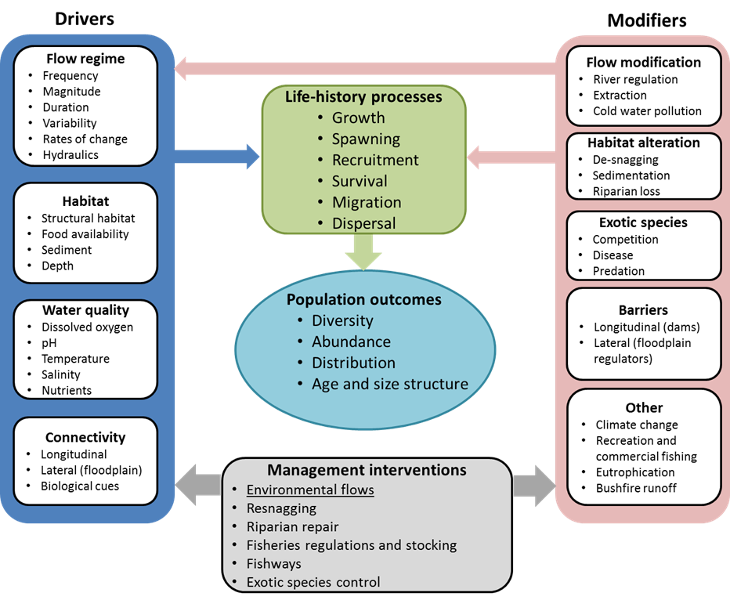

**Figure 4: Conceptual representation of how river flows and other modifiers link to fish life-history processes and population demography.**

Recruitment, defined as the number of new fish entering a population, is often measured to a point in the life cycle, such as, to young-of-the-year, juvenile and adult (sexually mature) life-stages (Wootton 1998; King *et al*. 2013). Ultimately, the rate of survival and subsequent recruitment to the mature population will determine long-term inter-generational population trends. High variation in survival and recruitment (in space and time) is a common characteristic of riverine fish populations, most likely due to the dynamic nature of the abiotic selective forces that act on lotic ecosystems (Biggs *et al*. 2005; Tonkin *et al*. 2017a).

Stream flow, in particular, is a major driver of lotic ecosystems. Hydrological characteristics can influence life history processes governing recruitment both directly (e.g. spawning and movement cues) and indirectly through the alteration of physical habitat attributes linked to survival. Specific mechanisms driving the latter include the well documented “flood pulse advantage” (Bayley 1991), whereby appropriately timed high flow events provide food rich floodplain habitats (and therefore increased survival) for many fish species occupying floodplain rivers. Conversely, excessive short-term variations in water levels during the spawning season, can adversely affect recruitment, including nest selection/abandonment and egg/larval mortality (e.g. Milner *et al*. 2003).

With many of the large-bodied Murray-Darling fish species are classified as ‘flow generalists’ in terms of their reproductive strategy, the major influence of river flow in governing population trajectories is likely to be around its role in governing survival, particularly at early life stages (eggs to juveniles). This has recently been demonstrated for Macquarie perch (*Macquaria australasica*) (Tonkin *et al*. 2017c) and more recently, Murray cod (Sharpe and Stuart 2015). Native large-bodied fish have considerable conservation, recreation and cultural value across northern Victoria. Encouragingly, positive population outcomes for this taxonomic group, including survival and recruitment, can be achieved under all planning scenarios, from drought conditions to wet conditions (as reflected in annual VEWH Seasonal Watering Plans 2016, 2017). In view of this, monitoring responses in survival and recruitment of large-bodied native fish to environmental water delivery has been identified as a high priority to enable managers and policy makers to demonstrate the ecological value of environmental water, and to develop appropriate delivery strategies through an adaptive management framework.

### Study design

The study design uses measures of fish population demographics (e.g. year-class strength) to generate annual trends in survival and recruitment, to correlate with attributes of flow (hydrology and hydraulics) as well as important modifiers (e.g. structural habitat values). Given the uncertainty surrounding many of the links between fish survival and recruitment and attributes of the flow regime, the study design uses a predominantly long-term monitoring approach that involves end-of-season (March to May) surveys to assess annual changes in demographics (abundance, size and age structure, and distribution) of long-lived native fish species. Due to the number of study rivers and years of existing population data, it will be possible to test many of the conceptual links between survival, recruitment and flow attributes, including base flows, flow variability and floodplain inundation (see DELWP 2017 *VEFMAP Stage 6 Part A,* Appendix 3). [Note: We anticipate a preliminary assessment of the data may provide direction for further targeted monitoring of specific flow events (e.g. providing winter baseflows to enhance survival) later in the program.]

The collection of end-of-season data will make it possible to build on the long-term condition monitoring data set of VEFMAP Stage 3, to assess trends in target fish populations over time (i.e. for Murray cod, golden perch, silver perch). Data from KEQs 3 and 4 will also meet Victoria’s monitoring and reporting obligations under the Commonwealth Murray-Darling Basin Plan, particularly for reporting against Schedule 12, Matter 8 of the Basin Plan (the achievement of environmental outcomes at an asset scale). The information will also contribute to the analysis of KEQ 3, to examine how patterns in age structure, abundance and distribution, particularly for species such as golden perch and silver perch, are linked to the migratory patterns observed through event-based monitoring.

### Survey locations

Long term population demography data collected from six northern Victorian Rivers will be used to investigate KEQ 4. Specific rivers and reaches monitored each year will most likely include the following systems:

1. Loddon River (Reach 4 and 5) / Pyramid Creek
2. Campaspe River: (Reach 2, 3 and 4)
3. Murray River: Barmah to Yarrawonga
4. Ovens River: Reach 5 (D/S Wangaratta)
5. Goulburn River: Reach 4 and 5)
6. Broken River (Reach 3)

Note: Monitoring of fish population demographics is currently being implemented or underway across a number of Victorian rivers as part of several long-term monitoring programs. Whilst negotiations are in place to use any relevant data (and capture additional information) from these programs for the final analysis of VEFMAP, there is not sufficient overlap with priority rivers subject to environmental watering to meet all of the data requirements of this KEQ. Therefore, selection of specific sites and target reaches will be finalised following consultation with waterway managers, site visits, and the identification and availability of complementary in-kind data from related programs (e.g. LTIM, TLM, Native Fish Report Card and previous VEFMAP data).

All rivers included in the study have environmental water delivery plans and fish objectives relevant to KEQ 4 (see 2016/17 & 2017/18 Seasonal Watering Plan, VEWH 2016, 2017).

### Sampling methods

A number of sampling approaches will be used to answer KEQ 4, including:

* electrofishing surveys
* fin clips
* otolith sampling
* hydraulic modeling and
* habitat mapping.

Indicators that will be monitored (or generated) to address KEQ 4 will include those related to:

* hydrology and hydrodynamics (i.e. daily flow time series, rates of rise and fall, water velocity, wetted habitat area)
* fish size (length and weight)
* fish age (and year class strength)
* fish abundance
* fish survival
* fish biomass
* fish condition (morphometric) and
* fish distribution.

#### **Fish surveys (electrofishing)**

For each of the targeted rivers (and reaches) there will be a continuation of the annual, boat based (and some backpack/bank mounted) electrofishing method used for VEFMAP Stage 3 (as well as other long-term monitoring programs including the Commonwealth LTIM program, and the MDBA’s TLM program). Additional sites and effort will be applied where required to increase the sample size for specific rivers, thus enhancing the ability to generate accurate measures of population demography (see below).

**Frequency and timing of sampling**

* End of season (annual) monitoring will be conducted during low, stable river flow conditions during Feb–May each year, when young-of-year fish are present and sampling efficiency is highest.
* Monitoring will require five days of electrofishing time in each of the systems.
* Additional days may be required in some reaches that have limited site access and/or fish abundance, thus increasing information gathered on population structure

**Fish sampling technique**

* Electrofishing will be conducted at each site using either boat-mounted (Smith-Root® Model 5 or 7.5GPP), bank-mounted (Smith-Root 7.5 Kva) or backpack (Smith-Root® Model 20b) electrofishing, with the method being dependent on depth, water conductivity and access (all of which influence the efficiency of capturing fish).
* Sites from previous VEFMAP stages will be sampled using established techniques (see Sustainable Rivers Audit protocols, MDBC 2004). Additional sites and effort will be applied where required to increase the sample size for specific rivers, thus enhancing the ability to generate accurate measures of population demography (see below).
* At each site, the total time during which electrical current is applied to the water will be recorded and used to determine CPUE to standardise results (Lyon *et al*. 2014). The length of river sampled at each site will be 100-200 metres.
* It should be noted that the lower Campaspe and Loddon rivers may require sampling using a Hans Grassl GmbH (www.hans-grassl.com) unit (with a 13 kVA, three-phase generator) during times of elevated EC (particularly for the Wimmera and Loddon). Specific settings will not be standardised, but selected based on the environmental conditions at each site to maximise sampling efficiency.
* Measures of captured fish will include the following:
  + species
  + counts
  + individual length (nearest mm)
  + weight (nearest g)
  + fish condition (as per SRA methodology, Davies *et al*. 2012) and
  + site-specific details of effort (electrofishing method (boat/backpack), seconds and geo-located site start and finish positions).

**Sampling effort**

* 10–15 sites are to be monitored in each of the study rivers.
* Up to 200 captured fish will also be PIT tagged every year (thus enabling quantified estimates of angler mortality and mark / recapture data).

For some reaches, it is acknowledged that site access and low fish abundance will limit the number of sites and/or fish that are detected (e.g. opportunities for complete “SRA” type surveys are limited in many areas of the Campaspe River due to difficulty of access, as well as lack of connectivity that limits where fish reside). Because of this, an additional week of sampling will be allocated for this region to specifically target priority species and increase information gathered on population structure.

The extended survey at the smaller sites along the Campaspe River will provide important information on annual measures of population structure and distribution, as long as electrofishing effort (seconds and geolocations) is recorded along with catch data.

#### **Otolith sampling**

Otolith collection will be used to assess age demographics of long-lived species (Murray cod, golden perch and silver perch (if samples are available)). This data will be accumulated with existing samples to generate system specific Age-Length Keys to use with past length-frequency data (thus generating estimates of age where appropriate).

Otolith samples will also be used for a current natal origin project (generating a secondary assessment of reach-scale migrations and its influence on population demographics: see KEQ 3) and future assessment of growth chronologies (e.g. Tonkin *et al*. 2017a).

**Frequency, timing and method of sampling**

* Fish will be collected for otolith sampling during the targeted fish surveys described for KEQ 3 (summer/autumn 2016/17 to 2018/19).

**Otolith sampling technique**

* Otolith preparation to determine year class strength and interpretation will follow that outlined in Anderson *et al.* (1992). Briefly, thin transverse sections of either the left or right sagittal otolith from each fish will be mounted on a glass slide and examined under a stereo microscope with transmitted light, independently labelled and photographed at x20 magnification. Counts of annuli, defined as a pair of translucent and opaque zones, will be determined by staff with extensive experience in otolith preparation and interpretation, as has previously been conducted for each of the study species (Anderson *et al*. 1992, Lyon *et al*. 2014).

**Sampling effort**

* For each of the three species, up to 50 fish per river will be collected and euthanised for otolith collection and analysis.
* Sampling effort will be spread over a large number of sites in each river, and only 3-4 fish will be retained per site.
* Existing otolith collections from previous study years will also be sourced to include in the final analysis.

#### **Hydraulic modelling and habitat mapping**

Key flow-related habitat features conceptually linked to fish survival and recruitment success include:

* total wetted area
* wetted area of appropriate depth (and associated water quality) and structural habitat (e.g. large wood) and
* water depth and velocity change.

These features were measured as part of previous VEFMAP investigations using 1D HECRAS models that were prepared for a number of river reaches based on:

* cross sectional surveys
* on-situ stage loggers and
* water surface profiles.

Where possible, existing VEFMAP HECRAS models will be used. For river reaches without existing HECRAS models, or where hydraulic data derived from the existing models are absent or deemed inappropriate (e.g. due to temporal/geomorphic alteration), new HECRAS models and habitat mapping will be undertaken, as described below.

* **Conduct 10 cross-section surveys along a 1 km river reach**
  + Cross-sections every 100 m.
  + Acoustic Doppler Current Profiler (ADCP) survey with Real Time Kinematic (RTK) to survey wet channel.
  + Differential GPS (DGPS) survey of water level on bank and installation of a star picket on the floodplain 100 m from bank top position.
  + Total station survey from water level on bank to floodplain star picket on both sides of river (note – DGPS unlikely to provide sufficient accuracy for cross-section under riparian canopy).
  + Equipment: ADCP, DGPS, total station, kayak, star pickets, 100 m tape.
* **Install stage loggers top and bottom of each reach**
  + Install ‘In-situ rugged Troll 100’ non-vented pressure loggers and barometric logger for each reach: two pressure loggers and one barometric logger.
  + Install loggers in a suitable location (near bank but with at least 0.5 m water depth at low flows) using a vertical PVC pipe to house the logger. The lower pipe end will be placed on a besser (concrete) block secured by 2 m long star pickets and the PVC pipe will be wired to the star pickets to provide a secure installation. A float will be attached to the upper end of the PVC pipe to allow it to be located at high water levels.
* **Survey water surface profiles at two discharges**
  + Survey late summer (low flow) and spring (high flow) events to measure upstream and downstream discharges at each river reach using ADCP with RTK capacity to measure discharge and velocity profile. DGPS will also be used at the upstream and downstream cross-section sites to check water surface longitudinal profiles, as the RTK capacity of the ADCP may not extend over the 1 km reach.
  + The data required for this component will be collected during the installation of loggers but will require a return visit to measure water surface profile at a higher or lower discharge.
* **Build the HECRAS models**
  + The information collected in the previous steps will be used to compile HECRAS models for each site.

### Evaluation and statistical analysis

The data collected on population demographics will be used for two purposes. First, the data collected on age structure and distribution will provide information on population level outcomes in response to the specific population processes being monitored. For example, KEQ 3 is monitoring movement responses of native fish into and throughout northern Victorian tributaries. As was demonstrated in 2016/17, annual measures of fish distribution and population structure will complement this targeted intervention monitoring by allowing an assessment of whether the fish movement leads to changes in population demographics (Tonkin *et al.* 2017b).

Second, due to the broad nature of KEQ 4 (relating to survival, recruitment, distribution and abundance of long-lived fish species), long-term data collected across multiple rivers will be used to analyse trends in year class strength, distribution and abundance in relation to hydrological and hydraulic covariates. Identifying links between these population processes and attributes of river flow will help guide future environmental water delivery.

Analytical approaches for specific components of the project may include (but are not limited to):

* Recruitment and year-class strength – catch curve regression to generate year class strength combined with general linear models (GLMs) or general additive models (GAMs) in relation to different hydraulic measures.
* Population trends, accounting for multiple processes and modifiers – population models and Bayesian hierarchical models have been used previously; a Bayesian approach is particularly relevant to these analyses given the data type and the prior information already collected.

Data collected on age structure and distribution will also provide information on population-level outcomes in response to the specific population processes being monitored in KEQ 3 (movement responses of native fish into and throughout northern Victorian tributaries). Annual measures of fish distribution and structure will complement this targeted intervention monitoring by assessing whether the movement results lead to changes in population demographics (particularly distribution, age-structure and abundance).

All analyses will incorporate specific hydraulic drivers (e.g. wetted area, water velocity) to facilitate the transferability of outcomes to other similar watering sites across the State. The data collected will also present opportunities to explore the usefulness of other measures relating to fish population health (growth, recruitment and survival). These include:

* genomic assessments;
* growth and condition indices (using otolith sclerochronology as well as length–weight condition indices); and
* population trajectories of other species (e.g. small bodied native fish species).

[Note: Otolith samples will also be used for an in-kind project (EWKR) determining natal origin and reach-scale movement of golden perch across the Murray-Darling Basin, as well as for several collaborative student projects examining growth responses to environmental covariates (particularly flows). Samples will allow future investigation of stocking outcomes (and therefore natural recruitment; funding dependent).]

### Reporting

Timely communication of key findings and photos/videos will be delivered to relevant CMAs and stakeholders in conjunction with each field sampling trip.

Important outputs will include annual activity reports for each of the first two years of the program. This reporting will provide stakeholders with key information on the project, and will provide regionally-specific results for CMAs and the VEWH that are both timely and consistent with the messaging of the VEFMAP program as a whole. Presentations and updates will be given at events such as EWRO meetings, to facilitate sharing of collected information.

A final report will be provided at the completion of the final year of the project, which will incorporate in-depth analyses that provide clear outputs relevant to the overarching question relating environmental water delivery to fish survival, recruitment and population. Results will be analysed (and presented) in such a way that outcomes are as transferable as possible to systems of similar hydrology and/or species composition across the region.

### Key partnerships and in-kind contributions

The program will involve a strong partnership between the DELWP Environmental Water team, ARI, VEWH, University of Melbourne, northern Victorian CMAs, SARDI, NSW DPI, LaTrobe University, the MDBA and the Commonwealth Environmental Water Office. For example:

* As mentioned, it is envisaged that the otoliths collected in this project will be used for the complementary project funded as part of the EWKR program, which is using otolith microchemistry to determine natal origin and reach-scale transitions of golden perch between the Murray River and tributaries of the southern MDB.
* A post graduate project (Katherine Harrison) has been established (collaboration between ARI and LaTrobe University). VEFMAP Stage 6 will assist this work by obtaining material (e.g. fin clips) for genetic analysis from all individual large-bodied fish species collected during sampling. This information will contribute to assessments that explore:
  + at what spatial scale population processes (recruitment, movement) operate for different fish species;
  + the implications of environmental flows for fish abundance/biomass;
  + the implications of environmental flows for fish movement; and
  + where and how best to target environmental flows to maximise outcomes for fish.
* A three-year research fellowship (Jian Yen) has been established (University of Melbourne) to develop a size-based framework that relates the growth of individual organisms to processes in ecological populations, communities, and ecosystems. Specific aims include:
  + analyse growth curves to identify common growth trajectories and to determine whether environmental factors influence growth;
  + develop size-based demographic models to predict size structure from environmental variables to determine whether or how environmental factors influence population dynamics;
  + combine multiple size-based population models to predict the size structure of entire ecological communities; and
  + predict core components of ecosystem function (e.g. productivity) from community size structure using metabolic theories to characterise hypothesised links between ecosystem function and individual sizes, and test the existence of these links with long-term ecological data sets (e.g. the VEFMAP monitoring data).

Substantial in-kind contributions are available from existing projects (subject to intellectual property and data custodian arrangements). These include:

* use of existing infrastructure such as traps and gantries installed in the Murray River, Goulburn River and elsewhere as part of Commonwealth LTIM project and the MDBA Dispersal and Flow Cues and Lamprey Spawning Migrations projects (in-kind contribution for 2016/17 only);
* functioning PIT antennas on Murray River fishways;
* MDBA cash contribution to the project for tagging and monitoring of fish; and
* data and information from existing monitoring programs such as EWKR, Commonwealth LTIM, MDBA TLM program, and the Victorian Fisheries report card program.

# **Aquatic and River Bank Vegetation Theme**

# **Monitoring vegetation responses to environmental flow delivery in Victoria**

VEFMAP Stage 6 vegetation objectives are aimed at measuring vegetation responses to environmental flows. The key difference between the proposed Stage 6 approach and work conducted for VEFMAP stages 1-5, is the focus on individual flow events in individual waterways to target the detection of short-term responses.

The timing of flow delivery can have large impacts on how it influences vegetation. Appropriately timed environmental watering can have benefits for aquatic and river bank vegetation, such as improved growth and reproduction, increased stimulation of germination, increased distribution of propagules and improved water quality. Assessment of environmental flow outcomes at different times of the year and for different objectives will allow us to evaluate the relative impacts of flows delivered in each season.

## Objectives

The broad objective for vegetation monitoring in VEFMAP Stage 6 is to:

* evaluate the effectiveness of implementing flow delivery plans (i.e. EWMPs, SWPs) in achieving vegetation objectives over the three-year sampling time frame.

Supplementary objectives include:

* Identify if vegetation responses to flow management vary within or among rivers or regions.
* Assess if vegetation responses to flow management are dependent on or enhanced by complementary management intervention (e.g. livestock exclusion).

## Key Evaluation Questions

Based on these objectives, the vegetation KEQs to be monitored in VEFMAP Stage 6 are as follows. These KEQs have been updated since the beginning of VEFMAP Stage 6 to more clearly express each question and ensure that the wording includes the focal components.

|  |  |
| --- | --- |
| **KEQ 1** | How does environmental flow discharge influence the spatial distribution, foliage cover and species diversity of in-stream semi-emergent and submerged vegetation at a sub-reach scale? |
| **KEQ 2** | How does environmental flow discharge influence the spatial distribution, foliage cover and species diversity of fringing emergent vegetation at a sub-reach scale? |
| **KEQ 3** | How does environmental flow discharge influence the spatial distribution, foliage cover and species diversity of fringing herbaceous vegetation at a sub-reach scale? |
| **KEQ 4** | How does environmental flow discharge influence the recruitment and establishment of fringing emergent, herbaceous, and woody vegetation at a sub-reach scale? |
| **KEQ 5** | How are vegetation responses to environmental flow discharge influenced by additional factors such as grazing, rainfall, soil properties, and season? |

Vegetation KEQs are focused around two broad questions relating responses of riverine vegetation to environmental flows:

* How does existing vegetation change as a result of flows?
* Do flows help create new vegetation populations?

A combination of both broad-scale and fine-scale monitoring approaches will be used to evaluate the KEQs listed above. In order to evaluate these questions fully, a series of subsidiary questions must also be answered:

* What are the impacts of flow variables (salinity/inundation) on vegetation? What are the survival thresholds for plants under inundation extremes (high or low)?
* Does grazing impact vegetation responses?
* How is soil-moisture influenced by flows?

The extent to which the questions listed above are addressed will depend on other program linkages and will be heavily dependent on the resources available.

The design and evaluation of KEQs for Stage 6 vegetation monitoring are based on specific vegetation responses to flows and flow regimes (Table 1). Most vegetation responses will be relevant to multiple KEQs. Some of these responses have been previously demonstrated and are well understood, while others are still poorly understood in Victoria. Vegetation monitoring for Stage 6 will aim to quantify the vegetation responses that are thought to be most important for environmental flow management, and to fill existing knowledge gaps. A summary of the key vegetation responses being monitored in the Stage 6 surveys are listed below (Table 1).

Table 1: The key vegetation responses associated with the five KEQs for vegetation and the monitoring approaches that will be used to observe and understand them.

|  |  |  |
| --- | --- | --- |
| **KEQs** | **Response** | **Monitoring approach** |
| 1-5 | Wetting can support the growth and reproduction of in-stream and fringing vegetation within the channel, and it is likely that the increased soil moisture provides benefits to deep rooted woody vegetation well outside the channel.  In the short term, inundation of understorey plants can have damaging effects to leaves/shoots, but if applied effectively, the benefits to these plants will far exceed the negative ones. | Broad-scale mapping data will inform large changes in species composition and distribution, while fine-scale transect surveys will record the magnitude of changes in foliage cover at a species level in relation to seasonal and hydrological changes (including inundation and soil moisture availability).  Soil moisture probes and student research projects into soil traits will help to inform the hydrology changes imposed upon plants during and between flow events. |
| 1-4 | The potentially damaging effects of inundation can be used very effectively to favour the more tolerant littoral species (fringing and in-stream) while limiting the encroachment of terrestrial species (particularly exotics) into the channel. This may help to increase the resilience of the channel vegetation to flooding and intermittent drought disturbance by favouring species that are specifically adapted to rapid recovery from flow disturbances. | Broad and fine-scale vegetation data on abundance, composition and richness will be used to inform changes towards (or away from) inundation tolerant species, and the subsequent vegetation response trajectories after inundation.  Longer-term and targeted evaluation of vegetation data may be required to fully evaluate the resilience of a channel ecosystem, but the data collected in Stage 6 will provide a starting point for this. |
| 1-5 | Flow events transport propagules (seeds and shoots) throughout the system, maintaining genetic diversity, species diversity, and colonisation of unoccupied areas. | Monitored through recruitment surveys in-situ as well as proposed ex-situ experiments. |
| 5 | Wetting events can stimulate germination of soil seedbanks as well as newly transported propagules. | Monitored by comparing recruitment data to vegetation cover data – transects and mapping – to show if species are recruiting without adults present, as well as proposed soil seedbank trials. |
| 5 | Livestock grazing will reduce the cover and reproductive capacity of plants depending on the extent and timing of grazing. Grazed sites may therefore show no vegetation response to flow management. | Grazing exclosures set up in all sites with current livestock grazing (two exclosures per site). These will inform the impact of livestock grazing on vegetation at the sites and the change in vegetation response to flows when it is grazed. |

The monitoring design includes event-based assessment to isolate the influence of environmental flow management from other factors that might affect aquatic and river bank vegetation populations and communities.

Proposed monitoring methods for the vegetation theme are broadly relevant to all five of the KEQs and will provide multiple lines of evidence for KEQ evaluation. Therefore, for the remainder of this section methods are outlined together, rather than separately for each KEQ (as for the fish theme).

## Survey locations

In 2016/17, the vegetation surveys were focused on a single river (Campaspe River, North Central CMA). This allowed us to field test the methods more carefully and refine the approach prior to expanding the survey methods across multiple river systems. In 2017/18, the surveys will be expanded across multiple river systems, including re-surveys of the Campaspe River sites so that we have a longer-term dataset for this waterway.

The following rivers have been selected for survey in 2017/18:

* Campaspe River
* Loddon River, Tullaroop Creek, 12 Mile Creek
* Wimmera tributaries: Mackenzie River, Burnt Creek, Mt William Creek
* Moorabool River, Sutherland Creek.

It is crucial for this program to demonstrate the value of environmental flows as soon as possible. To achieve this, we need to collect data for short-term responses in the places where we expect to see larger vegetation responses to flows, and look across previous data to evaluate longer-term changes. Surveys in low-rainfall areas are likely to show stronger short-term responses to flows. Surveys on sites with previous VEFMAP studies help to build a longer-term dataset. Rivers with 'control' reaches (e.g. 12 Mile Creek - Loddon, different Wimmera River tributaries, and Sutherland Creek - Moorabool), offer an ideal opportunity to get clearer data to demonstrate the effect of environmental flows. The rivers selected for monitoring meet these objectives and give VEFMAP the best opportunity to demonstrate outcomes in Stage 6. The number of sites varies for each waterway and some are entirely new survey sites while others are resurveys of previous VEFMAP locations.

## Methods

Methods proposed to evaluate the vegetation KEQs for VEFMAP Stage 6 include:

* broad-scale mapping surveys (measuring spatial distribution patterns and broader-scale change);
* fine-scale (targeted) transect and quadrat surveys (measuring short-term vegetation change);
* assessment of tree canopy cover photographs; and
* establishment and assessment of photo-point sites (visual tracking of vegetation).

These will be complemented by the analysis of hydrological data (surface and groundwater) and hydraulic modelling undertaken as part of the vegetation theme as well as the native fish theme - KEQ 4.

Indicators to be monitored will include those related to:

* percentage foliage cover (abundance) and species density of in-stream semi-emergent/submerged, fringing emergent and fringing herbaceous vegetation along river reaches;
* spatial extent, species composition and distribution of species in existing stands of in-stream semi-emergent/submerged, fringing emergent and fringing herbaceous vegetation;
* canopy cover and stem density of trees and percentage foliage cover of woody shrubs along river reaches; and
* density of all vegetation recruits along river reaches (understorey, trees and shrubs).

A series of supplementary tasks will be used to evaluate KEQ 5 and target specific parts of KEQs1-4, complementing the survey methods listed above. These supplementary tasks include:

* experiments to evaluate the effectiveness of grazing exclosures;
* installation of soil moisture probes;
* hydrological experiments (e.g. depth and duration of inundation);
* salinity trials; and
* literature reviews on experimental focus points.

Monitoring will be conducted three times within each water year (broadly spring, summer and autumn) and will occur both before and after the following treatments/events:

* a natural or environmental flow event (e.g. fresh or high-flow);
* a series of events close together; or
* the absence of an event, in some cases.

The minimum duration between the event and the resurvey should be eight weeks, to allow time for vegetation to respond and germinants to emerge. The exact interval will need to be flexible and will be adjusted to accommodate the particular flow regime of the survey period and to maximise the potential of detecting any vegetation responses at this scale.

#### **Broad-scale mapping surveys**

Broad-scale mapping will be conducted along river sections of up to 1-km length in each waterway; monitoring will include both river banks where possible. Monitoring will occur at all locations to be established along each target waterway. Mapping surveys will be conducted during the first (winter/spring) and third (autumn) surveys of each water year.

The methods to be deployed at each location were refined following an assessment of costs and capabilities during the 2016/17 pilot study (s1.6). On-ground surveys mapped onto aerial images proved to be the most beneficial, due to the ability to see below tree canopies and identify plants accurately to species. For each waterway, aerial images will be sourced via existing spatial data resources or new Unmanned Aerial Vehicle (UAV) images, depending on availability.

**On-ground broad-scale surveys**

On-ground surveys will be used to map the distribution of understory vegetation (species and/or communities) along the banks of the study rivers. Mapping will be area-based (e.g. quadrats or polygons).

Vegetation data collected during surveys will include polygon data for patches of individuals and point-location data for one or a few individuals. All riparian (fringing, emergent and in-stream) species and specific high-threat terrestrial weeds will be mapped at the individual species level (i.e. a data layer will be created for each species, made up of a series of points and/or polygons). Should two or more species occupy the same space, each species will be recorded for that patch.

Where patches are very small or an individual plant is observed, a point marker will be recorded rather than a patch (Figure 5). It is impractical to mark every individual plant where there are small gaps between them, or where many juvenile plants occur, so in these cases a patch will be drawn around the collection of individuals.

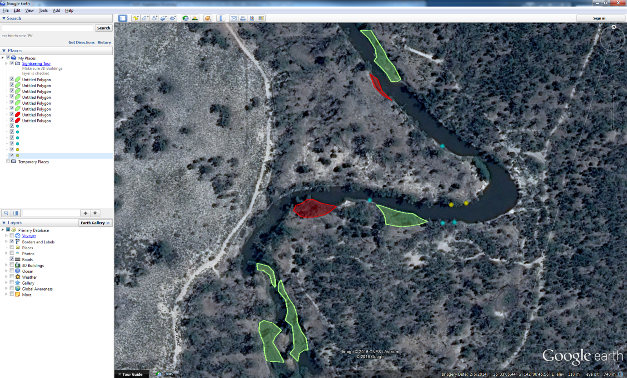

Figure 5: A hypothetical example of mapped patches of vegetation types along the Wimmera River. Different colours indicate different vegetation types or species. Some patches may be mapped as polygons (red/green), while very small patches or individual plants mapped as point locations (blue/yellow).

#### **Fine-scale transect and quadrat surveys**

Fine-scale monitoring will be undertaken during all three surveys in each water year to measure the expansion/contraction of existing plants or groups of plants, as well as the recruitment of new individuals. The methods used are based on the method currently used in the Commonwealth LTIM surveys (UoM 2016), with some changes to the data collection and the location of transects within a site. A detailed description of the methods is provided below.

Data are collected along transects (and sub-transects) as well as within quadrats.

**Location of transects**

Transect location is extremely important for the evaluation of change in aquatic and river bank vegetation. As VEFMAP Stage 6 monitoring will be used to assess the expansion/contraction of existing plants/groups of plants, and shifts up or down the elevation profile, transects need to be placed where existing vegetation (where present) occurs within the sampled area (Figure 6). Therefore, the transects are not randomly placed, but are stratified to maximise the likelihood of capturing the variation of vegetation types and abundance present within the sample area.

Ten transects will be established at each sampling site except for systems where many sites are required to cover the sampling area (i.e. the Wimmera tributaries). In these cases, the transect number will be reduced to five transects per site. Transects will be located within areas used for broad-scale mapping surveys and overlay previous VEFMAP transects (where present), so the data can be compared at varying spatial and temporal scales.

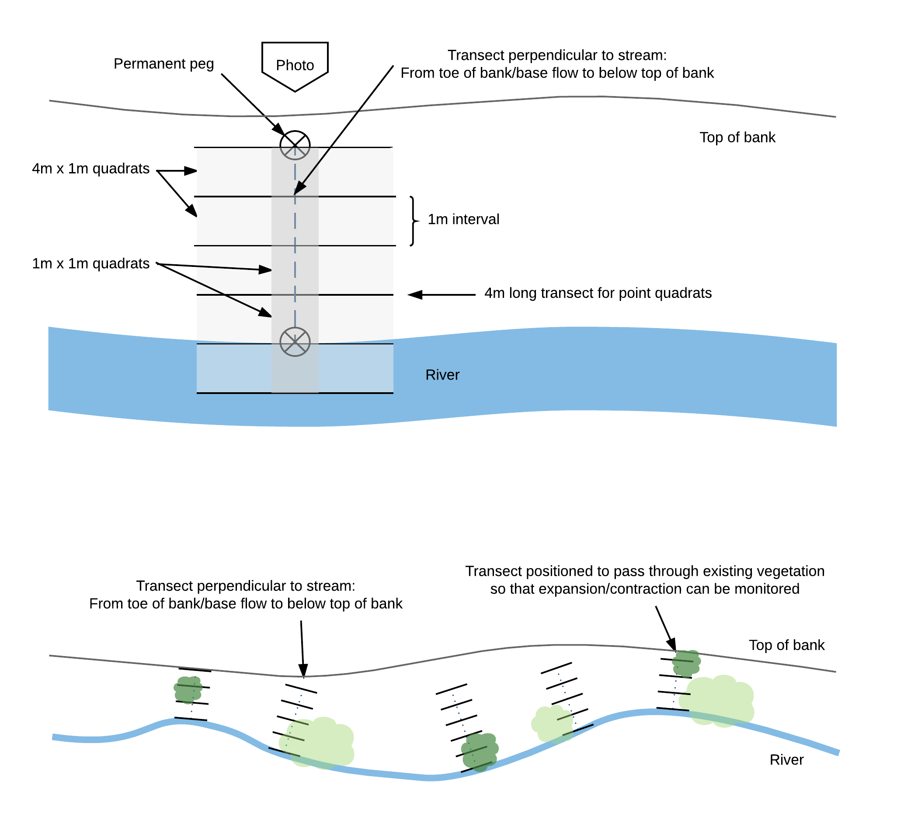

**Figure 6: Example of a targeted, fine-scale survey method for VEFMAP Stage 6.** The data do not aim to characterise a particular site, but rather record changes in existing vegetation patches and vegetation recruitment.

**Transect sampling**

At any particular sample site, a series of up to 10 transects positioned perpendicular to the stream will be permanently marked (with short wooden pegs) from the toe of bank/low flow mark to the top of bank (Figure 6). A series of sub-transects and quadrats will be sampled along each transect to collect vegetation data. Canopy cover will be sampled via photos taken at each end of the transect (i.e. the permanent peg markers). A photo-point will also be taken from the top of the bank, looking down the transect line.

Logistics include:

* Use a tape measure to mark out the distance from the peg on the low flow/toe of bank to the top of bank.
* Use a tape measure or 2 m long narrow pole with 10 cm intervals marked on it for the point transects; the pole can be repositioned from one side of the tape to the other to cover the full 4 m transect.
* Use an additional 2 m long narrow pole for point intercepts.

**Point intercept data along 4m long sub-transects**

Sub-transects will be spaced at 1 m intervals (starting at 0 m elevation above the water line). parallel to the direction of stream flow. Point-quadrat sampling at 10 cm intervals along each of the 4 m transects (total 40 points per transect) will then be used to measure ground-layer cover (bare ground, litter, etc.), understorey (<1 m) and mid-storey vegetation cover (1 to 5 m). At each point quadrat along the 4 m transects, the following data will be collected at 10 cm intervals:

* Ground layer (must be one at every point, can’t have multiple at a point)
  + litter, bare ground, bryophyte/lichen, rock, log, plant.
* Understorey vegetation up to 1 m tall (can have multiple at a point, or none)
  + species;
  + whether the species is native or exotic.
* Mid-storey vegetation 1 m to 5 m tall (can have multiple at a point, or none)
  + species;
  + whether the species is native or exotic.

**Quadrat areas between sub-transects**

Quadrat spaces between sub-transects will be sampled for seedling and tree counts. A 4 x 1 m quadrat is located between successive 4 m long point transects (Figure 6). A 1 x 1 m quadrat lies at the centre of this quadrat, overlaying the central tape laying up the bank. These quadrats will be used to detect/quantify plant recruitment, woody plant density and species richness. Within each of the central 1 x 1 m quadrats a count of all seedlings (identified by species or genus and native/exotic, where possible) will be compiled. For the purpose of this program, the definition of a seedling is a plant that appears to have germinated since the most recent winter, or since the previous survey (Figure 6). For dicots, this will typically mean the cotyledons are still present on the stem. For monocots, this includes plants less than 3 cm tall. For all plants, this excludes mature plants that have been grazed close to the ground.

In addition to the counts of seedlings, it is important to know the abundance of woody stems that occur within each 4 x 1 m quadrat, as that may influence the likelihood of recruitment success. The cover and presence of understorey vegetation will also influence recruitment, but these will be measured from the point transect data. Counts of woody plants with trunks within each quadrat will be counted and for trees, their DBH will be recorded (if they are <1.3 m tall then indicate DBH = 0 for these individuals and they will be recorded as juveniles).

In the aquatic quadrat below the lowest peg, the same information will be recorded. If the water level has receded then terrestrial or fringing species may germinate in this quadrat, whereas if water levels rise, this quadrat may only include aquatic species.

**Canopy cover photos**

Canopy cover photos will be taken during the first and third fine-scale surveys for each waterway in each water year. Canopy cover is extremely difficult to accurately estimate or measure. A balance between time taken to measure cover and the accuracy of the data can be obtained by taking canopy photos and processing them in the office. This reduces subjective sampling biases and it takes little time to collect the data. There are relatively efficient methods available to post-process the images en-masse. Point sampling of canopy with the aid of a visual scope is also less subjective than visual estimates, but is extremely time intensive.

The two most common types of canopy photos are hemispherical photos, or simple digital photos taken of the canopy at a consistent elevation from the ground. Hemispherical photos collect light data from a much wider area of the sky with the aim of determining the amount of potential light access to that point from many angles. A canopy photo taken with a generic digital camera with relatively narrow field of view gives an indication of foliage projective cover. This is comparable to someone standing below the canopy and looking directly up to estimate cover, but less subjective (Figure 7). For the purposes of this assessment, it is more appropriate to measure foliage projective canopy cover, so that it remains compatible with other survey data.

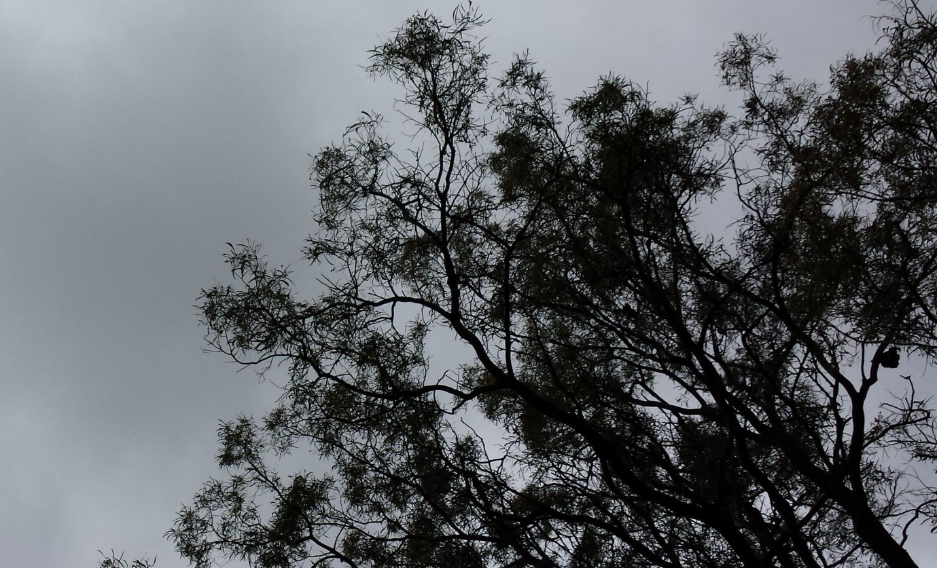

Figure 7: Example of a canopy cover photo from standard digital camera. Image can be post-processed to measure foliage projective cover (excluding major branches).

To take the canopy photo, the assessor must hold the camera at a consistent height (1.6 m from the ground) above each end of the transect. It is best to take the photo from a tripod with potential to correct the slope, to ensure the picture is level with the ground. If the view of the camera is impeded by shrub or juvenile tree cover, then the position can be moved slightly along the transect so that there is a clear view of the canopy.

Processing of the data should determine the foliage projective cover, excluding the cover of branches. It is crucial that the canopy photos are labelled and recorded appropriately so the data can be attributed correctly.

**Transect photo-point photo**

A photo should be taken standing at the permanent marker at the top of the bank looking down the transect towards the lower permanent marker. Where possible, previous photos should be referred to so there is consistency between images through time. It is crucial that the images are labelled and recorded appropriately so the data can be attributed correctly.

#### **Hydrology data**

The primary data for hydrological surveys will be the flow height (i.e. elevation up the bank) and the duration of that height change. This information will be used to evaluate vegetation responses to flows at different locations up the bank gradient, and to compare positions that did or didn’t get inundated, how deeply they were inundated and for how long. Hydrology data will be collected by staff from the University of Melbourne. Where channel form data already exist from previous surveys and flow data are recorded, elevations can be calculated using HECRAS models. Where this information is absent or insufficient, in-stream data loggers will be installed to record flows. The data collected will be used to calibrate existing HECRAS models for the river, to calculate flow elevation data at each transect sampling unit. These in-stream surveys are relatively simple and will require installation of stage loggers to record depth and duration of flows at each of the monitoring locations along a river during the flow event.

At each location, a vertical PVC pipe to house the logger will be installed in a suitable location (near bank but with at least 0.5 m water depth at low flows). The lower pipe end will be placed on a besser (concrete) block secured by 3 x 2 m long star pickets and the PVC pipe will be wired to the star pickets to provide a secure installation. A float will be attached to the upper end of the PVC pipe to allow it to be located at high water levels.

The data collected will translate directly to the elevation data collected at each transect sampling unit and provide information on the depth and duration of each elevation during the flow.

#### **Photo -points**

Photo-points are simple to set up, quick to visit, provide a good visual record of change through time, and are an effective communication device. Up to 10 photo-points will be established along each VEFMAP river and will include existing photo-points (e.g. CMA monitoring or previous surveys) plus new points where existing points are not identified. These will be permanently marked and GPS referenced. It should be noted that these are in addition to the photo-points included in the fine-detail transect sampling methods.

Photo-points will be positioned according to the following criteria – photo-points:

* should have a good viewpoint of the waterway and banks;
* must be easily accessible, but not in common recreation areas where permanent markers may be disturbed;
* should cover a range of vegetation types and conditions; and
* may be located in existing photo-point locations for historical reference.

It is critical that photos are taken of the same location and from the same position. The simplest way to achieve this is to use two permanent pegs, spaced approximately 6 m apart, where the photo is taken standing at one peg with the other peg in the centre of the photo view. The images must also be labelled and recorded appropriately so the data can be attributed correctly; it can be useful to position a board in the centre of the image (against the photo peg) with the site name and date.

#### **GPS data-point collection**

Point data locations for sub-transects will be collected using a Trimble Geo 7X (Centimetre Kit with Terra Sync and GPS Pathfinder Office software).

## Filling important knowledge gaps

The fine-scale and broad-scale monitoring methods outlined above will provide the core information required to answer KEQs 1-4. However, as noted in s3.2, there is a series of additional questions that are critical to forming a holistic understanding of vegetation responses to environmental watering. Specifically, these questions relate to grazing, soil moisture and depth/duration of inundation effects.

#### **Grazing exclosures**

Do environmental flows trigger regeneration or new growth of particular species/life-forms of aquatic and river bank vegetation, and if so, how is that regeneration impacted by grazing (e.g. by rabbits, kangaroos or livestock)?

In order to answer this question properly as part of VEFMAP Stage 6, grazing exclosures will be set up at all sites exposed to grazing. Germination rates and growth changes (cover) recorded within the exclosures will be compared with those in adjacent, unfenced control areas to quantify grazing impacts. At least two 10 x 10 m exclusion plots will be established at each site, with one transect each positioned adjacent to and within each fenced area.

#### **Soil moisture sampling**

One of the primary objectives for environmental flows is to provide water to parts of the channel that are not inundated under low flows. The aim of these environmental flows is to reduce the risk of plant mortality due to drying, and to increase available resources for plant growth and reproduction.

A crucial part of understanding how the addition of environmental water may benefit the bank vegetation is knowing how the water interacts with the bank soil. Key questions to ask in relation to the delivery of environmental water include:

* How wet does the soil get compared to pre-flow levels?
* How deep does the water penetrate the soil?
* How quickly does the water penetrate the soil?
* How long does the soil retain the water after the flow?
* How do environmental conditions, bank attributes and soil types influence the questions above?

In order to address these questions, soil moisture monitoring will be undertaken at a selection of sites during Stage 6. Two soil moisture probes (90 cm long) will be deployed at two positions along the width of a river bank (see Figure 8), within at least two of the 4-6 sites monitored at each river.

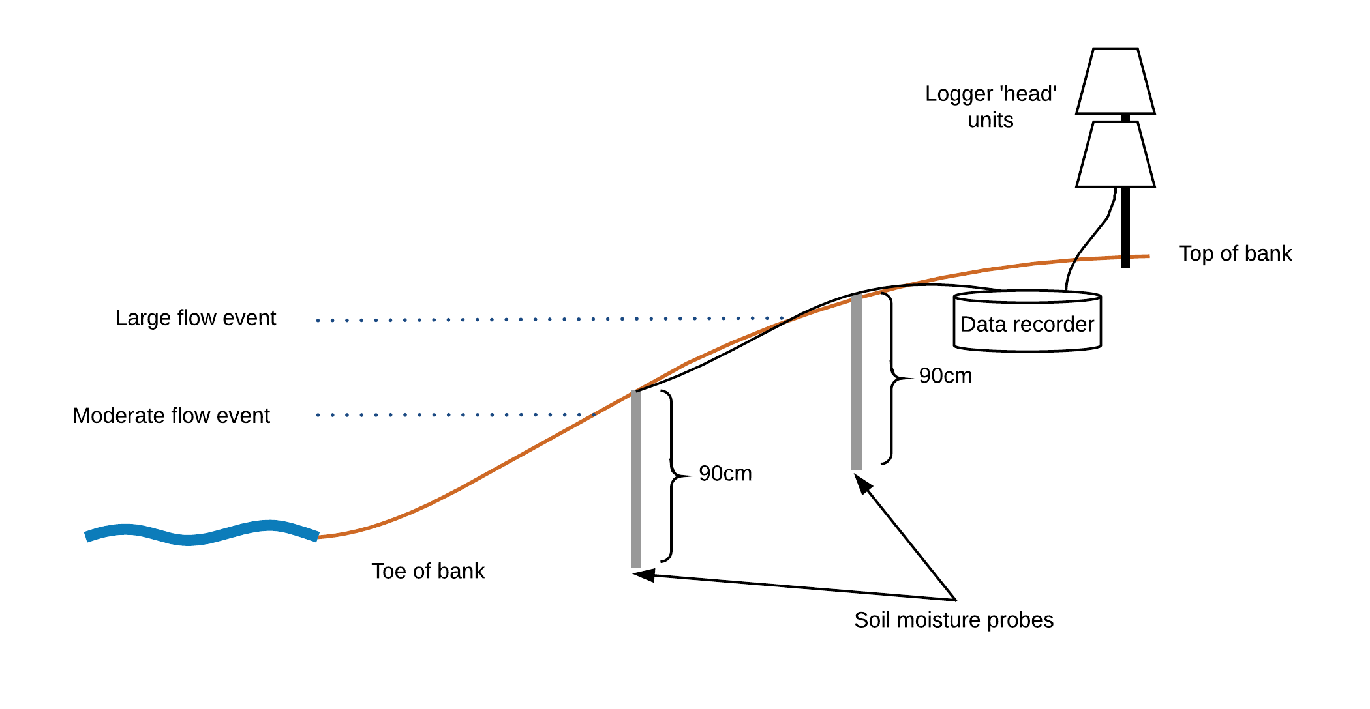

Figure 8: Schematic diagram of soil moisture probe layout for environmental flow data collection.

Soil moisture and temperature will be recorded every hour, at 10 cm intervals along each probe, from 5 to 85 cm depth. Data will be recorded using a data logger and processed using the IrriMAX10 software program.

To enable recording of pre-flow, peak-flow and post-flow soil moisture levels, probes will be positioned in the bank before a flow event and will remain in place for the duration of the flow, and for a period afterwards.

#### **Hydrology and flow variable studies: salinity and depth/duration of inundation**

Effects of salinity and depth/duration of inundation may be examined through literature reviews or experiments (or both). Either of these options would be well suited to university research collaboration or student research projects. Opportunities for collaboration and student involvement will be explored in more detail throughout 2017/18.

**Literature review** would involve the development of a report summarising the review of relevant literature.

**Experiments** would involve subjecting target vegetation species to varying levels of water salinity and depth/duration of inundation to determine survival tolerance thresholds. The experimental approach would use a controlled environment (most likely a glasshouse), allowing other variables (e.g. weather) to be controlled so that plant responses can be directly attributed to the treatments. Outcomes would help to inform the optimal timing, size and duration of flows to benefit vegetation. This work could be completed in 1-2 years, making it well suited for determining responses within the Stage 6 period.

## Approach to analysis and evaluation

Data analysis will be required for all components of the monitoring completed in Stage 6. In some cases, the analysis will be simple and include preliminary analyses that produce relevant and accessible summary statistics that can be used to communicate the findings of the monitoring to a broad audience. In other cases, more detailed analysis methods will be required. For these analyses, it is likely that a similar modelling approach to that used in Stage 5 will be adapted for Stage 6, as these models and processes have already been developed. These detailed methods will be based on a Bayesian framework using informative priors. Informative priors will be derived from existing datasets where available (e.g. previous VEFMAP cover data). Models would be hierarchical with levels for each individual transect and site for a given river. For analysis of vegetation cover, the point transect cover data will be expressed as the proportion of hits (where a plant was recorded) from the total number of points sampled (i.e. 40 points for each transect sample). These data are binomially distributed in comparison to count data for species richness or recruits along a transect or within a quadrat, which are Poisson distributed. The proportion of cover or count of richness on a transect is influenced by the depth and duration of inundation, due to the flow event at that point, as well as the location of the site along the river. Additional variables such as the presence or absence of grazing can be added where applicable. In this way, the analysis will model the influence of inundation due to flows at different elevations up the bank, before and after a flow event. Cover of different species and/or life-form groups is expected to change as a result of inundation beyond the influence of bank gradient in itself (i.e. vegetation changes from the toe to the top of the bank), but it is expected that inundation will result in a step-change along this gradient. In essence, the inundated transects on the bank will form the treatment units, while the transects not inundated will be the controls. This represents a type of pseudo BACI design that should be sufficient to evaluate the influence of flows between two sampling periods. This approach will evaluate the following types of questions relating to the Stage 6 KEQs:

* Does inundation influence the assessed vegetation variables (e.g. cover, richness, recruitment)?
* Does the depth or duration of inundation influence vegetation variables?
* Do factors such as grazing influence vegetation responses to a flow event (or series of events)?
* Do factors such as season or rainfall influence vegetation responses between rivers, seasons or years?

If preliminary results from the pilot study and initial data analysis prove that this approach is incapable of evaluating effects of flows, the analysis and/or survey method approaches will be modified accordingly.

The Stage 4 data analysis as summarised in Miller *et al.* (2014) used an expert elicitation approach to collect data to generate informative priors for Bayesian hierarchical models. Stage 4 analyses focused on the effects of frequency of inundation and flooding history on native vegetation cover. Data analysis to explore long-term trends within Stage 6 will have a similar structure, however the bulk of the analysis will examine short-term changes around flow interventions. Where appropriate, previous VEFMAP data may be used to examine long-term trends or to generate informative priors for short-term models. These models will likely be Bayesian hierarchical type, with response variables of vegetation cover, species richness and recruitment. Predictor variables for these models will include attributes of the intervention (e.g. flow depth, season, duration), historical flow, site (soil, slope, location), and vegetation. Expert elicitation will not be repeated in Stage 6 unless essential for model development.

Not all of the data will necessarily be most useful in formal statistical analysis. Some data, such as vegetation mapping, will be highly useful for waterway managers to visualise the vegetation trends along different sections of river. This mapping is also a very effective communication tool for the broader community. Nevertheless, the mapping data will be fully quantitative and many options exist for spatial analysis of the mapped vegetation regarding extent of occurrence, preferred elevation, preferred channel location, etc. for a given species or life-form. Once again, the specifics of any analysis will be determined once the methods are resolved and initial data have been collected.

### Other sources of potential data

A large number of datasets may be used as part of the analyses including:

* VEFMAP (Stage 3 data);
* DELWP Riparian Intervention Monitoring Program (RIMP);
* Commonwealth Short Term Intervention Monitoring program (STIM);
* Commonwealth LTIM program; and
* Riparian transect surveys on the Broken, Boosey and Nine Mile Creeks in GBCMA (Chris Jones’ PhD, 2013).

These data could be used to support analyses and reporting on any individual waterway or annual updates on VEFMAP Stage 6, in addition to the final report at the end of the Stage 6 period in 2020. A substantial amount of cost and effort has gone into collecting and processing these data and there could be large potential benefits to using these data for determining longer term trends.

## Key partnerships

It is anticipated that the program will benefit greatly from key collaborations with researchers, including academics (internal and external) and students, to expand upon the work outlined in this manual.

In terms of expected benefit for VEFMAP, collaboration is considered an extremely efficient way to expand the amount of expertise contributing the program outcomes, and the ultimate audience reached for communicating outcomes. Collaboration will also be used to extend the statistical analyses of datasets (both new and previous datasets) to extract the most out of the data. Funding to develop these collaborations will ensure the most is gained from the vegetation studies for environmental flows and will ensure maximum research output. The details of these collaborations are necessarily vague at this stage since the discussions cannot be properly conducted without the promise of funds to pursue them.

# **References**

Amtstaetter, F., O'Connor, J. and Pickworth, A. (2016). Environmental flow releases trigger spawning migrations by Australian grayling *Prototroctes maraena*, a threatened, diadromous fish. *Aquatic Conservation*: *Marine and Freshwater Ecosystems*, 26(1), 35–43.

Anderson, J., Morison, A. & Ray, D. (1992) Validation of the use of thin–sectioned Otoliths for determining the age and growth of Golden Perch, *Macquaria ambigua* (Perciformes: Percichthyidae), in the Lower Murray–Darling Basin, Australia. *Marine and Freshwater Research* 43, 1103–1128.

Arthington, A.H. (2012). 'Environmental Flows: Saving Rivers in the Third Millennium.' (University of California Press: California.)

Bayley, P.B. (1991). The flood pulse advantage and the restoration of river-floodplain systems. *Regulated Rivers: Research and Management* 6, 75-86.

Biggs, B.J.F., Nikora, V.I. and Snelder, T.H. (2005). Linking scales of flow variability to lotic ecosystem structure and function. *River Research and Applications* 21, 283-298.

Davies P.E., Stewardson M.J., Hillman, T.J., Roberts, J.R. and Thoms, M.C. (2012). Sustainable Rivers Audit 2: The ecological health of rivers in the Murray–Darling Basin at the end of the Millennium Drought (2008–2010). Volume 1. The Independent Sustainable Rivers Audit Group for the Murray–Darling Basin (ISRAG).

DELWP (2017). VEFMAP Stage 6 Part A: Program context and rationale. Department of Environment, Land, Water and Planning.

Harris, J.H. (1984). Impoundment of coastal drainages of south-eastern Australia, and a review of its relevance to fish migrations. *Australian Zoologist,* 21, 235-250.

Harris, J.H., Bond, N., Closs, G.P., Gerhke, P.C., Nicol, S.J., and Ye, Q. (2013). Dynamics of Populations. In *Ecology of Australian Freshwater Fishes*. (Eds. H P. and K Walker) 223–244. (CSIRO Publishing: Melbourne).

Milner, N.J., Elliott, J.M., Armstrong, J.D., Gardiner, R., Welton, J.S., and Ladle, M. (2003). The natural control of salmon and trout populations in streams. *Fisheries Research* 62(2), 111-125.

King, A.J., Humphries, P. and McCasker, N.G. (2013). Reproduction and early life history. In Ecology of Australian Freshwater Fishes. (Eds. P. Humphries & K. Walker) pp. 159–193. (CSIRO Publishing: Melbourne).

Koster, W. and Crook, D. (2008). Diurnal and nocturnal movements of River Blackfish (*Gadopsis marmoratus*) in a south-eastern Australian upland stream. *Ecology of Freshwater Fish* 17(1), 146–154.

Koster, W., Dawson, D. and Ramsey, D. (2009). Thomson and Macalister rivers environmental flows monitoring program. 2009 native fish survey report. Arthur Rylah Institute for Environmental Research. Department of Sustainability and Environment, Heidelberg, Victoria.

Koster, W.M., Dawson, D.R., O’Mahony, D.J., Moloney, P.D. and Crook, D.A. (2014). Timing, frequency and environmental conditions associated with mainstem–tributary movement by a lowland river fish, golden perch (*Macquaria ambigua*). *PloS One* 9, e96044.

Lyon, J., Kearns, J., Bird, T., Tonkin, Z, O’Mahony, J., Nicol, S., Hackett, G., Raymond, S., Todd, C. and Kitchingman, A. (2014). Monitoring of Resnagging between Lake Hume and Yarrawonga: Final Report 2014. Arthur Rylah Institute for Environmental Research Unpublished Client Report for the Murray-Darling Basin Authority, The Living Murray Program, Department of Environment and Primary Industries, Heidelberg, Victoria.

Mallen-Cooper, M., Stuart, I.G., Hides-Pearson, F. and Harris, J. (1996). Fish migration in the Murray River and assessment of the Torrumbarry fishway. In '1995 Riverine Environment Research Forum. Proceedings of the inaugural Riverine Environment Research Forum of MDBC Natural Resource Management Strategy funded projects.' (Eds. RJ Banens and R Lehane) pp. 33–39. (Murray Darling Basin Commission: Attwood).

Murray Darling Basin Commission. (2004). Fish Theme Pilot audit Technical Report. Sustainable Rivers Audit. Canberra, Murray-Darling Basin Commission.

Miller K.A., Webb A., de Little S., Stewardson M. and Rutherfurd I. (2014). How effective are environmental flows? Analyses of flow-ecology relationships in the Victorian Environmental Flow Monitoring and Assessment Program (VEFMAP) from 2011-2014. Report prepared for the Department of Environment and Primary Industries.

O'Connor, J.P., O'Mahony, D.J. and O'Mahony, J.M. (2005). Movements of *Macquaria ambigua* in the Murray River, south-eastern Australia. *Journal of Fish Biology*, 66, 392–403.

Sharpe, C. (2011). Fish surveys in Gunbower Creek downstream of Koondrook Weir in association with Environmental Flows. Client report to North Central Catchment Management Authority, December 2011.

Sharpe, C. and Tranter, M. (2012). Investigation of fish assemblages at Kow Swamp, Box Creek Weir and Pyramid Creek. Report for the Northern Victorian Irrigation Renewal Project.

Stuart, I. and Sharpe, C. (2015). Golden Perch tagging and potential for colonisation of Gunbower Creek. CPS Enviro and Kingfisher Research P/L report for North Central CMA.

Sharpe, C. and Stuart, I.  (2015). Optimising flow in Gunbower Creek to enhance spawning opportunities for Murray cod.Final Report to North Central Catchment Management Authority by CPS Enviro and Kingfisher Research P/L.

Thiem, J.D., Wooden, I.J., Baumgartner, L.J., Butler, G.L., Forbes, J.P. and Conallin, J. (2017). Recovery from a fish kill in a semi-arid Australian river: Can stocking augment natural recruitment processes? *Austral Ecology* 42(2), 218-226.

Tonkin, Z., Kitchingman, A., Lyon, J., Kearns, J., Hackett, G., O’Mahony, J., Moloney, P.D., Krusic-Golub, K. and Bird, T. (2017a). Flow magnitude and variability influence growth of two freshwater fish species in a large regulated floodplain river. *Hydrobiologia*, 797(1), 289-301.

Tonkin, Z., Jones, M., Koster, W., O’Connor, J., Stamation, K., Kitchingman, A., Dawson, D., Hackett, G., Stuart, I., O’Mahony, J., Kearns, J., and Lyon, J. (2017b). VEFMAP Stage 6: Monitoring fish response to environmental flow delivery in northern Victorian rivers, 2016/17. Department of Environment, Land, Water and Planning.

Tonkin, Z., Kearns, J., Lyon, J., Balcombe, S., King, A., and Bond, N. (2017c). Regional‐scale extremes in river discharge and localised spawning stock abundance influence recruitment dynamics of a threatened freshwater fish. *Ecohydrology*. DOI: 10.1002/eco.1842.

University of Melbourne (2016). Standard operating procedures for vegetation diversity, Version 1.1. University of Melbourne report for CEWH, LTIM (Goulburn).

Victorian Environmental Water Holder (2016). Seasonal Watering Plan 2016-17. Victorian Environmental Water Holder.

Victorian Environmental Water Holder (2017). Seasonal Watering Plan 2017-18. Victorian Environmental Water Holder.

Wootton, R.J. (1998). Ecology of Teleost Fishes. 2nd edition. (Kluwer Academic Publishers: Dordrecht) 386 pp.

Zampatti, B.P., Wilson, P.J., Baumgartner, L., Koster, W., Livore, J., Thiem, J., Tonkin, Z. and Ye, Q. (2015). Reproduction and recruitment of golden perch (*Macquaria ambigua*) in the southern Murray-Darling Basin in 2013/14: an exploration of river-scale response, connectivity and population dynamics. Report to Murray-Darling Basin Authority. South Australian Research and Development Institute, Narranderra Fisheries Centre, Arthur Rylah Institute for Environmental Research.

Webb, J.A., Koster, W.M., Stuart, I.G., Reich, P. and Stewardson, M.J., (2017). Make the Most of the Data You’ve Got: Bayesian Models and a Surrogate Species Approach to Assessing Benefits of Upstream Migration Flows for the Endangered Australian Grayling. Environmental Management, pp.1-10.