Macquarie perch love river rehabilitation

River rehabilitation boosts native fish populations

What is a Demonstration Reach?

It is estimated that 90% of native fish populations within the Murray-Darling Basin (MDB) have declined since European settlement. This decline is largely attributed to the threats of in-stream habitat removal, degraded riparian vegetation, un- regulated stock access to rivers, river bank deterioration, barriers to fish passage and introduced fish species. To mitigate impacts from these threats and improve native fish resilience, the Murray-Darling Basin Authority’s Native Fish Strategy (NFS) developed the demonstration reach concept. Demonstration reaches are stretches of river used to demonstrate the cumulative benefits of multiple river rehabilitation actions to enhance native fish populations.
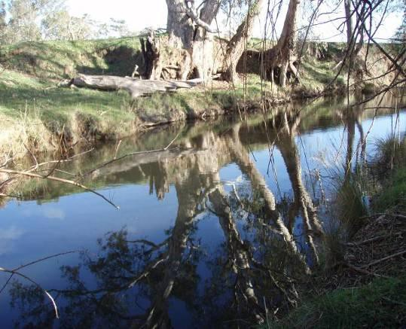

Hollands Creek habitat Photo: S. Raymond

Hollands Creek and rehabilitation for fish

In Hollands Creek, multiple river rehabilitation actions have been applied to address the threats to river health and improve native fish populations in the creek. Local, state and federal government agencies along with community groups have invested in a works and community education program to increase native fish numbers and build knowledge. The works program has provided additional habitat for native fish in the form of logs (snags) and rocks, removed riverbank weeds, managed stock access to the creek, improved creek connectivity, provided refuge from low flows, planted riparian vegetation and stocked the reach with native fish.
Rehabilitation works undertaken in Hollands Creek (2008- 2014):

- 126 habitat snags inserted
- 19 large rocks inserted
- 29 km of willows removed
- 24 km of fencing installed
- Installed a rock-bar (low flow refuge)
- Rock-bar constructed (low flow refuge)
- 3,200 shrubs planted along creek bank
- Re-stocking 300 Macquarie perch fingerlings into the creek (2010)

Hollands Creek fish community

Hollands Creek is home to the nationally endangered Macquarie Perch (Macquaria australasica), a large-bodied native fish historically widespread throughout Victoria. However, their distribution and abundance have severely declined over the last century and only a handful of populations remain in Victoria. Other large-bodied native fish species in Hollands Creek include two-spined blackfish (Gadopsis bispinosis) and River blackfish (Gadopsis marmoratus). The aim of the Demonstration Reach program is to improve these native fish populations using multiple river rehabilitation actions.
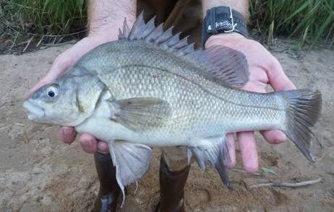

Macquarie Perch - a priority fish species expected to benefit from river rehabilitation activities. Photo: J. Kearns

Macquarie perch love river rehabilitation

Is it working?

Annual electrofishing surveys have been undertaken in Hollands and Ryans creeks since 2008 to monitor the response of native fish species to rehabilitation efforts in Hollands Creek. Results in Hollands Creek have been dramatic, with a

1200% increase in the Macquarie perch population

and a

1500% increase in the two-spined blackfish population

plus a 400% increase in River blackfish over the life of the program.

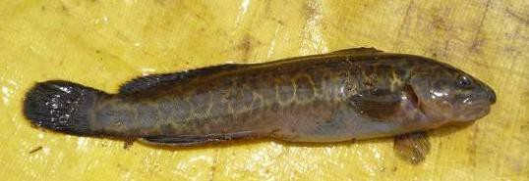

Two-spined blackfish Photo: S. Raymond

In addition to the increases in abundance, populations of Macquarie perch and two-spine blackfish have also been strengthened by increases in distribution and size classes, indicating improvements in natural recruitment.

Program partners and support groups

Partnering with relevant stakeholders was essential to foster ownership of the project, effectively improve creek health and demonstrate the value of collaboration. A Community Reference Group included landholders, representatives from local clubs (including Landcare groups and a fishing club) and government agencies. Regular engagement events were held, including on-site meetings and field days with local school students and program partners and through annual fish survey
demonstrations. Information signs were installed and project updates were communicated during meetings, in distributed reports, through Demonstration Reach agency webpages, in

Community field day on Hollands Creek Photo: S. Raymond
local media, and at research conferences. Project partners and support groups include;
- Murray-Darling Basin Authority (MDBA)
- Department of Environment and Primary Industries (DEPI)
- DEPI Arthur Rylah Institute
- DEPI Fisheries Victoria
- Goulburn Broken Catchment Management Authority (GBCMA)
- Rural City of Benalla
- Tatong-Mollyulah Landcare Group
- And the many landowners and interested community members who participated in field work, provided assistance with river access and advice, supported rehabilitation actions on their properties, and continue to advocate for a healthy Hollands Creek.

For more information on this project contact:

Dr. Scott Raymond: scott.raymond@depi.vic.gov.au

Mark Turner: markt@gbcma.vic.gov.au

Published by the Victorian Government Department of Environment and Primary Industries Melbourne, July 2014
© The State of Victoria Department of Environment and Primary Industries Melbourne 2014
This publication is copyright. No part may be reproduced by any process except in accordance with the provisions of the Copyright Act 1968.
Print managed by Finsbury Green July 2014
ISBN: 978-1-74326-996-1 (Print) 978-1-74326-997-8 (pdf)
Accessibility
If you would like to receive this publication in an alternative format, please telephone DEPI Customer Service Centre 136 186, email customer.service@dse.vic.gov.au (or relevant address), via the National Relay Service on 133 677 www.relayservice.com.au This document is also available in on the internet at www.depi.vic.gov.au
Disclaimer
This publication may be of assistance to you but the State of Victoria and its employees do not guarantee that the publication is without flaw of any kind or is wholly appropriate for your particular purposes and therefore disclaims all liability for any error, loss or other consequence which may arise from you relying on any information in this publication.

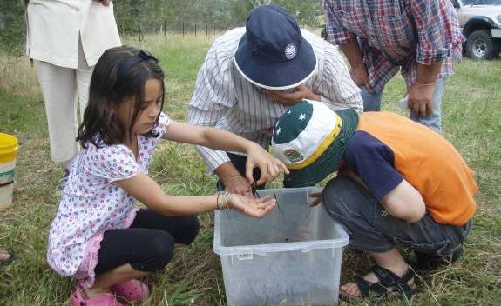

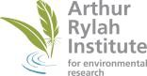www.depi.vic.gov.au

