|  |
| --- |
| Victorian Environmental Flows Monitoring and Assessment Program (VEFMAP) Stage 6 |
| Vegetation Project Update – 2018  Monitoring of Aquatic and River Bank Vegetation: **Moorabool River** |

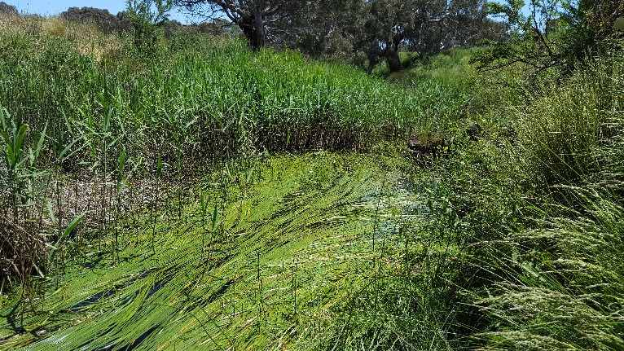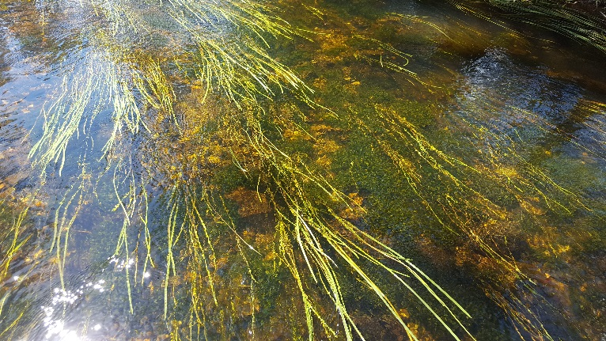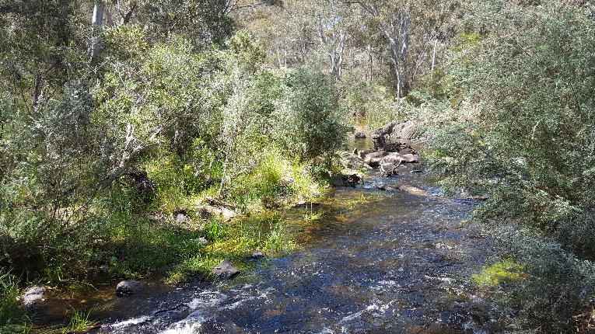

* 1. **VEFMAP Stage 6**

The Victorian Environmental Flows Monitoring and Assessment Program (VEFMAP) is now in its sixth stage of delivery. VEFMAP Stage 6 will run from 2016 to 2020, funded through the Victorian government’s $222 million investment in waterway and catchment health. VEFMAP Stage 6 focusses on ‘intervention’ or ‘event-based’ monitoring of fish and vegetation responses to flows and incorporates data from previous VEFMAP stages.

## Stage 6 – Vegetation Objectives

Stage 6 vegetation objectives aim to measure vegetation responses to environmental flows. The monitoring approach has been substantially modified from previous stages of the program and is initially focussing on individual flow events in individual waterways to detect short-term responses of native and exotic plant species to environmental water delivery. A longer-term understanding will be gained through repeated short-term assessments and by using data from previous stages of VEFMAP to create longer-term datasets. Importantly, these responses will be considered in relation to other factors that may influence flow responses, such as grazing, rainfall, soil properties and season (see program overview for details, DELWP 2017a).

## 2017/18 Monitoring on the Moorabool River

The Moorabool River was one of three river systems added to the vegetation monitoring program in 2017/18 (others incuded the Campaspe, Loddon and Wimmera tributaries). For the Moorabool system, surveys were conducted at four sites across two waterways (Figure 1). Three sites were located on the Moorabool River and one on the Sutherland Creek tributary.

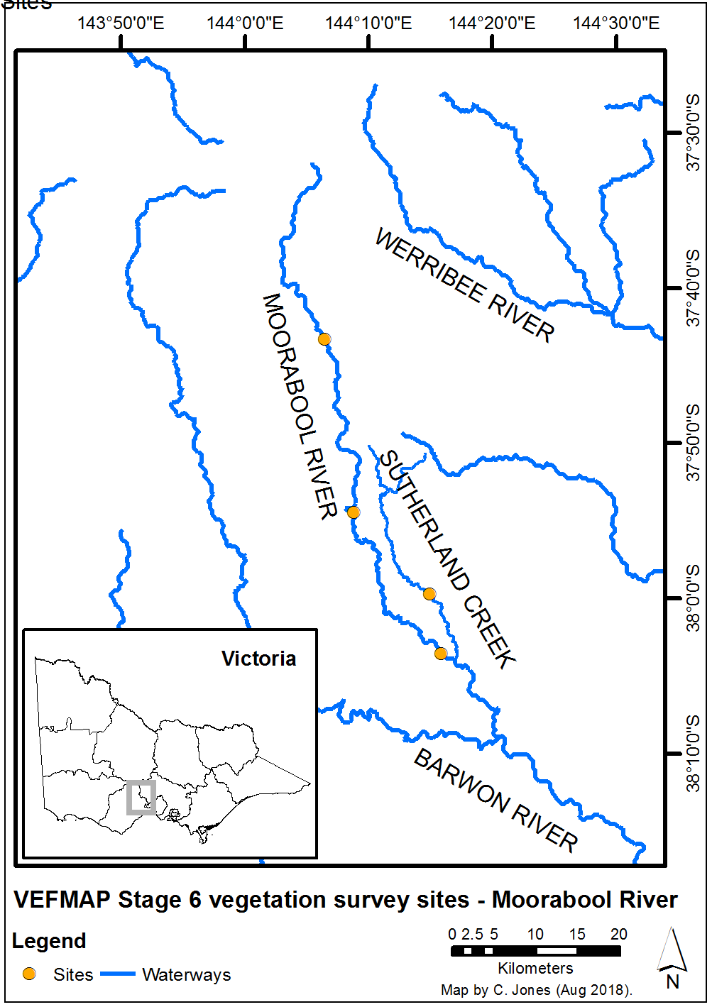

**Figure 1 – Map of survey sites on the Moorabool River system.**

## Survey timing and hydrology

Timing for the VEFMAP surveys considers rainfall and managed flow deliveries. The sampling design recommends surveys occur before a planned flow delivery and two to 12 weeks after the event, depending on the flow regime (to provide adequate time for vegetation to respond and for germinants to emerge). Timing is altered if rainfall increases the flow prior to a planned survey.

Rainfall on the Moorabool River, measured near Meredith (Darra) in 2017/18, did not result in large changes to the river flow outside of the managed flow events (Figures 2 and 3).

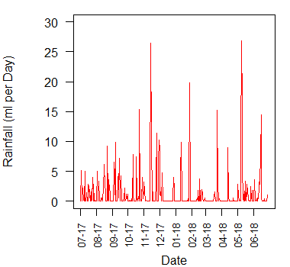

**Figure 2 – Daily rainfall recorded at Meredith (Darra) in 2017/18.**

In 2017, this resulted in an August survey prior to the first of two spring freshes in September and October, a second survey in November after the second fresh, and a third survey after the two summer freshes (Figures 3 and 4).

Although the first and second spring flows were planned to reach or exceed 80 ML/day for five days, rainfall during and after the second fresh in October meant that this discharge lasted for at least 2-3 days longer.

The larger summer fresh in early February 2018 was designed to be a longer event with a shorter peak, but the peak magnitude increased slightly due to coincidental rainfall.

The Sutherland Creek is an unregulated tributary of the Moorabool River and had no flow for the entire survey period.

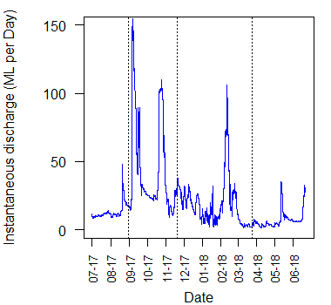

**Figure 3 – River flow discharge recorded at Sheoaks Weir in 2017/18 and VEFMAP vegetation survey timing for the three vegetation surveys (dotted lines).**

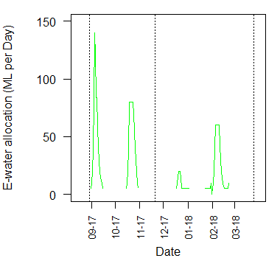

**Figure 4 – Environmental flow allocation coordinated by the Corangamite CMA for the Moorabool River in 2017/18 and VEFMAP vegetation survey timing for the three vegetation surveys (dotted lines).**

## Methods

Survey methods are outlined in detail in VEFMAP Stage 6 Part B: Monitoring design and sampling methods (DELWP 2017b). The surveys include a wide range of methods: fine-scale vegetation measurements, broad-scale mapping, tree canopy assessments and hydrology assessments.

## Survey observations

This first short fresh on the Moorabool in early September 2017 was too brief to kill terrestrial exotic species. The second spring fresh was slightly longer than planned (up to 8 days) due to coincidental rainfall and was sufficient to kill many exotic plants on the bank (Figure 5). This narrow difference in flow duration resulted in very different outcomes for vegetation, which provides valuable information for waterway managers as it demonstrates the flow conditions that are required to kill undesirable species.

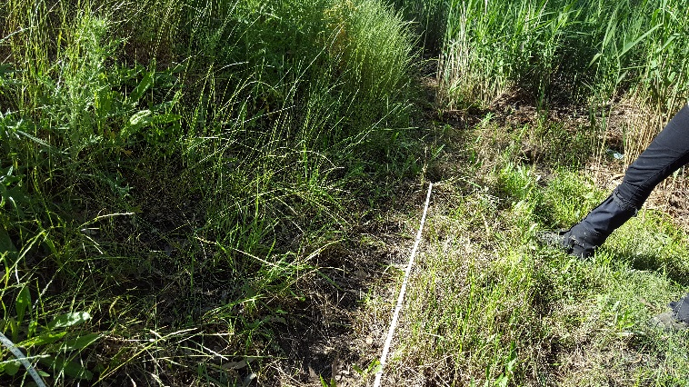Although most of the species that survived the inundation (below the inundation line) were native, some exotic species also survived, e.g. Aster-weed(*Symphyotrichum subulatum*). Species such as this can become problematic in the regularly inundated zone.

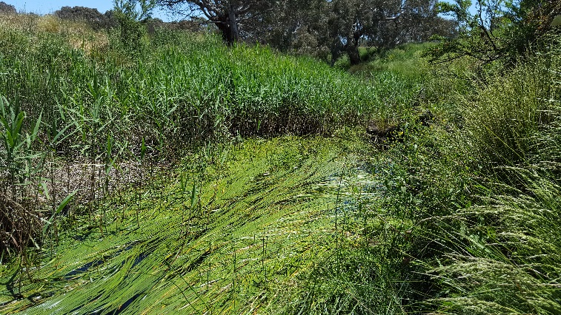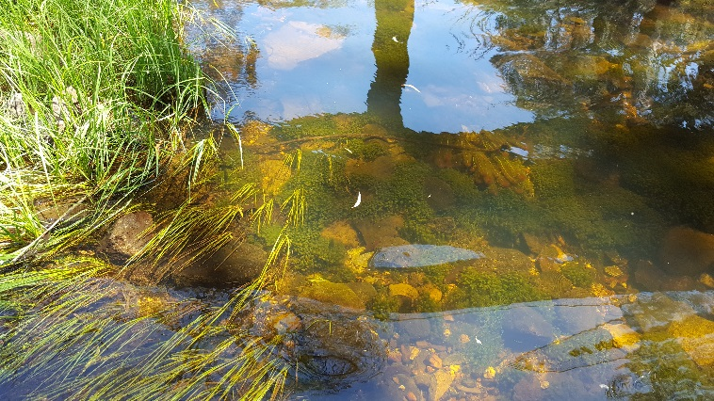

**Figure 5 – Exotic plants killed during environmental flows on the Moorabool River in 2017. Most vegetation below this inundation line is native, with the exotic plants dying during the eflow on MR in 2017.**

As with other rivers in higher rainfall parts of Victoria, perennial exotic species such as Blackberry (*Rubus* spp.) cause significant problems on the Moorabool River (Figure 6). Environmental flows are not able to influence these species, which are highly tolerant of inundation. Once the patches become particularly dense, they also prevent other native species from occupying the bank.

*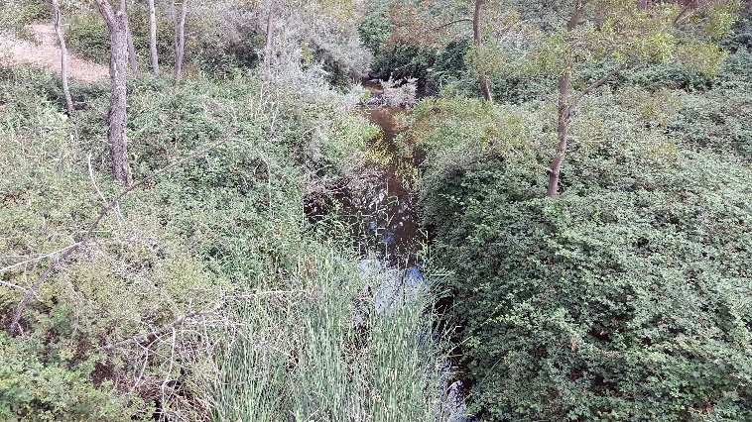***Figure 6 – Dense patches of Blackberry on the Moorabool River in 2017.**

The third major fresh on the Moorabool River in early February 2018 had little effect on exotic vegetation on the banks, but it did help to scour some of the algae that grow rapidly over the summer months within the river bed. Generally, the water turbidity is very low and the lack of high velocity flows has resulted in impressive instream vegetation growth throughout the river (Figures 7a and b). This instream vegetation is relatively species diverse and abundant, more so than in many of the larger southern Victorian rivers. This is likely the result of a number of factors, including lack of cattle grazing in the channel, good water quality, low water velocity (peak flows), sufficient low flows, flow management and channel geomorphology.

**Figure 7 – High diversity and abundance of in-stream aquatic vegetation throughout the Moorabool River.**

Aside from a series of deeper pools containing water, there was no water within the channel of the Sutherland Creek during the survey period. Unsurprisingly, the lack of flows resulted in riparian species only being found around the remaining pools. While the riparian channel of the creek can support a high diversity of species and provide habitat for fauna, there are few aquatic values persistent throughout the creek.

## Grazing

There is no livestock grazing within the two upstream sites on the Moorabool River, but the most downstream site has semi-permanent sheep grazing. Despite the sheep grazing pressure on the lower Moorabool site, the level of grazing is light enough for some native fringing species to persist (Figure 8). However, the vegetation at the top of the river bank and beyond is almost entirely exotic pasture species and weeds. Environmental flows are likely to be playing a critical role in preventing the exotic species from moving down the bank and excluding native species.

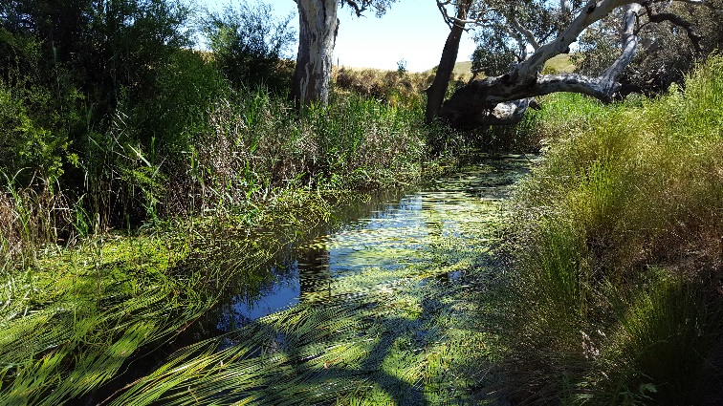

**Figure 8 – Native plant species persisting in the Moorabool River and on the banks despite sheep grazing.**

The Sutherland Creek site was formerly grazed but has recently been fenced off and revegetated. In the absence of grazing, much of the recovering vegetation is dominated by exotic species, with only a few native species remaining near temporary pools (Figure 9). There are no environmental flows available for the creek and the lack of natural flow will make it difficult for native understorey species to compete at this site without intervention.

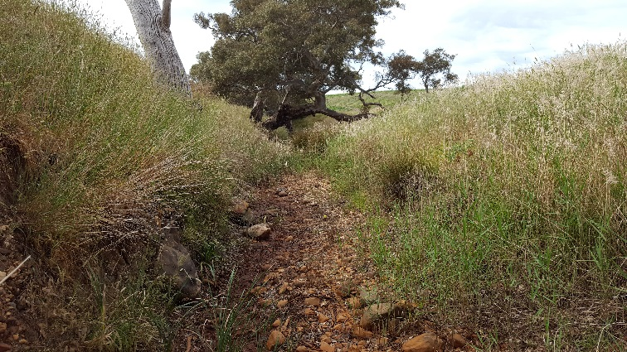

**Figure 9 – Exotic species dominating the banks of Sutherland Creek, apart from a few natives near the temporary pools.**

## Summary

Using multiple methods and surveying at regular intervals to directly address the VEFMAP Stage 6 monitoring objectives, the program has so far been successful in evaluating vegetation responses to flows. The observations summarised here form part of a larger story relating to vegetation responses to environmental water, which will continue to unfold in the coming years. Further information on the other systems surveyed and research projects is also available.

Environmental flows are being delivered on the Moorabool River to deliver benefits to vegetation and a wide range of fauna. Waterway managers are working closely with researchers, waterway authorities and a range of other stakeholders to manage flow deliveries as effectively as possible for the environment and other water users. Flows delivered at the right time, magnitude and duration can be beneficial to vegetation on the river banks. Flows delivered at non-ideal times or sizes may have detrimental effects on vegetation, but the native riparian vegetation is mostly very tolerant of variable flow conditions.

## Collaboration

VEFMAP Stage 6 includes many collaborations between DELWP staff, waterway managers and authorities, academics (internal and external) and students.

## References

DELWP (2017a) VEFMAP Stage 6 Part A: Program context and rationale. A report by Arthur Rylah Institute for Environmental Research and Integrated Water and Catchments Division, Department of Environment, Land, Water and Planning.

DELWP (2017b) VEFMAP Stage 6 Part B: Program design and monitoring methods. A report by Arthur Rylah Institute for Environmental Research and Integrated Water and Catchments Division, Department of Environment, Land, Water and Planning, Victoria.Department of Environment, Land, Water and Planning.

## Contact [Chris.Jones@delwp.vic.gov.au](mailto:Chris.Jones@delwp.vic.gov.au)

Jayden.Woolley@ccma.vic.gov.au

|  |  |
| --- | --- |
| © The State of Victoria Department of Environment, Land, Water and Planning 2018  LogoThis work is licensed under a Creative Commons Attribution 4.0 International licence. You are free to re-use the work under that licence, on the condition that you credit the State of Victoria as author. The licence does not apply to any images, photographs or branding, including the Victorian Coat of Arms, the Victorian Government logo and the Department of Environment, Land, Water and Planning (DELWP) logo. To view a copy of this licence, visit http://creativecommons.org/licenses/by/4.0/  ISBN 978-1-76077-356-4 (print), 978-1-76077-357-1 (pdf/online/MS word)  Disclaimer  This publication may be of assistance to you but the State of Victoria and its employees do not guarantee that the publication is without flaw of any kind or is wholly appropriate for your particular purposes and therefore disclaims all liability for any error, loss or other consequence which may arise from you relying on any information in this publication. | Accessibility  If you would like to receive this publication in an alternative format, please telephone the DELWP Customer Service Centre on 136186, email [customer.service@delwp.vic.gov.au](mailto:customer.service@delwp.vic.gov.au), or via the National Relay Service on 133 677 [www.relayservice.com.au](http://www.relayservice.com.au). This document is also available on the internet at https://www.ari.vic.gov.au/research/rivers-and-estuaries/assessing-benefits-of-environmental-watering |