|  |
| --- |
| Victorian semi-arid woodlands |
| Progress towards improving semi-arid woodland condition |

**Key Points:**

* Semi-arid woodlands of north-west Victoria are severely degraded due to historical land use (e.g. grazing, clearing). Woodland recovery is slow as regional productivity is low, and herbivore browsing (both domestic and native) impede recovery.
* A long-term restoration program is underway using herbivore population control measures to manage grazing pressure and improve woodland recovery.
* To measure woodland recovery a rolling long-term monitoring program is underway in semi-arid woodlands across Mallee parks and reserves.
* Monitoring shows that semi-arid woodlands are slowly recovering with some tree regeneration, and no significant decline in adults.

# What are semi-arid woodlands

Semi-arid non-eucalypt woodlands (hereafter, semi-arid woodlands) are an important biodiversity asset of the Victorian Mallee.

These woodlands are characterised by one or more canopy species - Belah (*Casuarina pauper*), Buloke (*Allocasuarina luehmannii*), Slender Cypress Pine (*Callitris gracilis*), and Sugarwood (*Myoporum platycarpum*) -over a diverse ground layer of saltbushes, herbs, grasses and soil crust (Figure 1).

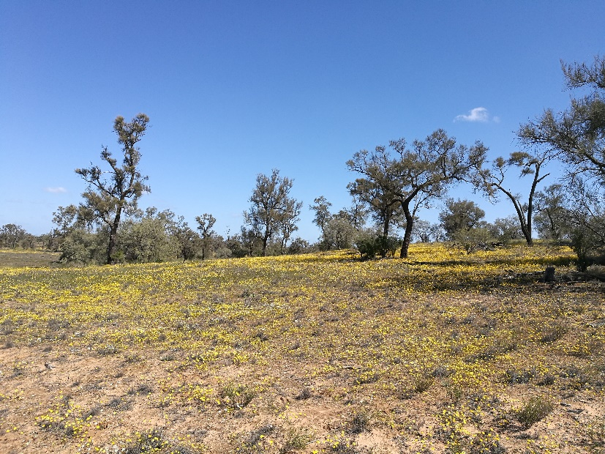

Figure 1: Semi-arid woodland with understorey in flower.

Credit: Sally Kenny, ARI.

## Disturbance history

Semi-arid woodlands once covered extensive tracts of the Mallee, but today are predominantly restricted to public land. Over 88,000 hectares are currently reserved in Mallee Parks.

The reduced extent of semi-arid woodlands is due in part to historical land use (land clearing, timber harvesting, livestock grazing), weed invasion, altered fire regimes and browsing by native (kangaroos) and introduced (rabbits and goats) herbivores.

Indeed, the historical land use impacts were so great that semi-arid woodlands (and the surrounding landscape) were classified as severely degraded at the time of reservation in the 1980s (Hattah-Kulkyne National Park) and 1990s (Murray-Sunset National Park) (Figure 2).

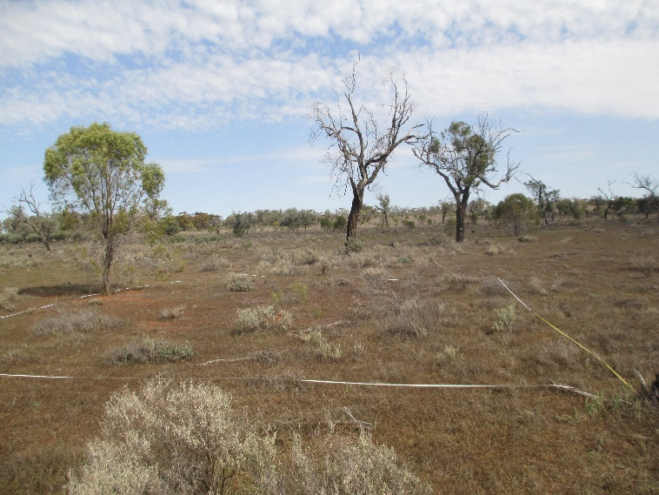

Figure 2: Severely degraded Sugarwood semi-arid woodland.

Credit: Sally Kenny, ARI.

.

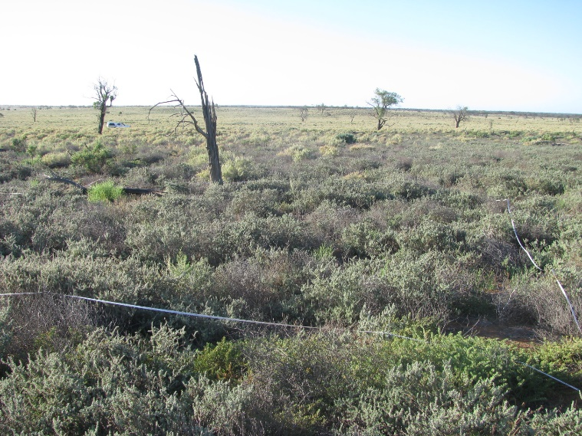

Figure 2: Severely degraded semi-arid woodland.

Credit: Alison Oates, Oates Environmental.

Today the remnant canopy layer is largely composed of sparsely distributed old individuals with limited natural regeneration and an altered native understorey that is weed invaded (Figures 2 & 3).

Despite the reservation of semi-arid woodlands in National Parks, and efforts by land managers to control grazing pressure, areas and times of high browsing pressure continue to occur. Herbivores target the highly palatable juveniles of woody perennials (e.g. shrubs and trees; Figure 4), greatly reducing regeneration.

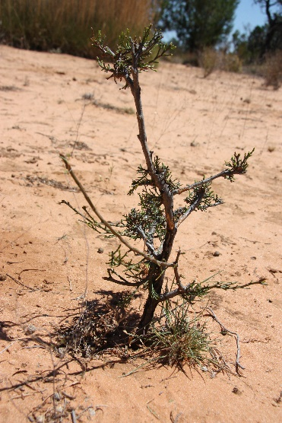

Figure 4: Grazed Slender Pine juvenile.

Credit: Dylan Osler, Ecological Perspective.

## Improving woodland condition

Semi-arid woodlands are slow-growing and reliant on high rainfall events to promote regeneration. Consequently, historical and current ecological impacts (e.g. land clearance, grazing, altered fire) have long-lasting consequences on woodland condition, even with adequate rainfall.

To improve woodland condition, a long-term restoration program (10-15 years) is underway which uses herbivore population control measures to manage total grazing pressure across the network of Mallee parks.

The program was formalised as the Total Grazing Management Plan (Parks Victoria 2016) for the restoration of semi-arid woodland and floodplain vegetation communities in the Mallee parks.

This plan aims to achieve healthy semi-arid woodland and floodplain vegetation communities by undertaking management interventions that reduce browsing and grazing impacts which will improve vegetation condition.

## Monitoring long-term woodland recovery

To measure progress against the Total Grazing Management Plan program goals of improving semi-arid woodland condition, a monitoring framework was developed and implemented (Figure 5).

The semi-arid woodland vegetation condition monitoring program consists of:

* 300 monitoring sites across three National Parks (Murray-Sunset, Hattah-Kulkyne, Wyperfeld) and Lake Albacutya.
* A rolling five-year program where monitoring is undertaken annually at a subset of 60 sites. Each group of 60 sites are assessed at five-year intervals.

Key measures include:

* Tree population dynamics – the number of individuals in life stage classes: seedling, juvenile, mature, senescent and dead.
* Understorey vegetation – the cover of native and exotic shrubs, herbs, grasses and ground layer substrate (e.g. bare ground, litter, soil crust).

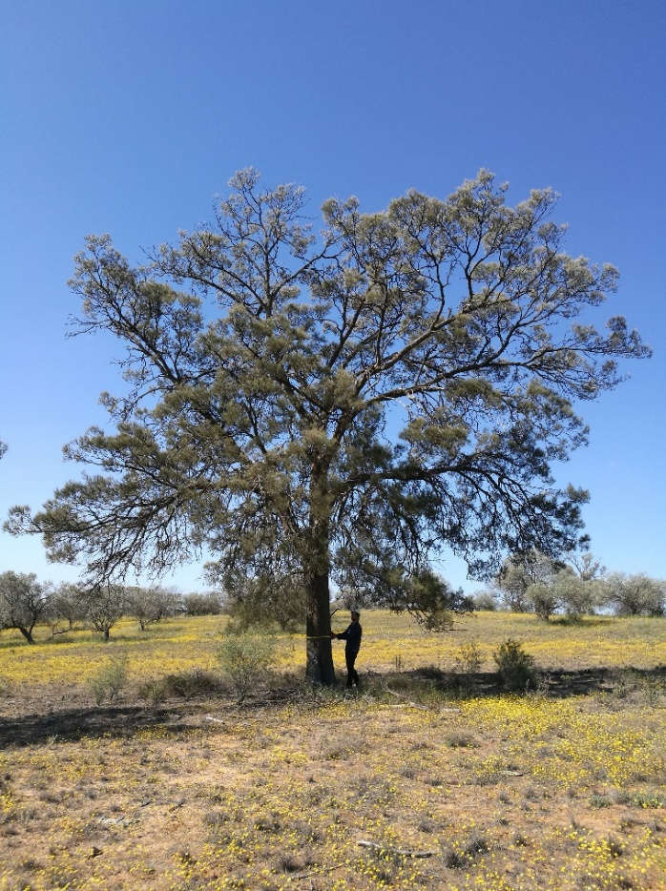

Figure 5: Surveying Buloke semi-arid woodland.

Credit: Sally Kenny, ARI.

# Progress towards recovery: update

Now that 120 monitoring sites have been monitored twice over a five-year period, we can assess the progress of recovery at these locations. The sites are grouped into three geographic regions and represent an environmental gradient from west to east (north-west Murray-Sunset, eastern Murray-Sunset and Hattah-Kulkyne National Parks; Figure 6).

Figure 6: Map of the three sampling regions in the Victorian Mallee.

|  |
| --- |
| The current management practice of reducing grazing pressure is maintaining semi-arid woodland condition. |

Reduced grazing pressure has contributed to stopping the decline in woodland condition and at some sites enabled an improvement. Positive changes that were detected in tree population dynamics over time (Figure 7) include:

* increased recruitment (i.e. seedlings and juveniles; Figure 8).
* no decline in adults (i.e. no increase in the number of senescent or dead trees).
* positive changes were greatest in north-west Murray-Sunset National Park.

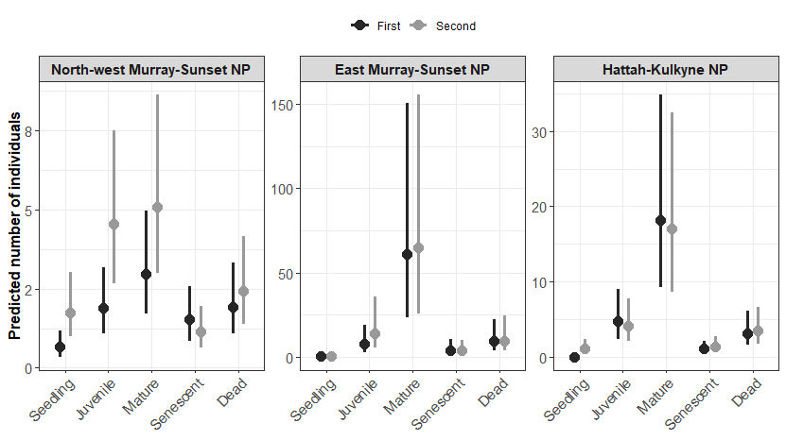



2012

2017/18

**Figure 7: Predicted number of seedlings, juveniles, mature, senescent and dead trees, across the three sampling regions, over the two monitoring periods. Note that the scale between rows is different to allow finer-scale differences between monitoring periods to be seen across the three sampling regions. 95% confidence intervals are shown.**

Figure 8: Mature Slender Cypress Pine with seedlings.

Credit: Sally Kenny, ARI.

Differences between regions

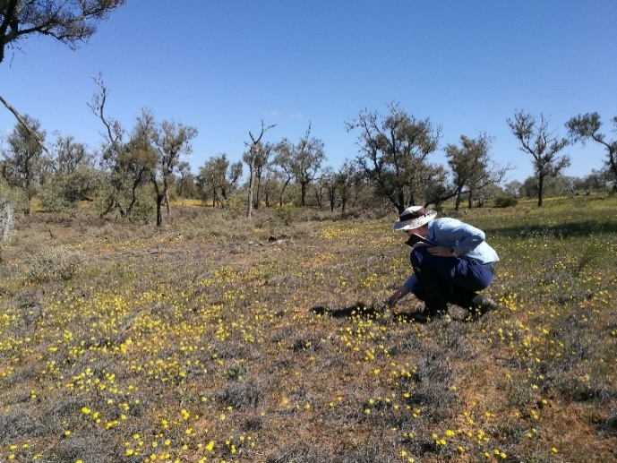Semi-arid woodland vegetation composition and recovery differed between the three regions. There appears to be a gradient from higher to lower native plant cover (and lower to higher bare ground cover) from the west (north-west Murray-Sunset) to the east (Hattah-Kulkyne). In addition, north-west Murray-Sunset had the highest herb cover and progress towards recovery was most pronounced in this park. This finding is being investigated and is likely related to subtle differences in starting condition, grazing pressure, climate and plant composition.

|  |  |
| --- | --- |
| © The State of Victoria Department of Environment, Land, Water and Planning 2021  LogoThis work is licensed under a Creative Commons Attribution 4.0 International licence. You are free to re-use the work under that licence, on the condition that you credit the State of Victoria as author. The licence does not apply to any images, photographs or branding, including the Victorian Coat of Arms, the Victorian Government logo and the Department of Environment, Land, Water and Planning (DELWP) logo. To view a copy of this licence, visit http://creativecommons.org/licenses/by/4.0/  ISBN 978-1-76105-618-5 (pdf/online/MS word)  Disclaimer  This publication may be of assistance to you but the State of Victoria and its employees do not guarantee that the publication is without flaw of any kind or is wholly appropriate for your particular purposes and therefore disclaims all liability for any error, loss or other consequence which may arise from you relying on any information in this publication. | Accessibility  If you would like to receive this publication in an alternative format, please telephone the DELWP Customer Service Centre on 136186, email [customer.service@delwp.vic.gov.au](mailto:customer.service@delwp.vic.gov.au), or via the National Relay Service on 133 677 [www.relayservice.com.au](http://www.relayservice.com.au). This document is also available on the internet at [www.delwp.vic.gov.au](http://www.delwp.vic.gov.au). |

Figure 9: Surveying Buloke semi-arid woodland.

Credit: Declan Leevers, ARI.

## Conclusion

These preliminary improvements in tree population dynamics are encouraging, however the small increase in recruitment remains a concern and implies that there is more work to do.

Due to climatic variation, sparse recruitment events and the slow growing nature of semi-arid woodlands, further active revegetation is required and management in these semi-arid woodlands requires a long-term perspective to ensure sustainability.

The Total Grazing Management Plan and associated monitoring should be continued to enable an evaluation of the medium to long-term benefits of management intervention.

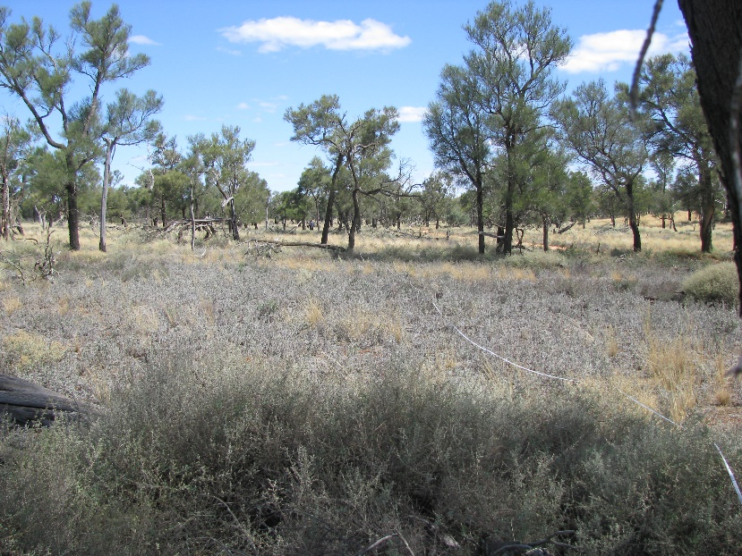

Figure 10: Belah semi-arid woodland.

Credit: Sally Kenny, ARI.

## Acknowledgements

The Total Grazing Management Plan and semi-arid woodland monitoring program is funded by Parks Victoria and DELWP (Weeds and Pests on Public Land program: Mallee Bounceback). This monitoring program is being undertaken by the Arthur Rylah Institute for Environmental Research, Department of Environment, Land, Water and Planning (DELWP), Victoria.

## Further information

For more information about this project, please contact [research.ari@delwp.vic.gov.au](mailto:research.ari@delwp.vic.gov.au)