
Native Fish Report Card 2025
Gunbower Creek
North Central Region

This report card summarises the 2025 Native Fish Report Card (NFRC) survey in the Gunbower Creek
Sites: 11, Electrofishing

Fish found in Gunbower Creek for NFRC
Target species
Golden Perch
Murray Cod
Silver Perch
Trout Cod

Non-target species captured since 2017*
Large-bodied native species
Bony Bream

Small-bodied native species
Australian Smelt
Carp Gudgeon
Flatheaded Gudgeon
Murray-Darling Rainbowfish
Unspecked Hardyhead

Exotic species
Common Carp
Eastern Gambusia
Goldfish
Redfin

* These non-target species were incidentally captured during NFRC surveys since 2017 but not measured as for target species

Gunbower Creek 2025
Fish Community

NFRC target species
The NFRC Program began in 2017 to monitor population dynamics of key iconic fish species that have high recreational and/or conservation values, in large rivers across Victoria.
In the Gunbower Creek, the target species are Golden Perch, Murray Cod, Silver Perch and Trout Cod. Surveys occur in April/May each year, at 11 sites from the offtake with the Murray River upstream of Torrumbarry to the junction of the Murray River at Koondrook. The equipment used and habitats surveyed target these species, which are measured to determine their population structures. Other fish species that are incidentally captured are counted, but not measured.

Summary of key health indicators for target species in 2025
Species | Key Health Indicators
 | Recent recruitment | Multiple size classes | Mature fish present
Golden Perch | No | Yes | Yes
Murray Cod | Yes | Yes | Yes
Silver Perch* | - | - | -
Trout Cod* | - | - | -

Recent recruitment means young-of-year fish
*- cannot be determined due to low abundances

Silver Perch were historically abundant throughout Gunbower Creek, while Trout Cod were rare downstream of Torrumbarry on the Murray River system. Both of these species have experienced dramatic declines across their range. The Yarrawonga population of Trout Cod was shown to have extended downstream from Barmah to Gunbower Island in 2012¹. Trout Cod were then captured in 2014, with NFRC sampling detecting this species in six of the nine sampling years from 2017, although in low densities. Silver Perch are also present in low densities. Overall, the Gunbower Creek appears to be maintaining healthy populations of Golden Perch and Murray Cod.

Non-target species
The non-target fish species that have been incidentally recorded in the Goulburn River during NFRC surveys since 2017 are:

Large-bodied native species
Bony Bream was the only other large-bodied species recorded in the 2025 survey and has been recorded in six of the nine years of NFRC surveys. Bony Bream, a lowland species across the Murray-Darling Basin, is intolerant of cold water and, within Gunbower Creek, is likely to be restricted to the lower portion (i.e., downstream of Koondrook). It is unlikely this species would be detected upstream of the barrier at Koondrook, although a new fishway installed in 2021 may assist fish passage to areas upstream of Koondrook. In 2025, Bony Bream was recorded downstream of Koondrook Weir, in Koondrook Weir and at Yarran Creek, suggesting the fishway installed at Koondrook Weir is providing successful fish passage. As Bony Bream were also detected at the headworks, it is also possible the species is migrating over the weir at the Headworks from the Murray River.

Small-bodied native species
Australian Smelt, Flatheaded Gudgeon, Murray-Darling Rainbowfish, Unspecked Hardyhead and Carp Gudgeon were recorded in the 2025 survey. With the exception of Murray-Darling Rainbowfish, all these species are common and expected to be widespread throughout the Gunbower Creek. Australian Smelt and Unspecked Hardyhead have been recorded in all nine NFRC surveys. Flatheaded Gudgeon and Murray-Darling Rainbowfish have been recorded in seven of the nine years of surveys and Carp Gudgeon in eight. Once widespread in the Murray-Darling Basin, Murray-Darling Rainbowfish, now has a patchy distribution and a restricted range and is listed under the Flora and Fauna Guarantee Act 1988 in Victoria. Carp Gudgeon are common and are expected to be widespread throughout the Gunbower Creek.

Exotic fish species
Common Carp, Eastern Gambusia and Goldfish were recorded in the 2025 survey. Common Carp and Goldfish have been recorded in all nine NFRC surveys and are widely distributed across sampling sites. Eastern Gambusia has been recorded in six of the nine NFRC surveys and is more common in the slower flowing waters. Redfin has been previously recorded twice in NFRC surveys and is also distributed throughout, but in lower abundances.

Other native species known from Gunbower Creek
Some fish species known to occur in the Gunbower Creek system have never been recorded during NFRC surveys (e.g. Flatheaded Galaxias, Freshwater Catfish). These species are more common in offstream habitats (such as billabongs, lagoons and wetlands), with Freshwater Catfish detected in permanent offstream habitats. No Obscure Galaxias has been recorded during the surveys. No Southern Pygmy Perch has been recorded during the NFRC surveys and this species has been absent from the Gunbower Creek system for over 30 years. The species outlined above are hard to detect using the NFRC sampling methods.

Other notable species
Surveys have also recorded Rakali, Yabbies and Turtle species.

^{1.} Douglas, J, Hunt, T and Trueman, W. (2012). Confirmed records of the endangered Trout Cod Maccullochella macquariensis from the Murray River at Gunbower Island, Victoria. Victorian Naturalist 129(4):152-155.

Gunbower Creek 2025
Environmental and Management Context

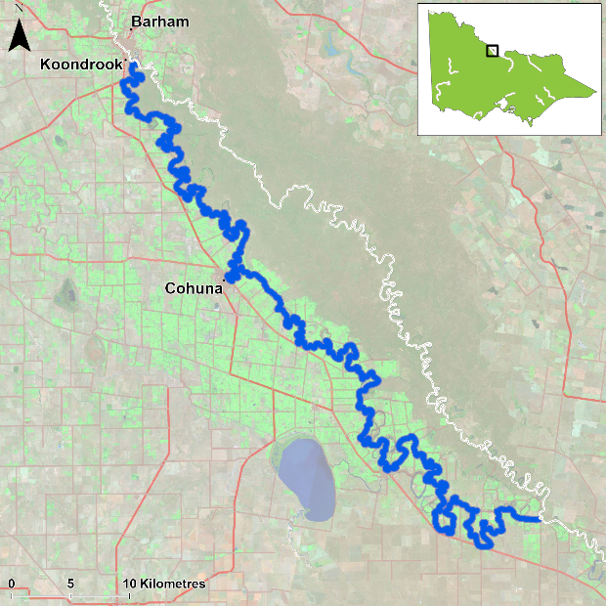
Figure 1. Map showing the section of Gunbower Creek where NFRC sampling occurs

Environment
Stream flow was consistent for the majority of Gunbower Creek from 2017 to 2025. However, at the time of sampling, the two sites downstream of Koondrook had fluctuating heights which were often very low. These sites were often fished later in autumn or early winter, when water levels had increased. Periods of low dissolved oxygen are frequently experienced in Gunbower Creek in the summer months of each year.

Waterway and fisheries management efforts in the Gunbower Creek
Many rehabilitation actions have occurred, and are underway, to improve the health of the Gunbower Creek and its fish community. These are informed by the North Central Regional Catchment Strategy 2021-2027 and in particular by the Native Fish Recovery Plan – Gunbower and lower Loddon. Actions include allocations of water for the environment, increasing connectivity by establishing fishways at Koondrook and Cohuna and upgrading Gunbower Fishway to improve fish passage, fish screens to prevent loss of fish to irrigation channels and pumps at Cohuna, protection and revegetation of riparian areas, management actions to control Carp, and reintroduction of threatened species including Southern Pygmy Perch, Southern Purple Spotted Gudgeon and Olive Perchlet into two wetlands (Black Charlie and Reedy lagoons) and River Blackfish into flowing water habitats.
There are a range of fish monitoring efforts related to the rehabilitation efforts above, including The Living Murray program and environmental flow assessments. The North Central Catchment Management Authority, DEECA, the Victorian Environmental Water Holder and the Victorian Fisheries Authority support rehabilitation and management of the Gunbower Creek and its fish community.

Golden Perch

Gunbower Creek, North Central Region

Key Health Indicators
Recent recruitment No
Multiple size classes Yes
Mature fish present Yes

Monitoring Results
Total number of fish caught 38
Fish per 1km of waterway 2.52
Largest fish by length (cm) 56.0
Largest fish by weight (kg) 3.45
% of the catch that is legal size 97

In 2025, the abundance of Golden Perch (Macquaria ambigua) was the highest since NFRC surveys started (Figure 2), although similar to abundances found in 2017, 2021 and 2023. Similar to 2024, the highest abundances were recorded at the Headworks, although in the 2025 survey Golden Perch were more evenly distributed, recorded from 11 of the 12 sites. Higher abundances recorded in 2017 and 2021-23 were associated with higher flow rates passing downstream of Koondrook Weir.
A large proportion (97%) of Golden Perch collected in the 2025 survey were adults (Figure 2, Figure 3). Juveniles have been present in all years, with recruits only detected in 2019 (Figure 2). It is unlikely that these are natural recruits, since the creek has many barriers which would limit spawning opportunities and egg/larval survival. The presence of adults and juveniles in all nine NFRC surveys indicates conditions in the system are suitable for recruit and juvenile survival and for maintaining adult Golden Perch populations. The population has likely been maintained by stockings. The construction of the Koondrook fishway in 2021 should allow Golden Perch to access areas further upstream in the Gunbower Creek system.

Stocking
Golden Perch were stocked into Gunbower Creek for the first time in 2016. Twenty thousand Golden Perch were stocked in 2016; 40,500 in 2017; 200,000 in 2018; 70,000 in 2019; 70,000 in 2020; 70,000 in 2021; 65,000 in 2022; 70,000 in 2024 and 60,000 in March 2025. No fish were stocked in 2023.

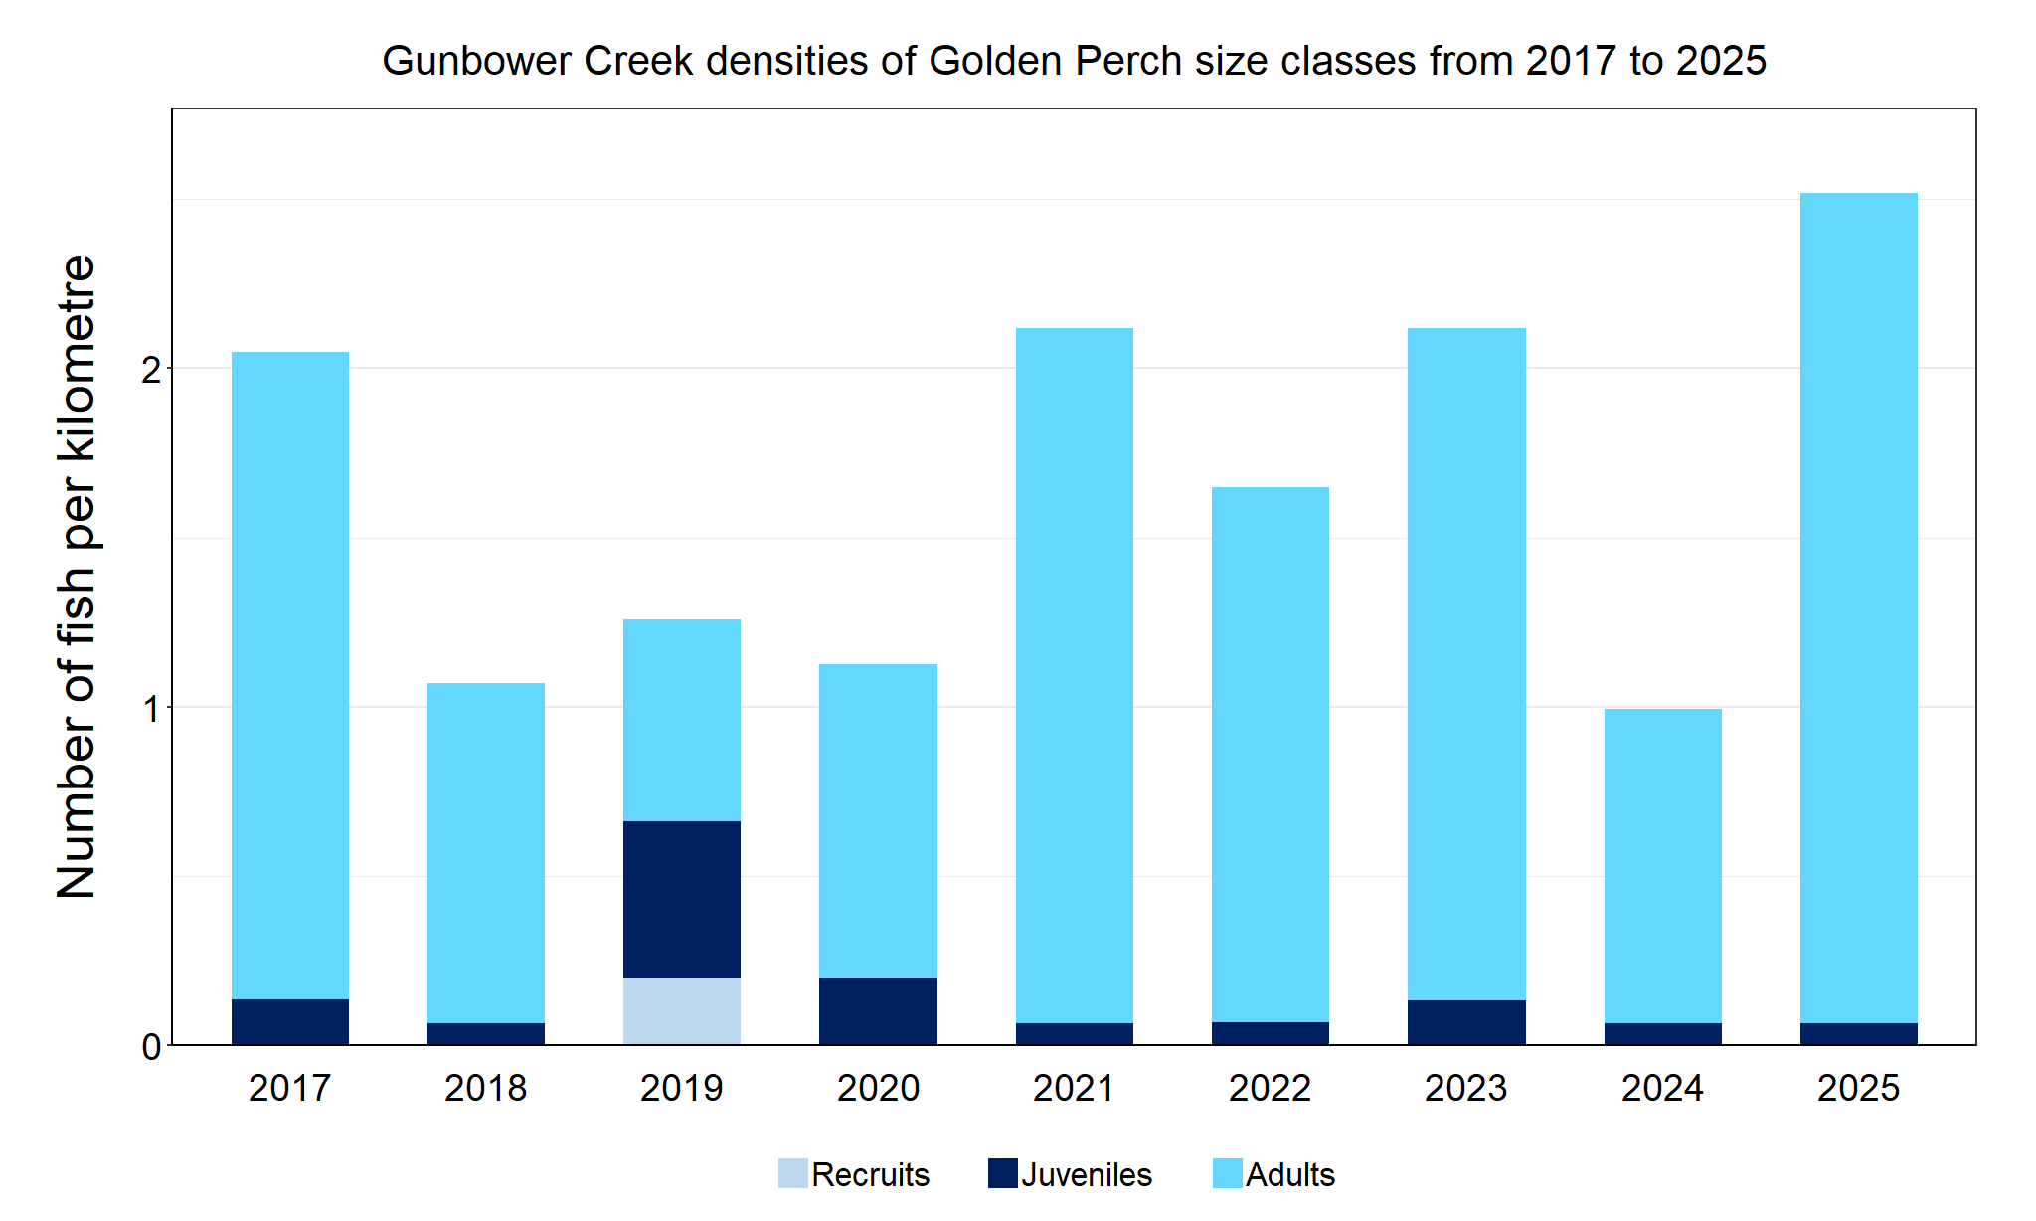
Figure 2. The densities of recruits, juveniles and adult Golden Perch in Gunbower Creek from 2017 to 2025

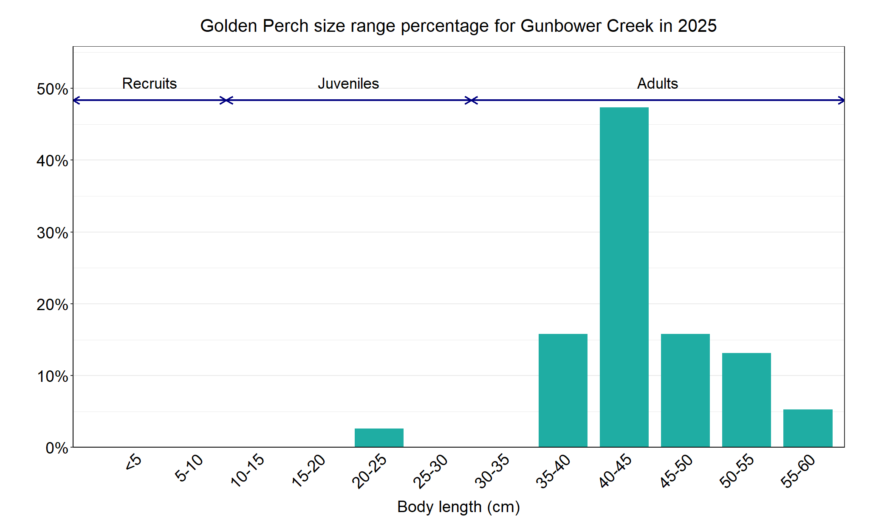
Figure 3. The size range percentage of Golden Perch in Gunbower Creek in 2025.

Murray Cod

Gunbower Creek, North Central region

Key Health Indicators
Recent recruitment Yes
Multiple size classes Yes
Mature fish present Yes

Monitoring Results
Total number of fish caught 94
Fish per 1km of waterway 6.23
Largest fish by length (cm) 113.0
Largest fish by weight (kg) 26.7
% of the catch that is legal size 11.7

The Murray Cod (Maccullochella peelii) population in the 2025 survey was the second highest since NFRC surveys commenced and was a dramatic increase compared to 2024 (Figure 4). Multiple size classes (adults and juveniles) have been recorded in all nine years, with recruits absent in 2023 and 2024. Most fish caught in 2025 were one- to two-year-old fish (10-20 cm) and are likely the result of stocking. There was a distinct gap in the 30-45 cm fish, highlighting the lack of recruitment observed in 2023 following the blackwater event of 2022/23 where there were reported fish deaths as well as translocations out of the system. This may have reduced the adult population, limiting natural recruitment. The presence of 11 legal size fish and nine oversize fish in 2025 indicates that there are enough adults to breed. However, it is unclear if the 10-20cm fish recorded in 2025 are a result of stocking or natural recruitment.

Stocking
Twenty thousand Murray Cod were stocked in 2016; 55,000 in 2017; 150,000 in 2018; 115,690 in 2020; 60,000 in 2022; 60,000 in 2023 and 72,000 in December 2024. Murray Cod stocking started in 2001, with 20,000 stocked in most years until 2016. The exceptions to this are: 120,000 in 2012 and 80,000 in 2014. No fish were stocked in 2019 or early 2025.

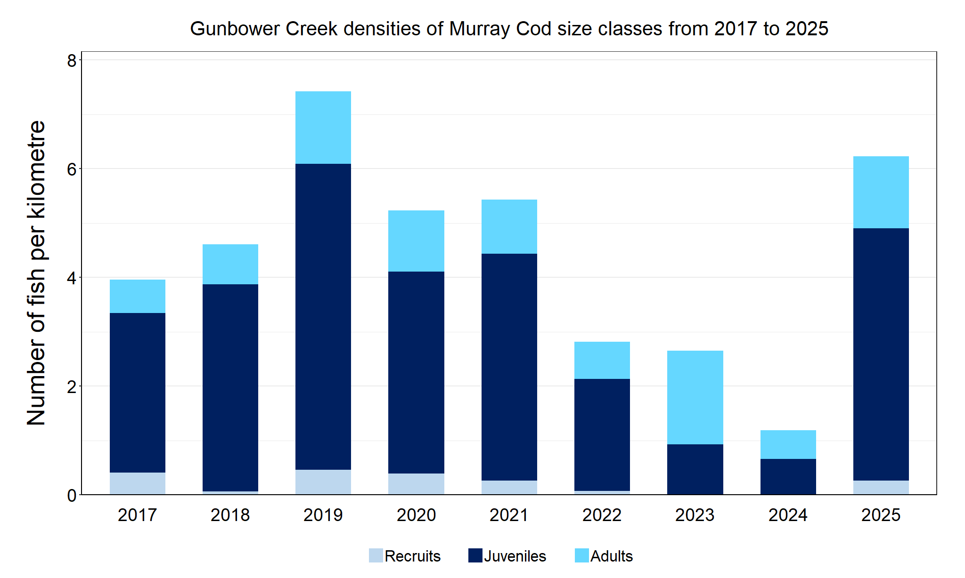
Figure 4. The densities of recruits, juveniles and adult Murray Cod in Gunbower Creek from 2017 to 2025

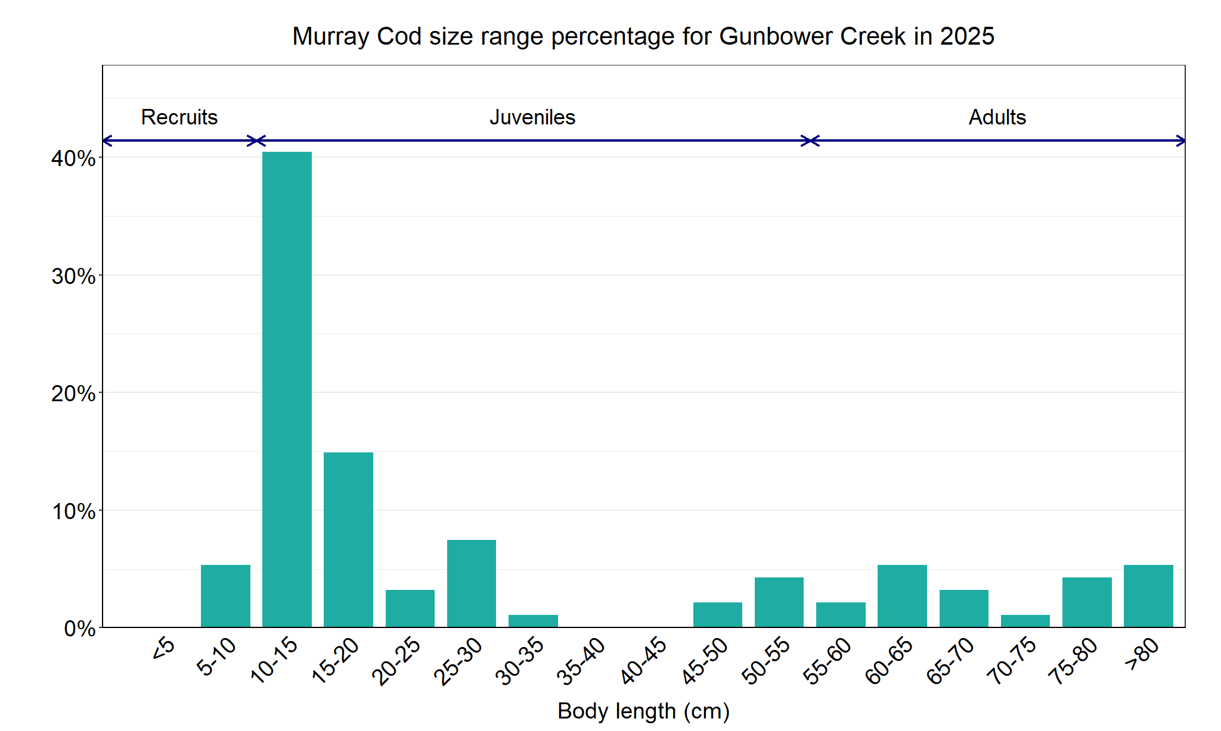

Figure 5. The size range percentage of Murray Cod in Gunbower Creek in 2025

Silver Perch

Gunbower Creek, North Central region

Key Health Indicators
Recent recruitment Cannot be determined
Multiple size classes Cannot be determined
Mature fish present Cannot be determined

Monitoring Results
Total number of fish caught 8
Fish per 1km of waterway 0.53
Largest fish by length (cm) 49.0
Largest fish by weight (kg) 2.21
% of the catch that is legal size NA#

# This species is a Protected Freshwater Species and taking or possessing is prohibited (Victorian Recreational Fishing Guide 2025).

The natural range of Silver Perch (Bidyanus bidyanus) includes most of the Murray-Darling Basin, excluding the cool, higher altitude upper reaches of streams. River regulation and barriers have all negatively affected Silver Perch populations, with these prevalent in Gunbower Creek. The NFRC does not expect to capture enough Silver Perch to measure key health indicators. However, by collecting data for non-recreational species including threatened species such as Silver Perch, it will allow a greater understanding of the current status of the populations providing essential information to the management of these species. Silver Perch is listed as endangered in Victoria (Flora and Fauna Guarantee Act 1988) and nationally (Environment Protection and Biodiversity Conservation Act 1999).

Low abundances of adult Silver Perch were detected in the 2025 survey as well as in all previous NFRC surveys (Figure 6). The highest abundance was detected in 2023 (Figure 6). Only adults were detected in the 2025 survey, with adults detected in all nine years (Figure 6; Figure 7). Juveniles were only detected in 2017, 2022 and 2023 and no recruits have been detected. Recruits of this species are difficult to catch using this sampling methodology. Silver Perch are unlikely to successfully spawn in Gunbower Creek due to the many barriers to fish movement.

Stocking
No stocking has occurred.
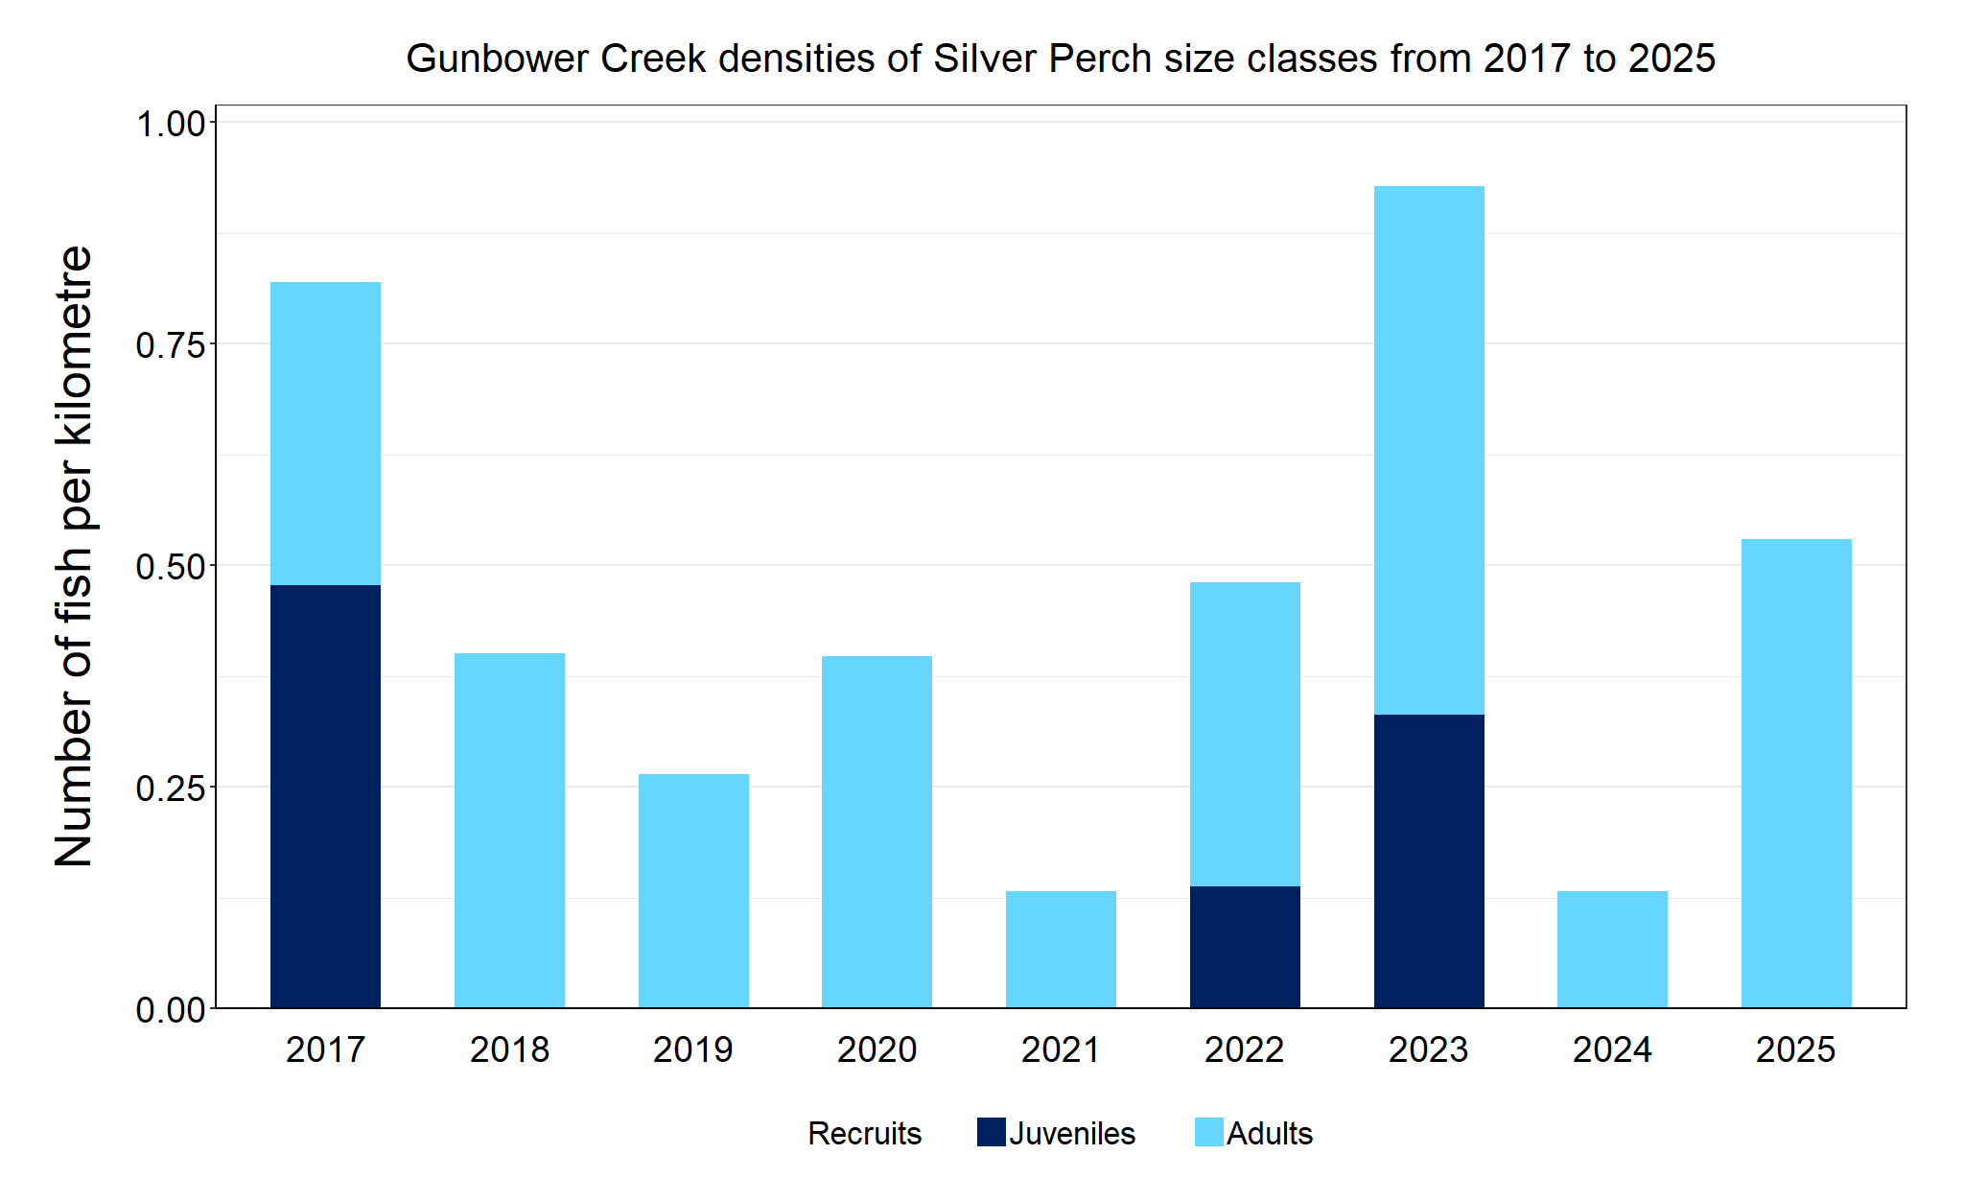
Figure 6. The densities of recruits, juveniles and adult Silver Perch in Gunbower Creek from 2017 to 2025

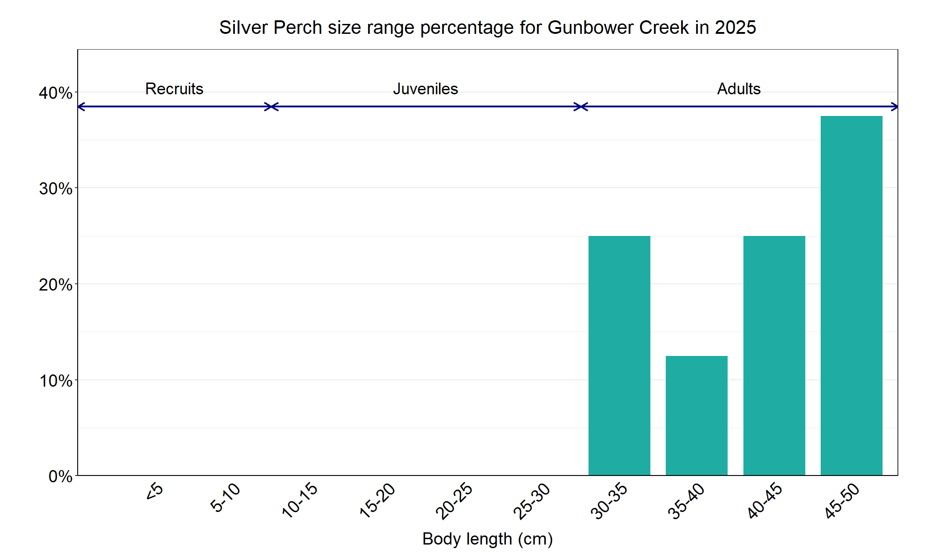
Figure 7. The size range percentage of Golden Perch in Gunbower Creek in 2025

Trout Cod

Gunbower Creek, North Central region

Key Health Indicators
Recent recruitment Cannot be determined
Multiple size classes Cannot be determined
Mature fish present Cannot be determined

Monitoring Results
Total number of fish caught 0
Fish per 1km of waterway 0
Largest fish by length (cm) NA
Largest fish by weight (kg) NA
% of the catch that is legal size NA#

# This species is a Protected Freshwater Species and taking or possessing is prohibited (Victorian Recreational Fishing Guide 2025).

The natural range of Trout Cod included Gunbower Creek, but the species was absent in this area from the 1980s until 2012. The NFRC does not expect to capture enough Trout Cod to measure key health indicators. However, collecting data for non-recreational species including threatened species such as Trout Cod, allows a greater understanding of the current status of the populations providing essential information to the management on these species. Due to the low abundances of Trout Cod collected during NFRC the key health indicators cannot be measured. Trout Cod was first detected again in Gunbower Creek in 2012 and has regularly been recorded since then, albeit in low abundances.

No Trout Cod were recorded in the 2025 survey; however, the species has been recorded in six of the nine years of NFRC sampling (Figure 8). No recruits have been detected in NFRC sampling, and juveniles have only been detected in 2017 and 2021. This indicates that Trout Cod are persisting in Gunbower Creek, but it is uncertain if they are breeding. It is possible that larvae or recruits enter the system via the national channel inlet upstream of Torrumbarry Weir. Monitoring during Koondrook and Cohuna fishway installations in 2021 captured juvenile Trout Cod (in higher abundances than NFRC sampling) immediately downstream of the weirs - potentially accumulating, which indicates a barrier to fish passage. The construction of the Koondrook fishway in 2021 should allow Trout Cod to access areas further upstream in the Gunbower Creek system.

Stocking
No stocking has occurred.
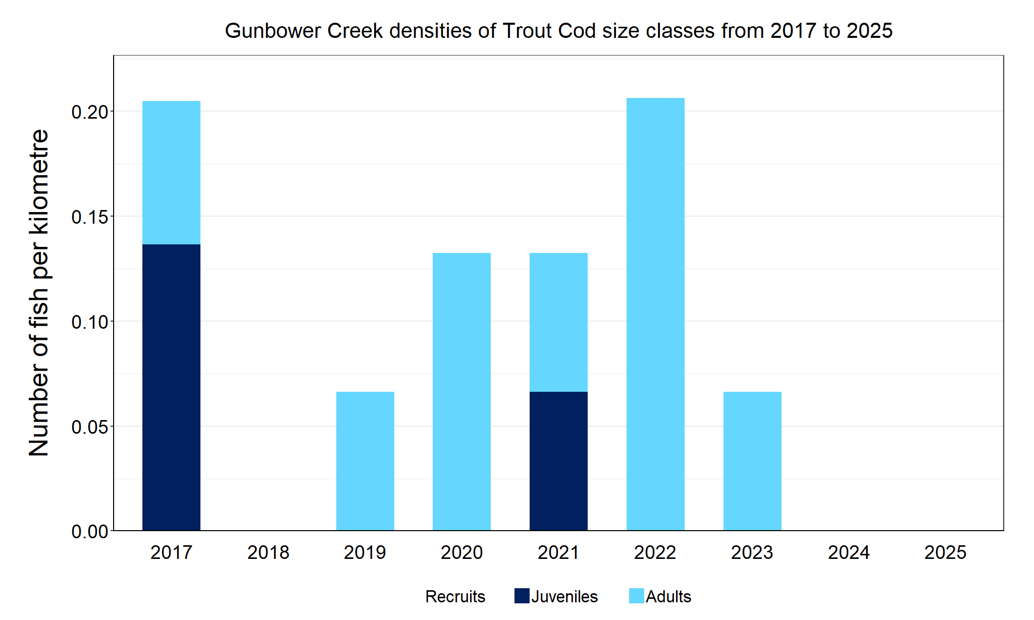
Figure 8. The densities of recruits, juveniles and adult Trout Cod in Gunbower Creek from 2017 to 2025

We acknowledge and respect Victorian Traditional Owners as the original custodians of Victoria’s land and waters, their unique ability to care for Country and deep spiritual connection to it. We honour Elders past and present whose knowledge and wisdom has ensured the continuation of culture and traditional practices.

© The State of Victoria Department of Energy, Environment and Climate Action 2025. This work is licensed under a Creative Commons Attribution 4.0 International licence. To view a copy of this licence, visit creativecommons.org/licenses/by/4.0/
ISSN 2981-9032 Online (pdf/word)

