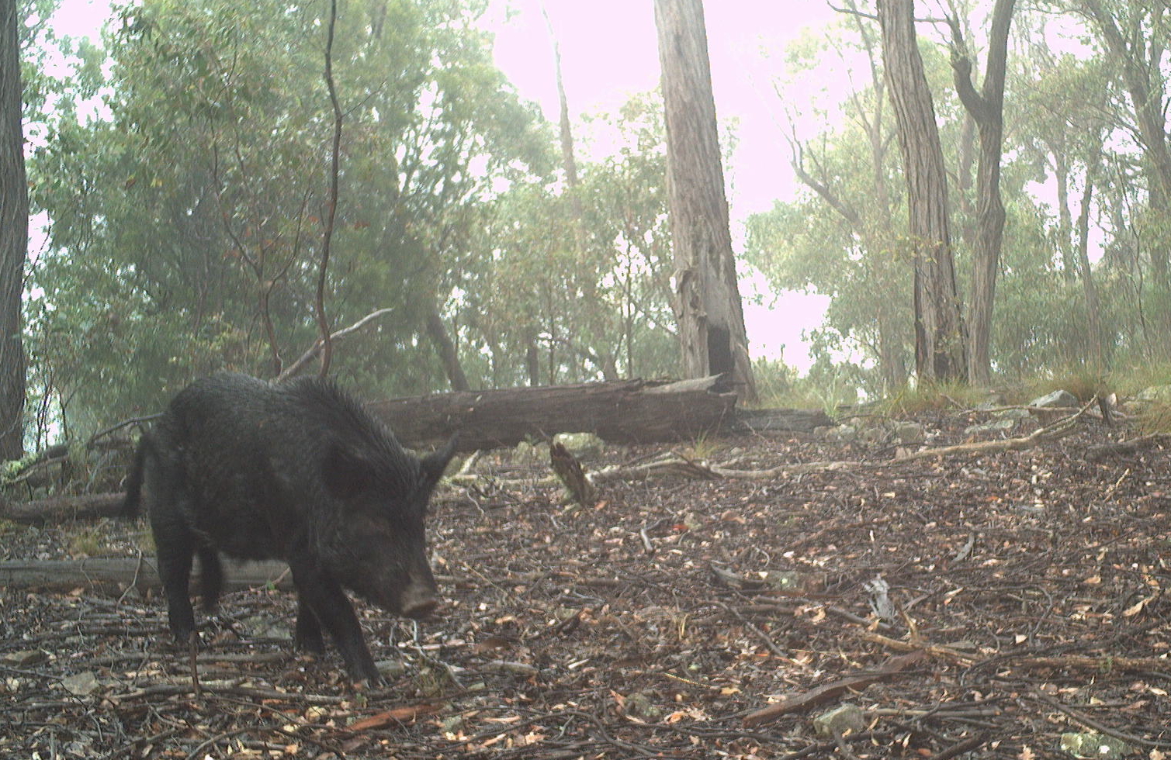


Arthur Rylah Institute for Environmental Research Technical Report Series No. 399
Risks of potential emergency animal disease transmission between Feral Pigs and farmed livestock
D.S.L. Ramsey and J.G. Cally
January 2026



Arthur Rylah Institute for Environmental Research
Department of Energy, Environment and Climate Action
PO Box 137, Heidelberg, Victoria 3084
Phone (03) 9450 8600
Website: www.ari.vic.gov.au
Citation: Ramsey, D.S.L. and Cally, J.G. (2026). Risks of potential emergency animal disease transmission between Feral Pigs and farmed livestock. Arthur Rylah Institute for Environmental Research Technical Report Series No. 399. Department of Energy, Environment and Climate Action, Heidelberg, Victoria.
Front cover photo: Feral Pig (Arthur Rylah Institute).

Edited by Fox Writing Services
ISSN 1835-3835 (pdf)
ISBN 978-1-76176-798-2 (pdf/online/MS word)

We acknowledge and respect Victorian Traditional Owners as the original custodians of Victoria’s land and waters, their unique ability to care for Country and deep spiritual connection to it.
We honour Elders past and present whose knowledge and wisdom
has ensured the continuation of culture and traditional practices.
DEECA is committed to genuinely partnering with Victorian Traditional Owners and Victoria’s Aboriginal community to progress their aspirations.
© The State of Victoria Department of Energy, Environment and Climate Action December, 2025
Creative Commons
This work is licensed under a Creative Commons Attribution 4.0 International licence, visit the Creative Commons website (http://creativecommons.org/licenses/by/4.0/).
You are free to re-use the work under that licence, on the condition that you credit the State of Victoria as author. The licence does not apply to any images, photographs or branding, including the Victorian Coat of Arms, and the Victorian Government, the Department and the ARI logos.
Disclaimer
This publication may be of assistance to you but the State of Victoria and its employees do not guarantee that the publication is without flaw of any kind or is wholly appropriate for your particular purposes and therefore disclaims all liability for any error, loss or other consequence which may arise from you relying on any information in this publication.
Accessibility
To receive this document in an alternative format, phone the Customer Service Centre on 136 186, email customer.service@deeca.vic.gov.au, or contact National Relay Service on 133 677. Available at DEECA website (www.deeca.vic.gov.au).

Risks of potential emergency animal disease transmission between Feral Pigs and farmed livestock

David S.L. Ramsey and Justin G. Cally

Arthur Rylah Institute for Environmental Research
Department of Energy, Environment and Climate Action
123 Brown Street, Heidelberg, Victoria 3084

Date

Arthur Rylah Institute for Environmental Research
Technical Report Series No. 399

Acknowledgements
We would like to thank the people who contributed camera monitoring data used for the Feral Pig survey in this study, including James Templeton (Conservation Ecology Centre), Gavin Melgaard, Luke Woodford, Thomas Schneider, Michael Scroggie (DEECA), and the team from Wildlife Unlimited. We would also like to thank Brett Mitchard (Agriculture Victoria) for providing spatial data on livestock farm locations. This project was funded by the Victorian Livestock Biosecurity Fund (projects CCF 24.02 and SGCF 24.03).

Contents
Acknowledgements ii
Summary 1
1 Introduction 3
2 Methods 5
2.1 Abundance and distribution of Feral Pigs 5
2.1.1 Sampling design 5
2.1.2 Field surveys and data collection 5
2.1.3 Supplemental monitoring data 5
2.1.4 Abundance model 5
2.2 Feral Pig disease risk to livestock 7
2.2.1 Converting Feral Pig abundance to risk 7
2.2.2 Applying a transmission kernel to determine exposure risk to farms 8
2.3 Cost-effective management of Feral Pigs to mitigate EAD risk 9
3 Results 14
3.1 Abundance and distribution of Feral Pigs 14
3.1.1 Camera trap distance sampling 14
3.1.2 Abundance model 15
3.2 Risk to livestock 18
3.3 Cost-effective Feral Pig management 22
3.3.1 Simulated FMD outbreak in Feral Pigs 22
3.3.2 Effects of disease management scenarios 22
3.3.3 Cost efficacy 24
4 Discussion 27
4.1 Relationship between the current work and the Australian Animal Disease Spread (AADIS) model 28
4.2 Conclusion 28
References 29
Appendix 33

Tables
Table 1. The relative risks of likely disease transmission to livestock from a Feral Pig source due to increasing herd size within a PIC grid cell. 9
Table 2. Parameter values used for the Feral Pig FMD model. Parameter values are per day unless otherwise specified. Min and Max values were used to incorporate the effects of uncertainty in some parameter values in the simulation model. 10
Table 3. Feral Pig management scenarios examined using the FMD epidemiological model. A total of four culling intensities were examined representing the percentage of the population culled. Response day refers to the number of days after disease incursion before management commenced. Frequency indicates either a single application of each culling intensity (once-off) or repeat application of each culling intensity every 7 days for three weeks (repeated). 12
Table 4. Model-based selection of the detection function used in CTDS. $p$ – probability of detection for a single individual, se – standard error, $∆AIC$ – difference in Akaike’s Information Criterion between the top model and alternatives. 14
Table 5. Covariate effects on the abundance process for Feral Pigs. Covariate effects with confidence intervals not overlapping zero are shown in bold. MRVBF = multi-resolution valley-bottom flatness; TWIND = Topographic Wetness Index. 15
Table 6. Abundance estimates for Feral Pigs in Victoria (total) as well as within each Department of Energy, Environment and Climate Action (DEECA) region. 16
Table 7. Number of 1-km PIC grid cells within each livestock exposure (LE) risk category (Low, Moderate, High) for different livestock species, within each region. LE is defined as the product of the (geographically weighted) risk from Feral Pig populations and the density of livestock within each PIC grid cell. 21
Table A1. Descriptions of covariates used to model Feral Pig density. 33

Figures
Figure 1. The relationship between Feral Pig densities and the risk of EAD transmission ($R$) used to model potential disease transmission risks to farmed livestock. Vertical dashed red lines indicate densities of 2, 5 and 10 pigs/km2. 8
Figure 2. Functional responses of the kill rate for aerial shooting versus Feral Pig density (left plot) and the per capita time taken per kill versus Feral Pig density (right plot). 12
Figure 3. Locations of all camera traps (n = 1,611) used in this analysis with point colour filled depending on whether pigs were detected. 14
Figure 4. Spatial variation in the density of Feral Pigs across Victoria. Grey shading includes all public land that was subject to monitoring. 17
Figure 5. Estimates of the livestock exposure (LE) for each 1-km grid cell containing livestock. Coloured points represent 1-km grid cells containing at least one domestic ungulate livestock farm. 19
Figure 6. Species-specific livestock exposure (LE) risk categories for domestic ungulate livestock species (cattle, sheep and pigs). 20
Figure 7. The progression of an outbreak of FMD in Feral Pigs over a 2-year period from the stochastic Individual-based model. Predictions show the trajectories from 500 simulated outbreaks. Solid black line – median, coloured lines – individual trajectories. N – total relative population size, S – susceptible, R – recovered, I – exposed + infected (prevalence). 22
Figure 8. Total length of outbreak (in days) for simulated FMD outbreaks, with one-off and repeated culling operations of varying intensity (0, 20, 40, 60 or 80%) at either 7 or 30 days after the initiation of the outbreak. Black points give the median, thick lines give the width of the 80% confidence interval, and thin lines give the width of the 95% confidence interval. Coloured bars give the distribution of outbreak length. 23
Figure 9. Mean number of infected pigs emigrating from the site (a measure of disease spread) for simulated FMD outbreaks under one-off and repeated aerial culling operations of varying intensity (0, 20, 40, 60 or 80%) at either 7, or 30 days after the initiation of the outbreak. Points give the median value, thick line the 80%, and thin line the 90% confidence interval, respectively. 24
Figure 10. Comparison of the costs and the efficacy (total outbreak length) under one-off and repeated aerial culling operations of varying intensity (0, 20, 40, 60 or 80%) undertaken at either 7, or 30 days after the initiation of the outbreak. 25
Figure 11. Comparison of the costs and the efficacy (number of infected pigs undertaking temporary emigration – a measure of disease spread) under one-off and repeated aerial culling operations of varying intensity (0, 20, 40, 60 or 80%) undertaken at either 7, or 30 days after the initiation of the outbreak. 26
Figure A1. Posterior predictive checks comparing summary statistics $T$ of the predicted counts of Feral Pigs for each camera under the model (Equation 1), with the observed counts. The summary statistics are the proportion of camera sites with zero counts, the mean count, the standard deviation of the count, and the maximum count. Pale-blue histograms give the distribution of the summary statistic predicted by the model $T(yrep)$, and dark-blue bars give the summary statistic for the observed counts $T(y)$. 34

Summary
Context:
Feral Pigs (Sus scrofa) pose significant threats to agriculture, biodiversity and biosecurity, and are considered to have a widespread but sporadic distribution across Victoria. However, more accurate estimates of the abundance and density of Feral Pigs in Victoria are currently hampered due to a lack of rigorous monitoring data. Feral Pigs are potential reservoirs for emergency animal diseases (EADs) such as Foot and Mouth Disease (FMD), Classical and African Swine Fever’s (CSF, ASF), and Japanese Encephalitis (JEV). Therefore, obtaining more accurate information on the distribution and abundance of Feral Pigs will be critical for managing disease transmission risks to livestock in Victoria.
Aims:
The specific aims of this project were to:
- design a statewide survey program, using remote infrared cameras, to obtain a more rigorous estimate of the abundance and distribution of Feral Pigs across Victoria
- use the spatial map of Feral Pig abundance/densities to assess risk of EAD exposure to farmed livestock from Feral Pig populations to identify high-risk areas
- evaluate cost-effective management strategies for Feral Pigs suitable for use during an EAD outbreak.
Methods:
We sampled 163 sites (1 km grid cells) across the state, primarily in public land, using a weighted random sampling design. Feral Pigs at each site were monitored using remote infrared cameras (camera traps), which were deployed for around 6 weeks. In addition to these sites, we assembled relevant monitoring data from a further 1448 sites from other camera trap surveys, which gave us a total of 1611 sites.
We used the distance of each encountered Feral Pig group from the camera to estimate density (pigs/km²) using camera-trap distance-sampling methods. This was implemented within a Bayesian hierarchical model that integrated both distance sampling and presence-absence data. A model-based approach was then used to predict the abundance of Feral Pigs across all public land in Victoria. Predictions of spatial variation in Feral Pig abundance across Victoria were used to assess the potential risk of EAD exposure to domestic livestock. This was undertaken by considering the proximity of livestock farms in relation to Feral Pig populations, and applying density-based risk models and geographic weighting to reflect how EAD exposure risk to livestock may vary spatially in relation to Feral Pig densities.
We then evaluated cost-effectiveness of management strategies for controlling a potential EAD outbreak in Feral Pigs by developing a stochastic individual-based epidemiological model to simulate an incursion of FMD in a Feral Pig population and examining the efficacy and costs of varying aerial culling strategies for reducing or eliminating the local outbreak as well as disease spread.
Results:
Feral Pigs were recorded at 85 out of 1611 camera sites with site densities ranging from 0–6 pigs/km². Monitoring results confirmed the relatively sporadic distribution of Feral Pigs, with highest densities found in north-east Victoria, the Murray River at Echuca, Hattah and Ned’s Corner, the central west around Enfield and Langi Ghiran State Parks, and in south-west Victoria around Heywood. The total abundance of Feral Pigs across 74,000 km² of public land was around 22,463 (90% CI: 14,300 – 33,599).
Highest risk to livestock from potential EAD exposure to Feral Pig populations were found in locations characterised by high numbers of livestock, especially cattle and sheep, that intersected with areas of high Feral Pig densities. Overall, 404 grid cell locations (1 km²) containing livestock farms were designated to be at high risk of EAD exposure from a Feral Pig source, with a further 1616 locations designated as moderate risk. However, the extent of the risk to livestock farms was geographically restricted and located in relatively few areas in Victoria. High-risk farms were located in the area between Bendoc and the Omeo Valley along the NSW border, the region around Beechworth, the region around Echuca and the upper Goulburn River, the area surrounding Enfield and Langi Ghiran State Parks (including Mount Buangor State Park and Ben Major Conservation Reserve), and the area around Heywood.
Simulations of an FMD outbreak in a high-density Feral Pig population (i.e. 5 pigs/km²) from the stochastic model suggested that, without control, an FMD outbreak would persist for an average of approximately 64 weeks. A one-off aerial cull initiated relatively rapidly post FMD infection (i.e. within 7 days) that removed 80% of the population was predicted to effectively eliminate the outbreak, but was also the most-costly management strategy. Lower intensity culls that removed 40% of the population repeated weekly for three weeks were predicted to be similarly effective. A one-off aerial cull that removed 60% of the population (i.e. reduced to less than 2 pigs/km²) was slightly less effective at reducing the outbreak length (mean 35 days), but was similarly effective at eliminating disease spread, and offered a good balance between efficacy and cost.
Conclusions and implications:
Feral Pigs are widely distributed across all regions of Victoria. However, the distribution is not contiguous, consisting mainly of relatively isolated, disparate populations restricted to certain areas. Spatial information on variation in Feral Pig and livestock densities identified several ‘hotspots’ where the risk of exposure of livestock to potential EAD transmission from Feral Pigs was high. In general, the isolated and sporadic occurrence of Feral Pigs across Victoria suggests that high risks to livestock from Feral Pigs are contained to relatively few areas. Therefore, rapid, high-intensity control of Feral Pigs in high-risk zones should be feasible for EAD containment in the event of an outbreak to reduce the risk of spillover (and spillback) transmission between livestock and Feral Pig populations. However, the level of control required will depend on the management response time from the initiation of the outbreak and whether it is needed to eliminate the outbreak in the minimum amount of time. Alternatively, preventive control that reduced Feral Pig populations could be considered to either locally eradicate these populations or reduce them to very low densities. Based on our modelling assumptions and previous research, reducing local Feral Pig densities to less than 2 pigs/km² should greatly reduce the risk of a prolonged outbreak of EADs such as FMD, CSF or ASF in Feral Pig populations.

- Introduction
Feral Pigs (Sus scrofa) are one of the most widespread pest animals in Australia causing significant agricultural, environmental and economic damage (Choquenot et al. 1996; Bengsen et al. 2017). They are also a significant potential reservoir for emergency animal diseases (EADs) including African Swine Fever (ASF), Classical Swine Fever (CSF), Japanese Encephalitis (JEV) and Foot and Mouth Disease (FMD) and consequently, pose significant risks to the livestock industry in the event of an exotic disease incursion (Pech and Hone 1988; Cowled et al. 2012; Pearson et al. 2016; Bradhurst et al. 2025). The impact of EADs on the economy, environment and community may be severe. For example, estimates suggest that an outbreak of FMD could have a direct economic impact of around $80 billion in Australia (ABARES 2022).
Management of any EAD outbreak in Australia operates at both the state and federal levels of government. The Victorian Government has developed The Victorian Government State Emergency Animal Disease Response Plan, which provides an overview of the arrangements for the management of a major EAD emergency in Victoria, and contains information on mitigation, preparedness, response and relief (DEECA 2023). Animal Health Australia also publishes the nationally agreed approach for the response to EAD incidents in Australia, through The Australian Veterinary Emergency Plans (otherwise known as AUSVETPLANs). These focus mostly on livestock, but also cover responses for wild animals that are a reservoir for disease likely to have impacts on human health or the economy (AHA 2023).
To quantify the potential risk of EAD transmission between livestock and Feral Pigs, it is essential to have up-to-date information on the distribution and abundance of Feral Pigs across the state, especially in relation to the locations of farmed livestock. Information on Feral Pig densities can also be used to assess whether they are above or below threshold values for establishment of an exotic infectious disease (May and Anderson 1979; Pech and Hone 1988; Hone 2019). At a national level, the abundance of Feral Pigs was estimated between the 1980s and 2000s from 142 different localised studies with estimates ranging from 3.0 to 4.4 million pigs nationally at an average density of 1.03 pigs/km² (Hone 2019). However, most of the studies used in that estimate were from New South Wales (NSW), Queensland and the Northern Territory, with no studies reported from Victoria. Feral Pigs are known to occur in all major ecological regions in Victoria, although their underlying densities are largely unknown and there remains potential for their spread and increase in abundance in many parts of the state, in some cases aided by illegal transportation and release (e.g. Spencer and Hampton 2005).
Obtaining robust estimates of density and abundance of wildlife populations over large spatial scales is challenging and costly due to a lack of suitable monitoring methods and tools that can scale over large geographic areas (Mason et al. 2022). The advent of remote infrared cameras (camera traps) has revolutionised biodiversity monitoring by providing a relatively low-cost tool that can record the presence of animals over extended periods of time (Meek and Fleming 2014). As the use of camera traps in wildlife monitoring programs has expanded, so has the development of analytical methods for estimating animal density and abundance from camera records. A recently developed method for estimating animal density from camera trap data, camera trap distance sampling (CTDS), applies point distance sampling methods to camera trap images to correct for imperfect detection of animals with increasing distance from the camera (Howe et al. 2017). This method has recently been applied to estimate the density of four deer species over all public land in Victoria, using a hierarchical Bayesian model to analyse data from 357 cameras (Cally and Ramsey 2023). Camera trap distance sampling methods have been shown to give unbiased estimates of animal density when the camera records adhere to the assumptions under the model (Gilbert et al. 2021; Palencia et al. 2021; Wiegers et al. 2025).
Several modelling studies have shown that outbreaks of EADs such as FMD in livestock are considerably larger and of longer duration when the outbreaks also involve transmission between livestock and Feral Pig populations (Ward et al. 2015; Bradhurst et al. 2025). Conversely, including Feral Pig control along with disease control in livestock resulted in smaller outbreaks and reduced times to achieve disease eradication. Higher densities of Feral Pigs also invariably resulted in more frequent spillover and more severe outbreaks in livestock (Bradhurst et al. 2025). However, modelling has also generally indicated that control of FMD in livestock would generally result in disease fadeout in Feral Pig populations (Ward et al. 2015; Bradhurst et al. 2025).
Given the potential role of Feral Pigs in the epidemiology of EADs affecting livestock, control of Feral Pigs should be considered as part of any EAD response strategy (Cowled and Garner 2008). Although modelling has indicated that FMD is unlikely to persist in Feral Pig populations, in the absence of other spillover transmission, it would still be desirable to understand what level of Feral Pig control would most cost-efficiently reduce or eliminate FMD or other EADs, in Feral Pig populations, especially in populations with densities higher than those examined in previous modelling studies. The costs of Feral Pig control increase non-linearly with reductions in Feral Pig density due to rapid increases in search effort required as density decreases (Choquenot et al. 1999; Hamnett et al. 2024). During an EAD incursion into livestock, an option for management may be to pre-emptively reduce Feral Pig populations to reduce the likelihood of spillover infection from livestock and subsequently reduce the likely size and duration of the outbreak. In addition, it would also be advantageous to know the level of effort required to cost-effectively reduce or eliminate any EAD outbreak in Feral Pigs in the minimal amount of time.
The objectives of this project are therefore, to undertake an extensive monitoring program, using camera traps, to estimate the abundance, densities and distribution of Feral Pigs across Victoria. This information will then be used to identify areas in Victoria where domestic livestock farms are at high risk of exposure to potential disease transmission from/or to, Feral Pig populations. For areas of high potential risk, we will also investigate options for the management of Feral Pig populations, and their cost, to mitigate this risk.

- Methods
  - Abundance and distribution of Feral Pigs
    - Sampling design
Feral Pigs are thought to have a variable and sporadic distribution across Victoria. Consequently, a random sampling design that was weighted to known areas of Feral Pig habitat enabled us to maximise encounters with pigs in suitable habitat while still allowing a broad geographic coverage across Victoria. Sampling weights were primarily derived from a national Feral Pig distribution (ABARES and CSIRO 2024). In addition, we filtered out areas that were composed of the following landuse classes that were not suitable pig habitats: Unclassified, Built up, Urban, Disturbed ground, Dryland cropping, and Saltmarsh (White et al. 2020). To ensure sample locations were accessible by field crews, 1-km² sample grid cells were filtered so that they were within 500 m of the nearest road and containing some publicly accessible land. Finally, in collaboration with the Hume region of DEECA, we were able to more intensively sample an area in the north-east of the state suspected of harbouring high densities of Feral Pigs. Broadly, this area consisted of the forested areas surrounding Beechworth, Myrtleford and Yackandandah. To enable more intensive sampling of this area, we multiplied sample weights in this area by 25. The resulting weighted random sample consisted of 163, 1-km² grid cells, 31 of which were in the north-east area of the state.
    - Field surveys and data collection
Between March and April 2025, camera traps were deployed at all 163 sample locations. Camera traps were deployed for between 41 and 76 days (mean = 49 days). Reconyx HF2X camera traps were deployed at a height of 1 m and set to Rapidfire motion triggered shooting (5 photos per trigger). The sensitivity of the camera was high with no quiet period. Reference images were taken during camera trap setup at distances of 2.5 m, 5 m, 7.5 m and 10 m from the camera, which consisted of a person holding a sign stating the distance in the centre of the camera’s field of view. These reference images were subsequently used to manually or semi-automatically estimate distance to animals that triggered the camera (Haucke et al. 2022; Henrich et al. 2023). These data can then be used to estimate the density of pigs at each site using CTDS methods (Howe et al. 2017) (see section 2.3.1).
Camera trap images had metadata tags designated for species, number of individuals in the photo, distance of closest individual from the camera, and any un-natural behaviour (e.g. interaction with camera) – because these may bias density estimates (Henrich et al. 2022). Data were tagged in DigiKam or Lightroom Classic with metadata extracted using the camtrapR R package (Niedballa et al. 2016). The metadata and tags for the camera trap images were written to a postgresql database alongside site information that was collected in-field.
    - Supplemental monitoring data
Given the sparsity of Feral Pig records in Victoria, we were able to supplement these camera trap distance sampling surveys with several other distance-sampling and presence-absence camera trap surveys. These surveys were conducted between 2021 and 2025 across seven different projects, four of which used camera trap distance-sampling. In total, data from an additional 1,448 sites was incorporated into the analysis giving us 667 distance-sampling sites and 944 presence-absence sites, for a total of 1,611 sites.
    - Abundance model
We used an integrated modelling approach to combine multiple data structures (CTDS and repeated nightly presence-absence records from camera traps) into a single statistical model that simultaneously predicts occupancy and abundance. We were able to estimate Feral Pig density and abundance at each site using a Bayesian hierarchical modelling approach (Royle and Dorazio 2008; Delisle et al. 2023). We used a range of informative environmental, climatic, and regional-based covariates to predict the estimated abundance/density of pigs at sampled locations and then used the model to predict Feral Pig abundance across 74,902 km² of suitable public tenured land. These grid-based predictions were then summed to provide regional and statewide estimates of Feral Pig abundance.

Camera trap distance sampling (CTDS)
CTDS estimates the detection probability of a detected animal group as a function of distance from the camera (out to a truncation distance) by fitting a detection function to the distance data. This detection function is derived from the distances of the pigs from the camera, whereby detection of individuals declines with increasing distance from the camera (Howe et al. 2017). This method assumes camera locations are independent of animal locations at a site (𝑖) for a time period (𝑇_{i}) and records images for as long as an individual is present to trigger the camera. Images are then obtained at a predetermined set of ‘moments’, 𝑡 units of time apart (snapshot instants). Temporal effort at each camera is then calculated as 𝑇 ⁄ 𝑡. Howe et al. (2017) recommended that a useful range for 𝑡 is 0.25 to 3 seconds, with values at the lower end being more suitable for fast-moving or rarer species. For our analysis, we used a snapshot instant (𝑡) of 2-second intervals. Given the camera covers a horizontal angle of view of 𝜃 radians, then the fraction of the circle visible by the camera field of view is 𝜃 ⁄ 2𝜋. Therefore, data consist of a set of snapshot instants captured 𝑡 units of time apart, with the overall sampling effort at each site 𝑖 expressed as (𝜃𝑇_{i})/2𝜋𝑡 (Howe et al. 2017).
In this study, we compared the fit of four detection functions to the distance sampling data based on half-normal and hazard-rate functions with and without cosine adjustments. The best-fitting detection function was chosen using AIC (Burnham and Anderson 2004) in the ‘Distance’ R package (Thomas et al. 2010). We then used this model formula in the Bayesian hierarchical model for abundance (see below). For all sites, the average estimated detection probability ${\hat{p}}_{i}$ (up to 12.5 m) was then included in the abundance model to account for imperfect detection of pigs in the camera counts (see below).
The count of the number of snapshot moments of pig images at a site was modelled as a function of variables representing spatial variation, relative frequency of group sizes, distance-sampling detection probability, survey effort (area in front of camera multiplied by the total snapshot moments the camera was deployed for) and proportion of time within a 24-hour cycle that pigs were active (Equation 1). We accounted for the excess of non-detections (zero counts) in the data by using a zero-inflated Poisson distribution. Therefore, snapshot moment camera counts at site $i$ were assumed to be a realisation of a zero-inflated Poisson (ZIP) process.
$$\begin{aligned}C_{i} \sim \left\{\begin{matrix}\text{Poisson}\left(λ_{i}∙p∙A∙g_{ij}∙e_{i}\right) & , \text{with probability} ψ_{i} \\ 0 & \text{, with probability} 1-ψ_{i}\end{matrix}\right.\#1\end{aligned}$$
Where $C_{i}$ are the counts of the Feral Pig snapshot moments at site $i$, $λ_{i}$ is the expected abundance in grid cell $i$ and $ψ_{i}$ is the probability that the grid cell was occupied. Furthermore, $p$ is the average detection probability derived from the distance sampling data, with $g_{ij}$ the variable representing the effect of group sizes ($j$) on detection. Additionally, $A$ is an estimate of relative pig activity within a 24-hour period, representing the proportion of time a given individual was active and potentially available for detection (e.g. not resting or sleeping). Estimation of this parameter is important to guard against availability bias, which may result in underestimates of density (Corlatti et al. 2020). $A$ is estimated by fitting a kernel density estimate to the image capture times (in radians). The area under the kernel density estimate is used as the estimate of $A$ (Rowcliffe et al. 2014), and was included in the Bayesian hierarchical model using an informative beta prior. Finally, $e_{i}$ is the sampling effort at site $i$ as described above.
A ZIP formulation allowed for pig distribution and abundance to be modelled as two separate processes, a process governing the probability the grid cell was occupied and an abundance process, given a grid cell was occupied. The abundance process was informed by solely the CTDS surveys, while the occupancy (zero-inflation) process was informed by both CTDS surveys and presence-absence camera trap records. Effects of each environmental variable (E ) on the expected abundance at site $i$ were incorporated using a log-linear model, such that:
$$\begin{aligned}{log⁡(λ}_{i})= β_{0}+ \sum_{k=1}^{n}{β_{k}}E_{i,k},\#2\end{aligned}$$
where $β_{0}$ is the intercept and $β_{k}$ are regression coefficients for the $n$ respective environmental variables $E_{k}$ ($k=1,…,n$). We used a range of informative environmental, climatic, and regional-based covariates to predict the estimated abundance/density of pigs at sampled locations. A description of the variables included in the model is provided in the Appendix (Table A1). Before model fitting, each continuous environmental variable was standardised by subtracting the mean and dividing by the standard deviation. Jointly, the probability of occupancy was modelled as:
$$\begin{aligned}\text{logit}\left(ψ_{i}\right)= GP\left(α_{0},K_{i,\acute{i}}\right)\#3\end{aligned}$$
Where GP represents a multivariate Gaussian process with mean parameter $α_{0}$ and covariance function $K_{i,\acute{i}}$ where $K$ represents the covariance between grid cell location $i$ and $\acute{i}$. Therefore, the GP function represents a spatial random effect. This was found to be more appropriate for modelling the occurrence of Feral Pigs on the landscape due to their patchy distribution, which was difficult to predict using relationships with environmental variables as the provenance of some populations was uncertain. For computational efficiency grid cells in the Gaussian process were aggregated to a 5-km² grid.

Abundance estimation
The model in Equation’s 1–3 was estimated in a Bayesian framework using Hamiltonian Markov Chain Monte Carlo (MCMC) methods in Stan (version 2.21.2) from within R using RStan (Carpenter et al. 2017). Weakly informative prior distributions were used for most parameters in the model specified as $N\left(0, 2.5\right)$. Informative prior distributions were used for the Gaussian process parameters and the scale parameter of the distance sampling detection function. A total of 1000 iterations were run for the model using five chains, with the first 500 iterations considered to be ‘warmup’ (tuning) iterations and discarded. This left a total of 2500 samples for each parameter to form inference. We judged convergence of the posterior distribution of the parameters based on visual inspection of traceplots and estimates of the Brooks–Gelman–Rubin convergence criterion $\hat{R}$ from three independent chains (Brooks and Gelman 1998). We assessed model fit by conducting posterior predictive checks (Gelman et al. 1996), which involved comparing the number of camera counts at each site with the corresponding number predicted by the model.
The fitted model was then used to predict Feral Pig abundance across 74,902 km² of public land in Victoria. Abundance predictions were made on a 1-km² grid, with predictions accounting for the proportion of the 1-km² grid cell that was suitable publicly tenured land.
  - Feral Pig disease risk to livestock
We used the predictions of the spatial variation in Feral Pig density and abundance across Victoria to assess the exposure of livestock farms to potential EAD transmission from a Feral Pig source. This was undertaken by considering the proximity of livestock farms in relation to Feral Pig populations, and applying density-based risk models and geographic weighting to reflect how EAD exposure risk may vary spatially in relation to Feral Pig densities.
    - Converting Feral Pig abundance to risk
It is likely that the risk ($R$) of transmission of an EAD from Feral Pig populations to livestock (and vice versa) scales with Feral Pig density (May and Anderson 1979). We assumed that the relative risk scaled non-linearly with Feral Pig density by applying a generalised logistic function (Equation 4).
$$\begin{aligned}R\text{ = }1/{\left(1+\text{exp}{\left(\text{-β∙}\left(N\text{-ζ}\right)\right)}^{\left(1/λ\right)}\right)}\#4\end{aligned}$$
Where $R$ is the relative risk and $N$ is the Feral Pig density (pigs/km²). The other parameters control the shape of the curve, where $\text{β}$ is the slope parameter, $ζ$ is the inflection point and $λ$ governs the degree of asymmetry. This transformation assumes that, above a certain pig density, the risks to livestock saturate (Ward et al. 2007). To determine appropriate values for the slope and shape parameters, we assumed that Feral Pig disease transmission risks were relatively low below 2 pigs/km², which then increased rapidly between 2 and 5 pigs/km² with high risks occurring at densities above 5 pigs/km² (Figure 1). These density-risk relationships were based on previous studies on the epidemiology of EADs such as FMD (e.g. Pech and Hone 1988), which suggested densities of 2 to 14 pigs/km² were required for FMD establishment. Supporting this, modelling has also shown that FMD does not persist in Feral Pigs when densities are less than 2/km² (Ward et al. 2015). Similarly, modelling suggested that CSF could establish in Feral Pigs at densities of 6.1 pigs/km² (Hone et al. 1992).
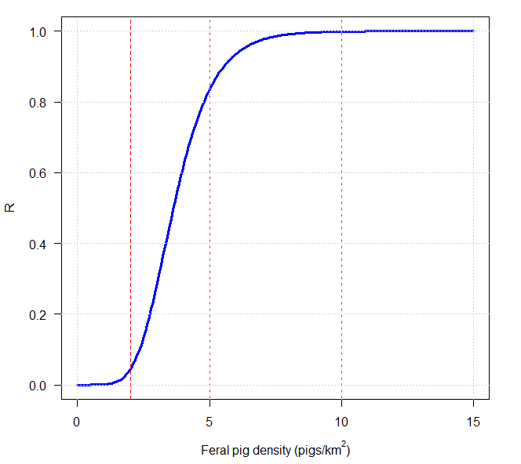
Figure 1. The relationship between Feral Pig densities and the risk of EAD transmission ($R$) used to model potential disease transmission risks to farmed livestock. Vertical dashed red lines indicate densities of 2, 5 and 10 pigs/km2.

    - Applying a transmission kernel to determine exposure risk to farms
We used a spatial dataset of de-identified property identification codes (PICs) summarised into a 1-km² grid with values representing the estimated total livestock (herd size) across eight ungulate species. This dataset is curated by Agriculture Victoria, as part its livestock identification program. Our goal was to determine the exposure risk to livestock from potential EAD transmission from Feral Pigs.
Exposure and risk to livestock at a farm/PIC from an EAD is anticipated to be dependent upon intrinsic factors at that location such as species, number and density of livestock, as well as their proximity to infected animals (e.g. Feral Pigs) (Keeling et al. 2001; Tildesley et al. 2012). Other factors, such as farm biosecurity, likely also play a role in the risk. We quantified the risk, hereafter defined as the livestock exposure (LE) risk, from potential EAD transmission from Feral Pig populations. We derived estimates of the spatial risk based on previous work investigating the spread of FMD in the UK in 2001 (Keeling et al. 2001; Tildesley et al. 2012). Our model estimates LE for a given grid cell containing one or more PICs as a product of Feral Pig densities in that grid cell (as well as neighbouring grid cells), the density of livestock species in that grid cell, and the relative susceptibility of each livestock species to EAD infection (e.g. from FMD).
Livestock density and susceptibility is weighted according to a transmission kernel that accounts for the proximity of the PIC grid cell to surrounding grid cells with non-zero densities of Feral Pigs. For this purpose, we used a half-normal transmission kernel ($K$) that has a strong local spread and sparser transmission risk with increasing distance ($d$) defined as follows:
$$\begin{aligned}K\left(d\right)=exp\left(\frac{d^{2}}{{2σ}^{2}}\right)\#6\end{aligned}$$

$$\begin{aligned}σ=\frac{r_{1/2}}{{\left(2 log⁡(2)\right)}^{0.5}}\#7\end{aligned}$$
Where $d$ is the distance from the focal PIC grid cell to neighbouring grid cells, $r_{1/2}$ is the distance at which the risk halves, and $σ$ is the half-normal shape. The parameter $r_{1/2}$ was set to 2.5 km. This results in a decay in the exposure of a PIC to a Feral Pig source to near zero at around 5 km and is similar to the transmission kernels used in Bradhurst et al. (2025). To apply the kernel-weighted risk at a given grid cell with one or more PICs ($j$), we calculated the kernel for all surrounding grid cells ($c$) and summed the product of the kernel density value and the respective Feral Pig density risk score (R) for a given grid cell (c) across all grid cells within 10 km ($G_{w}$). This produced a kernel-weighted Feral Pig pressure ($W$) for each PIC cell ($j$)$.$
$$\begin{aligned}W_{j} = \sum_{c∈G_{w}}{R_{c}} K\left(d_{jc}\right) \#8\end{aligned}$$
Additionally, we also assumed that disease transmission risk for each PIC grid cell would increase proportionally with herd size within each cell. Since herd sizes for the various livestock species within each PIC grid cell varied by several orders of magnitude, we converted herd size to a relative risk score ($L$), to reflect the likely increasing transmission risks (Table 1).
Table 1. The relative risks of likely disease transmission to livestock from a Feral Pig source due to increasing herd size within a PIC grid cell.
Herd size | Relative risk ($L$)
1–100 | 1
101–500 | 5
501–1000 | 10
1001–5000 | 20
>5000 | 50

Consequently, the risk of disease transmission from Feral Pigs to a PIC grid cell with a herd size > 5000 was 50 times higher than for a herd size of 100 or less. Each herd size risk score ($L$) was further modified to account for likely differences in the relative susceptibility to EADs (such as FMD) by including a species-specific multiplier to account for variable susceptibility between livestock species ($S_{s}$). Therefore, the total herd size risk score ($H$) for each PIC grid cell was calculated as the sum of all the risk scores for each livestock species.
$$\begin{aligned}H_{j} = \sum_{S}{S_{s}} L_{s,j}\#9\end{aligned}$$
For this purpose, all the relative susceptibilities ($S$) for each livestock species were set to 1, with the exception of domestic pigs, which was set to 10. However, depending on the particular EAD of interest, other susceptibility values can easily be accommodated.
Finally, the total livestock exposure ($LE$) for any given PIC grid cell was calculated as the product of the Feral Pig disease pressure and herd risk score as:
$$\begin{aligned}{LE}_{j}= H_{j}× W_{j}\#10\end{aligned}$$
The livestock exposure risk for a grid cell (${LE}_{j}$) could potentially vary widely, depending on the proximity and density of Feral Pig populations as well as herd size. We summarised the resulting continuous measures of ${LE}_{j}$ into risk categories to assist in interpreting the spatial variation in exposure risk. For this purpose, the top 1% of ${LE}_{j}$ values were classified as ‘High’ risk (i.e. 99% quantile), the top 95–99% of values classified as ‘Moderate’ risk, with the remaining values classified as ‘Low’ risk. All calculations were undertaken in R version 4.5 (R Development Core Team 2020).
  - Cost-effective management of Feral Pigs to mitigate EAD risk
We used modelling to investigate the level of management intervention, and the likely costs required to mitigate the potential for an EAD outbreak in a Feral Pig population. We developed a mathematical model of disease transmission to investigate the potential outbreak of an EAD in a Feral Pig population and used the model to investigate the cost effectiveness of various disease mitigation strategies. There are many different ways to model the dynamics of disease outbreaks in natural populations that vary in the level of complexity involved (e.g. Keeling and Rohani 2008). For the purposes of this study, we chose relatively simple host-disease compartment models (e.g. Kermack and McKendrick 1927; May and Anderson 1979). Simple host-disease compartment models typically consider a local population of individuals of a given size, where the population can be divided into different groups or ‘compartments’ based on their disease status (susceptible, infected, recovered, etc). The number of individuals in each compartment change as susceptible individuals become infected and recover. While relatively simple, these models are still one of the most popular ways of investigating the transmission of disease in populations (Vynnycky and White 2010). We describe our chosen model representation in more detail below.
For the purposes of the modelling, we chose to model the incursion of FMD into a Feral Pig population as a representative EAD case study. FMD is a highly contagious viral disease of cloven-hoofed animals, including pigs, cattle, sheep, goats and deer. While the disease is not usually fatal to adult individuals the symptoms include fever and vesicles (blisters) on the feet and in the mouth causing serious losses in productivity. FMD is typically spread through close contact with infected individuals and/or other objects (fomites) that have been in close contact with infected individuals.
Pigs are particularly susceptible to FMD infection and have the potential to excrete large amounts of airborne virus. As Australia has not had an FMD epidemic in over 100 years, the role of Feral Pigs in an outbreak of FMD in Australia is largely unknown. However, some investigations of FMD outbreaks in Feral Pigs have been explored using modelling (Pech and Hone 1988; Dexter 2003; Ward et al. 2015; Bradhurst et al. 2025). A deterministic model of FMD incursion into a Feral Pig population by Pech and Hone (1988) suggested that Feral Pigs densities in excess of 2.3 pigs/km² would be sufficient for the disease to spread and persist within a local Feral Pig population. However, more recent studies using stochastic spatial models of outbreaks of FMD in Feral Pigs and livestock at larger scales suggested that, if FMD is controlled in domestic livestock, it will be unlikely to persist in Feral Pigs (Ward et al. 2015; Bradhurst et al. 2025).
We constructed a stochastic, individual based model for FMD in Feral Pigs based on the model of Pech and Hone (1988). This model was constructed from the following differential equations:
$$\frac{dS}{dt}=\left(b-d-gN\right)S- βSI+ωR \\ \frac{dE}{dt}=βSI- \left(d+gN+σ\right)E \\ \frac{dI}{dt}=σE- \left(α+d+gN+υ\right)I \\ \frac{dR}{dt}=υI+\left(b-d-gN-ω\right)R \\ N=S+E+I+R$$
Where $S$ are susceptible, $E$ are exposed (latent), $I$ are infectious and $R$ are recovered individuals. The parameter $b$ is the density-independent per capita birth rate and $d$ is the density-dependent per capita minimum death rate, with $g$ governing the strength of density-dependence. This notation differs slightly from the notation given in Pech and Hone (1988), but uses much of the same parameter values (Table 2). The exception was for the estimates for the latent and infectious periods, which used mean values of 1 and 8 days, respectively, and the disease mortality rate, which was assumed to be 5% over the course of an outbreak (Bradhurst et al. 2025). Based on the values for the infectious period and mortality rate, the estimates for the corresponding values for the recovery rate ($ν$) and disease-induced mortality rate ($α$) were 0.12 and 0.0063, respectively.
Table 2. Parameter values used for the Feral Pig FMD model. Parameter values are per day unless otherwise specified. Min and Max values were used to incorporate the effects of uncertainty in some parameter values in the simulation model.
Parameter | Description | Values (day⁻¹) | Min. | Max.
$$b$$ | Per-capita birth rate | 0.0025 | - | -
$$d$$ | Minimum per-capita death rate | 0.00089 | - | -
$$g$$ | Strength of density-dependence | 0.00011 | - | -
$$β$$ | Transmission rate | 0.026 km² | 0.013 | 0.077
$$σ$$ | Latent period (1/$σ$) | 1 day | - | -
$$υ$$ | Infectious period (1/$ν$) | 8 days | 6 | 10
$$α$$ | Disease-induced mortality rate | 0.0063 | - | -
$$ω$$ | Immunity period (1/$ω$) | 120 days | 90 | 180
$$K$$ | Carrying capacity | 500 pigs | - | -
$$η$$ | Temporary emigration rate | 0.05/year | 0.01 | 0.1

The model was formulated initially as a deterministic ordinary differential equation (ODE) model (Vynnycky and White 2010). However, deterministic models are likely to underestimate the impacts of disease control on small populations where the influence of ‘chance events’ may result in an increase in disease extinction risks. To capture uncertainty around the impacts of an FMD incursion in the population, it was necessary to develop a stochastic version of the deterministic model. The stochastic approach used here was to recast the deterministic equations as an individual-based model (IBM) incorporating demographic stochasticity (Keeling and Rohani 2008). This approach simulates the fates of individuals with each individual subject to competing ‘events’ (e.g. births, deaths, infection, and recovery). Events occur in continuous time and incorporate stochastic outcomes by simulating a random time-to-the-next-event based on the underlying rate for that event. The times for each event type are then sorted in chronological order, with events occurring before the next ‘time horizon’ (e.g. 1 day) queued for processing. For example, if the transmission rate of a disease is given by $λ$, then a random time to the next transmission event is generated using:
$$∂t=\frac{-\text{log}\left(U\right)}{λ}$$
Where $U$ is a random uniform deviate [0,1] and $∂t$ is the time elapsed until the infection event occurs. If $∂t$ is less than the time horizon (i.e. 1 day), then the infection event occurs for that individual. This equation assumes that all events can be described as stochastic competing Poisson processes. This type of stochastic model is generally termed an ‘event driven’ model and is one of the most popular ways of incorporating demographic stochasticity into simulation models (Keeling and Rohani 2008).
One additional feature to the IBM model was included by indicating whether individuals had undertaken temporary emigration outside the population. Temporary emigration is defined as individuals leaving and then returning to the focal population during some period of time (e.g. Kendall et al. 1997; Chandler et al. 2011). Feral Pigs are known to occasionally undertake long-distance movements outside their home range (Caley 1997), which could facilitate disease spread. Although the model did not simulate actual movement of individuals, the model allowed individuals to be subject to ‘temporary emigration’ events, which signified that they had made a foray outside the population. We assumed that 5% of individuals per year could undertake long distance ‘temporary emigration’ movements (e.g. Cowled et al. 2012) with the number of daily temporary emigration events simulated as detailed above. Temporary emigration events that occurred for ‘exposed’ or ‘infected’ individuals were then tallied for each simulation. Therefore, a higher number of infected individuals recorded undertaking temporary emigration were used as an index of potential disease spread.
In addition to demographic stochasticity, we also included the effects of parameter uncertainty for some parameters, notably the disease transmission rate ($β$), the recovery rate ($ν$), the period of natural immunity ($ω$) and the frequency of temporary emigration ($η$). These were varied by providing minimum, most likely and maximum plausible values and then generating random values of these for each simulated outbreak using BetaPERT distributions (Table 1). All simulations of the model were undertaken in R using custom written functions.
This stochastic IBM model had the following set of assumptions:
- The model represented a discrete population of Feral Pigs and therefore, assumed that the population was closed to immigration and emigration. However, we explored the likelihood of disease spreading to any neighbouring Feral Pig populations by allowing some individuals to undertake an ‘temporary emigration’ to a putative neighbouring population.
- Transmission of disease was considered to be density-dependent, which assumed disease transmission scaled linearly with host density (McCallum et al. 2001).
- With respect to disease transmission, each population was assumed to be homogenously mixed. This was tantamount to saying that contact rates among individuals in the population were similar.
- Host dynamics of Feral Pigs were generally assumed to be subjected to population regulation, governed by density-dependence in the birth rate (e.g. Bellows 1981; Barlow 2000).

Disease mitigation scenarios
We assessed the impact of potential disease mitigation actions for eradicating an FMD outbreak within a Feral Pig population by conducting simulations based on a hypothetical population of Feral Pigs inhabiting a 100-km² area of mixed forest/agricultural habitat at a density of 5 pigs/km². We then simulated an incursion of FMD into the population and then investigated the level of management intervention (i.e. effort and cost) required to eradicate the outbreak. We also investigated the efficacy of various management scenarios for limiting disease spread to neighbouring Feral Pig populations through temporary emigration of infected individuals.
Feral Pig control was assumed to be undertaken primarily through aerial shooting, which has been shown to be the most effective method for Feral Pig control in mixed forest/agricultural habitat, especially when combined with thermal detection devices (Hamnett et al. 2024). We examined various intensities of aerial control that removed a proportion of the total population at varying times after the introduction of the disease representing rapid or slower response times to the outbreak. For these scenarios, we examined culling intensities varying between 20 and 80% of the population being removed by control, with the culls initiated either 7- or 30-days post FMD incursion (Table 3). In addition, we also examined repeated culls where each culling intensity was repeated every 7 days over a 3-week period again initiated either 7- or 30-days post FMD incursion (Table 3).
Table 3. Feral Pig management scenarios examined using the FMD epidemiological model. A total of four culling intensities were examined representing the percentage of the population culled. Response day refers to the number of days after disease incursion before management commenced. Frequency indicates either a single application of each culling intensity (once-off) or repeat application of each culling intensity every 7 days for three weeks (repeated).
Response day | Culling intensities (%) | Frequency
7 | 20, 40, 60, 80 | Once-off
30 | 20, 40, 60, 80 | Once-off
7 | 20, 40, 60, 80 | Repeated
30 | 20, 40, 60, 80 | Repeated

For each management scenario, we calculated the likely cost of the control operation based on a relationship between the helicopter search time and Feral Pig density and the hourly cost of a single helicopter shooting team. The hourly operation of the helicopter, shooting team and associated costs were estimated as $3500 per hour, based on a similar cost analysis for aerial deer control (Bengsen et al. 2022). However, the hourly cost does not include other fixed and variable costs that might also be incurred when conducting aerial shooting operations. Nevertheless, the variable cost calculation used should be suitable for gauging the relative cost-effectiveness of various strategies.
The kill rate of Feral Pigs through aerial shooting was dependent on Feral Pig density, which assumed that the kill rate declined as Feral Pig density declined according to a functional response (Choquenot et al. 1999; Bengsen et al. 2022) (Figure 2). Equally, this meant that per-capita costs of Feral Pig control were also dependent on Feral Pig density (Choquenot et al. 1999). We assumed a functional form of the relationship between the kill rate and per capita costs of Feral Pig control similar to that identified by Choquenot et al. (1999). These relationships suggest that the per-capita search time (time per kill) increases rapidly once Feral Pig density is reduced below 3 pigs/km², with per-capita search time at 0.5 pigs/km² assumed to take approximately 1 hour (Figure 2).

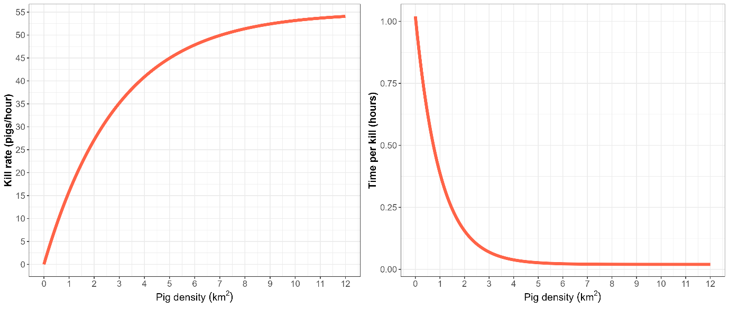

Figure 2. Functional responses of the kill rate for aerial shooting versus Feral Pig density (left plot) and the per capita time taken per kill versus Feral Pig density (right plot).

We simulated the total time required to achieve a fixed proportional reduction in Feral Pig density by progressively removing single pigs from the population, calculating the corresponding search time and then re-calculating the marginal change in pig density. This was repeated for every removal event until the required proportional reduction in the population was achieved. This sequential accumulation of search time should more closely mimic the actual changes in search effort experienced during aerial shooting operations. The total cost was then calculated by summing up search times (in hours) for each pig removed and multiplying by the hourly operational cost.
For each management scenario, simulations were conducted by initiating FMD infection in a single pig at time zero, with simulated outbreaks allowed to run for a total of two years (730 days). In addition to the cost, for each scenario we also recorded the time of the last infection (i.e. total length of the outbreak), the peak FMD prevalence reached and the number of infected pigs that undertook temporary emigration from the population (a measure of likely spread to neighbouring populations).

- Results
  - Abundance and distribution of Feral Pigs
We detected Feral Pigs at 85 camera sites out of all 1,611 camera sites that were used in this study. Seventy-nine (79) out of the 667 camera sites that employed CTDS recorded pigs with 24 out of the 163 camera sites from this study’s designated fieldwork detecting pigs (Figure 3).

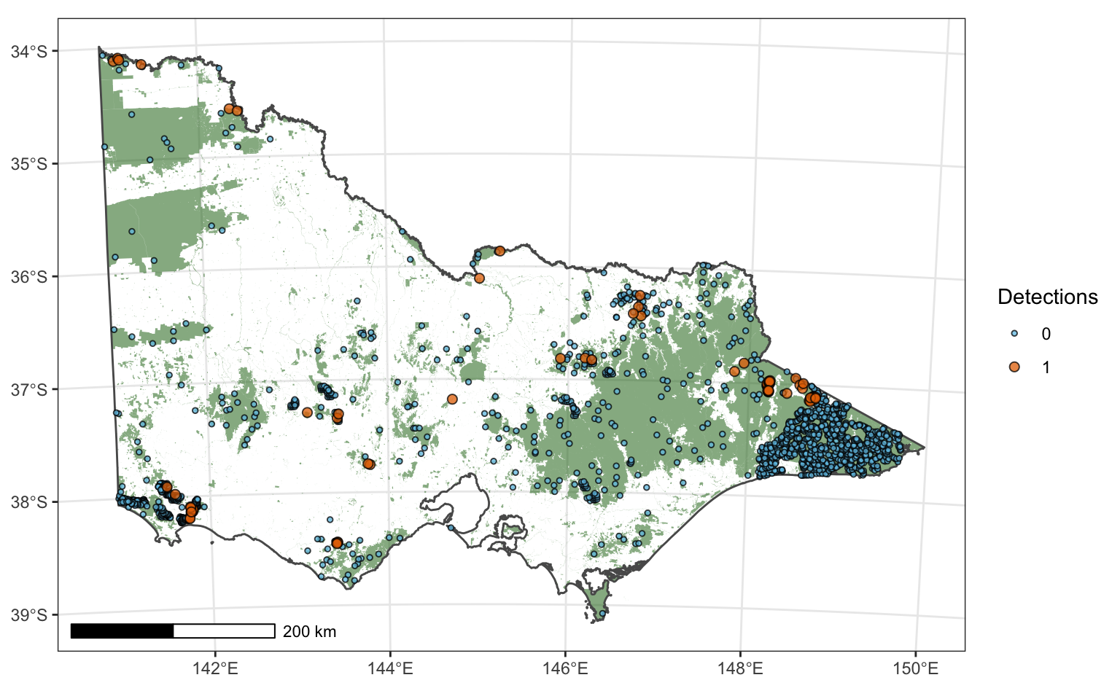
Figure 3. Locations of all camera traps (n = 1,611) used in this analysis with point colour filled depending on whether pigs were detected.

    - Camera trap distance sampling
We compared the predictive performance of four distance-sampling detection models (when group size = 1). The top performing model (according to AIC) was a half-normal function with a second-order cosine adjustment (Table 4). When this function was incorporated into a Bayesian model, it provided an average detection rate for the area in front of the camera of 0.13 (90% CI: 0.13–0.14) for a single individual in the camera field of view.
Table 4. Model-based selection of the detection function used in CTDS. $\hat{p}$ – probability of detection for a single individual, se – standard error, $∆AIC$ – difference in Akaike’s Information Criterion between the top model and alternatives.
Model | Key function | $$\hat{p}$$ | $$se\left(\hat{p}\right)$$ | $$Δ AIC$$
hn1 | Half-normal with cosine adjustment term of order 2 | 0.101 | 0.001 | 0.000
hr0 | Hazard-rate | 0.096 | 0.001 | 1525.2
hr1 | Hazard-rate with cosine adjustment term of order 2 | 0.096 | 0.001 | 1527.2
hn0 | Half-normal | 0.136 | 0.001 | 4721.2

    - Abundance model
Fitting of the Bayesian model (Equation’s 1–3), to the camera trap distance sampling data was judged to have converged after 500 iterations, based on visual inspections of the traceplots and values for $\hat{R}$ < 1.01. The model also appeared to provide an adequate fit to the data, as judged by the posterior predictive checks of the counts of Feral Pig detections at camera sites compared with that predicted by the model (Figure A1 – Appendix). However, the model tended to slightly underpredict both the variation and maximum counts (Figure A1).

Drivers of occupancy and abundance
The occupancy and abundance of pigs were dependent upon spatial, environmental, climate and topographic variables. The zero-inflation process (occupancy) was derived solely by a spatial random effect (GP – Equation 3). The spatial random effect had substantial but variable contributions across latitude and longitude (length scale = 2.1 km [95% CI: 1.4–3.0 km], σ = 2.13 [95% CI: 1.53–2.84]). Covariates that had non-negligible effects on pig abundance included ‘slope’, ‘amount of forest edge in surrounding landscape’, ‘MRVBF’, ‘soil nitrogen’, ‘temperature variation’ and ‘temperature of driest quarter’. Additionally, two interaction terms were also shown to have effects on abundance; these were TWIND and Forest edge, and Temperature variation and Temperature of driest quarter (Table 5).
Table 5. Covariate effects on the abundance process for Feral Pigs. Covariate effects with confidence intervals not overlapping zero are shown in bold. MRVBF = multi-resolution valley-bottom flatness; TWIND = Topographic Wetness Index.
Covariate | Mean | SD | 5% | 95%
Intercept | 0.37 | 0.180 | 0.06 | 0.37
Distance to pasture | 0.20 | 0.131 | -0.02 | 0.20
MRVBF | 0.34 | 0.185 | 0.04 | 0.34
Slope | 0.87 | 0.152 | 0.62 | 0.87
Forest edge | -2.38 | 0.367 | -3.00 | -2.38
Bare soil | -0.37 | 0.075 | -0.50 | -0.37
Nitrogen | -0.21 | 0.118 | -0.41 | -0.21
Non-photosynthetic vegetation | 0.07 | 0.118 | -0.11 | 0.07
TWIND | 0.09 | 0.240 | -0.29 | 0.09
TWIND X Forest edge | 2.47 | 0.381 | 1.86 | 2.47
Temperature variation | 1.70 | 0.190 | 1.39 | 1.70
Temperature of driest quarter | 4.33 | 0.649 | 3.26 | 4.33
Temperature variation X Temperature of driest quarter | -5.41 | 0.808 | -6.72 | -5.41

Site-level estimates
Amongst sites that were subject to CTDS surveys, density ranged from 0 to 6 pigs per km², with the mean being 0.20 (median = 0.07) pigs per km².

Regional and statewide estimates
Predictions from the fitted model across public land suggested that Feral Pigs were widely distributed across Victoria, but the distribution was patchy, with most areas consisting mainly of isolated, disparate populations occupying relatively restricted areas. Highest density estimates were in the north-east of Victoria (e.g. Wulgulmerang), along the upper Goulburn River and Murray River (e.g. Barmah, Hattah and Ned’s Corner), the central west (Enfield and Langi Ghiran State Park’s) as well as south-west Victoria (around Heywood) (Figure 4). In total, across 74,902 km² of suitable public tenured land, Feral Pig abundance was estimated at 22,464 (90 % CI: 14,300–33,599). This gives an average density estimate of 0.30 pigs/km² (90% CI: 0.19, 0.45). The largest Feral Pig populations were predicted to be in the Gippsland region, while the Hume and Loddon Mallee regions were predicted to have a similar Feral Pig abundance (Table 6; Figure 4).
Table 6. Abundance estimates for Feral Pigs in Victoria (total) as well as within each Department of Energy, Environment and Climate Action (DEECA) region.
Region | Estimate | SD | CV | 5% | 95% | Area  (km2) | Density  (90% CI)
Barwon South West | 881 | 342 | 0.39 | 424 | 1,476 | 4,785 | 0.18 (0.09, 0.31)
Gippsland | 12,696 | 3,946 | 0.31 | 7,611 | 19,992 | 25,333 | 0.50 (0.30, 0.79)
Grampians | 1,755 | 666 | 0.38 | 856 | 2,994 | 9,919 | 0.18 (0.09, 0.30)
Hume | 4,205 | 1,599 | 0.38 | 2,025 | 7,217 | 16,928 | 0.25 (0.12, 0.43)
Loddon Mallee | 2,559 | 1,078 | 0.42 | 1,270 | 4,479 | 15,651 | 0.16 (0.08, 0.29)
Port Phillip | 367 | 273 | 0.74 | 86 | 908 | 2,286 | 0.16 (0.04, 0.40)
Total | 22,463 | 6,005 | 0.27 | 14,300 | 33,599 | 74,902 | 0.3 (0.19, 0.45)

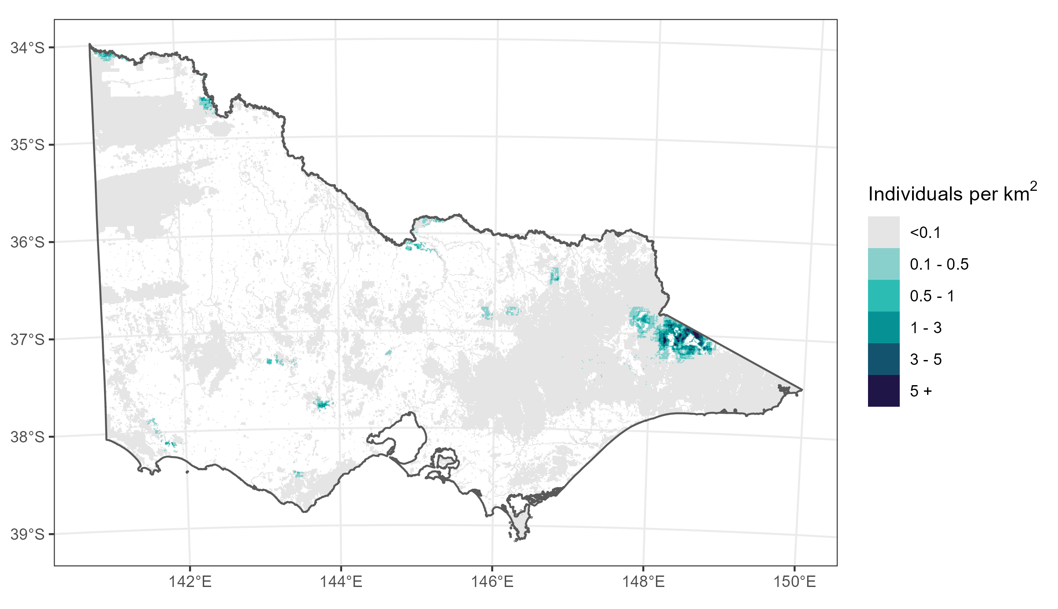
Figure 4. Spatial variation in the density of Feral Pigs across Victoria. Grey shading includes all public land that was subject to monitoring.

  - Risk to livestock
Highest risks of livestock exposure ($LE$) to potential EAD transmission from Feral Pigs were found in locations characterised by high numbers of livestock, especially cattle and sheep, that intersected with areas of high Feral Pig pressure (Figure 5). In particular, high $LE$ values were found over an extensive area between Bendoc and the Omeo Valley, near the Victorian/NSW border in East Gippsland. Other notable high-risk areas included the north-east around Beechworth, the area around Echuca and Barmah National Park, the area surrounding Enfield State Park, the area surrounding Langi Ghiran State Park (including Mount Buangor State Park and Ben Major Conservation Reserve), and the area around Heywood in the south-west (Figure 5).
Overall, 404 PIC grid cells were classified as ‘High’ risk with 1616 PIC grid cells classified as ‘Moderate’ risk (Table 7). Livestock exposure risks to cattle, sheep and domestic pig farms are given in Figure 6.

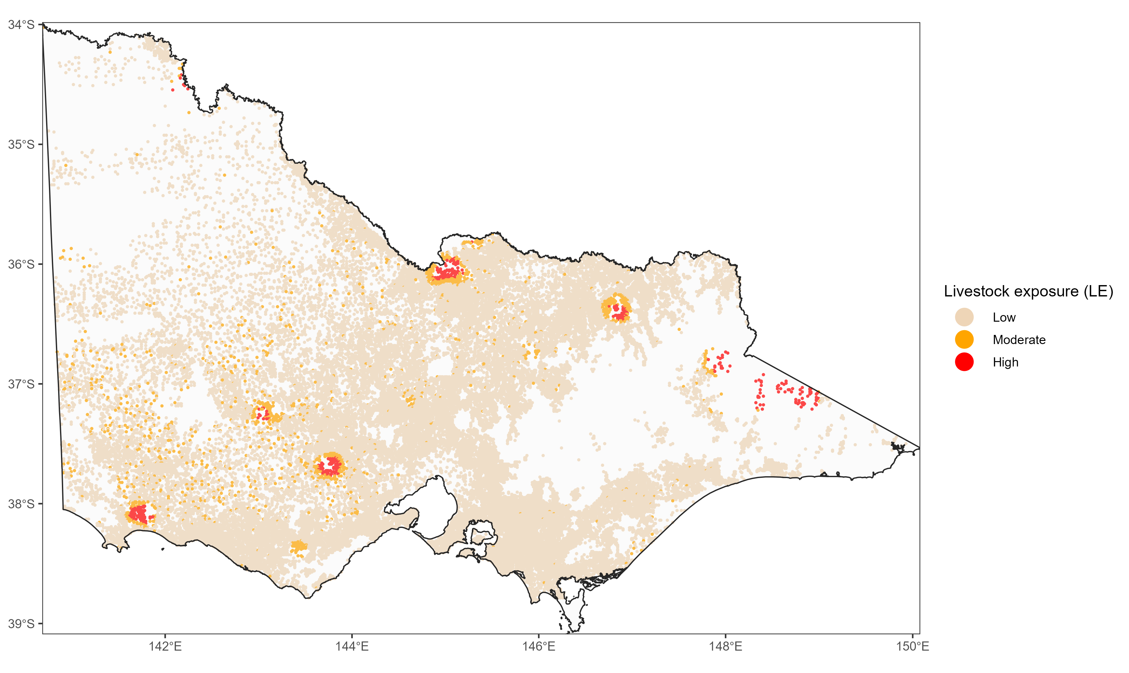
Figure 5. Estimates of the livestock exposure (LE) for each 1-km grid cell containing livestock. Coloured points represent 1-km grid cells containing at least one domestic ungulate livestock farm.

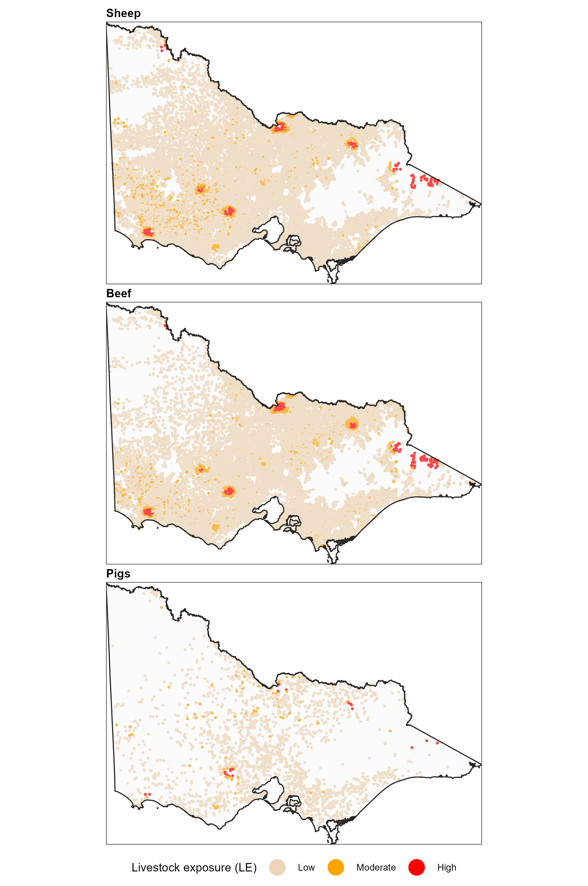
Figure 6. Species-specific livestock exposure (LE) risk categories for domestic ungulate livestock species (cattle, sheep and pigs).
Table 7. Number of 1-km PIC grid cells within each livestock exposure (LE) risk category (Low, Moderate, High) for different livestock species, within each region. LE is defined as the product of the (geographically weighted) risk from Feral Pig populations and the density of livestock within each PIC grid cell.
Species | Region | Low | Livestock exposure (LE)  Moderate | High
Sheep | Barwon South West | 4288 | 340 | 47
 | Gippsland | 3773 | 45 | 53
 | Grampians | 5166 | 367 | 99
 | Hume | 5400 | 198 | 46
 | Loddon Mallee | 5290 | 143 | 29
 | Port Phillip | 2086 | 2 | 0
Beef | Barwon South West | 5706 | 338 | 54
 | Gippsland | 6808 | 153 | 86
 | Grampians | 3655 | 211 | 66
 | Hume | 8371 | 474 | 90
 | Loddon Mallee | 4766 | 179 | 44
 | Port Phillip | 2970 | 5 | 0
Dairy | Barwon South West | 1457 | 61 | 10
 | Gippsland | 1686 | 36 | 6
 | Grampians | 242 | 12 | 7
 | Hume | 944 | 52 | 13
 | Loddon Mallee | 790 | 68 | 23
 | Port Phillip | 400 | 3 | 0
Pigs | Barwon South West | 322 | 9 | 2
 | Gippsland | 418 | 4 | 3
 | Grampians | 316 | 27 | 11
 | Hume | 428 | 19 | 6
 | Loddon Mallee | 461 | 33 | 2
 | Port Phillip | 257 | 0 | 0
Goats | Barwon South West | 616 | 17 | 3
 | Gippsland | 1045 | 14 | 5
 | Grampians | 744 | 52 | 33
 | Hume | 1164 | 86 | 10
 | Loddon Mallee | 1099 | 67 | 11
 | Port Phillip | 1204 | 12 | 0
Total | Barwon South West | 6551 | 399 | 68
 | Gippsland | 7247 | 74 | 84
 | Grampians | 5466 | 516 | 107
 | Hume | 9198 | 350 | 89
 | Loddon Mallee | 6401 | 275 | 56
 | Port Phillip | 3488 | 2 | 0

  - Cost-effective Feral Pig management
    - Simulated FMD outbreak in Feral Pigs
For the stochastic IBM model, the progress of an FMD outbreak in Feral Pigs for simulations where an outbreak was initiated, was characterised by a rapid increase in prevalence, with the proportion of exposed and infectious pigs reaching a median value of 26% approximately 33 days from the start of the outbreak (Figure 7). Following the initial peak prevalence, the proportion of exposed and infectious pigs declined steadily, with disease fadeout occurring (i.e. median prevalence of 0) at 448 days post infection (Figure 7). Only 40% of simulated outbreaks lasted the full two years. The proportion of recovered (and immune) individuals peaked at 75% before steadily declining. Total population size declined by around 10% over the course of the 2-year outbreak (Figure 7).

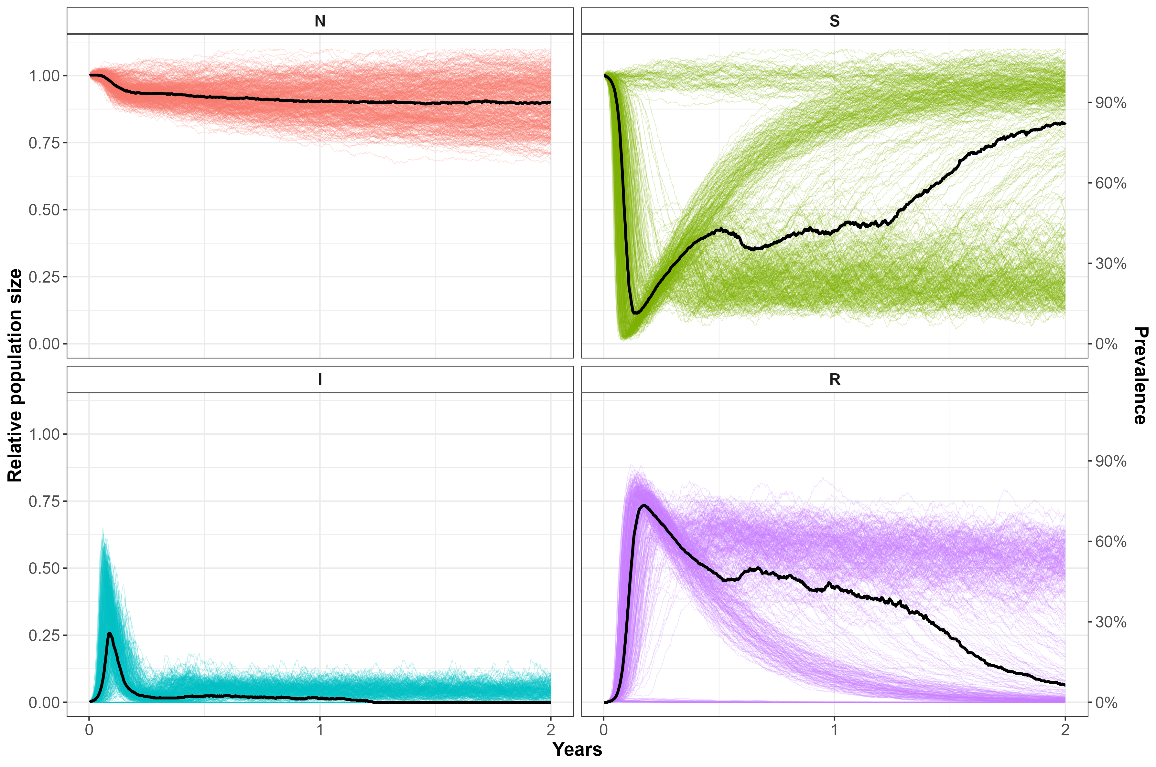
Figure 7. The progression of an outbreak of FMD in Feral Pigs over a 2-year period from the stochastic Individual-based model. Predictions show the trajectories from 500 simulated outbreaks. Solid black line – median, coloured lines – individual trajectories. N – total relative population size, S – susceptible, R – recovered, I – exposed + infected (prevalence).

    - Effects of disease management scenarios
Using the stochastic model, simulations assessed the effectiveness of one-off or repeated aerial culls of varying timing and intensity on the persistence of FMD. Under no (0%) culling of Feral Pigs, the FMD outbreak lasted for an average of 448 days (Figure 8). In contrast, one-off 80% culls had a mean outbreak length of 8 days (95% CI, 4–103) if initiated 7 days post incursion or 63 days, if initiated 30 days post incursion (Figure 8). Repeated 80% culls had a similar outbreak length to the one-off control if initiated 7 days post incursion, but outbreak length was reduced to 44 days (from 63) if initiated 30 days post incursion. A repeated 40% and 60% cull initiated 7 days post incursion was similarly effective at reducing the total length of the outbreak, with mean outbreak lengths of 24 and 14 days, respectively (Figure 8). One-off culls of 60% were less effective with mean outbreak lengths of 35 and 86 days, if initiated 7 or 30 days post incursion, respectively. Under less intense one-off culls of 20% or 40%, or repeated low intensity 20% culls, the outbreak length was longer and more variable, with mean outbreak lengths of between 100 and 180 days (Figure 8).
One-off culling intensities of 60% or 80% and repeated culls of at least 40%, initiating within 7 days post FMD incursion, were required to virtually eliminate disease spread from temporary emigration (Figure 9). While later culls reduced the number of infected emigrants, they were never guaranteed to eliminate disease spread (Figure 9).

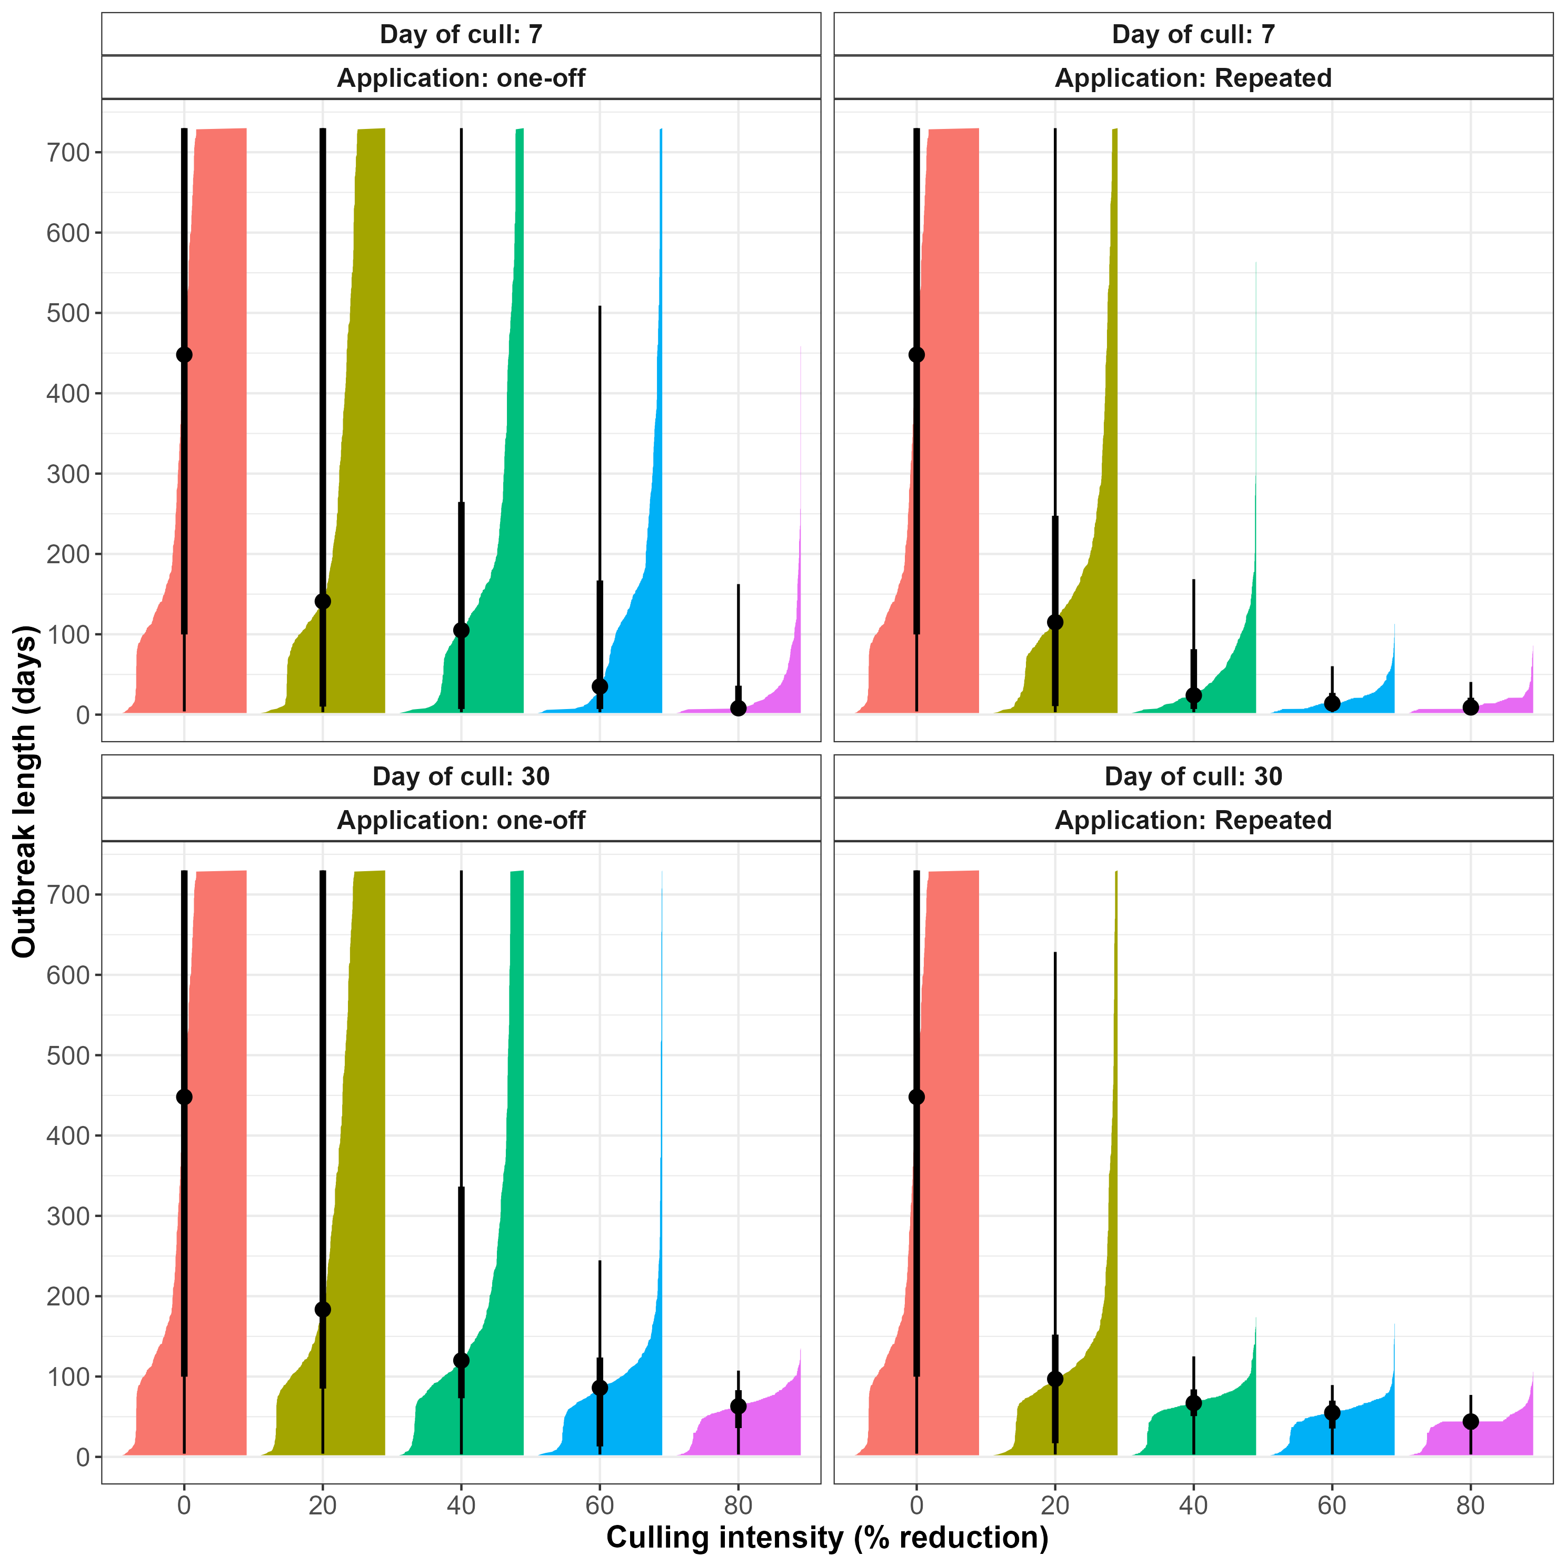
Figure 8. Total length of outbreak (in days) for simulated FMD outbreaks, with one-off and repeated culling operations of varying intensity (0, 20, 40, 60 or 80%) at either 7 or 30 days after the initiation of the outbreak. Black points give the median, thick lines give the width of the 80% confidence interval, and thin lines give the width of the 95% confidence interval. Coloured bars give the distribution of outbreak length.

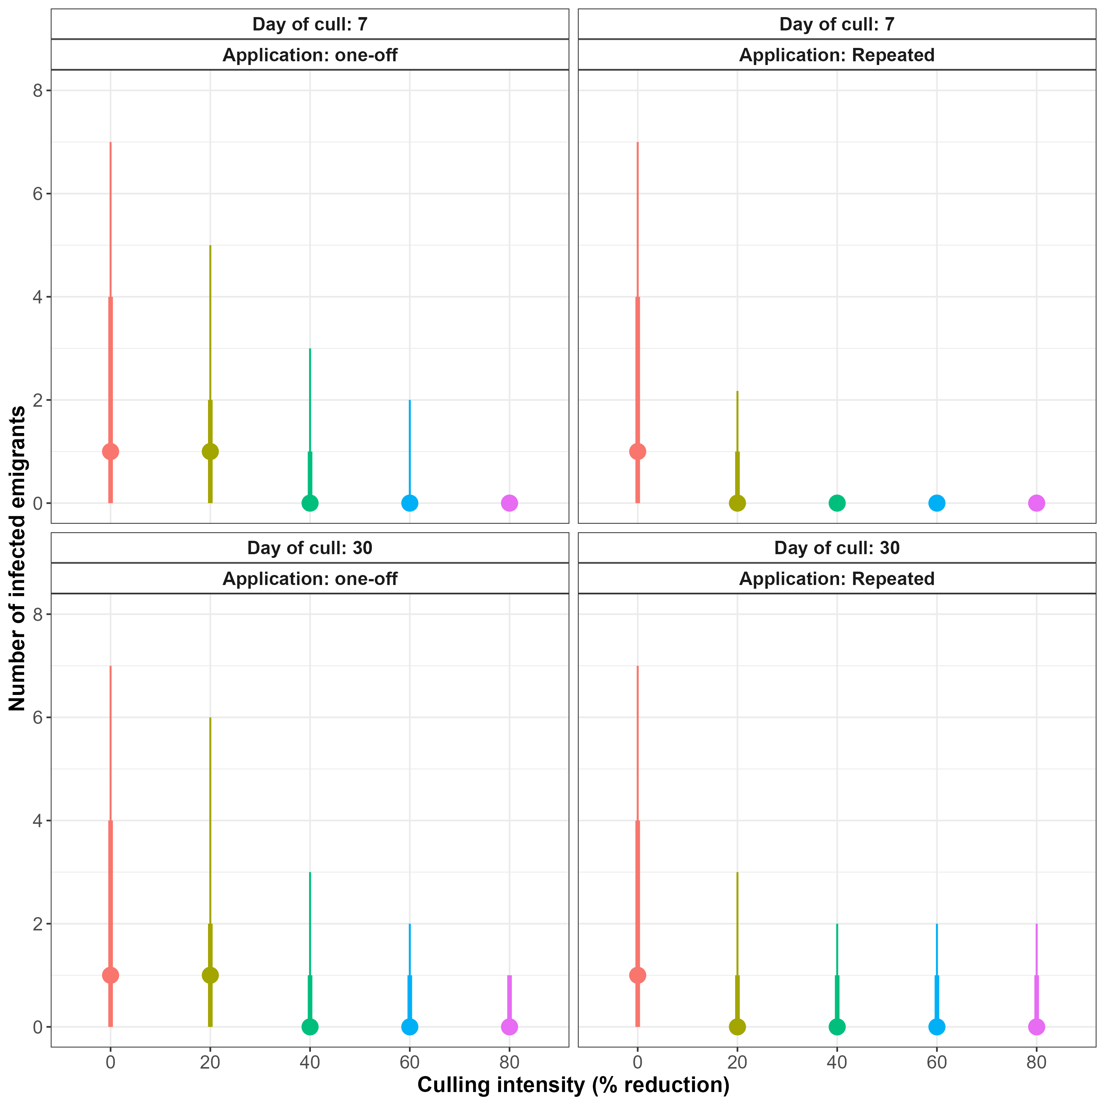
Figure 9. Mean number of infected pigs emigrating from the site (a measure of disease spread) for simulated FMD outbreaks under one-off and repeated aerial culling operations of varying intensity (0, 20, 40, 60 or 80%) at either 7, or 30 days after the initiation of the outbreak. Points give the median value, thick line the 80%, and thin line the 90% confidence interval, respectively.

    - Cost efficacy
Comparisons of the costs versus the efficacy of the various disease management scenarios for reducing the length of an FMD outbreak revealed that, while a one-off 80% cull or repeated 60% or 80% culls were the most effective at reducing the length of an FMD outbreak in Feral Pigs, they were also the most costly – being twice to four-times more expensive than a one-off 60% cull (Figure 10). This was due to the increase in helicopter search time required to achieve an 80% reduction in Feral Pig abundance. Although a one-off 60% cull was slightly less effective at reducing the outbreak length, it was just as effective at reducing disease spread as a one-off 80% cull or repeated 40% cull (Figure 11).

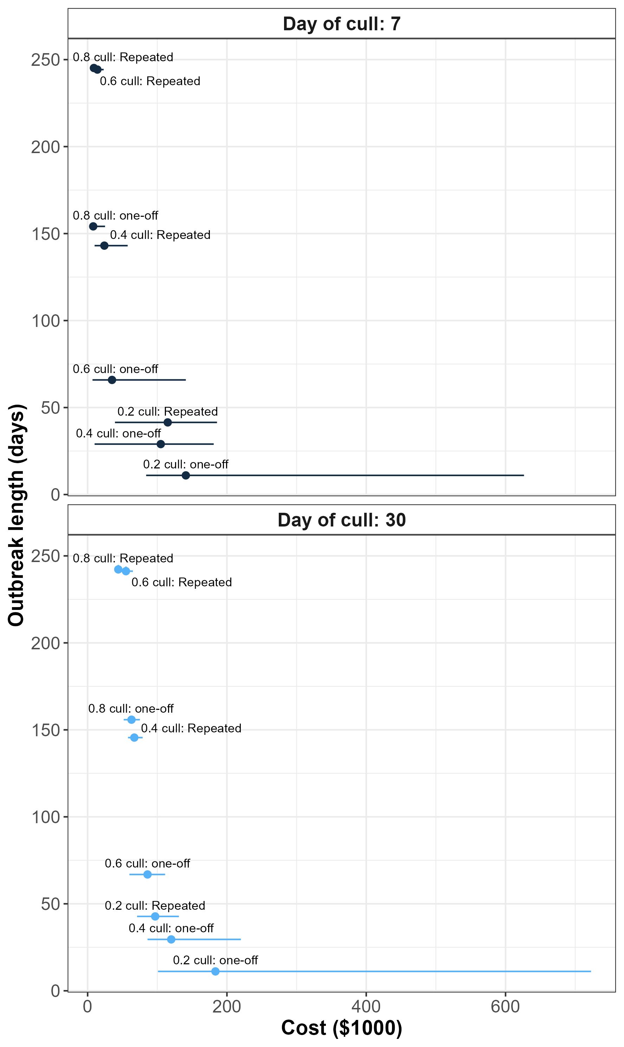
Figure 10. Comparison of the costs and the efficacy (total outbreak length) under one-off and repeated aerial culling operations of varying intensity (0, 20, 40, 60 or 80%) undertaken at either 7, or 30 days after the initiation of the outbreak.

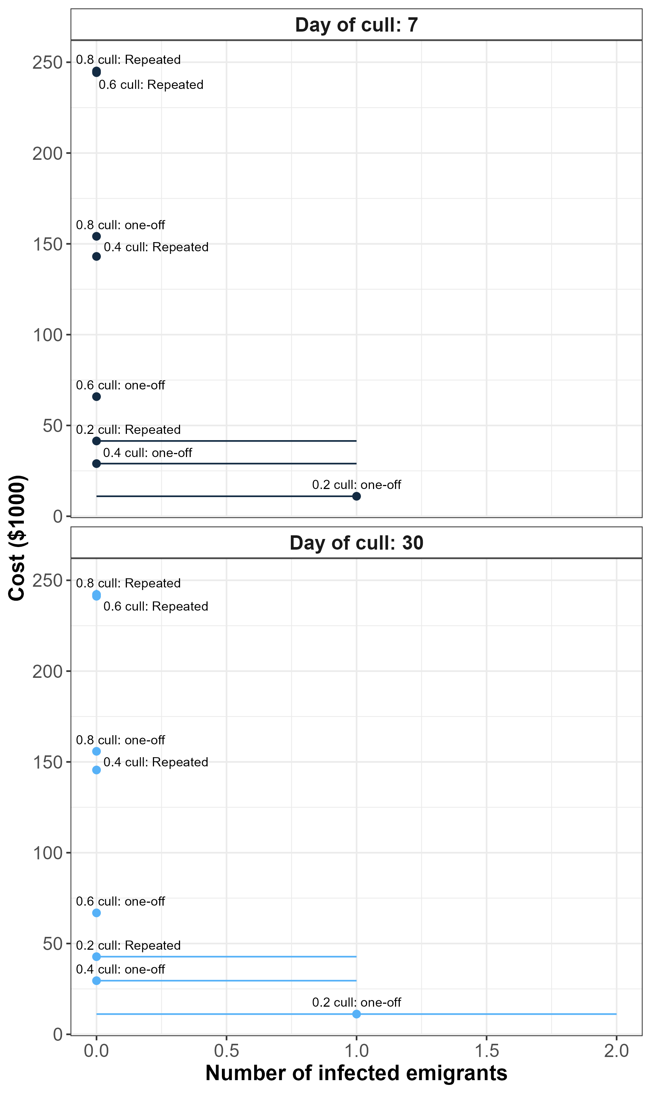
Figure 11. Comparison of the costs and the efficacy (number of infected pigs undertaking temporary emigration – a measure of disease spread) under one-off and repeated aerial culling operations of varying intensity (0, 20, 40, 60 or 80%) undertaken at either 7, or 30 days after the initiation of the outbreak.
- Discussion
We have undertaken the first statewide assessment of Feral Pig populations on public land in Victoria by assembling and integrating data from 1611 remote infrared cameras. Feral Pigs were recorded at 85 different sites across the state, with densities up to 6 pigs/km² recorded at some locations. The total abundance of Feral Pigs was estimated to be around 22,500 (90% CI: 14,300–33,600) distributed across 75,000 km² of public land at an average density of 0.30/km². Highest densities of pigs occurred in north-east Victoria, the upper Goulburn and Murray Rivers, the central-west and in south-west Victoria. Feral Pigs are widely distributed across all regions of Victoria. However, the distribution is not contiguous, with most areas consisting of relatively isolated, disparate populations occurring over relatively restricted areas. Recent genetic evidence suggests that Feral Pig populations have relatively short dispersal distances (average < 5 km) and that several populations, notably in south-west Victoria, are more closely related to populations in NSW suggesting that many populations of Feral Pigs in Victoria arose through illegal translocations (White et al. unpublished data).
To our knowledge, this is the largest contiguous survey of Feral Pigs ever undertaken in Australia. Previous surveys of Feral Pigs to estimate population density have usually been undertaken at relatively small spatial scales, often less than 500 km² (Hone 2019). However, large scale surveys of Feral Pigs have been undertaken using aerial surveys in Queensland over areas ranging from approximately 7,500–16,500 km² (Gentle et al. 2019). The abundance of Feral Pigs in Australia has previously been estimated from 124 studies carried out between the 1980s and 2000s, with estimates ranging from 3.2M to 4.4M pigs (Hone 2019). However, the individual field studies contributing to that estimate originated mainly from New South Wales, Queensland and the Northern Territory, with no field studies originating from Victoria. Therefore, the present study provides valuable information about the current status of Feral Pigs in Victoria. The overall average density of Feral Pigs in Victoria was much lower than the average Feral Pig densities in other parts of Australia (1.03 pigs/km²). Similarly, the abundance of Feral Pigs in Victoria is less than 1% of the total Australian abundance estimate (Hone 2019).
The abundance estimate of Feral Pigs for Victoria had reasonable precision, with a coefficient of variation (CV) of 27%. However, the estimates for DEECA regions were somewhat less precise, with all estimates having CV’s greater than 30%, with precision (inversely) related to sampling intensity in each region as well as the extremely patchy distribution of Feral Pigs in these landscapes. This patchy distribution poses sampling difficulties at a statewide scale, because it can be very easy for isolated pockets of pigs to escape detection. Consequently, the distribution of pigs estimated in this study may not reflect the presence of other small undetected populations or sporadic occurrences of pigs in the landscape. Since supplemental surveys occurred between 2021 and 2025, the resulting abundance estimates necessarily represent average Feral Pig densities that occurred over this period.
The distribution and abundance of Feral Pigs was related to several habitat variables, including slope, multi-resolution valley-bottom flatness (MRVBF), topographic wetness index (TWI), the amount of forest edge habitat, and temperature. Elsewhere, Feral Pigs are known to be habitat generalists and prefer areas close to permanent water that offer sufficient thermal refuge during hot weather. Consequently, their distribution appears to be primarily governed by the interaction between temperature and available thermal refugia (Choquenot et al. 1996; Caley 1997; Caley et al. 2011). The habitat interactions identified by our analyses, in particular, TWI and amount or forest edge, as well as temperature during the dryest quarter and temperature variation, generally support the findings on Feral Pig habitat associations found in previous studies (Choquenot et al. 1996; Caley 1997; Caley et al. 2011).
Spatial information on variation in Feral Pig and livestock densities was used to quantify the relative risk of exposure of livestock to potential EAD transmission from a Feral Pig source. These analyses identified several ‘hotspots’ where the risk of exposure of livestock to potential EAD transmission from Feral Pigs was high. Overall, a total of 404 locations containing one or more livestock farms were designated to be in the high-risk category due to their proximity to large Feral Pig populations, with a further 1618 locations categorised as moderate risk. High-risk farms were located in the areas between Bendoc and the Omeo Valley along the NSW border, the region around Beechworth, the region around Echuca and the upper Goulburn River, the area surrounding Enfield State Park, the area surrounding Langi Ghiran State Park (including Mount Buangor State Park and Ben Major Conservation Reserve), and the area around Heywood. Therefore, Feral Pig populations in the vicinity of these livestock farms could be prioritised for control in the event of an EAD outbreak. Alternatively, preventive control could be considered to either locally eradicate these populations or reduce them to very low densities, below which, the risk of them being a reservoir for EADs such as FMD, CSF or ASF, would be greatly reduced. Based on our modelling assumptions and previous research, reducing local Feral Pig densities to less than 2 pigs/km² should greatly reduce the risk of a prolonged outbreak of EADs such as FMD, CSF or ASF.
Modelling the efficacy of various disease management strategies on the persistence of an example EAD outbreak (based on FMD) in Feral Pigs revealed the level and timing of aerial culling intensities required to eradicate the disease. Aerial culling was selected as the chosen management technique, because it has previously been identified to be the quickest and most efficient method for reducing Feral Pig abundance, especially if using thermal detection devices (Hamnett et al. 2024; Cox et al. 2025). Modelling the efficacy and cost of aerial culling from a helicopter revealed that a rapid response to disease incursions reduced the length of an outbreak substantially. High culling intensities that removed 80% of the population initiated 7 days post-outbreak were required to reduce the average outbreak length of FMD from 448 days to 8 days. Alternatively, 40% culls undertaken at weekly intervals over a three-week period had similar efficacy. Culling intensities of at least 60% were required to eliminate disease spread from the focal population due to dispersal of infected individuals. Overall removing at least 60% of the population in a one-off cull offered a good balance between reduction in outbreak length and the cost of management. However, repeated lower intensity culls or a single high-intensity cull provided more certainty for disease eradication in the shortest possible time, albeit at greater expense.
  - Relationship between the current work and the Australian Animal Disease Spread (AADIS) model
The Australian Animal Disease Spread (AADIS) model was developed as a tool to support government and the livestock industry in the event of a FMD outbreak (Bradhurst et al. 2015). The core capability of the AADIS model was to simulate spatially explicit disease spread and control scenarios in domestic livestock, but has recently been extended to include disease spread from wildlife sources, especially Feral Pigs. Currently, there exists capability to model the spread of EAD’s in Feral Pigs and livestock such as FMD and ASF (Bradhurst et al. 2025) as well as the ability to explore candidate disease control measures.
The AADIS model represents Feral Pig populations as a raster layer, indicating the abundances of Feral Pigs within each grid cell at a 2-km resolution. Feral Pig populations are dynamic, with seasonal changes in abundance simulated at monthly time-steps, with dynamics governed by prevailing environmental conditions (Bradhurst et al. 2021). However, information on Feral Pig abundance is largely governed by variation in pig densities across broad bioclimatic regions (ecoregions), which provides a relatively course-grained understanding of spatial variation (Bradhurst et al. 2021). In addition, under the AADIS model, Feral Pigs in Victoria are represented mainly by a single ecoregion, which potentially overestimates the abundance and distribution of Feral Pigs in the state and subsequently, may not accurately represent the EAD risk to domestic livestock from Feral Pigs. This is not a criticism of AADIS, but a reflection of the paucity of survey data for Feral Pigs in Victoria at the relevant scales.
The current work is a static representation of spatial variation in EAD exposure risk to livestock from Feral Pigs and therefore, does not attempt to predict how any EAD incursion might spread. This functionality is the core purpose of AADIS. However, by providing a more accurate and up-to-date estimate of the distribution and abundance of Feral Pigs in Victoria, the current work could potentially be incorporated into the AADIS model to more accurately predict the role of Feral Pigs in the potential spread of an EAD incursion.
  - Conclusion
Feral Pigs represent a significant biosecurity risk in Victoria. Results from this project suggest that surveys undertaken at large-spatial scales were able to provide contemporary estimates of Feral Pig abundance suitable for quantifying spatially explicit predictions of the biosecurity risk to livestock. The generally isolated and sporadic occurrence of Feral Pigs across Victoria suggests that high risks to livestock from Feral Pigs are contained to relatively few areas. Consequently, rapid, high-intensity control of Feral Pigs in high-risk zones should be feasible for EAD containment in the event of an outbreak to reduce the risk of spillover (and spillback) transmission between livestock and Feral Pig populations. Further research is needed on estimating contact rates between Feral Pigs and livestock and integration with livestock biosecurity measures, to better predict the risks of EAD transmission from wildlife sources. We also recommend that decision support tools, such as AADIS, could benefit from having more accurate information on the spatial distribution and abundance of Feral Pigs in Victoria, which should result in improved predictions about the role of wildlife in any EAD outbreak.

References
ABARES (2022). Direct Economic Impacts of a Foot-and-Mouth (FMD) Disease Incursion in Australia, An Update of ABARES 2013 Estimate. Australian Bureau of Agricultural and Resource Economics and Sciences report. https://www.agriculture.gov.au/abares/research-topics/biosecurity/biosecurity-economics/fmd-update-of-2013-estimate#daff-page-main (accessed 1 October 2024).
ABARES (Australian Bureau of Agricultural and Resource Economics and Sciences) and CSIRO (Commonwealth Scientific and Industrial Research Organisation) (2024). National Feral Pig Current Distribution in Australia. Australian Bureau of Agricultural and Resource Economics and Sciences, Canberra. https://www.agriculture.gov.au/abares/research-topics/invasive-species/national-feral-pig-current-distribution-australia (accessed 10 October 2025).
AHA (2023). Australian Veterinary Emergency Plan (AUSVETPLAN) Publications. Animal Health Australia report. https://animalhealthaustralia.com.au/ausvetplan/ (accessed 1 November 2024).
Barlow, N.D. (2000). Non-linear transmission and simple models for bovine tuberculosis. Journal of Animal Ecology 69, 703–713 doi:10.1046/j.1365-2656.2000.00428.x
Bellows, T.S. (1981). The descriptive properties of some models for density dependence. Journal of Animal Ecology 50, 139–156.
Bengsen, A.J., Forsyth, D.M., Pople, A.R., Brennan, M., Amos, M., Leeson, M., Cox, T.E., Gray, B., Orgill, O., Hampton, J.O., Crittle, T. and Haebich, K. (2022). Effectiveness and costs of helicopter-based shooting of deer. Wildife Research doi:10.1071/WR21156
Bengsen, A.J., West, P. and Krull, C.R. (2017). Feral Pigs in Australia and New Zealand: Range, trend, management, and impacts of an invasive species. In: Ecology, Conservation and Management of Wild Pigs and Peccaries, pp. 325–338, Cambridge University Press, Cambridge, United Kingdom doi:10.1017/9781316941232.032
Bradhurst, R., Garner, G., Roche, S., Iglesias, R., Kung, N., Robinson, B., Willis, S., Cozens, M., Richards, K., Cowled, B., Oberin, M., Tharle, C., Firestone, S. and Stevenson, M. (2021). Modelling the Spread and Control of African Swine Fever in Domestic and Feral Pigs. University of Melbourne, Melbourne, Victoria. https://minerva-access.unimelb.edu.au/items/61021c1d-b7c2-5e82-b749-b4948c0f387c (accessed 23 January 2026).
Bradhurst, R.A., Roche, S.E., East, I.J., Kwan, P. and Garner, M.G. (2015). A hybrid modeling approach to simulating foot-and-mouth disease outbreaks in Australian livestock. Frontiers in Environmental Science 3 doi:10.3389/fenvs.2015.00017
Bradhurst, R.A., Sellens, E., Al Riyami, S., Burns, R. and Breed, A. (2025). Assessing the potential role of Feral Pigs in an outbreak of foot-and-mouth disease in Australia. Final report on CEBRA Project 23F, prepared for the Department of Agriculture, Fisheries and Forestry, Canberra, Australian Capital Territory.
Brooks, S. and Gelman, A. (1998). General methods for monitoring convergence of iterative simulations. Journal of Computational and Graphical Statistics 7, 434–455.
Burnham, K.P. and Anderson, D.R. (2004). Multimodel inference: Understanding AIC and BIC in model selection. Sociological Methods and Research 33, 261–304 doi:10.1177/0049124104268644
Caley, P. (1997). Movements, activity patterns and habitat use of Feral Pigs (Sus scrofa) in a tropical habitat. Wildlife Research 24, 77–87 doi:10.1071/WR94075
Caley, P., Tennant, P. and Hood, G. (2011). Modelling the distribution of vertebrate pests in New South Wales under climate change. Invasive Animals Cooperative Research Centre, Canberra, Australian Capital Territory.
Cally, J. and Ramsey, D. (2023). Abundance of deer in Victoria: Regional and statewide estimates of deer density and their impact on vegetation. Arthur Rylah Institute for Environmental Research Technical Report Series No. 368. Department of Energy, Environment and Climate Action, Heidelberg, Victoria. www.ari.vic.gov.au
Carpenter, B., Gelman, A., Hoffman, M.D., Lee, D., Goodrich, B., Betancourt, M., Brubaker, M., Guo, J., Li, P. and Riddell, A. (2017). Stan: A probabilistic programming language. Journal of Statistical Software 76, 1–32 doi:10.18637/jss.v076.i01
Chandler, R.B., Royle, J.A. and King, D.I. (2011). Inference about density and temporary emigration in unmarked populations. Ecology 92, 1429–1435 doi:10.1890/10-2433.1
Choquenot, D., Hone, J. and Saunders, G. (1999). Using aspects of predator-prey theory to evaluate helicopter shooting for Feral Pig control. Wildlife Research 26, 251–261 doi:10.1071/WR98006
Choquenot, D., McIlroy, J. and Korn, T. (1996). Managing Vertebrate Pests: Feral Pigs. Bureau of Resource Sciences, Australian Government Publishing Service, Canberra, Australian Capital Territory.
Corlatti, L., Sivieri, S., Sudolska, B., Giacomelli, S. and Pedrotti, L. (2020). A field test of unconventional camera trap distance sampling to estimate abundance of marmot populations. Wildlife Biology 2020, wlb.00652 doi:10.2981/wlb.00652
Cowled, B. and Garner, G. (2008). A review of geospatial and ecological factors affecting disease spread in wild pigs: Considerations for models of foot-and-mouth disease spread. Preventive Veterinary Medicine 87, 197–212 doi:10.1016/j.prevetmed.2008.03.012
Cowled, B.D., Garner, M.G., Negus, K. and Ward, M.P. (2012). Controlling disease outbreaks in wildlife using limited culling: Modelling classical swine fever incursions in wild pigs in Australia. Veterinary Research 43, 3 doi:10.1186/1297-9716-43-3
Cox, T.E., Leane, M., Baker, R., Sparkes, J. and Matthews, R. (2025). Investigations into aerial shooting approaches to achieve rapid removal of feral and pest animals. Wildlife Research 52, WR25020 doi:10.1071/WR25020
DEECA (2023). The Victorian Government State Emergency Animal Disease Response Plan – April 2023. Department of Energy, Environment and Climate Action, Victoria, Australia. https://agriculture.vic.gov.au/__data/assets/pdf_file/0017/1019222/2024_Victorian_EAD_response_plan.pdf
Delisle, Z.J., Miller, D.L. and Swihart, R.K. (2023). Modelling density surfaces of intraspecific classes using camera trap distance sampling. Methods in Ecology and Evolution 14, 1287–1298 doi:10.1111/2041-210X.14093
Dexter, N. (2003). Stochastic models of foot and mouth disease in Feral Pigs in the Australian semi‐arid rangelands. Journal of Applied Ecology 40, 293–306 doi:10.1046/j.1365-2664.2003.00792.x
Gallant, J.C. and Dowling, T.I. (2003). A multiresolution index of valley bottom flatness for mapping depositional areas. Water Resources Research 39, 2002WR001426 doi:10.1029/2002WR001426
Gelman, A., Meng, X.L. and Stern, H. (1996). Posterior predictive assessment of model fitness via realized discrepancies. Statistica Sinica 6, 733–807.
Gentle, M., Pople, A., Scanlan, J.C. and Carter, J. (2019). The dynamics of Feral Pig (Sus scrofa) populations in response to food supply. Wildlife Research 46, 191–204 doi:10.1071/WR17176
Gilbert, N.A., Clare, J.D.J., Stenglein, J.L. and Zuckerberg, B. (2021). Abundance estimation of unmarked animals based on camera-trap data. Conservation Biology 35, 88–100 doi:10.1111/cobi.13517
Guerschman, J.P. and Hill, M.J. (2018). Calibration and validation of the Australian fractional cover product for MODIS collection 6. Remote Sensing Letters 9, 696–705 doi:10.1080/2150704X.2018.1465611
Guerschman, J.P., Hill, M.J., Renzullo, L.J., Barrett, D.J., Marks, A.S. and Botha, E.J. (2009). Estimating fractional cover of photosynthetic vegetation, non-photosynthetic vegetation and bare soil in the Australian tropical savanna region upscaling the EO-1 Hyperion and MODIS sensors. Remote Sensing of Environment 113, 928–945 doi:10.1016/j.rse.2009.01.006
Hamnett, P.W., Saltré, F., Page, B., Tarran, M., Korcz, M., Fielder, K., Andrews, L. and Bradshaw, C.J.A. (2024). Stochastic population models to identify optimal and cost‐effective harvest strategies for Feral Pig eradication. Ecosphere 15, e70082 doi:10.1002/ecs2.70082
Haucke, T., Kühl, H.S., Hoyer, J. and Steinhage, V. (2022). Overcoming the distance estimation bottleneck in estimating animal abundance with camera traps. Ecological Informatics 68, 101536 doi:https://doi.org/10.1016/j.ecoinf.2021.101536
Henrich, M., Burgueño, M., Hoyer, J., Haucke, T., Steinhage, V., Kühl, H.S. and Heurich, M. (2023). A semi-automated camera trap distance sampling approach for population density estimation. Remote Sensing in Ecology and Conservation doi:10.1002/rse2.362
Henrich, M., Hartig, F., Dormann, C.F., Kühl, H.S., Peters, W., Franke, F., Peterka, T., Šustr, P. and Heurich, M. (2022). Deer behavior affects density estimates with camera traps, but Is outweighed by spatial variability. Frontiers in Ecology and Evolution 10 doi:10.3389/fevo.2022.881502
Hone, J. (2019). How many Feral Pigs in Australia? An update. Australian Journal of Zoology 67, 215–220 doi:10.1071/ZO20077
Hone, J., Pech, R. and Yip, P. (1992). Estimation of the dynamics and rate of transmission of classical swine fever (hog cholera) in wild pigs. Epidemiology and Infection 108, 377–386 doi:10.1017/S0950268800049840
Howe, E.J., Buckland, S.T., Després-Einspenner, M.L. and Kühl, H.S. (2017). Distance sampling with camera traps. Methods in Ecology and Evolution 8, 1558–1565 doi:10.1111/2041-210X.12790
Keeling, M.J. and Rohani, P. (2008). Modelling Infectious Diseases in Humans and Animals. Princeton University Press, Princeton, USA.
Keeling, M.J., Woolhouse, M.E.J., Shaw, D.J., Matthews, L., Chase-Topping, M., Haydon, D.T., Cornell, S.J., Kappey, J., Wilesmith, J. and Grenfell, B.T. (2001). Dynamics of the 2001 UK Foot and Mouth epidemic: Stochastic dispersal in a heterogeneous landscape. Science 294, 813–817 doi:10.1126/science.1065973
Kendall, W.L., Nichol, J.D. and Hines, J.E. (1997). Estimating temporary emigration using capture-recapture data with Pollocks robust design. Ecology 78, 563–578.
Kermack, W.O. and McKendrick, A.G. (1927). A contribution to the mathematical theory of epidemics. Proceedings of the Royal Society A115, 700–721.
Mason, S.S., Hill, R.A., Whittingham, M.J., Cokill, J., Smith, G.C. and Stephens, P.A. (2022). Camera trap distance sampling for mammal population monitoring: Lessons learnt from a UK case study. Remote Sensing in Ecology and Conservation 8, 717-–730 doi:10.1002/rse2.272
May, R.M. and Anderson, R.M. (1979). Population biology of infectious diseases: Part I. Nature 280, 361–367.
McCallum, H., Barlow, N. and Hone, J. (2001). How should pathogen transmission be modelled? Trends in Ecology and Evolution 16, 295–300 doi:10.1016/S0169-5347(01)02144-9
Meek, P. and Fleming, P. (2014). Camera Trapping: Wildlife Management and Research. CSIRO Publishing. https://books.google.com.au/books?id=js68oAEACAAJ
Niedballa, J., Sollmann, R., Courtiol, A. and Wilting, A. (2016). camtrapR: An R package for efficient camera trap data management. Methods in Ecology and Evolution 7, 1457–1462.
Palencia, P., Rowcliffe, J.M., Vicente, J. and Acevedo, P. (2021). Assessing the camera trap methodologies used to estimate density of unmarked populations. Journal of Applied Ecology 58, 1583–1592 doi:10.1111/1365-2664.13913
Pearson, H.E., Toribio, J-A.L.M.L., Lapidge, S.J. and Hernández-Jover, M. (2016). Evaluating the risk of pathogen transmission from wild animals to domestic pigs in Australia. Preventive Veterinary Medicine 123, 39–51 doi:10.1016/j.prevetmed.2015.11.017
Pech, R. and Hone, J. (1988). A model of the dynamics and control of an outbreak of foot and mouth disease in Feral Pigs in Australia. Journal of Applied Ecology 25, 63–77.
R Development Core Team (2020). R: A Language and Environment for Statistical Computing. http://www.r-project.org
Royle, J.A. and Dorazio, R.M. (2008). Hierarchical Modeling and Inference in Ecology: The Analysis of Data from Populations, Metapopulations and Communities. Academic Press. http://www.amazon.com/dp/0123740975
Spencer, P.B.S. and Hampton, J.O. (2005). Illegal translocation and genetic structure of Feral Pigs in Western Australia. Journal of Wildlife Management 69, 377.
Thomas, L., Buckland, S.T., Rexstad, E.A., Laake, J.L., Strindberg, S., Hedley, S.L., Bishop, J.R.B., Marques, T.A. and Burnham, K.P. (2010). Distance software: Design and analysis of distance sampling surveys for estimating population size. Journal of Applied Ecology 47, 5–14 doi:https://doi.org/10.1111/j.1365-2664.2009.01737.x
Tildesley, M.J., Smith, G. and Keeling, M.J. (2012). Modeling the spread and control of foot-and-mouth disease in Pennsylvania following its discovery and options for control. Preventive Veterinary Medicine 104, 224–239 doi:10.1016/j.prevetmed.2011.11.007
Vynnycky, E. and White, R. (2010). An Introduction to Infectious Disease Modelling. Oxford University Press, Oxford, United Kingdom.
Ward, M., Garner, M. and Cowled, B. (2015). Modelling foot-and-mouth disease transmission in a wild pig–domestic cattle ecosystem. Australian Veterinary Journal 93, 4–12 doi:10.1111/avj.12278
Ward, M.P., Laffan, S.W. and Highfield, L.D. (2007). The potential role of wild and feral animals as reservoirs of foot-and-mouth disease. Preventive Veterinary Medicine 80, 9–23 doi:10.1016/j.prevetmed.2007.01.009
White, M., Griffioen, P. and Newell, G. (2020). Multi-temporal native vegetation extent for Victoria. Arthur Rylah Institute for Environmental Research, Department of Environment, Land, Water and Planning, Victoria. https://www. environm ent. vic. gov. au/biodiversity/Victorias-Land-Cover-Time-Series.
Wiegers, J.N., Richard-Hansen, C., Blok, J.E., Van Der Kuil, R., Gradoz, M. and Van Kuijk, M. (2025). Can we count you: Validating density estimation methods for unmarked wildlife with camera traps. Biodiversity and Conservation 34, 255–270 doi:10.1007/s10531-024-02969-9

Appendix
Table A1. Descriptions of covariates used to model Feral Pig density.
Covariate | Description
MRVBF | Multi-resolution valley-bottom flatness (MRVBF) is a topographic index that identifies valley bottoms and calculates their relative elevation and flatness to their surroundings (Gallant and Dowling 2003).
Bare soil (%) | Fractional cover of bare soil estimated from remote sensing (MODIS Nadir BRDF-Adjusted Reflectance product: MCD43A4). The combined sum of bare soil, photosynthetic vegetation and non-photosynthetic vegetation is 100% (Guerschman et al. 2009).
Non photosynthetic vegetation (%) | Fractional cover of photosynthetic vegetation estimated from remote sensing (MODIS Nadir BRDF-Adjusted Reflectance product: MCD43A4). The combined sum of bare soil, photosynthetic vegetation and non-photosynthetic vegetation is 100% (Guerschman and Hill 2018).
Nitrogen (%) | Mass fraction of nitrogen in the topsoil (0–15 cm) by weight.
Distance to pasture (m) | Distance to nearest area of land that is classed as being under pastural use. Catchment scale land use data for Australia (CLUM) using The Australian Land Use and Management (ALUM) classification system was used to classify pastural areas. The following land use classes were considered as pasture:  2.1.0 Grazing native vegetation  3.2.0 Grazing modified pastures  3.2.1 Native/exotic pasture mosaic  3.2.2 Woody fodder plants  3.2.3 Pasture legumes  3.2.4 Pasture legume/grass mixtures  3.2.5 Sown grasses  4.2.0 Grazing irrigated modified pastures  4.2.1 Irrigated woody fodder plants  4.2.2 Irrigated pasture legumes  4.2.3 Irrigated legume/grass mixtures  4.2.4 Irrigated sown grasses
TWIND | Topographic Wetness Index (TWIND) estimates the relative wetness within catchments. It is also a measure of position on the slope, with larger values indicating a lower slope position (Guerschman and Hill 2018).
Forest edge per km² (m) | Length of forest edge within a 1-km² area. Forest cover is estimated from structural vegetation data (DEECA 2021). With forest classed as a type of open forest or woodland vegetation form.
Temperature variation (%) | Isothermality – calculated as the mean monthly diurnal temperature range divided by annual diurnal temperature range.
Temperature of dryest quarter | Mean temperature of the driest quarter of the year.

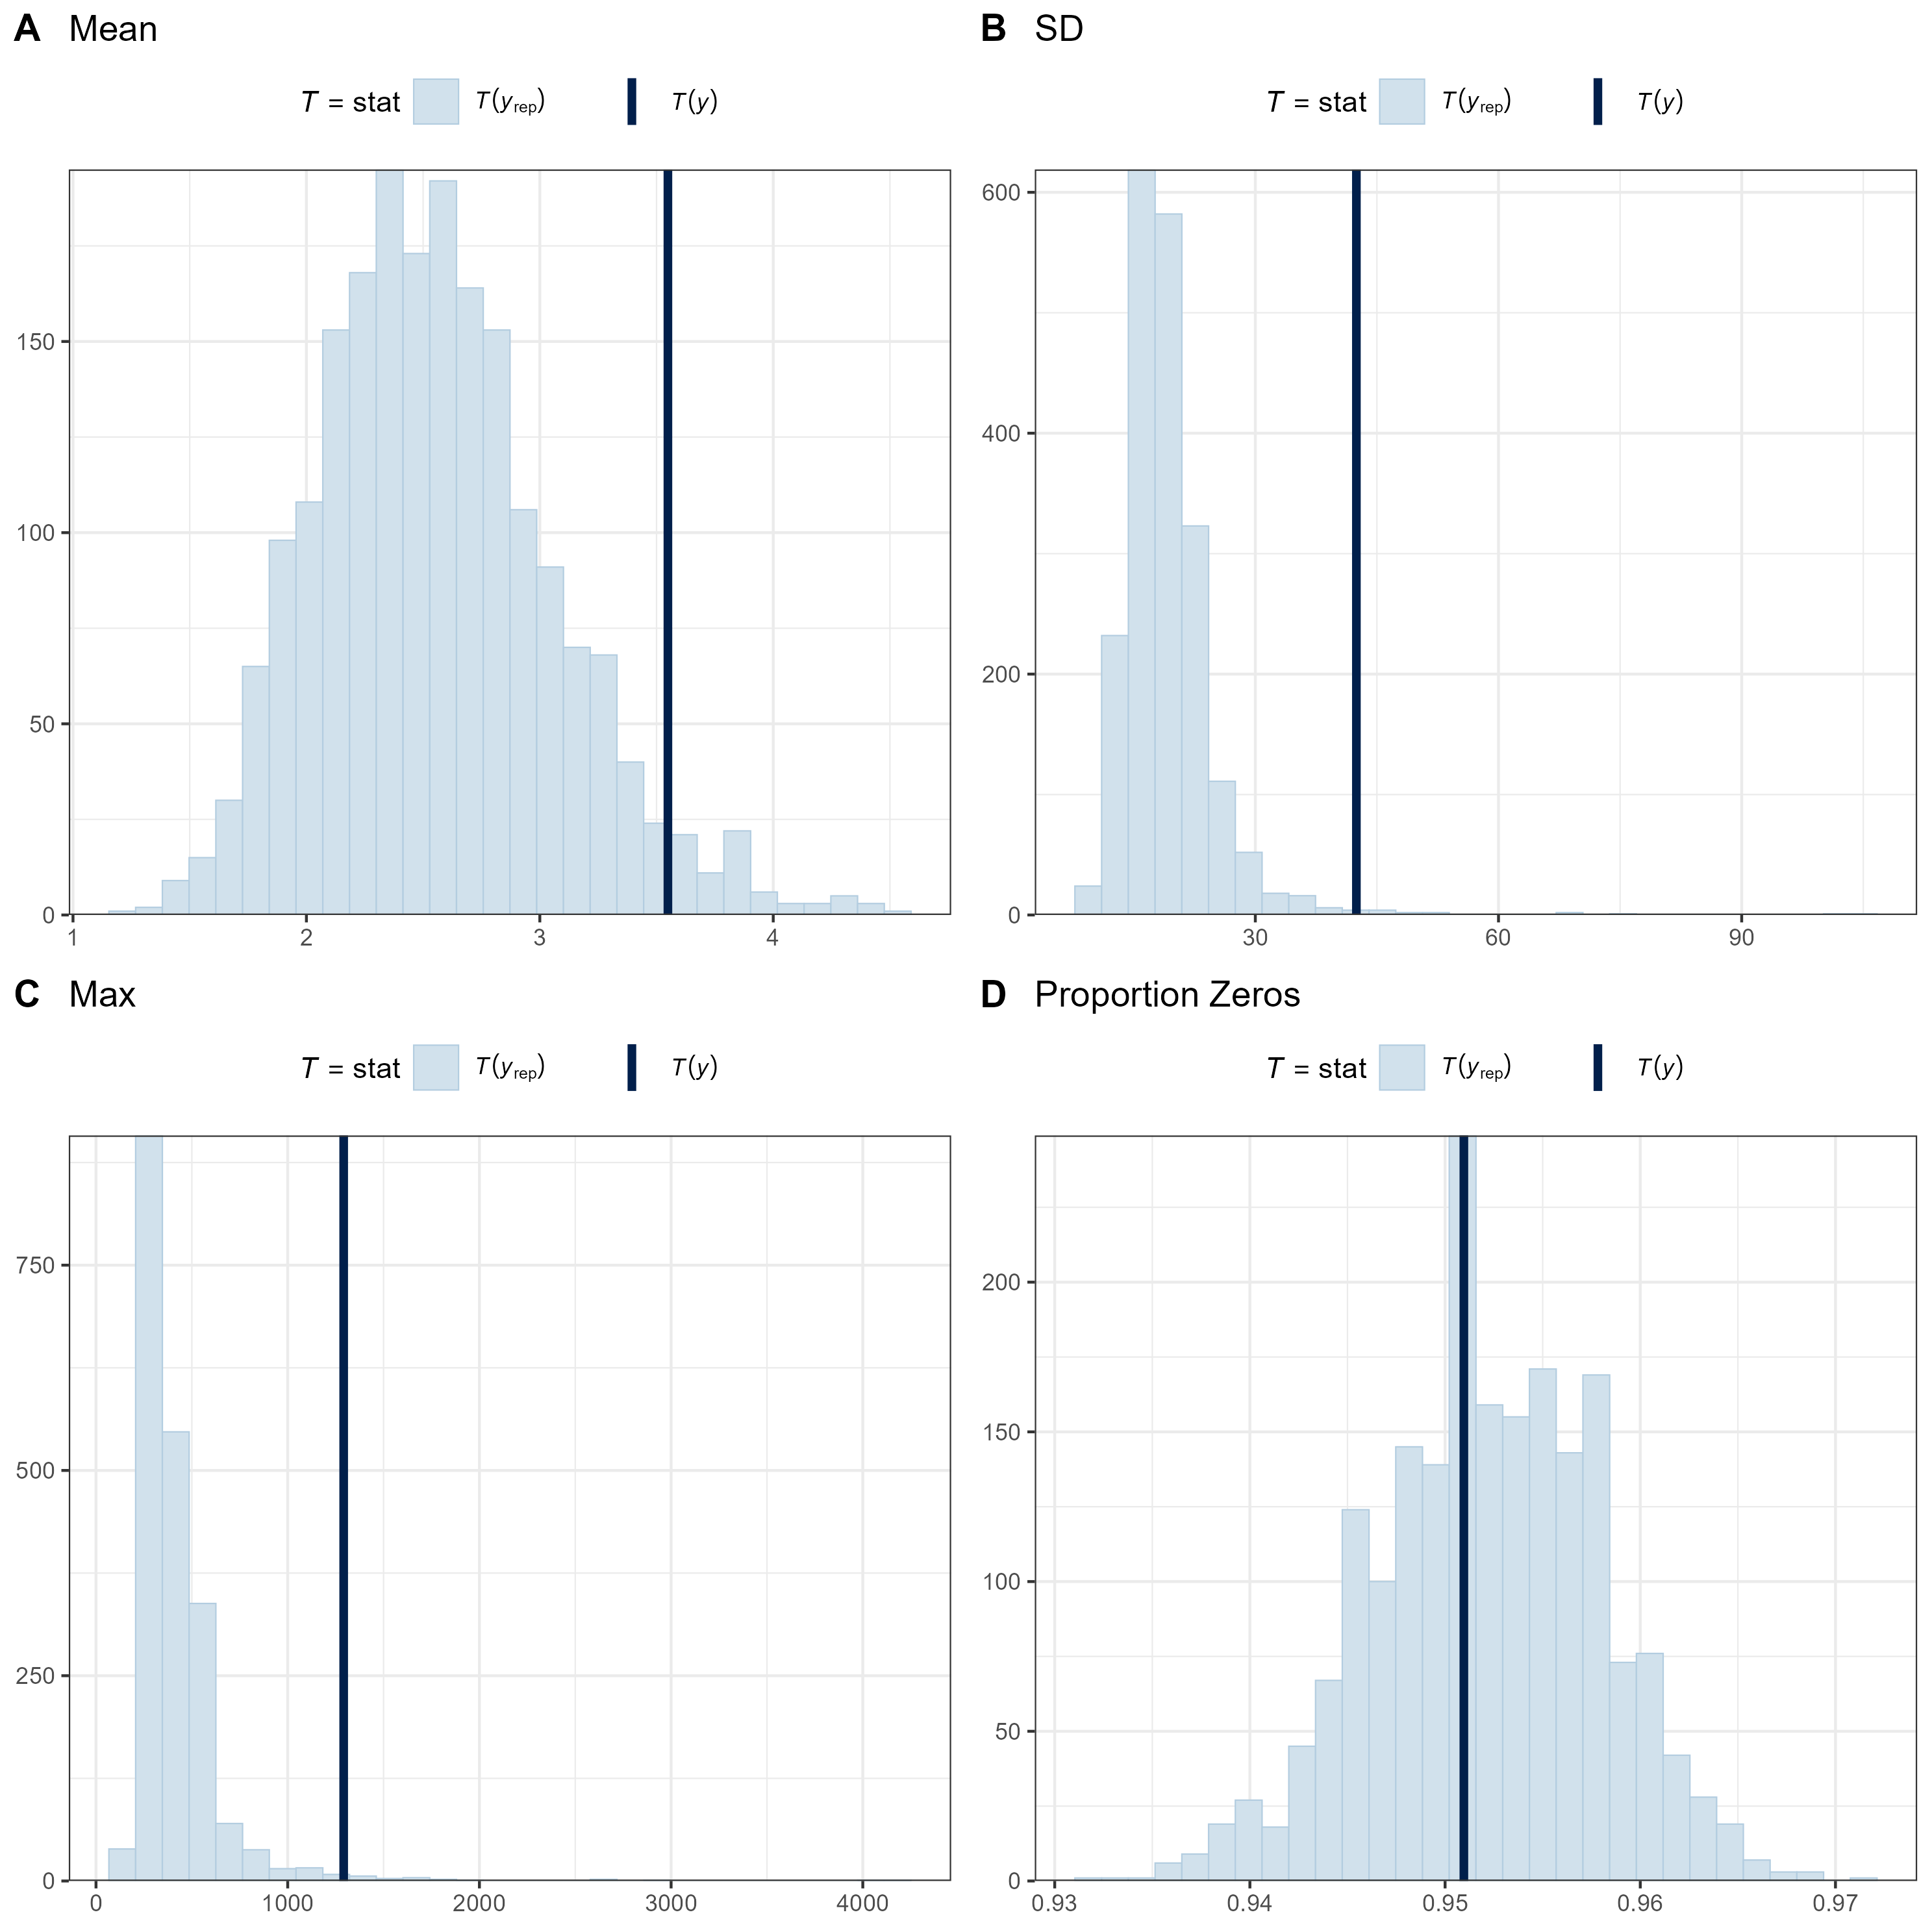
Figure A1. Posterior predictive checks comparing summary statistics $T$ of the predicted counts of Feral Pigs for each camera under the model (Equation 1), with the observed counts. The summary statistics are the proportion of camera sites with zero counts, the mean count, the standard deviation of the count, and the maximum count. Pale-blue histograms give the distribution of the summary statistic predicted by the model $T(y_{rep})$, and dark-blue bars give the summary statistic for the observed counts $T(y)$.

www.deeca.vic.gov.au

www.ari.vic.gov.au

