|  |
| --- |
| National Carp Control Plan  Project - A Carp biomass estimate for eastern Australia |
| Project Overview – October 2017 |

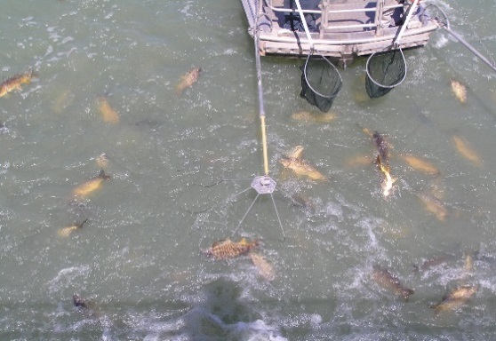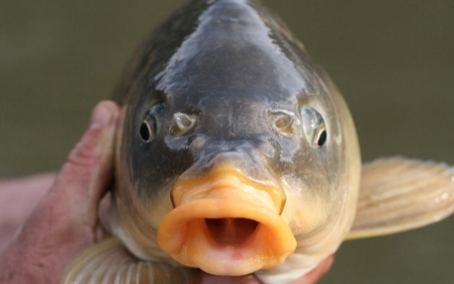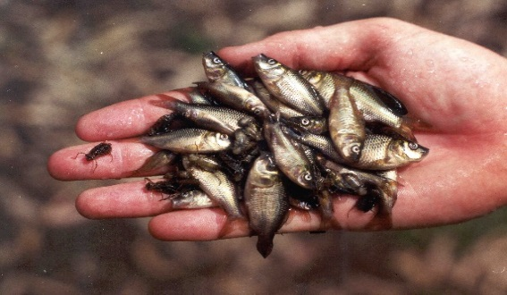

## Carp are a major problem in Australia

Common carp (*Cyprinus carpio*) have invaded most waterways of south eastern Australia and are now the most abundant large freshwater fish, forming up to 80% of the biomass (total fish weight) in some areas. They cause substantial social, environmental and economic impacts. Even at a low abundance (>88 kg/ha), carp negatively impact water quality, aquatic plants and native fish. Carp reduce the amenity value of rivers and lakes for all water users, including regional communities, fishers and irrigators.

## The National Carp Control Plan

In 2016, the Australian [government invested $15 million​](http://www.agriculture.gov.au/Pages/minister.aspx?link=http%3a//minister.agriculture.gov.au/joyce/Pages/Media-Releases/cleaning-australia-waterways.aspx) over 2.5 years to develop the National Carp Control Plan (NCCP), which operates within the Fisheries Research and Development Corporation (FRDC). The plan includes the research, planning, and consultation necessary to enable the Australian Government to make an informed decision on carp biocontrol using Cyprinid herpesvirus 3 (CyHV-3, hereafter ‘the carp virus’).

A successful continental-scale biocontrol program requires an integrated approach, working across portfolios and state governments, in partnership with communities. A Ministerial Taskforce oversees development of the NCCP to maximise the impact of the carp virus while minimising impacts to industry, communities and the environment.

A National Coordinator is working with stakeholders from across governments, industry, community and environmental groups, and research organisations to understand the issues and bring together a comprehensive plan, underpinned by research, risk assessment and a sound understanding of community views. The plan focuses on maximising carp reduction while minimising disruption to industries, communities and the environment should the carp virus release go ahead.

## The Carp Virus

The carp virus is a naturally occurring strain of carp herpesvirus. Years of rigorous testing has shown that the virus is specific to carp, and won’t cause disease in any other fish species or other animals, including humans. Testing by the CSIRO, through the Invasive Animals Cooperative Research Centre found that under optimal conditions the carp virus killed up to 95% of carp.

Nevertheless, carp are unlikely to be totally eradicated by the virus. Often a virus will kill large numbers of the target species in the early years and then gradually resistance builds up. Hence while carp may never recover to their original numbers, additional management actions will be needed to complement the virus in the long-term.

## Key information is needed to manage the release of the Carp Virus

Many projects are currently funded under the [NCCP Strategic Research and Technology Plan](http://www.carp.gov.au/en/What-we-are-doing/Research/Research-projects), which covers the main issues around potential use of carp biocontrol, ranging from virus epidemiology, to clean-up strategies and social dynamics. These projects are outlined on the NCCP website (<http://www.carp.gov.au/>).

## A Carp biomass estimate for eastern Australia

Effective carp biocontrol requires a fundamental understanding of carp abundance and biomass (total weight of carp in a given area) within representative habitats (i.e. rivers, lakes, billabongs, estuaries) and at appropriate geographic scales (local, river reach, river-basin, inter-basin) throughout eastern Australia. Priorities for the NCCP therefore include:

* planning for virus release
* efficiently allocating local and regional clean-up resources, and
* identifying and managing potential ecological impacts (e.g. water quality).

Ecological monitoring is also important to benchmark the condition of waterplants, aquatic invertebrates, fish communities, and water quality prior to possible release of the carp virus within a representative subset of catchments.

## Project Objectives

The carp biomass project aims to:

* provide a robust estimate of carp abundance and biomass in a broad range of aquatic habitats, reaches and river basins in eastern Australia
* inform resource allocation for the virus release planning, clean-up and management of potential ecological impacts, and
* At a sub-set of sites, benchmark the condition of macrophyte, macroinvertebrate, fish communities and water quality prior to release of the carp virus.

## Approach

This project represents an innovative approach to develop an international best-practice methodology to determine how many carp reside in eastern Australia.

**Using existing data**

There are already significant carp data sets, collected over the past 20 years, which will be important to provide a benchmark from which it can be shown that the virus has contributed to a demonstrable environmental change. The first step is to collate and prioritise data collected by major projects (e.g. Sustainable River Audit, MDB Fish Survey, MDBA Icon Site condition monitoring, Murray fishways, Victorian snags survey, Commonwealth Environment Water Office Long Term Intervention Monitoring and Lachlan River Carp program). There will also be new experiments to determine the efficiency of the sampling techniques (i.e. electrofishing catch rates) which are crucial for the carp biomass estimate.

## The Project Team

A five-state/territory collaborative team has been assembled:

* Arthur Rylah Institute for Environmental Research (Department of Environment, Land, Water and Planning), and La Trobe University (Vic)
* New South Wales Department of Primary Industries (NSW)
* South Australian Research and Development Institute (SA)
* Department of Agriculture and Fisheries (QLD)
* Environment, Planning and Sustainable Development Directorate (ACT).

## Project outcomes

This project will:

* identify the tonnage of carp that inhabit various aquatic habitats

It will also provide key information to support:

* planning the release of the carp virus across various spatial zones
* resource planning for clean-up
* other related NCCP research projects, including the potential water quality impacts.

|  |  |
| --- | --- |
| © The State of Victoria Department of Environment, Land, Water and Planning 2017  This work is licensed under a Creative Commons Attribution 4.0 International licence. You are free to re-use the work under that licence, on the condition that you credit the State of Victoria as author. The licence does not apply to any images, photographs or branding, including the Victorian Coat of Arms, the Victorian Government logo and the Department of Environment, Land, Water and Planning (DELWP) logo. To view a copy of this licence, visit http://creativecommons.org/licenses/by/4.0/  ISBN 978-1-76047-753-0 (Print)  ISBN 978-1-76047-754-73 (pdf/online)  Disclaimer  This publication may be of assistance to you but the State of Victoria and its employees do not guarantee that the publication is without flaw of any kind or is wholly appropriate for your particular purposes and therefore disclaims all liability for any error, loss or other consequence which may arise from you relying on any information in this publication. | Accessibility  If you would like to receive this publication in an alternative format, please telephone the DELWP Customer Service Centre on 136186, email [customer.service@delwp.vic.gov.au](mailto:customer.service@delwp.vic.gov.au), or via the National Relay Service on 133 677 [www.relayservice.com.au](http://www.relayservice.com.au). This document is also available on the internet at [www.delwp.vic.gov.au](http://www.delwp.vic.gov.au). |

## Project timeline

June 2017 – November 2018

**Contact:** Jarod.Lyon@delwp.vic.gov.au