
Factors influencing shorebird use of tidal flats adjacent to the Western Treatment Plant

D. I. Rogers, R. H. Loyn and D. Greer

October 2013

Arthur Rylah Institute for Environmental Research

Technical Report Series No. 250

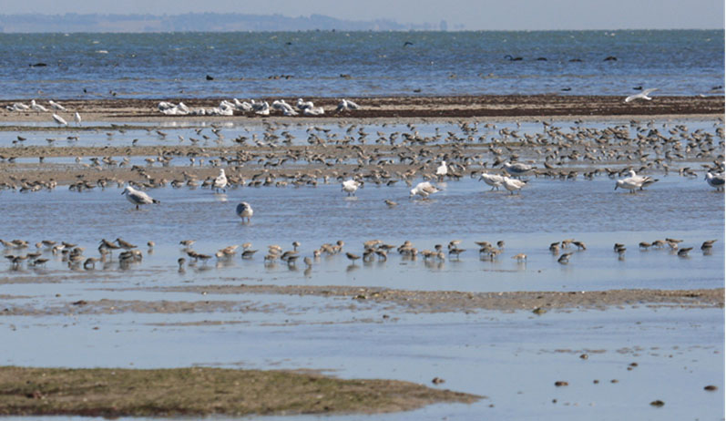



Danny I. Rogers¹, Richard H. Loyn¹ and Dougal Greer²

¹Arthur Rylah Institute for Environmental Research
123 Brown Street, Heidelberg, Victoria 3084

²eCoast, PO Box 151, Raglan, Waikato, New Zealand

October 2013

Arthur Rylah Institute for Environmental Research
Department of Environment and Primary Industries
Heidelberg, Victoria

Report produced by: Arthur Rylah Institute for Environmental Research
Department of Environment and Primary Industries
PO Box 137
Heidelberg, Victoria 3084
Phone (03) 9450 8600
Website: www.depi.vic.gov.au/ari
© State of Victoria, Department of Environment and Primary Industries 2013
This publication is copyright. Apart from fair dealing for the purposes of private study, research, criticism or review as permitted under the Copyright Act 1968, no part may be reproduced, copied, transmitted in any form or by any means (electronic, mechanical or graphic) without the prior written permission of the State of Victoria, Department of Environment and Primary Industries. All requests and enquiries should be directed to the Customer Service Centre, 136 186 or email customer.service@depi.vic.gov.au
Citation: Rogers, D.I., Loyn, R.H. and Greer, D. (2013) Factors influencing shorebird use of tidal flats adjacent to the Western Treatment Plant. Arthur Rylah Institute for Environmental Research Technical Report Series No. 250. Department of Sustainability and Environment, Heidelberg, Victoria

ISSN 1835-3827 (print)
ISSN 1835-3835 (online)
ISBN 978-1-74287-991-8 (print)
ISBN 978-1-74287-992-5 (online)
Disclaimer: This publication may be of assistance to you but the State of Victoria and its employees do not guarantee that the publication is without flaw of any kind or is wholly appropriate for your particular purposes and therefore disclaims all liability for any error, loss or other consequence which may arise from you relying on any information in this publication.
Accessibility:
If you would like to receive this publication in an accessible format, such as large print or audio, please telephone
136 186, or through the National Relay Service (NRS) using a modem or textphone/teletypewriter (TTY) by dialling 1800 555 677, or email customer.service@depi.vic.gov.au
This document is also available in PDF format on the internet at www.depi.vic.gov.au
Front cover photo: Shorebirds foraging on the tidal flats off the Western Treatment Plant (Richard Loyn).
Authorised by: Victorian Government, Melbourne
Printed by: NMIT PRINTROOM, 77 St Georges Rd, Preston 3072, Victoria, Australia

Contents
Acknowledgements iv
Summary 1
1 Introduction 3
2 Methods 5
2.1 Shorebird counts 5
2.2 Radio-telemetry 5
2.3 Benthos monitoring 6
2.4 Modelling of tide height and tidal flat area 10
3 Results 12
3.1 Flyway population trends 12
3.2 Availability of roosting and alternate foraging habitat in inland ponds 18
3.3 Area of exposed tidal flat 22
3.4 Benthic density 29
3.5 Effluent discharges 38
3.6 Relative importance of factors influencing shorebird numbers and distribution 39
4 Discussion 43
4.1 Victorian shorebird populations 43
4.2 Tidal flat exposure 44
4.3 Benthos density 45
4.4 Effluent content, thresholds and tolerance limits 46
References 48
Appendix 1: Exposure maps of tidal flats 51
Appendix 2: Estimation of tidal flat area at different tide heights 57
Appendix 3: Correlations of benthos density and effluent loads 59

Acknowledgements
We are grateful to Melbourne Water for commissioning this study through the Catchments Team of the Waterways Group. The report was improved by comments from Will Steele, Suelin Haynes, David Ramsay and Paul Maloney. This report draws on a number of different datasets:
Tide data were provided from gauges at Williamstown (Port of Melbourne) and Point Richards (Port of Geelong); we thank those organisations for permission to use their data, and Paul Davill of the National Tide Centre for data extractions. Ed Atkin (eCoast Ltd) assisted Dougal Greer with construction of the digital elevation models presented in this report.
Collection of data on water flows and effluent contents was commissioned by Melbourne Water and carried out by ALS Group Ltd. In this report we worked from summaries of this data prepared by David Petch and co-workers at GHD. All benthos samples were collected by Danny Rogers, often with the help of the staff who subsequently processed the samples: Shanaugh Lyon, Mike Nicol, David Bryant, Bronwyn Cumbo, Fiona Warry and Daniel Corrie of ARI, Lynda Avery (Infauna Data Pty) and Genefor Walker Smith. Initial advice on the design of the benthos sampling program was provided by Phil Papas and Joanne Potts (ARI), and processing procedures have been refined with advice from Greg Parry and David Petch. Ken Rogers helped with several of the statistical analyses.
Shorebird monitoring data has been collected at the WTP since 1981; we thank the Australasian Wader Studies Group and the Shorebirds 2020 program of Birdlife Australia for providing the data collected before 2001. Since then the ARI has carried out more detailed shorebird monitoring at the WTP; Dale Tonkinson co-ordinated the surveys from 2001 to 2004. Key personnel in shorebird monitoring surveys since 2004 (conducted at finer spatial resolution) have included Bob Swindley and Maarten Hulzebosch. Our simultaneous counts program would not have been possible without the skilful assistance provided by a large number of volunteers: we thank regular team leaders Ken Harris, Tania Ireton, Dave Torr, Jeff Davies, Will Steele, Ashley Herrod, Ken Rogers, Ken Gosbell, Dale Tonkinson, Jimmy Gunn – and some 50 other volunteers: Adrian Boyle, Amanda Bush, Alice Ewing, Andrew Silcocks, Noel, Asha and Brenna Billing, Barnaby Briggs, Birgitta Hansen, Claire Appleby, Chris Hassell, Craig Morley, Charles Smith, Doris Graham, Dean Ingwersen, David McCarthy, Dawn Neylan, David Wilson, Gina Hopkins, Ed McNabb, Frank Farr, George Appleby, Howard Plowright, Heidi Zimmer, Inka Velthiem, Joan Broadberry, Jen Spry, Jean Thomas, Joy Tansey, Keith Johnson, Lauren Beasley, Luke Einoder, Lyn Easton, Mark Barter, Liz Gower, Nathan Detroit, Naomi Hall, Penny Johns, Peter Gower, Richard Walsh, Rob Clemens, Sant Cann, Shirley Cameron, Sue Charles, Dale Tonkinson and John Stoney; we apologise to a few others whose names never made it onto a data sheet. Access to Point Wilson for supplementary shorebird surveys was provided by the Department of Defence and facilitated by Thales Security (notably Garry Smith and Gerard Hard); access to Avalon Saltworks for shorebird surveys was provided by Cheetham Salt and facilitated by Brendan O’Dowd.

Summary
This report presents some key findings from studies of shorebirds at the Western Treatment Plant (WTP) from 2001 to 2012, and also considers previous counts from 1981. The work was commissioned by Melbourne Water to help manage the WTP to treat half of Melbourne’s sewage, reduce nutrient emissions to Port Phillip Bay, and conserve waterbirds. The WTP forms part of a wetland complex listed as internationally significant under the Ramsar Convention.
Shorebirds use a range of habitats at and near the WTP, especially the tidal flats along 11 km of coast from the Werribee River to The Spits Nature Reserve (managed by Parks Victoria). Shorebirds also forage and roost on shallow non-tidal wetlands in and near the WTP, but the tidal flats appear to be the main foraging habitat for the most numerous shorebird species, all of which are migrants that nest in Arctic Siberia or Alaska. The shorebirds feed on benthic invertebrates in the tidal flats, and high densities of benthic invertebrates have been attributed to nutrient enrichment from the WTP. An Environment Improvement Program has been implemented to reduce nitrogen emissions to the bay, and a risk was recognised that this could reduce the value of the flats for shorebirds. These studies were initiated to monitor the response of shorebird species and attempt to understand their ecology better so that the response could be managed and mitigating measures implemented where necessary.
This report focuses on the tidal flats and the three most numerous migratory shorebird species that forage on them: Red-necked Stint, Curlew Sandpiper and Sharp-tailed Sandpiper. Data were collected through bird counts (several times each summer, at least once each winter), foraging observations, estimates of how many birds were foraging or roosting, photographs of prey species, observations of bird movements (including a radio-tracking study) and standardised collections of benthic invertebrates. Data were also obtained from previous shorebird counts at the WTP, and from similar counts elsewhere in coastal Victoria.
Numbers of shorebirds fluctuated seasonally and between years. Red-necked Stint declined in abundance at the WTP during the 2000s, but no more so than at other Victorian sites. Curlew Sandpiper declined greatly in numbers during the decade as part of a global decline in this species. Numbers of both species at the WTP were positively correlated with numbers at other Victorian sites. Sharp-tailed Sandpipers were influenced by availability of water inland, and hardly any visited the WTP in summer 2011 after the breaking of a twelve-year drought. In other years they showed a weak tendency to be more numerous at the WTP in years when they were scarce at other Victorian sites. None of these species showed a stronger decline at the WTP during the 2000s than at other Victorian sites.
Studies of benthic invertebrates revealed some striking changes over this short period of time, with a large decline in worms and a corresponding increase in crustaceans (mainly amphipods) in the middle of the decade. This is likely to have implications for some shorebird species, although the net effect was little change in edible biomass.
The relationships between numbers of shorebirds and benthic invertebrates are complex. Remote-sensed mapping of tidal flats proved necessary to explore these relationships and we present the first maps of the key intertidal foraging sites for shorebirds of the WTP to show the area exposed and submerged by water at specific water levels. We developed a hierarchical set of models that predicted shorebird numbers at any stretch of coast. According to these models, shorebird numbers at particular tidal foraging sites depend on the total number of shorebirds in the whole WTP (partly a product of events elsewhere in the flyway), the exposure of those flats at any one time (or the mean exposure over a longer period) and the abundance of benthic invertebrates on those flats. The data allowed us to parameterise these models for the three focal species. Significant positive relationships were found between local foraging abundance of shorebirds and density of benthic invertebrates.
Within periods of low tidal range, tide height had a strong influence on the numbers of birds that foraged on tidal flats. The proportion of WTP shorebirds foraging on tidal flats was highest on the lowest spring tides (<0.20 m), and lower on tides of 0.35–0.5m, even though there was still some tidal flat exposure in these conditions. Key areas were identified where shorebirds were able to forage at high tidal levels. These areas could be crucial for conserving shorebirds during neap tides when many areas of tidal flat can remain inundated and inaccessible to shorebirds for many days at a time: non-tidal wetlands on the WTP may perform a similar function.

- Introduction
The Western Treatment Plant (WTP) is a very large sewage treatment works on the shores of Corio Bay, which treats some 55% of the sewage of Melbourne. It attracts large numbers of shorebirds, including migratory species that breed in northern Asia and are subject to international agreements to protect migratory birds and their habitats. These shorebirds are among the principal biological assets that contributed to the site being listed as a wetland of international significance under the Ramsar Convention. Melbourne Water manages the WTP and has obligations to protect shorebird habitat under legislation including the Commonwealth Environment Protection and Biodiversity Conservation Act 1999 (EPBC Act). Melbourne Water also needs to meet commitments to treat wastewater, and to comply with a number of requirements set by the Victorian Environment Protection Authority as part of Melbourne Water’s accredited discharge licence. These include limitations on the amount of nitrogen discharged in effluent into Port Phillip Bay, and as a result, in 1998 Melbourne Water initiated upgrades to its treatment processes through an environment improvement project.
A number of ecological studies were commissioned by Melbourne Water to accompany the Environment Improvement Project. In part these studies were prompted by the concern that lowering nitrogen discharges might diminish the abundance of sediment-dwelling benthic invertebrates (hereafter simply referred to as ‘benthos’) in the tidal flats adjacent to the WTP. Subsequent mixing zone studies and historical reviews (Parry et al. 2008, 2009, 2011; Parry and Oldman 2011; Parry and Rogers 2012; Parry et al. 2013; GHD in prep.) tend to support this view. A decline in benthos density could be potentially detrimental to shorebird populations of the WTP, as benthos is considered their main dietary component.
In 2004, Melbourne Water commissioned a study of shorebird ecology at the Western Treatment Plant. The objectives of the study are:
- ‘To determine the key factors – biotic, environmental and physicochemical – that determine shorebird abundance and distribution at the WTP, and describe their relative importance.
To describe thresholds and estimate tolerance bands for species of migratory shorebird.’
This report summarises achievements over the past eight years. The report focuses on shorebird abundance and distribution on the tidal flat systems adjacent to the WTP, as these are known to be the main foraging areas for the most numerous migratory shorebird species of the WTP (Loyn et al. 2002, Beasley 2004). We comment on the relevance of our findings to changes in sewage treatment processes currently being considered by Melbourne Water. These include diversion of effluent from the 115E Outfall to other outfall points, potentially including newly created outfalls that are closer to tidal flats used by shorebirds. Finally, we suggest some directions for future research.
The report focuses on three species of small sandpiper (family Scolopacidae): Red-necked Stint Calidris ruficollis, Sharp-tailed Sandpiper Calidris acuminata and Curlew Sandpiper Calidris ferruginea. They are the three most abundant migratory shorebird species of the WTP, occurring at the site in internationally significant numbers (i.e. >1% of the entire population of the East Asian–Australasian Flyway). Adequate habitat management for these species is therefore a priority for compliance with the EPBC Act, and their relative abundance at the WTP enables us to work with larger sample sizes than are available for less common species.
The WTP experienced substantial changes over the study period that may have influenced shorebird numbers or habitat values. These included:
- The study started during a severe and widespread drought. This resulted in reduced inflows to the WTP, and reduced discharges into Port Phillip Bay. The drought is likely to have forced many waterbirds to coastal regions because of lack of wetland habitats inland. The opposite effects occurred at the end of the drought in 2009–2011.
- Melbourne Water implemented an Environment Improvement Project at the WTP, lowering nutrient discharges considerably between January 2003 and December 2004.
- Conversion of several former sewage ponds to conservation areas resulted in creation of some ‘new’ sites for roosting and foraging shorebirds at high tide, notably at 85W Lagoon series C Pond 9, Pond 28 of the Lake Borrie System, Ponds 4, 5 and 9 of the Western Lagoons and an area of irrigation runoff in the Q-section paddocks next to the Western Lagoon. One of these ponds (85W C Pond 9) is now managed to provide habitat for shorebirds, along with previously established conservation ponds at 35E and elsewhere. The other ponds provide shorebird habitat at the moment while being managed for other conservation objectives in the longer term, including restoring saltmarsh habitat for the critically endangered Orange-bellied Parrot Neophema chrysogaster in the Western Lagoon.
Four small experimental outfalls were opened on the coast between Borrie Outfall and Beacon Point in 2007; most were subsequently closed but one remained open in the summer of 2011/12.
Perhaps as a result of these changes, the abundance of benthos and shorebirds was dynamic during the study period, providing the opportunity to examine the relationship between shorebird abundance and distribution and other variables.

- Methods
  - Shorebird counts
The current program of waterbird counts began in 2001, commissioned by Melbourne Water to help assess effects of the Environment Improvement Program, which was implemented in subsequent years. However, shorebird numbers at the WTP had been monitored at lower intensity since 1981, beginning as a voluntary initiative of the Victorian Wader Study Group and contributing to national counts coordinated by the Australasian Wader Study Group (AWSG). Ever since then, annual summer and winter surveys have been carried out to coincide with national counts carried out concurrently at major shorebird sites of southern Australia. The counts are carried out at high tide when shorebirds are concentrated in roosts. Until 2000, the usual practice was to carry out a summer count close to the end of January, and a winter count in late June or early July, with additional surveys being conducted in some years. Counts were aggregated with counts from nearby Point Wilson and Avalon Saltworks to compile a ‘WTP–Avalon’ total which is published near-annually in the journal Stilt. It has been possible to extract WTP totals alone from databases provided by Birdlife Australia, but finer spatial resolution is not available for most counts carried out before 2000.
In 2001, the current intensified program commenced at the WTP, with a minimum of one winter count and three summer counts being carried out each year. On each of these surveys, shorebirds are counted at both high and low tide. Component counts are organised in ten separate districts of the WTP. Since 2004 the exact time and location of each component shorebird count has been recorded along with the proportion of birds foraging during each count. Knowing the time at which counts were made allows shorebird totals seen at any one site to be compared with tide conditions. Recording of exact location of counts (c. 160 component sites are counted on each survey) allows changes in foraging and roosting distribution within the WTP to be investigated.
Many of the counts carried out since January 2004 have been ‘simultaneous counts’. The surveys were carried out through a single day by seven small teams of volunteers, who counted the number of shorebirds (and the proportion foraging) at their allotted sites at approximately hourly intervals. In addition, additional counters carried out ‘standard’ counts of the entire WTP in order to maintain continuity with the methodology on earlier surveys. Simultaneous counts were initiated to document shorebird movements around the WTP in the course of a day, and to allow calculation of bird-foraging hours per site. The number of bird-foraging hours per intertidal site has proved to be closely correlated to the maximum count at low tide, and the latter value has been used in most analyses in this report.
  - Radio-telemetry
A radio-tracking study was carried out in February–March 2004 to investigate the movements of 15 Red-necked Stints and to check whether their nocturnal movements were similar to those observed in simultaneous counts by day. The birds were cannon-netted by the Victorian Wader Study Group on Pond 6 of the T-Section Lagoon on 22 February 2004. Small (1.1 g) Holohil radio-transmitters were attached to the lower back of 15 Red-necked Stints. A small (c. 1 cm2) area of feathers was trimmed on the lower back, and superglue was used to attach the transmitters to the trimmed feather-stubs, and to the underlying skin, with the aerials running along the top of the tail and projecting about 12 cm beyond the tail-tip. There were no apparent ill-effects on the birds, and the transmitters remained attached throughout the study period.
Radio-tagged birds were relocated with handheld receivers (ICOM IC-R10) attached to (directional) Yagi antennae. Receivers were programmed and fine-tuned for each of the 15 transmitters. On average, four days a week were spent relocating birds between 23 February 2004 and 30 March 2004. On each scan we recorded the presence/absence and location of each bird, and whether its radio-signals were stable or fluctuating. Direct resightings of birds indicated that signals of fluctuating strength were much more likely to be recorded when the birds were foraging; the fluctuations were caused by active birds sometimes pointing their aerials away from the observers, or moving so that flockmates interrupted the line of sight between aerials and receivers. Further details on methodology are given in Rogers et al. (2004).
  - Benthos monitoring
Benthos samples were taken from the top 5 cm of sediment with a cylindrical corer, 5 cm in diameter, and then placed directly in sample jars for future laboratory examination. Ethanol was used as a preservative. It is traditional to take larger, deeper cores in studies of intertidal benthos (e.g. Gill et al. 2001; van Gils & Piersma 2004, van Gils et al. 2005 a, b). Smaller cores were taken at the WTP in order to reduce laboratory processing time, and hence to increase the number of sites we could sample. Moreover, foraging observations indicated that the focal shorebird species only took prey from the top centimetre or so of sediment, and none have long enough bills to probe deeper than 5 cm (Red-necked Stint, bill length 16–22 mm; Curlew Sandpiper, bill length 32–43 mm; and Sharp-tailed Sandpiper, bill length 22–27 mm; bill measurements from Higgins and Davies 1996). It is possible that large polychaetes and bivalves may have been under-represented in our shallow cores, and although there is little reason to suspect that this resulted in underestimates of biomass of potential prey for small sandpipers (photography suggested they seldom or never ate large polychaetes or bivalves), it could have resulted in our biomass estimates being lower than those that would have been obtained with deeper sediment cores.
Previous studies at the WTP had shown the benthic fauna to be extremely abundant and dominated by small animals, suggesting small cores would be sufficient to capture enough animals to make a reasonable estimate of average biomass. Replicate samples collected in the first benthos survey were used to examine whether our sample sizes were adequate to assess average biomass of a shorebird foraging area. Within four separate shorebird foraging areas, we collected samples at four points, taking and processing five replicates at each sampling point. We then carried out a bootstrap analysis, calculating the mean biomass in each foraging area by randomly selecting one replicate from each sampling point, and repeating this random selection (with replacement) and calculation of the mean 1000 times. The resultant estimates of mean and standard deviation are shown in Table 1. The estimated means were quite variable, especially in two large shorebird foraging areas (Beach Road East and North Spit Lagoon) where density charts (Figure 1) suggested bimodal distributions. Examination of outlying values indicated that they were skewed because one or more of the randomly selected cores contained an unusually large individual invertebrate. The number of sampling points within key foraging sites was therefore increased in later surveys (Figure 2) so estimates of mean biomass per foraging area would not be so greatly influenced by outliers.
In our first benthos survey of the WTP in March 2005, we sampled benthos on all tidal flats adjacent to the WTP where shorebirds were known to forage (Rogers et al. 2007). Subsequent benthos sampling at the WTP was modified following this pilot survey. We focused on more intensive sampling of the eight intertidal foraging areas where shorebirds had been recorded foraging in their thousands (Figure 2). Collectively, these eight foraging sites were used by 72.6% of the Red-necked Stints, 68.6% of the Sharp-tailed Sandpipers, and 87.2% of the Curlew Sandpipers recorded on tidal flats of the WTP between 2004 and 2012; they are often referred to as ‘the key sites’ in this report. Eighty-one sampling points (shown in Figure 2) were selected to enable spatial variation of benthic abundance within each shorebird foraging area to be mapped. This analysis has not yet been completed and the extent of zonation in benthos density within each shorebird foraging area remains unclear. Nevertheless, the surveys are helpful in assessing changes in benthos density over time. In general, the same sampling points, located by GPS, were sampled on each benthic survey. Any spatial bias in our assessment of average benthic abundance and biomass for each shorebird foraging area was therefore similar on all surveys. In a few surveys it was not possible to visit all sampling points within each bird-foraging area. These surveys (referred to as ‘incomplete surveys’) are treated separately in the analyses because if there was spatial variation within the foraging sites, exclusion of some sites might have biased our estimate of the mean biomass.

Table 1. Probability distribution average edible biomass from four foraging sites, calculated by random sampling and replacement 1000 iterations.

Site | No. of sampling points | No. of replicates at each sampling point | No. of repeated samples | Mean | S.D.
Beach Rd East | 4 | 5 | 1000 | 34.9 | 12.12
Little R Mouth to 145W Outfall | 4 | 5 | 1000 | 19 | 4.28
North Spit Lagoon | 4 | 5 | 1000 | 17.7 | 8.36
Walsh’s Lagoon Pond 7 | 4 | 5 | 1000 | 26.7 | 4.8

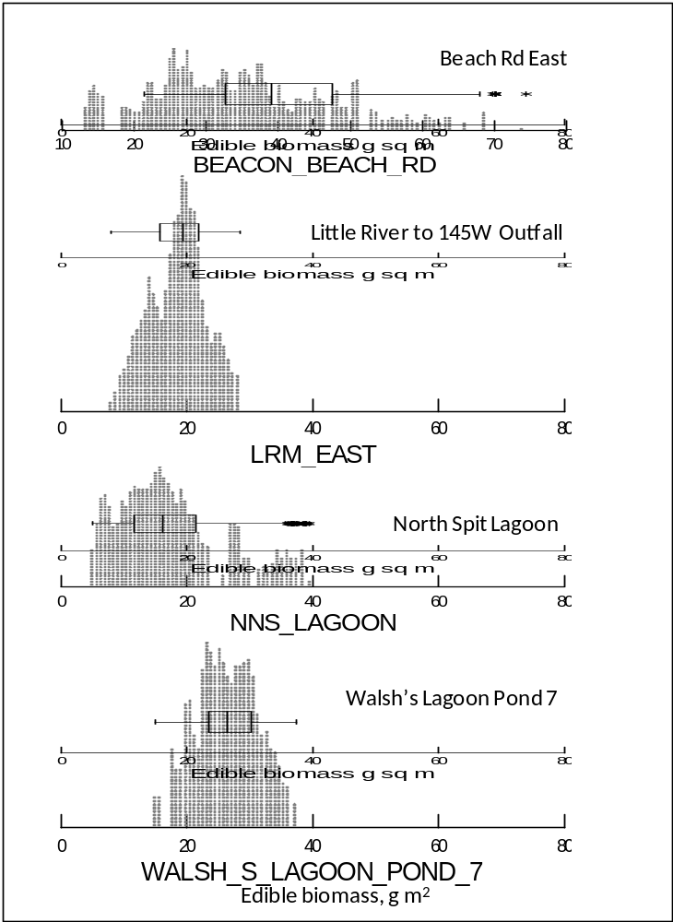

Figure 1. Dot density plots and superimposed box plots showing the distribution of estimates of mean biomass in four shorebird feeding sites, based on 1000 bootstrapped samples from each. In the boxplots, the centre vertical line marks the median; the length of each box shows the range in which the central 50% of values fall (between the 25th and 75th percentiles), the whiskers show the range of values within 1.5 x the interquartile range and asterisks show ‘outside values’ between 1.5 and 3 x the interquartile range.

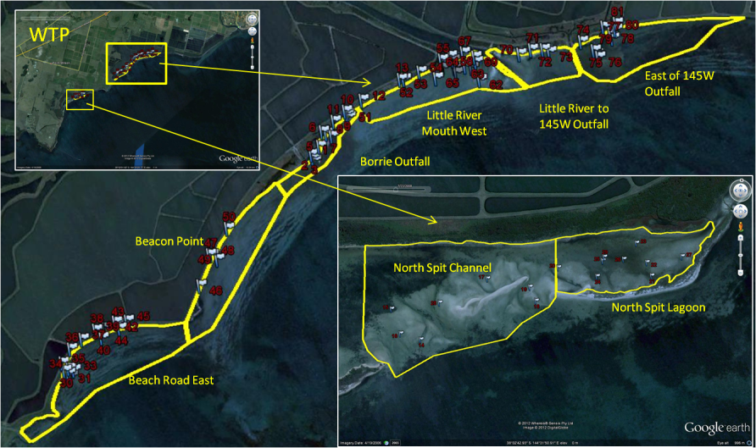
Figure 2. Google Earth imagery showing the eight main intertidal foraging areas of shorebirds of the WTP. Numbers (in red) indicate specific benthos sampling points.
In the laboratory, samples were mixed with water and split into 50% sub-samples, except in cases when the cores contained filamentous algae or weed which proved difficult to subdivide equally (in such cases the entire sample was processed, and appropriate corrections made when estimating biomass or number of animals per m²). Once the samples were split, they were washed through sieves with apertures of 500µm and 63µm respectively, to separate small and large organisms and remove excess substrate. The sieve contents were then transferred to a sorting tray and analysed under microscope at 10x magnification, zooming up to 50–100x magnification at times to check identifications.
The total number of individuals in one 50% sub-sample was recorded (or in the entire sample, in cases where the core could not be evenly subdivided). Each individual animal was identified, in most cases to a fairly coarse taxonomic level, and a simple morphological classification was made of each: short (<5 mm), medium (5–10 mm) or long (>10 mm). For worms we also assessed width as either thin (<0.8 mm) or thick (>0.8 mm) for use in biomass calculations. Polychaete and Oligochaete worms in the samples were often broken into fragments by the sieving process, a typical problem when working with this group. We processed all worm fragments (counting, identifying and assessing the morphology for each). It was not necessary to measure fragments in any other groups.
Direct measurement of biomass of each sampled animal was not practical, as weighing such small individuals (often <1 mg) would have at least tripled processing times. Instead we estimated biomass by using methods described in more detail by Rogers et al. (2007, 2011). In short, each sampled animal was assigned to a coarse taxonomic and morphological category. Polychaetes and other annelid worms were often fragmented, and in these we assigned fragments to a morphological category. Aggregated samples of animals (or worm fragments) in each of these categories were weighed to calculate the average mass of each animal or worm fragment (Table 2). This was a used as a conversion factor, multiplied by the number of animals of each taxonomic/morphological category in each core sample to estimate the biomass.
In this report we present three measures of benthic biomass (dry mass g per m²):
- ‘Edible Biomass’. The average biomass per foraging area of macrozoobenthic animals which the focal species in this study were considered capable of ingesting. This included most captured benthic animals, but brittle stars and hard-shelled molluscs and crabs > 10 mm long were not included.
- ‘Worms’ – Mainly polychaetes; also some oligochaetes, and those nematode worms large enough to be retained by our sieves.
‘Crustacea’ – Dominated by amphipods; ostracods were also abundant, but relatively low in biomass. Hard-shelled crabs >10mm long were not included, as there were no in-field observations of the three focal species eating large crabs.
  - Modelling of tide height and tidal flat area
The eight key intertidal foraging areas shown in Figure 2 were defined as polygons. Grids of each of these regions were made and post-processed to calculate intertidal areas at a range of sea levels. Hydrographic and topographic data collected using a Light Detection and Ranging (LIDAR) system was used as the primary dataset in constructing bathymetric grids. The dataset covers the coast and nearshore as part of the Vicmap Elevation Coastal 1 m and 2.5 m DEM topographic datasets. The vertical accuracy associated with the datasets is ±0.10 m at 68% confidence. The data were delivered using a negative down convention and referenced to Australian Height Datum (AHD) which is vertical datum very close to Mean Sea Level (MSL). Water levels and field data observations were all relative to Williamstown Chart Datum (CD) which is 0.524 m below AHD. For consistency 0.524 m was added to the topographic vertical measurements, reducing the dataset to CD. Throughout the remainder of this document sea levels and topographic heights are relative to CD unless otherwise stated.
Each subset of data was used to make a 5 m resolution grid of the foraging areas using a kriging interpolation method with search parameters tailored to each site. In some foraging areas there were substantial gaps in the LIDAR data in the intertidal regions and, although kriging can be used to fill in such gaps, the algorithm occasionally created unrealistic features in the grids. Observations collected over several years by DR were used to guide the process of correcting the grids. Observations included:
- Recorded GPS locations with time stamps, water depth and tidal flat width estimations;
- Photographic evidence, and;
Anecdotal evidence as to the existence/non-existence of topographic features.
Most notably, comparisons with observational data indicated that there was a consistent vertical offset of 0.25 m between the LIDAR data and field observations. This was corrected by applying a uniform 0.25 m vertical shift to all data points.
The surface area of exposed intertidal flats was estimated at sea levels of 0.1 to 0.7 m (CD) in 0.1 m intervals. Each cell in the grid represented 25 m² of terrain and, for each sea level, cells within the region of interest were defined as wet if they were lower than the sea level and dry if they were higher than the sea level leading to an estimation of the exposed intertidal area.
This methodology does not account for the hydrodynamic and metocean processes that may alter the wetting and drying of the intertidal flats (e.g. spatial variation tidal phase, wind and wave set-up and barometric pressure). Hydrodynamic process effects were of particular importance for North Spit Lagoon where the ebb tide is constricted considerably by barrier islands (Danny Rogers Pers. obs.) causing a lag in the tidal signal between the inside and outside of the lagoon system. In the Lagoon of the Spits Nature Reserve there was a consistent offset of 0.2 m between the corrected LIDAR data and field data observations. This may have been due to an error in the vertical component of the bathymetry in this area or due to the tidal lag effect described above. In any case, the 0.2 m correction was applied to the data prior to gridding. The North Spit Channel polygon takes in a region both inside and outside the lagoon system. Intertidal area estimations were calculated separately for the parts of North Spit Channel inside and outside the lagoon.
We needed to estimate water level, and hence the area of exposed tidal flat, at the time when each shorebird count was made. We did this with reference to data collected by the nearest permanent tide gauges, at Williamstown and Point Richards, where water depth is recorded at six-minute intervals. We checked that these tide gauges provided a suitable measure of tide conditions at the WTP by deploying two automatic water depth recorders (Odyssey Pty Ltd) on the tidal flats of the WTP through February and March 2012. Both were situated in locally deep areas and were submerged even on the lowest tides: one at the mouth of 145W Outfall, and one offshore from Murtcaim Outfall. Water level and time of high and low tides at these sites corresponded very closely with that at both Williamstown and Point Richards.

- Results
  - Flyway population trends
Numbers of migratory shorebirds vary seasonally at the WTP, peaking in the austral summer when adult shorebirds are present as well as young birds from the previous breeding season in the Northern Hemisphere. During the austral winter, nearly all adults leave Victoria to return to the breeding grounds. Red-necked Stints and Curlew Sandpipers have delayed maturity, not migrating north until their third calendar year, and immatures remain on the non-breeding grounds during the winter months: moderate numbers of these species (usually 10–20% of summer totals) are therefore present in the WTP during the austral winter. In contrast, Sharp-tailed Sandpipers do not have delayed maturity and winter records of this species at the WTP are very rare. Within the austral summer, shorebird numbers typically peak in January–February; numbers of all species build up during September–October and decrease rapidly in March, with few shorebirds remaining in the WTP between April–August (Figure 3). There can be considerable variation in numbers within a summer (see error bars in Figure 3).
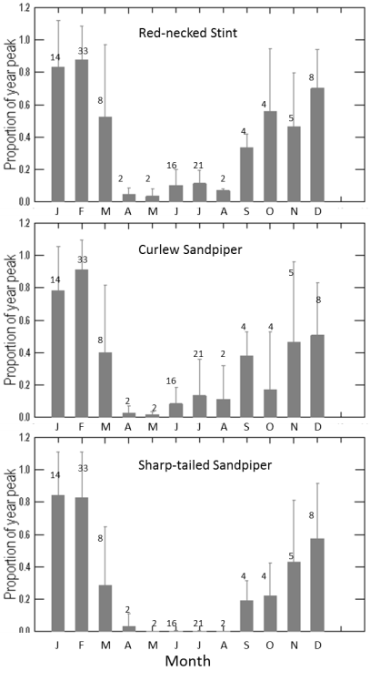
Figure 3. Monthly numbers of Red-necked Stint, Curlew Sandpiper and Sharp-tailed Sandpiper, expressed as a proportion of peak annual count. Error bars show Standard Deviation; the digits indicate number of counts carried out at the WTP each month.

Data plots (Figure 4) indicated that shorebird numbers at the WTP declined during the study period. In linear regressions of summer counts versus date, gradients were negative for Red-necked Stint (Coefficent = –441.69 ± SE 92.827; R² = 0.386, P < 0.001), for Curlew Sandpiper (Coefficent = –80.3 7 ± SE 29.206; R² = 0.417, P = 0.009) and for Sharp-tailed Sandpiper (Coefficent = –151.85 ± SE 29.206; R² = 0.417, P = 0.022). Comparisons with LOWESS smoothers applied to the same data (Figure 4) suggest the changes were imperfectly described by linear regressions, and examinations of residuals suggested the linear regressions for Curlew Sandpiper and Sharp-tailed Sandpiper may have been influenced by autocorrelation. Nevertheless, it is clear that summer counts varied over time.
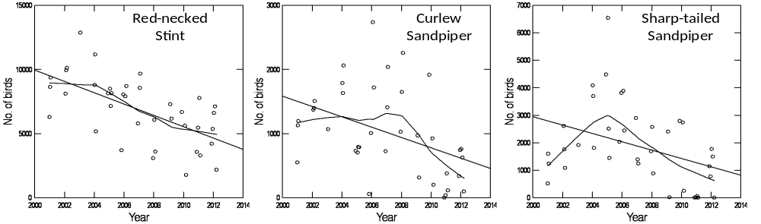
Figure 4. Summer counts (mid-November to early March) of Red-necked Stint, Curlew Sandpiper and Sharp-tailed Sandpiper at the WTP, 2001–2012. The straight lines depict linear regressions; the uneven lines are LOWESS smoothers.

The apparent declines in summer counts during our study period coincided broadly with implementation of the Environment Improvement Plan between 2004 and 2007. However, this is not proof of a causal relationship. Examination of the longer-term dataset provided by the program of national summer counts initiated in 1981 indicates that shorebird numbers at the WTP vary considerably from year to year, and temporal trends differ between species (Figure 5). Red-necked Stints increased in numbers through the 1990s and have been declining since the early 2000s; Curlew Sandpiper counts have declined considerably since the 1980s. Sharp-tailed Sandpipers numbers vary so much from year to year that long-term trends are difficult to detect. The summer of 2011, a year of widespread inland flooding, was a striking example: no Sharp-tailed Sandpipers could be found at all during the February count, and no more than 20 birds were observed at the WTP at any time during that summer season.

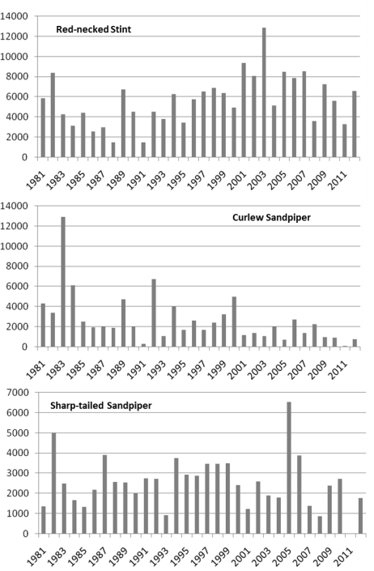

Figure 5. Annual summer counts of Red-necked Stint, Curlew Sandpiper and Sharp-tailed Sandpiper at the WTP.

The changes in numbers of these species at the WTP were compared with those at other Victorian sites which have also been monitored annually since 1980 (Western Port Bay, Corner Inlet, the Lake Connewarre System, Altona, Swan Bay and other shorebird sites in the west of Port Phillip Bay). Aggregated Red-necked Stint data from these sites showed similar smoothed time trends to the WTP; WTP counts were strongly correlated with counts in other Victorian sites (correlation coefficient = 0.741) and in most years WTP counts were within 95% confidence limits of Victorian counts overall (Figure 6). Similarly, Curlew Sandpiper declined markedly both in the WTP and in other Victorian sites (correlation coefficient = 0.825); however, inspection of Figure 6 suggests there was an extended period in the late 1980s and early 1990s in which Curlew Sandpiper numbers were proportionately lower in the WTP than in other Victorian sites. In contrast, there was a weak negative correlation between numbers of Sharp-tailed Sandpiper in the WTP and other Victorian sites (correlation coefficient = –0.299), with a long period in the late 1980s when Sharp-tailed Sandpiper numbers were markedly lower at the WTP than elsewhere, and another period in the late 1990s when numbers were markedly greater at the WTP than elsewhere.
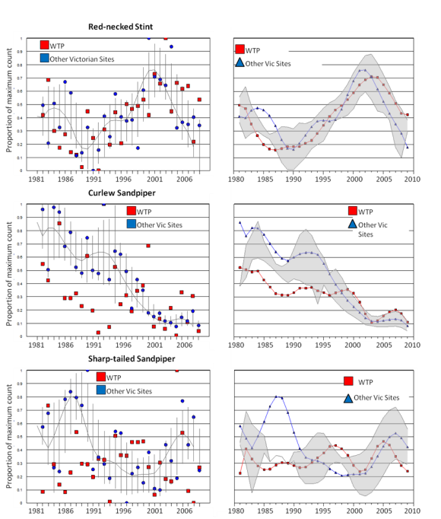

Figure 6. Comparison of shorebird numbers at the WTP and other Victorian sites over time. Number of birds (Y axis) is given as proportion of the maximum count for direct comparison across sites. In the left-hand panels, LOWESS smoothers for other Victorian sites are shown with their 95% confidence limits (found through bootstrapping). The right-hand panels compare LOWESS smoothers for the WTP and other Victorian sites, with the grey shaded area demarcating envelopes in which counts from WTP and other Victorian sites lie within the same 95% confidence intervals.

Long-term trends in shorebird numbers at the WTP and other Victorian sites are compared in Table 2. The plots presented above demonstrate that temporal changes in shorebird numbers are complex, and for most species the changes are not smoothly linear; for some species, examination of the residuals suggested that the assumptions of linear regression were not met. Accordingly, we used a non-parametric robust regression, the Theil-Sen estimator (which makes no distributional assumptions and is less sensitive to outliers than linear regression). Gradients were negative for most species of migratory shorebird, both at the WTP and in other Victorian sites. In contrast no clear trend was obvious in many Australasian shorebirds and some species were increasing.

Table 2. Comparison of long-term trends in shorebird numbers at the WTP and other Victorian sites, using annual counts 1980–2010. Summer counts were used for most species; winter counts were used for three species that visit the WTP mainly during the austral winter (Australian Pied Oystercatcher, Black-fronted Dotterel, and Double-banded Plover). Slopes from Theil-Sen robust regressions are presented, along with the probability that the slopes differed from zero.
 | WTP |  | Other Vic. sites
Species | Annual change | Significant at 95%? | Annual change | Significant at 95%?
Australasian species
Australian Pied Oystercatcher | –0.2% | Not sig. | 0.9% | Sig.
Banded Stilt | 162.6% | Not sig. | 1.5% | Not sig.
Black-fronted Dotterel | 0.2% | Not sig. | 0.0% | Not sig.
Black-winged Stilt | 8.5% | Sig. | –0.4% | Not sig.
Double-banded Plover | 5.3% | Not sig. | –0.4% | Not sig.
Masked Lapwing | –0.8% | Not sig. | –1.6% | Sig.
Red-capped Plover | 0.8% | Not sig. | 0.2% | Not sig.
Red-kneed Dotterel | –1.6% | Not sig. | 0.6% | Not sig.
Red-necked Avocet | 1.8% | Not sig. | –1.4% | Not sig.
Migratory species
Bar-tailed Godwit | 3.2% | Not sig. | –0.1% | Not sig.
Common Greenshank | 2.3% | Not sig. | –2.1% | Sig.
Curlew Sandpiper | –2.7% | Sig. | –3.0% | Sig.
Eastern Curlew | –4.1% | Sig. | –1.8% | Sig.
Marsh Sandpiper | 21.2% | Not sig. | 0.4% | Not sig.
Pacific Golden Plover | –2.4% | Not sig. | –3.0% | Sig.
Red Knot | –2.0% | Not sig. | –3.0% | Sig.
Red-necked Stint | 2.7% | Not sig. | –0.2% | Not sig.
Ruddy Turnstone | –1.8% | Not sig. | –2.4% | Sig.
Sharp-tailed Sandpiper | –0.1% | Not sig. | –2.2% | Sig.
  - Availability of roosting and alternate foraging habitat in inland ponds
A radio-telemetry study of Red-necked Stint during February-March 2004 (Rogers et al. 2004) demonstrated that:
- Of the 15 radio-tagged individuals, most commuted regularly between high tide roosts on inland ponds, and foraging grounds on tidal flats at low tide. However, one individual showed a strong preference for inland ponds, foraging at the T-Section Lagoons at both high and low tide.
- Habitat selection was similar or identical by day and night. Most individuals foraged on tidal flats at low tide, whether it was daylight or dark; at high tide they usually returned to the site where they had roosted on the previous high tide.
- Tracked individuals were found in the WTP on both high and low tides. There was no evidence that any individuals commuted on a daily basis to sites outside the WTP.
- Many individuals regularly commuted between high tide roosts on the T-Section Lagoons, and low tide foraging areas between Borrie Outfall and 145W Outfall — the longest possible flight between regularly used high tide roosts and intertidal foraging areas in the WTP, a flight distance of 8–10 km. As this was a return flight carried out every low tide, and there are on average 1.92 low tides per day at the WTP, these birds commuted 30–38 km per day.
- Most individuals which roosted at the T-Section Lagoons at the start of the study later relocated to ponds in the east of the WTP (mainly 85WC Lagoon Pond 9), where they both roosted and foraged at high tide. This shift was apparently in response to changing environmental conditions; the T-Section Lagoons were drying out rapidly at the time, while declining water levels at 85WC Pond 9 exposed increasingly large potential foraging areas. The timing of this shift was spread over several weeks rather than being tightly synchronised between individuals.
The program of simultaneous counts indicates that movement patterns of the WTP’s migratory shorebirds have remained similar ever since. Shorebird counts at low tide correspond very closely with counts made on the same day at high tide (Red-necked Stint, R² = 0.978, P < 0.001, n = 27; Curlew Sandpiper, R² = 0.954, P < 0.001, n = 30; Sharp-tailed Sandpiper, R² = 0.927, P < 0.001, n = 30). This is consistent with direct field observations indicating that there are no regular commuting flights between the WTP and sites outside the study area. The number of birds that occur at western roosts at high tide (T-Section Lagoons, Austin Road Summer Pond 2 and Western Lagoon Ponds 4 and 5) far exceeds the number of birds foraging on the adjacent Spit Lagoon, consistent with direct observations indicating that many birds from the western roosts still commute to intertidal foraging areas near the mouth of Little River.
The counts program undertaken at the WTP from 2004 to 2012 is consistent with previous studies (Loyn et al. 2002, Beasley 2004) showing that the tidal flats, when exposed at low tide, are the preferred foraging habitat of many shorebird species at the WTP. Table 3 shows the proportionate use of tidal flats by different species. Some species are apparently constrained in their habitat use, foraging exclusively on inland ponds at low tide (e.g. Red-kneed Dotterel Erythrogonys cinctus) or exclusively on tidal flats (e.g. Eastern Curlew Numenius madagascariensis). Other species are more adaptable, foraging on both tidal flats and inland ponds when the tide is low, though usually with a clear preference for one or the other.
The three focal migratory species of this study forage in both inland wetlands and on tidal flats, but have a preference for foraging on tidal flats when the tide is low. This preference is strongest in Red-necked Stint (85.7% of foraging records were on tidal flats), less marked in Curlew Sandpiper and Sharp-tailed Sandpiper (68.1 and 66.4% of foraging records respectively were on tidal flats). Although the majority of foraging records are from the tidal flats, it is clear that a considerable amount of foraging is also done on inland ponds. Moreover, still more foraging is done on inland ponds at high tide, when high water levels prevent birds from foraging on tidal flats (Table 3).
In general, shorebirds on the tidal flats of the WTP spend most of their time foraging. This is true of Red-necked Stints, Curlew Sandpiper and Sharp-tailed Sandpiper, in which some 90–95% of birds observed on the tidal flats were foraging (Table 3). In contrast, when these species were in inland ponds, they spent 38–49% of their time foraging at high tide, and 13–18% of their time foraging at low tide.
The proportion of shorebirds foraging on inland ponds rather than tidal flats at low tide differed considerably from survey to survey. This variation was not related to date. However, it was weakly related to the height of low tide predicted by Williamstown tide timetables, and significantly related to the observed lowest sea-water level on each survey (Figure 7, Table 4). The R² values in these general linear models indicate there was considerable variation (~60% to 70%) in the proportion of birds occurring on inland ponds at low tide that could not be explained by tide conditions, suggesting that the condition of inland ponds might also be an important factor; however, we do not a have a convenient measure of quality of inland ponds for every survey. The effects of tide conditions are investigated in more detail in the next section.

Table 3. Proportion of birds that were foraging on inland ponds, at high and low tide, and on tidal flats. Number of foraging birds represents pooled data from all surveys 2004-2012 in which numbers of foraging and non-foraging birds were recorded systematically.
Species | Average WTP count | Maximum WTP count | % on tidal flats when tide is low | % on inland ponds foraging at high tide | % on inland ponds foraging at low tide | % on tidal flats foraging at low tide
Common Sandpiper | 0.6 | 6 | 0.0% | 100.0% | 33.3%
Long-toed Stint | 0.1 | 3 | 0.0% | 100.0% | 83.3%
Pectoral Sandpiper | 1.1 | 11 | 0.0% | 57.1% | 45.5%
Red-kneed Dotterel | 33.7 | 436 | 0.0% | 61.2% | 32.2%
Black-fronted Dotterel | 25.9 | 151 | 1.1% | 64.9% | 24.3% | 25.0%
Banded Stilt | 106.7 | 3387 | 1.4% | 53.8% | 24.4% | 100.0%
Red-necked Avocet | 297.8 | 1876 | 6.3% | 37.9% | 21.0% | 69.1%
Black-winged Stilt | 183.2 | 453 | 7.4% | 58.1% | 27.6% | 86.6%
Black-tailed Godwit | 4.8 | 44 | 8.9% | 32.4% | 16.4% | 57.1%
Marsh Sandpiper | 14.6 | 238 | 15.1% | 77.4% | 26.9% | 100.0%
Masked Lapwing | 123.8 | 392 | 35.8% | 20.1% | 6.8% | 36.6%
Common Greenshank | 23.4 | 146 | 63.9% | 39.0% | 16.1% | 92.4%
Sharp-tailed Sandpiper | 1181.7 | 6536 | 66.4% | 49.0% | 18.2% | 93.9%
Curlew Sandpiper | 1163.8 | 12937 | 68.1% | 44.6% | 14.3% | 89.4%
Red-capped Plover | 54.0 | 282 | 69.1% | 35.1% | 25.3% | 84.4%
Bar-tailed Godwit | 4.6 | 56 | 70.3% | 0.0% | 23.9% | 93.1%
Double-banded Plover | 47.2 | 731 | 73.6% | 33.6% | 26.1% | 88.8%
Pacific Golden Plover | 7.7 | 61 | 81.6% | 25.0% | 6.0% | 45.5%
Red-necked Stint | 3530.0 | 12850 | 85.8% | 38.0% | 13.4% | 95.7%
Red Knot | 10.1 | 170 | 88.1% | 16.7% | 25.0% | 100.0%
Pied Oystercatcher | 33.0 | 100 | 94.1% | 3.6% | 4.1% | 75.0%
Eastern Curlew | 1.8 | 15 | 100.0% | 0.0% | 0.0% | 82.4%
Grey Plover | 1.0 | 22 | 100.0% |  | 0.0% | 67.9%
Ruddy Turnstone | 2.7 | 35 | 100.0% |  | 0.0% | 88.9%
Table 4. Generalised linear models of the proportion of Red-necked Stint, Sharp-tailed Sandpiper and Curlew Sandpiper occurring on inland wetlands during low tide, relative to date and observed lowest tide height.
Model | Proportion of birds found on inland ponds =  Constant + (A x Date) + (B x Observed lowest tide height)
Species | Red-necked Stint | Sharp-tailed Sandpiper | Curlew Sandpiper
Constant ± S.E., P | 1.84 ± 1.30, P = 0.166 | 1.98 ± 2.07, P = 0.349 | 0.41 ± 2.24, P = 0.854
Date: A ± S.E., P | 0.00 ± 0.00, P = 0.179 | 0.00 ± 0.00, P = 0.422 | 0.00 ± 0.00, P = 0.935
Tide height: B ± S.E., P | 0.73 ± 0.19, P < 0.001 | 0.82 ± 0.31, P = 0.016 | 0.78 ± 0.30, P = 0.014
N | 38 | 25 | 35
R² | 0.322 | 0.267 | 0.179
P | 0.001 | 0.016 | 0.043

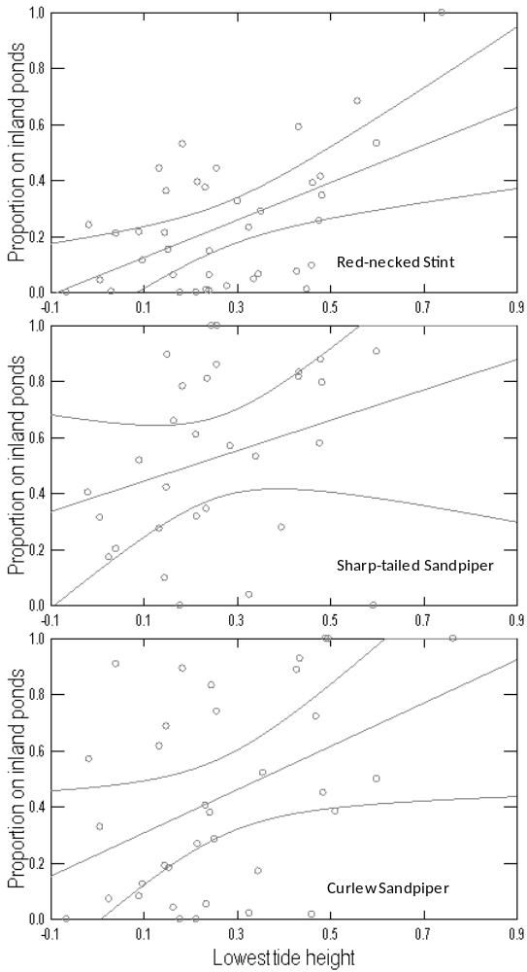
Figure 7: Proportion of birds occurring on inland ponds at low tide, plotted against observed tide height. The lines depict linear regressions (details in Table 4) and their 95% confidence limits.
  - Area of exposed tidal flat
Shorebirds can only forage on tidal flats when they are exposed at low tide. This constraint can have a strong influence on foraging distribution of the shorebirds of the WTP, because the shorelines have varied topography; some tidal flats are exposed on all low tides, while others are only accessible to shorebirds on the lowest tides.
Digital elevation models were made for the key intertidal foraging sites of shorebirds. The area of tidal flat exposed at 10 cm sea level intervals is summarised in Table 5, and illustrated with exposure maps in Appendix 1. Empirical models of exponential or logistic form (Figure 8) were used to interpolate between these points, allowing estimation of tidal flat area during every shorebird count of the key sites; the models are described more fully in Appendix 2. Tidal flats adjacent to the WTP are not particularly large; on low spring tides (0.1 m high) the total exposed area in the key foraging sites is c. 95 ha, and on neap low tides (0.4–0.5 m high) tidal flat area is less than 15 ha. It is noteworthy that some sites, notably Beacon Point and those east of Little River, are almost wholly submerged on tides of 0.4 m or more. The few tidal sites accessible to shorebirds on neap low tides include North Spit Lagoon, the spit of coarse sand bordering the western mouth of Little River, banks and beaches of shell grit and coarse sand at Borrie Outfall, and a boulder-strewn sandy point just north of Beach Road.

Table 5. Surface area (ha) exposed at key foraging sites for seven sea levels. From Greer 2012; area of North Spit Channel was calculated assuming that water levels on the lagoon side of this site are offset from those on the coastal side by 0.2 m (see Appendix 1).

 | Sea Level (m above Williamstown datum)
Locations | 0.1 | 0.2 | 0.3 | 0.4 | 0.5 | 0.6 | 0.7
145W_east | 7.935 | 3.868 | 1.985 | 0.873 | 0.608 | 0.470 | 0.345
LRM_to_145W | 2.058 | 1.608 | 1.118 | 0.545 | 0.368 | 0.233 | 0.160
Little R Mouth West | 20.143 | 19.268 | 14.805 | 1.650 | 1.065 | 0.873 | 0.713
Borrie Outfall | 15.078 | 13.328 | 10.685 | 7.230 | 4.110 | 1.585 | 0.185
Beacon Point | 14.175 | 6.288 | 1.358 | 0.685 | 0.378 | 0.155 | 0.098
Beach Road East | 27.238 | 24.135 | 4.870 | 0.918 | 0.705 | 0.540 | 0.350
North Spit Lagoon | 4.913 | 4.378 | 3.878 | 2.708 | 0.810 | 0.268 | 0.095
North Spit Channel | 3.780 | 2.273 | 1.370 | 0.815 | 0.533 | 0.163 | 0.100
TOTAL | 95.318 | 75.143 | 40.068 | 15.423 | 8.575 | 4.285 | 2.045

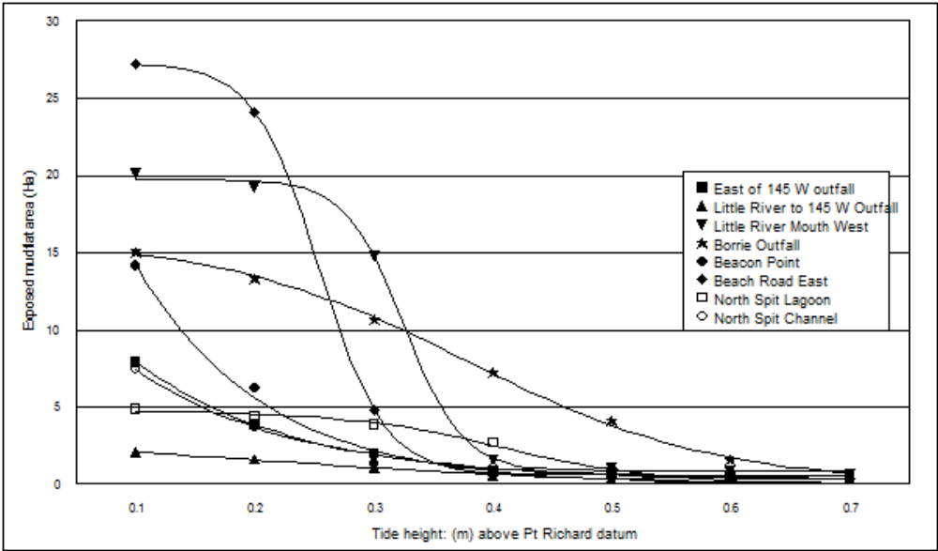
Figure 8. Logistic and exponential models of tidal flat area exposed at different sea levels for each foraging site. Tidal flat areas were modelled at 10 cm intervals of sea level above datum. The models fitted these data closely (e.g. r² > 0.99 for all sites); details are given in Appendix 2.

At all sites, a few counts were made of small numbers of birds foraging when the tide was too high to expose any tidal flats (Table 6). Observations of this kind involved a small number of birds pecking at the tide wrack or sand on a narrow beach: field observations did not suggest the birds were foraging with great intent or success.
A more robust measure of the sea levels at which different foraging sites are preferred by foraging shorebirds is given by the sea level below which 90% of foraging birds were observed (Table 6). This ‘preferred maximum sea-level’ differed considerably between sites. However, it is noteworthy that the minimum area of tidal flat exposed at the preferred maximum sea-level was quite consistent between sites, ranging from 0.3 ha at North Spit Lagoon to 1.58 ha at Borrie Outfall. Distance from the waterline to the nearest terrestrial vegetation at the preferred maximum sea-level was presumably quite consistent too: it has not been measured directly, but reference to the exposure maps (see Appendix 1) and opportunistic field observations suggest it is about 20–30 m at all sites. Rogers et al. (2007) previously suggested that shorebirds avoid the narrowest tidal flats because foraging there forces them close to terrestrial vegetation that might conceal predators.

Table 6. Maximum sea-level, and tidal flat area, when shorebirds were observed foraging at each foraging site.
Site | Maximum tide height (m) with foraging shorebirds | Preferred maximum sea-level: Sea level (m above Williamstown datum) in which 90% of foraging birds were counted | Minimum area (ha) used by 90% of foraging birds
145W_east | 0.69 | < 0.40 | 1.12
LRM_to_145W | 0.71 | < 0.38 | 0.85
Little R Mouth West | 0.70 | < 0.57 | 0.86
Borrie Outfall | 0.75 | < 0.57 | 1.58
Beacon Point | 0.81 | < 0.44 | 0.61
Beach Road East | 0.85 | < 0.58 | 0.54
North Spit Lagoon | 0.81 | < 0.59 | 0.30
North Spit Channel | 0.64 | < 0.52 | 0.55

Data collected during simultaneous counts (when each foraging site was counted repeatedly during a low tide cycle) suggested that within the constraint that shorebirds only used exposed tidal flats, tide conditions had further influences on shorebird distribution (Table 7). At Beacon Point and the two foraging sites east of Little River, the average tide height at which numbers peaked was 0.25 m (i.e. on very low tides). In contrast, the average tide height at which numbers peaked at North Spit Lagoon and Beach Road East was between 0.4 and 0.5 m, indicating that birds there moved to alternative sites on lower tides. This movement was also indicated by the average time (relative to the nadir of low tide) at which numbers peaked. At North Spit Lagoon and Borrie Outfall, numbers of birds were on average highest about an hour before low tide; in contrast numbers at the sites east of Little River peaked just after low tide.

Table 7. Tide height at times when numbers of birds peaked at different foraging sites, and the time of this peak relative to lowest water. Data come from simultaneous counts in which every site was counted repeatedly (at intervals of 1–2 hours) during a low tide cycle. Sample sizes differ between sites because birds did not use all sites during every survey.
Site | No. of counts | Williamstown tide height (mean) | Williamstown tide height (s.d.) | Minutes from low tide (mean) | Minutes from low tide (s.d.)
145W_east | 8 | 0.25 | 0.17 | 19 | 82
LRM_to_145W | 10 | 0.24 | 0.17 | 6 | 92
Little R Mouth West | 13 | 0.30 | 0.15 | –43 | 101
Borrie Outfall | 15 | 0.30 | 0.17 | –55 | 104
Beacon Point | 16 | 0.25 | 0.13 | –23 | 87
Beach Road East | 14 | 0.40 | 0.17 | –57 | 123
North Spit Lagoon | 12 | 0.43 | 0.17 | –56 | 136
North Spit Channel | 6 | 0.52 | 0.16 | –28 | 134
Density of shorebirds (i.e. number of birds per ha) would be expected to be higher on higher tides, when less tidal flat was exposed. This proved to be the case on tides from 0 to 0.40 m high when the majority of migratory shorebirds foraged on tidal flats (Table 8). On higher tides average density began to decline as few birds remained foraging on tidal flats. There were striking differences in average densities of shorebirds recorded on different tidal flats. The highest densities were recorded east of Little River Mouth, at the sites adjacent to 145W Outfall.

Table 8. Average density (birds ha²) of foraging migratory shorebirds at different tide heights, by site at and near the WTP.
 | Tide height (m)
Site | < 0.05 | 0.05–0.15 | 0.15–0.25 | 0.25–0.35 | 0.35–0.45 | 0.45–0.55 | <0.55
145W_east | 41 | 44 | 80 | 162 | 322 | 69 | 120
Little River Mouth to 145W | 337 | 415 | 192 | 215 | 399 | 57 | 269
Little River Mouth West | 25 | 29 | 21 | 36 | 98 | 224 | 72
Borrie Outfall | 50 | 57 | 32 | 33 | 20 | 12 | 34
Beacon Point | 1 | 28 | 51 | 70 | 193 | 107 | 75
Beach Road East | 7 | 4 | 5 | 7 | 52 | 116 | 32
North Spit Lagoon | 25 | 10 | 58 | 68 | 54 | 241 | 76
North Spit Channel | 1 | 7 | 11 | 3 | 9 | 60 | 15
All sites | 61 | 74 | 56 | 74 | 143 | 111 | 87

The local density of foraging shorebirds at the WTP is often much higher than indicated by the average densities presented above. Migratory shorebirds typically forage in flocks, and they are seldom evenly spread over a tidal flat, instead concentrating at the waterline. Peak observed densities of foraging shorebirds are presented in Table 9; all involved flocks of birds foraging on small tidal flat areas during neap tides or rising tides.

Table 9. Peak densities of foraging migratory shorebirds in key foraging sites at and near the WTP.
Site | Peak densities of foraging migratory shorebirds observed at the WTP (foraging birds ha-1)
145W_east | 2815
Little River Mouth_to_145W | 4620
Little River Mouth West | 2421
Borrie Outfall | 2299
Beacon Point | 2020
Beach Road East | 1561
North Spit Lagoon | 1949
North Spit Channel | 888

The duration for which tidal flats at the WTP were exposed at low tide was strongly related to tide height at the Williamstown tide gauge. The area of tidal flat exposed at WTP at any one time could be calculated effectively with general linear models using data from the Williamstown tide gauge, which records water depth at every 6 minutes: the gauge is maintained by the Port of Melbourne and the data are freely available on request through the National Tidal Centre. The tide data required for the models in Table 10 are observed water level at the time for which one needs to know tidal flat area, and the height of that tide at its lowest point (available as a direct measurement, or as a prediction published in tide timetables). Models predicting tidal flat area were more effective if the measured height of lowest tide (not predicted height of lowest tide) was used as the dependent variable (Table 10). This was because although the height of the observed lowest tide was significantly related to predicted lowest tide, it was far from identical. In Williamstown tide data collected continuously from 2000 to 2009, predicted lowest tide height only explained 48.8% of the variation in observed tide height. (Observed lowest tide height = 1.30 + 0.90 x Predicted tide height, n = 6307, R² = 0.488, P <0.001.) The discrepancies are thought to be driven by wind conditions, which can have a considerable influence on observed water height in confined shallow embayments such as Port Phillip Bay with a tidal range of only ~1 m.

Table 10. Models predicting duration for which tidal flats of a given elevation will be exposed during a low tide cycle, based on Williamstown tide data collected between 1 Jan 2000 and 30 June 2009.
Dependent variable | Exposure time (minutes) during low tide period
Model | A + (B x /W’town Height) +  (C x Predicted lowest tide height) | A + (B x /W’town Height) +  (C x Observed lowest tide height)
Constant A ± S.E., P | 45.574 ± 5.588, P<0.001 | 97.035 ± 3.279, P<0.001
Coefficient B ± S.E., P | 817.923 ± 6.902, P<0.001 | 1037.133 ± 4.849, P<0.001
Coefficient C ± S.E., P | –633.433 ± 14.875, P<0.001 | –969.390 ± 8.095, P<0.001
N | 6304 | 6304
R² | 0.694 | 0.880
P | <0.001 | <0.001
AIC | 77,408 | 71,528

The models in the final column of Table 10 (based on observed water levels at the Williamstown tide gauge) were used to calculate the amount of time that different foraging areas are exposed at the WTP (Table 11). Some sites such as Beach Road East were exposed on neap low tides as well as spring low tides, and on average provided foraging opportunities to shorebirds for 12–13 hours per day. Other sites, exposed only on lower tides, were less often available: notably, the benthos-rich foraging sites east of Little River were on average only exposed for ~ 6 hours per day. Their exposure varied seasonally, and on average during the austral winter they were only exposed for 4–6 hours per day. Exposure periods for foraging sites at the tide heights most strongly preferred by shorebirds (see Table 11) were still shorter: less than two hours per day during winter.

Table 11. Average duration per day (presented in the format hours:minutes) for which key intertidal foraging sites of the WTP are exposed at low tide.
Site | Tide level (m) |  | Jan | Feb. | Mar. | Apr. | May | Jun. | Jul. | Aug. | Sep. | Oct. | Nov. | Dec. | All year
Duration per day when foraging areas are exposed
East of 145W Outfall | 0.4 | 7:31 |  | 7:51 | 7:28 | 6:18 | 5:08 | 4:55 | 5:30 | 6:20 | 6:58 | 7:02 | 6:51 | 7:01 | 6:34
Little R to 145W Outfall | 0.38 | 6:53 |  | 7:12 | 6:48 | 5:38 | 4:32 | 4:24 | 4:58 | 5:45 | 6:18 | 6:22 | 6:12 | 6:24 | 5:57
Little R Mouth West | 0.57 | 13:09 |  | 13:34 | 13:13 | 12:01 | 10:43 | 10:14 | 10:48 | 11:53 | 12:40 | 12:47 | 12:34 | 12:42 | 12:11
Borrie Outfall | 0.57 | 13:09 |  | 13:34 | 13:13 | 12:01 | 10:43 | 10:14 | 10:48 | 11:53 | 12:40 | 12:47 | 12:34 | 12:42 | 12:11
Beacon Point | 0.44 | 8:48 |  | 9:11 | 8:48 | 7:39 | 6:24 | 6:02 | 6:37 | 7:34 | 8:18 | 8:23 | 8:11 | 8:19 | 7:51
Beach Road East | 0.57 | 13:09 |  | 13:34 | 13:13 | 12:01 | 10:43 | 10:14 | 10:48 | 11:53 | 12:40 | 12:47 | 12:34 | 12:42 | 12:11
North Spit Lagoon | 0.59 | 13:52 |  | 14:19 | 13:57 | 12:44 | 11:24 | 10:54 | 11:28 | 12:33 | 13:22 | 13:30 | 13:17 | 13:24 | 12:53
North Spit Channel | 0.52 | 11:29 |  | 11:51 | 11:29 | 10:19 | 9:03 | 8:33 | 9:08 | 10:13 | 10:58 | 11:03 | 10:52 | 11:00 | 10:29
Duration per day when tides are low enough to expose areas used when abundance of foraging birds peaks
East of 145W Outfall | 0.24 | 3:10 |  | 3:18 | 2:47 | 2:02 | 1:39 | 1:35 | 1:53 | 2:16 | 2:30 | 2:24 | 2:28 | 2:48 | 2:24
Little R to 145W Outfall | 0.25 | 3:24 |  | 3:33 | 3:02 | 2:13 | 1:49 | 1:44 | 2:04 | 2:29 | 2:43 | 2:36 | 2:39 | 3:00 | 2:36
Little R Mouth West | 0.3 | 4:38 |  | 4:50 | 4:19 | 3:16 | 2:40 | 2:38 | 3:04 | 3:38 | 3:57 | 3:48 | 3:44 | 4:09 | 3:43
Borrie Outfall | 0.3 | 4:38 |  | 4:50 | 4:19 | 3:16 | 2:40 | 2:38 | 3:04 | 3:38 | 3:57 | 3:48 | 3:44 | 4:09 | 3:43
Beacon Point | 0.25 | 3:24 |  | 3:33 | 3:02 | 2:13 | 1:49 | 1:44 | 2:04 | 2:29 | 2:43 | 2:36 | 2:39 | 3:00 | 2:36
Beach Road East | 0.4 | 7:31 |  | 7:51 | 7:28 | 6:18 | 5:08 | 4:55 | 5:30 | 6:20 | 6:58 | 7:02 | 6:51 | 7:01 | 6:34
North Spit Lagoon | 0.43 | 8:29 |  | 8:51 | 8:28 | 7:19 | 6:04 | 5:44 | 6:20 | 7:15 | 7:58 | 8:03 | 7:51 | 8:00 | 7:31
North Spit Channel | 0.52 | 11:29 |  | 11:51 | 11:29 | 10:19 | 9:03 | 8:33 | 9:08 | 10:13 | 10:58 | 11:03 | 10:52 | 11:00 | 10:29

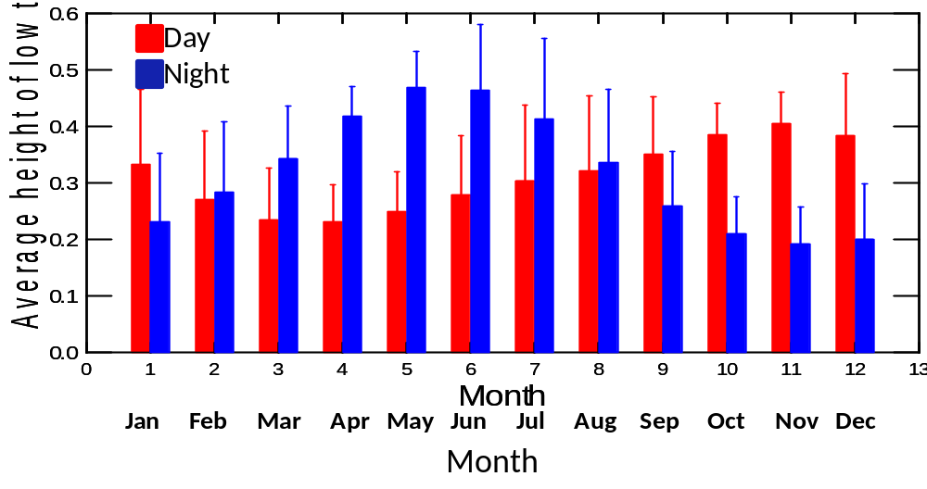
The tide cycles of Port Phillip Bay cause further constraints on the accessibility of tidal flats to foraging shorebirds of the WTP. During neap tide periods, which last several days, tidal range is lower than in spring periods, and tidal flats are therefore exposed less frequently and for shorter times; there were several periods during our study period, especially during winter, when neap tides coincided with southerly wind systems and the tidal flats east of Little River were submerged continuously for 4–7 days.
In spring and early summer, predicted heights of low tide are lowest during the night. The reverse occurs in late autumn and winter (Figure 9), and during April–July there can be extended periods (over a week) when low-lying foraging areas such as the tidal flats by 145W outfall are only exposed during daylight hours. This difference occurs because consecutive low tides at the WTP are typically quite different to one another, with very low tides alternating with moderately low tides (Figure 10.). The average difference between heights of consecutive low tides is 0.216 m; the difference can be negligible during neap tide series and as high as 0.5 m on spring tide series. In general the higher of these paired tides tends to occur during daylight hours during summer, and at night during winter.
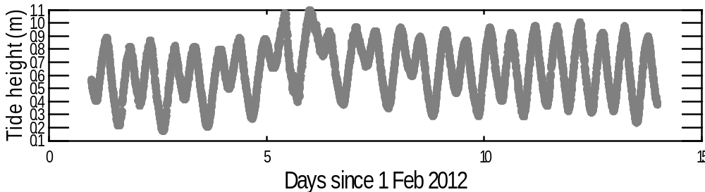
Figure 9. Average predicted height of diurnal and nocturnal low tides, by month, at Williamstown, 2000–2009.

Figure 10. Measurements of water depth at Williamstown in the first fortnight of February 2012, illustrating the semi-diurnal structure of a tidal cycle.
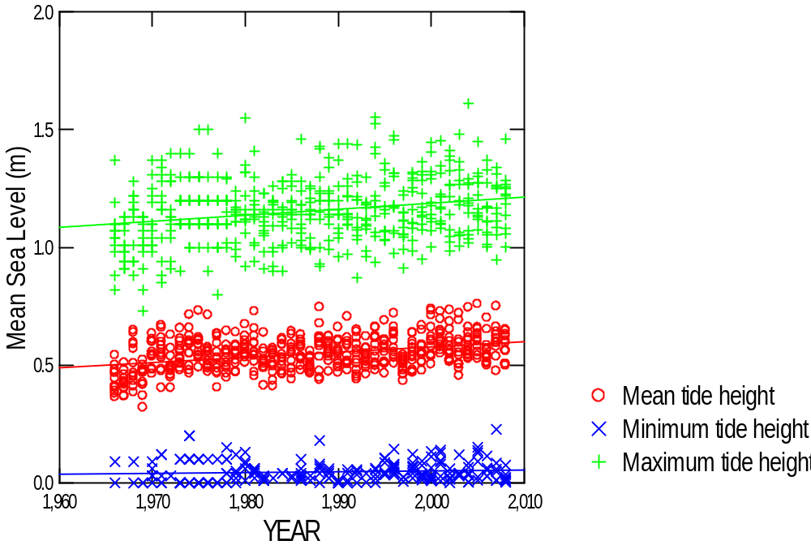
Finally, mean sea level has risen in Port Phillip Bay since systematic recording of tide height began in Williamstown in 1966 (Figure 11), increasing at 0.002 m per year (gradient = 0.002, R² = 0.140, P<0.001). Minimum sea-level has climbed at a similar rate (gradient = 0.002, R² = 0.069, P<0.001), as has maximum monthly sea-level (gradient = 0.003, R² = 0.056, P<0.001). As the tidal flats of the WTP are relatively small, they will be vulnerable to future increases in sea level.
Figure 11. Mean, minimum and maximum sea level at Williamstown, by month, from 1966 to 2008. The lines depict linear regressions.

  - Benthic density
In March 2005, benthos density was sampled on all tidal flats adjacent to the WTP where shorebirds were known to forage. The study revealed generally high benthic abundance compared to tidal flat systems worldwide (Rogers et al. 2007; Piersma et al. 1993), and striking differences from site to site within the WTP. The benthos surveys conducted since 2005 (more intensive sampling of key foraging areas) were consistent with the pilot survey in revealing high benthos density in the intertidal zone by world standards, and considerable variation from site to site. However, they also revealed substantial variation in benthos density from survey to survey (Table 12). Average edible biomass across the entire WTP ranged from 17.4 g dry mass /m² (during February 2011) to 44.8 g dry mass /m² (during March 2006), and within-site variation over time was still greater.

Table 12. Average benthic abundance (expressed as edible biomass g m-2) per complete survey of the main shorebird foraging sites on tidal flats adjacent to the WTP.

Site | No. of complete surveys | No. of sampling points | Edible biomass (dry mass g m⁻²)
Site | No. of complete surveys | No. of sampling points | Mean | SD | Min | Max
E Mouth of Little R | 10 | 4 | 69.4 | 34.7 | 5.7 | 124.7
145W Outfall | 9 | 10 | 65.0 | 35.8 | 19.7 | 113.5
W mouth of Little R | 9 | 20 | 34.1 | 17.8 | 10.6 | 66.3
Borrie Outfall | 8 | 13 | 24.0 | 10.9 | 12.6 | 48.5
N Spit Lagoon | 8 | 9 | 23.0 | 12.6 | 5.4 | 47.6
Beacon Point | 8 | 5 | 18.7 | 13.4 | 3.1 | 39.0
Beach Rd North | 9 | 16 | 13.3 | 7.0 | 5.7 | 27.8
N Spit Channel | 7 | 7 | 12.0 | 8.7 | 2.5 | 30.0
Entire WTP | 7 | 84 | 32.2 | 27.5 | 17.4 | 44.8

Linear regressions showed no significant relationships between overall benthic biomass and time. However, visual inspection of the data (Figure 12) suggests that there may have been non-linear changes in benthic biomass during the study period, with different responses at different sites. In the two sites adjacent to 145W Outfall, benthos density appears to have been declining since c. 2007; at Borrie Outfall and perhaps also in adjacent Beacon Point and Beach Road, benthos density appears to have been increasing over the same period. In the survey conducted in February 2007, benthos density was unusually low in the two foraging sites at the mouth of Little River, and in the two sites in the North Spit Lagoon system. A longer data series would be required to model these complex relationships.

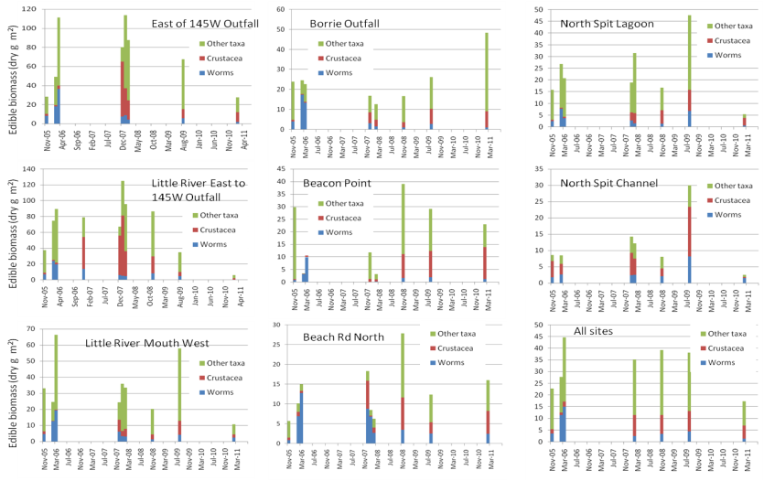

Figure 12. Average edible biomass (dry mass g m2) of benthos in the main foraging areas for shorebirds on the intertidal flats adjacent to the WTP. Biomass is shown in different colours for worms (mainly polychaetes, in blue), crustacea (mainly amphipods, in red) and other taxa (mainly mollusca, in green).
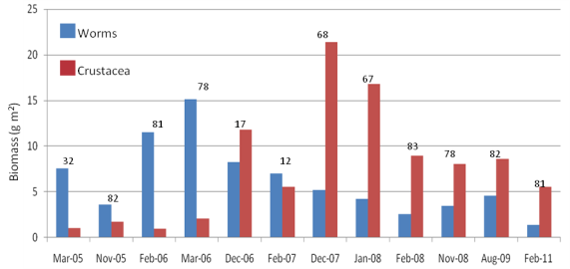
A much more striking temporal trend was found in the relative proportions of worms (dominated by polychaetes) and crustacea (dominated by amphipods) in the samples. Worm biomass relative to overall biomass decreased during the study period at most sites; crustacean biomass relative to overall biomass increased at most sites (Figure 12). The difference is shown more clearly in Figure 13, which includes also includes data from incomplete surveys in which it was not possible to sample at every point within some bird-foraging areas. Figure 13 suggests that the decline in worms occurred gradually through 2006 and 2007, while the increase in crustacea occurred more suddenly at the end of December 2006. Both changes followed the implementation of key components of the Environment Improvement Project, in which land filtration ended in December 2004. Polychaete worms were found to remain numerous at a few individual sampling sites near the 145W Outlet and the Borrie Outfall, despite the overall decrease on most stretches of coast.
Whatever their causes, the changes in benthos composition were striking. Visual inspection of Figures 12 and 13 suggests that the relationship with time was not linear. Its statistical significance can be by comparing complete samples collected before and after December 2007,the time at which biomass of crustacea increased dramatically (Table 13). Overall, biomass of worms declined to about a quarter of its previous level and that of crustacea increased by a factor of over four. To some extent these changes balanced each other out, and across all sites the combined biomass of worms and crustacea was quite similar before and after December 2007. Significant decreases in worm biomass, and increases in crustacean biomass, occurred within all key foraging sites except North Spit Channel (Table 13). In general the decline in worms was most marked at easternmost sites near 145W Outfall and the mouth of Little River; the increase in crustacea was more patchy and widespread (Table 13).

Figure 13. Average biomass of worms and crustaceans in benthos surveys at the WTP, 2005–2011. Data from incomplete benthos surveys are included; the digits indicate the number of cores in each survey.
Table 13. Comparison of biomass from completely sampled sites before and after December 2007; differences were tested with two-tailed t-tests.
 | Before |  |  | After |  |  |  |  | Change*
Site | mean | sd | n | Mean | sd | n | z | p | Change*
Worms
145W Outfall East | 13.7 | 12.4 | 6 | 6.3 | 2.85 | 6 | 4.68 | <0.01 | 46.0%
Little River Mouth East | 13.7 | 8.12 | 5 | 4.7 | 2.51 | 6 | 6.68 | <0.01 | 34.3%
Little River Mouth West | 11.4 | 6.54 | 6 | 3.3 | 1.63 | 6 | 6.88 | <0.01 | 28.9%
Borrie Outfall | 8.8 | 6.24 | 6 | 6.3 | 2.85 | 6 | 2.05 | <0.1 | 71.6%
Beacon Pt | 4.6 | 4.75 | 3 | 0.9 | 0.80 | 5 | 3.41 | <0.02 | 19.6%
Beach Rd East | 8.3 | 4.32 | 6 | 4.4 | 2.70 | 6 | 3.57 | <0.01 | 53.0%
North Spit Lagoon | 4.9 | 2.97 | 5 | 2.7 | 2.44 | 5 | 2.13 | <0.1 | 55.1%
North Spit Channel | 3.3 | 1.94 | 4 | 3.3 | 2.72 | 5 | –0.02 | ns | 100.0%
All sites | 9.1 | 7.38 | 41 | 3.5 | 2.63 | 45 | 11.77 | <0.01 | 38.5%
Crustacea
145W Outfall East | 5.2 | 5.23 | 6 | 22.8 | 18.34 | 6 | –8.91 | <0.01 | 438.5%
Little River Mouth East | 9.3 | 17.32 | 5 | 31.1 | 28.15 | 6 | –7.46 | <0.01 | 334.4%
Little River Mouth West | 2.5 | 2.92 | 6 | 4.9 | 2.70 | 6 | –2.52 | <0.05 | 196.0%
Borrie Outfall | 2.8 | 4.41 | 6 | 22.8 | 18.34 | 6 | –10.3 | <0.01 | 814.3%
Beacon Pt | 0.4 | 0.26 | 3 | 7.0 | 5.59 | 5 | –4.61 | <0.01 | 1750.0%
Beach Rd East | 0.7 | 0.22 | 6 | 4.2 | 3.22 | 6 | –4.64 | <0.01 | 600.0%
North Spit Lagoon | 0.5 | 0.32 | 5 | 5.1 | 2.39 | 5 | –6.23 | <0.01 | 1020.0%
North Spit Channel | 5.4 | 2.11 | 4 | 5.9 | 5.73 | 5 | –0.40 | ns | 109.3%
All sites | 3.4 | 6.74 | 41 | 11.0 | 15.41 | 45 | –10.5 | <0.01 | 323.5%
Worms and crustacea
145W Outfall East | 18.9 | 11.91 | 6 | 29.1 | 19.55 | 6 | –4.45 | <0.01 | 154.0%
Little River Mouth East | 23.0 | 19.29 | 5 | 35.8 | 29.30 | 6 | –4.23 | <0.01 | 155.7%
Little River Mouth West | 13.8 | 5.07 | 6 | 8.2 | 4.08 | 6 | 4.53 | <0.01 | 59.4%
Borrie Outfall | 23.0 | 19.29 | 6 | 29.1 | 19.55 | 6 | –2.41 | <0.05 | 126.5%
Beacon Pt | 5.0 | 4.90 | 3 | 7.9 | 6.30 | 5 | –1.63 | ns | 158.0%
Beach Rd East | 9.0 | 4.29 | 6 | 8.7 | 4.37 | 6 | 0.29 | ns | 96.7%
North Spit Lagoon | 5.4 | 2.69 | 5 | 7.8 | 4.65 | 5 | –1.95 | ns | 144.4%
North Spit Channel | 8.7 | 3.92 | 4 | 9.3 | 8.35 | 5 | –0.33 | ns | 106.9%
All sites | 12.5 | 10.12 | 41 | 14.5 | 16.80 | 45 | –2.52 | <0.05 | 116.0%  (cont.)
*biomass post-2007 as percentage of former biomass
 | Before |  |  | After |  |  |  |  | Change*
Site (cont.) | mean | sd | n | Mean | sd | n | z | p | Change*
Other taxa
145W Outfall East | 25.1 | 24.43 | 6 | 50.2 | 28.61 | 6 | –8.42 | <0.01 | 200.0%
Little River Mouth East | 39.5 | 18.64 | 5 | 33.3 | 23.49 | 6 | 2.23 | <0.05 | 84.3%
Little River Mouth West | 33.6 | 24.73 | 6 | 22.2 | 14.20 | 6 | 4.46 | <0.01 | 66.1%
Borrie Outfall | 10.1 | 6.43 | 6 | 50.2 | 28.61 | 6 | –16.6 | <0.01 | 497.0%
Beacon Pt | 9.5 | 16.46 | 3 | 13.3 | 9.72 | 5 | –1.48 | ns | 140.0%
Beach Rd East | 5.4 | 5.28 | 6 | 6.2 | 5.58 | 6 | –0.56 | ns | 114.8%
North Spit Lagoon | 16.6 | 2.55 | 5 | 16.3 | 12.27 | 5 | 0.17 | ns | 98.2%
North Spit Channel | 3.8 | 2.83 | 4 | 4.1 | 2.25 | 5 | –0.26 | ns | 107.9%
All sites | 18.8 | 19.22 | 41 | 20.7 | 20.88 | 45 | –1.96 | <0.1 | 110.1%
Total edible biomass
145W Outfall East | 44.1 | 35.46 | 6 | 79.3 | 29.92 | 6 | –10.7 | <0.01 | 179.8%
Little River Mouth East | 62.5 | 25.93 | 5 | 69.0 | 43.13 | 6 | –1.81 | ns | 110.4%
Little River Mouth West | 47.4 | 27.62 | 6 | 30.4 | 16.28 | 6 | 6.27 | <0.01 | 64.1%
Borrie Outfall | 21.6 | 7.57 | 6 | 79.3 | 29.92 | 6 | –23.1 | <0.01 | 367.1%
Beacon Pt | 14.5 | 13.62 | 3 | 21.1 | 14.13 | 5 | –2.43 | <0.1 | 145.5%
Beach Rd East | 14.4 | 7.34 | 6 | 14.9 | 7.79 | 6 | –0.26 | ns | 103.5%
North Spit Lagoon | 21.7 | 5.11 | 5 | 24.0 | 16.12 | 5 | –1.14 | ns | 110.6%
North Spit Channel | 12.5 | 6.71 | 4 | 13.4 | 10.31 | 5 | –0.43 | ns | 107.2%
All sites | 31.2 | 25.65 | 41 | 35.1 | 32.02 | 45 | –3.36 | <0.01 | 112.5%
*biomass post-2007 as percentage of former biomass

The relationship between benthos and shorebird abundance is difficult to unravel, as benthos density varies over time, and shorebird numbers and distribution at the WTP are also influenced by other factors including flyway population trends (Section 3.1) and tidal flat exposure (Section 3.3). We therefore examined the relationship between benthos and shorebird abundance on a single day, at the nadir of spring low tide. The average biomass of benthos in the tidal flats, and the number of shorebirds present in the WTP, do not vary substantially in the course of a single day. On spring low tides (< 0.24 m high, see Table 7) all potential foraging areas in the intertidal zone of the WTP are exposed and accessible to shorebirds; moreover foraging density is lower than it is on higher tides, suggesting that foraging interference is unlikely to limit bird distribution.
Three surveys were carried out in which these conditions were met, in February 2006, March 2006 and February 2011 (Figure 14, Table 14). On all such surveys, linear regression demonstrated a significant positive relationship between numbers of foraging Red-necked Stints and abundance of edible biomass. On two surveys the number of foraging Red-necked Stints was also significantly positively related to the biomass of worms, but it was not related to the abundance of crustaceans.
Numbers of foraging Sharp-tailed Sandpipers could only be assessed on two of these surveys as there were no Sharp-tailed Sandpipers at the WTP during the summer of 2011 (see Section 3.1). Sharp-tailed Sandpiper numbers were significantly positively related to worm abundance on both surveys, and to edible benthos density on one: they were not related to crustacean abundance. Curlew Sandpiper abundance was significantly positively related to abundance of edible biomass on two surveys, to worm abundance on one survey, and to crustacean abundance on one survey. For both Curlew Sandpipers and Sharp-tailed Sandpipers, samples were skewed by foraging areas with very few or no foraging birds, with the great majority of birds foraging at a small number of sites.
The linear regressions in Table 14 and Figure 14 are presented with and without constants. It is not known whether shorebirds forage in sites with no benthos (some may occur in such sites when exploring) so from this perspective it would seem more suitable to include a constant in the equation. On the other hand, most plots suggest the regression lines intercept the Y axis near the origin, and it could be argued that it is more suitable to exclude the constant and drive the regressions through the origin, as neither biomass nor number of birds can be negative. It would be more suitable to find a modelling approach that does not assume linearity, but this is problematic given the small sample sizes on a single date. A multivariate approach using all the data would be more desirable, and is attempted in Section 3.6.

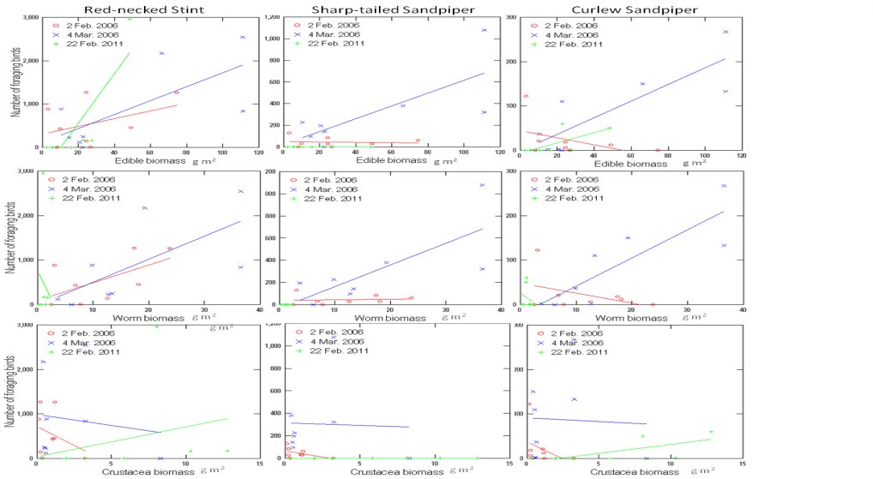

Figure 14. Relationships between shorebird abundance and benthic biomass on three spring low tides. Shorebird species are arranged in columns; edible biomass, worm biomass and crustacean biomass are arranged in separate rows. The coloured lines depict linear regressions (with constant); see Table 14 for details.

Table 14. Linear regressions showing relationship between shorebird and benthos density, with shorebird abundance treated as the dependent variable. Results are shown for regressions with and without constants. Regressions for which the relationship was significant are underlined and highlighted in boldface.
 |  |  | Regressions with constant |  |  |  | Regressions without constant
Species | Independent variable | Date | Constant | Coefficient | R² | P | Coefficient | R² | P
Red-necked Stint | Edible biomass | 2 February 2006 | 306.507 | 8.929 | 0.165 | 0.318 | 15.656 | 0.567 | 0.019
Red-necked Stint | Edible biomass | 4 March 2006 | 116.372 | 16.089 | 0.502 | 0.049 | 17.501 | 0.740 | 0.003
Red-necked Stint | Edible biomass | 22 February 2011 | –582.986 | 57.135 | 0.726 | 0.007 | 37.197 | 0.642 | 0.009
Sharp-tailed Sandpiper | Edible biomass | 2 February 2006 | 48.968 | –0.152 | 0.007 | 0.847 | 0.923 | 0.289 | 0.135
Sharp-tailed Sandpiper | Edible biomass | 4 March 2006 | 24.152 | 5.918 | 0.573 | 0.030 | 6.215 | 0.780 | 0.002
Curlew Sandpiper | Edible biomass | 2 February 2006 | 44.497 | –0.798 | 0.213 | 0.249 | 0.178 | 0.020 | 0.714
Curlew Sandpiper | Edible biomass | 4 March 2006 | –1.437 | 1.875 | 0.710 | 0.009 | 1.857 | 0.923 | 0.000
Curlew Sandpiper | Edible biomass | 22 February 2011 | –6.114 | 1.150 | 0.478 | 0.057 | 0.941 | 0.590 | 0.016
Red-necked Stint | Worm biomass | 2 February 2006 | 718.942 | –169.885 | 0.111 | 0.419 | 45.629 | 0.708 | 0.004
Red-necked Stint | Worm biomass | 4 March 2006 | 987.398 | –48.938 | 0.019 | 0.743 | 51.191 | 0.724 | 0.004
Red-necked Stint | Worm biomass | 22 February 2011 | 38.008 | 66.910 | 0.085 | 0.485 | 176.354 | 0.070 | 0.493
Sharp-tailed Sandpiper | Worm biomass | 2 February 2006 | 65.793 | –21.673 | 0.253 | 0.203 | 2.931 | 0.430 | 0.055
Sharp-tailed Sandpiper | Worm biomass | 4 March 2006 | 315.112 | –4.478 | 0.001 | 0.931 | 18.285 | 0.772 | 0.002
Curlew Sandpiper | Worm biomass | 2 February 2006 | 37.146 | –15.214 | 0.145 | 0.353 | 0.764 | 0.055 | 0.544
Curlew Sandpiper | Worm biomass | 4 March 2006 | –8.501 | 4.085 | 0.497 | 0.051 | 5.486 | 0.851 | 0.000
Curlew Sandpiper | Worm biomass | 22 February 2011 | 94.556 | 39.745 | 0.344 | 0.126 | 6.043 | 0.117 | 0.367
Red-necked Stint | Crustacean biomass | 2 February 2006 | –13.540 | 51.720 | 0.465 | 0.063 | 204.246 | 0.142 | 0.318
Red-necked Stint | Crustacean biomass | 4 March 2006 | 763.894 | –255.720 | 0.194 | 0.646 | 140.293 | 0.142 | 0.317
Red-necked Stint | Crustacean biomass | 22 February 2011 | 38.723 | 0.521 | 0.008 | 0.830 | 71.275 | 0.225 | 0.197
Sharp-tailed Sandpiper | Crustacean biomass | 2 February 2006 | 38.723 | 0.521 | 0.008 | 0.830 | 12.565 | 0.079 | 0.463
Sharp-tailed Sandpiper | Crustacean biomass | 4 March 2006 | –32.382 | 19.551 | 0.559 | 0.033 | 55.912 | 0.188 | 0.244
Curlew Sandpiper | Crustacean biomass | 2 February 2006 | –21.924 | 6.344 | 0.726 | 0.007 | 4.117 | 0.016 | 0.746
Curlew Sandpiper | Crustacean biomass | 4 March 2006 | 48.260 | –2.239 | 0.177 | 0.299 | 15.847 | 0.185 | 0.248
Curlew Sandpiper | Crustacean biomass | 22 February 2011 | 25.374 | –8.309 | 0.064 | 0.544 | 3.049 | 0.768 | 0.016

  - Effluent discharges
Water was not sampled within the key shorebird foraging areas of this study, and great variation would be expected as a result of varying currents and winds in the coastal waters that inundate different sections of the shore. However, Melbourne Water regularly samples water at the outfalls where effluent is discharged into Port Phillip Bay. Figure 15 is based on that dataset; it summarises annual flow, and loads of Total Suspended Solids (TSS), nitrogen and ammonia, from the three outfalls of the WTP that are adjacent to tidal flats used by foraging shorebirds. During our shorebird study (since 2004); 145W Outfall has had the highest flow rates and loads of TSS and nitrogen; there has been almost no flow from Murtcaim Outfall since grass filtration was phased out early in the decade. Flow increased somewhat during the study following the breaking of the drought, with total nitrogen following a similar pattern. Ammonia discharges declined abruptly following implementation of major components of the Environment Improvement Plan in December 2004, except at 145W Outfall.

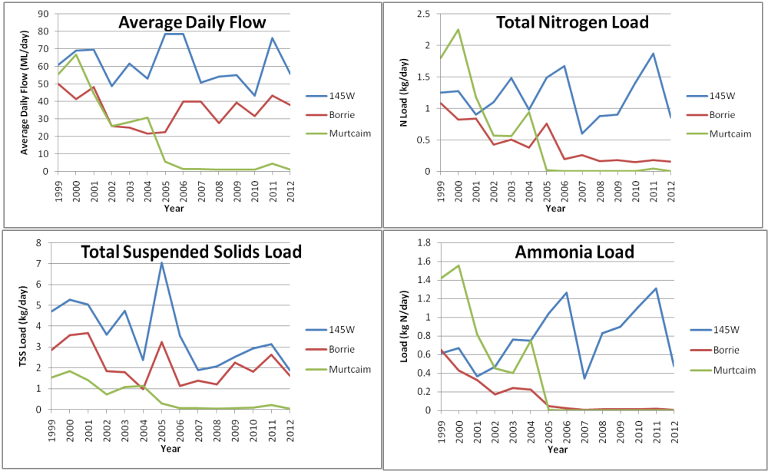
Figure 15. Annual flow, and loads of Total Suspended Solids, Nitrogen and Ammonia, from outfalls adjacent to shorebird foraging areas at the WTP.

Benthos density, measured on complete surveys, was compared with attributes of effluent measured in the same week and over the preceding three months (correlation matrices provided in Appendix 3). No clear picture emerged from these comparisons. There were some apparently strong associations in the correlation matrices, but many or all of them were probably spurious, given that they did not fit any expected pattern. For example crustacean abundance at 145W Outfall was positively associated with Flow, Nitrogen Load and Total Suspended Solids at Murtcaim Outfall, but there is unlikely to be any causality as these sites are over 6 km apart and flows from Murtcaim Outfall were considerably lower than those at 145 W Outfall. None of the apparent associations in the correlation matrices were statistically significant after Dunn-Sidak correction for multiple hypothesis testing, and in general the relationship between shorebird numbers and flows during the study period was much less clear and strong than the relationship between shorebird numbers and benthos density described in Section 3.4.
  - Relative importance of factors influencing shorebird numbers and distribution
The results above suggest that the numbers of birds foraging on specific intertidal sites at the WTP are influenced by several interacting variables, including shorebird numbers present at the WTP overall, tide height and benthos density. We used a modelling approach to get a better appreciation of the relative importance of these factors. Nitrogen Load in effluent was also included in the models; although it was not clear whether or not it had some effect on benthos or shorebird abundance (see Appendix 3) there are biological reasons to expect some effects.
Candidate models considered were linear regression models, and models based on the logistic growth curve. The latter had the following structure:
No. of foraging birds = | Coastal count .
No. of foraging birds = | 1+exp( a + (b*Biomass) + (c*Nitrogen))
Where:
No. of foraging birds = number of birds foraging in each key tidal site
Coastal count = Total number of birds foraging on all tidal flats of the WTP (including areas outside the key foraging sites) at the nadir of low tide.
Biomass = Edible biomass (g dry mass m²)
Nitrogen = Sum of Nitrogen load (Total N in kg N per day) from 145W, Borrie and Murtcaim Outfalls in the week that benthos surveys and bird counts were done.
The logit growth curve structure was considered potentially more appropriate because the number of foraging birds on a specific tidal flat is not open-ended; it cannot decline below zero, and it cannot be higher than the number of birds present at the WTP. Tide height and total number of birds in the WTP are not included directly in these models, but the variable ‘Coastal count’ (obtained through direct counts) can be described effectively as a function of the two (Table 15). The relationship between sea level and numbers of Curlew Sandpipers foraging on the tidal flats was particularly strong, indicating that this species had a strong preference for foraging on tidal flats provided the tide was sufficiently low. The relationship was considerably weaker for Sharp-tailed Sandpiper, perhaps because this species often forages for insects on inland ponds and grasslands, especially in the morning.

Table 15. Linear regression of the relationship
Coastal Count = a + (b * WTP total count) + (c *observed low tide height at Williamstown in m).
Based on counts carried out concurrently with benthos sampling.
Species |  | Constant | Coefficient of WTP total count | Coefficient of tide height | R² | P of model
Curlew Sandpiper | 41 | 209.4 | 0.103 | –323.4 | 0.90 | <0.001
Red-necked Stint | 41 | 2092.3 | 0.338 | –1707.7 | 0.61 | 0.056
Sharp-tailed Sandpiper | 41 | 726.3 | 0.283 | –1410.4 | 0.51 | 0.009
We used data from six complete, coupled surveys of shorebird and benthos density in the logistic models. Data from a seventh complete survey (March 2005) were not included as benthos sampling methodology differed on that occasion. Sites that were submerged at the lowest point of low tide (and therefore could not be accessed by shorebirds) were not included.
Candidate models were compared using Akaike’s Information Criterion (AIC, Table 16). In Red-necked Stint and Sharp-tailed Sandpiper, Akaike Weights indicate that the most strongly supported models were logistic curves in which edible biomass was the only independent variable included. Adding nitrogen load or interactions with nitrogen load to the models did not improve them. In contrast, in Curlew Sandpipers the most strongly supported models included both biomass and nitrogen load. The most successful of the remaining models for Curlew Sandpiper included biomass only, and models including nitrogen only were very weakly supported.
Table 16. Models predicting number of shorebirds at a foraging site, ranked in order of AIC weights.
Model | Independent Variables | Num Obs | AICc | Akaike weight
Curlew Sandpiper
Logit | Biomass, Nitrogen | 34 | 260.949 | 47.29%
Logit | Biomass, Nitrogen, Biomass x Nitrogen | 34 | 261.134 | 43.12%
Logit | Biomass | 34 | 264.173 | 9.43%
Linear | Biomass, coastal count, Biomass x Nitrogen | 34 | 274.086 | 0.07%
Linear | Biomass, coastal count | 34 | 275.058 | 0.04%
Logit | Nitrogen | 34 | 276.020 | 0.03%
Linear | Biomass, coastal count, Biomass x coastal count | 34 | 277.430 | 0.01%
Logit | Constant only | 34 | 277.714 | 0.01%
Linear | Nitrogen | 34 | 280.970 | 0.00%
Linear | Biomass, Biomass x Nitrogen | 34 | 348.707 | 0.00%
Red-necked Stint
Logit | Biomass | 39 | 502.434 | 68.73%
Linear | Biomass, coastal count | 39 | 506.563 | 8.72%
Logit | Biomass, Nitrogen | 39 | 506.738 | 7.99%
Logit | Biomass, Nitrogen, Biomass x Nitrogen | 39 | 507.008 | 6.98%
Linear | Biomass, Biomass x Nitrogen | 39 | 507.684 | 4.98%
Linear | Biomass, coastal count, Biomass x coastal count | 39 | 510.696 | 1.10%
Linear | Biomass, coastal count, Biomass x Nitrogen | 39 | 510.946 | 0.97%
Logit | Constant only | 39 | 512.747 | 0.40%
Linear | Nitrogen | 39 | 515.733 | 0.09%
Logit | Nitrogen | 39 | 518.002 | 0.03%
(cont.)
Model | Independent Variables | Num Obs | AICc | Akaike weight
Sharp-tailed Sandpiper
Logit | Biomass | 32 | 308.790 | 72.21%
Logit | Biomass, Nitrogen | 32 | 310.963 | 24.37%
Logit | Biomass, Nitrogen, Biomass x Nitrogen | 32 | 315.207 | 2.92%
Linear | Biomass, coastal count, Biomass x coastal count | 32 | 318.928 | 0.45%
Linear | Biomass, coastal count, Biomass x Nitrogen | 32 | 324.791 | 0.02%
Linear | Biomass, Biomass x Nitrogen | 32 | 326.616 | 0.01%
Linear | Biomass, coastal count | 32 | 326.929 | 0.01%
Logit | Nitrogen | 32 | 332.596 | 0.00%
Linear | Nitrogen | 32 | 342.195 | 0.00%
Logit | Constant only | 32 | 349.266 | 0.00%

Results from the three most strongly supported models for each species are presented in Table 17. The contribution of edible biomass was significant in all of the most strongly supported models. Nitrogen load from Murtcaim, Borrie and 145W Outfalls was not significantly related to number of foraging birds at specific foraging sites in any of the candidate models, whether it was expressed as nitrogen load in the week of sampling, or as nitrogen load in the three months preceding sampling.

Table 17. Models predicting number of birds at a foraging site from biomass and number of birds present on the coastline. Akaike weights are given in Table 17. The correlation coefficient measures the association between observed and expected values. Note that in the logistic regressions, when variables B and C (in the denominator of the equation) have a positive relationship with the dependent variable, their coefficients have a negative sign.

Model | Correlation coefficient | Parameter | Estimate of coefficient | Asymptotic standard error of coefficient | T | P of coefficient
Curlew Sandpiper
Logit | 0.7840 | Constant | –1.0023 | 2.3177 | –0.4325 | 0.3327
 |  | Biomass | –0.0265 | 0.0062 | –4.0035 | 0.0000
 |  | Nitrogen | 11.1655 | 7.2402 | 1.5422 | 0.9385
Logit | 0.8854 | Constant | 2.5850 | 0.8042 | 3.2144 | 0.9993
 |  | Biomass | –0.1861 | 0.1806 | –1.0306 | 0.1514
(cont.)
Model | Correlation coefficient | Parameter | Estimate of coefficient | Asymptotic standard error of coefficient | T | P of coefficient
 |  | Nitrogen | –1.5199 | 2.2445 | –0.6802 | 0.2482
 |  | Biomass x Nitrogen | 0.5390 | 0.6051 | 0.8908 | 0.8135
Logit | 0.7140 | Constant | 3.2336 | 0.6030 | 5.3624 | 1.0000
 |  | Biomass | –0.0314 | 0.0071 | –4.4107 | 0.0000
Red-necked Stint
Logit | 0.5987 | Constant | 2.6831 | 0.4057 | 6.6128 | 1.0000
 |  | Biomass | –0.0240 | 0.0058 | –4.1033 | 0.0000
Linear | 0.6016 | Constant | –368.5600 | 292.0650 | –1.2619 | 0.1035
 |  | Biomass | 14.9869 | 3.6908 | 4.0606 | 1.0000
 |  | Coastal count | 0.1182 | 0.0810 | 1.4590 | 0.9277
Logit | 0.5997 | Constant | 2.7691 | 0.5864 | 4.7220 | 1.0000
 |  | Biomass | –0.0247 | 0.0068 | –3.6526 | 0.0001
 |  | Nitrogen | –0.0524 | 0.2506 | –0.2090 | 0.4172
Sharp-tailed Sandpiper
Logit | 0.8478 | Constant | 3.0462 | 0.3946 | 7.7199 | 1.0000
 |  | Biomass | –0.0243 | 0.0042 | –5.8322 | 0.0000
Logit | 0.8536 | Constant | 1.1281 | 1.7645 | 0.6394 | 0.7387
 |  | Biomass | –0.0221 | 0.0044 | –5.0042 | 0.0000
 |  | Nitrogen | 5.4772 | 5.4560 | 1.0039 | 0.8423
Logit | 0.8549 | Constant | 2.9008 | 1.5050 | 1.9274 | 0.9730
 |  | Biomass | –0.0628 | 0.0590 | –1.0640 | 0.1437
 |  | Nitrogen | –0.3658 | 4.5790 | –0.0799 | 0.4682
 |  | Biomass x Nitrogen | 0.1350 | 0.1964 | 0.6873 | 0.7540

- Discussion
A key objective of this study was to discern the relative importance of factors that influence the distribution and abundance of shorebirds at the WTP. We conclude that the distribution and abundance of shorebirds on the tidal flats of the WTP are driven by the interplay of three main variables: population trends driven by factors outside the WTP, tidal flat exposure at each segment of coast, and benthos density on those tidal flats. While it is difficult to place a numeric value on their relative importance, all three factors contribute. They are discussed in more detail below, with some comments on priorities for future research. Just one of these variables (benthos density) is likely to be affected in the short term by management decisions at the WTP. Tidal flat exposure will be affected by changes in sea level (including rise predicted as a consequence of global warming) and patterns of sedimentation and erosion within Port Phillip Bay. Factors outside the WTP are the responsibility of various agencies in Australia and elsewhere on the East Asian–Australasian Flyway.
  - Victorian shorebird populations
Numbers of shorebirds at the WTP are strongly related to numbers of shorebirds in other major Victorian shorebird sites where shorebird numbers are monitored annually. For Red-necked Stint and Curlew Sandpiper the relationship is positive: the more birds there are in Victoria, the more birds there will be in the WTP. For Sharp-tailed Sandpiper the relationship appears more complex, with a tendency for a higher proportion of Victoria’s Sharp-tailed Sandpipers to occur in the WTP in years when overall Victorian numbers are low.
It is likely that numbers of these three species in Victoria are influenced by rainfall in inland Australia. In wet years there is extensive alternative habitat for them inland (especially for Sharp-tailed Sandpiper, which has a stronger preference for freshwater wetlands); in dry years when there is little habitat inland, more shorebirds are forced to coastal sites such as the WTP or Western Port (Alcorn et al. 1994, Dann et al. 1994). In addition, fluctuations in numbers of shorebirds in Victoria are thought to be influenced by the overall number of shorebirds in the East Asian–Australasian Flyway. Annual breeding success of migratory shorebirds varies naturally according to weather conditions and predation pressure on the near-arctic breeding grounds (Underhill et al. 1993, Minton 2003, 2004, Rogers et al. 2005). Furthermore, many shorebird species in the East Asian–Australasian Flyway are in decline because of loss of migratory staging habitat in Asia (e.g. Gosbell and Clemens 2006, Amano et al. 2010, Wilson et al. 2011). In Victoria it has been demonstrated that population changes in Red-necked Stint have been largely driven by fluctuations in breeding success, while those in Curlew Sandpiper are driven by high adult mortality, presumably while migrating (Minton et al. 2005, Rogers and Gosbell 2006).
The relationship of shorebird numbers at the WTP with broader population trends has implications for interpretation of shorebird counts. The number of birds counted at the WTP cannot be regarded as a direct index of habitat quality at the site. Shorebird counts at the WTP are valuable, but they need to be compared with trends elsewhere in Victoria in order to assess whether any of the changes in shorebird numbers at the WTP can be attributed to local habitat condition.
Most migratory shorebird species are declining in Victoria (e.g. Minton et al. 2012), and these trends are reflected in counts at the WTP. In these circumstances, it is possible that carrying capacity of the shorebird habitat available at the WTP could decline without having a detectable effect on shorebird numbers present. It is therefore important to monitor habitat quality through additional means, especially sampling of prey abundance. Moreover, it is helpful to assess distribution within the WTP to assess whether habitat changes might have caused localised declines or increases.
  - Tidal flat exposure
Exposure of tidal flats is one of the most important factors driving shorebird abundance and distribution at the WTP. The tidal flats of the WTP are not particularly extensive, mainly because Port Phillip Bay has a restricted tidal range of about 1 m. Moreover, with such a small tidal amplitude, wind conditions can also have a strong effect on water levels at the shoreline, with southerly winds driving water levels higher. On average the tidal flat areas of the WTP most strongly preferred by shorebirds, at the mouth of 145W Outfall, are only exposed for 6–7 hours per day in summer, and 4–5 hours per day in winter.
During periods of neap tides (which last several days), intertidal foraging opportunities for shorebirds at the WTP are restricted to a few small areas: within our key study sites, these were North Spit Lagoon, the spit of coarse sand bordering the western mouth of Little River, banks and beaches of shell grit and coarse sand at Borrie Outfall, and a boulder-strewn sandy point just north of Beach Road. Even these sites can be submerged, sometimes for several days, when neap tides coincide with strong southerly wind systems.
Tide height has effects on shorebird distribution outside the absolute constraint of whether or not tidal flats are exposed. Even within low tide periods, when tidal flats were exposed to some extent, there was a significant relationship between tide height and the number of birds that remained on inland roosts. The lower the tide, the more birds moved from inland ponds to forage on tidal flats. A corollary of this finding is that on tides that were only moderately low (e.g. between c. 0.35 and 0.50 m high), many birds preferred to remain on inland ponds.
The reasons for this are unclear. Benthic abundance is considerably higher on the tidal flats of the WTP than on inland ponds (Rogers et al. 2007, in prep.), but the fine scale distribution of benthos density on the tidal flats is poorly known. It is possible that the outer tidal flats (only exposed on the lowest tides) have higher prey abundance than upper tidal flats which are more frequently exposed to shorebird predation, so in some circumstances, inland ponds might provide more profitable foraging opportunities. It is also possible that when foraging shorebirds can only forage on upper tidal flats, their densities become so high that interference with other individuals reduces their foraging success. Wind conditions may also be of importance. In addition to driving the tides higher, shorebirds forage less successfully in strong winds (Taylor and Taylor 2005). In counts carried out during strong southerlies, we repeatedly observed shorebirds of the WTP seeking relatively sheltered foraging areas on inland ponds or on South Spit.
Width of tidal flats might also be of importance to the WTP’s shorebirds. It was noteworthy that at all key sites in the study, shorebirds did not occur on tidal flats in large numbers unless they were at least 20–30 metres wide (as previously suggested by Rogers et al. 2007). It is possible that narrower tidal flats are avoided by shorebirds because foraging there forces them close to terrestrial vegetation that might conceal predators. On open tidal flats shorebirds are usually able to see predators coming, and to take flight before they are in danger. They are much more vulnerable if surprised on the ground, and birds of prey therefore often hunt shorebirds by using vegetation or other landforms to conceal a fast low approach (e.g. Cresswell 1994, van Hout et al. 2008).
Tidal flat exposure varies seasonally at the WTP. Numbers of migratory shorebirds at the site peak at a time (December to February) when tidal flats are exposed for longer than at any other time of year. This is probably a fortunate coincidence caused by the constraints of seasonal migration, but it would be of interest to examine timing of peak occurrence at other Victorian sites to assess whether it differs. In addition, the lowest tides tend to occur by day during summer months, and at night during winter months. A similar annual cycle of daytime mudflat exposure has been observed in Western Port (Parry 1977), which correlates closely with numbers of migratory shorebirds (Loyn 1978). The relative costs and benefits to shorebirds of foraging by day or night are poorly understood (Colwell 2010) and it is not known if daytime tidal flat exposure influences seasonal shorebird foraging success at the WTP.
The findings presented here on the relationship between tidal flat exposure and shorebird numbers and distribution suggest some priorities for further work. Sea level has risen significantly, by some 9 cm, in Port Phillip Bay since the 1960s, and more substantial increases in future are predicted by climate-change modelling (CSIRO 2010). Given their small size, a large proportion of the tidal flats of the WTP could be lost to this process. The responsibility for developing management responses to this issue lies with the Government of Victoria, and it is a far broader issue than can be dealt with by Melbourne Water alone. In addressing the issue, it would be helpful to have detailed bathymetric mapping of the intertidal zone of the WTP. The contour maps presented in Appendix 1 should be helpful in this regard. It would be desirable to refine and extend the Digital Elevation Model, especially to identify and map potential neap-tide foraging sites outside the eight key foraging sites identified in this study.
Our study emphasises the importance of the uppermost tidal flats to shorebirds at the WTP. On neap low tides, only a small area of upper tidal flats are accessible to shorebirds, and these small sites should be considered a management priority. The fact that many shorebirds chose to remain on inland ponds during neap conditions rather than moving to tidal flats to forage suggests that prey availability on the tidal flats may be limiting in these conditions. Mechanisms that could cause such an effect include:
- naturally lower biomass of benthos on upper tidal flats related to greater exposure time (and hence reduced foraging time, and greater extremes of variation in temperature and salinity for benthic invertebrates
- greater depletion of benthic invertebrates by intense shorebird foraging at sites where shorebirds can forage in most tidal conditions; and
higher levels of interference between foraging birds when tidal flat area is small and shorebird densities are therefore high.
The role of these effects at the WTP is unknown. An analysis of existing datasets to assess whether prey abundance is lower on upper tidal flats than on outer tidal flats would help address this question, and it would also be helpful to assess the intake rates of shorebirds on inland ponds and upper tidal flats of the WTP.
Whatever the causes may be, the limited use of tidal flats by shorebirds during neap low tides suggests that the availability of supratidal foraging opportunities on inland ponds may be of considerable importance to the shorebirds of the WTP. The extensive work carried out by Melbourne Water on inland ponds, including the establishment of a network of conservation ponds, is likely to have been highly beneficial to shorebirds. Studies overseas have demonstrated that supratidal foraging habitat is required to maintain local populations of some tidal shorebirds (Masero and Pérez-Hurtado 2001).
  - Benthos density
The benthos sampling program that formed a major part of this study was initiated with the widely accepted understanding that shorebirds feed largely on benthos. However some overseas studies in the last decade suggest that this is not necessarily true of small sandpipers. Elner et al. (2005) investigated the mouth and tongue anatomy of small sandpipers and found that they have adaptations (such as a bristled tongue) suited for grazing on biofilm — a thin (0.1–2mm thick) surface layer of microbes and organic detritus bound in a mucilaginous matrix secreted by benthic bacteria and microphytobenthos (Mathot et al. 2010). It has since been demonstrated that biofilm grazing occurs in Red-necked Stints, and at some sites can provide over 70% of energy intake (Kuwae et al. 2012). The importance of biofilm to the shorebirds of the WTP has not been assessed, and would be worthy of investigation, especially as practical techniques to study this phenomenon have now been developed.
Although the relative importance of benthos and biofilm to the energy intake of shorebirds at the WTP is unknown, photographic studies in progress at the WTP confirm that benthos is an important part of the shorebird diet, with macrozoobenthic prey items being recorded in the bill of foraging shorebirds in almost all photographic sessions. It is also likely that areas with abundant biofilm also tend to have more abundant benthos. We think it likely therefore that benthos sampling is an adequate measure of the prey resources to shorebirds at the WTP, but it would be desirable to test this assumption more thoroughly.
The assumption of benthos-dominated diets is supported by the distribution and abundance of shorebirds at the WTP, which proved to have a strong positive relationship to benthos density. In short, shorebirds chose to forage in areas where benthos density was highest. The shape of the relationship is difficult to unscramble because of interactions with tide height, but our analyses suggest it is best described by a logistic curve, implying that the relationship is sigmoidal, with the lower asymptote (close to zero) being determined by benthos levels, and the upper asymptote being determined by shorebird abundance in the whole WTP. Whether the relationship is logistic or linear, it can be modelled effectively over the range of benthos densities observed at the WTP in this study. In combination with data on tidal flat exposure, this should allow the tools of optimal foraging theory to be used to estimate the number of shorebirds that can be supported by the benthos reserves available to shorebirds on the tidal flats of the WTP.
Benthos density in the key foraging sites of the WTP varied considerably between surveys. The causes of the variation are unclear, and may reflect complex interactions between effluent discharges, their dispersion by winds and currents, other nutrient input from tidal wrack, and depletion of benthic invertebrates by shorebirds and fish. During our study period it was difficult to identify a broad long-term trend in benthos density at the WTP, though there were significant changes at individual sites. Across the intertidal zone of the WTP, the most striking change over time was a dramatic decline in polychaete worm density, and an equally dramatic increase in density of crustacea (mainly amphipods). These changes occurred about two years after the final stages of implementation of the EIP, and it is not known whether there was a causal link. There is photographic evidence indicating that Red-necked Stints, Curlew Sandpipers and Sharp-tailed Sandpipers at the WTP all eat both polychaete worms and amphipods. However, the relative intake rates achieved by foraging on these prey items are unknown, so it is difficult to assess whether the changing benthos composition at the WTP has conservation implications for these or other species. More detailed dietary studies (perhaps using the new techniques developed by e.g. Kuwae et al. (2012) would be needed to solve this question.
  - Effluent content, thresholds and tolerance limits
Our study has not provided indisputable evidence of a positive relationship between the nutrient loads of effluent, and the density of benthos (and hence shorebird abundance) on the tidal flats of the WTP. Nitrogen loads from the outfalls in our study area were not significantly related to our measures of shorebird or benthos abundance, although inclusion of Nitrogen loads did improve our models describing local foraging abundance of Curlew Sandpipers. It is possible that the role of Nitrogen loads was obscured by the different sampling scales of effluent and benthos. Effluent flows and contents were measured at the outflows where they flow into Port Phillip Bay, and not directly on the tidal flats where shorebirds forage. Moreover, there may be a time lag of unknown duration between nutrient input from outfalls and resultant build-up in benthos density on the tidal flats. Mixing zone studies commissioned by Melbourne Water (e.g. Parry et al. 2008, Parry et al. 2011, Parry and Oldman 2011, Parry et al. 2013, ongoing studies by GHD and MAFRI) indicate that the distribution of the mixing zone is complex and dynamic, making it difficult to establish a clear link with benthos density measured over a large area.
It is nevertheless likely that the nutrient enrichment provided by outfalls has a positive relationship with benthic biomass. Such relationships have been demonstrated in other sites worldwide (e.g. Josefson and Rasmussen 2000, Nixon and Buckley 2002, Posey et al. 2006), and are suspected at the WTP on the basis of an historical analysis of effluent and benthos abundance (David Petch of GHD, in prep.). During our study we also observed circumstantial evidence suggesting a positive relationship, with an increase in shorebird abundance on the tidal flats north-east of Beacon Point coinciding roughly with the establishment of adjacent trial outlets.
Melbourne Water is considering operational changes in effluent discharge, with effluent from the 15E Outfall (which currently flows into an area with no adjacent tidal flats) being diverted to new outlets south-west of Little River in order to enhance benthos production for shorebirds. New outfalls of this kind would provide excellent opportunities for experimental study of the effect of nutrient enrichment on local benthos abundance at the WTP, and could prove to be a valuable management tool. However, new benthos-enhancing outfalls should be sited strategically to be of most value to shorebirds; we suggest that sites where tidal flats are exposed on higher neap tides should be considered a priority.

References
Alcorn, M., Alcorn, R. and Fleming, M. (1994) Wader movements in Australia. RAOU Report No. 94
Amano, T., Székely, K., Koyama, K., Amano, H. and Sutherland, W.J. (2010) A framework for monitoring the status of populations: an example from wader populations in the East Asian-Australasian flyway. Biological Conservation 143, 2238–2247
Beasley, L.E. (2004) Habitat Use by Three Species of Sandpiper at the Western Treatment Plant, Victoria. B. Environ. Sci. (Hons) report, School of Ecology & Environment, Deakin University, Melbourne
Colwell, M.A. (2010) Shorebird ecology, conservation and management. University of California Press, Berkeley and Los Angeles
CSIRO (2010) Sea Level Rise. Understanding the past—improving projections for the future. Sea Level home page. http://www.cmar.csiro.au/sealevel/index.html. Accessed 15 July 2012.
Cresswell, W. (1994) Age-dependent choice of redshank (Tringa totanus) feeding location: profitability or risk? Journal of Animal Ecology 63, 589–600
Dann, P., Loyn, R.H. and Bingham, P. (1994) Ten years of waterbird counts in Western Port, Victoria. 2. Waders, gulls and terns. Australian Bird Watcher 15, 351–365
Elner, R.W., Beninger, P.G., Jackson D.L. and Potter, P.L. (2005) Evidence of a new foraging mode in western sandpiper (Calidris mauri) and dunlin (Calidris alpina) based on bill and tongue morphology and ultrastructure. Marine Biology 146, 1223–1234
Gill, J.A., Sutherland, W.J. and Norris, K. (2001) Depletion models can predict shorebird distribution at different spatial scales. Proceedings of the Royal Society of London B (Biological Sciences) 268, 369-376.
Gosbell, K. and Clemens, R. (2006) Population monitoring in Australia: some insights after 25 years and future directions. Stilt. 50,162–175
Higgins, P.J. and Davies, S.J.J.F. (Eds) (1996) Handbook of Australian, New Zealand and Antarctic Birds. Volume 3. Snipe to Pigeons. Oxford University Press, Melbourne
Josefson, A.B. and Rasmussen, B. (2000) Nutrient Retention by Benthic Macrofaunal Biomass of Danish Estuaries: Importance of Nutrient Load and Residence Time. Estuarine, Coastal and Shelf Science 50, 205–216
Kuwae, R., Miyoshi, E., Hosokawa, S., Ichimi, K., Hosoya, J., Amano, T., Moriha, T., Kodoh, M., Ydenberg, R.C. and Elner, R.W. (2012) Variable and complex good web structures revealed by exploring missing trophic links between birds and biofilm. Ecology Letters 15, 347–356
Loyn, R.H. (1978) A survey of birds in Westernport Bay, Victoria, 1973–74 Emu 78, 11–19
Loyn, R.H., Lane, B.A., Tonkinson, D., Berry, L., Hulzebosch, M. and Swindley, R.J. (2002) Shorebird Use of Managed Habitats at the Western Treatment Plant. Unpublished consultant report prepared for Melbourne Water by the Arthur Rylah Institute for Environmental Research, Heidelberg, Victoria, and Brett Lane & Associates Pty Ltd, Mansfield, Victoria
Masero, J. and Pérez-Hurtado, A. (2001) Importance of the supratidal habitats for maintaining overwintering shorebird populations: how Redshanks use tidal mudflats and adjacent saltworks in southern Europe. Condor 103, 21–30
Mathot, K. J. Lund, D.R. and R.W. Elner, R.W. (2010) Sediment in stomach contents of Western Sandpipers and Dunlin provide evidence of biofilm feeding. Waterbirds 33 (3), 300–306
Minton, C. (2003) The importance of long-term monitoring of reproductive rates in waders. Wader Study Group Bulletin 100, 178–182
Minton, C. (2004) Measuring wader breeding success on the non-breeding grounds: the importance of excluding immatures. Wader Study Group Bulletin 105, 90–92
Minton, C. D. T., R. Jessop, P. Collins and K. Gosbell. (2005) Monitoring Shorebird Breeding Productivity be the percentage on first year birds in populations in South-eastern Australian non-breeding areas. Status and conservation of shorebirds in the East Asian–Australasian Flyway. Proceedings of the Australasian Shorebirds Conference, 13–15 December 2003, Canberra, Australia, Wetlands International Globals Series 18, International Wader Studies 17
Minton, C., Dann, P., Ewing, A., Taylor, S., Jessop, R., Anton, P. and Clemens, R. (2012) Trends of shorebirds in Corner Inlet, Victoria, 1982-2011. Stilt 61, 3-18.
Nixon, S.W. and Buckley, B.A. (2002) ‘A strikingly rich zone’—Nutrient enrichment and secondary production in coastal marine ecosystems. Estuaries and Coasts 25, 782–796
Parry G.D. 1977. Life-history strategies of five species of intertidal limpet. PhD Thesis, University of Melbourne.
Parry G.D., Longmore, A.R. and Black, K.P. (2008) Western Treatment Plant mixing zone study- Assessment of indicators. Department of Primary Industries, Marine and Freshwater Systems Internal Report No. 82. 100 pp.
Parry G.D., White, C.A., Werner, G.F., Longmore, A.R., and Black, K.P. (2009) Western Treatment Plant mixing zone study-Data report-Chemistry. Marine and Freshwater Systems Internal Report No. 7, Department of Primary Industries, Queenscliff. 67 pp.
Parry G.D., Hirst, A.J., White, C.A., Oldman, J., Werner, G.F., and Hommelhoff, J.L. (2011. Western Treatment Plant Mixing Zone Study—Data Report — Biology. Marine and Freshwater Systems Internal Report No. 9, Department of Primary Industries, Queenscliff. 65 pp.
Parry G.D. and Oldman, J. (2011) Western Treatment Plant mixing zone study synopsis report, 2010. Report prepared for Melbourne Water by ASR and DPI, Victoria, 54 pp.
Parry, G.D. and Rogers, D.I. (2012) Western Treatment Plant Mixing Zone Study– Additional studies, 2010-11. Report prepared for Melbourne Water by Marine Ecological Solutions and the Arthur Rylah Institute of Environmental Research, 52 pp.
Parry, G.D., Oakes, J.M. and White, C.A. (2013) The role of sewage effluent in maintaining the productivity of wader feeding areas near the Western Treatment Plant. MES Report No 6, 45pp. Marine Ecological Solutions, PO Box 265, Queenscliff, Victoria, Australia 3225
Piersma, T., de Goeij, P. and I. Tulp, I. (1993) An evaluation of intertidal feeding habitats from a shorebird perspective: Towards relevant comparisons between temperate and tropical mudflats. Netherlands Journal of Sea Research 31, 503–512
Posey, M.H., Alphin, T.D. and Cahoon, L. (2006) Benthic community responses to nutrient enrichment and predator exclusion: Influence of background nutrient concentrations and interactive effects. Journal of Experimental Marine Biology and Ecology 330, 105–118
Rogers, D.I., Loyn, R.H., I. Taylor, and L. Beasley, L. (2004) Radio-telemetry of Red-necked Stints at the Western Treatment Plant, Feb–Mar. 2004. Arthur Rylah Institute of Environmental Research: Informal Interim Report to Melbourne Water
Rogers, D.I., Rogers, K.G. and M.A. Barter, M.A. (2005) Measuring recruitment with telescopes: a pilot study of age proportions on Australian non-breeding grounds. Pp. 63–72 in Straw, P. (ed)., Status and conservation of shorebirds in the East Asian – Australasian Flyway. Proceedings of the Australasian Shorebirds conference 13-15 December 2003, Canberra, Australia. Wetlands International Global Series 18, International Wader Studies 17. Sydney, Australia
Rogers, K. G. and Gosbell, K. (2006) Demographic models for Red-necked Stint and. Curlew Sandpiper in Victoria. Stilt 50, 205–214
Rogers, D.I., Loyn, R.H., McKay, S., Bryant, D., Swindley, R.J. and Papas, P. (2007a) Relationships between shorebird and benthos distribution at the Western Treatment Plant. Arthur Rylah Institute for Environmental Research Technical Report Series No. 169. Department of Sustainability and Environment, Heidelberg
Rogers, D.I., Corrie, D., Hulzebosche, M., Menkhorst, P, Avery, L., Walker-Smith, G. and Loyn, R.H. (2011) Surveys of benthic invertebrates in habitats potentially used by shorebirds in the Port Phillip Bay (Western Shoreline) and Bellarine Peninsula Ramsar Site. Arthur Rylah Institute for Environmental Research Technical Report Series No. 227. Department of Sustainability and Environment, Heidelberg
Taylor, I.R. and Taylor, S.G. (2005) The effect of wind on the foraging behaviour of Black-winged Stilts in SE Australia. Wader Study Group Bulletin 106, 47–50
Underhill, L.G, Prŷs-Jones, R.P., Syroechkovski, E.E. Jr., Groen, N.M., Karpov, V., Lappo, H.G., Van Roomen, M.W.J., Rybkin, A., Schekkerman, H., Spiekman, H. and Summers, R.W. (1993) Breeding of waders and Brent Geese at Pronchishcheva Lake, n.e. Taimyr, Russia, in a peak and a decreasing lemming year. Ibis 135, 277–292
van Gils, J.A. and Piersma, T. (2004) Digestively constrained predators evade the cost of interference competition. Journal of Animal Ecology 73, 386-398.
van Gils, J.A., Piersma, T., Dekinga, A., Spaans, B. and Kraan, C. 2006. Shellfish dredging pushes a flexible avian top predator out of a marine protected area. PLOS Biology 4, 2399-2404
van Hout, P., Spaans, B. and Piersma, T. (2008) Differential mortality of wintering shorebirds on the Banc d’Arguin, Mauritania, due to predation by large falcons. Ibis 150 (Suppl. 1), 219–230
Wilson, H.B., Kendal, B.E., Fuller, R.A., Milton, D.A. and Possingham, H.P. (2011) Analyzing variability and the rate of decline of migratory shorebirds in Moreton Bay, Australia. Conservation Biology 25, 755–768

Appendix 1
Exposure maps of tidal flats in the most important tidal foraging areas of the Western Treatment Plant.

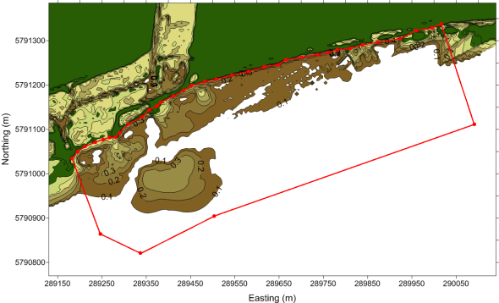
Figure A1.1. 145W Outfall East

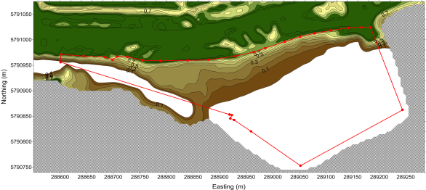
Figure A1.2. Little River Mouth East

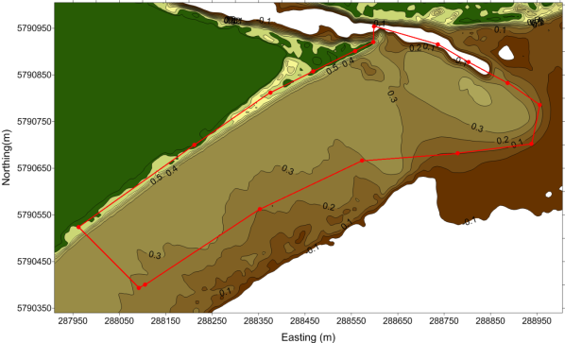
Figure A1.3. Little River Mouth West

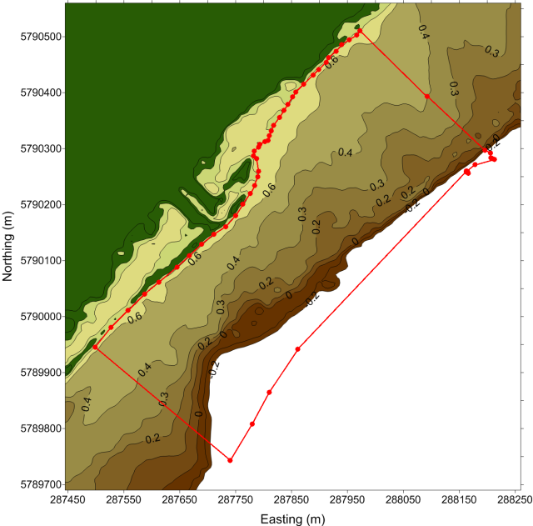
Figure A1.4. Borrie Outfall

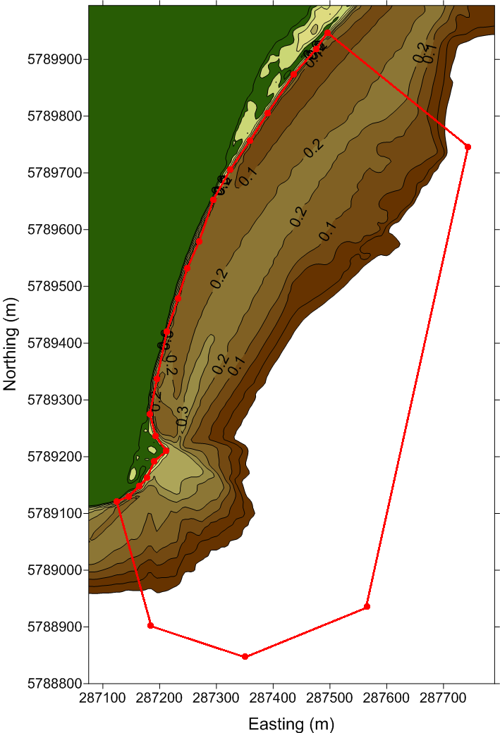

Figure A1.5 Beacon Pt

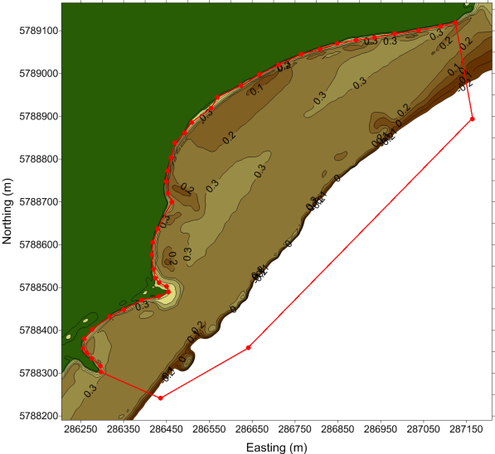
Figure A1.6 Beach Rd East

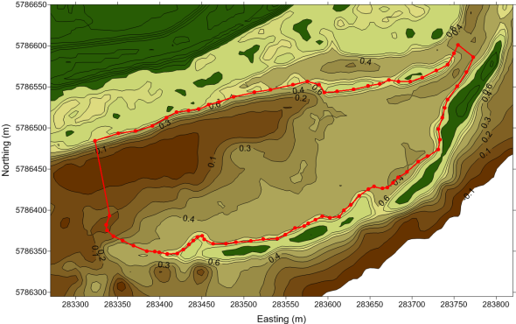
Figure A1.7. North Spit Lagoon
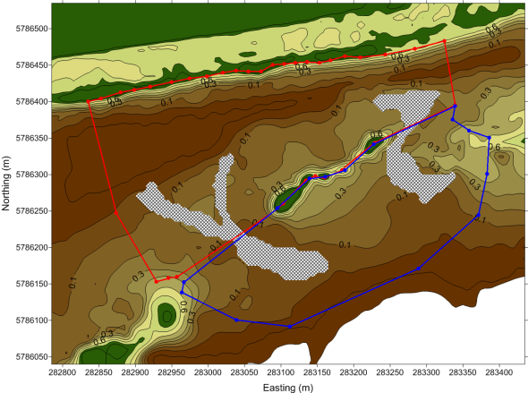

Figure A1.8 . North Spit Channel

Appendix 2

Estimation of tidal flat area at different tide heights
The eight intertidal shorebird foraging sites considered in this study differed in coastal topography (see maps in Appendix 1), so tidal flat area had to be modelled for each. Examination of data plots showed clearly that at low tide the eight sites were extensively exposed and that at high tides they were completely, or almost completely, inundated. They also suggested that the rates of change over time of exposed tidal flat areas would be reasonably described by models based on the simple logistic (or logit) function. The following model was found to give a good fit to the data for five of the sites:
Exposed mudflat area = HIGH + (LOW – HIGH) / {1 + EXP(A + B.TideHeight)}
where
• HIGH is the mudflat area exposed at all tide heights. This is zero on sites which are completely submerged on high tides;
• LOW is the mudflat area exposed on the lowest tides;
• A and B are parameters which describe the rate of change of mudflat area;
• EXP() is the exponential function.
For three of the intertidal shorebird foraging considered, the data do not show the sigmoid curve of the logistic function, but they do show a monotonic decrease, implying no point of inflexion, in exposed mudflat area as tide heights increase. The decreases appeared to follow an exponential pattern. This is consistent with data from the tail of the logistic function which approximates the exponential function. This is the model calibrated for these sites:
Exposed mudflat area = HIGH + (LOW – HIGH). EXP{- B.(TideHeight – 0.1)}
Note that TideHeight in this model is reduced by 0.1 m, the lowest tide height for which we have data. This adjustment ensures that we make no assumption or suggestion about what happens on lower tides, on which we have no data.
The table below gives parameter estimates and goodness of fit indicators. The ratio of Asymptotic Standard Error divided by Standard Deviation (equivalent to t-values) gives comparable indications of how good the estimated parameters are which are comparable. The Asymptotic Standard Errors themselves are somewhat indigestible, ranging from less than unity to several thousands. R-squared values are very high, but this is only to be expected when fitting model with several parameters to be estimated to a small number of points. The precision of the parameter estimates is a better indication of the fit of the models to the data. This is further illustrated by the plots of observed and expected values for each mudflat presented in the main body of this report (Figure 8).

Table A2.1 Models of the relationship between water depth and tidal flat area at shorebird foraging sites of the WTP

Site | Model  structure | HIGH; t | LOW; t | A; t | B; t | R2
East of 145W Outfall | Exponential | 2427; 3.66 | 77042; 74.73 | 0 | 7.6152, 28.86 | 0.9930
Little River to 145W Outfall | Logistic | 0 | 29694; 6.08 | -1.543, -2.67 | 7.0401, 7.23 | 0.9945
Little River Mouth West | Logistic | 8606; 4.295 | 189109; 5.75 | -13.276, -8.82 | 40.8328, 2.51 | 0.9993
Borrie Outfall | Logistic | 0 | 159791; 28.56 | -3.590, -10.05 | 9.50294, 13.22 | 0.9980
Beacon Point | Logistic | 0 | 143150; 29.32 | 0 | 9.41004, 13.63 | 0.9928
Beach Road East | Exponential | 5910; 6.048 | 267489; 116.7 | -9.281, -30.94 | 36.451, 33.91 | 0.9999
North Spit Lagoon | Logistic | 0 | 47608; 4.30 | -6.116, -7.06 | 14.9685, 7.72 | 0.9993
North Spit Channel | Exponential | 3143; 6.70 | 71421; 9.88 | 0 | 7.51535, 3.81 | 0.9996

Appendix 3
Table A3.1. Correlations of effluent attributes with concurrent measurements of benthos density. The table presents correlation coefficients r (1 = perfect positive correlation; –1 = perfect, negative correlation; 0 = no correlation). Strong associations (r>0.8) are underlined and highlighted to guide the eye, but none were significant at P < 0.1 after Dunn-Sidak corrections for multiple hypothesis testing.
 |  | 145W Outfall |  |  | Borrie Outfall |  |  | Murtcaim Outfall
Site | Date | Flow | Total N | TSS | Flow | Total N | TSS | Flow | Total N | TSS
Edible biomass
145W Outfall East | 0.03 | –0.26 | –0.12 | 0.40 | 0.06 | –0.09 | –0.38 | –0.09 | –0.27 | –0.14
Little River Mouth East | –0.49 | –0.51 | –0.49 | –0.23 | –0.40 | –0.63 | –0.36 | –0.04 | –0.54 | 0.20
Little River Mouth West | –0.39 | –0.32 | –0.20 | –0.39 | –0.22 | –0.50 | –0.21 | –0.24 | –0.46 | 0.42
Borrie Outfall | 0.66 | 0.80 | 0.36 | 0.77 | 0.58 | 0.55 | 0.92 | 0.11 | 0.79 | –0.36
Beacon Pt | 0.14 | 0.51 | 0.87 | 0.40 | 0.60 | 0.41 | 0.73 | 0.31 | 0.20 | 0.40
Beach Rd East | 0.10 | –0.01 | –0.54 | 0.03 | –0.10 | 0.00 | –0.30 | –0.46 | 0.28 | 0.14
North Spit Lagoon | 0.00 | –0.56 | –0.21 | –0.85 | 0.36 | –0.50 | –0.13 | –0.19 | –0.58 | –0.10
North Spit Channel | 0.10 | –0.44 | –0.16 | –0.58 | 0.36 | –0.49 | 0.04 | –0.11 | –0.48 | –0.08
Worm biomass
145W Outfall East | –0.40 | –0.41 | –0.51 | –0.08 | –0.42 | –0.54 | –0.33 | –0.06 | –0.39 | 0.18
Little River Mouth East | –0.41 | –0.40 | –0.54 | –0.09 | –0.40 | –0.51 | –0.37 | –0.07 | –0.39 | 0.11
Little River Mouth West | –0.59 | –0.27 | –0.48 | –0.10 | –0.46 | –0.48 | –0.45 | –0.27 | –0.33 | 0.50
Borrie Outfall | –0.39 | –0.25 | –0.40 | –0.03 | –0.18 | –0.32 | –0.31 | –0.04 | –0.32 | 0.14
Beacon Pt | –0.29 | 0.02 | –0.33 | 0.19 | –0.15 | –0.31 | –0.18 | –0.13 | –0.13 | 0.31
Beach Rd East | –0.33 | –0.51 | –0.84 | –0.28 | –0.55 | –0.57 | –0.57 | –0.35 | –0.27 | 0.10
North Spit Lagoon | 0.34 | –0.71 | –0.57 | –0.85 | –0.12 | –0.60 | –0.60 | –0.33 | –0.58 | 0.10
North Spit Channel | 0.24 | –0.34 | –0.26 | –0.48 | –0.42 | –0.37 | –0.37 | –0.18 | –0.34 | –0.23

(cont.)
 |  | 145W Outfall |  |  | Borrie Outfall |  |  | Murtcaim Outfall
Site | Date | Flow | Total N | TSS | Flow | Total N | TSS | Flow | Total N | TSS
Crustacean biomass
145W Outfall East | 0.98 | 0.68 | 0.20 | 0.43 | 0.82 | 0.72 | 0.50 | –0.45 | 0.68 | –0.74
Little River Mouth East | 0.87 | 0.83 | 0.18 | 0.67 | 0.68 | 0.92 | 0.43 | –0.07 | 0.96 | –0.47
Little River Mouth West | 0.47 | –0.28 | –0.02 | –0.45 | 0.48 | –0.07 | 0.17 | –0.03 | –0.12 | –0.31
Borrie Outfall | 0.68 | 0.18 | 0.06 | 0.08 | 0.44 | 0.48 | 0.29 | –0.09 | 0.39 | –0.50
Beacon Pt | 0.78 | 0.32 | –0.02 | 0.23 | 0.63 | 0.25 | 0.49 | –0.18 | 0.61 | –0.31
Beach Rd East | 0.48 | 0.07 | 0.28 | –0.13 | 0.71 | 0.08 | 0.45 | 0.11 | –0.12 | –0.38
North Spit Lagoon | 0.74 | 0.22 | 0.17 | –0.16 | 0.88 | 0.28 | 0.39 | –0.08 | 0.15 | –0.60
North Spit Channel | 0.09 | 0.44 | –0.03 | –0.65 | 0.44 | –0.47 | 0.13 | –0.05 | –0.53 | –0.05
Proportion of foraging Red-necked Stint in the WTP
145W Outfall East | –0.36 | –0.47 | –0.75 | –0.17 | –0.63 | –0.53 | –0.55 | –0.34 | –0.15 | 0.39
Little River Mouth East | –0.35 | –0.58 | –0.83 | –0.42 | –0.61 | –0.53 | –0.75 | –0.35 | –0.34 | 0.42
Little River Mouth West | –0.10 | –0.52 | –0.60 | –0.33 | –0.50 | –0.52 | –0.39 | –0.12 | –0.27 | –0.16
Borrie Outfall | 0.67 | 0.65 | –0.05 | 0.64 | 0.21 | 0.79 | 0.11 | –0.14 | 0.96 | –0.47
Beacon Pt | –0.02 | –0.36 | –0.52 | –0.44 | –0.58 | –0.44 | –0.64 | –0.05 | –0.14 | –0.46
Beach Rd East | 0.34 | –0.15 | 0.13 | –0.51 | 0.47 | –0.17 | –0.04 | 0.25 | –0.34 | –0.52
North Spit Lagoon | –0.29 | –0.09 | 0.75 | –0.03 | 0.10 | –0.09 | 0.61 | 0.23 | –0.32 | 0.49
North Spit Channel | 0.48 | –0.09 | 0.14 | 0.46 | 0.78 | –0.03 | 0.31 | –0.09 | –0.18 | –0.39

Table A3.2. Correlations of benthos density with effluent loads over the previous three months. The table presents correlation coefficients r (1 = perfect positive correlation; –1 = perfect negative correlation; 0 = no correlation). Strong associations (r>0.8) are underlined and highlighted to guide the eye, but none were significant at P < 0.1 after Dunn-Sidak corrections for multiple hypothesis testing.

 |  | 145W Outfall |  |  | Borrie Outfall |  |  | Murtcaim Outfall
Site | Date | Flow | Total N | TSS | Flow | Total N | TSS | Flow | Total N | TSS
Edible biomass
145W Outfall East | –0.26 | –0.71 | –0.38 | –0.74 | –0.59 | –0.60 | –0.60 | 0.32 | 0.39 | 0.27
Little River Mouth East | 0.91 | –0.98 | 0.01 | –0.93 | –0.91 | –0.91 | –0.88 | 0.20 | 0 | 0.69
Little River Mouth West | –0.39 | 0.09 | –0.03 | –0.03 | 0.65 | 0.59 | 0.65 | –0.34 | 0.05 | –0.42
Borrie Outfall | 0.65 | 0.57 | 0.36 | 0.36 | –0.36 | –0.47 | –0.31 | 0.67 | –0.19 | 0.82
Beacon Pt | 0.16 | 0.51 | 0.69 | 0.69 | 0.52 | –0.25 | 0.31 | 0.75 | 0.43 | 0.61
Beach Rd East | 0.10 | 0.37 | 0.61 | 0.61 | 0.69 | 0.73 | 0.83 | –0.01 | –0.68 | 0.13
North Spit Lagoon | 0.00 | –0.72 | –0.27 | –0.27 | 0.46 | 0.13 | 0.30 | –0.89 | –0.11 | –0.75
North Spit Channel | 0.10 | –0.77 | –0.29 | –0.29 | 0.16 | –0.17 | 0.04 | –0.70 | –0.11 | –0.54
Worm biomass
145W Outfall East | –0.49 | –0.87 | –0.41 | –0.41 | –0.48 | –0.48 | –0.51 | –0.55 | 0.61 | –0.50
Little River Mouth East | 0.94 | –0.99 | 0.08 | 0.08 | –0.93 | –0.93 | –0.91 | 0.13 | 0 | 0.64
Little River Mouth West | –0.59 | 0.12 | –0.30 | –0.30 | 0.39 | 0.51 | 0.47 | –0.24 | –0.19 | –0.33
Borrie Outfall | –0.39 | –0.26 | –0.26 | –0.26 | –0.35 | -0.29 | –0.34 | –0.35 | –0.13 | –0.36
Beacon Pt | –0.39 | 0.18 | –0.11 | –0.11 | –0.53 | –0.57 | –0.21 | –0.04 | –0.11 | –0.07
Beach Rd East | –0.32 | –0.30 | –0.74 | –0.74 | 0.10 | 0.33 | 0.23 | –0.46 | –0.46 | –0.37
North Spit Lagoon | –0.34 | –0.49 | –0.46 | –0.46 | 0.61 | 0.52 | 0.55 | –0.87 | –0.23 | –0.79
North Spit Channel | 0.24 | –0.69 | –0.43 | –0.43 | 0.15 | –0.16 | 0.07 | –0.66 | –0.30 | –0.44

(cont.)
 |  | 145W Outfall |  |  | Borrie Outfall |  |  | Murtcaim Outfall
Site | Date | Flow | Total N | TSS | Flow | Total N | TSS | Flow | Total N | TSS
Crustacean biomass
145W Outfall East | 0.90 | 0.78 | 0.39 | 0.39 | –0.40 | –0.41 | –0.32 | 0.98 | –0.97 | 0.99
Little River Mouth East | 0.78 | –0.90 | –0.24 | –0.24 | –0.77 | –0.78 | –0.73 | 0.44 | 0 | 0.85
Little River Mouth West | 0.46 | –0.53 | –0.15 | –0.15 | –0.06 | –0.34 | –0.16 | –0.43 | –0.11 | –0.24
Borrie Outfall | 0.68 | 0.03 | 0.16 | 0.16 | –0.31 | –0.20 | –0.16 | –0.21 | 0.03 | 0.29
Beacon Pt | 0.70 | 0.25 | –0.21 | –0.21 | –0.09 | –0.19 | 0.37 | 0.48 | –0.54 | 0.65
Beach Rd East | 0.87 | 0.59 | –0.04 | –0.04 | –0.04 | –0.18 | 0.02 | 0.59 | –0.55 | 0.81
North Spit Lagoon | 0.74 | –0.20 | –0.12 | –0.12 | 0.16 | –0.24 | 0.04 | –0.23 | –0.32 | 0.03
North Spit Channel | 0.09 | –0.77 | –0.12 | –0.12 | 0.24 | –0.14 | 0.07 | –0.69 | 0.05 | –0.58
Proportion of foraging Red-necked Stint in the WTP
145W Outfall East | –0.58 | –0.69 | –0.97 | –0.82 | –0.87 | –0.94 | –0.51 | –0.44 | 0.59 | –0.46
Little River Mouth East
Little River Mouth West | –0.28 | –0.36 | –0.55 | –0.21 | –0.43 | –0.50 | –0.25 | –0.23 | –0.21 | –0.18
Borrie Outfall | 0.64 | 0.82 | –0.41 | –0.23 | –0.22 | 0.91 | 0.25 | 0.59 | –0.71 | 0.79
Beacon Pt | 0.63 | –0.79 | –0.54 | –0.50 | –0.91 | –0.57 | –0.65 | –0.93 | –0.09 | –0.81
Beach Rd East | –0.24 | –0.74 | –0.28 | 0.22 | 0.35 | –0.13 | 0.08 | –0.77 | –0.01 | –0.73
North Spit Lagoon | –0.56 | –0.06 | 0.93 | 0.54 | –0.11 | –0.57 | –0.50 | 0.22 | 0.96 | –0.13
North Spit Channel | 0.45 | –0.44 | –0.13 | –0.29 | 0.95 | –0.06 | 0.80 | –0.54 | –0.16 | 0.36



ISSN 1835-3827 (print)

ISSN 1835-3835 (online)

ISBN 978-1-74287-991-8 (print)

ISBN 978-1-74287-992-5 (online)

