Arthur Rylah Institute for Environmental Research
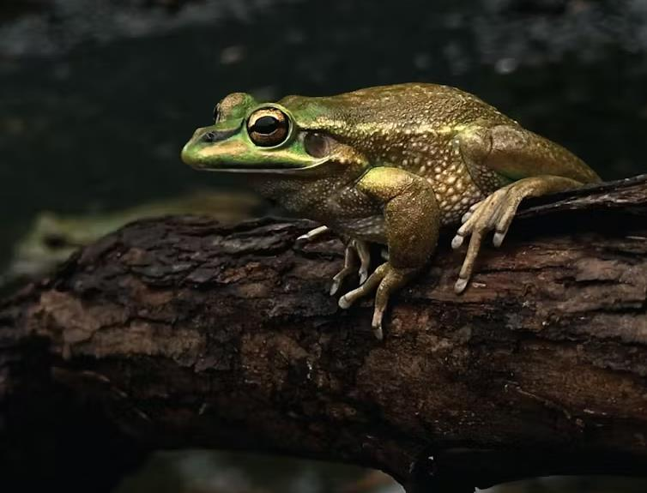


Arthur Rylah Institute for Environmental Research Technical Report Series No. 387
Assessing the risks of endemic and exotic diseases to Victorian terrestrial wildlife
DSL Ramsey, JK Cripps, MP Scroggie, C Pacioni, J Hufschmid, L Berger, F Scheelings, M Lynch, ATD Bennett and LF Skerratt
May 2025




Department of Energy, Environment and Climate Action
PO Box 137, Heidelberg, Victoria 3084
Phone (03) 9450 8600
Website: www.ari.vic.gov.au
Citation: Ramsey, D.S.L., Cripps, J., Scroggie, M.P., Pacioni, C., Hufschmid, J., Berger, L., Scheelings, F., Lynch, M., Bennett, A.T.D. and Skerratt, L.F. (2025). Assessing the risks of endemic and exotic diseases to Victorian terrestrial wildlife. Technical Report Series No. 387. Department of Energy, Environment and Climate Action, Heidelberg, Victoria.
Front cover photo: Green and Golden Bell Frog (Litoria aurea) (Anthony Waddle).

Edited by Fox Writing Services
ISSN 1835-3835 (pdf)
ISBN 978-1-76176-224-6 (pdf/online/MS word)

We acknowledge and respect Victorian Traditional Owners as the original custodians of Victoria’s land and waters, their unique ability to care for Country and deep spiritual connection to it.
We honour Elders past and present whose knowledge and wisdom
has ensured the continuation of culture and traditional practices.
DEECA is committed to genuinely partnering with Victorian Traditional Owners and Victoria’s Aboriginal community to progress their aspirations.
© The State of Victoria Department of Energy, Environment and Climate Action, May, 2025
Creative Commons
This work is licensed under a Creative Commons Attribution 4.0 International licence, visit the Creative Commons website (http://creativecommons.org/licenses/by/4.0/).
You are free to re-use the work under that licence, on the condition that you credit the State of Victoria as author. The licence does not apply to any images, photographs or branding, including the Victorian Coat of Arms, and the Victorian Government, the Department and the ARI logos.
Disclaimer
This publication may be of assistance to you but the State of Victoria and its employees do not guarantee that the publication is without flaw of any kind or is wholly appropriate for your particular purposes and therefore disclaims all liability for any error, loss or other consequence which may arise from you relying on any information in this publication.

Assessing the risks of endemic and exotic diseases to Victorian terrestrial wildlife

David S.L. Ramsey¹, Jemma K. Cripps¹, Michael P. Scroggie¹, Carlo Pacioni¹, Jasmin Hufschmid², Lee Berger², Andrew T.D. Bennett², Franciscus Scheelings², Michael Lynch² and Lee F. Skerratt²

¹Arthur Rylah Institute for Environmental Research
Department of Energy, Environment and Climate Action
123 Brown Street, Heidelberg, Victoria 3084
²OneHealth Research Group,
Melbourne Veterinary School,
The University of Melbourne, Werribee, Victoria, 3030

Date

Arthur Rylah Institute for Environmental Research
Technical Report Series No. 387

Acknowledgements
This project was funded by Agriculture Victoria under the EAD preparedness program, and we thank Julie Simonds (AgVic) and James Todd (ARI) for facilitating this funding.
The authors would also like to thank Tiggy Grillo, Steve Unwin and Clare Death from Wildlife Health Australia for their discussions and provision of information and advice.
Sally Salmon and Adam Kay from Agriculture Victoria provided useful documents outlining previous assessments of wildlife disease priorities and hazards.
Geoff Heard, Keren Cox-Witton, Lindy Lumsden, Steve Griffiths, Nicola Bail, Andre Chiaradia and Thierry Boulinier provided valuable feedback on the disease impact case studies. We also thank Ben Fanson and Simone Stevenson (ARI) for providing valuable feedback on a draft of this report.

Contents
Acknowledgements ii
Summary 9
1 Introduction 11
1.1 Aims 12
2 Methods 12
2.1 Wildlife disease risk analysis (WDRA) 12
2.1.1 WDRA purpose 13
2.1.2 WDRA aims 13
2.1.3 WDRA components 13
2.1.4 Assumptions and limitations 17
2.1.5 Other useful documentation 18
2.1.6 Implementation and review 18
2.2 Modelling disease impacts and potential mitigation options 18
2.2.1 Modelling components 19
3 Results 22
3.1 WDRA – general results 22
3.2 Conservation risks 23
3.3 Economic risks 23
3.4 Diseases of severe risk to high conservation status wildlife in Victoria 26
3.5 Modelling disease impacts and potential mitigation options 29
3.5.1 Foot and Mouth Disease in Feral Pigs 29
3.5.2 Highly Pathogenic Avian Influenza in Little Penguins 33
3.5.3 White Nose Syndrome in Southern Bent-wing Bats 38
3.5.4 Amphibian chytrid fungus in Bell Frogs 44
4 Discussion 56
4.1 General commentary 56
4.1.1 WDRA results: Conservation risks 56
4.1.2 WDRA results: Economic risks 57
4.2 Mitigation of wildlife disease risks 57
4.2.1 Conservation risks 58
4.2.2 Economic risks 59
4.2.3 Economic risks 60
4.3 Unknowns and uncertainties 60
4.4 Wildlife disease management 61
4.4.1 Recommendations for managing current and future disease risks 62
5 References 63
6 Additional modelling details and results 70
6.1 Foot and Mouth Disease in Feral Pigs 70
6.2 High Pathogenic Avian Influenza in Little Penguins 74
6.3 White Nose Syndrome in Southern Bent-wing Bats 77
6.4 Amphibian chytrid fungus in Bell Frogs 80

Tables

Table 1. The components of the wildlife disease risk assessment in Victoria. 13
Table 2. Level of uncertainty of predictions. 15
Table 3. Descriptions and definitions of the likelihood scores. 15
Table 4. Descriptions and definitions of consequence scores. 16
Table 5. Risk matrix. 16
Table 6. Disease hazards and affected fauna selected for the case studies. 19
Table 7. Summary of the number of disease risk assessments that were assigned a given risk rating for the conservation impacts of each disease hazard. 22
Table 8. Summary of the number of disease risk assessments that were assigned a given risk rating for the economic impacts of each disease hazard. 22
Table 9. Diseases with Extreme and High conservation risk ratings in the disease risk assessment. 24
Table 10. Diseases with Extreme and High economic risk ratings in the disease risk assessment 25
Table 11. Diseases that were assessed as representing potentially Extreme or High conservation risks to Endangered (EN) and Critically Endangered (CE) FFG-listed mammals in Victoria. 26
Table 12. Diseases that were assessed as representing potentially Extreme or High conservation risks to Endangered (EN) and Critically Endangered (CE) FFG-listed birds in Victoria. 27
Table 13. Diseases that were assessed as representing potentially Extreme or High conservation risks to Endangered (EN) and Critically Endangered (CE) FFG-listed reptiles in Victoria. 28
Table 14. Diseases that were assessed as representing potentially Extreme or High conservation risks to Endangered (EN) and Critically Endangered (CE) FFG-listed amphibians in Victoria. 28
Table A1. Parameter values used for the Feral Pig FMD model. Parameter values are per day. 70
Table A2. Parameter values used to model an outbreak of HPAI in Little Penguins. Parameter values are per day. 74
Table A3. Parameter values used to model an outbreak of WNS in SBWBs. Parameter values are per day. 78
Table A4. Parameter values used to model the epidemiology of chytrid in Bell Frogs. Parameter values are per day unless otherwise indicated. 81

Figures
Figure 1. The IUCN wildlife disease risk analysis process steps (Jakob-Hoff et al. 2014) 12
Figure 2. Compartment host-pathogen model including classes for susceptible (S), infected (I) and recovered (immune) (R) classes. 20
Figure 3. Compartment host-pathogen model including environmental transmission (ET), which was used to represent transmission pathways from an environmental reservoir or from sympatric species acting as a reservoir for the pathogen. 20
Figure 4. Flow chart of the Feral Pig FMD individual-based model showing the progression of individuals through each of the model compartments. $S$ – susceptible, $E$ – exposed, $I$ – infectious, $R$ – recovered. Parameter descriptions are given in the Appendix. 29
Figure 5a. The progression of an outbreak of FMD in Feral Pigs over a 5-year period from the deterministic model. Parameter estimates are given in Section 6.1. N – total relative population size. S – susceptible, I – exposed + infected, and R – recovered (prevalence). 30
Figure 5b. Predicted uncertainty in total (relative) population size and disease states for simulated outbreaks of FMD in a population of Feral Pigs from the stochastic individual-based model. Trajectories were generated by varying key parameters by $±$ 30% and simulating 250 sets of random parameter values using Latin hypercube sampling, Solid black line – mean, dashed black lines – 90% confidence intervals. N – total relative population size, S – susceptible, I – exposed + infected (prevalence). 31
Figure 6. Cumulative probability of eradication of an FMD outbreak in Feral Pigs over time under the most likely parameter values with one-off culling operations of varying intensity (0, 20, 40, 60 or 80%) at either 7, 28 or 64 days after the initiation of the outbreak 32
Figure 7. Mean time to eradication (in weeks) for simulated FMD outbreaks under the likely parameter values with one-off culling operations of varying intensity (0, 20, 40, 60 or 80%) at either 7, 28 or 64 days after the initiation of the outbreak. Black horizontal lines give the mean and blue bars give the width of the 95% confidence interval. 32
Figure 8. Peak FMD prevalences (proportion of exposed and infectious individuals in the population) for simulated FMD outbreaks under the likely parameter values with one-off culling operations of varying intensity (0, 20, 40, 60 or 80%) at either 7, 28 or 64 days after the initiation of the outbreak. Black horizontal lines give the mean and pink bars give the width of the 95% confidence interval. 33
Figure 9. Flow chart of the HPAI Little Penguin individual-based model showing the progression of individuals through each of the model compartments. $S$ – susceptible, $E$ – exposed, $I$ – infectious, $R$ – recovered. Parameter descriptions are given in Section 6.2. 34
Figure 10. Predicted mean trajectories for each of the disease states following an outbreak of HPAI in a population of Little Penguins. N – total population and D – deaths (relative population size), S – Susceptible, I – infected (and infectious), R – recovered (prevalence). 35
Figure 11. Predicted uncertainty in total (relative) population size (N), infection prevalence (I), and deaths (D) of High Pathogenic Avian Influenza (HPAI) in Little Penguins predicted from the stochastic IBM. Trajectories were generated by varying key parameters by $±$ 30% and simulating 250 sets of random parameter values using Latin hypercube sampling, Solid black line – mean, dashed black lines – 90% confidence intervals. Susceptible and Recovered states have been removed for clarity. 36
Figure 12. Maximum mortality rate of Little Penguins due to HPAI, estimated following vaccination programs achieving varying rates of population coverage. Vaccination was assumed to be applied just prior to arrival of HPAI. 37
Figure 13. Maximum mortality rate of Little Penguins due to HPAI, estimated following vaccination programs achieving varying rates of population coverage. Vaccination was assumed to be initiated 5 days following the arrival of HPAI, taking 30 days to achieve the desired level of population coverage. 37
Figure 14. Flow chart of the transmission of WNS in SBWBs during the hibernation phase (torpor period) used for the individual-based model, showing the progression of individuals through each of the model compartments. $S$ – susceptible, $E$ – exposed, $I$ – infectious, $P$ – pathogen in the cave environment. 39
Figure 15. Flow chart of the transmission of WNS in SBWBs during the active phase used for the individual-based model, showing the progression of individuals through each of the model compartments. $S$ – susceptible, $E$ – exposed, $I$ – infectious, $P$ – pathogen in the cave environment. Parameter descriptions are given in Section 6.3. 40
Figure 16a. Predicted mean trajectories for each of the disease states following an outbreak of White Nose Syndrome in a population of Southern Bent-wing Bats assuming bats undergo a 7-month period of torpor. N – total relative population size, S – susceptible, E – exposed, I – infected (prevalence). 41
Figure 16b. Predicted uncertainty in total relative population size (N), Susceptible (S) and infection prevalence (I) following an outbreak of White Nose Syndrome in a population of Southern Bent-wing Bats, assuming bats undergo a 7-month period of torpor. Trajectories were generated by varying key parameters by $±$ 30% and simulating 250 sets of random parameter values using Latin hypercube sampling. Solid black line – mean, dashed black lines – 90% confidence intervals. Exposed states have been removed for clarity. 42
Figure 17. Population trajectories of the SBWB following an incursion of WNS for varying numbers of days spent in torpor by bats during winter (see text for details). N – total population (relative to starting population); I – prevalence of infected bats (proportion of current population infected). Light blue and red lines indicate trajectories from each simulation while black solid and dashed lines indicate the mean and 90% confidence intervals, respectively. 43
Figure 18. Relative population size after 10 years following an introduction of WNS into the SBWB population in Warrnambool cave, for various periods (days) spent in winter torpor each year. 44
Figure 19. Flow chart of the transmission of the Chytrid pathogen in Bell Frogs inhabiting a single waterbody, used for the individual-based model showing the progression of individuals through each of the model compartments. $S$ – susceptible, $I$ – infected, $Sr$ – recovered and susceptible, $Ir$ – recovered and re-infected, $P$ – environmental reservoir of the pathogen. Parameter descriptions are given in Section 6.4. 45
Figure 20. Relationship between maximum zoospore load (log₁₀ scale) per infected individual $Zmax$ and temperature for frogs, with and without prior exposure to Bd. Dashed line indicates the threshold zoospore load $ZT$ above which, mortality from Chytridiomycosis occurs. 47
Figure 21. Growth rate of zoospores (Z) on infected frogs (log₁₀ scale) with time since infection at various ambient temperatures for frogs, with and without prior exposure to Bd. Dashed line indicates the value of $Zt$ above which, significant frog mortality occurs. 47
Figure 22. Seasonal maximum daytime temperature regimes for three simulated wetlands representing ‘cold’, ‘warm’ and ‘hot’ thermal environments. 49
Figure 23. Relative population size for Bell Frogs following the introduction of Bd for frogs inhabiting the ‘cold’ thermal environment. Black line – relative population size; red line – Bd prevalence. Shading represents 95% uncertainty intervals. 50
Figure 24. Relative population size for Bell Frogs following the introduction of Bd for frogs inhabiting the ‘warm’ thermal environment. Black line – total population; red line – Bd prevalence. Shading represents 95% uncertainty intervals. 50
Figure 25. Relative population size for Bell Frogs following the introduction of Bd for frogs inhabiting the ‘hot’ thermal environment. Black line – total population; red line – Bd prevalence. Shading represents 95% uncertainty intervals. 51
Figure 26. Relative population size for Bell Frogs following the introduction of Bd for frogs inhabiting the ‘warm’ thermal environment before and after the introduction of thermal shelters (vertical dashed line) where the percentage of the population using shelters was 50% or 90%. Each shelter had a thermal delta of 4°C. Shading represents 95% uncertainty intervals. 52
Figure 27. Relative population size for Bell Frogs following the introduction of Bd for frogs inhabiting the ‘cold’ thermal environment. Following extirpation, 50 heat treated Bd resistant frogs were re-introduced in year 20 (vertical dashed line). Plots show the percentage of the re-introduced population using shelters. Each shelter had a thermal delta of 4°C. 53
Figure 28. Relative population size for Bell Frogs following the introduction of Bd for frogs inhabiting the ‘cold’ thermal environment. Following extirpation, 50 heat treated Bd resistant frogs were re-introduced in year 20 (vertical dashed line). Plots show the percentage of the re-introduced population using shelters. Each shelter had a thermal delta of 8°C. 54
Figure A1. Partial effects of the values of the model parameters on the logarithm of the time to disease eradication in an unmanaged outbreak of FMD. Note, the large effect of the value taken by the parameter β, which represents the density-dependent transmission rate of FMD between individual pigs. 71
Figure A2. Trajectories of simulated FMD outbreaks where beta (transmission parameter) is set at the lower bound (top), likely value (middle) or upper bound (bottom). Each coloured line represents a separate run of the stochastic simulation, with heavy and light black lines giving the median and 95% confidence limits. The blue lines are the total number of pigs in the population and the red lines are number of pigs infected with FMD. 250 simulations were run for each of the three assumed values of beta. All other parameters were held at their likely values (Table A1). 72
Figure A3. Simulated FMD outbreaks where the transmission parameter beta is set at its upper bound. A one-off culling operations of varying intensity (C=20, 40, 60 or 80%) is conducted at 28 days after the origin of the outbreak. Blue lines are total population size (N), and red lines are the number of infected animals (exposed + infectious) over time. Light and heavy black lines give the median and 95% confidence intervals across all 250 runs of the simulation. 73
Figure A4. Sensitivity of the mortality rate (left) due to and peak prevalence (right) of HPAI in Little Penguins, with respect to variation in the key epidemiological parameters. 75
Figure A5. Trajectories for total population (N) and mortality rate (D) under vaccination programs achieving varying levels of population coverage. Vaccination was assumed to be applied just prior to the arrival of HPAI. 76
Figure A6. Trajectories for total population (N) and mortality rate (D) under vaccination programs achieving varying levels of population coverage. Vaccination was assumed to be initiated 5 days following the arrival of HPAI, taking 30 days to achieve the desired level of population coverage. 77
Figure A7. Counts of SBWBs (N) emerging from the Warrnambool cave and surrounding non-breeding caves during the breeding seasons 2018–2022 (Lumsden and Bush unpublished data). Counts were undertaken when pups were pre-volant (blue circles), and then around two months later as pups became volant (red circles). Error-bars denote the standard deviation of replicate counts. 79
Figure A8. Sensitivity of the rate of population reduction (left) and peak prevalence (right) of WNS in SBWBs, with respect to variation in the key epidemiological parameters. 80
Figure A9. Sensitivity of the rate of population reduction (left) and peak prevalence (right) due to amphibian chytrid in Bell Frogs, with respect to variation in the key epidemiological parameters. 82

Summary
Context:
With increasing globalisation of markets and transport networks, as well as other anthropogenic processes such as changing land-use patterns and climate change, comes the increasing risk of emerging (or re-emerging) diseases potentially impacting Australia’s native wildlife. Developing a strategic approach to these risks is a very high priority for the Victorian Government and aligns with the objectives under Biodiversity 2037 and Victoria’s Climate Change Adaptation and Action Plan for the Natural Environment. To understand the susceptibility of Victoria’s native fauna to risks from endemic and exotic diseases and the ability to manage potential impacts, assessments should be undertaken of the likelihood of diseases causing an emergency, their expected impacts, as well as potential response options (and their effectiveness).
Aims:
This project aimed to assess the likely risks of endemic and exotic diseases to terrestrial wildlife in Victoria by (i) undertaking qualitative disease risk assessments for Victoria’s terrestrial fauna (especially threatened species), and (ii) modelling the likely impacts and efficacy of potential mitigation strategies for selected disease case studies. Results from these investigations were then synthesised to identify gaps in current knowledge about potential wildlife disease impacts and how these gaps can be addressed to improve disease risk assessments and response planning.
Methods:
We applied the wildlife disease risk analysis (WDRA) method to identify and prioritise disease hazards for terrestrial wildlife in Victoria. WDRA is a structured process that aims to manage disease risks to acceptable levels. The first step in this approach was a risk assessment of potential disease hazards to evaluate the likelihood and the biological and economic consequences of the entry, establishment and spread of a wildlife pathogen based on the principle of ‘Risk = Likelihood $×$ Consequence’. Our risk assessment followed a common qualitative framework, using expert elicitation to score the likelihood, impacts and uncertainty for each disease hazard using a descriptive set of categories.
An initial, comprehensive list of disease hazards were compiled from several sources, including expert elicitation, published and grey literature, including existing lists of priority animal diseases compiled by the Victorian and Australian governments. For each disease hazard, risk assessments were then undertaken by assessors with expertise in veterinary epidemiology, wildlife health, disease ecology, and disease risk assessments. The risk assessments were undertaken for species and/or functional groups of terrestrial mammals, amphibians, birds and reptiles.
Based on the findings from the risk assessments, several pathogens were selected as case studies for detailed investigation of the magnitude of their likely impacts as well as the efficacy of potential mitigation options. These were Foot and Mouth Disease (FMD) in Feral Pigs (Sus scrofa) (Extreme economic impacts); Highly Pathogenic Avian Influenza (HPAI) in Little Penguins (Eudyptula minor) (Extreme economic impacts); White Nose Syndrome (WNS) in Southern Bent-wing Bats (SBWBs; Miniopterus orianae bassanii) (Extreme Conservation impact) and amphibian chytrid fungus in Green and Golden Bell Frogs (Litoria aurea) (Moderate conservation impact). For each case study, host-pathogen models were developed and used to investigate the likely impacts of an incursion of the pathogen, as well as the efficacy of mitigation actions.
Results:
Risk assessments were conducted for 222 pathogens involving 423 host/pathogen groups. A total of 20 host/pathogen groups were identified as either Extreme or High risk of potentially causing undesirable conservation impacts. These included HPAI, the amphibian chytrid fungus and WNS, an emerging fungal disease of cave-dwelling bats. Two additional avian diseases (Pacheco’s Disease and Beak and Feather Disease) were assessed as Extreme conservation risks to Victorian parrot species.
Seven host/pathogen groups were assessed as representing Extreme economic risks, with a further 12 being assessed as High risk. The risk of HPAI incursion in gulls, terns, waders, ducks, swans, geese, penguins and other birds was considered to represent an Extreme economic risk, due to likely spillover of disease to domestic poultry, and the costs associated with enhanced biosecurity activities in response to likely mass mortality of wildlife. FMD, infecting wild populations of deer, goats and pigs, also represented an Extreme economic risk due to the likely high risk of infection spreading to domestic ungulates.
Results from the detailed case studies suggest that mitigation actions have the potential to significantly ameliorate predicted impacts from incursions of exotic disease (FMD in Feral Pigs and HPAI in Little Penguins) or emerging endemic disease (amphibian chytrid fungus in Green and Golden Bell Frogs). However, there is currently no effective management for an incursion of WNS into the cave environment of the SBWB. Modelling did, however, provide insight into the magnitude of potential impacts, which were linked to the frequency and duration of winter torpor (a state in which bats lower their metabolic rate and temperature and become inactive) in this species. Unfortunately, torpor behaviour in this species is currently poorly understood and therefore, the potential impacts of WNS are highly uncertain.
Conclusions and implications:
Based on the results from the WDRA, we make the following recommendations for managing current and future disease risks to Victorian wildlife:
- To enable detection of outbreaks of known and novel diseases, a passive surveillance system could be developed. Pathology of unusual and/or large mortality events is the most efficient way to detect emerging disease, including novel pathogens. In addition, providing training to members of the public that regularly interact with wildlife, such as hunters, to recognise signs of disease may provide useful passive surveillance for diseases such as FMD in feral pigs and deer.
- Reserve capacity for field outbreak investigations is essential for responding to wildlife emergencies. To enable this capacity, Victoria should consider supporting a state wildlife epidemiologist and/or wildlife pathologist. To facilitate this, consideration could be given to establishing more formal links with the Wildlife Health Surveillance Unit at the University of Melbourne.
- In the event of an FMD outbreak in domestic livestock, consideration should be given to proactively culling high risk Feral Pig populations in the vicinity of livestock farms to prevent potential spillover and spillback of disease to domestic livestock. Culling should aim to achieve a 60 – 80% reduction of pig abundance to have a high probability of eradicating FMD. Research should be undertaken to determine the most cost-effective method for achieving this level of reduction.
- Due to the high risk of incursion of avian influenza (H5N1), structured surveillance of wild birds (e.g. gulls, terns, ducks, geese, swans) is recommended to be undertaken in spring each year for the foreseeable future to provide management agencies with early warning of the likelihood of an HPAI epidemic.
- Vaccination of high value captive populations (i.e. threatened species), should be considered to protect these populations from an incursion of H5N1. If vaccination is not possible then priority should be given to boosting biosecurity measures to limit transmission from infected wild birds.
- Vaccination of high value wild populations (e.g. the Little Penguin Parade) could provide protection against an H5N1 outbreak, but would need to be undertaken prior to disease arrival. Vaccination would need to achieve at least 70–80% coverage to provide adequate protection.
- For other wildlife populations, there are limited options available to mitigate the impacts of an outbreak of H5N1 and therefore, priority should be given to boosting biosecurity and containment measures to limit spillover of infection to humans and domestic animals.
- Due to the high risk of incursion of WNS into Australia, surveillance for the disease is recommended for the Victorian maternity caves of the SBWB. Due to the high uncertainty around the potential impacts of WNS on the SBWB, research is needed to provide greater understanding of the frequency and duration of winter torpor in this species.
- In the event of an incursion of WNS into a cave inhabited by SBWBs, options for mitigating disease impacts appear to be limited. However, consideration could be given to use of biocides for treating the sediments of infected caves, because recent evidence suggests this reduces fungal loads in some bat species.
- Due to the ongoing impacts of the amphibian chytrid fungus in Bell Frogs, consideration should be given to deploying artificial thermal shelters for mitigation in locations at risk of high chytrid impacts. For other cold-adapted frog species at Extreme risk of impacts from Chytridiomycosis, research is urgently needed on developing novel strategies for mitigating the impacts of this disease.
- Managers should consider where surveillance may already be providing information on high-priority pathogens (ranked as ‘Extreme’ or ‘High’), and if this is not in place, consider where and how surveillance systems should be implemented for these high-risk diseases.
- Finally, the increasing threats to wildlife caused by anthropogenic environmental changes are likely to result in more frequent wildlife disease emergencies. Hence, an increased focus on assessing and managing wildlife health is likely to be required to mitigate the worst impacts of disease emergence.
- Introduction
Australia has unique flora and fauna species, with high rates of endemism. This rich biological diversity has declined since European colonisation, and extinction rates now far exceed the global average for mammals and are predicted to escalate across all taxa (Legge et al. 2023). Given the uniqueness of Australia’s environment and biodiversity, it is important to protect it against potential threats. A recent review of nationally listed threatened taxa in Australia has shown that invasive species and disease have become among the most prevalent threats (Ward et al. 2021). With increasing globalisation of markets and transport networks, as well as other anthropogenic processes such as changing land-use patterns and climate change, comes the increasing risk of emerging (or re-emerging) diseases potentially impacting Australia’s native wildlife. For example, Psittacine Circoviral (beak and feather) disease in threatened parrot species is considered a key concern and, in 2001, was listed as a national threat by the Australian Government under the Environment Protection and Biosecurity Conservation Act 1999 (DCCEEW 2024). The incursion and/or potential spread of these diseases may also pose a risk to Australia’s agriculture and livestock sector through transmission via native or introduced free-ranging species (Cripps et al. 2019; Scott et al. 2020).
Australia is fortunately free of many of the serious diseases that infect animals in other parts of the world. The impact of emergency animal diseases (EADs) on the economy, environment and community may be severe. For example, estimates suggest that an outbreak of Foot and Mouth Disease (FMD) could have a direct economic impact of around $80 billion in Australia (ABARES 2022). Australia’s biosecurity system aims to protect the country from the risk of entry, establishment and spread of harmful exotic invasive species, and operates at both state and national levels. The Victorian Government has developed The Victorian Government State Emergency Animal Disease Response Plan, which provides an overview of the arrangements for the management of a major EAD emergency in Victoria and contains information on mitigation, preparedness, response and relief (DEECA 2023b). Animal Health Australia also publishes the nationally agreed approach for the response to EAD incidents in Australia, through The Australian Veterinary Emergency Plans (otherwise known as AUSVETPLANs). These focus mostly on livestock, but also cover responses for wild animals that are a reservoir for disease likely to have impacts on human health or the economy (AHA 2023).
The ’One Health’ initiative is an approach that recognises the significant interconnectivity of human health, animal health and environmental health. This concept is a focus of the World Organisation for Animal Health (OIE). By protecting wildlife health, diseases that affect domestic animals and humans can also be prevented. Emerging zoonotic diseases, such as COVID-19, are often associated with environmental and animal factors (Bonilla-Aldana et al. 2020). It is essential to understand the ecological factors affecting the transmission of infectious agents in wildlife, especially to consider the mechanisms involved in host-jumping and/or host-shifting and to predict the risk that both endemic and exotic pathogens pose to wildlife species, animal health and human health. An example of an emerging wildlife disease is Highly Pathogenic Avian Influenza (HPAI). Since October 2021, an unprecedented number of outbreaks of HPAI have been reported in several regions of the world, reaching new geographical areas and causing devastating impacts on animal health and welfare (OIE 2024). The disease has led to an alarming rate of wild bird die-offs and has quickly shifted into other taxon groups, such as mammals. Mortality rates as high as 70% have been seen in Southern Elephant Seals (Mirounga leonine) (Campagna et al. 2024). Unprecedented wild bird mortality was also observed, with one report from Peru establishing at least 100,000 wild birds belonging to 24 species (some of them threatened), had died due to this virus (Gamarra-Toledo et al. 2023). These examples demonstrate how swiftly disease outbreaks can occur, and that the conservation impacts of emerging pathogens on wildlife can be high.
DEECA has been engaging with key stakeholders over the past two to three years on a range of wildlife health risks and the increasing risk of diseases and their potential impacts on Victoria’s biodiversity and natural environment. Preventing disease-linked species extinctions will stabilise ecosystems, reduce zoonotic disease (Ostfeld 2009), and protect biodiversity and ecosystem services. Developing a strategic approach to these risks is a very high priority for the sector and aligns with the objectives and priorities under Biodiversity 2037 and Victoria’s Climate Change Adaptation and Action Plan for the Natural Environment. Understanding the susceptibility of Victoria’s fauna to risks from endemic and exotic diseases and the ability to manage potential impacts requires DEECA to assess the likelihood of diseases causing an emergency, their expected impacts, as well as potential response options (and their effectiveness).

  - Aims
This project aimed to assess the likely risks of endemic and exotic disease to terrestrial wildlife in Victoria by (i) undertaking qualitative disease risk assessments for terrestrial fauna and/or taxon groups (especially threatened species), and (ii) modelling the likely impacts and efficacy of potential mitigation strategies for selected disease case studies. Results from these investigations were then synthesised to identify gaps in current knowledge about potential wildlife disease impacts and how can these be addressed to improve disease risk assessments and response planning.
- Methods
  - Wildlife disease risk analysis (WDRA)
Disease risk analysis (DRA) is a structured process that aims to manage disease risk to an acceptable level. It can help determine the potential impacts of diseases on wildlife populations and assist decision making in the face of uncertainty. It is a repeatable tool that has been used in a variety of situations including for analysing risk of notifiable exotic disease incursion (Hartley et al. 2013), import risk analysis (DAWE 2020), and disease risks for individual species (e.g. the National Koala Disease Risk Analysis), (Vitali et al. 2022). In 2014, the International Union for the Conservation of Nature (IUCN) and the OIE jointly published the Manual of Procedures for Wildlife Disease Risk Analysis (WDRA) (Jakob-Hoff et al. 2014), which assembled current knowledge and provided a framework for developing, interpreting and utilising disease risk analysis in wildlife conservation. The WDRA framework and tools used in this analysis are described in this manual and include six interlinked steps as shown below (Figure 1).
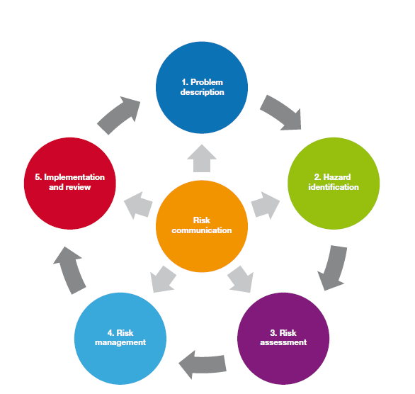
Figure 1. The IUCN wildlife disease risk analysis process steps (Jakob-Hoff et al. 2014)

WDRA is not a new concept, but much of the focus in wildlife in Australia to date has been on analysing the risks associated with moving animals, such as during wildlife translocations (e.g. Wicker et al. 2017) or analysing the risks of wildlife disease to domestic animals in a biosecurity context (e.g. Pearson et al. 2016; Cripps et al. 2019). In this study, we focused on the disease risk assessment component and developed a systematic qualitative approach to assess disease risk in wildlife, in the context of the potential for disease to cause population declines and threaten the conservation status of native wildlife species in Victoria. In addition, we also included risks of exotic animal disease in both native and introduced wildlife in the context of potential economic impacts on Victoria’s agricultural sector and health impacts on communities.

    - WDRA purpose
The purpose of this WDRA was to identify and prioritise disease hazards for terrestrial wildlife in Victoria based on risk, to investigate disease mitigation strategies for priority diseases and to inform future research and surveillance requirements of emerging wildlife diseases.
Government agencies will benefit from this WDRA by having a priority list of high-risk diseases to help focus disease mitigation planning and management efforts. This list will identify diseases that have the potential to cause significant harm to free-ranging Victorian wildlife and help inform biosecurity investigations of emergency wildlife disease outbreaks and population decline. The priority list may also guide agricultural biosecurity practitioners through identifying diseases that may spread to domestic animals from wild populations, or decision makers in public health through awareness of the potential for outbreaks of zoonotic diseases. Priority lists assist with planning, especially preparedness and response plans, but also enable targeted surveillance of priority diseases to prevent entry, establishment and spread.
    - WDRA aims
The aims of this WDRA were to:
- consolidate available knowledge about endemic and exotic diseases in terrestrial wildlife, especially in Victoria
- apply a transparent and scientifically sound qualitative framework to prioritise the disease risks for free-ranging terrestrial wildlife in Victoria
- assess disease hazards that have the potential to cause significant population declines in Victorian wildlife, especially threatened species, but also those that may have significant economic consequences through effects on human health or transmission of disease via invasive species to the agricultural sector
- record gaps in knowledge and identify potential research priorities.
    - WDRA components
The key components of this WDRA were:
- hazard identification
- risk assessment (likelihood of pathogen entry and exposure and expected consequence)
- risk management (see Section 2.3 – assess the effectiveness of mitigation measures for several high-risk wildlife diseases).
Our risk assessment is best described as an evaluation of the likelihood and the biological and economic consequences of the entry, establishment and spread of a wildlife pathogen within the state of Victoria, and is based on the principle of ‘Risk = Likelihood $×$ Consequence’. Our risk assessment followed a common qualitative framework, with three key assessment steps (Table 1). In qualitative WDRAs, likelihood, impact, and uncertainty are expressed using descriptive sets of categories, with clear meanings defined for each (for example, the consequences are described using terms like ‘high’, ‘medium’ or ‘low’) (Jakob-Hoff et al. 2014). Qualitative risk assessments are rapid, require less extensive information, and use expert elicitation and opinion where scientific data are missing.
Table 1. The components of the wildlife disease risk assessment in Victoria.
Step 1 |  |  | Step 2 |  |  | Step 3
Likelihood assessment |  |  | Consequence assessment |  |  | Overall risk
Entry | Exposure | Susceptibility |  | Conservation | Economic | Overall risk of hazard

Hazard identification
The hazard identification step was undertaken to identify pathogens that may potentially contribute to disease risk. Our pathogen list was compiled using a combination of expert knowledge and searches of several literature types, including scientific peer-reviewed literature (searched through Google Scholar), textbooks, and grey literature, such as government reports and factsheets. Our pathogen list also drew from existing lists for priority animal diseases, such as those compiled by the Victorian and Australian Governments. The key reports and factsheets that were examined were:
- The National Priority List of Exotic Environmental Pests, Weeds and Diseases (ABARES 2021)
- The National List of Notifiable Animal Diseases (DAFF 2019)
- Wildlife Health Australia’s Disease Fact Sheets (WHA 2024).
An initial comprehensive pathogen list should include all known or suspected pathogens to which the assessed species may be susceptible. Where knowledge is limited, information can be extrapolated from taxonomically related species. However, wildlife species carry many pathogens and are often asymptomatic, acting as carriers or reservoirs of potential pathogens. To be included in our list, the pathogen had to be capable of producing adverse consequences in a host species (or similar species) and cause clinical disease. For the purposes of this WDRA, a disease was defined as any impairment of the normal structural or physiological state of an organism (Jakob-Hoff et al. 2014). Our risk assessment didn’t include diseases only known to be associated with animals in captivity or originating through experimental research (i.e. laboratory-induced infections). Parasitic diseases were only included if there were reports of clinically significant infections. Therefore, this is not an exhaustive list of all pathogens infecting wildlife.
Pathogens of wildlife known to occur in Victoria (endemic pathogens) were included in the prioritisation process as well as exotic pathogens (either not yet present in Victoria or in Australia or already established but still regarded as exotic). The endemic pathogens of interest were those believed to have the potential to impact on wildlife hosts should they spread, or which may impact on other populations such as livestock. The risks of emerging diseases were also considered by reviewing international emerging diseases of wildlife.
For this risk assessment, all potential host species known to be susceptible were identified. We focused on free-ranging wildlife and invasive mammalian species that were covered under the Wildlife Act 1975 (Victoria). The host taxa that were assessed fell into four key taxon groups – mammals, birds, reptiles and amphibians. This classification thereby excluded taxon groups such as fish and invertebrates.
Threatened species were defined as those listed under Part 3 of the Flora and Fauna Guarantee Act 1988 (Victoria, FFG), according to the Act’s Threatened List, June 2023 (DEECA 2023a). Given that the conservation consequences of wildlife disease were a strong focus of the study, we made a special effort to identify diseases of likely conservation significance to species listed under the FFG act.
Disease is often interconnected to other hazards/threats affecting wildlife, including climate change, habitat removal, pollution and other disturbances, such as bushfires, droughts and floods. To successfully manage disease, it is also necessary to understand the consequences of these threats and how these simultaneously interact. However, due to the already large scope of this project we were unable to include assessments of non-infectious disease threats. Environmental risk assessments for some threats have been undertaken for a subset of Victorian species, under the Threatened Species and Communities Risk Assessment for Victoria's Regional Forest Agreements (DELWP 2020).

Uncertainty
Including measures of uncertainty is an important element of a prioritisation process that depends on assigning a degree of risk. WDRAs are based on currently available knowledge, which for wildlife disease is usually incomplete, uncertain or difficult to validate. Uncertainty will depend on the quality and detail of information available at the time of assessment. The process involves experts self-assigning levels of confidence (‘low’, ‘medium’, ‘high’) based on the quality of evidence available. It also includes uncertainty due to limited data as well as due to an individual’s experience and knowledge. Experts assessing risks in our WDRA for wildlife in Victoria were asked to provide a level of confidence in their assessment (Table 2). High uncertainty scores indicate knowledge gaps and areas where caution in interpreting and using the results for planning and decision-making are required. Future updates of this risk assessment may utilise new information to improve the results, and therefore the level of uncertainty may decrease. Identification of critical uncertainties (for example where risks are high, but also uncertain) provides a basis for prioritising future data collection, analysis and for conducting targeted research.

Table 2. Level of uncertainty of predictions.
Adapted from Cox-Witton et al. (2021).
Description | Definition
Low (1) | Strong level of confidence in the assessment. Scientific evidence and/or previous experience of similar situations is available.
Medium (2) | Moderate level of confidence in the assessment. Some scientific evidence and/or previous experience of somewhat similar situations is available.
High (3) | Limited level of confidence in the assessment. Scientific evidence and previous experience are lacking; high degree of variation across the scenarios considered; high potential for variability in the outcomes.

Likelihood assessment
The likelihood assessment comprised three components: entry, exposure, susceptibility. With the first category (‘entry’), we evaluated whether the pathogen is present in Victoria or alternatively, the likely risk of it being introduced and becoming established. With ‘exposure’, we considered the geographical distribution (based on detected cases) of pathogens already present in Victoria, or, alternatively, the likelihood of them becoming widespread should they arrive in the state. This included consideration of whether the known (or potential) distribution of the pathogen would match the distribution of the wildlife host. With ‘susceptibility’, we evaluated the degree to which there is certainty that the wildlife host species we considered are susceptible to the pathogen to facilitate establishment.
The following descriptions and definitions were used to assign the likelihood scores (Table 3) for each of the components defined above (i.e. Entry, Exposure, Susceptibility – Table 1). The final likelihood score was the average of these three likelihood scores and then rounded up or down as relevant.
Table 3. Descriptions and definitions of the likelihood scores.
Adapted from Cox-Witton et al. (2021).
Description | Definition
Negligible (1) | The event will almost certainly not occur.
Extremely low (2) | The event would be extremely unlikely to occur.
Very low (3) | The event would be very unlikely to occur.
Low (4) | The event would be unlikely to occur.
Medium (5) | The event would be likely to occur.
High (6) | The event would be very likely to occur.

Consequence assessment
The consequence assessment describes the likely magnitude of potential consequences for a given exposure. The key consequence categories examined were conservation and economic. The descriptions and definitions in Table 4 were used to assign the consequence scores. Economic considerations included control and eradication, surveillance and monitoring or other biosecurity activities, as well as trade or tourism losses. In each case, conservation and economic consequences were assessed separately for each pathogen/host combination, along with the associated level of uncertainty.

Table 4. Descriptions and definitions of consequence scores.
Adapted from Cox-Witton et al. (2021) and the DAW (2016).
Description | Definition
Negligible (1) | No detectable conservation or economic impacts.
Very minor (2) | Local short-term population loss, no significant ecosystem effect. Minor economic impact.
Low (3) | Some localised, reversible ecosystem impact. Low economic impact.
Moderate (4) | Measurable long-term damage to populations and/or ecosystem, but little spread, no extinction. Moderate economic impact.
High (5) | Long-term irreversible ecosystem change, spreading beyond local area. Significant economic impact.
Catastrophic (6) | Widespread, long-term population loss affecting several species OR extinction of a species. Serious ecosystem effects. Severe economic impact.

Disease risk assessment
The assessments were undertaken by a group of 10 assessors with expertise in veterinary epidemiology, wildlife health, disease ecology, and disease risk assessments. Assessors were split into groups to align with their expertise on specific taxon groups (e.g. mammals, birds, amphibians, reptiles). The WDRA was undertaken between January and June 2024 using data and expert knowledge available at the time. As described above, experts assigned a likelihood description, and its associated numerical value, to each of the likelihood and consequence assessments. Combining the results from the likelihood and consequence assessments, a final risk rating was obtained to examine the overall risk of each hazard. Table 5 details the risk rating categories, using a risk matrix. This was applied to both conservation and economic consequences.
Table 5. Risk matrix.
Adapted from DAW (2016).
Likelihood | Consequence
 | Negligible | Very minor | Low | Moderate | High | Catastrophic
High | Negligible risk | Very low risk | Low risk | Moderate risk | High risk | Extreme risk
Medium | Negligible risk | Very low risk | Low risk | Moderate risk | High risk | Extreme risk
Low | Negligible risk | Negligible risk | Very low risk | Low risk | Moderate risk | High risk
Very low | Negligible risk | Negligible risk | Negligible risk | Very low risk | Low risk | Moderate risk
Extremely low | Negligible risk | Negligible risk | Negligible risk | Negligible risk | Very low risk | Low risk
Negligible | Negligible risk | Negligible risk | Negligible risk | Negligible risk | Negligible risk | Very low risk

    - Assumptions and limitations
Making the assumptions and limitations of a WDRA clear and explicit is essential, as information is often scarce, and resources are limited. We provide the following non-exhaustive list of assumptions and limitations to provide transparency in our WDRA, and to provide important detail and context in which the conclusions and recommendations of this report must be considered.

Assumptions
- Free-ranging wildlife and invasive mammalian species in Victoria are susceptible to the pathogen hazards recorded in the same species or closely related species elsewhere (e.g. interstate or overseas).
- The presence of a pathogen in free-ranging wildlife and invasive mammalian species elsewhere in Australia will increase the likelihood that this pathogen will infect the Victorian species we assess, unless the pathogen is dependent on vectors and/or climatic conditions that do not occur in Victoria.
- Feral populations of domestic animals or livestock (e.g. horses, pigs, deer, cats) are similarly susceptible to conspecific or closely related domestic animals. Similarly, dingoes do not fundamentally differ from domestic or feral dogs in their susceptibility to disease, so these groups have been combined and ranked together.
- The available data, combined with the expertise and analytical processes used by the experts involved in this WDRA will produce reasonable outcomes and allows for a structured ranking of disease risks.

Limitations
- The risk period was defined as a five-year time horizon. Therefore, this risk assessment should be considered a snapshot and, by 2029, will require updating based on new data and knowledge. Importantly, such updating will need to include emerging, unforeseen and unforeseeable disease risks.
- Many pathogens that can infect wildlife cause only mild disease or are asymptomatic. For inclusion in this WDRA, pathogens had to have significant clinical impacts on their hosts. Endemic diseases that circulate through reservoir hosts without impacts were not comprehensively documented, because this would have expanded the scope of the WDRA immensely. Consequently, there will be pathogens that have the capacity to cross species barriers in the future, as well as newly evolved or emerging pathogens (classic historical examples being the Tasmanian devil facial tumour disease and amphibian chytrid fungus) that may have the potential to cause significant impacts in the future, but with risks that are not foreseeable from presently available knowledge and opinion.
- Compared with domestic animals, there is a considerable lack of basic knowledge, systematic screening or testing for many pathogens of wildlife. This means strong assumptions must be made for many Australian wildlife hosts because basic parameters such as susceptibility, host status, and transmission potential are unknown for many diseases.
- This WDRA has been conducted as a desktop-based exercise informed by existing published and unpublished data and expert opinion – no additional field or laboratory information was gathered to inform the assessment.
- The number of assessors contributing to the assessment was limited. It is well established that individual experts have subjective biases and differences in perspectives (Bennett et al. 2023). However, due to time constraints and the large number of assessments that had to be made, it was not feasible to engage a large panel of experts to conduct the WDRA. Both government (Arthur Rylah Institute) and non-government (University of Melbourne) experts contributed to the assessments of disease hazards and these included experts with broad knowledge of various wildlife species and direct experience with many wildlife diseases. Multiple meetings were held to discuss consensus, and highly ranked diseases were revised as a group until all participants were satisfied with the consistency of the results. Feedback was also solicited from other relevant experts outside the group that conducted the core assessments. To standardise the process, assessors were given a verbal briefing to describe the components of the risk assessment and to discuss any queries. They were also sent the scoring framework and had input into the final lists of disease hazards.
- Assessments also attempted to address the welfare consequences related to wildlife disease. However, this aspect was not progressed due to the difficulties with maintaining a consistent approach. To progress assessment of welfare impacts in free ranging wildlife a framework would need to be developed to ensure consistency.

For many pathogens included in the assessment, it proved necessary to undertake generic assessments which spanned entire taxonomic groups containing two or more host species. This approach was used because in many cases there was insufficient evidence to determine whether the risks and consequences posed by some pathogens varied across closely related host species. For example, for many diseases of reptiles, there was insufficient information available to allow detailed assessment of differences in risk and consequence across different species within a genus or family, or even higher-level groupings such as snakes or skinks. In these cases, a generic assessment of the risk posed by the pathogen to the entire group of hosts was undertaken and was assumed to apply to all hosts within the specified taxonomic group (e.g. ‘all reptiles’, ‘parrots’ or ‘dasyurids’). These generic assessments were made at various taxonomic levels (class, order, family, genus), or occasionally for an ecological or functional group (e.g. ‘waterbirds’, ‘marine mammals’) as was judged to be appropriate based on the expert knowledge of the assessors. Unsurprisingly, uncertainty scores (whether for risk or consequence) for these pathogens were often high, indicating the existence of large knowledge gaps, which we explore further elsewhere in this report. For any given pathogen, each potential host species was therefore assigned risk ratings based on the available risk assessment at the lowest possible taxonomic level. Consequently, while species-specific assessments were always preferred, higher level assessments were substituted when a species-specific assessment was unavailable.
    - Other useful documentation
Other documentation that could be read in conjunction with our WDRA include:
- Wildlife Heath Australia Factsheets (https://wildlifehealthaustralia.com.au/Resource-Centre/Fact-Sheets).
- AUSVETPLAN documents. The complete series of manuals is available on the Animal Health Australia website (https://animalhealthaustralia.com.au/ausvetplan/).
- relevant jurisdictional or industry policies, response plans, standard operating procedures and work instructions.
- the World Organisation for Animal Health website (https://www.woah.org/en/home/).
    - Implementation and review
The idea of WDRAs are that they are cyclical processes, improved by continuous inputs and new information can be used to revise the WDRA (Jakob-Hoff et al. 2014). The assessment presented here should be considered as an initial step in the ongoing task of assessing disease risks in Victorian wildlife, and will require frequent updating to reflect new circumstances and knowledge.
  - Modelling disease impacts and potential mitigation options
The WDRA identified several pathogens that were ranked as Extreme risk of causing undesirable conservation or economic impacts. Based on these findings, we selected a number of these pathogens as case studies to investigate their likely impacts as well as the efficacy of potential mitigation actions. This risk management step captures the process of identifying and selecting measures that can be applied to reduce the level of risk for these diseases. Case studies focused on exotic disease where these were known to cause high impacts on related fauna overseas and therefore, could reasonably be expected to cause high impacts to Victorian fauna (as indicated by the WDRA). The exception to this was Chytridiomycosis (caused by the amphibian chytrid fungus), which is endemic in Australia. For this disease interest was focused on susceptible species where high conservation impacts might be expected in the future. The disease hazards selected for the case studies are given in Table 6.

Table 6. Disease hazards and affected fauna selected for the case studies.
Disease/hazard | Affected fauna | Impact type
Foot and Mouth Disease | Feral pigs | Economic
High Pathogenic Avian Influenza | Little Penguin | Economic
White Nose Syndrome | Southern Bent-wing Bat | Conservation
Chytridiomycosis | Bell Frogs | Conservation

    - Modelling components
We used mathematical models of disease transmission to investigate the potential impacts of disease on populations and the effectiveness of mitigation actions. For each case study, a formal modelling process was undertaken with the components of this process as follows:
- Model representation of the host/pathogen system: There are many different ways to model the dynamics of disease outbreaks in natural populations that vary in the level of complexity involved (e.g. Keeling and Rohani 2008). For the purposes of this study, we chose relatively simple host-disease compartment models (e.g. Kermack and McKendrick 1927; May and Anderson 1979). Simple host-disease compartment models typically consider a local population of individuals (of people, animals, plants, etc.) of a given size, where the population can be divided into different groups or ‘compartments’ based on their disease status (susceptible, infected, recovered, etc). The number of individuals in each compartment change as susceptible individuals become infected and recover. While relatively simple, these models are still one of the most popular ways of investigating the transmission of disease in populations (Vynnycky and White 2010). We describe our chosen model representation in more detail below.
- Model parameters: Once a model representation of the host-disease system was constructed, the parameters governing the transition of individuals in to, and out of, each compartment were then compiled. The majority of parameter estimates were derived from the literature, usually from published sources where similar modelling had been undertaken. However, relevant literature that had documented birth and/or survival rates of the hosts or had documented population declines from the disease in question were also used as sources of parameters. In some instances, raw data were analysed to estimate parameters (e.g. recruitment rate in Southern Bent-wing Bats (SBWBs; Miniopterus orianae bassanii) – see below). Transmission parameters are notoriously hard to estimate and where there was no documented transmission rate, one was derived using calibration to achieve a target disease prevalence or disease reproductive rate ($R_{0}$).
- Model scenarios: Once a plausible model was constructed, a set of scenarios were then simulated to investigate the likely impacts of the disease on the host population as well as the effectiveness of selected interventions to mitigate those impacts. Host/disease dynamics and potential management interventions were simulated over a 5–20 year period. However, for diseases with rapid transmission (e.g. HPAI), dynamics over a single season (corresponding to one complete epidemic) were simulated.
- Uncertainty analysis: To capture the likely uncertainty in the modelled outcomes, two approaches were used. The first approach was to use a stochastic model representation, which was likely to better represent the outcomes of chance events in small populations (i.e. demographic stochasticity). More details about the stochastic model representation are presented below. The second approach was to investigate the influence of parameter uncertainty. For this purpose, global sensitivity analysis (e.g. Prowse et al. 2016) was used to explore the sensitivity of model outcomes to variation in the key model parameters. Depending on the model complexity, key parameters were varied between $±$ 30% of their value using Latin hypercube sampling, and between 200–500 simulations were conducted for each model scenario to capture the effects of uncertainty on model outcomes.
- Summary: Simulations for each scenario were collated and summarised to present the outcomes of a likely pathogen incursion on the host population as well as the outcomes of potential mitigation actions. These were usually summarised as mean trajectories (with 95% confidence intervals) over the simulated time period and/or selected summaries of key statistics (e.g. mortality rates, population reduction).

Model representation
The potential impacts of a pathogen incursion into populations of each species was evaluated using host-disease models (Kermack and McKendrick 1927; May and Anderson 1979). These models consisted of deterministic host-disease compartment models with compartments consisting of susceptible ($S$), Infected ($I$) or recovered ($R$) individuals, (and optionally exposed ($E$) individuals), with the number of compartments dependent on the characteristics of the host/pathogen system being modelled (Figure 2).

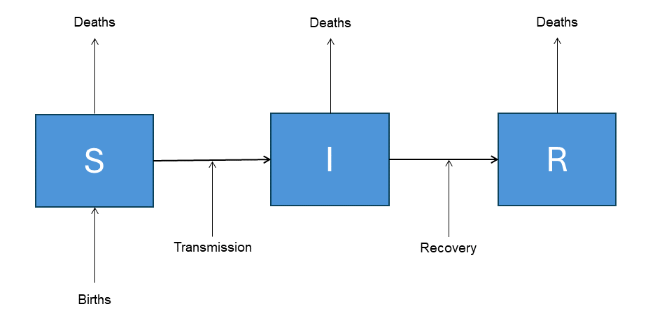
Figure 2. Compartment host-pathogen model including classes for susceptible (S), infected (I) and recovered (immune) (R) classes.

For particular host/pathogen systems, disease transmission could occur through pathways other than just through intra-specific contacts. These pathways could include infection from an environmental reservoir (e.g. caves containing the White Nose Syndrome (WNS) fungus), or could include sympatric species that share the pathogen leading to multi-host species transmission. The latter situation often occurs in diseases like Chytridiomycosis, where an abundant species with reduced susceptibility to infection acts a reservoir for the disease infecting other susceptible hosts (Heard et al. 2014). Rather than explicitly modelling the pathogen dynamics in these reservoir hosts (e.g. Barron et al. 2015), we opted to include an additional compartment representing ‘environmental transmission’, which acted as a general source of additional disease transmission to the primary host (Figure 3).

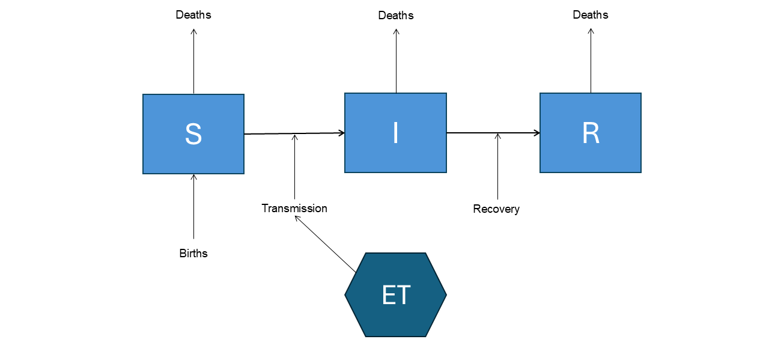
Figure 3. Compartment host-pathogen model including environmental transmission (ET), which was used to represent transmission pathways from an environmental reservoir or from sympatric species acting as a reservoir for the pathogen.

Host/pathogen models were formulated initially as deterministic ordinary differential equation (ODE) models (Vynnycky and White 2010). However, deterministic models were likely to underestimate the impacts of disease on small populations where the influence of ‘chance events’ may result in an increase in extinction risks in either the host or pathogen. To capture uncertainty around the impacts of pathogen incursions on populations, it was necessary to develop stochastic versions of the deterministic host/disease models. The stochastic approach used here was to recast the deterministic equations as an individual-based model (IBM) incorporating demographic stochasticity (Keeling and Rohani 2008). As a result, this approach simulates the fates of individuals with each individual subject to competing ‘events’ (e.g. births, deaths, infection, and recovery). Events occur in continuous time and incorporate stochastic outcomes by simulating a random time-to-the-next-event based on the underlying rate for that event. The times for each event type are then sorted in chronological order, with events occurring before the next ‘time horizon’ (e.g. 1 day) queued for processing. For example, if the transmission rate of a disease is given by $λ$, then a random time to the next transmission event is generated using:
$$∂t=\frac{-\text{log}\left(U\right)}{λ}$$

Where $U$ is a random uniform deviate [0,1] and $∂t$ is the time elapsed until the infection event occurs. If $∂t$ is less than the time horizon (i.e. 1 day), then the infection event occurs for that individual. This equation assumes that all events can be described as stochastic competing Poisson processes. This type of stochastic model is generally termed an ‘event driven’ model and is one of the most popular ways of incorporating demographic stochasticity into simulation models (Keeling and Rohani 2008).
Before describing models developed for each of the host/pathogen case studies in this report, we first outline the standard set of assumptions and settings that were used across all of the case studies.
- Modelled populations of each species represented a discrete subpopulation and therefore, assumed that the population (or subpopulation) was closed to immigration and emigration.
- Transmission of disease was considered to be density-dependent, which assumed disease transmission scaled linearly with host density (McCallum et al. 2001).
- With respect to disease transmission, each population (or subpopulation) was assumed to be homogenously mixed. This was tantamount to saying that contact rates among individuals in the population were similar.
- Host dynamics were generally assumed to be subjected to population regulation, governed by density-dependence in either birth or death rates (e.g. Bellows 1981; Barlow 2000).

Disease mitigation actions
For each wildlife host/pathogen system, we assessed the impact of potential disease mitigation actions by simulating each action’s relative effect on relevant model parameters (e.g. transmission rate, recovery rate or disease-induced mortality rate or combinations thereof). Estimation of the relative effect of management actions were based on information derived from the literature and/or expert elicitation from subject matter experts.

- Results
  - WDRA – general results
Disease risk assessments were undertaken for 222 disease hazards involving 423 host/pathogen groups (Tables 7 and 8). The entire set of assessments comprises a large and complex body of data. However, over 90% of the assessments were for disease hazards for which the risk ratings were either Negligible, Very low or Low, meaning that their conservation or economic impacts were considered to be minimal (Tables 7 and 8). Rather than exhaustively describing all of the risk assessment results, we considered it to be more useful to provide selected highlights that may prove informative to managers and policy makers. In particular, we draw attention to diseases where the rated risks were High or Extreme. We considered that these are the results that would be most useful and informative to managers charged with the tasks of preparing for and managing current and future impacts of wildlife disease in Victoria. Disease risk assessments for all host/pathogen complexes are presented in full as a supplementary appendix to this report.
Table 7. Summary of the number of disease risk assessments that were assigned a given risk rating for the conservation impacts of each disease hazard.
 |  |  | Risk rating
Taxon group | Negligible | Very low | Low | Moderate | High | Extreme
Mammals | 178 | 33 | 9 | 8 | 3 | 1
Birds | 46 | 19 | 10 | 1 | 1 | 4
Amphibians | 33 | 5 | 4 | 8 | 4 | 4
Reptiles | 44 | 2 | 3 | 0 | 3 | 0
Total | 301 | 59 | 26 | 17 | 11 | 9

Table 8. Summary of the number of disease risk assessments that were assigned a given risk rating for the economic impacts of each disease hazard.
 |  |  | Risk rating
Taxon group | Negligible | Very low | Low | Moderate | High | Extreme
Mammals | 70 | 75 | 54 | 18 | 12 | 3
Birds | 41 | 23 | 7 | 5 | 1 | 4
Amphibians | 54 | 3 | 0 | 1 | 0 | 0
Reptiles | 51 | 1 | 0 | 0 | 0 | 0
Total | 216 | 102 | 61 | 24 | 13 | 7

We have approached this task of summarisation and presentation of key results from two complementary perspectives. First, we present lists of all host/pathogen combinations that were assessed as being of High or Extreme Risk for conservation or economic risks. For each major class of vertebrate wildlife (mammals, birds, reptiles, amphibians), we have identified the top-ranking host/pathogen complexes. These high-risk items have been identified from conservation and economic points of view (based on the risk $×$ consequence approach). This approach provides useful lists of high-risk high-consequence host/pathogen complexes that managers and policy makers can use for response planning, which may include management actions intended to prevent establishment of exotic diseases, mitigate impacts of established diseases or achieve eradication. These results are presented in Tables 9 and 10.
Second, to provide insight into the risks that disease presents to listed (Flora and Fauna Guarantee, FFG) threatened species in Victoria, we have identified all diseases that represent an Extreme or High conservation risk to FFG-listed mammals, birds, reptiles and amphibians in Victoria with a conservation status of either Endangered (EN) or Critically Endangered (CR). In some cases, these results replicate the more general results presented in Tables 9 and 10; however, due to the sheer volume of assessments, many were done generically at taxonomic levels higher than the species (e.g. ‘gulls, terns and waders’ or ‘skinks’). Therefore, specifically listing likely Extreme or High conservation risks to FFG-listed species serves to highlights diseases with the greatest potential to cause declines in the conservation status of species which are most at risk of extinction from all causes, including disease. These results are presented in Tables 11–14 for FFG-listed mammals, birds, reptiles and amphibians, respectively.
  - Conservation risks
A total of 9 Extreme and 11 High risk host/pathogen combinations were identified (Table 7). The diseases that were assessed as being Extreme conservation risks included several diseases affecting frogs, mammals, and birds. Four species of frogs were evaluated as having extreme conservation risks due to the impacts of the globally significant amphibian chytrid fungus, Batrachochytrium dendrobatidis (Bd). These were the Spotted Tree Frog (Litoria spenceri), Baw Baw Frog (Philoria frosti), Brown Toadlet (Pseudophryne bibronii) and Alpine Tree Frog (Litoria verreauxii) (Table 9). Extreme conservation risks to mammals were limited to a single species, the Southern Bent-wing Bat, which was assessed as being at risk from a possible future incursion of White Nose Syndrome, an emerging fungal disease of cave-roosting bats that has caused devastating impacts on bat populations in North America, but which has never been recorded in Australia (Holz et al. 2018) (Table 9).
Several diseases of birds were evaluated as representing Extreme conservation risks. These included High Pathogenic Avian Influenza (HPAI), which was assessed as an Extreme Risk to populations of numerous species of gulls, terns, waders, ducks, swans and geese (Table 9). Assessments of the conservation risk of HPAI to most birds were made at higher taxonomic levels than species, meaning that granular assessments of risk to individual species were generally unavailable. As at the time of assessment, HPAI had not been detected in wild birds in Australia with information on likely impacts to individual species in Australia being essentially non-existent. Therefore, assessments were made on the basis of observed severe impacts of outbreaks on related species groups (e.g. waders and waterfowl) overseas, notably in Europe and South America. Two additional avian diseases (Pacheco’s Disease and Beak and Feather Disease) were assessed as Extreme conservation risks to Victorian parrots (all species), and to the Orange Bellied Parrot (Neophema chrysogaster), respectively (Table 9).
  - Economic risks
Seven host/disease combinations were assessed as representing Extreme economic risks in Victoria, with a further 13 being assessed as High risk (Table 8). Diseases assessed as representing particularly Extreme risks were HPAI (due to likely spillover of disease from gulls, terns, waders, ducks, swans, geese, penguins and other birds to domestic poultry as well as direct effects on tourism) and FMD (infecting wild populations of deer, goats, pigs, with likely high risk of infection spreading to domestic ungulates) (Table 10). Diseases judged to be of high economic risk included HPAI infecting various native and introduced mammals with subsequent economic effects on biosecurity, tourism and health, and Coronavirus in waterfowl and shorebirds posing risks to domestic poultry. In addition, Malignant Catarrhal Fever, African Swine Fever and Classical Swine Fever in Feral Pigs (Sus scrofa) were judged to be High risk for the potential to spill over into domestic livestock (Table 10).

Table 9. Diseases with Extreme and High conservation risk ratings in the disease risk assessment.
All other assessments had risk ratings of Moderate or lower. The full WDRA results can be found in the supplementary appendix.
Pathogen | Pathogen type | Disease | Host species | Group | Likelihood | Consequence | Uncertainty | Risk
Batrachochytrium dendrobatidis | Fungal | Chytridiomycosis | Alpine Tree Frog | Frogs | 6 | 6 | 1 | Extreme
Batrachochytrium dendrobatidis | Fungal | Chytridiomycosis | Baw Baw Frog | Frogs | 6 | 6 | 1 | Extreme
Batrachochytrium dendrobatidis | Fungal | Chytridiomycosis | Brown Toadlet | Frogs | 6 | 6 | 1 | Extreme
Batrachochytrium dendrobatidis | Fungal | Chytridiomycosis | Spotted Tree Frog | Frogs | 6 | 6 | 1 | Extreme
Psittacine circoviral disease virus | Viral | Beak and Feather Disease | Orange-bellied Parrot | Birds | 5.7 | 6 | 1 | Extreme
Pseudogymnoascus destructans | Fungal | White Nose Syndrome | Southern Bent-winged Bat | Mammals | 5.3 | 6 | 1 | Extreme
HPAI | Viral | Avian Influenza (highly pathogenic strain) | Gulls, terns and waders | Birds | 5.3 | 6 | 1 | Extreme
HPAI | Viral | Avian Influenza (highly pathogenic strain) | Ducks, swans, geese | Birds | 5.3 | 6 | 1 | Extreme
Psittacid alphaherpesvirus-1 | Viral | Pacheco’s Disease | Parrots | Birds | 5 | 6 | 1 | Extreme
Batrachochytrium dendrobatidis | Fungal | Chytridiomycosis | Southern Toadlet | Frogs | 6 | 5 | 2 | High
Batrachochytrium dendrobatidis | Fungal | Chytridiomycosis | Southern Barred Frog | Frogs | 5.7 | 5 | 1 | High
Batrachochytrium dendrobatidis | Fungal | Chytridiomycosis | Booroolong Tree Frog | Frogs | 5.7 | 5 | 2 | High
Batrachochytrium dendrobatidis | Fungal | Chytridiomycosis | Giant Burrowing Frog | Frogs | 5.7 | 5 | 2 | High
Pseudogymnoascus destructans | Fungal | White Nose Syndrome | Common Bent-wing Bat | Mammals | 5.3 | 5 | 1 | High
Pseudogymnoascus destructans | Fungal | White Nose Syndrome | Eastern Horseshoe Bat | Mammals | 5.3 | 5 | 1 | High
HPAI | Viral | Avian Influenza (highly pathogenic strain) | Seals | Mammals | 5.3 | 5 | 1 | High
HPAI | Viral | Avian Influenza (highly pathogenic strain) | Penguins | Birds | 5.3 | 5 | 2 | High
Nannizziopsis barbatae | Fungal | Lizard Fungal Disease | Dragons | Reptiles | 4.7 | 5 | 3 | High
Nannizziopsis barbatae | Fungal | Lizard Fungal Disease | Skinks | reptiles | 4.7 | 5 | 3 | High
Paranannizziopsis australasiensis | Fungal | Snake Fungal Disease | Reptiles | reptiles | 4.7 | 5 | 3 | High

Table 10. Diseases with Extreme and High economic risk ratings in the disease risk assessment
All other assessments had risk ratings of Moderate or lower. The full WDRA results can be found in the supplementary appendix.
Pathogen | Pathogen type | Disease | Host species | Group | Likelihood | Consequence | Uncertainty | Risk
Aphthae epizooticae | Viral | Foot and Mouth | Deer | Mammals | 4.7 | 6 | 1 | Extreme
Aphthae epizooticae | Viral | Foot and Mouth | Goats | Mammals | 4.7 | 6 | 1 | Extreme
Aphthae epizooticae | Viral | Foot and Mouth | Pigs | Mammals | 4.7 | 6 | 1 | Extreme
HPAI (high pathogenic strain) | Viral | Avian Influenza | Gulls, terns and waders | Birds | 5.3 | 6 | 1 | Extreme
HPAI (high pathogenic strain) | Viral | Avian Influenza | Ducks, swans, geese | Birds | 5.3 | 6 | 1 | Extreme
HPAI (high pathogenic strain) | Viral | Avian Influenza | Penguins | Birds | 5.3 | 6 | 2 | Extreme
HPAI (high pathogenic strain) | Viral | Avian Influenza | All other avian orders | Birds | 5 | 6 | 3 | Extreme
Coronavirus spp. | Viral | Coronaviruses | Ducks, shorebirds | Birds | 5.7 | 5 | 3 | High
HPAI | Viral | Avian Influenza | Seals | Mammals | 5.3 | 5 | 1 | High
HPAI | Viral | Avian Influenza | Pigs | Mammals | 5.3 | 5 | 1 | High
HPAI | Viral | Avian Influenza | Red Fox | Mammals | 5.3 | 5 | 1 | High
HPAI | Viral | Avian Influenza | Cats | Mammals | 5.3 | 5 | 1 | High
HPAI | Viral | Avian Influenza | Dog/dingo | Mammals | 5.3 | 5 | 1 | High
HPAI | Viral | Avian Influenza | Dolphins | Mammals | 5.3 | 5 | 1 | High
HPAI | Viral | Avian Influenza | Marsupial carnivores | Mammals | 5.3 | 5 | 3 | High
Gammaherpesvirus | Viral | Malignant Catarrhal Fever | Deer | Mammals | 5 | 5 | 2 | High
Gammaherpesvirus | Viral | Malignant Catarrhal Fever | Goats | Mammals | 4.7 | 5 | 2 | High
Gammaherpesvirus | Viral | Malignant Catarrhal Fever | Pigs | Mammals | 4.7 | 5 | 2 | High
Pestivirus spp. brescia | Viral | Classical Swine Fever Virus (CSFV) | Pigs | Mammals | 4.7 | 5 | 1 | High
ASFV | Viral | African Swine Fever | Pigs | Mammals | 4.7 | 5 | 1 | High

  - Diseases of severe risk to high conservation status wildlife in Victoria
To highlight diseases assessed as severe risks to threatened wildlife species in Victoria we have separately tabulated all diseases which were evaluated as being of High or Extreme conservation risks for one or more wildlife species listed as Endangered (EN) or Critically Endangered (CR) under the Flora and Fauna Guarantee Act. These results are presented separately for mammals, birds, reptiles and amphibians in Tables 11–14 below.
Among the Endangered or Critically Endangered mammals identified in Victoria, only two diseases were found to represent Extreme or High conservation risks. These were White Nose Syndrome, which was evaluated as being an Extreme or High risk for three threatened bat species, and High Pathogenic Avian Influenza, which was evaluated as representing a High conservation risk to the Victorian population of the Australian Sea-lion (Neophoca cinerea) (Table 11).
Table 11. Diseases that were assessed as representing potentially Extreme or High conservation risks to Endangered (EN) and Critically Endangered (CE) FFG-listed mammals in Victoria.
Common name | Scientific name | FFG status | Diseases with Extreme or High conservation risk | Risk rating
Miniopterus orianae bassanii | Southern Bent-wing Bat | CR | White Nose Syndrome | Extreme
Miniopterus orianae oceanensis | Common Bent-wing Bat (eastern subspecies) | CR | White Nose Syndrome | High
Rhinolophus megaphyllus megaphyllus | Eastern Horseshoe Bat | EN | White Nose Syndrome | High
Neophoca cinerea | Australian Sea-lion | EN | HPAI | High

For Endangered or Critically Endangered Victorian birds, several diseases were evaluated as representing High or Extreme conservation risks (Table 12). HPAI was assessed as being an Extreme risk to sixteen Endangered or Critically Endangered Victorian birds, most of which were various species of wading birds and terns. Several FFG-listed parrot species were judged to be at Extreme risk from Pacheco’s Disease and the Orange-bellied parrot was at Extreme risk from Beak and Feather Disease (Table 12).
Among the endangered and critically endangered Victorian reptiles, two fungal pathogens (Paranannizziopsis australiensis and Nannizziopsis barbatae) were assessed as High risks to the conservation status of numerous endangered and critically endangered reptile species in Victoria (Table 13). However, the assessments for these two pathogens had high levels of uncertainty (Table 9).
The globally significant fungal disease of amphibians, Chytridiomycosis, was the only disease that was assessed as representing either a High or Extreme risk to endangered or critically endangered Victorian frog species (Table 14). Among Victorian frogs, the Spotted Tree Frog, Alpine Tree Frog, Baw Baw Frog and Brown Toadlet were assessed as being at Extreme conservation risk from Chytridiomycosis. Four additional species were identified as being at High risk due to Chytridiomycosis (Table 14).

Table 12. Diseases that were assessed as representing potentially Extreme or High conservation risks to Endangered (EN) and Critically Endangered (CE) FFG-listed birds in Victoria.
Common name | Scientific name | Status | Diseases with Extreme or High conservation risk | Risk rating
Arenaria interpres | Ruddy Turnstone | EN | HPAI | Extreme
Calidris canutus | Red Knot | EN | HPAI | Extreme
Calidris ferruginea | Curlew Sandpiper | CR | HPAI | Extreme
Calidris tenuirostris | Great Knot | CR | HPAI | Extreme
Callocephalon fimbriatum | Gang-gang Cockatoo | EN | Pacheco’s Disease | Extreme
Calyptorhynchus banksii graptogyne | Red-tailed Black-Cockatoo (south-eastern) | EN | Pacheco’s Disease | Extreme
Charadrius mongolus | Lesser Sand Plover | EN | HPAI | Extreme
Gelochelidon nilotica macrotarsa | Gull-billed Tern | EN | HPAI | Extreme
Lathamus discolor | Swift Parrot | CR | Pacheco’s Disease | Extreme
Lophocroa leadbeateri | Major Mitchell's Cockatoo | CR | Pacheco’s Disease | Extreme
Neophema chrysogaster | Orange-bellied Parrot | CR | Beak and Feather Disease | Extreme
Neophema splendida | Scarlet-chested Parrot | EN | Pacheco’s Disease | Extreme
Numenius madagascariensis | Eastern Curlew | CR | HPAI | Extreme
Numenius phaeopus | Whimbrel | EN | HPAI | Extreme
Pezoporus wallicus | Ground Parrot | EN | Pacheco’s Disease | Extreme
Polytelis swainsonii | Superb Parrot | EN | Pacheco’s Disease | Extreme
Rostratula australis | Australian Painted-snipe | CR | HPAI | Extreme
Sternula albifrons | Little Tern | CR | HPAI | Extreme
Sternula nereis | Fairy Tern | CR | HPAI | Extreme
Stictonetta naevosa | Freckled Duck | EN | HPAI | Extreme
Tringa brevipes | Grey-tailed Tattler | CR | HPAI | Extreme
Tringa glareola | Wood Sandpiper | EN | HPAI | Extreme
Tringa nebularia | Common Greenshank | EN | HPAI | Extreme
Xenus cinereus | Terek Sandpiper | EN | HPAI | Extreme

Table 13. Diseases that were assessed as representing potentially Extreme or High conservation risks to Endangered (EN) and Critically Endangered (CE) FFG-listed reptiles in Victoria.
Common name | Scientific name | Status | Diseases with Extreme or High conservation risk | Risk rating
Acanthophis antarcticus | Common Death Adder | CR | Paranannizziopsis australasiensis (Fungal disease) | High
Ctenotus olympicus | Saltbush Striped Skink | CR | Nannizziopsis barbatae (Fungal disease). | High
Cyclodomorphus michaeli | Eastern She-oak Skink | CR | Nannizziopsis barbatae (Fungal disease) | High
Cyclodomorphus praealtus | Alpine She-oak Skink | CR | Nannizziopsis barbatae (Fungal disease) | High
Denisonia devisi | De Vis' Banded Snake | CR | Paranannizziopsis australasiensis (Fungal disease) | High
Eulamprus kosciuskoi | Alpine Water Skink | EN | Nannizziopsis barbatae (Fungal disease) | High
Eulamprus tympanum marnieae | Corangamite Water Skink | EN | Nannizziopsis barbatae (Fungal disease) | High
Hemiergis millewae | Millewa Skink | EN | Nannizziopsis barbatae (Fungal disease) | High
Lerista timida | Dwarf Burrowing Skink | EN | Nannizziopsis barbatae (Fungal disease) | High
Liopholis guthega | Guthega Skink | CR | Nannizziopsis barbatae (Fungal disease) | High
Liopholis montana | Mountain Skink | EN | Nannizziopsis barbatae (Fungal disease) | High
Liopholis multiscutata | Heath Skink | CR | Nannizziopsis barbatae (Fungal disease) | High
Lissolepis coventryi | Swamp Skink | EN | Nannizziopsis barbatae (Fungal disease) | High
Morethia adelaidensis | Samphire Skink | EN | Nannizziopsis barbatae (Fungal disease) | High
Pseudemoia cryodroma | Alpine Bog Skink | EN | Nannizziopsis barbatae (Fungal disease) | High
Pseudemoia pagenstecheri (High Country) | Tussock Skink | EN | Nannizziopsis barbatae (Fungal disease) | High
Pseudemoia pagenstecheri (Volcanic Plains) | Tussock Skink | EN | Nannizziopsis barbatae (Fungal disease) | High
Pseudemoia rawlinsoni | Glossy Grass Skink | EN | Nannizziopsis barbatae (Fungal disease) | High
Rankinia diemensis (Grampians) | Mountain Dragon Grampians form | CR | Nannizziopsis barbatae (Fungal disease) | High
Tympanocryptis petersi | Lined Earless Dragon | EN | Nannizziopsis barbatae (Fungal disease) | High
Tympanocryptis pinguicolla | Grassland Earless Dragon | CR | Nannizziopsis barbatae (Fungal disease) | High

Table 14. Diseases that were assessed as representing potentially Extreme or High conservation risks to Endangered (EN) and Critically Endangered (CE) FFG-listed amphibians in Victoria.
Common name | Scientific name | Status | Diseases with Extreme or High conservation risk | Risk rating
Litoria spenceri | Spotted Tree Frog | CR | Chytridiomycosis | Extreme
Litoria verreauxii alpina | Alpine Tree Frog | CR | Chytridiomycosis | Extreme
Philoria frosti | Baw Baw Frog | CR | Chytridiomycosis | Extreme
Pseudophryne bibronii | Brown Toadlet | EN | Chytridiomycosis | Extreme
Heleioporus australiacus | Giant Burrowing Frog | CR | Chytridiomycosis | High
Mixophyes balbus | Southern Barred Frog | CR | Chytridiomycosis | High
Litoria booroolongensis | Booroolong Tree Frog | EN | Chytridiomycosis | High
Pseudophryne semimarmorata | Southern Toadlet | EN | Chytridiomycosis | High

  - Modelling disease impacts and potential mitigation options
    - Foot and Mouth Disease in Feral Pigs
Foot and Mouth Disease (Aphthae epizooticae) is a highly contagious viral disease of cloven-hoofed animals, including pigs (Sus scrofa), cattle (Bos taurus), sheep (Ovis aries), goats (Capra hircus) and deer (family Cervidae). While the disease is not usually fatal to adult individuals, the symptoms include fever and vesicles (blisters) on the feet and in the mouth causing serious losses in productivity. FMD is not present in Australia, but there have been recent outbreaks reported in Indonesia (May 2022). FMD is typically spread through close contact with infected individuals and/or other objects (fomites) that have been in close contact with infected individuals.
Pigs are particularly susceptible to FMD infection and have the potential to excrete large amounts of airborne virus. Given that Australia has not had an FMD epidemic in over 100 years, the role of Feral Pigs in an outbreak of FMD in Australia is largely unknown. However, some investigations of FMD outbreaks in Feral Pigs have been explored using modelling (Pech and Hone 1988; Dexter 2003; Ward et al. 2015). A model of FMD incursion into a Feral Pig population by Pech and Hone (1988) suggested that Feral Pig densities in excess of 2.3 pigs/km² would be sufficient for the disease to spread and persist within the Feral Pig population. However, a more recent study modelling an outbreak of FMD in northwestern Australia suggested that, if FMD was controlled in domestic livestock, it would be unlikely to persist in Feral Pigs (Ward et al. 2015). However, the Feral Pig densities included in the model of Ward et al. (2015) ranged from 0.6–1.7 pigs/km², which were lower than the threshold density required for FMD persistence estimated by Pech and Hone (1988).
We constructed a model for FMD in Feral Pigs (Figure 4) based on the model of Pech and Hone (1988). This model was constructed as a stochastic, individual based model (IBM) founded upon the set of differential equations and parameters given in section 6.1.

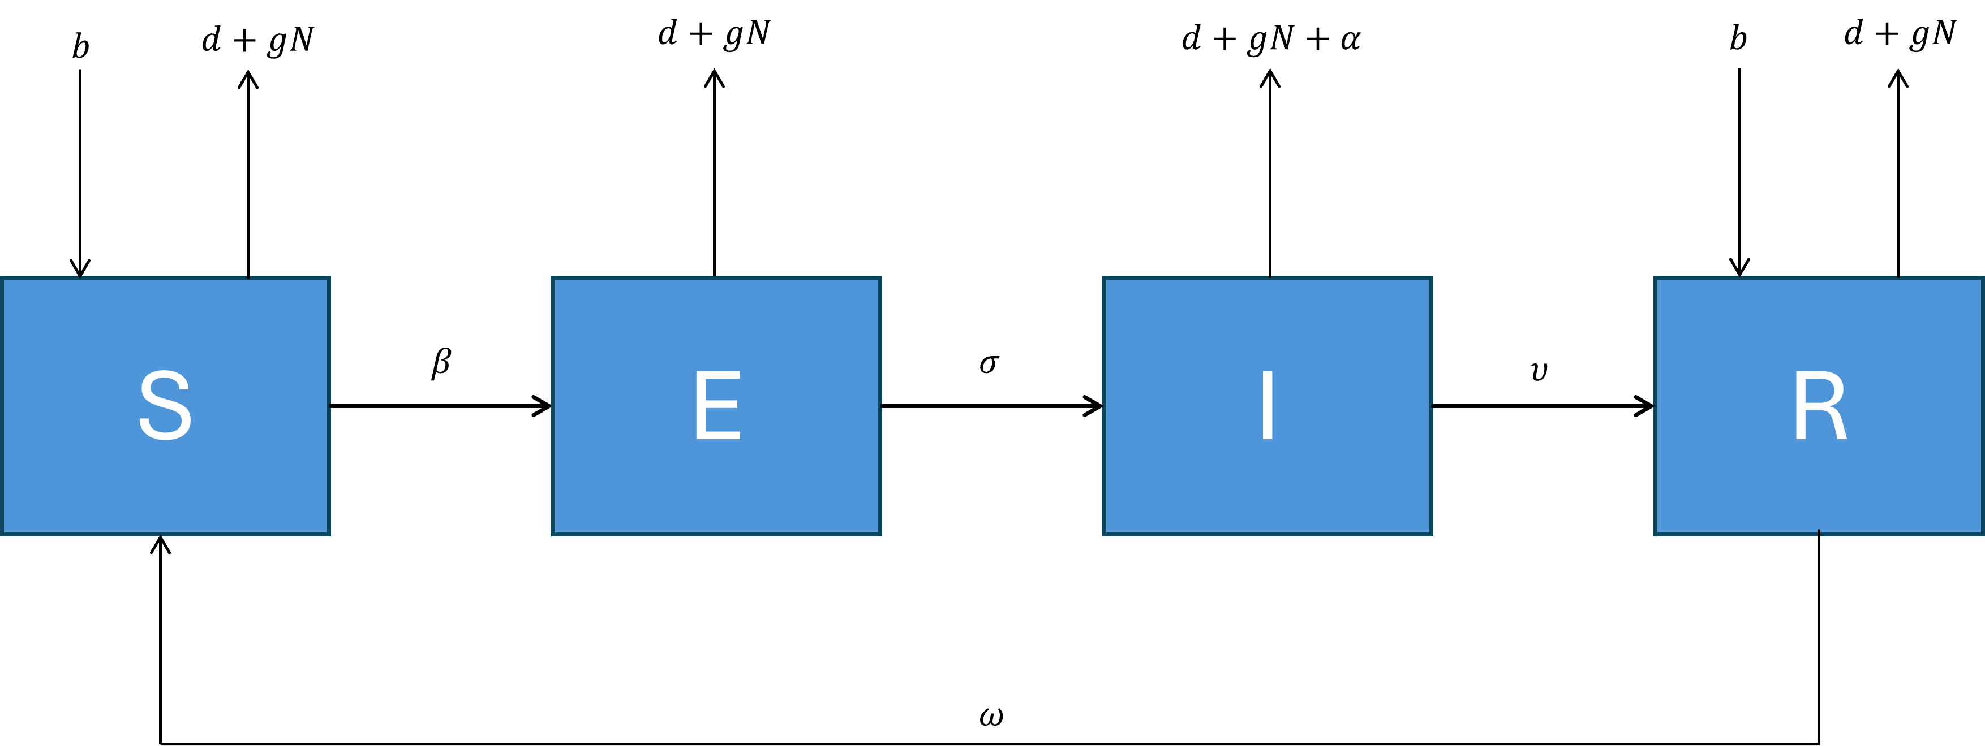
Figure 4. Flow chart of the Feral Pig FMD individual-based model showing the progression of individuals through each of the model compartments. $S$ – susceptible, $E$ – exposed, $I$ – infectious, $R$ – recovered. Parameter descriptions are given in section 6.1.

Where $S$ are susceptible, $E$ are exposed (latent), $I$ are infectious and $R$ are recovered individuals. The parameter $b$ is the density-independent per capita birth rate and $d$ is the density-dependent per capita minimum death rate, with $g$ governing the strength of density-dependence. This notation differs slightly from the notation given in Pech and Hone (1988). Other parameters are the transmission rate $β$, inverse of the latent period $σ$, recovery rate $υ$ and rate that recovered individuals lose immunity $ω$. Parameter values are given in Table A1 (section 6.1), which also provides a sensitivity analysis of the model to the key parameters.
We conducted our simulations based on a single, hypothetical population of 500 Feral Pigs inhabiting an isolated patch of habitat. The simulated population resembles in size and density the population of Feral Pigs in the area surrounding Budj Bim National Park in western Victoria, which was found to consist of 490 pigs (95% CI: 415–571) at a density of 5.4 pigs per km² (Woodford et al. 2023). We proceeded on the basis that this was a ‘typical’ population of Feral Pigs for such habitat in Victoria. The model could, however, easily be adapted to a Feral Pig population of any size or density.

Analysis of mitigation strategies
Assessment of some simple disease mitigation scenarios under likely and high-risk parameter combinations were explored by examining how the outcome of the simulation changed when a single population cull was conducted to remove a fixed proportion of the total population at varying times after the introduction of FMD. For these scenarios, culling intensities of 20, 40, 60 or 80% of the population were simulated with the culls conducted at 7, 28 and 64 days post-FMD introduction.
These scenarios (under the most likely parameter values) were compared to a smaller set of worst-case scenarios with a value of the transmission parameter β at the upper bound (Section 6.1), but with the culls always conducted on day 28. The purpose of this set of simulations was to explore the extent to which the effectiveness of the culling intervention is reduced under circumstances where transmission of the pathogen occurs at a higher-than-expected rate.
The set of scenarios explored reflects culling rates that are likely to be achievable using control methods such as poison baits, aerial shooting or ground shooting, with all categories of pigs (susceptible, exposed, infectious and recovered) being equally at risk from the culling operation. The selected timing of the simulated culling operations (7, 28 or 64 days) represents an essentially proactive approach to management, because it is considered unlikely that suitable surveillance data (e.g. blood samples from live or dead pigs sampled from the population) could be collected and analysed quickly enough to respond to a rapidly growing FMD outbreak with a reactive cull.

Simulated FMD outbreak in Feral Pigs
For the deterministic model, the progress of an FMD outbreak in Feral Pigs was characterised by a rapid increase in prevalence, with the proportion of exposed and infectious pigs reaching 19% approximately 38 days from the start of the outbreak (Figure 5a, b). Following the initial peak prevalence, the proportion of exposed and infectious pigs declined to an equilibrium of around 2%, with the proportion of recovered individuals peaking at 60% before steadily declining. Total population size declined by around 25% over the course of the 5-year outbreak (Figure 5a, b). These results are similar to that reported in Pech and Hone (1998).

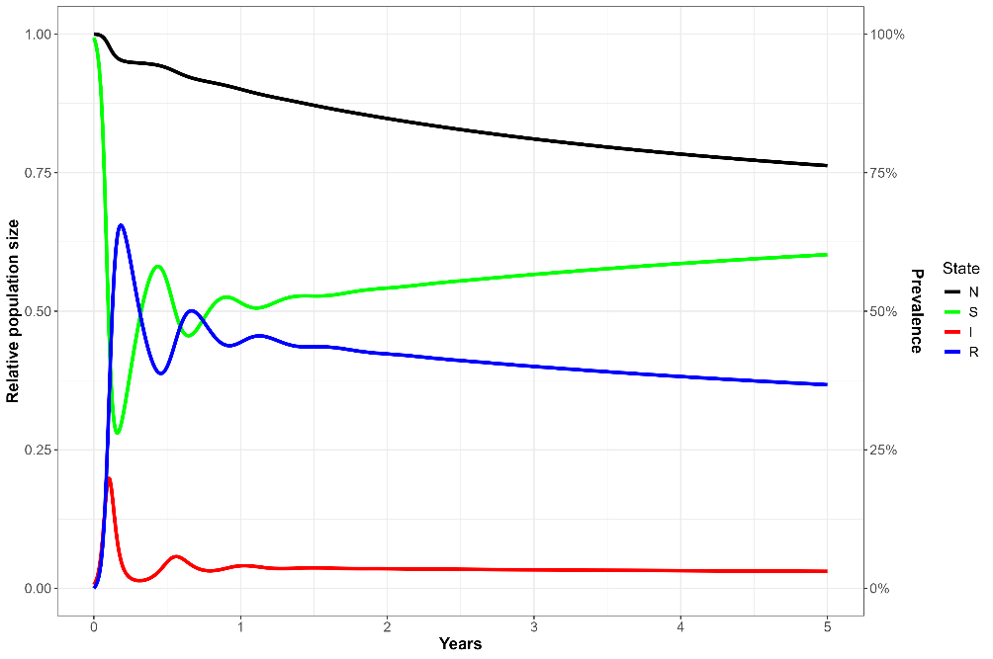
Figure 5a. The progression of an outbreak of FMD in Feral Pigs over a 5-year period from the deterministic model. Parameter estimates are given in Section 6.1. N – total relative population size. S – susceptible, I – exposed + infected, and R – recovered (prevalence).

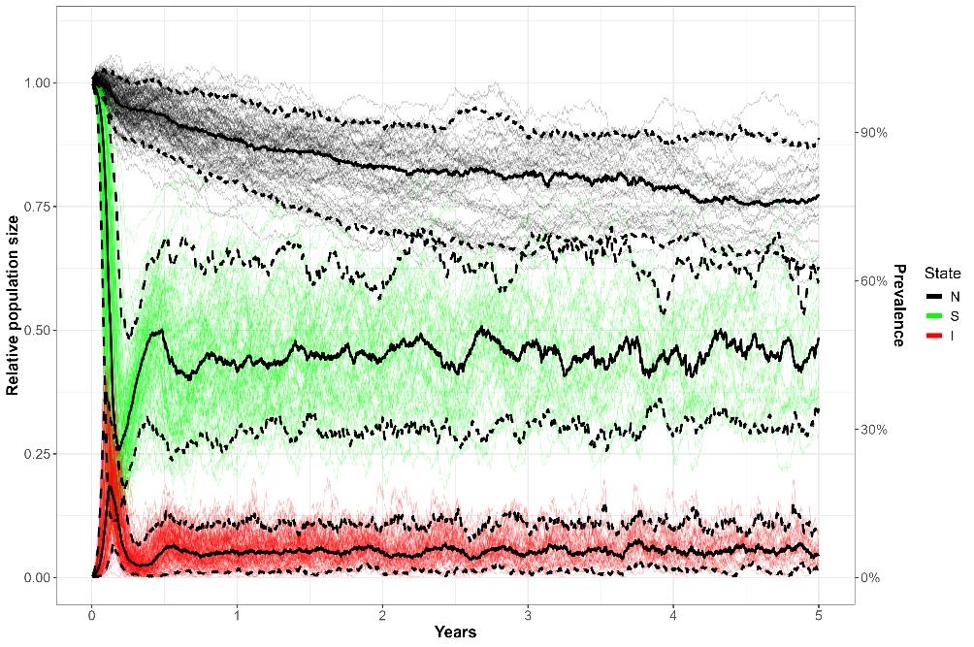
Figure 5b. Predicted uncertainty in total (relative) population size and disease states for simulated outbreaks of FMD in a population of Feral Pigs from the stochastic individual-based model. Trajectories were generated by varying key parameters by $±$ 30% and simulating 250 sets of random parameter values using Latin hypercube sampling, Solid black line – mean, dashed black lines – 90% confidence intervals. N – total relative population size, S – susceptible, I – exposed + infected (prevalence).

Effects of intensity and timing of culling
Using the stochastic IBM version of the FMD model, simulations assessed the effectiveness of one-off culls of varying timing and intensity on the persistence of the disease under likely and high (i.e. worst case) values for the transmission parameter. Under the likely parameter values, and no (0%) culling of Feral Pigs, the FMD outbreak lasted for an average of 47 weeks with high (34%) probability of persisting for at least 1 year (Figure 6). In contrast, one-off 60% or 80% culls had 95% probability of eradicating FMD within 90 days, regardless of the timing of the cull (Figure 6). One-off culls of 60% or 80% of the pig population initiated 7 days after the outbreak resulted in near-immediate eradication of the disease from the population within 2.5 weeks (Figure 7), with peak prevalence averaging less than 1% (Figure 8). Under less intense culls of 20% or 40%, the time to eradication was longer and more variable, with mean eradication times between 12–33 weeks (Figure 7). Furthermore, the timing of the cull influenced the progress of the outbreak, with later culls (e.g. 64 days post-outbreak) resulting in high peak prevalences, regardless of the intensity of the cull (Figure 8).

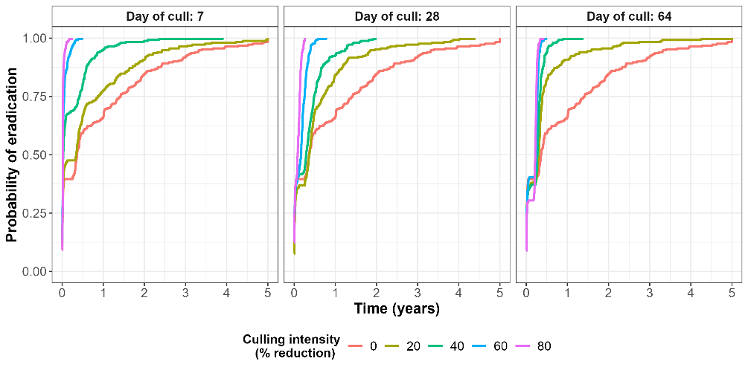
Figure 6. Cumulative probability of eradication of an FMD outbreak in Feral Pigs over time under the most likely parameter values with one-off culling operations of varying intensity (0, 20, 40, 60 or 80%) at either 7, 28 or 64 days after the initiation of the outbreak

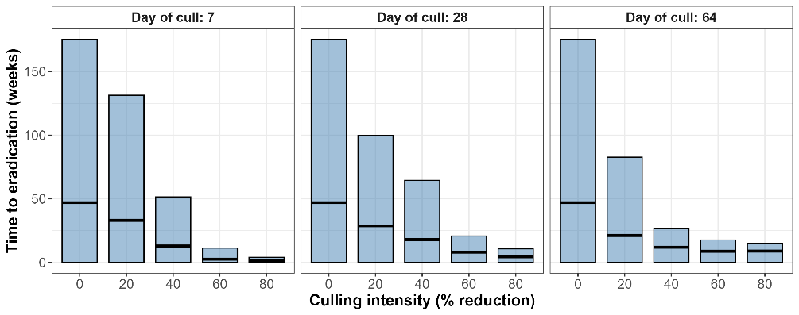
Figure 7. Mean time to eradication (in weeks) for simulated FMD outbreaks under the likely parameter values with one-off culling operations of varying intensity (0, 20, 40, 60 or 80%) at either 7, 28 or 64 days after the initiation of the outbreak. Black horizontal lines give the mean and blue bars give the width of the 95% confidence interval.

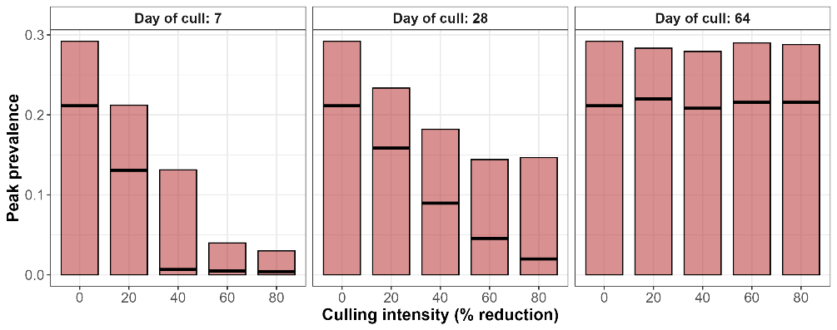
Figure 8. Peak FMD prevalences (proportion of exposed and infectious individuals in the population) for simulated FMD outbreaks under the likely parameter values with one-off culling operations of varying intensity (0, 20, 40, 60 or 80%) at either 7, 28 or 64 days after the initiation of the outbreak. Black horizontal lines give the mean and pink bars give the width of the 95% confidence interval.

Conclusions
While these results are sensitive to the value of the transmission parameter (section 6.1), the simulations clearly demonstrate the general principle that a sufficiently intense one-off cull in the early stages of the outbreak can drive the disease to eradication with a high degree of certainty. If continued transmission of FMD into the pig population remains a risk (perhaps due to the presence of infected livestock herds in close proximity), then repeated culling (or even local eradication) of Feral Pig populations with ongoing surveillance for the presence of the disease may prove necessary. Similarly, if it proves difficult to kill a sufficiently high proportion of the pig population in a one-off cull, then a series of culls of lower intensity would likely allow reliable eradication.
The individual-based model used could be easily adapted to support the analysis of other management strategies for the disease, such as continuous low-intensity culling. Further elaboration of the model might include spatialisation, to allow for the occurrence of hosts in discrete patches of habitat, and the inclusion of multiple host species (both livestock and feral ungulates). Such models may prove useful both for planning the state’s response to incursions and for decision-support subsequent to any outbreak of FMD that may occur in Victoria the future. Given the likely economic and social impacts of an FMD outbreak in Victoria, investment in decision support tools to support both planning and responses is likely to be a worthwhile strategy.

    - Highly Pathogenic Avian Influenza in Little Penguins
Avian Influenza (AI) is a viral pathogen predominantly affecting domestic and wild birds. The range of clinical signs presented by infected bird populations has been used to classify the virulence of the virus, with Low Pathogenic Avian Influenza (LPAI) causing only mild or no symptoms, and HPAI usually associated with systemic disease and high mortality (Olsen et al. 2006). Wild birds are the reservoirs for LPAI, and HPAI is thought to only develop in poultry after a spill-over event into the population from wild birds (Alexander 2000). However, HPAI may then spill back into wild bird populations and cause severe disease in these species. Prior to 2002, the HPAI strains of the virus were mainly only recorded in domestic poultry. However, since 2002, there have been increasing outbreaks of HPAI recorded in wild birds associated with a particular subtype, first detected in domestic geese in China in 1996, and subsequently designated as the H5N1 strain (Olsen et al. 2006; Ramey et al. 2022).
Since 2006, HPAI viruses have proliferated throughout 38 countries in Asia, Europe, Africa and the Middle East. Affected wild bird taxa predominantly include ducks, geese, swans, gulls, crows and raptors (Brown 2010). Since 2021, a strain of HPAI (H5N1 clade 2.3.4.4b) has caused ongoing outbreaks of disease in wild birds throughout North and South America, Europe, Asia and recently, Antarctica. Mortalities have been observed in a wide range of bird and mammal species. Between October 2021 and December 2023, there were over 0.5M mortalities recorded in 600 species of wild birds (mainly seabirds) and over 50K mortalities in at least 80 species of mammals (mainly marine) (FAO 2024). Outbreaks in penguins have included the 2018 outbreak of H5N1 in African Penguins (Spheniscus demersus), which resulted in an estimated 1000 deaths in the breeding population of around 7000 individuals (Molini et al. 2020; Roberts et al. 2024), suggesting mortality rates in excess of 14%. More recently, mortalities due to HPAI have been reported in Gentoo Penguins in the Falkland Islands and King Penguins on South Georgia in the South Atlantic Ocean (Vaughan-Higgins et al. 2024).
The Little Penguin (Eudyptula minor) is the smallest species of penguin weighing around 1–1.2 kg. It is only found in southern Australia and New Zealand, with the largest Australian colony (of around 40,000 birds) found on Phillip Island (Sutherland and Dann 2014). Overall, the population is considered to be stable and is listed as of ‘least concern’ by the IUCN (IUCN 2024). Management of Little Penguins on Phillip Island has concentrated on eliminating predation by foxes, as well as curtailing habitat destruction and human disturbance. It has been considered that an incursion of H5N1 into the Little Penguin colony on Phillip Island could have serious animal welfare and economic consequences for the ecotourism industry based around this population.
To investigate the consequences of an outbreak of H5N1 on Little Penguins on Phillip Island, we constructed the following stochastic IBM (Figure 9), based on the set of differential equations given in section 6.2.
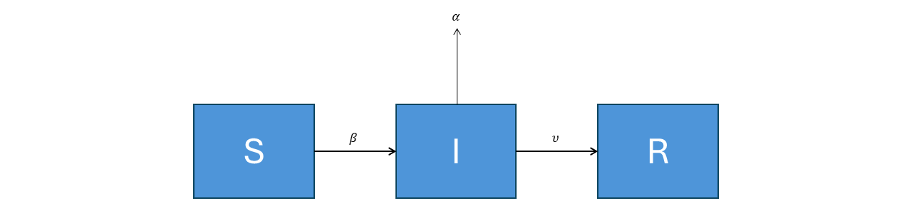
Figure 9. Flow chart of the HPAI Little Penguin individual-based model showing the progression of individuals through each of the model compartments. $S$ – susceptible, $E$ – exposed, $I$ – infectious, $R$ – recovered. Parameter descriptions are given in Section 6.2.

Where $S$, $I$, $R$ are the abundance of susceptible, infected (and infectious) and recovered hosts, respectively with $β$ being the transmission rate, $υ$ the recovery rate and $α$ the mortality rate due to HPAI. This model was based on the one developed for HPAI and LPAI in waterfowl in North America (Hénaux et al. 2010), and represents the dynamics of AI in a population closed to births, natural deaths, immigration or emigration. The rationale for assuming the population to be closed to natural births and deaths is that an outbreak of HPAI in a susceptible host would be rapid, such that the population dynamics of the host could be ignored for the duration of the epidemic.
The model outline in Figure 9 and parameter values given in section 6.2 were derived from North American waterfowl, mainly Mallard (Anas platyrhynchos), Black Duck (A. rubripes) and Blue-winged Teal (A. discors) (Hénaux et al. 2010; Hénaux et al. 2013). These studies suggested that the mean time to death for an infected individual ranged from 5–18 days, dependent on age class. Progression of the disease was rapid, with length of the latent period estimated as 0.4 days and the recovery rate, given the individual survived, estimated as 4.6 days (Hénaux et al. 2010). We excluded the short latent period and combined these into a single infected (and infectious class), with a mean infectious period of 5 days. Unfortunately, there are no estimates of these parameters for HPAI in any penguin species and therefore, we assumed that the dynamics of infection follow a similar epidemiology to that in waterfowl. Whether the dynamics of disease in Little Penguins are similar to waterfowl is obviously uncertain, but the epidemiological patterns are likely to be broadly similar. In the face of this uncertainty, we adopted this model as representative of a worst-case scenario and incorporate uncertainty in the actual response of Little Penguins to HPAI by varying the values of the key parameters by $±$ 30% and then drawing 250 random parameter values using Latin Hypercube sampling to determine the sensitivity of our conclusions to the key epidemiological parameters. More details of the sensitivity analysis are provided in section 6.2.

Potential mitigation actions
Vaccination against HPAI has been suggested as a possible mitigation for some high-value captive wildlife populations. Although vaccinating wild birds has logistical challenges (Roberts et al. 2024), a case for vaccination could be argued for the high-value colony of Little Penguins inhabiting the area around Summerland Beach (‘the Penguin Parade’) to protect the ecotourism industry associated with this sub-population.
Vaccination of wild birds with vaccines for the H5 and H7 subtypes of HPAI is reportedly safe in most taxonomic orders of wild birds (Vaughan-Higgins et al. 2024). Recent investigations of the use of vaccines in African Penguins for protection against HPAI infection indicated protective antibody titres lasting for 175 days (Roberts et al. 2024).
To model vaccination strategies for Little Penguins, we assumed that vaccinations were applied over a period of time (e.g. one month) reflective of the amount of time taken to achieve the required rate of population coverage. To facilitate this, an extra vaccinated class was added to the model, with vaccinated individuals added progressively over the designated period. Each vaccinated individual had a mean period of immunity of 175 days (Roberts et al. 2024). We investigated scenarios where vaccination was applied prophylactically (e.g. prior to disease arrival) as well as when diseased birds were first detected, which was assumed to be one week following initial disease arrival. We examined varying rates of vaccine coverage between 20% and 95% of the population vaccinated.

HPAI impacts
Simulation of an incursion of HPAI into a population of 1000 Little Penguins resulted in rapid disease progression, with the epidemic lasting approximately 6 weeks (Figure 10). Peak prevalence of infected individuals reached 29% approximately 2 weeks following initial infection. The cumulative mortality rate due to HPAI reached 30% and therefore, 300 of the 1000 individuals were lost during the epidemic. Following the epidemic, almost all remaining individuals had been exposed and recovered from infection (Figure 10).

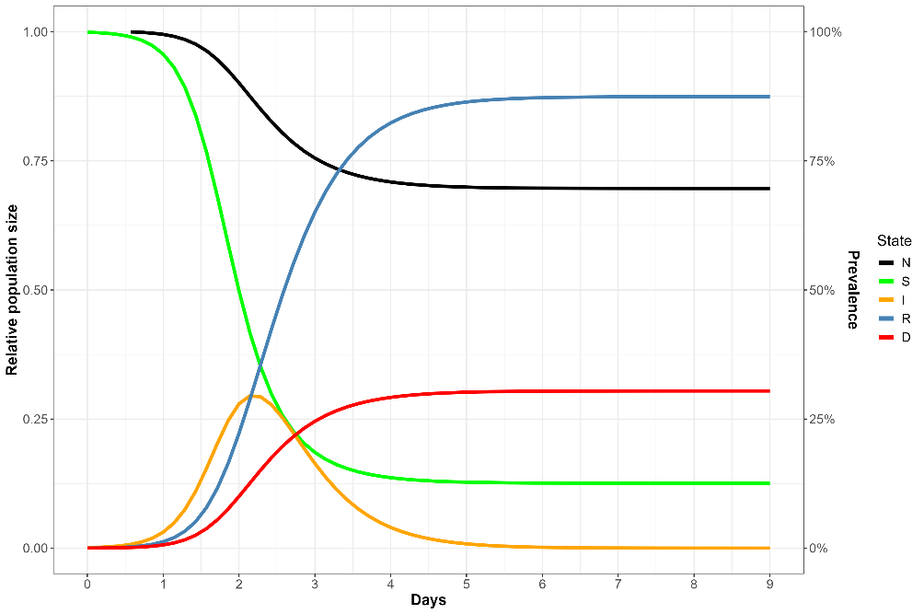
Figure 10. Predicted mean trajectories for each of the disease states following an outbreak of HPAI in a population of Little Penguins. N – total population and D – deaths (relative population size), S – Susceptible, I – infected (and infectious), R – recovered (prevalence).

Variation in the likely responses of Little Penguins to an incursion of HPAI, considering variation in the key epidemiological parameters, suggested that peak prevalence of HPAI infection could vary from 0% (i.e. epidemic fadeout) to 41% (Figure 11). The mortality rate was also equally variable, ranging from 0% to 42% mortality (Figure 11). Epidemic fadeout occurred where transmission of HPAI was insufficient to cause an epidemic, resulting in the extinction of HPAI from the population. This occurred in 18% of parameter sets. Excluding cases of epidemic fadeout, peak prevalence ranged from 7% to 43%, with mortality ranging from 21% to 42% (Figure 11).

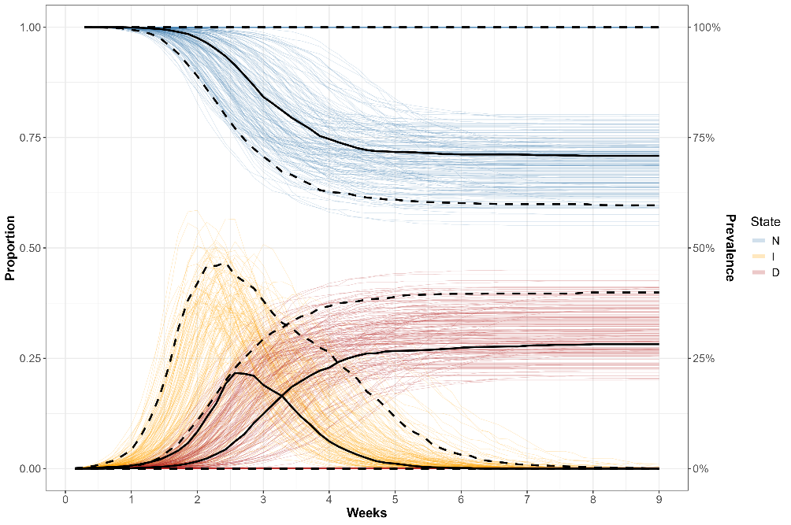
Figure 11. Predicted uncertainty in total (relative) population size (N), infection prevalence (I), and deaths (D) of High Pathogenic Avian Influenza (HPAI) in Little Penguins predicted from the stochastic IBM. Trajectories were generated by varying key parameters by $±$ 30% and simulating 250 sets of random parameter values using Latin hypercube sampling, Solid black line – mean, dashed black lines – 90% confidence intervals. Susceptible and Recovered states have been removed for clarity.

Vaccination strategies
When vaccinating the population prophylactically prior to HPAI arrival, high rates of vaccination, achieving at least 50% population coverage reduced mortalities due to HPAI by around 62% (Figure’s 12 and A5 – section 6.2). However, vaccination rates achieving 80% population coverage are required to reduce mortalities to negligible levels (Figure’s 12 and A5). This concurs with the analytical estimate of the herd immunity threshold, which is given by $1-1/{R_{0}}$ = 0.63 or 63% vaccination coverage required to eliminate disease, assuming a value of $R_{0}$ of 2.7 (section 6.2).
However, if vaccination doesn’t begin until discovery of HPAI in the population (here we assume 5 days from initial infection) and further, that a vaccination program takes around 30 days to achieve the desired level of population coverage, then higher rates of vaccination are required to significantly reduce mortality rates. Under this scenario, aiming for a vaccination coverage of 80% will only reduce the mortality rate of Little Penguins by around 55%, with vaccination rates of 95% required to reduce the mortality rate by 79% (Figure’s 13 and A6 – section 6.2).

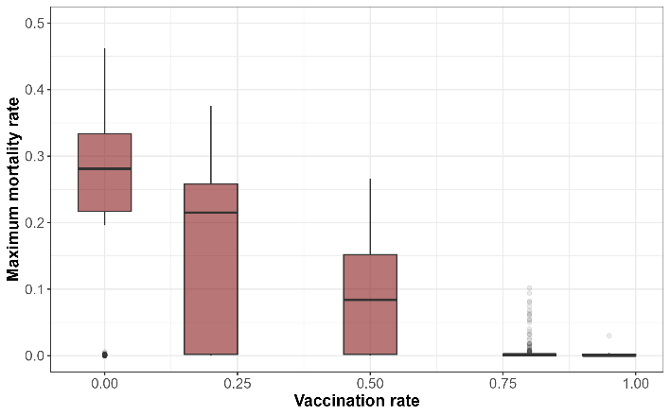
Figure 12. Maximum mortality rate of Little Penguins due to HPAI, estimated following vaccination programs achieving varying rates of population coverage. Vaccination was assumed to be applied just prior to arrival of HPAI.

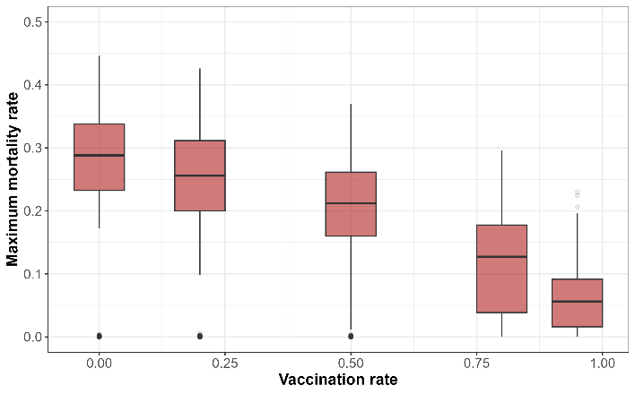
Figure 13. Maximum mortality rate of Little Penguins due to HPAI, estimated following vaccination programs achieving varying rates of population coverage. Vaccination was assumed to be initiated 5 days following the arrival of HPAI, taking 30 days to achieve the desired level of population coverage.

Conclusions
The susceptibility of Little Penguins to HPAI is obviously highly uncertain. In other penguin species, such as African Penguins (Spheniscus demersus), outbreaks of HPAI resulted in epidemics with high mortality rates. However, in species such as Adélie Penguins (Pygoscelis adeliae), exposure to HPAI appeared to result in little clinical disease (Vaughan-Higgins et al. 2024). If Little Penguins prove to be highly susceptible to HPAI, then the worst-case scenario suggests that mortality rates of at least 20% and as high as 40% could be expected following an outbreak lasting approximately 6 weeks. A 20–40% mortality rate would represent the deaths of around 8,000–16,000 penguins in the Summerland Peninsula.
Implementing a program of vaccination in any wildlife species has many practical and logistical challenges. While a suitable vaccine against H5N1 infection exists, its availability for use would need to overcome regulatory hurdles before it could be permitted for emergency use in Australian wildlife. Two types of vaccine have been previously tested in African Penguins, a vaccine based on an inactivated H5N8 viral strain and a second based on virus-like particles (VLP) (Roberts et al. 2024). Although no challenge trials were undertaken, both these vaccines appeared to result in antibody titres that were adequate for protection against H5N1 and therefore, it could be assumed that either of these vaccines would be suitable for use in Little Penguins. However, the inactivated vaccine required two doses to give similar levels of antibody titres compared with a single dose of VLP vaccine (Roberts et al. 2024). Trials of an inactivated H5N3 vaccine on five native birds in New Zealand are also currently underway. This vaccine requires a second booster dose to be administered at week 4, following initial vaccination.
The logistical challenges of vaccinating the entire mega colony of Little Penguins inhabiting Summerland Peninsula (approximately 40,000 birds) are obviously very daunting. However, it may be feasible to target one or several sub-colonies, such as the Penguin Parade and adjoining colonies, since sub-colonies only contain around 100 breeding pairs (~200 individuals) (Pulvirenti et al. 2023). Targeting the Penguin Parade for vaccination would make an obvious choice given the economic importance and high visibility of this sub-colony. Since most of the nesting sites in this sub-colony are known, this would presumably also make catching and administering the vaccine to penguins much easier than in other areas of the peninsula. Targeting the Penguin Parade and the adjoining sub-colonies would mean that around 800 – 1000 penguins would need to be vaccinated to give adequate protection against an incursion of H5N1.
To ensure that adequate coverage is achieved, any vaccination program would need to be administered prior to the arrival of H5N1. Modelling revealed that waiting until the arrival and discovery of H5N1 to start administering vaccinations would most likely be too late, because significant mortality is likely to occur before adequate vaccine coverage is achieved. Based on preliminary results from the New Zealand vaccine trial, peak antibody titres are not reached until around 10 weeks from the initial dose and therefore, beginning the vaccination program upon discovery of the first signs of disease would be too late to avoid significant mortality. Unfortunately, the arrival of H5N1 into Australia (should it occur) cannot be predicted with any certainty, although the greatest risk is likely to occur when migratory shorebirds start arriving during the Austral spring. As a result, the logistical challenges and economic costs associated with rolling out a vaccination program before or during the Austral spring would need to be balanced against the risks of arrival of H5N1 and the likely susceptibility and impacts of the virus on Little Penguins. Since the duration of protective antibody titres following vaccine administration is approximately 175 days, any vaccination program should provide protection for the population for approximately 6 months.

    - White Nose Syndrome in Southern Bent-wing Bats
WNS, caused by the fungal pathogen Pseudogymnoascus destructans (Pd), is a disease primarily affecting hibernating, cave-dwelling bats. Since its introduction into North America from Eurasia in 2006, WNS has killed millions of individuals of various hibernating bat species throughout the temperate regions of North America, with some species declining by at least 90% (Blehert et al. 2009; Foley et al. 2011; Cheng et al. 2021). WNS is a cold-loving fungus thriving at temperatures below 15°C ceasing growth above 20°C (Holz et al. 2016). Bat mortality due to WNS occurs predominantly during winter, where fungal growth on the skin of bats leads to high evaporative water loss and subsequent dehydration. This causes bats to wake frequently from hibernation, resulting in dehydration, electrolyte disturbance and the depletion of energy reserves, which eventually leads to death (Thomas et al. 1990; Verant et al. 2014).
Pd is believed to be absent from Australia (Holz et al. 2018) but recent risk assessments have concluded that the risk of the fungus entering bat populations in Australia is likely, with the most at-risk species being the cave-dwelling bats of southern Australia (Holz et al. 2016; Turbill and Welbergen 2020). Temperatures suitable for the growth of Pd are likely to occur in around one third of Australia’s cave-dwelling bat species (Turbill and Welbergen 2020). The impacts of WNS on bats are largely dependent on the thermal energetics during hibernation, and their effects on body fat stores as well interactions with immune responses (Turbill and Welbergen 2020). In North American Little Brown Bats (Myotis lucifugus), arousal from hibernation results in a large expenditure of energy, expending as much fat reserves as is consumed during 67 days of torpor (a state in which bats lower their metabolic rate and temperature and become inactive) (Thomas et al. 1990). Unfortunately, there is a lack of information on the thermal energetics of many of Australia’s cave-dwelling bats especially during winter torpor, despite this process being undertaken by many of Australia’s bat species (Turbill and Welbergen 2020).
The sensitivity of many bat species to WNS in Australia is likely to be alleviated by shorter winter periods and/or shorter bouts of torpor during hibernation, since these may retard the growth of WNS and reduce the severity of disease in affected individuals. Among the Victorian cave-dwelling bat species most likely to be affected by WNS is the Southern Bent-wing Bat (Miniopterus orianae bassanii – SBWB), which has a distribution restricted to south-west Victoria and south-east South Australia (Holz et al. 2019).
To Investigate the possible impacts of an incursion of Pd on the SBWB, we examined how variation in hibernation behaviour of the SBWB could affect the epidemiology and subsequent impacts of WNS. We adapted a model originally constructed to investigate WNS in Little Brown Bats in North America (Meyer et al. 2016; Cornwell et al. 2019) so that it would reflect the life history and ecology of the SBWB and the possible epidemiology of WNS in Australian conditions. Specifically, we linked mortality due to WNS to the length of torpor periods during winter hibernation in the SBWB. Although, winter hibernation behaviour by the SBWB is largely unknown, the objectives of the modelling were to investigate how variation in behaviour might affect the resulting epidemiology and impacts of disease. For this, we constructed the following model, representing two distinct phases in the life history of the SBWB.
Hibernation (torpor) phase
We first describe the period during the cooler winter months where SBWBs are believed to enter torpor. It is during this period that bats are at high risk of infection from WNS, because their body temperatures are conducive to growth of the fungus (i.e. < 20°C) (Dwyer 1964; van Harten 2020). Growth of the fungus on bat epidermis during these torpor periods is likely to impact bats through dehydration, arousal from torpor and loss of fat reserves leading to emaciation and death (Turbill and Welbergen 2020). Towards the end of autumn, SBWBs leave the maternity caves (see below) and seek non-breeding caves to spend the winter months (van Harten 2020; van Harten et al. 2022a). Although almost nothing is known about use of torpor by the SBWB, we can investigate the likely impacts of variation in the length of torpor periods on the epidemiology of WNS, assuming that, while in torpor, bat metabolic rates and body temperatures are conducive for the growth of the pathogen. Consequently, for an arbitrary period of torpor, the dynamics of the SBWB and epidemiology of WNS can be described by the following flow diagram (Figure 14).

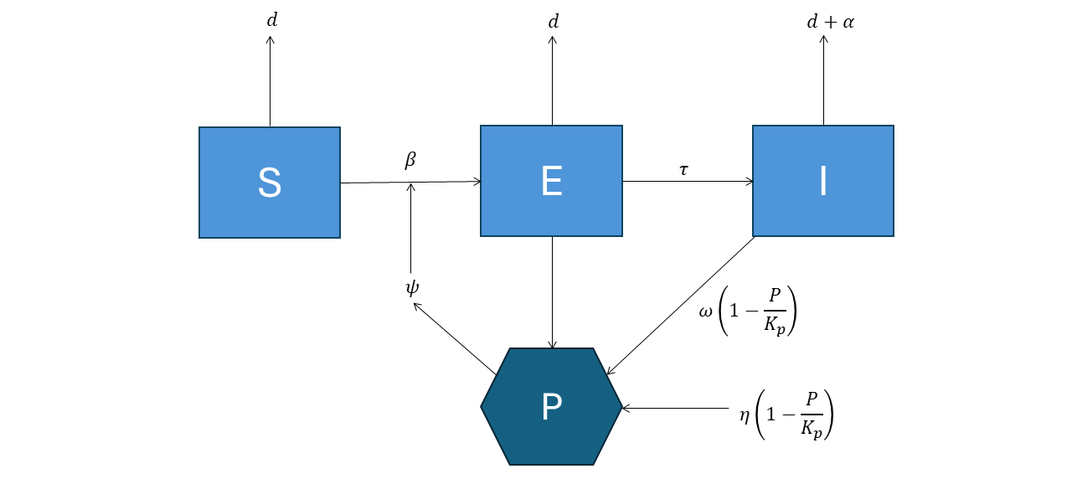
Figure 14. Flow chart of the transmission of WNS in SBWBs during the hibernation phase (torpor period) used for the individual-based model, showing the progression of individuals through each of the model compartments. $S$ – susceptible, $E$ – exposed, $I$ – infectious, $P$ – pathogen in the cave environment.

Where $S$, $E$, $I$ are abundance of susceptible, exposed and infected bats, respectively, with the total population $N=S+E+I$. The parameters $β$ and $ψ$ are the bat-to-bat and environment-to-bat transmission rates of WNS, respectively, where $P$ represents the abundance of the pathogen in the cave environment (Meyer et al. 2016). Bats exposed to the fungus become infected at a rate $τ$ and $ω$ is the rate of shedding of fungal spores from infected bats to the cave environment. Bats are also subject to natural mortality at a rate $d$ with $α$ representing the extra mortality rate of bats infected with WNS during the period of torpor. In the cave environment, the pathogen $P$ grows logistically at a rate $η$ eventually reaching the carrying capacity of the cave environment $K_{p}$.
Active phase
SBWBs congregate around three main maternity caves located at Naracoorte, South Australia, and Warrnambool and Portland in Victoria during the warmer months starting from around early September and finishing around late May (van Harten 2020). Numbers peak in the maternity caves during early summer and during this time, females give birth to a single pup, with juveniles emerging from the cave during January (van Harten 2020). During the active phase, bats can reach high densities inside the maternity caves and therefore, the risk of exposure to WNS from the cave environment is likely to be high. However, as bats are highly active and maintaining normal body temperatures during this time, it is unlikely that bats become infected with WNS. As a result, it is assumed that bat-to-bat transmission and shedding of the pathogen to the cave environment is negligible (Cornwell et al. 2019).
In addition, bats previously exposed or infected during the torpor phase that survive and enter the active phase can clear their exposure or infection and re-enter the susceptible class at a rate$γ$ and ε, respectively. During the summer breeding period, juveniles are recruited to the volant population at a rate $b$, which is also subject to density-dependence. Since bat-to-bat transmission during this period is assumed to be negligible, recruits initially enter the susceptible population where $b$ is the per-capita recruitment of juveniles to the volant population and $g$ represents the strength of density-dependence. The flow diagram for the active phase is given in Figure 15.
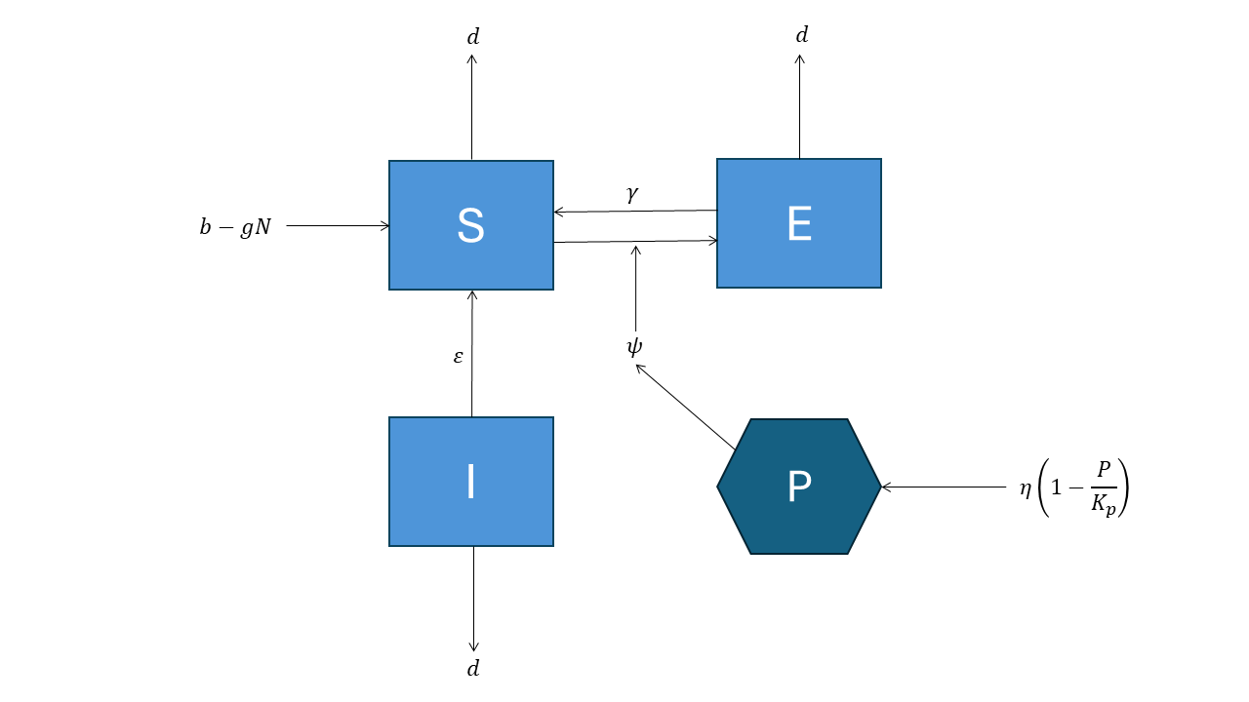
Figure 15. Flow chart of the transmission of WNS in SBWBs during the active phase used for the individual-based model, showing the progression of individuals through each of the model compartments. $S$ – susceptible, $E$ – exposed, $I$ – infectious, $P$ – pathogen in the cave environment. Parameter descriptions are given in Section 6.3.

Parameter values for this model were derived from several sources. Values for the recruitment rate $b$ were derived from data from Dr Lindy Lumsden and colleagues (unpublished), who undertook meticulous counts of SBWBs emerging from the Warrnambool maternity cave, as well as a few nearby caves known to be used by SBWBs. Counts were conducted during the summer birth pulse around mid-December, but when pups were still confined to the cave (pre-volant population) and then repeated around mid-February, as pups became volant and became part of the countable population (volant population). Counts were undertaken from the 2018–19 breeding season to the 2022–23 breeding season (Figure A7 – section 6.3). Assuming that immigration or emigration from the cave during a breeding season was negligible, the relative differences in the pre- and post-volant counts during a breeding season reflect recruitment to the bat population. Estimates of the recruitment rate for the years surveyed indicated that the volant population increased by an average of 28% over the 5 years monitored (range 16–43%) (Figure A7 – section 6.3). Consequently, we used the value of 0.28 as the estimate of the average annual recruitment rate.
Bat mortality rates were derived from data from PIT-tagged bats from the study by van Harten et al. (2022b) in South Australia. Discounting the low survival rates observed during 2016, the average annual survival rates of SBWBs was 0.73. However, we used a value of 0.8 for the annual survival rate to ensure that the population trajectory was consistent with the counts obtained between 2018–19 and 2022–23 in Victoria (Figure A7 – section 6.3). Other parameters related to the transmission of WNS indicated in the model were derived from the literature (Meyer et al. 2016; Cornwell et al. 2019) (section 6.3). Although transmission rates of WNS in SBWBs are unknown, we assumed that transmission would be similar to that estimated for North American bats that are known to form large roosting congregations similarly to SBWBs. The study of Meyer et al. (2016) estimated the basic disease reproductive rate $R_{o}$ during the hibernation phase as 4.15. Using $R_{o}$ = 4.15 as a guide, we substituted values for $d$ and $N$ for SBWBs and then found the corresponding estimate of $β$ that gave the target value of $R_{o}$(section 6.3). Following the hibernation period, the probability that bats infected or exposed to WNS would re-enter the susceptible class during the active phase was assumed to be 75% (Cornwell et al. 2019). However, both Meyer et al. (2016) and Cornwell et al. (2019) assumed lower recovery rates for infected bats. Due to the less extensive periods of torpor likely to be experienced by SBWBs, we assumed the recovery rate of infected bats was similar to exposed bats.

Scenarios
To investigate the likely impacts of WNS on SBWBs, we investigated the effects of the introduction of Pd into the cave sediments of the Warrnambool maternity cave. Since caves in this general region would all be potentially conducive to the growth of Pd, and bats move seasonally between caves, whether the introduction of Pd occurs in the maternity cave or non-breeding caves does not affect the outcomes from the model. We then investigated how varying the length of the torpor period by SBWBs would affect the epidemiology of WNS and the subsequent impacts on the bat population. For this purpose, the torpor period was varied between 5 and 60 days with the dynamics of the SBWB, and the epidemiology of WNS simulated over 10 years.

WNS impacts
The study of Meyer et al. (2016) modelled the impact of WNS on Little Brown Bats assuming a 7-month hibernation phase (i.e. 212 days), which indicated an approximate 75% decline in the population after two years, with eventual extinction of the population within 10 years (Meyer et al. 2016). Our model for SBWBs, assuming much of the same parameter values with a similar 7-month torpor period, gave qualitatively similar results (Figure 16a, b). Prevalence of exposed and infected bats reached 37% and 22%, respectively in the first year of the outbreak (Figure 16a, b).

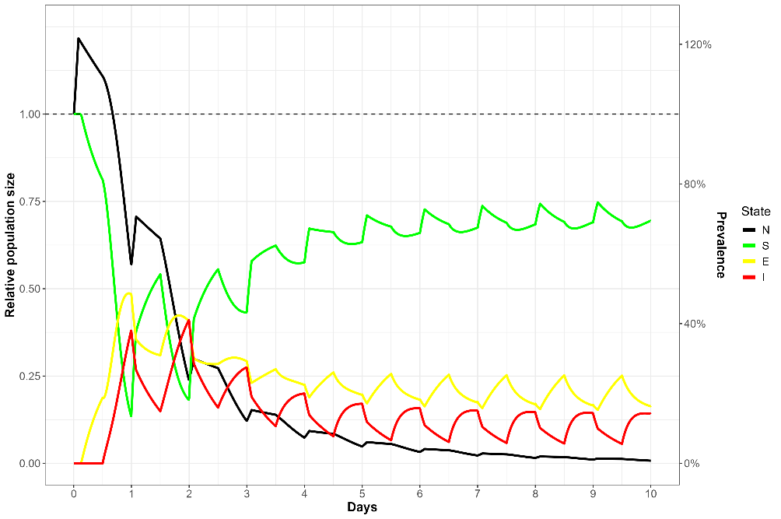
Figure 16a. Predicted mean trajectories for each of the disease states following an outbreak of White Nose Syndrome in a population of Southern Bent-wing Bats assuming bats undergo a 7-month period of torpor. N – total relative population size, S – susceptible, E – exposed, I – infected (prevalence).

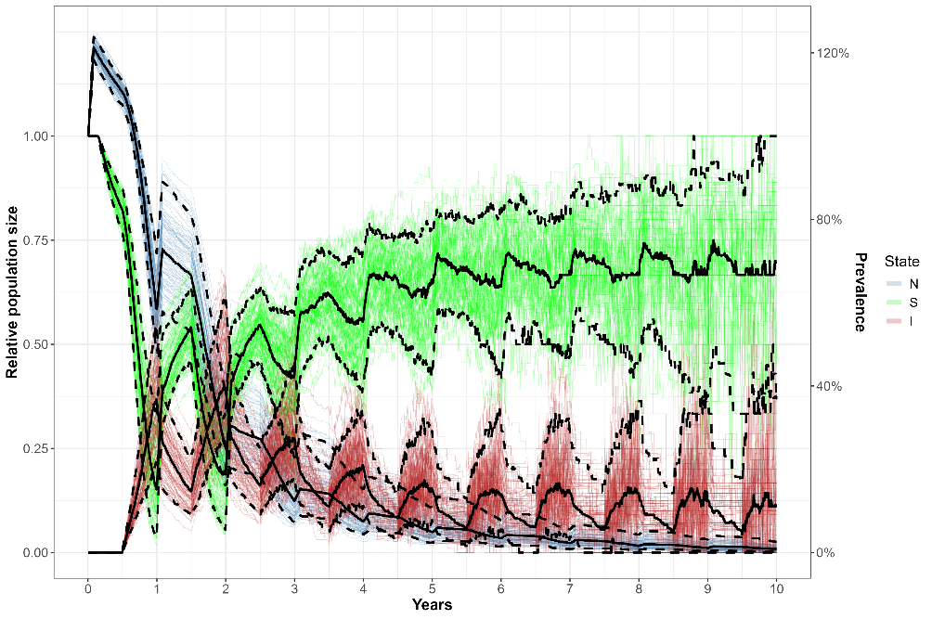
Figure 16b. Predicted uncertainty in total relative population size (N), Susceptible (S) and infection prevalence (I) following an outbreak of White Nose Syndrome in a population of Southern Bent-wing Bats, assuming bats undergo a 7-month period of torpor. Trajectories were generated by varying key parameters by $±$ 30% and simulating 250 sets of random parameter values using Latin hypercube sampling. Solid black line – mean, dashed black lines – 90% confidence intervals. Exposed states have been removed for clarity.

Length of torpor and impacts of WNS
The impact of the introduction of WNS into the cave environments at Warrnambool was highly dependent on the period bats spent in torpor (Figure’s 17 and 18). Only minor impacts on population abundance were observed for periods of torpor lasting up to 10 days, with predicted reductions of around 7% after 10 years and peak prevalence of WNS reaching 5%. However, longer periods of torpor lasting 30 or 60 days resulted in corresponding decreases over 10 years of 27% and 63%, respectively with peak prevalence of WNS reaching 12–21% (Figure’s 17 and 18).
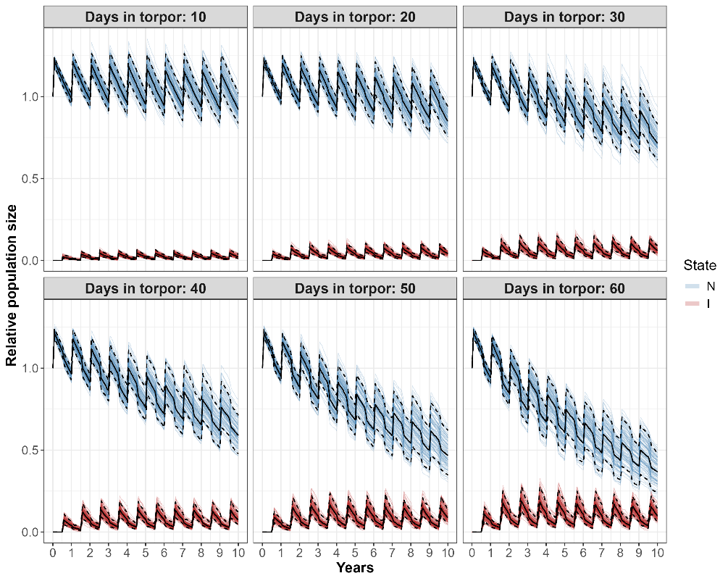
Figure 17. Population trajectories of the SBWB following an incursion of WNS for varying numbers of days spent in torpor by bats during winter (see text for details). N – total population (relative to starting population); I – prevalence of infected bats (proportion of current population infected). Light blue and red lines indicate trajectories from each simulation while black solid and dashed lines indicate the mean and 90% confidence intervals, respectively.

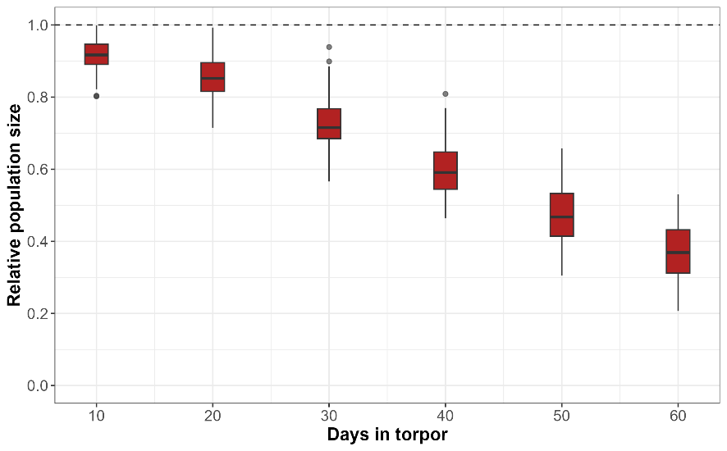
Figure 18. Relative population size after 10 years following an introduction of WNS into the SBWB population in Warrnambool cave, for various periods (days) spent in winter torpor each year.

Conclusions
Predictions of the potential impacts of WNS on the SBWB in southern Victoria are dependent on the modelling assumptions used here. The main assumption was that the susceptibility of the SBWB to WNS was similar to that experienced by many North American bat species, especially the Little Brown Bat, which has been the basis for many of the parameter values used for the current model. Susceptibility to WNS appears to vary widely among cave-dwelling bats inhabiting temperate regions, with the pathogen showing low levels of host specificity (Wu et al. 2025).
The current model assumes a fairly simple process for linking torpor periods to additional mortality due to WNS. Additional structure encompassing more complex winter behaviour incorporating the frequency of periods of foraging and torpor, would more realistically capture winter behaviour. However, this would require information about how the frequency of different behaviours affects impacts from WNS. For example, microclimate choice by hibernating bats may materially affect growth of Pd. In addition, due to the low frequency and duration of torpor, infection with Pd may only result in sub-clinical disease. However, this may still impact the fitness of individuals by depleting energy reserves. Research into winter torpor, bat immune responses and activity in SBWBs and other cave-dwelling bats is currently underway (Lindy Lumsden pers. comm.), which will be invaluable for determining the likely impacts of WNS on the SBWB.
    - Amphibian chytrid fungus in Bell Frogs
Since its discovery during the 1990s, the amphibian fungal pathogen, Batrachochytrium dendrobatidis (Bd) – the causative agent for chytridiomycosis (chytrid), has been implicated in the global decline and extinction of frog species world-wide (Berger et al. 1998; Briggs et al. 2005; Skerratt et al. 2007). In Australia, Bd most likely emerged in south-east Queensland in the 1970s before spreading rapidly north and south at a rate of about 100 km/year (Berger et al. 2016), reaching Western Australia during the 1980s (Skerratt et al. 2007). Bd is now considered endemic in many regions of Australia, resulting in seasonal outbreaks of disease in many frog species (Berger et al. 2016).
The infective stage of Bd consists of flagellated zoospores that infect the epidermis of frogs and then develop into zoosporangia. Zoosporangia produce new zoospores through asexual reproduction, which are then released into the environment (Vredenburg et al. 2010; Kinney et al. 2011). Chytridiomycosis causes frog mortality by severely disrupting epidermal functions and causing osmotic imbalance. However, tadpoles appear to be little affected by the disease (Vredenburg et al. 2010). Favourable environments for the spread and growth of Bd are cool and wet, with temperatures >30°C being lethal for the pathogen and temperatures >25°C potentially allowing frogs to clear the disease (Kinney et al. 2011; Waddle et al. 2024).
Among the species impacted by Bd in Australia are the Bell Frogs, including the Green and Golden Bell frog (Litoria aurea), Yellow Spotted Bell Frog (L. castanea) and the Southern Bell Frog (L. raniformis). These species have been largely extirpated from the high altitude tableland regions of the southern Great Dividing Range where it is likely that the cool and wet conditions were conducive to the rapid growth of Bd (Hamer et al. 2010). These species are now considered threatened and persist largely in the warmer lowland parts of their former range where the environmental conditions are less suitable for Bd growth (Heard et al. 2014). Studies have found that warm and saline wetlands provide refuges from Bd for Southern Bell Frogs, suggesting that these habitats should be priorities for conservation of the species (Heard et al. 2014).
Studies have demonstrated the role of temperature in mitigating the lethal effects of chytridiomycosis in Bell Frogs (Heard et al. 2014; Heard et al. 2015; Waddle et al. 2024). A recent study found that the provision of artificial sunlight heated shelters allowed Green and Golden Bell Frogs to raise body temperatures to levels that enabled them to clear Bd infections. Furthermore, once frogs had recovered from their initial infection, they had a reduced susceptibility to re-infection and clinical disease, even in conditions conducive for Bd growth (Waddle et al. 2024). Therefore, that study suggested that the provision of thermal refugia could be a valuable management tool to aid the recovery of this species from the impacts of chytridiomycosis by decreasing disease severity and stimulating host resistance to the disease.
Here we investigate the population-level effects of the provision of thermal shelters on the long-term persistence of Bell Frogs. We model the effects of thermal shelters on populations inhabiting warm environments typical of their current distribution as well as cooler environments more favourable for Bd growth. To investigate the effects of thermal refuges on the population dynamics of Bell Frogs and the epidemiology of Bd, we constructed a model consisting of four compartments, where $S$ and $I$ are the abundance of susceptible and infected frogs, and $S_{r}$ and $I_{r}$ are the abundance of susceptible and infected frogs that had recovered from a previous Bd infection (Figure 19).

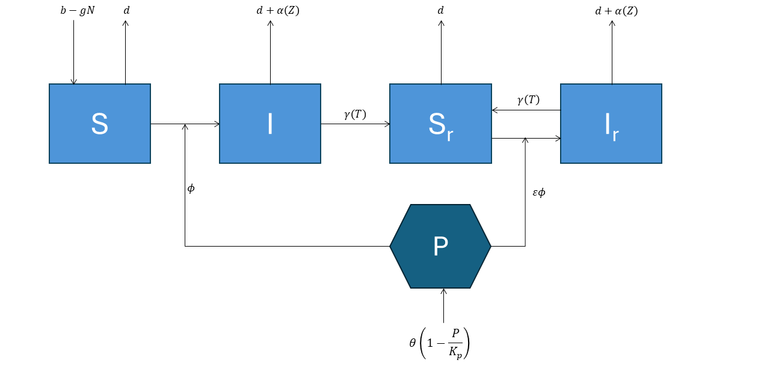
Figure 19. Flow chart of the transmission of Bd in Bell Frogs inhabiting a single waterbody, used for the individual-based model showing the progression of individuals through each of the model compartments. $S$ – susceptible, $I$ – infected, $S_{r}$ – recovered and susceptible, $I_{r}$ – recovered and re-infected, $P$ – environmental reservoir of the pathogen. Parameter estimates and descriptions are given in section 6.4.

This model structure follows from the work of Waddle et al. (2024), where it was found that L. aurea, that had recovered from a previous Bd infection following heat treatment by thermal shelters, were at lower risk of re-infection and disease from subsequent Bd infections (prior exposure). Frogs could only recover from chytridiomycosis once their temperature exceeded a threshold, set here at 25°C (Kinney et al. 2011), otherwise frogs remained infected. The parameter $γ\left(T\right)$ represents the temperature-dependent recovery rate of frogs from chytridiomycosis, with the mean time to recovery set at 27 days for both $I$ and $I_{r}$ stages (Waddle et al. 2024).
Transmission of Bd to susceptible frogs occurred through an environmental reservoir $P$, with transmission rate $ϕ$ (Figure 19). Although transmission of Bd between frogs undoubtably occurs, we assume this contact rate is negligible compared with contact through the environmental reservoir, and that it is similar to the transmission process used in other models of Bd transmission (Briggs et al. 2010). In addition, transmission to susceptible frogs that had prior exposure ($S_{r}$) was different to susceptible naïve frogs, with the parameter $ε$ being the relative susceptibility of frogs with prior exposure compared with naïve frogs. The compartment $P$ represents the log₁₀ zoospore load in the wetland environment, which grew logistically at a rate $θ$ eventually reaching the carrying capacity of the wetland environment $K_{p}$. Here, it was assumed that growth of zoospores in the environment occurred independently of the infection rate in Bell Frogs, due to the presence of infection in alternative, sympatric amphibian hosts. It was also assumed that Bell Frogs undergo a period of brumation during the winter months, where frogs shelter among terrestrial habitat such as fallen timber and vegetation. As frogs do not use aquatic habitat during this time, they were not at-risk of infection by Bd. However, frogs infected prior to entering brumation were still at-risk of mortality from chytridiomycosis. The period of brumation was set at 4 months from May 1 to August 31.
Recruitment to the adult life stage occurred seasonally (days 250–365) at a rate $b$, which was subject to density-dependence, where $g$ represents the strength of density-dependent regulation. The natural (background) mortality rate of frogs was $d$, with the Bd-induced mortality rate occurring in infected frogs at a rate $α\left(Z\right)$, where $α$ was a function of the log₁₀ zoospore load $Z$ for an individual. In addition, the zoospore load applied to infected frogs that had recovered from a prior infection was reduced compared with frogs with no prior exposure (see below). This was based on the findings that the survival rate of L. aurea infected with Bd was higher for frogs that had recovered from previous infections after thermal treatment (Waddle et al. 2024).

Chytridiomycosis mortality rate
Many studies have now shown that the mortality rate caused by Bd infection in many frog species is dependent on the zoospore load of individual frogs $\left(Z\right)$, and that significant mortality usually does not occur until the number of zoospore equivalents per swab reaches a threshold, estimated to be 10,000 (i.e. 4 on the log₁₀ scale) (Briggs et al. 2010; Vredenburg et al. 2010; Kinney et al. 2011; Cashins et al. 2013). However, some studies in L. aurea have found that chytridiomycosis appears to develop at considerably lower threshold of 68 (Stockwell et al. 2016). The difference in the threshold for $Z$ in that study compared with studies in other species may be due to differences in methodology for processing and analysing swabs rather than reflecting innate differences (Stockwell et al. 2016). In contrast, a more recent study on L. aurea appears to confirm a log₁₀ threshold for $Z$ of 4 for the chytridiomycosis mortality rate (Waddle et al. 2024).
Other studies have also established a relationship between the zoospore growth rate on infected frogs and the maximum zoospore load $\left(Z_{max}\right)$, which is dependent on the thermal environment (Vredenburg et al. 2010; Waddle et al. 2024). Frogs are ectotherms, which have body temperatures that fluctuate with the external environment. For habitats with endemic Bd, this manifests as pulses of seasonal mortality – with highest numbers of mortalities occurring during the cooler months, and recovery and disease resolution occurring during the warmer months (Berger et al. 2004; Kinney et al. 2011). Therefore, to simulate the dynamics of Bd in Bell Frogs for the current study, we assumed the following relationships between waterbody temperature, zoospore growth and chytridiomycosis mortality.

Maximum zoospore load
Once infected with Bd, zoospore growth $Z$ on individual frogs increased exponentially eventually reaching an asymptote $Z_{max}$. The value of $Z_{max}$ was dependent on both temperature and whether the frog had recovered from a prior infection with Bd (prior exposure) (Waddle et al. 2024). For temperature ranges in the environment from 10–30°C we assumed a decreasing, non-linear relationship between temperature and $Z_{max}$, that differed with prior exposure (Figure 20). Frogs with no previous exposure to Bd could attain a $Z_{max}$ of 5.9 on the log₁₀ scale at an ambient temperature of 10°C, which declined to a $Z_{max}$ of 2.1 at an ambient temperature of 30°C. Similarly, for frogs with prior exposure to Bd $Z_{max}$ could reach 4.9 and 1.7, at ambient temperatures of 10 and 30°C, respectively. These relationships were generated as follows:

$$Z_{max}\left(T\right)=6/{\left(1+\text{exp}\left(0.25 \left(T-27.5\right)\right)\right) :\text{no prior exposure}} \\ Z_{max}\left(T\right)=5/{\left(1+\text{exp}\left(0.25 \left(T-27.5\right)\right)\right)} \text{: prior exposure}$$
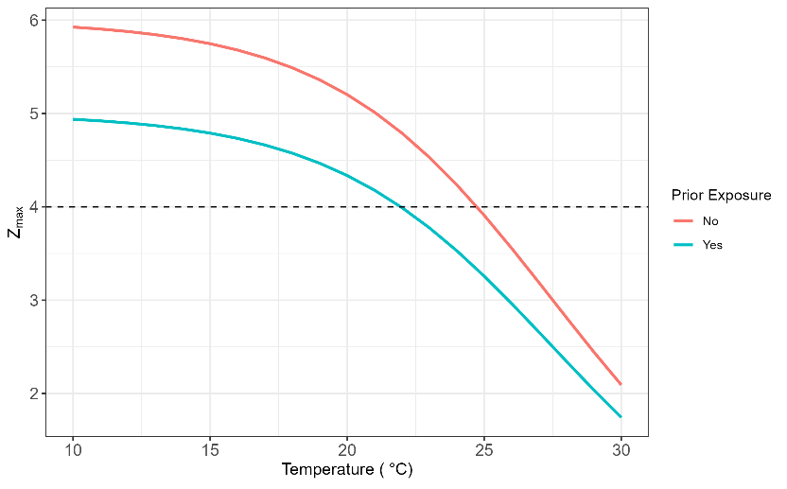
Figure 20. Relationship between maximum zoospore load (log₁₀ scale) per infected individual $\left(Z_{max}\right)$ and temperature for frogs, with and without prior exposure to Bd. Dashed line indicates the threshold zoospore load $Z_{T}$ above which, mortality from chytridiomycosis occurs.

Zoospore growth on individual frogs
Given $Z_{max}$ for an individual, the log₁₀ growth of zoospores on an infected individual ($Z$) increased to $Z_{max}$ according to the following growth function
$$Z_{t+1}=Z_{t}+υ\left(1-\frac{Z_{t}}{Z_{max}}\right)$$
Where the maximum growth rate $υ$ was set so that $Z_{max}$ was reached in around 4–6 weeks (Waddle et al. 2024). Given $Z_{max}$ was dependent on temperature and prior exposure, this gave rise to growth rates for $Z$ that were also dependent on temperature and prior exposure (Figure 21).

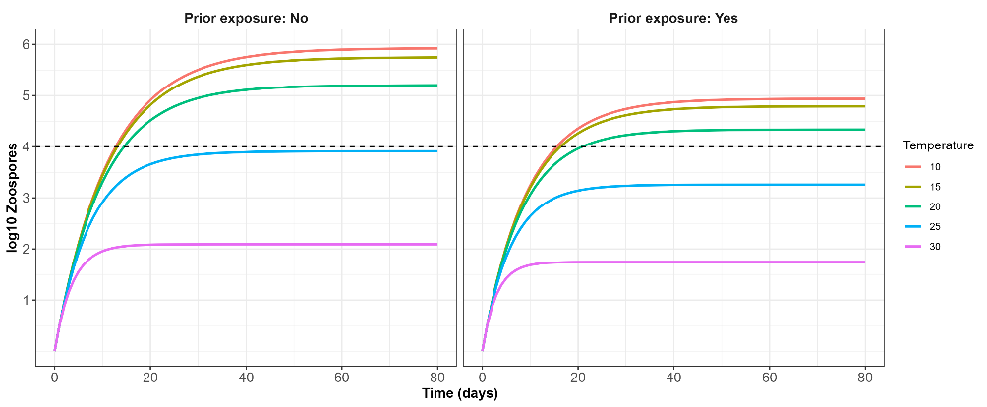
Figure 21. Growth rate of zoospores (Z) on infected frogs (log₁₀ scale) with time since infection at various ambient temperatures for frogs, with and without prior exposure to Bd. Dashed line indicates the value of $Z_{t}$ above which, significant frog mortality occurs.

Zoospore dependent mortality
The Bd-induced mortality rate of frogs $α\left(Z\right)$ was dependent on the frog zoospore load ($Z$). Here we assumed that mortality from chytridiomycosis only occurred at zoospore loads occurring above a threshold $Z_{T}$, which was set at 4 on the log₁₀ scale (i.e. 10,000 zoospore equivalents) (Vredenburg et al. 2010; Kinney et al. 2011). An estimate of the mortality rate from chytridiomycosis was derived from the study of Heard et al. (2024). That study estimated annual survival rates of L. aurea and L. raniformis from age structure data obtained from museum specimens prior to the arrival of Bd and compared these with annual survival estimates from post-Bd populations. The estimate of pre-Bd annual survival probability was 0.69 compared with the post-Bd annual survival probability of 0.35. These correspond to annual mortality rates of -log(0.69) = 0.37 and -log(0.35) = 1.05, respectively. Consequently, the corresponding chytridiomycosis mortality rate $α$ was 1.05 – 0.37 = 0.68/year or 0.0019/day. The estimate of pre-Bd survival was then used as the estimate of the natural (background) mortality rate ($d$ = 0.37/year).

Scenarios
To investigate the likely impacts of the introduction of thermal shelters on the epidemiology of Bd and the population dynamic of Bell Frogs, we investigated scenarios for Bell Frogs inhabiting wetlands with different thermal environments. For this purpose, we simulated seasonal temperature regimes for wetland environments where maximum daytime temperatures fluctuated between 13–21°C (‘cold’), 16–26°C (‘warm’) and 19–31°C (‘hot’) (Figure 22). These temperature regimes are used here for illustrative purposes, but are similar to the seasonal maximum daytime temperature fluctuations recorded in different wetland environments for southern Bell Frogs (Heard et al. 2018; Turner et al. 2021).
We simulated a population of 500 adult frogs inhabiting a single wetland where frog body temperatures were set by the given thermal environment. We then simulated population dynamics over 20 years to establish baseline conditions for each thermal environment. Following the baseline period, we then added thermal refugia to the wetland such that each frog utilised the thermal shelter for daytime basking with a given probability. As L. aurea have been shown to preferentially seek out thermal refugia (Waddle et al. 2024), adding more thermal shelters increased the probability of utilisation by individual frogs. Therefore, rather than explicitly model the number of thermal refugia, we instead just modelled the probability that an individual used a thermal shelter. We examined probabilities between 0 (no refugia) and 0.9 (90% of frogs were able to utilise thermal refugia). As a baseline, thermal refugia were able to increase frog body temperatures by 4°C $\left(∆\right)$. However, we also examined values for $∆$ of 8°C.
As an additional scenario, we also examined re-introductions of frogs to the cold thermal environments where frogs had previously been extirpated by Bd. Cold thermal environments provide ideal conditions for Bd growth, and Bell Frogs have been extirpated from the majority of cold climates where they have previously occurred. Here we simulated re-introductions of frogs that had been infected with Bd and then heat treated at 30°C to clear infections. Previous studies have shown that frogs treated in this manner are resistant to Bd and have lower transmission and zoospore growth (Waddle et al. 2024). We examined re-introductions of 50 heat-treated frogs to extirpated wetlands and examined population trajectories over 20 years. Re-introduced frogs entered into the susceptible recovered class $\left(S_{r}\right)$ and therefore, had reduced susceptibility to Bd infection $\left(ε\right)$ and reduced maximum zoospore loads $\left(Z_{max}\right)$ (Figure’s 20, 21). We also examined scenarios where wetlands were supplemented with thermal shelters, and compared these with scenarios where re-introductions occurred in wetlands without thermal shelters.

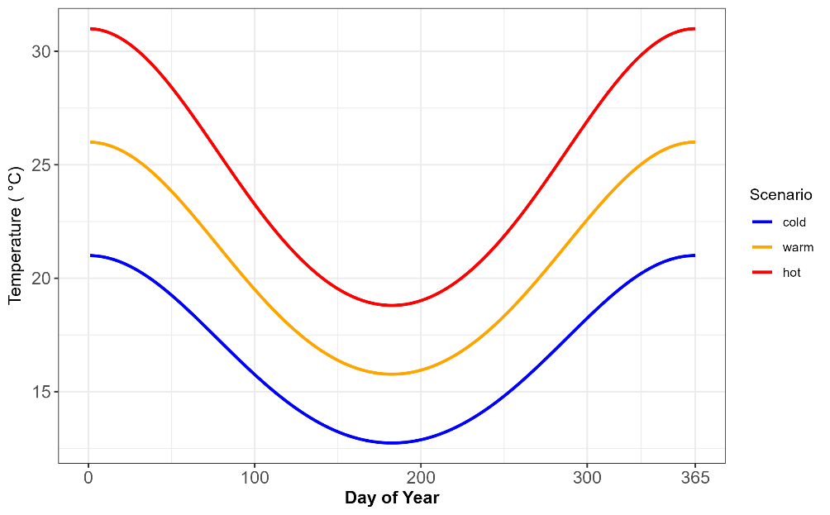
Figure 22. Seasonal maximum daytime temperature regimes for three simulated wetlands representing ‘cold’, ‘warm’ and ‘hot’ thermal environments.

Results
For the baseline ‘cold’ thermal environment, the introduction of Bd resulted in rapid population declines, with the population extirpated within around 10 years (Figure 23). Bd prevalence rapidly reached around 90% within one year of Bd introduction and fluctuated seasonally thereafter due to frog recruitment. Simulations for the ‘warm’ thermal environment resulted in around 75% declines in frog abundance over 20 years. Due to the warmer thermal environment, frogs were able to potentially recover from Bd infection during periods when wetland temperatures exceeded 25°C (Figure 24). As a result, Bd prevalence was more seasonably variable fluctuating between 20% and 40% (Figure 24). For frogs inhabiting the ‘hot’ thermal environment, the introduction of Bd resulted in small declines of around 20%, with Bd prevalence varying between 15% and 20% (Figure 25). This was due to the increased time where frogs were warmed above the Chytridiomycosis recovery threshold of 25°C compared with frogs in the ‘warm’ thermal environment, allowing more frogs to enter the prior exposure class $\left(S_{r}\right)$.
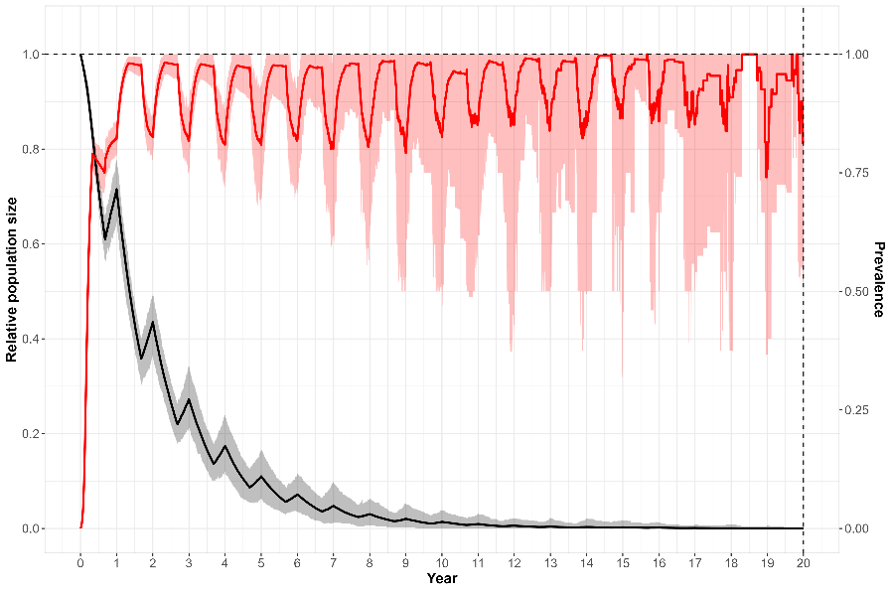
Figure 23. Relative population size for Bell Frogs following the introduction of Bd for frogs inhabiting the ‘cold’ thermal environment. Black line – relative population size; red line – Bd prevalence. Shading represents 95% uncertainty intervals.

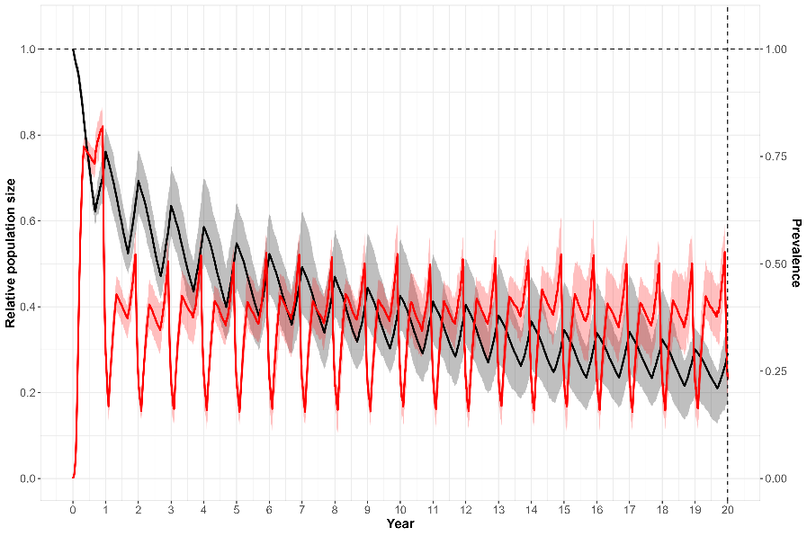
Figure 24. Relative population size for Bell Frogs following the introduction of Bd for frogs inhabiting the ‘warm’ thermal environment. Black line – total population; red line – Bd prevalence. Shading represents 95% uncertainty intervals.

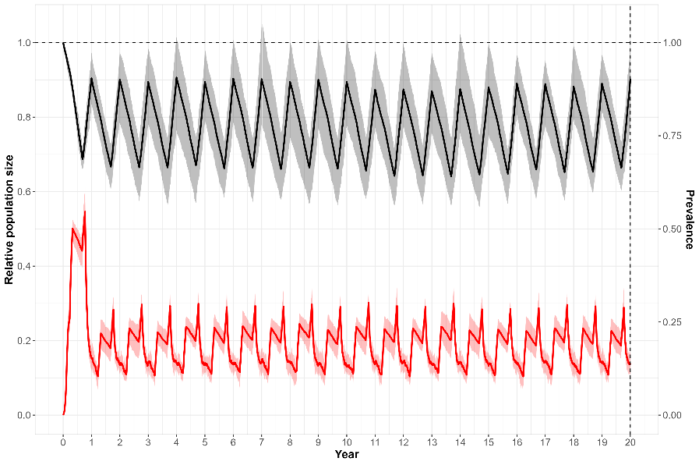
Figure 25. Relative population size for Bell Frogs following the introduction of Bd for frogs inhabiting the ‘hot’ thermal environment. Black line – total population; red line – Bd prevalence. Shading represents 95% uncertainty intervals.

Impacts of thermal shelters
Initially we examined the impacts of adding thermal shelters to the ‘warm’ thermal environment to determine whether the addition of shelters aided frog population recovery. Here thermal shelters increased frog temperatures by 4°C compared to the background thermal environment. Thermal shelters added at year 20 that had a probability of use of 50% resulted in populations stabilising at around 40% of carrying capacity (Figure 26). If the probability of shelter use was 90%, populations recovered to around 60% of carrying capacity over 20 years (Figure 26).
For the ‘cold’ thermal environment, re-introducing 50 Bd-resistant frogs at year 20 did not result in population recovery, with all frogs disappearing within 10 years (Figure 27). Providing thermal shelters for the re-introduced frogs that raised body temperatures by 4°C also did not result in population recovery for scenarios where shelter use was 50% or 90% (Figure 27). Scenarios where thermal shelters could raise frog body temperatures by 8°C were more successful at recovering frog populations in cold thermal environments, but only when 90% of frogs had access to thermal shelters (Figure 28).
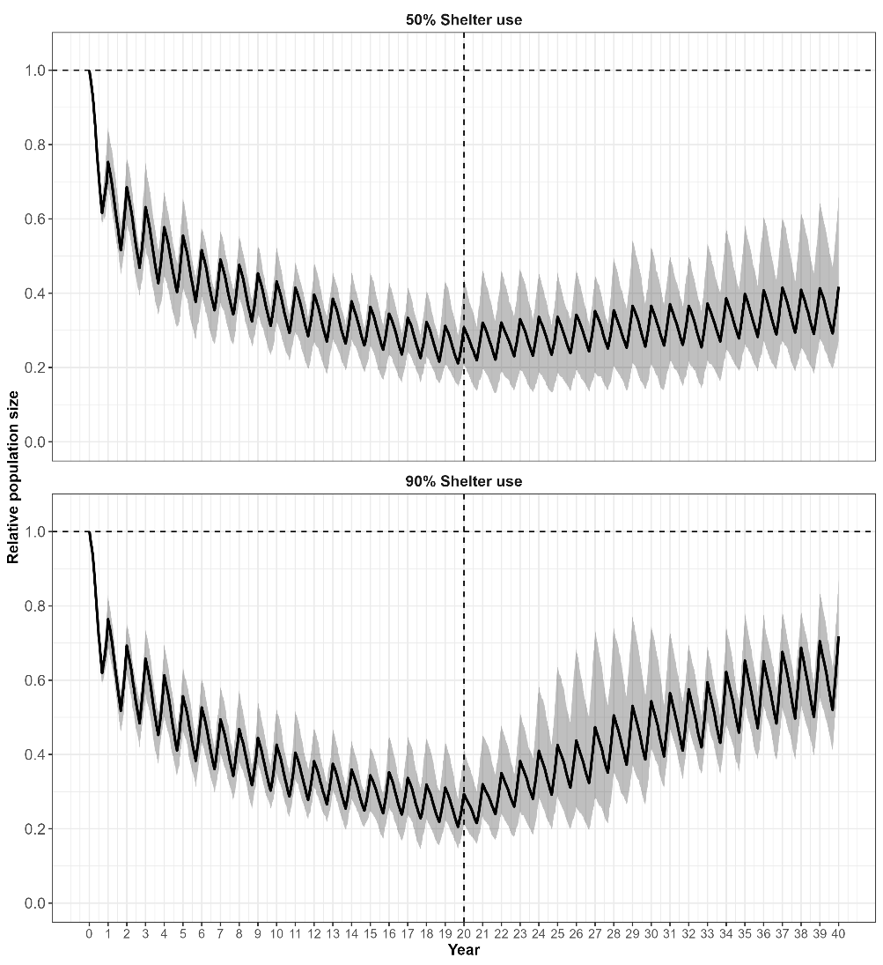
Figure 26. Relative population size for Bell Frogs following the introduction of Bd for frogs inhabiting the ‘warm’ thermal environment before and after the introduction of thermal shelters (vertical dashed line) where the percentage of the population using shelters was 50% or 90%. Each shelter had a thermal delta of 4°C. Shading represents 95% uncertainty intervals.

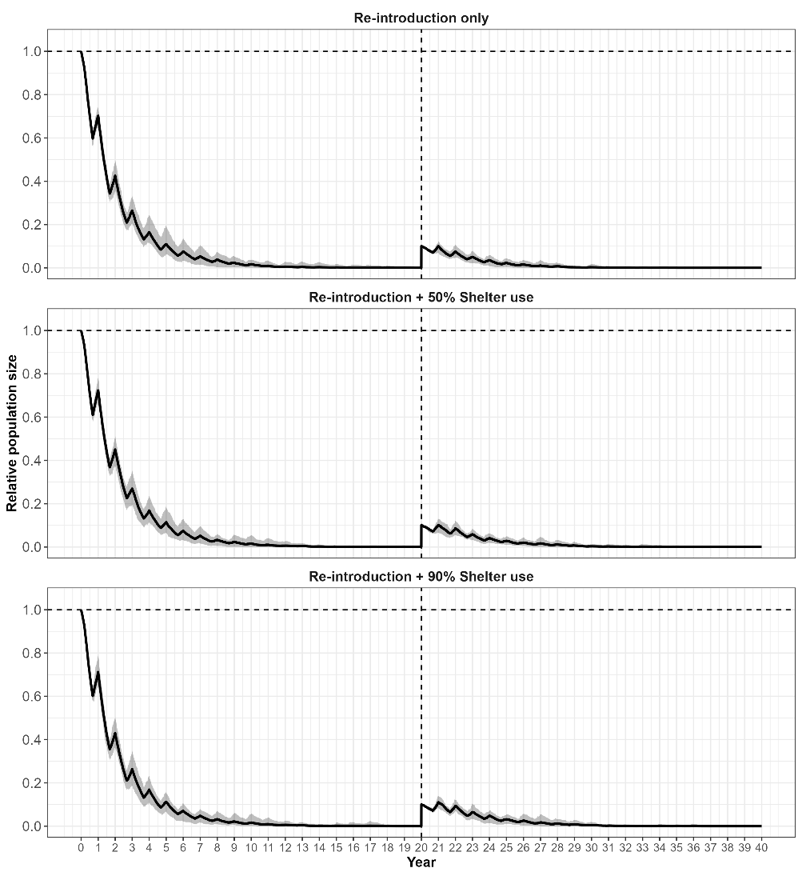
Figure 27. Relative population size for Bell Frogs following the introduction of Bd for frogs inhabiting the ‘cold’ thermal environment. Following extirpation, 50 heat treated Bd resistant frogs were re-introduced in year 20 (vertical dashed line). Plots show the percentage of the re-introduced population using shelters. Each shelter had a thermal delta of 4°C.
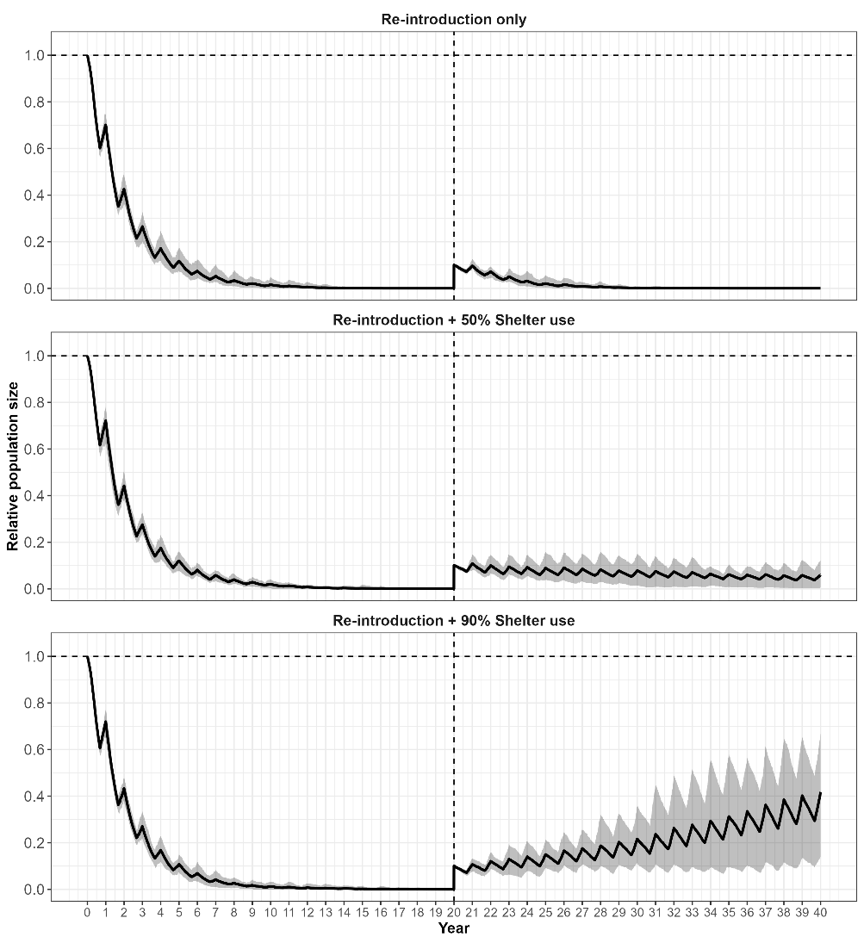
Figure 28. Relative population size for Bell Frogs following the introduction of Bd for frogs inhabiting the ‘cold’ thermal environment. Following extirpation, 50 heat treated Bd resistant frogs were re-introduced in year 20 (vertical dashed line). Plots show the percentage of the re-introduced population using shelters. Each shelter had a thermal delta of 8°C.

Conclusions
Recent studies have established that the provision of thermal shelters for Green and Golden Bell Frogs increased the survival rates of frogs by allowing frogs to clear Bd infections. Once recovered by heat treatments, individuals were subsequently resistant to further Bd infections, even under cooler thermal environments suitable for Bd growth (Waddle et al. 2024). The model developed here allowed the exploration of these recent findings on the likely outcomes at the population level for Bell Frogs managed with the use of thermal shelters. Results suggest positive outcomes for frog populations managed by the provision of thermal shelters that allow the majority of the population ($≥$ 90%) to utilise them. However, the results tend to depend on the prevailing thermal environment. Frogs inhabiting ‘warm’ thermal environments where Bd infections had reduced populations by ~75% benefited by the provision of thermal shelters that raised frog body temperatures by 4°C. Provided the probability of shelter use was high ($≥$90%), frog populations could recover to around 60% of carrying-capacity within around 20 years.
For colder parts of the former range of Bell Frogs where Bd had previously extirpated populations, population recovery would need to rely on a program of re-introductions. However, even if re-introduced frogs had been treated to convey increased resistance to Bd infections, modelling results suggest that these have a high probability of failure unless thermal shelters are also provided as thermal refugia. However, to enable a high probability of population recovery, thermal shelters would need to raise frog body temperatures by at least 8°C and be utilised by the majority of the population.
Although these results appear encouraging for designing potential management actions for the recovery of Bell frog populations to parts of their former range, it is unknown whether these results can be generalised to other south-eastern Australian frog species decimated by the impacts of Bd. For example, unlike Bell Frogs, the critically-endangered Baw Baw frog does not seek out thermal refugia and spends the majority of its life living among soil cavities and damp vegetation. Consequently, the provision of thermal shelters is only likely to be a successful means of mitigating the impacts of Bd for species which have a natural tendency to seek out warm microhabitats.
The individual-based model developed here to model the impact of Bd on Bell Frogs, has a number of interacting processes that are thought to be critical to the epidemiology of Bd in these species. Although parametrisation of these process was mostly based on published studies, they necessarily contain a number of assumptions which influence model behaviour. Chief among these was the assumption that Bell Frogs were able to recover from chytridiomycosis once their body temperature exceeded 25°C (i.e. parameter $γ\left(T\right)$). This assumption was largely drawn from Kinney et al. (2011), citing other published work and also from the work on Bell Frogs by Waddle et al. (2024). Model results were sensitive to the selection of this threshold temperature (section 6.4). Although frogs could recover from chytridiomycosis if their temperature exceeded this threshold, this did not occur deterministically because recovery rate was a stochastic process dependent on the mean time to recovery (which was set at 27 days). Therefore, on average, frogs needed to spend around this length of time above the temperature threshold in order to have a high probability of recovery.
Other critical processes included in the model structure related to rate of zoospore growth on individuals and its dependence of frog temperature, as well as the relationship between zoospore loads and frog mortality rates. Non-linear relationships were assumed between maximum zoospore loads and frog temperatures, with frog mortality from chytridiomycosis dependent on a threshold zoospore load. Maximum zoospore loads and frog temperatures were mostly based on Waddle et al. (2024), while threshold zoospore loads initiating chytridiomycosis mortality were also based on published estimates (Vredenburg et al. 2010; Kinney et al. 2011). The zoospore growth relationships used in the current model were deterministic; however, these could easily be represented as random variables based on studies documenting individual variation on zoospore growth rates and temperature (e.g. Waddle et al. 2024). In addition, it is suggested that alternative relationships between zoospore growth on individuals and frog body temperatures could also be explored to determine the sensitivity of our model results to different functional forms for these relationships.
- Discussion
  - General commentary
The first component of this study involved using the WDRA methodology to identify a suite of wildlife diseases that represent threats to the conservation of wildlife in Victoria, and to the state’s economy. In most cases, the diseases that were identified as being extreme or high risks were already well-recognised for their conservation or economic impacts on Victorian wildlife or domestic livestock. The qualitative risk assessments that we have undertaken here were conducted on the basis of existing published data and expert opinion, and provides a sound basis for identifying and prioritising currently known disease risks. However, it is important to recognise that this approach is inherently opinion-based, which means that it may underestimate the impacts of poorly known diseases, or may incorrectly rank the relative risks of diseases due to incomplete or incorrect knowledge. One thing to note is that each taxon group was assessed separately by different experts with different levels of information available and thus, may not be directly comparable. Hence, these assessments are most useful for prioritising risks within vertebrate groups. It is also not possible to predict risks associated with unknown disease hazards (i.e. Disease X). Ongoing re-assessment in light of new knowledge will be essential for maintaining the currency and usefulness of the WDRA.
The second component of this study involved using epidemiological modelling to undertake a more detailed examination of certain high-risk diseases, and provided a far more focussed and data-driven assessment of risks and impacts, and of the effectiveness of selected mitigation measures. The power of this approach was demonstrated by the insights that the modelling provided into the effectiveness of various mitigation measures, as well as through explorations of the sensitivity of the modelling results to key uncertainties. The modelling framework proved to be adaptable to a wide variety of different diseases and mitigation measures, meaning that it could be readily applied to other high priority diseases risks, or to provide insight into the effectiveness of additional mitigation approaches that may become available in the future. As arrival or emergence of new wildlife disease threats is a near-certainty (Daszak et al. 2000; Cunningham et al. 2017), the development of flexible modelling approaches to guide response planning for current and future disease threats is a durable achievement of this project.
    - WDRA results: Conservation risks
A relatively small number of diseases were identified as representing Extreme or High risks to the conservation status of Victorian wildlife. Among these diseases, several are already known to be present in Victoria and are recognised as existing threatening processes for various Victorian wildlife species. Foremost among this category are the amphibian chytrid fungus in frogs and Beak and Feather Disease in parrots (Skerratt et al. 2016; Raidal et al. 2015).
The impacts of these diseases on wildlife population have already manifested themselves in Victoria in amphibians in the form of documented declines or local extinctions (Scheele et al. 2019). However, impacts of these diseases are ongoing and may not yet be fully realised. Given that eradication of established wildlife diseases is usually impossible (or at least technically challenging and resource-intensive), mitigation of the impacts of such high conservation risk diseases is likely the preferred (or only) management approach.
A second group of high conservation risk diseases are not currently known to be present in Victoria, meaning that they have not yet had any impact on the conservation status of Victorian wildlife. Examples of high-risk diseases that fall into this category include:
- WNS, which infects cave-roosting bats and has caused severe population declines and local extinctions in North America (Hoyt et al. 2021). The WDRA identified WNS as a High or Extreme risk to three species of cave-roosting bats in Victoria, including the critically endangered SBWB (Table 9). The likely impacts of this disease were further explored in a modelling case study, which is discussed further below.
- HPAI, which has caused devastating impacts on bird and mammal populations in Europe, South America and Antarctica, and is considered likely to arrive in Australia (most likely carried by migratory birds or potentially marine mammals) in the near future (Leguia et al. 2023; Bennison et al. 2023). The WDRA suggests that this disease is likely to be an Extreme or High conservation threat to several species of birds in Victoria, in particular seabirds, waders, penguins and waterfowl as well as to a threatened marine mammal, the Australian Sea Lion (Neophoca cinerea). Options for mitigating the potential economic impacts of HPAI on the Little Penguin Parade on Phillip Island were explored as a case study, and are discussed further below.
- Pacheco’s Disease (Psittacid alphaherpesvirus 1), which is a viral disease of parrots that has been detected at low prevalence in some Australian parrot populations but is not currently known to occur in Victoria. This disease is known to be capable of infecting numerous species of Australian parrots, based on documented cases in captive specimens of several Australian parrot species (Kasimov et al. 2023). Pacheco’s Disease is a highly lethal viral disease, and it has been considered that an outbreak of the disease in an endangered parrot species (e.g. Orange-bellied parrot) could result in severe loss or even extinction (Kasimov et al. 2023).
The most effective means of mitigating disease impacts will likely involve (where feasible) (i) preventing the arrival of such diseases in Victoria through strong biosecurity measures, (ii) undertaking systematic surveillance to detect any outbreaks, and (iii) responding aggressively to stamp the disease out. However, for some high-risk diseases, such as HPAI, preventing the arrival of the disease in Australia is probably infeasible because the pathogen is highly likely to be carried into the country by migratory birds, which will then pass the disease on to resident bird populations in Victoria. In such cases, a prudent approach to risk-mitigation would involve surveillance to provide early warning of an incursion, as well as working to prepare for the impacts of outbreaks and their mitigation, where feasible. The latter would include biosecurity measures to limit further spread and risk of infection, especially to domestic poultry, and rigorous quarantine measures for captive populations of species judged to be at greatest conservation risk. Vaccination to mitigate impacts is being considered for endangered wildlife species.
    - WDRA results: Economic risks
Two pathogens were identified as having Extreme economic risks, FMD and HPAI. Several other pathogens were identified as having High risks of economic impacts, including pathogens affecting ungulates (Malignant Catarrhal Fever [MCF], Classical Swine Fever [CSF] and African Swine Fever [ASF]). Avian Coronaviruses, in general, were also identified as having a High risk of economic impacts.
- FMD – An incursion of FMD in Victoria is most likely to occur initially in domestic livestock, and would mobilise a massive response from government and industry to stamp out the disease. However, efforts to eradicate FMD from livestock would be hampered by the spillover of disease into the wildlife population, because wild ungulates such as Feral Pigs and deer could potentially act as a reservoir of FMD, with the associated risk of spillback into domestic livestock. Therefore, managing outbreaks of FMD in wildlife, if they occur, will be critical for stamping out and preventing recurrent outbreaks in livestock. Results from the detailed case study identified the level and timing of population reduction required to eradicate FMD from Feral Pig populations.
- HPAI – An incursion of HPAI in Victoria, such as H5N1 clade 2.3.4.4b, could potentially affect many avian species (especially ducks, geese and swans, as well as gulls, terns, waders, and penguins), and many species of mammals. H5N1 is characterised by its high pathogenicity, high viral loads and wide host range, and therefore has an elevated level of risk compared with other highly pathogenic strains of AI. Effective mitigation measures in wildlife for an incursion of H5N1 are unlikely and consequently, management will need to focus on surveillance, biosecurity and containment to limit spillover to domestic poultry and humans. Results from the detailed case study examine the potential impacts of H5N1 on the Little Penguin population inhabiting Phillip Island, and the potential for vaccination to mitigate impacts to the ecotourism industry based around the sub-colonies at Summerland Beach.
  - Mitigation of wildlife disease risks
The wildlife disease modelling undertaken here provided valuable insights into potential impacts of an incursion of exotic diseases such as FMD, HPAI and WNS. In the case of FMD, modelling revealed clear guidelines for managing Feral Pig populations that are in the vicinity of affected livestock properties in the process of FMD eradication. Modelling also revealed knowledge gaps around mapping the potential FMD risk to farmed livestock posed by wildlife populations. In the case of HPAI, modelling also revealed the potential threat to the Little Penguin population inhabiting Phillip Island and the associated ecotourism industry. If Little Penguins prove to be susceptible to HPAI, then mortalities of up to 16,000 individuals could be expected. While unlikely to cause conservation concerns, this level of mortality would likely result in a considerable wildlife emergency, with associated animal welfare and human health concerns. For the sub-colonies inhabiting the Penguin Parade, modelling provided guidelines for vaccination strategies that would mitigate the impacts of HPAI to help protect the associated ecotourism industry. For WNS, models were used to provide estimates of potential impacts of an incursion of this disease in SBWBs. Since impacts were closely related to the length and frequency of torpor, modelling provided insights into the potential conservation risks of WNS to this threatened species, and highlighted the importance of research to better understand torpor behaviour. For Bd in Bell Frogs, models were able to quantify the benefits of proposed management actions to restore Bell Frog populations previously decimated by Bd, in their former range. Below, we provide a more detailed overview of the mitigation strategies for each of these disease cases.

    - Conservation risks

Amphibian chytrid fungus in Bell Frogs
Batrachochytrium dendrobatidis (Bd) has been implicated in the declines of over 500 amphibian species worldwide resulting in the extinctions of at least 90 species (Scheele et al. 2019). The disease is now endemic in many ecosystems and attention is now turning to managing coexistence with the disease (Waddle et al. 2024). Species that have undergone dramatic contractions in their range and abundance offer managers opportunities to investigate actions to secure existing populations as well as recover populations previously extirpated by the actions of Bd.
Recent studies in outdoor mesocosms have established that the provision of thermal shelters for Green and Golden Bell Frogs increased the survival rates of frogs, by allowing frogs to clear Bd infections. Once recovered by heat treatments, individuals were subsequently resistant to further Bd infections, even under cooler thermal environments suitable for Bd growth (Waddle et al. 2024). The model developed here allowed the exploration of these recent findings on the likely outcomes at the population level for Bell Frogs managed with the use of thermal shelters. Results suggest positive outcomes for frog populations managed by the provision of thermal shelters that allow most of the population ($≥$90%) to utilise them. However, the results tend to depend on the prevailing thermal environment. Frogs inhabiting ‘warm’ thermal environments where Bd infections had reduced populations by ~75%, benefited by the provision of thermal shelters that raised frog body temperatures by 4°C. Provided the probability of shelter use was high ($≥$90%), frog populations could recover to around 60% of carrying-capacity within around 20 years.
For colder parts of the former range of Bell Frogs where Bd had previously extirpated populations, population recovery would need to rely on a program of re-introductions. However, even if re-introduced frogs had been treated to convey increased resistance to Bd infections, modelling results suggest that these have a high probability of failure unless thermal shelters are also provided as thermal refugia. However, to enable a high probability of population recovery, thermal shelters would need to raise frog body temperatures by at least 8°C and be utilised by the majority of the population. Consequently, these results provide a guide for management of these species in different environments, as well as guidelines for the design of thermal shelters used as refugia. While these results are encouraging, it should be noted that the thermal environments modelled here are somewhat contrived. Therefore, we recommend that future modelling include waterbody temperature regimes from actual locations targeted for management. The impacts of large changes in temperature on frog metabolism and energy expenditure should also be investigated.
Although these results appear encouraging for designing potential management actions for the recovery of Bell Frog populations to parts of their former range, it is unknown whether these results can be generalised to other cold-adapted frog species decimated by the impacts of Bd. For example, unlike Bell Frogs, the critically endangered Baw Baw Frog does not seek out thermal refugia, and instead spends the majority of its life living among soil cavities and damp vegetation. As a result, the provision of thermal shelters is unlikely to be successful for many frog species that do not actively use thermal refugia. In addition, some species of frog, such as the Booroolong Frog (Litoria booroolongensis), did not show evidence of increased immunity after prior infection with Bd (Cashins et al. 2013). Therefore, to secure these populations from the impacts of Bd, other mitigation strategies are urgently needed. Given the diversity of life-histories, behaviour and habitat use of frog species in south-eastern Australia, suitable mitigation measures are likely to be specific to particular species and habitats, and generalised solutions are unlikely to benefit every species. Successful interventions from global research includes translocating resistant frogs from recovered populations into former habitats, translocation into disease refugia and building disease-free enclosures (Berger et al. 2024). Promising research underway aims to improve frog resistance using recent biotechnological advances, by targeting pathogen virulence factors or host immunity (Berger et al. 2024).

White Nose Syndrome in Southern Bent-wing Bats
Transmission of the fungal disease, WNS, especially through bat-to-bat transmission, appears to be strongly related to cave roosting behaviour, with species that form large roosting aggregations facilitating rapid transmission of the disease (Thogmartin et al. 2013; Meyer et al. 2016; Holz et al. 2019). SBWBs are known to form large aggregations in maternity caves numbering in the thousands of individuals, although smaller aggregations are usually seen in overwintering populations (Holz et al. 2019; van Harten 2020). As a result, the generally gregarious behaviour of SBWBs is likely to facilitate high bat-to-bat transmission of WNS. In the absence of information on the susceptibility of SBWBs to WNS, we have elected to adopt the conservative assumption that SBWBs could be highly susceptible.
Mortality due to WNS only occurs during winter hibernation and therefore, bats that do not hibernate are at low risk from WNS (Jackson et al. 2022a). WNS causes bats to arouse more frequently from winter torpor than normal, prematurely depleting body fat reserves during a period when there is little available food (Foley et al. 2011; Reeder et al. 2012). Although frequent arousal from winter torpor can be detrimental in areas with cold and prolonged winters, the impacts of more frequent arousal may not be so severe in areas with milder winter climates (Jackson et al. 2022a; Jackson et al. 2022b). In areas with milder winter temperatures, arousal from torpor may allow bats to increase body temperature and immune responses retarding the growth of Pd. Milder winters may also offer more opportunities for winter foraging, allowing bats to replenish energy reserves. This appears to be the case for the Eastern Small-footed Bat (M. leibii) inhabiting the southern United States, which exhibits relatively high skin temperatures during torpor, as well as frequent torpor arousal and high levels of foraging activity during winter. This behaviour is hypothesised to allow the species to be largely resistant to the effects of WNS, due to frequent periods where their body temperatures are likely to be suboptimal for the growth of Pd (Jackson et al. 2022b). In contrast to this species, Tricolored Bats (Perimyotis subflavus) inhabiting similar areas also exhibited frequent torpor arousal and high levels of activity, but had lower skin temperature during torpor conducive for the growth of Pd and therefore experienced high levels of Pd-induced mortality.
Compared to North America, winters in southern Australia are relatively mild and short and consequently, there are likely to be more opportunities for winter foraging than in the northern latitudes of North America. In addition, due to low frequency and duration of torpor, infection with Pd may only result in sub-clinical disease. However, this may still impact the fitness of individuals by depleting energy reserves.
Nevertheless, the impacts of WNS in SBWBs are likely to be largely dependent on the length and frequency of torpor periods undertaken by SBWBs during the winter months, and whether skin temperatures during torpor are conducive to the growth of Pd. The current modelling suggests that winter torpor periods in excess of 30 days could have impacts exceeding 25% reductions in population abundance over 10 years, with torpor periods of 60 days resulting in corresponding decreases of >60%.
In the event of an incursion of WNS into a cave inhabited by SBWBs, the disease is likely to spread quickly due to the frequent movement of SBWBs among available maternity and non-breeding caves (van Harten et al. 2022a). Therefore, the majority of caves used by SBWBs are likely to contain a reservoir of active Pd in their cave sediments. Options for the mitigation of WNS in bats appear limited, so regular surveillance is recommended to provide an early warning of any incursion. In the event of an incursion of WNS, a recent study has suggested that treating cave sediments with a biocide, such as CIO2, could drastically reduce the abundance of Pd in cave sediments, leading to reduced fungal loads on bats (Hoyt et al. 2023). Consequently, this option should be explored in the event of an WNS incursion into Australia.
    - Economic risks

FMD in Feral Pigs
Analysis of the dynamics of FMD outbreaks in Feral Pig populations in Victoria provide some clear insights into the likely outcome of uncontrolled outbreaks, and the effectiveness of simple, one-off culls as a strategy for mitigating the impacts of such outbreaks. Where outbreaks are not managed, there is a moderate chance of long-term persistence of the disease in Feral Pig populations under either expected or worst-case epidemiological parameters. Such an outcome would likely be unacceptable to stakeholders on economic and biosecurity grounds, given the potential for the disease to spread back into nearby livestock populations, or to other uninfected populations of either Feral Pigs or other feral hosts, such as goats or deer.
The simulations have demonstrated that a one-off culling strategy in the early stages of an outbreak can achieve near-certain eradication of FMD if the culling intensity is high enough. Assuming the worst-case, high transmission parameter scenarios (section 6.1), culling rates in the order of 80% of the population reliably resulted in eradication of the disease. Under lower (likely) values of the transmission parameter, the same outcome could be achieved with somewhat lower culling rates in the order of 60% of the pig population.
An important consideration in managing any outbreak of FMD in Victoria would involve deciding when and where to undertake culling of wild hosts, including Feral Pigs. This could involve (i) proactively culling populations of feral ungulates regardless of the infection status of their populations, or (ii) reactively culling in response to the detection of the disease in the host population. Proactive culling of Feral Pig populations would benefit from knowledge about the distribution and abundance of Feral Pig populations in Victoria, as well as their proximity to farmed livestock. Since little is known about the distribution and abundance of Feral Pig populations in Victoria, this knowledge gap would benefit from additional research.
While monitoring of Feral Pig populations for the presence of FMD and then reactively culling in response to detection of FMD in Feral Pig populations might be possible, given the rapidity with which outbreaks grow (peak prevalence within the first few weeks of an outbreak), a reactive strategy is unlikely to allow rapid suppression of outbreaks. Instead, the preferred strategy in the event of a confirmed FMD outbreak in Victoria would be to proactively cull known Feral Pig populations (regardless of their infection status) within a geographic radius of known outbreaks among either livestock or feral ungulates without awaiting confirmatory evidence for the presence of the disease in the target population.
Regardless of the assumed epidemiological parameters, maximum infection prevalence of FMD in Feral Pig populations during an uncontained outbreak peaks within weeks of the first case, before declining again as the proportion of recovered/immune individuals in the population grows. The rapid progress of such outbreaks means that disease surveillance would need to very thorough indeed (a large proportion of population being frequently tested) in order to allow reactive culling subsequent to the detection of the disease in the population to be an effective mitigation strategy. Such a surveillance program would be very expensive and may be technically unachievable. Accordingly, an approach where populations are culled proactively is likely to be preferable. Such an approach can be expected to rapidly eradicate any existing outbreak of FMD in a Feral Pig population, and will also at least temporarily reduce the risks of any exposure leading to a further outbreak by reducing host density, and thereby transmission rates in cases where the populations is exposed to the disease in the period after the cull. For the same reason, actively managing existing feral pig populations to keep them at low density and preventing the establishment of new populations would also considerably reduce to risk of FMD establishment in feral pig populations, should there be an incursion.
    - Economic risks

HPAI in Little Penguins
Modelling suggested that the worst-case scenario of an incursion of HPAI in the Little Penguin colony on Phillip Island could result in mortality rates of at least 20% and as high as 40%. A 20–40% mortality rate would represent the deaths of around 8,000 to 16,000 penguins in the Summerland Peninsula. While not posing a significant conservation risk to this species, the high occurrence of sick and moribund individuals would likely pose a significant wildlife emergency as well as an economic concern to the ecotourism industry centred on the sub-colonies inhabiting the Summerland Beach area.
The logistical challenges of vaccinating wildlife against HPAI would mean that it is only feasible in relatively small, high value wildlife populations. For Little Penguins, it may be feasible to target sub-colonies in the vicinity of the Penguin Parade, given the economic importance and high visibility of this population. To provide protection for the Penguin Parade against an incursion of H5N1 around 800 – 1000 penguins would need to be vaccinated to give adequate vaccine coverage. In addition, a vaccination program would need to be initiated prior to the arrival of H5N1 and allow sufficient time to achieve the required vaccine coverage. Initiating a vaccination program after the discovery of H5N1 would most likely be too late, because significant mortality is likely to occur before adequate vaccine coverage is achieved. Vaccines requiring a booster dose, such as that used in the current trial being undertaken in New Zealand, could require at least 10 weeks before adequate protection is achieved. Unfortunately, the arrival of H5N1 into Australia (should it occur) cannot be predicted with any certainty, although the greatest risk is likely to occur when migratory shorebirds start arriving during the Austral spring. Consequently, the logistical challenges and economic costs associated with rolling out a vaccination program before or during the Austral spring would need to be balanced against the risks of arrival of H5N1 and the likely susceptibility and impacts of the virus on Little Penguins. Current evidence suggests that vaccination should provide protection for the population for approximately 6 months.
Apart from vaccinating high value wildlife populations, there appears to be limited options for mitigating the impacts of an H5N1 outbreak in wildlife. Therefore, in the event of an outbreak, priority should be given to boosting biosecurity and containment measures to limit spillover of infection to humans and domestic animals. These actions would also benefit from early warning of a likely H5N1 outbreak. As a result, surveillance of high-risk wildlife species (such as gulls, terns, ducks, geese and swans) during the spring period (e.g. Wille and Klaassen 2023) should be supported for the foreseeable future to provide early warning of an incursion, which should enable adequate time for the implementation of biosecurity and containment measures.
  - Unknowns and uncertainties
Important Australian (and global) wildlife disease emergencies during recent decades have often involved previously unknown diseases which have emerged and become major conservation threats with little or no warning. Two well-known examples that illustrate this point are the amphibian chytrid fungus, which has caused global declines in frog populations since the 1970s and 1980s, and the Tasmanian Devil facial tumour disease. Amphibian chytrid was unknown to science until severe impacts (declines and extinctions) were already being experienced in what became a massive threat to biodiversity both globally and in Australia. Similarly, Tasmanian Devil facial tumour disease, a transmissible cancer, emerged suddenly and unexpectedly and caused unpredicted and severe population declines in the iconic Tasmanian Devil. Neither of these major wildlife disease emergencies were foreseen or foreseeable. Some emerging pathogens identified by the WDRA were categorised as High risk, but with high levels of uncertainty (uncertainty level 3). These included Snake and Lizard Fungal Disease for reptiles and Coronavirus in birds. As a result, we currently lack the knowledge to determine the actual level of risk posed by these diseases. It is likely that other unknown or emerging diseases will represent major threats to wildlife in Victoria. This highlights the importance of surveillance, especially passive surveillance systems, which can provide an early warning of potential disease emergencies.
The clear implication for managers of wildlife disease responses in Victoria is that reliance on a WDRA (which can only consider diseases that are known to exist) will provide an inadequate basis for planning the state’s responses to wildlife disease emergencies.
  - Wildlife disease management
Emerging infectious diseases are increasing in geographic and host range globally, impacting wildlife, agriculture and human health (Tompkins et al. 2015). The links between emerging infectious diseases and anthropogenic environmental changes are becoming increasingly accepted (Woolaston et al. 2022). Global change processes such as biodiversity loss, climate change, agricultural intensification and wildlife trade have all been implicated in the increasing emergence of wildlife and zoonotic disease by increasing contacts among formally disparate taxa, as well as humans, leading to greater opportunities for pathogen spill-over (Woolaston et al. 2022).
The management of invasive pathogens causing disease in wildlife continues to be one of the most challenging areas in biodiversity conservation, requiring expertise from multiple disciplines, including ecology, conservation science, veterinary epidemiology, modelling and environmental policy (Tompkins et al. 2015; Carver et al. 2022). In addition, wildlife disease must be managed in many contexts including threatened species conservation, animal welfare concerns and spillover into human and domestic animal populations (Carver et al. 2022).
Due to a lack of solutions to reduce disease impacts, supporting research is key to developing novel approaches. However recent advances in agricultural and human health, such as pipelines for rapid vaccine production, can be adapted for wildlife use while also incorporating the challenges of landscape applications.
The objectives for wildlife disease management are also likely to be context dependent, and are usually formulated to provide outcomes that provide the greatest benefit. However, the outcome with the greatest benefit may not always be achievable. For example, incursions of exotic disease that result in economic impacts to agriculture, would usually have an objective of eradication of the disease as quickly as possible (e.g. FMD, African Swine Fever, HPAI). However, pathogens that have significant wildlife reservoir hosts may prove problematic for an eradication strategy in domestic hosts, especially where the wildlife host is abundant, widespread and hard to control (e.g. Bovine Tuberculosis in wild deer). Consequently, wildlife disease management may necessarily need to meet revised objectives to limit disease impacts. In general, four broad outcomes can be identified that are relevant to the aims of wildlife disease management. These include:
- conservation of a disease host
- prevention of disease transmission to domestic animals
- prevention of disease transmission to humans
- prevention of adverse animal welfare outcomes.
To achieve these outcomes, wildlife disease management will generally involve one or more of the following objectives:
- Eradication of the disease (stamping out).
- Suppression of pathogen transmission or prevalence.
- Suppression of disease impacts (clinical treatment).
- Limiting disease spread (containment).
Epidemiological modelling can be a valuable tool in wildlife disease management, especially for assessing the efficacy of competing management actions. This, in turn, can provide valuable insight into which of the management objectives listed above are feasible. The epidemiology of many wildlife diseases usually involves an understanding of complex non-linear dynamics and their associated impacts. Well parameterised models can provide increased understanding of disease dynamics and impacts, and the efficacy of proposed management interventions. Closer integration between modellers and on-ground managers has been proposed as two complementary and essential phases for progressing the science of wildlife disease management (Carver et al. 2022).

    - Recommendations for managing current and future disease risks
Based on the results from the WDRA, we make the following recommendations for managing current and future disease risks to Victorian wildlife:
- To enable detection of outbreaks of known and novel diseases, a passive surveillance system could be developed. Pathology of unusual and/or large mortality events is the most efficient way to detect emerging disease, including novel pathogens. In addition, providing training to members of the public that regularly interact with wildlife, such as hunters, to recognise signs of disease may provide useful passive surveillance for diseases such as FMD in feral pigs and deer.
- Reserve capacity for field outbreak investigations is essential for responding to wildlife emergencies. To enable this capacity, Victoria should consider supporting a state wildlife epidemiologist and/or wildlife pathologist. To facilitate this, consideration could be given to establishing more formal links with the Wildlife Health Surveillance Unit at the University of Melbourne.
- In the event of an FMD outbreak in domestic livestock, consideration should be given to proactively culling high risk Feral Pig populations in the vicinity of livestock farms to prevent potential spillover and spillback of disease to domestic livestock. Culling should aim to achieve a 60 – 80% reduction of pig abundance to have a high probability of eradicating FMD. Research should be undertaken to determine the most cost-effective method for achieving this level of reduction.
- Due to the high risk of incursion of avian influenza (H5N1), structured surveillance of wild birds (e.g. gulls, terns, ducks, geese, swans) is recommended to be undertaken in spring each year for the foreseeable future to provide management agencies with early warning of the likelihood of an HPAI epidemic.
- Vaccination of high value captive populations (i.e. threatened species), should be considered to protect these populations from an incursion of H5N1. If vaccination is not possible then priority should be given to boosting biosecurity measures to limit transmission from infected wild birds.
- Vaccination of high value wild populations (e.g. the Little Penguin Parade) could provide protection against an H5N1 outbreak, but would need to be undertaken prior to disease arrival. Vaccination would need to achieve at least 70–80% coverage to provide adequate protection.
- For other wildlife populations, there are limited options available to mitigate the impacts of an outbreak of H5N1 and therefore, priority should be given to boosting biosecurity and containment measures to limit spillover of infection to humans and domestic animals.
- Due to the high risk of incursion of WNS into Australia, surveillance for the disease is recommended for the Victorian maternity caves of the SBWB. Due to the high uncertainty around the potential impacts of WNS on the SBWB, research is needed to provide greater understanding of the frequency and duration of winter torpor in this species.
- In the event of an incursion of WNS into a cave inhabited by SBWBs, options for mitigating disease impacts appear to be limited. However, consideration could be given to use of biocides for treating the sediments of infected caves, because recent evidence suggests this reduces fungal loads in some bat species.
- Due to the ongoing impacts of the amphibian chytrid fungus in Bell Frogs, consideration should be given to deploying artificial thermal shelters for mitigation in locations at risk of high chytrid impacts. For other cold-adapted frog species at Extreme risk of impacts from Chytridiomycosis, research is urgently needed on developing novel strategies for mitigating the impacts of this disease.
- Managers should consider where surveillance may already be providing information on high-priority pathogens (ranked as ‘Extreme’ or ‘High’), and if this is not in place, consider where and how surveillance systems should be implemented for these high-risk diseases.
- Finally, the increasing threats to wildlife caused by anthropogenic environmental changes are likely to result in more frequent wildlife disease emergencies. Hence, an increased focus on assessing and managing wildlife health is likely to be required to mitigate the worst impacts of disease emergence.

- References
ABARES (2022). Direct economic impacts of a foot-and-mouth (FMD) disease incursion in Australia, an update of ABARES 2013 estimate. Australian Bureau of Agricultural and Resource Economics and Sciences report. Available at: https://www.agriculture.gov.au/abares/research-topics/biosecurity/biosecurity-economics/fmd-update-of-2013-estimate#daff-page-main (accessed 1 October 2024).
ABARES (2021). The national priority list of exotic environmental pests, weeds and diseases: Information paper (Version 2.0). Australian Bureau of Agricultural and Resource Economics and Sciences report to the Chief Environmental Biosecurity Officer, Department of Agriculture, Water and the Environment. Canberra, Australia. Available at: https://www.agriculture.gov.au/biosecurity-trade/policy/environmental/priority-list (accessed 1 October 2024).
AHA (2023). Australian Veterinary Emergency Plan (AUSVETPLAN) publications. Animal Health Australia report. Available at: https://animalhealthaustralia.com.au/ausvetplan/ (accessed 1 November 2024).
Alexander, D.J. (2000). A review of avian infuenza in different bird species. Veterinary Microbiology. 74 (1-2), 3–13 doi:10.1016/s0378-1135(00)00160-7
Barlow, N.D. (2000). Non-linear transmission and simple models for bovine tuberculosis. Journal of Animal Ecology 69, 703–713 doi:10.1046/j.1365-2656.2000.00428.x
Barron, M.C., Tompkins, D.M., Ramsey, D.S.L. and Bosson, M.A.J. (2015). The role of multiple wildlife hosts in the persistence and spread of bovine tuberculosis in New Zealand. New Zealand Veterinary Journal 63, 68–76 doi:10.1080/00480169.2014.968229
Bellows, T.S. (1981). The descriptive properties of some models for density dependence. Journal of Animal Ecology 50, 139–156.
Bennett, A.F., Haslem, A., White, M., Hollings, T. and Thomson, J.R. (2023). How expert are ‘experts’? Comparing expert predictions and empirical data on the use of farmland restoration sites by birds. Biological Conservation 282, 110018 doi:10.1016/j.biocon.2023.110018
Bennison, A., Byrne, A.M., Reid, S.M., Lynton-Jenkins, J.G., Mollett, B., Silva, D.D., Peers-Dent, J., Finlayson, K., Hall, R., Blockley, F., others (2023). Detection and spread of high pathogenicity avian influenza virus H5N1 in the Antarctic Region. bioRxiv, 2023–11.
Berger, L., Roberts, A.A., Voyles, J., Longcore, J.E., Murray, K.A. and Skerratt, L.F. (2016). History and recent progress on chytridiomycosis in amphibians. Fungal Ecology 19, 89–99 doi:10.1016/j.funeco.2015.09.007
Berger, L., Speare, R., Daszak, P., Green, D.E., Cunningham, A.A., Goggin, C.L., Slocombe, R., Ragan, M.A., Hyatt, A.D. and McDonald, K.R. (1998). Chytridiomycosis causes amphibian mortality associated with population declines in the rain forests of Australia and Central America. Proceedings of the National Academy of Sciences of the United States of America 95, 9031.
Berger, L., Speare, R., Hines, H., Marantelli, G., Hyatt, A., McDonald, K., Skerratt, L., Olsen, V., Clarke, J., Gillespie, G., Mahony, M., Sheppard, N., Williams, C. and Tyler, M. (2004). Effect of season and temperature on mortality in amphibians due to chytridiomycosis. Australian Veterinary Journal 82, 434–439 doi:10.1111/j.1751-0813.2004.tb11137.x
Berger L., Skerratt L.F., Kosch T.A., Brannelly L.A., Webb R.J. and Waddle A.W. (2024). Advances in Managing Chytridiomycosis for Australian Frogs: Gradarius Firmus Victoria. Annual Review of Animal Biosciences 12, 113–133. doi:10.1146/annurev-animal-021122-100823
Blehert, D.S., Hicks, A.C., Behr, M., Meteyer, C.U., Berlowski-Zier, B.M., Buckles, E.L., Coleman, J.T.H., Darling, S.R., Gargas, A., Niver, R., Okoniewski, J.C., Rudd, R.J. and Stone, W.B. (2009). Bat White Nose Syndrome: An emerging fungal pathogen? Science 323, 227–227 doi:10.1126/science.1163874
Bonilla-Aldana, D.K., Dhama, K. and Rodriguez-Morales, A.J. (2020). Revisiting the one health approach in the context of COVID-19: A look into the ecology of this emerging disease. Advances in Animal and Veterinary Sciences 8 doi:10.17582/journal.aavs/2020/8.3.234.237
Bourouiba, L., Teslya, A. and Wu, J. (2011). Highly pathogenic avian influenza outbreak mitigated by seasonal low pathogenic strains: Insights from dynamic modeling. Journal of Theoretical Biology 271, 181–201 doi:10.1016/j.jtbi.2010.11.013
Briggs, C.J., Knapp, R.A. and Vredenburg, V.T. (2010). Enzootic and epizootic dynamics of the chytrid fungal pathogen of amphibians. Proceedings of the National Academy of Sciences 107, 9695–9700 doi:10.1073/pnas.0912886107
Briggs, C.J., Vredenburg, V.T., Knapp, R.A. and Rachowicz, L.J. (2005). Investigating the population-level effects of Chytridiomycosis: An emerging infectious disease of amphibians. Ecology 86, 3149–3159 doi:10.1890/04-1428
Brown, I.H. (2010). Summary of avian influenza activity in Europe, Asia, and Africa, 2006–2009. Avian diseases 54, 187–193.
Caley, P. and Ramsey, D. (2001). Estimating disease transmission in wildlife, with emphasis on leptospirosis and bovine tuberculosis in possums, and effects of fertility control. Journal of Applied Ecology 38, 1362–1370.
Campagna, C., Uhart, M., Falabella, V., Campagna, J., Zavattieri, V., Vanstreels, R.E. and Lewis, M.N. (2024). Catastrophic mortality of southern elephant seals caused by H5N1 avian influenza. Marine Mammal Science 40, 322–325.
Carver, S., Peters, A. and Richards, S.A. (2022). Model Integrated Disease Management to facilitate effective translatable solutions for wildlife disease issues. Journal of Applied Ecology 59, 2902–2910 doi:10.1111/1365-2664.14298
Cashins, S.D., Grogan, L.F., McFadden, M., Hunter, D., Harlow, P.S., Berger, L. and Skerratt, L.F. (2013). Prior infection does not improve survival against the amphibian disease Chytridiomycosis Ed B Gratwicke. PLoS ONE 8, e56747 doi:10.1371/journal.pone.0056747
Cheng, T.L., Reichard, J.D., Coleman, J.T., Weller, T.J., Thogmartin, W.E., Reichert, B.E., Bennett, A.B., Broders, H.G., Campbell, J., Etchison, K., others (2021). The scope and severity of White Nose Syndrome on hibernating bats in North America. Conservation Biology 35, 1586–1597.
Cornwell, E., Elzinga, D.C., Stowe, S. and Capaldi, A. (2019). Modeling vaccination strategies to control White Nose Syndrome in little brown bat colonies. Ecological Modelling 407, 108724 doi:https://doi.org/10.1016/j.ecolmodel.2019.108724
Cox-Witton, K., Baker, M.L., Edson, D., Peel, A.J., Welbergen, J.A., Field, H. (2021). Risk of SARS-CoV-2 transmission from humans to bats–An Australian assessment. One Health 13, 100247.
Cripps, J.K., Pacioni, C., Scroggie, M.P., Woolnough, A.P. and Ramsey, D.S.L. (2019). Introduced deer and their potential role in disease transmission to livestock in Australia. Mammal Review 49, 60–77.
Cunningham, A.A., Daszak, P. and Wood, J.L.N. (2017). One Health, emerging infectious diseases and wildlife: Two decades of progress? Philosophical Transactions of the Royal Society B: Biological Sciences 372, 20160167 doi:10.1098/rstb.2016.0167
DAFF (2019). The national list of notifiable animal diseases. Australian Department of Agriculture, Fisheries and Forestry report. Available at: https://www.agriculture.gov.au/sites/default/files/documents/notifiable.pdf (accessed 1 October 2024).
Daszak, P., Cunningham, A.A. and Hyatt, A.D. (2000). Emerging infectious diseases of wildlife – Threats to biodiversity and human health. Science 287, 443–449.
DAW (2016). Biosecurity import risk analysis guidelines 2016: Managing biosecurity risks for imports into Australia. Australian Department of Agriculture and Water Resources report. Available at: https://www.agriculture.gov.au/biosecurity-trade/policy/risk-analysis/guidelines (accessed 20 January 2024).
DAWE (2020). Import risk review for psittacine birds from all countries – draft review. Australian Department of Agriculture, Water and the Environment report. Available at: https://www.agriculture.gov.au/sites/default/files/documents/draft-psittacine-review-for-public-comment.pdf (accessed 18 January 2024).
DCCEEW (2024). Key threatening processes under the EPBC Act. Australian Department of Climate Change, Energy, the Environment and Water report. Available at: http://www.environment.gov.au/cgi-bin/sprat/public/publicgetkeythreats.pl (accessed 1 November 2024).
DEECA (2023a). Flora and Fauna Guarantee Act 1988 Threatened List, June 2023. Department of Energy, Environment and Climate Action, Victoria, Australia.
DEECA (2023b). The Victorian Government State Emergency Animal Disease Response Plan – April 2023. Department of Energy, Environment and Climate Action, Victoria, Australia. Available at: https://agriculture.vic.gov.au/__data/assets/pdf_file/0017/1019222/2024_Victorian_EAD_response_plan.pdf
DELWP (2020). Threatened species and communities risk assessment. Victoria’s regional forest agreements. Department of Environment, Land, Water and Planning, Victoria, Australia.
Dexter, N. (2003). Stochastic models of Foot and Mouth Disease in feral pigs in the Australian semi‐arid rangelands. Journal of Applied Ecology 40, 293–306 doi:10.1046/j.1365-2664.2003.00792.x
Dwyer, P. (1964). Seasonal changes in activity and weight of Minipterus schreibersi blepotis (Chiroptera) in north-eastern NSW. Australian Journal of Zoology 12, 52–69.
FAO (2024). Global Avian Influenza Viruses with Zoonotic Potential situation update. Available at: https://www.fao.org/animal-health/situation-updates/global-aiv-with-zoonotic-potential/bird-species-affected-by-h5nx-hpai/en
Foley, J., Clifford, D., Castle, K., Cryan, P. and Ostfeld, R.S. (2011). Investigating and managing the rapid emergence of White Nose Syndrome, a novel, fatal, infectious disease of hibernating bats: White Nose Syndrome in bats. Conservation Biology 25 (2), 223–231 doi:10.1111/j.1523-1739.2010.01638.x
Gamarra-Toledo, V., Plaza, P.I., Angulo, F., Gutiérrez, R., García-Tello, O., Saravia-Guevara, P., Mejía-Vargas, F., Epiquién-Rivera, M., Quiroz-Jiménez, G., Martinez, P., Huamán-Mendoza, D., Inga-Díaz, G., La Madrid, L.E., Luyo, P., Ventura, S., Lambertucci, S.A. (2023). Highly Pathogenic Avian Influenza (HPAI) strongly impacts wild birds in Peru. Biological Conservation 286, 110272 doi:10.1016/j.biocon.2023.110272
Hamer, A., Lane, S. and Mahony, M. (2010). Using probabilistic models to investigate the disappearance of a widespread frog-species complex in high-altitude regions of south-eastern Australia. Animal Conservation 13, 275–285.
van Harten, E. (2020). Population dynamics of the critically endangered, southern bent-winged bat Miniopterus orianae bassanii. PhD Thesis, La Trobe University, Melbourne, Victoria.
van Harten, E., Lawrence, R., Lumsden, L.F., Reardon, T., Bennett, A.F. and Prowse, T.A.A. (2022a). Seasonal population dynamics and movement patterns of a critically endangered, cave-dwelling bat, Ed S Parsons. Wildlife Research 49, 646–658 doi:10.1071/WR21088
van Harten, E., Lawrence, R., Lumsden, L.F., Reardon, T. and Prowse, T.A.A. (2022b). Novel passive detection approach reveals low breeding season survival and apparent lactation cost in a critically endangered cave bat. Scientific Reports 12, 7390 doi:10.1038/s41598-022-11404-4
Hartley, M., Voller, F., Murray, T. and Roberts, H. (2013). Qualitative veterinary risk assessment of the role of wild deer in the likelihood of incursion and the impact on effective disease control of selected exotic notifiable diseases in England. European Journal of Wildlife Research 59, 257–270 doi:10.1007/s10344-012-0674-7
Heard, G., Scroggie, M.P., Hollanders, M. and Scheele, B. (in press). Age truncation due to disease shrinks metapopulation viability for amphibians. Journal of Animal Ecology.
Heard, G.W., Scroggie, M.P., Clemann, N. and Ramsey, D.S.L. (2014). Wetland characteristics influence disease risk for a threatened amphibian. Ecological Applications 24 doi:10.1890/13-0389.1
Heard, G.W., Scroggie, M.P., Ramsey, D.S.L., Clemann, N., Hodgson, J.A. and Thomas, C.D. (2018). Can habitat management mitigate disease impacts on threatened amphibians? Conservation Letters 11 doi:10.1111/conl.12375
Heard, G.W., Thomas, C.D., Hodgson, J.A., Scroggie, M.P., Ramsey, D.S.L. and Clemann, N. (2015). Refugia and connectivity sustain amphibian metapopulations afflicted by disease. Ecology Letters 18 doi:10.1111/ele.12463
Hénaux, V., Parmley, J., Soos, C. and Samuel, M.D. (2013). Estimating transmission of avian influenza in wild birds from incomplete epizootic data: Implications for surveillance and disease spread Ed M Bennett. Journal of Applied Ecology 50, 223–231 doi:10.1111/1365-2664.12031
Hénaux, V., Samuel, M.D. and Bunck, C.M. (2010). model-based evaluation of highly and low pathogenic avian influenza dynamics in wild birds Ed SJ Cornell. PLoS ONE 5, e10997 doi:10.1371/journal.pone.0010997
Holz, P., Hufschmid, J., Boardman, W., Cassey, P., Firestone, S., Lumsden, L., Prowse, T., Reardon, T. and Stevenson, M. (2016). Qualitative risk assessment: White Nose Syndrome in bats in Australia. A report prepared for Wildlife Health Australia. Wildlife Health Australia: Sydney, NSW, Australia.
Holz, P., Hufschmid, J., Boardman, W.S.J., Cassey, P., Firestone, S., Lumsden, L.F., Prowse, T.A.A., Reardon, T. and Stevenson, M. (2019). Does the fungus causing White Nose Syndrome pose a significant risk to Australian bats? Wildlife Research 46, 657 doi:10.1071/WR18194
Holz, P.H., Lumsden, L.F., Marenda, M.S., Browning, G.F. and Hufschmid, J. (2018). Two subspecies of bent-winged bats (Miniopterus orianae bassanii and oceanensis) in southern Australia have diverse fungal skin flora but not Pseudogymnoascus destructans Ed ML Baker. PLOS ONE 13, e0204282 doi:10.1371/journal.pone.0204282
Hoyt, J.R., Kilpatrick, A.M. and Langwig, K.E. (2021). Ecology and impacts of White Nose Syndrome on bats. Nature Reviews Microbiology 19, 196–210.
Hoyt, J.R., Parise, K.L., DePue, J.E., Kaarakka, H.M., Redell, J.A., Scullon, W.H., O’Reskie, R., Foster, J.T., Kilpatrick, A.M., Langwig, K.E. and White, J.P. (2023). Reducing environmentally mediated transmission to moderate impacts of an emerging wildlife disease. Journal of Applied Ecology 60, 923–933 doi:10.1111/1365-2664.14371
IUCN (2024). The IUCN red list of threatened species. Version 2024-1. Available at: http://www.iucnredlist.org (accessed 30 September 2024).
Jackson, R.T., Willcox, E.V. and Bernard, R.F. (2022a). Winter torpor expression varies in four bat species with differential susceptibility to White Nose Syndrome. Scientific Reports 12, 5688 doi:10.1038/s41598-022-09692-x
Jackson, R.T., Willcox, E.V., Zobel, J.M. and Bernard, R.F. (2022b). Emergence activity at hibernacula differs among four bat species affected by white‐nose syndrome. Ecology and Evolution 12, e9113 doi:10.1002/ece3.9113
Jakob-Hoff, R.M., MacDiarmid, S.C., Lees, C., Miller, P.S., Travis, D. and Kock, R. (2014). Manual of Procedures for Wildlife Disease Risk Analysis. OIE and IUCN, Paris, France.
Kasimov, V., Wille, M., Sarker, S., Dong, Y., Shao, R., Hall, C., Potvin, D., Conroy, G., Valenza, L., Gillett, A., Timms, P. and Jelocnik, M. (2023). Unexpected pathogen diversity detected in australian avifauna highlights potential biosecurity challenges. Viruses 15, 143 doi:10.3390/v15010143
Keeling, M.J. and Rohani, P. (2008). Modelling Infectious Diseases in Humans and Animals. Princeton University Press, Princeton, New Jersey, USA.
Kermack, W.O. and McKendrick, A.G. (1927). A contribution to the mathematical theory of epidemics. Proceedings of the Royal Society A115, 700–721.
Kinney, V.C., Heemeyer, J.L., Pessier, A.P. and Lannoo, M.J. (2011). Seasonal pattern of Batrachochytrium dendrobatidis infection and mortality in Lithobates areolatus: Affirmation of Vredenburg’s ‘10,000 Zoospore Rule’ Ed K Nielsen. PLoS ONE 6, e16708 doi:10.1371/journal.pone.0016708
Legge, S., Rumpff, L., Garnett, S.T. and Woinarski, J.C. (2023). Loss of terrestrial biodiversity in Australia: Magnitude, causation, and response. Science 381, 622–631.
Leguia, M., Garcia-Glaessner, A., Muñoz-Saavedra, B., Juarez, D., Barrera, P., Calvo-Mac, C., Jara, J., Silva, W., Ploog, K., Amaro, Lady, others (2023). Highly pathogenic avian influenza A (H5N1) in marine mammals and seabirds in Peru. Nature Communications 14, 5489.
May, R.M. and Anderson, R.M. (1979). Population biology of infectious diseases: Part I. Nature 280, 361–367.
McCallum, H., Barlow, N. and Hone, J. (2001). How should pathogen transmission be modelled? Trends in Ecology and Evolution 16, 295–300 doi:10.1016/S0169-5347(01)02144-9
Meyer, A.D., Stevens, D.F. and Blackwood, J.C. (2016). Predicting bat colony survival under controls targeting multiple transmission routes of White Nose Syndrome. Journal of Theoretical Biology 409, 60–69 doi:10.1016/j.jtbi.2016.08.033
Molini, U., Aikukutu, G., Roux, J-P., Kemper, J., Ntahonshikira, C., Marruchella, G., Khaiseb, S., Cattoli, G. and Dundon, W.G. (2020). Avian Influenza H5N8 outbreak in African Penguins (Spheniscus demersus), Namibia, 2019. Journal of Wildlife Diseases 56, 214 doi:10.7589/2019-03-067
OIE (2024). Statement on avian influenza and mammals. World Organisation for Animal Health. Available at: https://www.woah.org/en/statement-on-avian-influenza-and-mammals/ (accessed 1 November 2024).
Olsen, B., Munster, V.J., Wallensten, A., Waldenstrom, J., Osterhaus, A.D.M.E. and Fouchier, R.A.M. (2006). Global patterns of influenza a virus in wild birds. Science 312, 384–388 doi:10.1126/science.1122438
Ostfeld, R.S. (2009). Biodiversity loss and the rise of zoonotic pathogens. Clinical microbiology and infection 15, 40–43.
Pearson, H.E., Toribio, J-A.L., Lapidge, S.J. and Hernández-Jover, M. (2016). Evaluating the risk of pathogen transmission from wild animals to domestic pigs in Australia. Preventive Veterinary Medicine 123, 39–51.
Pech, R. and Hone, J. (1988). A model of the dynamics and control of an outbreak of Foot and Mouth Disease in Feral Pigs in Australia. Journal of Applied Ecology, 63–77.
Prowse, T.A.A., Bradshaw, C.J.A., Delean, S., Cassey, P., Lacy, R.C., Wells, K., Aiello-Lammens, M.E., Akçakaya, H.R. and Brook, B.W. (2016). An efficient protocol for the global sensitivity analysis of stochastic ecological models. Ecosphere 7, e01238-n/a doi:10.1002/ecs2.1238
Pulvirenti, J., Reina, R.D. and Chiaradia, A. (2023). Exploring subcolony differences in foraging and reproductive success: The influence of environmental conditions on a central place foraging seabird. Royal Society Open Science 10, 220362 doi:10.1098/rsos.220362
Raidal, S., Sarker, S. and Peters, A. (2015). Review of psittacine Beak and Feather Disease and its effect on Australian endangered species. Australian Veterinary Journal 93, 466–470 doi:10.1111/avj.12388
Ramey, A.M., Hill, N.J., DeLiberto, T.J., Gibbs, S.E.J., Camille Hopkins, M., Lang, A.S., Poulson, R.L., Prosser, D.J., Sleeman, J.M., Stallknecht, D.E. and Wan, X. (2022). Highly pathogenic avian influenza is an emerging disease threat to wild birds in North America. The Journal of Wildlife Management 86, e22171 doi:10.1002/jwmg.22171
Reeder, D.M., Frank, C.L., Turner, G.G., Meteyer, C.U., Kurta, A., Britzke, E.R., Vodzak, M.E., Darling, S.R., Stihler, C.W., Hicks, A.C., Jacob, R., Grieneisen, L.E., Brownlee, S.A., Muller, L.K. and Blehert, D.S. (2012). Frequent arousal from hibernation linked to severity of infection and mortality in bats with White Nose Syndrome Ed R Arlettaz. PLoS ONE 7, e38920 doi:10.1371/journal.pone.0038920
Roberts, L.C., Abernethy, D., Roberts, D.G., Ludynia, K., O’Kennedy, M.M. and Abolnik, C. (2024). Vaccination of African penguins (Spheniscus demersus) against high-pathogenicity avian influenza. Veterinary Record 194, e3616.
Scheele, B.C., Pasmans, F., Skerratt, L.F., Berger, L., Martel, A., Beukema, W., Acevedo, A.A., Burrowes, P.A., Carvalho, T., Catenazzi, A., Riva, I.D. la, Fisher, M.C., Flechas, S.V., Foster, C.N., Frías-Álvarez, P., Garner, T.W.J., Gratwicke, B., Guayasamin, J.M., Hirschfeld, M., Kolby, J.E., Kosch, T.A., Marca, E.L., Lindenmayer, D.B., Lips, K.R., Longo, A.V., Maneyro, R., McDonald, C.A., Mendelson, J., Palacios-Rodriguez, P., Parra-Olea, G., Richards-Zawacki, C.L., Rödel M-O., Rovito, S.M., Soto-Azat, C., Toledo, L.F., Voyles, J., Weldon, C., Whitfield, S.M., Wilkinson, M., Zamudio, K.R. and Canessa, S. (2019). Amphibian fungal panzootic causes catastrophic and ongoing loss of biodiversity. Science 363, 1459–1463 doi:10.1126/science.aav0379
Scott, A., Hernandez-Jover, M., Groves, P. and Toribio, J-A. (2020). An overview of avian influenza in the context of the Australian commercial poultry industry. One Health 10, 100139.
Skerratt, L.F., Berger, L., Speare, R., Cashins, S., McDonald, K.R., Phillott, A.D., Hines, H.B. and Kenyon, N. (2007). Spread of chytridiomycosis has caused the rapid global decline and extinction of frogs. EcoHealth 4, 125–134.
Skerratt L.F., Berger L., Clemann N., Hunter D.A., Marantelli G., Newell D.A., Philips A., McFadden M., Hines H.B., Scheele B.C., Brannelly L.A., Speare R., Versteegen S., Cashins S.D. and West M. (2016). Priorities for management of chytridiomycosis in Australia: saving frogs from extinction. Wildlife Research 43, 105–120. doi:10.1071/WR15071
Stockwell, M.P., Garnham, J.I., Bower, D.S., Clulow, J. and Mahony, M.J. (2016). Low disease-causing threshold in a frog species susceptible to chytridiomycosis Ed R Boden. FEMS Microbiology Letters 363, fnw111 doi:10.1093/femsle/fnw111
Sutherland, D.R. and Dann, P. (2014). Population trends in a substantial colony of Little Penguins: Three independent measures over three decades. Biodiversity and Conservation 23, 241–250 doi:10.1007/s10531-013-0597-y
Thogmartin, W.E., Sanders-Reed, C.A., Szymanski, J.A., McKann, P.C., Pruitt, L., King, R.A., Runge, M.C. and Russell, R.E. (2013). White Nose Syndrome is likely to extirpate the endangered Indiana bat over large parts of its range. Biological Conservation 160, 162–172 doi:10.1016/j.biocon.2013.01.010
Thomas, D.W., Dorais, M., Bergeron, J-M. (1990). Winter energy budgets and cost of arousals for hibernating little brown bats, Myotis lucifugus. Journal of mammalogy 71, 475–479.
Tompkins, D.M., Carver, S., Jones, M.E., Krkošek, M. and Skerratt, L.F. (2015). Emerging infectious diseases of wildlife: A critical perspective. Trends in Parasitology 31, 149–159 doi:10.1016/j.pt.2015.01.007
Turbill, C. and Welbergen, J.A. (2020). Anticipating white‐nose syndrome in the Southern Hemisphere: Widespread conditions favourable to Pseudogymnoascus destructans pose a serious risk to Australia’s bat fauna. Austral Ecology 45, 89–96 doi:10.1111/aec.12832
Turner, A., Wassens, S. and Heard, G. (2021). Chytrid infection dynamics in frog populations from climatically disparate regions. Biological Conservation 264, 109391 doi:10.1016/j.biocon.2021.109391
Vaughan-Higgins, R., Skerratt, L.F. and Hufschmid, J. (2024). Phillip Island (Millowl) Little Penguin (Eudyptula minor) disease risk assessment. Report prepared for Phillip Island Nature Parks, University of Melbourne, Victoria.
Verant, M.L., Meteyer, C.U., Speakman, J.R., Cryan, P.M., Lorch, J.M. and Blehert, D.S. (2014). White Nose Syndrome initiates a cascade of physiologic disturbances in the hibernating bat host. BMC Physiology 14, 1–10.
Vitali, S.D., Reiss, A.E., Jacob-Hoff, R.M., Stephenson, T.L., Holz, P.H. and Higgins, D.P. (2022). National Koala Disease Risk Analysis Report. University of Sydney, Sydney, Australia.
Vredenburg, V.T., Knapp, R.A., Tunstall, T.S. and Briggs, C.J. (2010). Dynamics of an emerging disease drive large-scale amphibian population extinctions. Proceedings of the National Academy of Sciences 107, 9689–9694.
Vynnycky, E. and White, R. (2010). An Introduction To Infectious Disease Modelling. Oxford University Press, Oxford, UK.
Waddle, A.W., Clulow, S., Aquilina, A., Sauer, E.L., Kaiser, S.W., Miller, C., Flegg, J.A., Campbell, P.T., Gallagher, H., Dimovski, I., Lambreghts, Y., Berger, L., Skerratt, L.F. and Shine, R. (2024). Hotspot shelters stimulate frog resistance to chytridiomycosis. Nature 631, 344–349 doi:10.1038/s41586-024-07582-y
Ward, M., Carwardine, J., Yong, C.J., Watson, J.E., Silcock, J., Taylor, G.S., Lintermans, M., Gillespie, G.R., Garnett, S.T., Woinarski, J., others (2021). A national-scale dataset for threats impacting Australia’s imperiled flora and fauna. Ecology and Evolution 11, 11749–11761.
Ward, M., Garner, M. and Cowled, B. (2015). Modelling Foot and Mouth Disease transmission in a wild pig–domestic cattle ecosystem. Australian Veterinary Journal 93, 4–12 doi:10.1111/avj.12278
WHA (2024). Disease Factsheets. Wildlife Health Australia factsheets. Available at: https://wildlifehealthaustralia.com.au/Resource-Centre/Fact-Sheets (accessed 1 October 2024).
Wicker, L., Portas, T., Hartnett, C. and Harley, D. (2017). Leadbeater’s possum translocation disease risk analysis. Unpublished Technical Report. Zoos Victoria, Victoria, Australia.
Wille, M. and Klaassen, M. (2023). No evidence for HPAI H5N1 2.3.4.4b incursion into Australia in 2022. Influenza and other respiratory viruses 17, e13118 doi:10.1111/irv.13118
Wood, S.N. (2017). Generalized Additive Models: An Introduction with R. CRC Press, Taylor and Francis Group, Boca Raton, Florida, USA.
Woodford, L.P., Ramsey, D.S.L. and Robley, A. (2023). Assessing Feral Pig and deer abundance on Indigenous Protected Areas adjoining Budj Bim National Park. Arthur Rylah Institute for Environmental Research Technical Report Series No. 350., Arthur Rylah Institute for Environmental Research Technical Report Series No. 350. Department of Environment, Land, Water and Planning, Heidelberg, Victoria.
Woolaston, K., Nay, Z., Baker, M.L., Brockett, C., Bruce, M., Degeling, C., Gilbert, J., Jackson, B., Johnson, H., Peel, A., Sahibzada, S., Oskam, C. and Hewitt, C.L. (2022). An argument for pandemic risk management using a multidisciplinary One Health approach to governance: An Australian case study. Globalization and Health 18, 73 doi:10.1186/s12992-022-00850-4
Wu, N.C., Welbergen, J.A., Villada-Cadavid, T., Lumsden, L.F. and Turbill, C. (2025). Vulnerability of Southern Hemisphere bats to White Nose Syndrome based on global analysis of fungal host specificity and cave temperatures. Conservation Biology 39, e14390.

- Additional modelling details and results
  - Foot and Mouth Disease in Feral Pigs
We constructed an individual based model for FMD in Feral Pigs based on the model of Pech and Hone (1988). This model was constructed from the following set of differential equations:
$$\frac{dS}{dt}=\left(b-d-gN\right)S- βSI+ωR \\ \frac{dE}{dt}=βSI- \left(d+gN+σ\right)E \\ \frac{dI}{dt}=σE- \left(α+d+gN+υ\right)I \\ \frac{dR}{dt}=υI+\left(b-d-gN-ω\right)R \\ N=S+E+I+R$$
Where $S$ are susceptible, $E$ are exposed (latent), $I$ are infectious and $R$ are recovered individuals. The parameter $b$ is the density-independent per capita birth rate and $d$ is the density-dependent per capita minimum death rate, with $g$ governing the strength of density-dependence. This notation differs slightly from the notation given in Pech and Hone (1988). Other parameters are given in Table A1. These were subsequently used as the basis for the construction of the stochastic IBM.
As the parameter values were derived from a variety of sources, it was considered undesirable to rely on a single set of assumed parameter values when assessing the outcomes of simulated FMD outbreaks. Rather, we explored the sensitivity of the simulated model outcomes to the assumed values by running simulations with varying values for the parameters. For most parameters, little information about the range of plausible values was available. Accordingly, we considered lower and upper bound values that were 30% more and less than the likely values (Table A1). An exception to this approach was the transmission rates, β, where Pech and Hone (1988) provided uncertainty bounds on the estimates used in their model, based on estimates of home-range size for Feral Pigs in floodplain environments in NSW.
Table A1. Parameter values used for the Feral Pig FMD model. Parameter values are per day.
Parameter | Description | Values (day⁻¹)
$$b$$ | Per-capita birth rate | 0.0025
$$d$$ | Minimum per-capita death rate | 0.00089
$$g$$ | Strength of density-dependence | 0.00011
$$β$$ | Transmission rate | 0.026 km²
$$σ$$ | Latent period | 0.5
$$υ$$ | Recovery rate | 0.17
$$α$$ | Disease-induced mortality rate | 0.0064
$$ω$$ | Loss of immunity | 0.011
$$K$$ | Carrying capacity | 500 pigs

We undertook a sensitivity analysis to assess the relative importance of the parameters in a simple scenario, where an outbreak of FMD in a population of 500 Feral Pigs is initiated by infection of a single individual at time zero. The simulation was allowed to run for 1825 days (~5 years), with the time at which the last infected pig was present in the population recorded as a measure of the tendency of the disease to persist in the population.
To assess the relative influence of each parameter, a global sensitivity analysis (Prowse et al. 2016) was conducted. First, a Latin hypercube sample of 1000 parameter combinations from the plausible ranges in Table A1 was generated. For each set of parameters, a single simulation of the pig-FMD individual-based disease model was run, with one infected pig introduced on the first day of the simulation. The time at which the last infected pig was lost from the population (via death or recovery) was recorded for each of the 1000 scenarios.
The results of 1000 simulations were then analysed to discern the relationships between the values of the individual parameters in each simulation and the outcome (time of eradication of FMD from the population). This sensitivity analysis was conducted using generalised additive models (GAMs, Wood 2017), which are based on a regression modelling framework that extends conventional generalised linear models to allow for possibly non-linear responses. The fitted GAM related the time to disease eradication to the parameter values, with a log-normal error distribution being assumed (given that time to eradication cannot be negative). To assess the relative importance of each variable in the model, partial response curves for each parameter were constructed across the assumed plausible range of each parameter (Figure A1).
The sensitivity analysis revealed the overwhelming influence of the transmission parameter, β, in driving the persistence of FMD in the modelled pig populations, with much lower sensitivities to the values of the other parameters of the model. (Figure A1). Accordingly, we undertook further analyses based on scenarios where all other parameters were held at their likely values, with the exception of the transmission parameter – which was either held at its likely value or at the upper bound. This was considered to provide a reasonable exploration of probable outcomes under both ‘likely’ and ‘worst case’ dynamics for the disease within a Feral Pig population in Victoria. For each of these two scenarios, 250 simulations of an uncontrolled outbreak of FMD were run to assess the likely range of outcomes in terms of the duration of the outbreak and the likelihood of prolonged persistence of the disease in the population.

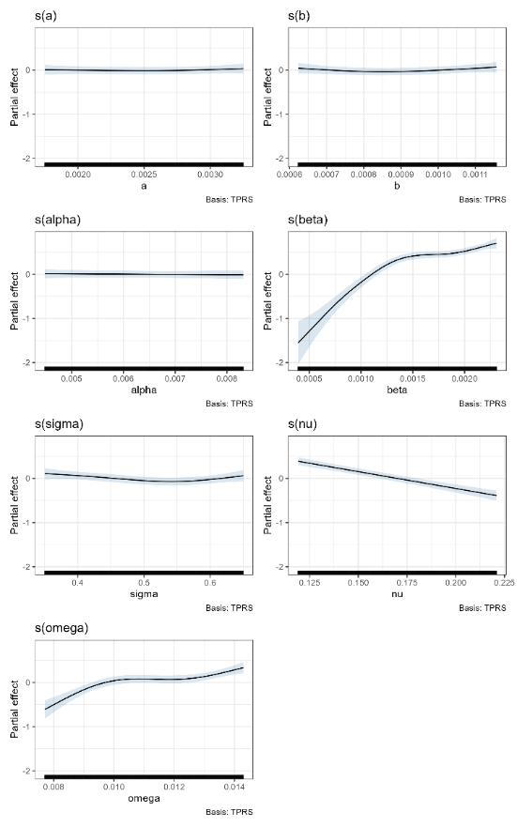
Figure A1. Partial effects of the values of the model parameters on the logarithm of the time to disease eradication in an unmanaged outbreak of FMD. Note, the large effect of the value taken by the parameter β, which represents the density-dependent transmission rate of FMD between individual pigs.

The dynamics of simulated unmanaged outbreaks under low, likely and high values of beta are illustrated in Figure A2. Under a low-beta scenario, the number of infected animals initially increased, reaching a peak within the first few weeks of the outbreak, before declining to zero. It appears that, under such conditions, rates of transmission are insufficient for the disease to establish and become self-sustaining.
In contrast, under a high-beta scenario, the population experienced a rapid increase in the number of infected individuals, peaking within a few weeks of the commencement of the outbreak before rapidly declining as infected individuals either recovered or died. While some trajectories resulted in extinction of the disease, a large proportion of simulation runs led to the disease being maintained in the population out to the five-year mark, albeit at relatively low prevalence.
Scenarios run under the likely value of beta represented a middle ground between these two extremes, with a lower peak prevalence, and the majority of simulated trajectories resulting in extinction of the disease, with a minority of replicates resulting in persistence of the disease for months or years. Suppression of the total abundance of pigs by the disease under the likely and low-beta scenarios was minimal, while under high-beta scenarios, numbers were typically suppressed in the long term to around 80% of the carrying capacity of 500 pigs.
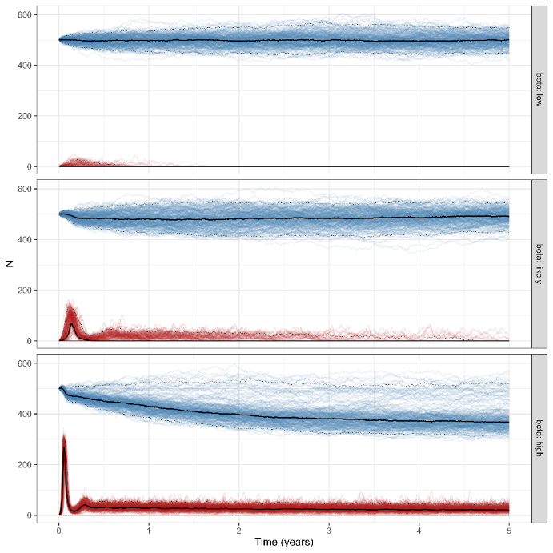
Figure A2. Trajectories of simulated FMD outbreaks where beta (transmission parameter) is set at the lower bound (top), likely value (middle) or upper bound (bottom). Each coloured line represents a separate run of the stochastic simulation, with heavy and light black lines giving the median and 95% confidence limits. The blue lines are the total number of pigs in the population and the red lines are number of pigs infected with FMD. 250 simulations were run for each of the three assumed values of beta. All other parameters were held at their likely values (Table A1).

The implications of ‘worst-case’ high transmission parameter conditions on the effectiveness of one-off cull operations are illustrated in Figure A3. All culls were conducted on day 28 of the outbreak. These simulations revealed that reliable suppression of the outbreak required culling of over 60% of the population, with only the 80% culling scenario resulting in reliable eradication of the disease. Low culling fractions (20 or 40%) frequently failed to eradicate the disease, with FMD persisting (albeit at low prevalence) in such populations for years in a substantial proportion of simulation runs (Figure A3).

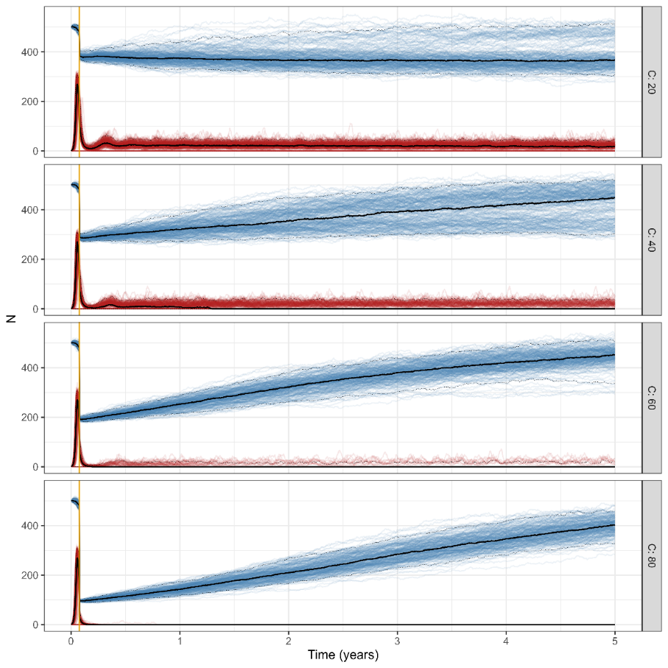
Figure A3. Simulated FMD outbreaks where the transmission parameter beta is set at its upper bound. A one-off culling operations of varying intensity (C=20, 40, 60 or 80%) is conducted at 28 days after the origin of the outbreak. Blue lines are total population size (N), and red lines are the number of infected animals (exposed + infectious) over time. Light and heavy black lines give the median and 95% confidence intervals across all 250 runs of the simulation.

  - High Pathogenic Avian Influenza in Little Penguins
To Investigate the consequences of an outbreak of H5N1 on Little Penguins on Phillip Island, we constructed the following model:
$$\frac{dS}{dt}=-βSI \\ \frac{dI}{dt}=βSI- υI-αI \\ \frac{dR}{dt}=υI \\ \frac{dD}{dt}=αI \\ N=S+I+R$$
Where $S$, $E$, $I$, $R$ are as described previously and $D$ refers to the number of deaths in the population, with $α$ being the mortality rate due to HPAI infection. Parameter values are provided in Table A2. This model was based on the one developed for HPAI and LPAI in waterfowl in North America (Hénaux et al. 2010), and represents the dynamics of AI in a population closed to births, natural deaths, immigration or emigration. The rationale for assuming the population to be closed to natural births and deaths is that an outbreak of HPAI in a susceptible host would be rapid, such that the population dynamics of the host can be ignored for the duration of the epidemic. This model was used as the basis for the construction of the stochastic individual-based model.
Table A2. Parameter values used to model an outbreak of HPAI in Little Penguins. Parameter values are per day.
Parameter | Description | Values (day⁻¹)
$$N$$ | Initial population size | 1000
$$β$$ | Transmission rate (scaled to initial $N$) | 0.00085
$$υ$$ | Recovery rate (inverse of infectious period) | 1/5
$$α$$ | Disease-induced mortality rate | 1/10
$$γ$$ | Vaccination rate | Variable [0–95%]
$$ω$$ | Loss of vaccine immunity | 1/175

To model vaccination strategies for Little Penguins, we assumed that vaccination was applied over a period of time (e.g. one month) reflective of the amount of time taken to achieve the required rate of population coverage. To facilitate this, an extra vaccinated class, $V$, was added to the model with vaccinated individuals added progressively over the designated period. Therefore, the model was modified with the following additions:
$$\frac{dS}{dt}=-βSI-γS+ωV \\ \frac{dV}{dt}=γS-ωV$$
Where $γ$ is the rate of vaccination and $ω$ is the rate of loss of vaccine immunity, which was set at 1/175 (Table A2). To achieve a desired proportion of vaccine coverage (e.g. 80%), the daily vaccination rate $γ$ was calculated as ${-\text{log}\left(1-p\right)}/τ$ , where $p$ is the desired proportional coverage and $τ$ is the period (days) where the vaccine was applied. We investigated scenarios where vaccination was applied prophylactically (e.g. just prior to disease arrival) as well as when diseased birds were first detected, which was assumed to be one week following initial disease arrival. We examined varying rates of vaccine coverage between 20% and 95% of the population vaccinated.

Using the default parameter values (Table A2), the basic disease reproduction number $\left(R_{0}\right)$ of HPAI in Little Penguins in this model system is given by (e.g. Caley and Ramsey 2001):
$$R_{0}=\frac{βN}{α+υ}$$
which, for an initial population of susceptible penguins ($N$) of 1000 gives an estimate of $R_{0}$ = 2.7, which is within the plausible range of values assumed for HPAI in waterfowl (Bourouiba et al. 2011).
Simulation of the 250 random sets of parameter values using Latin Hypercube sampling revealed the potential variation in the response of Little Penguins to HPAI to variation in the key epidemiological parameters. The proportion of deaths in the population (mortality rate) was most sensitive to variation in the transmission rate $\left(β\right)$, the mortality rate due to HPAI $\left(α\right)$ as well as the recovery rate $\left(υ\right)$, while peak HPAI prevalence was most sensitive to the transmission rate as well as the recovery rate (Figure A4). In general, the epidemiology of HPAI appeared to be little influenced by variation in the latent period $\left(σ\right)$ (Figure A4).
Further results relating to the effect of vaccination against HPAI on Little Penguins are given in Figure A5 and A6. These are discussed in detail in Section 3.5.2.
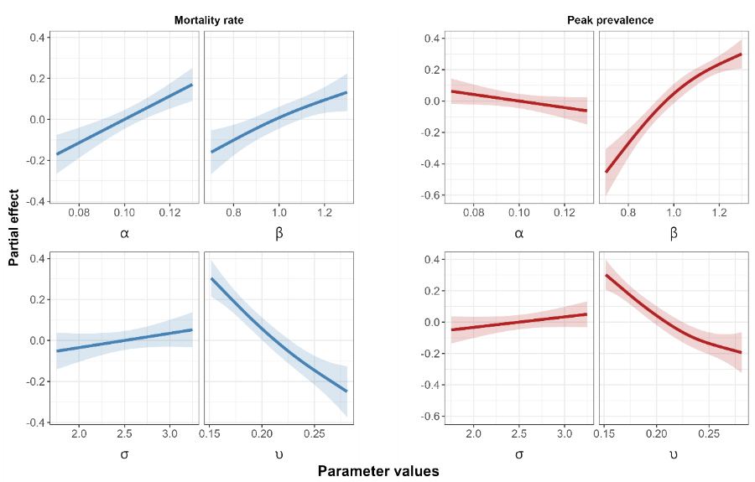
Figure A4. Sensitivity of the mortality rate (left) due to and peak prevalence (right) of HPAI in Little Penguins, with respect to variation in the key epidemiological parameters.

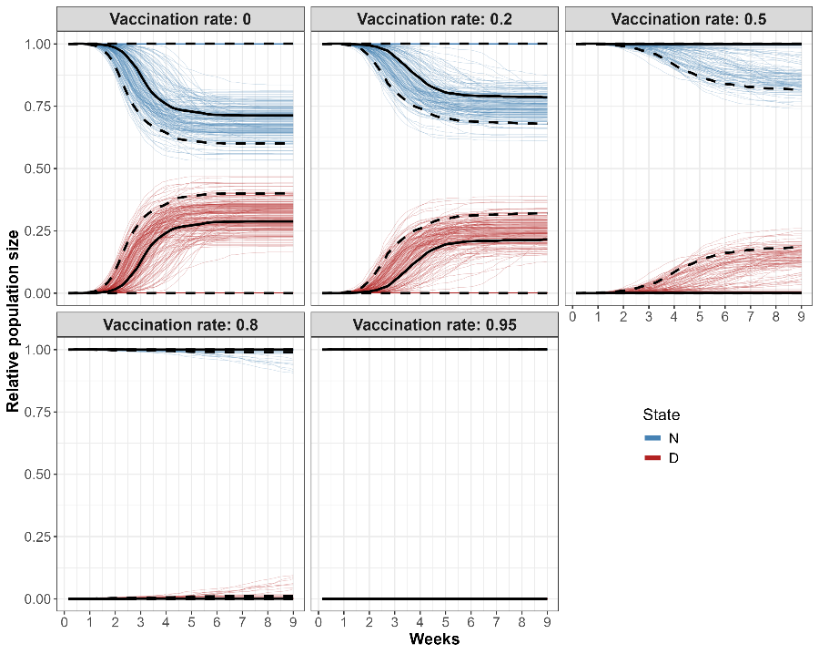
Figure A5. Trajectories for total population (N) and mortality rate (D) under vaccination programs achieving varying levels of population coverage. Vaccination was assumed to be applied just prior to the arrival of HPAI.

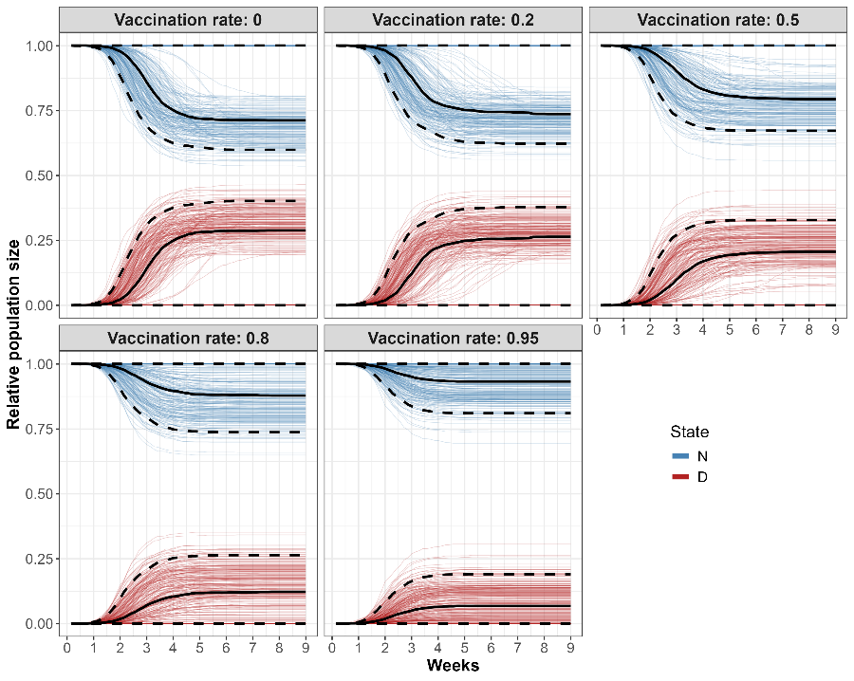
Figure A6. Trajectories for total population (N) and mortality rate (D) under vaccination programs achieving varying levels of population coverage. Vaccination was assumed to be initiated 5 days following the arrival of HPAI, taking 30 days to achieve the desired level of population coverage.
  - White Nose Syndrome in Southern Bent-wing Bats
The dynamics of SBWBs and epidemiology of WNS during a period when bats are in torpor was represented by the following set of differential equations.
$$\frac{dS}{dt}=-\left(βI+ ψP\right)S- dS \\ \frac{dE}{dt}=\left(βI+ ψP\right)S- \left(τ+d\right)E \\ \frac{dI}{dt}=τE- \left(d+α\right)I \\ \frac{dP}{dt}=\left(ηP+ ωI\right)\left(1-\frac{P}{K_{p}}\right) \\ N=S+E+I$$
Where $S$, $E$, $I$ are abundance of susceptible, exposed and infected bats, respectively with the total population $N=S+E+I$. The parameters $β$ and $ψ$ are the bat-to-bat and environment-to-bat transmission rates of WNS, respectively, where $P$ represents the abundance of the pathogen in the cave environment (Meyer et al. 2016). Bats exposed to the fungus become infected at a rate $τ$ and $ω$ is the rate of shedding of fungal spores from infected bats to the cave environment. Bats are also subject to natural mortality at a rate $μ$, with $δ$ representing the extra mortality rate of bats infected with WNS during the period of torpor. In the cave environment, the pathogen, $P$, grows logistically at a rate, $η$, eventually reaching the carrying capacity of the cave environment, $K_{p}$.
SBWBs congregate around three main maternity caves located at Naracoorte, South Australia, and Warrnambool and Portland in Victoria during the warmer months, starting from around early September and finishing around late May (van Harten 2020). Numbers peak in the maternity caves during early summer and during this time, females give birth to a single pup with juveniles emerging from the cave during January (van Harten 2020). During the roosting phase, bats can reach high densities inside the maternity caves and therefore, the risk of exposure to WNS from the cave environment is likely to be high. However, as bats are highly active and maintaining normal body temperatures during this time, it is unlikely that bats become infected with WNS. As a result, it is assumed that bat-to-bat transmission and shedding of the pathogen to the cave environment is negligible (Cornwell et al. 2019). The dynamics of WNS were therefore represented as follows:
$$\frac{dS}{dt}=-ψPS- dS+εI+γE \\ \frac{dE}{dt}=ψPS-\left(d+γ\right)E \\ \frac{dI}{dt}=-\left(ε+d\right)I \\ \frac{dP}{dt}=ηP\left(1-\frac{P}{K_{p}}\right)$$
In addition, bats previously exposed or infected during the torpor phase, that survive and enter the roosting phase, have the opportunity to clear their infection and recover at a rate,$γ$, and, ε,, respectively, whereupon they re-enter the susceptible class. During the summer breeding period, juveniles are recruited to the volant population at a rate, $b$, which is also subject to density-dependence. Since bat-to-bat transmission during this period is assumed to be negligible, recruits initially enter the susceptible population. The equation for the susceptible class was therefore modified to include the recruitment pulse as follows:
$$\frac{dS}{dt}=\left(b-gN\right)N-ψPS- dS+εI+γE$$
Where $b$ is the per-capita recruitment of juveniles to the volant population and $g$ represents the strength of density-dependence. Recruitment rate was estimated as the difference between the pre-volant and volant counts of bats emerging from caves near Warrnambool (Figure A7). The study of Meyer et al. (2016) estimated the basic disease reproductive rate, $R_{o}$, during the hibernation phase as:
$$R_{o}=\frac{βNτ}{\left(α+d\right)\left(τ+μ\right)}$$
Which was estimated as 4.15. This value was used to derive a transmission rate for SBWBs to give the equivalent value of $R_{o}$.
Table A3. Parameter values used to model an outbreak of WNS in SBWBs. Parameter values are per day.
Parameter | Description | Values
$$K$$ | Bat carrying capacity | 18,000
$$b$$ | Recruitment rate during breeding period | 0.00823
$$d$$ | Natural mortality rate | 0.00061
$$g$$ | Density-dependent factor | 0.00076
$$β$$ | Bat-to-bat transmission rate | 4.19e-06
$$ψ$$ | Cave-to-bat transmission rate | 1.73e-13
$$τ$$ | Latent period | 1/83
$$α$$ | Disease-induced mortality rate | 1/60
$$γ$$ | Recovery rate of exposed bats during active phase | 0.00396
$$ε$$ | Recovery rate of infected bats during active phase | 0.00396
$$K_{p}$$ | Cave carrying-capacity for P. destructans | 1e10
$$η$$ | Growth rate of P. destructans in cave sediments | 0.5
$$ω$$ | Shedding rate from infected bats to cave sediments | 50

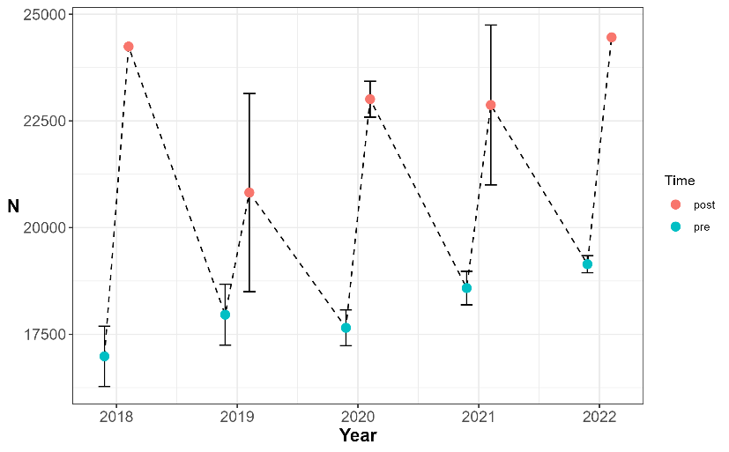
Figure A7. Counts of SBWBs (N) emerging from the Warrnambool cave and surrounding non-breeding caves during the breeding seasons 2018–2022 (Lumsden and Bush unpublished data). Counts were undertaken when pups were pre-volant (blue circles), and then around two months later as pups became volant (red circles). Error-bars denote the standard deviation of replicate counts.

Qualitatively, our model of WNS impacts on SBWBs was similar to that of Meyer et al. (2016), which indicated a 75% decline in Little Brown Bats within two years, assuming bats undergo a 7-month torpor period with eventual extinction within 10 years (Figures 16a,b).
As with the other case studies, we varied the values of the key parameters by $±$ 30% and then drew 500 random parameter values using Latin Hypercube sampling to determine the sensitivity of our conclusions to the key epidemiological parameters. Sensitivity analysis revealed that the proportional reduction in the population size after 10 years was most sensitive to the recovery rate of exposed bats, following emergence from winter torpor ($γ$) as well as the bat-to-bat transmission rate ($β$). Peak prevalence was most sensitive to both bat-to-bat and environment-to-bat transmission ($ψ$), as well as the latent period for exposed bats ($τ$) (Figure A8).

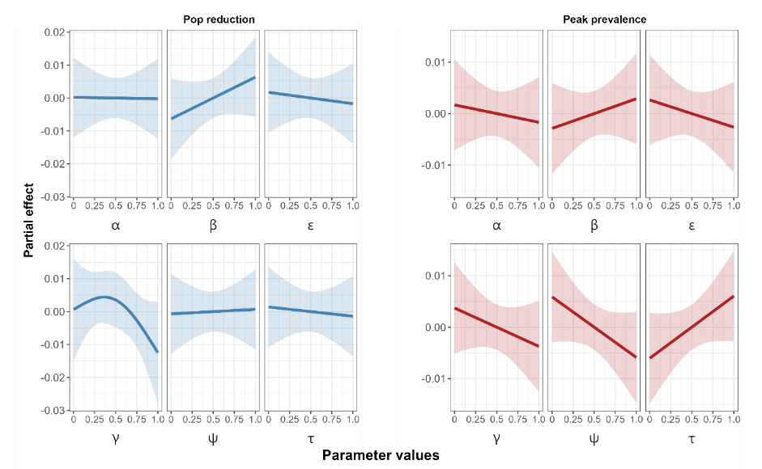
Figure A8. Sensitivity of the rate of population reduction (left) and peak prevalence (right) of WNS in SBWBs, with respect to variation in the key epidemiological parameters.
  - Amphibian chytrid fungus in Bell Frogs
To investigate the effects of thermal refuges on the population dynamics of Bell Frogs and the epidemiology of Bd, we constructed the following model:
$$\frac{dS}{dt}=\left(b-gN\right)N-ϕPS- dS \\ \frac{dI}{dt}=ϕPS- \left(d+α\left(Z\right)+γ\left(T\right)\right)I \\ \frac{dS_{r}}{dt}= γ\left(T\right)\left(I+ I_{r}\right)- εϕPS_{r}- dS_{r} \\ \frac{dI_{r}}{dt}= εϕPS_{r}-\left(d+ α\left(Z\right)+γ\left(T\right)\right)I_{r} \\ \frac{dP}{dt}=θP\left(1-\frac{P}{K_{p}}\right) \\ N=S+I+S_{r}+I_{r}$$
Where $S$, $I$, $S_{r}$, $I_{r}$ are the abundance of susceptible and infected frogs ($S, I$), and susceptible and infected frogs that had recovered from a previous infection ($S_{r}, I_{r}$). This model structure follows from the work of Waddle et al. (2024) where it was found that L. aurea that had recovered from a previous Bd infection following heat treatment by thermal shelters, were at lower risk of infection and impacts from subsequent Bd infections (prior exposure). Frogs could only recover from Bd infection once their temperature exceeded a threshold, set here at 25°C (Kinney et al. 2011), otherwise frogs remained infected. The parameter $γ\left(T\right)$ represents the temperature-dependent recovery rate of frogs from Chytridiomycosis with the mean time to recovery set at 27 days and was the same for both $I$ and $I_{r}$ stages (Waddle et al. 2024). Similarly, the Chytridiomycosis mortality rate $α\left(Z\right)$ was dependent on the (log₁₀) zoospore load of frogs, $Z$, which was, in turn, dependent on the prevailing temperature regime of the wetland environment (see main text for details). Due to the complex nature of the temperature and zoospore dependence of these parameters (e.g. $γ$, $α$), a deterministic, continuous-time model was not developed and therefore, modelling only involved the stochastic individual-based model.

Table A4. Parameter values used to model the epidemiology of chytrid in Bell Frogs. Parameter values are per day unless otherwise indicated.
Parameter | Description | Values
$$b$$ | Recruitment rate of adult frogs during breeding season | 0.0049
$$d$$ | Natural mortality rate of uninfected frogs | 0.0010
$$g$$ | Density-dependent factor | 0.0015
$$K$$ | Frog carrying-capacity of waterbody | 500
$$ϕ$$ | Transmission (contact) rate of chytrid from environment | 0.20/$K$
$$T_{r}$$ | Temperature above which, frogs could recover from chytrid | 25$°C$
$$γ\left(T\right)$$ | Temperature dependent recovery rate | 1/27 ($T$ $>T_{r}$)
$$ε$$ | Relative susceptibility of frogs previously exposed | 0.18
$$Z_{T}$$ | Zoospore load which initiates chytrid mortality (log₁₀ scale) | 4.0
$$Z_{max}\left(T\right)$$ | Maximum frog zoospore load (temperature dependent) | variable
$$α\left(Z\right)$$ | Chytrid mortality rate (zoospore dependent) | 0.0019 $\left(Z >Z_{T}\right)$
$$θ$$ | Maximum growth rate of zoospores in environment | 0.1
$$K_{p}$$ | Carrying-capacity of zoospores in environment (log₁₀ scale) | 50
$$υ$$ | Maximum zoospore growth rate on individual frogs | 0.5
$$Δ$$ | Increase in body temperature for frogs using thermal shelter | 4–8°C

We varied the values of the key parameters by $±$ 30% and then drew 1000 random parameter values using Latin Hypercube sampling to determine the sensitivity of our conclusions to the key epidemiological parameters. The proportional reduction in the population size after 20 years and peak prevalence were most sensitive to the temperature threshold triggering recovery from chytrid ($T_{r}$). Population reduction was also influenced by the threshold zoospore load triggering mortality from Chytridiomycosis ($Z_{T}$). Variation in the other parameters examined had relatively minor impacts in comparison (Figure A9).

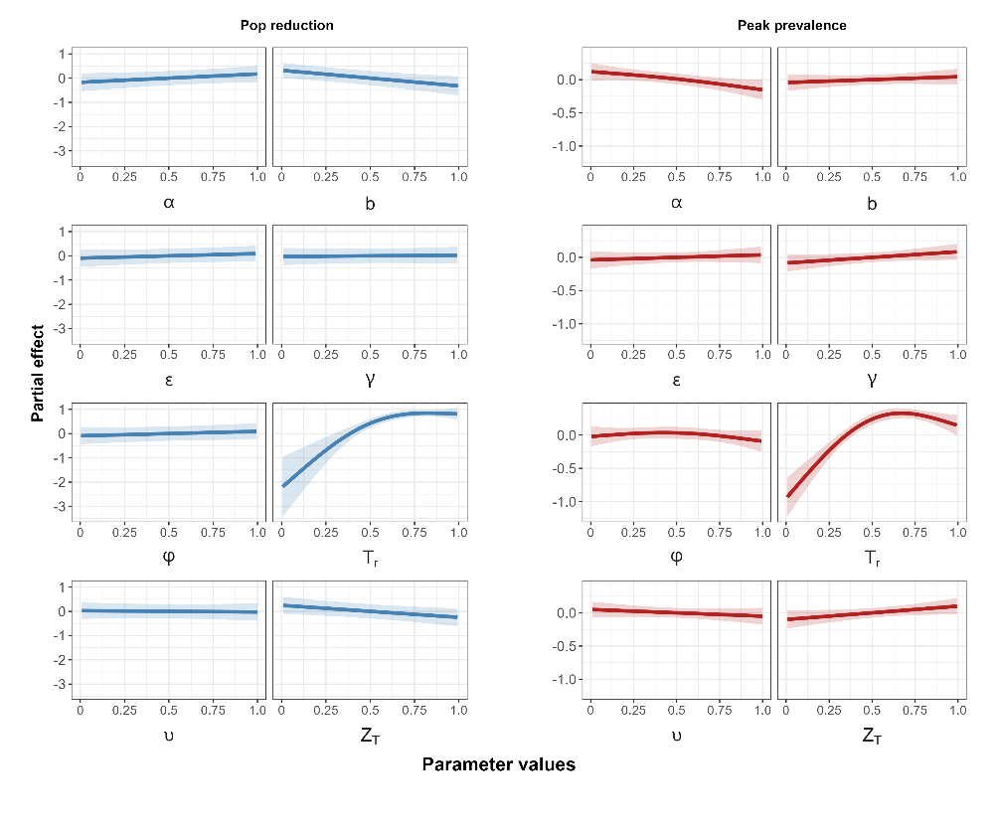
Figure A9. Sensitivity of the rate of population reduction (left) and peak prevalence (right) due to amphibian chytrid in Bell Frogs, with respect to variation in the key epidemiological parameters.

www.deeca.vic.gov.au

www.ari.vic.gov.au

