
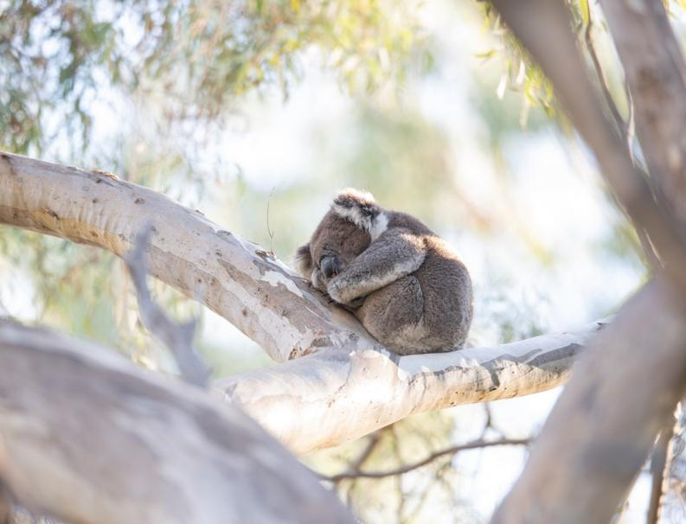

Arthur Rylah Institute for Environmental Research Technical Report Series No. 393
The status of Victoria’s Koala population
Surveys to estimate abundance, genetic diversity and Koala health
D.S.L. Ramsey, D.A. Whisson, J.G. Cally, L. Wicker, L. White, F. Hogan, C. Pacioni, C. Frere, K. Smith, A. Legione, L. Francis and P. Griffioen
June 2025








Arthur Rylah Institute for Environmental Research
Department of Energy, Environment and Climate Action
PO Box 137, Heidelberg, Victoria 3084
Phone (03) 9450 8600
Website: www.ari.vic.gov.au
Citation: Ramsey, D.S.L., Whisson, D.A., Cally, J.G., Wicker, L., White, L., Hogan, F., Pacioni, C., Frere, C., Smith, K., Legione, A., Francis, L. and Griffioen, P. (2025). The status of Victoria’s Koala population: Surveys to estimate abundance, genetic diversity and Koala health. Arthur Rylah Institute for Environmental Research Technical Report Series No. 393. Department of Energy, Environment and Climate Action, Heidelberg, Victoria.
Front cover photo: Resting Koala in Cobram (Justin Cally).
Edited by Fox Writing Services
ISSN 1835-3835 (pdf)
ISBN 978-1-76176-236-9 (pdf/online/MS word)

We acknowledge and respect Victorian Traditional Owners as the original custodians of Victoria’s land and waters, their unique ability to care for Country and deep spiritual connection to it.
We honour Elders past and present whose knowledge and wisdom
has ensured the continuation of culture and traditional practices.
DEECA is committed to genuinely partnering with Victorian Traditional Owners and Victoria’s Aboriginal community to progress their aspirations.
© The State of Victoria Department of Energy, Environment and Climate Action May 2025.
Creative Commons
This work is licensed under a Creative Commons Attribution 4.0 International licence, visit the Creative Commons website (http://creativecommons.org/licenses/by/4.0/).
You are free to re-use the work under that licence, on the condition that you credit the State of Victoria as author. The licence does not apply to any images, photographs or branding, including the Victorian Coat of Arms, and the Victorian Government, the Department and the ARI logos.
Disclaimer
This publication may be of assistance to you but the State of Victoria and its employees do not guarantee that the publication is without flaw of any kind or is wholly appropriate for your particular purposes and therefore disclaims all liability for any error, loss or other consequence which may arise from you relying on any information in this publication.
Accessibility
To receive this document in an alternative format, phone the Customer Service Centre on 136 186, email customer.service@delwp.vic.gov.au, or contact National Relay Service on 133 677. Available at DEECA website (www.deeca.vic.gov.au).

The status of Victoria’s Koala population

Surveys to estimate abundance, genetic diversity and Koala health

David Ramsey¹, Desley Whisson², Justin Cally¹, Leanne Wicker², Lauren White¹, Fiona Hogan³, Carlo Pacioni¹, Celine Frere⁴, Kelly Smith³, Alistair Legione⁵, Lachlan Francis¹ and Peter Griffioen¹

¹Arthur Rylah Institute for Environmental Research
Department of Energy, Environment and Climate Action
123 Brown Street, Heidelberg, Victoria 3084
²School of Life and Environmental Sciences
Deakin University
Locked Bag 20000, Geelong, Victoria 3220
³Institute of Innovation, Science and Sustainability
Federation University
PO Box 859, Berwick, Victoria 3806
⁴School of Environment
University of Queensland
Sir Fred Schonell Drive, St Lucia, Queensland 4072
⁵Melbourne Veterinary School
Faculty of Science
University of Melbourne
Cnr Park Dr and Flemington Rd, Victoria 3010

Date

Arthur Rylah Institute for Environmental Research
Technical Report Series No. 393

Acknowledgements
This project was funded by the Regulatory Reform and Emergencies Branch, Biodiversity Division, Department of Energy, Environment and Climate Action (DEECA) under the Victorian Koala Management Strategy.
For Koala surveys, we acknowledge Anthony Rendall for assisting with logistics and Matthew Lefoe, Stacey Harwood, Nell Glover, Richie Nguyen, Seb Snow, Joel Kraus, Simeon Zylinski, Angie Symon, Campbell Mole, Tom Healey, Kristal Kostoglou and Clorinda Schofield for assistance with field monitoring. We also thank Faye Wedrowicz (Federation University) for the genetic analysis of Koala scat samples as well as Andrew Hoskins (North Australian Indigenous Land and Sea Management Alliance) for access to the CSIRO Koala food tree spatial layer used in these analyses.
For the health and disease surveys, we acknowledge Hayley Forster, Stacey Harwood, Ryley Johnston for assisting with finding and capturing Koalas, and for assisting Leanne Wicker with the veterinary examinations and Elizabeth Dobson for provision of pathology services, including histopathology of necropsy tissues. Thanks also need to go to Lachlan Butson and Abby Smith for allowing us access to the management program at Budj Bim NP. Thanks also to the many DEECA personnel and hardwood plantation managers for assisting with access to monitoring sites. We also thank the multiple landholders and community groups who helped us locate Koalas.
We also acknowledge the volunteers who contributed to collecting Koala scats. These volunteers came from local property owners, Landcare and Friends groups and wildlife shelters. Your assistance with this project was invaluable.

Permits
Deakin Animal Ethics Committee: 2024/AE000016 (Koala health and disease) and 2023/AE028033 (Koala distribution and abundance). Wildlife Act Research Permit 10011001.

Contents
Acknowledgements ii
Tables v
Figures vi
Summary 1
1 Introduction 4
1.1 Objectives 5
2 Methods 6
2.1 Koala distribution and abundance 6
2.1.1 Sampling design 6
2.1.2 Monitoring 6
2.1.3 Analysis 7
2.2 Koala population genetics 10
2.2.1 Sample collection and DNA extraction 10
2.2.2 Genotyping and data filtering 10
2.2.3 Analyses 10
2.3 Koala health and disease 11
2.3.1 Study areas 11
2.3.2 Koala capture 12
2.3.3 Physical health assessment 13
2.3.4 Factors associated with chronic ill-health 14
3 Results 16
3.1 Koala abundance 16
3.1.1 Abundance at sampled sites 16
3.1.2 Statewide and regional abundance 16
3.2 Koala distribution 18
3.2.1 Factors influencing Koala distribution and abundance 19
3.2.2 Factors influencing Koala detection 20
3.3 Koala population genetics 22
3.3.1 Genotyping and filtering 22
3.3.2 Population genetic structure 23
3.3.3 Diversity and inbreeding 26
3.3.4 Dispersal across South Gippsland 27
3.4 Koala health and disease 28
3.4.1 Koala capture 28
3.4.2 Physical examination 28
3.4.3 Infectious disease 29
3.4.4 Non-infectious disease 31
3.4.5 Factors associated with chronic ill-health 34
4 Discussion 37
4.1 Koala abundance and distribution 37
4.1.1 Comparison to previous estimates 37
4.1.2 Drivers of Koala abundance and distribution 37
4.1.3 Future directions 38
4.2 Koala population genetics 38
4.2.1 Population genetic diversity and structure of Victorian Koalas 38
4.2.2 The spatial extent of the South Gippsland genetic cluster 38
4.2.3 Koala dispersal characteristics 39
4.2.4 The genetic management of Victorian Koalas 39
4.3 Koala health and disease 40
4.3.1 Infectious disease in Koalas 42
4.3.2 Non-infectious disease in Koalas 43
4.4 Recommendations 43
5 References 45
6 Appendix 56
6.1 Abundance and distribution model supplementary details 56
6.1.1 Abundance model details 56
6.1.2 Detection process 58
6.1.3 Cross-validation and posterior predictive checks 59
6.1.4 Koala presence probability 61
6.1.5 Threshold of abundance estimates to generate occupancy distribution 62
6.1.6 Covariate estimates 63
6.2 Koala call recogniser development 64
6.2.1 Sample structure 64
6.2.2 Convolutional Neural Network (CNN) model 64
6.2.3 Field data processing 65
6.2.4 Data validation 65
6.3 Population genetics supplementary method details and results 66
6.4 Further genetics results derived from Koala scats 69
6.4.1 Genotyping 69
6.4.2 Population structure analysis 69
6.5 Heath and disease surveys 71
6.5.1 Koala capture 71
6.5.2 Physiological parameters and response to anaesthesia 71
6.5.3 Health indicators and body measurements 72

Tables
Table 1. Descriptions of the covariates used to model Koala abundance and distribution. 8
Table 2. Characteristics of study regions selected for health and disease surveys. 12
Table 3. Variables relating to disease diagnoses, health conditions and environmental variables used to predict Koalas presenting with chronic ill-health requiring euthanasia during the health and disease surveys. 15
Table 4. Regional and statewide estimates of Koala abundance (rounded to the nearest 100) for native forest and plantations across both survey years. SD = standard deviation, CV = coefficient of variation. Density is in Koalas per suitable habitat km². 17
Table 5. Sample sizes and summary statistics for each sampling region. n=number of samples, F_{H} = individual inbreeding, PH_{t}=internal heterozygosity, Ne=effective population size, sd=standard deviation, 95% CI = 95% confidence intervals. n(subset) excludes samples of related individuals. IPA = Indigenous Protected Area. 23
Table 6. Distribution of captures across life stages and sexes. 28
Table 7. Summary of the average Koala body condition scores (BCS) assessed through physical examination. 1 – emaciated, 5 – excellent condition¹. Values in brackets provide the range. n – sample size. The number of reproductively mature females (Mature females) and the percentage observed to have recently reproduced (% Breeding). 29
Table 8. Infectious organisms found during in-field clinical examination, necropsies, and via molecular diagnostics for 68 Koalas from seven regions in Victoria. n – total number examined or tested, P – prevalence of condition. 30
Table A1. Marginal coefficients for covariates used in the Poisson process when modelling Koala abundance. Covariates with 90% confidence intervals (CI) that do not overlap zero are shown in bold. SD = Standard Deviation. NPP = Net Primary Productivity, TWIND = Topographic Wetness Index. 63
Table A2. Accuracy of the three Convolutional Neural Network (CNN) models applied to the Koala call recogniser training data. 64
Table A3. Confusion matrix for the manual validation of Koala detections from the final Convolutional Neural Network (CNN) ensemble model. 65
Table A4. Details of the genetic data filtering steps used in this study. SNP = Single Nucleotide Polymorphisms. 66
Table A5. Capture details for 62 Koalas captured using the ‘noose and flag’ method. Duration of capture was measured from first disturbance (flagging or noosing) to restraint in bag. 71
Table A6. Body temperature, heart rate and respiratory rates recorded on first measurement following induction of anaesthesia. 71
Table A7. Health indicators, morphometrics and other animal related parameters assessed and recorded for each Koala. 72
Table A8. Koala age, reproductive maturity and life stages, following the approaches described by Canfield et al (1989) and Butcher et al (2020). TWC = Tooth Wear Class. 74
Table A9. Body condition scoring for Koalas in this study. 74

Figures
Figure 1. Locations of monitoring sites used to estimate the abundance of Koalas (red/orange circles). Coloured regions give the associated sampling probabilities used during the site selection process. 6
Figure 2. Prediction layer raster at 1-km resolution used to model Koala distribution and abundance, showing the area of potential Koala habitat within each grid cell included in the original sampling design. 8
Figure 3. Sample size of captured Koalas (n) within the seven regions selected for health and disease surveys. 12
Figure 4. Koala detections (0 – absent, 1 – present) from transect counts or acoustic monitoring from 182 sites across two survey years, 78 out of 174 for 2022–23 and 80 out of 141 for 2024. 16
Figure 5. Abundance of Koalas in Victoria for both survey years. Abundance is estimated at a 1-km² spatial resolution and considers the proportion of each grid cell with potentially suitable habitat. White areas have no estimated suitable habitat. 18
Figure 6. Distribution of Koalas in Victoria for 2024 according to the mean threshold abundance predictions (areas with more than 2.35 Koalas per km² are considered occupied). The proportion of area occupied in each 1-km² grid cell accounts for the proportion of suitable Koala habitat (Figure 2). 19
Figure 7. Partial (marginal) covariate effects on Koala abundance. The continuous covariate values (x-axis) are scaled. MrVBF = Multi-resolution valley-bottom flatness and TWIND = Topographic Wetness Index. 20
Figure 8. Effect of (A) windspeed on nightly Koala acoustic detection probability and (B) cumulative detection probability of Koalas with number of deployment days for two acoustic recorders (songmeters) when density was 5 Koalas per km² and under average windspeed conditions. 21
Figure 9. The mark-recapture model estimate of the detection (recapture) probability for each observer (Obs1 and Obs2) and observers combined (Obs1 $∪$ Obs2), The estimate of g(0) is the intercept of the blue line. The value of g(0) was then combined with the distance-sampling detection probability function to estimate an overall detection probability for a 90-m half-strip width transect. 22
Figure 10. Genetic sampling locations for all blood and tissue samples included in the dataset after filtering. Each point represents a sampled individual. IPA – Indigenous Protected Area. 23
Figure 11. Principal components analysis results showing PCs 1 and 2. Each point represents an individual coloured by sampling region. Placement relative to other samples is indicative of genetic similarity. IPA – Indigenous Protected Area. 24
Figure 12. ADMIXTURE results. Each bar represents an individual, grouped by sampling region. Colours represent the estimated proportional ancestry from each cluster. Results of analyses are shown for which the number of clusters was assumed to be three (K=3), based on the cross-validation results (Figure A4 – Section 6.2). IPA – Indigenous Protected Area. 24
Figure 13. (A) Results from the tess3R analysis (top figure) (colours represent the distribution of ancestral clusters, interpolated across space; black points indicate sampling locations; red polygon shows the boundary of the South Gippsland cluster); and (B) close-up topographic map (bottom figure) showing the boundaries of the South Gippsland cluster (red polygon). 25
Figure 14. Individual inbreeding (F_{H}) results by sampling region. Each point represents a sampled individual. Middle horizontal lines represent the median, the boxes are bound by the 25th and 75th quartiles and vertical lines show the minimum and maximum range of values excluding outliers. 26
Figure 15. Genetic diversity (internal heterozygosity, PH_{t}), interpolated across the study area. Black points represent included samples. 27
Figure 16. Spatial autocorrelation plots (i.e. correlograms) calculated using individuals sampled within the South Gippsland, Erica or Gippsland Lakes regions. Each point represents a distance class for which a Mantel test was run, and the y axis represents the Mantel correlation coefficient, r. Points are sized by how many pairs of individuals were found in that distance class. Red circles represent values for the Mantel r that are significantly greater than zero (the dotted black line). 27
Figure 17. Dental malocclusions commonly seen in Victorian Koalas. 32
Figure 18. Dental disease in Koalas. 33
Figure 19. Plots of the marginal effect size of each variable (disease diagnostic, health condition or environmental) on Koala ill-health (euthanised – 1 or released – 0). Effect sizes were estimated from a BRT model with 650 trees using 10-fold cross validation to determine the optimal tree size. Vertical lines give the 95% confidence intervals based on fitting the final BRT model to 500 bootstrap samples of the dataset. Values in brackets give the relative influence (%) of that variable. 35
Figure 20. Partial dependence plot for the interaction between Koala density and the occurrence of dental disease on the probability of Koala euthanasia. Boxplots were generated from fitting the final BRT model to 500 bootstrap samples of the dataset. Black horizontal line denotes the median, box size gives the interquartile range and lines give 1.5 times the interquartile range. 36
Figure A1. Distribution and relationship of acoustic and transect counts in 2023 and 2024. 58
Figure A2. A comparison of the probability of detecting at least one Koala for two acoustic devices over seven or 14 nights to the detection probability along transects. 59
Figure A3. Posterior predictive checks (PPCs) compare the observed counts against the model predicted values. Within our integrated models, these are generated for total acoustic nightly detections (purple) and total observed Koalas on the transect (teal). PPCs include a comparison of the proportion of zeros in the data (A,B), the mean number of detections and counts (C,D) and the maximum number of detections and counts (E, F). The mean acoustic detections and transect counts are also compared using scatterplots following square root transformation (G, H).. 60
Figure A4. Realised gaussian process showing the estimates for habitat suitability ($ψ$) in the zero-inflation section of the model. 62
Figure A5. The distribution of Koalas in Victoria in 2023 and 2024. If at least part of a 1 km2 grid cell is estimated to have Koala densities above the threshold value, then the grid is considered occupied. Confidence intervals are shown with variable shadings. 61
Figure A6. Distribution of scores from the Convolutional Neural Network (CNN) model classifier for snippets that were validated as either being a Koala or not a Koala. Only 5% of validated Koala calls were below 0.5. 65
Figure A7. Individual call rate and inbreeding coefficient before (above) and after (below) applying more stringent filtering thresholds and removing scat samples from the dataset. 68
Figure A8. ADMIXTURE cross-validation (CV) error for each value of K (the number of putative ancestral populations or genetic clusters). The lowest CV score indicates the most appropriate K given the data. 68
Figure A9. Spatial distribution of Koala samples coloured by STRUCTURE-inferred genetic cluster assignment. Only individuals with >60% ancestry assigned to a single cluster are shown; admixed individuals (Q ≤ 0.6) are excluded for clarity. 70
Figure A10. Population genetic structure inferred using GENELAND on the Koala samples (scats + blood) collected during this project. 70
Figure A11. Radiographs taken post-mortem of a female found moving slowly, with an abnormal gait, in the Murray River region. 75
Figure A12. A Malignant thyroid carcinoma (A) in the thoracic cavity of a female Koala from the Ballarat area (surrounded by yellow arrows). This mass occupied a significant portion of the animal’s thoracic cavity. B The light blue arrows point to masses seen on the surface, and within the tissue of both kidneys at gross necropsy. 76

Summary
Context:
In Victoria, the status of Koala (Phascolarctos cinereus) populations varies greatly across the species’ range. In some areas Koalas can reach unsustainable densities leading to overbrowsing and ultimately, significant welfare implications for affected Koalas. Koalas also occur at high densities in Victoria’s hardwood plantation estate. In other areas of Victoria, Koalas occur in naturally low densities throughout lowland and foothill eucalypt woodlands. Despite the long history of Koala management and the differing population status across Victoria, a state-wide Koala population survey has never been conducted.
Previous research has identified that many of Victoria’s Koala populations have low genetic diversity, which has implications through increased risk from the impacts of disease, climate change and other stressors. While the role of Koala genetics in disease susceptibility and expression is poorly understood, recent studies have shown a genetic role in several important infectious and non-infectious diseases in Koalas. Therefore, understanding the genetic variation in Victoria’s Koala population may have significant implications for how they are managed to mitigate disease risks.
This project sought to undertake population, genetics, health and disease monitoring across the state to better understand the status of Victoria’s Koala population. Monitoring was undertaken using a scientifically rigorous sampling design to obtain a robust, contemporary estimate of the abundance and distribution of Victoria’s Koala population. In addition, capture and sampling of Koalas was undertaken at selected sites across their range to estimate genetic diversity and population structure, including the genetic extent of the remnant Koala population in South Gippsland. Extensive sampling of captured Koalas also provided baseline data on the health status and presence of infectious diseases such as Chlamydia (Chlamydia pecorum), and Koala Retrovirus (KoRV). Koala abundance, genetics, health and disease data collected during this project were used to help understand the potential threats to Koalas and provide baseline data on the status of Victora’s Koala population. This information will be used to refine Koala management strategies, which will help secure the future for Victoria’s Koala population.
Aims:
The specific aims of this project were to:
- Design and undertake a Koala population survey for Victoria that will provide robust estimates of abundance and distribution on public land in Victoria. An additional component of this aim was to undertake surveys and provide estimates of Koala abundance for Victoria’s eucalypt plantations.
- Conduct genetic analysis to provide information on the genetic diversity and population structuring of Koala populations, including analysis to more clearly define the genetic extent of the remnant South Gippsland Koala population.
- Conduct health and welfare assessments and targeted disease surveillance to provide baseline data on the health status of Koalas, to better understand the occurrence of diseases and their potential impact on Koala populations.
Methods:
The abundance and distribution of Victoria’s Koala population was estimated from monitoring data collected at 182 sites selected across the Koala range using a spatially-balanced random sampling design. Surveys were undertaken in both 2023 and 2024. At each site, Koalas were monitored using two different methods: (1) observations of Koalas on 1-km walked transects using double-observer distance sampling methods and (2) a pair of acoustic recorders placed at each site >600 m apart attached to trees approximately 1.5 m above the ground to detect Koala vocalisations.
Genetic analysis was undertaken using 2257 Single Nucleotide Polymorphisms (SNPs), extracted from 111 blood and tissue samples from 10 different locations across the Koala’s range. Additional analyses were also undertaken on a panel of 12 microsatellite markers extracted from 144 Koala scats. Population genetic structure was examined by estimating the likely number of ancestral populations (genetic clusters). The pattern of genetic structuring was then projected over space to visualise the spatial extent of each cluster.
We also quantified individual inbreeding (F_{H}) and the proportion of heterozygous loci (PHt) for each individual from allele frequencies. Furthermore, we characterised Koala dispersal for samples in South Gippsland and the Gippsland Lakes using spatial autocorrelation of genetic similarity (i.e. genetic isolation by distance).
For the health and disease surveys, Koalas were captured from seven different regions that broadly represented a range of environmental conditions, landscapes, habitat types, tree species and Koala population densities. Each Koala was given a general anaesthetic under the guidance of a veterinarian and then subject to a thorough physical health examination and the collection of a range of biological samples following a standardised approach. Blood and tissue swab samples were taken for molecular diagnostics for infectious diseases including Chlamydia, KoRV and Phascolarctid Gammaherpesviruses (Pha-HV). Blood samples were also subject to haematological and biochemical analyses.
Results:
Following the abundance monitoring, Koalas were detected at 95 out of the 182 unique sites (52%). Koalas were detected on walked transects at 22% of sites and on 64% of sites that had acoustic recorders. Total Koala population size across Victoria was estimated at 217,100 individuals [90% CI: 174,900 – 266,200] in 2023 and 224,800 individuals [90% CI: 181,300 – 276,600] in 2024. In 2024, a total of 51,700 Koalas were estimated to reside in the hardwood plantation estate. The average density of Koalas in Blue Gum (Eucalyptus globulus) hardwood plantations in southwest Victoria was more than six times higher than in neighbouring native forest (65.6 vs 9.8 Koalas per km²). The distribution of Koalas in Victoria was estimated at 19,459 km² (90% CI: 14,067 – 31,775), which represents around 34% of the modelled, potentially suitable Koala habitat in Victoria.
Genetic analyses revealed that Koalas in the South Gippsland region have higher diversity than the rest of the state, supporting the results of previous research. Analysis to define the spatial extent of the South Gippsland cluster suggested that the cluster boundaries likely extend from Corinella and Western Port Bay in the east, to Loch Sport in the Gippsland Lakes region, and are restricted to the north by the Central Highlands. Analysis of the genetic structure derived from the microsatellite markers further suggested that the South Gippsland cluster included populations from Wilson’s Promontory. Genetic results also indicated that the eastern populations of Gelantipy and Mallacoota had the highest inbreeding and lowest diversity in the state. All other sampled sites had diversity and inbreeding metrics that were intermediate between South Gippsland and Gelantipy. Our analysis of Koala dispersal in the Gippsland region indicated that most dispersal events occur within 25 km.
A total of 68 Koalas were sampled for health and disease assessments. Based on the in-field clinical exams, 39 (57%) Koalas were considered healthy and released, while 29 Koalas (43%) were found to be in poor health and were euthanised on welfare grounds. Healthy Koalas were recorded from all locations and across all life stages, although were less frequently recorded for older (senior) animals. Infectious organisms were detected in 59% of Koalas with Chlamydia percorum DNA detected in 43% of Koalas, KoRV pol DNA detected in 23% of Koalas and Pha-HV detected in 10% of Koalas. There was no clear association between detection of infectious disease agents and health concerns on physical examination. Analysis revealed that Koalas that were euthanised due to ill-health were more likely to have poor coat condition, dental disease, and ‘wet bottom’, and were more likely to occur in areas with high Koala densities. Dental disease was recorded in 37% of Koalas across all life stages and regions, except Mallacoota, with just over half of all cases associated with dental malocclusion. There was little evidence of other diseases, such as Sarcoptic Mange and Oxalate Nephrosis.
Conclusions and implications:
Approximately 23% of Victoria’s Koala population now resides in the Blue Gum (Eucalyptus globulus) plantation estate where they occur at much higher density than Koalas in neighbouring native forest. Given the high estimated density of Koalas within Blue Gum plantations, changes to the plantation estate size and/or stand ages may result in significant changes to population size.
Victorian Koalas are considered genetically vulnerable, with low adaptive potential to face emerging threats and future climates. Therefore, gene flow augmentation should be considered to prevent inbreeding depression and increase the adaptability of Victorian Koala populations. If augmented gene flow is considered for Victorian Koalas, the South Gippsland population would represent the best source population available in the state due to its higher diversity and comparably stable demographic history. However, as Koalas from northern NSW and Queensland have higher genetic diversity than Victorian populations, any gene flow augmentation plan could also consider sourcing Koalas from these populations.
Our study raises concerns for the health of Victorian Koalas. We found a higher-than-expected proportion of Koalas from seven geographically distinct regions in a state of chronically poor health and welfare. Clinical signs consistent with chronic ill-health were observed across all life stages, suggesting that multiple individual, environmental and demographic stressors may be contributing to prolonged physiological stress within these populations. Infectious diseases were widely detected, although there was no clear relationship between infection status and the expression of clinical signs of disease. Dental disease secondary to dental malocclusion was also frequently observed, suggesting that this may play a more significant role in poor health outcomes for Koalas than previously thought. The possible link between dental malocclusion, dental disease and low genetic diversity in Victorian Koalas should be further investigated.
Our study provides important information on the status of Victoria’s Koala population, documenting current distribution and abundance, genetic health, disease status and general health and welfare across a number of regional Koala populations. Based on these results, we therefore make the following recommendations:
- Periodic monitoring (e.g. at 5-yearly intervals) of Koalas is required to determine statewide trends in Koala abundance and distribution, especially in the Blue Gum plantation estate.
- Information on plantation age and rotation for Victoria’s hardwood (Blue Gum) plantation estate is required to better understand how changes in hardwood plantations affect Koala populations using these habitats.
- Since a high proportion of the Victorian Koala population resides in Blue Gum plantations, research is urgently needed to better understand the fates of these Koalas following plantation harvesting.
- Genetic management is needed for Koala populations identified as having a high risk of inbreeding depression (e.g. Ballarat, Murray River, Mallacoota) to increase genetic diversity. To augment genetic diversity in these populations, consideration should be given to introducing Koalas from the South Gippsland genetic cluster. Alternatively, Koalas sourced from areas with relatively higher genetic diversity, such as NSW, could also be considered for translocation to Victorian populations of relatively low genetic diversity.
- To help facilitate genetic management, consideration should be given to undertaking population viability analysis (PVA) that includes a genetic component, to better understand the long-term outcomes of any planned translocation program to improve genetic diversity.
- Further research is required to better understand the diversity of factors contributing to poor health in Koala populations and the significance of these factors to the long-term viability of Koalas in Victoria. This would involve sampling at more locations to better understand variation in genetics, infectious and non-infectious diseases and Koala health across their range in Victoria.
- Further research should be undertaken to better understand the relationships between genetics and the occurrence of dental malocclusion and other craniofacial abnormalities in Victorian Koalas.
- Koalas captured in management programs should undergo a thorough physical examination, involving the collection of genetic, diagnostic and disease screening samples to help understand relationships between disease processes and the individual, environmental and population factors that influence disease exposure and expression.
- A central repository for Koala health data, samples, and DNA extractions should be established. This could utilise pre-existing disease surveillance projects such as Wildlife Health Australia’s electronic Wildlife Health Information System, Melbourne University’s Wildlife Health Surveillance program and other university research projects investigating the presence of specific infectious organisms in Koalas, as well as mandatory record keeping and reporting for registered wildlife carers in Victoria. Such a repository would provide a more comprehensive understanding of the distribution and prevalence of disease processes and health status of Koalas in Victoria.
- There is an urgent need to address the significant health and welfare issues associated with unsustainably high-density Koala populations, and to ensure that Koala welfare and population management objectives are evidence-based and regularly evaluated.

- Introduction
The Koala (Phascolarctos cinereus) is an iconic Australian marsupial that is distributed widely across eastern Australia. The security of Koala populations varies greatly across the species’ range. In New South Wales, Queensland and the Australian Capital Territory, Koalas are listed as endangered under the Environment Protection and Biodiversity Conservation Act 1999. However, in Victoria and South Australia, Koala populations can reach unsustainable densities in some areas, leading to overbrowsing and ultimately both significant mortality of the favoured Eucalypt species (generally Manna Gum, Eucalyptus viminalis) and significant welfare implications for affected Koalas. The Victorian Government has been actively managing overabundant Koala populations since 1923, using translocation and sterilisation as the primary management techniques to reduce local population densities (Menkhorst 2008). In other areas of Victoria, Koalas occur in naturally low densities throughout lowland and foothill Eucalypt woodlands (Menkhorst 2008). In these environments, management objectives focus on ensuring habitat protection is adequate to support viable populations of the species. Despite the long history of Koala management and the differing population status across Victoria, a state-wide Koala population survey has never been conducted.
In 2019, the Arthur Rylah Institute for Environmental Research was engaged to undertake the first systematic state-wide estimate of Koala abundance in Victoria. The study reviewed and utilised existing monitoring data from the previous 15 years to develop a model to predict Koala abundance across their Victorian range (Heard and Ramsey 2020). The review of the available data revealed strong regional biases, with quality long-term data largely restricted to areas of overabundance and management programs (south-west Victoria, French Island and Raymond Island) and hardwood plantations in the Strzelecki Ranges. Large areas of the Loddon-Mallee, Grampians, Port Phillip, Hume and Gippsland regions were either represented by a few scattered counts, or no counts at all (Heard and Ramsey 2020). Furthermore, the dataset was constructed from surveys that were conducted for purposes other than population modelling at large spatial scales, and were undertaken using a variety of survey methods. The report recommended that standardised surveys be undertaken state-wide to address the identified data gaps (Heard and Ramsey 2020). Consequently, undertaking a standardised survey would allow a more robust and contemporary estimate of the Victorian Koala population, and addresses a key priority in the Victorian Koala Management Strategy (VKMS) to better understand the size, distribution and habitat associations of Victoria’s Koala population (DEECA 2023). In addition, a contemporary statewide survey will contribute to efforts to estimate the Koala population nationally (Robinson et al. 2022).
Previous research has also identified that many of Victoria’s Koala populations have low genetic diversity (McLennan et al. 2025). This has been hypothesised as due to populations being founded through translocations from very few individuals, therefore creating a genetic bottleneck (Martin and Handasyde 1999; Menkhorst 2008; McLennan et al. 2025). This generally low genetic diversity contrasts with the higher genetic diversity found in major relict populations, such as the one that occurs in the Strzelecki ranges (Lee et al. 2011). Low genetic diversity has implications for Koala populations through increased risk from the impacts of disease and/or climate change. While the role of Koala genetics in disease susceptibility and expression is poorly understood (Vitali et al. 2022), recent studies have shown a genetic role in several important infectious and non-infectious disease processes in Koalas, including Chlamydiosis (Cristescu et al. 2022), Koala Retrovirus (KoRV) (Madden et al. 2018), testicular abnormalities (atrophy, aplasia and asymmetry), Oxalate Nephrosis-related renal failure and a number of skeletal abnormalities including microcephaly (reduction in head size), craniofacial tumours, micropthalmia (reduction in eye size) and scoliosis (curvature of the spine) (Tarlinton et al. 2021). Therefore, understanding the genetic variation in Victoria’s Koala population may have significant implications for how Koalas are managed to mitigate disease risks. For example, policies around translocation of Koalas may be improved significantly by including a requirement to investigate both genetics and disease status of source and recipient populations to reduce any potential impacts from disease. Therefore, one of the priorities of the VKMS is to better understand the genetic diversity, population structuring and disease status of Victoria’s Koala population.
Diseases are commonly listed among the threats to the conservation of Koala populations in Australia. However, the relative importance of disease among other threatening processes for Koalas is poorly understood (Grogan et al. 2018; Vitali et al. 2022) and we have very little understanding of the complex interplay between disease agents, Koalas and their environment which drives the clinical expression of disease, leading to poor welfare, altered reproduction and Koala mortality. The urgent need for collaborative research involving ecologists, wildlife health specialists and geneticists to support a more holistic understanding of these key knowledge gaps was highlighted during the recently completed national Koala Disease Risk Analysis (KDRA) (Vitali et al. 2022). The current project will represent an important first step in addressing these recommendations and knowledge gaps for Victoria.
This project aims to design and deliver a population, genetics, health and disease status survey for Victorian Koalas that will address some of the major research priorities identified in the VKMS and the national KDRA. Monitoring of Koalas was undertaken across the state to provide a robust, contemporary estimate of abundance and habitat associations of Victoria’s Koala population. In addition, capture and sampling of Koala individuals and scats at selected sites enabled estimates of the genetic diversity and structuring of subpopulations of Koalas, including analysis to better define the genetic extent of the remnant Koala population in South Gippsland. Extensive sampling will also provide baseline data on the health status and presence of diseases such as Chlamydia (Chlamydia pecorum), and KoRV.
Koala abundance, genetics, health and disease data collected during this project will be used to help understand the potential threats to Koalas and provide baseline data on the status of Victora’s Koala population. This information will then be used to refine management strategies for Koalas, which will help secure the future for Victoria’s Koala population.
  - Objectives
The specific objectives of this project were to:
- Design and undertake a Koala population survey for Victoria that will provide robust estimates of Koala abundance and distribution on public land in Victoria. An additional component of this objective was to undertake surveys and provide estimates of Koala abundance for Victoria’s Eucalypt plantations.
- Conduct genetic analysis to provide information on the genetic diversity and population structuring of Koala populations, including analysis to more clearly define the genetic extent of the remnant South Gippsland Koala population.
- Conduct health and welfare assessments and targeted disease surveillance to provide baseline data on the health status of Koalas, to better understand the occurrence of disease and their potential impact on Koala populations.

- Methods
  - Koala distribution and abundance
    - Sampling design
A contemporary estimate of the abundance and distribution of Victoria’s Koala population was estimated from monitoring data collected at sites selected using a statistically robust sampling design. A spatially-balanced sampling design (Foster et al. 2017) was used to select sites across Victoria, and was developed in conjunction with researchers from the CSIRO so that the Victorian sampling design was compatible with the national sampling design being developed for the National Koala Monitoring Program (NKMP) (Robinson et al. 2022). The selection of sites was based on sampling probabilities developed by the NKMP working group using information on a broad set of environmental drivers thought to govern the distribution of Koalas across their range in eastern and southern Australia. However, the Victorian sampling design also included some additional stratification to ensure adequate coverage of the hardwood plantation estate.
Surveys were undertaken in both 2023 and 2024. A total of 139 sites were chosen across public land in Victoria to be monitored in 2023. These included 107 sites in native forest, chosen using the NKMP sampling probabilities, with an additional 32 sites selected randomly from the Eucalypt hardwood plantation estate. An additional 39 native forest sites, which were used to monitor Koalas in East Gippsland during 2022, were also added to the analysis (Cally et al. 2022). In 2024, 141 sites were monitored, including 133 of the sites that had been sampled during 2023. New sites were selected in locations where sample coverage was poor or the site that was intended to be sampled was inaccessible due to plantation harvesting. This gave 182 unique sites (Figure 1).
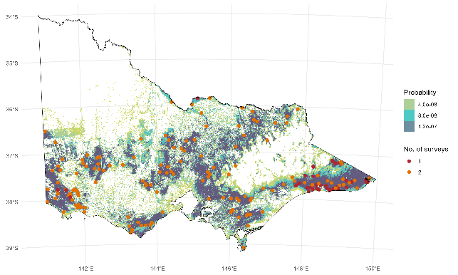
Figure 1. Locations of monitoring sites used to estimate the abundance of Koalas (red/orange circles). Coloured regions give the associated sampling probabilities used during the site selection process.

    - Monitoring
At each site, Koalas were monitored using two different methods. For the first method, Koalas were monitored from the ground by two observers walking transects during the day using double-observer distance sampling methods (Cripps et al. 2021). This involved two individuals walking a transect 10–15 minutes apart, with trees searched either side for individual Koalas. Koalas observed with dependent young were treated as a single individual in these analyses. Between one and three transects were walked, with the total length of transects around 1 km. Upon detection of a Koala, the observer took measurements using a laser rangefinder (Nikon Laser Forestry Pro II Laser Rangefinder). These measurements comprised the geographical coordinates of the observer from a handheld GPS unit, the horizontal distance to the animal and the true distance to the animal. These measurements enabled the calculation of the height of the animal. Upon completion of the transects, observers compared observations to establish whether an individual Koala was (i) only detected by Observer 1, (ii) only detected by Observer 2, or (iii) detected by both observers. Transects were monitored during spring/summer from 22 October 2023 to 5 January 2024, and from 7 October 2024 to 21 November 2024. Previous surveys in East Gippsland occurred in May 2022.
The second monitoring method used passive acoustic detection methods by placing two acoustic recorders (Song Meter Mini, Song Meter Micro or Song Meter SM4) at each site. Recorders were attached to trees approximately 1.5 m above the ground and placed 1 km apart, and were left in place for several weeks during the spring/summer breeding period when Koala bellowing frequency was expected to be highest (Hagens et al. 2018). When combining nights from both recorders, the maximum total recording nights was 59 (mean = 34, SD = 14). Acoustic recorders were set to record at 48,000 Hz, with a 12 dB gain and were active each night between 21:00 and 03:00 (6 hours in total). Acoustic monitoring data from previous surveys in East Gippsland in May 2022 were not included in this analysis.
Acoustic data were processed using a custom deep learning Convolutional Neural Network (CNN) ensemble model on a high-end desktop computer. The ensembled model consisted of three CNN models with differing modelling strategies of the same dataset. For each individual recording, every second of data was processed with an overlapping 1.5-second sample window. Results were recorded only for positive Koala detections, or if no Koala detections were identified within the complete recording, the sample with the highest Koala probability (0–0.5 probability) for that recording was taken. Complete model details are provided in the Appendix (Section 6.2). We validated possible Koala call snippets by taking the snippet with the highest probability of being a Koala according to the CNN model each night for each recorder. This meant we were only validating one snippet per recorder per night and were often validating snippets that were predicted by the CNN model to not be a Koala. To aid in the validation approach, we used a custom software program developed specifically for this purpose.
    - Analysis
We analysed the data collected from double observer distance sampling and acoustic detections of Koala bellows using a hierarchical model that integrated data from both sources. In particular, we combined a mark-recapture distance sampling model (Burt et al. 2014) for the transect counts with a relative abundance model for the presence-absence data obtained for the acoustic recorders to estimate Koala distribution and abundance in a unified framework (e.g. Pagel et al. 2014; Zipkin et al. 2017; Farr et al. 2021). By sharing parameters, integrated models improve the accuracy and precision of abundance estimates compared to separate analyses of the individual data sets. The general idea behind integrated modelling is the construction of a joint likelihood that combines a shared biological process (e.g. parameters governing spatial variation in abundance) with separate observation processes unique to each type of data (Doser et al. 2021; Farr et al. 2021; Gilbert et al. 2024).

Environmental data
To describe the spatial variation in Koala abundance, we first identified habitat containing tree cover that could be occupied by Koalas using the ‘VIC_LANDCOVER_TS’ spatial layer, which consisted of a raster identifying land use types at 25 m resolution (White et al. 2020). We retained pixels identified to contain Native Trees, Native scattered trees and Hardwood plantations. We then aggregated these pixels up to a
1-km spatial resolution recording the proportion of the 1-km pixel that contained the selected habitat types. Predictions of Koala abundance were then constrained to this area. The prediction grid was also constrained to areas that were included in the original sampling design; that being areas with non-zero inclusion probabilities (Robinson et al. 2022) (Figure 2). The total area that was included in our sampling design and which we considered potentially suitable Koala habitat was 57,556 km². We note that this estimate of potentially suitable habitat is inclusive, as we wished to ensure that sampling could be undertaken on the periphery of the koala range.
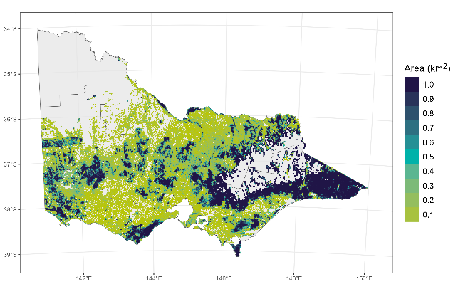
Figure 2. Prediction layer raster at 1-km resolution used to model Koala distribution and abundance, showing the area of potentially suitable Koala habitat within each grid cell included in the original sampling design.

We then identified potential environmental predictors of Koala distribution and density across Victoria. This was guided by previous modelling work for this species (e.g. Heard and Ramsey 2020; Cally et al. 2022) as well as from spatial layers developed through the NKMP (Robinson et al. 2022).
Variables were identified as potential predictors of Koala density across Victoria based on their relationship with Koala occurrence across the species’ range (Heard and Ramsey 2020; Cally et al. 2022) (Table 1). Values for each environmental variable were extracted for each cell on the prediction grid by resampling each to a 1-km prediction grid cell resolution.
Table 1. Descriptions of the covariates used to model Koala abundance and distribution.
Covariate | Description
Land use | Classification of whether the habitat cell consisted of native trees or Eucalypt hardwood plantation (Department of Environment, Land, Water and Planning (DELWP) 2024)
Temperature seasonality | The standard deviation of monthly mean temperatures (BIO4 in WorldClim variables). That is, the standard deviation of the monthly precipitation estimates expressed as a percentage of the mean of those estimates (i.e. the annual mean). This broadly reflects how much temperature varies throughout the year (Karger et al. 2017).
Temperature of the coldest month (°C) | Mean daily minimum air temperature of the coldest month
NPP | Net primary productivity
Food trees | Percentage cover of modelled Koala food trees (CSIRO unpublished data)
Elevation (m) | Elevation of the cell (meters above sea level)
Valley-bottom flatness | Multi-resolution valley-bottom flatness (MrVBF) is a topographic index that identifies valley bottoms and calculates their relative elevation and flatness to their surroundings (Gallant et al. 2012)
Slope (%) | Inclination of the land surface (O’Brien 2021)
TWIND | Topographic Wetness Index (TWIND) estimates the relative wetness within catchments. It is also a measure of position on the slope, with larger values indicating a lower slope position (Guerschman and Hill 2018).
Photosynthetic vegetation (%) | Fractional cover of photosynthetic vegetation estimated from remote sensing (MODIS Nadir BRDF-Adjusted Reflectance product: MCD43A4). The combined sum of bare soil, photosynthetic vegetation and non-photosynthetic vegetation is 100% (Guerschman 2014).
Soil nitrogen | Modelled mass fraction of nitrogen in the topsoil (0–15 cm) by weight (Guerschman and Hill 2018)
Maximum temperature | Mean daily maximum air temperature of the warmest month (BIO5 in WorldClim variables) (Karger et al. 2017)
Soil moisture | Soil moisture layer derived from the AWRA-L water balance model (Frost et al. 2018)
Year/iteration | The survey year, either 2022/2023 (2023) or 2024

Integrated model
Locations of transects and acoustic recorders were assigned to one of the 1-km² prediction grid cells across Victoria. Values for each environmental layer were also extracted for each surveyed grid cell. To develop the integrated model, we first constructed a model describing the spatial variation in Koala abundance. Koala abundance in a grid cell $i$ was assumed to be a realisation of a thinned Poisson process:
$$\begin{aligned}N_{i} \sim \text{Poisson}\left(λ_{i}ψ_{i}P_{i}\right).\#Eq. 1\end{aligned}$$
Where the parameter $λ_{i}$ is the expected abundance in grid cell $i$, $ψ_{i}$ is the probability that the grid cell contained Koalas and $P_{i}$ is the proportion of the grid cell that contained suitable Koala habitat. A thinned Poisson model was adopted for the Koala monitoring data due to the number of surveyed grid cells with zero detections because of the complete absence of Koalas from parts of the study area containing suitable habitat. Thinning also allowed us to model the Koala monitoring data as two separate processes, a process governing the probability the grid cell contained Koalas and an abundance process, given a grid cell contained Koalas. Note that a prediction of zero Koalas in a cell could also arise through either the probability of presence or abundance processes and hence, our thinned Poisson model is conceptually similar to a zero-inflated Poisson (ZIP) model. The model was informed by both acoustic detections (presence/absence data) as well as the transect counts and therefore, represents a hierarchical occupancy/abundance model (Pagel et al. 2014). The statewide abundance of Koalas was estimated by summing the predicted abundances for each cell in Equation 1 across Victoria. Further details of the model structure are provided in Section 6.1.
We implemented the integrated model (Section 6.1) using the Stan programming language (Gelman et al. 2015). Several models with a reduced number of covariates were compared to the global model using leave-one-out cross-validation (LOO CV) (Vehtari et al. 2020). Model diagnostics and performance were evaluated with traceplots and posterior predictive checks (Gabry et al. 2019). Further details are provided in Section 6.1.

Estimating range size across Victoria
Using the model predictions for each grid cell in the sampling frame (Equation 1), we created a binary prediction of occupied and unoccupied areas. This was undertaken by estimating a density threshold which was closest to perfect sensitivity and specificity (Perkins and Schisterman 2006; Robin et al. 2011). We generated 90% confidence intervals for the threshold estimate by using 10,000 bootstrapped iterations (Robin et al. 2011). From these values, we were able to assign areas across the 57,556 km² of potentially suitable habitat as being occupied/unoccupied based on median threshold estimates as well as lower-bound (5%) and upper-bound (95%) thresholds.
  - Koala population genetics
    - Sample collection and DNA extraction
Samples were collected across Victoria via three different programs: (i) blood samples were collected during Koala capture (see Section 2.3), (ii) ear clip tissue samples collected between 2007 and 2018 were provided by Southern Ash Wildlife Shelter through Federation University, and (iii) scat samples collected opportunistically by citizen scientist volunteers between November 2023 and March 2024 were collated and supplied by Federation University. Blood and tissue DNA samples were extracted using the DNeasy Blood and Tissue kit (Qiagen), following the manufacturer’s instructions. DNA extracts from scats were processed using previously established methods (Wedrowicz et al. 2018).
    - Genotyping and data filtering
DNA extracts were sent to Diversity Arrays Technology Pty. Ltd. (DArT), for library preparation, sequencing, quality control and Single Nucleotide Polymorphism (SNP) genotyping. High quality blood and tissue extracts were processed using DArT-seq (high density sequencing – a method that uses enzyme digestion to prepare samples for reduced representation sequencing), followed by read assembly, quality control, SNP discovery and genotype calling through DArT’s proprietary software (Kilian et al. 2012; Cruz et al. 2013; Georges et al. 2018). DNA extracted from scats is usually highly fragmented and co-extracted with substantial exogenous DNA, which makes it unsuitable for DArT-seq (White et al. 2019). For this reason, scat extracts were processed by the more recently developed DArTag method, which uses pre-designed ‘baits’ to enrich DNA samples for known variable sites (identified via DArT-seq of high quality samples) before sequencing, quality control and genotype calling (Hardigan et al. 2023).
We filtered these datasets using the R package ‘dartR’ (Mijangos et al. 2022) based on sensible quality control thresholds to reduce noise, artefacts and errors that can be introduced in the laboratory or through genotyping error. Filtering details are given in the Appendix (Section 6.3).
Many population genetic analyses can be biased by co-sampling of close kin (Wang 2018). In wildlife studies, it often difficult to avoid preferentially sampling kin, because limited sampling distributions in time and space increase the chances of sampling relatives, who are likely to be found in close proximity (Prugnolle and de Meeus 2002; Wolf et al. 2011; Wang 2018). Here, we used the PC-AiR algorithm (Conomos et al. 2015) implemented in the R package ‘GENESIS’ (Gogarten et al. 2019) to identify and exclude close kin from the dataset prior to downstream analyses. PC-AiR uses ancestry divergence metrics calculated from the program ‘KING’ (Manichaikul et al. 2010) to select individuals that carry the most unique ancestry information, maximising the number of individuals for inclusion in the ‘unrelated’ subset (Conomos et al. 2015). We use this ‘unrelated’ subset in analyses of population genetic structure, dispersal, spatial autocorrelation, and to calculate global allele frequencies when estimating genetic diversity and inbreeding.
    - Analyses

Population genetic structure
The PC-AiR function also performs principal components analysis (PCA) using the unrelated subset, with ‘related’ individuals projected onto the plots based on genetic similarity. We visualised the first two principal components of this PCA. We also attempted to define genetic clusters from the ‘unrelated’ subset using the program ‘ADMIXTURE’ (Alexander et al. 2009). We ran ADMIXTURE assuming the number of ancestral populations (K) was in the range of 1–10 and determined the most likely K as the one with the lowest cross-validation error.
We also used the alternating projected least squares algorithm implemented in the R package ‘tess3r’ to visualise the genetic structure in space (Caye et al. 2016; Caye et al. 2018). This method applies a model of genetic structure that incorporates the spatial location of samples, to remove bias associated with patterns of isolation-by-distance. We used the ‘unrelated’ subset and specified the number of ancestral populations (K) as three, based on the admixture results. We interpolated the results over geographic space using the tess3R function ‘ggtess3Q’, and used the predictions to define the geographic extent of the South Gippsland genetic cluster.

Diversity and inbreeding
We quantified individual inbreeding (F_{H}; also known as genome-wide homozygosity) for all individuals using allele frequencies estimated from the ‘unrelated’ subset and the program ‘PLINK’ (v1.9; (Purcell et al. 2007; Chang et al. 2015). F_{H} is a measure of the how homozygous an individual is, relative to expectations given the global allele frequencies. An F_{H} of <0 indicates that an individual is less homozygous (i.e. more outbred) than expected, and an F_{H} of >0 indicates that an individual is more homozygous (i.e. more inbred) than expected. We also estimated internal heterozygosity, the proportion of heterozygous loci for each individual (PH_{t}; (Aparicio et al. 2006)), using allele frequencies estimated from the ‘unrelated’ subset and the R function ‘GENHET’ (Coulon 2010).
To examine the spatial extent of PH_{t}, particularly in South Gippsland, we used a simplified kriging approach to interpolate PH_{t} over a spatial grid spanning the study area, with points occurring at every 0.025 units of latitude/longitude. The semi-variance relationship was set to direct proportionality (i.e. covariance proportional to distance). The method was implemented in R using helper functions from the ‘BioDT’ package (https://github.com/mtrw/BioDT).
We also estimated the effective population size (Ne) for each site with more than 10 samples in the ‘unrelated’ subset using the linkage disequilibrium approach (Waples and Do 2008) and the program ‘NeEstimator’ (Do et al. 2014). When estimating Ne, we excluded loci with a minor allele frequency of 0.05 or lower as recommended by (Gilbert and Whitlock 2015). We report the 95% confidence intervals (95% CI) generated by the jackknife method.

Dispersal across South Gippsland
We limited analyses of dispersal and spatial autocorrelation to unrelated individuals sampled in South Gippsland, Erica and the Gippsland Lakes, because these had the most even sampling distribution from this region. Examining dispersal in this region was also relevant to our objective of characterising the spatial extent of the unique South-Gippsland genetic cluster.
We tested for sex-biased dispersal using the method described by (Goudet et al. 2002) and implemented in the R package ‘hierfstat’ (Goudet 2005) using the function ‘sexbias.test’. This method involves calculating the corrected Assignment Index (AIc) (which estimates the probability that each individual is an immigrant at its location) and comparing the mean AIc’s between sexes with p-values calculated using 1000 permutations. The dispersing sex is expected to have lower AIc on average.
‘Isolation-by-distance’ is a term that refers to the phenomenon in which limited dispersal leads to increasing genetic dissimilarity with geographic distance between individuals or populations. We ran a spatial auto-correlation analysis to describe the extent and scale of isolation-by-distance in our dataset (Epperson 2005). Doing so can give an indication of maximum dispersal distances and average neighbourhood sizes (i.e. spatial scale over which individuals interact and exchange genes). We used ‘dartR’ (Mijangos et al. 2022) to calculate genetic dissimilarity (scaled Euclidean distance) and the package ‘geosphere’ (Hijmans et al. 2005) to calculate the straight-line geographic distance between pairs of individuals. We then used the R package ‘ecodist’ (Goslee and Urban 2007) to conduct Mantel tests and construct a correlogram. Mantel tests assess the correlation between two matrices (here genetic and geographic distance). We constructed a correlogram by dividing the geographic distances into 5-km distance classes and calculating the Mantel correlation coefficient for each bin, allowing the decay in isolation-by-distance to be visualised (Diniz-Filho et al. 2013).
  - Koala health and disease
    - Study areas
We selected seven regions within the range of the Koala in Victoria to represent a broad range of geographical locations, environmental conditions, landscapes, habitat types, tree species and Koala population densities (Table 2; Figure 3).

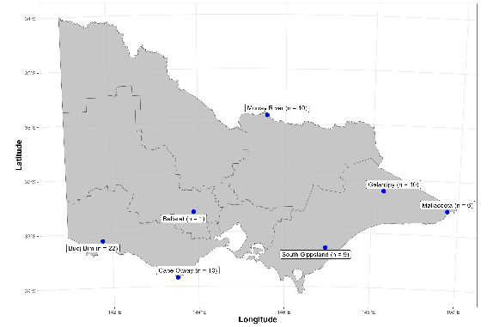
Figure 3. Sample size of captured Koalas (n) within the seven regions selected for health and disease surveys.

Table 2. Characteristics of study regions selected for health and disease surveys.
Region | Min. temp. | Max. temp. | Rainfall (mm) | Dominant Koala food tree | Mean canopy height (m)¹ | Koala density
Ballarat | 7.1 | 17.5 | 685 | E. viminalis/globulus | 22 | Very low
Mallacoota | 11.0 | 19.6 | 939 | E. cypellocarpa/globulus | 18 | Low
South Gippsland | 6.1 | 19.9 | 1000 | E. viminalis/ovata | 18 | Low
Murray River | 12.9 | 25.5 | 397 | E. camaldulensis | 17 | Moderate
Cape Otway | 10.6 | 17.3 | 896 | E. viminalis | 18 | High
Budj Bim IPA | 7.7 | 19.2 | 616 | E. viminalis | 14 | Very high
Gelantipy | 6.8 | 16.6 | 779 | E. viminalis/camphora | 11 | Very high
¹Modelled canopy heights based on Lang et al. (2023). IPA = Indigenous Protected Area.
    - Koala capture
Koala capture was undertaken from 18 March to 4 October 2024. In each area, we searched on foot for Koalas in habitat that appeared to be suitable, and captured Koalas as they were found. At Budj Bim Indigenous Protected Area (IPA), Koalas were captured by contracted staff as part of a management program. We used the ‘noose and flag’ capture method (Madani et al. 2020) if the Koala could be reached from the ground or by a climber with an 8-m extendable pole. We used a Koala trap (Ashman and Whisson 2020) for Koalas that could not be reached using this method.
The noose and flag method involved using a flag on an extendable pole to encourage the Koala to climb down the tree and into a suitable position for placing a loop of rope with a stop-knot over its head. Once the rope was placed, the flag was waved again over the Koala’s head. The Koala either climbed into a hessian or canvas bag held against the tree or was restrained by hand once on the ground and placed into the bag. We did not attempt to capture any Koala for which the process was deemed to be too risky for the Koala or personnel (e.g. dead trees, very tall trees with large canopies, near busy roads). Capture was aborted if the Koala showed signs of significant stress (vocalising, panting) or if it remained unresponsive after approximately 10 minutes of flagging.
Koala traps were comprised of a temporary fence of Corflute sheets (610 x 915 mm) connected with cable ties, constructed at approximately 2 m around the Koala’s tree. In an opening, we set a large cage trap (128 x 42 x 42 cm) which was covered over the top and two sides with a small tarpaulin. We did not cover the rear of the trap to ensure that Koalas would be able to see through the cage and perceive it to be an exit from the fenced area. We set a motion and heat activated camera (X-Trail 4GR 12MP HD Cellular Trail Camera, Little Acorn Australia, Oakleigh South, Victoria, Australia) facing the trap. The camera was programmed to send a multimedia message with a photo to a mobile phone, when triggered, thereby alerting us to a Koala entering the trap. When alerted, we drove to the trap location to release and process the Koala as soon as possible.

Field anaesthesia
Koalas were manually restrained inside a hessian or canvas bag during induction of anaesthesia via 5% Isoflurane (IsoFlo® Inhalational Anaesthesia, Zoetis Australia Pty Ltd) in medical oxygen at a flow rate of 1.5–2 L/min, delivered by face mask. Concentration of Isoflurane in medical oxygen was reduced to 1–2% to maintain a light plane of anaesthesia to allow thorough clinical health examination and collection of samples (Blanshard and Bodley 2008).
Depth of anaesthesia was monitored throughout, via measurement of heart rate and rhythm, respiratory rate, overall muscle relaxation, jaw tone, palpebral and pedal reflexes and rectal temperature. A surgical heat mat and towels were used to provide active heating as required. When body temperature was above 37°C, all active heating was immediately ceased and active cooling measures were initiated (alcohol-soaked gauze wiped over the footpads, water sprayed over the body). Body temperature was then monitored at more frequent intervals until it returned to the expected range, or until monitoring using a rectal thermometer was no longer possible because the animal was recovering from anaesthesia.
At the completion of sample collection, Isoflurane concentration was reduced to 0%, and Koalas were maintained on 100% oxygen at a flow rate of 1.5–2 L/min, delivered via face mask until they regained consciousness (i.e. able to lift and control head movements and respond as expected to auditory and visual stimuli).
Following recovery from anaesthesia, Koalas were released at the base of the tree they were captured from and visually monitored from the ground until they had climbed the tree and were exhibiting normal behaviour (Downey et al. 2020).
    - Physical health assessment
Physical health examination by a veterinarian followed a standardised approach based on the clinical protocol developed by the Koala Health Hub (KHH), University of Sydney, Australia (https://Koalahealthhub.org.au/sampling-protocols/). Health assessment included distant visual exam of the animal while conscious, and thorough physical examination of body systems and collection of a range of biological samples while under general anaesthesia (see Section 6.5 for details of measurements). This aimed to develop a holistic understanding of overall health status, and to document clinical evidence of the diseases of significance in Koalas, including trauma, dental and renal disease, and infectious diseases caused by infection with Chlamydia pecorum, KoRV, Phascolarctid Gammaherpesviruses (Pha-HV), and Sarcoptes scabiei. Health information recorded for each Koala is described in Section 6.5.
Koalas were also placed in one of four life stages, based on an assessment of tooth wear (e.g. Butcher et al. 2020). Details for each category are given in Table A6 (Section 6.5). Based on physical examination, Koalas were also given a body condition score based on assessment of muscle mass and tone ranging from 1 (emaciated) to 5 (excellent condition). Details of the scoring are provided in Table A7 (Section 6.5). Animals found to be in a state of good welfare were recovered from anaesthesia and released back to the tree from which they were originally captured. Koalas that were assessed as being in a state of poor welfare, showing clinically significant evidence of disease on physical examination, were humanely euthanased by intravenous delivery of a 325 mg/mL solution of sodium pentobarbitone (Lethabarb®, Virbac Australia PTY Ltd.). For some Koalas that were euthanised, a thorough necropsy examination was performed, and any gross abnormalities were recorded. Multiple tissue samples were collected from all necropsied Koalas and fixed in 10% neutral buffered formalin. Formalin-fixed tissues were subsequently embedded in paraffin, sectioned 4 mm thick and stained with haematoxylin and eosin (Melbourne Histology Platform, the University of Melbourne, Victoria, Australia). Stained slides were then examined by a pathologist.

Blood sampling
Blood was collected from the cephalic vein via aseptic venipuncture using a 22-gauge needle. Whole blood was drawn into microhaematocrit capillary tubes (Statspin® Microhaematocrit Tubes, Tris, Chatsworth, California) to measure total plasma protein (TP; 38 Koalas) and packed cell volume (PCV; 40 Koalas) in the field. Blood for genetic analysis was transferred into screw top vials containing ethylenediaminetetraacetic acid (EDTA) (Microsample Tube EDTA K3, Sarstedt Australia Pty Ltd, Australia) and stored at -20°C.
Blood was collected for laboratory assessment of serum biochemical and haematological parameters for 25 Koalas. Blood for biochemical analysis was decanted into serum separator blood tubes (BD Vacutainer® SSTTM Tube, Becton Dickinson Pty Ltd, Australia), and stored at 4°C until submission to Gribbles Veterinary Pathology (Clayton, Victoria, Australia). Serum was analysed for concentrations of Albumen, Alkaline phosphatase, Alanine transaminase, Aspartate transaminase, Bicarbonate, Calcium, Chloride, Cholesterol, Creatine kinase, Creatinine, Urea, Gamma glutamyl transferase, Globulin, Glucose, Inorganic phosphate, Potassium, Sodium, Total bilirubin and Total protein, and the index of haemolysis and lipaemia were measured. Samples with a haemolysis index of three or greater were discarded from subsequent analysis.
Blood for haematological analysis was decanted into screw top vials containing EDTA (Microsample Tube EDTA K3, Sarstedt Australia Pty Ltd, Australia), and stored at 4°C until submission to Gribbles Veterinary Pathology (Clayton, Victoria, Australia). The following haematological parameters were measured: red cell count, haemoglobin, haematocrit (HCT), mean corpuscular volume (MCV), mean corpuscular haemoglobin concentration (MCHC), reticulocytes, leukocytes, neutrophils, monocytes, eosinophils, basophils, platelets, nucleated red blood cells/100 white blood cells.
Remaining whole blood was used to make blood smears, which were fixed in methanol, air dried and stored at ambient temperature until submission to Gribbles Veterinary Pathology.

Molecular diagnostics for infectious disease
Molecular diagnostics for infectious disease screening were conducted by the Asia-Pacific Centre for Animal Health (APCAH), University of Melbourne. DNA extracted from blood was tested for the presence of the Koala retrovirus pol proviral gene (KoRV pol) using KoRV pol quantitative PCR primers and methods described previously (Legione et al. 2017). Tissue swabs were collected from all Koalas to test for the presence of Chlamydial and herpesviral DNA. Sterile, fine tipped, aluminium shaft swabs (Copan Swab Alum Shaft, Copan Italia S.p.A.) were used to collect mucosal cell samples from the left and right ocular conjunctiva (all Koalas), and from the urogenital sinus (in females) and the urethral opening at the tip of the penis (in males) following the protocol developed by the KHH (https://Koalahealthhub.org.au/sampling-protocols/). Swabs were stored at -20°C until submission to the laboratory.
To extract DNA from swabs, 500 µL phosphate buffer solution was added to vials and rigorously vortexed. DNA was extracted from 200 µL of the resulting mix using a MagMax core nucleic acid extraction kit and a Kingfisher Flex extraction robot (Vaz et al. 2019). Quantitative PCR was then used to test for the presence of Chlamydia spp. targeting the Chlamydia 16S rRNA gene (Legione et al. 2016a); and nested PCR was used to test for the presence of Pha-HV followed the methods described by Vaz et al. (2019).
    - Factors associated with chronic ill-health
The outcomes of the field health examination of each Koala and whether it was euthanised on welfare grounds or released were analysed to determine factors (e.g. disease diagnostics, heath conditions or environmental variables) that may be associated with Koalas presenting with chronic ill-health requiring euthanasia. We analysed the health data collected on the 68 Koalas examined using boosted regression trees (BRT), an ensemble method based on regression trees (Elith et al. 2008). BRT models were employed for the analyses because these models allow the additive and interactive contributions of different variables to be handled naturally and have proven to have superior predictive performance compared to other similar statistical models (Elith et al. 2008). The analysis included a number of factors representing various disease diagnoses and health conditions recorded for each examined Koala as well as environmental variables at each site (Table 3). We used the ‘gbm.step()’ function in the R package ‘dismo’ (Elith et al. 2008) to fit our BRT model, with the optimal number of trees selected by minimising the cross-validation residual deviance. We set the training data fraction using 75% (51) of the observations, with the remaining 17 observations used as the hold-out data for cross validation. This process was repeated using 10 different folds for cross-validation purposes. The final model was then used to predict the partial (marginal) contribution of each variable to the response outcome. Confidence intervals for partial dependence plots were generated using bootstrap resampling of the data. Model performance was assessed by estimating the predictive accuracy of the final model (i.e. percentage of correctly predicted Koalas that were euthanised).

Table 3. Variables relating to disease diagnoses, health conditions and environmental variables used to predict Koalas presenting with chronic ill-health requiring euthanasia during the health and disease surveys.
Variable | Description
Life stage | Koala age class (Juvenile or Adult/ Senior)
Koala density | Relative Koala density at capture site (Low/ Moderate/ High)
Landscape | Visual assessment of habitat condition at capture site (Poor/ Fair or Good)
Coat condition | Koala coat condition: (Normal/ Poor)
‘Wet bottom’ | Presence of discoloration around the cloaca (Absent/ Present)
Dental disease | Evidence of dental disease (Absent/ Present)
Malocclusion | Evidence of dental malocclusion (Absent/ Present)
Chlamydia detected | Evidence of Chlamydia percorum infection from PCR (Absent/ Present)
Herpesvirus detected | Evidence of Herpesvirus infection from PCR (Absent/ Present)
KoRV detected | Evidence of Koala Retrovirus from PCR (Absent/Present)
Skin wounds | Evidence of traumatic skin lesions/lacerations (Absent/ Present)

- Results
  - Koala abundance
We detected Koalas at 95 out of 182 unique sites (52%, Figure 4. ). Koalas were detected on transects at 22% of sites and on 64% of sites that had acoustic recorders. For sites where Koalas were detected, the average count on transects was 1.5 adults, and the maximum was 20. For these same sites, the mean proportion of recorder-nights with identified Koala vocalisations was 0.45, with a maximum of 1.0. These data enabled us to estimate Koala abundance at sites and across Victoria. Details of model selection, validation and diagnostics are provided in Section 6.1.
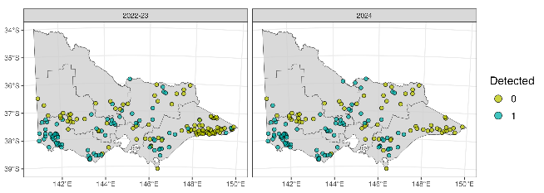
Figure 4. Koala detections (0 – absent, 1 – present) from transect counts or acoustic monitoring from 182 sites across two survey years, 78 out of 174 for 2022–23 and 80 out of 141 for 2024.

    - Abundance at sampled sites
The predicted mean density of Koalas at sampled sites averaged 13.7 Koalas per km² across all sampled sites and years. The mean density estimate varied from 0 to 142.4 Koalas per km².
    - Statewide and regional abundance
Total Koala population size across Victoria was estimated at 217,100 individuals [90% CI: 174,800 – 266,200] in 2023 and 224,800 individuals [90% CI: 181,300 – 276,600] in 2024 (Table 4. ). There was no evidence that the difference in abundance between survey years indicated a real change, with the estimated population change having confidence intervals overlapping zero. In 2024, most of Victoria’s Koala population was predicted to reside in native forest (173,200 individuals [90% CI: 135,900 – 217,900]), with a smaller but denser population inhabiting hardwood plantations (51,700 [90% CI: 42,600 – 61,800]). The average density of Koalas in hardwood plantations was more than sixteen times higher than in native forests (50.7 versus 3.1 Koalas per km²) and six times higher than in native forest in the Barwon South West region, where most of the Blue Gum (Eucalyptus globulus) plantations occur. Koalas were predicted to inhabit all six DEECA regions, with Barwon South West containing most Koalas (Table 4; Figure 5).

Table 4. Regional and statewide estimates of Koala abundance (rounded to the nearest 100) for native forest and plantations across both survey years. SD = standard deviation, CV = coefficient of variation. Density is in Koalas per suitable habitat km².
Region | Year | Habitat | Estimate | SD | CV | 5% CI | 95% | Area km² | Density
Barwon South West | 2023 | Plantation | 45,400 | 5,300 | 0.12 | 37,300 | 54,600 | 717 | 63.3
Barwon South West | 2024 | Plantation | 47,000 | 5,300 | 0.11 | 38,900 | 56,400 | 717 | 65.6
Barwon South West | 2023 | Native | 65,900 | 9,100 | 0.14 | 51,900 | 81,500 | 6,939 | 9.5
Barwon South West | 2024 | Native | 68,300 | 9,600 | 0.14 | 53,400 | 85,100 | 6,939 | 9.8
Barwon South West | 2023 | All | 111,300 | 13,400 | 0.12 | 90,700 | 134,300 | 7,656 | 14.5
Barwon South West | 2024 | All | 115,300 | 13,800 | 0.12 | 93,800 | 138,700 | 20,226 | 5.7
Gippsland | 2023 | Plantation | 1,500 | 300 | 0.18 | 1,000 | 1,900 | 177 | 8.2
Gippsland | 2024 | Plantation | 1,500 | 300 | 0.18 | 1,100 | 2,000 | 177 | 8.5
Gippsland | 2023 | Native | 44,400 | 9,700 | 0.22 | 30,400 | 62,100 | 20,049 | 2.2
Gippsland | 2024 | Native | 46,000 | 10,100 | 0.22 | 31,700 | 64,000 | 20,049 | 2.3
Gippsland | 2023 | All | 45,800 | 9,800 | 0.21 | 31,600 | 63,900 | 9,120 | 5
Gippsland | 2024 | All | 47,500 | 10,200 | 0.22 | 33,100 | 65,600 | 13,125 | 3.6
Grampians | 2023 | Plantation | 2,800 | 600 | 0.22 | 1,700 | 3,800 | 105 | 26.4
Grampians | 2024 | Plantation | 2,900 | 600 | 0.22 | 1,800 | 3,900 | 105 | 27.3
Grampians | 2023 | Native | 23,300 | 4,700 | 0.2 | 16,400 | 31,700 | 9,015 | 2.6
Grampians | 2024 | Native | 24,100 | 5,000 | 0.21 | 17,000 | 33,000 | 9,015 | 2.7
Grampians | 2023 | All | 26,000 | 5,100 | 0.2 | 18,600 | 35,200 | 4,513 | 5.8
Grampians | 2024 | All | 27,000 | 5,300 | 0.2 | 19,200 | 36,400 | 2,917 | 9.2
Hume | 2023 | Plantation | 300 | 100 | 0.29 | 100 | 400 | 20 | 12.7
Hume | 2024 | Plantation | 300 | 100 | 0.29 | 100 | 400 | 20 | 13.2
Hume | 2023 | Native | 16,500 | 3,100 | 0.19 | 11,900 | 21,800 | 13,105 | 1.3
Hume | 2024 | Native | 17,000 | 3,200 | 0.19 | 12,300 | 22,800 | 13,105 | 1.3
Hume | 2023 | All | 16,700 | 3,100 | 0.19 | 12,100 | 22,100 | 7,656 | 2.2
Hume | 2024 | All | 17,300 | 3,200 | 0.19 | 12,600 | 23,200 | 20,226 | 0.9
Loddon Mallee | 2023 | Native | 13,000 | 3,000 | 0.23 | 8,500 | 18,400 | 4,513 | 2.9
Loddon Mallee | 2024 | Native | 13,500 | 3,100 | 0.23 | 8,900 | 18,800 | 4,513 | 3
Loddon Mallee | 2023 | All | 13,000 | 3,000 | 0.23 | 8,500 | 18,400 | 9,120 | 1.4
Loddon Mallee | 2024 | All | 13,500 | 3,100 | 0.23 | 8,900 | 18,800 | 13,125 | 1
Port Phillip | 2023 | Native | 4,200 | 2,600 | 0.61 | 800 | 8,700 | 2,917 | 1.4
Port Phillip | 2024 | Native | 4,400 | 2,700 | 0.61 | 800 | 9,000 | 2,917 | 1.5
Port Phillip | 2023 | All | 4,200 | 2,600 | 0.61 | 800 | 8,700 | 4,513 | 0.9
Port Phillip | 2024 | All | 4,400 | 2,700 | 0.61 | 800 | 9,000 | 2,917 | 1.5
All | 2023 | Native | 167,200 | 23,500 | 0.14 | 131,000 | 209,800 | 56,537 | 3
All | 2024 | Native | 173,200 | 24,600 | 0.14 | 135,900 | 217,900 | 56,537 | 3.1
All | 2023 | Plantation | 49,900 | 5,800 | 0.12 | 41,200 | 59,800 | 1,019 | 49
All | 2024 | Plantation | 51,700 | 5,800 | 0.11 | 42,600 | 61,800 | 1,019 | 50.7
All | 2023 | All | 217,100 | 27,800 | 0.13 | 174,800 | 266,200 | 57,556 | 3.8
All | 2024 | All | 224,800 | 28,900 | 0.13 | 181,300 | 276,600 | 57,556 | 3.9

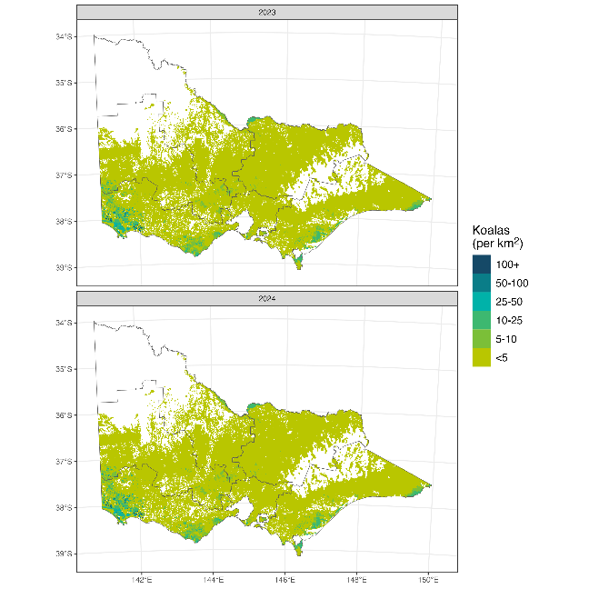
Figure 5. Abundance of Koalas in Victoria for both survey years. Abundance is estimated at a 1-km² spatial resolution and considers the proportion of each grid cell with potentially suitable habitat. White areas have no estimated suitable habitat.
  - Koala distribution
We estimated Koala range size in Victoria at 19,459 km² [90% CI: 14,067 – 31,775] in 2024, which represents around 34% of the potentially suitable Koala habitat in Victoria. This range estimate was based on a density threshold of 2.35 Koalas per km² [95% CI: 1, 3.55]; meaning densities below these values were considered unoccupied and vice versa. The predicted mean distribution of Koalas, accounting for the proportion of each grid cell that had suitable habitat, is given in Figure 6.
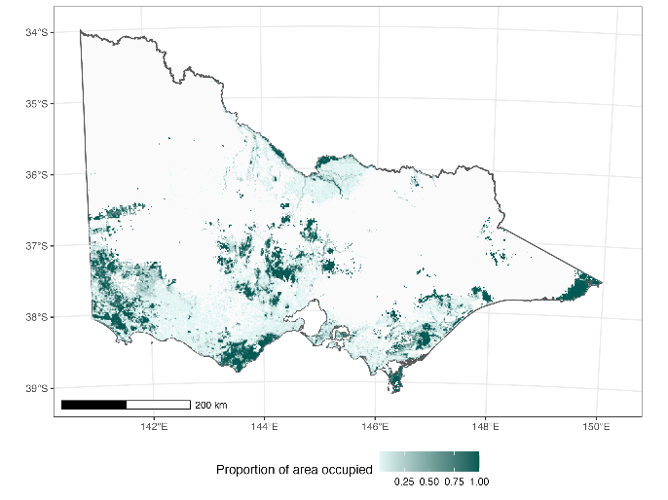
Figure 6. Distribution of Koalas in Victoria for 2024 according to the mean threshold abundance predictions (areas with more than 2.35 Koalas per km² are considered occupied). The proportion of area occupied in each 1-km² grid cell accounts for the proportion of potentially suitable Koala habitat (Figure 2).

    - Factors influencing Koala distribution and abundance
The abundance of Koalas in a grid cell were driven by a range of spatial, environmental, climate and topographic variables. Two separate processes were modelled for Koala abundance. The probability of Koala presence was driven solely by a spatial random effect (Section 6.1). The parameters for the Gaussian process showed that the probability of presence had a substantial but variable contribution from latitude and longitude (length scale = 34.5 km [95% CI: 25.1 – 46.5 km], σ = 6.39 [95% CI: 4.5 – 8.96]). The predicted spatial Gaussian process is given in Figure A4 (Section 6.1). Covariates that had non-negligible effects on Koala abundance included ‘land use’ (native versus plantation), ‘temperature seasonality’, ‘minimum temperature of coldest month’, ‘net primary productivity’, ‘topographic wetness index’, ‘photosynthetic vegetation’, ‘soil nitrogen’, and ‘maximum temperature’ (Table A2; Figure 7).
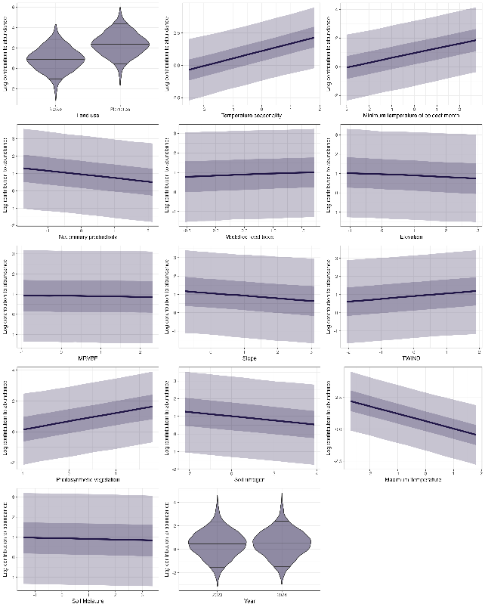
Figure 7. Partial (marginal) covariate effects on Koala abundance. The continuous covariate values (x-axis) are scaled. MrVBF = Multi-resolution valley-bottom flatness and TWIND = Topographic Wetness Index.

    - Factors influencing Koala detection

Acoustic detection
The probability that a Koala vocalisation was detected at a site varied based on the estimated abundance of Koalas at a site as well as the average nightly windspeed for each detection period (night). A significant negative effect of windspeed (-0.45 [90% CI: -0.49 – -0.41] on the logit scale) meant that Koala detection probability was lower on windy nights (Figure 8). For a relatively low-density Koala population (5 Koalas per km²) the average nightly detection probability was 0.11 [90% CI: 0.1, 0.12]. Model predictions suggested that, in a relatively low-density population the probability of Koala detection with two recorders deployed was more than 0.75 after one week and more than 0.95 after two weeks (Figure 8). Across both survey years, we validated 10,178 snippets with possible Koala calls, with each snippet representing the maximum Koala probability according to the CNN classification. Based on validation of these data, there were low levels of false negatives (5%, n = 252) (i.e. Koala calls identified by the CNN model with a probability score of < 0.5 that were subsequently confirmed as Koalas). Alternatively, there were substantial levels of false positives (46%, n = 2,144) (Koala calls identified by the CNN model with a probability score > 0.5, that could not be subsequently confirmed as Koalas). In total, 2,776 Koala call snippets were positively validated. The distribution of CNN model scores for validated ‘Koala’ and ‘not a Koala’ results is shown in Section 6.2.

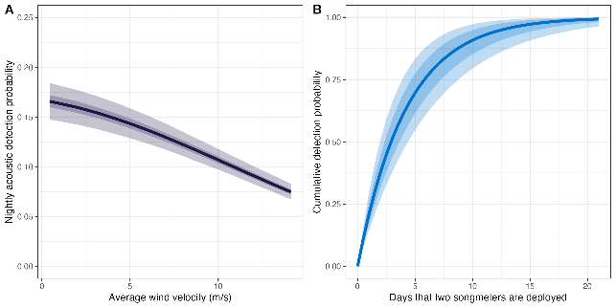
Figure 8. Effect of (A) windspeed on nightly Koala acoustic detection probability and (B) cumulative detection probability of Koalas with number of deployment days for two acoustic recorders (songmeters) when density was 5 Koalas per km² and under average windspeed conditions.

Detection on transects
For the analysis of the double-observer distance sampling data, the detection probability on the transect line for either Observer 1 or Observer 2 was 0.71 [90% CI: 0.63 – 0.77], meaning the combined detection rate for both observers along the transect ($g_{0}$) was 0.92 [90% CI: 0.87 – 0.95]. The effect of distance within the mark-recapture model was significant (-0.04 [90% CI: -0.05 – -0.02]). We also found that the angle from the ground to the Koala position in the tree had a negative effect on detection (-0.45 [90% CI: -0.67 – -0.25]), meaning that Koalas at steeper angles to the observer (e.g. directly above the observer) were less readily detected. For the distance sampling process, the half-normal shape parameter was estimated at 25.9 m [90% CI: 24.1 m – 28.0 m]. When combined with the estimate of $g_{0}$, the average detection probability for a Koala present on a transect (90 m half-strip width) was 0.33 [90% CI: 0.3 – 0.36]. The MRDS model is visualised in Figure 9. 9. In comparison with two passive acoustic recorders deployed for 1–2 weeks, double observer searches on 1-km transects have substantially lower detection probability when density is low (e.g. < 10 Koalas per km²; Figure A2. , Section 6.1).
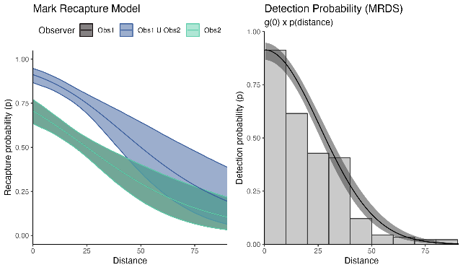
Figure 9. The mark-recapture model estimate of the detection (recapture) probability for each observer (Obs1 and Obs2) and observers combined (Obs1 $∪$ Obs2), The estimate of g(0) is the intercept of the blue line. The value of g(0) was then combined with the distance-sampling detection probability function to estimate an overall detection probability for a 90-m half-strip width transect.
  - Koala population genetics
    - Genotyping and filtering
We sent 80 blood, 94 tissue and 760 scat sample extracts to DArT for genotyping. Unfortunately, the application of the DArT-tag method to scat samples did not work as anticipated, with most scat samples having very low call rates across loci (i.e. high amounts of missing data) that did not meet filtering thresholds. Samples that passed filtering thresholds had significantly lower heterozygosity than blood or tissue samples, indicating that filtering was not sufficient to remove biases related to genotyping error (Figure A7, Section 6.3). Due to these issues, we chose to exclude all scat samples and DArT-tag data from the analysis and increased our filtering thresholds to prevent bias (Table A4, Section 6.3). After filtering, we retained 2257 SNPs across 111 samples from 10 locations (Table 5; Figure 10). An additional 18 samples were excluded from the ‘unrelated’ subset to avoid sampling close-kin for certain analyses (Table A4, Section 6.3).
Since we could not utilise scat DNA to obtain SNPs, a subset of 144 scat samples were genotyped using a panel of 12 microsatellite markers. These data were primarily analysed to determine population structure to compare with the results from the SNP analyses, especially in relation to the identification of the extent of the South Gippsland cluster. Further details on these analyses are given in Section 6.4.

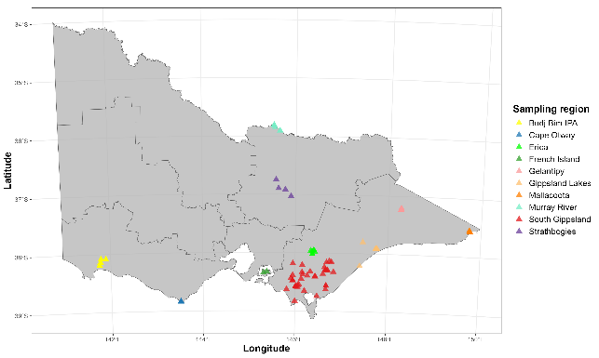
Figure 10. Genetic sampling locations for all blood and tissue samples included in the dataset after filtering. Each point represents a sampled individual. IPA – Indigenous Protected Area.

Table 5. Sample sizes and summary statistics for each sampling region. n=number of samples, F_{H} = individual inbreeding, PH_{t}=internal heterozygosity, Ne=effective population size, sd=standard deviation, 95% CI = 95% confidence intervals. n(subset) excludes samples of related individuals. IPA = Indigenous Protected Area.
Sampling region | n (total) | n (subset) | Mean F_{H} (sd) | Mean PH_{t} (sd) | Ne (95% CI)
Budj Bim IPA | 28 | 22 | 0.11 (0.05) | 0.26 (0.02) | 110 (79–175)
Cape Otway | 4 | 3 | 0.18 (0.03) | 0.24 (0.01) | -
Murray River | 7 | 6 | 0.16 (0.06) | 0.25 (0.02) | -
Strathbogies | 4 | 4 | 0.1 (0.07) | 0.27 (0.02) | -
French Island | 2 | 1 | 0.11 (0.01) | 0.26 (0.00) | -
Erica | 7 | 7 | 0.11 (0.05) | 0.26 (0.02) | -
South Gippsland | 39 | 36 | 0.03 (0.07) | 0.29 (0.02) | 215 (109–898)
Gippsland Lakes | 6 | 5 | 0.13 (0.09) | 0.26 (0.03) | -
Gelantipy | 9 | 5 | 0.27 (0.06) | 0.22 (0.02) | -
Mallacoota | 5 | 4 | 0.22 (0.03) | 0.23 (0.01) | -
 | 111 | 93

    - Population genetic structure
Our PCA results (Figure 11) show divergence along PC1 of the South Gippsland Koalas from all other sampled regions, which formed an approximate cline along PC2. However, a single individual sampled at the eastern end of the Gippsland Lakes also grouped strongly with the South Gippsland cluster and four individuals from Erica shared genetic similarity with both the South Gippsland cluster and the majority cline, falling intermediately between the two groups. Additionally, four South Gippsland individuals did not fall with the rest of the individuals from this region and instead were more genetically similar to individuals from the western part of the Gippsland Lakes, Budj Bim IPA and the Strathbogies (Figure 11).

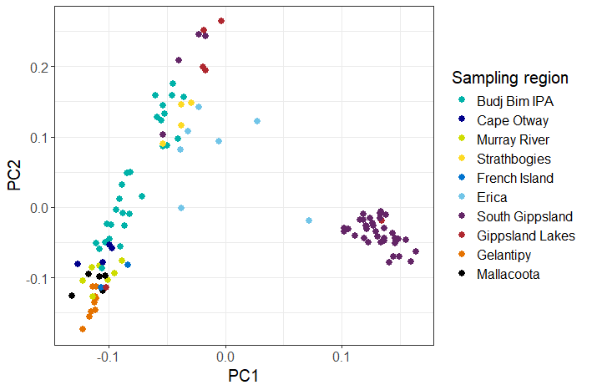
Figure 11. Principal components analysis results showing PCs 1 and 2. Each point represents an individual coloured by sampling region. Placement relative to other samples is indicative of genetic similarity. IPA – Indigenous Protected Area.

The ADMIXTURE results indicated that the most appropriate number of ancestral clusters (K) was three (Figure A8 – Section 6.3). The distribution of ancestry across individuals (Figure 12) and spatial locations (Figure 13a) reiterates the results from the PCA: most individuals from South Gippsland, and a single individual from the western end of the Gippsland Lakes derive most of their ancestry from ‘Cluster 3’. Individuals from Gelantipy, Mallacoota, the Murray River, Cape Otway, French Island and a single individual from the north of the Gippsland Lakes are mostly derived from ‘Cluster 2’, corresponding to one end of the cline visible on PC2. Finally, individuals from the eastern end of the Gippsland Lakes, the southern coast of South Gippsland, the Strathbogies, Erica and Budj Bim IPA have most ancestry from ‘Cluster 1’, representing the opposite end of the PC2 cline. However, as shown in the ADMIXTURE plot (Figure 12), most individuals from Budj Bim IPA, the Strathbogies and Erica also have significant ancestry from ‘Cluster 2’, and Erica individuals have additional ancestry from ‘Cluster 3’.

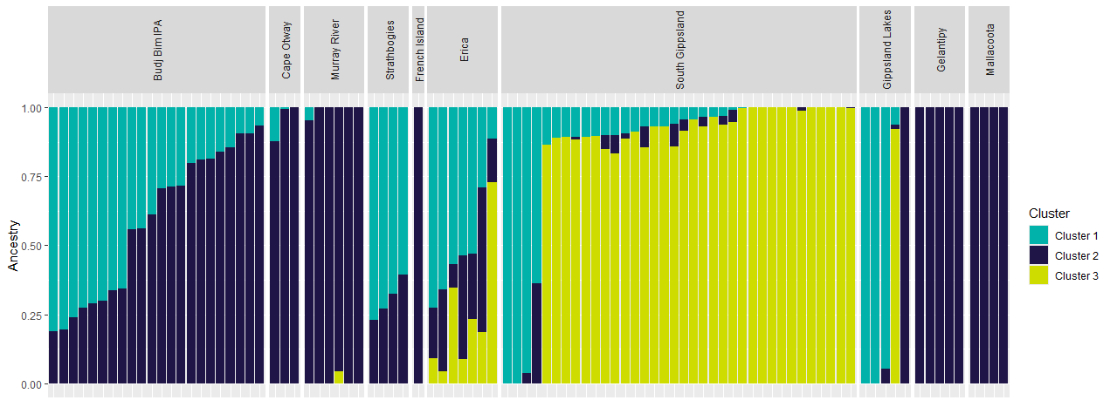
Figure 12. ADMIXTURE results. Each bar represents an individual, grouped by sampling region. Colours represent the estimated proportional ancestry from each cluster. Results of analyses are shown for which the number of clusters was assumed to be three (K=3), based on the cross-validation results (Figure A4 – Section 6.2). IPA – Indigenous Protected Area.

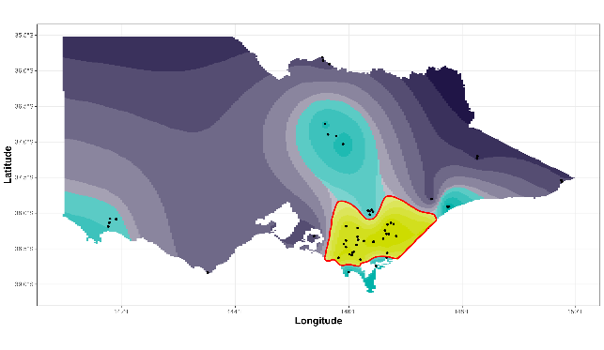
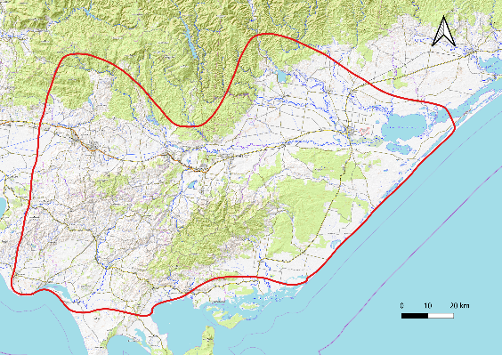
Figure 13. (A) Results from the tess3R analysis (top figure) (colours represent the distribution of ancestral clusters, interpolated across space; black points indicate sampling locations; red polygon shows the boundary of the South Gippsland cluster); and (B) close-up topographic map (bottom figure) showing the boundaries of the South Gippsland cluster (red polygon).

Based on the results from the tess3R analysis (Figure 13A), we found that the extent of the South Gippsland cluster likely extends from Corinella and Westernport Bay in the east to Loch Sport on the western edge of the Gippsland Lakes region, and is bounded to the north by the Central Highlands (Figure 13B). The population around the township of Erica, at the southern edge of the Central Highlands, displays some admixture from the South Gippsland cluster, indicating that dispersal between South Gippsland and this region may still be occurring, although it is difficult to rule out translocations as the cause of this mixing.
Analysis of scat and blood DNA samples using the microsatellite markers identified that the distribution of the South Gippsland cluster may also extend south into Wilson’s Promontory (Section 6.4). This inference was possible due to the additional locations where scats were collected, which included locations in Wilson’s Promontory that were not present in the SNP dataset. More details of the analysis of the microsatellite data are given in Section 6.4.
    - Diversity and inbreeding
The diversity and inbreeding metrics reported here are calculated based on allele frequencies estimated from within the sample (specifically from the unrelated subset). Therefore, it is important to note that these metrics are relative to the sample; comparisons between individuals and regions sampled for this study are valid, but estimates should not be directly compared to metrics from other studies that have used different genetic markers and metrics.
Inbreeding was highest and diversity lowest among individuals from Gelantipy and Mallacoota, while inbreeding was lowest and diversity highest among individuals from South Gippsland (Figures 14 and 15). On a finer scale, the south-coast of the South Gippsland area was defined by lower diversity (and accordingly, higher individual inbreeding) than the inland part of this region (Figure 15).
Due to small sample sizes, we were only able to estimate effective population size for the South Gippsland and Budj Bim IPA sampling regions. We found that Ne in South Gippsland (215.2, 95% CI= 109.4–898.4) was approximately double that found in Budj Bim IPA (109.6, 95% CI= 79–174.8; Table 4).

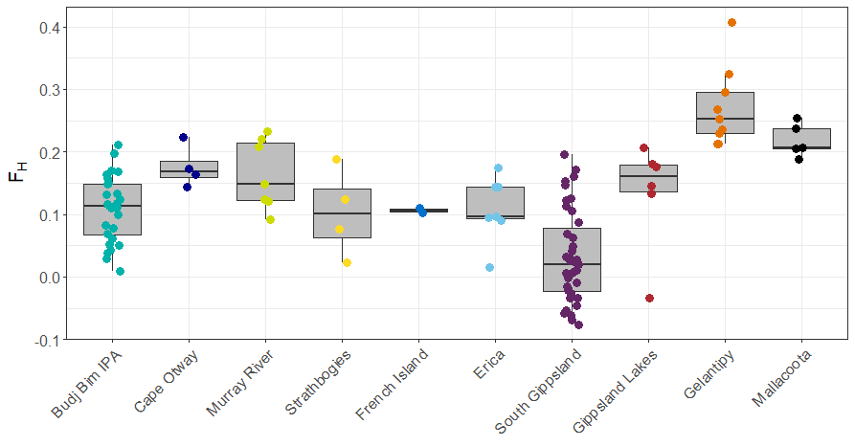
Figure 14. Individual inbreeding (F_{H}) results by sampling region. Each point represents a sampled individual. Middle horizontal lines represent the median, the boxes are bound by the 25th and 75th quartiles and vertical lines show the minimum and maximum range of values excluding outliers.

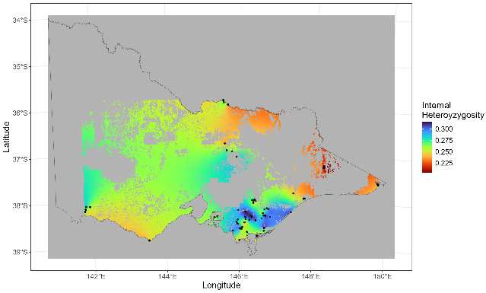
Figure 15. Genetic diversity (internal heterozygosity, PH_{t}), interpolated across the study area. Black points represent included samples.

    - Dispersal across South Gippsland
The average AIc value for females was 3.82, compared to -3.18 for males. However, the difference in means was not statistically significant (p=0.59). We found positive, but declining, spatial autocorrelation up to 25 km, after which the correlation between genetic and geographic distance became non-significant (Figure 16).

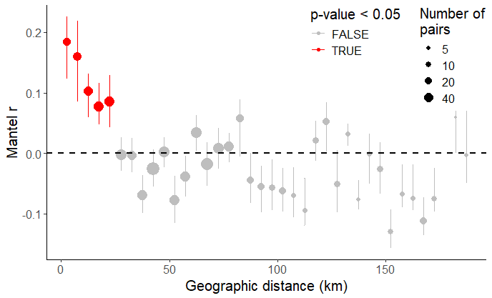
Figure 16. Spatial autocorrelation plots (i.e. correlograms) calculated using individuals sampled within the South Gippsland, Erica or Gippsland Lakes regions. Each point represents a distance class for which a Mantel test was run, and the y axis represents the Mantel correlation coefficient, r. Points are sized by how many pairs of individuals were found in that distance class. Red circles represent values for the Mantel r that are significantly greater than zero (the dotted black line).
  - Koala health and disease
    - Koala capture
We sampled 68 Koalas across the seven regions. Twenty-two Koalas were sampled from those captured by contracted staff during a management program at Budj Bim. The remainder were captured specifically for this project, with sample size varying due to population density, which impacted our ability to find and capture Koalas. We captured ten Koalas from each of the Murray River, Gelantipy and Cape Otway regions, nine Koalas from South Gippsland, six Koalas from Mallacoota, and only one Koala from Ballarat. Three Koalas were found on the ground, with two being in very poor condition (Cape Otway, Murray River) and one moving between trees. All other Koalas were in trees, with 63% (41/65) being in the upper canopy. Further details about Koala capture are provided in Section 6.5.
    - Physical examination

Life stage and sex ratio
Adult Koalas were the most common life stage across all study areas (57% of all Koalas; Table 6). This was observed in all study areas although senior Koalas tended to comprise a higher proportion of Murray River Koalas (five of ten Koalas captured) than in other locations. Only one senior Koala was captured in Gelantipy and none were captured in Mallacoota. Juveniles were only captured at Budj Bim, but young adults were sampled from all regions. There was a slight female bias in adult Koalas sampled (Table 6).
Table 6. Distribution of captures across life stages and sexes.
Life stage¹ | Age (years) | Male | Female | Total | Percentage
Juvenile | 1-2 | 2 | 3 | 5 | 7.4%
Young adult | 3-4 | 7 | 6 | 13 | 19.1%
Adult | 5-12 | 16 | 22 | 38 | 57.4%
Senior | 12+ | 5 | 7 | 12 | 16.2%
Total |  | 30 | 38 | 68
¹Based on Canfield et al. (1989) and Butcher et al (2020).

Presence of young
Only 23.5% (8/34) of reproductively mature females had pouch young or signs of recent young (evidence of lactation, with clean, elongated nipple and mammary gland enlargement). Of those without young/signs of recent young, 69.2% (18/26) had pouches that were shallow and greasy, one female’s pouch contained a mat of sticky fur (possibly pine sap), and the remainder were shallow, clean and dry without any evidence of active reproduction (mammary gland enlargement, lactation). Most non-reproductive, mature females (16/26; 61.5%) were in poor to extremely poor condition. Highest breeding rates for reproductively mature females occurred at Budj Bim (42%), with no breeding recorded for reproductively mature females at Cape Otway and the Murray River (Table 7).

Health assessment
Based on the in-field clinical exam, 57% (39/68) Koalas were considered healthy and released back to their points of capture. Healthy Koalas were recorded from all locations and across all life stages, although were less frequently recorded for senior animals (χ² = 10.69, d.f. = 3, p = 0.013). Healthy Koalas had a body condition score (BCS) of three or more, with good to excellent muscle coverage and tone, and normal hydration. Most (37/39) had a fur coat that was well-groomed and in good condition. Clinically insignificant findings in apparently healthy Koalas included mild-to-moderate dental disease (six Koalas), malocclusion (nine Koalas) and trauma (five Koalas). The fur inside one female’s pouch was matted with a sticky substance that may have been tree resin. Five Koalas (all males) had healed or healing wounds: two with multiple old scars on the face, and three with puncture wounds on a forelimb. Two otherwise healthy Koalas had mild clinical signs consistent with Chlamydiosis (or other urogenital tract diseases): one female had wet fur around the cloaca, and a male had a small number of crusted lesions on his penis.
Following a thorough physical examination, 29 Koalas (43%) were found to be in a state of poor welfare and were euthanised on welfare grounds. These Koalas were from all regions except Mallacoota, and across all life stages. Body condition scores averaged less than 3.0 in five of the seven regions, with Koalas in Mallacoota having the highest average body condition scores (4.0 – Table 7). All Koalas euthanised during this study showed signs of chronic ill-health, including lean-to-emaciated body condition (BCS 1 or 2), with atrophied muscles over the head, prominent vertebrae and pelvis, poor muscle tone in the hind- and forelimbs, and poor coat condition (including unkempt, matted fur and brittle, thin fur coat). Most (25/29) also showed clinical signs consistent with mild to severe dehydration, as evidenced by tacky movement of skin over the bony prominences of the scapular spines and skull, and sunken eyes, and most (19/29) showed varying degrees of dental disease.
A high proportion 83% (10/12) of senior Koalas were in poor health, showing a range of clinical signs suggestive of chronic ill-health that may be expected in aged animals. These included poor fur condition (scruffy, unkempt, brown tinged, thinning, with multiple clumps of matted fur over the rump and back), poor body condition, and poor dental health (moderate to severe dental wearing, with discoloured teeth and a high incidence of gingivitis, fractured teeth and pulp cavity exposure). Senior female Koalas did not show any evidence of active reproduction. There were no pouch or back young present in senior females, and in all cases the pouch was clean and shallow, with no nipple or mammary gland enlargement, suggesting all senior female Koalas were likely in reproductive senescence. The two senior Koalas in good health were from the Murray River region and had good body condition (BCS 3) and fur coat condition. Their dental health was relatively good compared to other senior Koalas. Neither of these Koalas showed any clinical evidence of Chlamydial disease, and no other significant health abnormalities were noted.
Table 7. Summary of the average Koala body condition scores (BCS) assessed through physical examination. 1 – emaciated, 5 – excellent condition¹. Values in brackets provide the range. n – sample size. The number of reproductively mature females (Mature females) and the percentage observed to have recently reproduced (% Breeding).
Region | BCS | n | % Breeding | Mature females
Ballarat | 2.0 (2, 2) | 1 | 0% | 1
Budj Bim | 2.5 (1, 4) | 22 | 42% | 12
Cape Otway | 2.5 (1, 4) | 10 | 0% | 5
Gelantipy | 2.4 (1, 4) | 10 | 20% | 5
Mallacoota | 4.0 (3, 5) | 6 | 25% | 4
Murray River | 3.0 (1, 5) | 10 | 0% | 4
South Gippsland | 2.5 (1, 4) | 9 | 25% | 4
¹See Table A9 (Section 6.5) for a description of body condition scoring.

Biochemistry and haematology
For 46 Koalas, we obtained in-field data on total plasma protein (TPP; 38 Koalas) and packed cell volume (PCV; 40 Koalas), and/or received results from laboratory analysed serum biochemistry (24 Koalas) and haematology (25 Koalas). Blood smear morphology was evaluated for 36 Koalas.
Biochemistry and haematology were generally unremarkable. Mild hypoproteinaemia was observed for nine Koalas (20%) across all life stages (three senior, four adult, one young adult and one juvenile Koala). Other abnormalities included mild hypoglycaemia (five Koalas), a mild-to-moderate elevation in Creatine Kinase and blood urea nitrogen (BUN; one Koala), and a mildly elevated result for the liver enzyme gamma glutamyl transferase (GGT; one Koala). No Koalas were found to be azotaemic (elevated creatinine and BUN) on biochemical analysis.
Reactive white blood cells were seen on blood smear morphological assessments for two Koalas:
- An adult male from Gelantipy in poor condition (BCS 2), with a poor coat and flaky skin, and multiple crusting lesions found on the penis. Retroviral but not Chlamydial or herpesviral DNA was detected on tissue swabs. This Koala was euthanised on welfare grounds, after being assessed as being in poor health condition.
- An adult female from Gelantipy in good condition (BCS 3) with no external signs of disease, an insignificant number of ticks present on the ears, a large unfurred pouch young, and for which Chlamydial, retroviral and herpesviral DNA was not detected on tissue swabs. This Koala was released because no signs of ill health were found during physical examination, and the animal was assessed as being in a state of good welfare.

    - Infectious disease
Infectious organisms were detected for 59% (40/68) of Koalas across all regions and life stages (Table 8). Of these, 48% (19/40) were in poor body condition (BCS 1 or 2).
Chlamydial DNA and KoRV pol DNA was detected in six Koalas from the Murray River (five Koalas) and South Gippsland (one Koala) indicating coinfection with these two diseases. Chlamydial DNA was detected in two animals from which Pha-HV was also detected, including one Koala from Budj Bim and the other from South Gippsland. There was no overlap in detection of both Pha-HV and KoRV pol from any Koala.
Table 8. Infectious organisms found during in-field clinical examination, necropsies, and via molecular diagnostics for 68 Koalas from seven regions in Victoria. n – total number examined or tested, P – prevalence of condition.
Life stage | Juvenile  (n=5) | Young adult  (n=13) | Adult  (n=38) | Senior  (n=12) | n | P
Chlamydia pecorum | 1 | 4 | 11 | 9 | 68 | 0.37
Koala Retrovirus | 0 | 4 | 7 | 3 | 60 | 0.23
Phascolarctid Gammaherpesvirus | 0 | 0 | 5 | 2 | 68 | 0.10
Gastrointestinal worms (e.g. tapeworms) | 0 | 0 | 4 | 1 | 15 | 0.33
Dermal mites (including Sarcoptes scabiei) | 0 | 1 | 0 | 0 | 68 | 0.01
Ticks (ears/face) | 1 | 2 | 9 | 4 | 68 | 0.24
The number of Koalas testing positive for Chlamydia pecorum, Koala Retrovirus pol proviral gene and Phascolarctid Gammaherpesvirus (Pha-HV) refers to the detection of C. pecorum or Pha-HV DNA in ocular or urogenital swabs, or the detection of the KoRV pol proviral gene from blood collected from anaesthetised Koalas during physical examination.

Chlamydia pecorum
Chlamydia pecorum DNA was detected from 37% (25/68) Koalas including 14 males, and 11 females. Chlamydial DNA was detected in Koalas from Budj Bim, Cape Otway, Gelantipy, the Murray River, and South Gippsland. For most positive Koalas, Chlamydial DNA was detected in urogenital swabs 92% (23/25), with only four Koalas returning positive detections from ocular swabs. Of these, Chlamydial DNA was detected on ocular swabs only for two Koalas, and from both ocular and urogenital swabs from another two Koalas.
Chlamydial DNA was detected from Koalas from all life stages but tended to be more frequent in senior Koalas (73%, $χ^{2}$ = 5.33, d.f. = 3, p = 0.064) compared to other life stages. Positive detections were obtained from samples collected from 86% (6/7) of senior females, and 14% (4/28) of young adult and adult females. Chlamydial DNA was also detected in the urogenital swab collected from one sexually immature juvenile female Koala (Tooth Wear Class (TWC) 1; age 1–2 years).
There was no clear association between detection of Chlamydial DNA and a finding of clinically significant health concerns on physical examination. Of the 25 Koalas from which Chlamydial DNA was detected, 48% (12/25) were in good physical health and were released back to their original location following recovery from anaesthesia, while a range of clinically significant health concerns were found for 52% (13/25) of Koala with C. pecorum detected. Only 32% (8/25) of C. pecorum positive Koalas showed overt clinical signs of Chlamydiosis, including classical ‘wet bottom’ signs of stained, wet or clumped fur around the cloacal region, or inflammation and lesions on the vulva or external penis, or those commonly associated with Chlamydial ocular disease (e.g. conjunctivitis, ocular discharge or other signs suggestive of chronic inflammation of the tissues of the eye). Conversely, overt clinical signs commonly associated with Chlamydiosis, including wet, matted or stained fur around the cloacal, crusted/ulcerative lesions on the penis and vulva or ocular disease, including inflamed, swollen conjunctiva, were found on physical examination of 10 Koalas from which Chlamydial DNA was not detected.
Varying degrees of urogenital tract pathology, including vaginitis, endometritis, cystitis, ovarian and uterine cysts in females, and prostatitis, cystitis and urethritis in males, were found on histological examination of all 15 Koalas necropsied during this study. However, C. pecorum was only detected from swabs collected from nine of these Koalas (60%; 9/15).

Koala Retrovirus pol
The KoRV pol gene was detected in DNA extracted from blood samples collected from 23% (14/60) of Koalas. KoRV pol was detected in Koalas from all life stages except juveniles, and in Koalas from Budj Bim, Cape Otway, Gelantipy, Mallacoota, the Murray River and South Gippsland.
In this study, most KoRV pol positive Koalas (71%; 10/14) were found to have good overall clinical health and positive overall welfare status, and were released back to their original tree. Four KoRV pol positive Koalas were euthanised on welfare grounds following physical examination. All four of these Koalas were in poor body condition (BCS 1 or 2), and three of these were senior Koalas.

Phascolarctid gammaherpesvirus
Pha-HV DNA was detected in samples for 10% (7/68) of Koalas sampled from Ballarat, Budj Bim, Cape Otway and South Gippsland. Herpesviral DNA was not detected in any independent juveniles or young adults, but was detected in swabs collected from 13% of adult Koalas and 18% of senior Koalas. Four of these Koalas were in poor body condition and were euthanised on welfare grounds.

External parasites
Upon physical examination, a small number of ticks were found on the external pinnae of the ears and face of 24% (16/68) of Koalas across all life stages and in numbers considered normal for the species. No Koalas showed evidence of inflammation or irritation associated with the presence of ticks. Although ticks were found on Koalas in good or poor body condition, the four Koalas having the highest tick load were found in poor body condition (BCS 1 or 2) individuals from Budj Bim.
There was no clinical evidence of infestation with the mite Sarcoptes scabiei during clinical examination of Koalas during this study. Although one adult female Koala had a single small (<2 cm diameter) patch of thickened (hyperkeratotic) skin near the sternum, this lesion was not associated with cracking of the skin, exudate, secondary infections or other pathology commonly seen in Koala scabies, and no mites were seen upon microscopic examination of samples collected from this Koala.

Internal parasites
On gross post-mortem examination, five of 15 necropsied Koalas (four Cape Otway, one Gelantipy) had a moderate-to-high cestode (tapeworm) infestation in the small intestines. The infestations were most likely attributed to Bertella obesa, which has previously been reported as being a non-pathogenic cestode, commonly found in the gastrointestinal tract of healthy Koalas. Chronic eosinophilic enteritis was found on histological examination of small intestinal tissue collected from two of these animals. All five animals found to have moderate-to-severe cestodiasis were in poor body condition (BCS 1 and 2), and were at least five years old (adult or senior life stages). Histological examination of the small intestine collected from one emaciated adult female from Cape Otway with severe cestodiasis also found co-infection, with a moderate burden of nematodes in the small intestines.
    - Non-infectious disease

Malocclusion and dental disease
Malocclusion (e.g. Figure 17) was recorded for 31% (21/68) of Koalas across all regions except Mallacoota, and for all adult life stages. Type 2 malocclusion (significant overbite) was most frequently observed (48%). Dental disease (Figure 18) was also recorded for 37% (25/68) of Koalas across all regions except Mallacoota, and for all adult life stages. Just over half of all cases with dental disease were associated with malocclusion. Evidence of dental disease found on physical examination included staining and abnormal tooth wear, fractured, missing, abnormally positioned or mobile incisors, canines, pre-molars and molars, pulp cavity exposure (particularly on the incisors, both upper and lower), swelling, redness and bleeding of the gum tissue, gingival recession and ulcerative lesions on the gum tissue surrounding teeth, and mucosa of the hard palate. A high proportion (76%, 19/25) of Koalas showing clinical evidence of dental disease were in poor body condition (BCS 1 or 2).

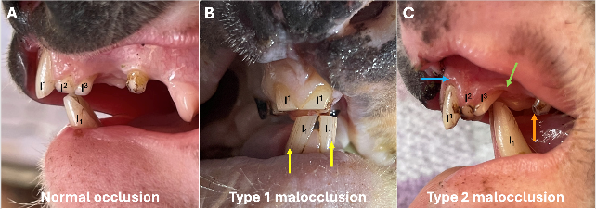
Figure 17. Dental malocclusions commonly seen in Victorian Koalas.
A) Normal occlusion in a Victorian koala: the mandibular (lower) incisors (I₁) occlude against the 2nd maxillary (upper) incisors (I²), with some overlap onto the 3rd maxillary incisors (I³) also considered normal. Wear of the upper and lower premolars during mastication has historically been used to determine koala age (‘tooth wear class’, or TWC). B) Type I malocclusion: the mandible juts forwards causing a relative maxillary underbite. The mandibular incisors (I₁) occlude directly against the maxillary 1st incisors (I¹). Over time, abnormal shearing forces on the upper and lower 1st incisors result in rotation of the teeth, asymmetrical wear and vertical crazing in the enamel (yellow arrows), which weakens the teeth and increases the risk fracture and loss of these important first incisors. Estimation of TWC in koalas with a Type 1 malocclusion is likely to significantly underestimate the age of the animal, as wear of the cheek teeth (molars and premolars) is limited until the incisors have abraded sufficiently to allow significant contact (and hence wear) between the upper and lower premolars during mastication. C) Type II malocclusion: causes a relative maxillary overbite in which the mandibular incisors (I₁) occlude behind their normal position, either directly onto the soft tissue of the hard palate between the upper incisors (I², I³), or behind the crown of I³, as seen in this young adult male koala from the Budj Bim region. Abnormal wear from the lower incisors during mastication results in erosive lesions on the hard palate between the upper incisors, and abnormal enamel wear, rotation and root exposure (green arrow), gingivitis (blue arrow), fracture and loss of I² and I³ over time. In some cases, the lower incisors also grind against the upper canines during mastication, resulting in enamel wear (orange arrow) rotation and increased risk of fractures to the upper canine teeth In Type III malocclusions (no image provided here) the maxillary overbite is even more pronounced, with the mandibular (lower) incisors (I₁) occluding even further back in the oral cavity, generally directly on the hard palate between the upper canine teeth. Abnormal grinding between the mandibular incisors and the soft tissue of the hard palate causes severe erosive lesions and loss or significant wear to the canine teeth, often to the gum line.

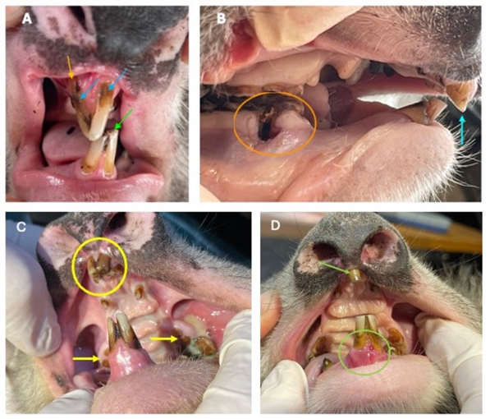
Figure 18. Dental disease in Koalas.
(A) Moderate gingivitis and periodontal disease in an adult male Koala from South Gippsland with a maxillary underbite causing diagonal wear to the incisors and pulp cavity exposure (lime green arrow). Rotation of the upper right incisor may have resulted from the abnormal shearing forces caused by this malocclusion, or may have occurred following blunt trauma (e.g. a blow to the face resulting from a fall). The gingiva around the upper incisors is receded and inflamed, exposing the root of the upper right incisor (orange arrow), and there is significant tartar build up around the base of the incisors, particularly the upper right incisor (blue arrows). At the time of examination, dental disease was considered an incidental finding, and this young male was in very good body condition (BCS 4). However, ongoing abnormal wear is likely to eventually result in fracture/loss of the upper right incisor, and progressively poor body condition and overall health status as dental disease worsens over time. (B) Severe dental disease in an aged female Koala from Ballarat, with maxillary overbite causing sharpened occlusal surface in the upper incisors (aqua arrow). Abnormal wear to molars in Koalas with this type of malocclusion commonly causes compaction of vegetation (Pettett et al. 2019), which may have contributed to the severe gingivitis and periodontitis circled in orange. There is exposure of the roots of the lower premolar and first molar, the gum around these lower cheek teeth was significantly inflamed, with gingival recession and loss of alveolar bone. (C) Severe dental disease in a senior (Tooth Wear Class (TWC) 7, >14 years) male Koala from South Gippsland. The maxillary pre-molars are worn to the level of the gum, with separation between the two roots (yellow arrows). There first upper left molar is loose, surrounded by impacted food and yellow coloured purulent discharge. The cheek mucosa is inflamed and swollen. This Koala had a significant swelling visible and palpable under the left eye. The upper incisors are discoloured and worn, with pulp cavity exposure (yellow circle). (D) This aged male Koala from South Gippsland has one missing upper incisor, the remaining upper right incisor is discoloured and worn (green arrow). There is inflammation, ulceration, bleeding and gingival recession around the lower incisors (green circle).

Kidney disease
There was no biochemical indication of kidney disease based on blood biochemical analysis. No Koalas were azotemic (elevated plasma creatinine and blood urea nitrogen levels) based on previously published normal values for Koalas (Canfield 1989; Speight et al. 2014). Mild Oxalate Nephrosis was seen on histological examination of formalin fixed kidney tissue collected at necropsy from one aged, debilitated female. However, given the degree of renal pathology noted, these changes were considered unlikely to impact renal function at the time of death, and blood biochemistry values (including blood urea nitrogen and creatinine) were normal for this Koala.

Other diseases
Other disease issues noted in specific cases included trauma, spinal and thyroid abnormalities. Further details of these diseases are provided in Section 6.5.
    - Factors associated with chronic ill-health
A BRT model fitted to the data on Koala euthanasia that contained 650 trees was optimal based on minimising the cross-validation deviance. The final model explained 64% of the deviance in the training data (mean residual deviance 0.49) and 50% of the deviance in the hold-out data used for cross validation (mean CV deviance 0.68, SE = 0.10). Analysis suggested that Koalas that were euthanised due to ill-health were associated with poor coat condition (75% influence), presence of dental disease (11% influence), occurrence of ‘wet bottom’ (5% influence) and were more likely to occur in areas with high Koala density (5% influence). The remaining variables were relatively uninfluential in the model (collectively, <5% relative influence) (Figure 19). The final BRT model had a classification accuracy of 90% (percentage of observations with correct predictions).
Interactions identified by the BRT model suggested that bivariate effects involving Koala density, dental disease, detection of Chlamydial DNA and occurrence of ‘wet bottom’ were the most important. Of these the interaction between Koala density and dental disease was approximately 10 times more important than the other interactive effects, and suggested that the effects of Koala density on the probability of a Koala presenting with chronic ill-health were less important if the individual had dental disease (Figure 20).

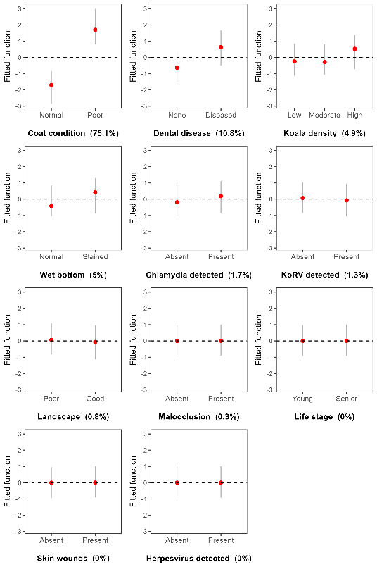
Figure 19. Plots of the marginal effect size of each variable (disease diagnostic, health condition or environmental) on Koala ill-health (euthanised – 1 or released – 0). Effect sizes were estimated from a BRT model with 650 trees using 10-fold cross validation to determine the optimal tree size. Vertical lines give the 95% confidence intervals based on fitting the final BRT model to 500 bootstrap samples of the dataset. Values in brackets give the relative influence (%) of that variable.

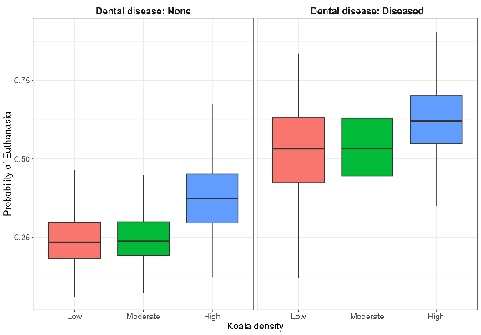
Figure 20. Partial dependence plot for the interaction between Koala density and the occurrence of dental disease on the probability of Koala euthanasia. Boxplots were generated from fitting the final BRT model to 500 bootstrap samples of the dataset. Black horizontal line denotes the median, box size gives the interquartile range and lines give 1.5 times the interquartile range.
- Discussion
  - Koala abundance and distribution
We used double-observer distance sampling on transects and passive acoustic recorder detections from 315 site visits at 182 unique locations across two survey years to estimate Koala abundance across 57,556 km² of suitable habitat in Victoria. Total statewide Koala abundance from the most recent (2024) survey was estimated as 224,800 individuals (90% CI: 181,300 – 276,600). This included Koala populations inhabiting native forest (173,200 individuals [90% CI: 135,900 – 217,900]) and hardwood plantations (51,700 [90% CI: 42,600 – 61,800]). Therefore, 23% of Victoria’s Koala population now resides in the hardwood (Blue Gum) plantation estate. Approximately 51% of Victoria’s Koala population resides in the Barwon South-West region (115,300 Koalas), with Gippsland and the Grampians having the next largest populations (47,500 and 27,000 Koalas, respectively).
    - Comparison to previous estimates
The estimates of Koala abundance in this study are lower than previous estimates for Victoria, which estimated Koala abundance across both native forests and plantations at 460,000 (Heard and Ramsey 2020). This discrepancy may be attributed to several key differences in methodological features between this study and that of Heard and Ramsey (2020). The current study represents the first statewide survey of Koala populations in Victoria. Our study used a stratified random sampling design to select sampling locations across available Koala habitat. It is well known that random sampling designs are required to provide scientifically and statistically sound inferences about populations (Thompson et al. 1998; Hankin et al. 2019). In comparison, Heard and Ramsey (2020) did not have access to robust survey data, but were limited to data that primarily targeted areas with known high density populations as well other locations of known Koala occurrence. Ultimately these non-randomly collected data may have had the effect of positively biasing population estimates for Victoria. The limitations in the data used by Heard and Ramsey (2020) were identified by the authors of that report. Consequently, they recommended that random sampling designs be used for future surveys (Heard and Ramsey 2020).
Second, in our study, we jointly modelled Koala probability of presence and abundance using a thinned Poisson process that was better able to account for Koala absence from a site. Given that Koala abundance and distribution is not always explained by environment and climate factors, but also historical translocation patterns, the inclusion of a spatial random effect was essential for predicting suitable but unoccupied habitat. Lastly, it is also possible that there was a decline in Koala abundance as Heard and Ramsey (2020) used data collected between 2004 and 2018; therefore, there may have been changes in population size compared with the data collected in the current study. However, given the stated methodological and sampling differences, it is unlikely that the discrepancy in estimates represents a real decline. Repeat surveys at sites monitored in the current study will provide more robust estimates of trends in abundance and distribution over time.
    - Drivers of Koala abundance and distribution
We found that plantations of Blue Gums generally had much higher densities of Koalas than native forest. This was most likely due to Blue Gums being a preferred food tree for Koalas. In Victoria, the total hardwood plantation estate declined by 23% in the past decade, from 2,065 km² in 2012–13 to 1,595 km² in 2022–23 (ABARES 2023). Given the high estimated density of Koalas within Blue Gum plantations, changes to the Blue Gum plantation estate size may result in significant changes to population size. This change may be especially pronounced within regions where Blue Gum plantations are prevalent (e.g. Southwest Victoria). Other important effects shown in this study were the associations between Koala density, climate and habitat. Higher Koala densities were associated with lower variation and extremes in temperature, as has been reported in other studies (Adams-Hosking et al. 2011; Santika et al. 2014; Sequeira et al. 2014). Higher Koala densities were also found in areas characterised by relatively moist, flat topography with higher levels of photosynthetic vegetation, which may reflect a preference for areas having foliage with higher water content (Moore and Foley 2000; Adams-Hosking et al. 2011; Sequeira et al. 2014; Law et al. 2017). Although it is tempting to interpret these effects as causative, it is just as likely that these effects are indirect, with these variables associated with other, unmeasured variables that are driving Koala abundance. Additionally, we found that the presence of Koalas at sites was largely explained by a spatial random effect. This suggests that Koala distribution may not be solely dependent on climate and habitat preferences, but also the contribution of historic hunting, translocation, and disturbance events (Menkhorst 2008).

    - Future directions
Koala distribution and abundance are highly variable across Victoria. Due to the statewide focus of our survey design, abundance estimates are relatively precise at the regional level, but may lack precision for smaller areas due to low sample coverage. For instance, due to low sample coverage in locations like the Little Desert and Wilson’s Promontory, there is higher uncertainty about the presence and density of Koalas in these regions. If accurate estimates of abundance are required for small specific regions (e.g. Budj Bim National Park, Wilson’s Promontory), then targeted surveys may be required to provide estimates with sufficient precision to progress management objectives for these areas.
Given the high density of Koalas in Blue Gum plantation forests, especially in Southwest Victoria, estimates of Blue Gum plantation age and rotations may have a significant impact on population estimates. Unfortunately, these data are not easily available. Land cover changes are also likely to contribute to changes in Koala abundance and distribution, but time series data for this ceased in 2019 (White et al. 2020).
  - Koala population genetics
    - Population genetic diversity and structure of Victorian Koalas
Our results reiterate previous work that has consistently shown that Koalas in the South Gippsland region have higher diversity than the rest of the state although their diversity is still generally lower than that of NSW’s and Queensland’s populations (Houlden et al. 1996; Lee et al. 2011; Lau et al. 2014; Wedrowicz et al. 2018; Kjeldsen et al. 2019; McLennan et al. 2025). This region likely represents a relict population that survived the fur trade, and which has retained unique genetic diversity due to receiving minimal translocations from island-descendent populations (Menkhorst 2008; Wedrowicz et al. 2018). Due to its higher genetic diversity, the South Gippsland population may possess a greater capacity to adapt to future environmental challenges, making the conservation of both the population and its genetic diversity critically important (Lee et al. 2011; Wedrowicz et al. 2018; DEECA 2023).
Our results indicate that the eastern populations of Gelantipy and Mallacoota have the highest inbreeding and lowest diversity in the state, in agreement with recent work based on whole genome data (McLennan et al. 2025). All other sampled sites have diversity and inbreeding metrics that are intermediate between South-Gippsland and Gelantipy. Like most Koala populations in Victoria, Gelantipy and Mallacoota were sourced from island-descendent populations (Menkhorst, 2008). Our results suggest that these populations may have been founded by a smaller number of Koalas, or from Koalas whose lineage has experienced more bottlenecks than other parts of the state, or else went through a period of small population size after translocation which further eroded diversity. Mallacoota is particularly interesting because this site is adjacent to the NSW border where some gene-flow from more northern populations might have been expected. Our results suggest that gene-flow is not occurring with more northern populations, or that Koalas in adjacent NSW are equally genetically depauperate. Extending sampling across the border would allow us to test these alternate hypotheses.
Our ADMIXTURE analysis suggested that the number of genetic clusters was three, one of which represents the well-defined South Gippsland cluster. The other two clusters are less well defined as they do not represent geographically contiguous areas, and many Koalas have putative ancestry from both clusters. The resultant mixed ancestry could indicate a recent or historic mixing of two previously isolated groups. For example, these clusters may represent ancestry from French Island alone, and from mixtures of French and Phillip Island Koalas at translocation sites. Unfortunately, translocation records are incomplete, making it difficult to relate detailed translocation histories to these genetic results. Our results from Koalas outside of South Gippsland may alternatively be indicative of clinal genetic similarity without strong delineation between groups. Clustering programs like ADMIXTURE and tess3R are not designed to describe clinal variation and will always attempt to define clusters, even if the data does not wholly suit this model of diversity partitioning. Our PCA analysis, which does not use a model based on clustering, suggests that diversity outside of South Gippsland is better defined as a cline, as does a similar analysis based on whole genome data (McLennan et al. 2025). Sampling ancient or historical Koala specimens from museum collections may help to understand how translocation histories have led to the spatial distribution of genetic diversity in Victorian Koalas today.
    - The spatial extent of the South Gippsland genetic cluster
Our analysis is the first to attempt to define the spatial extent of the unique South Gippsland cluster. We found that the cluster likely extends from Corinella and Westernport Bay in the east to the western edge of the Gippsland Lakes region, near Loch Sport, and is bounded to the north by the Central Highlands. The population around the township of Erica, at the southern edge of the Central Highlands, displays some admixture from the South Gippsland cluster, indicating that dispersal between South Gippsland and this region may still be occurring, although it is difficult to rule out translocations as the cause of this mixing. We also found that individuals along the south coast of South Gippsland did not form part of the high-diversity South Gippsland cluster. Instead, these were more genetically similar to populations in the Budj Bim IPA, the Strathbogies, Erica and the eastern Gippsland Lakes. This pocket of low genetic diversity may reflect the fact that Koalas from both French and Phillip Island descent were released into this area, particularly around the townships of Welshpool, Hedley and Gelliondale (Wedrowicz et al. 2017). It is interesting that despite at least 70 years since the first translocations to this area, admixture from the South Gippsland cluster is still limited among sampled animals along the coast. This may indicate limited dispersal into and out of this region, or ongoing release of low genetic diversity Koalas to the area.
Unfortunately, our blood and tissue samples did not include any animals from Wilson’s Promontory, the eastern boundary of South Gippsland, or Mornington Peninsula. However, analysis of microsatellite markers from scats sampled in these areas indicated that samples from the eastern boundary of South Gippsland and Wilson’s Promontory grouped with the South Gippsland cluster. However, scats samples from Koalas on the Mornington Peninsula grouped with French Island, reflecting the translocation history of this region (Lee et al. 2012).
    - Koala dispersal characteristics
Our analysis of Koala dispersal in the Gippsland region indicated that most dispersal events are within 25 km, with highest genetic autocorrelation occurring within 10 km. This agrees well with previous radio-tracking studies (Dique et al. 2003; Matthews et al. 2016) and parentage-based studies of dispersal (Norman et al. 2019), which found that average distance between natal and breeding home ranges was 3.5 km, with some recorded dispersal events over 10 km and up to 40 km.
We found no evidence of sex-biased dispersal, similar to a genetic-based study of Koalas from north-eastern NSW and south-eastern Queensland (Dennison et al. 2017). Previous work has also indicated that genetic patterns are primarily driven by natal dispersal, which was shown to be similar between male and female Koalas (Dique et al. 2003). Although long distance dispersal events in Koalas are relatively rare, management that aims to maintain dispersal corridors across spatial scales that reflect known long-dispersal distances should be prioritised to help promote population connectivity and prevent the continuing loss of small but significant populations.
    - The genetic management of Victorian Koalas
Victorian Koalas are considered genetically vulnerable, with low adaptive potential to face emerging threats and future climates (Lott et al. 2022; McLennan et al. 2025). The initial assessment for Koalas using the Victorian ‘Genetic Risk Index’ identified a moderate genetic risk and indicated that some populations would benefit from genetic intervention (Kriesner et al. 2020). Although there is currently limited evidence that inbred Koala populations have reduced fitness (Sherwin et al. 2000; Cristescu et al. 2009), a number of studies have found genetic associations with Chlamydia susceptibility and disease progression (Lau et al. 2014; Quigley et al. 2018; Robbins et al. 2020; Silver et al. 2022), underscoring the importance of genetic factors in Koala disease resistance. The Victorian Koala Management Strategy (DEECA 2023) highlights the need to develop a genetic management plan for Victorian Koalas to develop potential approaches, such as gene flow augmentation, to prevent inbreeding depression and increase the adaptability of Victorian Koala populations
Across Victoria, the Gelantipy and Mallacoota Koala populations have the lowest diversity and highest level of inbreeding. Consequently, these populations are at higher risk of inbreeding depression and likely have the lowest adaptive potential to face emerging threats. Ordinarily, both populations would be considered as candidates for augmented gene flow (i.e. genetic rescue). However, the Gelantipy population is currently over-abundant, with evidence of over-browsing of Eucalypts, complicating genetic management at this site. Over-abundance has also been an issue at many other Victorian and South Australian Koala populations with known or likely low diversity and high inbreeding due to the history of translocations and extreme population bottlenecks (Menkhorst 2008; McAlpine et al. 2015; Whisson et al. 2016; Whisson and Ashman 2020). Management of over-abundant Koala populations has so far focused on reducing population size using translocations or sterilisations. No management strategy has yet considered how to manage the dual issues of genetic vulnerability and over-abundance simultaneously.
This occurrence of population over-abundance as well as genetic vulnerability is a rare, if not unique situation. While over-abundance of threatened, genetically vulnerable fauna is relatively common in populations translocated to islands or fenced reserves where threats have been removed and dispersal limited (Short 2009), Koalas have become over-abundant in regions with substantial prevalence of threats and diseases, and at sites surrounded by suitable habitat. Hypothesised explanations for Koala over-abundance include high densities of preferred food trees (e.g. E. viminalis/E. ovata) occurring in areas with elevated levels of soil nutrients and moisture levels promoting leaf growth with high nitrogen content (Ramsey et al. 2016), or even low genetic-diversity, which may have narrowed their behavioural range and reduced aggression (Whisson and Ashman 2020).
While it is tempting to disregard the genetic threats to Victorian Koalas when faced with issues of over-abundance, decades of conservation genetic research shows that this would be unwise (Frankham 2010; Frankham et al. 2017; Liddell et al. 2021). All populations of Victorian Koalas are at risk of collapse due to genetic effects (McLennan et al. 2025). The Tasmanian devil (Sarcophilus harrissi) provides a cautionary tale with relevance to Koalas. Although once an abundant species, the Tasmanian devil had a history of genetic bottlenecks resulting in low genetic diversity and, after the emergence of a highly contagious disease in 1996, the population decreased by up to 90% (McCallum 2008; Brüniche-Olsen et al. 2014; Pye et al. 2016). Furthermore, changing climates will necessitate adaptation to new conditions, including greater incidence of drought and heat waves (Adams-Hosking et al. 2011; Briscoe et al. 2016). The Koala’s ability to adapt to these emerging threats will be limited unless genetic diversity is managed and maximised.
To manage genetic threats to Victorian Koalas, we suggest augmented gene flow be considered as a management tool where high genetic diversity individuals are introduced into inbred populations in a controlled manner. Populations that have not had issues of overabundance should be considered as initial candidates for augmented gene glow (e.g. Mallacoota, Ballarat, Murray River). Planning for these management actions could be assisted by dedicated population viability analysis that includes genetic outcomes. Further research into the cause of over-abundance, and the interaction between disease, demography and genetics will also be critical for paving a way forward for Koala management in Victoria to address both the issue of over-abundance and genetic vulnerability. Routine genetic monitoring of Koala populations would also assist in the genetic management of Koalas by testing for continued decline in diversity that could be used to trigger intervention. Genetic monitoring could be incorporated into proposed programs for predicting when overabundance issues are likely to occur (Ramsey et al. 2016). The development of SNP assays that can be applied easily to scat samples would make routine genetic monitoring highly feasible.
If augmented gene-flow is considered for Victorian Koalas, the South Gippsland population would represent the best source population available in the state due to its higher than average diversity and comparably stable demographic history (DEECA 2023). However, it is clear from the large body of previous genetic studies (Houlden et al. 1996; Fowler et al. 1998; Houlden et al. 1999; Lau et al. 2014; Kjeldsen et al. 2016; Kjeldsen et al. 2019; Lott et al. 2022; Silver et al. 2022; McLennan et al. 2024) that Koalas from the southern states of Victoria and South Australia have lower diversity than northern populations in NSW and Queensland. This includes the South Gippsland population that, while maintaining the highest diversity of any southern Koalas, still has lower diversity than the majority of NSW and Queensland Koala populations (McLennan et al. 2025). For this reason, any gene-flow augmentation plan could consider using NSW or Queensland Koalas as potential sources. Variation in Koalas (both morphological and genetic) largely forms a cline along latitude, with Koalas becoming less diverse, larger and with longer and darker fur the further south they are found (Sherwin et al. 2000; Briscoe et al. 2015). While concerns regarding disrupting local adaptation by augmenting gene flow across climatic regions are not baseless, they should be considered alongside the risks of inbreeding depression and lost adaptive potential (Frankham et al. 2011; Weeks et al. 2011; Frankham et al. 2017; Ralls et al. 2018). In the case of the Koala, concerns around outbreeding depression should not be used to dismiss interstate genetic management because a test case has already been established: the reintroduced population at Narrandera in NSW has ancestry from both an inbred Victorian population and a more genetically diverse population from northern NSW or southern Queensland (McLennan et al. 2024). The population continues to persist and has higher diversity and lower inbreeding than any sampled population in Victoria or southern New South Wales, highlighting how interstate gene augmentation can significantly improve diversity and inbreeding metrics (McLennan et al. 2025).
  - Koala health and disease
Our study raises concerns for the health of Victorian Koalas. We found a higher-than-expected proportion of Koalas from seven geographically distinct regions in a state of chronically poor health and welfare. Clinical signs consistent with chronic ill-health were observed in Koalas across all life stages and in populations with varying habitat and population densities, suggesting that multiple individual, environmental and demographic stressors may be contributing to prolonged physiological stress within these populations. Analysis of the outcomes of Koala health assessments suggested that Koalas that were diagnosed as in chronic ill-health and requiring euthanasia were associated with several common stressors, including poor coat condition, occurrence of dental disease and ‘wet bottom’, and were more likely to occur in areas with high population abundance. Infectious diseases were widely detected, although there was no clear relationship between infection status and the expression of clinical signs of disease. Dental disease secondary to dental malocclusion was also frequently observed, suggesting that this may play a more significant role in poor health outcomes for Koalas than previously thought. Importantly, Koalas were randomly sampled and not targeted based on ease of capture, age, sex or visible signs of illness, indicating that our findings likely reflect broader population-level trends rather than sampling bias. However, further sampling is needed from regions where Koalas occur at low densities (e.g. Ballarat, and the Yarra Ranges). Although we attempted to find and catch Koalas from low-density populations, we spent multiple days searching for Koalas without success. The use of drones to locate Koalas for capture may facilitate future sampling.
To our knowledge, this is the first study reporting on the active surveillance for multiple infectious and non-infectious disease processes in free-ranging Koalas via thorough physical examination and diagnostic sampling. Our study provides useful baseline measures of health and disease status, which can be considered relative to population genetics, habitat and population densities. Most studies on the health of free-ranging Koalas have been based on veterinary or wildlife rehabilitator records (Cooley et al. 2022; Kerlin et al. 2022; Lunney et al. 2023), findings of necropsy examination of wild Koalas, (McKenzie 1981; Obendorf 1983; Speight et al. 2018), or have focused on surveillance for specific infectious or non-infectious diseases (Speight et al. 2013; Henning et al. 2015; Legione et al. 2016a; Pettett 2016; Speight et al. 2017; Church et al. 2025). In Victoria, studies into the prevalence of infectious and non-infectious diseases have mostly used samples collected from Koalas captured and assessed during management programs, thereby biasing incidence and prevalence data to locations where Koalas occur at unsustainably high population densities (Patterson et al. 2015; Legione et al. 2016a; Vaz et al. 2019). More recently, there has been considerable focus on the impact of emergency events such as bushfire on the health and welfare of free-ranging Koalas, including detailed descriptions of the pathology caused by smoke inhalation and thermal burns (Baek et al. 2023), and investigations into the welfare of Koalas following release to the wild after rehabilitation (Lane et al. 2023).
Considering the sampling approach of this study, it is not surprising that our results contrast with previous Victorian studies that report a high prevalence of severe traumatic injuries including fractured bones, infected abscesses and skin lacerations caused by motor vehicle accidents, fights with other Koalas, or gunshot wounds (Obendorf 1983; Schlagloth et al. 2021). Although some Koalas in our study presented with signs of trauma (bite wounds, burns), these wounds had healed or were healing, and did not appear to be a primary cause of poor health in any of these Koalas.
A high proportion of Koalas across all life stages showed a range of clinical signs consistent with prolonged physiological and nutritional stress, including lean-to-emaciated body condition, with poor muscle coverage and tone and poor fur coat condition. The condition of mammalian fur can provide a useful external indication of the general health and well-being of individuals because it can be impacted by a range of systemic diseases, including skin infections, endocrine disfunction, musculoskeletal trauma affecting grooming, and nutritional deficiencies (Berg et al. 2009). Some of these Koalas also presented with abnormally high burdens of gastrointestinal tapeworms, which are commonly reported and considered non-pathogenic in healthy Koalas (Spratt et al. 2008). These cases were associated with significant gastrointestinal pathology, most likely secondary to chronic stress related immunosuppression. Many Koalas showed clinical signs consistent with ‘Koala stress syndrome’, a condition previously described by wildlife carers and veterinarians (Degabriele 1989; Marik and Levitov 2010; Narayan 2019). With this syndrome, Koalas present with non-specific clinical signs such as depression, lethargy, poor appetite, and a rapid decline in metabolic function leading to dehydration, emaciation and ultimately death. Chronic exposure to stressful conditions is postulated to contribute to the development of this syndrome, but other factors including health, age, reproductive status, and environmental factors such as population density, habitat quality and the availability of suitable food resources, are also likely to contribute (Obendorf 1983; Marik and Levitov 2010).
Finding Koalas in poor condition was somewhat expected in areas where high Koala population densities and overbrowsing of preferred food trees has occurred (e.g. Budj Bim, Gelantipy). High Koala densities can result in frequent agonistic interactions between males (Watchorn and Whisson 2019), as well as food limitation (Whisson et al. 2016). In the Budj Bim region, the harvest of Blue Gum plantations resulting in ongoing movement of Koalas through the landscape (Hynes et al. 2021), is an additional stressor. Some Koalas sampled from Budj Bim presented in very poor condition, yet no other underlying health concerns were found. Food limitation due to ongoing overbrowsing of food trees and exacerbated by drought conditions is the most probable cause of poor body condition in this population. This significant welfare issue is likely to become increasingly important under a changing climate.
Koalas in chronically poor heath were also found in the Murray River region, South Gippsland and Cape Otway where population densities were lower, and Koalas had access to a good food supply (based on the presence and canopy cover of preferred food trees). The continuing poor condition of Koalas at Cape Otway, where the population has been managed to reduced density and Manna Gum condition has improved, raises questions about how management program success is evaluated. Traditionally, effectiveness is measured by reduced population densities and improved tree canopy condition (Ramsey et al. 2016), but these indicators may not fully reflect Koala welfare outcomes. Multiple underlying health concerns such as dental disease, low genetic diversity, and extrinsic factors such as the nutritional quality of foliage, and climate may be contributing to the poor health of Koalas in these areas.

    - Infectious disease in Koalas
Evidence of urogenital tract disease has been widely reported for Koalas throughout their geographic range (Brown et al. 1984; Legione et al. 2018; Hulse et al. 2021), and infertility secondary to pathology of the reproductive tract in male and female Koalas is considered a significant threat to the conservation of the species (Grogan et al. 2017; Hulse et al. 2021). We found widespread evidence of urogenital tract disease during our study; however, the underlying causes are unclear. Although the clinical sign of ‘wet bottom’ is often attributed to Chlamydial infection, wet bottom has also been recorded in Koalas free of Chlamydia pecorum, suggesting other causative agents in those individuals (Legione et al. 2018). The impact of reproductive tract pathology on fecundity and recruitment in Victorian Koala populations is also unclear. Despite recording relatively low fecundity and a high incidence of urogenital tract disease of varying severity in Koalas from high-density populations in our study, these populations typically exhibit high reproductive rates.
As in previous studies on Victorian Koalas, there was no clear relationship between detection of clinical signs of urogenital tract disease (either on physical examination or at necropsy) and the detection of Chlamydial DNA from swabs collected from Koalas (Legione et al. 2016b; Legione et al. 2018). Failure to detect C. pecorum in swabs may reflect latency or low shedding of infectious particles from chronically infected animals, or conversely, may represent the absence of infection in these animals (Wedrowicz et al. 2016).
KoRV has been linked to immunosuppression, the development of tumours and expression of Chlamydiosis in animals co-infected with C. pecorum. (Quigley and Timms 2020). In our study, KoRV was detected in 23% of samples, a prevalence comparable to that reported by Legione et al. (2017) who found replication-competent KoRV pol present in 17–40% of Victorian Koalas. However, we did not observe co-infection with C. pecorum and KoRV to increase the expression and severity of Chlamydial disease in Koalas, as has been reported previously (Patterson et al. 2015). We found very low levels of co-infection with these two pathogens, yet widespread expression of urogenital tract disease. Unlike previous studies, our sampling was not confined to high-density populations where individuals are more likely to be suffering significant health and welfare issues. Consequently, although our sample size was relatively small, it may be more representative of the situation for Victorian Koalas.
The impact of infectious diseases for Koalas is likely exacerbated by a range of environmental factors as well as co-infection with other infectious agents. Although considerable attention has focussed on co-infection with C. pecorum and KoRV in Koalas, there is increasing interest in understanding the prevalence and clinical significance of gammaherpesviruses, two of which have been described for Koalas: Phascolarctid gammaherpesvirus-1 (Pha-HV1) and Pha-HV2 (Church et al. 2025). Gammaherpesviruses invade lymphocytes (white blood cells which function as part of the immune system) and epithelial cells, and significant associations have been documented between infection with Pha-HV2 and co-infection with both C. pecorum and KoRV, and reduced fertility in Victorian Koalas (Devlin and Stalder 2019; Vaz et al. 2019; Church et al. 2025). Gammaherpesviruses can remain latent in otherwise healthy animals; however, increased shedding is documented in hospitalised Koalas, which suggests that physiological stress may play a role in shedding, and increased risk of transmission and the expression of clinical disease in infected Koalas (Wright et al. 2024). Detection of Pha-HV at low levels during this study (10% prevalence) precluded further investigation into the relationship between gammaherpesviruses and the individual and environmental variables impacting Koala health and welfare. Of note, Pha-HV was the only infectious disease detected from the one animal in our study that was found to be suffering from a significant malignant thyroid carcinoma, a neoplastic disease that has not previously been reported for Koalas.
Sarcoptic mange resulting from infection with Sarcoptes scabiei, is an emerging infectious disease of Koalas, but it was not observed in this study. This is despite sampling Koalas in the Murray River region, an area from which most published records of sarcoptic mange in Victoria have originated (Speight et al. 2017; Young et al. 2024). The absence of cases of sarcoptic mange found in our study may be due to the sampling period rather than disease significance. Sarcoptic mange has not been reported during winter which is when most of our field work was conducted, and the aetiology of this disease in free-ranging Koalas is poorly understood (Speight et al. 2017; Young et al. 2024). Sarcoptic mange was first identified in Victorian Koalas in 2008 and was recently identified as being one of the ten most significant disease processes affecting Koalas across their geographic range. It also is highlighted as a concern for free-ranging Koalas in Victoria in the 2023 Victorian Koala Management Strategy (Vitali et al. 2022; DEECA 2023).
Multiple infectious organisms were detected for all Koala life stages and across all regions of our study. However, determining their impact on Koala health is challenging due to the complexity of intrinsic and extrinsic factors that influence a Koala’s resilience to infection and expression of disease. Although we observed a high incidence of poor health across our study population, the relationship between co-infection and poor health status remains unclear. Most of the Koalas for which multiple infectious organisms were detected were subclinically infected, showing no overt signs of disease, and were assessed to be in good health. Environmental conditions, nutritional status, and co-infections likely mediate the clinical signs and severity of disease.
    - Non-infectious disease in Koalas
In contrast to infectious organisms, we identified a strong association between several non-infectious disease processes and poor health status of Koalas. Notably, dental disease was recorded across all life stages and in all regions except Mallacoota, with most affected individuals found to be in poor body condition. The importance of good dentition for efficient nutrient extraction from Eucalyptus foliage has long been recognised (Lanyon and Sanson 1986; Logan 2003), yet few studies have investigated the contribution of dental disease to poor body condition and overall health in free-ranging Koalas. Research has reported a high incidence of periodontal disease in Koalas from Queensland (Pettett 2016) and South Australia (Butcher et al. 2020), highlighting the need for further investigation. To better understand the impact of dental disease at both individual and population levels, future health assessments of free-ranging Koalas in Victoria should incorporate the standardised dental assessment protocol developed by Pettett (2016).
Risk factors for the development of dental disease in Koalas include extrinsic factors such as the type and abrasiveness of available foliage, and intrinsic factors such as Koala age, oral cavity trauma, neoplasia and co-infection with pathogens such as KoRV (DeSantis et al. 2018; Butcher et al. 2020). Dental malocclusion, which refers to any deviation from normal occlusion of the teeth when the mouth is closed, is also an important intrinsic risk factor for the development of dental disease over time. Malocclusion has previously been documented in Koalas (Pettett et al. 2019) and can lead to progressive dental disease by impairing the function of the oral cavity such that the Koala cannot masticate Eucalyptus leaves sufficiently to meet their nutritional requirements.
We recorded a high prevalence (31%) of dental malocclusion in Koalas across all regions, with a high proportion being Type 2 or 3 malocclusions. Most Koalas with dental malocclusions also exhibited varying degrees of dental disease. Although dental malocclusion can occur secondary to trauma, neoplasia, infection, or food quality, it commonly has a genetic or congenital basis (Pettett et al. 2019). Supporting this, we observed a cleft lip in one Koala with malocclusion. In other species, cleft lips are considered a type of congenital deformity caused by abnormal craniofacial development during gestation (McMichael et al. 2023).
Similar cases of cleft lips have been anecdotally reported in two South Gippsland Koalas (Stacey Harwood, personal communication). The genetic basis for cleft lips may explain the presence of malocclusion in Victorian Koalas, which are known for their low genetic diversity (McLennan et al. 2025). It is concerning that four cases of malocclusion were recorded in South Gippsland Koalas, which have relatively higher genetic diversity and are considered to have higher conservation value than other Victorian populations (Wedrowicz et al. 2018).
We did not find any evidence of some non-infectious disease processes previously reported for Victorian Koalas, including skeletal fluorosis (Death et al. 2017) and testicular asymmetry (Cristescu et al. 2009). Furthermore, we only found one case each of Oxalate Nephrosis (Speight et al. 2020) and scoliosis of the spine. As with infectious disease like sarcoptic mange, the absence or low prevalence of these diseases may be due to sample size, geographic coverage and the timeframe of data collection. This further highlights the importance of ongoing, broad-scale monitoring of Koala health and welfare across Victoria.
  - Recommendations
Our study provides important baseline information on the status of Victoria’s Koala population, documenting current distribution and abundance, genetic health, disease status and general health and welfare. Koalas were sampled across their range, encompassing populations inhabiting a wide variety of habitats, climates and population densities. However, it is important to note that the timeframe for sampling was relatively short, and therefore, sample sizes for genetics, health and disease surveys were relatively low and contain many geographic gaps in coverage. Additional sampling from more low-density populations, and ongoing monitoring are essential for understanding the significance, seasonality and impacts of infectious and non-infectious disease, and their relationship with Koala genetics, health and environmental factors. We therefore make the following recommendations:
- Periodic monitoring (e.g. at 5-yearly intervals) of Koalas is required to determine statewide trends in Koala abundance and distribution, especially in the Blue Gum plantation estate.
- Information on plantation age and rotation for Victoria’s hardwood (Blue Gum) plantation estate is required to better understand how changes in hardwood plantations affect Koala populations using these habitats.
- Since a high proportion of the Victorian Koala population resides in Blue Gum plantations, research is urgently needed to better understand the fates of these Koalas following plantation harvesting.
- Genetic management is needed for Koala populations identified as having a high risk of inbreeding depression (e.g. Ballarat, Murray River, Mallacoota) to increase genetic diversity. To augment genetic diversity in these populations, consideration should be given to introducing Koalas from the South Gippsland genetic cluster. Alternatively, Koalas sourced from areas with relatively higher genetic diversity, such as NSW, could also be considered for translocation to Victorian populations of relatively low genetic diversity.
- To help facilitate genetic management, consideration should be given to undertaking population viability analysis (PVA) that includes a genetic component, to better understand the long-term outcomes of any planned translocation program to improve genetic diversity.
- Further research is required to better understand the diversity of factors contributing to poor health in Koala populations and the significance of these factors to the long-term viability of Koalas in Victoria. This would involve sampling at more locations to better understand variation in genetics, infectious and non-infectious diseases and Koala health across their range in Victoria.
- Further research should be undertaken to better understand the relationships between genetics and the occurrence of dental malocclusion and other craniofacial abnormalities in Victorian Koalas.
- Koalas captured in management programs should undergo a thorough physical examination, involving the collection of genetic, diagnostic and disease screening samples to help understand relationships between disease processes and the individual, environmental and population factors that influence disease exposure and expression.
- A central repository for Koala health data, samples, and DNA extractions should be established. This could utilise pre-existing disease surveillance projects such as Wildlife Health Australia’s electronic Wildlife Health Information System, Melbourne University’s Wildlife Health Surveillance program and other university research projects investigating the presence of specific infectious organisms in Koalas, as well as mandatory record keeping and reporting for registered wildlife carers in Victoria. Such a repository would provide a more comprehensive understanding of the distribution and prevalence of disease processes and health status of Koalas in Victoria.
- There is an urgent need to address the significant health and welfare issues associated with unsustainably high-density Koala populations, and to ensure that Koala welfare and population management objectives are evidence-based and regularly evaluated.
- References
ABARES (2023). Australian Plantation Statistics 2023 Update. doi:10.25814/HHK8-4X26
Adams-Hosking, C., Grantham, H.S., Rhodes, J.R., McAlpine, C. and Moss, P.T. (2011). Modelling climate-change-induced shifts in the distribution of the Koala. Wildlife Research 38, 122 doi:10.1071/WR10156
Alexander, D.H., Novembre, J. and Lange, K. (2009). Fast model-based estimation of ancestry in unrelated individuals. Genome Research 19, 1655–1664 doi:10.1101/gr.094052.109
Aparicio, J.M., Ortego, J. and Cordero, P.J. (2006). What should we weigh to estimate heterozygosity, alleles or loci? Molecular Ecology 15, 4659–4665 doi:10.1111/j.1365-294X.2006.03111.x
Ashman, K.R. and Whisson, D.A. (2020). Developing guidelines for the use of traps to capture Koalas. Australian Mammalogy 42, 380–384.
Baek, C., Woolford, L., Funnell, O., McLelland, J., Eddy, S., Stephenson, T. and Speight, N. (2023). Cutaneous and respiratory lesions in bushfire-affected Koalas. Veterinary Sciences 10, 658 doi:10.3390/vetsci10110658
Berg, W., Jolly, A., Rambeloarivony, H., Andrianome, V. and Rasamimanana, H. (2009). A scoring system for coat and tail condition in ringtailed lemurs, Lemur catta. American Journal of Primatology 71, 183–190 doi:10.1002/ajp.20652
Blanshard, W. and Bodley, K. (2008). Chapter 8. Koalas. In: Vogelnest, L. and Woods, R. (Eds.) Medicine of Australian Mammals, pp. 227–329. CSIRO Publishing, Collingwood, Victoria.
Briscoe, N.J., Kearney, M.R., Taylor, C.A. and Wintle, B.A. (2016). Unpacking the mechanisms captured by a correlative species distribution model to improve predictions of climate refugia. Global Change Biology 22, 2425–2439 doi:10.1111/gcb.13280
Briscoe, N.J., Krockenberger, A., Handasyde, K.A. and Kearney, M.R. (2015). Bergmann meets Scholander: Geographical variation in body size and insulation in the Koala is related to climate. Journal of Biogeography 42, 791–802 doi:10.1111/jbi.12445
Brown, A.S., Carrick, F.N., Gordon, G. and Reynolds, K. (1984). The diagnosis and epidemiology of an infertility disease in the female Koala: Phascolarctos cinereus (Marsupialia). Veterinary Radiology 25, 242–248.
Brüniche-Olsen, A., Jones, M.E., Austin, J.J., Burridge, C.P. and Holland, B.R. (2014). Extensive population decline in the Tasmanian devil predates European settlement and devil facial tumour disease. Biology Letters 10, 20140619 doi:10.1098/rsbl.2014.0619
Buckland, S.T., Laake, J.L. and Borchers, D.L. (2010). Double-observer line transect methods: Levels of independence. Biometrics 66, 169–177 doi:10.1111/j.1541-0420.2009.01239.x
Burt, M.L., Borchers, D.L., Jenkins, K.J. and Marques, T.A. (2014). Using mark-recapture distance sampling methods on line transect surveys. Methods in Ecology and Evolution 5, 1180–1191.
Butcher, R.G., Pettett, L.M., Fabijan, J., Ebrahimie, E., Mohammadi-Dehcheshmeh, M., Speight, K.N., Boardman, W.S.J., Bird, P.S. and Trott, D.J. (2020). Periodontal disease in free-ranging Koalas (Phascolarctos cinereus) from the Mount Lofty Ranges, South Australia, and its association with Koala retrovirus infection. Australian Veterinary Journal 98, 200–206 doi:10.1111/avj.12919
Cally, J.G., Ramsey, D.S.L. and Whisson, D.A. (2022). East Gippsland Koala population surveys. Unpublished Client Report for the CSIRO National Koala Monitoring Program, Arthur Rylah Institute for Environmental Research, Department of Environment, Land, Water and Planning, Heidelberg, Victoria.
Canfield, P.J. (1989). A survey of urinary tract disease in New South Wales Koalas. Australian Veterinary Journal 66, 103–106 doi:10.1111/j.1751-0813.1989.tb09758.x
Caye, K., Deist, T.M., Martins, H., Michel, O. and François, O. (2016). TESS3: Fast inference of spatial population structure and genome scans for selection. Molecular Ecology Resources 16, 540–548 doi:10.1111/1755-0998.12471
Caye, K., Jay, F., Michel, O. and François, O. (2018). Fast inference of individual admixture coefficients using geographic data. The Annals of Applied Statistics 12, 586–608.
Chang, C.C., Chow, C.C., Tellier, L.C., Vattikuti, S., Purcell, S.M. and Lee, J.J. (2015). Second-generation PLINK: Rising to the challenge of larger and richer datasets. GigaScience 4, s13742-015-0047–8 doi:10.1186/s13742-015-0047-8
Church, C., Casteriano, A., Muir, Y.S., Krockenberger, M., Vaz, P.K., Higgins, D.P. and Wright, B.R. (2025). New insights into the range and transmission dynamics of a Koala gammaherpesvirus, phascolarctid gammaherpesvirus 2. Scientific Reports 15, 6136.
Conomos, M.P., Miller, M.B. and Thornton, T.A. (2015). Robust inference of population structure for ancestry prediction and correction of stratification in the presence of relatedness. Genetic Epidemiology 39, 276–293 doi:10.1002/gepi.21896
Cooley, M., Whiteley, P., Thornton, G. and Stevenson, M. (2022). Health surveillance representative of Koala (Phascolarctos cinereus) distribution in Victoria, Australia. Australian Veterinary Journal 100, 605–612 doi:10.1111/avj.13208
Coulon, A. (2010). genhet: An easy-to-use R function to estimate individual heterozygosity. Molecular Ecology Resources 10, 167–169 doi:10.1111/j.1755-0998.2009.02731.x
Cripps, J.K., Nelson, J.L., Scroggie, M.P., Durkin, L.K., Ramsey, D.S.L. and Lumsden, L.F. (2021). Double-observer distance sampling improves the accuracy of density estimates for a threatened arboreal mammal. Wildlife Research 48 doi:10.1071/WR19136
Cristescu, R., Cahill, V., Sherwin, W.B., Handasyde, K., Carlyon, K., Whisson, D., Herbert, C.A., Carlsson, B.L.J., Wilton, A.N. and Cooper, D.W. (2009). Inbreeding and testicular abnormalities in a bottlenecked population of Koalas (Phascolarctos cinereus). Wildlife Research 36, 299–308 doi:10.1071/WR08010_CO
Cristescu, R.H., Strickland, K., Schultz, A.J., Kruuk, L.E.B., de Villiers, D. and Frère, C.H. (2022). Susceptibility to a sexually transmitted disease in a wild Koala population shows heritable genetic variance but no inbreeding depression. Molecular Ecology 31, 5455–5467 doi:10.1111/mec.16676
Cruz, V.M.V., Kilian, A. and Dierig, D.A. (2013). Development of DArT marker platforms and genetic diversity assessment of the U.S. collection of the new oilseed crop Lesquerella and related species. PLOS ONE 8, e64062 doi:10.1371/journal.pone.0064062
Death, C., Coulson, G., Kierdorf, U., Kierdorf, H., Ploeg, R., Firestone, S.M., Dohoo, I. and Hufschmid, J. (2017). Skeletal fluorosis in marsupials: A comparison of bone lesions in six species from an Australian industrial site. Science of The Total Environment 584–585, 1198–1211 doi:10.1016/j.scitotenv.2017.01.183
DEECA (2023). Victorian Koala Management Strategy. Department of Energy, Environment and Climate Action.
Degabriele, R. (1989). Wasting disease in the Koala, Phascolarctos cinereus. Perspectives in Biology and Medicine 32, 414–418.
Dennison, S., Frankham, G.J., Neaves, L.E., Flanagan, C., FitzGibbon, S., Eldridge, M.D.B. and Johnson, R.N. (2017). Population genetics of the Koala (Phascolarctos cinereus) in north-eastern New South Wales and south-eastern Queensland. Australian Journal of Zoology 64, 402–412 doi:10.1071/ZO16081
Department of Environment, Land, Water and Planning (DELWP) (2024). Vicmap Vegetation - Plantation Polygon. Available at: https://metashare.maps.vic.gov.au/geonetwork/srv/eng/catalog.search#/metadata/9364f104-007f-5d31-94c9-2647f5e85729 [accessed 5 December 2024]
DeSantis, L.R., Alexander, J., Biedron, E.M., Johnson, P.S., Frank, A.S., Martin, J.M. and Williams, L. (2018). Effects of climate on dental mesowear of extant Koalas and two broadly distributed kangaroos throughout their geographic range. PLoS one 13, 0201962.
Devlin, J. and Stalder, K. (2019). Marsupial herpesviruses. In: Vogelnest, L. and Portas, T. (Eds.) Current Therapy in Medicine of Australian Mammals, pp. 353–358. CSIRO Publishing: Clayton South, Victoria.
Diniz-Filho, J.A.F., Soares, T.N., Lima, J.S., Dobrovolski, R., Landeiro, V.L., de Campos Telles, M.P., Rangel, T.F. and Bini, L.M. (2013). Mantel test in population genetics. Genetics and Molecular Biology 36, 475–485 doi:10.1590/S1415-47572013000400002
Dique, D.S., Thompson, J., Preece, H.J., Villiers, D.L.de, and Carrick, F.N. (2003). Dispersal patterns in a regional Koala population in south-east Queensland. Wildlife Research 30, 281–290 doi:10.1071/wr02043
Do, C., Waples, R.S., Peel, D., Macbeth, G.M., Tillett, B.J. and Ovenden, J.R. (2014). NeEstimator v2: Re-implementation of software for the estimation of contemporary effective population size (Ne) from genetic data. Molecular Ecology Resources 14, 209–214 doi:10.1111/1755-0998.12157
Doser, J.W., Finley, A.O., Weed, A.S. and Zipkin, E.F. (2021). Integrating automated acoustic vocalization data and point count surveys for estimation of bird abundance. Methods in Ecology and Evolution 12, 1040–1049 doi:10.1111/2041-210X.13578
Downey, P.M.R., Caraguel, C.G.B., Speight, N., Fabijan, J. and Boardman, W.S.J. (2020). Field immobilization using alfaxalone and alfaxalone-medetomidine in free-ranging Koalas (Phascolarctos cinereus): A randomized comparative study. Veterinary anaesthesia and analgesia 47, 368–376.
Elith, J., Leathwick, J.R. and Hastie, T. (2008). A working guide to boosted regression trees. Journal of Animal Ecology 77, 802–813 doi:10.1111/j.1365-2656.2008.01390.x
Epperson, B.K. (2005). Estimating dispersal from short distance spatial autocorrelation. Heredity 95, 7–15 doi:10.1038/sj.hdy.6800680
Farr, M.T., Green, D.S., Holekamp, K.E. and Zipkin, E.F. (2021). Integrating distance sampling and presence-only data to estimate species abundance. Ecology 102, 1–9 doi:10.1002/ecy.3204
Foster, S.D., Hosack, G.R., Lawrence, E., Przeslawski, R., Hedge, P., Caley, M.J., Barrett, N.S., Williams, A., Li, J., Lynch, T., Dambacher, J.M., Sweatman, H.P.A. and Hayes, K.R. (2017). Spatially-balanced designs that incorporate legacy sites. Methods in Ecology and Evolution 8, 1433–1442.
Fowler, E.V., Hoeben, P. and Timms, P. (1998). Randomly amplified polymorphic DNA variation in populations of eastern Australian Koalas, Phascolarctos cinereus. Biochemical Genetics 36, 381–393 doi:10.1023/A:1018701630713
Frankham, R. (2010). Inbreeding in the wild really does matter. Heredity 104, 124–124 doi:10.1038/hdy.2009.155
Frankham, R., Ballou, J.D., Eldridge, M.D.B., Lacy, R.C., Ralls, K., Dudash, M.R. and Fenster, C.B. (2011). Predicting the probability of outbreeding depression. Conservation Biology 25, 465–475 doi:10.1111/j.1523-1739.2011.01662.x
Frankham, R., Ballou, J.D., Ralls, K., Eldridge, M., Dudash, M.R., Fenster, C.B., Lacy, R.C. and Sunnucks, P. (2017). Genetic Management of Fragmented Animal and Plant Populations, Oxford University Press, Oxford, UK.
Frost, A., Ramchurn, A. and Smith, A. (2018). The Australian landscape water balance model (AWRA-L v6). Technical Description of the Australian Water Resources Assessment Landscape Model Version 6.
Gabry, J., Simpson, D., Vehtari, A., Betancourt, M. and Gelman, A. (2019). Visualization in Bayesian Workflow. Journal of the Royal Statistical Society Series A: Statistics in Society 182, 389–402 doi:10.1111/rssa.12378
Gelman, A., Lee, D. and Guo, J. (2015). Stan: A Probabilistic Programming Language for Bayesian Inference and Optimization. Journal of Educational and Behavioral Statistics 40, 530–543 doi:10.3102/1076998615606113
Georges, A., Gruber, B., Pauly, G.B., White, D., Adams, M., Young, M.J., Kilian, A., Zhang, X., Shaffer, H.B. and Unmack, P.J. (2018). Genomewide SNP markers breathe new life into phylogeography and species delimitation for the problematic short-necked turtles (Chelidae: Emydura) of eastern Australia. Molecular Ecology 27, 5195–5213 doi:10.1111/mec.14925
Gilbert, K.J. and Whitlock, M.C. (2015). Evaluating methods for estimating local effective population size with and without migration. Evolution 69, 2154–2166 doi:10.1111/evo.12713
Gilbert, N.A., Blommel, C.M., Farr, M.T., Green, D.S., Holekamp, K.E. and Zipkin, E.F. (2024). A multispecies hierarchical model to integrate count and distance-sampling data. Ecology, e4326.
Gogarten, S.M., Sofer, T., Chen, H., Yu, C., Brody, J.A., Thornton, T.A., Rice, K.M. and Conomos, M.P. (2019). Genetic association testing using the GENESIS R/Bioconductor package. Bioinformatics 35, 5346–5348 doi:10.1093/bioinformatics/btz567
Goslee, S.C. and Urban, D.L. (2007). The ecodist package for dissimilarity-based analysis of ecological data. Journal of Statistical Software 022. Available at: https://ideas.repec.org//a/jss/jstsof/v022i07.html (accessed 14 November 2023).
Goudet, J. (2005). hierfstat, a package for R to compute and test hierarchical F-statistics. Molecular Ecology Notes 5, 184–186 doi:10.1111/j.1471-8286.2004.00828.x
Goudet, J., Perrin, N. and Waser, P. (2002). Tests for sex-biased dispersal using bi-parentally inherited genetic markers. Molecular Ecology 11, 1103–1114 doi:10.1046/j.1365-294X.2002.01496.x
Grogan, L.F., Ellis, W., Jones, D., Hero, J.-M., Kerlin, D.H. and McCallum, H. (2017). Current trends and future directions in Koala Chlamydial disease research. Biological Conservation 215, 179–188 doi:10.1016/j.biocon.2017.09.001
Grogan, L.F., Peel, A.J., Kerlin, D., Ellis, W., Jones, D., Hero, J.-M. and McCallum, H. (2018). Is disease a major causal factor in declines? An evidence framework and case study on Koala Chlamydiosis. Biological Conservation 221, 334–344.
Guerschman, J.P. and Hill, M.J. (2018). Calibration and validation of the Australian fractional cover product for MODIS collection 6. Remote Sensing Letters 9, 696–705 doi:10.1080/2150704X.2018.1465611
Hagens, S.V., Rendall, A.R. and Whisson, D.A. (2018). Passive acoustic surveys for predicting species’ distributions: Optimising detection probability Ed MS Crowther. PLOS ONE 13, e0199396 doi:10.1371/journal.pone.0199396
Hankin, D., Mohr, M.S. and Newman, K.B. (2019). Sampling Theory: For the Ecological and Natural Resource Sciences. Oxford University Press, Oxford, UK.
Hardigan, M.A., Feldmann, M.J., Carling, J., Zhu, A., Kilian, A., Famula, R.A., Cole, G.S. and Knapp, S.J. (2023). A medium-density genotyping platform for cultivated strawberry using DArTag technology. The Plant Genome 16, e20399 doi:10.1002/tpg2.20399
Heard, G.W. and Ramsey, D.S.L. (2020). Modelling Koala abundance across Victoria. Unpublished Client Report for Biodiversity Division, Department of Environment, Land, Water and Planning, Arthur Rylah Institute for Environmental Research, Department of Environment, Land, Water and Planning, Heidelberg, Victoria.
Henning, J., Hannon, C., McKinnon, A., Larkin, R. and Allavena, R. (2015). The causes and prognoses of different types of fractures in wild Koalas submitted to wildlife hospitals. Preventive Veterinary Medicine 122, 371–378 doi:10.1016/j.prevetmed.2015.10.015
Hersbach, H., Bell, B., Berrisford, P., Hirahara, S., Horányi, A., Muñoz-Sabater, J., Nicolas, J., Peubey, C., Radu, R., Schepers, D., Simmons, A., Soci, C., Abdalla, S., Abellan, X., Balsamo, G., Bechtold, P., Biavati, G., Bidlot, J., Bonavita, M., De Chiara, G., Dahlgren, P., Dee, D., Diamantakis, M., Dragani, R., Flemming, J., Forbes, R., Fuentes, M., Geer, A., Haimberger, L., Healy, S., Hogan, R.J., Hólm, E., Janisková, M., Keeley, S., Laloyaux, P., Lopez, P., Lupu, C., Radnoti, G., de Rosnay, P., Rozum, I., Vamborg, F., Villaume, S. and Thépaut, J.-N. (2020). The ERA5 global reanalysis. Quarterly Journal of the Royal Meteorological Society 146, 1999–2049 doi:10.1002/qj.3803
Hijmans, R.J., Cameron, S.E., Parra, J.L., Jones, P.G. and Jarvis, A. (2005). R Package ‘geosphere’. Available at: https://github.com/rspatial/geosphere
Hoffmann, T. and Onnela, J.-P. (2024). Scalable Gaussian Process Inference with Stan. doi:10.48550/arXiv.2301.08836
Houlden, B.A., Costello, B.H., Sharkey, D., Fowler, E.V., Melzer, A., Ellis, W., Carrick, F., Baverstock, P.R. and Elphinstone, M.S. (1999). Phylogeographic differentiation in the mitochondrial control region in the Koala, Phascolarctos cinereus (Goldfuss 1817). Molecular Ecology 8, 999–1011 doi:10.1046/j.1365-294x.1999.00656.x
Houlden, B.A., England, P.R., Taylor, A.C., Greville, W.D. and Sherwin, W.B. (1996). Low genetic variability of the Koala Phascolarctos cinereus in south-eastern Australia following a severe population bottleneck. Molecular Ecology 5, 269–281 doi:10.1046/j.1365-294X.1996.00089.x
Hulse, L., Beagley, K., Larkin, R., Nicolson, V., Gosálvez, J. and Johnston, S. (2021). The effect of Chlamydia infection on Koala (Phascolarctos cinereus) semen quality. Theriogenology 167, 99–110 doi:10.1016/j.theriogenology.2021.03.016
Hynes, E.A., Whisson, D. and Stefano, J.D. (2021). Response of an arboreal species to plantation harvest. Forest Ecology and Management 490 (5), 119092 doi: 10.1016/j.foreco.2021.119092
Karger, D.N., Conrad, O., Böhner, J., Kawohl, T., Kreft, H., Soria-Auza, R.W., Zimmermann, N.E., Linder, H.P. and Kessler, M. (2017). Climatologies at high resolution for the earth’s land surface areas. Scientific data 4, 1–20.
Kerlin, D.H., Grogan, L.F. and McCallum, H.I. (2022). Insights and inferences on Koala conservation from records of Koalas arriving to care in South East Queensland. Wildlife Research 50, 57–67 doi:10.1071/WR21181
Kilian, A., Wenzl, P., Huttner, E., Carling, J., Xia, L., Blois, H., Caig, V., Heller-Uszynska, K., Jaccoud, D., Hopper, C., Aschenbrenner-Kilian, M., Evers, M., Peng, K., Cayla, C., Hok, P. and Uszynski, G. (2012). Diversity arrays technology: A generic genome profiling technology on open platforms. In: Pompanon, F. and Bonin, A. (Eds.) Data Production and Analysis in Population Genomics: Methods and Protocols, pp. 67–89. Humana Press, Totowa, NJ doi:10.1007/978-1-61779-870-2_5
Kjeldsen, S.R., Raadsma, H.W., Leigh, K.A., Tobey, J.R., Phalen, D., Krockenberger, A., Ellis, W.A., Hynes, E., Higgins, D.P. and Zenger, K.R. (2019). Genomic comparisons reveal biogeographic and anthropogenic impacts in the Koala (Phascolarctos cinereus): A dietary-specialist species distributed across heterogeneous environments. Heredity 122, 525–544 doi:10.1038/s41437-018-0144-4
Kjeldsen, S.R., Zenger, K.R., Leigh, K., Ellis, W., Tobey, J., Phalen, D., Melzer, A., FitzGibbon, S. and Raadsma, H.W. (2016). Genome-wide SNP loci reveal novel insights into Koala (Phascolarctos cinereus) population variability across its range. Conservation Genetics 17, 337–353 doi:10.1007/s10592-015-0784-3
Kriesner, P., Weeks, A., Razeng, E. and Sunnucks, P. (2020). Assessing genetic risks to Victorian flora and fauna. Department of Environment, Land, Water and Planning.
Lane, M.R., Lowe, A., Vukcevic, J., Clark, R.G., Madani, G., Higgins, D.P., Silver, L., Belov, K., Hogg, C.J. and Marsh, K.J. (2023). Health assessments of Koalas after wildfire: A temporal comparison of rehabilitated and non-rescued resident individuals. Animals 13, 2863 doi:10.3390/ani13182863
Lanyon, J.M. and Sanson, G.D. (1986). Koala (Phascolarctos cinereus) dentition and nutrition. I. Morphology and occlusion of cheekteeth. Journal of Zoology 209, 155–168 doi:10.1111/j.1469-7998.1986.tb03572.x
Lau, Q., Griffith, J.E. and Higgins, D.P. (2014). Identification of MHCII variants associated with Chlamydial disease in the Koala (Phascolarctos cinereus). PeerJ 2, e443 doi:10.7717/peerj.443
Law, B., Caccamo, G., Roe, P., Truskinger, A., Brassil, T., Gonsalves, L., McConville, A. and Stanton, M. (2017). Development and field validation of a regional, management-scale habitat model: A Koala Phascolarctos cinereus case study. Ecology and Evolution 7, 7475–7489 doi:10.1002/ece3.3300
Lee ,T., Zenger, K.R., Close, R.L. and Phalen, D.N. (2011). Genetic analysis reveals a distinct and highly diverse Koala (Phascolarctos cinereus) population in South Gippsland, Victoria, Australia. Australian Mammalogy 34, 68–74.
Legione, A.R., Amery-Gale, J., Lynch, M., Haynes, L., Gilkerson, J.R., Sansom, F.M. and Devlin, J.M. (2016a). Chlamydia pecorum Infection in Free-ranging Koalas (Phascolarctos cinereus) on French Island, Victoria, Australia. Journal of Wildlife Diseases 52 doi:10.7589/2015-10-276
Legione, A.R., Amery-Gale, J., Lynch, M., Haynes, L., Gilkerson, J.R., Sansom, F.M. and Devlin, J.M. (2018). Variation in the microbiome of the urogenital tract of Chlamydia-free female Koalas (Phascolarctos cinereus) with and without ‘wet bottom’. PLoS ONE 13 doi:10.1371/journal.pone.0194881
Legione, A.R., Patterson, J.L.S., Whiteley, P., Firestone, S.M., Curnick, M., Bodley, K., Lynch, M., Gilkerson, J.R., Sansom, F.M. and Devlin, J.M. (2017). Koala retrovirus genotyping analyses reveal a low prevalence of KoRV-A in Victorian Koalas and an association with clinical disease. Journal of Medical Microbiology 66 doi:10.1099/jmm.0.000416
Legione, A.R., Patterson, J.L.S., Whiteley, P.L., Amery-Gale, J., Lynch, M., Haynes, L., Gilkerson, J.R., Polkinghorne, A., Devlin, J.M. and Sansom, F.M. (2016b). Identification of unusual Chlamydia pecorum genotypes in Victorian Koalas (Phascolarctos cinereus) and clinical variables associated with infection. Journal of medical microbiology 65, 420–428 doi:10.1099/jmm.0.000241
Liddell, E., Sunnucks, P. and Cook, C.N. (2021). To mix or not to mix gene pools for threatened species management? Few studies use genetic data to examine the risks of both actions, but failing to do so leads disproportionately to recommendations for separate management. Biological Conservation 256, 109072 doi:10.1016/j.biocon.2021.109072
Logan, M. (2003). Effect of tooth wear on the rumination-like behavior, or merycism, of free-ranging Koalas (Phascolarctos cinereus). Journal of Mammalogy 84, 897–902.
Lott, M.J., Wright, B.R., Neaves, L.E., Frankham, G.J., Dennison, S., Eldridge, M.D.B., Potter, S., Alquezar-Planas, D.E., Hogg, C.J., Belov, K. and Johnson, R.N. (2022). Future-proofing the Koala: Synergising genomic and environmental data for effective species management. Molecular Ecology 31, 3035–3055 doi:10.1111/mec.16446
Lunney, D., Cope, H., Sonawane, I., Stalenberg, E. and Haering, R. (2023). An analysis of the long-term trends in the records of Friends of the Koala in north-east New South Wales: I. Cause and fate of Koalas admitted for rehabilitation (1989–2020). Pacific Conservation Biology 29, 177–196 doi:10.1071/PC22008
Madani, G.F., Ashman, K.R., Mella, V.S.A. and Whisson, D.A. (2020). A review of the ‘noose and flag’method to capture free-ranging Koalas. Australian Mammalogy 42, 341–348.
Madden, D., Whaite, A., Jones, E., Belov, K., Timms, P. and Polkinghorne, A. (2018). Koala immunology and infectious diseases: How much can the Koala bear? Developmental and Comparative Immunology 82, 177–185 doi:10.1016/j.dci.2018.01.017
Manichaikul, A., Mychaleckyj, J.C., Rich, S.S., Daly, K., Sale, M. and Chen, W.-M. (2010). Robust relationship inference in genome-wide association studies. Bioinformatics 26, 2867–2873 doi:10.1093/bioinformatics/btq559
Marik, P.E. and Levitov, A. (2010). The ‘Koala stress syndrome’ and adrenal responsiveness in the critically ill. Intensive Care Medicine doi:10.1007/s00134-010-1974-6
Martin, R. and Handasyde, K.A. (1999). The Koala: Natural History, Conservation and Management. UNSW Press, Sydney, NSW. Available at: https://books.google.com.au/books?id=RdWg_f5UI7cC
Matthews, A., Lunney, D., Gresser, S. and Maitz, W. (2016). Movement patterns of Koalas in remnant forest after fire. Australian Mammalogy 38, 91–104 doi:10.1071/AM14010
McAlpine, C., Lunney, D., Melzer, A., Menkhorst, P., Phillips, S., Phalen, D., Ellis, W., Foley, W., Baxter, G., de Villiers, D., Kavanagh, R., Adams-Hosking, C., Todd, C., Whisson, D., Molsher, R., Walter, M., Lawler, I. and Close, R. (2015). Conserving Koalas: A review of the contrasting regional trends, outlooks and policy challenges. Biological Conservation 192, 226–236 doi:10.1016/j.biocon.2015.09.020
McCallum, H. (2008). Tasmanian devil facial tumour disease: Lessons for conservation biology. Trends in Ecology and Evolution 23, 631–637 doi:10.1016/j.tree.2008.07.001
McKenzie, R.A. (1981). Observations on diseases of free‐living and captive Koalas (Phascolarctos cinereus). Australian Veterinary Journal 57, 243–246 doi:10.1111/j.1751-0813.1981.tb02670.x
McLennan, E.A., Kovacs, T.G.L., Silver, L.W., Chen, Z., Jaya, F.R., Ho, S.Y.W., Belov, K. and Hogg, C.J. (2025). Genomics identifies Koala populations at risk across eastern Australia. Ecological Applications 35, e3062 doi:10.1002/eap.3062
McLennan, E.A., Kovacs, T.G.L., Silver, L.W., Chen, Z., Jaya, F.R., Ho, S.Y.W., Belov, K. and Hogg, C.J. (2024). Genomics identifies Koala populations at risk across eastern Australia. Ecological Applications n/a, e3062 doi:10.1002/eap.3062
McMichael, L., Mclean, J., Taylor, J., Martinez, Y. and Meers, J. (2023). Cleft Palate Syndrome in the endangered Spectacled Flying Fox (Pteropus conspicillatus): Implications for conservation and comparative research. Veterinary Sciences 10, 38 doi:10.3390/vetsci10010038
Menkhorst, P. (2008). Hunted, marooned, re-introduced, contracepted: A history of Koala management in Victoria. In: Lunney, D., Munn, A. and Meikle, W (Eds.) Too Close For Comfort: Contentious Issues In Human-Wildlife Encounters, pp. 73–92. Royal Zoological Society of NSW, Mosman, NSW.
Mijangos, J.L., Gruber, B., Berry, O., Pacioni, C. and Georges, A. (2022). dartR v2: An accessible genetic analysis platform for conservation, ecology and agriculture. Methods in Ecology and Evolution 13, 2150–2158 doi:10.1111/2041-210X.13918
Moore, B.D. and Foley, W.J. (2000). A review of feeding and diet selection in Koalas (Phascolarctos cinereus). Australian Journal of Zoology 48, 317–333.
Narayan, E. (2019). Physiological stress levels in wild Koala sub-populations facing anthropogenic induced environmental trauma and disease. Scientific Reports 9 doi:10.1038/s41598-019-42448-8
Norman, J.A., Phillips, S.S., Blackmore, C.J., Goldingay, R. and Christidis, L. (2019). Integrating measures of long-distance dispersal into vertebrate conservation planning: Scaling relationships and parentage-based dispersal analysis in the Koala. Conservation Genetics 20, 1163–1174 doi:10.1007/s10592-019-01203-2
Obendorf, D.L. (1983). Causes of mortality and morbidity of wild Koalas, Phascolarctos cinereus (Goldfuss), in Victoria, Australia. Journal of Wildlife Diseases 19, 123–131.
O’Brien, L. (2021). slga: Data Access Tools for the Soil and Landscape Grid of Australia. Available at: https://github.com/obrl-soil/slga
Pagel, J., Anderson, B.J., O’Hara, R.B., Cramer, W., Fox, R., Jeltsch, F., Roy, D.B., Thomas, C.D. and Schurr, F.M. (2014). Quantifying range-wide variation in population trends from local abundance surveys and widespread opportunistic occurrence records. Methods in Ecology and Evolution 5, 751–760 doi:10.1111/2041-210X.12221
Patterson, J.L.S., Lynch, M., Anderson, G.A., Noormohammadi, A.H., Legione, A., Gilkerson, J.R. and Devlin, J.M. (2015). The prevalence and clinical significance of Chlamydia infection in island and mainland populations of Victorian Koalas (Phascolarctos cinereus). Journal of Wildlife Diseases 51, 309–317 doi:10.7589/2014-07-176
Perkins, N.J. and Schisterman, E.F. (2006). The inconsistency of ‘optimal’ cutpoints obtained using two criteria based on the Receiver Operating Characteristic Curve. American Journal of Epidemiology 163, 670–675 doi:10.1093/aje/kwj063
Pettett, L.M. (2016). Oral health in South East Queensland Koalas: Prevalence of periodontal disease and other pathologies. Available at: https://api.semanticscholar.org/CorpusID:79449432
Pettett, L.M., Wilson, G.J., Nicolson, V., Boardman, W.S.J., Speight, N., Fabijan, J., Trott, D.J. and Bird, P.S. (2019). Malocclusions in the Koala (Phascolarctos cinereus). Australian Veterinary Journal 97, 473–481 doi:10.1111/avj.12863
Prugnolle, F. and de Meeus, T. (2002). Inferring sex-biased dispersal from population genetic tools: A review. Heredity 88, 161–165 doi:10.1038/sj.hdy.6800060
Purcell, S., Neale, B., Todd-Brown, K., Thomas, L., Ferreira, M.A.R., Bender, D., Maller, J., Sklar, P., de Bakker, P.I.W., Daly, M.J. and Sham, P.C. (2007). PLINK: A tool set for whole-genome association and population-based linkage analyses. The American Journal of Human Genetics 81, 559–575 doi:10.1086/519795
Pye, R.J., Pemberton, D., Tovar, C., Tubio, J.M.C., Dun, K.A., Fox, S., Darby, J., Hayes, D., Knowles, G.W., Kreiss, A., Siddle, H.V.T., Swift, K., Lyons, A.B., Murchison, E.P. and Woods, G.M. (2016). A second transmissible cancer in Tasmanian devils. Proceedings of the National Academy of Sciences 113, 374–379 doi:10.1073/pnas.1519691113
Quigley, B.L., Carver, S., Hanger, J., Vidgen, M.E. and Timms, P. (2018). The relative contribution of causal factors in the transition from infection to clinical Chlamydial disease. Scientific Reports 8, 8893 doi:10.1038/s41598-018-27253-z
Quigley, B.L. and Timms, P. (2020). Helping Koalas battle disease – Recent advances in Chlamydia and Koala retrovirus (KoRV) disease understanding and treatment in Koalas. FEMS Microbiology Reviews 44, 583–605 doi:10.1093/femsre/fuaa024
Ralls, K., Ballou, J.D., Dudash, M.R., Eldridge, M.D.B., Fenster, C.B., Lacy, R.C., Sunnucks, P. and Frankham, R. (2018). Call for a paradigm shift in the genetic management of fragmented populations. Conservation Letters 11, e12412 doi:10.1111/conl.12412
Ramsey, D.S.L., Tolsma, A.D. and Brown, G.W. (2016). Towards a habitat condition assessment method for guiding the management of overabundant Koala populations. Arthur Rylah Institute Technical Report Series No. 272., Heidelberg, Victoria.
Robbins, A., Hanger, J., Jelocnik, M., Quigley, B.L. and Timms, P. (2020). Koala immunogenetics and Chlamydial strain type are more directly involved in Chlamydial disease progression in Koalas from two south east Queensland Koala populations than Koala retrovirus subtypes. Scientific Reports 10, 15013 doi:10.1038/s41598-020-72050-2
Robin, X., Turck, N., Hainard, A., Tiberti, N., Lisacek, F., Sanchez, J.-C. and Müller, M. (2011). pROC: An open-source package for R and S+ to analyze and compare ROC curves. BMC bioinformatics 12, 1–8.
Robinson, C.J., Murray, J.V., Hoskins, A.J., Foster, S., Vanderduys, E., Brown, S., Burke Da Silva, K., Cappie-Wood, T., Cristescu, R., Crowther, M., Gillespie, G., Hamilton, G., Hillyard, K., Rhodes, J., Law, B., Lawler, I., Lunney, D., Marsh, K., Martin, R., McAlpine, C., Melzer, A., Preece, H., Ramsey, D., Renwick, J., Rodgers, C., Rogers, D., Roache, M., Runge, C., Shima, A., Whisson, D. and Youngentob, K. (2022). Co-designing a National Koala Monitoring Program. Summary of National Koala Monitoring Program Technical Community of Practice May workshop.
Royle, J.A. and Nichols, J.D. (2003). Estimating abundance from repeated presence-absence or point counts. Ecology 84, 777–790.
Santika, T., McAlpine, C.A., Lunney, D., Wilson, K.A. and Rhodes, J.R. (2014). Modelling species distributional shifts across broad spatial extents by linking dynamic occupancy models with public‐based surveys. Diversity and Distributions 20, 786–796 doi:10.1111/ddi.12189
Schlagloth, R., Santamaria, F., Melzer, A., Keatley, M.R. and Houston, W. (2021). Vehicle collisions and dog attacks on Victorian Koalas as evidenced by a retrospective analysis of sightings and admission records 1997 – 2011. Australian Zoologist doi:10.7882/AZ.2021.030
Sequeira, A.M.M., Roetman, P.E.J., Daniels, C.B., Baker, A.K. and Bradshaw, C.J.A. (2014). Distribution models for Koalas in South Australia using citizen science-collected data. Ecology and Evolution 4, 2103–2114 doi:10.1002/ece3.1094
Sherwin, W.B., Timms, P., Wilcken, J. and Houlden, B. (2000). Analysis and conservation implications of Koala genetics. Conservation Biology 14, 639–649 doi:10.1046/j.1523-1739.2000.99384.x
Short, J. (2009). The characteristics and success of vertebrate translocations within Australia: A progress report to Department of Agriculture, Fisheries and Forestry. Department of Agriculture, Fisheries and Forestry.
Silver, L.W., Cheng, Y., Quigley, B.L., Robbins, A., Timms, P., Hogg, C.J. and Belov, K. (2022). A targeted approach to investigating immune genes of an iconic Australian marsupial. Molecular Ecology 31, 3286–3303 doi:10.1111/mec.16493
Speight, K.N., Boardman, W., Breed, W.G., Taggart, D.A., Woolford, L. and Haynes, J.I. (2013). Pathological features of Oxalate Nephrosis in a population of Koalas (Phascolarctos cinereus) in South Australia. Veterinary Pathology 50, 299–307 doi:10.1177/0300985812456215
Speight, K.N., Haynes, J.I., Boardman, W., Breed, W.G., Taggart, D.A., Rich, B. and Woolford, L. (2014). Plasma biochemistry and urinalysis variables of Koalas (Phascolarctos cinereus) with and without Oxalate Nephrosis. Veterinary clinical pathology 43, 244–254 doi:10.1111/vcp.12145
Speight, K.N., Hicks, P., Graham, C., Boardman, W., Breed, W.G., Manthorpe, E., Funnell, O. and Woolford, L. (2018). Necropsy findings of Koalas from the Mount Lofty Ranges population in South Australia. Australian Veterinary Journal 96 doi:10.1111/avj.12690
Speight, K.N., Whiteley, P.L., Woolford, L., Duignan, P.J., Bacci, B., Lathe, S., Boardman, W., Scheelings, T.F., Funnell, O., Underwood, G. and Stevenson, M.A. (2017). Outbreaks of sarcoptic mange in free-ranging Koala populations in Victoria and South Australia: A case series. Australian veterinary journal 95, 244–249 doi:10.1111/avj.12598
Speight, N., Bacci, B., Stent, A. and Whiteley, P. (2020). Histological survey for Oxalate Nephrosis in Victorian Koalas (Phascolarctos cinereus). Australian Veterinary Journal 98, 467–470 doi:10.1111/avj.12986
Spratt, D.M., Beveridge, I., Skerratt, L.F. and Speare, R. (2008). Appendix 2: Guide to the identification of common parasites of Australian mammals. Available at: https://api.semanticscholar.org/CorpusID:81689324
Tarlinton, R.E., Fabijan, J., Hemmatzadeh, F., Meers, J., Owen, H., Sarker, N., Seddon, J.M., Simmons, G., Speight, N., Trott, D.J., and others (2021). Transcriptomic and genomic variants between Koala populations reveals underlying genetic components to disorders in a bottlenecked population. Conservation Genetics 22, 329–340.
Thompson, W.L., White, G.C. and Gowan, C. (1998). Monitoring Vertebrate Populations. Academic Press, New York, USA.
Vaz, P.K., Legione, A.R., Hartley, C.A. and Devlin, J.M. (2019). Detection and differentiation of two Koala gammaherpesviruses by use of high-resolution melt (HRM) analysis reveals differences in viral prevalence and clinical associations in a large study of free-ranging Koalas. Journal of Clinical Microbiology 57 doi:10.1128/JCM.01478-18
Vehtari, A., Gabry, J., Magnusson, M., Yao, Y., Bürkner, P.-C., Paananen, T. and Gelman, A. (2020). loo: Efficient leave-one-out cross-validation and WAIC for Bayesian models. Available at: https://mc-stan.org/loo/
Vitali, S.D., Reiss, A.E., Jacob-Hoff, R.M., Stephenson, T.L., Holz, P.H. and Higgins, D.P. (2022). National Koala Disease Risk Analysis Report. University of Sydney, Sydney, NSW.
Wang, J. (2018). Effects of sampling close relatives on some elementary population genetics analyses. Molecular Ecology Resources 18, 41–54 doi:https://doi.org/10.1111/1755-0998.12708
Waples, R.S. and Do, C. (2008). ldne: A program for estimating effective population size from data on linkage disequilibrium. Molecular Ecology Resources 8, 753–756 doi:10.1111/j.1755-0998.2007.02061.x
Watchorn, D.J.D.J. and Whisson, D.A.D.A. (2019). Quantifying the interactions between Koalas in a high-density population during the breeding period. Australian Mammalogy 42 doi:10.1071/AM18027
Wedrowicz, F., Mosse, J., Wright, W. and Hogan, F.E. (2018). Genetic structure and diversity of the Koala population in South Gippsland, Victoria: A remnant population of high conservation significance. Conservation Genetics 19, 713–728 doi:10.1007/s10592-018-1049-8
Wedrowicz, F., Saxton, T., Mosse, J., Wright, W. and Hogan, F.E. (2016). A non-invasive tool for assessing pathogen prevalence in Koala (Phascolarctos cinereus) populations: Detection of Chlamydia pecorum and Koala retrovirus (KoRV) DNA in genetic material sourced from scats. Conservation Genetics Resources 8 doi:10.1007/s12686-016-0574-3
Wedrowicz, F., Wright, W., Schlagloth, R., Santamaria, F. and Cahir, F. (2017). Landscape, Koalas and people: A historical account of Koala populations and their environment in South Gippsland. Australian Zoologist 38, 518–536 doi:10.7882/AZ.2017.007
Weeks, A.R., Sgro, C.M., Young, A.G., Frankham, R., Mitchell, N.J., Miller, K.A., Byrne, M., Coates, D.J., Eldridge, M.D.B., Sunnucks, P., Breed, M.F., James, E.A. and Hoffmann, A.A. (2011). Assessing the benefits and risks of translocations in changing environments: A genetic perspective. Evolutionary Applications 4, 709–725 doi:10.1111/j.1752-4571.2011.00192.x
Whisson, D.A. and Ashman, K.R. (2020). When an iconic native animal is overabundant: The Koala in southern Australia. Conservation Science and Practice 2, e188 doi:10.1111/csp2.188
Whisson, D.A., Dixon, V., Taylor, M.L. and Melzer, A. (2016). Failure to respond to food resource decline has catastrophic consequences for Koalas in a high-density population in Southern Australia. PLOS ONE 11, e0144348 doi:10.1371/journal.pone.0144348
White, L.C., Fontsere, C., Lizano, E., Hughes, D.A., Angedakin, S., Arandjelovic, M., Granjon, A.-C., Hans, J.B., Lester, J.D., Rabanus‐Wallace, M.T., Rowney, C., Städele, V., Marques‐Bonet, T., Langergraber, K.E. and Vigilant, L. (2019). A roadmap for high-throughput sequencing studies of wild animal populations using noninvasive samples and hybridization capture. Molecular Ecology Resources 19, 609–622 doi:10.1111/1755-0998.12993
White, M., Griffioen, P. and Newell, G. (2020). Multi-temporal native vegetation extent for Victoria. Arthur Rylah Institute for Environmental Research, Department of Environment, Land, Water and Planning, Victoria. https://www. environm ent. vic. gov. au/biodiversity/Victorias-Land-Cover-Time-Series.
Wolf, J.B.W., Traulsen, A. and James, R. (2011). Exploring the link between genetic relatedness r and social contact structure k in animal social networks. The American Naturalist 177, 135–142 doi:10.1086/657442
Wright, B.R., Casteriano, A., Muir, Y.S.S., Hulse, L., Simpson, S.J., Legione, A.R., Vaz, P.K., Devlin, J.M., Krockenberger, M.B. and Higgins, D.P. (2024). Expanding the known distribution of phascolartid gammaherpesvirus 1 in Koalas to populations across Queensland and New South Wales. Scientific Reports 14, 1223 doi:10.1038/s41598-023-50496-4
Young, E.T., Phalen, D., Greenville, A.C., Donkers, K. and Carver, S. (2024). A retrospective epidemiological study of sarcoptic mange in Koalas (Phascolarctos cinereus) using wildlife carer admission records. International Journal for Parasitology: Parasites and Wildlife 24, 100955 doi:10.1016/j.ijppaw.2024.100955
Zipkin, E.F., Rossman, S., Yackulic, C.B., Wiens, J.D., Thorson, J.T., Davis, R.J. and Grant, E.H.C. (2017). Integrating count and detection–nondetection data to model population dynamics. Ecology 98, 1640–1650 doi:10.1002/ecy.1831

- Appendix
  - Abundance and distribution model supplementary details

    - Abundance model details
Locations of transects and acoustic recorders were assigned to one of the 1-km² prediction grid cells across Victoria. Values for each environmental layer were also extracted for each surveyed grid cell. To develop the integrated model, we first constructed a model describing the spatial variation in Koala abundance. Koala abundance in a grid cell $i$ was assumed to be a realisation of a thinned Poisson process:
$$\begin{aligned}N_{i} \sim \text{Poisson}\left(λ_{i}ψ_{i}P_{i}\right).\#Eq. 1\end{aligned}$$
Where the parameter $λ_{i}$ is the expected abundance in grid cell $i$, $ψ_{i}$ is the probability that the grid cell contained Koalas and $P_{i}$ is the proportion of the grid cell containing suitable Koala habitat. A thinned Poisson model was adopted for the Koala monitoring data due to the number of surveyed grids cells with zero detections, owing to the complete absence of Koalas from parts of the study area containing suitable habitat. A thinned model also allowed us to model the Koala monitoring data as two separate processes, a process governing the probability the grid cell contained Koalas and an abundance process, given a grid cell contained Koalas. Note that a prediction of zero Koalas in a cell could arise through either the probability of presence or abundance processes. As shown below, the model was informed by both acoustic detections (presence/absence data) as well as the transect counts and therefore, represents a hierarchical occupancy/abundance model (Pagel et al. 2014). Effects of each environmental variable (E ) on the expected abundance in grid cell $i$ were incorporated using a log-linear model, such that:
$$\begin{aligned}{log⁡(λ}_{i})= β_{0}+ \sum_{k=1}^{n}{β_{k}}E_{i,k},\#Eq. 2\end{aligned}$$
Where $β_{0}$ is the intercept and $β_{k}$ are regression coefficients for the $n$ respective environmental variables $E_{k}$ ($k=1,…,n$). Prior to model fitting, each continuous environmental variable was standardised by subtracting the mean and dividing by the standard deviation. Similarly, the probability that a grid cell could contain Koalas was modelled as:
$$\begin{aligned}\text{logit}\left(ψ_{i}\right)= GP\left(α_{0},K_{i,\acute{i}}\right)\#Eq. 3\end{aligned}$$
Where GP represents a multivariate Gaussian process with mean parameter $α_{0}$ and covariance function $K_{i,\acute{i}}$, where $K$ represents the covariance between grid cell location $i$ and $\acute{i}$. For computational efficiency, grid cells in the Gaussian process were aggregated to a 5-km² grid. For the model described here, the covariance was modelled using a Matérn covariance function (Hoffmann and Onnela 2024). Consequently, Equation 3 represents a spatially correlated random effect for the Koala presence probability process.

Acoustic detection process
Two separate observation processes were used to model the transect counts of Koalas and the acoustic detections. Data from multiple acoustic recorders deployed in a grid cell $i$ were combined for analysis. The total deployment time for the acoustic recorders was divided into $J$ nightly (9 pm – 3 am) blocks, with each block considered a temporal replicate survey $\left(j=1,…,J\right)$. The total amount of nights a recorder was effectively deployed was variable. For each nightly block, Koala detection was recorded as either present or absent. As replicate recorders within a grid cell were separated by at least 600 m, we assume that any recorded Koala bellows on the same night in different recorders represented different Koalas. As a result, Koala detections in grid cell $i$ on night $j$ ($x_{ij}$) were modelled as follows:
$$\begin{aligned}x_{ij}\sim \text{Bernoulli}\left({1-\left(1-p_{ij}\right)}^{R_{i}}\right)\#Eq. 4\end{aligned}$$
Where $p_{ij}$ is the probability of detecting an individual in grid cell $i$ on night $j$, and $R_{i}$ was the (relative) abundance of Koalas in grid cell $i$. Equation 4 therefore represents a functional link between Koala detections and relative Koala abundance (Royle and Nichols 2003). Here, relative abundance refers to the population of potentially vocalising Koalas rather than the entire population as in Equation 1. The relative Koala abundance $\left(R_{i}\right)$ was given by:
$$R_{i}\sim \text{Poisson}\left(γ_{i}ψ_{i}O_{i}\right)$$

With expected abundance $γ_{i}$ given by:
$$\begin{aligned}\text{log}\left(γ_{i}\right)= η_{0}+ \sum_{k=1}^{n}{β_{k}E_{i,k}}\#Eq. 5\end{aligned}$$
Consequently, the linear predictor for Equation 5 is the same as given for the abundance process (Equation 2) albeit with a separate intercept $\left(η_{0}\right)$. A separate intercept was required as we were modelling the population of Koalas vocalising rather than the entire population in the grid cell, but we still wished to maintain the functional link between the acoustic detection data and the process governing Koala abundance. The parameter $O_{i}$ was the area offset representing the area potentially sampled by the acoustic recorders, which was set to 0.25 km². The individual level detection probability $\left(p_{ij}\right)$ was also dependent on the covariate measuring wind speed because it was thought that acoustic detection of Koala bellows would be reduced during nights with a high amount of wind. Therefore, the following model was adopted:
$$\begin{aligned}\text{logit}\left(p_{ij}\right)=ξ_{0}+ξ_{1}W_{i,j}\#Eq.6\end{aligned}$$
Where $W_{i,j}$is the average wind speed at site $i$ during night $j$, and $ξ_{0}$ and $ξ_{1}$are parameters to be estimated. Average nightly windspeed was calculated using the average hourly windspeed at sites from ERA5 climate analysis data (Hersbach et al. 2020).

Transect counts
The total number of Koala individuals detected on the transect located in grid cell $i$ $\left(n_{i}\right)$ was modelled as:
$$\begin{aligned}n_{i} \sim \text{Binomial}\left(M_{i}, \overline{π}\right)\#Eq. 7\end{aligned}$$
Where $M_{i}$ is the total number of Koalas available to be detected on the transect and $\overline{π}$ is the average probability of detecting a Koala on the transect. The transect abundance $M_{i}$ was given as:
$$\begin{aligned}M_{i} \sim \text{Poisson}\left(λ_{i}{ψ_{i}A}_{i}\right)\#Eq.8\end{aligned}$$
Where $A_{i}$ is the transect area as a proportion of the 1-km grid cell, and $λ_{i}$ and $ψ_{i}$ were described previously (Equations 2 and 3). The average detection probability on the transect was derived from the distance sampling data. Perpendicular distances to Koalas were categorised into $B$ distance bins $\left(b=1,…,B\right)$, with the detection probability of a Koala in distance bin $b$ $\left(π_{b}\right)$given by:
$$\begin{aligned}π_{b}=g_{0}e^{\left(\frac{-d_{b}^{2}}{2σ^{2}}\right)}×T_{b}\#Eq. 9\end{aligned}$$
Which is the half-normal distance detection function, where $d_{b}$is the distance between the transect line and the midpoint of distance bin $b$, with $σ$ being the scale parameter (Buckland et al. 2010). $T_{b}$ is the area of distance bin $b$ as a proportion of the total transect area, and $g_{0}$ is the probability of detection on the transect line, which was estimated from the detection histories of the two observers using the point independence assumption (Buckland et al. 2010). Average detection probability was then given by the sum of the probabilities for each distance bin.
$$\begin{aligned}\overline{π}= \sum_{b=1}^{B}{π_{b}}\#Eq.10\end{aligned}$$
Model-based prediction of Koala abundance for each grid cell containing suitable habitat was then given by:
$$\begin{aligned}{\hat{N}}_{i}= \left\{\begin{matrix}\text{Poisson}\left(λ_{i}P_{i}\right) & \text{, with probability} ψ_{i} \\ 0 & \text{, with probability} \left(1-ψ_{i}\right)\end{matrix}\right.\#Eq. 11\end{aligned}$$
To complete the model, total statewide abundance was given by:
$$\begin{aligned}N_{T}= \sum_{i=1}^{T}{N_{i}}\#Eq.12\end{aligned}$$
Where $T$ is the total number of grid cells containing suitable Koala habitat.

    - Detection process
Patterns of Koala detections along transects and acoustic recorders were correlated and similar between years (Figure ).
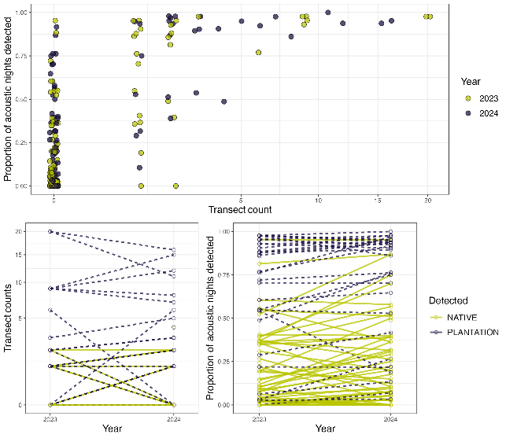
Figure A1. Distribution and relationship of acoustic and transect counts in 2023 and 2024.

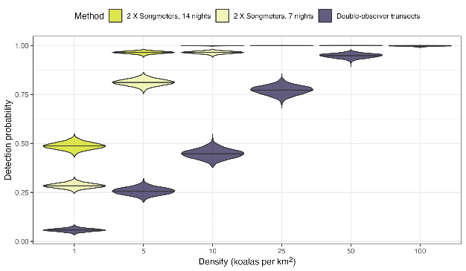
Figure A2. A comparison of the probability of detecting at least one Koala for two acoustic devices over seven or 14 nights to the detection probability along transects.

    - Cross-validation and posterior predictive checks
After initial data exploration, our global model used 14 covariates on the Poisson abundance process and a spatial-random effect (Gaussian process) on the presence absence process. Posterior predictive checks were made to compare the observed nightly detections and transect counts of Koalas against predicted distribution from our integrated model (Figure A3). These checks suggest our model performs well in predicting the observed patterns of data.

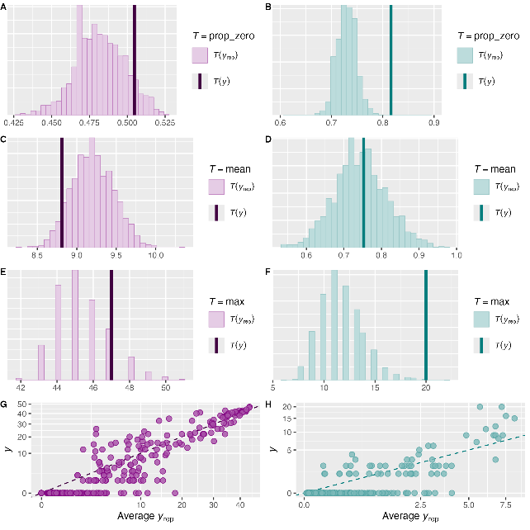
Figure A3. Posterior predictive checks (PPCs) compare the observed counts against the model predicted values. Within our integrated models, these are generated for total acoustic nightly detections (purple) and total observed Koalas on the transect (teal). PPCs include a comparison of the proportion of zeros in the data (A, B), the mean number of detections and count (C, D) and the maximum number of detections and counts (E, F). The mean acoustic detections and transect counts are also compared using scatterplots following square root transformation (G, H).

    - Koala presence probability
Estimates of the probability that a grid cell contained Koalas were derived from the thinning parameter of our Poisson model (parameter $ψ$, Equation 1). The estimate of the probability of presence for each cell $i$ ($ψ_{i}$) was estimated using a 2-dimensional Gaussian process with Matern kernel and accordingly, represents a spatial random effect in the model. The spatial estimates of the probability of presence are given in Figure A4.
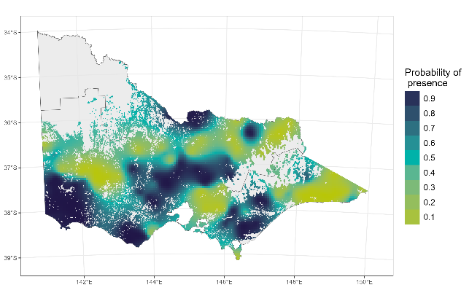
Figure A4. Realised gaussian process showing the estimates for the probability of Koala presence ($ψ$) used in the model (Equation 1).

    - Threshold of abundance estimates to generate occupancy distribution
We were able to estimate the range size/distribution of Koalas by thresholding the abundance estimates using the presence-absence of the combined acoustic and transect data (Figure A5. ). We did this via bootstrapping a Response to receiver Operating Curve (ROC). Based on our thresholding approach, we estimate the distribution of Koalas in Victoria to cover 20,355 km² [90% CI: 9,910, 34,479] in 2023 and 19,459 km² [90% CI: 14,067, 31,385] in 2024. In 2023, this range estimate was based on a density threshold of 2.14 Koalas per km² [95% CI: 0.78, 5.15]. The sensitivity was 0.65 [95% CI: 0.5, 0.77] and the specificity was 0.6 [95% CI: 0.48, 0.72]. In 2024, this range estimate was based on a density thresholds of 2.35 Koalas per km² [95% CI: 1.03, 3.55]. The sensitivity was 0.64 [95% CI: 0.52, 0.76] and the specificity was 0.62 [95% CI: 0.52, 0.72].

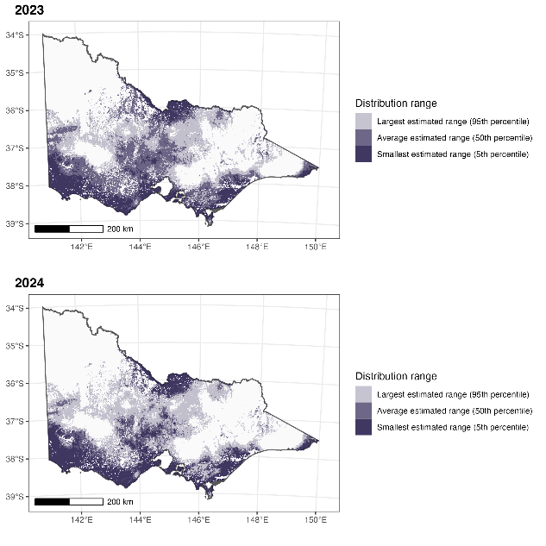
Figure A5. The distribution of Koalas in Victoria in 2023 and 2024. If at least part of a 1 km² grid cell is estimated to have Koala densities above the threshold value, then the grid is considered occupied. Confidence intervals are shown with variable shadings.

    - Covariate estimates
Table A1. Marginal coefficients for covariates used in the Poisson process when modelling Koala abundance. Covariates with 90% confidence intervals (CI) that do not overlap zero are shown in bold. SD = Standard Deviation. NPP = Net Primary Productivity, TWIND = Topographic Wetness Index.
Covariate | Mean | SD | 5% CI | 95% CI
(Intercept) | 0.90 | 1.17 | -0.99 | 2.85
Land use: Plantation | 1.49 | 0.11 | 1.30 | 1.68
Temperature seasonality | 1.25 | 0.26 | 0.83 | 1.67
Temperature of the coldest month (°C) | 0.95 | 0.17 | 0.68 | 1.25
NPP | -0.40 | 0.13 | -0.62 | -0.19
Food trees | 0.11 | 0.11 | -0.07 | 0.28
Elevation (m) | -0.15 | 0.16 | -0.41 | 0.11
Valley-bottom flatness | -0.03 | 0.10 | -0.19 | 0.13
Slope (%) | -0.26 | 0.16 | -0.53 | 0.00
TWIND | 0.29 | 0.11 | 0.10 | 0.47
Photosynthetic vegetation (%) | 0.73 | 0.14 | 0.50 | 0.96
Soil nitrogen | -0.36 | 0.11 | -0.53 | -0.18
Maximum temperature | -1.33 | 0.22 | -1.70 | -0.97
Soil moisture | -0.07 | 0.05 | -0.14 | 0.01
Year: 2023 | 0.45 | 1.16 | -1.51 | 2.31
Year: 2024 | 0.49 | 1.16 | -1.48 | 2.37

  - Koala call recogniser development
    - Sample structure
A 48 Khz sampling rate was chosen as the standard for the model, because this is commonly used for quality field recorders and would allow detection of sound frequencies up to 24 Khz. The input data, which were generally 16-bit, were converted from stereophonic to monophonic forms. A 1.5-second exemplar sample window was selected, as this seemed suitable to distinguish Koala calls from other sounds in clear recordings. Each 1.5-second sample provides approximately 72,000 measurements for analysis. These were partitioned into 70×1024 number frames, with each frame being a 21.3-millisecond subsample. A decibel spectrogram for each of the 70 frames was calculated in the software Librosa (https://librosa.org/) using a short-term Fourier transform. The spectral data were normalised and 512 (+1 zero frequency) frequency bins are subsampled to 128 (+1 zero frequency) bins. The result is a 70×129 matrix representing the spectral data. In addition, the 70 frames of sound data are analysed with PyAudio Analysis (https://github.com/tyiannak/pyAudioAnalysis) to extract additional features. There are 34 of these features such as energy, spectral centroid, Mel Frequency Cepstral Coefficients (MFCCs) and Chroma Vectors. These feature data were also normalised by the ranges observed across thousands of samples, and appended to the spectral data resulting in final 70×163 exemplar matrices that constituted the raw data for the neural network. Each sound exemplar was also identified as either a Koala or not. Koala sample data were also augmented via incremental time shifts of all Koala samples. This provided a slightly adjacent windowing of the sample frames for additional model training.
There was a total of 184,161 samples used in the model training dataset. This consisted of 5,023 samples of Koala vocalisations, and 179,138 samples of other non-target animal vocalisations, environmental noises and anthropogenic sounds.
    - Convolutional Neural Network (CNN) model
Model training and data processing were completed on a high-performance desktop computer running Windows 11, with a AMD 3990X 64 core ThreadRipper Central Processing Unit, 256Gb RAM and a Nvidia RTX3090 Graphics Processing Unit. Modelling was completed in the Python 3.8 programming language using the Tensorflow 2.10, Librosa 0.9.2 and pyAudioAnalysis 0.3.14 libraries.
For the purposes of this study, a three-network ensemble was made as the final ‘recogniser’ model. Ensembles average the predictions of several networks and generally exhibit higher model accuracies and generality across a variety of data than single network models (Opitz and Maclin 1999). The first model was a 1-dimentional Convolutional Neural Network (CNN) consisting of 1,592,590 parameters with a 13 layer design. The second and third models were each a single model that included 1-dimensional and 2-dimensional CNN processing streams consisting of 5,415,570 parameters with a 24 layer design, which combined their final layers of their streams to a single output.
For all three networks 70% of the available exemplars were used for training using the TensorFlow software. The remaining holdout 30% of the exemplars were used to test the performance of each network. Data augmentation exemplars were not split across the training and testing datasets from their original timing exemplars such that they wouldn’t artificially boost the test dataset performance by also having the same call in training dataset. Similarly, overlapping exemplars extracted from single long sound sequences were also not split across the training and testing datasets. Note that each individual model drew their 70% training data from different overlapping sections of all the available data. The assumption in doing so is that the final three-network ensemble would perform at least as well, and likely better, than any individual model because it has seen a larger and more comprehensive dataset. However, independent statistics were not available to verify this likely outcome for the production ensemble as it had incorporated all the possible training data.
Each model within the final ensemble model reported the following accuracies during model development. The final ensemble model will be at a minimum equivalent to the minimum accuracy reported here.
Table A2. Accuracy of the three Convolutional Neural Network (CNN) models applied to the Koala call recogniser training data.
Model | Koala accuracy | Non-target accuracy
Model 1 | 92.80% | 99.90%
Model 2 | 92.65% | 99.90%
Model 3 | 95.18% | 99.67%

    - Field data processing
A total of 34,800 files (10.7 TB) were processed, with the final ensemble model on a desktop computer. Processing achieved approximately 200 s of audio data processed each second, and took 7 days of computing. There were 68,000 Koala detections across the whole dataset, and 31,703 files were processed as having no Koala vocalisations recorded.
    - Data validation
The results of the validation of detections and non-detections of Koalas from the call recogniser were assessed by manually validating approximately 10,000 snippets classified by the CNN as either a Koala (CNN score $≥$ 0.5) or not a Koala (CNN score < 0.5) (Table A3 and Figure A5). Validation data were collated by extracting the snippet with the highest CNN score from each detection night, for each site. Therefore, Koala presence and absence data derived from acoustic recorders were manually validated for every site. Results suggested the CNN model had a low false negative rate (5%) but a high false positive rate (0.46).
Table A3. Confusion matrix for the manual validation of Koala detections from the final Convolutional Neural Network (CNN) ensemble model.
CNN model classification | Validated as not a Koala | Validated as a Koala
Not a Koala | 0.95 (n = 5,258) | 0.05 (n = 252)
Koala | 0.46 (n = 2,144) | 0.54 (n = 2,524)
Total | 7402 | 2766

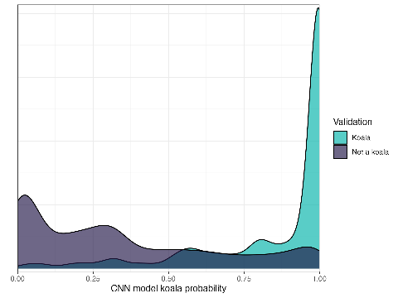
Figure A3. Distribution of scores from the Convolutional Neural Network (CNN) model classifier for snippets that were validated as either being a Koala or not a Koala. Only 5% of validated Koala calls were below 0.5.
  - Population genetics supplementary method details and results

Table A4. Details of the genetic data filtering steps used in this study. SNP = Single Nucleotide Polymorphism.
Filter | Description | Threshold | Retained
Raw data import | DArT-seq data only | Exclude scat samples/DArT-tag data | 155 samples and 26551 loci
Sex-linked | Retain autosomal SNPs only | Remove loci that were identified as potentially sex-linked using the R package ‘dartR.sexlinked’ | 155 samples and 26530 loci
Repeatability average | Based on Dart's repeatability score for each locus. The threshold was chosen to remove low-quality loci, while not being too stringent to over-filter SNPs with higher heterozygosity levels (which can create bias). | >0.95 | 155 samples and 25108 loci
Read count average | Filtering on average read count (per locus) is done to exclude loci with high levels of allelic drop-out (low read counts) and potential paralogous regions (high read counts). Thresholds were chosen by examining the frequency of heterozygous calls plotted against average read depth, under the assumption that there should be no relationship between the two. | >15 <200 | 155 samples and 4679 loci
Call rate (individual) | This threshold was chosen based on balancing the number of individuals retained against the number of loci retained | >0.96 | 117 samples and 4679 loci
Call rate (loci) | This threshold was chosen by examining the correlations between locus call rates and the frequency of heterozygotes or the minor allele frequency. The threshold that minimised these correlations, while still retaining a useable dataset, was chosen. | >0.98 | 117 samples and 4023 loci
Minor allele frequency | MAF filters are used to exclude potential sequencing errors, which commonly appear as low-frequency variants. A minimum threshold that equated to each allele appearing in the dataset a minimum of three times was used. | >0.01 | 117 samples and 3197 loci
Secondaries | Non-independent SNPs were removed by selecting a single SNP per sequence and excluding other loci found on the same fragment. Loci to keep were chosen based on their average repeatability score. | 1 loci/sequence | 117 samples and 3186 loci
Linkage disequilibrium | LD was assessed by estimating pairwise genotypic correlations between loci on each chromosome within 10000000 bp of each other. Correlations were estimated using the dartR function ‘gl.report.ld.map’. A standard correlation (r) threshold was chosen, with a single loci from each pair with this score or above chosen to retain based on repeatability score. | <0.2 | 117 samples and 2257 loci
Missing data | Exclude individuals with missing geolocation data |  | 111 samples and 2257 loci
Close-kin | The PC-Air algorithm is used to exclude highly related individuals which may bias certain analyses. This subset was used in the current study for analyses of population genetic structure, dispersal, spatial autocorrelation, and to calculate global allele frequencies when estimating genetic diversity and inbreeding. | PC-Air threshold = 0.022 (approximately fourth degree relatives) | 93 samples and 2257 loci

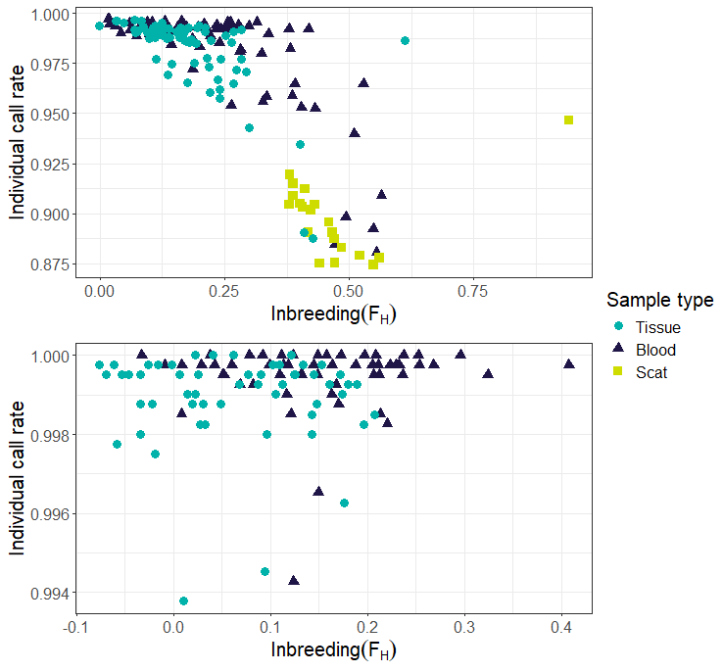
Figure A4. Individual call rate and inbreeding coefficient before (above) and after (below) applying more stringent filtering thresholds and removing scat samples from the dataset.

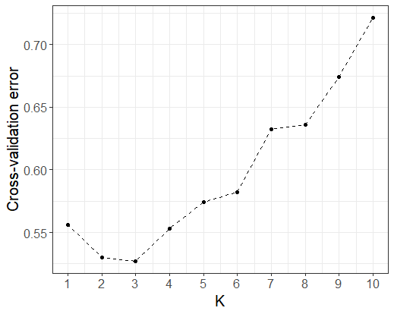
Figure A5. ADMIXTURE cross-validation (CV) error for each value of K (the number of putative ancestral populations or genetic clusters). The lowest CV score indicates the most appropriate K given the data.

  - Further genetics results derived from Koala scats
    - Genotyping
DNA was extracted from 224 Koala samples, comprising scat-derived (n = 144) and blood-derived (n = 80) material. All samples were genotyped using a panel of 12 microsatellite loci: K10.1, K2.1, Pcv24.2, Pcv25.2, Pcv30, Pcv31, Pcv6.1, Pcv6.3, Phc13, Phc4, Phci10, and Phci2 (Houlden et al. 1996; Cristescu et al. 2009; Ruiz-Rodriguez et al. 2014).
Raw allele size data were integrated with a previously genotyped reference dataset (Federation University database; n = 277) and scored using TANDEM (Matschiner and Salzburger 2009). Consensus multilocus genotypes were generated from replicate samples using the R package ‘ConGenR’ (Lonsinger and Waits 2015). To identify recaptures and matching individuals, the R package ‘allelematch’ (Galpern et al. 2012) was used to group genotypes with exact or near-exact allele matches, accounting for potential genotyping errors. Only genotypes with data for at least eight loci were retained for downstream population genetic analyses (n = 208).
The R package allelematch (Galpern et al. 2012) was also used to identify genotypes likely to have originated from the same individual, based on exact and near-exact allele matches, accounting for potential genotyping errors. This analysis identified 12 individuals that were each sampled twice and one individual sampled three times, with all recaptures occurring at the same general location. Removal of these duplicate genotypes resulted in a final dataset of 194 unique Koala genotypes.
    - Population structure analysis
The 194 unique Koala genotypes were combined with previously sampled genotypes, retaining only the 10 microsatellite loci shared between datasets (K10.1, K2.1, Pcv24.2, Pcv25.2, Pcv30, Pcv31, Pcv6.1, Pcv6.3, Phc13, Phc4). Pairwise relatedness was assessed using the dyadic maximum likelihood estimator implemented in COANCESTRY (Wang 2011), and individuals with a relatedness coefficient of r ≥ 0.5 were considered close relatives. To reduce potential bias from kin structure, one individual from each related pair was removed, resulting in 175 genotypes. These were analysed alongside 277 reference genotypes.
Population structure was assessed using STRUCTURE v2.3.4 (Pritchard et al. 2000), testing K values from 1 to 20, with 20 independent replicates per K. Each run employed a burn-in of 250,000 iterations followed by 750,000 Markov Chain Monte Carlo (MCMC) repetitions.
Analysis in STRUCTURE indicated that the most likely number of genetic clusters (K) in the dataset was four: South East NSW, South Gippsland, Phillip Island (ancestry) and French Island (ancestry). To visualise spatial patterns of genetic structure, individual Koalas were assigned to clusters based on their STRUCTURE membership coefficients (Q > 0.6) and their sampling locations were mapped (Figure A8).
To investigate fine-scale population structure, we applied GENELAND to analyse the population structure using 12 loci in samples collected during this project (scat and blood n = 159). Here, potential relatives and samples without GPS were removed). GENELAND (Guillot et al. 2008) employs a spatially explicit Bayesian clustering approach that integrates both genetic and geographic data, enabling the identification of population structure shaped by spatial distribution. This method is particularly valuable in contexts where landscape features may influence gene flow. Results suggested the presence of eight genetic clusters, including a single South Gippsland cluster, which included Koalas from the eastern edge of Westernport Bay as well as Wilson Promontory (Figure A9).

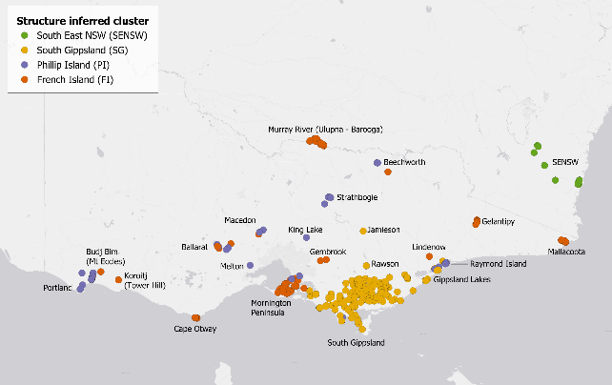
Figure A6. Spatial distribution of Koala samples coloured by STRUCTURE-inferred genetic cluster assignment. Only individuals with >60% ancestry assigned to a single cluster are shown; admixed individuals (Q ≤ 0.6) are excluded for clarity.

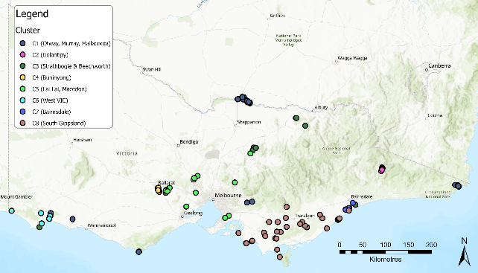
Figure A7. Population genetic structure inferred using GENELAND on the Koala samples (scats + blood) collected during this project.

  - Heath and disease surveys
    - Koala capture
Three Koalas were found on the ground, with two being in very poor condition (Cape Otway, Murray River) and one moving between trees. All other Koalas were in trees, with 63% (41/65) being in the upper canopy (Table A5). All but four of these Koalas were captured with the ‘noose and flag’ method (Table A5), with 21/61 (34%) requiring a climber to initiate the capture. Most (47/61; 77.1%) were highly responsive to flagging and/or noosing. Low responsiveness was observed for Koalas that were found to be in poor condition or that had existing injuries. Koalas vocalised during 16.1% (10/62) of captures and 75.8% (47/62) were highly responsive to the flag or rope. Capture difficulty was scored low for 48.4% (30/62) Koalas.
Koalas suffered a fall during five captures, with four falls from heights of 1 to 3 m. One Koala captured at Budj Bim fell from a height of 8 m after it attempted to jump to a neighbouring tree. This was provoked by a climber getting into position. Acute injuries were not found for any of these Koalas. On six occasions, captures were aborted due to the Koala becoming stressed, or being unresponsive to flagging (four in Cape Otway, one in Gelantipy, and one in South Gippsland). Traps were successful in capturing Koalas in four of six attempts. Three Koalas entered traps within 12 hours, and one within 30 hours of trap set. All Koalas were removed from traps within 1.5 hours.
Table A5. Capture details for 62 Koalas captured using the ‘noose and flag’ method. Duration of capture was measured from first disturbance (flagging or noosing) to restraint in bag.
Capture characteristic | Mean + SE | Range
Koala height in tree (m) | 7.79 + 0.40 | 3–15
Duration of capture (minutes) | 5.39 + 0.62 | 1–22
Ambient temperature (°C) | 16.39 + 0.41 | 7.2–27

    - Physiological parameters and response to anaesthesia
There was high variation in heart rate, respiratory rate and rectal thermometer-measured body temperature of Koalas on first measurement following induction of anaesthesia (Table A6). Some Koalas had slightly elevated body temperature, heart rate or respiratory rate compared to published data for free-ranging Koalas (Canfield 1989). These parameters were not found to be influenced by ambient temperature or capture duration (GLM, p>0.05); however, the level of difficulty of the capture, and physical restraint during induction of anaesthesia to deliver isoflurane via face mask, may have contributed to elevated values. Over 80% of Koalas with moderate or high difficulty captures also recorded at least one elevated parameter, compared to only 53% of low difficulty captures.
In all cases where body temperature was above 37°C, body temperature stopped rising once active cooling measures were implemented. Body temperature continued to drop in all cases until the point where recovery from general anaesthesia meant that measurement of body temperature using a rectal thermometer was no longer possible. Recovery of all Koalas from anaesthesia was unremarkable. All Koalas were released back to the tree from which they were captured, showing normal ambulation and behaviour and with no visible or behavioural evidence of lingering physiological impacts associated with capture and restraint.
Table A6. Body temperature, heart rate and respiratory rates recorded on first measurement following induction of anaesthesia.
Parameter | Mean + SE | Range
Heart rate | 136.8 + 2.50 | 80–180
Temperature | 36.17 + 0.13 | 33.7–38.4
Respiratory rate | 18.48 + 0.93 | 4–40

    - Health indicators and body measurements
Table A7. Health indicators, morphometrics and other animal related parameters assessed and recorded for each Koala.
Health parameter | Description
Movement, gait and posture | Use of limbs and mobility were observed during capture. Abnormal posture, reluctance to move, or favouring a particular limb may indicate fear, pain or debilitation due to an underlying disease.
Demeanour | Demeanour was observed during capture, and prior to anaesthesia. Healthy animals in a state of good welfare are normally bright, alert and responsive to stimuli (e.g. sound, proximity of people, use of flags for capture).
Airways and breathing | Prior to anaesthesia, respiration was assessed by monitoring the rise and fall of the chest (normal respiratory rate 10–15 breaths per minute [Blanshard and Bodley 2008]). Respiratory rates between 8–17 breaths per minute have been recorded in non-anaesthetised Koalas at rest (Colombelli-Négrel et al. 2023). Once anaesthetised, respiration rate and effort were monitored by thoracic auscultation using a stethoscope.
Heart rate and rhythm | Heart rate and rhythm, and the strength, rate and rhythm of the femoral pulse, capillary refill time and colour of the mucous membranes of the oral cavity were measured throughout the period of anaesthesia to monitor depth of anaesthesia and assess cardiac function. Heart rates between 56.2–142.9 beats per minute have been measured in non-anaesthetised, free-living Koalas (Ropert-Coudert et al. 2009).
Body temperature (°C) | Body temperature was measured on induction of anaesthesia, at least five minutes after induction, and where possible, just prior to recovery from anaesthesia. A digital rectal thermometer was inserted into the rectum via the dorsal aspect of the cloaca. Normal body temperature ranges from 35.5–36.5°C (Blanshard and Bodley 2008), but temperatures ranging from 34.2–39.0°C have been recorded in apparently healthy wild Koalas (Adam et al. 2021).
Body weight (kg) | Koalas were weighed on digital baby scales once anaesthetised.
Head length (mm) | Head length was measured using Vernier callipers from the occipital protuberance at the base of the skull to the tip of the nose (as described by (Martin 1985).
Body condition score | A holistic assessment of muscle mass and tone was used to score Koala body condition score on a scale of 1–5, where 1 indicated emaciation and 5 indicated excellent body condition (see Table A7).
Sex | Sex was determined by the presence of a pouch or external testicles.
Skin condition | The skin over the whole body was checked for presence of external parasites (ticks, fleas or mites), including evidence of sarcoptic mange (caused by infestation with the mite Sarcoptes scabiei), trauma (e.g. bite or fight wounds) or other skin lesions.
Fur condition | The condition of the fur coat was described for all Koalas. In healthy Koalas, the fur is generally clean, well-groomed and appears to be in good condition. Brittle fur, thin fur coverage and a brown tinge to the fur can indicate chronic ill thrift in Koalas. Clumps of matted fur can indicate chronic ill health or reduced grooming due to injuries to the limbs or digits.
Tooth wear class | An assessment of wear of the upper pre-molar was used to assign Tooth Wear Class (TWC) as per (Martin and Handasyde 1999); however, since rate of tooth wear is influenced by factors other than the individual’s age, including genetics, anatomical deformities of the skull, and moisture/fibre content of foliage consumed (Pettett et al. 2019; Foley et al. 2022), animals were subsequently assigned to broader life stage classes – independent juvenile, young adult, mature adult and aged adult. This also supports a more holistic assessment of the significance of clinical findings at different life and reproductive stages (see Table 4).
Dental occlusion | The presence of dental malocclusion was noted for all Koalas. Dental malocclusion (incorrect positioning of the teeth in the upper and lower jaw when the mouth is closed) is commonly seen in Koalas, causing dental disease and chronic ill health over time. In Koalas with normal occlusion, the lower incisors occlude with the 2nd upper incisors, and the lower premolar sits just in front of the upper premolar at rest (Pettett et al. 2019). Malocclusions include maxillary overbite, where the lower incisors occlude behind the normal resting position (Figure 2A), and maxillary underbite where the lower incisors occlude directly with the upper 1st incisors (Figure 2B).
Dental disease | The presence, severity and type of dental disease was noted for all Koalas. Dental diseases (Figure 3A and B) including gingivitis (inflammation, swelling and bleeding of the gums) and periodontitis (a progression of gingivitis involving loss, or recession of the gum around the base of the teeth, loss of attachment and bone around the teeth, leading to tooth loss) are commonly reported in Koalas (Butcher et al. 2020).
Hydration status | Hydration status was assessed as per Blanshard and Bodley (2008) and described as normal, mild dehydration (<5% dehydrated), moderate dehydration (5–10%) or severe (>10% dehydration).
Abdominal palpation and ‘gut fill’ | The abdomen was palpated to check for the presence of palpable abdominal masses, including ovarian cysts, and to assess the level of ‘gut fill’ – the volume of ingesta present in the gastrointestinal tract.
Eyes | Eyes were assessed for evidence of disease. Trauma (e.g. lacerations to the eye and eyelids caused by fights), burns, and conjunctivitis (varying degrees of inflammation, swelling, ocular discharge) due to infection with pathogens including Chlamydia pecorum (see Reynolds et al. 2022).
Ears | Ears were checked for the presence of previously applied ear tags or tears or full thickness circular lesions, which may suggest loss of a previously applied ear tag. Ears were checked for active wounds or other lesions and scars from previous wounds, and the presence of ectoparasites including mites and ticks.
Nares | Both nares were checked for nasal discharge or other abnormalities.
Presence of young | The presence of back young or pouch young was documented for all females and, where present, the stage of development of young was described (e.g. whether the young were furred or unfurred, attached to the teat, eyes and ears sealed or unsealed).
Pouch condition | The condition of the pouch, presence of pouch young and evidence of mammary gland enlargement, nipple elongation or active lactation were assessed.
External genitalia | Sex was determined by the presence of a pouch or external testes.
Cloaca | The soft tissues and fur surrounding the cloaca was assessed for any abnormalities, including clinical signs consistent with Chlamydial disease such as ‘wet bottom’ – wet, stained or matted fur surrounding the cloaca, inflammation or lesions on the vulva, penis or tissues of the cloaca (as described by Griffith (2010)).
Faecal pellet | When voided by the Koala following capture or during anaesthesia, size, shape and consistency of pellets were examined. Small or inconsistently sized, dry faecal pellets can indicate poor dietary intake, reduced gastrointestinal function or dehydration. The presence of large or irregularly sized leaf particles in faecal pellets suggests dental disease or underlying ill health.
Musculoskeletal exam | All limbs and joints were palpated and moved through their expected range of motion to assess for the presence of underlying injury or evidence of anatomical abnormality (e.g. joint instability, fracture, arthritic degeneration).
Feet | Footpads were checked for wounds, missing or abnormal claws, or evidence of excessive pad wear, which can suggest the Koala has been walking on the ground more than expected.

Table A8. Koala age, reproductive maturity and life stages, following the approaches described by Canfield et al (1989) and Butcher et al (2020). TWC = Tooth Wear Class.
Reproductive maturity | Life stage | TWC | Age (in years)
Immature | Juvenile | 1 | 1–2
Mature | Young adult | 2 and 3 | 3–4
 | Adult | 4 and 5 | 5–12
 | Senior | 6 and 7 | 12+

Table A9. Body condition scoring for Koalas in this study.
Description | Score | Clinical findings used to assign score
Emaciated | 1 | All muscles atrophied, bony prominences of the vertebrae, pelvis and skull easily palpated, muscles of the scapular spine are markedly concave, and the scapular bone is easily palpable.
Lean | 2 | Muscle tone is generally poorer than expected for body size and sex. The bony prominences of the skull, vertebrae, scapular spine and pelvis are prominent; muscles on either side of the scapular spine and the top of the head are concave.
Good | 3 | Good muscle coverage over scapular spine, skull and pelvis, but bony prominences are all palpable. The muscles of the forelimbs or hindlimbs may be leaner than expected based on body size and sex. The muscles on either side of the scapular spine and the top of the head are flat to slightly convex.
Very good | 4 | Very good muscle tone overall, with good muscle coverage over the bony prominences of the skull, vertebrae, and pelvis. The muscles of the forelimb and hindlimbs are well developed. Flat to slightly convex muscles on either side of the scapular spine and the top of the head. The bony prominences may be palpable.
Excellent | 5 | Excellent muscle tone overall, and good coverage of all bony prominences of the skull, vertebrae, scapular spine, and pelvis. The muscles of the forelimb and hindlimbs are very well developed. The muscles over the top of the head and scapular spine are obviously convex.

Other disease issues

Trauma
Signs of trauma were found for 18% (12/68) of Koalas, with one of these only found during gross necropsy. Post-mortem examination of this Koala found multiple longitudinal bruises over a large portion of the left abdominal muscle wall. Histological examination of formalin-fixed muscle tissue confirmed abdominal muscle damage, with mild-to-moderate haemorrhage within the muscle and connective tissue, and evidence of active healing and repair, presumably attributed to a previous traumatic event resulting in significant shearing forces causing significant damage to the abdominal muscle wall. All traumatic wounds found during physical exam or on post-mortem examination during this study had healed or were healing. Bite wounds (punctures, scabbed lesions) were found on the forearms, feet or face of nine Koalas. One Koala had scar tissue on foot pads characteristics of burn wounds, and another (from Budj Bim) had a crusted ear lesion caused by an ear tag.

Scoliosis and spinal abnormalities
One aged female Koala had severe lesions in the vertebrae, including scoliosis of the spine. She was observed moving slowly, and with abnormal limb movement. Physical examination found signs of chronic ill thrift, with poor body condition, a scruffy fur coat with multiple matts of fur on her sides and rump area, severely worn teeth, and crepitus and a reduced range of motion in her right hip. She was euthanased on welfare grounds. Post-mortem radiographs confirmed multiple abnormalities in the lumbar vertebrae (Figure A11), including an old fracture in the lumbar spine and severe intervertebral disc degeneration.
Degenerative joint disease was seen in several other adult Koalas. Histological examination of necropsy tissues collected from the left knee (stifle) joint of an aged male found chronic thickening and erosions on the articular surfaces of the joint. Mild degenerative joint disease in the digits of the forelimb were seen in one aged female, one adult male, and an aged adult male.
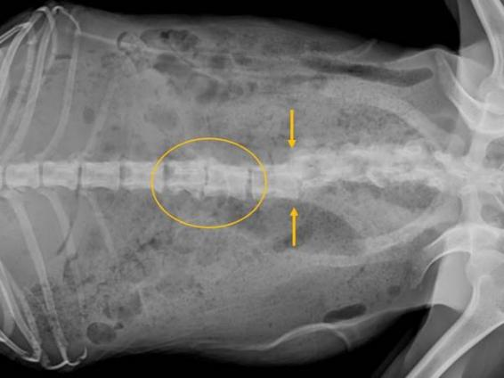
Figure A8. Radiographs taken post-mortem of a female found moving slowly, with an abnormal gait, in the Murray River region.
Upon physical examination, a severe abnormality in the alignment of the spine was visible and palpable. Radiographs confirm scoliosis of the spine, with sclerosis and narrowing of the intervertebral disc space between the 2nd and 3rd lumbar vertebrae (yellow oval). The 5th lumbar vertebra was fractured, resulting in abnormal lateral alignment of the spine (yellow arrows).

Thyroid abnormalities
Gross and histological abnormalities were found in the thyroid gland of 93% (14/15) of male and female Koalas that were euthanased and necropsied, all of which were in adult or senior life stages. Grossly, abnormal thyroids were consistently large, and pale brown in colour, with multiple cyst-like nodules extending throughout the tissue. Histologically, changes consistent with colloidal goitre were seen, with widely distended follicles filled with colloid extending throughout the sections examined. Nodular hyperplasia with cystic adenomas (benign tumours) were observed histologically in the thyroids of three Koalas with abnormal thyroids.
Histological examination of furred skin samples collected during gross necropsy found evidence of chronic inflammatory change and hair follicle atrophy suggestive of an underlying endocrine disorder, which may have been related to the thyroid abnormalities seen post-mortem.
In one female Koala euthanased after physical examination found in poor body condition (BCS 2) and with severe dental disease, gross necropsy revealed a large, firm, irregular mass in the thoracic cavity, with additional masses in the kidneys (Figure A12). Histologically, the thoracic mass was a malignant thyroid gland carcinoma, and masses within the kidney were considered most likely to be metastatic epithelial cell tumours of thyroid gland origin.
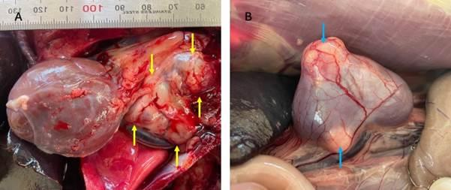
Figure A9. A Malignant thyroid carcinoma (A) in the thoracic cavity of a female Koala from the Ballarat area (surrounded by yellow arrows). This mass occupied a significant portion of the animal’s thoracic cavity. B The light blue arrows point to masses seen on the surface, and within the tissue of both kidneys at gross necropsy.
Upon histological examination, neoplastic epithelial cells, most likely of thyroid origin, replaced the normal kidney cellular structure in more than 90% of the sections examined. Areas of kidney adjacent to these masses had significant areas of fibrous scar tissue. These metastatic lesions are likely to have had a significant impact on the normal functioning of the kidneys in this Koala.

www.delwp.vic.gov.au

www.ari.vic.gov.au

