|  |
| --- |
| Victorian Environmental Flows Monitoring and Assessment Program (VEFMAP) Stage 6 |
| Project Update – 2018  Northern Victorian Rivers - Fish |

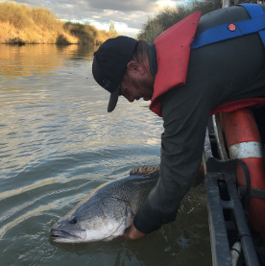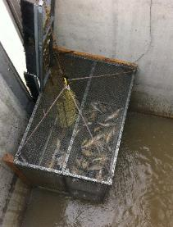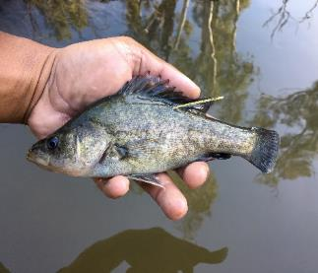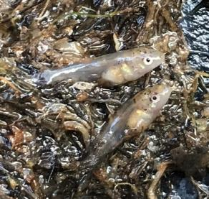

**Background**

The Victorian Environmental Flows Monitoring and Assessment Program (VEFMAP) was established by the Victorian Government in 2005 to monitor and assess ecosystem responses to environmental watering in priority rivers across Victoria. The program’s results help inform decisions for environmental watering by Victoria’s Catchment Management Authorities (CMAs), Melbourne Water and the Victorian Environmental Water Holder (VEWH). Over the past 12 years, the information collected through VEFMAP has provided valuable data and informed significant changes to the program. VEFMAP is now in its sixth stage of delivery and includes a strong focus on “intervention” or “flow event” type questions, for vegetation and fish.

**Fish Monitoring – Northern Victorian Rivers**

The core objective for fish monitoring in VEFMAP Stage 6 is to examine the importance of environmental flows in promoting population growth and the rehabilitation of native fish populations via dispersal, colonisation, recruitment and survival.

There are two key evaluation questions for fish in northern Victorian rivers, which were developed in collaboration with CMAs. (Note: KEQs 1 and 2 relate to southern Victorian rivers.)

KEQ 3 Do environmental flows support immigration of native fish into, and dispersal throughout, northern Victorian rivers?

KEQ 4: Does environmental flow management for native fish species enhance: (i) survival (ii) abundance and (iii) distribution?

**2017/18 Survey Sites and Timing**

In 2017/18 surveys were undertaken to investigate KEQ 3 and 4 processes at the following sites:

* ***Immigration*** – Murray River (Torrumbarry Weir fishway), Campaspe and Goulburn rivers (Dec 2016, Feb 2017, Mar-Apr 2018).
* ***Dispersal*** – Loddon River catchment, acoustic tagging (2017-2018) and fishway trapping (The Chute, Kerang Weir, Box Creek fishlock) (Mar-April and Sept-Oct 2017)
* ***Population demography*** – Broken, Campaspe, Goulburn and lower Loddon rivers (including Little Murray River and Pyramid Creek) (Mar-June 2018).

**Methods**

Different survey methods were used for each component of the study.

***Immigration***

* *Acoustic telemetry* – fish were tagged in Dec 2016, Feb 2017 and Mar-Apr 2018 in the Murray River at the Torrumbarry Weir fishway. An acoustic listening station array was deployed in the Murray River (Torrumbarry Weir to Yarrawonga Weir), and at the entrance of the Campaspe, Goulburn and Edwards rivers (to detect fish movements in and out of these tributaries). A listening station was also deployed within the National Channel to detect fish entering the irrigation system.

***Dispersal***

* *Fishway trapping ­*– undertaken at three sites: The Chute fishway on the Loddon River near Leaghur, Kerang Weir fishway on the Loddon River near Kerang (Figure 1), and Box Creek fishlock on Pyramid Creek at Kow Swamp (three weeks over Mar-April 2017 and four weeks over Sept-Oct 2017).
* *Acoustic telemetry –* Golden Perch *Macquaria ambigua* were captured using boat electrofishing, tagged with acoustic tags and released.Acoustic listening stations were deployed throughout the Loddon River, Pyramid Creek and Washpen Creek in 2017-2018.

***Population demographics***

* *Electrofishing* – boat, bank-mounted or backpack electrofishing was undertaken (dependent on depth, water conductivity and access). This occurred at 13 sites in the Broken River (including a concentration on 10 sites in Reach 3), 19 sites in the Campaspe River, 12 sites in the Goulburn River and nine sites in the lower Loddon River, including Pyramid Creek.

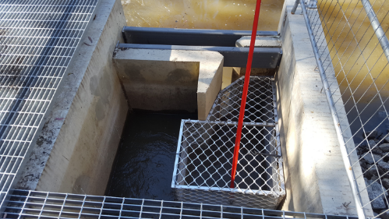All fish were identified, counted, weighed and measured. Samples of Golden Perch, Silver Perch *Bidyanus bidyanus* and Murray Cod *Maccullochella peelii* were also collected for aging to contribute to the generation of system specific growth models.

**Figure 1 – The Chute fishway with aluminium fish trap installed (Photo: ARI)**

**Results**

***Hydrology and environmental flow delivery***

Environmental water was delivered to the Murray, Goulburn and Campaspe rivers in summer/autumn 2017 as within-channel pulses or ‘freshes’ (i.e. small flow events that exceed the baseflow and last up to several weeks). In summer/autumn 2018, no environmental water was delivered because flows were elevated due to inter-valley transfers. Environmental water was delivered via two freshes, once to the downstream end of the Loddon River in autumn 2017 (Apr) and once in spring 2017 (Oct).

***Immigration***

This acoustic study has provided evidence of movement of Silver Perch and Golden Perch over large spatial scales and between mainstem and tributary habitats. Fish exhibited a considerable diversity of movement behaviour, with results suggesting a strong link between tributary flow delivery and immigration of juvenile Silver Perch. These results, in combination with the population demography data, suggest that immigration and restoration of juvenile Silver Perch can be achieved using flow management in Victorian tributaries. The magnitude of metapopulation outcomes within the tributary, however, is dependent on flow delivery and density of juvenile Silver Perch in the mid-Murray River.

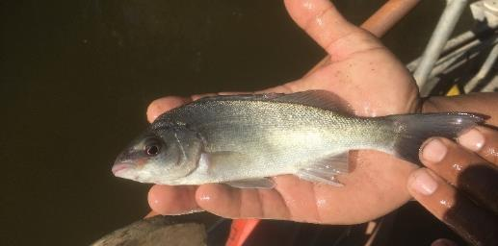These results also highlighted the potential loss of native fish into the irrigation network, with 16% of Silver Perch in 2018 entering the National Channel (Torrumbarry Irrigation system).

**Figure 2 – A juvenile Silver Perch (Photo: ARI)**

***Dispersal***

The catch of native fish at fishways, including small-bodied species, increased during the managed freshes in autumn and spring. The acoustic movement data provided more detailed behavioural information for Golden Perch, supporting the fishway trapping data with a clear upstream movement response by part of the tagged population during rising discharge. Although the results are preliminary, together they provide strong support for increased native fish movement during freshes, particularly during autumn. These data also support the hypothesis that freshes improve fish dispersal and population demographic outcomes (see below) in some of Victoria’s most flow stressed rivers (e.g. the Loddon).

***Population demography***

Annual electrofishing surveys in multiple reaches of the lower Loddon (including Pyramid Creek), Campaspe, Broken and Goulburn rivers allowed us to describe the distribution and size structure of four native fish species (Murray Cod, Golden Perch, Silver Perch and Murray River Rainbowfish *Melanotaenia fluviatilis*) in each surveyed reach. Temporal trends in abundance and distribution could also be explored, using data collected in earlier VEFMAP stages. Otolith and genetic samples are currently being used to assess growth, recruitment, survival and natal origin.

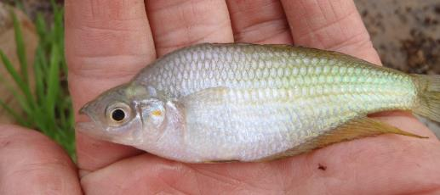

**Figure 3 – A Murray Rainbowfish (Photo: ARI)**

Key findings include:

* A reduction in juvenile Silver Perch captured across the systems (except Broken River) in 2018 compared to 2017. Therefore, despite flows still being effective in promoting immigration of these fish into Victorian tributaries, the outcome at a metapopulation level (river scale) will depend on the abundance of juvenile fish, which is dependent on flow patterns in the Murray River.
* The number of Murray Cod captured in most systems was similar over the past two years, with the size structure data of 2018 indicating a continuation of the dominant cohorts detected in 2017. Compared to 2017, the 2018 surveys captured a relatively low number of young-of-year (YOY) Murray Cod (indicative of poor recruitment), particularly in the Broken and Campaspe rivers. There are several mechanisms that may be linked to this pattern, particularly the large flow event with rapid rates of rise and fall that occurred during late Nov to mid-Dec in the Campaspe, Broken and Goulburn rivers, which may have influenced survival and/or retention of Murray Cod larvae at monitoring sites.
* Population monitoring data also detected major changes in Murray River Rainbowfish in 2018 compared to 2017. With the exception of the lower Loddon River, their abundance reduced substantially, with Reach 3 (Campaspe Weir to Campaspe Siphon) of the Campaspe River showing the greatest reduction. The lower numbers of Murray River Rainbowfish captured in 2018 (relative to 2017) may be due to lower recruitment success, likely driven by the increased summer flows (largely IVT water) in 2018, which may have reduced water temperatures and/or habitat availability for early life-stages.
* At a broad level, long-term monitoring data showed a general increase in distribution, abundance and biomass for most of the priority native species across VEFMAP waterways since 2012. Whilst this pattern is likely to represent a period of recovery from the Millennium drought and major blackwater events, it also highlights that flow conditions since this time, which include large volumes of environmental water, have facilitated a broad population recovery trend for northern Victorian rivers.

**Key Observations**

* 1. Key observations from the first two years of VEFMAP Stage 6 include:
* A strong link between tributary flow delivery and immigration of juvenile Silver Perch from the Murray River.
* A clear link between increased movement by small and large-bodied native species to flow pulses in the Loddon system.
* A reduction in recruitment of Murray Cod (to YOY) and Murray River Rainbowfish in 2018 compared to 2017, at most sites.
* A general increasing trend in abundance and distribution for most priority native fish species across the selected northern Victorian tributaries since 2012.
* Based on the results for Silver Perch in the Campaspe and Goulburn rivers, there are clear advantages to the VEFMAP Stage 6 approach of monitoring both (i) life history process responses to flow interventions, and (ii) fundamental population outcomes.

**Flow Recommendations to Support Managers**

* 1. Whilst these results and analyses are preliminary, some patterns have emerged which have prompted particular flow recommendations to test over the next year. These are focussed at:
* maximising upstream movement responses of large and small-bodied fish in the Loddon River
* maximising recruitment of Murray Cod (to YOY) and
* maximising recruitment and survival of Murray River Rainbowfish.

|  |  |
| --- | --- |
| © The State of Victoria Department of Environment, Land, Water and Planning 2018  LogoThis work is licensed under a Creative Commons Attribution 4.0 International licence. You are free to re-use the work under that licence, on the condition that you credit the State of Victoria as author. The licence does not apply to any images, photographs or branding, including the Victorian Coat of Arms, the Victorian Government logo and the Department of Environment, Land, Water and Planning (DELWP) logo. To view a copy of this licence, visit http://creativecommons.org/licenses/by/4.0/  ISBN 978-1-76077-327-4 (print), 978-1-76077-328-1 (pdf/online)  Disclaimer  This publication may be of assistance to you but the State of Victoria and its employees do not guarantee that the publication is without flaw of any kind or is wholly appropriate for your particular purposes and therefore disclaims all liability for any error, loss or other consequence which may arise from you relying on any information in this publication. | Accessibility  If you would like to receive this publication in an alternative format, please telephone the DELWP Customer Service Centre on 136186, email [customer.service@delwp.vic.gov.au](mailto:customer.service@delwp.vic.gov.au), or via the National Relay Service on 133 677 [www.relayservice.com.au](http://www.relayservice.com.au). This document is also available on the internet at https://www.ari.vic.gov.au/research/rivers-and-estuaries/assessing-benefits-of-environmental-watering |

**What’s Next?**

Monitoring methods tested during the past two years have been encouraging, producing several positive results. Based on findings to date and project team discussions, a similar monitoring program is proposed for 2018/19. The VEFMAP team will continue to interrogate monitoring data to identify new approaches for managing flows and fish community restoration.

**Collaborations**

VEFMAP Stage 6 includes many collaborations between DELWP staff, waterway managers and water authorities, universities (Melbourne, La Trobe and Deakin), the Victorian Fisheries Authority, and the Commonwealth Environmental Water Office (both through LTIM, the Long-Term Intervention Monitoring program and EWKR, the Environmental Water Knowledge and Research Project). These include several investigations of fish genomics; analysis of otoliths to determine natal origin; an assessment of stocking outcomes; and development of extended statistical models to explore the effects of flow on fish populations.

**Further Details**

See DELWP (2018) VEFMAP Stage 6: Monitoring fish response to environmental flow delivery in northern Victorian rivers, 2017/18. A client report to Water and Catchments, the Department of Environment, Land, Water and Planning.

**Acknowledgements**

Most of this work was funded by DELWP Water and Catchments, as part of the Victorian Government’s $222 million investment to improve catchment and waterway health across regional Victoria. Goulburn River sites were surveyed as part of the Long-term Intervention Monitoring Program (Commonwealth Environmental Water Office) and Native Fish Report Card monitoring program (DELWP/Victorian Fisheries Authority).

**Contacts:**

Zeb.Tonkin@delwp.vic.gov.au (fish program leader and population demographics),

Matthew.Jones@delwp.vic.gov.au (Dispersal)

Wayne.Koster@delwp.vic.gov.au (Immigration)

Justin.O’Connor@delwp.vic.gov.au (Dispersal)

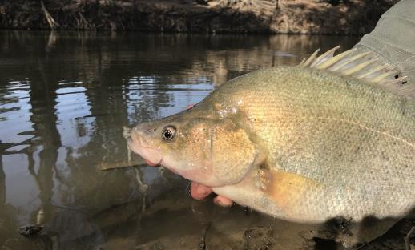

**Figure 4 - A Golden Perch (Photo: ARI)**

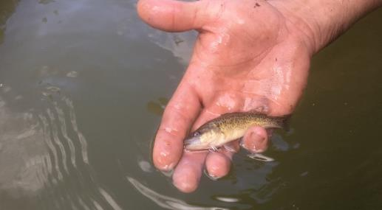

**Figure 5: A juvenile Murray Cod (Photo: ARI)**