A national estimate of carp biomass for Australia

Ivor Stuart, Ben Fanson, Jarod Lyon, Jerom Stocks, Shane Brooks, Andrew Norris, Leigh Thwaites, Matt Beitzel, Michael Hutchison, Qifeng Ye, John Koehn, and Andrew Bennett

October 2019
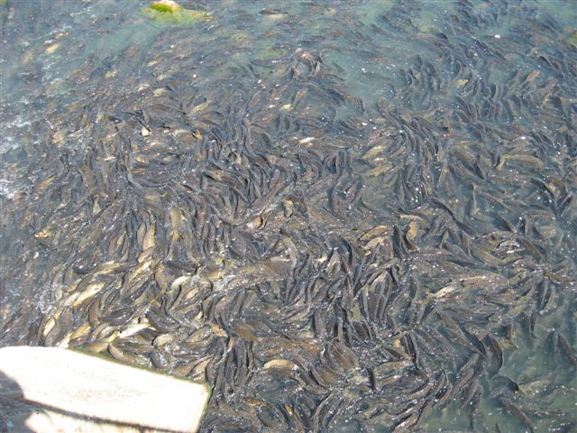

Arthur Rylah Institute for Environmental Research
Client Report

Arthur Rylah Institute for Environmental Research
Department of Environment, Land, Water and Planning
PO Box 137
Heidelberg, Victoria 3084
Phone (03) 9450 8600
Website: www.ari.vic.gov.au
Citation: Ivor Stuart, Ben Fanson, Jarod Lyon, Jerom Stocks, Shane Brooks, Andrew Norris, Leigh Thwaites, Matt Beitzel, Michael Hutchison, Qifeng Ye, John Koehn and Andrew Bennett (2019). A national estimate of carp biomass for Australia. Unpublished Client Report for the Fisheries Research and Development Corporation. Arthur Rylah Institute for Environmental Research, Department of Environment, Land, Water and Planning, Heidelberg, Victoria.
Front cover photo: Carp in the lower Murray (Ivor Stuart).
© The State of Victoria Department of Environment, Land, Water and Planning 2019
Edited by Pam Clunie (ARI)
Disclaimer
This publication may be of assistance to you but the State of Victoria and its employees do not guarantee that the publication is without flaw of any kind or is wholly appropriate for your particular purposes and therefore disclaims all liability for any error, loss or other consequence which may arise from you relying on any information in this publication.

A national estimate of carp biomass for Australia

Ivor Stuart¹, Ben Fanson¹, Jarod Lyon¹, Jerom Stocks², Shane Brooks³, Andrew Norris⁴, Leigh Thwaites⁵, Matt Beitzel⁶, Michael Hutchison⁴, Qifeng Ye⁵, John Koehn¹ and Andrew Bennett^{1,7}

¹Arthur Rylah Institute for Environmental Research 123 Brown Street, Department of Environment, Land, Water and Planning, Heidelberg, Vic, 3084
²New South Wales DPI, Batemans Bay Fisheries Centre, PO Box 17, NSW, 2536,
³LitePC Technologies Pty Ltd, 138 Brysons Rd, Warrandyte South, Vic, 3134,
⁴Animal Science, Queensland Department of Agriculture and Fisheries, Bribie Island Research Centre, PO Box 2066, Woorim, Qld, 4507
⁵SARDI Aquatic Sciences, 2 Hamra Avenue, West Beach, Adelaide, SA, 5024
⁶Conservation Research, Environment, Planning and Sustainable Development Directorate, ACT Government, GPO Box 158, Canberra, ACT, 2601
⁷Department of Ecology, Environment and Evolution, La Trobe University, Bundoora, Vic, 3083

Date

Arthur Rylah Institute for Environmental Research
Unpublished Client Report for the Fisheries Research and Development Corporation

Acknowledgements
For their valued contributions to fieldwork in Victoria, we thank Graeme Hackett, Peter Fairbrother, Adrian Kitchingman, Matt Jones, Andrew Pickworth, Jason Lieschke, Scott Raymond, Kris Pitman and Kim Loeun (Arthur Rylah Institute). From NSW, we thank Michael Rodgers, Patrick Martin, Luke van Lawick and Dylan van der Meulen (NSW DPI). From South Australia, we thank Neil Wellman, David Schmarr, Kate Frahn, George Giatas, Luciana Bucater and David Short (SARDI). From Queensland, we thank David Nixon, Rod Cheetham and Keith Chilcott (QDAF) and Jonathan Marshall (DES). From the ACT, we thank Mark Jekabsons, Zohara Lucas and Josh Van Lier (ACT EPSDD). From the Inland Fisheries Service, Tasmania, Chris Wisniewski and John Diggle provided Carp data for Lake Sorrell. From Murdoch University, Steve Beatty and Dave Morgan provided advice on the distribution of Carp in Western Australia. For providing spatial information we are grateful to Mark Hore (Southern Rural Water), Barry Ginn (Lower Murray Water) and Garry Fyfe (SA Water). Sincere thanks also go to Melissa Brooks for additional assistance with the spatial layers.

We thank the many state agency researchers and private consulting firms who contributed existing or new data on Carp that supported the biomass model, including Clayton Sharpe (CPS Enviro), Dion Iervasi (Austral Research and Consulting), Chris Bloink (Ecology Australia) and Joe Pera (WaterNSW). For extra Carp information, sincere thanks to Chis Wisniewski and John Diggle (Inland Fisheries Service, Tasmania) and Stephen Beatty and David Morgan (Murdoch University, Western Australia). We thank numerous landholders and also Kelvin Berry who facilitated access for field crews. At Hazelwood Power Station, staff from ENGIE facilitated sampling at North Morwell wetland. Greg Fletcher and Oakley Gasson, Wimmera CMA, provided logistical and funding support for Carp sampling.

Our grateful thanks go to Matt Barwick, Jennifer Marshall, Toby Piddocke and Jamie Allnutt (FRDC) for project management and support, and to Charles Todd, Arthur Rylah Institute and Brenton Zampatti (SARDI) for contributions during project inception. We thank two anonymous independent reviewers for constructive comments that improved an earlier version of this report. Thanks to Pam Clunie, Arthur Rylah Institute, for editing the report. Finally, we thank commercial Carp fishers Keith Bell (K&C Fisheries Global) and Gary Warwick for their personal data, observations and contributions to the project.

This project was completed under Victorian Fisheries Permits RP827, RP1196 and ARI animal ethics permit AEC 17-010; NSW Fisheries and Animal Care and Ethics Permits ACEC 17/05 and P01/0059(A)-4.0Permit F93/158(C)-9.0; South Australian Fisheries Management Act 2007: Section 115, Ministerial Exemption ME9903001; Qld General Fisheries Permit 186281, Qld Animal Ethics Permit CA2017/09/1106, and ACT EPSDD Ethics permit CEAE 13-18.

Contents
Acknowledgements 4
Summary 8
Background 8
Aim 8
Methods 8
Results 9
Conclusions and management implications 12
1 Introduction 13
2 Objective 15
3 Methods 15
3.1 Overview of the conceptual framework for estimating biomass 15
3.2 Development of spatial layers and river attributes (Step 1) 18
3.3 Predicting CPUE and average body mass of Carp for rivers and waterbodies (Steps 2 and 3) 27
3.4 Conversion factors (Steps 4 and 5) 28
3.4.1 Converting CPUE to density of Carp 28
3.4.2 Assessing habitat utilisation in lakes and storages 29
3.5 Juvenile (<150 mm fish) biomass (Step 6) 30
3.6 Estimating biomass (Step 7) 31
3.7 Model validation 32
3.8 Additional biomass estimates for irrigation channels and Western Australia 33
4 Results 34
4.1 National Carp database 34
4.2 GIS mapping of Carp habitat 37
4.3 Predicting CPUE and fish mass for rivers and waterbodies 38
4.4 Predicting Carp densities from efCPUE 40
4.4.1 efCPUE conversion factors 40
4.5 Lakes – estimating change in offshore catch rate 41
4.5.1 Storages – variation with depth 43
4.6 Juvenile biomass rate 44
4.7 Estimates of Carp biomass 45
4.8 Comparison of estimated carp biomass with recorded biomass from standing waterbodies 47
4.9 Case studies 48
5 Discussion 50
5.1 Estimates of Carp biomass 50
5.2 Validation of model estimates for lakes and storages 52
5.3 Case studies 52
5.4 Carp biomass, national and local impacts 53
5.5 Model scope and limitations 54
5.5.1 Spatial area 54
5.5.2 Area vs. volume 54
5.5.3 Missing zeros in existing data 55
5.5.4 Habitat utilisation 55
5.5.5 Estimates of biomass for waterbodies 55
5.5.6 Juvenile biomass 56
5.5.7 Irrigation channels 56
5.5.8 Potential bias in the conversion factor 56
5.5.9 Static vs dynamic model 56
5.5.10 Sensitivity analysis 57
6 Conclusions and management implications 58
7 References 59
8 Appendices 64
8.1 Appendix A1: State summary of Carp invasion, legal status, ecology and management 64
8.2 Appendix A2 - Predicting river widths 76
8.3 Appendix A3 - Predicting waterhole area 81
8.4 Appendix A4 - Existing datasets for Carp 84
8.5 Appendix A5 - Description of standard sampling methods 90
8.6 Appendix A6 - Sites for assessing conversion factors 92
8.7 Appendix A7 – Length-mass relationships for Carp 94
8.8 Appendix A8 – Predictive models for CPUE and average fish mass 95
8.9 Appendix A9- Conversion factor experiments 105
8.10 Appendix A10 - Habitat utilisation experimental design 115
8.11 Appendix A11 – Estimating Irrigation and Western Australia biomasses 117
8.12 Appendix A12 - State biomass maps 123
8.13 Appendix A13: Site photographs 126

Abbreviations and definitions

Term | Definition | Units
%CV | percent coefficient of variation
area | surface area of river or waterbody | ha
bGAMM | Bayesian Generalised Addditive Mixed Model
bGLM | Bayesian General Linear Model
bGLMM | Bayesian Generalised Linear Mixed Model
biomass density | mass of Carp per surface area of waterbody | kg/ha
Carp density | total number of individual Carp per ha of surface area | No/ha
CI | 95% confidence intervals
CPUE | total number of individual Carp per hour of survey effort | No/hr
CrI | 95% credible intervals
E-fishing | electrofishing
efCPUE | electrofishing CPUE | No/hr
Geofabric | Australian hydrological geospatial fabric
GIS | Geographic Information Systems
MDB | Murray–Darling Basin
MDBA | Murray–Darling Basin Authority
NCCP | National Carp Control Plan
nCPUE | net (gill or fyke) CPUE | No/hr
SRA | sustainable rivers audit
total biomass | total mass of Carp summed across a specified area | metric tonne

Summary

Background
The Common Carp (Cyprinus carpio) (hereafter ‘Carp’) is one of the world’s most destructive vertebrate pest animals. In Australia, Carp dominate many aquatic ecosystems, where they can form up to 90% of the fish biomass (i.e. the total weight of Carp in a given area), and have a severe impact on aquatic plants, invertebrates, water quality, native fish and social amenity. The economic cost is conservatively estimated at AUD$200 M/year. The Australian Government is considering the use of a cyprinid herpesvirus-3, commonly known as Carp herpesvirus (CyHV-3 virus; hereafter the ‘Carp virus’), as a potential biological control agent for Carp. The Fisheries Research and Development Corporation (FRDC) is leading a National Carp Control Plan (NCCP) to assess the feasibility of introduction of the Carp virus.
Carp occur in a broad range of aquatic habitats (e.g. rivers, estuaries, wetlands, lakes, impoundments and irrigation networks) and their density varies spatially and temporally among these environments. Estimates of Carp biomass are important for effective planning, to understand the feasibility of releasing the virus, the resource allocation required for clean-up, the management of potential ecological impacts in a broad range of aquatic habitats, and to establish the benchmark from which to measure the efficacy of the Carp control. In short, a nationally co-ordinated approach to Carp management requires a reliable, continental-scale estimate of Carp biomass.

Aim
The aim of this project was to develop and apply transparent and robust methods to estimate the biomass of Carp in Australia. This included estimating biomass within a range of major aquatic habitat types (i.e. rivers, lakes, billabongs, estuaries), at appropriate geographic scales (local, river reach, river-basin and, inter-basin) across the recorded distribution of the species in Australia; and to determine a national estimate for Carp biomass.

Methods
Carp biomass was estimated by using models that linked historic and contemporary catch data with catch efficiency rates for different aquatic habitat types. In summary, the methodological approach was as follows.
(i) Classify aquatic environments that Carp occupy into a discrete set of habitat types.
(ii) Compile a national map of aquatic ecosystems into a GIS spatial framework (aligned to the Australian National Aquatic Ecosystem (ANAE) classification framework). Using this resource, calculate the spatial extent (i.e. total area) of each habitat type identified in step (i).
(iii) Assemble a comprehensive national database of existing site-based estimates of the relative density of Carp (catch-per-unit-effort; CPUE) and associated environmental co-variates (e.g. depth, turbidity, electrical conductivity). Supplement existing CPUE data with contemporary sampling in data-poor habitat types.
(iv) Develop predictive models of environmental and other factors that influence a) CPUE and b) the average mass of individual Carp at a site. Use these predictive models to assign values of CPUE and average fish mass to all rivers and waterbodies known to be occupied by Carp.
(v) Conduct a series of field experiments (in summer 2018) to determine the relationship between CPUE and the true density of Carp (kg/ha) (e.g. using capture-mark-recapture experiments and wetland draw-downs to determine capture probability) in representative habitats throughout eastern Australia. The conversion factors derived from these relationships can then be used to reliably link CPUE to Carp density (kg/ha). For juvenile Carp (<150 mm FL) we used the same conversion factors as for adult fish.
(vi) Develop models to calculate biomass estimates for specific habitat types based on CPUE, average fish mass and the habitat-specific conversion factor. Validate these modelled estimates in relation to site-based studies of absolute abundance (e.g. where lakes dried out and total biomass was determined).
(vii) Upscale these estimates of biomass to generate total biomass for each habitat type and total biomass at the Australian continental scale.
(viii) For Western Australia and irrigation channels, CPUE data were not available and so coarse biomass estimates were made.

Results
Geographic distribution of Carp
In the 45 years since Carp first escaped into the Murray-Darling Basin they have invaded almost all major aquatic habitat types in south-eastern Australia and now inhabit a total estimated aquatic area of 16 569 km². For our database, a total of 153 fish monitoring studies were collated, comprising 574 145 Carp collected in eastern Australia between 1994 and 2018. Given the large spatial and temporal resolution of the existing CPUE dataset, a broad range of climatic conditions, including wet and drought scenarios were sampled.
Predicting CPUE and the average size of Carp
Predictive models were used to generate spatial maps of i) CPUE and ii) average fish mass for all rivers and waterbodies within the range of Carp. Overall, the fits of these models were moderate; the average correlation between predicted and observed data ranged from 0.48 to 0.65 (S.E. 0.02 - 0.07). Predicted CPUE for rivers and waterbodies were highest along the Murray, Lower Darling and the Lachlan River. Within lake habitats, the CPUE estimate decreased by 36.9% (95%CrI: 0.5%, 63%) for offshore habitats (~200 m offshore) compared with lake edges; while for large impoundments there was an 81.9% decline in CPUE at >12 m depth compared with the water surface.
Spatial patterns in predicted average mass of Carp were strongly affected by presence of recruits, which were more common in aquatic habitats at lower elevations. In addition, the model demonstrated a general increase in the predicted average mass of individual Carp at: (i) higher altitudes, and (ii) toward the southern extent of the species range.
Detection efficiency
Rates of Carp detection with electrofishing (compared with known abundance) varied from 4% in large, lowland rivers to 20% in small wetland habitats. These results were used to calculate conversion factors, to convert CPUE estimates (combined with average fish mass) into estimates of Carp biomass density (kg/ha) for different aquatic habitats on mainland Australia. Detection rates for juvenile carp (<150 mm long and <1-year-old) were low relative to larger fish.

Trends in estimates of Carp biomass density
Case studies revealed that, unsurprisingly, there was considerable variation in estimates of Carp biomass density (kg/ha) among and within the representative aquatic habitats, ranging from 0 to 1 200 kg/ha. Carp density tended to be higher for lowland rivers and adjacent wetlands than for upland rivers and deep impoundments. For example, the lower Murray River (SA) had some of the highest recorded biomass estimates (~550 kg/ha), reflective of the series of regulated, slow-flowing weir pools and permanent adjacent wetlands, which provide optimal habitat for Carp. In contrast, the Glenelg River had a low biomass density of Carp with an average of ~42 kg/ha. Carp density of the Moonie, and Middle Murray was higher, with an average river density of 132 kg/ha and 115 kg/ha, respectively. The average density for the Lachlan River was 71 kg/ha but varied across the region with densities up to 249 kg/ha.

Young-of-the-year Carp (<150 mm long and <1-year-old) were not represented well in the biomass estimates because electro-fisher catch efficiency for young-of-the-year fish is low relative to larger fish (Dolan and Miranda 2003). A low detection rate then resulted in an underestimate of modelled juvenile biomass, especially in wet years immediately following floodplain recruitment events (Stuart and Jones 2006). Biomass of young-of-the-year Carp is very dynamic due to very low survival rates (Brown and Walker 2004) especially in the first few months when small fish leave the floodplain and over-winter in rivers (McCrimmon 1968; Driver et al. 2005). For managers involved in planning Carp clean-up, we recommend planning for uncertainty by preparing for biomass at the upper confidence intervals of our estimates.

National estimate of Carp biomass
The Carp biomass estimate for May 2018 represented a moderately ‘wet’ year in the southern basin but a dry year in the north, while the estimate for May 2011 represents a flood scenario where survival may be much higher. We estimated the biomass of Carp in south-eastern Australia in May 2018 to be 205 774 tonnes (95%CrI: 117 532, 356 482). Standing waterbodies had a total biomass of 162 838 tonnes (95%CrI: 79 621, 307 561) and rivers had 42 936 tonnes (95%CrI: 23 055, 77 769). For Western Australia and irrigation channels, where biomass was coarsely estimated, there was an additional 15 855 and 3 570 tonnes, respectively. The national biomass of Carp was extrapolated from a large number of existing CPUE observations (4744 sites; 574 145 individual Carp) with a wide spatial coverage in south-eastern Australia, Tasmania and Western Australia.
Biomass fluctuates through time and in a ‘wet’ scenario, such as May 2011, it may be much greater; estimated to be 368,357 tonnes (95%CrI: 184,234, 705,630), plus the additional coarse estimates for Western Australia and irrigation channels (i.e. 15 855 and 3 570 tonnes, respectively). The modelled increase in biomass was driven by changes in the underlying CPUE rather than change in aquatic habitat area which was a static estimate of a random, moderately wet year. Results of modelling Carp biomass are presented as ‘heat maps’ showing the spatial distribution of biomass and concentrations of biomass along the Murray and Darling areas (Figure 1). The carp biomass estimates were for two points in time (i.e. May 2011 and May 2018) however populations appear to reach maximum and minimum densities, during flood or droughts respectively (Koehn et al. 2016). For our biomass estimates, the underlying CPUE and carp mass models had a temporal component but only in the sense that they described a historical trend; there were no antecedent hydrological conditions or population processes explicitly incorporated into the model. Hence, the continental biomass estimate will vary greatly between years and so should be used cautiously (Hone and Buckmaster 2014).

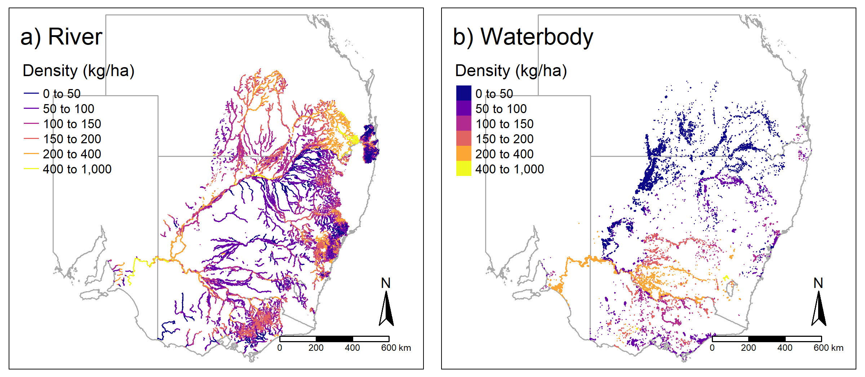
Figure 1: Modelled estimates of Carp biomass density (kg/ha) across a) river systems and b) waterbodies of eastern Australia. Different colours reflect the variation in density of Carp.

Validation and reliability of the biomass estimate
There were several inherent uncertainties in the modelled estimate of biomass where further refinement could increase accuracy. These refinements include: (i) increasing the quality of the spatial data for Carp occurrence and CPUE, especially for coastal systems and the ‘wetted’ area of ephemeral systems; (ii) completing additional site-based estimates of detectability and total abundance (and thus generate more precise conversion factors; Lyon et al. 2014), particularly for habitats with limited data such as impoundments, large fast-flowing rivers, irrigation channels, farm dams, and estuaries; (iii) further validation of modelled estimates of Carp biomass with total abundance data from wetland/lake draining events; and (iv) future development and use of a dynamic Carp population model to examine population predictions for future scenarios under different environmental conditions (e.g. estimated Carp biomass in the year 2023 under a range of hydrological scenarios; Todd et al. 2019).

Conclusions and management implications

This estimate of the national Carp biomass provides data vital to evaluating the feasibility of CyHV-3 virus release under the National Carp Control Program. It provides a quantitative understanding of the location and magnitude of Carp biomass across a range of spatial scales, from whole-of-continent to specific river reaches and individual wetlands. Understanding the distribution of Carp biomass within different habitats is essential for the NCCP to evaluating feasibility, particularly for identifying implications in locations where Carp density exceeds a threshold level for environmental harm. We also highlight that for managers planning on-ground action, preparing for biomass at the upper confidence intervals of our estimates would be appropriate.
In many locations, particularly for lowland rivers and wetlands, the biomass densities of Carp are well above the accepted threshold levels (i.e. 80-100 kg/ha) at which detrimental ecological impacts may occur, thus highlighting the spatial extent to which detrimental impacts may occur in ecosystems across large areas of Australia. The extent to which integrated management interventions, at local, regional and national scales, can reduce Carp biomass and hence reduce ecological impacts so that natural values can begin to recover can now be more transparently evaluated. Importantly, this study not only provides a national estimate for Carp biomass in Australia, but the methods developed could be applied to existing datasets to provide estimates for other vertebrate pests or indeed for populations of native fishes. A reliable estimate of continent-scale biomass provides a base-line from which to: (i) focus Carp management efforts, (ii) help set appropriate management and policy targets, and (iii) track ecosystem recovery.

- Introduction
The Common Carp (Cyprinus carpio) (hereafter ‘Carp’) is one of the world’s most destructive vertebrate pest animals (Lowe et al. 2004). Carp have established self-sustaining populations across a diverse array of climatic and habitat conditions in 91 of 120 countries in which it has been introduced (Casal 2006). In North America, Canada, South America, Australia, Africa, parts of western Europe and New Zealand, Carp cause serious ecological, economic and social amenity problems, and are implicated in ongoing serious reductions in the geographic range and abundance of native flora and fauna (Parkos et al. 2003; Vilizzi 2012; Forsyth et al. 2013; Vilizzi et al. 2015; Macklin et al. 2016; Maceda-Veiga et al. 2017; Bajer et al. 2009; 2018; Marshall et al. 2019). Like many vertebrate pest species, Carp largely remain an intractable problem for which practical management solutions are still being sought.
In Australia, Carp are major environmental pests, and since the late 1960s have spread throughout the south-east of the continent and to some parts of Tasmania and Western Australia (Koehn 2004). Across their distribution, Carp inhabit a diverse array of habitats, ranging from estuarine lakes to upland streams, and densities vary among these habitats (Koehn 2004). A brief summary of the history of Carp invasion for each Australian state and territory is provided in Appendix A1. In some areas Carp can dominate aquatic ecosystems, forming up to 100% of the fish biomass (i.e. the total weight of Carp in a given area; Harris and Gehrke 1997; Koehn et al. 2000). The most severe impacts of Carp have been on aquatic plants, invertebrates, water quality and native fish species, but there have also been serious social amenity and economic impacts (Vilizzi et al. 2014). Globally, the density of Carp in riverine systems is commonly 200–400 kg/ha, and occasionally exceeds 1800 kg/ha in shallow lakes (Bajer and Sorenson 2010; Farrier et al. 2018). The ecological impacts increase significantly when the density exceeds a low threshold of 80–120 kg/ha for rivers globally (Brown and Gilligan 2014; Vilizzi et al. 2014; Bajer et al. 2009; 2016).
The high densities of Carp and their associated ecological impacts are compounded by the regulation and degradation of rivers, which have favoured the rapid spread and increase in abundance of Carp (Koehn 2004; Bajer et al. 2016). Consequently, Carp continue to expand their geographic distribution and to have negative impacts on aquatic ecosystems (Weber and Brown 2009; Badiou and Goldsborough 2015; Vilizzi et al. 2015; Conallin et al. 2016). While there has been some success managing Carp at a local scale (Stuart and Conallin 2018), at a landscape scale Carp cannot be controlled with any combination of conventional control techniques (e.g. commercial fishing, piscicides, wetland screens and trapping). Therefore, an integrated combination of conventional and biological control methods is required (Roberts and Tilzey 1997; Hillyard et al. 2010; Thwaites et al. 2010; Gibson-Reinemer et al. 2017; Lechelt et al. 2017; Phelps et al. 2017).
The Australian Government is considering release of cyprinid herpesvirus-3, commonly known as carp herpesvirus (CyHV-3) (hereafter ‘carp virus’), as a potential biological control agent for Carp (McColl et al. 2014, 2016, 2018). This follows the success of other biocontrol agents, such as the rabbit haemorrhagic disease virus (RHDV1) introduced in 1995 to control the environmental impacts of the invasive European Rabbit (Oryctolagus cuniculus) (Cooke 2018). The Fisheries Research and Development Corporation (FRDC) is leading the preparation of a National Carp Control Plan (NCCP) to examine all factors concerning the feasibility of releasing carp virus.
There are considerable environmental and social concerns associated with the proposed release of the Carp virus, a robust evidence base is needed to help understand the benefits and risks (Becker et al. 2018; Marshall et al. 2018; McGinness et al. 2019). The FRDC and its delivery partners are therefore conducting a range of studies with the aim of informing a decision by government on whether the virus release should proceed. A key research project being delivered for FRDC, and the focus of this report, aims to determine the biomass of Carp in Australia. Precise estimates of biomass are important for evaluating the potential release of the virus, assessing social and environmental risks, allocating resources for the release and clean-up, managing potential ecological impacts in a broad range of aquatic habitats, and establishing a benchmark from which to measure the efficacy of the Carp control program.
A nationally coordinated approach to Carp management requires a reliable, continental-scale, estimate of biomass. However, there are no continental-scale estimates of total Carp numbers or biomass for Australia or anywhere else in the world. Although several population models have been used to explore various aspects of Carp ecology and different management scenarios, these were limited to specific case-study sites (Brown and Walker 2004; Donkers et al. 2012; Forsyth et al. 2013; Brown and Gilligan 2014; Koehn et al. 2016, 2018; Thwaites et al. 2016).
The challenge in estimating biomass at a broad scale is that carp numbers are hyper-variable both spatially and temporally, with dramatic population increases following flooding and major declines during drought (Koehn et al., 2016). While some population estimates exist for specific sites, usually in lakes, where there are reliable local monitoring data (e.g. Donkers et al., 2012; Bajer and Sorenson 2015), these are generally on small scales, and as such are not suitable to inform continental scale control programs. There are also major challenges for extrapolating data from these studies to larger-scale estimates because carp occupy a broad range of aquatic habitats, their abundance varies considerably in response to floods and droughts (Stuart and Jones 2006; Crook and Gillanders 2006), their detectability varies among habitats (Bayley and Austen 2002), existing survey data coverage is uneven, and sampling methods vary (Davies et al., 2010). Therefore, predicting continental carp biomass requires the use of an appropriate method that accounts for differences in densities and detection abilities among aquatic habitats, as well as compensating for spatial and temporal trends.
Estimating Carp densities is difficult and often time-intensive, and sound estimates are therefore rarely obtained, especially in large rivers and waterbodies. As a consequence, fish catch rate is used as a proxy for density (i.e. relative abundance). A large repository of historic Carp fish catch rates has been accumulated in Australia and could provide a wealth of information on temporal and spatial trends in carp densities. However, the relationship between fish catch and Carp density is not known, so that estimating the probability of capture (Lyon et al. 2014) and establishing a relationship between CPUE and biomass (kg/ha) is essential for providing a national estimate of biomass.

- Objective
The objective of this project was to develop and apply robust methods to estimate the biomass of Carp within a range of major aquatic habitat types (rivers, lakes, billabongs and estuaries) at appropriate geographic scales (local, river reach, river basin and inter-basin) across the recorded distribution of the species on the Australian continent, to inform the NCCP.

- Methods
The conceptual approach used to estimate the total Carp biomass in Australia is outlined below. This section outlines the steps used to obtain the estimate. The methods for each step are set out in the subsequent sections, supplemented by additional detail in the relevant Appendices. Commonly used terms are defined in the Abbreviations and definition section at the beginning of the document.

  - Overview of the conceptual framework for estimating biomass
Estimating total Carp biomass required two main components: (1) the available area of Carp-occupied habitats, and (2) the Carp biomass density (kg/ha) for those habitats. With these two components, it is then possible to obtain an estimate of the total biomass by multiplying the area occupied by the biomass density for each habitat and then summing those habitat biomasses. However, obtaining estimates for those components (biomass density and habitat area) was non-trivial and required a multi-step approach (Figure 2): Step 1 defined carp habitat types and the estimated area for each habitat; Steps 2 to 6 estimated biomass densities for each habitat type; and Step 7 calculated total biomass (combining habitat area and biomass density). We outline each step below, and further details are given in Sections 3.2 – 3.6.
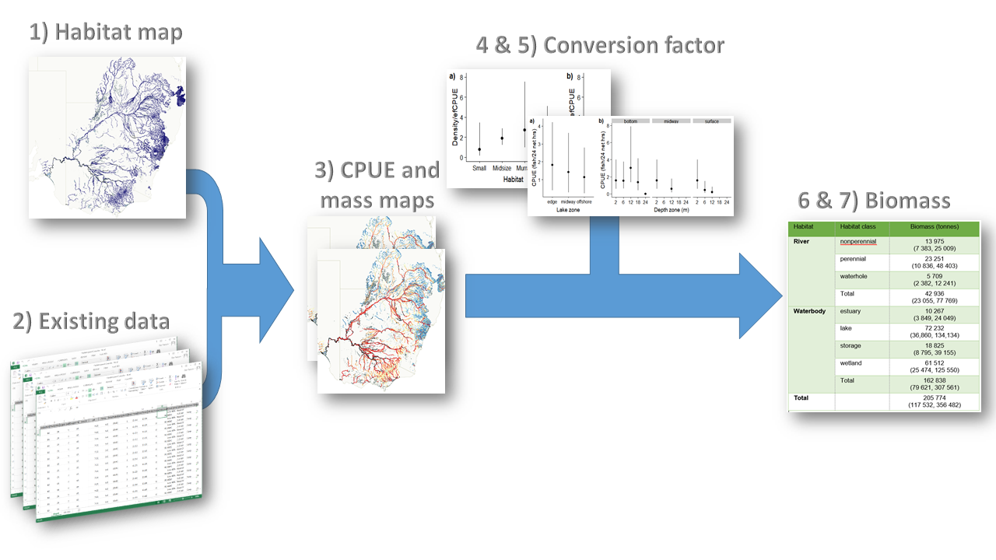
Figure 2: Conceptual model for estimating the total biomass of Carp in Australia.

- Step 1: Classify aquatic environments that Carp occupy into discrete habitat types and develop a GIS map of Carp habitat. Because the hydrological patterns of Australia are temporally dynamic, creating a spatial map that represents the availability of Carp habitat (and hence habitat area) was a major obstacle. There are no GIS layers that map yearly patterns in hydrological conditions in Australia and since Carp density differs between habitat types, we needed to classify waterbodies according to habitat. Consequently, this first step required an integrated process that included using available GIS layers (such as the Australian National Aquatic Ecosystem and the Geofabric layers), expert consultation, and a rule-based algorithm to develop a GIS spatial layer for the river system and waterbodies (e.g. wetlands, lakes, storages). These GIS layers represented the current distribution of Carp in 2018, reflected the hydrological conditions of a moderately wet hydrological scenario, and classified waterbodies and rivers into general habitat types (e.g. storage, lake, wetland, river). Using these layers, we developed two new GIS layers — rivers and waterbodies — that represent Carp habitats and allowed an estimation of surface areas.
- Step 2: Create a Carp database. Due to the spatial scale of this study, collecting contemporary data across Australia was not possible and hence we needed to use existing data. We collated over 20 years of Carp sampling data from across the range of the species. These data included relative abundance data (e.g. CPUE data from electrofishing and netting), fish length and mass data, as well as Carp density (e.g. from wetland pump outs and mark-recapture) data. Contemporary sampling was also done to supplement the database and improve our estimate for 2018. These data were essential for providing estimates across the species’ range, as well as for indicating temporal trends in abundance. This step identified a paucity of data for Western Australia (all presence/absence only), and hence Western Australia was removed from the modelling approach described below using CPUE data, but we do provide a less formal approach separately to provide a very coarse estimate (see Section 3.8).
- Step 3: Use existing data to predict CPUE and average Carp mass for Carp habitats. The vast majority of existing data for Carp was relative abundance data from electrofishing (efCPUE). Therefore, we used efCPUE data to understand spatial patterns in abundance. As detection and counts are less reliable for small fish (Dolan and Miranda 2003), we used efCPUE and mass data only for Carp > 150 mm in length. We mapped efCPUE patterns across the GIS layers in order to predict efCPUE for every habitat. For the river system, we predicted efCPUE for May 2018 based on environmental and physical attributes of the rivers, as well as temporal trends (year, month) and spatial location. For waterbodies (e.g. wetland and lakes), predicted CPUEs were based on spatial and temporal variables and habitat type. However, predicted values for efCPUE provide only a measure of relative abundance. To calculate biomass density (kg/ha), we needed the average Carp mass for each habitat as well as a conversion factor to convert efCPUE to density (No/ha). To obtain average Carp mass, we repeated the same models above to predict Carp mass across habitats, and spatial/temporal scales. The development of a conversion factor was the next step.
- Step 4: Convert predicted efCPUE to density (No/ha). As efCPUE is only a relative abundance measure, we needed a conversion factor (i.e. a calibration approach: Driver et al. 2005) to convert efCPUE to density (No/ha). Carp conversion factors developed previously require estimating the ratio between density (No/ha) and efCPUE (Driver et al. 2005; Gilligan et al. 2010). However, these published conversion factors were for smaller rivers, and they did not include any measure of uncertainty. To obtain an estimate of the conversion factor in this study, Carp density and efCPUE (for fish ≥ 150 mm) were measured for multiple sites across multiple habitat types and the ratio between efCPUE and density was calculated.
- Step 5: Estimate Carp habitat use in lakes and storages to correct biomass density for offshore zones. In lakes and storages, existing efCPUE data were collected mainly from the littoral zone, as electrofishing is less efficient at greater depths. However, Carp density is likely lower in offshore zones compared to littoral zones where there are greater feeding and spawning resources (Wisniewski et al. 2015). Hence, our estimates using only littoral zone catch data would over-estimate the biomass. Consequently, we needed to correct for this difference. Two steps were required for this process: (1) estimate offshore spatial area (i.e. area of a lake not within the littoral zone), and (2) estimate the change in density between littoral and offshore zones. We estimated offshore spatial area for every lake and storage by using a combination of Water Observations from Space and expert opinion (see below for details). For the proportional change in density, an experiment was conducted in which the changes in net CPUE (i.e. CPUE when using nets) were compared from littoral to offshore zones in lakes, and with increasing depth in storages.
- Step 6: Estimate juvenile (< 150 mm) biomass. The above steps were used to calculate biomass for fish ≥ 150 mm in length. This minimum length of 150 mm was used because the assumption of equal detection is tenuous for smaller fish (Dolan and Miranda 2003). However, an estimate of juvenile biomass was required and so we created a foundation to provide some estimate of juvenile mass. We adopted a simplified version of the approach used for the biomass of individuals ≥ 150 mm. Data on juvenile fish were included the efCPUE dataset and so we used these data to model and estimate the average juvenile biomass (kg) in relation to nonjuvenile efCPUE (≥ 150 mm fish), habitat attributes, space and time. Thus, we could predict average juvenile biomass (kg) for a sampling event based on the predicted efCPUE of the ≥ 150 mm and habitat attributes. Unfortunately, the detection rates for fish <150 mm are unknown and difficult to obtain, so the factor for converting the juvenile biomass rate (kg per efCPUE) to biomass density is also unknown. For this report we took the very conservative approach that the conversion factor for juveniles is the same as that for the ≥ 150 mm fish (see Section 3.5).
- Step 7. Estimate the total Carp biomass. Using the above steps, we obtained the estimated area and biomass density (kg/ha) of Carp for every river segment and waterbody object. We then estimated biomass for each river/waterbody by multiplying the area by biomass density. Lakes and storages had littoral and offshore components, and these were included in the calculations. These estimates for individual rivers and waterbodies were then summed to get total biomass (metric tonnes). Uncertainty in the estimate of total biomass was obtained through posterior sampling of the model estimates at each step.

  - Development of spatial layers and river attributes (Step 1)
Developmental of spatial layers
To estimate Carp biomass in Australia, we developed a spatially explicit map of aquatic ecosystems in which Carp are found over the full extent of their known range in Australia (Figure 3). The Carp habitat types identified included riverine ecosystems (rivers and streams), which are those systems that are contained within a channel, including both single-channel and multi-channel systems (e.g. braided channel networks). The beds of channels are not typically dominated by emergent vegetation, may be naturally or artificially created, periodically or continuously contain moving water, and may form a connecting link between two bodies of standing water.
Ephemeral river systems are dominant in the northern basin (i.e. the Queensland tributaries) and typically contain permanent and semi-permanent waterholes or river pools that connect during flow events but are separated by dry stream beds between flow events. The duration of flow events and the distance between waterholes is highly variable.
Lacustrine systems (or lakes) are open-water dominated systems characterised by deep, standing or slow-moving water with little or no emergent vegetation. Temporary lakes that dry out periodically are also included in this category.
Palustrine systems are primarily shallow, vegetated, non-channel environments, including billabongs, marshes, wetlands and treed swamps.
Storages are artificially constructed reservoirs, town water storages and large irrigation storages. They are typically similar to lakes with highly regulated hydrological regimes. Estuaries have oceanic water diluted with freshwater runoff from the land.

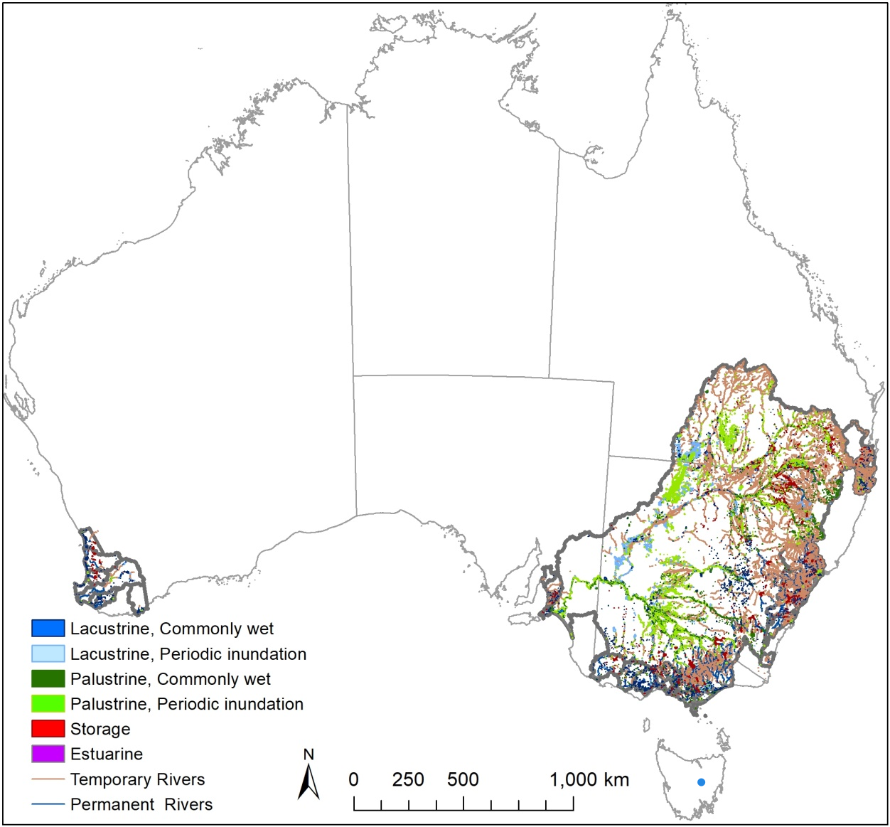
Figure 3: Current distribution of the Common Carp in Australia. Mapping of aquatic habitats was compiled in GIS for the categories of aquatic ecosystems aligned to the Australian National Aquatic Ecosystem (ANAE) classification framework (Aquatic Ecosystems Task Group 2012).

The Australian National Aquatic Ecosystem (ANAE) classification of aquatic ecosystems in the MDB (Brooks et al. 2014; Brooks 2017) was a primary data set for this compilation. This data set contains the ANAE classification for rivers, floodplains and the most complete and detailed mapping of wetland features across the Basin to date. Expanding the mapping to the range of Carp beyond the Murray–Darling Basin was facilitated by state mapping layers from South Australia, Victoria, Queensland and the Australian Capital Territory that are based on, or compatible with, the ANAE classification. Coastal catchments in New South Wales and in Western Australia were mapped using the Australian Hydrological Geospatial Fabric (Geofabric, BOM 2014) and other state wetland and river mapping that has been compiled into a national map by Geosciences Australia (Geosciences Australia 2018). For a full list of data sources, refer to Table 1. Tasmania has only 1 small population of carp, in Lake Sorrell and this was included from the Geofabric mapping.

Table 1: Data sources contributing to the map of aquatic ecosystems in Australia that support Carp.

No. | Area | Data | Used for mapping
1 | MDB | Classification of aquatic ecosystems in the MDB (2017 update) | · All waterbodies in the MDB
2 | All | Geofabric v2.1 Surface Cartography Australia Commonwealth of Australia (Bureau of Meteorology) 2011 | · National rivers layer  · Water storages  · Larger lakes, wetlands outside the MDB  · Larger “named” irrigation channels
3 | SA | S.A: Topo Statewide Wetlands | · Waterbodies outside the MDB
4 | ACT | ACT ANAE Classification (2017) | · Artificially constructed waterbodies not included in the ANAE classification of the MDB (e.g. Lake Burley Griffin)
5 | QLD | QLD Wetland Mapping v4 - Regional Ecosystems | · Coastal catchments
6 | Vic | Victoria Wetlands_Current state mapping | · Victorian Coastal catchments, artificially constructed waterbodies
7 | Vic | Index of Stream Condition  LiDAR data set 2010 | Victorian rivers
8 | All | Surface Hydrology Lines (Regional) (best available data supplied by Jurisdictions and aggregated by Geoscience Australia 2018) | · river lines where polygon mapping was not available after aligning to the Geofabric
9 | All | Surface Hydrology Polygons (Regional) (best available data supplied by Jurisdictions and aggregated by Geoscience Australia 2018) | · Coastal catchments in WA and NSW, river areas throughout the range
10 | All | Water Observations from Space (WOfS) | · Used to estimate the area of deep permanent water in storages distinct from the shallow littoral zone.
11 | QLD | Waterholes mapping 2018 | · Aggregated to represent the persistent habitat area of ephemeral rivers in QLD
12 | MDB | MDB mapped floodplain extent (1 in 100) BWS Layers, Canberra | · Used to identify temporary lakes and wetlands that can be colonised by Carp via flood waters.
13 | All | Geodata Topo 250K Series 3 | Irrigation channels
14 | Vic | Goulburn Murray Water Irrigation channel network | Larger “backbone” irrigation channels
15 | Vic | Southern Rural Water Macalister Irrigation district | Irrigation channels. Supply channels only.

Habitat areas suitable for Carp were calculated from the mapped extent using the Australia Albers equal-area projection and Geodetic Datum of Australia 1994. Small farm dams (< 4 ha) typically used for watering stock were omitted because they were not surveyed for fish, and hydrological data are lacking to determine the proportion of dams that might hold water for sufficient duration to support Carp populations (should they be colonised by Carp).

Irrigation channel networks
Water authorities were approached in order to develop a GIS layer for irrigation networks. These included Goulburn-Murray Water, North East Water, Gippsland Water, Southern Rural Water, Grampians Wimmera Mallee Water, Water NSW, Murray Irrigation Limited, Lower Murray Water, and SA Water. A GIS layer was built for irrigation networks where data were available, but not all water authorities possess these resources and hence there were some gaps in spatial coverage. In short, irrigation water supply channels were mapped using a number of complementary sources (Table 1) with a focus on the larger supply channels that typically hold permanent water sufficient to sustain carp populations. High resolution State jurisdiction hydroline mapping was examined but not used because channels that held sufficient water to support carp could not be distinguished from the overwhelmingly dominant small-scale ditches, drains and channels associated with individual farm paddocks that typically do not hold water outside of when the paddock is irrigated.
Habitat area was estimated using aerial imagery from Google Earth to measure the wetted width of channels at 1233 randomly selected spot locations spread over 28 irrigation districts (see Appendix A11 for further detail). Approximately 72% of the spot locations had water visible with the largest channels being Backbone 04 in the Torrumbarry Irrigation Area (67m wide) and the Mulwala Canal (45m wide). The largest proportion of dry locations was observed in the Victorian Ouyen district (92% dry) and Murray Mallee (81% dry) where channels were decommissioned and replaced by pipelines in 2010-2014. Available mapping represented the channels as simple lines with no data to indicate width or volume. The distribution of wetted widths and mapped length in each irrigation district was used to calculate the potential carp habitat area for each district.

In addition, there were few Carp electrofishing survey data (i.e. standard CPUE) from irrigation channels within the jurisdictional databases. Consequently, we chose to remove the irrigation channels from the formal analysis process performed for the rivers and waterbodies. Rather, we performed less formal analysis to provide some coarse biomass estimates under different carp densities (see Section 3.8).
Rivers
Rivers were mapped by using a combination of jurisdiction surface hydrology polygons and lines and river line mapping from the Surface Cartography data set of the Australian Geofabric (Table 1). Waterway area polygons were segmented by intersection with Geofabric catchment boundaries and the segments and river reaches were assigned Geofabric segment identifiers (SegmentNo and Pfafstetter numbers).
The hydro area mapping represents areas for larger rivers where they are sufficiently wide to be mapped as polygons. The polygon area was measured in GIS and used in modelling as the measure of potential habitat area available for Carp. River line mapping, by contrast, defines the length of a river but not the width; but as width is required to estimate potential habitat area, river widths were obtained from a number of complementary sources. Appendix 2 sets out details of methods used for estimating river width, and comparisons between methods.
In the northern Murray–Darling Basin many rivers recede to pools in the dry season, which is the time when fish surveys and monitoring typically occur. For these intermittent and ephemeral rivers, the estimate of potential Carp habitat at the time of sampling was improved by using the summed area of mapped waterholes within each river segment, instead of the total channel area (width × length), which can overestimate habitat availability in these ephemeral arid-zone rivers. Methods for predicting and mapping the area of waterholes are given in Appendix 3.
Rivers were designated as permanent or temporary using the Geofabric perennialism attribute with some corrections made during the jurisdictional consultation process. Ephemeral headwater streams that flow too infrequently to support Carp populations (stream order < 5 with summer month flow rates < 100 ML/day) were removed to improve model performance. These thresholds were chosen arbitrarily, and the resulting maps were then checked by jurisdictional experts and against catch data to ensure streams that contain Carp were not removed prematurely.
For rivers, several key river attributes were extracted from the Environmental Stream Attributes dataset (v1.1.5; Table 2) that complements the Geofabric data (Stein et al. 2012). Attributes were divided into three categories: climate, terrain, and flow. Climate strongly affects the distribution and abundance of animal species, and physiological constraints associated with climate limit geographic distributions. Climate also defines the optimal range for intrinsic population growth rates. The physical attributes of rivers strongly affect the abundances of many riverine fish species. River types can be characterised by their flow rates, elevation, slope, catchment area, and distance from source (Figure 4). Mean annual flow reflects river size as well as a metric of river productivity, with higher or more variable flows associated with increased productivity (Tonkin et al. 2017). Furthermore, high flow variability, and high spring flows in particular, are associated with increased recruitment of young Carp (Stuart and Jones 2006).

Table 2: Environmental attributes for the river spatial layer. Note – this list represents the attributes attached to the river spatial layer. Not all variables were used in all models and some variables were not used as they were strongly correlated and dropped before being added to a model.
Type | Variable | Description | Units
Climate | strannrain | Stream and environs average annual mean rainfall | mm
 | stranntemp | Stream and environs average annual mean temperature | °C
 | strcoldmthmin | Stream and environs average coldest month minimum temperature | °C
 | strdryqrain | Stream and environs average driest quarter rainfall | mm
 | strhotmthmax | Stream and environs average hottest month maximum temperature | °C
Flow | runannmean | Annual mean accumulated soil water surplus | ML
 | runmthcofv | Coefficient of variation of monthly totals of accumulated soil water surplus
 | runpereniality | % contribution to mean annual discharge by the six driest months of the year | %
 | runsummermean | Summer means of accumulated soil water surplus | ML
 | runspringmean | Spring means of accumulated soil water surplus | ML
Habitat | habitatcla | Habitat class
 | hierarchy | Major or minor stream classification
 | perennial | ANAE permanent or temporary
Terrain | catarea | Catchment area | km²
 | d2outlet | Distance to outlet | km
 | downavgslp | Average slope of downstream flow path | %
 | strahler | Strahler stream order
 | strelemean | Mean segment elevation | m
 | subarea | Sub-catchment area | km²
 | upsdist | Distance to source | km
 | valleyslope | Stream segment slope | %

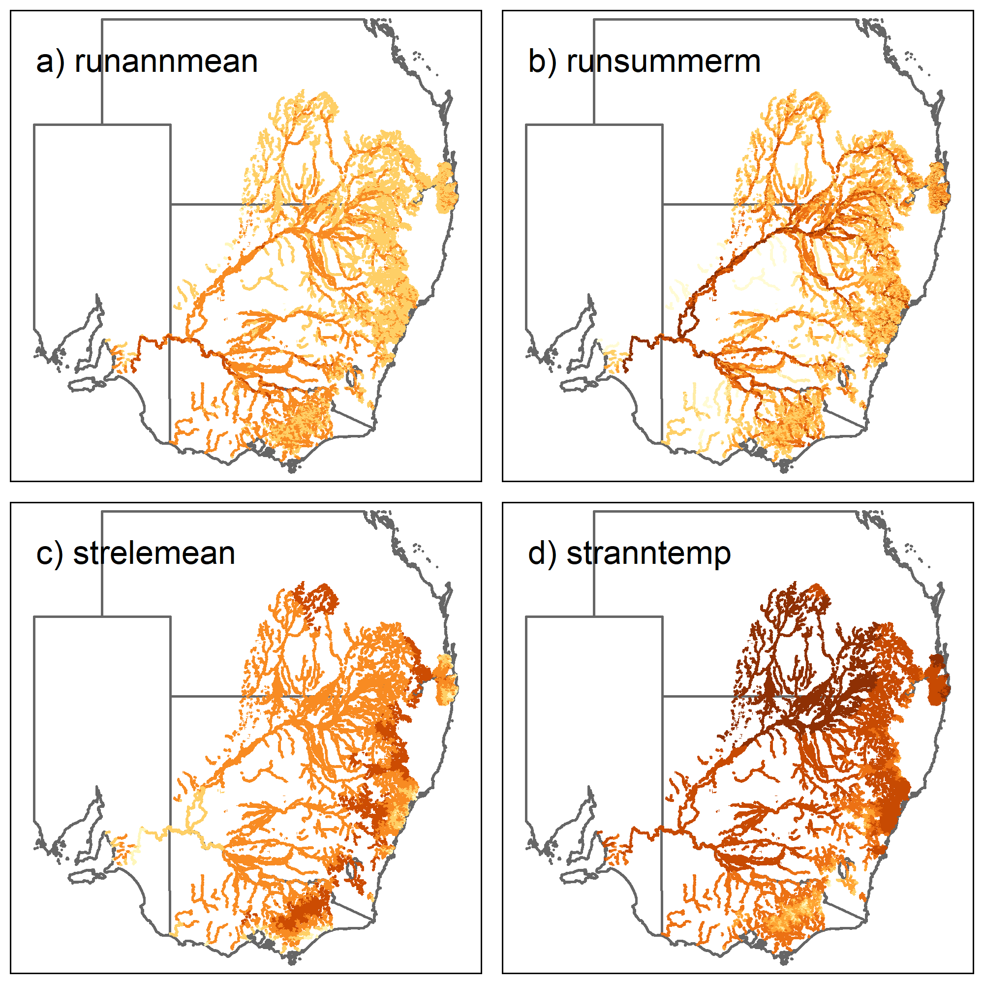
Figure 4: Mapping of four examples of river attributes. Each panel shows the spatial pattern for a river attribute, with redder colours indicating higher levels. Note - attributes are on the log-scale. A definition of each attribute is given in Table 2.

Wetlands and lakes
Wetlands and lakes were assigned to permanent and temporary categories using the relevant hydrological regime attributes from state classifications and ANAE data sets. For example, all waterbodies in the Murray–Darling Basin ANAE classification are attributed as ‘commonly wet’ (containing water at least 80% of the time) or ‘periodically inundated’. All permanent lakes and wetlands were included. Habitat area was calculated using GIS from the mapped extent.
Mapping of temporary lake and wetland ecosystems also includes ephemeral clay pans and rain-filled depressions that rarely hold water and cannot support Carp populations. Therefore, based on expert opinion, temporary lakes and wetlands were included only if they were within 250 m of an included waterway or river floodplain (Figure 5) that could be a source for colonisation by Carp during floods. Temporary wetlands that were classified as salt lakes, clay pans, freshwater meadows, or temporary sedge/grass/forb marshes were removed as these habitat types regularly dry out. Permanent peat bog or fen marsh wetlands and springs were also removed as these systems are not characterised by open water likely to support fish. Finally, large temporary lakes >10 ha were removed if the Water Observations from Space (WOfS; Geoscience Australia) data set showed water was not detected at any location within the lake in at least 40% of Landsat views since 1987. This removed large commonly dry basins that are otherwise included because they meet criteria of being on the floodplain or adjacent to a waterway (e.g. Lake Albacutya in Victoria which has been dry for the last 30 years).
For all lakes and storages (see next section), the waterbody area was divided into offshore and littoral zones. In general, most lakes are shallow and only gradually increase in depth; consequently, the littoral zone was defined as < 200 m from the shore. In these habitats the depth can increase quickly in some locations but slowly at others. As depth data were not available, we used WOfS and defined deep offshore habitat as the area that recorded water at least 80% of the time.
For waterbodies we used the ANAE classification, spatial location and size of the waterbody as the main characteristics. In comparison to river systems, little data existed, limiting the potential for correlating attributes of these waterbodies with CPUE.
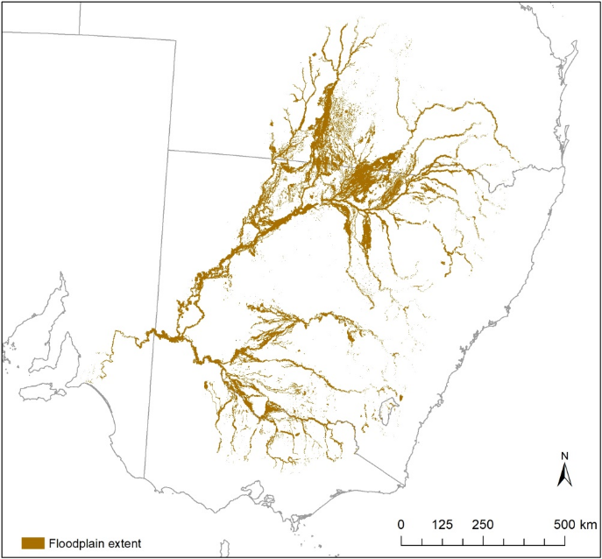
Figure 5: Maximum extent of floodplain (1-in-100-years flood) in the Murray–Darling Basin (MDBA 2018).
Storages and Impoundments
Water storages were included as permanent waterbodies, unless monitoring data or jurisdiction experts nominated them as not supporting Carp. Past monitoring of Carp has shown that Carp densities in shallow littoral zones are higher than for the deep open water zone in the middle of the impoundment (Conallin et al. 2012; Wisniewski et al. 2015). To improve the Carp biomass estimate, we therefore classified the littoral and deep zones and portioned the area accordingly (Figure 6). The deep-water zone was classified as that area that contained water in >80% of satellite views since 1987 in the WoFS data set. This includes areas that retained water through the millennium drought and is a measure that was available for all impoundments. Determining the deep water zone by using available water level hydrographs and bathymetry was impractical and would be possible only for a small number of storages in the study area. The area of the littoral zone was calculated by subtracting the area of the deep-water zone from the mapped storage area.

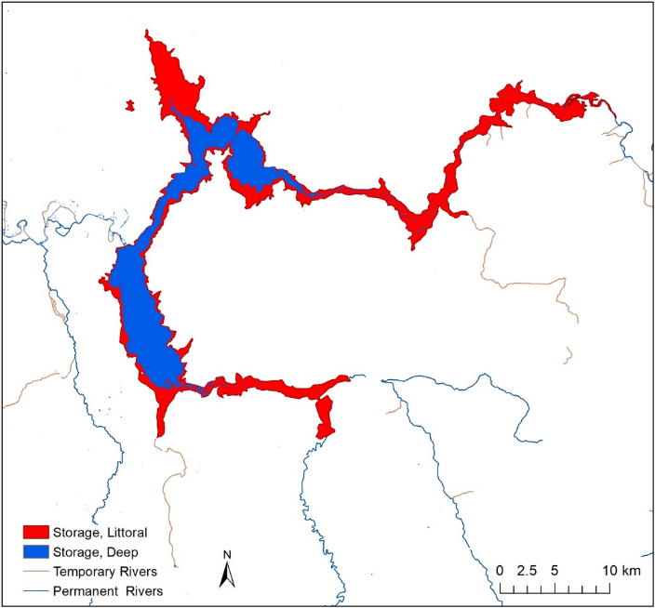
Figure 6: Hume Dam water storage, showing the total habitat area partitioned (using Water Observations from Space) into the deep zone (water detected in > 80% of Landsat images) and the littoral zone.

Expert consultation
Jurisdictional experts informed the initial mapping of Carp habitat by defining the range of Carp in their jurisdiction. Draft maps were then provided to each jurisdiction for review and specific feedback was provided to add in catchments that may have been missed, and to remove those known to be Carp-free. This feedback enabled the removal of individual storages and the sub-catchments that feed into them, and the addition of river segments or waterbodies that support localised Carp populations.
  - Predicting CPUE and average body mass of Carp for rivers and waterbodies (Steps 2 and 3)

Methods
A key component of the project was the collection and collation of existing CPUE data across the distribution of Carp (Figure 7, Appendix A4). To this end, collaborators from each state were asked to collate existing datasets from studies in which the whole fish community was surveyed and the methods were deemed acceptable for including in this study. Datasets that had data on CPUE or mass, date information, site type (e.g. river, wetland), geographical coordinates for each site sampled, and general information on how the data were collected, were included. Datasets without this information were disregarded. A description of standard sampling methods is given in Appendix A5.
Data analysis
Using the spatial layers, we assigned a river/waterbody segment to the existing sampling sites. For each site, we identified the closest river (if a river site) or waterbody (if a waterbody site) segment. If a site was > 500 m from the nearest river/waterbody segment, then the site was dropped as Carp occupation was deemed too uncertain to include. Overall there were 4968 sites in the database, and 73.8% were linked to an aquatic spatial object. Additionally, only sampling events that had fish size data recorded were included because the conversion factor developed in Step 4 is based on converting efCPUE for Carp > 150 mm in length.
For river sites we conducted two analyses to predict CPUEs and average body mass of Carp across the whole spatial map. For CPUE we first attempted to fit a Bayesian generalised additive mixed models (bGAMM) but we were not able to adequately capture the CPUE patterns across the basin. Consequently, we implemented a boosted regression tree (BRT) approach which uses machine learning to improve predictions (Elith et al. 2008). The response variable was efCPUE (i.e. catch per unit effort using electrofishing) for Carp > 150 mm in length. Predictor variables in the models were river attributes (relating to climate, flow, terrain), time (year and month) and major spatial region (Murray, Darling, Northern Basin (waterhole), Lachlan, and Coastal areas). Note: A filtering process was performed for river attributes by identifying strongly correlated variables and, where this occurred, including only one variable from a strongly correlated pair (see Appendix A8).
For body mass, we fitted a Bayesian general additive mixed model (bGAMM) assuming a Gaussian distribution. The response variable was the average mass of individual fish per survey (log-transformed; for Carp > 150 mm, length was converted to mass as described in Appendix A7). The final model included select river attributes (relating to climate, flow, terrain — all continuous factors as splines), time (year and month — both as splines) and major spatial region (fixed effect). As yearly patterns may differ for different spatial regions, yearly trends were modelled for the major spatial regions. River basin was included as a random effect. Site was included as a random effect if there were repeated measures at multiple sites. The model for average fish mass also included efCPUE as a predictor, because we expected a high efCPUE to reflect high recruitment and hence low average mass. Further details of the modelling approach and steps taken to assess model fit are outlined in Appendix A8.
For waterbodies, a similar approach was used in which bGLMM were conducted for both CPUE and average fish mass, except that the predictor variables were ANAE waterbody type (lake, storage, wetland), spatial regions (fixed), river basin (random), and year (spline). Again, efCPUE was included for the mass model. We initially fitted separate temporals splines for each region but the model was not deemed a better model using WAIC. Further details of the modelling approach and steps taken to assess model fit are outlined in Appendix A8.
  - Conversion factors (Steps 4 and 5)

    - Converting CPUE to density of Carp
A key component in developing conversion factors for different aquatic habitats was to estimate the relationship between efCPUE of Carp and Carp density (No/ha). Full explanations of the methods used and the logic behind the conversion factor are given in Appendix A10, and briefly summarised below.
Methods
The existing efCPUE data are only a measure of relative abundance of Carp. To calculate biomass density, there was a need to derive conversion factors between efCPUE (n/hr) and Carp density (No/ha). As sampling efficiency likely varies by habitat and spatial regions, we carried out field studies across five states/territories (QLD, NSW, VIC, SA and ACT), covering various size rivers (width: 4 m to 170 m) and wetlands (up to 12 ha) and spanning various depths and turbidity conditions. Overall, we sampled 31 sites: 20 river sites and 11 wetland sites (see Appendix A4 for a listing of sites). For each of these sites, the Sustainable Rivers Audit (SRA) electrofishing protocol (MDBA 2011) was implemented to obtain efCPUE (fish > 150 mm FL) and then the density (of Carp > 150 mm length) was estimated by using one of four methods: mark-recapture, depletion sampling, chemical treatment (rotenone), or draining (pump-out) (Table 3; Figure 7).
Data Analysis
Using the efCPUE and density estimate at each site, we calculated the conversion factor as the ratio of density to efCPUE (i.e. conversion factor = density / efCPUE). We then modelled the relationship between the conversion factor and habitat groups using a Bayesian general linear model (bGLM). The response variable was the natural log of the conversion factor; and we assumed a Gaussian distribution for the error distribution. Four habitat groupings were used: (1) rivers with river width ≤ 50 m, (2) rivers with width > 50 m, (3) waterholes, and (4) wetlands. The habitat grouping was included as a predictor in the model. Additional explorations of model fit were undertaken but did not lead to a better model (see Appendix A8 for more analysis methods). Note: two wetland sites were excluded because no mark–recapture model was deemed appropriate for fitting the data.

Table 3: Number and location of sites used for calculating conversion factors and assessing habitat utilisation
Type | Method | ACT | NSW | QLD | SA | VIC | Total
Conversion | Depletion | 0 | 0 | 0 | 0 | 2 | 2
 | Mark–recapture | 1 | 7 | 6 | 4 | 7 | 25
 | Pump out | 2 | 0 | 0 | 0 | 0 | 3
 | Rotenone | 1 | 0 | 0 | 0 | 1 | 1
Utilisation |  | 0 | 3 | 0 | 2 | 2 | 7
Total |  | 4 | 10 | 6 | 6 | 12 | 38

    - Assessing habitat utilisation in lakes and storages

Methods
Most existing CPUE data for lakes and storages are from the littoral zone. As Carp density may be lower in the offshore zone especially in deep storages, it was necessary to estimate the proportional change in density from littoral to offshore zones. To achieve this, we compared netCPUE (catch per unit effort using nets) between littoral and offshore zones for four lakes and three storages. As electrofishing is ineffective at depths over 5 m, we used gill nets instead. For lakes, gill nets were set at three locations: edge (about 5 m from the lake edge); midway (about 50 m from the edge); and offshore (about 200 m from the edge). These three locations were chosen to assess how density changed with distance from shore. For storages, depth often changes more quickly than in lakes, therefore we used depth rather than distance. Gill nets were set at varying depth zones (2 m, 6 m, 12 m, 18 m, 24 m) in the storage. Within each depth zone, gill nets were set at different water depths (surface, midway, or bottom) depending on the depth zone. See Appendix A11 for more details on the methods used.
Data Analysis
Two separate analyses (lake and storage) were performed using Bayesian generalised linear mixed models (bGLMM), assuming a negative binomial distribution.
Lakes
For the lake data, netCPUE was compared across the three sampling locations (edge, midway, offshore). A bGLMM was used. The response variable was the number of fish caught and we assumed a negative binomial distribution. The fixed effect was lake location, and random effects were lake and lake site (nested within lake). Sampling effort (log-transformed) was included as an offset.
All analyses were performed using R v3.4.1 and the brms package (Bürkner 2017). All models were checked for fit by using posterior predictive checks and ensuring they converged through graphical examination and Gelman-Rubin statistics. Estimates are shown with 95% credible intervals (95%CrI). Significant changes were defined as estimates in which the 95%CrI did not overlap with zero.
Storages
The analysis of data from storages was similarly carried out for netCPUE. For netCPUE, the same GLMM model using a Bayesian framework was performed, except that the fixed effect was the combination of net depth (surface, midway, bottom) and depth zone (2 m, 6 m, 12 m, 18 m, 24 m) as the design was not fully crossed (e.g. only one depth at 2 m contour and only bottom nets for 18 and 24 m depth zones; see Appendix for full design). All comparisons were with the 2 m depth zone net as the reference category.

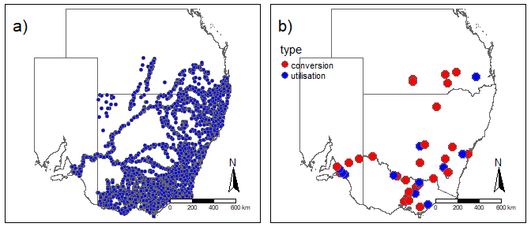
Figure 7: Maps of (a) existing CPUE data and (b) NCCP sites used for conversion and habitat utilisation experiments. For the NCCP map, different coloured dots indicate whether the site was for the conversion factor or habitat utilisation.

  - Juvenile (<150 mm fish) biomass (Step 6)
The previous steps were used to estimated biomass for fish ≥ 150 mm FL. We developed a simplified version of the above approach for the <150 mm FL (called juvenile here) fish. The approach was a two-step process: (1) map juvenile biomass rate (kg of < 150 mm FL fish / 3600 s of electrofishing), and (2) then take the conservative approach of applying the adult conversion factor to these estimates.
To map juvenile fish biomass rate, we used the same efCPUE data used for fish ≥ 150 mm FL. For every sampling event, we calculated the total mass of fish < 150 mm FL. For sampling events in which all fish were measured, we used the total juvenile biomass. For the sampling events that did not record all fish, we adjusted the juvenile biomass by the proportional catch that was measured (e.g. if only 25% of fish were measured, then we multiply the juvenile biomass for that 25% by 4). For simplicity we did not include any uncertainty in those conversions into the model. We used juvenile biomass rate as the response variable (log-transformed + 0.1 kg).
We performed a single bGAMM assuming a normal distribution. As the response variable was juvenile biomass rate, we only needed a biomass model (i.e. we did not need separate models for CPUE and average mass, as for adult Carp). Furthermore, to further reduce model complexity we combined river and waterbody data into a single model. After expert consultation about river attributes, we decided that river attributes should focus only on stream slope, because spawning areas are known to be in areas of low slope near wetlands, and the slope of the stream provides a useful proxy for such areas. We gave the waterbodies a slope of zero (and tested the effect by re-running the model, setting waterbodies slope to the mean river slope and no substantial differences were found). The predictors in the model were efCPUE for ≥ 150 mm fish (log-transformed + 1; thin-plate spline), aquatic habitat class (categorical: wetland, lake, river), stream slope (thin-plate spline), year (thin-plate spline, and month (cyclic cubic spline). The efCPUE for ≥ 150 mm FL fish was included as high efCPUE often reflected more juveniles in the catch.
  - Estimating biomass (Step 7)
The final step was to combine the previous steps into an estimate of biomass for each river segment and waterbody.
Rivers
To obtain biomass estimates for a river segment, we took the following steps.
1 We predicted the CPUE for every river segment using the river CPUE model.
2 We multiplied each CPUE by the appropriate conversion factor to obtain density (fish/ha).
3 We multiplied the density by the predicted average Carp mass to obtain biomass density (kg/ha).
4 We multiplied the biomass density by the river area to obtain an estimate of Carp biomass (tonnes) for that river.
5 To add in juvenile biomass, we used the predicted CPUE for ≥ 150 mm fish to predict juvenile biomass rate for each segment and then multiplied this rate by the conversion factor and segment area to determine juvenile biomass.
Wetland
To obtain biomass estimates for each wetland waterbody, we took the following steps.
1 We predicted the CPUE for every waterbody using the wetland CPUE model.
2 We multiplied each CPUE by the appropriate conversion factor to get density (fish/ha).
3 We multiplied the density by the predicted average Carp mass to get biomass density (kg/ha).
4 We multiplied the biomass density by the wetland area to obtain total biomass (tonnes).
5 To add in juvenile biomass (fish < 150 mm), we predicted juvenile mass rate from the CPUE for ≥ 150 mm and then multiplied by the wetland conversion factor and total area.
Storages and Lakes
Unlike rivers and wetlands, we used both the predicted and observed efCPUE for the waterbody estimation as larger waterbodies had distinct boundaries. We restricted the observed CPUE to lakes/storages with areas > 100 ha and for which there was a recent efCPUE observation (from 2017-on).
For lakes and storages, we took the following steps:
1 We predicted the littoral CPUE from the waterbody model or used observed data if available (as described above).
2 We then predicted the offshore CPUE using the habitat utilisation estimate.
3 Biomass density (kg/ha) was obtained by multiplying each CPUE by the conversion factor and predicted average Carp mass.
4 Littoral total biomass was estimated by multiplying biomass density by littoral area.
5 Offshore total biomass was estimated by multiplying biomass density by offshore area.
6 The total biomass was obtained by summing littoral total biomass and offshore total biomass.

Incorporating uncertainty
To obtain an estimate of the uncertainty in the estimate of total biomass, we assumed that segment area was constant (known for sure) and the other variables (predicted CPUE, average Carp mass, juvenile biomass rate, conversion factor, habitat utilisation variable) were treated as random variables. An estimate of the variation in biomass was then obtained by sampling from the distributions of each random variable 10 000 times. For each of these 10 000 replicates the data from each segment was then summed either at the state level or across the whole distribution of Carp, and then summarised to obtain state-level biomass or total biomass. From these replicates, we calculated the mean biomass as well as 95%CrI.
For all bGLMM/bGAMM models, we used the fitted() function in brms to obtain posterior samples. Unfortunately, we were not able to obtain a reasonable bGAMM model for CPUE, so we employed a boosted regression tree (BRT) approach that predicted the data well (see Appendix A8). Consequently, we used the bGAMM model to estimate the uncertainty in the mean efCPUE (log-scale). We then assumed the same uncertainty for the BRT efCPUE and assumed the efCPUE was a random variable with Gaussian distribution with the same variance.
  - Model validation
Finally, biomass predictions were compared with known estimates of absolute biomass for lakes and storages in which biomass has been measured (see Appendix A4). These data were obtained from dry-downs and pump out events in which total Carp biomass was quantified for the waterbody. These data have no measures of uncertainty and are treated as being ‘known’ for the validation. In addition to these sites, we had two other data points. The first was a biomass estimate for the Lower Lakes from Koehn et al. (2016), which was about 1700 tonnes. This estimate was based on a mark–recapture study and then extrapolated for the whole Lower Lake area. The second datum was a biomass estimate for Lake Burragorang using DIDSON surveys of 1.9 ha of lake edge which resulted in an estimate of 216-648 tonnes. Overall, we have eight sites for comparison.
For the validation, we obtained our predicted range of biomass for each waterbody with a known estimate of absolute biomass and asked whether the known biomass was within the 95%CrI of our estimate for the waterbody.

  - Additional biomass estimates for irrigation channels and Western Australia
As noted previously, irrigation channels and Western Australia were deemed as lacking sufficient data (GIS and CPUE) and hence were not included in the formal analysis described above. As it was deemed useful to provide some estimate based the limited information available, we undertook a less formal approach. We provide a short description of this approach here but see Appendix A11 for more details on approach. Briefly, we performed the following steps for the irrigation channels: 1) GIS layers were created using methods by piecing together disparate pieces of spatial information; 2) irrigation channel area was estimated using a mixture modelling approach of estimating probability of having water and if water is present, the estimated channel width; and 3) multiple total channel area by three density levels (e.g. low = 50 kg/ha, medium = 150 kg/ha, and high = 300 kg/ha). Western Australia followed similar approach except that rivers were predicted from eastern Australia river width model and total water area was the sum of river and waterbody area (no separation of habitats). As with irrigation, no CPUE were available to guide densities so three carp density scenarios were used. For both estimates, no attempt was made at quantifying uncertainty in estimates.

- Results
  - National Carp database
All existing datasets (Appendix A4) were imported into a central, purpose-built Carp database, complemented by the addition of data from contemporary sampling and conversion factor experiments. Data from a total of 153 research studies were collated (Table 4), giving a total of 574 145 Carp caught at 4831 sites. The MDBA (mainly through the Sustainable Rivers Audit- SRA; Davies et al. 2010) provided the largest amount of data and there was a wide spatial coverage across the Murray Darling Basin (Figure 8). Spatially, most studies were conducted in NSW and Victoria (Figure 8). Temporally, data were collected from 1994 to 2018, though mostly since 2010 (71.9% of studies), with 41.1% of studies being since 2015 (Figure 9).
Finally, the vast majority of CPUE data was electrofishing, especially boat (Figure 10). For the electrofishing data, the time for the majority of surveys ranged from 800 to 1600 s (Figure 11).

Table 4: Summary table of existing data by state. This summary table includes all sites in the database, independent of whether the site was linked to the GIS layers (i.e. the site was on or near a river segment or waterbody object in our spatial layers).
State | Number of projects | Year range | Number sites | Number carp caught | Number carp  mass
ACT | 8 | 2007–2018 | 36 | 72820 | 1654
NSW | 71 | 1995–2018 | 2673 | 180153 | 16271
QLD | 17 | 2001–2018 | 390 | 93158 | 8995
SA | 18 | 1994–2018 | 163 | 103424 | 493
TAS | 1 | 2016–2016 | 1 | 987 | 775
VIC | 38 | 1999–2018 | 1568 | 123603 | 8138
Total | 153 | 1994–2018 | 4831 | 574145 | 36326
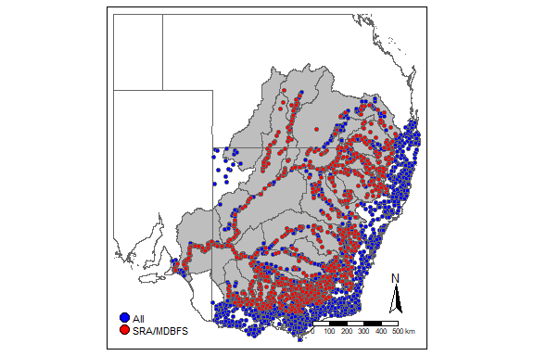
Figure 8: Spatial distribution of sampling sites across Australia. Different coloured dots indicate whether the site was for the Sustainable Rivers Audit (SRA) (red) or other projects. Note - not all sites contained Carp.

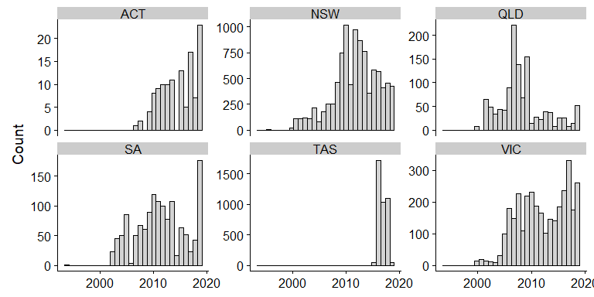
Figure 9: Temporal distribution of sampling events across eastern Australian jurisdictions. Each bar represents the number of sampling events.

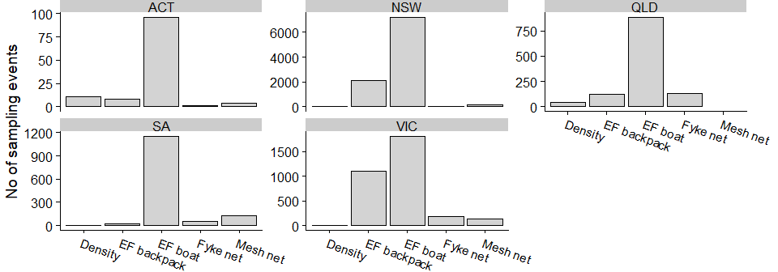
Figure 10: Distribution of sampling methods across states. Each bar represents the number of sampling events for that method. Density refers to methods obtaining density estimates (e.g. mark-recapture, pump outs, dry downs).

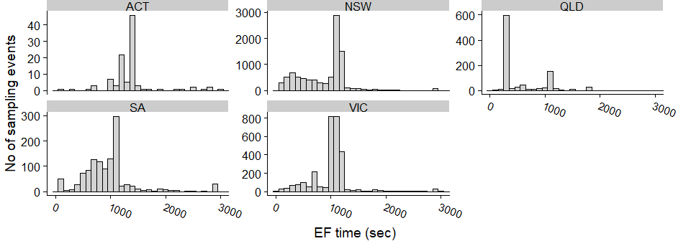
Figure 11: Distribution of electrofishing times by sampling events across states. Note - we truncated the x-axis to 3000 to better show distributions (129 events were > 3000 s).

  - GIS mapping of Carp habitat
Overall, we estimated that there is 2 477 ${km}^{2}$ of river habitat and 14 092 ${km}^{2}$ of standing waterbody habitat for Carp within eastern Australia (Table 5). This spatial area of aquatic habitat represents a constant (with known certainty) and represents a random, moderately wet year where wetlands are full. Standing waterbody habitats comprised 85% of the total Carp habitat area: of these, lakes and wetlands had similar area estimates and accounted for the majority of the waterbody areas (Table 5; Figure 12).

Table 5: Total area (${km}^{2}$) for each habitat type (with Carp presence) broken up by state.
Class | Habitat | ACT | NSW | QLD | SA | VIC | Total
River | Nonperennial | 0 | 1,000 | 33 | 19 | 132 | 1,184
 | Perennial | 4 | 692 | 37 | 96 | 232 | 1,061
 | Waterhole | 0 | 49 | 182 | 0 | 0 | 232
 | All | 4 | 1,742 | 253 | 115 | 363 | 2,477
Waterbody | Estuary | 0 | 219 | 0 | 241 | 133 | 593
 | Lake | 8 | 3,099 | 423 | 951 | 1,232 | 5,713
 | Storage | 3 | 763 | 328 | 18 | 781 | 1,894
 | Wetland | 0 | 3,998 | 772 | 155 | 968 | 5,893
 | All | 10 | 8,079 | 1,524 | 1,365 | 3,114 | 14,092

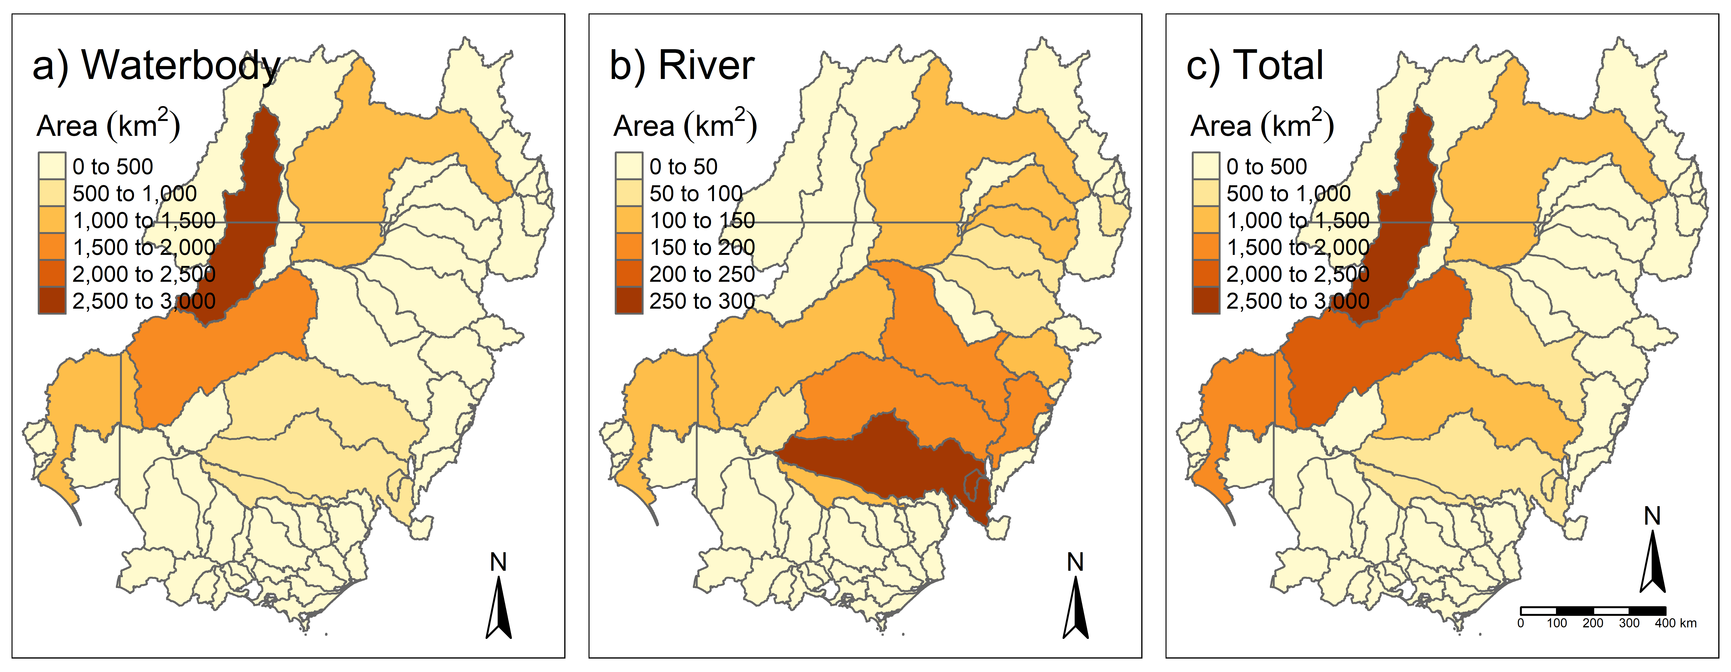
Figure 12: Area estimates of Carp habitat summarised by basin. Panels represent area of (a) waterbody habitat, (b) river habitat, and (c) waterbody and river combined.

  - Predicting CPUE and fish mass for rivers and waterbodies
Overall, the fits of the models predicting efCPUE and average fish mass for rivers and waterbodies were moderate (see Appendix 8). From the 10-fold cross-validation of the models, the average correlation between predicted and observed data ranged from 0.48 to 0.65. The standard error for the 10-fold cross validation was low, ranging from 0.02 to 0.07. Thus, the models indicate robustness to the data included in the model and similar predictive capacity for data not included in the model.
Spatial patterns in predicted efCPUE and predicted average fish mass are shown in Figure 13. The predicted efCPUE for rivers and waterbodies was highest along the Murray and into the Lachlan, with high efCPUE locations near the NSW and Qld border (see Figure 13a, c). Spatial patterns in average Carp mass were strongly affected by the presence of recruits. As Carp recruits were more common at lower elevations, generally the average fish mass increased with higher elevation (see Figure 13b, d). Additionally, average Carp mass increased toward the southern end of the geographic distribution.

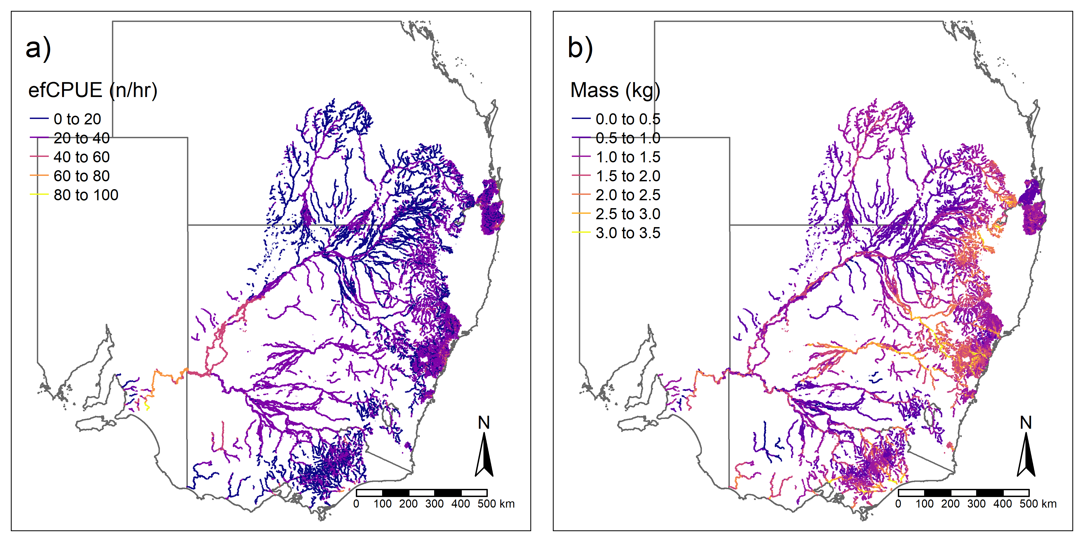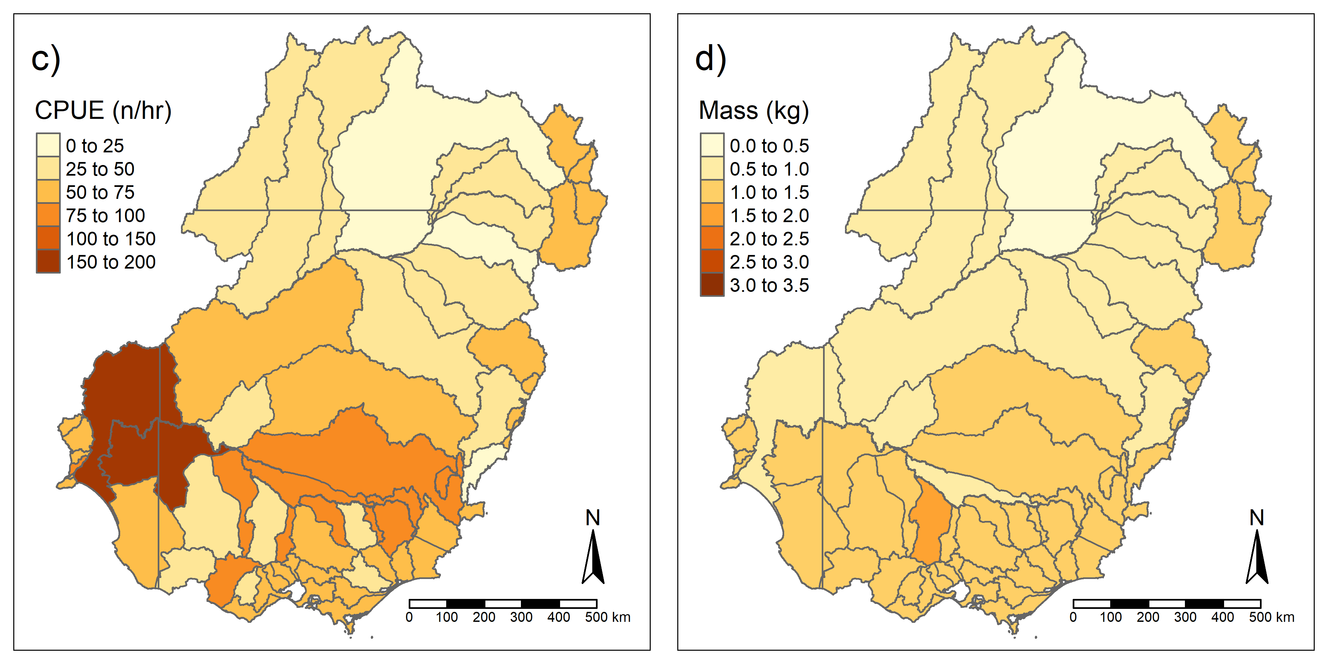
Figure 13: Maps of predicted efCPUE and predicted average fish mass for Carp across eastern Australia. Panels (a) and (b) show results for rivers. Panels (c) and (d) show results for standing waterbodies, by basin.

  - Predicting Carp densities from efCPUE
    - efCPUE conversion factors
For 29 sites at which the actual Carp density was calculated (see Appendices A4 and A10), a conversion factor representing the ratio of Carp density to efCPUE was determined. These values were then modelled in relation to the main habitat groupings to obtain a conversion factor estimate for each habitat type (Figure 14). The lowest conversion factor estimate was for rivers <50 m width, followed by wetlands, rivers >50 m width, and waterholes. The conversion factor estimates had largely overlapping distributions. Only those for the waterholes and smaller rivers were significantly different (log scale 95%CrI: 0.44, 2.09). There was large variation in the conversion factors.

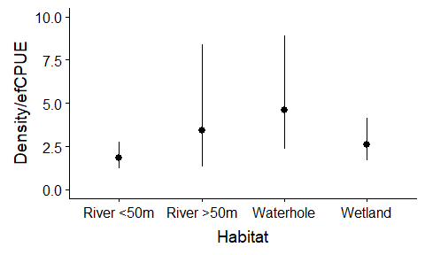
Figure 14: Estimated conversion factor for each habitat grouping. River habitats were grouped by width. Error bars are 95%CrI. Density is No/ha and efCPUE is No/hr.

Table 6: Estimated conversion factors for each habitat grouping from a bGLMM. Estimates are based on a log-scale and raw scale. We provide the log-scale estimates as they follow a normal distribution and can be used in future models.
Habitat | Log-scale |  |  | Raw scale
 | Estimate ± SE | 95%CrI |  | Estimate | 95%CrI
River <50 m | 0.6 ± 0.2 | ( 0.2, 1) |  | 1.8 | ( 1.2, 2.7 )
River >50 m | 1.2 ± 0.5 | ( 0.3, 2.1) |  | 3.3 | ( 1.3, 8.2 )
Waterhole | 1.5 ± 0.3 | ( 0.9, 2.2) |  | 4.5 | ( 2.5, 9.0 )
Wetland | 1 ± 0.2 | ( 0.5, 1.4) |  | 2.7 | ( 1.6, 4.1 )

We provide the following brief example to demonstrate the use of the conversion factor. If a CPUE of 10 Carp was sampled from a wetland using SRA electrofishing (1080 seconds of electrofishing effort), the efCPUE (fish/sec) = 10 fish/1 080 sec and to get efCPUE (fish/hr) = 10/1 080 sec 3 600 sec1 hr= 33.3 (No/hr) where 3 600 is total seconds in an hour. Then, using the conversion factor of 2.6 (Figure 14), the estimated density at that site = 33.3 x 2.6 = 86.6 No/ha.

  - Lakes – estimating change in offshore catch rate
Overall, offshore catch (~200 m from shore) was estimated to decrease by 36.9% (95% CI: 0.5%, 63%) compared to the edge (Figure 15a). No significant decline at the midway location (i.e. ~50 m from shore) was detected (the estimated decline was 20.8% but the credible interval varied from a decline of 55% to an increase of 27.9%) (Figure 15a).
However, it should be noted that the net catch rates were very low for both lakes and storages (Table 6) and this low rate contributed to greater uncertainty in the estimates. The average netCPUE (fish/24 hrs of net time) was only around 3 fish for lakes and 1 fish for storages. Values for efCPUE were low, except for Lake Albert for which the efCPUE was exceptionally high. Given this high rate, it is surprising how poorly the gill nets performed in this same lake.
In the GIS spatial layers, a lake’s area was divided into littoral and offshore, using a 200 m boundary. Our results from the habitat utilisation showed substantial variation but there was strong evidence that offshore areas had lower densities as indicated by 95% CrI not including positive changes. We are not able to delineate the exact relationship with distance from shore and the change in density at the ~50m location is more likely a decrease than an increase. However, for simplicity we use the 200m threshold and use the offshore (~200 m) habitat utilisation factor (~36.9% decrease) for the biomass model.

Table 7: Summary of results from surveys of lakes and storages. Site netCPUE was the average total catch/24 hr of net time at a site. Site effort is the average total net hours (all nets summed). Site efCPUE is the average efCPUE (n / 1080 sec) at a site.

Waterbody | Location | No sites | Site netCPUE | Site effort (hrs) | Site efCPUE
Lake | Lake Albert NCCP | 4 | 1.8 ± 2.0 | 161.3 ± 5.6 | 82 ± 43.2
 | Lake Alexandrina NCCP | 4 | 3.0 ± 1.4 | 158.5 ± 11.2 | 10 ± 6.4
 | Lake Cargelligo NCCP | 4 | 4.7 ± 0.6 | 220.0 ± 37.0 | 4.75 ± 4.5
 | Reedy Lake NCCP | 4 | 3.0 ± 0.7 | 65.1 ± 1.9 | 14.25 ± 2.5
Storage | Burrinjuck Dam NCCP | 4 | 1.2 ± 0.7 | 161.9 ± 25.2 | 10 ± 2.2
 | Eildon Dam NCCP | 4 | 0.7 ± 0.78 | 98.8 ± 14.4 | 15 ± 9.4
 | Warragamba Dam NCCP | 3 | 1.9 ± 0.3 | 138.4 ± 35.3 | 5 ± 3.5

    - Storages – variation with depth
For surface nets, both 6 m and 12 m depth zones differed significantly from the 2 m depth zone net (Figure 15b). The 6 m surface net declined by 61.9% (95Crl%: -22.5%, 94.2%) and at 12 m declined by 81.9% (95Crl%: 30.6%, 98.5%). The midway nets declined by 52% (95Crl%: -55.1%, 92.1%). Finally, only the bottom net at the 24 m depth zone differed significantly from the 2 m zone net. No fish were caught at this depth, resulting in an estimated decline of 99.86% (95Crl%: 99.82%, 100%).
For storages, we divided every storage into littoral and offshore habitat using WoFS criteria of 80%. Without actual bathymetry data, we used this method as a proxy for depth. For the biomass mass model, we assume that the offshore habitat is represented by the ≥24m results. We discussion this assumption more in the discussion section.

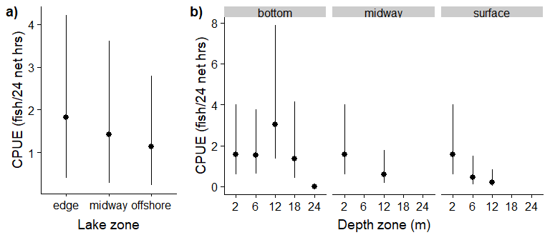
Figure 15: CPUE estimates for (a) lakes and (b) storages. The lake plot shows mean CPUE for each lake zone (distance from shore). The storage plot shows mean CPUE for each depth zone, separated by net depth (surface, midway, bottom). Points are model estimates with 95%CrI. Note - The near shore net (depth zone of 2) is shown in each panel for comparison.

  - Juvenile biomass rate
Overall, all four splines in the model had significant effects (defined as none of smooth term variance parameter overlapping with 0). Juvenile biomass rates were highest for rivers that had very little slopes, for higher fish catch rates, during 2011 and 2016-2017, and around April (Figure 16). For habitats, storage had the lowest juvenile biomass rate (log difference = -1.6 ± 0.5) and waterholes had the highest rates (log difference = 1.2 ± 0.2). For assessing model fit, the cross-validation correlation was 0.59 ± 0.05, indicating moderate to good fit for the model.

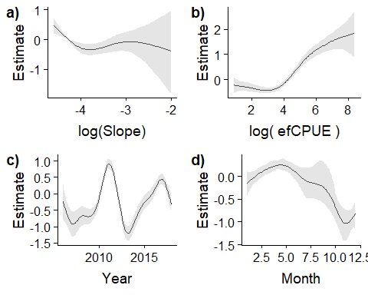
Figure 16: Effect of slope, survey efCPUE, year, and month on juvenile biomass rate. Each panel shows the fitted relationship with 95%CrI and standardised by the mean.

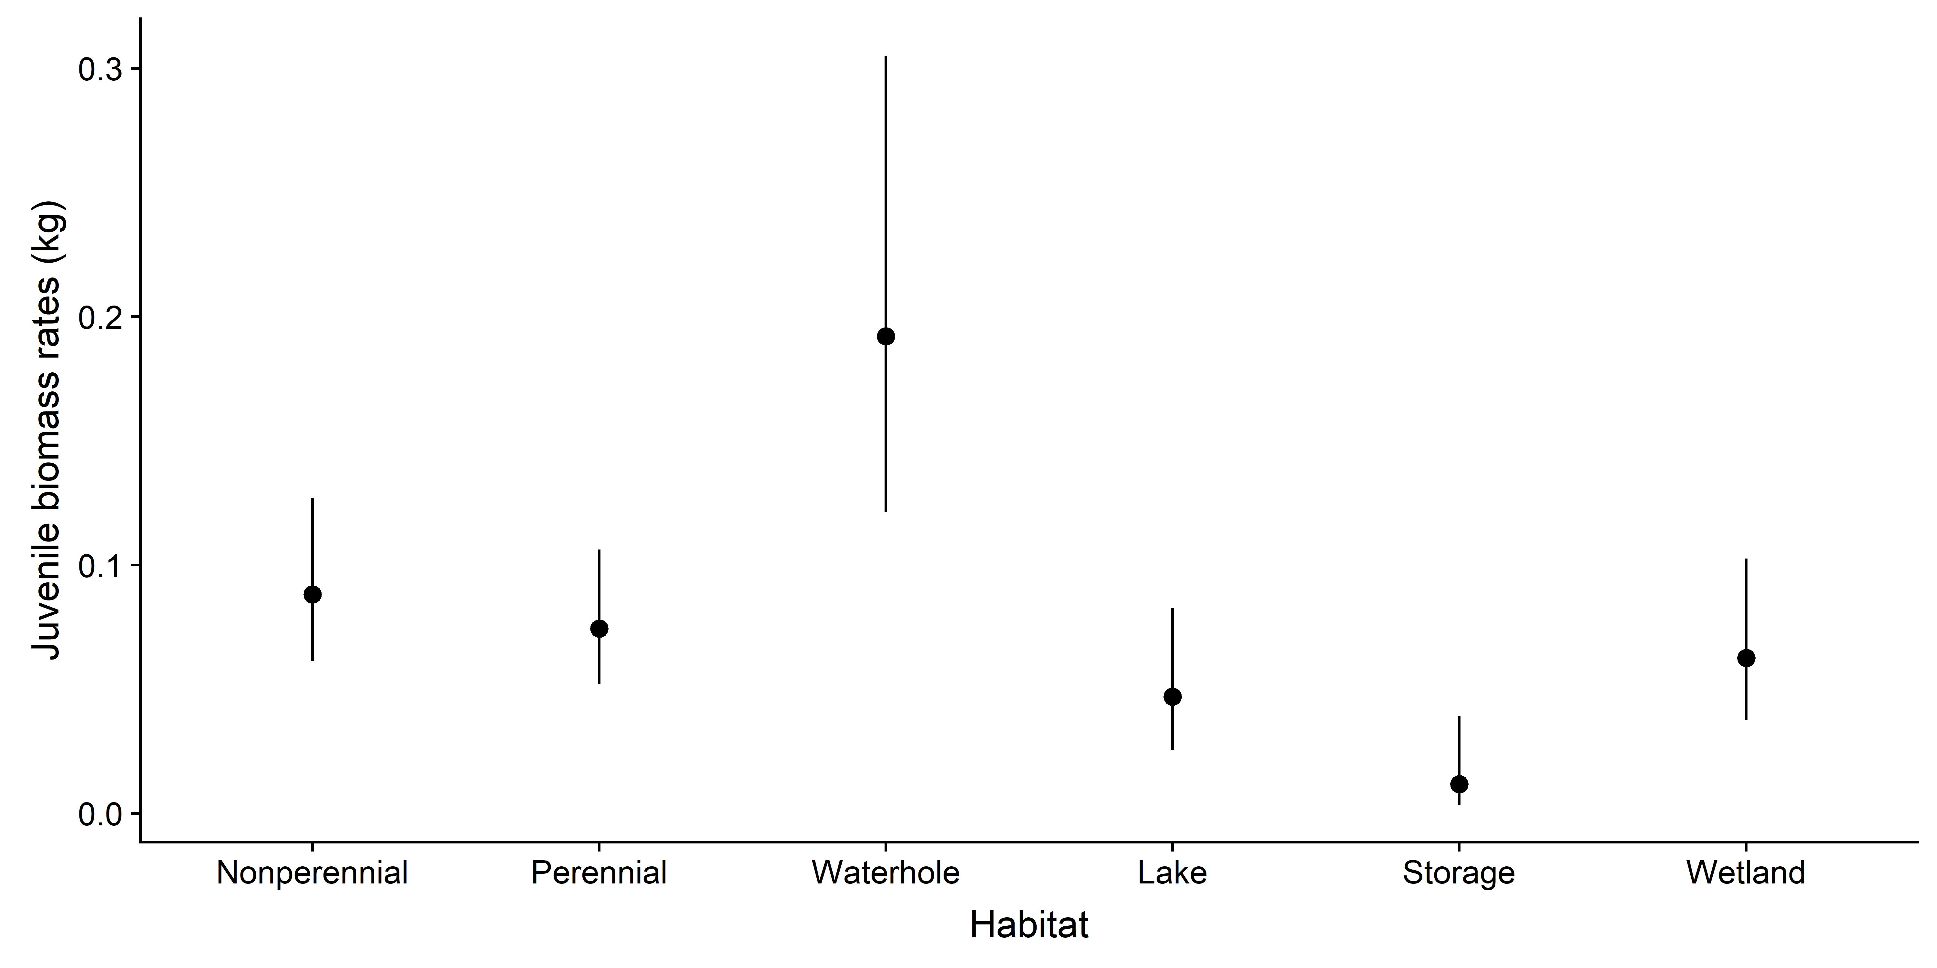
Figure 17: Juvenile biomass rates for each habitat. Nonperennial and perennial refer to the rivers. Estimates were obtained by setting the other variables at their means. Error bars are 95%CrI.

  - Estimates of Carp biomass
Overall, the total biomass of Carp (all habitats, all states) in May 2018 was estimated at 205 774 tonnes (95%CrI: 117 532, 356 482). Waterbodies had a total biomass of 162 838 tonnes (95%CrI: 79 621, 307 561) and rivers had 42 936 tonnes (95%CrI: 23 055, 77 769). The spatial distribution of the Carp biomass varied, with the highest biomass density estimates (kg/ha) along the Murray and Darling areas (Figure 18). For Western Australia and irrigation channels, the area estimate was multiplied by a high, medium and low biomass to produce a coarse additional biomass estimate (Table 8).
Figure 18: Carp biomass density estimates (kg/ha) across eastern Australia for a) river systems, and b) waterbodies. Different colours reflect variation in the density of Carp.

Table 8: Carp biomass estimates (kg/ha) by aquatic habitat types for eastern Australia, Tasmania and Western Australia. For Irrigation and Western Australia, the estimates reflect low, medium, and high density scenarios. There are no confidence intervals for Irrigation, Tasmania, and Western Australia. Note - Total estimates will not be the simple addition of each component as the biomass estimates are means and the distributions are asymmetric (95%CrI in parentheses).

Spatial Region | Habitat | Habitat class | Biomass (tonnes)
Eastern Australia (SA, NSW, VIC, QLD) | River | nonperennial | 13 975  (7 383, 25 009)
 |  | perennial | 23 251  (10 836, 48 403)
 |  | waterhole | 5 709  (2 382, 12 241)
 |  | Total | 42 936  (23 055, 77 769)
 | Waterbody | estuary | 10 267  (3 849, 24 049)
 |  | lake | 72 232  (36,860, 134,134)
 |  | storage | 18 825  (8 795, 39 155)
 |  | wetland | 61 512  (25 474, 125 550)
 |  | Total | 162 838  (79 621, 307 561)
 | Total (River + Waterbody) |  | 205 774  (117 532, 356 482)
 | Irrigation | Total | Low = 585  Medium = 1 755  High = 3 570
Tasmania | Total | Total (~20 fish) | 0.04
Western Australia | Total | Total | Low = 2 643  Medium = 7 927  High = 15 855

  - Comparison of estimated carp biomass with recorded biomass from standing waterbodies
Finally, we compared our model estimates to recorded biomass measures for specific wetlands where biomass estimates have been obtained from wetland drying events and other mark-recapture biomass estimates (Figure 19). Overall, 62.5% of the 95%CrI intervals from modelled estimates contained the measured biomass (note – we averaged the multiple estimates from Moira Lake). The largest misfit was with the Lower Lakes and Lake Brewster. The Lower Lake estimate was based on extrapolation from a mark-recapture study in Lake Albert to the entire Lower Lakes and reflected a very low density of 20 kg/ha (Koehn et al. 2018). Our model’s estimate was much higher at 350 kg/ha which we consider more realistic. The second case is for Lake Brewster where the biomass estimate after wetland drying was remarkably low at only 4 kg/ha, which appears unreliable. Finally, the model’s mean estimates were higher for five of the wetlands and two were lower, and one was similar; it was difficult to comment on any systematic bias, except that no extreme bias appeared present.

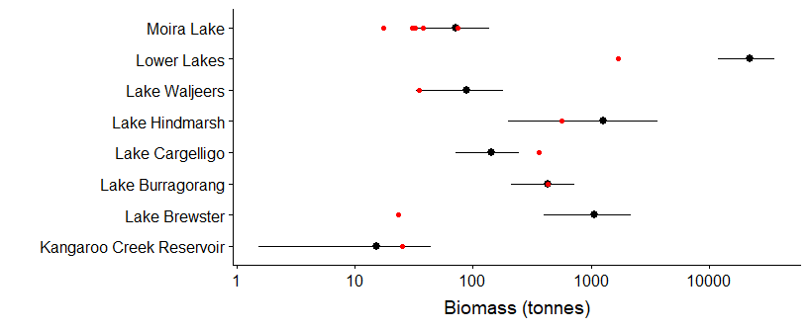
Figure 19: Comparison between model estimates and observed biomass records for selected locations. Black points and lines show the mean and 95%CrI for modeled biomass. Red dots are recorded estimates from other studies. For Moira Lake, there were multiple years of records. Note that the x-axis is log-scaled so all examples could be shown.

  - Case studies
We utilized five case studies to demonstrate more detailed examples of Carp density estimates at a catchment scale (Figure 20): the Lachlan, Moonie, Lower Murray, Middle Murray, and Glenelg river systems. Data sources were from the relevant jurisdiction and included historic CPUE. The Glenelg River had the lowest density of Carp with an average river biomass density of approximately 42 kg/ha. By contrast, the Carp density of the Moonie, Middle Murray and Lower Murray was higher, with average river biomass density of 132 kg/ha, 115 kg/ha, and 330 kg/ha, respectively. For the Lachlan, average biomass density was 71 kg/ha, though it varied across the region with densities up to 249 kg/ha. Total biomass estimates for these case study areas are shown in Table 9.
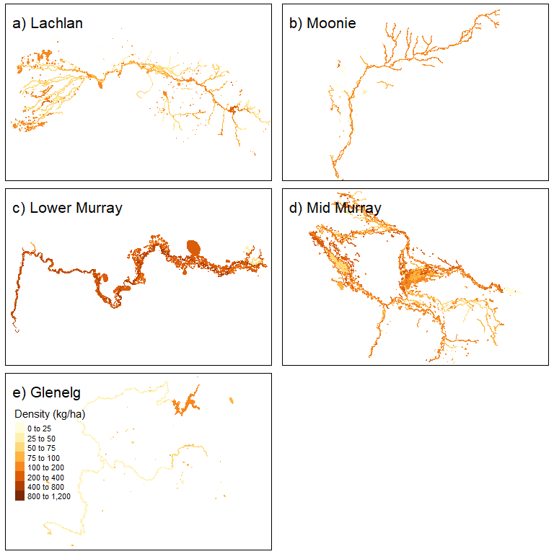
Figure 20: Maps of Carp biomass density (kg/ha) for each case study. The map shows estimates for both rivers and waterbodies.

Table 9: Biomass estimates (tonnes) for each case study area (95%CrI are shown in parentheses).
Case study | Zone | Biomass (tonnes)
Glenelg | All | 1 287  (572, 2 613)
Lachlan | upstream of Wyangala Dam | 145  (35, 351)
 | Wyangala Dam to Jemalong Weir | 1 901  (894, 3 569)
 | Lake Cowal and upper drainage region | 917  (328, 2 071)
 | Jemalong Weir to Brewster Weir | 886  (280, 1 920)
 | Lake Cargelligo | 208  (97, 396)
 | Lake Brewster | 1 077  (373, 2 453)
 | Willandra Creek | 7 491  (2 586, 17 086)
 | Brewster Weir to Great Cumbung Swamp | 4 977  (1 729, 11 427)
Lower Murray | All | 13 561  (5 523, 27 396)
Mid Murray | All | 9 987  (4 018, 21 928)
Moonie | All | 258  (29, 791)

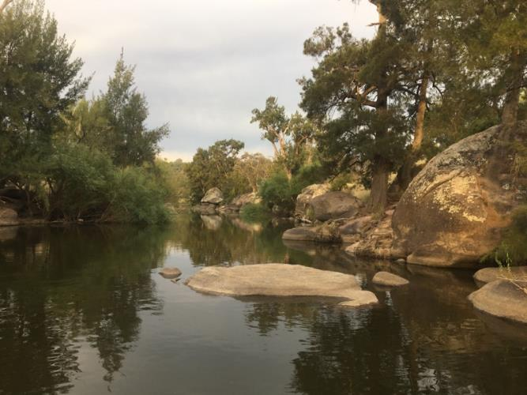
Macquarie River (NSW)

- Discussion
  - Estimates of Carp biomass
In the 45 years since the ‘Boolarra’ strain of Carp first escaped into the MDB (Shearer and Mulley 1978), Carp have invaded almost all major aquatic habitats in south-eastern Australia (Koehn et al. 2000; Koehn 2004). In south-eastern Australia, Carp are absent, or at very low densities, above barriers that prevent colonisation and in unsuitable habitats, such as high-altitude creeks (>700 m ASL; Driver et al. 1997) and highly saline lakes, but these make up a relatively limited component of the total area of aquatic habitats. Carp remain absent from: (i) the Northern Territory, (ii) sub-tropical/tropical Queensland (i.e. north of the Brisbane River) and Lake Eyre Basin, and (iii) Western Australia where they are largely restricted to urban catchments of Perth (WA). In eastern NSW and Victoria, there are still several major carp-free catchments. In Tasmania, Carp were eradicated from Lake Crescent and a very small population remains in Lake Sorrell (Wisniewski et al. 2015; John Diggle, Inland Fisheries Service, pers. com. 2018).
Our modelling was based on: (i) calculating biomass from CPUE using site-specific conversion factors for a range of aquatic habitat types, (ii) estimating the total area of specific habitat types, and (iii) up-scaling the biomass for specific habitat types to the continental biomass estimate. The modelled national biomass of Carp in this study utilised data from a large number of sites (4 744 sites; 574 145 individual Carp) across a wide spatial coverage in south-eastern mainland Australia, Tasmania and Western Australia. The Tasmanian and Western Australian data were not included in the model as these represent small local populations and hence were only included as an absolute biomass, based on prior estimates. From these data, we estimated the total biomass of Carp in south-eastern Australia to be 205 774 tonnes (95%CrI: 117 532-356 482 tonnes). There was an additional biomass estimate of 15 855 and 3 570 tonnes from Western Australia and irrigation channels, respectively. We note that, the precision of the continental estimates (i.e. 95%Crl) are broad and the upper and lower bounds of biomass should be included as a critical part of planning management actions (Hone and Buckmaster 2014).
Carp often follow a ‘boom-bust’ style population dynamic whereby the biomass may substantially increase during and immediately post-flooding in periods of above-average rainfall, but then substantially contract during drought (Gibson-Reinemer et al. 2017; Koehn et al. 2018). This dynamic was also evident from the national estimate of biomass where biomass could increase to 368,357 tonnes (95%CrI: 184,234, 705,630) in a ‘wet’ year scenario, such as May 2011. Historically, during a series of consecutive floods, such as in the 1990s, then Carp biomass could be expected to be even higher than in a single wet year scenario. Predicting biomass for the year 2023, under different hydrological scenarios, including dry, wet and average years, has recently been completed utilising a dynamic model of Carp population size (Koehn et al. 2018; Todd et al. 2019).
At a continental scale, there are few estimates of total population size for invasive animals in Australia, with the notable recent exception of the feral Cat (Legge et al. 2017). For Carp, previous population estimates have been limited to specific case-study lakes or river reaches and these have not been ‘scaled-up’ to examine the national situation (Brown and Walker 2004; Forsyth et al. 2013; Koehn et al. 2018). Despite Carp being a globally invasive species, there are no other international biomass/population estimates at a national scale for comparison, but the site-specific densities that we modelled in Australia are broadly within the ranges of those reported internationally, including those from Canada (490-1 830 kg/ha; Barton et al. 2000), USA (105-2 409 kg/ha; Farrier et al. 2018), New Zealand (40-325 kg/ha for Koi Carp; Hicks et al. 2015) and for previous Australian studies (150-690 kg/ha; Hume et al. 1983; Fletcher et al. 1985).
Since the biomass of Carp in shallow river and wetland ecosystems across eastern Australia appears to commonly approach 200–400 kg/ha, well above the accepted density impact threshold for ecological harm (i.e. 80-100 kg/ha; Brown and Gilligan 2014) it is reasonable to suggest that Carp pose an ongoing and severe threat to aquatic habitats and ecosystem function across vast areas of the Australian aquatic landscape (Koehn 2004). While there was considerable variation in modelled Carp biomass density within the representative aquatic habitats, in general densities tended to be higher for lowland rivers and adjacent wetlands than for upland rivers and impoundments; this variation likely reflects the preferred feeding and spawning habitats of Carp (Driver et al. 2005). For example, the lower Murray River (in SA) had some of the highest modelled biomasses (e.g. ~550 kg/ha), reflective of the regulated series of slow-flowing weir pools and permanent adjacent wetlands, which provide optimal habitats for Carp (Smith et al. 2009; Conallin et al. 2012; 2016; Koehn et al. 2016, 2018).
Many aquatic habitats of the Australian continent remain Carp-free, including the Northern Territory, sub-tropical/tropical Queensland, the Lake Eyre Basin, and much of Western Australia where they are largely restricted to urban catchments of Perth. In eastern NSW and Victoria, there are also several major Carp-free catchments. In Tasmania, Carp were eradicated from Lake Crescent and only a very small population remains in Lake Sorrell (Wisniewski et al., 2015). Carp are also largely absent from high-altitude creeks (>700 m ASL; Driver et al., 2005) and hypersaline lakes. The northern tropics also remain Carp-free with the Paroo River being the northern most limit of their distribution and a closer examination of the factors that cause carp to become invasive in some habitats but not others may be instructive for optimising control strategies (Bajer et al., 2019; Poole et al., 2019).
Young-of-the-year Carp (<150 mm long and <1-year-old) were not represented well in the biomass estimates because electro-fisher catch efficiency for young-of-the-year fish is low relative to larger fish (Dolan and Miranda 2003). A low detection rate then resulted in an underestimate of modelled juvenile biomass, especially in wet years immediately following floodplain recruitment events (Stuart and Jones 2006). Nevertheless, biomass of young-of-the-year Carp is very dynamic due to very low survival rates (Brown and Walker 2004) especially in the first few months when small fish leave the floodplain and over-winter in rivers (McCrimmon 1968; Driver et al. 2005). For managers in involved in planning Carp clean-up, we recommend planning for uncertainty by preparing for biomass at the upper confidence intervals of our estimates.
There were several inherent uncertainties in the modelled estimate of biomass where further refinement could increase accuracy. These refinements include: (i) increasing the quality of the spatial data for carp occurrence and CPUE, especially for coastal systems, irrigation channels and nonperennial rivers; (ii) completing additional site-based estimates of detectability and total abundance (and thus generate more precise conversion factor; Lyon et al., 2014), particularly for habitats with limited data such as storages, large fast-flowing rivers, irrigation channels, farm dams and estuaries; and (iii) further validation of modelled estimates of carp biomass with total abundance data from wetland/lake draining events. We expect that carp biomass was underestimated in deep rivers and waterbodies where electrofishing is less effective (Bayley and Austen 2002).

  - Validation of model estimates for lakes and storages
For lakes and storages, 62.5% of our predicted biomass estimates included observed biomass data. Such a result appears discouraging but further exploration of the misfits suggests that at least for two of the cases that the observed data are more unreliable than our biomass estimates. In particular, Lake Brewster and the Lower Lakes had substantial misfits, with our model predicting much higher densities. We discuss each case below.
For the Lower Lakes, we estimated ~28,000 tonnes (density = ~330 kg/ha) from our model compared to Koehn et al. (2016) estimate of 1,700 tonnes (20 kg/ha). These results are an order of magnitude different and hence require further discussion. The estimates for Koehn et al. (2016) were based on a mark-recapture undertaken by Thwaites et al. (2010). Koehn et al. (2016) extrapolated the population estimate from Lake Albert to both lakes. The Lake Albert estimate was based on 99 tagged fish in which 5 were recaptured. One potential weakness of this estimate was that all 5 recaptured fish were caught in a restricted area called the Narrows in which 69 fish were released. None were caught in the main lake in which 30 were released. Thus, the population estimates in Thwaites et al. (2010) (and hence Koehn et al. (2016)) may be better viewed as being just for the Narrows, which only represents <15% of the area of Lake Albert. Therefore, the biomass estimate may be substantially higher if the above is correct and hence would be closer to our model’s estimate.

The second case is for Lake Brewster where the biomass estimate, after wetland drying, was remarkably low at only 4 kg/ha. Given observed densities in the nearby Lake Cargelligo being ~250 kg/ha, we suspect that the Lake Brewster recorded estimate is likely incorrect. The inaccuracy of this record may due to the actual area that was harvested as Lake Brewster is physically divided into sections and it was assumed that the Carp biomass reflected the whole lake. Our model predicts an average density of 160 kg/ha for Lake Brewster.

  - Case studies

The five case studies (Lachlan, Moonie, Lower Murray, mid-Murray and Glenelg river systems) reflect the wide range of estimated Carp densities, both within and among each catchment. The low density of Carp in the Glenelg system (i.e. 42 kg/ha) is below the density-impact threshold for ecological harm, though Carp can form dense aggregations in specific marsh-like habitats (Thwaites 2016). The lower Murray River had the highest estimated Carp density (i.e. 550 kg/ha), with this river reach characterised by a series of slow-flowing weir pools with adjacent wetlands which are the preferred habitats of Carp (Smith and Walker 2004). The middle Murray is also a known ‘hotspot’ for Carp, with large expanses of low-lying River Red Gum floodplains where Carp aggregate to spawn after flood events (Brown et al. 2005; Stuart and Jones 2006). In an average flow-year scenario (i.e. May 2018, this study), there was a moderate estimated density (i.e. 105-227 kg/ha near Koondrook) of Carp in the middle Murray but this density is likely to be highly sensitive to recruitment events during flooding and it could be expected that this reach periodically carries far greater Carp densities. Similarly, the Moonie and Lachlan rivers, characterised by intermittent flows and a more boom-bust ecology are also characterised by high temporal variability in Carp biomass and CPUE. In ephemeral rivers such as these, as the rivers dry out carp become more concentrated in the contracting permanent waterholes, so can reach very high densities at a localised scale. Where there are long ephemeral river dry spells, Carp density may substantially decrease due to food limitation and local mortality.

  - Carp biomass, national and local impacts

The national estimate for Carp biomass provides strong support for the perception they may have profound impacts on Australian ecosystems and native biodiversity (Koehn et al. 2000). Evidence from numerous field studies demonstrates that there is a sudden, non-linear shift from clear to turbid water in shallow water bodies where Carp biomass exceeds 80-100 kg/ha (Brown and Gilligan 2014). As this density-impact threshold is further exceeded, there are increasing impacts on vegetation, invertebrates, native fish and ecosystems (Vilizzi et al. 2015). In some naturally turbid rivers, these impacts are more nuanced with Carp causing fewer issues in terms of water quality and macrophytes (Jon Marshall, DES, pers. com.). From the present study, modelled Carp biomass exceeds this threshold across large areas of south-east Australia and therefore is consistent with the view that Carp have played a major role in the decline of water quality, native flora and fauna biodiversity, and social amenity values. Similar impacts have been documented globally (Badiou and Goldsborough 2014; Vilizzi et al. 2015; Bajer et al. 2016; Maceda-Veiga et al. 2017). In Australia, the Carp biomass estimate and the simultaneous decline of river health and native fish communities provides strong evidence of the impacts of Carp along with other major factors such as river regulation and habitat degradation (Koehn 2004).

For the NCCP, this national estimate of Carp biomass and its spatial distribution throughout eastern Australia provides a context for evaluating the potential release of the CyHV-3 virus, especially in relation to identifying likely efficacy and for estimating environmental, social and economic risks, and the necessary resource allocations to mitigate these risks. The biomass estimate also provides value if the Carp virus were not released as it highlights areas where localised conventional control is a priority.

  - Model scope and limitations
Models are simplistic representations of the real world and by necessity use simplifying assumptions to reduce the complexity of the system to be modelled. This Carp biomass model required a range of assumptions. As with any model, it is important to understand the major assumptions that underpin the model so that the model’s scope and its limitations are readily apparent. We have attempted to identity several of these assumptions in the methods section, but some assumptions were implicit. Consequently, delineation of the major assumptions and links to the model’s scope are briefly explored below.

    - Spatial area
In this model, we treated spatial area as a constant (known with certainty). However, in reality there was uncertainty in area. River and waterbody surface areas are temporally dynamic and quantifying area requires specialised hydrological models. Though we modelled a moderately wet year, there would be substantial variation in what constitutes a moderately wet year and hence the spatial area of aquatic habitats. Furthermore, we had to predict river widths for most of the rivers from predicted flow volume (runannmean) and the waterhole areas in Paroo River were poorly predicted. Ignoring this uncertainty means that our Carp biomass estimate is an underestimate of the uncertainty.

    - Area vs. volume
Though we used spatial area, Carp actually inhabit three-dimensional habitats. Consequently, volume (m³) would have been the preferred unit of measure. Thus, a wetland with a depth of 2 m would have much greater space for Carp than a wetland of the same area but with a depth of only 1 m. In this study, we chose to use area rather than volume, because quantifying volume would have been an immense task, well beyond the project resources. For example, there are no GIS bathymetry layers for waterbodies or rivers and depth is even more temporally dynamic than spatial area, so defining a single depth to a river or waterbody would be difficult.
Carp density by area is the most common method used for reporting densities (e.g. Driver et al. 2005, Gilligan et al. 2010, Bajer and Sorensen 2012, Farrier et al .2018). This reality is due more to convenience (i.e. it is much simpler to measure surface area than waterbody volume), rather than area providing any inherently superior reflection of Carp population processes.
The question remains: what would be the consequences for our Carp biomass estimates if volume represents a superior spatial unit? Overall, we expect that our model underestimated the total Carp biomass. In particular, the Carp biomass in large deep waterbodies may be substantially underestimated. Electrofishing results were for the littoral zone and hence in shallow water (1-3 m). Thus, our area estimate is based on spatial area to a 2 m depth and hence likely to miss the volume at deeper depths. Nevertheless, our results from the habitat utilisation experiments suggest that Carp density in deep water zones is substantially lower (mitigating these effects). A similar scenario exists for rivers; electrofishing is effective up to 2-3 m depth and thus the efCPUE will reflect the volume. So, again the Carp biomass will likely be underestimated for deeper rivers in which efCPUE does not include these habitats. However, as for impoundments, if Carp mainly reside in the shallower zones where much of the electrofishing is performed, then the underestimation of biomass may be minimal.

    - Missing zeros in existing data
Though they were requested, we suspect that some field surveys in which no Carp were caught were not included in the data sets submitted for the database. This would lead to an overestimation of CPUE, though most likely in lower density areas, mitigating some of the bias.

    - Habitat utilisation
It is well-known that electrofishing efficiency decreases with depth and hence it was not possible to use electrofishing to sample Carp between littoral habitat and deeper lake/reservoir habitats to obtain the proportional change in relative density. Consequently, we used panel nets at varying depths for comparison assuming that the efficiency was similar. However, we cannot eliminate the possibility that nets in the littoral habitat have similar efficiency as nets placed at the bottom in deeper depths. It may be that, for carp, nets in deeper water were easier to detect and avoid than in the littoral habitat. From the literature, there is a strong spring habitat preference for littoral areas (Wisniewski et al. 2015).
Currently, our approach to storages was to break up offshore and littoral habitat using WoFS at the 80% cutoff, meaning that there was water recorded at that location 80% of the time. We used this approach as bathymetry data were incomplete for calculating actual depths and hence used WoFS probability as proxy for depth. Our storage findings suggest that carp density may be very low below 24m in depth. This 80% cutoff will represent different depths for different storages. For instance, we obtained water level heights for several dams and found that Dartmouth and Blowering dams had water levels that exceeded 24m below full supply level (FSL) 42% and 33% of the time, respectively, but Hume and Burrinjuck dams only exceeded that height difference 7% and 1% of the time, respectively. These results suggested that 80% may be too high for deeper storages and too low for shallower dams. Further refinements could be made to improve this component of the model. Of course, the validity of assuming full supply level as the area needs to be considered depending on the scenario of interest.

    - Estimates of biomass for waterbodies
Few attributes were available for waterbodies (compared with rivers) to use in predictive models of CPUE and fish mass. Hence, predictions of Carp biomass for waterbodies were based primarily on habitat class (lake, wetland, or storage) and spatial region. Such a simplification likely misses the true heterogeneity in waterbodies. Furthermore, our model assumes a constant Carp density for the whole waterbody (or one for the littoral zone and one for the offshore zone). This was necessary as there was no other information with which to adjust biomass estimates. Therefore, the biomass estimates for waterbodies should be viewed as very coarse (which is reflected in the large credible intervals).
    - Juvenile biomass
As noted throughout, juvenile (<150 mm long) biomass was a significant unknown. Juvenile carp are difficult to catch and to estimate their density. Without any available information on detection rates, we took the conservative approach of using the conversion factor for fish >150 mm FL. It is most likely that we have underestimated juvenile biomass and hence underestimated total biomass. The underestimate will be greatest during flood years when carp recruit (Stuart and Jones 2006) but lower during non-flood years and winter when there are fewer juvenile carp.

    - Irrigation channels
Irrigation channels were coarsely included in the carp biomass estimate because there was a lack of adequate spatial mapping and we strongly suspect that we did not capture all irrigation channels. Irrigation channels support carp populations (Stuart and Jones 2002; Brown 2004) especially since these retain water, often perennially (Stuart et al. 2019). We advocate for further GIS work into mapping irrigation channels to fill this spatial information gap, as we likely underestimated biomass.

    - Potential bias in the conversion factor
We suspect that our estimates of the conversion factor may underestimate the true conversion factor for standard SRA protocols. During the conversion factor experiments, Carp were the main focus of the electrofishing survey and so it is likely that field crews targeted Carp habitat as well as observed Carp more efficiently than they would for a standard SRA protocol, which normally is focused on all fish species. Such an effect could result in a higher detection probability than for most of the surveys within the main database. This effect would lead to underestimating the total Carp biomass.

    - Static vs dynamic model

The Carp biomass model developed here is a static model, for two points in time (i.e. May 2011 and May 2018). However, Carp population dynamics depend on hydrological conditions and flood events lead to major spawning events. The population consequences of these spawning events depend on the following years hydrological conditions (Koehn et al. 2016). Multiple wet years can lead to large recruitment into the broader Carp population. Our model does not account for any of these dynamics. The spatial area developed is static and represents a random, moderately wet year. The CPUE and Carp mass models had a temporal component but only in the sense that they described a historical trend. There are no population processes incorporated into the model. The estimates (nominally for May 2011 and May 2018) are based on the trends in the last few years combined with contemporary data. The estimates do not explicitly take into account antecedent hydrological conditions. A recent dynamic model (e.g. population model) has enabled for modelling unique hydrological scenarios (e.g. Koehn et al. 2018; Todd et al. 2019).

    - Sensitivity analysis

The Carp biomass model should be viewed an initial model. The model involved multiple components to obtain its biomass estimates. Understanding the sensitivity of these components on the biomass estimate may provide valuable insights on the robustness of the model. However, before implementing such a process, it may be worth conducting a strategic assessment of the potential benefits in relation to management efforts. For this assessment, two important points should be considered. First, there was considerable variation in our estimates, especially at the individual river segment or waterbody scale, as indicated by the large credible intervals for estimates. Therefore, the model already has substantial uncertainty in it and any mean estimate has high uncertainty associated with it. Thus, a doubling of the mean will still result in substantial overlap in credible intervals at the object scale. Second, the specification of the spatial map strongly affects the biomass estimate and for tractability, we assumed a ‘known’ spatial scenario and this map strongly affected the biomass estimate. However, the spatial layer is highly dynamic and there are large uncertainties with regard to actual waterbody area and river widths. A strategic assessment may find that focusing efforts on the actual spatial component may prove more beneficial for management purposes. For managers involved in planning Carp (i.e. clean-up programs), we recommend planning for uncertainty by preparing for biomass at the upper confidence intervals of our estimates.

- Conclusions and management implications
This study provides a quantitative understanding of the location and magnitude of carp populations across the Australian continent at a range of scales, providing the evidence base needed for managers to more effectively reduce invasive carp and their impacts. This estimate of the national Carp biomass provides data vital to evaluate the potential release of the CyHV-3 virus under the National Carp Control Program, by providing a quantitative understanding of the location and magnitude of Carp biomass across a range of spatial scales, from whole-of-continent to specific river reaches and individual wetlands. Understanding the distribution of Carp biomass within different habitats is essential for the NCCP to improve the evaluation of a potential release of the CyHV-3 virus, particularly for identifying locations where carp density exceeds the ecological harm threshold levels. We also highlight that for managers planning on-ground action, preparing for biomass at the upper confidence intervals of our estimates would be appropriate.
More broadly, the biomass of Carp on the Australian continent is synonymous with landscape-scale impacts, the decline of native species and a critical ongoing threat to freshwater ecosystems. In many locations, particularly for lowland rivers and wetlands, the biomass densities of Carp are well above the accepted threshold levels (i.e. 80-100 kg/ha) at which detrimental ecological impacts may occur, thus highlighting the spatial extent to which carp represent a profound threat to diverse ecosystems across vast areas of Australia’s aquatic environment.
This assessment means that it will now be possible to more transparently evaluate the extent to which integrated management interventions at local, regional and national scales (such as the CyHV-3 in combination with conventional techniques like commercial fishing), can reduce Carp biomass and hence reduce ecological impacts so that natural values can begin to recover. Importantly, this study not only provides a national estimate for Carp biomass in Australia, but the methods developed could be applied to existing datasets to provide estimates for other vertebrate pests (e.g. pest fish species), or indeed for populations of native fishes. A reliable estimate of continent-scale biomass provides a base-line from which to: (i) focus Carp management efforts, (ii) help set appropriate management and policy targets, and (iii) track ecosystem recovery (Doherty et al. 2019).

- References
Aquatic Ecosystems Task Group (2012). Aquatic Ecosystems Toolkit. Module 2 Interim Australian National Aquatic Ecosystems (ANAE) Classification Framework. Department of Sustainability, Environment, Water Population and Communities, Canberra, Australia.
Badiou, H.J. and Goldsborough, L.G. (2014). Ecological impacts of an exotic benthivorous fish, the common Carp (Cyprinus carpio L.), on water quality, sedimentation, and submerged macrophyte biomass in wetland mesocosms. Hydrobiologia 755, 107-121.
Bajer, P.G., Sullivan, G. and Sorensen, P.W. (2009). Effects of a rapidly increasing population of common Carp on vegetative cover and waterfowl in a recently restored Midwestern shallow lake. Hydrobiologia 632, 235-245.
Bajer, P.G. and Sorensen, P.W. (2010). Recruitment and abundance of an invasive fish, the common carp, is driven by its propensity to invade and reproduce in basins that experience winter-time hypoxia in interconnected lakes. Biological Invasions 12, 1101-1112.
Bajer P.G. and Sorensen P.W. (2012). Using boat electrofishing to estimate the abundance of invasive common carp in small Midwestern lakes. North American Journal of Fisheries Management 32, 817-822.
Bajer, P.G., Beck, M.W., Cross, T.K., Koch J.D., Bartodziej, W.M. and Sorenson, P.W. (2016). Biological invasion by a benthivorous fish reduced the cover and species richness of aquatic plants in most lakes of a large North American ecoregion. Global Change Biology 22, 3937-3947.
Bajer, P.G., Beck, M.W. and Hundt, P.J. (2018). Effect of non-native versus native invaders on macrophyte richness: are carp and bullheads ecological proxies? Hydrobiologia 817, 379–391.
Bajer P.G., Ghosal, R., Maselko, M., Smanski, M.J., Lechelt, J.D., Hansen, G., and Kornis, M.S. (2019) Biological control of invasive fish and aquatic invertebrates: a brief review with case studies. Management of Biological Invasions 10, 227-254.
Bar-On, Y.M., Phillips, R. and Milo, R. (2018). The biomass distribution on Earth. Proceedings of the National Academy of Sciences, p.201711842.
Barton, D.R., Kelton, N. and Eedy, R.I. (2000). The effects of carp (Cyprinus carpio L.) on sediment export from a small urban impoundment. Journal of Aquatic Ecosystem Stress Recovovery 8, 155–159.
Becker, J.A., Ward, M.P. and Hick, P.M. (2018). An epidemiologic model of koi herpesvirus (KHV) biocontrol for carp in Australia. Australian Zoologist
Benito, J., Benejam, L., Zamora, L. and García-Berthou, E. (2015). Diel cycle and effects of water flow on activity and use of depth by common carp. Transactions of the American Fisheries Society 144, 491-501.
BOM (2014). Australian Hydrological Geospatial Fabric (Geofabric) v2.1.1. Commonwealth of Australia (Bureau of Meteorology). Available from http://www.bom.gov.au/water/geofabric/.
Brooks, S.S., Cottingham, P., Butcher, R. and Hale, J. (2014). Murray-Darling Basin aquatic ecosystem classification: Stage 2 report. Murray-Darling Basin Authority, Canberra, Australia.
Brooks, S.S. (2017). Classification of aquatic ecosystems in the Murray-Darling Basin: 2017 update. Report to the Murray-Darling Basin Authority and Commonwealth Environmental Water Office, Canberra.
Brown, P. (2004). Carp population biology in Victoria. Marine and Freshwater Resources Institute, Department of Primary Industry, 2003.
Brown, P. and Walker, T.I. (2004). CARPSIM: stochastic simulation modelling of wild carp (Cyprinus carpio L.) population dynamics, with applications to pest control. Ecological Modelling 176, 83-97.
Brown, P., Sivakumaran, K.P., Stoessel, D. and Giles, A. (2005). Population biology of carp (Cyprinus carpio L.) in the mid-Murray River and Barmah Forest Wetlands, Australia. Marine and Freshwater Research 56, 1151-1164.
Brown, P. and Gilligan, D. (2014). Optimising an integrated pest management strategy for a spatially structured population of common carp (Cyprinus carpio) using meta-population modelling. Marine and Freshwater Research 65,538–550.
Bunn, S., Kennard, M., Bond, N., Ward, D., Tews, K., Peterson, E. and Sims, N. (2014). Flow regimes and ecological assets. A technical report from the Ecological Responses to Altered Flow Regimes Flagship Research Cluster (SubProject 2).
Casal, C.M.V. (2006). Global documentation of fish introductions: the growing crisis and recommendations for action. Biological Invasions 8, 3–11.
Cooke, B., Chudleigh, P., Simpson, S. and Saunders, G. (2013). The economic benefits of the biological control of rabbits in Australia, 1950–2011. Australian Economic History Review 53, 91-107.
Conallin, A.J., Smith, B.B., Thwaites, L.A., Walker, K.F. and Gillanders, B.M. (2012). Environmental water allocations in regulated lowland rivers may encourage offstream movements and spawning by common carp, Cyprinus carpio: implications for wetland rehabilitation. Marine and Freshwater Research 63, 865-877.
Conallin, A.J., Smith, B.B., Thwaites, L.A., Walker, K.F. and Gillanders, B.M. (2016). Exploiting the innate behaviour of common carp, Cyprinus carpio, to limit invasion and spawning in wetlands of the River Murray, Australia. Fisheries Management and Ecology 23, 431-449.
Crook, D.A. and Gillanders, B.M. (2006). Use of otolith chemical signatures to estimate carp recruitment sources in the mid‐Murray River, Australia. River Research and Applications 22, 871-879.
Davies, P.E., Harris, J.H., Hillman, T.J. and Walker, K.F. (2010). The sustainable rivers audit: assessing river ecosystem health in the Murray–Darling Basin, Australia. Marine and Freshwater Research 61, 764-777.
DoEE (2018). Draft Common carp distribution to inform assessment of potential impacts on matters of national environmental significance under the EPBC Act. Department of the Environment and Energy. Australia.
Doherty, T.S., Driscoll, D.A., Nimmo, D.G., Ritchie, E.G., Spencer, R.J. (2019) Conservation or politics? Australia’s target to kill 2 million cats. Conservation Letters, e12633.
Dolan, C.R. and Miranda, L.E. (2003). Immobilization thresholds of electrofishing relative to fish size. Transactions of the American Fisheries Society 132, 969-976.
Donkers, P., Patil, J. G., Wisniewski, C. and Diggle, J.E. (2012). Validation of mark‐recapture population estimates for invasive common carp, Cyprinus carpio, in Lake Crescent, Tasmania. Journal of Applied Ichthyology 28, 7-14.
Driver, P.D., Harris, J.H., Closs, G.P. and Koen, T.B., (2005). Effects of flow regulation on carp (Cyprinus carpio L.) recruitment in the Murray–Darling Basin, Australia. River Research and Applications 21, 327-335.
Farrier, S. M., Brashers, Z. and Koupal, K.D. (2018). Assessment of common carp biomass in Rat and Beaver lake. Great Plains Research 28, 65-72.
Fletcher, A.R., Morison, A.K. and Hume, D.J. (1985). Effects of carp (Cyprinus carpio L.) on aquatic vegetation andturbidity of waterbodies in the lower Goulburn River Basin. Australian Journal of Marine and Freshwater Research 36, 311–327.
Forsyth, D.M., Koehn, J.D., MacKenzie, D.I. and Stuart, I.G. (2013). Population dynamics of invading freshwater fish: common carp (Cyprinus carpio) in the Murray-Darling Basin, Australia. Biological Invasions 15,341-354.
Geosciences Australia. (2018). Surface Hydrology Polygons (Regional).
Gibson-Reinemer, D.K., Chick, J.H., VanMiddlesworth, T.D., VanMiddlesworth, M. and Casper, A.F. (2017). Widespread and enduring demographic collapse of invasive common carp (Cyprinus Carpio) in the Upper Mississippi River System. Biological Invasions 19, 1905-1916.
Gilligan, D., Hartwell, D. and McGregor, C. (2008). June. Identification of'hot-spots' of carp reproduction in the Murray-Darling Basin. In Proceedings of the 14th Australasian Vertebrate Pest Conference (pp. 10-12).
Gilligan, D., Jess, L., McLean, G., Asmus, M., Wooden, I., Hartwell, D., McGregor, C., Stuart, I., Vey, A., Jefferies, M. and Lewis, B. (2010). Identifying and implementing targeted carp control options for the Lower Lachlan Catchment. Fisheries Final Report Series 118.
Harris, J.H., and Gehrke, P.C. (1997). Fish and rivers in stress—the NSW rivers survey. NSW Fisheries Ofﬁce of Conservation and the Cooperative Research Centre for Freshwater Ecology, Cronulla and Canberra.
Hicks, B.J., Brijs, J., Daniel, A.J., Morgan, D.K.J. and Ling, N. (2015). Biomass estimation of invasive fish. In: K.J. Collier and N.P.J. Grainger (Eds), New Zealand Invasive Fish Management Handbook. pp. 116–122. Lake Ecosystem Restoration New Zealand (LERNZ) and Department of Conservation, Hamilton, New Zealand.
Hillyard, K., Smith, B., Conallin, A. and Gillanders, B. (2010). Optimising exclusion screens to control exotic carp in an Australian lowland river. Marine and Freshwater Research 61, 418–429.
Hone, J., Buckmaster, T. (2014) How many are there? The use and misuse of continental-scale wildlife abundance estimates. Wildlife Research 41, 473-479.
Hume, D.J., Fletcher, A.R. and Morison, A.K. (1983). Carp Program – Final Report. Arthur Rylah Institute for Environmental Research, Fisheries and Wildlife Division, Ministry for Conservation Victoria, Australia, 214 pp.
Koehn, J.D., Brumley, A. R. and Gehrke, P. (2000). Managing the Impacts of Carp. Bureau of Rural Resources, Canberra, Australia.
Koehn, J.D. (2004). Carp (Cyprinus carpio) as a powerful invader in Australian waterways. Freshwater Biology 49, 882-894.
Koehn, J., Todd, C., Thwaites, L., Stuart, I., Zampatti, B., Ye, Q., Conallin, A. and Dodd, L. (2016). Managing Flows and Carp. Arthur Rylah Institute for Environmental Research Technical Report Series No. 255. Department of Environment and Primary Industries, Heidelberg, Victoria.
Koehn, J.D., Todd, C.R., Zampatti, B.P., Stuart, I.G., Conallin, A., Thwaites, L. and Ye, Q. (2018). Using a population model to inform the management of river flows and invasive carp (Cyprinus carpio). Environmental Management 61, 432-442.
Kopf R.K., Humphries P., Bond N., Sims N.C., Watts R., Thompson R., Hladyz S., Koehn J., King A., McCasker N. and McDonald S. (2017). Invasive species and river regulation turn fish community food webs upside down. Canadian Journal of Fisheries and Aquatic Sciences dx.doi.org/10.1139/cjfas-2017-0544
Lechelt, J.D., Kocian, M.J. and Bajer, P.G. (2017). Low downstream dispersal of young-of-year common carp from marshes into lakes in the Upper Mississippi River region and its implications for integrated pest management strategies. Management of Biological Invasions 8, 485-495.
Legge, S., Murphy, B.P., McGregor, H., Woinarski, J.C.Z., Augusteyn, J., Ballard, G., Baseler, M., Buckmaster, T., Dickman, C.R., Doherty, T. and Edwards, G. (2017). Enumerating a continental-scale threat: how many feral cats are in Australia? Biological Conservation 206, 293-303.
Lowe, B., M. Browne, S. Boudjelas, and M. De Poorter. (2004). 100 of the world’s worst invasive alien species. The Invasive Species Specialist Group (ISSG) of the World Conservation Union (IUCN), Auckland, New Zealand.
Lyon, J.P., Bird, T., Nicol, S., Kearns, J., O’Mahony, J., Todd, C.R., Cowx, I.G. and Bradshaw, C.J. (2014). Efficiency of electrofishing in turbid lowland rivers: implications for measuring temporal change in fish populations. Canadian Journal of Fisheries and Aquatic Sciences 71, 878-886.
Maceda-Veiga, A., López, R. and Green, A.J. (2017). Dramatic impact of alien carp Cyprinus carpio on globally threatened diving ducks and other waterbirds in Mediterranean shallow lakes. Biological Conservation 212,74-85.
Macklin, R., Brazier, B., Harrison, S., Chapman, D.V. and Vilizzi, L. (2016). A review of the status and range expansion of common carp (Cyprinus carpio L.) in Ireland. Aquatic Invasions 11, 75-82.
Marshall, J., Davison, A.J., Kopf, R.K., Boutier, M., Stevenson, P. and Vanderplasschen, A. (2018). Biocontrol of invasive carp: risks abound. Science 359, 877-877.
Marshall, J.C., Blessing, J.J., Clifford, S.E., Hodges, K.M., Negus, P.M. and Steward, A.L. (2019). Ecological impacts of invasive carp in Australian dryland rivers. Aquatic Conservation: Marine and Freshwater Ecosystems.
McColl, K.A., Cooke, B.D., and Sunarto, A. (2014). Viral biocontrol of invasive vertebrates: lessons from the past applied to cyprinid herpesvirus3 and carp (Cyprinus carpio) control in Australia. Biological Control 72,109–117.
McColl, K.A., Sunarto, A. and Holmes, E.C. (2016). Cyprinid herpesvirus 3 and its evolutionary future as a biological control agent for carp in Australia. Virology journal 13(1), 206.
McColl, K.A., Sunarto, A. and Neave, M.J. (2018). Biocontrol of carp: more than just a herpesvirus. Frontiers in Microbiology 9, 2288.
McCrimmon, H.R. (1968). Carp in Canada. Bulletin of the Fisheries Research Board of Canada, 165.

McGinness, H.M., Paton, A., Gawne, B., King, A.J., Kopf, R.K., Mac Nally, R. and McInerney, P.J. (2019). Effects of fish kills on fish consumers and other water-dependent fauna: exploring the potential effect of mass mortality of carp in Australia. Marine and Freshwater Research.
MDBA (2011). Sustainable Rivers Audit Protocols: Approved manual for Implementation Period 8: 2011-2012. Murray–Darling Basin Authority, Canberra, Australia.
MDBA (2018). Murray-Darling Basin mapped floodplain extent (1 in 100), BWS Layers.
NSW Fisheries. (1997). The Australian Code of Electrofishing Practice. NSW Fisheries Management Publication No. 1.
Parkos J.J., Santucci, V.J., and Wahl, D.H. (2003). Effects of adult carp (Cyprinus carpio) on multiple tropic levels in shallow mesocosms. Canadian Journal of Fisheries and Aquatic Sciences 60, 182-192.
Penne, C.R. and Pierce, C.L. (2008). Seasonal distribution, aggregation, and habitat selection of common carp in Clear Lake, Iowa. Transactions of the American Fisheries Society 137, 1050-1062.
Phelps, Q.E., Tripp, S.J., Bales, K.R., James, D., Hrabik, P.A., and Herzog, D.P. (2017). Incorporating basic and applied approaches to evaluate the effects of invasive Asian carp on native fishes: A necessary first step for integrated pest management. PloS one, 12.
Poole, J.R., Bajer, P.G. (2019). A small native predator reduces reproductive success of a large invasive fish as revealed by whole-lake experiments. PloS one 14, p.e0214009.
Roberts, J. and Tilzey, R. (Eds) (1997). Controlling Carp in Australia. Proceedings of a Workshop, 22-24 October 1996. CSIRO, DPIE, MDBC, Canberra.
Scroggie, M.P., Forsyth, D.M., McPhee, S.R., Matthews, J., Stuart, I.G., Stamation, K.A., Lindeman, M. and Ramsey, D.S. (2018). Invasive prey controlling invasive predators? European rabbit abundance does not determine red fox population dynamics. Journal of Applied Ecology 55, 2621-2631.
Shearer, K.D. and Mulley, J.C. (1978). The introduction and distribution of the carp, Cyprinus carpio Linnaeus, in Australia. Marine and Freshwater Research 29, 551-563.
Smith, B.B. and Walker, K.F. (2004). Spawning dynamics of common carp in the River Murray, South Australia, shown by macroscopic and histological staging of gonads. Journal of Fish Biology 64, 336-354.
Smith, B., Conallin, A. and Vilizzi, L. (2009). Regional patterns in the distribution, diversity and relative abundance of wetland fishes of the River Murray, South Australia. Transactions of the Royal Society of South Australia 133, 339-360.
Stein, J.L., Mutchinson, M. and Stein, J.A. (2012). National Environmental Stream Attributes v1.1.5. Geoscience Australia.
Stuart, I. and Jones, M. (2002). Ecology and management of common carp in the Barmah-Millewa forest. Arthur Rylah Institute for Environmental Research: Melbourne.
Stuart, I.G. and Jones, M.J. (2006). Large regulated forest floodplain an ideal recruitment zone for non-native common carp (Cyprinus carpio L.). Marine and Freshwater Research 57, 333–347.
Stuart, I.G. and Conallin, A.J. (2018). Control of globally invasive common carp: an 11‐Year commercial trial of the Williams’ cage. North American Journal of Fisheries Management 38, 1160-1169.
Stuart, I., Sharpe, C., Stanislawski, K., Parker, A. and Mallen-Cooper, M. (2019). From an irrigation system to an ecological asset: adding environmental flows establishes recovery of a threatened fish species. Marine and Freshwater Research 70,1295-1306.
Tonkin, Z., Kitchingman, A., Lyon, J., Kearns, J., Hackett, G., O’Mahony, J., Moloney, P.D., Krusic-Golub, K. and Bird, T. (2017). Flow magnitude and variability influence growth of two freshwater fish species in a large regulated floodplain river. Hydrobiologia 797, 289-301.
Thwaites, L., Smith, B., Decelis, M., Fleer, D. and Conallin, A. (2010). A novel push trap element to manage carp (Cyprinus carpio L.): a laboratory trial. Marine and Freshwater Research 61, 42–48.
Thwaites, L., Fredberg, J. and Ryan, S. (2016). Understanding and managing Common Carp (Cyprinus carpio L.) in the Glenelg River, Victoria, Australia. Final report to the Glenelg Hopkins Catchment Management Authority. South Australian Research and Development Institute (Aquatic Sciences), Adelaide. SARDI Publication No. F2012/000122-4. SARDI Research Report Series No. 915. 53pp.
Todd, C.R., Koehn, J.D., Brown, T.R. Fanson, B., Brooks, S., and Stuart, I. (2019). Modelling Carp Biomass: Estimates for the Year 2023. Unpublished Client Report for Fisheries Research and Development Corporation. Arthur Rylah Institute for Environmental Research, Department of Environment, Land, Water and Planning, Heidelberg, Victoria.
Vilizzi, L. (2012). The common carp, Cyprinus carpio, in the Mediterranean region: origin, distribution, economic benefits, impacts and management. Fisheries Management and Ecology 19, 93-110.
Vilizzi, L., Thwaites, L.A., Smith, B.B., Nicol, J.M. and Madden, C.P. (2014). Ecological effects of common carp (Cyprinus carpio) in a semi-arid floodplain wetland. Marine and Freshwater Research 65, 802-817.
Vilizzi, L., Tarkan, A.S. and Copp, G.H. (2015). Experimental evidence from causal criteria analysis for the effects of common carp Cyprinus carpio on freshwater ecosystems: a global perspective. Reviews in Fisheries Science and Aquaculture 23,253-290.
Weber, M.J. and Brown, M.L. (2009). Effects of common carp on aquatic ecosystems 80 years after “carp as a dominant”. Ecological insights for fisheries management. Reviews in Fisheries Science 17, 524-537.
Wisniewski, C.D., Diggle, J.E. and Patil, J.G. (2015). 5.1 Managing and eradicating carp: a Tasmanian experience. New Zealand Invasive Fish Management Handbook, Lake Ecosystem Restoration New Zealand (LERNZ; The University of Waikato) and Department of Conservation, KJ Collier, NPJ Grainger (ed), Hamilton, New Zealand, pp. 82-89. ISBN 9780473330712 (2015).

- Appendices
  - Appendix A1: State summary of Carp invasion, legal status, ecology and management

National
Carp were first introduced into Australia in the mid-1800s, though they remained relatively contained until the introduction of the ‘Boolara’ strain in the 1960s. Significant floods in 1974 and 1975 created ideal conditions for Carp to reproduce and colonise new areas. They are now widely established throughout the Murray-Darling Basin and can also be found in all states and territories except the Northern Territory. Carp have not established populations in north Queensland and the northern limit of their range appears to be the Brisbane River. Conversely, Carp occupy most of the southeast Australian mainland, with isolated populations in Tasmania and Western Australia. Carp occupy almost the entire Murray-Darling Basin, apart from a small number of upland regions, upstream of waterfalls or large dams, which act as barriers to colonisation (Driver et al. 1997).

Queensland
History of invasion
There is very little information recorded in the literature regarding the invasion of Queensland by Carp and very few Queensland Museum Records. It is believed that Carp moved up the Darling River system from the southern Murray-Darling Basin during the large flood events of 1974 and 1975 (Brumley 1996; Koehn et al. 2000). The Queensland Museum has a record of Carp from the Balonne River 32 km south of St George from 1976. According to Sarac et al. (2011) local residents first noticed Carp in the Paroo River approximately 30 years ago. There is also a Queensland Museum record from the Paroo River, dated 1983. These records suggest Carp first appeared in the Paroo River in the early 1980s. Apparently, “Carp came on very rapidly in the Paroo River, affected the native fish community and changed the river” (Sarac et al. 2011).
The Queensland Museum has a record of Carp from the Moonie River dated 1984. There are no Queensland Museum records for the Border Rivers, but the Moonie River system is a tributary of the Barwon River, so it is likely that Carp probably reached the Border Rivers no later than 1984. Carp now occur throughout most of the northern Murray-Darling Basin, wherever there are suitable habitats. They are still absent from most headwater stream sites and are yet to occur upstream of some dams, including Storm King Dam, near Stanthorpe, Cooby Dam near Toowoomba and Glen Lyon Dam near Texas. However, Carp appeared in Leslie Dam near Warwick at least 10 years ago, are also present in Beardmore Dam near St George, and according to angler reports have recently appeared in Coolmunda Dam near Inglewood. They are most likely to have reached Leslie Dam and Coolmunda Dam through deliberate translocation, either as bait for Murray cod Maccullochella peelii, or as an illegal introduction for fishing.
Carp also occur in some coastal catchments of south-eastern Queensland. It is not known how Carp reached the Logan-Albert River system, but it is possible they were an illegal translocation from the northern Murray-Darling Basin. The Queensland Museum has a record of Carp from the lower Albert River dated December 1986. Carp therefore reached the Logan-Albert system sometime prior to then. The majority of Carp in the Logan-Albert system appear to be the wild form, but one tributary of the lower Logan River (Scrubby Creek) has Carp that resemble ornamental Koi (DAF data). These Carp may be the result of a more recent illegal release. The Queensland Museum has a record from Scrubby Creek dated August 1999.
Carp also occur in the Pimpama River system (Gold Coast City Council data), which lies just south of the Logan-Albert system. It is not known when Carp first reached the Pimpama River, or how they reached that system. They may have entered it from the Logan-Albert system during a major flood event or were possibly illegally translocated. Carp have also been recorded from the Coomera River, which is the next catchment south of the Pimpama River. A single Carp was first recorded from the Coomera River in an electrofishing survey in 2004 (DAF Database). More recently (2017) anglers have reported Carp from the lower-middle reaches of the Coomera River. However, access to the lower-middle Coomera River by DAF’s electrofishing boat is now impossible due to urbanisation and blockages to vehicular access in the form of large boulders installed by local government. This has made it difficult to validate angler observations.
Carp are present in some tributaries of the Lower Brisbane River including Rocky Waterholes Creek, Bulimba Creek, Jindalee Creek and Oxley Creek (Biosecurity Queensland Data). These appear to be koi Carp and are probably the result of releases since the 1990s. A single koi Carp was captured in the Mary River near Gympie in May 2001 (Queensland Museum records). However, Carp do not appear to have established in the Mary River, as there have been no further verified records since, despite extensive electrofishing surveys in the catchment by various research groups. There have been unconfirmed reports of Carp in the Nogoa River catchment (a sub-catchment of the Fitzroy River Basin) between 2009 and 2012 (Biosecurity Queensland data). However, their presence is yet to be validated by a scientific survey.

Legal status of Carp in Queensland
In Queensland Carp is a Category 3, 5, 6 and 7 restricted noxious fish under the Biosecurity Act 2014. They must not be kept, fed, given away, sold, or released into the environment without a permit. If caught by anglers, Carp must be humanely destroyed immediately and disposed of as soon as practicable by burying a suitable distance from the waterway where it was caught or placed in a rubbish bin. Carp must not be returned to the water alive or dead. Using Carp for any reason, such as for eating or use as fertiliser is not permitted in Queensland (Biosecurity Queensland 2018). In Queensland, Carp and other noxious fish cannot be used as bait. The strategy in Queensland is to prevent Carp from having a value, in order to discourage its spread. Persons found to possess Carp without a permit can face a maximum penalty of up to 500 penalty units. A penalty unit is currently $130.55. Therefore, the maximum fine can be $65 275. If a corporation is in breach of noxious fish regulations, they may be liable for fines up to five times more.

Population status and abundance
Carp are reasonably common throughout most of the Queensland Murray-Basin and are also common in the Logan-Albert Basin in south-eastern Queensland. Carp are also present in the adjacent Pimpama and Coomera River catchments. Populations of koi Carp occur in tributaries of the lower Brisbane River. There are very few absolute density and biomass estimates available for Queensland Rivers but there are some estimates for sites in a few scattered locations. Biomass estimates for Carp in six ephemeral river waterholes in the Queensland part of the Murray-Darling Basin ranged between 94 and 173 kg/ha and density estimates ranged between 109 and 176 Carp/ha (current study).

Past mark and recapture research has recorded densities of Carp in two wetlands near Goondiwindi at levels of 425 Carp/ha and 220 Carp/ha, respectively. A density of 3144 Carp/ha was recorded from a lagoon near Thallon (Norris et al. 2014). Some relatively high densities of Carp recorded in Queensland’s rivers include 571 Carp/ha from a site in the MacIntyre River near Goodiwindi, and 747 Carp/ha in the Moonie River near Thallon (Norris et al. 2014). In contrast, at some other river sites in the Queensland Murray-Darling Basin densities of less than 50 Carp/ha have been recorded. Densities in an oxbow wetland in the Logan-Albert catchment have been recorded at 259 Carp/ha and in a turf irrigation dam at 194 Carp/ ha. A drying lagoon in the Logan-Albert catchment had a density of 4247 Carp/ha. Density estimates in riverine sections of the Logan-Albert catchment have ranged from 27 Carp/ha to 230 Carp/ha (Norris et al. 2014).

Key habitat types
Carp occur in a range of habitat types in Queensland, these include the following.
Ephemeral Rivers
Most of the waterways in the Queensland Murray-Darling Basin are ephemeral. Carp become confined to river waterholes between flow events. Ephemeral river waterholes represent the major Carp habitat type in the Queensland section of the Murray-Darling Basin.
Regulated Rivers
Some sections of river in the Queensland Murray-Darling Basin have regulated flows, primarily the Border Rivers downstream from Glen Lyon Dam and the Culgoa-Balonne Rivers downstream from Jack Taylor Weir near St George. Carp are common in most sections of these regulated rivers.
Wetlands
Carp occur in a number of wetland types in south-east coastal Queensland and in the Queensland Murray-Darling Basin. The most prevalent of these wetland systems are oxbow lagoons, in which Carp can reach high densities at times.
Lakes
There are few permanent or semi-permanent freshwater lakes in Queensland available to Carp. Exceptions include Lake Broadwater near Dalby in the Condamine catchment, Lake Numalla in the Paroo catchment, and Tygum Lagoon, a small circular lake on the lower Logan River.
Reservoirs
Many reservoirs remain Carp free in Queensland, but some large reservoirs in the Murray-Darling Basin, including Beardmore Dam near St George, Coolmunda Dam and Leslie Dam contain populations of Carp. In south-east coastal Queensland, Wyaralong Dam in the Logan-Albert system is a major dam with Carp present. Riverine weir pools on the Logan-Albert and in the Queensland Murray-Darling system also support Carp populations.
Farm dams
Carp occur in numerous farm dams throughout the northern Murray-Darling Basin. Dams on turf farms in the Logan-Albert catchment contain high numbers of Carp. Many of these dams source their water by pumping from the river.
Perennial coastal rivers and their tributaries
Carp occur in several perennial coastal rivers and their tributaries in south-eastern Queensland. This includes the Brisbane, Logan-Albert, Pimpama and Coomera River systems. Carp are prevalent in the Logan-Albert system.
Upper estuarine areas
Carp occur in upper estuarine areas in the Logan and Albert Rivers (Jebreen et al. 2002; DAF Long-Term Monitoring Team data). It is also probable that they occur in estuarine areas of the Brisbane, Pimpama and Coomera rivers.
Hotspots
The following are areas where Carp are most prevalent in Queensland.
Logan-Albert River
Carp are common in the Logan–Albert System. Lagoons and off-stream irrigation dams have the highest densities in the Albert catchment, whereas in the Logan catchment, the highest densities have been observed in the middle reaches of the river system (Norris et al. 2006). Small juveniles were most prevalent in irrigation dams and wetlands in the Albert system.
Border-Rivers downstream from Goondiwindi and associated floodplain wetlands
Within the Queensland Border Rivers, Carp are most abundant from the vicinity of Goondiwindi downstream. Carp are also abundant in the more permanent wetland or lagoon systems in this region. This is based on observations from the Mesoscale Movements of Fish research project (Hutchison et al. 2008) and Carp surveys conducted for the Invasive Animal CRC (Norris et al. 2014). Young of year were present in both wetlands and the river in this area.
Lower Balonne
Within the Condamine-Balonne system Carp are more prevalent downstream of Chinchilla Weir than in reaches upstream. Anecdotal reports suggest Carp can reach very high densities downstream of Jack Taylor Weir on the Balonne River. New recruits have been captured in this area during sampling for the MDBFS.
Moonie River
Some of the highest densities of adult Carp in Queensland have been recorded from the Moonie River (the present study and Norris et al. 2014) but there is not much evidence of localised recruitment (Jon Marshall pers. com. 2018).
Downstream from Cunnamulla Weir
Within the Warrego River, some of the highest Carp electrofishing catch rates in the Queensland section of Murray-Darling Basin Fish Survey (MDBFS) have come from a site downstream from Cunnamulla Weir. New recruits have also been recorded in the same area.

Past efforts to control Carp
Carp fishing competitions
Many community groups in Queensland have been concerned about the impact Carp are having on their waterways. In response to this concern some community groups organised fish out events (Norris et al. 2013) also known as “Carp busting events”. Some of the earliest of these Carp busting competitions were held in the Logan-Albert catchment. The Rathdowney Hotel Social Fishing Club became incorporated under the name of Carpbusters in 2002 and through Carp busting events removed more than 10 tonnes of Carp from the Logan-Albert Rivers over the following years (Logan and Albert Fish Management Association 2014). Other groups ran Carp busting competitions in the northern Murray-Darling Basin (Norris et al. 2013).

It is well known that fishing pressure can decrease stock levels in a river, but the Carp competitions did not remove an adequate proportion of the Carp population to have a long-term effect on Carp populations or their impacts. The mean numerical reduction to local Carp populations from the angling competitions was only 1.3% (Norris et al. 2014). For long-term declines in Carp populations to occur, the rate of removal needs to exceed the rate of replacement (reproduction or immigration) and all Carp must be at risk of removal. If competitions are held only once a year, they need to be removing greater than 90% of the Carp population biomass at one time (Thresher 1997).

Carp fishing competitions do however have a range of more non-tangible management benefits. The events help educate the wider community on the detrimental impact pest fish have, raise awareness and ownership of the pest fish issue and provide a social focal point for smaller regional communities. The competitions can generate revenue, which can be directed into native fish restocking or fund Carp removal activities in high value areas (Norris et al. 2014).

Carp traps
A large Carp trap with an automated feed hopper that dispersed chicken layer pellets as an attractant was trialled by Norris et al. (2014). The trap was trialled at seven sites in the Logan-Albert catchment, three sites in the Condamine catchment and one site in the MacIntyre catchment. These traps worked best in summer and least well in winter and removed a greater proportion of Carp when Carp densities were high. Traps were set for a period of 4 days at a time and removed between 0.35% and 79.9% of Carp at a site in that period (mean 17.1%) (Norris et. al. 2014). In Myall Creek, a combination of the Carp traps and electrofishing removed most of the Carp from the Edward Street Weir pool (Butcher and Norris 2010) and Carp numbers were observed to remain low for several years after removal. The weir acted as a barrier to reinvasion, except on very high flows.

The natural resource management groups, Queensland Murray-Darling Basin Committee and South West Natural Resource Management Ltd continue to use these traps under a permit to remove Carp from certain sites in the northern Murray-Darling Basin. http://www.southwestnrm.org.au/news/2013/reducing-Carp-menace. The traps are probably most effective in waterholes and lagoons (oxbows) in ephemeral systems where immigration is absent for extended periods and localised suppression can be maintained between connecting flow events.

Eradications from farm dams, ponds and lagoons
Occasionally Carp are located in isolated water bodies such as farm dams, ornamental lakes, lagoons and fish ponds well outside their current known range in Queensland, including parts of north Queensland (Biosecurity Queensland data; Kroon et al. 2015). These instances generally involve koi Carp, but occasionally common Carp. In such cases, Fisheries Queensland have undertaken eradications using a combination of methods, depending on the situation. Eradications have included electrofishing, netting and use of rotenone, and in one instance line fishing. These appear to have been successful because there are no known current wild populations of Carp in north Queensland (Biosecurity Queensland data).

New South Wales
History of invasion
The only substantial Carp-free regions within NSW are in the New England tablelands region, the snowy region, a selection of coastal catchments and some smaller upland areas in the southern catchments. Carp continue to expand their range within NSW with the potential for future invasion of many large river systems of Australia (Koehn 2004). Within NSW, Carp can be found within all freshwater aquatic habitats including river, lakes, reservoirs, wetlands and coastal streams. However, Carp abundance can vary depending upon the habitat type and climatic conditions, particularly wet and dry periods and the frequency of flood event.

Legal status of Carp in NSW
It is not currently illegal to immediately return captured Carp to the waters from which they were taken. However, Carp are a noxious fish in NSW and Industry & Investment NSW encourages recreational fishers to retain and utilise any captured Carp rather than returning them live to the water. Wherever possible, captured Carp should be utilised (e.g. for human consumption, pet or stock feed or fertiliser). Where there are no options for utilisation, captured Carp must be disposed of appropriately.

Hotspots
Within the Lachlan catchment studies have identified primary recruitment hotspots (Gilligan et al. 2010, Macdonald et al., 2010); these included the Great Cumbung Swamp, Lake Brewster, Lake Cargelligo and Lake Cowal. Other Carp hotspots within NSW include areas such as the Macquarie Marshes, Gwydir Wetlands and Barmah-Millewa Forest (Gilligan et al. 2010). These hotspot regions are characterised as floodplain area with large areas of shallow inundated terrestrial vegetation, recognised as the preferred spawning habitat for common Carp.

Past efforts to control Carp
Conventional Carp control measures, such as poisoning (Gehrke 2003), habitat and water-level modification, exclusion netting, trapping and removal, community fishing competitions (Norris et al. 2013) and restocking native predators have been implemented throughout NSW though have made a negligible impact on the biomass of Carp in Australia’s rivers. Carp separation cages have been installed at numerous sites throughout NSW and the Murray Darling Basin. These devices have the potential to remove large quantities of Carp, and in some circumstances, eliminate Carp from stretches upstream of cages. However, their effectiveness depends on the proportion of the Carp population that is static versus migrating. Furthermore, the ongoing maintenance is human-resource intensive; requiring regular checking and disposal of captured Carp.

ACT
History of invasion
Carp were first detected in the ACT in Lake Burley Griffin in 1976 (Lintermans 2002). They have been identified as Koi genetic strain and are likely to have been introduced through contamination of recreational fish stockings. Their establishment resulted in a reduction in macrophytes within the lake. Since then Carp have expanded to inhabit over 20 large and medium lake and ponds in urban Canberra and dominate the Murrumbidgee and Molonglo Rivers in the ACT. Carp have recently established in the Molonglo River upstream of the ACT border and are present in the Murrumbidgee as upstream and downstream of the ACT including tributaries such as the Numeralla and Bredbo Rivers. There are significant waterways that remain free from Carp including the Cotter River above Cotter Dam and the Nass Gudgenby River system. Carp have only once been detected in the nearby Googong Reservoir on the Queanbeyan River with two large Carp caught in 1990 (Lintermans 2002). In 2012 Icon Water constructed a Carp exclusion mesh on a new pipeline to supply water from the Murrumbidgee River to Googong. However, recent reports of Carp sightings are in Googong Reservoir are under investigation (Hyam - Icon Water pers coms.).

Legal status of Carp in ACT.
Carp are listed as a pest species in the ACT. However, it is not illegal to return them to the water at the point of capture. Assisted movement or release of Carp to other waterways is an offence in the ACT as is the use of live fish (including Carp) as bait.

Hotspots
The Murrumbidgee and Molonglo rivers have reasonably high levels of Carp however the locations of recruitment hotspots are not known though they are assumed to be tributary junctions and small wetlands and backwaters as major floodplain habitat is limited in these upland rivers. In the urban lakes, Lake Burley Griffin particularly near Jerrabomberra Wetlands and Sullivans Creek, are known for high numbers of Carp and breeding activity along with Lake Tuggeranong, Point Hut and Gungahlin Ponds.

Past efforts to control Carp
The only dedicated control of Carp in the ACT has been included in this report being the opportunistic draining of two medium urban ponds (Upper Stranger Pond and Isabella Pond) and the rotenone application to a pond upstream (Fadden Pond). In the 1990’s, Carp removal from farm dams in the Googong Catchment was undertaken to protect the reservoir from Carp establishment. Trials of Carp traps have been investigated locally but catch rates were very low. Additionally, Carp-Out fishing competitions have been regularly run by local fishing clubs in Lake Burley Griffin and other urban lakes and occasionally in the Murrumbidgee River.

South Australia
History of invasion
Carp first spread into the Murray-Darling Basin from Lake Hawthorn, situated on the Murray River floodplain near Mildura in north-western Victoria. Their dispersal into South Australia coincided with large flooding event that occurred during the mid-1970s (Koehn et al. 2000). Through various mechanisms (i.e. release of unused live bait, deliberate translocation, pumping) carp now occupy a broad array of habitats including rivers, wetlands, lakes, farm dams, reservoirs and urban storm-water treatment facilities.
Legal status
Carp are declared a noxious species under South Australia’s Fisheries Management Act 2007. This means a person must not, except when authorised by a permit issued by the Minister; transport or assist in the transportation of carp into the State, take carp from any waters, sell, purchase or deliver carp or have possession or control of carp. If carp are captured while angling, they may not be returned to water and should be euthanised.
Hotspots
The South Australian section of the Murray River contains 250 wetland complexes comprising 1100 wetlands (Jenson et al. 1996). As a result of river regulation (i.e. locks, weirs, flood plain levees), approximately 70% of these wetlands are permanently inundated (Pressey 1990). These wetlands are predominately shallow, well-vegetated, slow-flowing habitat which is characteristic of areas that carp actively seek for spawning and nursery sites (Koehn and Nicol 1998; Smith and Walker 2004; Stuart and Jones 2006; Conallin et al. 2012). Indeed, up to 98% of carp recruits are produced in shallow off-channel wetlands (Crook and Gillanders 2006). As such, the entire South Australian section of the Murray River (including the shallow lower lakes) should be considered a Carp hotpot.
Past efforts to control Carp
Carp control within South Australia has relied on commercial fishing, carp exclusion screens (CES) (French et al. 1999; Hillyard et al. 2010), wetland drying (Hillyard 2011), jumping traps (William’s carp separation cages; Stuart et al. 2006; Thwaites 2011; Stuart and Conallin 2018), and chemical piscicides such as rotenone (Clearwater et al. 2008; Thwaites et al. 2017). In terms of carp harvesting, commercial fishing and the Williams cage represent the more successful control strategies. The commercial fishery removed approximately 308-709 metric tonnes annually (Earl 2017; Koehn et al. 2017; Stuart and Conallin 2018) while the Williams carp separation cage has removed approximately 723 metric tonnes (~289, 431 carp) with minimal by-catch in the 11 years of its commercial operation (Stuart and Conallin 2018). CES are one of the more commonly deployed carp management strategies with a recent survey recording 45 CES at wetland inlets within South Australia (Hillyard 2011). CES can be beneficial by restricting access of large breeding carp to spawning sites and providing a local scale eradication when used in conjunction with wetland drying to desiccate stranding carp (Hillyard 2010). However, without carful design and management they can have negative impacts on native flora and fauna. Rotenone provides localised control and has generally been used to eradicate carp from urban wetlands associated with storm water harvesting schemes (Thwaites et al. 2017)
References
Clearwater, S.J., Hickey, C.W., and Martin, M.L. (2008). Overview of potential piscicides and molluscicides for controlling aquatic pest species in New Zealand.
Conallin, A., Smith, B., Thwaites, L. Walker, K. and Gillanders, B. (2012). Environmental water allocations in regulated lowland rivers may encourage offstream movements and spawning by common carp, Cyprinus carpio: implications for wetland rehabilitation. Marine and Freshwater Research 63: 865-877
Crook, D. A., and Gillanders, B. M. (2006). Use of otolith chemical signatures to estimate carp recruitment sources in the mid-Murray River, Australia. River Research and Applications 22: 871–879.
Earl, J. (2017). Fishery statistics and performance indicators for the South Australian Lakes and Coorong ﬁshery. Report to Primary Industries and Regions South Australia, Fisheries and Aquaculture, by the South Australian Research and Development Institute (Aquatic Sciences), Publication Number F2009/000669-8, Adelaide
French, J.R.P., Wilcox, D.A., and Nicols, S.J. (1999). Passing of northern pike and common carp through experimental barriers designed for use in wetland restoration. Wetlands 19: 883-888.
Hillyard, K.A., Smith, B.B., Conallin, A.J., and Gillanders, B.M. (2010). Optimising exclusion screens to control exotic carp in an Australian lowland river. Marine and Freshwater Research 61: 418-429.
Hillyard, K. A. (2011) Carp exclusion screens on wetland inlets: their value for control of common carp (Cyprinus carpio L.) and effects on offstream movements by other species in the River Murray, Australia. Presented for the degree of Doctor of Philosophy in the School of Earth and Environmental Sciences, University of Adelaide. 159 pp.
Jenson, A., Paton, P., Mowbray, T., Simpson, D., Kinnear, S., and Nichols, S. (1996). Wetlands atlas of the South Australian Murray Valley: a summary of current knowledge of Murray Valley wetlands as a basis for integrated catchment management. South Australian River Murray Wetlands Management Committee, Department of Environment and Natural Resources. 153 pp.
Koehn, J.D. and Nichol, S.J. (1998). Habitat and movement requirements of fish. In proc. 1996 Riverine Environment Forum Eds. R.J. Banens and R. Lehane) pp. 1-6. October 1996, Brisbane Queensland. Publ. Murray Darling Basin Commission.
Koehn, J. D., C. R. Todd, B. P. Zampatti, I. G. Stuart, A. Conallin, L. Thwaites, and Q. Ye. (2017). Using a population model to inform the management of river ﬂows and invasive carp (Cyprinus carpio). Environmental Management 61:432–442.
Lintermans, M. (2002) Fish in the Upper Murrumbidgee Catchment: A Review of Current Knowledge. Environment ACT, (Australian Capital Territory Government).
Norris, A., Chilcott, K. and Hutchison, M. (2006). Carp surveys of the Logan and Albert Rivers Catchment, 2006-2009.
Pressey, B. (1990). Wetlands. In ‘The Murray’. (Eds N. Mackay and D. Eastburn.) pp. 167–181. (Murray–Darling Basin Commission: Canberra).
Smith, B.B., and Walker, K.F. (2004). Reproduction of common carp in South Australia, shown by young-of-the-year samples, gonadosomatic index and the histological staging of ovaries. Transactions of the Royal Society of South Australia 128: 249-257.
Stuart, I.G., and Jones, M. (2006). Large, regulated forest floodplain is an ideal recruitment zone for non-native common carp (Cyprinus carpio L.). Marine and Freshwater Research 57: 333-347.
Stuart, I.G., Williams, A., McKenzie, J., and Holt, T. (2006). Managing a migratory pest species: a selective trap for common carp. North American Journal of Fisheries Management 26: 888-893.
Stuart, I. G., and Conallin, A. J. (2018) Control of Globally Invasive Common Carp: An 11-Year Commercial Trial of the Williams’ Cage. North American Journal of Fisheries Management 38: 1160-1169.
Thwaites, L.A. (2011). Proof of concept of a novel wetland carp separation cage at Lake Bonney, South Australia. A summary report for the Invasive Animals Cooperative Research Centre and the South Australian Murray-Darling Basin Natural Resources Management Board. South Australian Research and Development Institute (Aquatic Sciences), Adelaide. SARDI Publication No. F2011/000086-1. SARDI Research Report Series No. 530. 38 pp.
Thwaites, L., Fredberg, J. and Strange, D. (2017). City of Playford Managed Aquifer Recharge Scheme: Carp Eradication Program. South Australian Research and Development Institute (Aquatic Sciences), Adelaide. SARDI Publication No. F2017/000038-1. SARDI Research Report Series No. 938. 28pp.

Victoria
History of invasion
Carp were first imported into Victoria in 1859 but it was not until the Boolarra strain were stocked into Lake Hawthorn near Mildura in the mid-1960s that they began to radiate into the Murray-Darling Basin assisted by large floods in the mid-1970s (Koehn et al. 2000; Koehn 2004; Forsyth et al. 2013). Early Victorian research demonstrated that Carp dominated many aquatic habitats (Hume et al. 1983) but they are still absent from some areas (e.g. Otway streams and east of Snowy River), although there is a slow ongoing invasion of the Glenelg River system.

Legal status of Carp in Victoria
Carp are a declared noxious aquatic species in Victoria, and it is an offence to possess, transport or release live Carp, or use live Carp (including all forms of Carp and goldfish) as fishing bait. The declaration of "noxious" fish does not mean that Carp cannot be angled or eaten.

Hotspots
In Victoria, hotspots are usually associated with large low-lying shallow floodplains with abundant vegetation, adjacent to rivers, such as Barmah, Gunbower, lower Ovens floodplains and the lower reaches of rivers and floodplains which drain into the Gippsland lakes (Koehn et al. 2000; Stuart and Jones 2006). These habitats are the preferred spawning locations for Carp (Koehn et al. 2018). Other hotspots include the highly modified urban streams in the Melbourne and Geelong area.

Past efforts to control Carp
In Victoria, rotenone was historically used to eradicate Carp from farm dams and ponds but these efforts have become uncommon over the past few decades. At present, Carp continue to be commercially fished and community fish competitions are also common. The William’s Carp separation cage was developed in Victoria (Stuart et al. 2006) but the only ongoing application of this technology is restricted to the lower Murray in South Australia (Stuart and Conallin 2018). Wetland screens are present at several sites but the efficacy of these varies substantially. Stocking of native fish may also contribute to a small amount of local Carp control. In the Glenelg River, there are screens on the outlet of Rocklands Reservoir and there have been trials using ‘Judas’ tagged fish to locate and remove Carp schools. Finally, there has also been significant recent efforts to model population dynamics of Carp to determine the influence of river flows in maintaining populations and to identify management opportunities (Forsyth et al. 2013; Koehn et al. 2018).

References
Biosecurity Queensland (2018). Restricted Invasive Fish: Carp Cyprinus carpio Fact Sheet https://www.daf.qld.gov.au/__data/assets/pdf_file/0008/1238075/IPA-Carp-Fact-Sheet.pdf
Brumley, A.R. (1996). Family Cyprinidae: Carps, minnows, etc: In R.M. McDowall (Ed.) Freshwater fishes of south-eastern Australia (second edition). pp 99-106. Reed Books, Chatswood,
Butcher, A. and Norris, A. (2010). Integrated Carp removal in the Dewfish Demonstration Reach: a report to the Condamine Alliance. June 2010. Department of Employment, Economic Development and Innovation.
Driver, P., Harris, J., Norris, R. and Closs, G. (1997). The role of the natural environment and human impacts in determining biomass densities of common Carp in New South Wales rivers. Fish and Rivers in Stress. The NSW Rivers Survey’.(Eds P.C. Gehrke and J.H. Harris) pp, 225-250.
Forsyth, D.M., Koehn, J.D., MacKenzie, D.I. and Stuart, I.G. (2013). Population dynamics of invading freshwater fish: common carp (Cyprinus carpio) in the Murray-Darling Basin, Australia. Biological Invasions 15, 341-354.
Gehrke, P. C. (2003). Preliminary assessment of oral rotenone baits for Carp control in New South Wales. Managing invasive freshwater fish in New Zealand. Wellington New Zealand: Department of Conservation.
Gilligan, D., Jess, L., Mclean, G., Asmus, M., Wooden, I., Hartwell, D., Mcgregor, C., Stuart, I., Vey, A., Jeffries, M., Lewis, B. and Bell, K. (2010). Identifying and implementing targeted Carp control options for the Lower Lachlan Catchment. Cronulla: Industry and Investment NSW.
Hume, D.J., Fletcher, A.R. and Morison, A.K. (1983). Carp program. Final Report. 'Arthur Rylah Institute for Environmental Research, Fisheries and Wildlife Division, Ministry for Conservation, Victoria, Australia, 10, p.214.
Hutchison, M., Butcher, A., Kirkwood. J., Mayer, D., Chilcott, K. and Backhouse, S. (2008). Mesoscale movements of small and medium sized fish in the Murray-Darling Basin. MDBC Publication 41/08.
Jebreen, E., Helmke, S., Bullock,C. and Hutchison, M. (2002). Fisheries Long-term Monitoring Program Freshwater Report: 2000-2001. Department of Primary Industries Queensland.
Koehn, J., Brumley, A. and Gehrke, P. (2000). Managing the impacts of Carp Bureau of Rural Sciences (Department of Agriculture, Fisheries and Forestry – Australia), Canberra.
Koehn, J.D. (2004). Carp (Cyprinus carpio) as a powerful invader in Australian waterways. Freshwater Biology 49, 882-894.
Koehn, J.D., Todd, C.R., Zampatti, B.P., Stuart, I.G., Conallin, A., Thwaites, L. and Ye, Q. (2018). Using a population model to inform the management of river flows and invasive Carp (Cyprinus carpio). Environmental Management 61, 432-442.
Macdonald, J., McNeil, D. G. and Crook, D. A. (2010). Identification of Carp recruitment hotspots in the Lachlan River using otolith chemistry, Invasive Animals Cooperative Research Centre.
Kroon, F., Phillips, S., Burrows, D. and Hogan, A. (2015). Presence and absence of non-native fish species in the wet tropics region Australia. Journal of Fish Biology 86, 1177-1185.
Logan Albert Fish Management Association (2014). History: Carp Busters to Logan and Albert Fish Management Association https://sites.google.com/site/loganalbertfishmanagementass/home/triad-bass-challenge-1
Norris, A., Chilcott, K. and Hutchison, M. (2013). The role of fishing competitions in pest fish management. PestSmart Toolkit publication, Invasive Animals Cooperative Research Centre, Canberra, Australia.
Norris A., Hutchison, M., Chilcott, K. and Stewart, D. (2014). Effectiveness of Carp removal techniques: options for local governments and community groups. PestSmart Toolkit Publication, Invasive Animals Cooperative Research Centre, Canberra, Australia.
Stuart, I.G., Williams, A., McKenzie, J. and Holt, T. (2006). Managing a migratory pest species: a selective trap for common carp. North American Journal of Fisheries Management 26, 888-893.
Stuart I.G, Jones, M. (2006). Large, regulated forest floodplain is an ideal recruitment zone for non-native common Carp (Cyprinus carpio L.). Marine and Freshwater Research 57, 333-47.
Stuart, I.G. and Conallin, A.J. (2018). Control of globally invasive common Carp: An 11‐Year commercial trial of the Williams’ cage. North American Journal of Fisheries Management 38, 1160-1169.
Thresher, R. (1997) Physical removal as an option for the control of feral Carp populations, pp 58-73 In: Roberts, J. and Tilzey, R. (Eds) Controlling Carp: Exploring options for Australia, Proceedings of a workshop held 22-24 October 1996 in Albury. CSIRO and Murray-Darling Basin Commission, Canberra.

  - Appendix A2 - Predicting river widths

A2.1 Overview
A key component for obtaining a biomass estimate is calculating the area of available habitat. Consequently, it was necessary to have estimates of river area. For most rivers, available GIS layers only included the length of stream segments. Therefore, we needed to predict river width for the majority of the river network in order to estimate the area of each segment (assuming river width is constant throughout the river segment).
A variety of approaches were used, based on the accuracy of available information and the hydrological characteristics of the river system.
- For any river in which river width/area has been mapped as surface hydrology polygons (e.g. most of the Murray, major rivers near estuaries, river near storages), the polygon area was used.
- For the intermittent rivers of Queensland and northern NSW that have been mapped for waterholes, river area was based on the area of permanent waterholes along the river segment.
- For major rivers in Victoria with no surface hydrology polygons, river widths were predicted by using the wetted river width from LIDAR data used to map river beds.
- For the remaining rivers (mainly in NSW), river widths were predicted by randomly sampling rivers from aerial maps across the whole river network combined with field measurements. Widths were then predicted based on models of hydrological characteristics.

A2.2 Data sources for river widths
Surface hydrology polygon area
Major rivers and some rivers near waterbodies had surface hydrology polygons associated with the streams (Figure A1a). These areas came from a mix of Hydro Areas (Geosciences Australia 2018), waterhole mapping in QLD and northern NSW, and from LIDAR mapping in 2009-2010 as part of the Index of Stream Condition (ISC) for Victoria.
Satellite measurements of river width
Using Google Earth, 867 sites were selected by first randomly selecting from 121,129 possible river segments across the river spatial layer. Then, for each segment selected, a random point along the segment was selected at which the river width was measured from the Google Earth satellite imagery by using the arcGIS measurement tool (Figure A1b)
Field data on river width
For NSW, ~81 000 field-measured river widths were extracted from the NSW Aquatic Ecosystems Research database. This dataset was then filtered by removing any sites with river widths >100 m, as these sites were either lake/wetland sites or abnormally high values (e.g. flooded). Next, as some sites had multiple measurements (due to sampling across years), the median river width was estimated for every site, leaving ~6 100 site data. Finally, sites were mapped to the nearest river segment in our river network, with a 200 m limit rule applied (i.e. sites had to be within 200 m of a river segment to be retained). This 200 m limit was based on visual inspection of sites on Google Earth to assess the reason for failure to be included (e.g. no river segment present in our spatial layer, site was in a wetland and not a river). After this filtering process, 4 799 sites remained (Figure A1c).

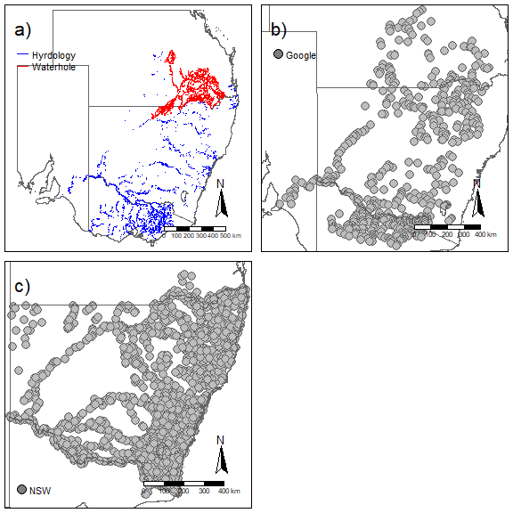

Figure A1: Maps showing (a) hydrological surfaces, (b) the locations of sites measured using Google Earth aerial imagery and (c) the location of sites measured by field sampling (NSW Aquatic Ecosystems Research database).

A2.3 Data analysis to model and predict river width
To predict river widths, we used the satellite and field data to fit a boosted regression tree (BRT) model using the gbm.step() function in the dismo package (Hijmans et al. 2017). The learning rate was set to 0.01, bag.fraction to 0.75, and tree complexity to 3. A 10-fold cross-validation (CrV) process was implemented to assess the fit of the model. The response variable, river width, was log-transformed and a Gaussian error distribution was assumed. All river covariates described in the main text (see Section 2.2, Table 2) were included in the model as predictors. We added an additional variable, data source, to indicate whether the data were obtained from satellite or field measurements. River width predictions from the boosted regression tree model were based on 1 000 trees. Graphical analysis of residuals was performed to assess model assumptions.
In addition to the cross-validation performed above, we compared the predicted widths from the best model with the measured river width at all sites at which conversion factor experiments were conducted (see Appendix 4, Table A5). A Pearson correlation test was performed to assess the goodness of fit between predicted and measured widths.

A2.4 Results

A2.4.1 Comparison among data sources
When measurements from satellite and field data were available for the same river segment, the correlation was strong (r = 0.84) (Figure A2). We next performed a linear regression with widths centered to the mean field measurements. For this regression, the intercept did not differ from zero (-1.44, 95%CrI -4.5 and 1.73) and the slope estimate did not differ from 1 at 0.91 (95%CrI of 0.75 to 1,07). We then asked what was the probability that the slope was between 0.9 to 1.1 (10% equivalence test) and we obtained an estimate of 0.54. Therefore, we cannot conclude either way if there is a bias at the 10% criteria but there a strong positive correlation between the variables.
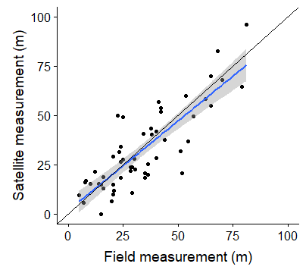

Figure A2: Relationship between satellite and field measurements of river width for the same river segment (r = 0.84). The blue curve shows the fitted spline, shading represents the 95% confidence limit of the spline, and the black line shows a 1:1 relationship. Dots represent the raw data for river segments.

A2.4.2 Predictions of river width
Overall, the boosted regression tree analysis resulted good predictive performance for the data (Figure A3). The correlation between predicted and actual estimates for river width was 0.83 (Figure A3) and the overall cross-validation correlation for the model was 0.77 (SE = 0.01). Several variables were found to be strong predictors of river width, with runannmean (annual flow), runspringmean, basin, catarea, and runsummerm being the top five predictors.
The fit between residuals and fitted values are shown in (Figure A3). The residual vs. fitted plot does not show heteroscedasticity in variation, except potential at the highest fitted values but there are also fewer data points complicating interpretation. However, a more distinct pattern in variation decreasing in the actual versus predicted values. This result strongly suggested that additional information was missing from model. If the model predicts a river to be wide, it will be fairly accurate, but if it predicts it to be low, there is much less certainty in that estimate. In explanation, part of the reason is that stream barriers result in widening of the river system (e.g. lakes, dams, other rivers).

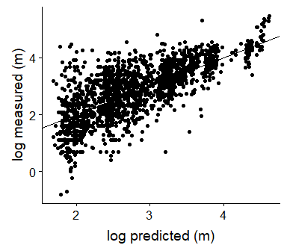
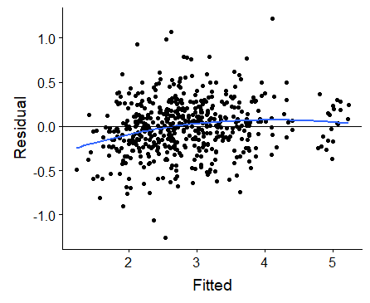

Figure A3: Top plot shows the relationship between measured and predicted widths with the black line showing the linear regression line. The bottom plot shows the relationship between model residuals and fitted with a spline shown as a blue line and the black line as the yintercept=0.

Reference
Hijmans, R.J., Phillips, S., Leathwick, J., Elith, J. and Hijmans, M.R.J. (2017). Package ‘dismo’. Circles, 9(1).

  - Appendix A3 - Predicting waterhole area

A3.1 Overview
The mapping of waterholes had been implemented only in the north-east section of the MDB (Figure A4). However, the Paroo and Warrego River regions also have similar waterhole hydrology, so without any additional information on amount of river area, we had to predict the waterhole area for the Paroo/Warrego region (Figure A4).
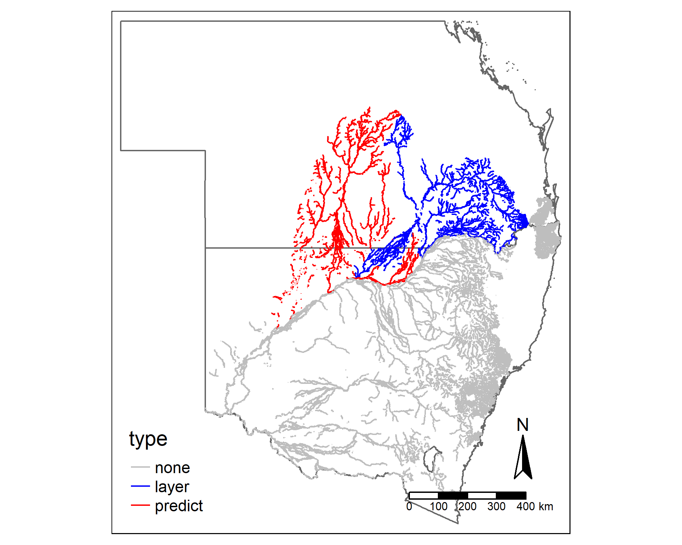
Figure A4: Map showing areas in NSW and QLD where waterholes are a prominent feature of river systems. Blue lines show mapped waterholes. Red lines show the area where waterholes were predicted for the Paroo and Warrego systems. Grey shows the rest of the river system.

A3.2 Methods
To predict the waterhole area for the Paroo/Warrego region (not mapped), we fitted a boosted regression tree (BRT) model to data from the region where waterholes have been mapped (see Figure A4). We used the gbm.step() function in the dismo package (Hijmans et al. 2017). The learning rate was set to 0.01, the bag.fraction to 0.75, and tree complexity to 1. A 10-fold cross-validation (CrV) process was implemented to assess fit. The response variable was the ratio of waterhole area to river length (log-transformed). After removing strongly correlated stream attributes, we included the following four predictors: annual flow (runannmean), flow pereniallity (runperenia), hierarchy (major or minor), and elevation (strelemean). The error distribution was modelled as Gaussian. All covariates were log-transformed (log(x+1)) prior to analysis. Model fit was assessed through correlation between predicted and fitted values. Using this model, we then predicted waterhole area for the Paroo River region by using 1 000 trees.

A3.3 Results
Overall, annual flow (runannmean) had the highest relative influence (50.8%), followed by elevation (strelemean) (30.2%), flow pereniallity (runperenia) (17%) and the river hierarchy (2%) (Figure A5). Waterhole area was strongly positively associated with higher annual flow (Figure A6). Overall, the correlation between observed and predicted values was modest at 0.56, with a CrV correlation of 0.53.
The average area of waterhole per kilometre of river was 0.87 ha/km for the mapped waterhole layer (NE of MDB) and 0.4 ha/km for the predicted region (Paroo/Warrego River regions). Using the predicted waterhole area rather than assuming all rivers had water (as we do for the rest of the river network), the waterhole area was 27.3% of the total river area for the Paroo/Warrego regions. For comparison, the mapped waterhole layer was 62.1% of the total river area for the Condamine region.

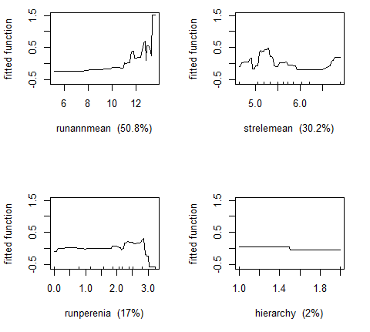
Figure A5: Relationship between waterhole area and each covariate from the boosted regression tree model. Variable key: runannmean is an annual flow volume proxy; strelemean is mean stream elevation; runperenia is a measure of stream's perenniallity; and hierarchy is whether a stream is a minor or major stream.

  - Appendix A4 - Existing datasets for Carp

A4.1 Collection of relative abundance datasets
Collaborators from each state were asked to collate existing datasets from studies in which the fish community was surveyed. Our approach to constructing the Carp database was to obtain as much data on Carp as possible. The historical datasets varied in quality and comparability (e.g. some studies electrofished for 100 sec, others for >5000 sec). We did not want to impose strict inclusion criteria for the database given the large spatial scope of this project. This approach allowed us to explore the variation in survey methods and in spatial location of sampling. We could then balance the benefits of making studies more comparable versus the loss of spatial scope.
Therefore, we asked collaborators to compile a list of studies that they deemed had scientific merit (e.g. surveys that were conducted to answer scientific questions). Furthermore, the datasets had to meet the following criteria to be included in the database:
- have CPUE and/or fish size (length or mass).
- contain date information
- have geographical coordinates for each site sampled. Sites without geographical coordinates were dropped.
- describe the survey methods used, including sampling effort and the method for measuring fish length (fork length vs. total length).

Table A1: List of studies included in the Carp database.
State | Study | Year start | Year end | CPUE data | Density data
ACT | Annual Monitoring - Macquarie Perch | 2009 | 2009 | X
 | Murrumbidgee River Monitoring | 2009 | 2017 | X
 | Murrumbidgee to Googong | 2010 | 2013 | X
 | Queanbeyan Council | 2011 | 2011 | X
 | Urban Lakes Monitoring | 2009 | 2017 | X
Multiple | Abundance survey | 1994 | 2018 |  | X
 | SAS database | 1989 | 2011 | X
 | SRA/MDBFS | 2004 | 2018 | X
NSW | 2012FM | 2012 | 2012 | X
 | BEM | 2009 | 2010 | X
 | BIDGEF | 2012 | 2014 | X
 | BMFC | 2009 | 2018 | X
 | BPEOM | 2014 | 2018 | X
 | CCS | 2010 | 2011 | X
 | CEM | 2012 | 2013 | X
 | CHEM | 2015 | 2015 | X
 | CHMJ | 2012 | 2012 | X
 | CYHV3 | 2015 | 2017 | X
 | EWB | 2014 | 2014 | X
 | EWCMA | 2010 | 2015 | X
 | Gunbower database | 2008 | 2017 | X
 | HEM | 2011 | 2011 | X
 | HHD | 2009 | 2015 | X
 | HLHRM | 2012 | 2012 | X
 | IFM | 2009 | 2012 | X
 | IMEFR | 2009 | 2009 | X
 | KP | 2014 | 2016 | X
 | KPCM | 2011 | 2018 | X
 | Lake Cargelligo | 2010 | 2010 |  | X
 | LBW | 2011 | 2011 | X
 | LCD | 2009 | 2011 | X
 | LMPR | 2009 | 2017 | X
 | Lower Darling | 2018 | 2018 | X
 | LTIM EW | 2015 | 2017 | X
 | LTIM GWY | 2015 | 2018 | X
 | LTIM LACH | 2015 | 2018 | X
 | LTIM MURR | 2015 | 2017 | X
 | LTIM TOO | 2009 | 2017 | X
 | MDBFS | 2014 | 2018 | X
 | MEM | 2014 | 2015 | X
 | MER | 2009 | 2016 | X
 | Moira Lake | 2001 | 2001 |  | X
 | MRFS | 2012 | 2012 | X
 | NCCP | 2018 | 2018 | X
 | NEH | 2016 | 2016 | X
 | NFA | 2009 | 2014 | X
 | NFF | 2015 | 2017 | X
 | NSW Reid Harris | 1997 | 1997 | X
 | O pipe | 2014 | 2018 | X
 | PFA | 2009 | 2012 | X
 | PWCC | 2010 | 2012 | X
 | RPS | 2010 | 2010 | X
 | RRP | 2012 | 2016 | X
 | SRA | 2009 | 2013 | X
 | SRBS | 2009 | 2015 | X
 | SWBS | 2017 | 2017 | X
 | TDAF | 2009 | 2013 | X
 | TIS | 2011 | 2015 | X
 | TSM | 2009 | 2017 | X
 | URS | 2010 | 2011 | X
 | WRBP | 2009 | 2010 | X
QLD | DAF dewfish | 2008 | 2016 | X
 | DAF mesoscale | 2005 | 2009
 | QLD Hydrobio | 2006 | 2006 | X
 | QLD IACRC | 2006 | 2009 | X | X
 | QLD LTMP | 2000 | 2007 | X
SA | Chowilla data | 2017 | 2017 | X
 | Katarapko data | 2011 | 2017 | X
 | Lake Albert | 2010 | 2010
 | LMD Sharpe | 2004 | 2013 | X
 | LTIM Lower Murray Lock 1-3 | 2017 | 2017 | X
 | Murray Fishway | 2002 | 2013 | X
 | Pike data | 2016 | 2016 | X
 | SA Murray wetlands 2013 | 2013 | 2013 | X
 | Torrens 2011 & 2017 | 2017 | 2017 | X
TAS | Lake Sorell | 2015 | 2018 | X
VIC | Barmah Living Murray | 2007 | 2016 | X
 | Clydebank Morass | 2018 | 2018 |  | X
 | Glenelg 2012-15 | 2012 | 2015 | X
 | Glenelg River | 2016 | 2016 | X
 | Greens Swamp Gunbower | 2015 | 2015 |  | X
 | Jones Barmah | 1999 | 2000 | X
 | Lake Boga | 2008 | 2008 |  | X
 | Lake Dartmouth | 2010 | 2017 | X
 | LTIM Goulburn | 2014 | 2017 | X
 | Moodamere | 2018 | 2018 | X
 | Ovens River | 2008 | 2018 | X
 | Perch Monitoring Jo | 2006 | 2018 | X
 | Reedy Lagoon Gunbower | 2017 | 2017 |  | X
 | Snags | 1999 | 2017 | X
 | Southern Basin | 2005 | 2011 | X
 | VBA rivers | 2007 | 2018 | X
 | VEFMAP | 2016 | 2017 | X
 | Vic Lakes - Jason | 2015 | 2016 | X
 | Western Victoria | 2018 | 2018 | X
 | Wimmera River | 2016 | 2017 | X

A4.2 Collection of data on the absolute abundance of Carp
Besides data on relative abundance and fish size, we obtained data (where it existed) on the absolute biomass of Carp for waterbodies. These data come from historical records of drying waterbodies in which Carp were removed, or where a waterbody was pumped out. We used these data to provide a validation of our model’s predictions.
To obtain these data, we contacted various governmental agencies and commercial harvesters to inquire about historical records of drying waterbodies from which Carp were removed and for which the absolute biomass was measured. For each record, we obtained the total Carp biomass (usually in metric tonnes) and the estimated total area of the waterbody before drying. We then calculated the biomass density (kg/ha). Overall, a total of 18 records were obtained.
It should be noted that although we treat these estimates as having no uncertainty (i.e. there are no error bars), there are many potential sources of uncertainty in these estimates. We highlight the major assumptions below.
- Defining the actual waterbody’s area is difficult as the drying process covers an extended period and the estimates were based on best guess
- The majority of juvenile fish are not recorded as they are eaten by birds, or decay, and hence not collected. This is true for both ‘dry downs’ and ‘pump outs’.
- It is assumed that no adult fish were removed (e.g. migrated, died) from the waterbody throughout the dry down process. Obviously, this assumption is invalid, but it is not known how this might affect estimates. Drying down of a waterbody is likely a stressful event and mortality is likely to increase before the waterbody fully dries.
- The harvesting efficiency of fish (percentage of the total fish in the waterbody that were measured) is not known.

Table A2: List of sites in which the absolute abundance of Carp was measured. Site information was obtained by surveying government and commercial personnel working with Carp.
Method | Site | Year | Area (ha) | Biomass (kg/ha)
dry down | Banrock Station wetland | 1994 | 120 | 500
 | Bushells Lagoon @ Freemans Reach | 2018 | 40 | 265
 | Clyde Bank Morass (Gippsland) | 2018 | 12 | 225
 | Greens Swamp Gunbower | 2015 | 2 | 269
 | Kanagroo Ck reservoir (SA) | 2018 | 103 | 243
 | Lake Brewster (NSW) | 2013 | 6 200 | 4
 | Lake Cargelligo | 2010 | 1440 | 250
 | Lake Hindmarsh |  | 13 500 | 41
 | Lake Waljeers | 2018 | 540 | 65
 | Moira Lake | 2001 | 400 | 188
 | Moira Lake | 2010 | 400 | 82
 | Moira Lake | 2011 | 400 | 43
 | Moira Lake | 2014 | 400 | 94
 | Moira Lake | 2015 | 400 | 76
 | Riemore Downs lagoon |  | 88 | 63
 | Thegoa Lagoon | 2015 | 6 | 1 613
pump out | Black Swamp Gunbower | 2017 | 2 | 199
 | Reedy Lagoon Gunbower | 2017 | 5 | 152

  - Appendix A5 - Description of standard sampling methods
For all surveys and experiments in this study, standard operating procedures were developed for each sampling method (Table A3). Electrofishing methods were based on the SRA/MDBFS protocols (MDBA 2011). Netting methods were based on procedures routinely used for Carp.

Table A3: Description of standard CPUE methods used in this study.
Type | Method | Description | River | Wetland | Lake | Impoundment
CPUE | E-fishing backpack | • Deploy 8 shots during the day  • A shot is 150 seconds of accumulated power-on time  • In portions of streams <10 m wetted channel width (as estimated by sampling teams), adopt zigzag coverage of sampled area  • In streams >10 m wetted channel width (as estimated by sampling teams), adopt alternate shots alongside both banks  • Carp are counted, measured and tagged for mark-recapture sites | X
 | E-fishing boat | • Deploy 12 shots during the day  • A shot is 90 seconds of accumulated power-on time  • In portions of streams >100 m wetted channel width (as estimated by sampling teams), adopt consecutive shots on one bank followed by consecutive shots on the other bank  • In portions of streams >15 m - < 100 m wetted channel width (as estimated by sampling teams), adopt alternate shots alongside both banks  • In portions of streams <15 m wetted channel width (as estimated by sampling teams), adopt zigzag coverage of sampled area  • Deploy two mid-channel shots when mid-channel water depth <4 m  • Carp are counted, measured and tagged for mark-recapture sites | X | X | X | X
 | Fyke Nets | • Deploy 6 single-wing fyke nets ~2 hours prior to dusk  • Minimum soak time of 12 h  • Nets should be at least 30 m apart  • Set nets perpendicular or angled to wetland edge  • Carp are counted, measured and tagged for mark-recapture sites |  | X
 | Gill nets | • Set nets ~2 hours prior to dusk. Number of nets will be specified in habitat protocol.  • Set nets in depths not exceeding 2 m, unless otherwise specified (such as the habitat utilisation experiment for lakes and impoundments)  • Minimum soak time of 12 h  • All nets must be visibly monitored for movement of fish which are ensnared along with lifting the net at regular time intervals (every 30 min) to enable the retrieval and immediate release of netted mammals and birds  • Fish captured must be carefully removed, measured (if Carp) and released as quickly as practical  • Setting nets in areas with platypus, birds or other non-target animals must be avoided. If non-target animals are observed within 50 m of a net, the net must be removed from the water immediately and moved to another location  • Carp are counted, measured and tagged for mark-recapture sites |  |  | X | X
Site | Site assessment | For each site, do the following:  • Assess the actual water coverage by drawing the locations of the stopnets on the site’s map in the site assessment datasheet and record GPS points  • Take a representative number of depth samples and add the depth to the site’s map  • Conduct the standard water quality tests | X | X | X | X
 | Water quality | Measure the following at a depth of 20 cm  • Dissolved oxygen (DO)  • Electroconductivity (EC)  • pH  • Turbiity  • Water temperature | X | X | X | X

  - Appendix A6 - Sites for assessing conversion factors
Historical and contemporary surveys provide CPUE data for Carp as a measure of relative abundance. To calculate estimates of Carp biomass, it is necessary to determine the actual abundance (or density) of Carp in different types of aquatic habitats across the species’ range. Consequently, a series of field studies were undertaken at selected sites to determine the relationship between CPUE and actual abundance. The ratio between these measures represents a conversion factor, which can then be used to convert CPUE values at many other sites to density, and then biomass (see Appendix A9 for details on calculation of conversion factors).

Site selection for conversion experiments
For each habitat type, except ephemeral rivers, a list of potential sites was obtained from South Australia, Victoria and New South Wales/ACT. Ephemeral rivers are mainly restricted to Queensland, so a site list for these habitats was created only for Queensland. Furthermore, since Queensland has relatively few of the other habitats within the Carp distribution range, no site lists for the other habitats were required. The site lists were created by identifying stretches of rivers and multiple waterbodies that are logistically feasible to sample, are spread throughout the state, and which varied in depth and turbidity conditions. Sites were classified by three main stratification variables: state, turbidity and size (e.g. large vs small rivers). Lists were then collated and sites were randomly selected within each combination of the stratification variables (e.g. small rivers with high turbidity in SA). Those sites at which field studies were undertaken are listed in Table A4, together with the method used for determining the actual abundance/density of Carp at the site. Table A4 also lists sites used for habitat utilisation studies (see Appendix A10).

Table A4: List of sites and methods selected for conversion experiments and habitat utilisation studies.
State | Study | Type | Method | River | Waterbody
ACT | Fadden Pond | Conversion | Rotenone |  | X
 | Isabella/stranger pond pump out | Conversion | Pump out |  | X
 | Kambah Pool NCCP | Conversion | Mark recapture | X
NSW | Barwon River NCCP | Conversion | Mark recapture | X
 | Boorowa River NCCP | Conversion | Mark recapture | X
 | Burrinjuck Dam NCCP | Utilisation |  |  | X
 | Jingellic Creek NCCP | Conversion | Mark recapture | X
 | Lake Cargelligo NCCP | Utilisation |  |  | X
 | Lake Gillawarna NCCP | Conversion | Mark recapture |  | X
 | Macquarie River NCCP | Conversion | Mark recapture | X
 | Wallaroi Creek NCCP | Conversion | Mark recapture | X
 | Warragamba Dam NCCP | Utilisation |  |  | X
 | Yanco Wetland NCCP | Conversion | Mark recapture |  | X
QLD | 22 Mile Waterhole Warrego River NCCP | Conversion | Mark recapture | X
 | 7 Mile Waterhole Warrego River NCCP | Conversion | Mark recapture | X
 | Gundi Waterhole NCCP | Conversion | Mark recapture | X
 | QLD contemporary NCCP | Utilisation |  | X | X
 | Undulla Creek Hole 1 NCCP | Conversion | Mark recapture | X
 | Warrie 2 Moonie R. NCCP | Conversion | Mark recapture | X
 | Warrie, Moonie R NCCP | Conversion | Mark recapture | X
SA | Causeway Lagoon NCCP | Conversion | Mark recapture |  | X
 | Currency Creek NCCP | Conversion | Mark recapture | X
 | Henley Park NCCP | Conversion | Mark recapture |  | X
 | Lake Albert NCCP | Utilisation |  |  | X
 | Lake Alexandrina NCCP | Utilisation |  |  | X
 | Mount Bold NCCP | Utilisation |  |  | X
 | Torrens River NCCP | Conversion | Mark recapture | X
VIC | Broken Creek NCCP | Conversion | Mark recapture | X
 | Broken River NCCP | Conversion | Depletion | X
 | Brushy Creek NCCP | Conversion | Depletion | X
 | Eildon Dam NCCP | Utilisation |  |  | X
 | Flemington Racecourse NCCP | Conversion | Rotenone |  | X
 | Gippsland Rivers NCCP | Utilisation |  | X
 | Hughes Creek NCCP | Conversion |  | X
 | King River NCCP | Conversion | Mark recapture | X
 | Little Gunbower wetland NCCP | Conversion | Mark recapture |  | X
 | Lock 10 NCCP | Conversion | Mark recapture | X
 | Morwell wetland NCCP | Conversion | Mark recapture |  | X
 | Ovens River NCCP | Utilisation |  | X
 | Reedy Lake NCCP | Utilisation |  |  | X
 | Yarra Glen Wetland NCCP | Conversion | Mark recapture |  | X

  - Appendix A7 – Length-mass relationships for Carp

A7.1 Overview
Length is the most common physical measurement taken for captured Carp; however, we needed Carp mass to estimate biomass. Therefore, it was necessary to predict mass from measures of Carp length. For this report, we assumed a constant length-mass relationship across the entire geographic distribution. Future analyses will be conducted to test this assumption.

A7.2 Methods
Carp length (fork length, mm) and mass (g) were extracted from the Carp database. We ran a general linear model (GLM) with mass (log10-transformed) as the response variable and length (log-10 transformed) as the predictor.

A7.3 Results
Overall, the fit was very good (R² = 0.97) (Table A6, Figure A6). The final equation then becomes:
$$\log_{10}\left( weight \right)= -4.3+\log_{10}\left( fork length \right)2.84*+ e$$
$where e \sim N(0, 0.006)$
Table A6: Statistical model of the length-mass relationship for Carp.
Variable | Estimate | SE | T | P-value
Intercept | -4.300 | 0.016 | -270.420 | <0.001
log10(Length) | 2.840 | 0.006 | 457.670 | <0.001
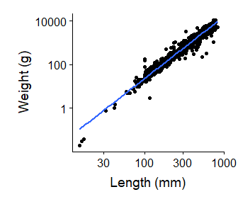
Figure A6: Predicted relationship between Carp fork length (mm) and mass (g).

  - Appendix A8 – Predictive models for CPUE and average fish mass

A8.1 Data filtering and preparation process
To develop predictive models to spatially map CPUE of carp and average fish mass, the following data filtering and preparation protocol was performed. First, only electrofishing data were used because electrofishing was the most commonly used method in the existing Carp dataset (see Results section). As the procedure to calculate conversion factors (see Appendix 10) was based on SRA surveys, we only used data that had similar survey lengths of sampling effort and settled on surveys that sampled for 800 to 1600 sec. We chose this range because it represented the core of the sampled survey times and still included good spatial coverage (after applying the next filter). Finally, as the conversion factor is defined as the relationship between density (No/ha) and CPUE for Carp >150 mm FL, we only used studies that included measures of fish lengths. As some studies measured only a subsample of fish, we calculated the proportion of fish >150 mm FL and multiplied this proportion by the total number of fish caught to get an estimated number of fish >150 mm FL. This calculation was done only if the number of fish caught exceeded the number of fish measured. This filtering process resulted in ~30% of efCPUE surveys for the river habitat and 70% for waterbody habitats being retained.

A8.1 Correlation among environmental covariates for rivers
Our goal was to model the relationship between CPUE and environmental covariates of rivers for sites for which CPUE data were available, such that the model could then be used to predict CPUE for all other river sites. Initial graphical analyses of covariates for rivers (see Table 2 for definitions) indicated that several variables required transformations, so we implemented a log(x+1) transformation to these variables. Next, we calculated all pairwise comparisons between continuous covariates (Figure A7). We first assessed the correlation between the attributes to determine if any correlated strongly (r >0.80). For strong correlations, only one variable was kept because multicollinearity in predictors can lead to problems with model fits and prediction.
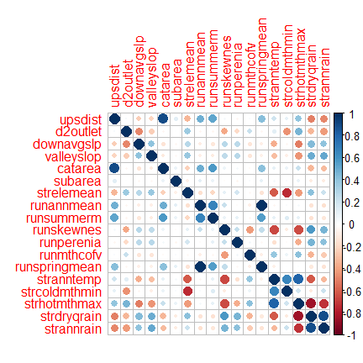
Figure A7: Correlation plot between environmental covariates of rivers. Larger circles indicate stronger correlations between the row and column variable, with blue and red colours indicating positive and negative correlations, respectively. Descriptions of covariates are provided in the main text (Section 2.2, Table 2).

A8.2 Predictive models for river spatial layers
Models of efCPUE
To predict CPUE across the whole river spatial layer, we first attempted to fit a Bayesian generalised additive mixed model (bGAMM). This bGAMM included the continuous river predictors as splines in the model with no interactions between them. After assessment of posterior predictive plots, graphical analyses of the residuals vs fitted plots, plotting the residuals across each river attributes, and performing a 10-fold cross validation procedure using Pearson correlation between actual and model predicted values, we concluded that we were unable to capture the patterns in efCPUE. The predictive performance was low (~0.4) and obvious spatial patterns still emerged in the residuals. we were not able to adequately capture the CPUE patterns across the study area.
Consequently, we implemented a boosted regression tree (BRT) approach which uses machine learning to improve predictions (Elith et al. 2008). For the boosted regression tree, we used efCPUE (log-transformed) of Carp >150 mm length as the response variable. There were no negative binomial options for the boosted regression tree, and as the data were overdispersed a Poisson model could not be used. Therefore, we used the log-transformation(x+1) for the response variable and assumed a normal distribution. Graphical analysis of the residuals indicated that only for efCPUE = 0s was the distribution not normal and homoscedastic. Though we would prefer to model the 0s in more statistically rigorous way, the BRT approach strongly increased the predictive performance of the models and less worried about the lower carp density locations. As the BRT does not handle random effects, we selected only the more recent efCPUE data for each site (i.e. to avoid multiple data points for the same site). For the predictors, we included river attributes (as noted above), time (year and month), and spatial subregions (Figure A8). We used spatial subregions as we could not use river basins as there was not CPUE data for all basins and hence could not predict CPUE for those basins (as can be done if river basin is a random effect). The bag fraction was set at 0.7 and the learning rate at 0.01. Tree complexity was set to 3. We performed a 10-fold cross-validation and used the Pearson correlation between testing data and the model fit as a measure of model predictive performance. We again assessed model fit plotting model residual versus fitted looking for heteroscedasticity in the residuals and biases, checking normality assumptions, and plotting residuals across the predictors to assess in remaining patterns remained. As noted before, the main concern with the model was due to 0s and some misfit with the model. We did not conduct spatial correlation analyses of the residuals. We attempted to account for some of this correlation through spatial subregions and by the fact that BRT often incorporate spatial patterns into the results through interactions between predictors.
Models of fish mass
We fitted a bGAMM using the brm() function in brms package (Bürkner 2017). We used the average fish mass (for Carp >150 mm) per survey as the response variable (log-transformed) and assumed a normal distribution. Fish mass was estimated for all fish from measured fish lengths. The predictors for the model comprised four main components; 1) river attributes, 2) efCPUE, 3) time, and 4) spatial layers (region and basins). For the river attributes, we calculated the correlation between pairs of continuous environmental co-variates and removed any strongly correlated river attributes (i.e. r >0.7). The remaining continuous variables were included as thin-plate splines (Wood 2006). We also included efCPUE as a spline because high values of efCPUE were associated with smaller fish and hence lower average mass. Time was handled by including year as a thin-plate spline for each spatial region (Lachlan, Murray, Darling, Northern basin, and coast) and month as a cyclic spline. Finally, we mitigated some of the remaining spatial correlation by including spatial region and river basin (see Figure A8) as random factors. A random effect for site was also included because some sites were repeatedly sampled. Model assumptions were assessed through graphical analysis of Pearson residuals and posterior predictive plots. Model convergence was checked using traceplot and Rubin-Gelman convergence statistics.
To assess model fit, we performed the following steps: 1) model residuals were explored for residual patterns against excluded variables and for abnormalities indicating a poor model fit; 2) we calculated the correlation between fitted and actual values; 3) we ran a boosted regression tree (BRT) model with all river attributes to help indicate potentially important interactions; and 4) the model structure for the bGAMM was re-run using the gam() function in the mgcv package and a 10-fold cross-validation process was performed to assess model predictions (the fit between bGAMM and GAM were very similar given the use of weak priors). For the cross-validation, we used Pearson correlation between the test data and model predictions as a measure of predictive performance. We used a GAM for the cross-validation as it was substantially quicker re-fitting the models for the cross-validation. Overall, the bGAMM fitted a similar model as the BRT.
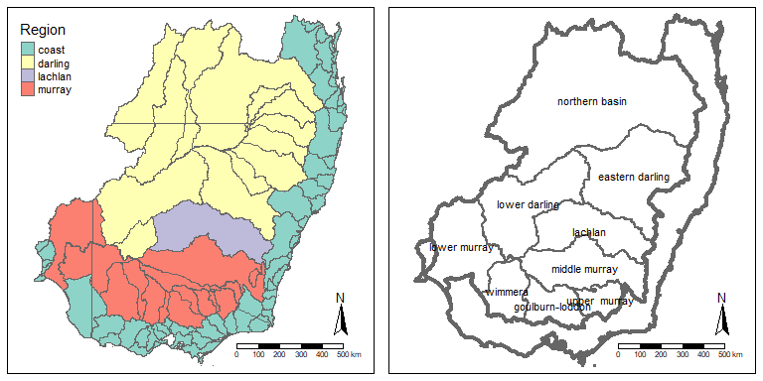
Figure A8: Map showing spatial levels (spatial region, river basin) for models. Colored areas are the major spatial regions and the thin lines are the river basins. Since river basins could not be used in the BRT model, we included a spatial subregions for the MDB instead (right plot).

A8.3 Predictive models for waterbody spatial layers
To predict efCPUE and average fish mass for waterbodies, we performed bGAMM models using the same general process as performed for the rivers, except that a) for the response variable we assumed a negative binomial distribution for CPUE and b) the predictor variables included waterbody size (fitted as thin-plate spline) and waterbody type (lake, storage, or wetland) rather than river covariates. Time and spatial regions were included as before. efCPUE was included as predictor for the fish mass model as before.

A8.4 Results for river models

A8.4.1 efCPUE in rivers
Overall, the two most influential predictors in the BRT model were year (18.8% relative influence) and spatial regions (17.2%). Predicted values for efCPUE varied markedly between years with, for example, low values in 2010 and high values in 2011 – 2014 (following drought-breaking rains in 2010-2011). The marginal relationships for the six most influential parameters are shown in Figure A10.
Overall, the relationship between predicted and observed efCPUE is shown in Figure A9: the cross-validation correlation was moderate at 0.61 (SE: 0.02).
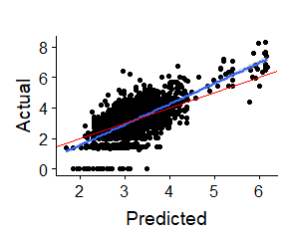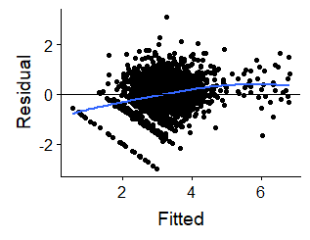
Figure A9: Relationship between predicted efCPUE and actual efCPUE for Carp (>150 mm length) at each river site (left) and residual vs. fitted plot. The blue line shows the fitted regression line and the red line shows a 1:1 relationship. Note - values are log-transformed.

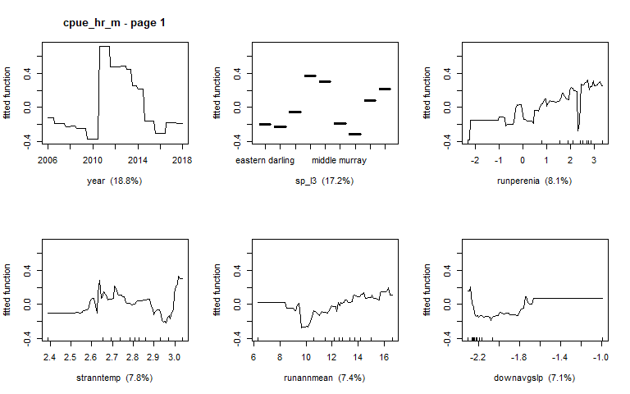
Figure A10: Relationship between scaled efCPUE for Carp and the six most influential covariates of rivers. These are marginal relationships and hence smooth over potential interactions between variables. Descriptions of river covariates are given in Table 2 (Section 2.2 of main text).

A8.4.2 Average fish mass in rivers
Overall, the predictive performance of the model for average fish mass was moderate, as indicated by the cross-validation correlation of 0.64 (SE: 0.04). The relationship between the predicted values of average fish mass and the actual values is shown in Figure A11. In general, there was marked temporal variation in average mass of carp across all spatial regions, with a noticeable decrease in average mass after the 2010 floods, corresponding to more recruits in the samples (Figure A12). The relationship between average mass of Carp per site and key variables is shown in Figure A13. One key variable was efCPUE, with average mass being lower in samples that had high efCPUE (Figure A13).

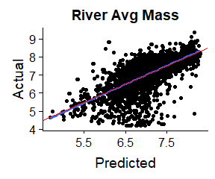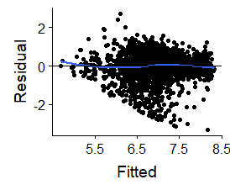
Figure A11: Relationship between predicted values for average fish mass and actual average mass for Carp in river systems and the residual vs fitted plot. Blue line shows fitted regression line and red line shows 1:1 relationship. Note - values are log-transformed.

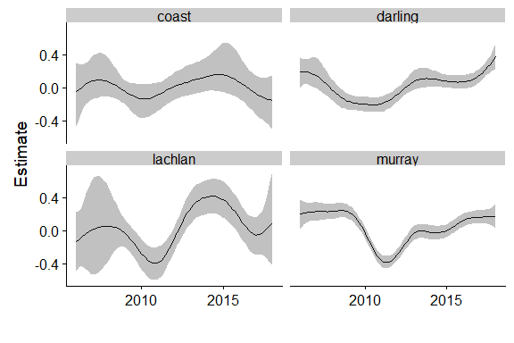
Figure A12: Effect of year on average mass (log-scale) for MDB and coastal regions. Each panel shows the fitted relationship (line) with 95%CrI (grey shading) and standardised by the mean.

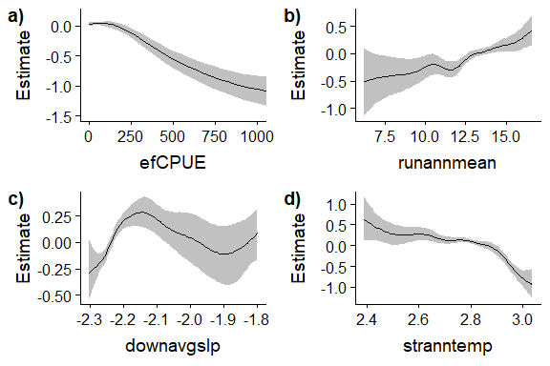
Figure A13: Effects of key variables on average fish mass for Carp at sites in rivers. Each panel shows the fitted relationship with 95%CrI (grey shading) and standardised by the mean.

A8.5 Results for waterbody models
Overall the fit of models for efCPUE and average fish mass for waterbodies was moderate as indicated by cross-validation correlations of 0.48 (SE: 0.07) and 0.65 (SE: 0.05), respectively. The fit between actual and predicted data are shown in Figure A14. It appeared that there was a negative bias for waterbody efCPUE in which the model underestimated the actual efCPUE which will result in an underestimation in the full model. Residuals plotted against fitted values are shown in Figure A14c,d and shows for the efCPUE model, we had some large positive residuals (>3) which the model could not fully account for. This was not surprising as these catches reflect large reproductive events in which there are larger number of younger fish. The year of sampling was also an important influence on efCPUE and average fish mass for Carp in waterbodies: efCPUE decreased from 2010 to 2016, whereas average fish mass showed an initial increase (2011-2016) before becoming steady (2016-2018) (Figure A15). These results are consistent with major recruitment following the 2010-11 floods (high CPUE, lower average fish mass) followed by increase in average fish mass as the recruits grow and age. Finally, the estimates of efCPUE and average fish mass, respectively, for different types of waterbody habitat classes (lake, storage, wetland) were similar and very variable (Figure A16).

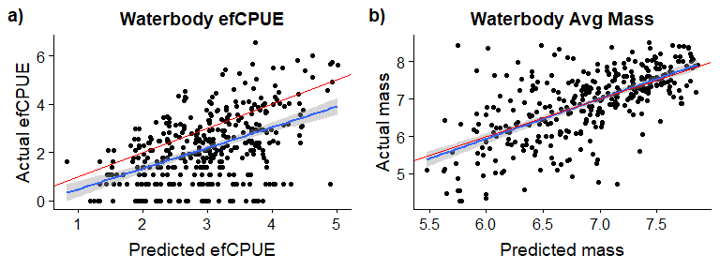
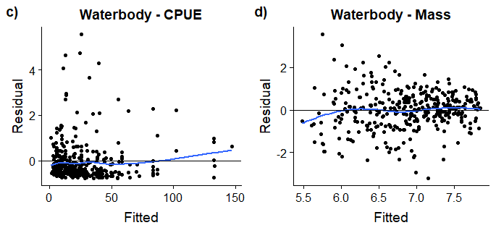
Figure A14: Relationship between predicted and actual efCPUE(a)) and mass (b) for each waterbody location as well as the plots of residual vs. fitted for egCPUE (c) and mass (d). For a) and b), blue line shows fitted regression line and red line shows 1:1 relationship. Note - values are log-transformed. For c) and d) blue line shows fitted LOWESS curve and black line shows y-intercept=0.

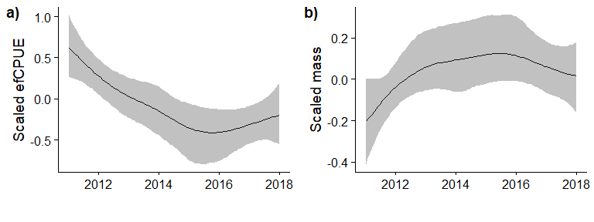

Figure A15: Effect of year on a) efCPUE and b) average mass of Carp for sites in waterbodies. Each panel shows the fitted relationship with 95%CrI and standardised by the mean.

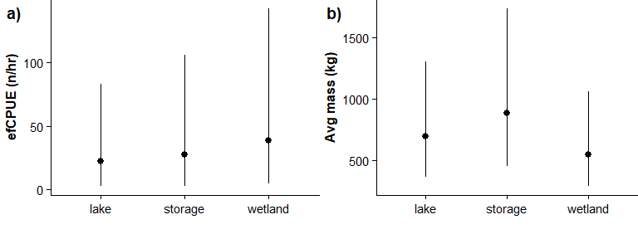
Figure A16: Effect of habitat type on (a) efCPUE and (b) average mass of Carp in waterbodies. Each panel shows the fitted relationship with 95%CrI.

References
Bürkner, P.C. (2017). brms: An R package for Bayesian multilevel models using Stan. Journal of Statistical Software 80, 1-28.
Elith, J., Leathwick, J.R. and Hastie, T. (2008). A working guide to boosted regression trees. Journal of Animal Ecology 77, 802-813.
Wood, S.N. (2006). Generalized additive models: an introduction with R. Chapman and Hall/CRC.

  - Appendix A9- Conversion factor experiments

A9.1 Experimental design
Overview
After predicting CPUE and average mass across the Carp’s distribution, we needed a method to convert those CPUE to density (No/ha), which could then be converted to biomass. The key component to developing the conversion factor was estimating the relationship between efCPUE and Carp density (No/ha). The number of fish caught during an EF survey depends on the proportion of area searched (search effort) and the probability of detecting the fish if the area is searched. Combining those probabilities is the probability of detecting a fish during an EF survey in a fixed area. By comparing the ratio of carp density and CPUE across different habitats and multiple sites, it is possible to obtain an estimate of this conversion factor with some measure of the error. Because of poor detection of <150 mm Carp using standard sampling techniques, we only estimated density of fish ≥150 mm FL and hence the conversion factor is only applicable for fish ≥150 mm FL. The conversion factor approach we used is similar to that of Gilligan et al. (2010), though we used data to estimate the ratio instead of assuming the amount of area searched in a standard SRA survey and the sampling efficiency of the survey.
Site selection
Site selection was divided into two parts: the first was a designed experiment and the second represented opportunistic sampling. For the first component, we designed an experiment in which we sampled 27 sites: 20 river sites and 7 wetland sites (Table A7). For each of these sites, the standard electrofishing protocol was implemented to get efCPUE and then density (No/ha) was estimated using one of three methods (see below): 1) mark-recapture, 2) depletion, or 3) acoustic tagging (see below). Sites were selected by obtaining a list of potential sites from each state, from which sites were chosen based on logistical feasibility as well as to select sites varying in depth, turbidity, and size. Sites were then stratified by the main factors (state, turbidity, and expected depth) and randomly selected within each stratum. This stratification approach was used in order to attempt to capture the variation in detection probabilities. In other words, we wanted to attempt to sample locations that would represent the potential extremes of the detection probabilities (e.g. shallow and clear rivers vs. deeper, turbid rivers across different states). We expected that states to differ as climate, habitats, carp populations, and sampling cultural differ between states (some states more than others). However, since we had limited number of sites and site attributes like turbidty and depth could not be assigned to the GIS spatial layers we do not account for these sources of variation in the model as.
In addition to the designed experiment, we took advantage of wetlands in which Carp were being removed. These experiments were conducted opportunistically, thus we had no control in choosing these four sites. The Carp were removed either through pump-outs or by using rotenone. During these experiments, the standard electrofishing protocol was performed at the wetland site, Carp were then removed and quantified after wetland drainage or the addition of rotenone.

Calculating site area
To estimate the area for the assessments of density outlined below, the area for each site was obtained by creating a point shapefile with the GPS coordinates obtained from the standard site assessment (see standard methods, Appendix 3), overlaying this layer on Google Maps satellite layer, and then tracing the likely water boundary. This measure of total area was used in calculating the density estimate for the waterbody. All sites for experimental components 1 and 2 were sampled between Jan to June 2018, with the exception of pump-outs at Isabella and Upper Stranger Pond (ACT) which occurred in May 2017.
Table A7: Sample sizes for the conversion factor experiment, broken up by type and method.
Type | Method | River | Waterbody
Designed | Depletion | 2 | 0
 | Mark recapture | 17 | 7
 | Acoustic tagging | 1 | 0
Opportunistic | Pump out | 0 | 2
 | Rotenone | 0 | 2
Total |  | 20 | 11

A9.2 Density Method 1: Mark-recapture methods for closed systems
Methods
Three types of closed system were present in this study: 1) mid-size rivers, 2) wetlands, and 3) ephemeral waterholes. Methods were similar for mid-size rivers and wetlands. Ephemeral waterholes differed slightly due to the ethical requirement to remove invasive Carp on recapture.
First, for all sites, stop-nets (or natural barriers) were used to create a closed system preventing migration into and out of the site. For rivers, the section stop-netted was extended slightly beyond the necessary river length required to complete the standard electrofishing survey. The standard SRA boat or backpack electrofishing protocol was then implemented to get baseline efCPUE. All fish (>150 mm FL) caught were tagged, measured for length and then released. After completion of the standard electrofishing protocol, crews performed repeated electrofishing passes at a higher intensity aimed at capturing as many fish as possible. During each subsequent electrofishing pass a similar sampling effort was employed to ensure that all areas were sampled.
For non-Queensland sites, a minimum of three electrofishing passes were performed over multiple days. A power analysis indicated that, after three passes, if the percentage of tagged fish exceeded 40% of the total catch the population estimate should have a %CV less than 20%. Thus, crews halted sampling if the catch on passes was >40% tagged fish or if they had sampled for five days. For Queensland sites, Carp sampling was broken into two phases, an initial tagging phase and then the recapture phase. For the initial tagging phase, intensive electrofishing was performed over three days. Then after three or more days, another three days of electrofishing was performed, during which all Carp captured were humanely euthanased.
Note that our initial experimental design included gill and fyke nets in the wetlands; however, gill netting success was low and logistically problematic and hence not collected for most sites. Fyke nets caught mainly small fish and hence was strongly biased to small fish. Therefore, these data were excluded from the analyses (i.e. we only used efCPUE).

Analysis
To estimate population sizes, state-space models were used (Kéry and Schaub 2011). State-space models provide flexibility in structure to deal with time-varying catchabilities and incorporation of factors that affect catchability. Models were constructed using JAGS software (Plummer 2003) in junction with the R2jags package (Su and Yajima 2015). Population size estimation was obtained through data augmentation. For non-Qld sites, models assuming constant catchability between mark and recapture sessions were compared with models assuming time-varying catchability (QLD sites had a different design in which there was a single mark and single recapture period). Posterior sampling was used to obtain credible estimates for population size and catchability. Density was obtained by dividing the total estimated population size by total area sampled (i.e. No/ha).
Four models were compared: null model, the avoidance model, the effort model, and the avoidance and effort model. Models were compared using DIC and we presented the model with the lowest DIC. As the focus here is on the density estimate, we limit our reporting to that key component rather than the specific for each of the model. To assess model fit, we used a Freeman-Tukey statistic (Kéry and Schaub 2011) as a goodness-of-fit statistic and compared to simulated data from the fitted model.
The general model structure was as follows and included only the relevant parameter depending on the model being performed.
$$y_{i,t}|z_{i}\sim Bernoulli(z_{i}*p_{i,t}) \\ z_{i} \sim Bernoulli\left(Ω\right) \\ logit\left(p\right)= β_{0}+ β_{recap}*I_{recap}+ β_{effort}*effort \\ β_{i}\sim Normal(0,100)$$

A9.2 Density Method 2: Depletion methods for closed systems
Methods
For small streams, stop-nets were used to preclude migration and then the standard backpack electrofishing protocol was implemented. After completion of the standard survey, repeated passes were performed during which Carp were removed and stored in a holding cage. All passes had similar sampling effort and surveyed all possible areas. A minimum of four passes was performed.
Analysis
The same modelling approach was adopted as for the capture-recapture models, except that once a fish was caught, it could not be caught again and hence had no effect on the detection probability. Therefore, there was no avoidance behavior modelled.
The depletion model structure was then the following:
$$y_{i,t}|z_{i} \left\{\begin{aligned}\sim Bernoulli\left(z_{i,t}*p_{i,t}\right) if never caught before \\ \text{NA if fish was caught before}\end{aligned}\right. \\ z_{i} \sim Bernoulli\left(Ω\right) \\ logit\left(p\right)= β_{0}+ β_{effort}*effort \\ β_{i}\sim Normal(0,100)$$

A9.3 Density Method 3: Acoustic tagging for open systems
Methods
For large permanent rivers, it was not possible to close off the system to migration. Therefore, the radio-tag method developed by Lyon et al. (2014) was implemented. In brief, a 1-km stretch of river was selected near Lock 10 of the Murray River. The standard SRA CPUE method for the river was first performed. Next, 64 Carp were tagged (following Lyon et al. 2014). Carp of varying sizes were targeted to test whether fish size affected detection rate.
After a week to allow recovery, the river section was re-sampled a total of four times (e.g. at 1 week, 2 weeks, 3 weeks, 8 weeks). During each resampling event, an independent radio-tracking team first determined how many radio-tagged Carp were within the sample reach. Then the standard SRA CPUE boat electrofishing method was performed without knowledge of the number of tagged fish present. The team recorded the number of radio-tagged fish that were caught using the standard SRA protocol.
Analysis
Due to very low recapture rates, we could not replicate the approach used in Lyon et al. (2014) to estimate density and instead performed a simple Bayesian General Linear Model (bGLM) assuming a binomial distribution. For each week, we summed the total number of tagged fish caught in relation to the number of tagged fish counted by the radio-tracking crew. No predictors were included in the model. Our estimate of the density was the inverse of the detection probability estimate from the model.

A9.4 Analysis for the conversion factors
Using the efCPUE and density estimate at each site, we calculated the conversion factor as ratio of density to efCPUE (i.e. conversion factor = density / efCPUE). We then modelled the relationship between the conversion factor and habitat groups using a bGLM. The response variable was the natural log of the conversion factor and the predictor variable (fixed factor) was habitat type (waterhole, wetland, river <50 m, river >50 m width). We assumed a normal distribution for the response variable. Model convergence was assessed by checking model convergence statistics (e.g. traceplots, Rubin-Gelmen convergence statistics). Model fit was assessed through graphical plots of model residuals and posterior predictive plots. We defined significant differences where the 95%CrI of the difference between habitat types did not overlap with zero.
The model residuals suggested that there might be unequal variance between the habitats, so we re-run the model assuming separate variances for each habitat type. We compared the models and the WAIC (better defined as <0.01 overlap in WAICs) indicated that the equal variance model was preferred, so we kept the equal variance model.
Finally, a second model was performed for just the river data to assess whether river width improved the fit compared to just having the small/medium vs. large habitat grouping. Comparison of WAIC indicated no improvement in the model so just the habitat grouping model was kept.
A9.5 Results
Overall, most mark-recapture models fitted the data reasonably as assessed by the posterior predictive p-values, though the density estimates ranged in precision (Table A8). The depletion models (Brushy and Hughes) were good fits to the data and had the most precise estimates. The acoustic tagging model had substantial variation in the estimate due to the low sample sizes. The pump-out/rotenone sites were assumed to be without uncertainty.
Using the density and efCPUE data, we estimated a conversion factor and its uncertainty for each habitat group (Table A9). These showed substantial overlap between habitats. Comparison between habitats found a significant difference only between rivers <50 m width (lowest value) and waterholes (highest value) (log-scale difference = 1.1; 95%CrI 0.4, 2.1). The estimate of remaining variation (SD) was 0.8 (± 0.1), indicating substantial remaining variation.
Exploratory relationships between site area, density (n/ha), percent caught (%) and efCPUE are shown in Figures A17-A19.
Table A8: Estimated density and efCPUE (No/hr) of Carp for every site from the designed experiment. Bolded sites were pump-out or rotenone sites so the density are assumed known.
Habitat | Habitat class | Site | efCPUE | Density  (No/ha) | Density/  efCPUE
River | Shallow rivers (backpack EF) | Brushy Creek, VIC | 14 | 193 | 13.8
 |  | Hughes Creek, VIC | 77 | 75 | 1.0
 |  | Jingellic, NSW | 21 | 23 | 1.1
 | Rest of rivers  (boat EF) | Balbardie, NSW | 79 | 169 | 2.1
 |  | Broadwater, NSW | 65 | 109 | 1.7
 |  | Broken Creek, VIC | 53 | 92 | 1.7
 |  | Broken River, VIC | 160 | 1 029 | 6.4
 |  | Combadgery, NSW | 33 | 253 | 7.7
 |  | Currency creek, SA | 157 | 381 | 2.4
 |  | Kambah Pool, ACT | 27 | 159 | 5.9
 |  | King River, VIC | 87 | 79 | 0.9
 |  | Torrens river, SA | 67 | 40 | 0.6
 |  | Wallaroi, NSW | 113 | 199 | 1.8
 |  | Zone 2, NSW | 43 | 87 | 2.0
 | Waterhole | 22 Mile Waterhole Warrego River, QLD | 53 | 158 | 3.0
 |  | 7 Mile Waterhole Warrego River, QLD | 10 | 168 | 16.8
 |  | Gundi waterhole, QLD | 33 | 208 | 6.3
 |  | Undulla Creek Hole 1, QLD | 13 | 301 | 23.2
 |  | Warrie 2 Moonie R., QLD | 27 | 140 | 5.2
 |  | Warrie, Moonie R, QLD | 37 | 172 | 4.6
Waterbody | Wetland | Fadden Pond, ACT | 187 | 331 | 1.8
 |  | Flemington Racecourse, VIC | 57 | 89 | 1.6
 |  | Gillawarna, NSW | 227 | 844 | 3.7
 |  | Isabella Pond, ACT | 52 | 242 | 4.7
 |  | Little Gunbower wetland, VIC | 517 | 901 | 1.7
 |  | Morwell wetland, VIC | 110 | 170 | 1.5
 |  | Upper Stranger Pond, ACT | 57 | 249 | 4.4
 |  | Yanco, NSW | 103 | 269 | 2.6
 |  | Yarra Glen Wetland, VIC | 73 | 282 | 3.9

Table A9: Estimated conversion factors for each habitat grouping from a bGLMM. Estimates are based on a log-scale and raw scale. We provide the log-scale estimates as they follow a normal distribution and can be used in future models.

Habitat | Log-scale |  |  | Raw scale
 | Estimate ± SE | 95%CrI |  | Estimate | 95%CrI
River <50 m | 0.6 ± 0.2 | ( 0.2, 1) |  | 1.8 | ( 1.2, 2.7 )
River >50 m | 1.2 ± 0.5 | ( 0.3, 2.1) |  | 3.3 | ( 1.3, 8.2 )
Waterhole | 1.5 ± 0.3 | ( 0.9, 2.2) |  | 4.5 | ( 2.5, 9.0 )
Wetland | 1 ± 0.2 | ( 0.5, 1.4) |  | 2.7 | ( 1.6, 4.1 )

A9.6 Discussion
Conversion factors from other studies
Several other studies have estimated a conversion factor (aka calibration factor) between CPUE and density for Carp (Table A10). Gilligan et al. (2010) used expert opinion to estimate a conversion factor of 13.33 which was based on assuming a 25% efficiency and 0.3 ha sampled for an SRA sample. Though it is not explicitly written, the units for this conversion factor are likely density (No/ha) per SRA (n/1080 sec). Converting this to efCPUE (No/hr) [units for our study], results in a conversion factor of 4.0.
Another conversion factor was used by Driver et al. (2005), based on Reid and Harris (1997). They provided an estimate of 20.25 using Reid and Harris (1997). Unfortunately, we were not able to exactly reproduce the same conversion factor using the results in Reid and Harris (1997), so cannot be confident of the exact logic used. For the Bogan River (i.e. Driver et al. 2005), our estimate was 21.92 based on the ratio of density (No/ha) to one sampling survey (combination of 1200s of electrofishing and netting), or in our units, 7.3. Repeating this process for the Little River (i.e. Reid and Harris 1997), we estimate a conversion factor of 0.6. Outside Australia, we are aware of two studies that estimated a conversion factor. Both were conducted in lakes in North America. Bajer and Sorensen (2012) sampled 10 lakes and obtained an average conversion factor of 5.1 and Farrier et al. 2018 obtained an estimate of 7.6.

Table A10: Conversion factors from the literature for Carp. Conversion factors are expressed in density (No/ha) per efCPUE (No/hr)
Source | Density Method | Location | Waterbody | Conversion factor [density / efCPUE]
Gilligan et al. 2010 | Assumes 25% efficiency. Expert opinion? | Australia | NA | 4.0
Reid and Harris 1997 | Repeated removal for carp >100 mm | Australia | Bogan River | 7.3
Reid and Harris 1997 | Repeated removal for carp >100 mm | Australia | Little River | 0.6
Driver et al. 2005 | Derived from Reid and Harris 1997 | Australia | NA | 6.8
Bajer and Sorensen 2012 | Mark-recapture | North America | Multiple Lakes | Mean = 5.1  Range: 2.5 to 6.9
Farrier et al. 2018 | Mark-recapture | North America | Rat and Beaver Lake | 7.6

How does our estimate compare to other studies?
As Gilligan et al. (2010) was based on expert opinion and Driver et al. (2005) is derived from Reid and Harris (1997), we are left with the estimate from Reid and Harris (1997) for rivers which ranged from 0.6 to 7.0. These estimates compared to our estimate of 1.22 for smaller rivers, though there was large variation in observed conversion factors (0.6 to 13.8) from this study. Thus, the estimate from Reid and Harris (1997) falls into this range, suggesting large uncertainty in the estimates.
For the lake studies (Bajer and Sorensen 2012; Farrier et al. 2018), the comparison is more difficult but our wetland estimate is much lower. We estimated our conversion factor based on wetlands which were assumed to have constant density and obtained an estimate of 2.7 (1.6, 4.1). The range of uncertainty for wetlands was lower than the rivers. For Bajer and Sorensen (2012) and Farrier et al. (2018), the lakes sampled ranged in depth from 3 to 15 m and ranged in size from 22 to 194 ha. Our habitat utilization experiment suggested lower densities at deeper depths. As the conversion factor estimate is the average density across the whole lake (i.e. averaging the high density littoral habitat and low density deeper section) and that the electrofishing was only conducted in the littoral zone, we would expect the lake conversion factor to actually be an underestimate of the density in the littoral habitat. In other words, to estimate the littoral habitat density, the conversion factor would be higher than 5.1 times the efCPUE, as the lower density in the rest of the lake drags down the conversion factor. Thus, we would have predicted our conversion to be higher, assuming that lake and wetland electrofishing have similar efficiency.
Why are the conversion estimates so variable?
A main conclusion from the above analysis is that we were not able to obtain a consistent estimate of the relationship between efCPUE and density. Exploring potential reasons for why there is such large variation is important for understanding potential ways to obtain a more precise conversion factor.
The variation in the conversion factor can be classified into two main sources: 1) true variation in the conversion factor due to different detection rates and 2) estimation error. Examples of true variation in detection probabilities are likely due to varying habitat attributes (e.g. flow rates, turbidity, depth, in-stream woody habitat) and different sampling crews (e.g. some crews are more efficient than others). It was not possible to incorporate these potential sources into our model as the spatial layers or sampling information were not available (or deemed impractical given the project’s scope and budget). As part of our experimental design, we had experts identify key factors affecting detection rates, and turbidity and depth emerged as the most likely. Consequently, we chose the conservative approach of selecting sampling sites that covered the range of turbidity and depths (without weighing by actual frequency is not known) so that we could capture that variation and incorporate it into our estimate.
The second main source of variation is estimation error. Two main sources for this error are uncertainty in the efCPUE and density estimates. For efCPUE, the actual EF time is only 20 min. Repeating the SRA protocol for the same site (ignoring avoidance behaviour due to multiple events) would result in different catch numbers simply due to random chance. Data likely exist to be able to obtain an estimate of the level of variation expected and this could be considered in the future. Furthermore, the mark-recapture density estimates had uncertainty as well. Thus, even though the detection efficiency is exactly the same, there will be sampling error. Note that due to time constraints, the current analysis did not incorporate known uncertainties for the density estimate into the model but this could be done in the future.
Potential bias in the conversion factor
Besides understanding the variation in our estimate, it is also important to consider possible biases in our conversion factor. We suspect that our conversion factor estimates underestimate the conversion factor for standard SRA protocols. As Carp were the focus of the conversion factor experiments, we expect that the sampling crews likely targeted Carp habitat more than normal and spotted carp more efficiently, resulting in much higher detection probability than the surveys in the main Carp data base. This would lead to an underestimate of the total Carp biomass.
Different methods for estimating the conversion factors
We modelled the ratio of density to efCPUE as the response variable. We used this approach instead of linear regression (as used by Bajer and Sorensen 2012) as we know that there is a fundamental relationship between density and efCPUE (e.g. it is not possible to catch any carp if density is zero, it is not possible to catch more than the available fish). This approach is similar to that used by Gilligan et al. (2010), though we used a general linear model to estimate the ratio (which is a combination of detection efficiency and area surveyed by the efCPUE (which is variable and unknown)). This approach does assume a constant ratio independent density which may or may not be true. We might expect that at high densities the efficiency may plateau as it is not possible to catch and count all carp stunned by the EF equipment, but we do not think that this was a problem for the range of densities sampled here. Assuming this fundamental relationship also provides a basis for extrapolating outside the recorded efCPUE in the conversion factor study.
Incorporating this uncertainty into biomass estimate
A major consequence of this uncertainty is that our estimate of total Carp biomass will be less precise. Assuming that the conversion is constant would provide a false impression of precision of any estimate. As noted above, there are two main sources of variation: one due to actual differences in detection probabilities and the other due to sampling error. Ideally, we would know the proportion due to each for our estimate. However, we cannot distinguish between these types of variation and consequently they are combined together in the error term of the model. We could then include the true variation for each segment and the uncertainty in the mean conversion factor (the standard error) across all segments. For our estimate of uncertainty in the model, we decided to use the uncertainty in the mean conversion factor (SE) rather than the prediction interval as the prediction interval would likely be too conservative and the SE for the mean still reflected high uncertainty.

References
Bajer P.G. & Sorensen P.W. (2012) Using boat electrofishing to estimate the abundance of invasive common carp in small Midwestern lakes. North American Journal of Fisheries Management 32, 817-822.
Driver, P.D., Harris, J.H., Closs, G.P. and Koen, T.B., (2005). Effects of flow regulation on carp (Cyprinus carpio L.) recruitment in the Murray–Darling Basin, Australia. River Research and Applications 21(2‐3), 327-335.
Gilligan, D., Jess, L., McLean, G., Asmus, M., Wooden, I., Hartwell, D., McGregor, C., Stuart, I., Vey, A., Jefferies, M. and Lewis, B. (2010). Identifying and implementing targeted carp control options for the Lower Lachlan Catchment. Fisheries Final Report Series 118.
Kéry, M., and Schaub, M. (2011). Bayesian population analysis using WinBUGS: a hierarchical perspective. Academic Press.
Lyon, J.P., Bird, T., Nicol, S., Kearns, J., O’Mahony, J., Todd, C.R., Cowx, I.G. and Bradshaw, C.J. (2014). Efficiency of electrofishing in turbid lowland rivers: implications for measuring temporal change in fish populations. Canadian Journal of Fisheries and Aquatic Sciences 71, 878-886.
Plummer, M., (2003). March. JAGS: A program for analysis of Bayesian graphical models using Gibbs sampling. In Proceedings of the 3rd international workshop on distributed statistical computing (Vol. 124, No. 125.10).
Su, Y.S. and Yajima, M. (2015). R2jags: Using R to run ‘JAGS’. R package version 0.5-7.

  - Appendix A10 - Habitat utilisation experimental design

A10.1 Experimental design
Nearly all existing data for Carp from lakes/storages are from the littoral zone. Collective evidence suggests that common Carp aggregate in shallow, vegetated areas during spring spawning, scatter in littoral habitats during summer, and move to relatively deeper water during winter (2-20 m depth) (Edwards and Twomey 1982; García-Berthou 2001; Horváth 1985; Johnsen and Hasler 1977; Otis and Weber 1982; Penne and Pierce 2008; Swee and McCrimmon 1966; Taylor et al. 2012; Benito et al. 2015; Wisniewski et al. 2015). Thus, it is likely that most Carp will be present in the littoral zone during sampling. Therefore, estimating Carp density in the offshore zone required an estimate of the proportional change in density from littoral to offshore zones.
To obtain this estimate, we compared CPUE rates from using gill nets placed at varying distances from shore for shallow lakes and at different depths for storages. Our assumption was that netCPUEs have similar efficiency, hence differences in catch rates reflect differences in Carp density. We selected 7 sites: 4 lakes and 3 storages. Sites were randomly selected from a list of logistically feasible sites across the spatial range (SA, VIC, NSW). The sites were: Burrinjuck Dam, Eildon Dam, Lake Albert, Lake Alexandrina, Lake Cargelligo, Reedy Lake and Warragamba Dam, with experiments conducted during April/May 2018.
For shallow lakes, gill nets were placed at three locations; near the shore edge, midshore (~50 m from edge), and offshore (~200 m from edge), except for Reedy Lake in which nets were placed only at the edge and offshore. Gill netting followed a standard protocol. Net sampling was performed for a single night and repeated at four separate locations per lake site (all locations sampled within 7 days).
For storages, gill nets were placed at varying depth zones (Figure A22). As with lakes, gill nets were set for a single night and replicated at four sites per storage, except for Warragamba Dam NCCP in which only three sites were sampled due to logistical issues.
Finally, at every location within each site, the standard SRA boat electrofishing protocol was performed.
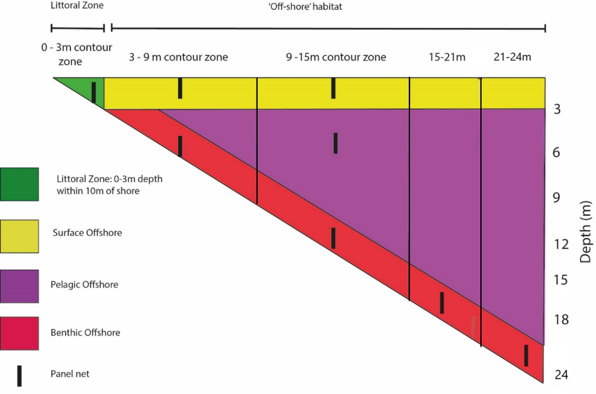
Figure A20: Deployment of vertical panel gill nets to examine the distribution of Carp in relation to depth in storage waterbodies.

References
Bürkner, P.C. (2017). brms: An R package for Bayesian multilevel models using Stan. Journal of Statistical Software, 80(1), pp.1-28.
Edwards, E.A. and Twomey, K. (1982). Habitat suitability index models: common carp (No. 82/10.12). US Fish and Wildlife Service.García-Berthou 2001;
Horváth, L. (1985). Egg development (oogenesis) in the common carp (Cyprinus carpio L.). In Recent advances in aquaculture (pp. 31-77). Springer, Boston, MA.
Johnsen, P.B. and Hasler, A.D. (1977). Winter aggregations of carp (Cyprinus carpio) as revealed by ultrasonic tracking. Transactions of the American Fisheries Society 106, 556-559.
Otis, K.J. and Weber, J.J. (1982). Movement of carp in the Lake Winnebago system determined by radio telemetry (No. 134). Department of Natural Resources.
Penne, C.R. and Pierce, C.L. (2008). Seasonal distribution, aggregation, and habitat selection of common carp in Clear Lake, Iowa. Transactions of the American Fisheries Society 137, 1050-1062.
Swee, U.B. and McCrimmon, H.R. (1966). Reproductive biology of the carp, Cyprinus carpio L., in Lake St. Lawrence, Ontario. Transactions of the American Fisheries Society 95, 372-380.
Taylor, A.H., Tracey, S.R., Hartmann, K. and Patil, J.G. (2012). Exploiting seasonal habitat use of the common carp, Cyprinus carpio, in a lacustrine system for management and eradication. Marine and Freshwater Research 63, 587-597.

  - Appendix A11 – Estimating Irrigation and Western Australia biomasses
A11.1 Estimating Irrigation biomass
Overview
This appendix describes the method behind an estimation of carp biomass density for channels in Eastern Australia. A multiple step process was implemented:
- we created a GIS layer of channels reflecting possible carp habitat using a variety of spatial sources
- As no information was available on presence of water and channel width, we predicted water presence and channel width based on random sampling channel segments from aerial photographs.
- Using the predicted channel area, we estimated carp biomass based on multiple scenarios.
Methods
Creation of channel GIS layer for Carp
The irrigation GIS layer was developed as described in Section 3.2. Available mapping represented the channels as simple lines with no data to indicate width or volume.
Estimating channel area
No spatial data on channel size or probability of having water were available. Therefore, a random sample of 1,233 points along the channel network were measured for channel widths and water presence using Google Earth. These random points were spread over 28 irrigation districts. Approximately 72% of the spot locations had water visible with the largest channels being Backbone 04 in the Torrumbarry Irrigation Area (67m wide) and the Mulwala Canal (45m wide). The largest proportion of dry locations was observed in the Victorian Ouyen district (92% dry) and Murray Mallee (81% dry) where channels were decommissioned and replaced by pipelines in 2010-2014. The distribution of wetted widths and mapped length in each irrigation district was used to calculate the potential carp habitat area for each district.

Using these points, two separate models were run to predict probability of a segment having water and if so, what is the predicted channel width. Little spatial information was available to use as predictors in the model. For our analysis, we hypothesized that channels in the same irrigation network would be more similar, both in size and probability of being wet. Additionally, we asked if longer segments had higher probability of having water. For the first model, we ran a generalised additive model (GAM - binomial distribution) in which the presence of a dry channel was the response variable and irrigation network name was the predictor. Using this model, we predicted probability of a channel being dry. For any network not sampled, we set the dryness probability to the average dryness across all irrigation networks.
For channel width, we included only channels that had water (width > 0) and then ran a GAM with a Gaussian distribution. Width was log-transformed to normalise the variation. Again, irrigation network name was the predictor variable. Similar to before, any irrigation networks not sampled were assigned the mean width across all sampled regions.

Results
Estimating channel area
For both models, including irrigation networks and length of segment explained a substantial portion of the variance (~50%; Table A11.1.1). Overall, irrigation networks accounted for the vast majority of that variance (>90%).
Using these models, we predicted probability of being dry and channel width if wet (Figure A11.1.1). Finally, we estimated the mean total area of channel by multiplying segment length (km) by width (converted to km) by probability of being wet ( 1- P(dry) ). Adding up all the segments resulted in an estimate of 117 $km^{2}$.
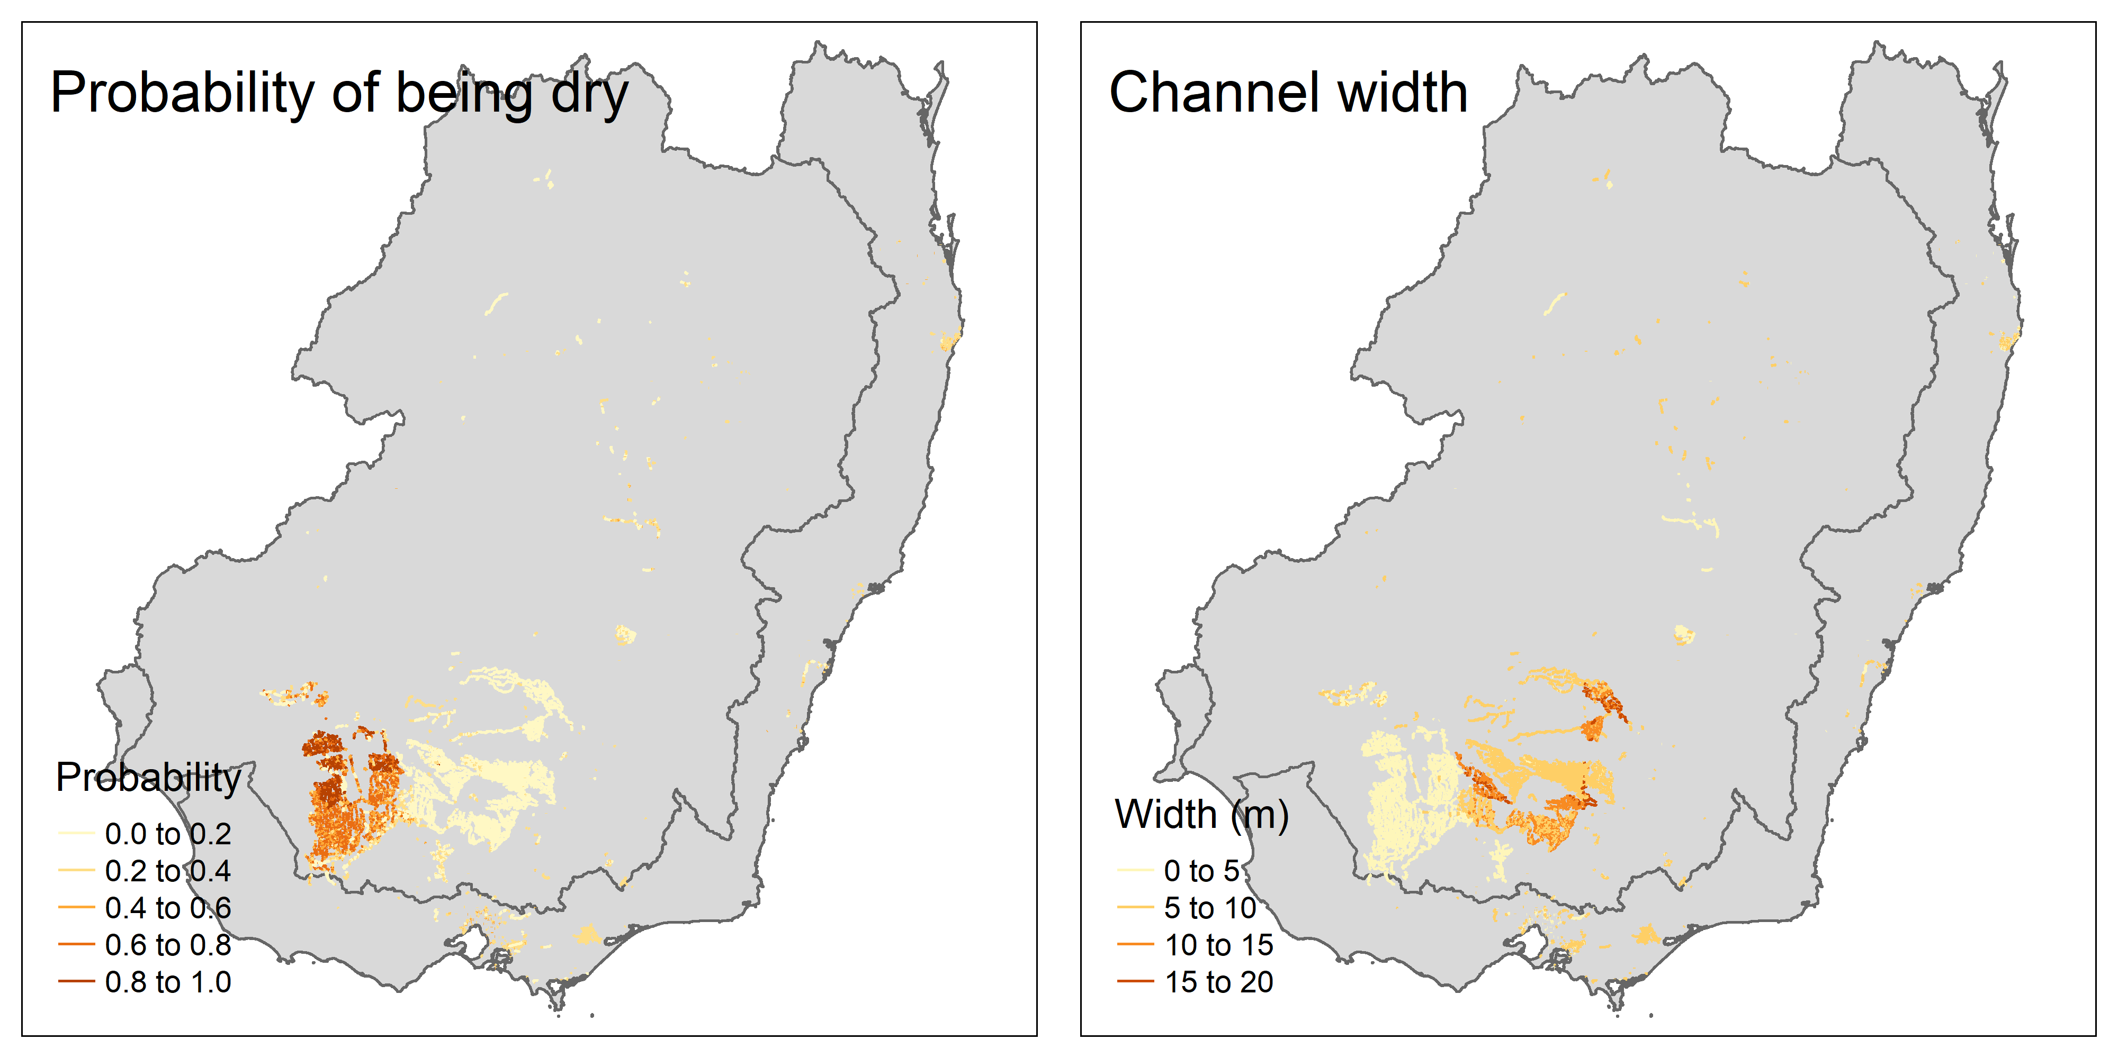

Figure A11.1.1: Predicted probability of being dry and channel width. Colours indicate different dryness probabilities and channel widths (m).

Table A11.1.1: Statistical models for probability of being dry and channel width.
Variable | R² | Term | EDF | Statistic | P-value
dry | 47.6% | s(lengthkm) | 2.1 | 5.480 | 0.11
 |  | s(irrigation) | 25.2 | 281.260 | <0.001
width | 55.8% | s(lengthkm) | 4.9 | 11.660 | <0.001
 |  | s(irrigation) | 24.6 | 29.550 | <0.001

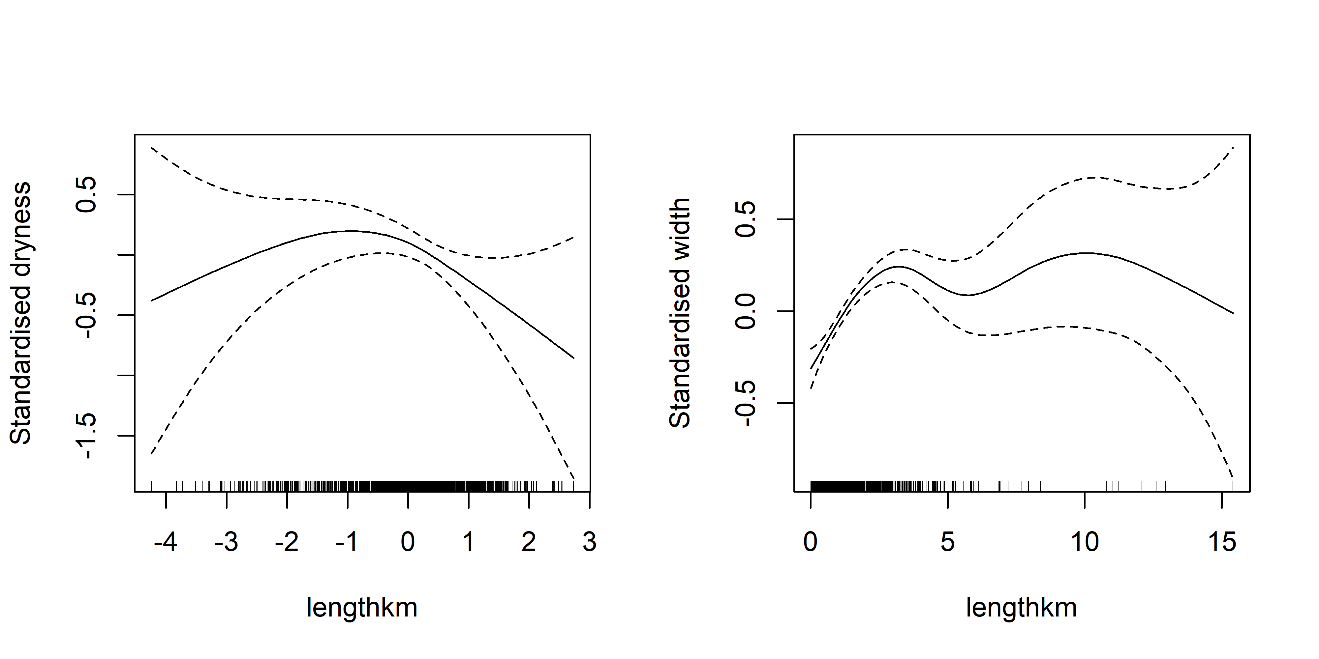
Estimating carp biomass
Using varying levels of carp density, we estimated biomass (tonnes; Table A11.1.2).

Table A11.1.2: Estimates of carp biomass (tonnes)
Scenario | Biomass kg/ha | Total area (km²) | Total biomass tonnes
Low | 50 | 117 | 585
Medium | 150 | 117 | 1,755
High | 300 | 117 | 3,510

Discussion
Several caveats should be acknowledged in the above analysis:
- The spatial layer was coarse and incomplete. The presented layer was missing spatial features and presents channels that do not exist anymore. The above spatial layer should be seen as a reasonable starting point for thinking about channels, but much more could be done in future projects
- Estimating channel widths from Google Earth aerial photographs used to measure width have several issues: 1) these photographs reflect a single temporal snapshot and 2) measuring small distances will have large uncertainty.
- Though our models did account for 50% of the variation, there was still large uncertainties in the estimates. With more time and money, better models could be construct that utilised structural information about the channel structures and potential spatial information. The complex branching and joining of the channel systems complicates simple branching algorithm used for systems like rivers.
- Additionally, there are substantial uncertainties to what extent carp may inhabit the channel systems and what the population dynamics are like. Do carp densities in channel reflect neighbouring river systems and the systems fairly independent? How much recruitment happens in channel systems?
Because of the large uncertainties and difficulty to quantity the uncertainty, we do not attempt to present confidence intervals for our estimates. The estimates should be viewed as ballpark estimates to allow some idea of potential carp biomass in relation to our other estimates.

A11.2 Estimating Western Australia
Overview
This section described the approach to estimating carp biomass for Western Australia.
Methods
The approach for Western Australia had the following main steps. First, we used expert opinion and presence/absence data to construct a spatial layer representing possible spatial extent of carp in Western Australia (See Section 3.2 for details; Figure A11.2.1). Second, we used the BRT model trained on Eastern Australia rivers to predict river widths for Western Australia (See Appendix A2 for BRT methods). To provide a measure of fit for the BRT model, we randomly selected 30 segments from the WA shapefile and measured the river width of a random point on segment using Google aerial photographs. We then assessed the relationship between predicted and aerially measured widths. Finally, we estimated carp biomass assuming constant density across river and waterbodies.

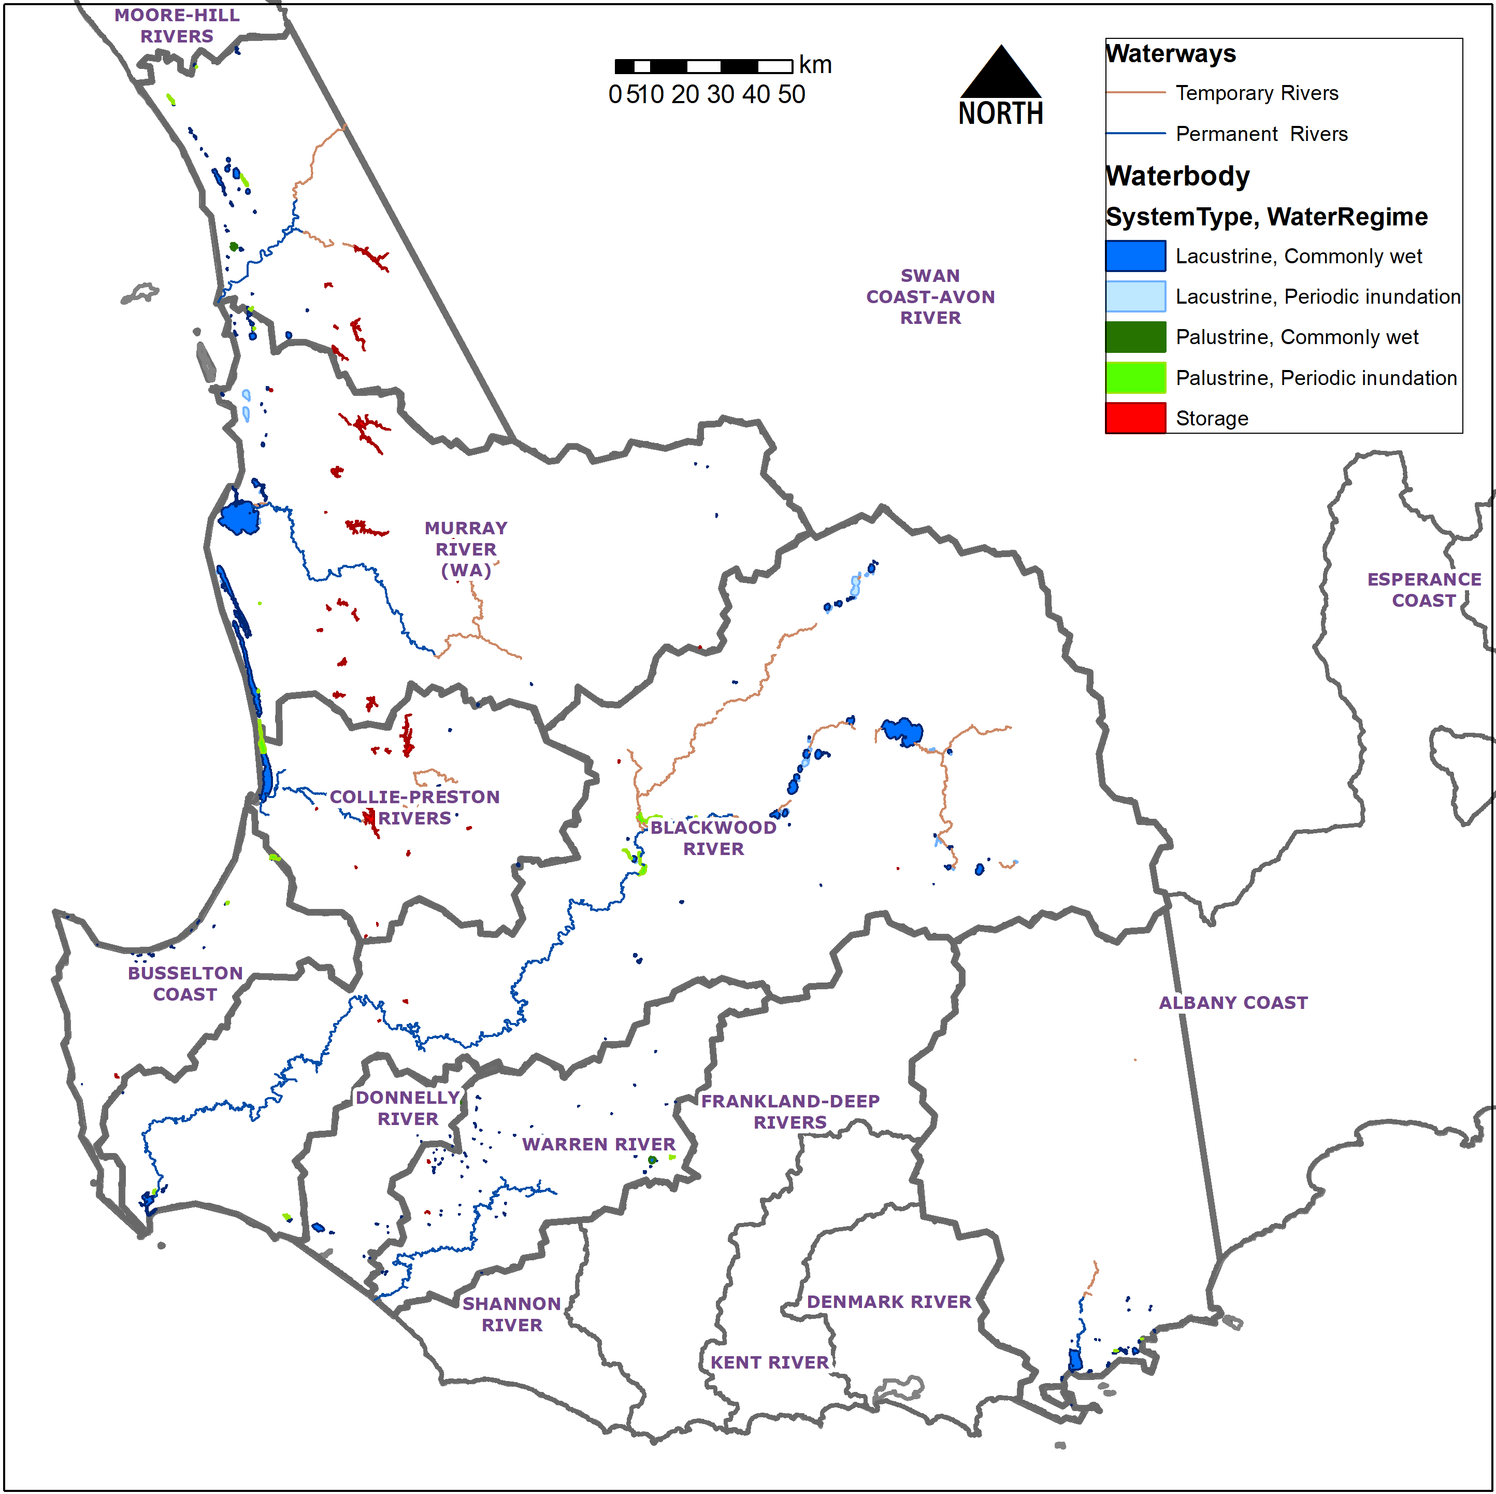

Figure A11.2.1: Western Australia map showing rivers and waterbodies (classified by type) showing suspected carp distribution.

Results
For the predicted river widths, we found in general agreement in predicted and measured widths, except for large discrepancies near the mouth of rivers (the two largest measured points shown in Figure A11.2.2a). Without the two outliers, the Pearson correlation was 0.66. Some obvious clumping (remaining correlations) were present and were due to points being from the same river and hence leads to consistent overestimating or underestimating of the estimates.
Using the predicted widths and calculating predicted area, we obtain the area estimates of 2 775 ha for rivers and 50 076 ha for waterbodies. The different carp density scenarios and resulting biomass estimates are shown in Table A11.2.1.
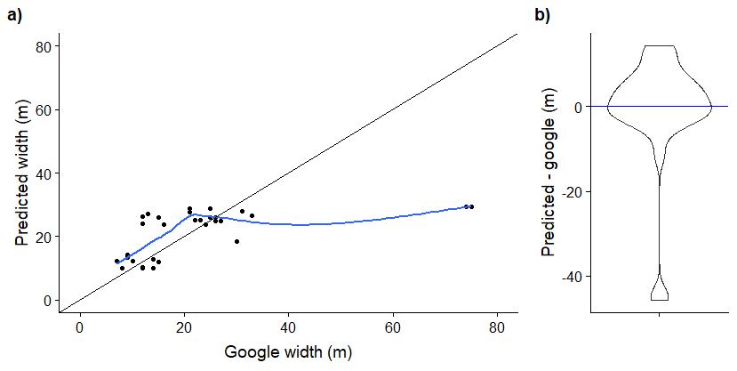

Figure A11.2.2. Comparison between predicted river width and measured widths from Google aerial images. Panel a) shows relationship between Google measurements and predicted measurements with the black line shows 1:1 relationship and blue line showing LOESS curve. Panel b) shows difference in meters between predicted and google as a violin plot.

Table A11.2.1: Biomass estimates for various density scenarios.
Scenario | Biomass kg/ha | Total area (km²) | Total Biomass tonnes
Low | 50 | 528.5 | 2 643
Medium | 150 | 528.5 | 7 927
High | 300 | 528.5 | 15 855

Discussion
The Western Australia biomass estimates obviously should be taken as a very coarse estimate. Without good data on actual carp distributions, no catch rate (CPUE) data, and no specific river width model for Western Australia rivers, the estimate is highly uncertain. Improvement in the estimates could be improved by addressing all three of these areas.

  - Appendix A12 - State biomass maps
We provide biomass maps for each state. For each state, we created a 1km buffer around the state boundaries and clipped the river and waterbodies using the buffer.
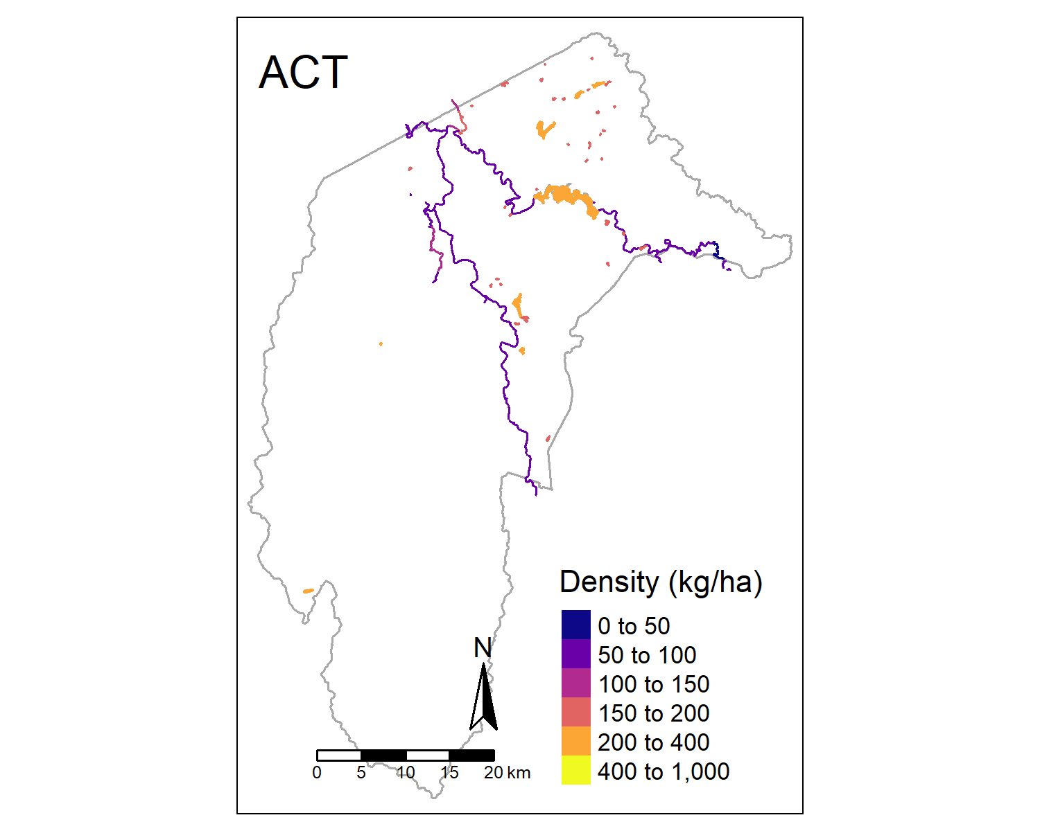

Figure A21: ACT state biomass map.

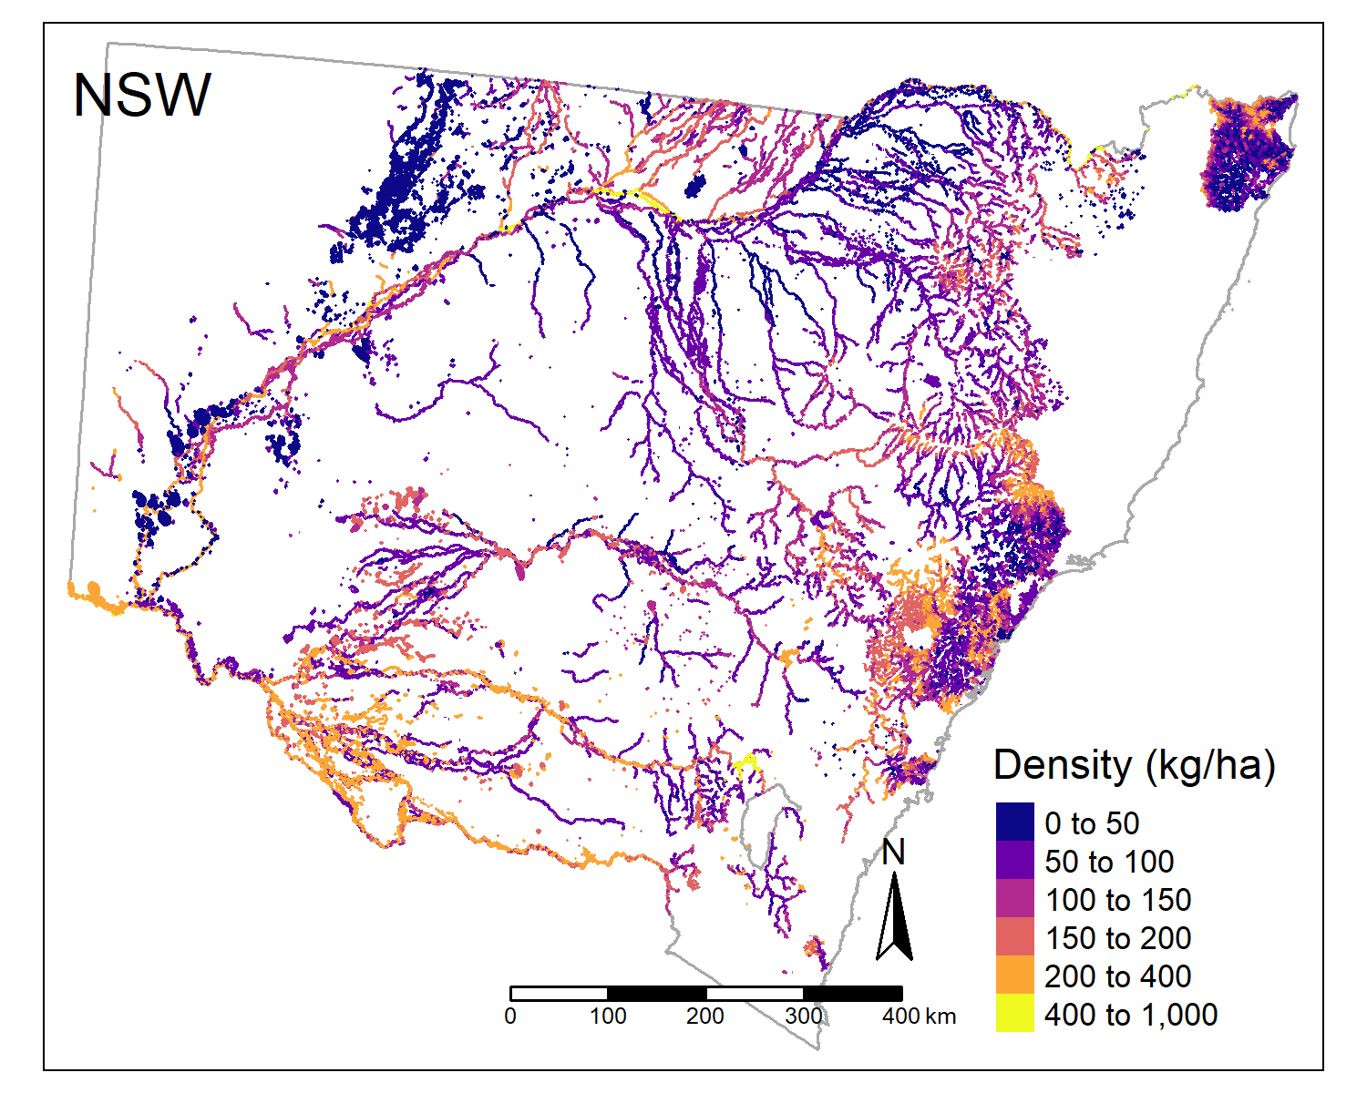

Figure A22: New South Wales state biomass map.
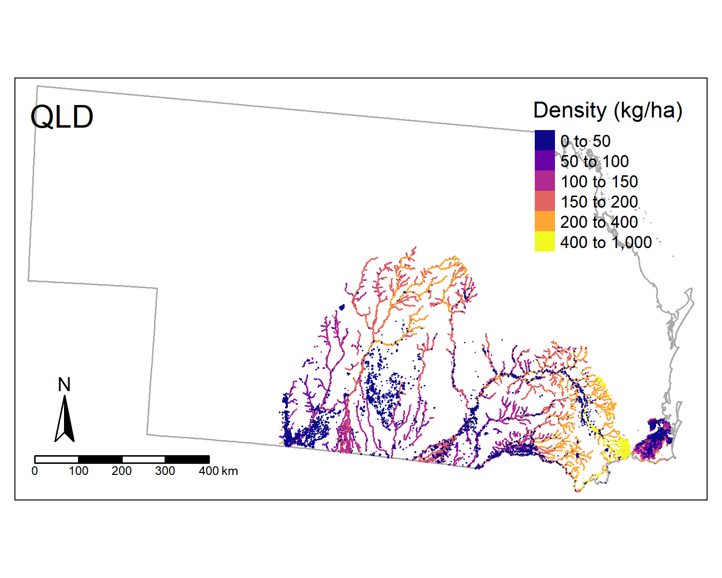
Figure A23: Queensland state biomass map.
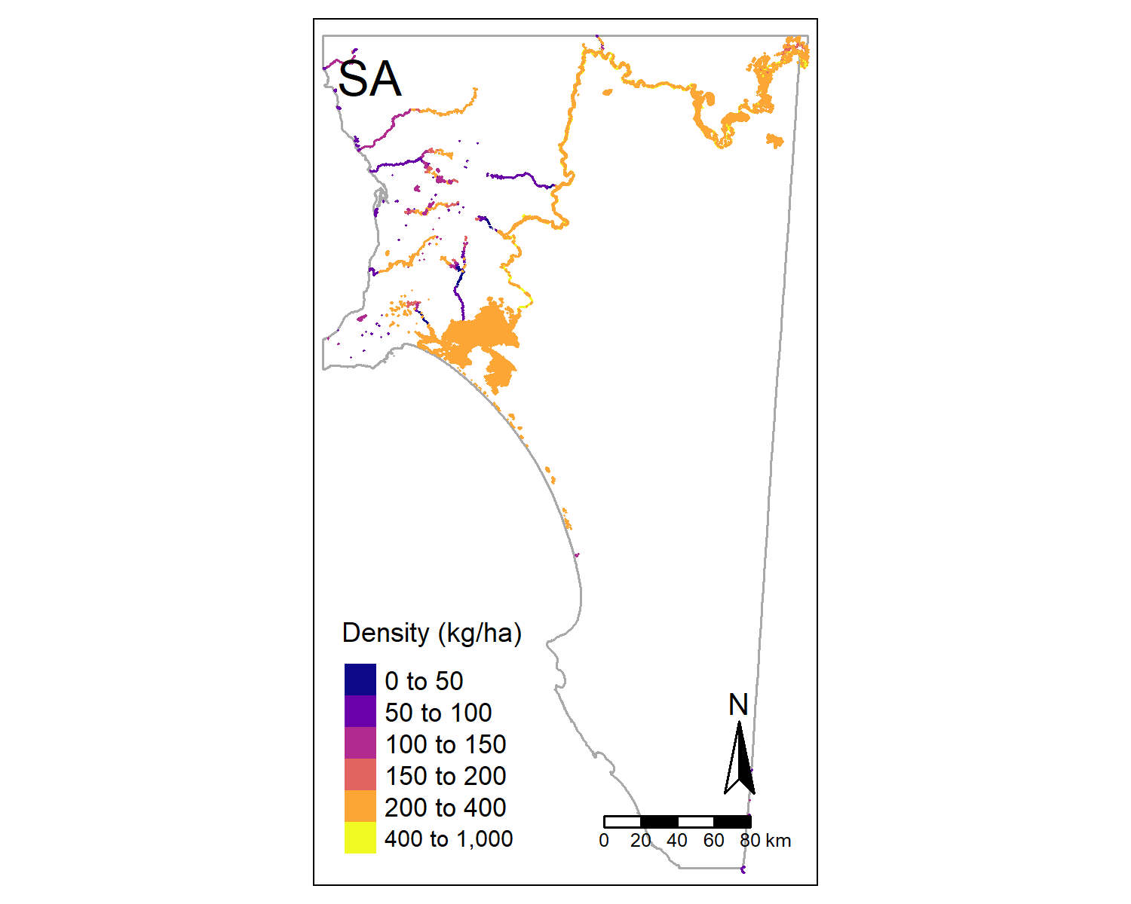

Figure A24: South Australia state biomass map.

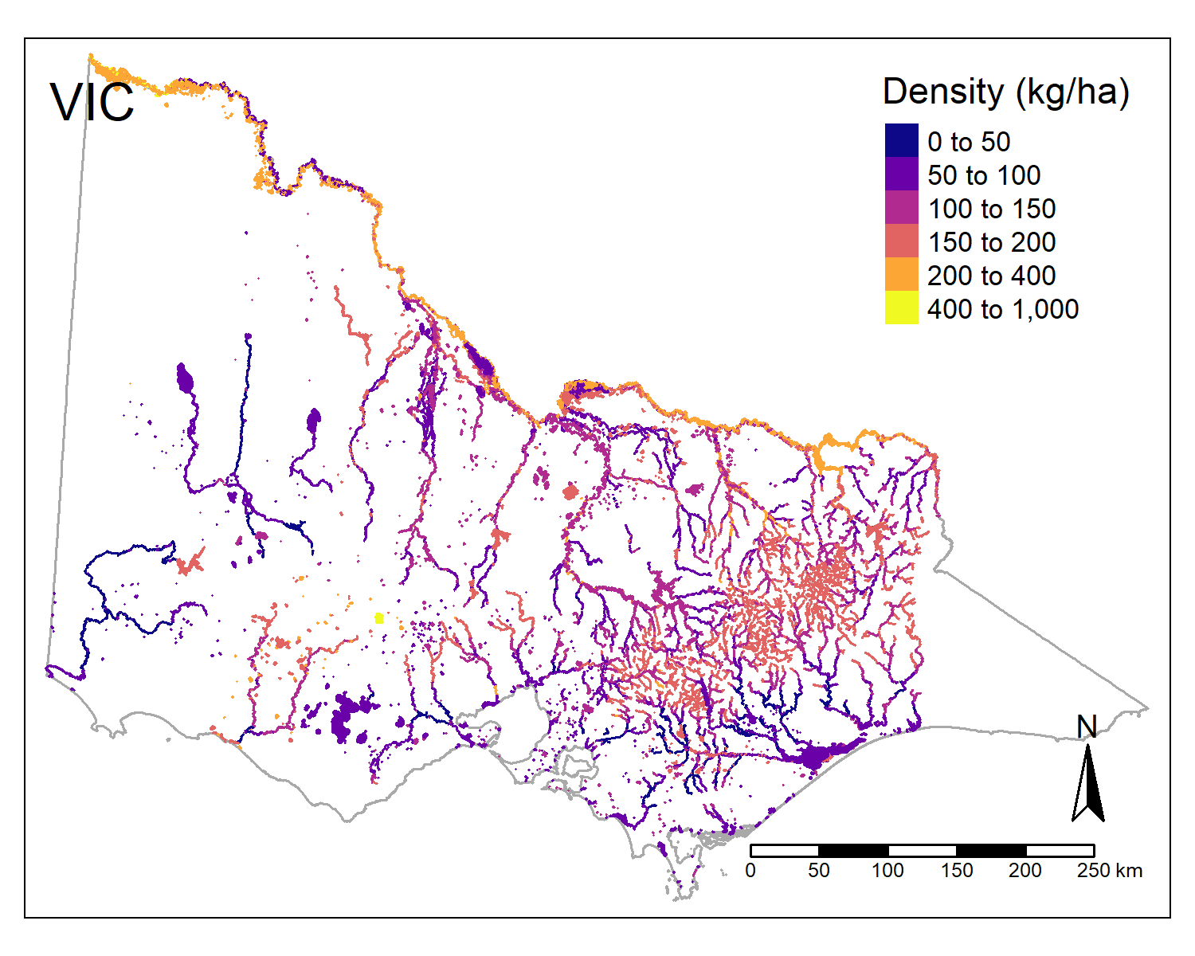

Figure A25: Victoria state biomass map.

  - Appendix A13: Site photographs
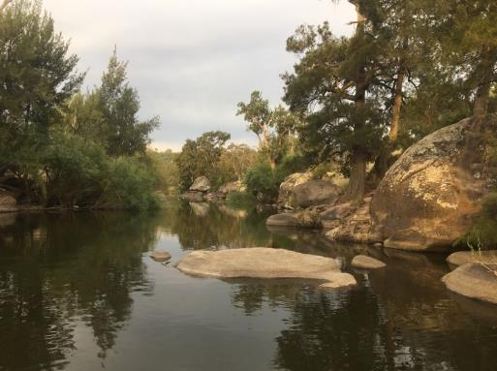
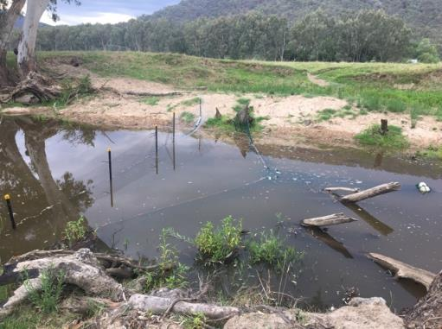
(b)
(a)

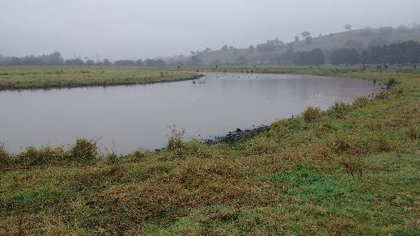
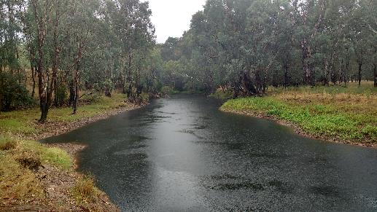

(d)
(c)

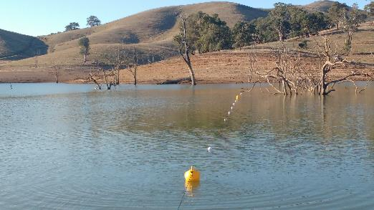
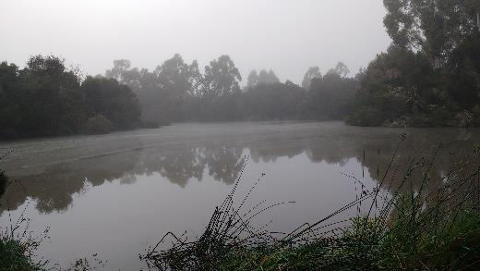
(f)
(e)

Figure A26. Detection experiment sites on: (a) Jingellic Creek (NSW), (b) the Macquarie River (NSW), (c) the King River (Vic), (d) Yarra Glen wetland, (e) Morwell wetland, and (f) Eildon Dam (Vic).
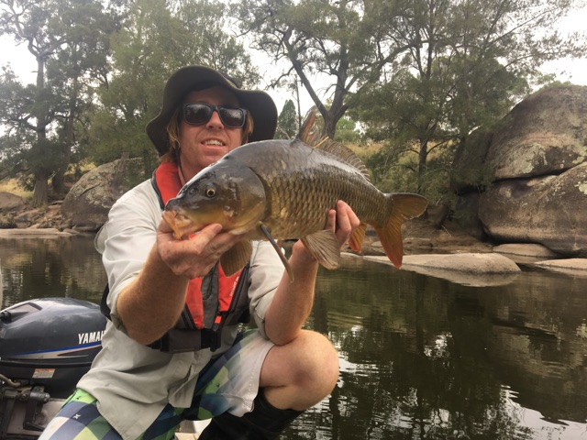

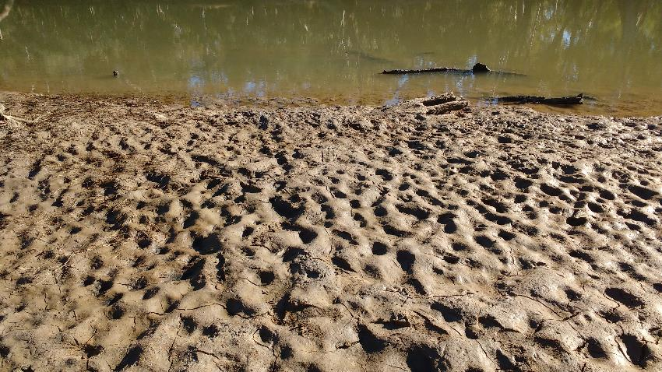

Figure A27. (Top) Tagged Carp from the detection efficiency trial and (Bottom) Carp damage in the lower Ovens River.

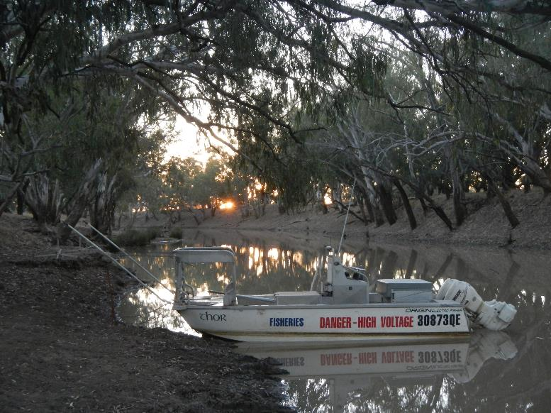

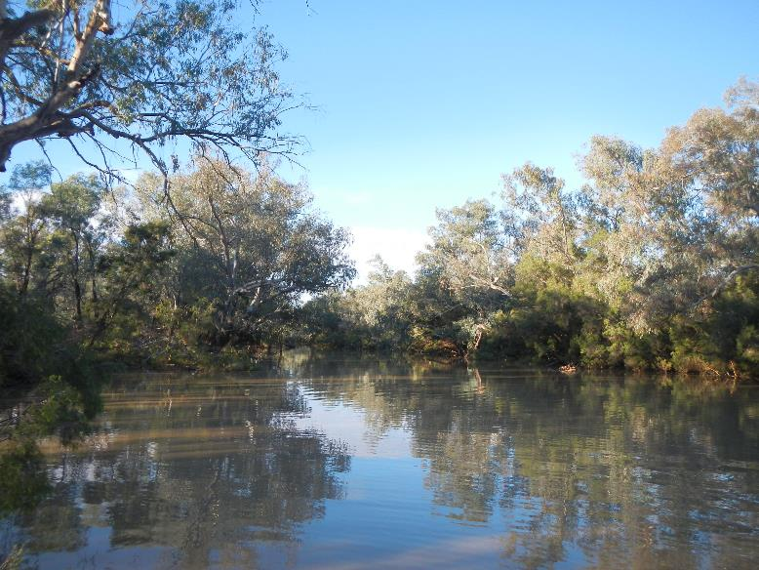

Figure A28. Sampling sites on the Moonie and Warrego rivers, Queensland.
Macquarie River (NSW)

