|  |
| --- |
| Stock Exclusion Fencing:  Improving native vegetation |
| Why is stock exclusion important? |

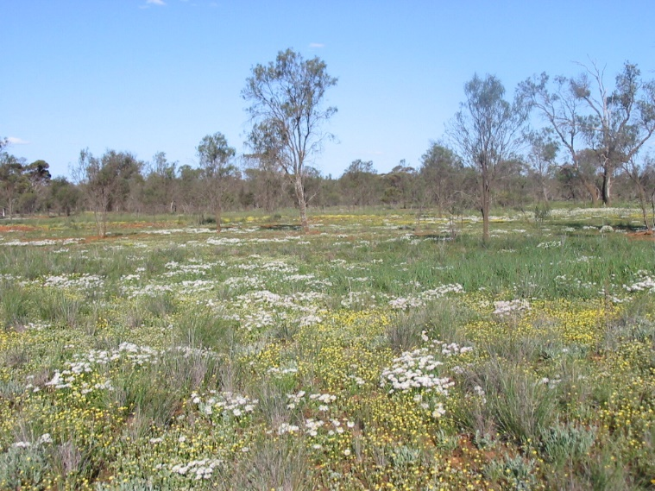



## Key points

* Stock exclusion fencing is an effective mangament action that can improve or maintain native vegetation
* Many factors drive the recovery of native vegetation in stock excluded areas (e.g. rainfall, region, remnant shape)
* Only through long term monitoring can we better understand how we can best manage native vegetation on private land



## Native vegetation on private land

Almost one third (approximately 3 million hectares) of Victoria's remaining native vegetation is on private land, much of which is of high conservation significance.

Native vegetation on private land supports 30% of Victoria's threatened species populations, and provides many ecological services such as, erosion control and improved water quality.

Hence, the management of native vegetation on private land is important to maintain functioning ecosystems and is dependent on substantial efforts by private landholders.

Often private landholders are supported by a range of incentive and extension schemes.

|  |
| --- |
| One of the main threats to the retention of native vegetation on private land is inappropriate grazing by livestock |

## Impacts of inappropiate grazing

* Increased bare ground and subsequent erosion
* Soil compaction
* Bank erosion and nutrients in waterways
* Altered nutrient levels and increased run-off
* Decreased water quality
* Weed invasion
* Loss of grazing sensitive native plants
* Altered habitat for wildlife
* Reduced survival of native plants

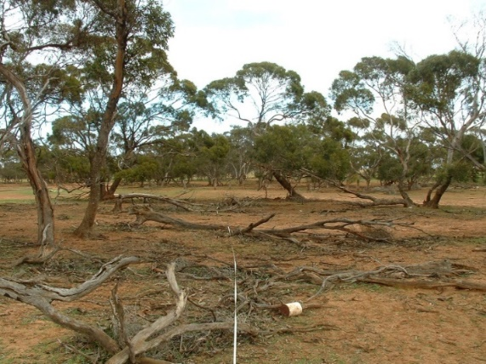

|  |
| --- |
| Stock exclusion fencing is one of the most effective management actions to protect native vegetation and wildlife habitat. It has great potential to improve native vegetation condition over the long-term. |

## Benefits of excluding livestock

* Protects native vegetation, rare plants and animals and areas of high value biodiversity
* Provides refuges from which native plants and animals can survive and recolonise
* Reduced soil compaction and erosion and leads to greater cover of native plants, which reduces the amount of bare ground and protects soil structure
* Increased habitat for native animals, including birds, reptiles, mammals and insects
* Increased ecosystem services such as, pest control, wind buffers, shelter and water quality
* Reduced rate of nutrient enrichment from manure and stock feed which in turn may reduce weed cover and leaves the livestock poo in the paddock where it is good fertiliser
* Increased aesthetic values

# Monitoring vegetation responses

Recent monitoring programs have shown the effectiveness of stock exclusion in maintaining or improving vegetation condition over time. These include:

* Increased native vegetation cover
* Increased number of native species
* Decreased bare ground
* Decreased weed cover

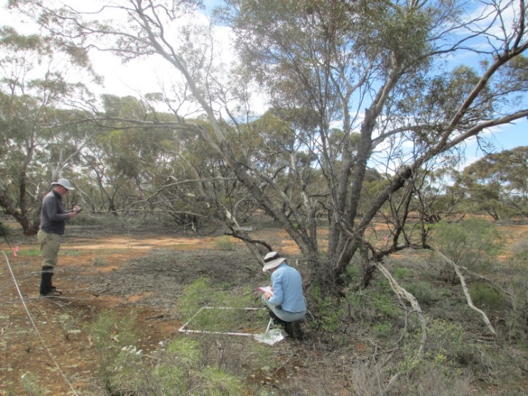

## Figure 2. Stock exclusion survey plot

## Recommendation

While many of the factors that influence vegetation, condition are outside of land holders control (rainfall, soil type etc.), stock exclusion fencing is a simple but effective management action that generally improves the vegetation health on private land.

|  |  |
| --- | --- |
| © The State of Victoria Department of Environment, Land, Water and Planning 2020  LogoThis work is licensed under a Creative Commons Attribution 4.0 International licence. You are free to re-use the work under that licence, on the condition that you credit the State of Victoria as author. The licence does not apply to any images, photographs or branding, including the Victorian Coat of Arms, the Victorian Government logo and the Department of Environment, Land, Water and Planning (DELWP) logo. To view a copy of this licence, visit http://creativecommons.org/licenses/by/4.0/  ISBN 978-1-76105-189-0 (print)  ISBN 978-1-76105-190-6 (pdf/online/MS word)  Disclaimer  This publication may be of assistance to you but the State of Victoria and its employees do not guarantee that the publication is without flaw of any kind or is wholly appropriate for your particular purposes and therefore disclaims all liability for any error, loss or other consequence which may arise from you relying on any information in this publication. | Accessibility  If you would like to receive this publication in an alternative format, please telephone the DELWP Customer Service Centre on 136186, email [customer.service@delwp.vic.gov.au](mailto:customer.service@delwp.vic.gov.au), or via the National Relay Service on 133 677 [www.relayservice.com.au](http://www.relayservice.com.au). This document is also available on the internet at [www.delwp.vic.gov.au](http://www.delwp.vic.gov.au). |

## Acknowledgements

This project was funded with support of the Victorian Government as part of the Biodiversity On-ground Action Adaptive Learning project.

## Further information

[research.ari@delwp.vic.gov.au](mailto:research.ari@delwp.vic.gov.au)

[ari.vic.gov.au](https://www.ari.vic.gov.au/)