|  |
| --- |
| Victorian semi-arid woodlands |
| Natural tree regeneration depends on rainfall and limited browsing |

**Key points:**

* Victorian semi-arid woodlands are severely degraded due to historical land use (e.g. grazing, clearing). Recovery is slow and inhibited by herbivore browsing.
* A long-term restoration program is underway to manage grazing pressure and improve woodland condition. However, understanding why there is limited natural tree regeneration and how to encourage recruitment is required.
* Monitoring has found that natural tree regeneration occurs following large rainfall events if grazing pressure is low. However, seed supply and seedling survival are still of concern.
* Active revegetation is required to supplement natural processes to ensure long-term survival.

Semi-arid (non-eucalypt) woodlands support a canopy of Belah (*Casuarina pauper*), Buloke (*Allocasuarina luehmannii*), Slender Cypress Pine (*Callitris gracilis*) or Sugarwood (*Myoporum platycarpum*) over a variable layer of small trees and shrubs (e.g. Cattle Bush, Wattles, Hakeas), with a ground layer of herbs, salt bushes and grasses (Figure 1).

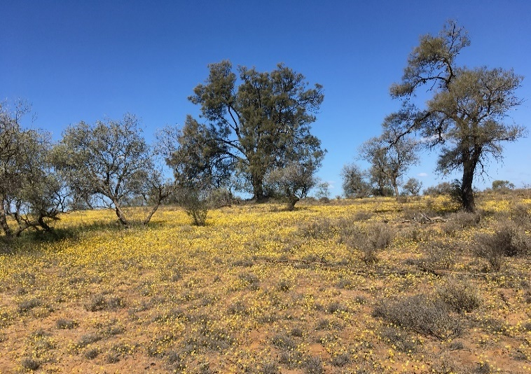

Figure 1: Semi-arid woodland in flower

Credit: S. Kenny, ARI.

The regeneration problem

Once widespread, today in Victoria, the largest stands occur within Mallee conservation reserves. These woodlands are under threat from incremental clearing, grazing by rabbits, goats and kangaroos, and weed invasion. As such most woodlands are degraded and composed of old trees with limited natural regeneration, threatening the long-term survival of these woodlands (Figure 2).

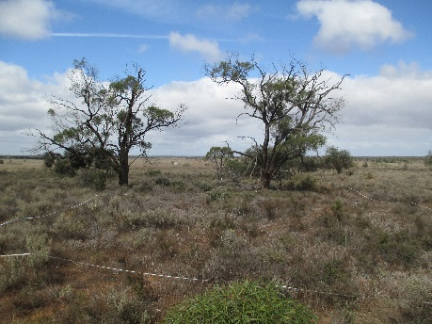

Figure 2: Severely degraded semi-arid woodland.

Credit: S. Kenny, ARI.

**Long-term persistence of semi-arid woodland trees are in jeopardy**

These slow-growing woodlands are reliant on high rainfall events to promote regeneration. Key to improving the woodland condition and long-term survival is understanding what is limiting tree regeneration, in order to better inform future management actions.

Regeneration cues are thought to be linked to above-average rainfall over at least one or two consecutive years. But this needs to coincide with low grazing pressure so that the highly palatable seedlings of these species are not grazed out (Figure 3).

Figure 3: Slender Cypress Pine juvenile ungrazed (left) and grazed (right). Credit: S. Kenny, ARI.

In the summer of 2012, 17 months after the mid-2010 breaking of the Millennium Drought, 310 semi-arid woodland sites were assessed across Murray-Sunset, Hattah-Kulkyne and Wyperfeld National Parks. Above average rainfall occurred in 12 of the 17 months between the drought breaking and assessment occurring.

We investigated if this above-average rainfall stimulated a tree germination pulse. We asked: is high rainfall alone enough to increase survival of juveniles or do other factors (e.g. grazing) also play a part?

# Regeneration findings

Seedlings and juveniles were present across the landscape (Figure 4). Several key trends were found:

* Seedling numbers increased with the number of adult trees and rainfall while decreasing with the level of herbivore grazing.
* High juvenile numbers were related to high rainfall, noting that this response was compromised by competition in areas with high understorey cover.
* There was a limited germination pulse for Belah, Buloke, Slender Cypress Pine and Sugarwood following the breaking of the Millennium Drought, suggesting that other factors are influencing germination and seedling survival for these species.
* The long-term survival of these semi-arid woodlands is in jeopardy without a concerted effort to improve condition through revegetation works, weed control and grazer management.

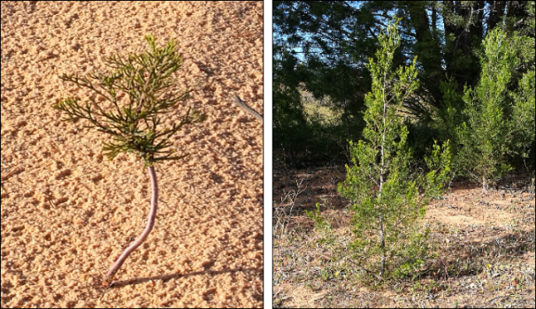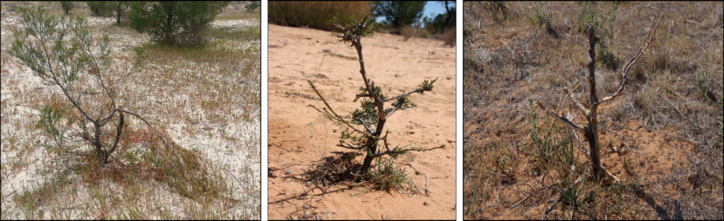

Figure 4: The number of seedlings and juveniles (top) and the percent of sites they were present at (bottom) for each tree species and in total.

## Ongoing monitoring

The outcomes of this study have informed a substantial revegetation project across the semi-arid woodlands of the Mallee (2013-2017, Parks Victoria). In addition, findings inform Parks Victoria’s Total Grazing Management (TGM) Plan, a long-term program which aims to improve the health of semi-arid woodlands.

The monitoring program associated with the plan is required to address a range of knowledge gaps and contribute to adaptive management and reporting.

## Acknowledgements

The Total Grazing Management Plan and semi-arid woodland monitoring program are funded by Parks Victoria and DELWP (Weeds and Pests on Public Land program: Mallee Bounceback). This monitoring is undertaken by the Arthur Rylah Institute for Environmental Research, Department of Environment, Land, Water and Planning (DELWP), Victoria.

## Further information

For more information about this project, please contact [research.ari@delwp.vic.gov.au](mailto:research.ari@delwp.vic.gov.au)

|  |
| --- |
| © The State of Victoria Department of Environment, Land, Water and Planning 2021Logo.  This work is licensed under a Creative Commons Attribution 4.0 International licence. To view a copy of this licence, visit http://creativecommons.org/licenses/by/4.0/  **ISBN** 978-1-76105-617-8 **(pdf/online/MS word)** |