|  |
| --- |
| Linear Grassland Reserves Program  Weed Control Monitoring Program |
| Who wins the battle for space after weed control in  critically endangered grassland remnants? |

**Key Points**

* Weed control is effective at reducing weed cover, only as long as it is maintained.
* Within the first year after weed control finished, weeds recovered.
* Weed control did not result in an increase of native species diversity or cover.
* Native species recovery in grasslands requires multiple recovery actions, weed control alone is inadequate.
* We need to experiment with a range of weed control and recovery actions, paired with long-term monitoring, to identify effective approaches to grassland restoration.



## Weed Control

Many **weeds pose a significant** **threat to high-quality native grasslands.** Weeds can reduce native plant diversity, threaten rare and endangered species, modify ground cover, and alter disturbance regimes (for example weeds can increase the risk and intensity of fire).

Native and weedy grassland plants are often densely mixed together. Therefore, **weed control is difficult** as some natives are killed to ensure most weeds are eradicated, or some weeds will be missed to avoid killing natives.

While control of high-threat weeds, using herbicides, is a commonly used grassland management activity, there is only **limited quantitative (i.e. measured) evidence** to demonstrate the positive effects of weed control for native grasslands.

## Natural Temperate Grasslands

Here we describe a monitoring program that is generating **new knowledge about** **the effectiveness of weed control** across 40 high-quality grassland remnants on Victorian Volcanic Plain (VVP) roadsides and rail lines in western Victoria.

**Natural temperate grassland is a critically endangered ecological community**

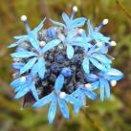

**Blue pincushion**

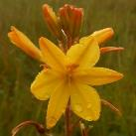

**Bulbine lily**

**Weed Control Monitoring Program**

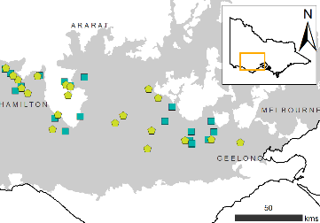

**Location of monitoring sites within the VVP**(squares – no weed control; pentagons – weed control)

This research is part of the **Linear Grassland Reserves Program** and was developed to examine the effectiveness of weed control actions on grassland biodiversity. The knowledge generated from the program will be used to improve grassland management and conservation outcomes.

**Native grasslands need to be monitored to determine if management improves grassland values (for example wildflowers, species diversity, cultural values)**

  
It was anticipated that weed control would reduce weed cover and that native species would be able occupy the space vacated by weeds.

**Project Timeline**

Project planning **(teal)** took place prior to monitoring. Baseline monitoring was established prior to weed control in spring 2014, followed by recurring weed control in autumn **(yellow)** and annual monitoring in spring. Final analysis and reporting **(purple)** occurred after three consecutive years of monitoring.

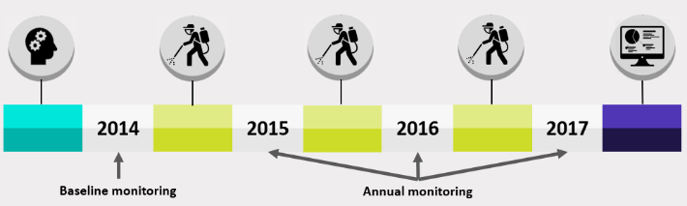



**Methods**

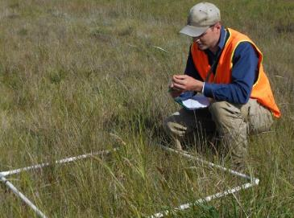

**ARI staff member conducting monitoring**

Detailed surveys of all plants were undertaken at the same locations each year (2014-2017).

Plant responses to weed control were examined by comparing the abundance and richness of plants in grassland sites with weed control against untreated control sites.

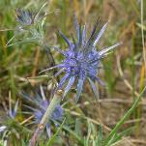

**Blue devil**

**Hoary Sunray**

**Plant Cover**

**Weed cover in sites with weed control decreased** by 37%, relative to untreated controls sites, in 2015. Subsequent weed control in 2016 maintained the difference in weed cover (Figure a).

**Weed cover in sites where weed control ended increased** by 34%, relative to sites where weed control continued. This indicates that **weed cover can quickly return when weed control ends** (Figure b).

**Native species (abundance or the number of species) did not change** after two consecutive years of weed control, or in the year after weed control ended.



**Knowledge Gap:**

Why don’t native plants respond to the reduction in weed cover during, or after, two years of weed control?





**Ground Cover**

**Litter and bare ground cover increased after weed control**. It appears that dead weeds turn into litter in the first year, and the following year that litter either blows away or breaks down, creating bare ground the following year.

**Biological soil crust cover declined after weed control**. While the driver of this pattern is unclear, it is a concern as biological soil crust (i.e. **moss, algae, lichen, bacteria, fungi**) is crucial for soil health. A disruption to soil health could lead to altered survival and recruitment of native species.

None of the ground covers (i.e. litter, bare ground or biological soil crust) changed in the first year after weed control ended.

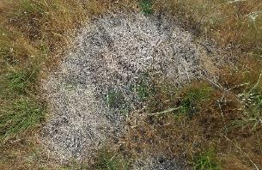

**A patch of target weeds sprayed with herbicide**

**Change in target weed abundance (cover %)**

**(a) During weed control: Two years of weed control (2015 and 2016)**. Weed control (black circles) vs. Untreated control (grey circles)

**(b) Once weed control ended: First year after weed control ended (2017).** Weed control (black diamonds; continuous weed control) vs. Weed control ended (grey diamonds; two years of weed control stopped after 2016)

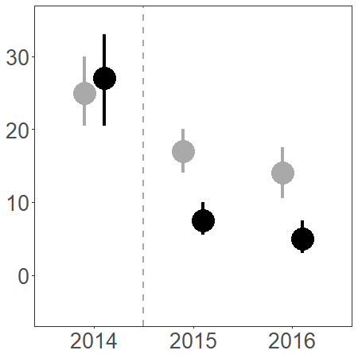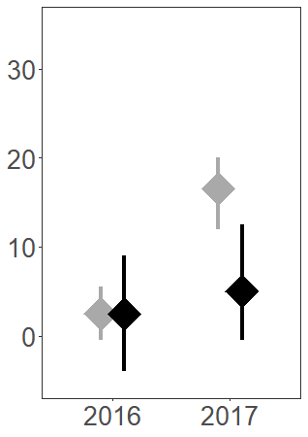

**b)**

**a)**

**Change in ground cover**

In the first year after the weed control program began (i.e. 2015) litter cover increased in weed control sites. This was followed by an increase in bare ground and a decrease in biological soil crust cover in the weed control sites the following year (i.e. 2016).

Dash symbols indicate no change. All comparisons are made to the pre-weed control state in 2014.

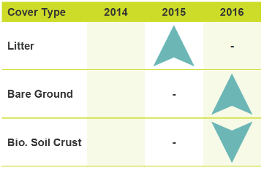

## Conclusions

**Weed control reduced weed cover by 37%** in the first year, which was maintained with continued weed control.

**Weeds began to return within the first year** after weed control stopped.

**Native grassland plants did not respond** to weed control during application, or in the year after weed control ended. However, two years may not be long enough for native plants to respond. Therefore, long-term monitoring is required to identify these patterns.

**Ground cover (litter, bare ground and biological soil crust) were all modified by weed control** and could have implications for native plant species recruitment.



## Acknowledgements

This Linear Grassland Reserves Program is a partnership between the Arthur Rylah Institute for Environmental Research (DELWP), Glenelg Hopkins CMA, Corangamite CMA, DELWP Regions and public land managers (VicRoads, local shires, CFA).

The program was administered by DELWP Barwon South West Region. Thanks to Ammie Jackson, Garry Peterson and Bryan Roberts for support with this project.

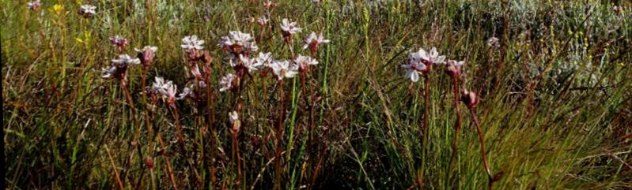

|  |  |
| --- | --- |
| © The State of Victoria Department of Environment, Land, Water and Planning 2021  LogoThis work is licensed under a Creative Commons Attribution 4.0 International licence. You are free to re-use the work under that licence, on the condition that you credit the State of Victoria as author. The licence does not apply to any images, photographs or branding, including the Victorian Coat of Arms, the Victorian Government logo and the Department of Environment, Land, Water and Planning (DELWP) logo. To view a copy of this licence, visit http://creativecommons.org/licenses/by/4.0/  ISBN 978-1-76105-668-0 (pdf/online/MS word)  Disclaimer  This publication may be of assistance to you but the State of Victoria and its employees do not guarantee that the publication is without flaw of any kind or is wholly appropriate for your particular purposes and therefore disclaims all liability for any error, loss or other consequence which may arise from you relying on any information in this publication. | Accessibility  If you would like to receive this publication in an alternative format, please telephone the DELWP Customer Service Centre on 136186, email [customer.service@delwp.vic.gov.au](mailto:customer.service@delwp.vic.gov.au), or via the National Relay Service on 133 677 [www.relayservice.com.au](http://www.relayservice.com.au). This document is also available on the internet at [www.delwp.vic.gov.au](http://www.delwp.vic.gov.au). |

## Lessons for Decision Makers

* Weed control can substantially reduce weed cover, but weeds can return if weed control ends.
* Native species showed no immediate response to weed control in grasslands.
* Additional management actions (e.g. fire) may be effective in facilitating a native species response.
* Longer-term monitoring is required to determine the effectiveness of weed control in VVP grasslands.

**These lessons would not have been possible without investment in ecological monitoring.**

## Further information

For more information about this research contact:   
Brad Farmilo (brad.farmilo@delwp.vic.gov.au)

