Background

|  |
| --- |
| Responses of large-bodied native fish to flows in the mid-Murray River |

The controlled management of water flows (river regulation) is a major threatening process to the ecological sustainability and integrity of rivers throughout the Murray-Darling Basin (MDB). To address such threats, water delivery is increasingly being planned to meet environmental needs. There is evidence that aspects of flow regimes are linked to important components of the life history of fish species, including their growth, spawning and recruitment.

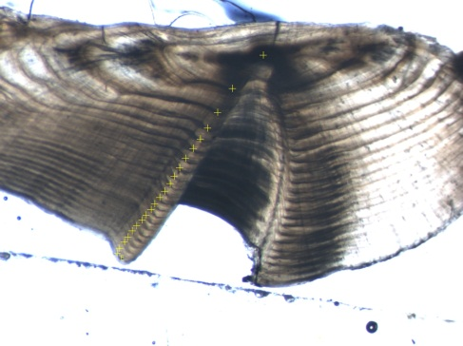Key fish populations, with recreational and cultural values, are often used as indicator or ‘flagship’ species for target setting and reporting on outcomes of such environmental watering. Our knowledge of how the various aspects of flow regimes affect the life history of fish species is incomplete however, particularly for long-lived species. This limits our ability to implement optimal environmental water delivery programs to enhance fish populations in the MDB.

In 2013, a project commenced to examine long term fish monitoring data to investigate linkages between flow regimes in rivers and the growth, recruitment and population responses of large-bodied fish.

An otolith from a 21 year old Trout cod

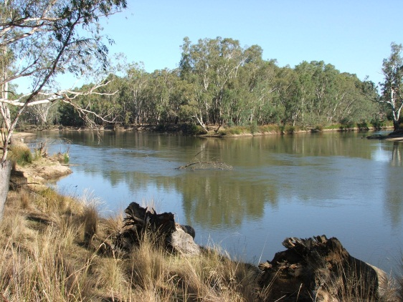

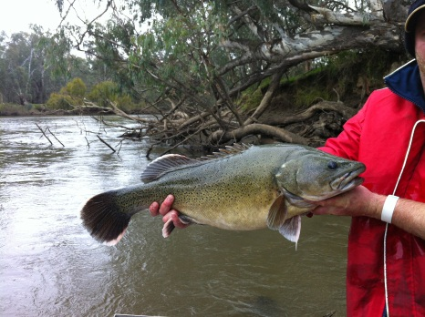

A Trout cod

Environmental water delivery helps native fish species

Environmental water delivery helps native fish species

Environmental water delivery helps native fish species

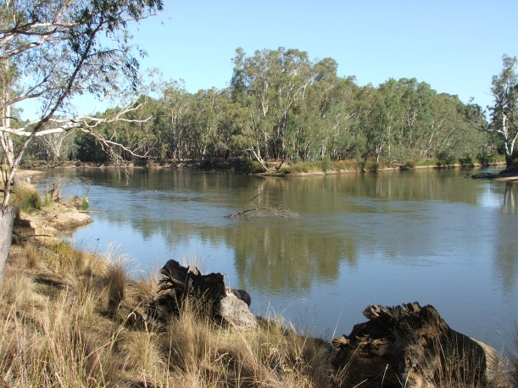

Monitoring a response

We investigated annual growth patterns of long-lived fish species, including the nationally endangered Trout cod, Murray cod and golden perchin both the regulated Murray River and unregulated Ovens River. This involved examining growth bands on otoliths (ear bone of fish) to reconstruct annual fish growth over a 23-year period, encompassing times of major drought, flood and environmental water delivery. River flow data was then used to analyse the importance of key aspects of the flow regime in governing the growth of these fish species. We then compared our results between regulated and unregulated systems, and made projections of fish growth in the Murray River under a natural flow regime, and also under a regime with and without environmental water delivery.

What were the findings

Results indicated that several aspects of a rivers flow regime are important for large-bodied fish productivity in temperate floodplain rivers. Growth of all three fish species in the Murray River was greater in years when flow was higher and more variable, particularly in spring, summer and autumn. This same pattern occurred for Trout cod in the Ovens River.

Modelling predicted that Trout cod growth would be significantly higher under an unregulated flow regime, supporting the view that increased river regulation has been a major contributing factor in the decline of native fish populations in the Murray-Darling Basin.



Results also indicated that periods of high fish growth in the Murray River coincided with environmental water delivery. The project also revealed that it is important to consider past conditions when planning and measuring the responses of large-bodied fish species.

**These findings provide support and guidance for the effective use of environmental water to enhance fish productivity in Australian temperate floodplain rivers.**

This project was funded by The Living Murray, a joint initiative of Victorian, NSW, SA, ACT and Commonwealth governments, coordinated by the Murray-Darling Basin Authority. For more information, please contact Zeb.Tonkin@delwp.vic.gov.au

**These findings provide support and guidance for the effective use of environmental water to enhance fish productivity in Australian temperate floodplain rivers.**

**These findings provide support and guidance for the effective use of environmental water to enhance fish productivity in Australian temperate floodplain rivers.**