Barry Mountains Ark—
managing the Great Dividing Range
Long-footed Potoroo population 2007–2022

A. Robley, J. Thomson, G. Johnson,
E. Wemyss, L. Woodford and G. Melgaard

August 2023


Arthur Rylah Institute for Environmental Research
Technical Report Series No. 359

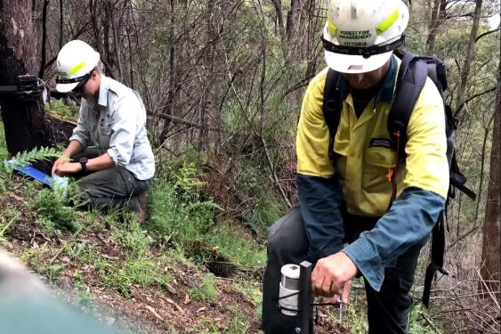

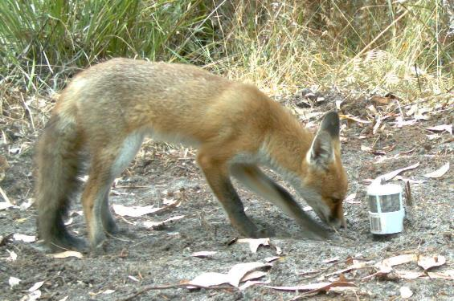
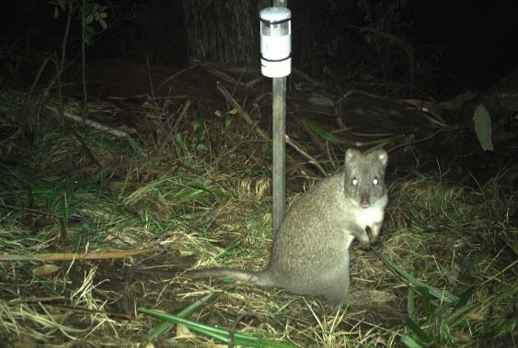


0

Acknowledgement
We acknowledge and respect Victorian Traditional Owners as the original custodians of Victoria’s land and waters, and their unique ability to care for Country and deep spiritual connection to it. We honour Elders past and present, whose knowledge and wisdom has ensured the continuation of culture and traditional practices.
We are committed to genuinely partnering, and meaningfully engaging, with Victoria’s Traditional Owners and Aboriginal communities to support the protection of Country, the maintenance of spiritual and cultural practices and their broader aspirations in the 21st century and beyond.

Arthur Rylah Institute for Environmental Research
Department of Energy, Environment and Climate Action
PO Box 137
Heidelberg, Victoria 3084
Phone (03) 9450 8600
Website: www.ari.vic.gov.au
Citation: Robley, A., Thomson, J., Johnson, G., Wemyss, E., Woodford, L. and Melgaard, G. (2023). Barry Mountains Ark—managing the Great Dividing Range Long-footed Potoroo population 2007–2022. Arthur Rylah Institute for Environmental Research Technical Report Series No. 359. Department of Energy, Environment and Climate Action, Heidelberg, Victoria.
Front cover photo: Clockwise: Barry Mountains (Buckland Valley); Red Fox; Long-footed Potoroo; DEECA staff setting cameras (DEECA).

© The State of Victoria Department of Energy, Environment and Climate Action 2023

This work is licensed under a Creative Commons Attribution 3.0 Australia licence. You are free to re-use the work under that licence, on the condition that you credit the State of Victoria as author. The licence does not apply to any images, photographs or branding, including the Victorian Coat of Arms, the Victorian Government logo, the Department of Energy, Environment and Climate Action logo and the Arthur Rylah Institute logo. To view a copy of this licence, visit http://creativecommons.org/licenses/by/3.0/au/deed.en
Printed by Print Room, Preston
Edited by Organic Editing (Jeanette Birtles)
ISSN 1835-3827 (print)
ISSN 1835-3835 (pdf)
ISBN 978-1-76136-260-6 (Print)
ISBN 978-1-76136-261-3 (pdf/online/MS word)

Disclaimer
This publication may be of assistance to you but the State of Victoria and its employees do not guarantee that the publication is without flaw of any kind or is wholly appropriate for your particular purposes and therefore disclaims all liability for any error, loss or other consequence which may arise from you relying on any information in this publication.

Accessibility
If you would like to receive this publication in an alternative format, please telephone the DEECA Customer Service Centre on 136 186, email customer.service@delwp.vic.gov.au or contact us via the National Relay Service on 133 677 or www.relayservice.com.au. This document is also available on the internet at www.deeca.vic.gov.au

Barry Mountains Ark—managing the Great Dividing Range Long-footed Potoroo population 2007–2022

Alan Robley¹, Jim Thomson¹, Glen Johnson², Elizabeth Wemyss², Luke Woodford¹ and Gavin Melgaard²

¹Arthur Rylah Institute for Environmental Research
123 Brown Street, Heidelberg, Victoria 3084
²Forest, Fire and Regions, Hume Region, Department of Energy, Environment and Climate Action
Nicholson Street, East Melbourne, Victoria 3000

Date

Arthur Rylah Institute for Environmental Research
Technical Report Series No. 359

Acknowledgements
This project was funded through the Victorian Government Bushfire Biodiversity Response and Recovery (BBRR) program (supporting Victoria’s bushfire-impacted wildlife and biodiversity), the Weeds and Pests on Public Land Program, and Parks Victoria. This funding was supported by the Australian Government's Bushfire Recovery Program for Wildlife and Their Habitat package.
Field work for the 2020–2022 sampling was undertaken by Jerry Alexander, Travis Applegarth, Nathan Beach, Brett Bouker, Nick Buckley, Mick Cafe, Kylie Croucher, Kaustuv Dahal, Pennie Keenes, Lachlan King, Vanessa Lucy, Damien McMaster, Gavin Melgaard, Keith Primrose, Nikki Sigmund, Ben Staker, Rhiannon Stute, Elizabeth Wemyss and Blair Yates from DEECA; Jim Craven, Remi Flynn-Lindsay, Zoey Godfrey, Thomas Grounds and Steph Riley from Parks Victoria; Lochlann Allen, Veronika Munar and Aiden O’Dempsey from BIIK Environmental; and Ben Collins from Charles Sturt University.
The 2007–2009 field sampling was undertaken by Ryan Chick, Katie Howard, Micaela Jemison, Ruth Lennie, Phoebe Macak, Dan Purdey, Manieka Reid and Luke Woodford (Arthur Rylah Institute) and Steve Coulson, Amie Douglas, Rena Gabrov, Laura Owen and Heidi Snow (Wildlife Unlimited). This component was led by Lindy Lumsden, with contributions from Jerry Alexander, Charlie Pascoe and Michael Scroggie. Funding was provided from the (then) Department of Sustainability and Environment, the (then) Department of the Environment and Water Resources, and Parks Victoria.
Earlier drafts of this report were improved by Lindy Lumsden and Dave Ramsey.

Contents
Acknowledgements ii
Glossary v
Summary 1
Context: 1
Aims: 1
Methods: 1
Results: 1
Conclusions and implications: 2
1 Introduction 3
2 Methods 5
2.1 Study area 5
2.2 The Expansion fox control program 2021–2022 6
2.3 Detecting native and introduced species 7
2.3.1 Data collection 7
2.4 Statistical analysis 9
2.4.1 Occupancy modelling 9
2.4.2 Native species naïve occupancy 12
3 Results 13
3.1 Long-footed Potoroo occupancy 13
3.2 Fox occupancy 17
3.3 Feral cat occupancy 19
3.4 Naïve occupancy of other native species 21
4 Discussion 22
4.1 Conclusion 24
References 25
Appendices 27

Tables
Table 1. Summary of camera trap survey effort and numbers (proportions) of Long-footed Potoroo, fox and feral cat detections from 2007 to 2022. 9
Table 2. Parameter estimates (posterior means and 95% credible intervals) and corresponding conditional odds ratios for three models of Long-footed Potoroo occupancy: Basic Trend Model, Best-supported Model (based on Bayesian variable selection), and Conditional Trend Model (trends conditioned on supported predictors for all years). 16
Table 3. Conditional odds ratios for Long-footed Potoroo occurrence in 2022 relative to 2007 within Core and Expansion zones based on the mean changes in predictor variable values within each zone, and the corresponding effect sizes estimated in the Best-supported Model. 16
Table 4. Parameter estimates (posterior mean and 95% credible intervals) and corresponding conditional odds ratios¹ for three models for foxes: Basic Trend Model, Best-supported Model (based on Bayesian variable selection), and Conditional Trend Model (trends conditioned on supported predictors for all years). 19
Table 5. Parameter estimates (posterior means and 95% credible intervals) and corresponding conditional odds ratios for the feral cats: Basic Trend Model for all years. 20

Figures
Figure 1. Map of the Barry Mountains Ark area. 5
Figure 2. The locations of baited tracks and roads used for the control of foxes in the Barry Mountains Ark program. 6
Figure 3. Locations of cameras used to survey changes in Long-footed Potoroo occupancy 2007–2022. 8
Figure 4. Estimated occupancy of Long-footed Potoroo in the Core and Expansion baiting zones in all surveyed years since 2007. 14
Figure 5. Estimated relationship between the probability of Long-footed Potoroo occurrence and modelled habitat suitability. 14
Figure 6. Estimated relationship between the probability of Long-footed Potoroo occupancy and time since fire, assuming average habitat quality (HDM value = 58). 15
Figure 7. Estimated relationship between the probability of Long-footed Potoroo occupancy and the number of years the site had been baited (within 1 km of the bait station), assuming average habitat quality (HDM value = 58) and time since fire (5.8 years). 15
Figure 8. Estimated occupancy (mean probability of occurrence) of foxes in the Core and Expansion baiting zones in all surveyed years since 2007. 18
Figure 9. Estimated relationship between the probability of fox occurrence and modelled habitat suitability for Long-footed Potoroos. 18
Figure 10. Estimated occupancy (mean probability of occurrence) of feral cats in the Core and Expansion baiting zones in all surveyed years since 2007. 20

Glossary
Occupancy = the average probability of occurrence and is equivalent to the expected proportion of sites at which the species (ever) occurs within a season. Occupancy is a landscape-scale metric indicating the proportion of all sites at which the species occurs.
For fox and cats, the proportion of sites visited (i.e., the proportion of sites at which the species ever occurs) is interpreted as their ‘occupancy’. Arguably, this is actually a measure of their activity across the landscape (i.e., the occurrence of a predator at a site indicates predatory activity).
Occurrence = species is present (occurs) at a site for some or all of the survey season (the spring of a given year). Occurrence is a site-scale metric indicating whether the species occurs at a particular site.

Summary

Context:
The Long-footed Potoroo (Potorous longipes) is currently known from only three isolated populations (in East Gippsland, north-eastern Victoria, and south-eastern New South Wales). The north-eastern Victorian population, referred to as the ‘Great Dividing Range population’ straddles the Great Dividing Range but is centred around the Barry Mountains.
The Long-footed Potoroo is listed as Endangered under both the Environment Protection and Biodiversity Conservation Act 1999 (Cth) and the Victorian Flora and Fauna Guarantee Act 1988, due to its limited range, low population density, vulnerability to predators like the Red Fox (Vulpes vulpes; ‘fox’), and to inappropriate fire regimes, and climate change.
In 2004, a fox control program was commenced centred on the Barry Mountains (the ‘Core’ baiting zone; 45,000 ha). This program continued until 2021. However, delivery was disrupted due to weather-related access issues, the impact of wildfires in 2006 and 2019/2020, and conflicts with recreational hunters. A revised Expansion program (~229,000 ha) was commenced in 2021. The Expansion and Core zones are known as the Barry Mountains Ark.

Aims:
The aims of this report are to assess:
(1) the trends in Long-footed Potoroo occupancy (proportion of sites occupied) from 2007 to 2022 in the Barry Mountains region
(2) the impacts of fire, feral predators [foxes and feral cats (Felis catus)], and fox baiting on Long-footed Potoroo occupancy in the Barry Mountains region
(3) the trends in fox and feral cat populations
(4) the initial changes in occurrence of a range of native species detected during surveys in 2020–2022.

Methods:
Camera traps were used to collect data on the presence or absence of Long-footed Potoroos, other native species, foxes, and feral cats. Camera traps were deployed in 2007–2009 and in 2020–2022. Each camera location was assigned to one of two fox baiting ‘treatment’ zones: Core (baited since 2007) or Expansion (baited since December 2021).
We analysed the combined camera survey data using hierarchical Bayes models to explore trends in Long-footed Potoroo occupancy, and associations between potoroo occupancy and fire history, habitat values, fox baiting, and various proxy measures of predator density.
The Long-footed Potoroo data comprised detection histories from a total of 591 camera trap locations (210 in the period 2007–2009 and 381 in the period 2020–2022). Fire history was derived from DEECA’s fire history overlay and fire severity models for the 2019/2020 fires. A Habitat Distribution Model (HDM) built in 2021 using historic Victorian Biodiversity Atlas records and all recent Long-footed Potoroo detections was used as an indicator of overall habitat suitability. Fox densities for the Core area and the Expansion area were predicted using individually based spatially explicit population modelling. The camera data included detection histories of foxes, cats, and native species.

Results:
Long-footed Potoroo occupancy was higher in the Core baiting zone and increased in both the Core and Expansion baiting zones over the full study period (2007–2022). Occupancy in both zones was strongly associated with habitat quality (HDM value), and increased with time since fire, and with the number of years of fox baiting within 1 kilometre of the site in question.
The estimated effect sizes (changes in the odds of each effect between 2007 and 2022) suggest that post-fire recovery is the largest contributor to positive trends in Long-footed Potoroo occupancy, potentially accounting for 12- and 4-fold increases in the odds of occurrence from 2007 to 2022 in the Core and Expansion zones, respectively. Ongoing fox baiting was also indicated as having had a substantial influence on occupancy within the Core zone: 15 years of fox baiting nearly tripled the odds of Long-footed Potoroo occupancy, assuming constant time since fire and constant HDM values.
Fox occurrence (visitation) was lower in the Core baiting zone than in the Expansion zone, and there was marginal evidence of declines in fox occurrence in both areas [Core baiting zone trend = –22% (95% credible interval: –49%, +2%) per annum; Expansion baiting zone trend = –12% (95% credible interval: –28%, +1%) per annum].
Two variables had strong support as predictors of fox occurrence: Long-footed Potoroo HDM value, and the presence of a fox baiting station within 1 kilometre of the survey site in the survey year. The odds of fox occurrence were ~70% lower at baited sites than at unbaited sites and declined with increasing Long-footed Potoroo HDM value. The negative association between foxes and HDM value was largely independent of baiting history: there was no interaction between HDM value and baiting, and negative HDM effects were evident in both the Expansion and Core zones.
There was marginal evidence that feral cats had higher occurrence in the Core baiting zone than in the Expansion zone in 2020–2022, but no evidence of trends in either the Core or Expansion baiting zones over time. Cat occurrence was not associated with time since fire, Long-footed Potoroo HDM, fox-occurrence, or fox baiting.
Seventy-one native species were detected on camera traps between 2020 and 2022. Naïve occupancy estimates (not taking into account detection probabilities) indicated that the rates of occurrence of several native species had increased from 2020 to 2022. Assessment of the drivers for these changes was outside the scope of this study, so further investigation is suggested.

Conclusions and implications:
The outcomes show that Long-footed Potoroo occupancy increased in both baiting zones, and at a faster rate in the Core zone, driven by both time since fire and the number of years of fox baiting. Higher HDM values were also a strong predictor of the occurrence of Long-footed Potoroos. These results reinforce the earlier finding that the longer-running Core baiting strategy has increased the occupancy of Long-footed Potoroos; they also indicate that the baiting strategy is reducing the occurrence of foxes and that Long-footed Potoroos are responding with increases in occupancy. The Expansion baiting operation has only been in effect for 2 years (data analysis effectively covering only 1 year post-baiting); therefore, more years of fox control and monitoring are required before the full effect of the Expansion program will be detectable.
Long-footed Potoroo occupancy showed a strong association with HDM value and with time since fire. The relationship with HDM was expected but confirms the usefulness of the HDM in identifying areas of suitable habitat. The association with time since fire suggests that fires impact Long-footed Potoroo either directly through increased mortality and/or indirectly by reducing the availability of habitat resources (e.g. cover from predators). This has potential implications for how the frequency of fire is managed in the landscape.
Understanding of what drives the occurrence of feral cats in the landscape remains elusive. While there was some evidence for feral cat occurrence being higher in the Core baiting zone, this was not strongly supported. It is, however, broadly in line with other research indicating increased feral cat occurrence (or activity) in areas with a history of ongoing fox suppression. The impact of feral cats on Long-footed Potoroo is poorly understood, but feral cats would be capable of preying on young at foot and on small juvenile potoroos. The impact of feral cats and their response to long-term fox control requires further investigation.
The monitoring program is scheduled to be repeated in 2023. The extra year’s data will be informative and should reduce the degree of uncertainty for some of the model outcomes. To maintain and improve on the gains made to date, the fox control program needs to be ongoing. Future monitoring should be undertaken annually or at least every 2 years. Continuation of the program will allow sufficient time for the Expansion baiting strategy to take effect, increase the certainty of the findings, and improve understanding of the environmental drivers of Long-footed Potoroo occupancy, and of the responses of foxes and (possibly) feral cats. It will also allow a more robust assessment of the changes observed in occupancy by other native species.
- Introduction
In the mesic forests of south-eastern Australia, mammal declines have been severe, with recent evidence suggesting that at least 21 species, mostly terrestrial, have experienced significant declines since European settlement (Bilney et al. 2010; Woinarski et al. 2014). Factors that are thought to have contributed to these declines include habitat alteration by timber harvesting, changed fire regimes, and predation by introduced carnivores. However, the relative contributions of these factors (and their interactions) to the decline of each particular species have been difficult to evaluate.
One species that has likely been impacted by these factors is the Long-footed Potoroo (Potorous longipes). The Long-footed Potoroo is listed as Endangered under both the Environment Protection and Biodiversity Conservation Act 1999 (Cth) and the Victorian Flora and Fauna Guarantee Act 1988. This conservation status is based on its restricted and fragmented distribution, its low population density and its vulnerability to predation by introduced Red Foxes (Vulpes vulpes; ‘foxes’), and possibly Dingoes (Canis familiaris; Jackson et al. 2017, 2019) and feral cats (Felis catus). Inappropriate fire regimes and climate change are also thought to be threatening processes (Brereton et al. 1995).
The first record of the Long-footed Potoroo being encountered by non-Indigenous people was in the late 1960s, but it was not formally described until 1980 (Seebeck and Johnston 1980). It is currently known from three apparently disjunct populations (in East Gippsland, north-eastern Victoria and south-eastern New South Wales). The first non-Indigenous record of the north-eastern Victorian population was in the Great Dividing Range area in 1995 (Jones and Johnson 1997). It is usually referred to as the ‘Great Dividing Range population’, as it straddles the Great Dividing Range, occurring in both the upper Ovens and Mitchell River catchments in the north-east and Gippsland, respectively, but appears centred around the Barry Mountains region within this area.
In 2004, a year-round fox baiting program began in the Barry Mountains to support conservation of the Great Dividing Range Long-footed Potoroo population. This program covered ~45,000 hectares (Robley et al. 2005), approximately two-thirds of the then known range of the Long-footed Potoroo in north-eastern Victoria. Conflict between the baiting program and deer hunters’ use of dogs for hunting curtailed the implementation of the baiting program on all land tenures, including National Parks, between 2009 and 2012. To manage the possible risk to dogs during the deer-hunting season (April–November), baiting for foxes was suspended in 2013–2014. Other impacts (such as disruption from fire, and logistical and staffing changes) also affected the delivery of the fox control program during this time.
Most of the known distribution of the Long-footed Potoroo within the Great Dividing Range population has been burnt in several large-scale bushfires. In 2003, the Alpine Fires burnt ~47% of the known range of the species, to varying degrees of severity. In 2006/2007, bushfires known as the Great Divide Fires burnt an estimated 86% of the known range of Long-footed Potoroos, with 32% of their range being burnt in both fires (Lumsden et al. 2012). The 2019/2020 Ovens Fire Complex, which affected extensive areas of north-eastern Victoria and Gippsland, is estimated to have burnt ~60% of their known range once again. Other smaller fires have likely had lower and more localised impacts within the Long-footed Potoroo’s range.
In 2004, a 5-year project was commenced to assess the status of the Great Dividing Range Long-footed Potoroo population, in relation to (i) the effects of the 2003 Alpine Fires and (ii) the current management of the species via protection zones and fox control. That project found that, as predicted, fox baiting had a suppressive effect on foxes. This, in turn, was matched by an increased probability of occupancy by Long-footed Potoroos, centred on the Barry Mountains (Lumsden et al. 2012). The project also found that Long-footed Potoroos mainly survived in unburnt or lightly scorched sites, although populations did utilise areas of burnt habitat and persisted in areas following broad-scale fire events. The long-term impacts of fire on this species, however, are unknown.
In 2019, Parks Victoria engaged the Arthur Rylah Institute for Environmental Research (ARI) to design and implement a survey to assess the status of Long-footed Potoroos in the Barry Mountains in relation to the fox control program. We deployed 120 camera traps in October 2020 across an area covering the Great Dividing Range population, both inside and outside fire-affected areas, within and external to the then baited area, and across sites predicted to have high and low habitat suitability for the Long-footed Potoroo.
Supported by funding from the Victorian Government for Bushfire Biodiversity Response and Recovery (BBRR) and from the Australian Government’s Bushfire Recovery Program for Wildlife and Their Habitat package, we constructed population models to predict the likely response of the Long-footed Potoroo population in the Barry Mountains to a proposed expanded (~229,000 ha) fox control program. By combining presence–absence data for Long-footed Potoroos, fox population models, habitat models for Long-footed Potoroos, 2019/2020 fire severity mapping, and population viability assessment, it was shown that an expanded baiting strategy was required for the reduction of fox densities, that potoroos were more than three times more likely to occur in unburnt areas than in areas that had been severely burnt, and that modelled potoroo populations had much lower extinction risks under the expanded fox baiting scenarios (Robley 2022). Based on the modelled outcomes for the expanded baiting strategy, the presence–absence data for potoroos, and the predicted impacts of severe fires of varying frequency, the likelihood of Long-footed Potoroos becoming locally extinct over 50 years was predicted to be very low (9%, i.e., the expanded baiting strategy offered the Long-footed Potoroo a improved chance of survival).
The Expansion baiting program was implemented in December 2021 in conjunction with an extensive camera trap monitoring program operating from 2020 to 2022. The Expansion fox control operation (Barry Mountains Ark) incorporates protection for hunting dogs. This baiting program operates on State Forest estate outside the April–November deer-hunting season, and on Parks Victoria estate baiting is undertaken year-round, access permitting.
We built an occupancy model for Long-footed Potoroos using data from 2007–2009 and 2020–2022 (post-2019/2020 fires) for assessing trends in Long-footed Potoroo occupancy (proportion of sites occupied) and for investigating the impacts of fire, feral predators (foxes and cats) and fox baiting on Long-footed Potoroo occupancy in the Barry Mountains region.
The findings provide guidance for public land managers in the development of management plans for Long-footed Potoroos and other species at risk from fox predation in the Barry Mountains. The fox – Long-footed Potoroo modelling reported here provides measurable targets for management actions and can guide adaptation of both the management actions and the methods of evaluation as new information becomes available.
- Methods
  - Study area
The study area is centred on the Barry Mountains (37.08322°S, 146.79989°E) in the Great Dividing Range region of north-eastern Victoria (Figure 1). It is an area of ~229,000 hectares and encompasses Abbeyard, Mount Selwyn, Mount Cobbler, the Buckland Valley, Demon Ridge and the old Wonnangatta Station areas. The study area was defined by the area that (i) encompassed the Habitat Distribution Model (HDM; Liu et al. 2013) for Long-footed Potoroos in the Great Dividing Range population, (ii) included land both inside and outside the 2019/2020 fire footprint and (iii) covered the proposed Expansion fox control strategy footprint.
The area contains a mix of Ecological Vegetation Classes, but all sites are located within the bioregions of ‘Victorian Alps’ and ‘Highlands – Northern Fall’. The area was extensively burnt in both the 2003 Alpine Fires and the 2006/2007 Great Divide fires and was partially burnt (with a mix of severity classes) in the 2019/2020 Ovens Fire Complex (Figure 1).
Internally, the area was divided into five management zones: four on State Forest and one on Parks Victoria estate (Figure 1). These management zones define the operational areas for the proposed Barry Mountains Ark fox control operations. See section 2.2 for details.
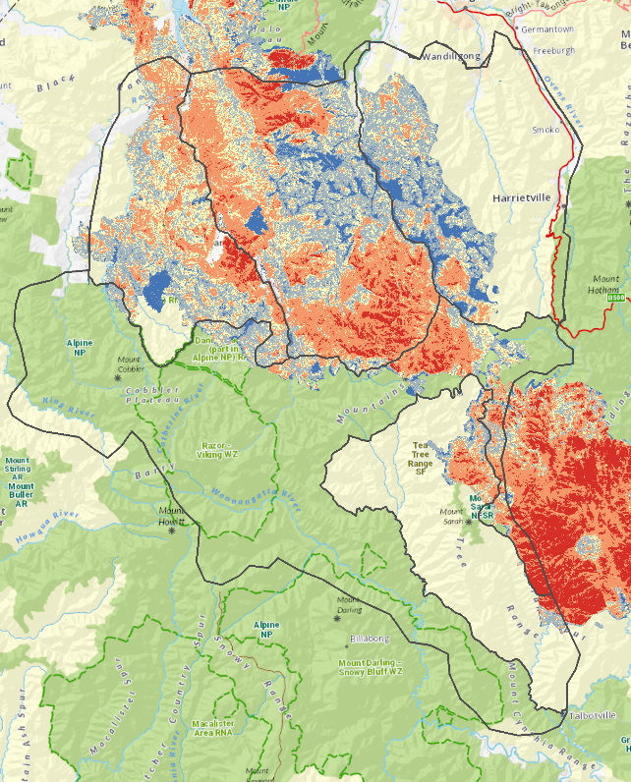
Figure 1. Map of the Barry Mountains Ark area.
Internal divisions indicate the location of the four State Forest zones (yellow background) and the Alpine National Park zone (green background). The map also shows the severity of the burn [red (severe) to light blue (unburnt within the fire footprint)] and the area burnt in the 2019/2020 Ovens Fire Complex.
  - The Expansion fox control program 2021–2022
A detailed description of the Barry Mountains Ark program has been provided by DELWP (2021). Here we summarise the main characteristics of the program.
Between 2004 and 2019, baiting was undertaken year-round in the Core baiting zone within the Alpine National Park (Figure 2); the Expansion baiting strategy commenced in December 2021. In the Expansion baiting strategy, the Alpine National Park and a small section of State Forest in the Tea-Tree Range is being baited year-round. In areas above 900 metres, baits are removed, and baiting is generally ceased in June/July or when snow conditions or other access factors dictate. In State Forest, bait is laid continuously from December to March inclusive only (i.e., outside deer-hunting season), and baiting is generally ceased above 900 metres when snow conditions or other access factors dictate.
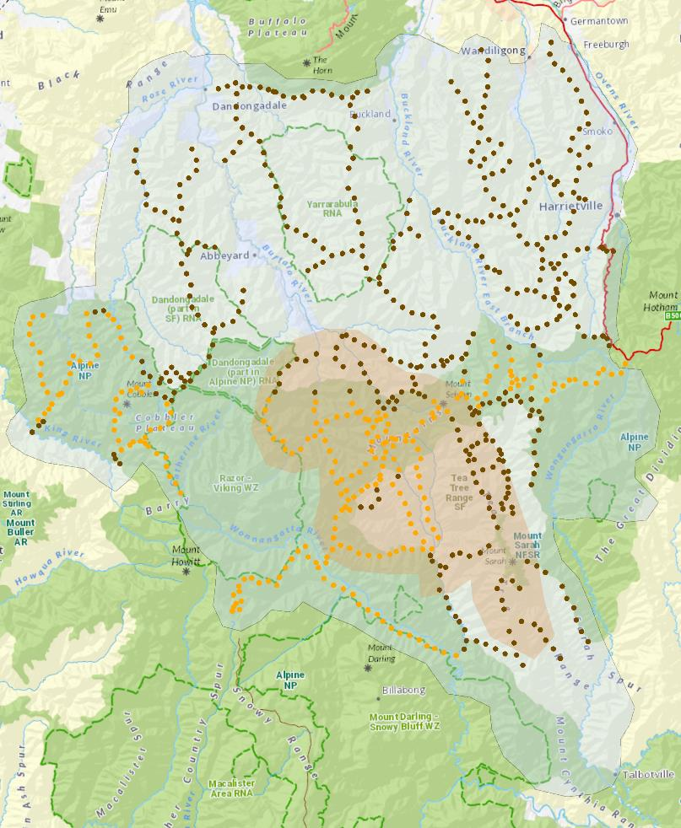
Figure 2. The locations of baited tracks and roads used for the control of foxes in the Barry Mountains Ark program.
Tan area = Core baiting zone (2003–2009); pale-blue area = Expansion baiting zone (December 2021–2022); brown dots indicate stations mostly in State Forest, operated predominantly outside the April–November deer-hunting season, access permitting; orange dots indicate stations mostly in the Alpine National Park, operated all year round, access permitting.
  - Detecting native and introduced species
    - Data collection
Camera trapping was undertaken over two periods: 2007–2009 (Lumsden et al. 2012; Lumsden et al. unpublished data) and 2020–2022. In general, camera traps were used to collect data on the presence or absence of Long-footed Potoroos, other native species, foxes, and feral cats. Each camera was set ~30 centimetres above ground, attached to a stake or tree, and facing south. A mammal lure was housed in a metal cage attached to a stake at 2 metres above ground level, or in PVC cowling and pegged to the ground, either set-up being placed ~2 metres in front of the camera. Standard mammal bait (a mixture of peanut butter, rolled oats, and golden syrup/honey) was used as the lure. Pistachio essence (Pistachio Nut Flavour E42174, Keith Harris & Co. Ltd, Thornleigh, New South Wales) was added to simulate the smell of hypogeal fungi – the primary food source of Long-footed Potoroos (Green et al. 1999).
The camera traps were first established in 2007–2009 as part of a 5-year project to assess the status of Long-footed Potoroos (Figure 3), coinciding with an existing fox control program focused on a Core baiting zone located in the Barry Mountains. The aims of a 3-year camera trap component of the study were to investigate the patterns of distribution and the status of the species, to understand the effects both of bushfires and of predator control on the population, and to evaluate the use of Special Management Areas as a conservation management tool for the species (Lumsden et al. 2012; Lumsden et al. unpublished). Sampling was stratified across ‘primary’, ‘secondary’ and ‘other’ habitats, based on previous information on the species’ preferences for particular Ecological Vegetation Classes. Sites were randomly selected, both within and outside the known distribution of the species in the Great Dividing Range area. Site selection included sites within and outside areas baited for foxes, and for each site remote-sensed mapped fire history, and on-site indices of fire severity were recorded. Two cameras were set at each site to increase the likelihood of detecting potoroos, and cameras were left in place for a minimum of 3 weeks. In the first 2 years TrailMAC cameras (Trail Sense Engineering, Middletown, Delaware, USA) were used, and in the final year PixController DigitalEye 7.2 Trail Cameras (PixController Inc., Export, Pennsylvania, USA) were used. A total of 271 sites were sampled over three successive late spring – autumn seasons; however, in some years not all cameras were operational. Of the 271 sites, we used a subset of 210 camera sites that were within the study boundary.
In October 2020, we established 120 camera trap sites at a subset of the 2007–2009 camera locations (using Reconyx cameras, models PC900 and HP2X, Reconyx Inc., WI USA) to assess the status of Long-footed Potoroos in the Barry Mountains. The sites were stratified by topographical position aspect, and fire intensity. Surveys were undertaken in October 2021 (n = 138) and October 2022 (n = 123) (Figure 3). The number of cameras varied each year, as additional camera sites were added to improve estimates, or some cameras failed to operate or were stolen.
We analysed the combined camera survey data [2007–2009 and 2020–2022 (post 2019/2020 fires)] to assess trends in Long-footed Potoroo occupancy (MacKenzie et al. 2017) and to investigate the impacts of fire, feral predators (foxes and cats) and fox baiting on Long-footed Potoroo occupancy in the Barry Mountains region. Camera trap data were available from both the Core and Expansion baiting zones (Figure 3) for a total of 5 years prior to baiting of the Expansion zone in December 2021 and in 2022 (2007–2009, 2020, 2021). This allowed a comparison of trends in Long-footed Potoroo occupancy between baited and unbaited areas prior to the Expansion program, and also an assessment of any immediate baiting impacts in the Expansion baiting zone (during 2022). Importantly, continued monitoring in both the Core and Expansion baiting zones will allow comparison of trends in Long-footed Potoroo occupancy between the pre- and post-Expansion baiting periods, and comparison of contemporary trends between the Core and Expansion baiting zones. This will provide a strong evidence base for assessing the ecological response to fox baiting.
Long-footed Potoroo data comprised detection histories from a total of 591 camera trap locations over the study period (210 over the period 2007–2009 in the Core baiting zone, and 388 over the period 2020–2022 in the Core and Expansion baiting zones; Table 1). Cameras were deployed for an average of 41 days and 36 days during the 2007–2009 and 2020–2022 periods, respectively. Most surveys in the period 2007–2009 involved deployment of two cameras per site, but some sites had only one camera operating for part or the whole of the annual survey. Surveys since 2020 involved deployment of only one camera per site.
Fire history was derived from DEECA’s fire history overlay and the Collins et al. (2021) fire severity model for the 2019/2020 fires. A Long-footed Potoroo HDM was built as an overall measure of habitat suitability, using historic Victorian Biodiversity Atlas (http://vba.dse.vic.gov.au/vba/#/) records and all Long-footed Potoroo detections up to 2021.
The camera data included detections of foxes and cats for all years. The 2020–2022 data also included detection histories for a range of other native species.
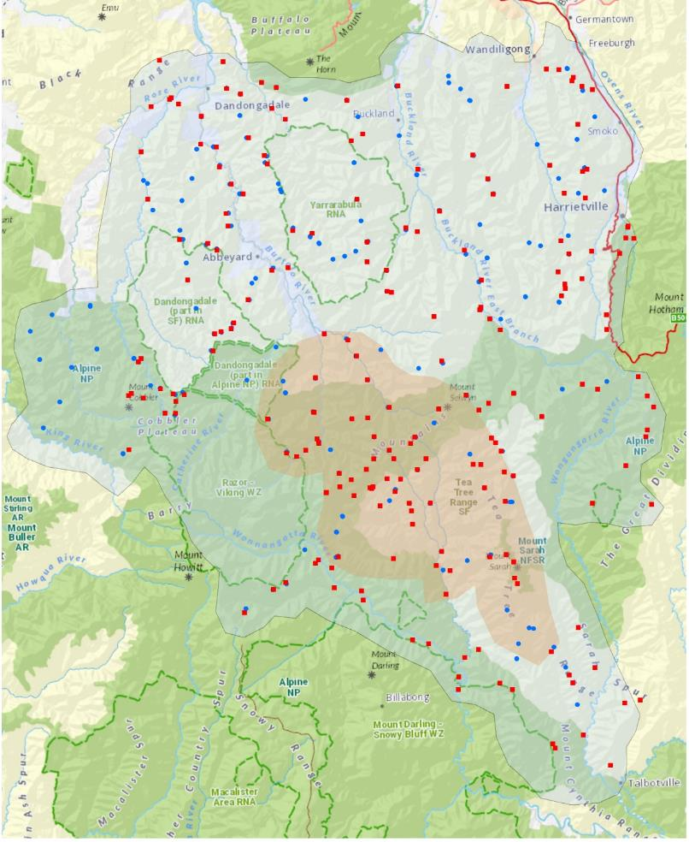
Figure 3. Locations of cameras used to survey changes in Long-footed Potoroo occupancy 2007–2022.
Tan shading: Core baiting zone; pale-blue shading: Expansion baiting zone. Red squares: camera locations 2007–2009; blue dots: camera locations 2020–2022. Note, some camera locations were the same in all years.
Table 1. Summary of camera trap survey effort and numbers (proportions) of Long-footed Potoroo, fox and feral cat detections from 2007 to 2022.
Year | Treatment zone | Sites | Long-footed Potoroo detections | Fox detections | Feral cat detections | Mean HDM value | Mean time since fire
2007 | Core | 7 | 2 (0.29) | 0 (0.00) | 2 (0.29) | 68 | 0
2007 | Expansion | 35 | 2 (0.06) | 8 (0.23) | 7 (0.2) | 54 | 3
2008 | Core | 33 | 10 (0.30) | 2 (0.06) | 8 (0.24) | 70 | 1
2008 | Expansion | 60 | 6 (0.10) | 8 (0.13) | 10 (0.17) | 42 | 4
2009 | Core | 17 | 7 (0.41) | 3 (0.18) | 0 (0.00) | 59 | 3
2009 | Expansion | 58 | 8 (0.14) | 7 (0.12) | 9 (0.16) | 47 | 3
2020 | Core | 33 | 17 (0.52) | 1 (0.03) | 6 (0.18) | 69 | 10
2020 | Expansion | 87 | 17 (0.20) | 0 (0.00) | 11 (0.13) | 61 | 4
2021 | Core | 37 | 26 (0.70) | 1 (0.03) | 14 (0.36) | 70 | 11
2021 | Expansion | 100 | 26 (0.26) | 9 (0.09) | 19 (0.19) | 56 | 6
2022 | Core | 36 | 27 (0.75) | 0 (0.00) | 6 (0.17) | 70 | 12
2022 | Expansion | 88 | 21 (0.24) | 5 (0.06) | 20 (0.23) | 57 | 7
2007–2009 | All | 210 | 35 (0.17) | 28 (0.13) | 36 (0.17) | 57 | 2
2020–2022 | All | 381 | 134 (0.35) | 16 (0.04) | 76 (0.20) | 64 | 8
HDM: Habitat Distribution Model. Values for mean HDM and mean time since fire are for sampled sites.
  - Statistical analysis

2.4.1 Occupancy modelling
We used the general ‘occupancy’ model framework of MacKenzie et al. (2017) to explore spatial patterns and temporal trends in the distribution of Long-footed Potoroo and two feral predators (foxes and feral cats), while accounting for imperfect detections. Occupancy models simultaneously estimate the probability of species occurrence (presence) and the probability of detecting a species when it is present (hereafter, ‘detectability’), based on observed detection histories from repeated surveys (daily camera recordings). Both occurrence and detectability can be modelled as functions of covariates. Detectability estimates are strictly valid only under the assumption that species do not move in or out of sites within a survey season – the ‘closure’ assumption (MacKenzie et al. 2017). When this closure assumption is not met, ‘occupancy’ models actually estimate (i) the probability that a site was visited (or the proportion of sites visited) within a survey season and (ii) the probability of detecting a species at a site that is ever visited within a survey season, which we call the ‘detection rate’ (to differentiate it from detectability per se). The estimated ‘detection rate’ is a function of two independent factors: (i) the probability of detecting a species when it is present (detectability) and (ii) the frequency of visitation within a survey season (equivalent to the proportion of time at which the species is present). Note, the probability that a site is ever visited during a season also depends on the frequency of visitation. Thus, when closure is not met, occurrence and detection are not independent, and occupancy models must be applied and interpreted with caution.
For the Long-footed Potoroo, we assumed closure, and therefore interpreted occupancy as the proportion of sites occupied for the duration of the annual survey period (or the probability that a site will be occupied each year). For foxes and feral cats, we did not assume closure, and therefore interpreted ‘occupancy’ as the proportion of sites visited (by one or more individuals) during a survey period. For all response taxa, we interpreted the term ‘occurrence’ as indicating the species was present for some (foxes, feral cats) or all (Long-footed Potoroo) of an annual spring survey.
Model structure
Each camera location was assigned to one of two fox baiting ‘Treatment’ zones: the Core baiting zone (baited since 2004) or the Expansion baiting zone (baited since December 2021 only).
The observed detection history (number of days on which a species was detected/not detected at a given site in a single year) was modelled as a function of the true site occurrence (presence or absence) and the probability of detecting the species on a camera trap given they were (ever) present during the survey period. Because detection is not perfect, the true occurrence state is unknown when no individuals are detected.
In the occupancy model, site $i$ in year $j$ is occupied by the focal species with probability $p_{ij}$. Hence,
$y_{ij}∼Bernoulli\left(p_{ij}\right)$, where $y_{ij}$= 1 when present and zero otherwise (y is the true, unobserved occurrence status). In the detection model, the number of detections, $dets_{ij}$, depends on the (partially observed) presence of the species ($y_{ij}$), the number of days of camera operation ($ndays_{ij}$) and the per-day probability of detecting the species at a site, given they are (ever) present ($q_{ij}$): $dets_{ij}∼Binomial\left(ndays_{ij}, q_{ij} × { y}_{ij}\right)$.
First, we fitted a Basic Trend Model, comparing species occupancy between Core and Expansion baiting zones, and testing for linear trends (on a logit scale) in occupancy within zones. The occupancy component of the Basic Trend Model was:
$$\begin{matrix}y_{ij} & ∼Bernoulli\left(p_{ij}\right) \\ logit\left(p_{ij}\right) & =α+β_{core}.I_{i}+β_{t_exp}.time_{j}+δ_{t}.I_{i}.time_{j}+year_{j}+{area}_{a[i]}+site_{i} (1)\end{matrix}$$
In equation (1), α is the (log-odds transformed) occupancy (mean probability of occurrence) in the Expansion zone at time t = 0 (2020); $βcore$ is the difference in occupancy between the Core and Expansion zones at time t = 0; β_{t_exp} is the linear trend for the Expansion zone; $δ_{t}$ is the difference in trends between the Core and Expansion zones (thus the Core zone trend is given by: β_{t_Core} = $β_{t_exp}+δ_{t}$). The binary indicator $I_{i}$ equals 1 for sites in the Core baiting zone and zero for sites in the Expansion zone. The remaining parameters represent random error terms capturing unexplained temporal (year) and spatial (area, site) variation. Note that area here refers to one of seven management areas within the study area, which are included here to capture spatial variability (potential correlation among sites) at a spatial scale intermediate between individual sites and the two broad baiting zones (Expansion and Core areas).
To test explicitly for a change in occupancy following the expansion of baiting in 2022, the Basic Trend Model without covariates was also fitted with an additional ‘step change’ parameter, which allowed for an abrupt change in occupancy in 2022 within the Expansion zone only: $βexp22 .\left(Year=2022\right).(I_{i}$= 0). Next, we used Bayesian variable selection (O’Hara and Sillanpää 2009) to identify the best predictors of Long-footed Potoroo from a set of candidate variables related to habitat quality, fire and predators. For computational tractability, variable selection was performed using a binary response variable (presence–absence) with the probit link function (Lunn et al. 2008), ignoring detectability, and with random site errors but no other random effects. The model was:
$$\begin{matrix}y_{ij} & ∼Bernoulli\left(p_{ij}\right) \\ probit\left(p_{ij}\right) & =α+\sum_{n=1}^{Q}{k_{n}}.β_{n}.x_{nij}+site_{i} (2)\end{matrix}$$
In (2), $Q$ is the total number of candidate predictors in design matrix X, k_{n} is a binary indicator for the inclusion (k_{n} = 1) of variable n in the best model, β_{n} is the coefficient for variable n, when included, x_{nij} is the value of variable n at site i in year j, and site is the random site-level error term. We set the prior probability of inclusion for each variable at 0.5, $k_{n} \sim Bernoulli\left(0.5\right)$, and used exchangeable normal prior distributions for effect sizes β_{n} ~ Normal(0,θ); θ ~ Uniform(0,1). Note that the effective linear coefficient for the variable n is k_{n} × β_{n}; if k_{n} = 0, the variable has zero effect in the model. The posterior probability that the variable is included in the model Pr($k_{n}$= 1) is therefore equivalent to the posterior probability of a non-zero effect, $\operatorname{Pr}\left(β_{n}≠0\right).$
Bayesian variable selection updates prior probabilities of variable inclusion based on the marginal likelihood, a measure of the relative support in the data for a given model structure that intrinsically penalises model complexity (O’Hara and Sillanpaa 2009). Bayes factors (Kass and Raftery 1995) are ratios of marginal likelihoods that measure the relative evidence for one model structure or hypothesis over another. With prior probability equal to 0.5, the Bayes factors for the hypothesis that variable n has a non-zero effect (i.e. is included in the best-supported model) are given by the posterior odds of inclusion [posterior probability/(1 – posterior probability)]. We considered Bayes factors > 3, i.e. $\operatorname{Pr}\left(β_{n}≠0\right)>0.75$, as good evidence of non-zero effects (Thomson et al. 2010), with higher values indicating stronger evidence (Kass and Raftery 1995).
The variable selection model was fitted twice for each response variable: once with additive models only (no interactions), and once with all possible two-way interactions included as candidate predictors.
Following identification of variables with strong support as predictors $(\operatorname{Pr}\left(β_{n}≠0\right)>0.75)$, a full occupancy model with logit link, detectability submodel and site, zone, year and zone.year random effects was fitted with those variables only included. The full covariate model was:
$$\begin{matrix} & \\ logit\left(p_{ij}\right) & =α+\sum_{n=1}^{q}{β_{n}.x_{nij}}+year_{j}+{area}_{a[i]}+site_{i}\end{matrix} (3)$$

In addition, a Conditional Trend Model was fitted to test for residual trends in occupancy not explained by the identified predictors:
$$\begin{matrix} & \\ logit\left(p_{ij}\right) & =α+β_{core}.I_{i}+β_{t_exp}.time_{j}+δ_{t}.I_{i}.time_{j}+\sum_{n=1}^{q}{β_{n}.x_{nij}}+year_{j}+{area}_{a[i]}+site_{i} (4)\end{matrix}$$

In (3) and (4), q is the number of predictors with strong support (posterior probability of inclusion > 0.75) identified in the variable selection model (1).
Detectability submodels
We assumed the detection probabilities for all three response taxa were constant across days within each survey period but varied over larger temporal and spatial scales in response to environmental and/or methodological factors. In general, the probabilities of both occurrence and detection may vary with time and with habitat conditions, and models fitted for Long-footed Potoroo. Both occupancy and detectability were assumed to be constant across the survey period.
For Long-footed Potoroo, we assumed that factors influencing occupancy (time, treatment zone, fire history, HDM value, predators) could also influence detectability (which may vary with local density as well as local environmental factors). Detection submodels therefore had similar structure to that of fitted occupancy models, except that random effects were omitted. In addition, we included a binary indicator for the 2007–2009 period variable, to allow for general differences in methods between the survey programs, and a continuous mean number of cameras variable to account for higher site-level detection probabilities at a site that had two cameras rather than one camera in operation in the 2007–2009 period. (The provided detection histories gave the total number of detections per day, aggregated across all cameras in operation.) For the fox and feral cat occupancy models, only the period and mean number of cameras variables were included in the detectability submodels, because detections were too infrequent to make meaningful inferences about possible influences of other variables on detection rates (more complex models did not converge).
Model fitting
All models were fitted by Markov chain Monte Carlo (MCMC) methods using WinBUGS software (Spiegelhalter et al. 2003), with Lunn et al.’s (2008) reversible jump Markov Chain Monte Carlo (RJMCMC) add-on (used for variable selection). Note that the RJMCMC add-on requires use of the probit link function for binary response variables (Lunn et al. 2008). To improve modelling fitting, all continuous variables were standardised to have a zero mean (except time, which was centred on 2020) and unit standard deviation. Posterior distributions were estimated from 20,000 MCMC iterations after 5000 iteration burn-in periods. Adequate MCMC convergence and mixing were confirmed by inspection of MCMC chain histories and R-hat statistics (Spiegelhalter et al. 2003). Posterior predictive checks (Gelman et al. 2000) were used to confirm that fitted models could plausibly generate data with the same structure as the observed data.
Odds ratios
Conditional odds ratios (ORs) are a way to compare the chances of a particular outcome (e.g., the occurrence of Long-footed Potoroo) between two different groups (e.g., the Core vs the Expansion zone). We sought to determine how the chances of Long-footed Potoroo occurring differed between these two groups. To calculate the ORs, we looked at the probabilities of that event happening in each group. For example, we called the probability of Long-footed Potoroo occurring in the Core zone ‘p1’, and the probability of it occurring in the Expansion zone ‘p0’. The formula for the Conditional OR is:
OR = [p1 / (1 – p1)] / [p0 / (1 – p0)]. We assumed all other factors (e.g. different predictors or random spatial variations) were kept constant. To see how the odds changed over time for the time variable comparison, we compared the odds occurrence at time t + 1 year with that at time t. The proportional change from year t to year t + 1 was expressed as (ORt – 1). For continuous predictors (e.g. HDM values), variables can take different values; we can use the OR to understand the impact of changing these values. For example, if one site has an HDM value of ‘x’ and another has a slightly different value ‘x + σ’ (where σ is the standard deviation of x), the ORx gives us the ratio of the odds at these two sites, and subtracting 1 from ORx tells us the proportional change in the odds associated with a change in the value of x equivalent to one standard deviation. Conditional ORs help us compare the chances of something happening between different groups, times, or varying values of a specific variable. They give us insights into how one situation compares with another, while considering other relevant variables.
    - Native species naïve occupancy
Occupancy estimation takes into account the probability that a species was present at a camera site but went undetected during the survey period. While incorporating this factor has been shown to yield a more accurate estimate of the occupancy of a species at a given location, a naïve estimate can provide a close approximation of occupancy if detection is high. A naïve estimate is simply the proportion of sites at which a species is detected during a survey, without adjusting for the probability that it may have gone undetected. We derived the naïve occupancies for a range of other native species detected on camera from 2020 to 2022. Investigation of the full dataset was outside the scope of this report but could be undertaken in future years to assess changes in other native species preyed on by foxes and feral cats, and that may also respond to changes in time since fire or other predictor variables.
- Results
  - Long-footed Potoroo occupancy
The basic trend model indicates that Long-footed Potoroo occupancy was higher in the Core baiting zone than in the Expansion baiting zone throughout both survey periods and increased with time in both areas. The estimated annual trends in occupancy were slightly higher in the Core zone {1.19 [95% credible interval (CI): 1.04, 1.36]} compared with the Expansion zone [1.13 (95% CI: 1.01,1.26)] (Figure 4, Table 2-A). There was no support for an immediate increase in Long-footed Potoroo occupancy in 2022 following the commencement of baiting in December 2021 (Table 2-A).
Including explanatory variables in the variable selection model resulted in three of the six variables having strong support as additive predictors of Long-footed Potoroo occupancy (Appendix 1). Long-footed Potoroo occupancy was positively associated with the HDM ($β_{H})$ value, time since fire ($β_{F}$), and the number of years of fox baiting within 1 kilometre of the site ($β_{baityrs}$) (Figures 5–7, Table 2-B). The only interaction term with any support in the variable selection model was a positive interaction between HDM value and feral cat presence (Appendix 2). We did not include this term in subsequent analyses, because a plausible ecological mechanism was not obvious, and because the very low detection probabilities for cats (see section 3.3) make the binary ‘cat presence’ variable a potentially unreliable measure of cat occurrence/activity. As more data become available, future analyses should explore associations between potoroo occurrence and feral cat occurrence, while accounting for imperfect detections of both species.
Temporal trends conditioned on the three supported variables were essentially zero (Table 2-C), suggesting that the observed increases in Long-footed Potoroo occurrence at the survey sites can be explained by the combination of post-fire recovery, ongoing fox baiting, and higher average habitat suitability (HDM value) of sites surveyed all years (Table 2-C).
The estimated effect sizes (changes in the OR between 2007 and 2022) suggest that post-fire recovery (i.e. time since fire) is the largest contributor to the observed positive trends in Long-footed Potoroo occupancy, potentially accounting for 12- and 4-fold increases in the odds of occurrence from 2007 to 2022 in the Core and Expansion zones, respectively (Table 3). Ongoing fox baiting was also estimated to have had a substantial influence on occupancy within the Core zone: the estimated years of baiting coefficient implied that 15 years of fox baiting nearly tripled the odds of Long-footed Potoroo occupancy, assuming constant time since fire and HDM values (Table 3). Some of the observed increases in occurrence (at the sampled sites) may also be attributable to increased average habitat suitability at the sites surveyed in recent years, especially in the Expansion zone (Table 3). Note that the HDM is a static model of long-term habitat suitability: higher average HDM values in recent years reflect changes in the survey design (i.e. greater targeting of high-HDM-value locations), not actual improvements in habitat quality.
Detection probabilities for Long-footed Potoroo showed similar patterns to occupancy: increase being associated with HDM values, time since fire, and years of baiting (Appendix 3). In 2007–2009, site-level detection probabilities increased with the average number of cameras in operation per day, but two cameras in 2007–2009 had similar detection probability [0.11 (95% CI: 0.09, 0.14) per day] to that of one camera in 2020–2022 [0.10 (95% CI: 0.09, 0.11) per day] (see Appendix 3).

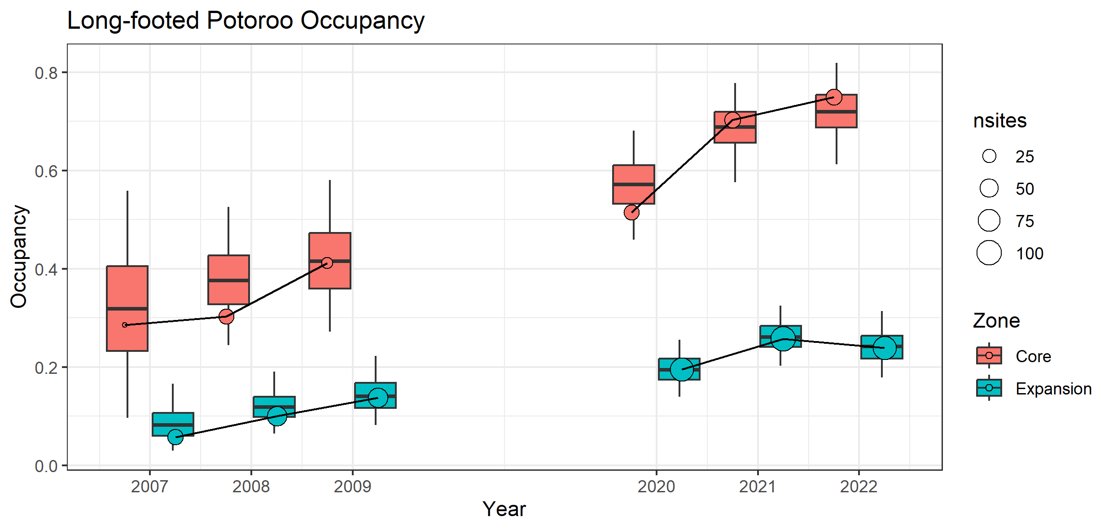
Figure 4. Estimated occupancy of Long-footed Potoroo in the Core and Expansion baiting zones in all surveyed years since 2007.
Boxplots show posterior distributions of the estimated occupancy within each year, derived from the Basic Trend Model with random spatial and temporal effects. Points show raw proportions of surveyed sites with at least one Long-footed Potoroo detection (naïve occupancy). Naïve occupancy (raw counts) may differ from model estimates of actual occupancy [because of imperfect detection and because model estimates tend towards long-term means (or trends) within spatial zones]. nsites = number of sites.

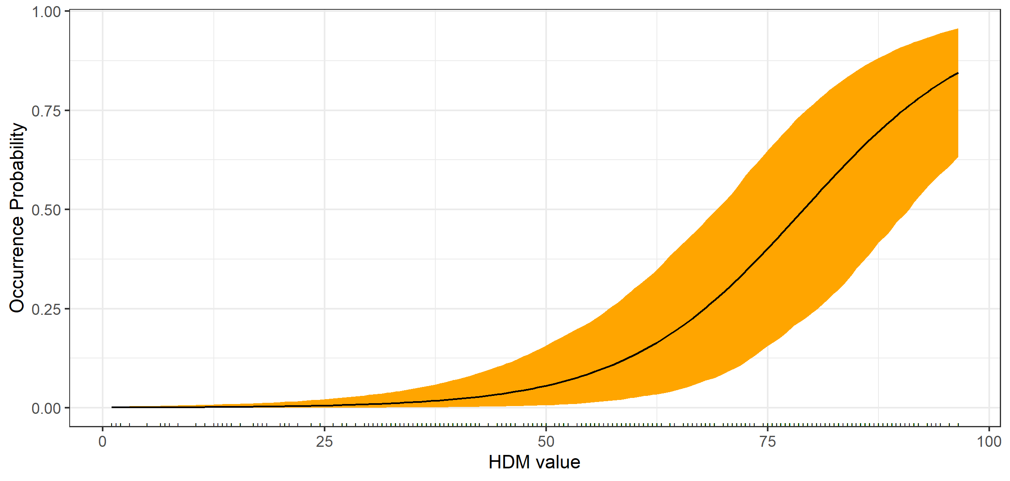
Figure 5. Estimated relationship between the probability of Long-footed Potoroo occurrence and modelled habitat suitability.
Black line shows posterior mean occurrence probability; orange band extends to the 95% credible interval. The fitted relationship assumes time since fire (5.8 years) and number of years of baiting (3.2 years) are held constant at their means. HDM: Habitat Distribution Model.
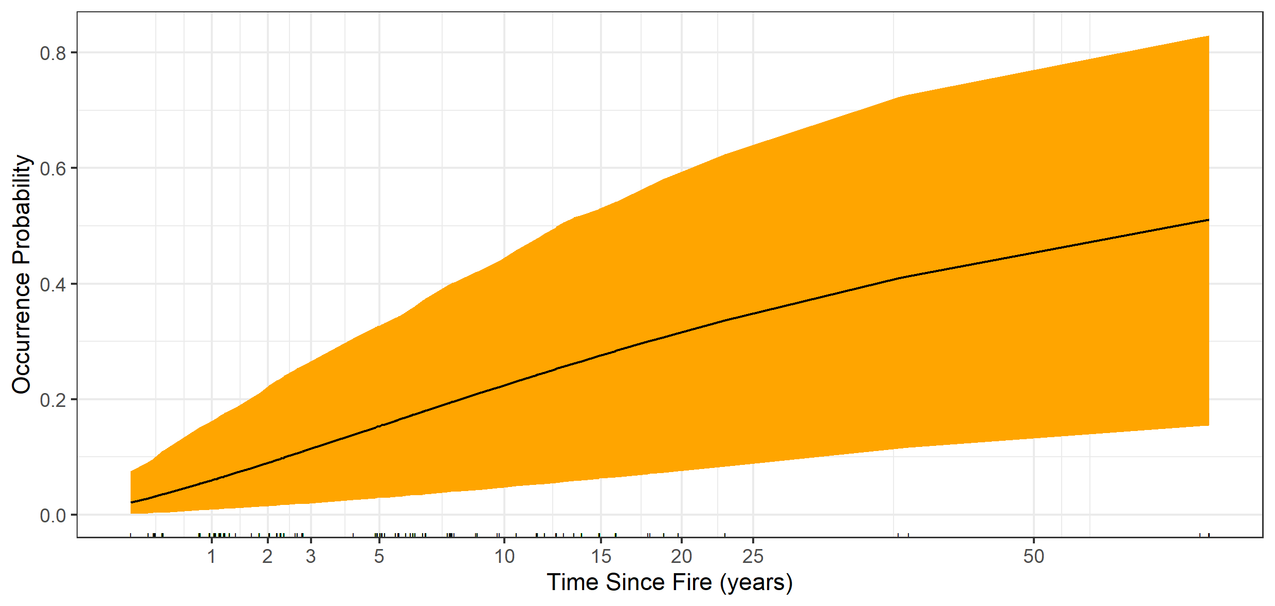
Figure 6. Estimated relationship between the probability of Long-footed Potoroo occupancy and time since fire, assuming average habitat quality (HDM value = 58).
HDM: Habitat Distribution Model.

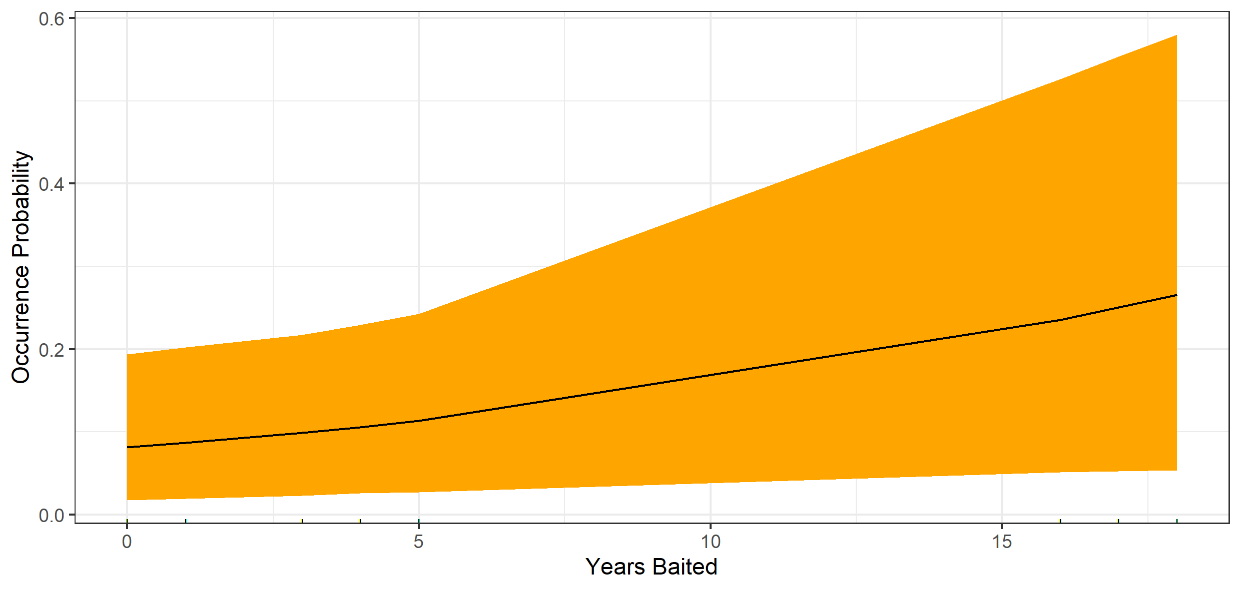
Figure 7. Estimated relationship between the probability of Long-footed Potoroo occupancy and the number of years the site had been baited (within 1 km of the bait station), assuming average habitat quality (HDM value = 58) and time since fire (5.8 years).
HDM: Habitat Distribution Model.
Table 2. Parameter estimates (posterior means and 95% credible intervals) and corresponding conditional odds ratios for three models of Long-footed Potoroo occupancy: Basic Trend Model, Best-supported Model (based on Bayesian variable selection), and Conditional Trend Model (trends conditioned on supported predictors for all years).
Parameter | Estimate  (95% CI) | ¹Odds ratio  (95% CI) | Interpretation
- A: Basic Trend Model
- $β_{core}$ | 2.13  (1.1, 3.33) | 8.41  (3.00, 27.94) | - Occupancy higher in Core than Expansion zones (8-fold higher odds in Core in 2020)
- $β_{t_core}$ | 0.17  (0.04, 0.31) | 1.19  (1.04, 1.36) | - Positive trend in occupancy in Core zone  - (19% p.a. increase in odds of occurrence)
- $β_{t_exp}$ | 0.12  (0.01, 0.23) | 1.13  (1.01, 1.26) | - Positive trend in occupancy in Expansion zone  - (13% p.a. increase in odds of occurrence)
- $δ_{t}$ | 0.05  (–0.08, 0.18) | 1.05  (0.92, 1.20) | - No clear difference in trends between Core and Expansion zones
- $β_{exp22}$ | –0.33  (–1.52, 0.74) | 0.72  (0.22, 2.10) | - No increase in Expansion zone occupancy in 2022 compared with 2021
- B: Best-supported Model
- $β_{baityrs}$ | 0.48  (0.03, 0.98) | 1.62  (1.03, 2.66) | - Positive relationship between Long-footed Potoroo occurrence and years-baited
- $β_{H}$ | 2.55  (1.70, 3.58) | 12.81  (5.47, 35.87) | - Positive relationship between Long-footed Potoroo occurrence and HDM value
- $β_{F}$ | 0.85  (0.38, 1.36) | 2.34  (1.46, 3.90) | - Positive relationship between Long-footed Potoroo occurrence and time since fire
- C: Conditional Trend Model
- $β_{t_core}^{'}$ | 0.03  (–0.14, 0.22) | 1.02  (0.87,1.24) | - No trend in occupancy in Core zone after accounting for best-supported predictors
- $β_{t_exp}^{'}$ | 0.04  (–0.11, 0.17) | 1.04  (0.90,1.19) | - No trend in occupancy in Expansion zone after accounting for best-supported predictors
CI = credible interval; p.a. = per annum; HDM: Habitat Distribution Model.
Table 3. Conditional odds ratios for Long-footed Potoroo occurrence in 2022 relative to 2007 within Core and Expansion zones based on the mean changes in predictor variable values within each zone, and the corresponding effect sizes estimated in the Best-supported Model.
Variable (units) | Core zone |  | Expansion zone
 | Change¹ | OR (95% CI) | Change¹ | OR (95% CI)
Years of baiting | +13.5 | 2.9 (1.1, 8.5) | +0.8 | 1.1 (1.0, 1.1)
HDM value (0–100) | +2.0 | 1.2 (1.2, 1.4) | +3.5 | 1.5 (1.3, 1.7)
Time-since-fire (years) | +12.0 | 11.9 (3.0, 52.3) | +4.0 | 3.9 (1.8, 8.9)
Time (years) | +15 | 12.8 (1.8, 104.6) | +15 | 6.1 (1.2, 31.5)
¹Difference in means between 2022 and 2007. OR values indicate the expected multiplicative change in odds from 2007 to 2022 for an average site, assuming only the named (row) variable changed. The Time (years) values and corresponding implied change (OR) from the Basic Trend Model are provided for reference. CI = credible interval; HDM = Habitat Distribution Model; OR = odds ratio.
  - Fox occupancy
Fox occupancy was lower (had lower visitation rates) in the Core baiting zone than in the Expansion zone (Table 4-A). There was marginal evidence of declines from 2007 to 2022 in fox occurrence in both areas [Core baiting zone trend = –22% (95% CI: –49%, +2%) per annum; Expansion baiting zone trend = –12%
(–28%, +1%) per annum)] (Table 4-A, Figure 8).
Two variables had strong support as predictors of fox occurrence in the variable selection model (Appendix 4): Long-footed Potoroo HDM variable, and the binary Baited variable (bait stations within 1 km of the survey site in the survey year) (Table 3-B). No interaction terms were supported in the variable selection model (Appendix 2). The odds of fox occurrence were ~70% lower at baited sites than at unbaited sites (Table 4-B) and declined with increasing Long-footed Potoroo HDM value (Table 4-B, Figure 9). The negative association between foxes and Long-footed Potoroo HDM value was largely independent of baiting history: there was no interaction between Long-footed Potoroo HDM value and baiting (Table 4-B, Appendix 2), with negative Long-footed Potoroo HDM effects evident at both baited and unbaited sites (Table 4-B). A negative fox – Long-footed Potoroo HDM association was evident, even in the Expansion zone prior to 2022 (i.e. before any baiting occurred): the estimated Long-footed Potoroo HDM coefficient when using data from pre-2022 Expansion zone sites only was –0.75 (95% CI: –1.43, –0.16), similar to the estimate (–0.88) derived from all data (Table 4).
Trends conditioned on Long-footed Potoroo HDM and Baited variables were highly uncertain, though suggestive of declines in fox occurrence in the Expansion zone (Table 4-C).
Estimated detection probabilities (daily probabilities of detecting a fox at a site that was visited at any time during a season) were 0.04 (95% CI: 0.03, 0.06) and 0.07 (95% CI: 0.04, 0.09) in 2007–2009 and 2020–2022, respectively (Appendix 5). Detection probabilities for foxes did not differ substantially between periods, or according to the number of cameras in operation in 2007–2009 (Appendix 5).
The very low detection probabilities for foxes made it difficult to estimate the true ‘occupancy’ status of sites, increasing the uncertainty of the model parameters. (Typically, foxes were detected on only 1 day out of 30+ days of camera operation per season.) Coupled with the change in survey methods between 2009 and 2020 (two cameras vs one camera), the low detectability of foxes made inferences about trends particularly difficult.
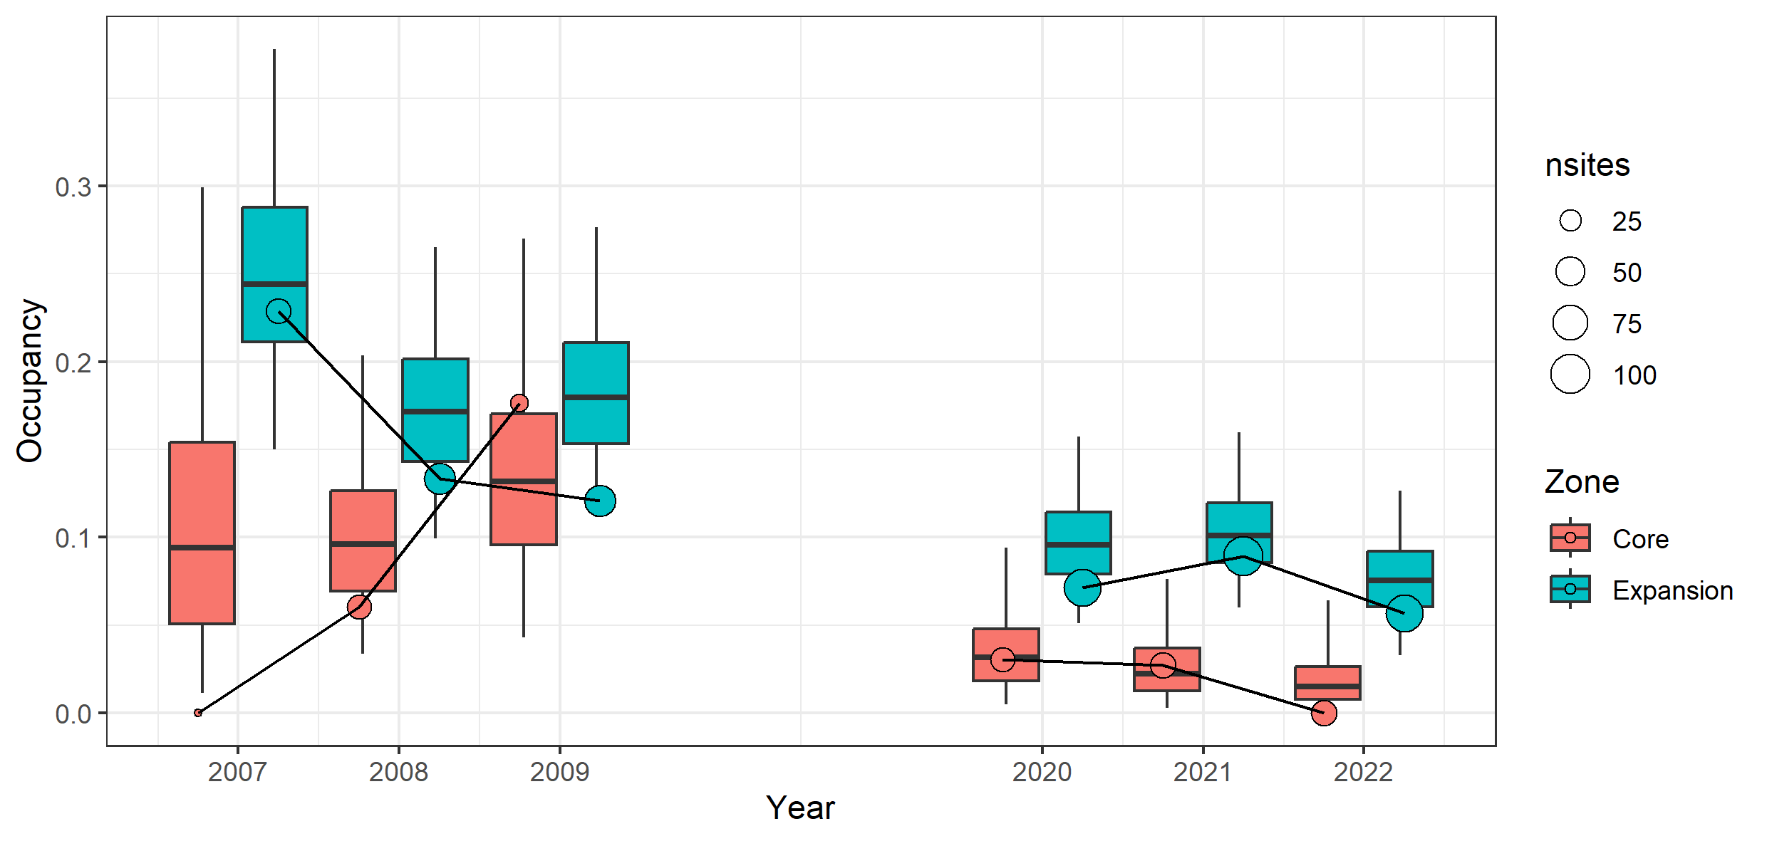
Figure 8. Estimated occupancy (mean probability of occurrence) of foxes in the Core and Expansion baiting zones in all surveyed years since 2007.
Boxplots show the posterior distributions of the estimated occupancies within each year, derived from the Basic Trend Model with random spatial and temporal effects. Note that, for foxes, we interpreted occupancy as being indicated by the proportion of sites visited. The data points/circles show the raw proportions of surveyed sites with at least one fox detection (naïve occupancy). Naïve occupancy may differ from the model estimates because of low and highly uncertain detection probabilities (which, for foxes, are affected by visitation rates), and because model estimates tend towards long-term means (or trends) within spatial zones. nsites = number of sites.

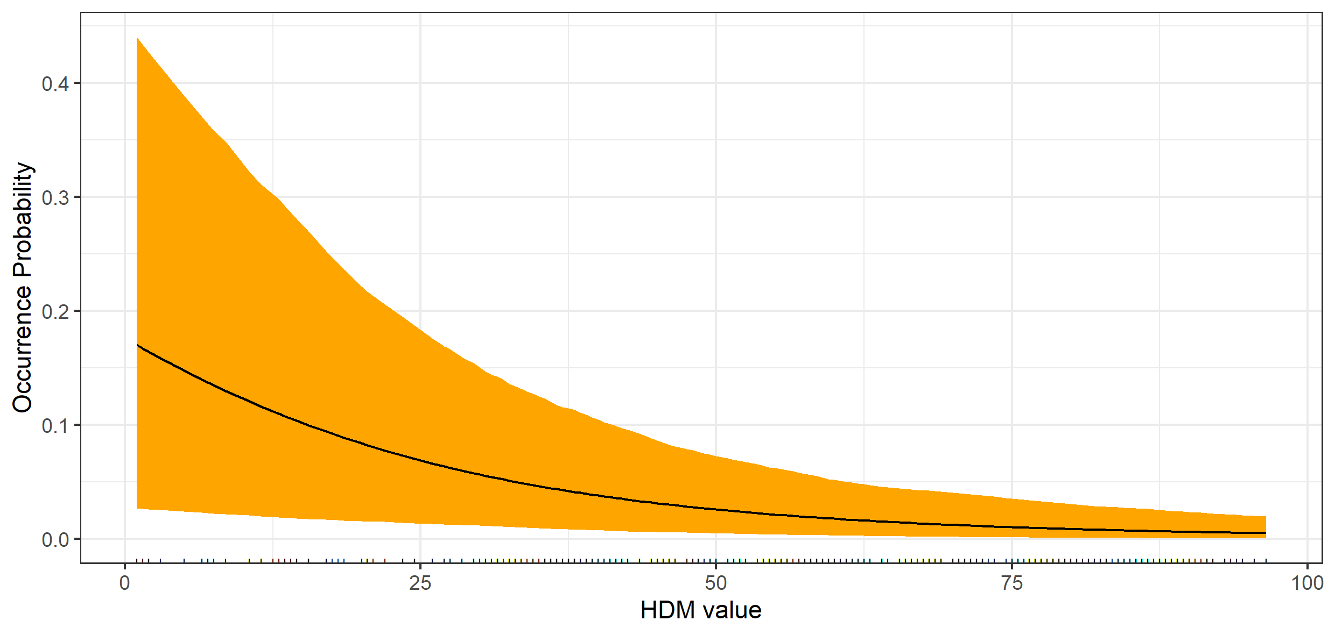
Figure 9. Estimated relationship between the probability of fox occurrence and modelled habitat suitability for Long-footed Potoroos.
HDM = Habitat Distribution Model.
Table 4. Parameter estimates (posterior mean and 95% credible intervals) and corresponding conditional odds ratios¹ for three models for foxes: Basic Trend Model, Best-supported Model (based on Bayesian variable selection), and Conditional Trend Model (trends conditioned on supported predictors for all years).
Parameter | Estimate  (95% CI) | Odds ratio  (95% CI) | Interpretation
A: Basic Trend Model
- $β_{core}$ | –1.90  (–4.11, –0.14) | 0.15  (0.012, 0.87) | Fox occurrence was lower in the Core zone than in the Expansion zone (85% lower odds in the Core zone in 2020)
- $β_{t_core}$ | –0.22  (–0.49, 0.02) | 0.80  (0.61, 1.02) | Marginal negative trend in occurrence in the Core zone
- $β_{t_exp}$ | –0.12  (–0.28, 0.01) | 0.88  (0.75, 1.01) | Marginal negative trend in occurrence in the Expansion zone
- $δ_{t}$ | 0.09  (–0.13, 0.32) | 1.09  (0.88, 1.38) | No clear difference in trends in occurrence between the Core and Expansion zones
- $β_{exp22}$ | 0.60  (–0.63, 1.85) | 1.82  (0.53, 6.36) | No change in occurrence in the Expansion zone in 2022
B: Best-supported Model
- $β_{Baited}$ | –1.22  (–2.53, –0.02) | 0.30  (0.08, 0.98) | Fox occurrence was lower at baited sites (70% lower odds of occurrence at baited sites)
- $β_{H}$ | –0.88  (–1.47, –0.38) | 0.41  (0.23, 0.68) | Fox occurrence declined with increasing Long-footed Potoroo habitat quality (Long-footed Potoroo HDM value)
- $β_{B×H}1$ | –0.59  (–1.92, 0.60) | 0.55  (0.15, 1.82) | No interaction: fox occurrence declined with HDM value in both baited and unbaited sites¹
C: Conditional Trend Model
- $β_{t_core}^{'}$ | –0.44  (–1.30, 0.28) | 0.65  (0.27, 1.32) | No trend in occurrence in the Core zone
- $β_{t_exp}^{'}$ | –0.21  (–0.49, 0.01) | 0.81  (0.61, 1.01) | Marginal negative trend in occurrence in the Expansion zone
¹The interaction term was not supported in the variable selection model (Appendix 2) but was estimated with the full occupancy model accounting for detectability, and temporal and spatial structures in the data, to confirm the lack of interaction. The estimates for $β_{baited}$ and $β_{H}$ reported here are for the model with no interaction ($β_{B×H}=0$). HDM = Habitat Distribution Model. CI = credible interval.
  - Feral cat occupancy
There was marginal evidence that feral cats had higher occupancy in the Core baiting zone than in the Expansion zone in 2020–2022, but there was no evidence of trends in feral cat occupancy in either the Core or Expansion baiting zones over time (Figure 10, Table 5). No variables had support as predictors of cat occurrence in the variable selection model (Appendix 2, Appendix 6).
Estimated feral cat detection rates were extremely low [0.02 (95% CI: <0.01, 0.02) per day] in both periods (Appendix 8). In 2007–2009, the site-level probability of detecting a cat was higher when two cameras were in operation throughout the survey (Appendix 7).
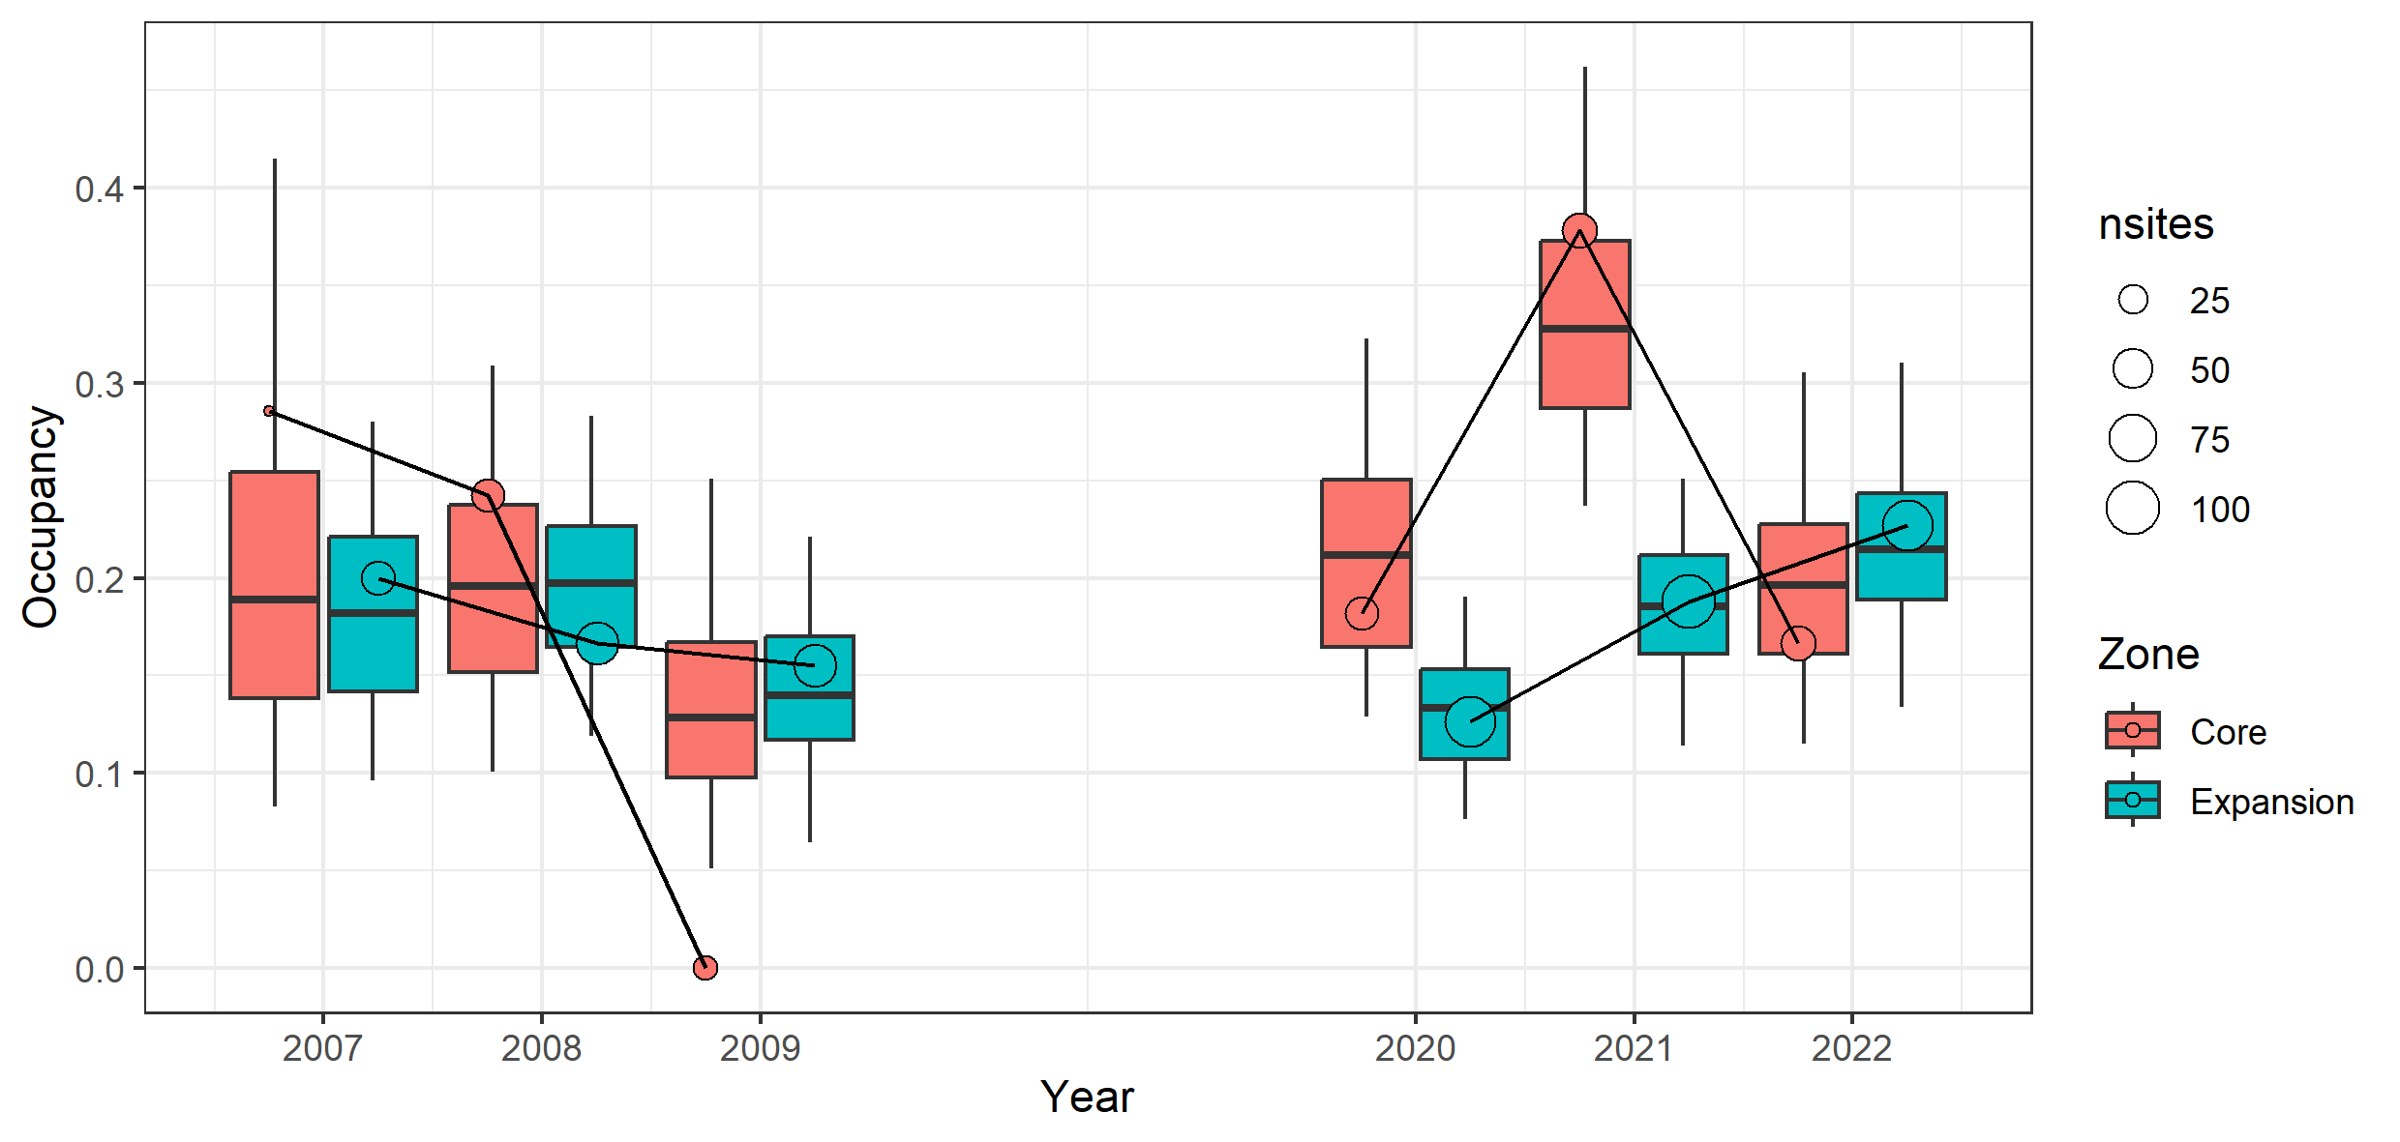
Figure 10. Estimated occupancy (mean probability of occurrence) of feral cats in the Core and Expansion baiting zones in all surveyed years since 2007.
Boxplots show posterior distributions of the estimated feral cat occupancy within each year, derived from the Basic Trend Model with random spatial and temporal effects. Note that, for cats, we define occupancy as the proportion of sites visited. Data points/circles show the raw proportions of the surveyed sites with at least one cat detection (naïve occupancy). Naïve occupancy may differ from model estimates because of low and highly uncertain detection probabilities (which, for cats, are affected by visitation rates), and because model estimates tend towards long-term means (or trends) within spatial zones. nsites = number of sites.

Table 5. Parameter estimates (posterior means and 95% credible intervals) and corresponding conditional odds ratios for the feral cats: Basic Trend Model for all years.
Parameter | Estimate  (95% CI) | Odds ratio  (95% CI) | Interpretation
- $β_{core}$ | 1.35  (–0.24, 3.65) | 3.86  (0.79, 38.45) | Cat occurrence marginally higher in 2020 in Core zone
- $β_{t_core}$ | –0.07  (–0.39, 0.15) | 0.93  (0.67, 1.16) | No trend in occurrence in Core zone
- $β_{t_exp}$ | –0.07  (–1.04, 0.39) | 0.94  (0.36, 1.48) | No trend in occurrence in Expansion zone
- $δ_{t}$ | 0.01  (–4.82, 2.27) | 1.01  (0.09, 614) | No difference in trends in occurrence between Core and Expansion zones
- $β_{exp22}$ | 1.39  (–0.74, 3.60) | 4.01  (0.48, 36.6) | No change in occurrence in Expansion zone in 2022 compared with 2021
CI = credible interval.

  - Naïve occupancy of other native species
Seventy-one native and introduced species were detected by camera traps between 2020 and 2022 (Appendix 8).
The naïve occupancy (the percentage of sites at which a species was detected) was higher in 2022 (with a cumulative increase in percentage of >10%) for Bush Rat (Rattus fuscipes), Rattus sp., Mountain Brush-tailed Possum (Trichosurus caninus), Grey Currawong (Strepera versicolor), Grey Shrikethrush (Colluricincla harmonica), Pied Currawong (Strepera graculina), Superb Lyrebird (Menura novaehollandiae) and White-browed Scrubwren (Sericornis frontalis). Southern Long-nosed Bandicoot (Perameles nasuta) occupancies increased by 8.1%.
- Discussion
Monitoring of the Long-footed Potoroo population in the Great Dividing Range took place between 2004 and 2009, focusing on fire effects, predator control, and the effectiveness of Special Management Areas for conservation (Lumsden et al. 2012). The monitoring covered the Core and Expansion baiting zones. A renewed monitoring effort occurred in 2020 due to expansion of the planned fox control in 2021 to include both the Core and Expansion zones.
We analysed Long-footed Potoroo occupancy trends during 2007–2009 and 2020–2022 (excluding the 2004–2006 hair-tube data), investigating the impacts of fire, foxes, and feral cats, along with fox baiting, in both the Core and Expansion zones. In addition, we examined trends in fox and feral cat occurrence from 2007 to 2022 and documented initial changes detected in native species occurrence during the 2020–2022 surveys.
There is good evidence that Long-footed Potoroos have increased occupancy rates (occupied more sites) in both the Core and Expansion baiting zones over the past 15 years. The increases can largely be explained, statistically, by a combination of increasing time since fire, ongoing fox control, and a tendency to survey higher quality habitats in recent years. The role of fox control in these changes is difficult to quantify, because both time since fire and habitat quality are partially related to baiting history, making it difficult to separate out the baiting effects with confidence. Nevertheless, there is good evidence that fox baiting is associated with declines in fox occurrence (activity) and increases in Long-footed Potoroo occurrence.
There was a negative relationship between fox occurrence and Long-footed Potoroo habitat quality (HDM value), but no relationship was found between fox occurrence and time since fire. The negative relationship between foxes and Long-footed Potoroo HDM values suggests that foxes may be less active in higher quality potoroo habitats. This negative association was independent of baiting history (i.e. there was no baiting–HDM interaction), and it was evident within the Expansion zone before any baiting occurred, so cannot be explained by fox control in high-quality Long-footed Potoroo habitats.
There are several possible explanations for the negative association between foxes and Long-footed Potoroo HDM value, including: (1) foxes and Long-footed Potoroos have different habitat preferences, so foxes are coincidentally less active in habitats preferred by Long-footed Potoroos (i.e. the HDM reflects the fundamental habitat niche of Long-footed Potoroo); or (2) Long-footed Potoroos avoid (or are excluded from) habitats favoured by foxes, and are therefore largely absent from otherwise suitable habitats because of foxes (i.e. the HDM reflects a realised habitat niche in the context of predator exclusion). The lack of interactions between HDM value and baiting variables (Baited, BaitYears, Core/Expansion) in Long-footed Potoroo models is suggestive of the first explanation, because if the HDM was reflecting a realised niche then the strength of association between Long-footed Potoroos and HDM value should have declined as fox density declined. However, it may require very low or zero fox densities before such an outcome would be detectable, and interactions can be difficult to detect statistically without large amounts of data.
The negative relationship between fox occurrence and Long-footed Potoroo HDM value could arise spuriously if foxes were less detectable, when present, in high-quality Long-footed Potoroo habitats. Unfortunately, with the data available, there is no way to separate detectability per se from the probability of a site being visited. Movement data from tracking individuals would be required. However, it is doubtful that foxes would be less likely to be captured by a camera trap when they visited a site with high-quality Long-footed Potoroo habitat than when they visited a site with lower-quality habitat. This explanation is the least likely of the three possibilities.
With ongoing baiting, we expect fox densities to continue to decline in the Core and Expansion zones. In the Otway Ranges, fox control has been in place for 3 years and has reduced fox density by 43% (Rees et al. 2023), while at Glenelg Ark, after 18 years of fox control, the fox occurrence at locations without fox control has been found to be 3.9 times higher (95% CI: 2.3–6.4) than that at locations with fox control (Robley et al. 2023). If fox densities decline further in the Barry Mountains area, we can assess whether Long-footed Potoroos are using low-HDM value sites more frequently and clarify the influence of foxes on the apparent habitat preferences of Long-footed Potoroo.
Our findings are consistent with those of Lumsden et al. (2012). Those authors found that the occurrence of Long-footed Potoroos was strongly negatively associated with the occurrence of foxes. They also found that the occurrences of both Long-footed Potoroos and foxes were weakly related to several environmental covariates. They found that Long-footed Potoroos were somewhat more likely to occur at sites with intermediate elevations, higher stream density, and an easterly aspect, while foxes were more likely to occur at sites with either high or low elevation, and with easterly aspects, and were less likely to occur on steep, mid-slope habitats. They concluded that resolving the Long-footed Potoroo’s relationship with vegetation type was complicated by the fact that foxes were negatively associated with ‘primary’ Long-footed Potoroo habitat, which made it difficult to separate out the influences of foxes and vegetation type on the occurrence of Long-footed Potoroos.
We showed that fox occurrence was lower in the Core zone, which was in line with expectations, given the long baiting history and the fact that fox occurrence was lower at baited sites across both zones. We also showed that there was no change in fox occurrence in the Expansion zone in 2022. This too was in line with expectations, as the Expansion baiting program has effectively been in place for only 1 year, and patterns are unlikely to emerge that quickly.
The baiting in the Core zone has been inconsistent, albeit more continuous than what is planned for the Expansion baiting zone. From 2004 to 2009, baiting was continuous throughout the year in the Core zone, then was reduced to 4–5 months per year until 2021, after which it was again baited continuously (access and weather permitting). Despite this disrupted implementation, fox occurrence was ~70% lower at Core baited sites than at Expansion unbaited sites The Expansion fox control program occurs across a much larger area but is not applied continuously throughout the year. Effectively, there is no baiting in State Forest (~70% of the total footprint) for 8 months of the year. Spatial modelling of the reduction in fox density (DELWP 2022) indicated that a similar program across the Expansion zone could lead to a 46% reduction in modelled fox density over 10 years, with 30% of the area achieving >65% reduction in density. This modelled control operation was different to the one implemented. The modelled Expansion strategy incorporated several 10-day pulsed baiting periods across State Forest to accommodate the absence of baiting during the hound-hunting period between April and November. Within the Expansion zone, the modelled baiting occurred every fortnight in the Alpine National Park when not snowbound.
The effectiveness of ‘pulsed’ fox baiting versus continuous fox baiting has been assessed at various locations in Victoria, and pulsed baiting has been shown to be less effective than continuous baiting over the short term [over 2 years (Robley et al. 2008) and over 10 years (Francis et al. 2020)]. There is a risk that the current fox control may have the effect of slowing the rate of reduction in foxes, as it allows time for some immigration back into the area. Lieury et al. (2015) observed strong compensatory density feedback acting through immigration, noting that it allowed fox populations to resist high culling rates over a period of a year. There is also some evidence that fox populations can compensate for reductions by increasing their fertility rates. Marlow et al. (2016) demonstrated that the ovulation rate, implantation rate, and litter size were greater on treated sites 1 year after control compared with the fertility indicators on similar untreated sites. More time (further years of control and monitoring) are needed in order to have confidence that the trends in declining fox occurrence in the Barry Mountains are associated with the fox control operation, as documented in other areas.
The marginal difference in feral cat occupancy between the Core and Expansion zones is due to the apparent outlier in 2021, during which the occupancy rate was nearly double that of any other year in the Core zone. We have no explanation for this aberration in the data. There was also a very low feral cat detection rate, which might be explained by a range of factors, including feral cats not being attracted to the standard mammal lure used at the camera trap sites, or them being actively excluded from sites occupied by foxes.
We documented the naïve occupancy of a range of native species that were detected incidentally. A number of these species (e.g., Superb Lyrebird and Southern Long-nosed Bandicoot) have the potential to respond to lowered fox abundance, and it may be possible in future years to formally incorporate the other native species into the analysis.

  - Conclusion
Long-footed Potoroo occupancy has increased in the Barry Mountains since 2007. This has primarily been driven by the duration of the fox control and the increasing time since fire.
A final year of fox control, with monitoring in October, is planned for 2023, but there is currently no commitment to undertake control or monitoring after that. We believe that the gains made in higher occupancy rates of Long-footed Potoroo to date would be at significant risk if fox control were to cease. It is likely that a minimum of two to three more years of the Expansion fox control program and data collection beyond 2023 are required in order to have confidence that the indicated positive trends in Long-footed Potoroo occupancy will be consistent over space and time.

References
Bilney, R.J., Cooke, R. and White, J.G. (2010). Underestimated and severe: small mammal decline from the forests of south-eastern Australia since European settlement, as revealed by a top-order predator. Biological Conservation 143, 52–59.
Brereton, R., Bennett, S. and Mansergh, I. (1995). Enhanced greenhouse climate change and its potential effects on selected fauna of south-eastern Australia: a trend analysis. Biological Conservation 72, 339–354.
Collins, L., Bradstock, R.A., Clarke, H., Clarke, M.F., Nolan, R.H. and Penman, T.D. (2021). The 2019/2020 mega-fires exposed Australian ecosytems to an unprecedented extent of high-severity fire. Environmental Research Letters 16, 044029. doi:10.1088/1748-9326/abeb9e
DELWP (2021). Fox control management plan for the protection of Long-footed Potoroo: Great Dividing Range (Barry Mountains). Department of Environment, Land, Water and Planning, Melbourne, Victoria.
DELWP (2022). Managing the Great Dividing Range Long-footed Potoroo population. Fact Sheet. Department of Environment, Land, Water and Planning, Melbourne, Victoria.
Francis, L., Robley, A. and Hradsky, B. (2020). Evaluating fox management strategies using a spatially explicit population model. Arthur Rylah Institute for Environmental Research Technical Report Series No. 304. Department of Environment, Land, Water and Planning, Heidelberg, Victoria.
Gelman, A., Goegebeur, Y., Tuerlinckx, F. and Van Mechelen, I. (2000). Diagnostic checks for discrete data regression models using posterior predictive simulations. Journal of the Royal Statistical Society: Series C (Applied Statistics) 49, 247–268.
Green, K., Tory, M.K., Mitchell A.T., Tennat, P. and May, T.W. (1999). The diet of the long-footed potoroo (Potorous longipes). Australian Journal of Ecology 24, 151–156. doi:10.1046/j.1442-9993.1999.241957.x
Jackson, S.M., Groves, C.P., Flemming, P.J.S., Aplin, K.P., Eldridge, M.D.B., Gonzalez, A. and Helgen, K.M. (2017). The wayward dog: is the Australian native dog or dingo a distinct species? Zootaxa 4317, 201–224. doi:org/10.11646/zootaxa.4317.2.1
Jackson, S.M., Fleming, P.J.S., Eldridge, M.D.B., Ingleby, S., Flannery, T.F., Johnson, R.N., Cooper, S.J.B., Mitchell, K.J., Souili, T., Cooper, A., Wilson, D.E. and Helgen, K.M. (2019). The dogma of dingoes – taxonomic status of the dingo: a reply to Smith et al. Zootaxa 4564, 198–212.
Jones, N. and Johnson, G.A. (1997). The Long-footed Potoroo in the north-eastern Victorian Alps: 1995–96 survey report. Flora and Fauna Technical Report No. 147. Department of Natural Resources and Environment, Melbourne, Victoria.
Kass, R. and Raftery, A. (1995). Bayes factors. Journal of the American Statistical Association 90, 773–795.
Lieury, N., Ruette, S., Devillard, S., Albaret, M., Drouyer, F., Baudoux, B. and Million, A. (2015). Compensatory immigration challenges predator control: an experimental evidence–based approach improves management. Journal of Wildlife Management 79, 425–434. doi:10.1002/jwmg.850
Liu, C., White, M., Newell, G. and Griffioen, P. (2013). Species distribution modelling for conservation planning in Victoria, Australia. Ecological Modelling 249, 68–74.
Lumsden, L., Chick, R., Scroggie, M., Howard, K., Woodford, L., Douglas, A., Alexander, J. and Pascoe, C. (2012). Assessing management strategies and wildfire impact on Long-footed Potoroos in the Great Dividing Range area of Victoria. 4th Progress Report. Arthur Rylah Institute for Environmental Research Unpublished Report. Department of Sustainability and Environment, Heidelberg, Victoria.
Lunn, D.J., Best, N. and Whittaker, J. (2008). Generic reversible jump MCMC using graphical models. Statistics and Computing 19, 395. doi:10.1007/s11222-008-9100-0
MacKenzie, D.I., Nicols, J.D., Royle, J.A., Pollock, K.H., Bailey, L.L. and Hines, J.E. (2017). Occupancy Estimation and Modeling. Inferring Patterns and Dynamics of Species Occurrence. Elsevier, San Diego, California, USA.
Marlow, N.J., Thomson, P.C., Rose, K. and Kok, N.E. (2016). Compensatory responses by a fox population to artificial density reduction in a rangeland area in Western Australia. Conservation Science Western Australia 10, 1–10.
O’Hara, R.R. and Sillanpää, M.J. (2009). A review of Bayesian variable selection methods: what, how and which. Bayesian Analysis 4, 85–117. doi:org/10.1214/09-BA403
Rees, M.W., Pascoe, J.H., Le Pla, M., Robley, A., Birnbaum, E.K., Wintle, B. and Hradsky, B.A. (2023). Mesopredator release among invasive predators: controlling red foxes can increase feral cat densities and alter their behaviour. Journal of Applied Ecology 60, 1100–1114. doi:10.1111/1365-2664.14402
Robley, A. (2022). Managing the Great Dividing Range Long-footed Potoroo population – Fact Sheet. Arthur Rylah Institute for Environmental Research, Department of Environment Land, Water and Planning, Heidelberg, Victoria.
Robley, A., Moloney, P.D. and Le Duc, E. (2023). Glenelg Ark—2022 monitoring and evaluation update. Arthur Rylah Institute for Environmental Research Technical Report Series No. 358. Department of Energy, Environment and Climate Action, Heidelberg, Victoria.
Robley, A., Scroggie, M., Chick, R., Gillespie, G., Alexander, J., Wentworth, A., Purdey, D., Bush, A. and Miles, J. (2005). Assessing management strategies and wildfire impact on Long-footed Potoroos in North East Victoria. Progress Report 1: Results from the 2004/05 predator control and Long-footed Potoroo monitoring program. Unpublished report. Department of Sustainability and Environment, Heidelberg, Victoria.
Robley, A., Wright, J., Gormley, A. and Evans, I. (2008). Adaptive experimental management of foxes. Final Report. Parks Victoria Technical Series No. 59. Parks Victoria, Melbourne, Victoria.
Roshier, D.A. and Carter, A. (2021). Space use and interactions of two introduced mesopredators, European red fox and feral cat, in an arid landscape. Ecosphere 12, e03628. doi:10.1002/ecs2.3628
Seebeck, J.H. and Johnston, P.G. (1980). Potorous longipes (Marsupialia: Macropodidae); a new species from eastern Victoria. Australian Journal of Zoology 28, 119–134.
Spiegelhalter, D., Thomas, A., Best, N. and Lunn, D. (2003). WinBUGS user manual. Version 1.4. https://www.mrc-bsu.cam.ac.uk/wp-content/uploads/manual14.pdf .(accessed April 2023).
Thomson, J.R., Kimmerer, W.J., Brown, L.R., Newman, K.B., Nally, R.M., Bennett, W.A., Feyrer, F. and Fleishman, E. (2010). Bayesian change point analysis of abundance trends for pelagic fishes in the upper San Francisco Estuary. Ecological Applications, 20, 1431–1448.
Woinarski, J.C.Z., Burbidge, A.A. and Harrison, P.L. (2014). The Action Plan for Australian Mammals 2012. CSIRO Publishing, Melbourne, Victoria.

Appendices
Appendix 1. Posterior probabilities of non-zero coefficients, $Pr(β≠0)$¹, and posterior mean (95% credible interval) estimated effects (standardised probit coefficients) for all candidate predictors tested in the Best-supported Model (a Bayesian variable selection model) for the occurrence of Long-footed Potoroo. Continuous variables were standardised (mean = 0, standard deviation = 1) prior to model fitting.
Variable | Definition (units) | $$Pr(β≠0)$$ | Estimate effect  (95% CI)
Baited ($β_{Baited})$ | Binary indicator that baiting occurred within 1 km of the site in the survey year | 0.1 | 0  (–0.08, 0.05)
BaitYears ($β_{baityrs}$) | No. of years prior to the survey year in which fox baiting occurred within 1 km of the site (decimal years) | 1 | 0.29  (0.13, 0.46)
Fox ($β_{fox}$) | Binary indicator for the detection of fox(es) at a site within the survey year | 0.16 | 0.01  (–0.05, 0.13)
Feral cat ($β_{cat}$) | Binary indicator for the detection of feral cat(s) at a site within the survey year | 0.67 | 0.11  (0, 0.29)
Long-footed Potoroo HDM ($β_{H}$) | Long-footed Potoroo HDM value (0–100) | 1 | 1.12  (0.87, 1.43)
Time since fire ($β_{F}$) | Time since the last fire (wild or planned) at a site (log-transformed decimal years) | 1 | 0.52  (0.34, 0.71)
¹$Pr\left(β≠0\right)$ is equivalent to the posterior probability that a variable is included in the best model of the set of candidate models considered (all possible linear combinations of the candidate predictors are considered here). Note that reported coefficient estimates are not conditional on variable inclusion: they are model-averaged coefficients that shrink towards zero as the probability of inclusion declines [if $Pr\left(β≠0\right)=0,β=0).$ 95% CI: 95% credible interval; HDM: Habitat Distribution Model.

Appendix 2. Bayesian variable selection results with all two-way interaction terms included as candidate predictors of Long-footed Potoroo, fox and feral cat occupancy (activity).
 | Long-footed Potoroo |  |  | Red Fox |  |  |  |  | Feral cat
Variable | Prob. | Coefficient |  |  | Prob. |  | Coefficient |  |  | Prob. |  | Coefficient
Baited ($β_{Baited})$ | 0.07 | 0.01  (0, 0.1) | 0.68 |  |  | –0.14  (–0.38, 0) |  | 0.31 |  |  | 0 .01  (–0.02, 0.09)
BaitYears ($β_{baityrs}$) | 0.77 | 0.23  (0, 0.53) | 0.21 |  |  | –0.02  (–0.3, 0.05) |  | 0.29 |  |  | 0.00  (–0.03, 0.08)
Long-footed Potoroo HDM ($β_{H})$ | 1 | 1.12  (0.91, 1.33) | 0.95 |  |  | –0.25  (–0.48, 0) |  | 0.31 |  |  | 0.01  (–0.02, 0.10)
Time since fire ($β_{F}$) | 1 | 0.52  (0.36, 0.69) | 0.26 |  |  | –0.03  (–0.24, 0) |  | 0.38 |  |  | 0.01  (–0.02, 0.12)
Fox ($β_{fox}$) | 0.02 | 0  (0, 0) | N.A. |  |  | N.A. |  | 0.27 |  |  | 0.00  (–0.04, 0.04)
Feral cat ($β_{cat}$) | 0.05 | 0.01  (0, 0.1) | 0.1 |  |  | 0  (–0.06, 0.04) |  | N.A. |  |  | N.A.
Baited × BaitYears | 0.14 | 0.01  (–0.11, 0.25) | 0.16 |  |  | 0  (–0.15, 0.07) |  | 0.31 |  |  | 0.00  (–0.06, 0.05)
Baited × Fox | 0.08 | –0.01  (–0.17, 0) | N.A. |  |  | N.A. |  | 0.28 |  |  | 0.00  (–0.09, 0.03)
Baited × Cat | 0.07 | 0.01  (0, 0.13) | 0.12 |  |  | 0  (–0.1, 0.02) |  | N.A. |  |  | N.A.
BaitedYears × Fox | 0.08 | 0  (–0.05, 0.06) | N.A. |  |  | N.A. |  | 0.31 |  |  | 0.01  (–0.05, 0.09)
BaitedYears × Cat | 0.04 | 0  (0, 0.03) | 0.11 |  |  | 0  (–0.02, 0.13) |  | N.A. |  |  | N.A.
HDM × Baited | 0.03 | 0  (0, 0) | 0.13 |  |  | 0  (–0.09, 0.05) |  | 0.30 |  |  | 0.00  (–0.03, 0.08)
HDM × BaitYears | 0.23 | 0.05  (0, 0.37) | 0.13 |  |  | 0  (–0.08, 0.06) |  | 0.27 |  |  | 0.00  (–0.07, 0.04)
HDM × Fox | 0.14 | 0.02  (0, 0.28) | N.A. |  |  | N.A. |  | 0.26 |  |  | 0  (–0.05, 0.04)
HDM × Cat | 0.96 | 0.32  (0, 0.54) | 0.12 |  |  | 0  (–0.08, 0.03) |  | N.A. |  |  | N.A.
HDM × TsFire | 0.05 | 0  (0, 0) | 0.12 |  |  | 0  (–0.03, 0.1) |  | 0.29 |  |  | 0.00  (–0.06, 0.04)
TsFire × Baited | 0.06 | 0.01  (0, 0.11) | 0.13 |  |  | –0.01  (–0.15, 0) |  | 0.41 |  |  | 0.02  (–0.01, 0.17)
TsFire × BaitYears | 0.16 | 0.02  (0, 0.24) | 0.13 |  |  | –0.01  (–0.13, 0) |  | 0.30 |  |  | 0.01  (–0.03, 0.09)
TsFire × Fox | 0.04 | 0  (0, 0) | N.A. |  |  | N.A. |  | 0.26 |  |  | 0.00  (–0.05, 0.04)
TsFire × Cat | 0.02 | 0  (0, 0) | 0.13 |  |  | 0  (–0.06, 0.06) |  | N.A. |  |  | N.A.
Fox × Cat | 0.29 | 0.05  (0, 0.3) | N.A. |  |  | N.A. |  | N.A. |  |  | N.A.
Prob = posterior probability of inclusion in the best model (i.e. the probability of a non-zero coefficient). Coefficient = the posterior mean (95% credible interval) of the probit coefficient, integrated over all possible models (i.e. the model-averaged coefficient). Prob > 0.75 (bold typeface) is considered strong evidence of a predictive relationship (prior prob = 0.5). HDM: Habitat Distribution Model; N.A. = not available; TsFire = time since fire.
Appendix 3. Mean (95% CI) detection parameter estimates for the Best-supported Model for Long-footed Potoroo occupancy. The third column shows the corresponding probability for detectability (first two rows) or the odds ratio associated with each parameter.
Parameter | Estimate  (95% CI) | Probability or odds ratio  (95% CI) | Interpretation
Detectability in 2020–2022 | –2.20  (–2.37, –2.04) | 0.10  (0.09, 0.11) | Per-day probability of detecting Long-footed Potoroo at an occupied site in 2020–2022 (1 camera/site)
Detectability in 2007–2009 | –2.08  (–2.36, –1.81) | 0.11  (0.09, 0.14) | Per-day probability of detecting Long-footed Potoroo at an occupied site in 2007–2009 (1.75 cameras/site average).
Detectability in 2007–2009 vs 2020–2022 | 0.12  (–0.18, 0.39) | 1.13  (0.84, 1.48) | Similar site-level detection probabilities in both periods
No. of cameras | 0.85  (0.53, 1.21) | 2.34  (1.70, 3.35) | In 2007–2009, the per-day odds of detection increased with the mean number of cameras (odds doubled with 2 cameras vs 1 camera)
BaitYears  ($β_{baityrs}$) | 0.13  (0.07, 0.19) | 1.14  (1.07, 1.21) | Long-footed Potoroo detectability increased with number of years baited
HDM  ($β_{H})$ | 0.36  (0.24, 0.48) | 1.43  (1.27, 1.62) | Long-footed Potoroo detectability increased with HDM value
Time since fire  ($β_{F}$) | 0.44  (0.35, 0.54) | 1.55  (1.42, 1.72) | Long-footed Potoroo detectability increased with time since fire
95% CI: 95% credible interval; HDM: Habitat Distribution Model.

Appendix 4. Posterior probabilities of non-zero coefficients, $Pr(β≠0)$¹, and posterior mean (95% credible interval) coefficient (probit link) for all candidate predictors tested in the Best-supported Model (a Bayesian variable selection model) for the occurrence of foxes. Continuous variables were standardised (mean = 0, standard deviation =1) prior to model fitting.
Variable | Definition (units) | $$Pr(β≠0)$$ | Coefficient  (95% CI)
Baited ($β_{Baited})$ | Binary indicator that baiting occurred within 1 km of the site within the survey year | 0.75 | –0.06  (–0.42, 0.00)
BaitYears ($β_{baityrs}$) | No. of years prior to the survey year in which fox baiting had occurred within 1 km of the site (decimal years) | 0.33 | –0.03  (–0.27, 0.07)
Feral cat ($β_{cat}$) | Binary indicator for the detection of feral cat(s) at a site in the survey year | 0.23 | 0.00  (–0.10, 0.11)
Long-footed Potoroo HDM ($β_{H})$ | Long-footed Potoroo HDM value (0–100) | 0.97 | –0.29  (–0.51, 0)
Time since fire ($β_{F}$) | Time since the last fire (wild or planned) at a site (log-transformed decimal years) | 0.45 | –0.06  (–0.29, 0)
¹$Pr\left(β≠0\right)$ is equivalent to the posterior probability that a variable is included in the best model of the set of candidate models considered (all possible linear combinations of the candidate predictors are considered here). Note that reported coefficient estimates are not conditional on variable inclusion: they are model-averaged coefficients that shrink towards zero as the probability of inclusion declines [if $Pr\left(β≠0\right)=0, β=0].$ CI = credible interval; HDM = habitat distribution model.

Appendix 5. Mean detection parameter estimates for the Best-supported Model for fox occupancy. The third column shows the corresponding probability of detection (first two rows) or the odds ratio (third and fourth rows) associated with each parameter.
Parameter | Estimate  (95% CI) | Probability or odds ratio  (95% CI) | Interpretation
Detectability 2020–2022 | –3.07  (–3.42, –2.72) | 0.04  (0.03, 0.06) | Per-day probability of detecting a fox at a fox-visited site in 2020–2022 (1 camera/site)
Detectability 2007–2009 | –2.64  (–2.99, –2.34) | 0.07  (0.04, 0.09) | Per-day probability of detecting a fox at a fox-visited site in 2007–2009 (1.75 cameras/site average)
Detectability in 2007–2009 vs 2020–2022 | 0.42  (–0.11, 0.89) | 1.52  (0.90, 2.43) | Similar site-level detection probabilities in both periods (despite 2 vs 1 cameras)
No. of cameras | 0.85  (0.53, 1.21) | 1.07  (0.78, 1.51) | No difference in fox detection with 2 cameras vs 1 camera in 2007–2009 period
CI = credible interval.
Appendix 6. Posterior probabilities of non-zero coefficients, $Pr(β≠0)$¹, and posterior mean (95% credible interval) coefficient (probit link) for all candidate predictors tested in the Best-supported Model (a Bayesian variable selection model) for the occurrence of feral cats. Continuous variables were standardised (mean = 0, standard deviation = 1) prior to model fitting.
Variable | Definition (units) | $$Pr(β≠0)$$ | Coefficient  (95% CI)
Baited ($β_{Baited})$ | Binary indicator that baiting occurred within 1 km of the site in the survey year | 0.47 | 0.03  (–0.06, 0.21)
BaitYears ($β_{baityrs}$) | No. of years prior to survey year that fox baiting occurred within 1 km of the site (decimal years) | 0.39 | 0.01  (–0.04, 0.12)
Fox ($β_{fox}$) | Binary indicator for the detection of fox(es) at a site within the survey year | 0.34 | 0.00  (–0.07, 0.05)
Long-footed Potoroo HDM ($β_{H})$ | Long-footed Potoroo HDM value (0–100) | 0.41 | 0.01  (–0.04, 0.13)
Time since fire ($β_{F}$) | Time since the last fire (wild or planned) at a site (log-transformed decimal years) | 0.50 | 0.03  (–0.02, 0.17)
¹$Pr\left(β≠0\right)$ is equivalent to the posterior probability that a variable is included in the best model of the set of candidate models considered (all possible linear combinations of the candidate predictors are considered here). Note that reported coefficient estimates are not conditional on variable inclusion: they are model-averaged coefficients that shrink towards zero as the probability of inclusion declines [if $Pr\left(β≠0\right)=0,β=0].$ CI = credible interval; HDM = habitat.
Appendix 7. Mean detection parameter estimates for the Basic Trend Model for feral cat occupancy. The third column shows the corresponding probability of detection (first two rows) or the odds ratio (third and fourth rows) associated with each parameter.
Parameter | Estimate  (95% CI) | Probability or odds ratio  (95% CI) | Interpretation
Detectability 2020–2022 | –3.99  (–4.30, –3.75) | 0.02  (<0.01, 0.02) | Per-day probability of detecting a cat at a cat-visited site in 2020–2022 (1 camera/site)
Detectability 2007–2009 | –3.95  (–4.59, –3.40) | 0.02  (<0.01, 0.02) | Per-day probability of detecting a cat at a cat-visited site in 2007–2009 (1.75 cameras/site average)
Detectability in 2007–2007 vs 2020–2022 | 0.04  (–0.78, 0.76) | 1.04  (0.45, 2.13) | Similar site-level detection probabilities in both periods (despite 2 cameras rather than 1 camera)
No. of cameras | 0.41  (0.01, 0.83) | 1.51  (1.01, 2.29) | In 2007–2009, per-day odds of detection increase with mean number of cameras (odds 50% higher with 2 cameras than with 1 camera)
CI = credible interval; HDM = Habitat Distribution Model.

Appendix 8. The naïve occupancy for species detected in each year by camera traps, and the change between 2020 and 2022. Bold typeface indicates >10% cumulative difference between 2020 and 2022.
Taxon | Species | 2020 | 2021 | 2022 | Cumulative change  2020–2022
Amphibian | Unidentified frog or toad | 0 | 0.7 | 0 | 0
Bird | Australian Magpie  (Gymnorhina tibicen) | 3.4 | 3.5 | 0.7 | –2.7
Bird | Australian Owlet-nightjar  (Aegotheles cristatus) | 0 | 0.7 | 0 | 0
Bird | Bassian Thrush  (Zoothera lunulata) | 9.4 | 15.5 | 10.9 | 1.5
Bird | Black-faced Cuckooshrike  (Coracina novaehollandiae) | 1.7 | 0 | 0 | –1.7
Bird | Blue-faced Honeyeater  (Entomyzon cyanotis) | 0 | 0.7 | 0 | 0
Bird | Crimson Rosella  (Platycercus elegans) | 2.6 | 7.7 | 4.4 | 1.8
Bird | Eastern Rosella  (Platycercus eximius) | 0 | 0.7 | 0 | 0
Bird | Eastern Whipbird  (Psophodes olivaceus) | 0.9 | 2.1 | 2.9 | 2
Bird | Eastern Yellow Robin  (Eopsaltria australis) | 1.7 | 12 | 5.1 | 3.4
Bird | Common Blackbird  (Turdus merula) | 1.7 | 0 | 0 | –1.7
Bird | Fan-tailed Cuckoo  (Cacomantis flabelliformis) | 0 | 0.7 | 0 | 0
Bird | Flame Robin  (Petroica phoenicea) | 3.4 | 2.1 | 2.9 | –0.5
Bird | Grey Currawong  (Strepera versicolor) | 0.9 | 4.9 | 11.7 | 10.8
Bird | Grey Fantail  (Rhipidura albiscapa) | 1.7 | 4.9 | 1.5 | –0.2
Bird | Grey Shrikethrush  (Colluricincla harmonica) | 12 | 29.6 | 26.3 | 14.3
Bird | Laughing Kookaburra  (Dacelo novaeguineae) | 5.1 | 13.4 | 4.4 | –0.7
Bird | Noisy Friarbird  (Philemon corniculatus) | 2.6 | 0 | 0.7 | –1.9
Bird | Olive Whistler  (Pachycephala olivacea) | 0.9 | 1.4 | 0 | –0.9
Bird | Painted Buttonquail  (Turnix varius) | 0.9 | 2.1 | 0 | –0.9
Bird | Pied Currawong  (Strepera graculina) | 35 | 56.3 | 49.6 | 14.6
Bird | Pilotbird  (Pycnoptilus floccosus) | 0 | 9.9 | 8 | 8
Bird | Ravens and crows | 0.9 | 1.4 | 2.9 | 2
Bird | Red Wattlebird  (Anthochaera carunculata) | 0.9 | 1.4 | 2.2 | 1.3
Bird | Red-browed Finch  (Neochmia temporalis) | 0 | 0.7 | 0 | 0
Bird | Red-browed Treecreeper  (Climacteris erythrops) | 0 | 0.7 | 0.7 | 0.7
Bird | Satin Bowerbird  (Ptilonorhynchus violaceus) | 8.5 | 13.4 | 13.9 | 5.4
Bird | Silvereye  (Zosterops lateralis) | 0 | 0.7 | 0 | 0
Bird | Southern Boobook  (Ninox boobook boobook) | 0 | 0.7 | 0 | 0
Bird | Spotted Pardalote  (Pardalotus punctatus) | 0 | 1.4 | 0 | 0
Bird | Spotted Quail-thrush  (Cinclosoma punctatum) | 0 | 2.8 | 3.6 | 3.6
Bird | Superb Fairywren  (Malurus cyaneus) | 1.7 | 3.5 | 1.5 | –0.2
Bird | Superb Lyrebird  (Menura novaehollandiae) | 34.2 | 46.5 | 49.6 | 15.4
Bird | Tawny Frogmouth  (Podargus strigoides) | 0 | 1.4 | 0 | 0
Bird | White-browed Scrubwren  (Sericornis frontalis) | 13.7 | 23.2 | 24.8 | 11.1
Bird | White-eared Honeyeater  (Nesoptilotis leucotis) | 0 | 0 | 0.7 | 0.7
Bird | White-naped Honeyeater  (Melithreptus lunatus) | 2.6 | 0 | 0 | –2.6
Bird | White-throated Treecreeper  (Cormobates leucophaea) | 1.7 | 9.2 | 2.9 | 1.2
Bird | White-winged Chough  (Corcorax melanorhamphos) | 0.9 | 3.5 | 1.5 | 0.6
Bird | Wonga Pigeon  (Leucosarcia melanoleuca) | 2.6 | 2.8 | 2.2 | –0.4
Bird | Yellow-faced Honeyeater  (Caligavis chrysops) | 3.4 | 7 | 0.7 | –2.7
Mammal | Antechinus spp. | 20.5 | 23.2 | 19 | –1.5
Mammal | Black Rat  (Rattus rattus) | 0 | 0 | 0.7 | 0.7
Mammal | Black Wallaby  (Wallabia bicolor) | 41.9 | 47.9 | 41.6 | –0.3
Mammal | Brush-tailed possum sp.  (Trichosurus sp.) | 28.2 | 26.1 | 21.9 | –6.3
Mammal | Bush Rat  (Rattus fuscipes) | 6 | 12 | 16.1 | 10.1
Mammal | Common Brush-tailed Possum  (Trichosurus vulpecula) | 41.9 | 54.2 | 38 | –3.9
Mammal | Common Wombat  (Vombatus ursinus) | 33.3 | 42.3 | 38 | 4.7
Mammal | Cow  (Bos taurus) | 0.9 | 2.8 | 0 | –0.9
Mammal | Dingo and Dog (feral)  (Canis familiaris; Jackson et al. 2017) | 8.5 | 15.5 | 7.3 | –1.2
Mammal | Dusky Antechinus  (Antechinus mimetes) | 0.9 | 0.7 | 0 | –0.9
Mammal | Eastern Grey Kangaroo  (Macropus giganteus) | 0.9 | 0.7 | 0.7 | –0.2
Mammal | Eastern Pygmy-possum (Cercartetus nanus) | 0.9 | 16.2 | 7.3 | 6.4
Mammal | Eastern Ring-tailed Possum  (Pseudocheirus peregrinus) | 0.9 | 2.8 | 1.5 | 0.6
Mammal | European Rabbit  (Oryctolagus cuniculus) | 2.6 | 5.6 | 3.6 | 1.0
Mammal | Feral Cat  (Felis catus) | 14.5 | 23.9 | 20.4 | 5.9
Mammal | House Mouse  (Mus musculus domesticus) | 0 | 1.4 | 1.5 | 1.5
Mammal | Hunters Dog  (Canis familiaris) | 1.7 | 0 | 0 | –1.7
Mammal | Long-footed Potoroo  (Potorous longipes) | 29.1 | 36.6 | 37.2 | 8.1
Mammal | Southern Long-nosed Bandicoot  (Perameles nasuta) | 0.9 | 6.3 | 9.5 | 8.6
Mammal | Mountain Brush-tailed Possum  (Trichosurus caninus) | 50.4 | 72.5 | 78.1 | 27.7
Mammal | Rattus spp. | 1.7 | 30.3 | 42.3 | 40.6
Mammal | Red Fox  (Vulpes vulpes) | 7.7 | 7 | 5.1 | –2.6
Mammal | Sambar  (Rusa unicolor) | 30.8 | 33.8 | 21.9 | –8.9
Mammal | Swamp Rat  (Rattus lutreolus) | 0.9 | 1.4 | 0.7 | –0.2
Mammal | Short-beaked Echidna  (Tachyglossus aculeatus) | 9.4 | 19 | 14.6 | 5.2
Reptile | Blotched Blue-tongued Lizard  (Tiliqua nigrolutea) | 3.4 | 4.9 | 0.7 | –2.7
Reptile | Red-bellied Black Snake  (Pseudechis porphyriacus) | 0 | 0.7 | 0 | 0
Reptile | Tree Dragon  (Amphibolurus muricatus) | 0 | 0 | 0.7 | 0.7
Reptile | Unidentified skink | 0 | 1.4 | 0.7 | 0.7

www.deeca.vic.gov.au

www.ari.vic.gov.au

Note that foxes and feral cats have large home ranges (2–5 km²) (Roshier and Carter 2021) relative to the scale of the Long-footed Potoroo camera trap spacing; detection by foxes and feral cats at a particular Long-footed Potoroo camera trap indicates the proportion of sites visited by foxes and feral cats, i.e. the occurrence (see the Glossary for further clarification).

