Native Fish Report Card 2025
Lindsay River system
Mallee Region


This report card summarises the 2025 Native Fish Report Card (NFRC) survey in the Lindsay River system
Sites: 10, Electrofishing

Fish found in Lindsay River system for NFRC
Target species
Golden Perch
Murray Cod
Silver Perch

Non-target species captured since 2017*
Large-bodied native species
Bony Bream
Freshwater Catfish

Small-bodied native species
Australian Smelt
Carp Gudgeon
Flatheaded Gudgeon
Murray-Darling Rainbowfish
Unspecked Hardyhead

Exotic species
Common Carp
Eastern Gambusia
Goldfish
Redfin

* These non-target species were incidentally captured during NFRC surveys since 2017 but not measured as for target species

Lindsay River system 2025
Fish Community

NFRC target species
The NFRC Program began in 2017 to monitor population dynamics of key iconic fish species that have high recreational and/or conservation values, in large rivers across Victoria.
In the Lindsay River system, the target species are Golden Perch, Murray Cod and Silver Perch. The number of sites differs through time due to the level of collaboration with the Living Murray Project. The equipment used and habitats surveyed target these species, which are measured to determine their population structures. Other fish species that are incidentally captured are counted, but not measured except Freshwater Catfish which are also captured, measured and weighed. Surveys occur in March each year, at 10-13 sites from both the Mullaroo (6-8 sites) and Lindsay (4-5 sites) offtakes with the Murray River upstream of weir seven to the junction of the Lindsay and Murray rivers.

Summary of key health indicators for target species in 2025
Species | Key Health Indicators
 | Recent recruitment | Multiple size classes | Mature fish present
Golden Perch | No | Yes | Yes
Murray Cod | No | Yes | Yes
Silver Perch* | - | - | -

Recent recruitment means young-of-year fish
*- cannot be determined due to low abundances
Silver Perch were historically abundant throughout the Lindsay River system but have experienced dramatic declines across their range. Silver Perch are present in low densities. Overall, the Lindsay River system appears to be maintaining healthy populations of Golden Perch with the Murray Cod population recovering following the 2016 and 2022 blackwater events.

Non-target species
The non-target fish species that have been incidentally recorded in the Lindsay River system during NFRC surveys since 2017 are:

Large-bodied native species
Bony Bream and Freshwater Catfish were recorded in the 2025 survey, with Bony Bream detected in the highest abundances. Bony Bream, which has been recorded in all nine NFRC surveys, is intolerant of cold water and common in the lower Murray-Darling Basin, including the Lindsay River system. The species is often in higher abundances in slower flowing habitats. Freshwater Catfish has been recorded in seven of the nine NFRC surveys. This species is a lowland species, generally found at altitudes below 200 m. It has declined in distribution and abundance across Victoria. In 2021, young-of-year Freshwater Catfish were collected for the first time during NFRC surveys.

Small-bodied native species
Australian Smelt, Carp Gudgeon, Flatheaded Gudgeon, Murray-Darling Rainbow Fish and Unspecked Hardyhead were detected in the 2025 survey. Australian Smelt and Unspecked Hardyhead are common and are expected to be widespread throughout the Lindsay River system and more broadly within the Murray-Darling Basin. Murray-Darling Rainbowfish is common throughout the Lindsay River system. Whilst once widespread in the Murray-Darling Basin, its range has become more restricted. The species now has a patchy distribution and is listed under the Flora and Fauna Guarantee Act 1988 in Victoria. Carp Gudgeon (recorded in all years except 2024), and Flatheaded Gudgeon (recorded in six of the nine years), are common and expected to be widespread throughout the Lindsay River system and more broadly within the Murray-Darling Basin.

Exotic fish species
Common Carp, Eastern Gambusia and Goldfish were recorded in the 2025 survey. Common Carp has been recorded in all nine NFRC surveys, albeit in lower densities in 2025 compared to 2024. Eastern Gambusia has been recorded in the last five NFRC surveys (2020-25). It is not as widely distributed and is more likely to be collected in the slower flowing waters. Goldfish are widely distributed across sampling sites and have been recorded in all years except 2024. Redfin, not recorded in 2025, has been recorded in five previous NFRC surveys and is distributed throughout the survey area, but in low abundances.

Other native species known from the Lindsay River system
There is a range of other species historically known from this system, although they have not been detected for many decades.

Other notable species
Surveys have also recorded Yabbies and turtle species.

Lindsay River system 2025
Environmental and Management Context

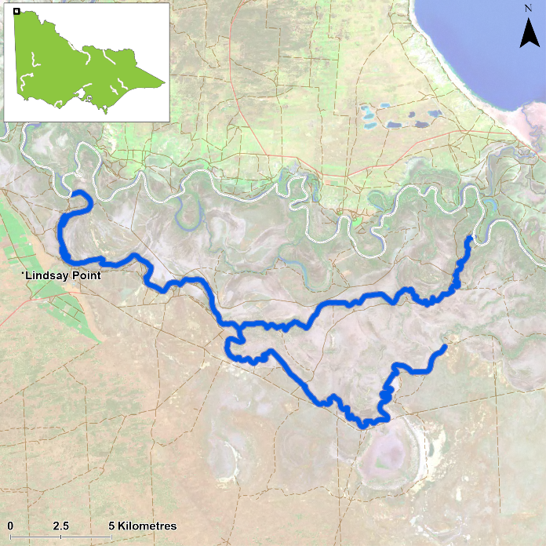
Figure 1. Map showing the section of Lindsay River and Mullaroo Creek where NFRC sampling occurs

Environment
Two blackwater events negatively affected fish populations in 2016 and 2022. Generally, stream flows were similar during the autumn sampling periods in 2017 to 2022 and 2024 to 2025 but were higher in 2023. Prior to 2022 surveys, the Murray River has had varying levels of connectivity with the upper Lindsay River since the 2016 flood. As such, the upstream reaches of the Lindsay River (above the Mullaroo Creek junction) generally experienced lower flows and water levels from 2017-2022 and again in 2025. Working collaboratively with The Living Murray Project, the number of sites fished and used in the analysis has varied with 12 sites fished in 2017, 13 in 2018- 2020, 10 sites in 2021-22, 11 sites in 2023-24 and 10 sites in 2025. Sites were surveyed by an electrofishing boat in March 2017-22 and 2024-25 but were delayed until April in 2023 due to flooding. The water turbidity levels were much higher in 2022 and 2023, which likely reduced the efficiency of the electrofishing surveys.

Waterway and fisheries management efforts in the Lindsay River
A range of rehabilitation actions to improve the health of the Lindsey River system and its fish community have been identified within the Mallee Waterway Strategy 2014-2022. The core current focus involves allocation of water for the environment and improving fish passage. Since 2006, fish monitoring has occurred for the Lindsay, Mulcra and Wallpolla Islands, as part of The Living Murray Program. The Mallee Catchment Management Authority, DEECA, Victorian Environmental Water Holder and Victorian Fisheries Authority support rehabilitation and management of the Lindsay River and its fish community.

Golden Perch

Lindsay River system, Mallee region

Key Health Indicators
Recent recruitment No
Multiple size classes Yes
Mature fish present Yes

Monitoring Results
Total number of fish caught 52
Fish per 1km of waterway 4.43
Largest fish by length (cm) 45.2
Largest fish by weight (kg) 1.43
% of the catch that is legal size 86.5

The catch rate of Golden Perch (Macquaria ambigua) in the 2025 survey was consistent with surveys since 2019, aside from the relatively low catch rate in 2022 (Figure 2). The species’ abundance appears to have declined after the higher abundances in 2017 and 2018. An increase in juvenile abundances in 2023 contributed to the higher catch rate in 2023 compared to 2022, with a higher proportion of adults in 2024 and 2025, indicating the cohort of juveniles in 2023 has reached maturity (Figure 3). It is likely that the 2016 and 2022 floods attracted juvenile Golden Perch into the system, with abundances of juveniles in the upper Lindsay system (above the Mullaroo Creek junction) being highest in 2017 and 2023 when flows were high. Recruits were detected in 2017 and 2022. In 2022 the small Golden Perch which were present throughout the study areas were spawned in the Darling River (confirmed using otolith* chemistry) but had dispersed into, and were growing in, Victorian Mallee floodplains. The movements of these Golden Perch have also been tracked using acoustic telemetry and the results indicate that while some fish have moved out of the area, most fish have remained within Lindsay Island despite the 2022-23 flooding¹. Golden Perch are consistently captured in the Lindsay-Mullaroo system.

Stocking
Thirty-six thousand Golden Perch fingerlings were stocked into the Lindsay River in 2024 and 13,320 in April 2025 (after 2025 NFRC surveys). No Golden Perch were stocked into this system prior to 2024.

*Otoliths are fish earbones

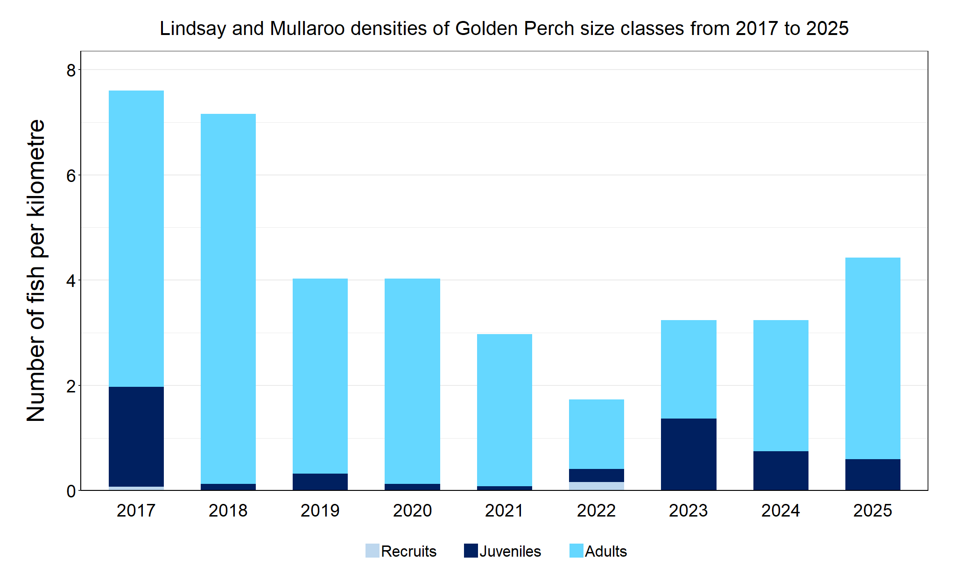
Figure 2. The densities of recruits, juveniles and adult Golden Perch in the Lindsay River system from 2017 to 2025

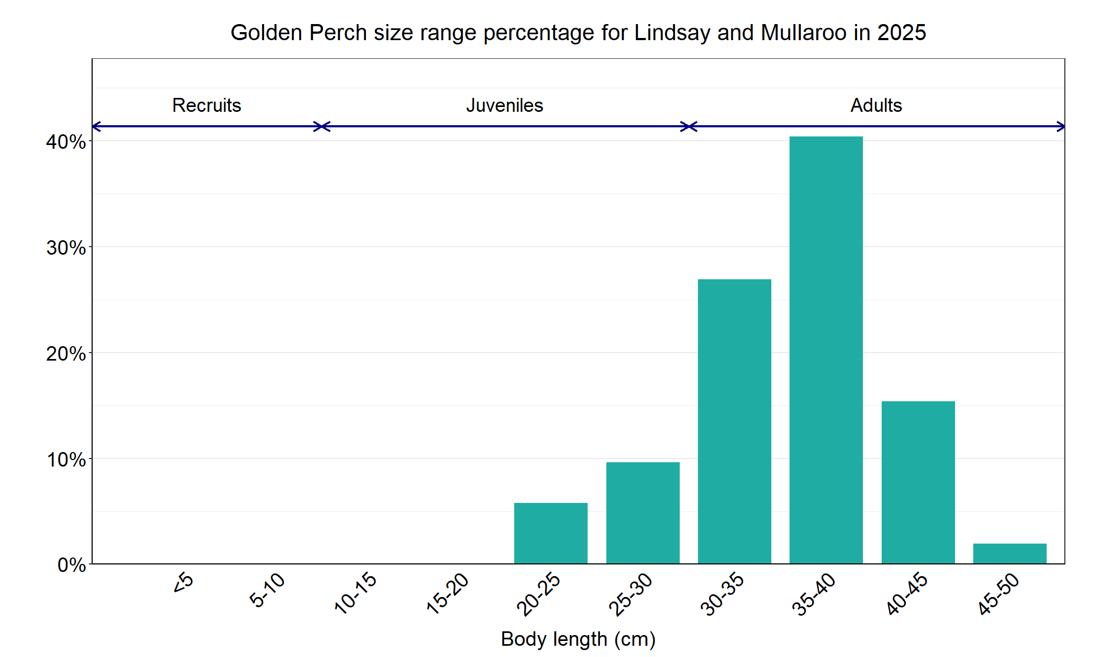
Figure 3. The size range percentage of Golden Perch in the Lindsay River system in 2025

1. Justin O’Connor, Chris Jones, Zeb Tonkin, Brenton Zampatti, Jarod Lyon, Arron Strawbridge, Steven Saddlier and Jason Lieschke (in prep). Using multiple lines of evidence to assess movement and habitat use of juvenile Golden perch in the lower Murray River, south eastern Australia. [Manuscript to be submitted for publication].

Murray Cod

Lindsay River system, Mallee region

Key Health Indicators
Recent recruitment No
Multiple size classes Yes
Mature fish present Yes

Monitoring Results
Total number of fish caught 51
Fish per 1km of waterway 4.34
Largest fish by length (cm) 97
Largest fish by weight (kg) 17
% of the catch that is legal size 3.92

The abundance of Murray Cod (Maccullochella peelii) in the Lindsay River system has been improving since the lowest recorded abundances in 2023 across NFRC surveys (Figure 4), following the 2022 floods which caused a minor blackwater event (ARI unpublished data). A dramatic decline in abundances was also recorded following the 2016 blackwater event either through emigration or mortality^{2,3}. Of the juveniles observed in the 2025 survey, most were 30-45 cm in length and may take several years to reach legal size (Figure 5). There is a distinct gap in 55-75 cm fish in 2025 (Figure 5), which corresponds with the gap between 15-35 cm detected in 2022, 20-50 cm in 2023 and 35-75 cm in 2024. There were more large adults (75 cm +) than legal size adults (55-75 cm) in 2025, indicating there are large breeding adults in the system albeit in low abundances (Figure 5). The highest abundances of adults collected were in 2021 and 2022, indicative of fish surviving and reaching maturity following the 2017 spawning event. From 2018-25 multiple size classes have been recorded, though recruits were absent in 2022, 2024 and 2025 (Figure 4). The single individual collected at 12 cm in 2025 is likely a recruit, as Murray Cod have been shown to have faster growth rates in this system compared to the rest of Victoria. The first Murray Cod detected during NFRC surveys from the Lindsay River was in 2022, three Murray Cod were detected in 2023 (a recruit, a juvenile and an adult), three juveniles in 2024 and three juveniles in 2025. This suggests that either increased flows in 2021 and 2022 have increased Murray Cod dispersal within the system or they are stocked fish.

Stocking
Twenty-seven thousand Murray Cod were stocked into the Lindsay River in 2021; 56,000 in 2023; and 60,000 in early February 2025.

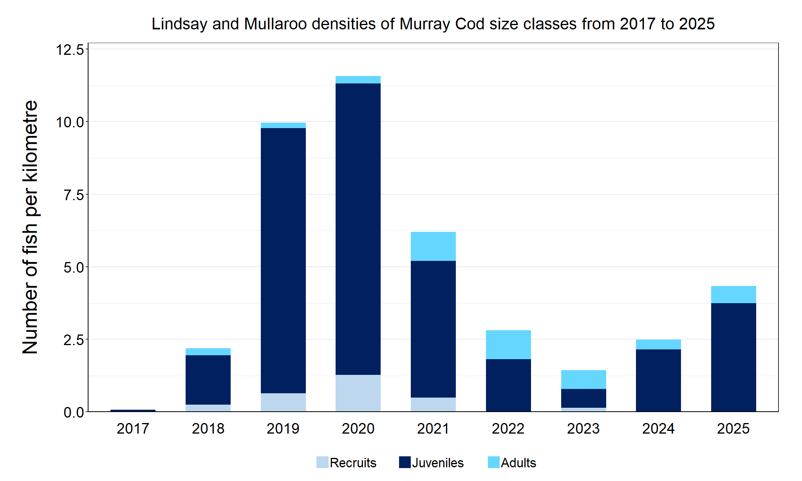
Figure 4. The densities of recruits, juveniles and adult Murray Cod in the Lindsay River system from 2017 to 2025
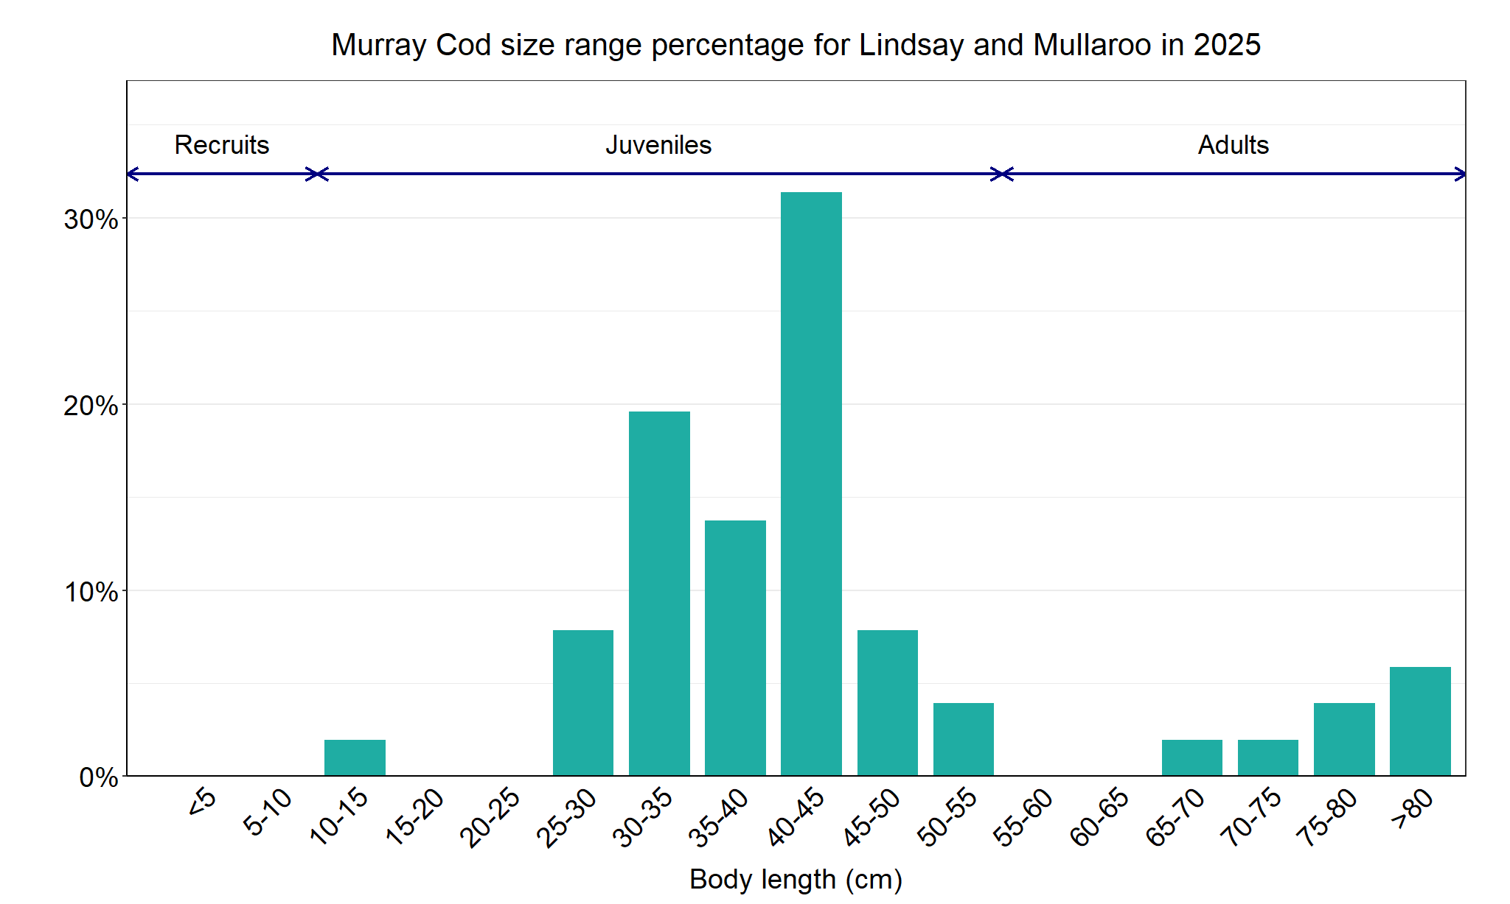
Figure 5. The size range percentage of Murray Cod in the Lindsay River system in 2025

2. Tonkin, Z., O’Mahony, J., McMaster, D., Raymond, S., Moloney, P. and Lyon, J. (2017). Fish movement in the Lindsay and Mulcra Island anabranch systems: 2017 Progress report. Unpublished Client Report for the Mallee Catchment Management Authority. Arthur Rylah Institute for Environmental Research. Department of Environment, Energy, Environment and Climate Change Group, Heidelberg, Victoria.

3. Tonkin, Z., O’Mahony, J., Kitchingman, A., Moloney, P., Raymond, S., Hackett, G., and J. Lyon (2020). Murray cod movement and population structure in the Lindsay Island anabranch system: 2020 Report. Unpublished Client Report for the Mallee Catchment Management Authority. Arthur Rylah Institute for Environmental Research, Department of Environment, Land, Water and Planning, Heidelberg, Victoria.

Silver Perch

Lindsay River system, Mallee region

Key Health Indicators
Recent recruitment Cannot be determined
Multiple size classes Cannot be determined
Mature fish present Cannot be determined

Monitoring Results
Total number of fish caught 1
Fish per 1km of waterway 0.09
Largest fish by length (cm) 23.6
Largest fish by weight (kg) 0.22
% of the catch that is legal size NA#

# This species is a Protected Freshwater Species and taking or possessing is prohibited (Victorian Recreational Fishing Guide 2025).

The natural range of Silver Perch (Bidyanus bidyanus) includes most of the Murray-Darling Basin, excluding the cool, higher altitude upper reaches of streams. River regulation and barriers have been listed as factors negatively impacting Silver Perch populations, with these relevant to the Lindsay River system. While the NFRC only expects to capture low numbers of this species, the monitoring can provide a greater understanding of the current status of the populations which is essential to inform management of the species. Due to the low abundances of Silver Perch collected during NFRC the key health indicators cannot be measured.

Only one juvenile Silver Perch was detected in 2025 (Figure 6, Figure 7). Silver Perch have been captured in eight of the nine years surveyed, albeit in low abundances, and were absent in 2023 (Figure 6). The Silver Perch detected during NFRC surveys are a mixture of recruits (2020), juveniles (2017, 2019, 2021-22 and 2025) and adults (2018–19, 2021–22 and 2024) (Figure 6). Recruits of this species are difficult to catch using the NFRC sampling methods. Recruits were only detected in 2020 suggesting spawning success in 2019. As Silver Perch are only detected in low abundances, it cannot be determined whether the 2022 blackwater (hypoxia) event impacted the population. Silver Perch are a highly mobile species with previous studies demonstrating positive impacts of high flows and flooding on their survival, growth and condition^{3,4}. Whilst Silver Perch have been shown to benefit from flow events, even if those flow events are associated with hypoxia, in systems or circumstances where they cannot move, they are susceptible to hypoxia⁵.

Stocking
No stocking has occurred.

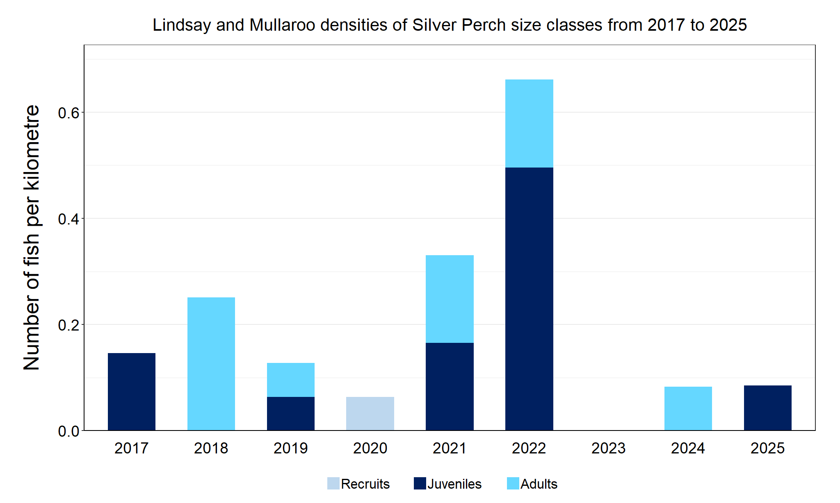
Figure 6. The densities of recruits, juveniles and adult Silver Perch in the Lindsay River system from 2017 to 2025

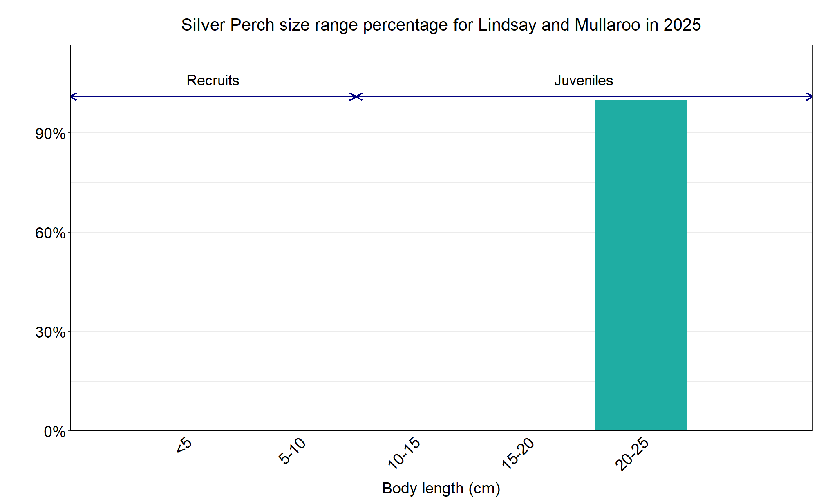

Figure 7. The size range percentage of Silver Perch in the Lindsay River system in 2025

3. Tonkin, Z., Stuart, I., Kitchingman, A., Jones, M., Thiem, J., Zampatti, B., Hackett, G., Koster, W. and Koehn, J. (2017). The effects of flow on silver perch population dynamics in the Murray River. Arthur Rylah Institute for Environmental Research. Technical Report Series No. 282. Department of Environment, Land, Water and Planning, Heidelberg, Victoria

4. Tonkin, Z., Stuart, A. Kitchingman, J. D. Thiem, B. Zampatti, G. Hackett, W. Koster, J. Koehn, J. Morrongiello, M. Mallen-cooper and J. Lyon (2019). Hydrology and water temperature influence recruitment dynamics of the threatened silver perch Bidyanus bidyanus in a regulated lowland river. Marine and Freshwater Research, 70: 1333-1344.

5. Thiem, J. D., L. J. Baumgartner, B. Fanson, A. Sadekov, Z. Tonkin and B. P. Zampatti (2022). Contrasting natal origin and movement history informs recovery pathways for three lowland river species following a mass fish kill. Marine and Freshwater Research, 73: 237-246

We acknowledge and respect Victorian Traditional Owners as the original custodians of Victoria’s land and waters, their unique ability to care for Country and deep spiritual connection to it. We honour Elders past and present whose knowledge and wisdom has ensured the continuation of culture and traditional practices.

© The State of Victoria Department of Energy, Environment and Climate Action 2025. This work is licensed under a Creative Commons Attribution 4.0 International licence. To view a copy of this licence, visit creativecommons.org/licenses/by/4.0/
ISSN 2981-9059 Online (pdf/word)

