Potential impacts of sea-level rise on waterbirds at the Western Treatment Plant, Victoria

D. Rogers, K. Stamation and P. Menkhorst

July 2021
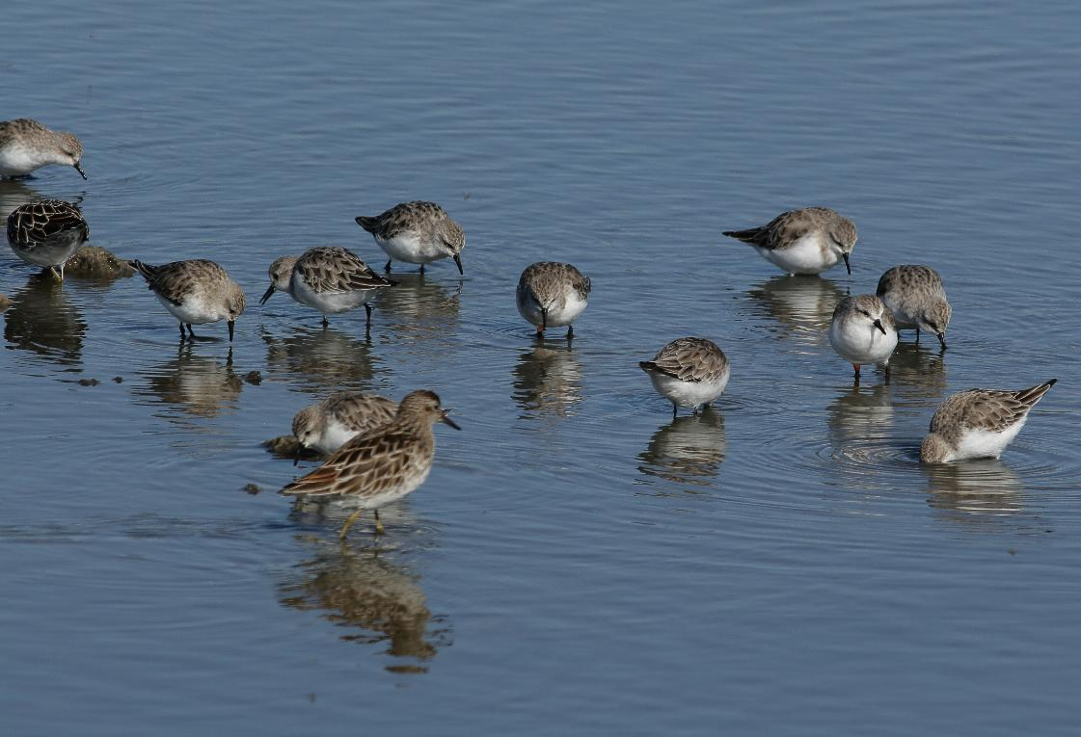

Arthur Rylah Institute for Environmental Research
Report





Acknowledgment
We acknowledge and respect Victorian Traditional Owners as the original custodians of Victoria's land and waters, their unique ability to care for Country and deep spiritual connection to it. We honour Elders past and present whose knowledge and wisdom has ensured the continuation of culture and traditional practices.
We are committed to genuinely partner, and meaningfully engage, with Victoria's Traditional Owners and Aboriginal communities to support the protection of Country, the maintenance of spiritual and cultural practices and their broader aspirations in the 21st century and beyond.

Arthur Rylah Institute for Environmental Research
Department of Environment, Land, Water and Planning
PO Box 137
Heidelberg, Victoria 3084
Phone (03) 9450 8600
Website: www.ari.vic.gov.au

Citation: Rogers, D., Stamation, K. and P. Menkhorst (2021). Potential impacts of sea-level rise on waterbirds at the Western Treatment Plant, Victoria. Report for Melbourne Water, Arthur Rylah Institute for Environmental Research, Department of Environment, Land, Water and Planning, Heidelberg, Victoria.

Front cover photo: Red-necked Stints and Sharp-tailed Sandpipers feeding on the foreshore of the Western Treatment Plant, Feb. 2010 (P. Menkhorst).
ISBN 978-1-76176-880-4 (pdf/online/MS word)
© The State of Victoria Department of Environment, Land, Water and Planning 2021

This work is licensed under a Creative Commons Attribution 3.0 Australia licence. You are free to re-use the work under that licence, on the condition that you credit the State of Victoria as author. The licence does not apply to any images, photographs or branding, including the Victorian Coat of Arms, the Victorian Government logo, the Department of Environment, Land, Water and Planning logo and the Arthur Rylah Institute logo. To view a copy of this licence, visit http://creativecommons.org/licenses/by/3.0/au/deed.en

Disclaimer
This publication may be of assistance to you but the State of Victoria and its employees do not guarantee that the publication is without flaw of any kind or is wholly appropriate for your particular purposes and therefore disclaims all liability for any error, loss or other consequence which may arise from you relying on any information in this publication.

Accessibility
If you would like to receive this publication in an alternative format, please telephone the DELWP Customer Service Centre on 136 186, email customer.service@delwp.vic.gov.au or contact us via the National Relay Service on 133 677 or www.relayservice.com.au. This document is also available on the internet at www.delwp.vic.gov.au

Potential impacts of sea-level rise on waterbirds at the Western Treatment Plant, Victoria

Danny Rogers, Kasey Stamation and Peter Menkhorst

Arthur Rylah Institute for Environmental Research
123 Brown Street, Heidelberg, Victoria 3084

Date

Arthur Rylah Institute for Environmental Research
Report for Melbourne Water,
Department of Environment, Land, Water and Planning

Acknowledgements
Funding for this study was generously provided by the Treatment and Resources Section of Melbourne Water. In particular, we thank Eva Diestelhorst and Will Steele for their support and guidance. We also acknowledge Melbourne Water’s on-going funding and other support for the waterbird monitoring program at the Western Treatment Plant, now in its 22nd year, and associated studies on waterbird habitats, without which the analyses presented here would not have been possible.
David Petch (GHD) and Greg Parry provided helpful discussions on tidal flat biota and environments. Mike Davis (Tidal Unit, Bureau of Meteorology) kindly provided tide height data. The report was improved by constructive comments on earlier drafts by Eva Diestelhorst and Will Steele (Melbourne Water), Nevil Amos and Will Sowersby (ARI).

Contents
Acknowledgements 4
Summary 6
1 Background 7
1.1 Background on shorebird ecology at the WTP 7
1.2 Background on the significance of the WTP for waterfowl 9
1.3 Waterfowl ecology at the WTP 10
2 Methods 11
2.1 Shorebirds 11
Approach to estimating tidal flat area needed by shorebirds at the WTP 11
Data sources 18
2.2 Waterfowl 19
Data sources and compilation 19
Approach taken 19
3 Results 21
3.1 Shorebirds 21
Target carrying capacity for shorebirds at the WTP 21
Daily energy requirements 22
Tidal flat area and carrying capacity 22
Foraging density and interference 27
Intake rates 28
3.2 Waterfowl 30
Usage of the seaward ponds 30
Comparison to the Ramsar Limits of Acceptable Change (LAC) 31
4 Discussion 37
4.1 Shorebirds 37
Provision of additional supratidal foraging habitat. 38
Improving prey quality in nearshore tidal flats 38
Coastal retreat 39
Data needed to refine estimates 39
4.2 Waterfowl 42
Usage of the seaward ponds 42
Comparison to the Ramsar Limits of Acceptable Change (LAC) 42
5 Conclusions and implications 43
5.1 Shorebirds 43
5.2 Waterfowl 43
References 45

Summary
Context:
The Western Treatment Plant (WTP) attracts internationally significant numbers of waterbirds. Under current climate change scenarios, sea-level rise can be expected to significantly alter the foreshore and low-lying parts of the WTP. Melbourne Water is currently planning how to adapt to sea-level rise via a WTP Foreshore Adaptation Plan. To assist with the preparation of the plan, Melbourne Water requested information on the current extent and distribution of high-quality waterbird habitats that may be at risk from sea-level rise.
Aims:
To investigate the potential implications for waterbirds of reduction in the area and carrying capacity of the main WTP waterbird habitats that are at risk from sea-level rise (i.e. tidal flats and the most seaward sewage treatment ponds).
Methods:
For migratory shorebirds we used a combination of foraging theory and empirical data on shorebirds and their prey, collected at the WTP over the past 20 years, to provide an estimate of the area of tidal flat required to maintain current population levels.
For waterfowl, we examined mean and maximum counts per species for two pond groups, the most seaward line of ponds (those most vulnerable to sea-level rise) vs ponds further from the coast, over the same 20-year period. The metric used was the proportion of total WTP waterfowl that occupied the seaward ponds.
Results:
Shorebirds: With current water levels, the carrying capacity for shorebirds at the WTP is high and so it is likely that some tidal flat could be lost without causing a decline in shorebird numbers. However, a decrease in duration of exposure of the tidal flats is likely to have more of an impact than the area exposed. Our modelling indicates that shorebirds struggle to achieve the intake rates required to meet their energetic needs at low tide and that this is most problematic during the period of pre-migratory mass gain.
Waterfowl: Seaward ponds equate to 11% of the surface area of non-marine wetlands at the WTP. However, except for one feeding guild, they do not have habitat features that are unavailable elsewhere in the WTP. The exception is diving carnivores (Musk Duck, cormorants and darter) that forage on macroinvertebrates and small fish that are likely to be most abundant in ponds at the later stages of the sewage treatment process. Given the very large numbers of birds supported by the WTP, a loss of 11% of habitat equates to many individuals that need to be catered for elsewhere (~4,000-14,000 waterbirds, excluding shorebirds).
Conclusions and implications:
- We estimate that, in the key foraging areas of the WTP, an area of 8 ha of tidal flat needs to be exposed for an average of 41.8% of each day to maintain current populations of the three most abundant shorebirds. At present, 8 ha or more of tidal flat is exposed for an average of 48.0% of each day.
- Energetic requirements of shorebirds are highest during the period of pre-migratory mass gain. Our intake rate estimates during this period suggested that shorebirds would need to forage almost continuously to meet their energetic demands. Shorebirds must have a mechanism to increase their intake rates during this period and we suspect they do so by selecting prey of higher quality.
- The constraints to shorebird intake rates suggest that the uppermost tidal flats (those nearest shore, exposed for the longest periods at low tide) are of disproportionate importance to foraging shorebirds. Potential approaches to maintain or improve foraging success on the uppermost tidal flats include local nutrient enrichment to increase prey quality, management of vegetation and disturbance on the adjacent shore, or coastal engineering to increase the area of upper tidal flats.
- Loss of the seaward row of treatment ponds to sea-level rise represents an 11% reduction in the surface area of ponds available for waterfowl. In summer, this equates to habitat for about 14,000 individual waterbirds (excluding shorebirds).
- Few species are reliant on the seaward ponds and of those that prefer them the Musk Duck is the most significant. This preference likely relates to water quality towards the end of the treatment process and its effect on prey abundance for this carnivorous species.
- Strategies to minimise the reduction in waterfowl populations that can be supported at the WTP should focus on a combination of wetland creation and increasing carrying capacity of existing ponds.
- Background
The Western Treatment Plant (WTP) attracts internationally significant numbers of waterbirds and forms part of a series of coastal wetlands recognised under the Ramsar Convention as being of international significance. Melbourne Water is required to contribute to the conservation of waterbird populations at the WTP to meet its obligations under State and Commonwealth legislation, while continuing to treat about half of Melbourne’s wastewater at the property.

Under current climate change scenarios, sea-level rise can be expected to significantly alter the foreshore and low-lying parts of the Western Treatment Plant (WTP) by 2070-2100 (Water Technology 2017). Depending on mitigation measures adopted, this process is likely to seriously degrade some Matters of National Environmental Significance under the Environment Protection and Biodiversity Conservation Act 1999, including some Ramsar values. In particular, the extent of low-tide mudflats available to shorebirds for feeding is likely to be reduced, especially as Port Phillip Bay naturally has a small tide range and narrow tidal flats. Moreover, it is likely that climate change will also reduce frequency of inland flooding in southern Australia, with higher inland temperatures increasing the speed at which inland wetlands dry out in summer (CSIRO 2021). Coastal refugia such as the WTP may therefore become increasingly important for waterbirds and shorebirds.

Melbourne Water is committed to its Ramsar obligations and is currently planning how to mitigate erosion and adapt to sea-level rise to protect WTP’s values via a WTP Foreshore Adaptation Plan. Management options being considered in this plan include coastal retreat and sacrificing some near-coastal ponds to replace them with foreshore habitats. To assist with the preparation of a WTP Foreshore Adaption Plan, Melbourne Water requested information on the current extent and distribution of high-quality waterbird habitats along the coastal and estuary fringes of the WTP that may be at risk from sea-level rise. Melbourne Water also sought estimates of potential population losses and the quantum of replacement habitat that may be required to offset losses of current habitat. There are two broad habitats involved – 1) marine, tidal mudflats and 2) freshwater, non-tidal, open-water ponds containing wastewater at the later stages of the treatment process.
In this report we address the potential implications of reduction in the area and carrying capacity of these two major waterbird habitat types:
- We estimate the area of tidal flat required to maintain current shorebird populations at the WTP. The estimates are based on a combination of foraging theory and empirical data on shorebirds and their prey collected at the WTP during studies commissioned by Melbourne Water over the past 20 years.
- Using a 20-year time series of waterbird counts, we examine the significance for waterbirds of the most seaward line of sewage treatment ponds and discuss what their loss may mean for retention of Ramsar values and current waterbird numbers at the site.
  - Background on shorebird ecology at the WTP
The WTP is renowned for its non-breeding populations of migratory shorebirds. Three species regularly occur in internationally significant numbers (>1% of the population in the East Asian – Australasian Flyway; Loyn et al. 2014a, Hansen et al. 2016): Red-necked Stint Calidris ruficollis, Curlew Sandpiper Calidris ferruginea and Sharp-tailed Sandpiper Calidris acuminata (Figure 1). All three species are small sandpipers that forage for buried invertebrates while wading in very shallow water or when walking on exposed wet mud. They breed in the tundra of northern Siberia, mainly within the Arctic Circle, and migrate annually to non-breeding grounds in Australasia (Higgins & Davies 1996). They arrive in their non-breeding grounds of southern Australia, such as the WTP, between September and December (Choi et al. 2016). Adults almost immediately begin their annual wing moult, which most individuals complete in January or February (Higgins & Davies 1996). At about the time they complete wing moult, adults begin pre-migratory mass gain, accumulating fuel (mainly fat) for northward migration. Their weight increases by 50 to 75% before their departure on northwards migration in March or April (Rogers et al. 1997; Higgins & Davies 1996). On both northwards and southwards migration there are multiple stopovers on the coast of Asia to refuel (Lisovski et al. 2020).
Immature migratory shorebirds arrive in Australia slightly later than adults and do not carry out a full moult of flight feathers in their first austral summer. Immature Red-necked Stints and Curlew Sandpipers remain in Australasia for their first year; and therefore do not undergo substantial pre-migratory mass gain and many remain in the WTP through the austral winter. In contrast, immature Sharp-tailed Sandpipers undergo pre-migratory mass gain and migrate north at about the same time as adults (Higgins & Davies 1996).
At the WTP, Red-necked Stints, Sharp-tailed Sandpipers and Curlew Sandpipers usually occur in mixed flocks. At low tide the majority forage on the tidal flats of the foreshore; their diets are imperfectly known but all three species feed on small benthic invertebrates. They forage on the tidal flats both by day and night (whenever the tide is low, Rogers et al. 2013), as is typical of coastal shorebirds (Lourenco et al 2008). Benthos surveys have confirmed that prey densities on the tidal flats of the WTP are very high by world standards (Rogers et al. 2007, Rogers et al. 2013). Although they usually forage in loose flocks there is some segregation by water depth: Red-necked Stints prefer exposed wet mud or very shallow water <5 mm deep; Curlew Sandpipers usually forage when wading in water 3-5 cm deep, and Sharp-tailed Sandpipers usually forage in water 1-3 cm deep (Rogers and Hulzebosch 2014).
At high tide, when the tidal flats of the WTP are submerged, all three species move to ‘roosts’ – supratidal sites with low predation risk where shorebirds gather in flocks to sit out the high tide (Rogers 2003). Melbourne Water has identified 17 former wastewater treatment ponds as ‘conservation ponds’ to be managed to provide habitat for particular faunal values (shorebirds, waterfowl, marsh birds, Orange-bellied Parrot and Growling Grass Frog). The priority value to be promoted in a given pond may vary between years according to vegetation succession and the need to ‘rest’ ponds, but in any given year there are 11-12 conservation ponds allocated to providing roosting and foraging habitat for shorebirds (Melbourne Water unpubl.). High water levels are maintained in these ponds for much of the year to control vegetation incursion (and in some cases, to also provide habitat for Growling Grass Frog). Water levels are drawn down in summer to provide shallow water and exposed mud where shorebirds can and do forage.
Although roosts are popularly associated with sleeping or at least resting, shorebirds also spend some of their time foraging at these sites, though, in general, prey densities are considerably lower than those on the tidal flats. Very shallow water levels cannot be maintained in conservation ponds for long periods because doing so causes vegetation incursion (Rogers and Hulzebosch 2014, Rogers et al. 2015), so individual conservation ponds can only provide foraging shorebird habitat for a few weeks. Melbourne Water therefore aims to stagger the drawdown of conservation ponds so that different ponds provide shorebird foraging habitat at different times. Roosts with supratidal foraging habitat for shorebirds are available at the WTP for much of the austral summer, especially in the late summer when the pre-migratory mass gain of shorebirds increases their energetic requirements. The water level management of conservation ponds is challenging, and there are times when no conservation ponds are suitable for shorebirds. At such times, shorebirds of the WTP often roost at sites where feeding is not possible (e.g., the barrier islands of The Spit Nature Conservation Reserve) or fly ~15 km to roosts in Avalon Saltworks (Menkhorst et al. 2020).
Several lines of evidence suggest that the supratidal foraging opportunities provided by conservation ponds at the WTP are important to the local persistence of shorebirds (Parry & Rogers 2019; Rogers et al. 2021):
(1) Shorebird flocks on the tidal flats are dominated by species (small sandpipers) that can (and do) forage on both tidal flats and non-tidal wetlands. These species far outnumber obligate coastal species that only forage on tidal flats (e.g., Red Knot Calidris canutus and Bar-tailed Godwit Limosa lapponica) or species that only feed in non-tidal ponds (e.g., Red-kneed Dotterel Erythrogonys cinctus).
(2) Shorebirds at the WTP lose weight during neap tide series, suggesting their energy intake decreases when there is less exposure of tidal flats.
(3) Modelling of intake rates indicates that during neap tide series, the tidal flats of the WTP are not exposed for long enough for small sandpipers to meet their daily energy requirements.
It is likely that increasing the number or area of conservation ponds managed for shorebirds would be a helpful management response to loss of tidal flats at the WTP. However, conservation ponds have lower prey densities than tidal flats at the WTP, and individual ponds are only suitable for foraging shorebirds during the drawdown period (i.e., only a few weeks per year). The area of conservation ponds required to compensate for sea-level rise would therefore need to be larger than the area of lost tidal flats. This would probably be unachievable, given geographical constraints within the WTP and the ongoing need for Melbourne Water to use most of the ponds in the WTP for sewage treatment. In this report we therefore assume that the area of conservation ponds and their capacity to support shorebirds will remain similar to current levels.
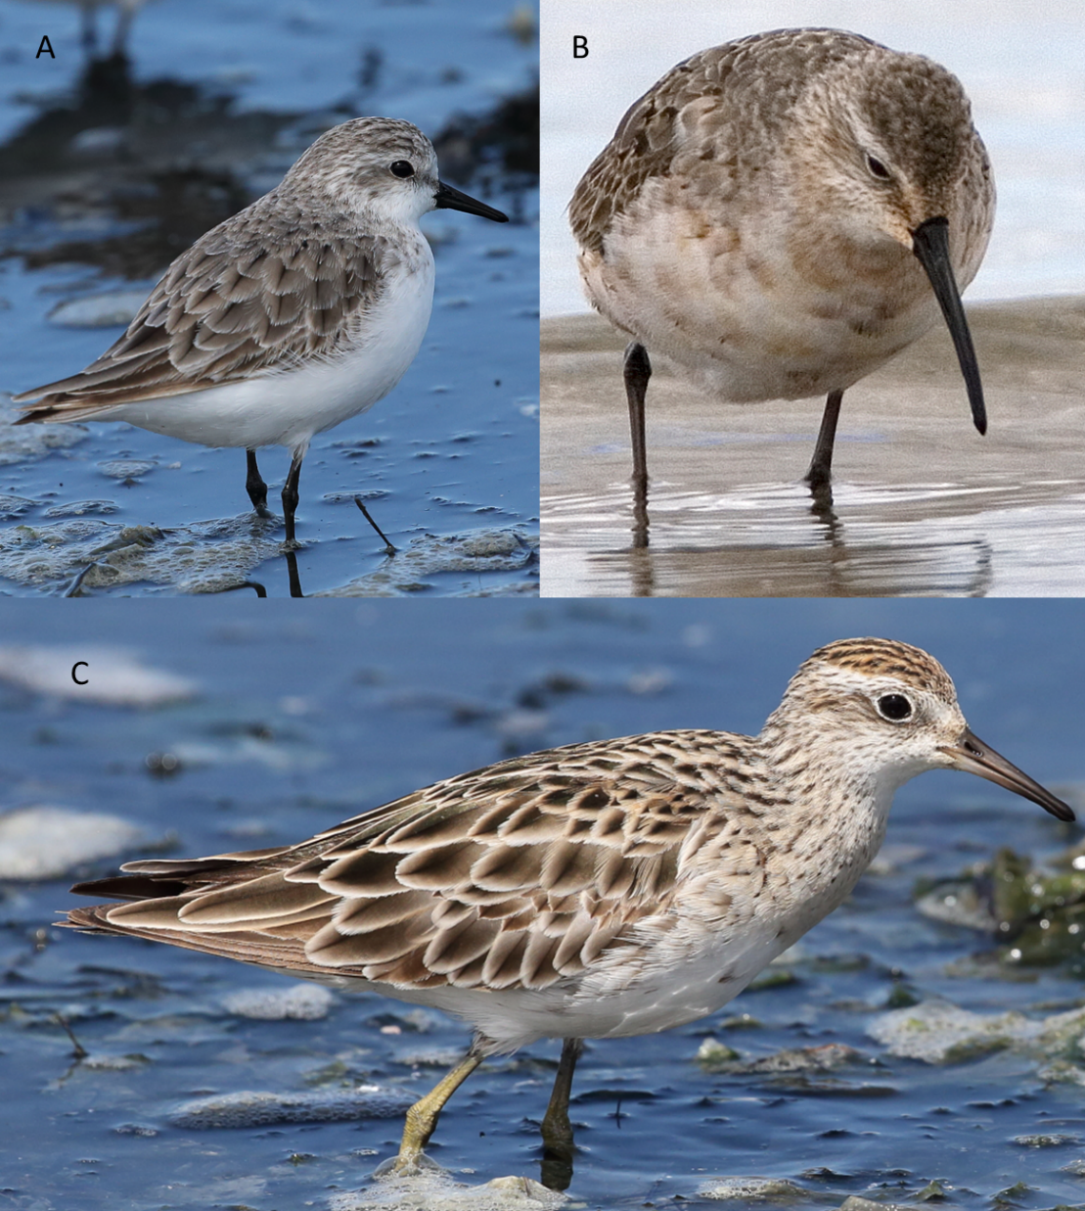
Figure 1.The study species: (a) Red-necked Stint; (b) Curlew Sandpiper; (c) Sharp-tailed Sandpiper. Photographer D. Rogers.
  - Background on the significance of the WTP for waterfowl
Here we define waterfowl as all Anatidae (ducks, geese and swans) along with coot and grebes, which also habitually feed while swimming on ponds. Where appropriate, we also consider other groups of waterbirds including cormorants, pelicans and large wading birds.
Sewage treatment plants have been recognised as providing important habitats for waterfowl globally. For example, over a 22-year period across Victoria, sewage treatment plants supported a greater number of individuals and a greater density of species than four other wetland types (deep marsh, open water, permanent saline, semi-permanent saline) (Murray et al. 2012).
As the case in many wetlands of in south-eastern Australia, numbers of most waterbird species at the WTP fluctuate widely from year to year in response to climatic conditions across roughly one third of the Australian continent. Waterbird numbers at the WTP tend to be highest in years of drought, when the drying of wetlands in inland Australia forces waterbirds to move to more reliably watered drought refugia. Waterbird numbers at the WTP are lower in wet years when large numbers of birds can move to flooded inland wetlands. Few waterfowl species breed at the WTP, rather it functions as non-breeding habitat for large numbers of waterfowl and other waterbirds. For most species, peak numbers at the WTP occur during their non-breeding season, commonly in summer and early autumn (Loyn et al. 2014a) but there is considerable variation driven by the availability of floodwater in inland eastern Australia (Loyn et al. 2014a, Papas et al. 2021). For example, waterfowl numbers at the WTP fell dramatically in 2010-11 after the breaking of a 13-year drought resulted in the wide availability of preferred breeding habitat in inland eastern Australia. In subsequent years, waterfowl numbers at the WTP increased to roughly pre-drought levels (Loyn et al. 2014a). Time-series models showed that climate was the dominant driver of change in waterfowl numbers at the WTP (Loyn et al. 2014a).
Based on annual Summer Waterfowl Counts conducted across Victoria between 1987 and 2019, the numbers of waterfowl counted at the WTP have consistently exceeded those at other Victorian wetlands, often by an order of magnitude (see, for example, Menkhorst et al. 2019, Table 7). Waterfowl numbers at the WTP have also exceeded numbers on most wetlands counted during annual spring aerial surveys of eastern Australia since 1984 (ARI unpublished data, Kingsford et al. 1999, 2009). The densities of waterfowl recorded (mean of 33 birds per hectare, calculated for ~2,000 ha of ponds and other wetland habitats at the WTP) (Loyn et al. in prep) are high compared with other wetland types (see, for example, Murray et al. 2012, Table 2), and similar to those recorded at a smaller treatment plant in South Australia (peak of 9804 waterbirds on 340 ha, Breed et al. 2020).
Maximum numbers of one species recorded at the WTP (12,178 Blue-billed Duck in 2002, or ~13,000 on a non-scheduled count in 2002) exceed previous estimates of the total population of this Australian endemic species (12,000, Garnett and Crowley 2000).
  - Waterfowl ecology at the WTP
Within a treatment plant, waterfowl abundance, density and species richness tend to be greater in ponds that are further advanced in the treatment process (Hamilton et al. 2005, Murray et al. 2014). This was also true for aquatic invertebrate communities in a study based at a single treatment plant (Hamilton et al. 2005). This greater trophic richness (more complex invertebrate community) may partially explain the preference by waterbirds for waters towards the end of the treatment process.
Sewage treatment at the WTP relies upon a series of 190 treatment ponds organised into 13 lagoon systems with a total water surface area of 9150 ha. There are also other wetland habitats present including former treatment ponds that have become redundant for sewage treatment and are now managed to provide various waterbird and frog habitats, and almost 20 km of foreshore with, in places, extensive coastal saltmarsh vegetation and tidal mud flats. Most of the waterfowl inhabit the sewage treatment ponds (Loyn et al. 2014a) but for some species, notably Chestnut Teal, Grey Teal and Black Swan, intertidal areas are also important as feeding grounds. Some large fish-eating birds (cormorants, Australian Pelican) feed mostly in the adjacent marine waters of Port Phillip and use the WTP mostly as a roosting site between bouts of feeding, taking advantage of dead trees in some lagoons or artificial platforms provided in Lake Borrie by Melbourne Water.
Loyn et al. (2014b) sought to determine relationships between the density of waterfowl (considered as seven feeding guilds) on 26 selected treatment ponds and five key water variables measured in those ponds. The five water variables were Cumulative Retention Time (CRT), Chlorophyll A concentration, Carbon Biological Oxygen Demand (CBOD5), Total Kjeldahn Nitrogen (TKN) and pH. The water data had been collected from regular monitoring on behalf of Melbourne Water during 2000-2011.
Three waterfowl guilds (diving ducks, grebes and swans) responded negatively to CBOD5, a measure of bacterial activity (and closely correlated with total organic carbon). Members of each of these three guilds take their food from deeper levels in the water column: diving ducks and grebes by diving, and swans by using their long neck to reach well below the surface, sometimes including upending. The results suggest that some treatment ponds sometimes contain higher levels of organic carbon and associated bacterial activity than are optimal for these species. Conversely, filter-feeding ducks responded positively to CBOD5. They feed from the surface layers, which may be less affected by the oxygen depletion that can accompany high bacterial activity. The availability of zooplankton in the surface waters may be enhanced by high levels of organic carbon. Diving ducks, grazing ducks and swans showed a positive relationship with Chlorophyll A. Chlorophyll A is an indicator of algal abundance, and algae may be an important driver of productivity, as food for zooplankton, or perhaps consumed directly by some waterfowl species. Most waterfowl include vascular plants in their diet, in the form of seeds and green shoots. An important theme to emerge from this work is that waterfowl tend to favour water bodies with intermediate levels of nutrients.

- Methods
  - Shorebirds

Approach to estimating tidal flat area needed by shorebirds at the WTP
The core question addressed in the shorebird sections of this report is: ‘What is the area of tidal flat required to maintain current shorebird populations at the WTP?’. In Europe in particular, carrying capacity estimates are often used to address questions of this kind. Carrying capacity in this context has been defined as the “maximum numbers of migratory animals that can be supported in a particular locality at a particular time of year” (Goss-Custard et al. 2002); it can also be expressed as the total number of bird-days an area can support, or the maximum numbers of birds that can survive in an area over a given period of time (in the case of the WTP, the number of birds that can survive the non-breeding season).
This study builds on the analysis of Parry & Rogers (2019), by estimating carrying capacity of the tidal flats of the WTP for shorebirds based on the Daily Ration modelling approach. A similar approach was also used to estimate carrying capacity of shorebirds in Gladstone Harbour (Choi et al. 2017). Daily Ration Models estimate carrying capacity based on the energetic requirements of an average individual animal, and the total amount of food available (Alonso et al. 1994; Stillman et al. 2010). Daily Ration models are computationally simple, and data necessary for these calculations is available from the WTP. There is a long history of shorebird counts at the site, the mass of the birds (directly related to energy demands) has been assessed in local banding studies, and benthos surveys have been carried out in the areas where shorebirds forage (see section ‘Data Sources’ for more information).

Amount of available food
Daily Ration Models require an estimate of the total amount of food available. While the benthic survey work at the WTP has documented the amount of shorebird food present at the WTP, not all this food is available to shorebirds. Key factors that are likely to limit the availability of food for shorebirds in the tidal flats of the WTP are outlined below, along with notes on our approach to correcting for these effects.

Target Carrying Capacity for shorebirds
Shorebird numbers at the WTP vary annually. Numbers peak in the austral summer, and are highest in years of inland drought, when many inland wetlands dry out and many waterbirds are forced to coastal refugia such as the WTP (Loyn et al. 2014a; Papas et al. 2021). Melbourne Water aims to maintain shorebird populations of the WTP at their current level, and to comply with the Limits of Acceptable Change (LAC) for shorebirds in the Port Phillip Bay (Western Shoreline) and Bellarine Peninsula Ramsar Site (DELWP 2018, pp 26-27) (note that these LACs are for the entire Ramsar site, not just the WTP section of it):
Abundance of waterbirds will not decline below the following: (calculated as a rolling five-year average of maximum annual count; percentages calculated based on the latest Wetlands International Waterbird Population Estimates): Total shorebirds - 17,000; Curlew sandpiper – 3%; Red-necked stint – 2%; Sharp-tailed sandpiper – 2%.
Translating 5-year rolling averages to the longer time-frames relevant to sea-level rise is problematic, but the intent of the Ramsar LAC is clearly to maintain the status quo. To obtain information on this, we examined shorebird count data collected from the WTP between 2001 and 2021. Paired surveys of high tide and low tide counts have been carried several times per year in this period; we used the higher of the two counts each day for this analysis. Using data from summer counts (December-February) when shorebird numbers are highest, we calculated mean summer count for each year, for each species, and for migratory shorebirds overall. We selected the highest mean summer count for each species and also calculated the highest mean summer count for the three species combined. Mean counts throughout the entire study period were used to estimate a lower limit of carrying capacity but were not considered the ideal basis for estimating management targets. It is likely that in non-drought years, when many shorebirds remain inland instead of visiting coastal refugia, the number of birds at the WTP is below carrying capacity. The highest single-day counts recorded since 2001 were used to estimate an upper limit of carrying capacity. We did not consider these upper limits to be an ideal management target, because it is possible that the maximum counts on which they are based were made at times when numbers at the WTP briefly exceeded carrying capacity; moreover, the chances that the varying numbers of the three focal species would all peak concurrently are slim.

Daily energy requirements of shorebirds
The relationship between the mass of shorebirds and their Basal Metabolic Rate (BMR) was studied by Kersten et al. (1998). Working on 16 species of non-breeding shorebirds in West Africa, they developed the following equation relating BMR to Body Mass (M):
BMR (W) = 4.02 x M(kg)^{0.724}
BMR represents the energy requirements of shorebirds under thermoneutral conditions when they are not expending energy on any activities beyond life-sustaining functions (e.g., breathing) and maintenance (e.g., cell repair). Daily Energy Requirements of wild-living birds are considerably higher, as they also need to use energy for other essential activities including foraging, predator avoidance and movements between feeding sites and roosts (Rogers et al. 2006). We follow Piersma (2002) in assuming that Daily Energetic Requirements of shorebirds are twice BMR, increasing to 4-5 times BMR during the period of pre-migratory mass gain (we used 4.5 as a convenient single conversion factor). These conversion factors were based on laboratory studies (Piersma et al. 2003) of Red Knot Calidris canutus, coupled with data on activity budgets in the field (time spent walking, resting, foraging etc) in that species. They have not been assessed directly on smaller sandpiper species such as those occurring at the WTP.
For simplicity we assumed that birds operated under thermoneutral conditions (i.e., that they expend no energy in thermoregulation; Kersten et al. 1998). This is probably reasonable during the summer months when shorebirds are present in the largest numbers. It may lead to underestimation of energy needs in the austral winter. However, as shorebird numbers at the WTP are at their lowest at this time of year (adults having migrated to the Arctic), the total amount of food consumed by shorebirds at the WTP during the austral winter will be considerably lower than the amount consumed in summer, meaning that summer is the time when foraging area is most likely to be limiting.

Prey depth
None of the three focal species probe deeply for their prey at the WTP – they have relatively short bills (Red-necked Stint bill length 16–22 mm; Curlew Sandpiper bill length 32–43 mm; and Sharp-tailed Sandpiper bill length 22–27 mm; bill measurements from Higgins and Davies 1996) and cannot probe more deeply than their bill length; indeed they seldom probe deeper than 1 cm (pers. obs).
In estimating carrying capacity, we therefore only used data on benthos abundance from surveys that sampled the uppermost few cm of sediment. We used data from the surveys carried out by ARI (Rogers et al. 2007, 2011, 2013), which used core samples from the top 5 cm of sediment. We considered using data from Parry & Rogers (2019), which sampled the top 3 cm of sediment, but they only carried out one survey, and we considered it preferable to base carrying capacity estimates on a longer data series.

Prey ingestibility
Most benthic animals in the top 5 cm of the tidal flats of the WTP are rather small and within the size ranges that can be ingested by small sandpipers. However, the benthic fauna includes some animals (e.g., large molluscs) that are too large to be swallowed or too heavily armoured to be digested by the small shorebird species considered in this study. Rogers et al. (2007, 2011, 2013) corrected for this effect by estimating ‘Edible Biomass’. Guided by studies of gut contents of Curlew Sandpipers and Red-necked Stints in Western Port (Dann 1999) and south-eastern Tasmania (Thomas and Dartnall 1971), bill measurements (Higgins & Davies 1996, D. Rogers unpubl. data) and photographs of these species handling prey at the WTP (D. Rogers unpubl.), the following benthic animals were regarded as potential prey:
Red-necked Stint: soft animals (such as dipteran larvae and amphipods) less than 12 mm long and 3 mm wide; and hard-shelled animals (such as gastropods and bivalves) less than 5 mm long and 3 mm wide. In addition, slim polychaetes up to 50 mm long were considered edible for Red-necked Stints, as they have been seen or photographed taking such prey. Brittle Stars were considered inedible.
Curlew Sandpiper: soft animals (including polychaetes, amphipods and dipteran larvae) up to 7 mm wide; hard-shelled animals (such as gastropods and bivalves) less than 6 mm in diameter. Brittle Stars were considered inedible. Studies of gut contents in southern Australia suggest Curlew Sandpipers do not eat ostracods or similarly sized amphipods. We therefore treated tiny prey to be effectively inedible to Curlew Sandpipers at the WTP (e.g., nematode worms, ostracods, and amphipods <2 mm long).
Sharp-tailed Sandpiper: In the absence of direct data, we assumed diet to be like that of the similarly sized Curlew Sandpiper. This was done with some reservations, as Dorsey (1981) showed that gut contents of Sharp-tailed Sandpipers from the WTP contained fewer Ceratonereis polychaetes than did gut contents of Curlew Sandpipers. However, the details have not been published.
While we can make an approximation of the upper size limits of prey ingestible by shorebirds at the WTP, estimating the lower size limits is difficult. Shorebirds may be unable to handle prey under a particular size threshold, or they may reject potential prey under a particular size threshold as it is unprofitable (i.e., it does not yield enough energy to compensate for the energy spent on its capture). We have no direct data on these size thresholds, but a pragmatic lower size limit is provided by the mesh size of the sieves used to sort benthos samples (0.5 mm in the sampling by Rogers et al. 2007).
Parry & Rogers (2019) compared the biomass extracted by 0.5- and 1.0-mm sieves and found that while the smaller mesh collected many more benthic animals, those animals between 0.5 and 1 mm made a negligible contribution to biomass. The lower size limit of prey taken is therefore unlikely to have an important effect on estimates of the edible biomass available to small sandpipers. However, the lower size limit of prey may have important effects on prey intake rates – see next section.

Intake rates
If prey densities are even, large areas of tidal flat will obviously hold more shorebird food than small areas of tidal flat. However, the amount of food that shorebirds eat per day is not only limited by the amount of food in the tidal flat – it is also limited by intake rate, the rate at which they can ingest food. Intake rates have been studied in many species of shorebirds that consume large prey, usually through direct observation of the rate at which they swallow prey items, coupled with assessments of the size of the prey through observation (e.g., estimating the size of the prey item relative to bill size) or through the study of prey remnants in gut contents, pellets or droppings (e.g., Zwarts 1985, 1990; Cayford and Goss-Custard 1990, Dekinga and Piersma 1993, Ens et al. 1996). However, direct measurement of the intake rates of small sandpipers such as Red-necked Stint, Curlew Sandpiper and Sharp-tailed Sandpiper is very difficult. Photography at the WTP (D. Rogers unpubl.) has shown that they hunt and eat benthic prey, but they handle prey so rapidly that many prey captures are overlooked by direct observation; some (perhaps many) prey items are tiny (<2 mm) and may be swallowed without lifting the bill clear of substrate or water; and many of the prey items are soft-bodied animals that may not leave identifiable remains in droppings.
We therefore estimated intake rates using a generic equation developed for shorebirds by Goss-Custard et al. (2006). It is based on metanalysis of intake rates recorded in studies of 23 shorebird species and predicts the functional response: an asymptotic relationship between intake rate and prey density. When prey densities are high, intake rates will plateau because they are limited by the rate at which birds can handle or find prey. Goss-Custard et al. (2006) found that the functional response asymptote was typically reached at quite low prey levels, the implication being that if intake rates should drop below the asymptote, shorebirds are likely to give up and move locally to patches with higher prey abundance. We estimated the predicted intake rates of Red-necked Stint, Curlew Sandpiper and Sharp-tailed Sandpiper using the two-variable model in Goss-Custard et al. (2006):
log_{e} intake rate = -2.977 + (0.245 * log_{e} body mass) + (0.365 * log_{e} prey mass)
Body mass data for shorebirds were taken from banding records, and population mean was calculated by month for estimation of intake rates. Average prey mass could only be estimated crudely in view of the limited knowledge of prey taken by shorebirds at the WTP. We used the 'edible biomass' classification described in the ‘prey ingestibility’ section above and calculated the mean mass of edible prey items for each of the three shorebird species collected in benthos samples at the WTP, using the database compiled by Rogers et al. (2013).
Intake rates were used to estimate the proportion of each day that shorebirds would need to spend foraging to meet their energetic requirements. We treated a day as a period of 24 hours. The shorebirds of the WTP are known to forage on tidal flats both by day and night. It is not known if their foraging success differs between day and night and we did not make corrections for any potential effects of duration of daylight on foraging success. A European study comparing the foraging success of shorebirds by day and night showed that diurnal foraging is more successful than nocturnal foraging in most species (Lourenco et al. 2008). However, the differences were modest in many species, and there was one species (Grey Plover) which obtained more energy when feeding at night than it did by day (Lourenco et al. 2008).
As there were no data on the lower limit of the size of prey items taken by shorebirds at the WTP, we also explored the intake rates that could be achieved if shorebirds were to avoid tiny prey and select larger prey items. We used a WTP benthos dataset (from Rogers et al. 2013) in which benthic infauna were identified to the finest readily identifiable taxonomic level (e.g., to family level for polychaetes) and then further categorised according to morphology (e.g., ‘Short fat Capitellidae’, ‘Long Skinny Capitellidae’). Number of animals and mean biomass for each category was measured or estimated by Rogers et al. (2013). We sorted the list of infauna by average biomass of each category, and progressively removed the smallest species (or categories) from the samples, recalculating the mean biomass of the remaining sample each time. The revised mean biomass was used to calculate the intake rate achieved by rejecting smaller prey items. We plotted these results as mean biomass of prey against the proportion of each day that would need to be spent foraging to meet required energy targets.

Tidal flat exposure
Shorebirds forage when wading in very shallow water or when walking on wet substrates, so the prey in tidal flats is only accessible to them when the tide is low and tidal flats are exposed. Water levels, and hence the area of exposed tidal flat, change constantly on tidal flats (Figure 2). Tidal flat area and tide height must therefore be considered concurrently in estimates of the extent of feeding areas available to shorebirds. Information on tide height is recorded regularly (currently at 3 second intervals) by several automated water level gauges in Port Phillip. A previous study showed that water levels at the Williamstown gauge correspond closely with those at the WTP (Rogers et al. 2013). That report also presents Digital Elevation Models (developed by Dougal Greer, eCoast) that can be used to estimate tidal flat area at the WTP at different water levels; an example is shown in Figure 3.

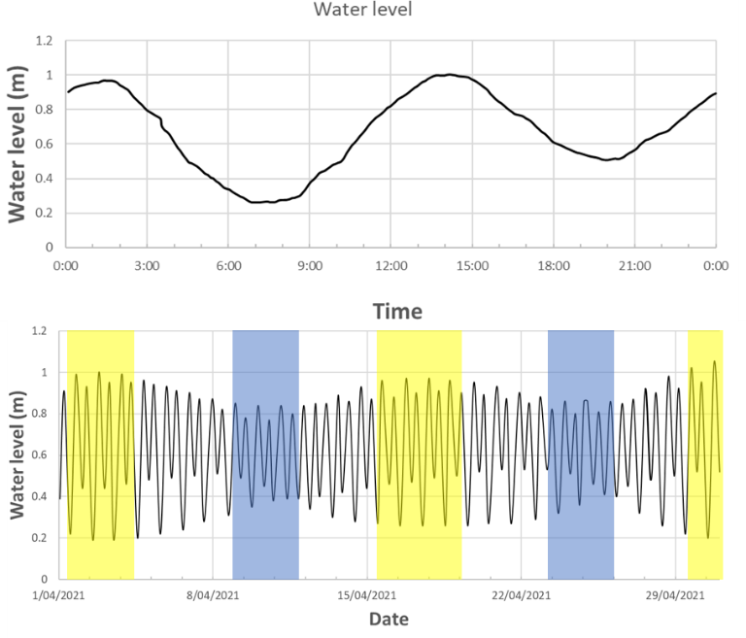
Figure 2. Examples of changes in water level (tide height) at the WTP. Water level is given as m above datum at the Williamstown tide gauge. The upper panel shows changes in tide height over a single day (4th April 2021). The lower panel shows predicted tide height over a single month (April 2021); blue shading indicates neap tides (when the gravitational pull of the sun and moon counteract one another, resulting in small tidal ranges) and yellow shading indicates spring tides (when the gravitational pull of the sun and moon reinforce one another and cause larger tidal ranges).
The models did not apply to the entire foreshore of the WTP, but they covered eight key shorebird intertidal foraging areas, including the coast from Beach Road to 145W Outfall, and part of The Spit Nature Conservation Reserve. Collectively, these feeding areas were used by 83.5% of foraging shorebirds at the WTP at low tide (Rogers et al. 2013; Table 1). The relationship between Williamstown water levels and tidal flat areas in the key WTP foraging areas is shown in Figure 4A. Tidal flat area on spring low tides (of 0.2 m or less) was over 75 ha; in contrast, on neap low tides (>0.4 m), tidal flat area was less than 15 ha (Figure 3).
Food intake of shorebirds is limited by their prey intake rates and the duration of exposure of tidal flats. In this study we used models of energetic demands and food intake rates to estimate the amount of time that shorebirds need to forage profitably on tidal flats per day. We then calculated the area of tidal flat that is exposed for at least this amount of time (Figure 4B), using historical water level data from the Williamstown gauge 2004-2021 to assess the frequency of occurrence of different water levels. The relationship between water level and duration of exposure of tidal flats was close to linear (Figure 4B). To appreciate this relationship it helps to visualise a transect of pegs on the tidal flats: one placed at the waterline when the water level is 0.1 m, one placed at the waterline when the water level is 0.2 m and so forth. The lower peg (at the 0.1 m level) will only be exposed briefly when water levels are very low; in contrast a peg placed at the waterline when the water level is (e.g.) 0.8 m will be on the uppermost tidal flats and will be exposed for much of the time.

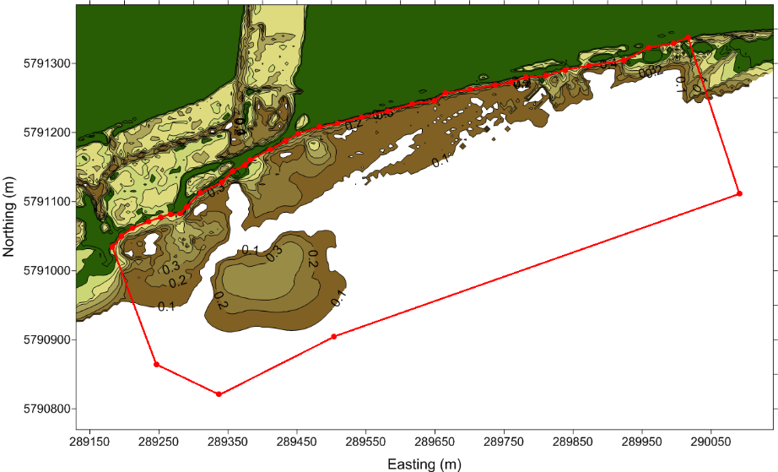

Figure 3. Example of an exposure map developed from the digital elevation models in Rogers et al. (2013). This map shows the tidal flats opposite 145W Outfall. Unshaded areas are submerged when tide height is >0.1 m, dark olive areas are only exposed when the tide height is >0.2 m, and so on. Green shading is used for land areas that are never submerged. The red line indicates the boundary of the foraging area.

Table 1. Distribution of foraging shorebirds at the WTP during low tide counts, 2001-2020: proportion that forage in main feeding areas (for which digital elevation models were presented in Rogers et al. 2013), in other coastal areas and in conservation ponds.
Species | Total number of birds recorded foraging | Proportion in key intertidal feeding areas | Proportion in other coastal sites | Proportion in conservation ponds
Curlew Sandpiper | 26,133 | 79.8% | 1.4% | 18.9%
Red-necked Stint | 210,830 | 86.9% | 7.5% | 5.6%
Sharp-tailed Sandpiper | 67,695 | 74.5% | 13.1% | 12.5%
Total | 304,658 | 83.5% | 8.2% | 8.3%

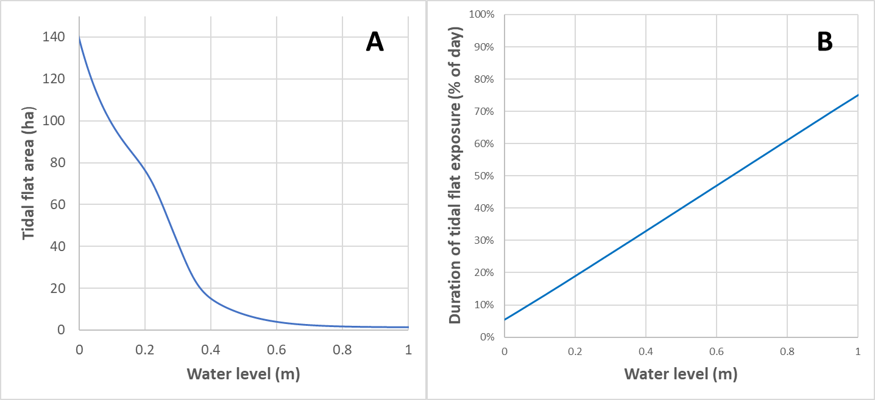

Figure 4. The relationships between water level at Williamstown, tidal flat area and duration of exposure of tidal flats at the WTP. Panel A plots the area of tidal flat exposed against water level {at Williamstown). Panel B plots the duration of exposure (expressed as % of the 24-hour day) against Williamstown water level. For example, a point on the tidal flats that is on the waterline when the water level is 0.2 m would be exposed for ~20% of a 24-hour day; a point on the tidal flats that is on the waterline when the water level is 0.8 m would be exposed for ~60% of a 24-hour day.

Foraging density and Interference
Daily Ration models of carrying capacity that do not have a spatial component assume that prey is evenly distributed and equally available through the study area. However, it is possible that the accessibility of prey to shorebirds on upper tidal flats is limited by foraging interference. Although shorebirds of the WTP are gregarious and usually forage in flocks, foraging theory predicts that if the density of foraging flocks is too high, the foraging success of individuals will decline. This can occur through direct competition for the same prey (Figure 5). It is likely that there are other interference mechanisms that are also important, but harder to detect. For example, shorebirds at the WTP typically stay a few bird-lengths away from flockmates, perhaps because benthic animals conscious of the presence of nearby birds may take evasive measures (e.g. burrowing deeper) and become harder to catch. Territorial disputes often occur if one shorebird strays too close to another (Figure 6). Interactions of this type cost birds foraging time, and foraging success may be further reduced if the presence of other birds restricts the path that a foraging shorebird follows on the tidal flats.
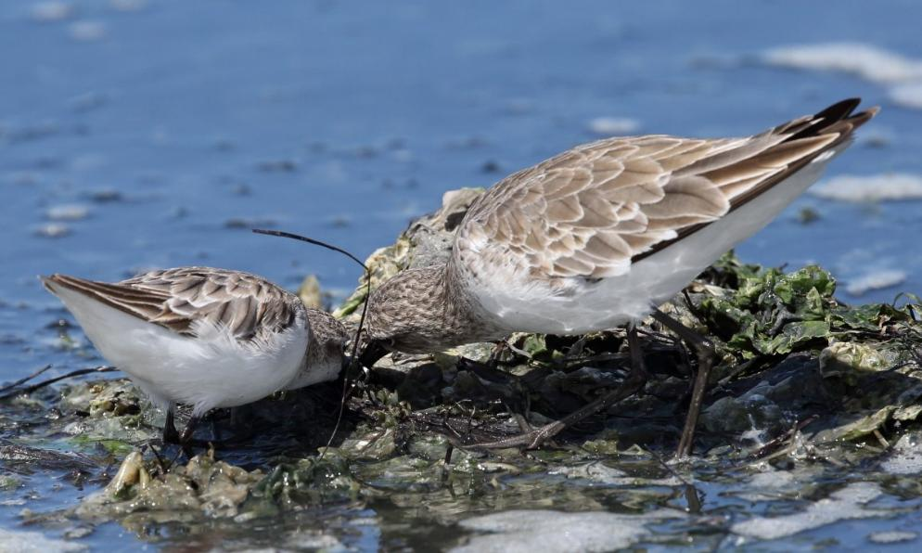
Figure 5. Direct interference. Red-necked Stint (left) and Curlew Sandpiper (right) lunging for the same prey item, Beach Road, November 2020. Neither bird managed to catch the prey item. Photographer D. Rogers

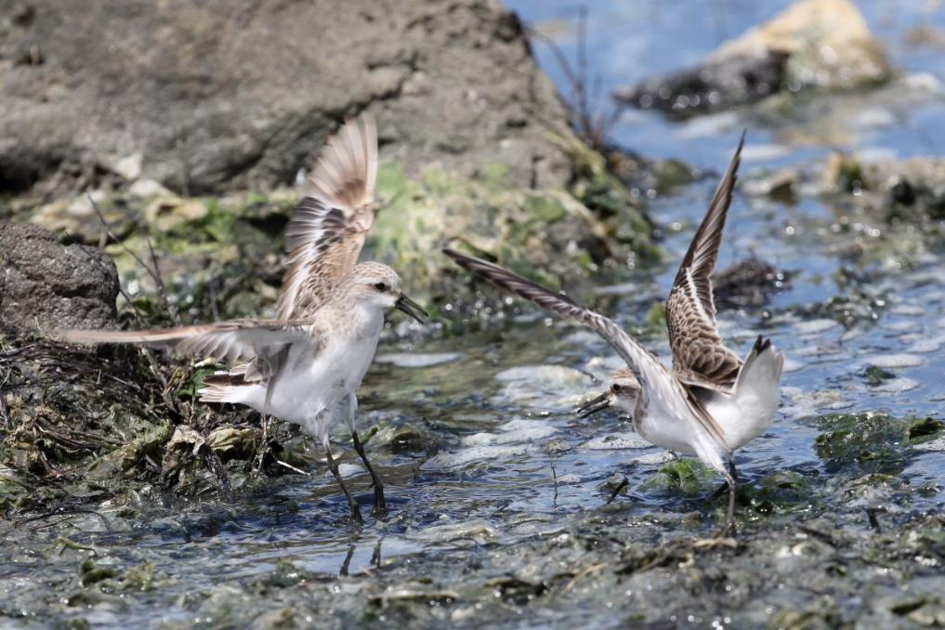
Figure 6. Territorial dispute. Adult (left) and Juvenile (right) Red-necked Stints that strayed too close to one another when foraging, Beach Road, November 2020. In this case the adult was displaced and left the area. Photographer D. Rogers
Estimating the effects of interference on foraging success has been one of the most difficult challenges in studies of foraging shorebirds, and most insights have come from experiments in captive settings. These studies indicate that interference substantially reduces foraging success (especially in more subordinate individuals); and that this is largely due to ‘cryptic interference’ (birds avoiding physical encounters with conspecifics) rather than to interference mechanisms such as kleptoparastism or territorial disputes that are
readily visible in the field (Bijlevelt et al. 2012). Interference causes a lower frequency of prey encounters, and some species compensate by becoming less choosy about their prey, rejecting fewer prey items when bird densities are high (Vahl et al. 2005). Interference has stronger effects when prey distribution is patchy than it does if prey is evenly distributed (Vahl et al. 2007).
The effects of interference are strongest when bird densities are high. On the tidal flats of the WTP, shorebird densities are highest when the ebbing tide has just begun to expose tidal flats, or when the rising tide has submerged all but a small area of upper tidal flats. In these circumstances it is also possible that shorebirds avoid those tidal flats closest to the shoreline because they are wary of shoreline vegetation, which could potentially be used as cover by predators. Rogers et al. (2013) noted that shorebirds on the tidal flats of the WTP typically stayed 20-30 m from the nearest terrestrial vegetation. More recently, shorebirds on the tidal flats north of Beach Road have often been seen foraging within 10-20 m of coastal saltmarsh (D. Rogers, pers. obs). These coarse field estimates are consistent with more quantitative observations in conservation ponds (Rogers & Hulzebosch 2014) which indicate that most shorebirds forage at least 20 m from vegetation, but a few individuals will venture closer.
We explored the relationship between water levels and the number of birds on the tidal flats. Our expectation was that when shorebird densities are so high that interference reduces foraging success, many individuals will not bother to forage on the tidal flats at all, instead continuing to roost or perhaps to forage in conservation ponds. By identifying the water levels at which shorebird abundance on the tidal flats drops off, we aimed to identify the area of upper tidal flats which is unsuitable for foraging shorebirds, either because (1) is it unprofitable to shorebirds due to foraging interference, or (2) because it is too close to fringing vegetation. We do not have the data necessary to distinguish between these two possibilities, but either mechanism would have the same effect, effectively making some upper tidal flats unsuitable for shorebirds.

Data sources
Shorebird Weights
Mass (g) data were obtained from birds cannon-netted at the WTP by the Victorian Wader Study Group (VWSG), using previous analyses by Rogers et al. (1997) and Parry and Rogers (2019). Data were only included if birds were captured by cannon-netting at high tide. In the late 1970s and early 1980s the VWSG
often captured birds by mist-netting; weights from these birds were not included, as many would have been captured when foraging at low tide and may have been carrying undigested food in their digestive tract. In contrast, the guts of shorebirds cannon-netted at high tide would be expected to be empty, or nearly so, as captures occur at least an hour after rising waters force birds to stop feeding on tidal flats and gut passage rates are fast (D. Rogers unpubl.).
For simplicity, we did not include weights of immature shorebirds, which comprise ~ 5-30% of the migratory shorebirds of the WTP in summer (Minton et al. 2020), with numbers varying considerably from year to year. Other studies have shown immature weights to be similar to those of adults, except in the departure season when immature Red-necked Stints and Curlew Sandpipers do not undergo pre-migratory mass gain (Higgins and Davies 1996, Rogers et al. 1997).
Tide Height
We obtained data from the National Tidal Centre of seawater levels measured to the nearest mm at the Williamstown tide gauge at 6-minute intervals between January 2004 and May 2021 (henceforth referred to as ‘water level’). We then applied the regression models in Rogers et al. (2013, Appendix 1) to those tide height data to estimate tidal flat area in each of the key foraging areas at the WTP at 6-minute intervals from 2004 to May 2021. The sum of the tidal flat area in each foraging area at a given time gave the tidal flat area for the WTP that we used in this report. We used the information to calculate water level (and hence tidal flat area) when each shorebird count was carried out at the WTP. We also used the information to calculate average tidal flat area at the WTP each month, to explore variation within and between years. In carrying capacity estimates, we used three measures of water level: (1) Average water level throughout the year; (2) Average water level in December, specifically for shorebirds in their non-breeding season; and (3) Average water level in March, specifically for shorebirds fuelling for northward migration.

Density of foraging shorebirds on tidal flats
Rogers et al. (2013) presented information on foraging density of shorebirds on the tidal flats of the WTP. It was based on a ‘simultaneous counts’ program held intermittently at the WTP between 2004 and 2011 to obtain a better understanding of local movements of shorebirds at the WTP. On 14 field days separate teams carried counts at intervals of 1-2 hours at key foraging (and roosting sites) of the WTP (Rogers et al. 2013). Tidal flat area at the time of each count was estimated on the basis of time, water level at the Williamstown Tidal Gauge, and the digital elevation models of Rogers et al. (2013). Very high densities of foraging shorebirds were found at some sites (up to 4620 birds per ha), and we were concerned that this may have been related to the use of an indirect measure of tidal flat area. We therefore checked foraging densities against an independent data set collected opposite the multiple outlets north of Beacon Point in 2017 (Unpublished ARI study by D. Rogers and J. Davies). That study involved marking 10 quadrats on the tidal flats, ranging from 0.19 ha to 0.34 ha in area. The number of birds in each quadrat was recorded at approximately hourly intervals during low tide. The area of each quadrat was known from direct measurement and the proportion of each quadrat that was exposed was estimated on every count. Density estimates from the study were therefore based on direct observation at the WTP, and would not have been affected by, for example, imprecision of the Digital Elevation Model, or slight differences in timing of tides between the WTP and the Williamstown Tide Gauge.

  - Waterfowl

Data sources and compilation
Under a program initiated by Melbourne Water as part of the WTP Environment Improvement Project, waterfowl were counted by species on a pond-by-pond basis across the WTP six times per year from 2001 to 2018 and three times per year thereafter (Menkhorst et al. 2020). For further information on count methods see Loyn et al. (2014a). All data from the WTP waterfowl counts are housed in a MS Access database and can be retrieved for individual waterbodies or other site combinations, as needed. Area estimates (in ha) for each pond are also included in the database.Extracts of the data (with species totals for the entire WTP but without data to exact ponds) are provided to the Victorian Biodiversity Atlas and the Birdata database of Birdlife Australia.

Approach taken
We identified the treatment ponds that are closest to the foreshore of the WTP as being most vulnerable to sea-level rise. These are shown in Figure 7 and are referred to henceforth as seaward ponds.
Note that although waterfowl using the foreshore and shallow tidal waters are included in the counts, data from these areas were excluded from the current analyses as they are open-ended on the seaward side meaning their area cannot be defined. Additionally, we have assumed that this habitat (shallow tidal waters) is likely to continue to be available as a viable foraging habitat despite sea-level rise, i.e., we assume that coastal retreat will be possible although that may require engineering works to remove the existing bunds on the seaward side of the seaward ponds.
Summary data were extracted for the two groups of ponds (seaward ponds vs all others) in the form of the maximum and mean counts per species in summer and in winter over the 20-year period (2001-2020; n=112 counts). We did not include shorebirds in these data extracts as they use the pond system in a very different way to waterfowl. Most shorebirds recorded in the pond system are using the conservation ponds at high tide, following targeted drawdown of water levels (Rogers and Hulzebosch 2014). Shorebirds are capable of considerable mobility within a single day, e.g., flying up to 15 km between intertidal foraging areas and roosts in conservation ponds or Avalon Saltfields (Rogers et al. 2010, Menkhorst et al. 2020). Their presence in ponds therefore reflects local management of water levels rather than proximity to the coast.
Waterfowl numbers at the WTP vary annually and seasonally. Numbers peak in summer and are highest in years of inland drought when many inland wetlands dry out and many waterbirds are forced to coastal refugia such as the WTP (Loyn et al. 2014a; Papas et al. 2021). Melbourne Water aims to maintain waterfowl populations at the WTP at their current level, and to comply with the Limits of Acceptable Change (LAC) for waterfowl in the Port Phillip Bay (Western Shoreline) and Bellarine Peninsula Ramsar Site (DELWP 2018, pp 26-27) (note that these LACs are for the entire Ramsar site, not just the WTP section of it):
Abundance of waterbirds will not decline below the following: (calculated as a rolling five-year average of maximum annual count; percentages calculated based on the latest Wetlands International Waterbird Population Estimates): Total waterbirds excluding shorebirds - 45,000; Australasian Shoveler – 3%; Australian Shelduck – 1%; Blue-billed Duck – 25%; Chestnut Teal – 4%; Hoary-headed Grebe – 1%; Musk Duck – 2%; Pink-eared Duck – 1%.
Translating 5 year rolling averages to the longer time-frames relevant to sea-level rise is problematic, but the intent of the Ramsar LAC is clearly to maintain the status quo.
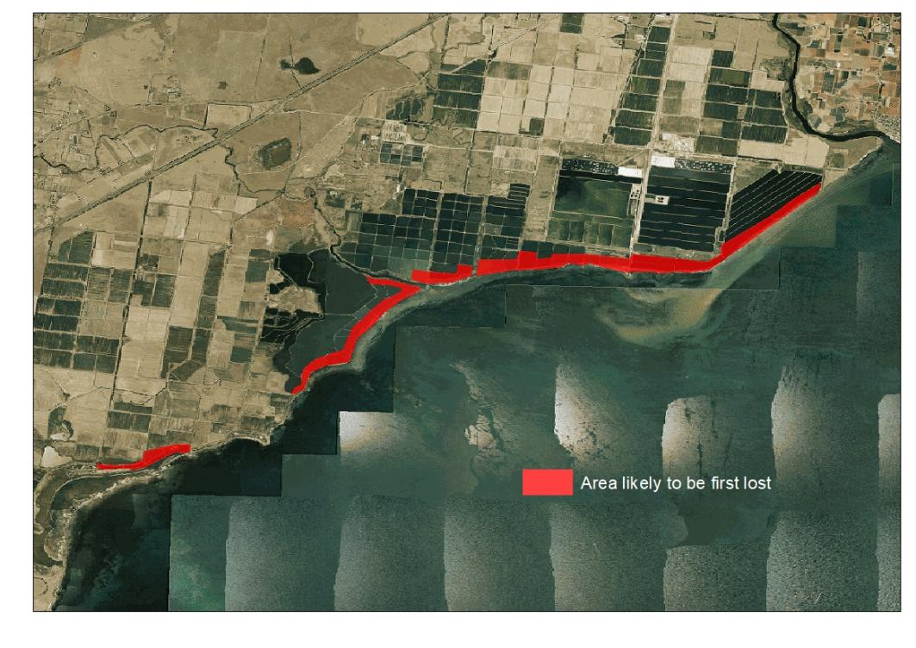
Figure 7. Map of the WTP showing the seaward ponds (within red polygons) most likely to be first affected by sea-level rise.

- Results
  - Shorebirds

Target carrying capacity for shorebirds at the WTP
Annual summer counts of the three focal species have varied since 2000 and have been high in recent years (Figure 8), probably in large part because shorebirds were forced to coastal refugia by the severe drought that affected much of inland eastern Australia from 2017-2020. The climate change models that predict increased sea-levels at the WTP over the next few decades also predict higher temperatures and more frequent drought (CSIRO 2021), so the WTP is likely to continue to play an important role as a drought refuge for shorebirds (and other waterbirds) from inland Australia.
While numbers of the three focal species have been correlated over the years, the correlation is imperfect. For example, numbers of Red-necked Stint at the WTP showed a peak in the early 2000s that was not matched by Curlew or Sharp-tailed Sandpipers; in 2019 and 2020 numbers of Sharp-tailed Sandpiper climbed to record levels while Curlew Sandpiper numbers remained stable (Figure 8). Possible reasons for the differences between species include annual variations in breeding success (all three species nest in different parts of the Siberian Arctic), different levels of site fidelity to non-breeding sites, or differing tolerance to inland drought conditions.
Potential target numbers for carrying capacity estimates are provided in Table 2. We recommend the maximum of annual mean counts (Table 2) as targets for carrying capacity estimates. Rounding off, these targets are 2,400 Curlew Sandpipers, 12,850 Red-necked Stints, 8,550 Sharp-tailed Sandpipers, or combined species count of 22,900 small sandpipers. For comparison, the highest single count recorded at the WTP between 2001 and 2021 was 25,715 small sandpipers (in 2020), and the sum of peak numbers for all three is 28,053.
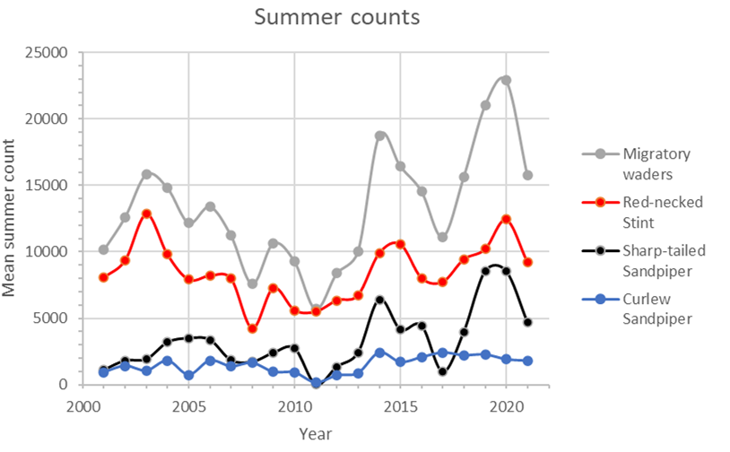
Figure 8. Scatterplot of mean summer counts by year (with datapoints connected by smooth lines to guide the eye).

Table 2. Summer counts of three focal shorebird species at the WTP
Species | Mean summer count 2001 - 2021 | Maximum of annual mean | Maximum single count
Curlew Sandpiper | 2027 | 2417 | 3156
Red-necked Stint | 7123 | 12,850 | 14,455
Sharp-tailed Sandpiper | 2984 | 8552 | 10,442
Total: All three species | 12,691 | 22,892 | 25,715

Daily energy requirements
Many shorebirds have been weighed during banding studies at the WTP (>8,000 Red-necked Stint, >3,000 Curlew Sandpiper and >4,000 Sharp-tailed Sandpiper). Wieght samples were small in other seasons, and there were no winter weight samples for Sharp-tailed Sandpiper as that species leaves Victoria in winter. We took the monthly average for adults of each species. Weights of adults of the three species were consistent in most months but increase during the period of pre-migratory mass gain, Feb-April.
Calculations of daily energy expenditure by individual birds are summarised in Table 3. Energy consumption almost triples during pre-migratory mass gain (February to April) and consumption of an individual Red-necked Stint was about half that of a Curlew Sandpiper or Sharp-tailed Sandpiper. During the non-breeding season, the daily dry weight of food required by an individual bird was 6.7 % of body mass in Red-necked Stint, 5.6 % in Curlew Sandpiper and 5.5% in Sharp-tailed Sandpiper; during pre-migratory mass gain, the dry weight of required food was about 15.1 % in Red-necked Stint, 12.6 % in Curlew Sandpiper and 12.4% in Sharp-tailed Sandpiper.
When dry mass consumption is known, knowledge of wet mass consumed is not needed for carrying capacity estimates, but it gives a more intuitive impression of the amount of food consumed. Assuming the water content of prey to be about 78% (typical in infauna surveys, e.g., Brey et al. 2010), it can be calculated that an individual Red-necked Stint consumes about 31% of its body weight per day during most of the non-breeding season, and up to 69% of its body weight per day when fuelling; Curlew and Sharp-tailed Sandpipers consume about 25% body weight per day during the non-breeding season, and up to 57% of their body weight per day when fuelling.

Tidal flat area and carrying capacity
The area of tidal flat exposed at the WTP changes continuously, ranging from >95 ha on the lowest tides of ~0.10 m to near-zero on tides >0.7 m (Figure 3). Average water levels at the WTP tend to be higher in winter (Figure 9), probably in large part because low pressure systems and southerly winds are more likely to occur at this time of year, pushing water against the shore. Tidal flat area tends to be greatest in summer when there are more frequent north-westerly (offshore) winds, and is coincident with the period when migratory shorebirds are most abundant at the WTP.
Mean tidal flat area by month varied considerably from year to year; for example, average tidal flat area in October ranged from 9.1 ha (in 2013) to 31.8 ha (in 2009). These fluctuations cannot be explained solely by tidal forces (i.e., the gravitational pull of the moon and sun). They are driven largely by weather conditions. Water levels at the WTP tend to be lower when there are northerly winds and high air pressures. Tidal range is low (less than 1 m) at the WTP, so the fluctuations in water level at the WTP caused by wind and air pressure variations are considerably more noticeable than they would be in sites with a larger tidal amplitude.
Mean tidal flat area at the WTP also varied considerably between years (Figure 10). Interestingly, the data plot suggests that there may be a relationship between water levels and the phase of the El Niño Southern Oscillation (Figure 10), with tidal flat area tending to be largest in years when there is a high likelihood of drought and high numbers of shorebirds move from inland Australia to coastal refugia.

Table 3. Daily energy consumption of individual non-breeding and fuelling shorebirds, by month.
To convert required intake from Joules to grams we used the equation 1 g AFDM dry food mass = 21.48 kJ, following Zwarts and Wannink (1993), where AFDM = Ash-free dry mass of food.

Species | Month | Mass (g) | Daily  expenditure of non-breeding birds (J) | Daily expenditure in fuelling birds (J) | Food per day required by non-breeding bird (average, in g dry mass) | Food per day required by fuelling bird (g dry mass)
Red-necked Stint | 1 | 31.5 | 56.8 | 127.9 | 2.12 | 4.76
 | 2 | 29.9 | 54.8 | 123.3 | 2.04 | 4.59
 | 3 | 32.3 | 57.9 | 130.2 | 2.15 | 4.85
 | 7 | 30.0 | 54.9 | NA | 2.04 | NA
 | 8 | 28.0 | 52.2 | NA | 1.94 | NA
 | 11 | 29.0 | 53.5 | NA | 1.99 | NA
 | 12 | 28.9 | 53.3 | NA | 1.99 | NA
 | All | 31.1 | 56.2 | 126.5 | 2.09 | 4.71
Curlew | 1 | 57.1 | 87.5 | 196.8 | 3.26 | 7.33
Sandpiper | 2 | 66.0 | 97.1 | 218.4 | 3.62 | 8.13
 | 3 | 74.3 | 105.8 | 238.1 | 3.94 | 8.87
 | 8 | 60.3 | 91.0 | NA | 3.39 | NA
 | 11 | 55.6 | 85.8 | NA | 3.19 | NA
 | 12 | 56.4 | 86.6 | NA | 3.23 | NA
 | All | 61.4 | 92.2 | 207.4 | 3.43 | 7.72
Sharp-tailed | 1 | 66.1 | 97.2 | 218.6 | 3.62 | 8.14
Sandpiper | 2 | 67.6 | 98.8 | 222.3 | 3.68 | 8.28
 | 3 | 66.2 | 97.3 | 218.9 | 3.62 | 8.15
 | 11 | 63.1 | 94.0 | NA | 3.50 | NA
 | 12 | 62.4 | 93.2 | NA | 3.47 | NA
 | All | 63.7 | 94.6 | 212.8 | 3.52 | 7.92

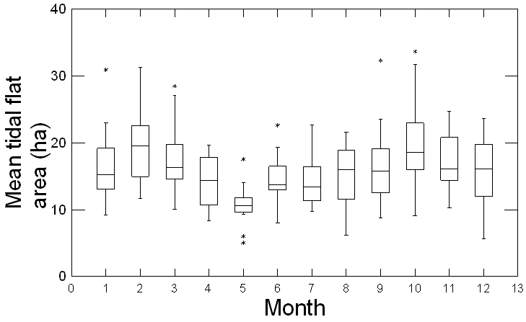
Figure 9. Box-plot of mean tidal flat area of the WTP by month, 2004–2021.

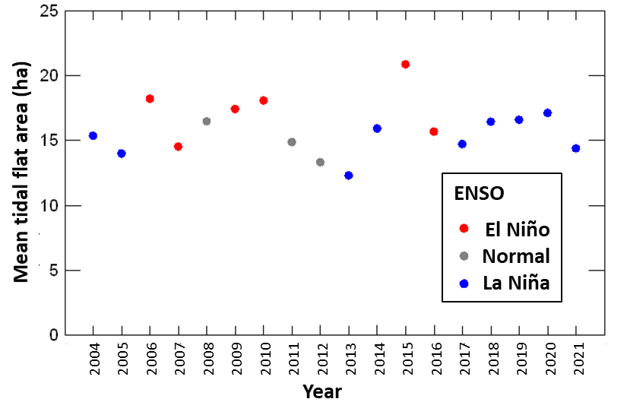
Figure 10. Annual mean tidal flat area of the WTP, 2004–2021.

Prey depletion rates were calculated, applying the long-term average of 15.88 ha of tidal flat exposed per day (Table 4). Adding the three focal species together, the prey consumed per day by 22,892 shorebirds would be 1.2% of the standing benthos crop during the non-breeding season, 6.2% of the standing benthos crop at times when all species were fuelling for migration. If no benthos production occurred, it would take shorebirds ~83 days to deplete the prey in 12.97 ha during the non-breeding season, and ~19 days to so in the period of pre-migratory mass gain (Table 4).
These estimates are coarse, and several caveats should be considered in their interpretation. The estimates are based on the physiological food requirements of shorebirds. In more detailed carrying capacity studies, the ecological food requirements of shorebirds have been estimated to be 2–7.8 times higher than physiological food requirements (Stillman et al. 2016), because e.g., shorebirds cannot find all the food, or because some of the potential food is eaten by other species such as crabs. In the estimation of bird-days needed to deplete prey, we have estimated the number of days required to reduce prey abundance to zero; in reality we would not expect shorebirds to deplete prey to this level, as they would abandon sites once prey density became too low for profitable foraging.
On the other hand, several considerations make us suspect that prey depletion rates may be lower than shown in the estimates in Table 4, and the carrying capacity may therefore be underestimated. First, our analysis does not involve a spatial component. On lower tides, the area of tidal flat at the WTP far exceeds 15.7 ha, and in these conditions most shorebirds forage on outer tidal flats; our estimates of prey depletion rates do not correct for this effect and are therefore higher than local reality. Moreover, prey depletion rates at the WTP will be offset by local benthos production. Benthos production has not been measured directly at the WTP, but it is likely to be high, given that benthos has been abundant at the site for many years. Edgar and Shaw (1995) found average benthic production rates of 0.21 g m⁻² day ⁻¹ in a study of benthic production at 30 sites in southern Australia, and benthic production rates of 0.61 g m⁻² day ⁻¹ at the five most productive sites. If production approaches either value at the WTP, it would take shorebirds months to deplete prey resources to zero, even at times when they were fuelling.

Table 4. Shorebird prey, consumption and carrying capacity on the tidal flats of the WTP. In this table we apply the maximum average summer count. Numbers in parentheses are ranges, the lower being the estimate assuming average summer count, the higher being the estimate if maximum shorebird counts are applied).
Season | Parameter | Red-necked Stint | Curlew Sandpiper | Sharp-tailed Sandpiper | Species Combined
NA | Mean edible biomass (g/m²) | 32.2 | 25.8 | 25.8 | 33.5
NA | Shorebird numbers at summer peak | 12,850  (7123–14,455) | 2417  (2027–3156) | 8552  (2984–10,442) | 22,892  (12,691–25,715)
Non-breeding (Dec) | Mean tidal flat area (ha) | 15.70 | 15.70 | 15.70 | 15.70
 | Dry mass of food (kg) consumed per day | 25.55  (14–28) | 7.80  (65–102) | 29.69  (10–36) | 63.04  (31–75)
 | Dry mass of food (g) consumed per m² per day | 0.162  (0.1–0.2) | 0.050  (0.04–0.06) | 0.189  (0.06–0.23) | 0.402  (0.2–0.5)
 | Prey consumed per day as % of standing crop | 0.51%  (0.3–0.6%) | 0.19%  (0.16–0.25%) | 0.73%  (0.3–0.9%) | 1.20%  (0.6–1.4%)
 | Bird-days to deplete standing crop to zero | 105.4  (93–190) | 83.2  (68–175) | 81.0  (81–169) | 83.42  (70–169)
Pre-migratory (Mar) | Mean tidal flat area (ha) | 17.67 | 17.67 | 17.67 | 17.67
 | Dry mass of food (kg) consumed per day | 124.62  (69–140) | 42.84  (36–56) | 139.45  (49–54) | 306.91  (154–366)
 | Dry mass of food (g) consumed per m² per day | 0.705  (0.4–0.8) | 0.242  (0.2–0.3) | 0.789  (0.3–1.0) | 1.737  (0.9–2.1)
 | Prey consumed per day as % of standing crop | 2.19%  (1.2–2.5%) | 0.94%  (0.8–1.2%) | 3.06%  (1.1–3.7%) | 6.19%  (3.1–7.4%)
 | Bird-days to deplete standing crop to zero | 24.4  (21–44) | 19.2  (16–38) | 18.7  (15–39) | 19.3  (16–38)

Foraging density and interference
In the study of foraging density on the tidal flats opposite the multiple outlets in 2017, the average foraging density per quadrat (when shorebirds were present) was 566.3 shorebirds per ha. Shorebird densities (total of Red-necked Stints, Curlew Sandpipers and Sharp-tailed Sandpipers) were highest when the ebbing tide first exposed tidal flats, or when the rising tide has submerged most of the tidal flats, confining the birds present to a small area. In 135 records of density (i.e., one or more shorebirds present) made over three days (D. Rogers and J. Davies unpublished data), 20 exceeded 1000 foraging shorebirds per ha and densities exceeding 2350 shorebirds per ha were made on each day of the study. There were four records of densities exceeding 4000 shorebirds per ha; the highest density observed was 9300 shorebirds per ha.
The high densities of shorebirds reported by Rogers et al. (2013) therefore appear realistic. The mean of peak densities across the sites was 2277 birds per ha. If we assume this to represent the maximum density at which WTP shorebirds can forage, tidal flat area for the ‘target’ population of 22,892 shorebirds (lower limit of 12,691 shorebirds, upper limit of 25,715) would need to exceed 10.05 ha (range 5.52-11.29 ha). At present the tidal flats are exposed to this extent when tides are 0.45 m or lower (range 0.44–0.55 m).
Shorebirds do not forage on the tidal flats of the WTP at all when water levels exceed 0.85 m (Table 6 in Rogers et al. 2013), and different foraging areas are preferred at different water levels (Rogers et al. 2013). We examined the highest water levels at which large numbers of foraging shorebirds occurred at individual foraging sites at the WTP (Table 5), considering counts to be ‘large’ if they were the highest count observed at the foraging site during a day of repeated observations. On ebbing tides, tidal flats first became exposed at North Spit Lagoon, Beach Road East, Little River Mouth and Borrie Outfall. Shorebirds first began feeding in large numbers at these sites when the water level was between 0.65 and 0.74 m and the tidal flat area of the WTP was between 2.16 ha and 3.11 ha. Adding site totals together, over 13,154 shorebirds were observed foraging on tidal flats at these tide levels. Given the high densities that have been observed foraging at the WTP, it is likely that the first-exposed sites could support still larger numbers of shorebirds for short periods on ebbing or rising tides. Our experience in carrying out low tide shorebird counts at the WTP since 2004 is that nearly all shorebirds foraging on the tidal flats of the WTP gather at these four sites in the initial stages of ebbing tides or the final stages of rising tides.
Few or no shorebirds foraged on the tidal flats of the WTP when the total tidal flat area was less than 2–3 ha (we cannot estimate the cut-off more precisely). We therefore suspect the uppermost 2–3 ha of the tidal flats to be unprofitable to shorebirds, due to a combination of (1) interference – when tidal flats are smaller, birds are too tightly packed to forage profitably; (2) shorebirds avoiding unsuitable habitat at the top of the tidal flats, either because it is too close to vegetation, or because of deep wrack accumulating at the high tide line. The size of this ‘unprofitable’ zone is likely to be closely correlated to length of coastline. It would therefore be expected to remain consistent as sea-level rises and tidal flat area declines.

Table 5. Highest water levels at which numbers of foraging shorebirds peaked at individual foraging sites, and tidal flat areas at those times.
Foraging site | Highest water level (m) when daily shorebird numbers peaked | Peak shorebird count at highest water level | Area of foraging site (ha) | Tidal flat area of WTP (ha) when daily shorebird numbers peaked
North Spit Lagoon | 0.74 | 241 | 0.03 | 2.16
Beach Road East | 0.7 | 648 | <0.01 | 2.49
Little River Mouth West | 0.67 | 7200 | 0.86 | 2.83
145W East | 0.65 | 2165 | 0.36 | 3.11
Borrie Outfall | 0.65 | 2900 | 1.11 | 3.11
Beacon Point | 0.63 | 2845 | 0.097 | 3.44
Little River Mouth to 145W | 0.58 | 5688 | 0.22 | 4.57
North Spit Channel | 0.38 | 850 | 1.2 | 17.93

Intake rates
Average daily mass of prey items was calculated to be 0.059 mg for Red-necked Stint, and 0.237 mg for both Curlew and Sharp-tailed Sandpipers. Inserting these values into the model of intake rates, we estimated predicted asymptotic intake rates, and then calculated the foraging time required to consume enough food to reach the daily energy targets (Table 6).
During the non-breeding season, our calculations indicate that Red-necked Stints need to forage for 40.5 % of each 24-hr day in order to satisfy their energy requirements; Curlew Sandpipers need to forage for 34.1 % of each 24-hr day, and Sharp-tailed Sandpipers need to forage for 35.6 % of each 24-hr day (Table 6; December is presented as an example of a typical month). These estimates seem consistent with field observations from the WTP, where shorebirds forage through most of the low tide period (Rogers et al. 2013).
Using the model relating tide heights to tidal flat area (Figure 3), on long-term average only tidal flats higher than 0.53 m above datum are exposed for the 40.5 % or more of the day at the WTP required by Red-necked Stints. The tidal flat area when water levels are at this height is 5.87 ha. Curlew Sandpipers and Sharp-tailed Sandpipers do not need to spend as much time per day feeding as Red-necked Stints (Table 6), so on an ebbing tide they can start feeding later, when the tide has dropped further and a larger area of tidal flat (11.4-13.1 ha) is exposed. As the habitat of all three species overlaps, these estimates of required foraging area are not additive: i.e., if there is sufficient tidal flat area for Red-necked Stint, there will also be sufficient tidal flat area for Sharp-tailed and Curlew Sandpipers.
We examined water level data from 2004 to 2021 to calculate the number of days per month that non-breeding shorebirds can forage profitably (taking in enough food to meet their energetic requirements) given the constraints on their intake rates. Assuming that the shorebird population of the WTP could not forage profitably when tidal flats were smaller than 3.1 ha (i.e. on tide heights >0.65 m, see section above on foraging density and interference), tidal flats were not exposed for long enough for non-breeding Red-necked Stints to meet daily energetic requirements on 19.2% of days; 15.1% and 14.1% of days had insufficient tidal flat exposure for Curlew and Sharp-tailed Sandpipers respectively. In all species, days of insufficient tidal flat exposure were most likely to occur in the winter months; adequate areas of tidal flat were most often exposed in February, a period that often coincides with highest shorebird numbers at the WTP (Figure 11).
February also coincides with the period of pre-migratory mass gain, when food requirements of individual shorebirds are higher than they are in the non-breeding calculations presented above. We estimated that, during the period of pre-migratory mass gain, birds need to forage almost continuously (Curlew and Sharp-tailed Sandpiper) or an impossible 120% of the time in Red-necked Stint (Table 6). The estimates of required feeding time in refuelling shorebirds at the WTP are therefore unrealistic. There are several possible explanations that cannot be tested at this point (see discussion). However, we explored the possibility that

Table 6. Intake rates, foraging duration and tidal flat area required to meet daily energy demands for focal shorebird species of the WTP.

Species | Month | Predicted asymptotic intake rate (mg/sec) | Required intake rate to meet daily needs (mg/sec) | Foraging time required to meet daily target in non-breeding season (% of day) | Water level (m above datum) below which tidal flats are exposed for required duration | Minimum area of tidal flat exposed for required duration (ha)
Non-breeding season
Red-necked Stint | 12 | 0.057 | 0.023 | 40.5% | 0.53 | 5.87
Curlew Sandpiper | 12 | 0.109 | 0.037 | 34.1% | 0.42 | 13.1
Sharp-tailed Sandpiper | 12 | 0.113 | 0.040 | 35.6% | 0.44 | 11.4
During pre-migratory mass gain
Red-necked Stint | 3 | 0.059 | 0.071 | 120.0% | NA | NA
Curlew Sandpiper | 3 | 0.119 | 0.127 | 106.5% | NA | NA
Sharp-tailed Sandpiper | 3 | 0.115 | 0.117 | 101.7% | NA | NA

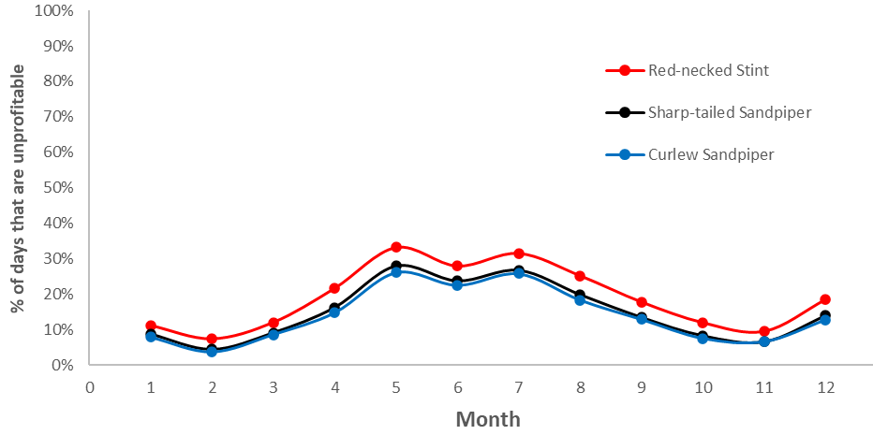
Figure 11. Percentage of days per month when tidal flats are not exposed for long enough for shorebirds to meet their daily energetic requirements.

shorebirds of the WTP take larger prey items during the period of pre-migratory mass gain. While there are no data on whether or not diet shifts occur at the WTP, some studies of other shorebird species overseas have demonstrated diet changes before migration to increase intake rates (e.g., Zwarts 1990, van Gils et al. 2005). The simulation for Red-necked Stint (Figure 12) suggested that by excluding smaller prey species from their diet (e.g., ostracods, small amphipods) they could increase intake rates sufficiently to meet their daily energy demands when fuelling. If they restrict their prey choices in this way, their diet would be dominated by polychaetes during the fuelling period.

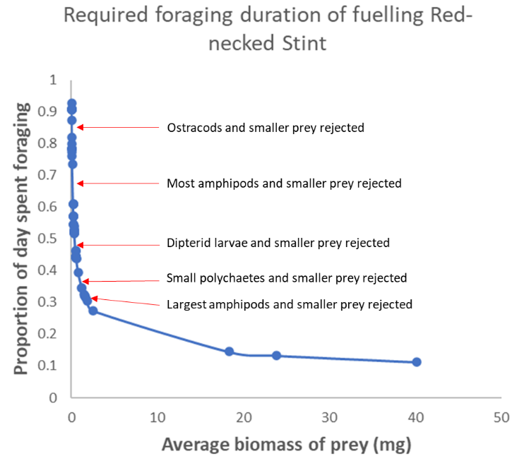
Figure 12. Simulation of the proportion of the day that fuelling Red-necked Stints would need to forage to meet their energy demands, assuming they increase their food intake rates by restricting their diet to larger prey items.

  - Waterfowl

Usage of the seaward ponds
The proportion of the total wetland areas at the WTP that is occupied by the seaward (potentially first affected) ponds is 11% (Table 7). Thus, if waterfowl were randomly distributed across the WTP ponds one would expect the seaward ponds to support roughly 11% of the total population. However, amongst waterfowl species there was a very wide range in proportion of population occupying the seaward ponds – from 0 to 71% using the mean count (Tables 8 and 9), suggesting a degree of selection for seaward ponds by some species. In the following discussion we consider only species whose proportional presence in the seaward ponds was different to 11% (we used 19% as a lower cut-off).

Table 7. Total water surface area of the pond system at the WTP and of the seaward ponds.
Pond class | Area (ha) | %
Seaward ponds | 213 | 11
All other ponds | 1799 | 89
Total | 2012 | 100

During summer, species with the highest proportions of mean summer count in the potentially impacted ponds fell into three foraging groups (Table 8):
- Species that forage to a large extent in intertidal areas and presumably loaf on the adjacent wetlands when not feeding – Little Egret (57%), Chestnut Teal (39%), White-faced Heron (31%), Silver Gull (23%), Grey Teal (21%) and Black Swan (19%).
- Piscivorous species that mostly feed offshore and were presumably roosting close to their feeding habitat - Little Black Cormorant (36%), Little Pied Cormorant (28%), Great Cormorant (19%), but not Pied Cormorant (1%) presumably because it prefers to roost further inland on dead trees and platforms erected in Lake Borrie. Note that Little Pied Cormorant, for which macroinvertebrates are an important dietary item (Marchant and Higgins 1990), also frequently feeds in the impact ponds, presumably for similar reasons to group three species (below).
- Species that forage underwater on macroinvertebrates and small fish, prey species that are likely to be most abundant in ponds closest to the end of the treatment process – Great Crested Grebe (56%), Musk Duck (36%) and Australasian Darter (20%). The grebe and Musk Duck also feed at sea in calm conditions.
The suite of species that used the impacted ponds during winter (Table 9) showed many similarities to that in summer, but also some major differences. Large wading birds including both species of spoonbill, Great Egret and the Brolga were more likely to be recorded in seaward ponds in winter, as were the two small grebes (Australasian and Hoary-headed) but not the Great Crested Grebe. The Australian Pelican and Silver Gull were less frequently in the seaward ponds in winter.

Comparison to the Ramsar Limits of Acceptable Change (LAC)
The LACs for the entire Port Phillip Bay (Western Shoreline) and Bellarine Peninsula Ramsar Site are summarised in Table 10. The LAC for total waterbirds (excluding shorebirds) (>45,000 individuals based on a 5-year rolling annual average maximum count) (DELWP 2018) is routinely met at the WTP alone. For example, in the 20 years of February counts since 2001, numbers fell below 45,000 only once, at the end of the millennial drought when inland floods attracted many birds away from the WTP (Loyn et al. 2014a; see also Menkhorst et al. 2020, Figure 4). Indeed, in recent years, February counts of waterfowl (ducks, swans, coots and grebes) have consistently been 2-3 times and up to 4 times the LAC for total waterbirds (excluding shorebirds). Thus, there is little likelihood that loss of the seaward ponds will threaten that target.
For individual species assigned targets under the LAC (Table 10) only the Chestnut Teal, Grey Teal and Musk Duck showed a preference for the seaward ponds (Tables 8 and 9). Of these, the Musk Duck is of most concern because its preference for seawards ponds is likely to be related to diet rather than loafing convenience.
The species with the most stringent LAC is Blue-billed Duck (support 25% of the global population), however, that species did not prefer the seaward ponds so should not be greatly affected by sea level rise within the period being considered here (within the next 50 years).

Table 8. Species of waterbirds (except migratory shorebirds) that were recorded in the seaward ponds (see Figure 7) during summer counts in at least 8 of the 20 summers (2001-2020). Species are ranked by the proportion of the summer mean count that was in the seaward ponds, maximum counts per species are also provided. FFG – Flora and Fauna Guarantee Act at June 2021. EN – endangered; VU - vulnerable
Species, guild, conservation status (FFG) and number of years recorded (N) |  |  |  |  | Non-seaward ponds |  | Seaward ponds |  | Proportion in seaward ponds
Common name | Scientific name | Guild | FFG | N | Mean count | Max count | Mean count | Max count | % of Mean counts | % of Max counts
Little Egret | Egretta garzetta | Large Wading Birds | EN | 14 | 2 | 14 | 3 | 6 | 57 | 31
Great Crested Grebe | Podiceps cristatus | Grebes |  | 19 | 5 | 28 | 6 | 49 | 56 | 64
Chestnut Teal | Anas castanea | Dabbling Ducks |  | 20 | 3219 | 7772 | 2039 | 5141 | 39 | 40
Musk Duck | Biziura lobata | Diving Ducks | VU | 20 | 544 | 1044 | 310 | 601 | 36 | 37
Little Black Cormorant | Phalacrocorax sulcirostris | Fish-eaters |  | 14 | 71 | 525 | 41 | 173 | 36 | 25
White-faced Heron | Egretta novaehollandiae | Large Wading Birds |  | 8 | 18 | 67 | 8 | 24 | 31 | 26
Little Pied Cormorant | Phalacrocorax melanoleucos | Fish-eaters |  | 13 | 39 | 147 | 15 | 102 | 28 | 41
Silver Gull | Larus novaehollandiae | Gulls |  | 15 | 1762 | 8196 | 531 | 2627 | 23 | 24
Grey Teal | Anas gracilis | Dabbling Ducks |  | 20 | 4952 | 13,969 | 1279 | 3483 | 21 | 20
Australasian Darter | Anhinga melanogaster | Fish-eaters |  | 8 | 3 | 9 | 1 | 2 | 20 | 18
Great Cormorant | Phalacrocorax carbo | Fish-eaters |  | 9 | 6 | 33 | 1 | 7 | 19 | 18
Black Swan | Cygnus atratus | Swans |  | 20 | 3824 | 6711 | 873 | 1403 | 19 | 17
White-winged Black Tern | Chlidonias leucopterus | Freshwater Terns |  | 19 | 47 | 412 | 11 | 50 | 18 | 11
Whiskered Tern | Chlidonias hybridus | Freshwater Terns |  | 18 | 1689 | 8041 | 343 | 1640 | 17 | 17
Australian Pelican | Pelecanus conspicillatus | Fish-eaters |  | 20 | 179 | 657 | 34 | 262 | 16 | 29
Black-fronted Dotterel | Elseyornis melanops | Australasian wader |  | 12 | 11 | 30 | 2 | 10 | 16 | 25
Hoary-headed Grebe | Poliocephalus poliocephalus | Grebes |  | 20 | 13,672 | 26,548 | 2477 | 5521 | 15 | 17
Pacific Black Duck | Anas superciliosa | Dabbling Ducks |  | 20 | 1346 | 4218 | 231 | 568 | 15 | 12
Hardhead | Aythya australis | Diving Ducks | VU | 20 | 5931 | 16,443 | 967 | 5026 | 14 | 23
Yellow-billed Spoonbill | Platelea flavipes | Large Wading Birds |  | 16 | 18 | 46 | 3 | 16 | 12 | 26
Royal Spoonbill | Platelea regia | Large Wading Birds |  | 16 | 16 | 59 | 2 | 21 | 12 | 26
Australasian Shoveler | Anas rhynchotis | Filter-feeding Ducks | VU | 20 | 5197 | 15,251 | 701 | 2222 | 12 | 13
Australian White Ibis | Threskiornis molucca | Large Wading Birds |  | 11 | 122 | 530 | 16 | 155 | 11 | 23
Straw-necked Ibis | Threskiornis spinicollis | Large Wading Birds |  | 11 | 443 | 2335 | 45 | 350 | 9 | 13
Pink-eared Duck | Malacorhynchus membranaceus | Filter-feeding Ducks |  | 20 | 17,083 | 53,462 | 1681 | 8271 | 9 | 13
Eurasian Coot | Fulica atra | Coots |  | 20 | 6256 | 17,001 | 570 | 2034 | 8 | 11
Purple Swamphen | Porphyrio porphyrio | Hens |  | 15 | 232 | 1317 | 21 | 144 | 8 | 10
Australasian Grebe | Tachybaptus novaehollandiae | Grebes |  | 20 | 47 | 407 | 4 | 44 | 8 | 10
Australian Shelduck | Tadorna tadornoides | Grazing Ducks |  | 20 | 21,414 | 74,770 | 1663 | 5199 | 7 | 7
Cape Barren Goose | Cereopsis novaehollandiae | Misc |  | 19 | 20 | 64 | 2 | 27 | 7 | 30
Blue-billed Duck | Oxyura australis | Diving Ducks | VU | 20 | 4235 | 10,728 | 317 | 1301 | 7 | 11
Red-kneed Dotterel | Erythrogonys cinctus | Australasian wader |  | 9 | 21 | 85 | 2 | 6 | 7 | 6
White-bellied Sea-Eagle | Haliaeetus leucogaster | Raptors | EN | 9 | 2 | 3 | 0 | 1 | 6 | 25
Freckled Duck | Stictonetta naevosa | Filter-feeding Ducks | EN | 19 | 143 | 553 | 7 | 65 | 4 | 11
Brolga | Grus rubicunda | Large Wading Birds | EN | 15 | 3 | 8 | 0 | 2 | 4 | 20
Australian Wood Duck | Chenonetta jubata | Grazing Ducks |  | 19 | 14 | 109 | 1 | 4 | 4 | 4
Pied Cormorant | Phalacrocorax varius | Fish-eaters |  | 9 | 208 | 1190 | 1 | 10 | 1 | 1
Black-tailed Native-hen | Gallinula ventralis | Hens |  | 15 | 19 | 140 | 0 | 1 | 0 | 1

Table 9. Species of waterbirds (except migratory shorebirds) that were recorded in the seaward ponds (see Figure 7) during winter counts in at least 8 of the 20 winters (2002-2020). Species are ranked by the proportion of the winter mean count that was in the seaward ponds, maximum counts per species are also provided. FFG – Flora and Fauna Guarantee Act at June 2021. EN – endangered; VU – vulnerable.
Species, guild, conservation status (FFG) and number of years recorded (N) |  |  |  |  | Non-seaward ponds |  | Seaward ponds |  | Proportion in seaward ponds
Common name | Scientific name | Guild | FFG | N | Mean count | Max count | Mean count | Max count | % of Mean count | % of Max count
Little Egret | Egretta garzetta | Large Wading Birds | EN | 10 | 1 | 8 | 3 | 6 | 71 | 43
Little Pied Cormorant | Phalacrocorax melanoleucos | Fish-eaters |  | 10 | 36 | 200 | 29 | 180 | 44 | 47
Musk Duck | Biziura lobata | Diving Ducks | VU | 20 | 742 | 1260 | 344 | 641 | 32 | 34
Chestnut Teal | Anas castanea | Dabbling Ducks |  | 20 | 784 | 2354 | 310 | 1473 | 28 | 38
Yellow-billed Spoonbill | Platelea flavipes | Large Wading Birds |  | 16 | 23 | 44 | 7 | 42 | 24 | 49
Royal Spoonbill | Platelea regia | Large Wading Birds |  | 15 | 12 | 28 | 4 | 13 | 23 | 32
Brolga | Grus rubicunda | Large Wading Birds | EN | 8 | 3 | 8 | 1 | 6 | 21 | 43
Great Egret | Ardea alba | Large Wading Birds | VU | 13 | 5 | 15 | 1 | 3 | 17 | 17
Australasian Grebe | Tachybaptus novaehollandiae | Grebes |  | 19 | 75 | 557 | 15 | 173 | 17 | 24
Hoary-headed Grebe | Poliocephalus poliocephalus | Grebes |  | 20 | 4573 | 13,059 | 864 | 2742 | 16 | 17
Little Black Cormorant | Phalacrocorax sulcirostris | Fish-eaters |  | 10 | 269 | 1535 | 50 | 500 | 16 | 25
Eurasian Coot | Fulica atra | Coots |  | 20 | 1634 | 6470 | 260 | 1459 | 14 | 18
Hardhead | Aythya australis | Diving Ducks | VU | 20 | 1832 | 14,609 | 287 | 1464 | 14 | 9
Grey Teal | Anas gracilis | Dabbling Ducks |  | 20 | 2055 | 14,872 | 290 | 856 | 12 | 5
Australian White Ibis | Threskiornis molucca | Large Wading Birds |  | 9 | 14 | 43 | 2 | 14 | 12 | 24
Cape Barren Goose | Cereopsis novaehollandiae | Misc |  | 16 | 4 | 17 | 1 | 2 | 11 | 11
Blue-billed Duck | Oxyura australis | Diving Ducks | VU | 20 | 3174 | 9201 | 371 | 1673 | 10 | 15
Freckled Duck | Stictonetta naevosa | Filter-feeding Ducks | EN | 15 | 43 | 252 | 5 | 37 | 10 | 13
Pink-eared Duck | Malacorhynchus membranaceus | Filter-feeding Ducks |  | 20 | 7615 | 21,036 | 857 | 7317 | 10 | 26
Great Crested Grebe | Podiceps cristatus | Grebes |  | 8 | 6 | 18 | 1 | 3 | 10 | 14
Black Swan | Cygnus atratus | Swans |  | 20 | 746 | 1441 | 79 | 411 | 10 | 22
Pacific Black Duck | Anas superciliosa | Dabbling Ducks |  | 20 | 1033 | 4767 | 104 | 416 | 9 | 8
Australasian Shoveler | Anas rhynchotis | Filter-feeding Ducks | VU | 20 | 1301 | 9543 | 129 | 847 | 9 | 8
Straw-necked Ibis | Threskiornis spinicollis | Large Wading Birds |  | 10 | 158 | 629 | 15 | 128 | 9 | 17
Purple Swamphen | Porphyrio porphyrio | Hens |  | 16 | 225 | 419 | 21 | 129 | 8 | 24
Whiskered Tern | Chlidonias hybridus | Terns |  | 15 | 9 | 27 | 0 | 2 | 4 | 7
Australian Pelican | Pelecanus conspicillatus | Fish-eaters |  | 19 | 132 | 340 | 5 | 70 | 4 | 17
Silver Gull | Larus novaehollandiae | Gulls |  | 12 | 348 | 1205 | 4 | 33 | 1 | 3
Australian Shelduck | Tadorna tadornoides | Grazing Ducks |  | 20 | 58 | 411 | 1 | 6 | 1 | 1

Table 10. Summary of targets for waterbird species under the Limits of Acceptable Change (LAC) for the Port Phillip Bay (Western Shoreline) and Bellarine Peninsula Ramsar Site (DELWP 2018) and the mean counts in the non-seaward ponds for the period 2001-2020 (Table 8) as a highly conservative estimate of actual population number at the Western Treatment Plant. Note that these targets apply to the entire Ramsar site. All are met at the Western Treatment Plant alone.
Species | Wetlands International population estimate | LAC target | Target number (5-year rolling mean of max annual count) | Mean summer count (2001-2020) in non-seaward ponds
Australasian Shoveler | 25,000 | 3% | 750 | 5197
Australian Shelduck | 240,000 | 1% | 2400 | 21,414
Blue-billed Duck | 10,000 | 25% | 2500 | 4235
Chestnut Teal | 100,000 | 4% | 1000 | 3219
Hoary-headed Grebe | 1,000,000 | 1% | 10,000 | 13,672
Musk Duck | 25,000 | 2% | 500 | 544
Pink-eared Duck | 1,000,000 | 1% | 10,000 | 17,083
Total waterbirds (excluding shorebirds) | NA | 45,000 | NA | 92,813

- Discussion
  - Shorebirds
Calculations of carrying capacity are quite complex, requiring many input variables. Some of these variables have been measured locally and are well known at the WTP (e.g., number of shorebirds present and their body mass, and tidal flat area in the key foraging sites). Others have not been measured locally; for example, there is little direct information on the diet and size of prey captured by shorebirds at the WTP, and we relied to some extent on gut contents reported in other south-east Australian sites several decades ago. We also had to use generic formulae to estimate energy consumption and prey intake rates which were calibrated on studies carried out on other shorebird species in the Northern Hemisphere.
There are therefore several potential sources of error in our estimates. Nevertheless, we consider our key conclusions realistic, as they are consistent with observations of shorebird behaviour at the WTP. We considered carrying capacity of the site based on benthos abundance, tidal flat area and the predicted energy consumption of the three shorebird species considered in this study. Shorebird counts (independent of any of these variables) are consistent with the prediction of high carrying capacity, with large numbers of shorebirds occurring at the site and carrying out most of their foraging on the tidal flats when the tide is low (Rogers et al. 2013). We assessed whether shorebirds have the foraging time needed to meet their energy targets by considering duration of tidal flat exposure (adequately known through local studies) with estimated intake rates based on estimates of shorebird size (well-known through local studies), prey abundance (adequately known through local studies) and prey size (not well known at the WTP). We concluded that tidal flats are sometimes not exposed for long enough per day to allow foraging shorebirds to meet their energy targets. This finding is consistent with (1) the tendency of shorebirds to forage more on supratidal ponds during neap tides (Rogers et al. 2013); (2) their tendency to forage in very high densities in the first small areas of tidal flats to be exposed on ebbing tides, and in the last small areas of tidal flats to be submerged on rising tides; (3) the finding that shorebirds of the WTP lose weight during neap tide periods when tidal flat exposure is briefer.
We concluded that, in order to meet their energy requirements, non-breeding Red-necked Stints need, on average, to forage on tidal flats for 41.8% of each day. When there is enough tidal flat exposed for Red-necked Stints, there will also be enough tidal flat for Curlew and Sharp-tailed Sandpipers, which are likely to select larger prey and achieve higher intake rates; they need to forage for 35.6% of the day (Sharp-tailed Sandpiper) or 34.0% of the day (Curlew Sandpiper). Again, these time allocations seem consistent with field observations at the WTP (Rogers et al. 2013, pers. obs.).
On long-term average, only tidal flats 0.53 m above datum are exposed for 41.8% of the day. The tidal flat area when water levels are at this height is 5.87 ha. However, shorebirds cannot forage profitably throughout this 5.87 ha area. Data from repeated counts demonstrate that the majority of shorebirds begin foraging on tidal flats when water levels are lower than 0.65 m to 0.74 m, when the tidal flat area is between 2.16 and 3.11 ha (we cannot estimate this area any more precisely). It seems that shorebirds consider foraging in the uppermost ~2–3 ha tidal flats to be more costly than roosting or foraging on supratidal ponds. These uppermost tidal flats may be unprofitable because (1) shorebirds using them occur at such high densities that their foraging success is reduced by interference; (2) local prey abundance may be low as wrack and coarse sand tend to accumulate on upper tidal flats; or (3) shorebirds may consider them too risky, as the uppermost tidal flats abut coastal vegetation or sea walls that could be used as cover by predators. These possibilities are not mutually exclusive, and the size of the near-shore zone where shorebirds cannot forage profitably is unlikely to become much smaller as sea-level rises
On the basis of intake rates and tidal flat exposure, we concluded that an area of 5.87 ha of tidal flat needs to be exposed for an average of 41.8% of each day to maintain current shorebird populations at the WTP. However, as the uppermost 2–3 ha of this area is unsuitable for foraging shorebirds, the required tidal flat area is effectively larger. Adding ~2 ha to the 5.87 ha, and rounding off in recognition of the imprecisions in these calculations, we conclude that an area of 8 ha of tidal flat needs to be exposed for an average of 41.8% of each day. Between 2004–2021, an area of at least 8 ha at the WTP was exposed for 48.0% of each day. When shorebirds are present in largest numbers in mid-summer, tidal flats are exposed for longer as air pressure tends to be higher and northerly winds are more common. Tidal flat areas of 8 ha or more are exposed for 46.9 % of each day in December, 49.3% in January, 52.9% in February. However, there are periods of neap tides or southerly winds in which shorebirds cannot meet their energetic demands solely by foraging on the tidal flats of the WTP. It is likely that they already make up some shortfall through foraging on supratidal conservation ponds.
All the above calculations consider shorebirds during their non-breeding period. Their energy requirements are higher during the period of pre-migratory mass gain, when much energy is devoted to accumulation of fat (and some protein) used to fuel their long-distance northward migration. The intake rates we estimated on the basis of a generic equation and the assumption that shorebirds are unselective in their diet fell far short of the intake rates required when fuelling. We carried out simulations indicating that shorebirds could meet their required intake rates during the period of pre-migratory mass gain by restricting their diet to larger, more energy-rich prey items. While this scenario is plausible, there are no empirical data to test it. It also invites the question “why don’t shorebirds select higher quality prey all of the time?”. It is possible that lower mass (and presumably lesser foraging effort) by shorebirds before the onset of pre-migratory mass gain is strategic, with lower body mass in mid-summer decreasing the risk of thermogenic stress or predation by birds of prey.
Below, we consider potential management responses to maintain shorebird populations at the WTP in the face of sea-level rise. They can broadly be assigned to three categories:

Provision of additional supratidal foraging habitat.
Melbourne Water’s strategy of allocating 17 ponds as conservation ponds has become critical to maintaining shorebird numbers at the WTP. With the benefit of hindsight and the work carried out on carrying capacity and intake rates in this report, the broad management approach for conservation ponds appears prudent and far-sighted. Sea-level rise is likely to reduce the size of tidal flats at the WTP and the duration for which they are exposed. Appropriate management of conservation ponds will allow shorebirds to spend more of the day foraging, compensating for at least some the energetic shortfall caused by reduced food intake on tidal flats.
In general terms, provision of more conservation ponds should be beneficial to shorebirds as sea-level rises. It is unlikely that shorebird populations at the WTP would be maintained if conservation ponds were the only foraging habitat available to them; the value of conservation ponds to shorebirds is that they provide the capacity for shorebirds to ‘top up’ on food if they cannot meet their full energy requirements by foraging on tidal flats at low tide. Conservation ponds have lower prey densities than tidal flats at the WTP, and individual ponds are only suitable for foraging shorebirds during the drawdown period (i.e., only a few weeks per year). Moreover, on tidal flats at low tide there is always a band of very shallow water along the shoreline where shorebirds can forage; this shallow band moves tens of metres in and out per day as the tide rises and falls. In contrast, the areas within conservation ponds that are shallow enough for shorebirds to forage in are small and relatively static, so the likelihood of shorebirds causing local depletion of prey is considerably higher in conservation ponds. The area of conservation ponds required to compensate for sea-level rise would therefore need to be larger than the area of lost tidal flats. This would probably be unachievable, given geographical constraints within the WTP and the ongoing need for Melbourne Water to use most of the ponds in the WTP for sewage treatment.
A potential option to increase the extent of conservation ponds for shorebirds of the WTP is to improve management of shorebird habitat at Avalon Saltfields. Shorebirds from the WTP often move to Avalon at high tide (Menkhorst et al. 2020), although the site is some 15 km away. Avalon, a former commercial saltworks, has an array of shallow saline ponds where shorebirds forage when water levels are suitable. Shorebird habitat has deteriorated at Avalon in recent years (Rogers et al. 2016) and it is now often unsuitable for large numbers of shorebirds, especially in drought conditions. There is considerable potential to improve the site for shorebirds through management of water levels. However, the site is managed by another agency (Parks Victoria), and habitat improvements there cannot be implemented directly by Melbourne Water.

Improving prey quality in nearshore tidal flats
While sea-level rise will undoubtedly reduce the tidal flat area of the WTP, it is possible that some tidal flat areas will remain, especially if there is shorewards redistribution of sediment. Management of the remaining tidal flats to maintain or improve the abundance and biomass of benthic infauna would be beneficial to shorebirds and could potentially be simpler and cheaper than the construction works required to make new conservation ponds (see above) or for coastal retreat (see section below).
Limits to intake rates, and the limited duration of exposure of tidal flats, combine to make the upper tidal flats of the WTP disproportionately important to shorebirds. Shorebirds are likely to spend more of their time foraging on upper tidal flats than they do on lower tidal flats that are only exposed on the lowest tides, a phenomenon also noted at shorebird sites in China (Mu and Wilcove 2020) and likely to occur worldwide. Our analysis of intake rates of the three focal species, and exposure times of tidal flats at the WTP, strongly suggests that shorebirds can only forage for long enough to meet their daily energy demands at the WTP if they exploit upper (nearshore) tidal flats.
Maintaining habitat quality of these upper tidal flats is therefore of considerable importance to shorebirds. Disturbance may influence shorebird occupancy and foraging success on upper tidal flats, due to their proximity to roads and tracks (providing human access) and to tall vegetation (which shorebirds avoid, probably as it can be used as cover by approaching predators; Rogers and Hulzebosch 2014). The extent of wrack on upper tidal flats may also be of importance; at times deep wrack can cover large areas of upper tidal flats at the WTP, making them temporarily inaccessible to shorebirds. It is not known if the extent of wrack on upper tidal flats has changed in the past, or whether it is likely to change in the future. Parry and Rogers (2019) suggested a low-cost approach (time-lapse photography) to monitor extent of wrack on the foreshore of the WTP.
Most importantly, shorebirds require upper tidal flats with adequate stocks of benthic prey. A potential management tool to achieve higher prey abundance on upper tidal flats is the provision of multiple sewage outlets along the foreshore. Melbourne Water has installed multiple outlets along some sections (<10%) of the WTP coast (notably the stretch between Beacon Point and Borrie Outfall), which release controlled amounts of treated effluent directly onto tidal flats. The intention of this infrastructure is to provide local enrichment of benthic fauna for shorebirds. Monitoring of benthos opposite the multiple outfalls (GHD 2019) has demonstrated a positive response to the provision of multiple outlets: abundance and biomass of benthic infauna increased. Importantly, the relative abundance of polychaetes increased. In this report we have shown that if shorebirds of the WTP select higher-quality prey (mainly polychaetes), they can achieve substantial increases in intake rate. Increasing the average prey size of benthos in upper tidal flats through local nutrient enrichment of remnant tidal flats could therefore be a helpful management response to sea-level rise, enabling shorebirds to achieve higher intake rates and thus attain their daily energetic requirements in the shorter foraging periods anticipated as sea-level rises.

Coastal retreat
As sea-level rises at the WTP it may be necessary to sacrifice some sewage ponds, removing the seaward walls so that tidal waters flow into former ponds. This management practice, often referred to as ‘coastal retreat’, ‘managed retreat’ or ‘managed realignment’, may be necessary to reduce flood risk, or because the costs of maintaining sea-walls become unsustainable. Studies in Europe and North America have shown that managed realignment has considerable potential to create new shorebird habitat, but the results of realignments are quite difficult to predict (Esteves 2014). Some benthic infauna species readily colonize newly created tidal habitat while others are slower to do so (Marquiegui and Aguirrezabalaga 2009, Valdemarsen et al. 2018). Similarly, some shorebird species colonize newly created tidal habitat more readily than others; for example, in Britain, Dunlin Calidris alpina and Common Redshank Tringa totanus used newly created sites within two years, Red Knots Calidris canutus first used the sites 4-5 years after realignment and Oystercatchers Haematopus ostralegus, which feed on large bivalves, had not colonized the sites 5 years after realignment. The rate of colonisation by benthos and shorebirds varies depending on attributes of local management including height in the tidal frame and drainage between the ‘new’ tidal area and the sea. It may take years for managed realignment sites to develop the biodiversity found in natural intertidal habitats (Atkinson et al. 2004). At the WTP, managing vegetation may pose particular challenges; when Western Lagoons Ponds 4 and 5 were opened to tidal waters the sites initially attracted many shorebirds, but numbers of foraging shorebirds have declined in these ponds as saltmarsh encroached (unpubl. Data).
Given the challenges involved in creating shorebird habitat through managed realignment, it should be introduced carefully if it becomes necessary to use the approach at the WTP. Monitoring of vegetation, benthos and water levels at trial sites may be valuable in informing realignment of other parts of the coast.

Data needed to refine estimates

Improved data on tidal flat exposure.
In this analysis we have relied on data from Rogers et al. (2013), based on a lidar dataset collected in 2009. Low-lying coastal habitats are dynamic, and it is quite possible that there have been changes to the tidal flats of the WTP since the lidar data was collected, though the extent of tidal flats has not changed in ways that are obvious to the human eye during our ongoing surveys. More importantly, Rogers et al. (2013) only described the tidal flat area in the main shorebird foraging sites along the WTP foreshore. They include the broadest areas of tidal flat in the WTP, and in shorebird counts over the years, these have been used by >~80% of shorebirds at the WTP. However, they encompass <50% of the length of the WTP foreshore, and they do not include some sites occasionally used by large numbers of shorebirds: notably South Spit (sometimes used by several thousand shorebirds when there are strong south-westerly winds) and the narrow tidal flats on the coast between Kirk Pt and Beach Road.
It would be desirable to have a measure of tidal flats that currently exist along the entire WTP foreshore. This could be obtained through a Lidar study. Based on our past experience of working with a Lidar data set at the WTP, we recommend that such a survey be accompanied by some ground-truthing, using differential GPS to measure elevation at various points on the tidal flats of the WTP. This would enable calibration of the lidar dataset, and some potential to assess whether lidar data are affected by e.g., reflections from seagrass.
In addition, we suggest it may be helpful to install permanent water level gauges at the WTP, perhaps near the Beach Road boat ramp and in North Spit Lagoon. Excellent water level data can be obtained from gauges managed by the National Tidal Centre at Williamstown and Pt Richards. Water levels correspond well between the WTP and these gauges (Rogers et al. 2013) but there are minor differences, perhaps driven by local wind strength or the few minutes difference between peak tides at the sites. More locally obtained water level data may prove to be relevant in future as coastal morphology changes, or to inform coastal realignment that may need to be undertaken in future.
Finally, we note the importance of long-term monitoring of local tidal flat exposure and extent. Low-lying coastal habitats are dynamic, and it is likely that there will be redistribution of sediment (and potentially of key shorebird foraging areas) as sea-level rises. If sea-level rise is accompanied by long-term changes in air pressure systems or wind conditions at the WTP, this too could have considerable effects on tidal flat exposure. There would probably be long-term efficiencies with some investment in computer programs to automate the calculation of tidal flat area and exposure at the WTP based on periodic updates of Lidar and meteorological data. There is also likely to be need for continued observational work. For example, redistribution of sediment may influence where wrack gathers on the shoreline, which could in turn influence shorebird access to critical upper tidal flats; changes of this kind could not be detected without direct observation.

Prey abundance at the WTP
Benthic surveys have shown patchiness in the abundance of prey on the tidal flats of the WTP (Parry et al. 2013, Rogers et al. 2013). Benthos abundance is dynamic, with local abundance sometimes differing markedly between benthos surveys.
It is probably not necessary to fully understand the complex dynamics of benthos communities at the WTP to make reasonable estimates of carrying capacity. It is clear from previous survey reports (Rogers et al. 2007, 2013, Morris et al. 2017, GHD 2019) that prey is abundant at many sites at the WTP, and that its abundance in particular locations can change over time, so that the location of ‘hotspots’ with highest prey abundance can differ from survey to survey.
However, the estimates could be refined if some knowledge-gaps could be filled:
- At present, our understanding of seasonal trends in benthos abundance at the WTP is limited, and the rate of benthos production (e.g. the rate at which benthos recovers after being depleted by feeding shorebirds) is unknown. Knowledge of the rate of benthos production (which probably varies seasonally) would improve estimates of the number of bird-days taken for shorebirds to deplete prey at the WTP.
- Zonation of benthos on the tidal flats is poorly known. It is possible that prey is more abundant on the outer flats, which are not exposed for so long at low tide, and are therefore less likely to be depleted by foraging shorebirds. Our estimates of intake rates did not include any correction for such effects (we note that making the appropriate corrections would require complex modelling, requiring the input of biometricians).
- Ongoing monitoring of benthos at the WTP would be desirable, so that carrying capacity estimates can be updated in future years. Parry and Rogers (2019) proposed some guidelines for future benthos monitoring at the WTP, noting the importance of processing samples in a manner suited to estimation of edible biomass.

Shorebird diets.
There are few data on shorebird diets at the WTP, and in developing our definition of edible biomass we were dependent on some old studies of gut contents of Red-necked Stint and Curlew Sandpiper in other parts of south-eastern Australia (Thomas and Dartnall 1971; Dann 1999). One of these studies suggested that shorebirds changed their diet according to the prey resources available. While this is plausible, it has not been tested at the WTP. We do not know the extent of overlap in diets of the three core species, which typically forage in slightly different water depths. Moreover, we do not know if shorebirds at the WTP change their diet at the onset of pre-migratory mass gain. If shorebirds switch to larger prey at this time, it will increase their intake rates and therefore enable them to meet energy demands more readily when duration of tidal flat exposure is limited.
Obtaining data on the diets of small sandpipers is challenging. Even if we wanted to do so, nowadays it would be extremely difficult to get ethics approval for the traditional approach of collecting birds and studying their gut contents (especially as Curlew Sandpiper is now listed as Critically Endangered). Photographing foraging birds to identify prey held in the bill before swallowing has potential, and the Waterbirds and Wetlands program at ARI has a large collection of helpful images for this kind of work, sufficient to confirm that the three focal species forage largely on benthic invertebrates. However, this approach may give skewed perspectives on diet, as photographs are unlikely to reveal smaller prey items that are swallowed without the bird lifting its bill clear of mud or water before swallowing.
A further challenge is the issue of biofilm grazing. Kuwae et al. (2008) and Mathot et al. (2010) studied foraging of small sandpipers in western Canada and concluded that part of their diet consists of surficial biofilm – a thin (0.1-1.2 mm) but dense layer of microbes, their detritus and sediments in a mucus matrix secreted by benthic bacteria and microphytobenthos. Kuwae et al. (2012) concluded that biofilm contributed 50-78% of the energy uptake of Red-necked Stints in study sites in Japan, and that it makes a smaller contribution to the diet of larger shorebird species because of restrictions in uptake rate. Biofilm grazing by small sandpipers was only discovered recently and is difficult to detect, requiring a combination of high-resolution video footage and stable isotope analysis of sediments and samples from captured birds. It should be noted that some shorebird biologists are concerned by some aspects of this research, and remain unconvinced that biofilm grazing is a targeted or important part of the diet of shorebirds. Nevertheless, the potential importance to the energy intake of small sandpipers suggests that biofilm grazing could have a substantial effect on shorebird energy intake and therefore should be examined further.
Potential approaches to identifying the diet of small sandpipers at the WTP include:
- A short-term study involving analysis of photographs and/or video footage of foraging birds on the WTP tidal flats, coupled with observation of dropping intervals of foraging shorebirds (the amount of time between passing one dropping and the next) and microscopic examination of shorebird droppings collected from the tidal flats of the WTP. This would provide some information on the diet of shorebirds at the WTP, and may allow intake rates to be assessed directly at the WTP, rather than relying on a generic formula as done in this report. Sample collection would be straightforward for Red-necked Stint, but potentially difficult for Curlew and Sharp-tailed Sandpipers, as they usually forage in shallow water and their droppings disintegrate if they fall in water. There would be some uncertainty about the success of such a study, as it is difficult to predict the condition of prey remnants in droppings samples. The samples would not be ‘clean’ if collected from mudflats, so they would not be well suited to e-DNA examination.
- A more detailed study that also involves sampling of potential prey on both tidal flats and in conservation ponds, coupled with catching foraging shorebirds on the tidal flats with walk-in traps. Note that the VWSG’s existing catching program at the WTP would not be suitable for this kind of work, as they capture birds at high tide when their guts are empty. The following samples could be taken from birds captured while foraging: (1) ‘clean’ droppings for microscopic examination and eDNA and stable isotope assessments and (2) blood samples for stable isotope work. It may also be possible to use stomach flushing to obtain samples of gut contents (Martin and Hockey 1993), but this would be a last resort used if the prey remnants in droppings proved to be unidentifiable; Verkuil (1996) has argued that stomach-flushing is an intrusive sampling method that does not always provide better information than faecal samples.
A key advantage of the more detailed approach (involving capture of birds) is that stable isotope analyses could be used to: (1) assess the contribution of surficial biofilm to the diet (building on the approach of Kuwae et al. 2012) and (2) assess the contribution of food from conservation ponds to energy intake of shorebirds at the WTP. Isotope signatures of C, N, H, O and S in prey differ between marine and freshwater systems because of different photosynthetic pathways, and methods to exploit these differences to estimate the contribution of marine and terrestrial/freshwater prey have been developed by Martinez del Rio et al. (2009), Hobson et al. (2013) and Lei et al. (2021).

Activity scans
The models used here to estimate energy requirements assumed Daily Energetic Rates to be 2 x BMR (rising to 4-5 x BMR during the period of pre-migratory mass gain). These conversion factors were based on studies of Red Knots in Western Europe and Africa (Piersma et al. 2002). It would be possible to refine estimates of the conversion rate at the WTP with observational behavioural studies, using activity scans to document the proportion of each day that shorebirds spend foraging, walking, standing motionless and in flight. This approach was used by Rogers et al. (2006) to refine estimates of daily energetic costs of shorebirds in north-western Australia.
  - Waterfowl

Usage of the seaward ponds
Analysis of species that are proportionally most common in the seaward ponds suggests that those ponds do not have unique habitat features that are not available elsewhere in the WTP. Rather, the species that make highest proportionate use of them are likely to be loafing in the most convenient sites to their preferred feeding areas/habitats at times when their food is unavailable to them or when they are satiated. The two exceptions to this may be the Musk Duck and Little Pied Cormorant that forage on macroinvertebrates and small fish that are most abundant in ponds at the later stages of the sewage treatment process and therefore closest to the coast.
Either way, those roles can presumably be equally well performed by the next line of ponds if the seaward ponds are degraded by sea-level rise. The concern then becomes how much habitat loss can be tolerated and how can it be compensated for. Options include engineering solutions to create new wetlands, and increasing the productivity of existing wetlands by habitat improvements such as manipulation of nutrient levels and provision of protected areas for loafing birds.
Given the very large numbers of birds supported by the WTP, a loss of 11% of habitat equates to many individuals that need to be catered for elsewhere. The mean total waterbird count (excluding migratory shorebirds) in the seaward ponds in summer was 14,326 and in winter was 4,067. Providing new habitat, or improving existing habitat, to cater for that number of individuals will be a challenge. However, recognition should be given to the considerable efforts already made by Melbourne Water over the past 20 years to improve habitat for waterbirds at the WTP. These efforts include the management of some redundant ponds as conservation ponds, the creation of new wetland habitat (e.g., the Q4 wetland), the multiple outlets project and the diversion of partially treated water, rather than fully treated water, into Lake Borrie to provide increased food for dabbling ducks etc. (Loyn et al. in review).
Of the species with a high proportion of WTP total population in the seaward ponds in summer (those listed first in Table 8), two are listed as threatened in Victoria – the Little Egret and Musk Duck – and none are listed at the national level. In winter, there was a higher number of Victorian-listed threatened species (4) occurring in greater proportion than expected in the seaward ponds – Little Egret, Musk Duck, Great Egret and Brolga (Table 9). The Brolga is likely to be an anomalous case here because they make use of ponds in the Western Lagoons when they are dry, or close to dry, a special case related to management of those ponds for other values. There seems no reason to think that these threatened species would decline in number if the seaward ponds were lost to sea-level rise because the habitat would presumably transfer to those ponds that replace the current seaward ponds in the treatment process.

Comparison to the Ramsar Limits of Acceptable Change (LAC)
The LACs for the entire Port Phillip Bay (Western Shoreline) and Bellarine Peninsula Ramsar Site are routinely met at the WTP alone, for both total waterfowl and individual species (Table 10). The species most at risk of falling below the LAC is the Musk Duck (target 500 individuals) which has been in a steady decline in numbers over much of our 20-year monitoring program (Menkhorst et al 2020, Figure 5). This species shows a strong preference for the seaward ponds and close monitoring of its population is warranted if and when the seaward ponds begin to be degraded by sea-level rise.

- Conclusions and implications
We draw several conclusions from the estimates presented in this study that we consider relevant to future management that will be needed to ensure that the WTP retains its waterbird populations as sea-level rises:
  - Shorebirds
- Although the tidal flats of the WTP are not particularly extensive by world standards, they hold abundant benthic infauna and there is plentiful food for shorebirds. With current water levels the carrying capacity is high. It is likely that some tidal flat could be lost without causing a decline in shorebird numbers.
- There are limits to the rate at which shorebirds can ingest food, and the duration of tidal flat exposure is also limited. Our modelling indicates that there are periods when the WTP tidal flats are not exposed for long enough for shorebirds to meet their daily energetic requirements. Such periods are most likely to occur during neap tide periods, and in adverse weather conditions (e.g., low air pressure and southerly winds).
- At present, the periods when shorebirds can forage profitably on the tidal flats of the WTP (gaining weight) are longer than the periods when there is insufficient tidal flat exposure (losing weight). This has been the case since at least 2004 and numbers of Red-necked Stint, Sharp-tailed Sandpiper and Curlew Sandpiper have not declined since then (Menkhorst et al. 2020). Thus far, there is no reason to suspect that sea-level rise has impacted shorebird populations at the WTP.
- Future sea-level rise is likely to first impact shorebirds by reducing the amount of time they can spend foraging on tidal flats, rather than through a reduction in size of the tidal flats. For this reason, future monitoring of the extent of intertidal habitat for shorebirds should consider exposure time in addition to absolute area of tidal flats.
- We estimate that, in the key foraging areas of the WTP (North Spit, and the shoreline from 145W Outfall to Beach Road), an area of 8 ha of tidal flat needs to be exposed for an average of 41.8% of each day to maintain current populations of Red-necked Stint at the WTP. This area will also be sufficient to maintain current populations of Curlew Sandpiper and Sharp-tailed Sandpiper. At present, 8 ha or more of tidal flat is exposed for an average of 48.0% of each day.
- Energetic requirements of shorebirds are highest during the period of pre-migratory mass gain, a period of several weeks between February and April in which adult migratory shorebirds increase their mass by >60% in order to fuel their northward migration. Our intake rate estimates during this period were unrealistically low; they suggested that shorebirds would need to forage almost continuously to meet their energetic demands. Shorebirds must have a mechanism to increase their intake rates during this period. We suspect they do so by selecting prey of higher quality, but this hypothesis is untested.
- The constraints to shorebird intake rates suggest that the uppermost tidal flats (those nearest shore, exposed for the longest periods at low tide) are of disproportionate importance to foraging shorebirds. If shorebirds can forage successfully in these areas, they can spend more time feeding, and increase the likelihood of obtaining sufficient food during the low tide period. Potential approaches to maintain or improve foraging success on the uppermost tidal flats include local nutrient enrichment to increase prey quality, management of vegetation and disturbance on the adjacent shore, or coastal engineering to increase the area of upper tidal flats.
  - Waterfowl
- Loss of the seaward row of treatment ponds to sea-level rise equates to an 11% reduction in the surface area of ponds available for waterfowl. In summer, this equates to habitat for about 14,000 individual waterbirds (excluding shorebirds).
- Few species are reliant on the seaward ponds and of those that prefer them the Musk Duck is the most significant, being listed as Vulnerable in Victoria and showing a disproportionate use of the seaward ponds in both summer and winter. This preference likely relates to water quality towards the end of the treatment process and its effect on prey abundance for this carnivorous species. Further, Musk Duck numbers have been steadily declining at the WTP over the past 20 years.
- Even if the seaward ponds were lost to sea-level rise, we assume that their function will still be required and therefore a series of final treatment ponds will continue to provide foraging and loafing habitat for waterfowl. However, there will be a net loss of 11% (213 ha) of surface area of ponds.
- It seems unlikely that an equivalent area of wetland could be created elsewhere on the WTP, so attempts to minimise the reduction in waterfowl populations that can be supported at the WTP should focus on a combination of wetland creation and increasing carrying capacity of existing ponds.
- Habitat creation should aim to replace like for like – so deepish ponds filled with water that is close to the end of the treatment process should be the target. Increasing the length of edge (loafing sites) and perching sites surrounded by water may also boost carrying capacity.
- Even if a loss of 11% of surface area of pond habitat were to occur it is unlikely to affect the ability of the Western Treatment Plant to meet the Ramsar site Limits of Acceptable Change because it routinely over-performs in that regard.

References
Atkinson, P.W., Crooks, S., Drewitt, A., Grant, A., Rehfisch, M.M., Sharpe, J. and Tyans, C.J. (2004). Managed realignment in the UK – the first 5 years of colonization by birds. Ibis 146 (Suppl. 1): 101–110.
Bijleveld, A.I., Folmer, E.O. and Piersma, T. (2012). Experimental evidence for cryptic interference among socially foraging shorebirds. Behavioural Ecology 23: 8060814.
Breed, W.G., Hatch, J.H., Rogers, C., Brooker, W., Breed, A.C., Marklund, M.H.K., Roberts, H. and Breed, M.F. (2020). Bolivar Wastewater Treatment Plant provides an important habitat for South Australian ducks and waders. Australian Field Ornithology 37: 190-199.

Brey T, Muller-Wiegmann C, Zittier ZMC, Hagen W. (2010). Body composition in aquatic organisms – A global databank of relationships between mass, elemental composition and energy content. Journal of Sea Research 64: 334- 340.
Cayford, J. T. & Goss-Custard, J. D. (1990). Seasonal changes in the size selection of mussels, Mytilus edulis, by oystercatchers, Haematopus ostralegus: an optimality approach. Animal Behaviour 40: 609–624.
Choi, C-Y., Rogers, K.G., Gan, X., Clemens, R.S., Bai, Q-q, Lilleyman, A., Lindsey, A., Milton, D.A., Straw, P., Yu, Y-t, Battley, P.F., Fuller, R.A. and Rogers, D.I. (2016). Phenology of southward migration of shorebirds in the East Asian – Australasian Flyway and inferences about stop-over strategies. Emu – Austral Ornithology 116: 178-189.
Choi C.-Y., Coleman, J., Klaassen, M., Moffitt, D.J., Rogers, D., Skilleter, G., & Fuller, R.A. (2017). Final Report: Migratory Shorebird Monitoring – Understanding Ecological Impact (CA12000284). Report produced for the Ecosystem Research and Monitoring Program Advisory Panel as part of GPC’s Ecosystem Research and Monitoring Program. 133 pp.
CSIRO 2021. Climate change in Australia. https://www.csiro.au/en/research/environmental-impacts/climate-change/climate-change-information. Consulted July 2021, last updated December 2020.
Dann, P. (1999). Foraging behaviour and diets of red-necked stints and curlew sandpipers in southeastern Australia. Wildlife Research 27: 61-68.
Dekinga, A. & Piersma, T. (1993). Reconstructing diet composition on the basis of faeces in a mollusc-eating wader, the knot Calidris canutus. Bird Study 40: 144–156.
DELWP (2018). Port Phillip Bay (Western Shoreline) and Bellarine Peninsula Ramsar Site Management Plan. Department of Environment, Land, Water and Planning, Melbourne.
Dorsey, J. H. (1981). The ecology of Australonereis ehlersi (Augener 1913) and Ceratonereis erytrhaensis Fauvel 1919 (Polychaeta, Neriedae) living offshore from the Werribee Sewage-treatment Farm, Port Phillip Bay, Victoria, Australia. PhD Thesis, University of Melbourne.
Edgar, G.J. and Shaw, C. (1995). The production and trophic ecology of shallow-water fish assemblages in southern Australia. III General relationships between sediments, sea-grasses, invertebrates and fishes. Journal of Experimental Marine Biology and Ecology 194: 107-131.
Ens, B. J., Dirksen, S., Smit, C. J. & Bunskoeke, A. E. J. (1996). Seasonal changes in size selection and intake rate of oystercatchers Haematopus ostralegus feeding on the bivalves Mytilus edulis and Cerastoderma edule. Ardea 84A: 159–176.
Esteves, L.S. 2014. Managed realignment: A viable long-term coastal management strategy? SpringerBriefs in Environmental Science. New York: Springer.
Garnett, S.T. and Crowley, G.M. (2000). The Action Plan for Australian Birds 2000. Environment Australia, Canberra.
GHD 2019. Western Treatment Plant Upgrades Intertidal Benthic Infauna Monitoring Report. Unpublished GHD report to Melbourne Water.
Hamilton, A. J., Robinson, W., Taylor, I. R. and Wilson, B. P. (2005). The ecology of sewage treatment gradients in relation to their use by waterbirds. Hydrobiologia 534: 91–108. DOI: 10.1007/s10750-004-1415-z
Hansen, B.D., Fuller, R.A., Watkins, D., Rogers, D.I., Clemens, R.S., Newman, M., Woehler, E.J. and Weller, D.R. (2016). Revision of the East Asian-Australasian Flyway Population Estimates for 37 listed Migratory Shorebird Species. Report for the Department of the Environment. Birdlife Australia, Melbourne.
Higgins, P.J. and S.J.J.F. (Eds). (1996). Handbook of Australian, New Zealand and Antarctic Birds. Volume 3: Snipes to Pigeons. Oxford University Press, Melbourne.
Hobson, K.A., Slater, G.L., Lank, D.B., Milner, R.L. and Gardiner, R. (2013). Agricultural lands subsidize winter diet of the Dunlin at two major estuaries. The Condor 115(3): 515-524. https://doi.org/10.1525/cond.2013.120118

Kersten M, Bruinzeel LW, Wiersma P, and Piersma, T. (1998). Reduced basal metabolic rate of migratory
waders wintering in coastal Africa. Ardea 86: 71– 80.
Kingsford, R., Wong, P., Braithwaite, L. and Maher, M. (1999). Waterbird abundance in eastern Australia, 1983–92. Wildlife Research 26: 351–366.
Kingsford, R. and Porter, J. (2009). Monitoring waterbird populations with aerial surveys – what have we learnt? Wildlife Research 36: 29–40.
Lei, W., Masero, J.A., Dingle, C., Liu, Y., Chai, Z., Zhu, B., Peng, H., Zhang, Z., & Piersma, T. (2021). The value of coastal saltpans for migratory shorebirds: Conservation insights from a stable isotope approach based on feeding guild and body size. Animal Conservation. https://doi.org/10.1111/acv.12717
Lisovski, S., Gosbell, K., Minton, C.D.T. and Klaassen, M. (2020). Migration strategy as an indicator of resilience to change in two shorebird species with contrasting population trajectories. Journal of Animal Ecology 1365-2656 (13393), https://doi.org/10.1111/1365-2656.13393
Lourenco, P.M., Silva, A., Santos, C.D., Miranda, A.C., Granadeiro, J.P. and Palmeirim, J.M. (2008). The energetic importance of night foraging for waders wintering in a temperate estuary. Acta Oecologia 34: 122-129.
Loyn, R. H., Rogers, D. I., Swindley, R. J., Stamation, K., Macak, P. and Menkhorst, P. (2014a). Waterbird monitoring at the Western Treatment Plant, 2000–12: The effects of climate and sewage treatment processes on waterbird populations. Arthur Rylah Institute for Environmental Research Technical Report Series No. 256. Department of Environment and Primary Industries, Heidelberg, Victoria.
Loyn, R.H., Potts, J., Duncan, D., Stamation, K. and Menkhorst, P. 2014b. Relationships between waterfowl numbers and water chemistry of ponds at the Western Treatment Plant, Victoria. Arthur Rylah Institute for Environmental Research Technical Report Series Number 260.
Marchant, S. and Higgins, P.J. (1990). Handbook of Australian, New Zealand and Antarctic Birds. Volume 1: Ratites to Ducks. Oxford University Press, Melbourne.
Marquiegui, M.A. and Aguirrezabalaga, F. (2009). Colonization process by microbenthic infauna after a managed coastal realignment in the Bidasoa estuary (Bay of Biscay, NE Atlantic). Estuarine, Coastal and Shelf Science 84: 589 – 604.
Martin, A.P. & Hockey, P.A.R. 1993. The effectivess of stomach-flushing in assessing wader diets. Wader Study Group Bulletin 67: 79 - 80.
Martínez del Rio, C., Sabat, P., Anderson-Sprecher, R. and Gonzalez, S.P. (2009). Dietary and isotopic specialization: the isotopic niche of three Cinclodes ovenbirds. Oecologia 161: 149–159 (2009). https://doi.org/10.1007/s00442-009-1357-2
Menkhorst, P., Stamation, K. and Brown, G. (2019). Victorian Summer Waterbird Count, 2019. Unpublished Client Report for the Game Management Authority. Arthur Rylah Institute for Environmental Research, Department of Environment, Land, Water and Planning, Heidelberg, Victoria.
Menkhorst, P., Macak, P., Rogers, D., Stamation, K. and Fansen, B. 2020. Monitoring waterbird populations at the Western Treatment Plant – 2020 annual report. Unpublished Client Report for Melbourne Water. Arthur Rylah Institute for Environmental Research, Department of Environment, Land, Water and Planning, Heidelberg, Victoria.
Minton, C & Jessop, R. & Hassell, C. & Patrick, R & Atkinson, R & I. Marks. (2020). Wader breeding success in the 2018 arctic summer, based on juvenile ratios of birds which spend the non-breeding season in Australia. Stilt 73: 87-89.
Morris, L., Petch, D., May, D. and Steele, W.K. (2017). Monitoring for a specific management objective: protection of shorebird foraging habitat adjacent to a water treatment plant. Environmental Monitoring Assessment 189: 208. DOI 10.1007/s10661-017-5924-4
Mu, T. and Wilcove, D.S. (2020). Upper tidal flats are disproportionately important for the conservation of migratory shorebirds. Proceedings of the Royal Society B 287: 20200278. http://doi.org/10.1098/rspb.2020.0278
Murray, C.G., Loyn, R.H., Kasel, S., Hepworth, G., Stamation, K. and Hamilton, A.J. (2012). What can a database compiled over 22 years tell us about the use of different types of wetlands by waterfowl in south-east Australian summers? Emu – Austral Ornithology 112: 2009-217.
Murray, C.G., Kasel, S., Szantyr, E., Barratt, R. and Hamilton, A.J. (2014). Waterbird use of different treatment stages in waste-stabilisation pond systems. Emu – Austral Ornithology 114: 30-40.
Papas, P., Hale, R., Amtstaetter, F., Clunie, P., Rogers, D., Brown, G, Brooks, J., Cornell, G., Stamation, K., Downe, J., Vivian, L., Sparrow, A., Frood, D., Sim, L., West, M., Purdey, D., Bayes, E., Caffrey, L., Clarke-Wood, B. and Plenderleith, L. (2021). Wetland Monitoring and Assessment Program for Environmental Water: Stage 3 Final Report (PDF, 6.6 MB). Arthur Rylah Institute for Environmental Research Technical Report Series No. 322. Department of Environment, Land, Water and Planning, Heidelberg, Victoria.
Parry, G.D., Oakes, J.M., White, C.A. (2013). The role of sewage effluent in maintaining the productivity of wader feeding areas near the Western Treatment Plant. MES Report No. 6, 45 pp. Marine Ecological Solutions, 60 Mercer St, Queenscliff, Victoria 3225.
Parry, G.D. and Rogers, D.I. (2019). Review of monitoring of the Western Treatment Plant Marine Discharge. Marine Ecological Solutions: Report to Melbourne Water.
Piersma T. (2002). Energetic bottlenecks and other design constraints in avian annual cycles. Integrative and Comparative Biology 42: 51–67.
Piersma, T., Dekinga, A., Van Gils, J.A., Achterkamp, B. and Visser, G.H. (2003). Cost-benefit analysis of mollusc eating in a shorebird. 1. Foraging and processing costs estimated by the doubly labelled water method. Journal of Experimental Biology 206: 3361–3368. doi:10.1242/jeb.00545.
Railsback, S.F. and Grimm, V. (2012). Agent-based and individual-based modelling: a practical introduction. Princeton University Press, Princeton.
Rogers, D. and Hulzebosch, M. (2014). Use of non-tidal ponds by shorebirds at the Western Treatment Plant. Arthur Rylah Institute for Environmental Research. Unpublished client report for Melbourne Water.
Rogers, D.I. (2003). High-tide roost choice by coastal waders. Wader Study Group Bulletin 100: 73-79.
Rogers, D.I., Piersma, T. and Hassell, C.J. (2006). Roost availability may constrain shorebird distribution: Exploring the energetic costs of roosting and disturbance around a tropical bay. Biological Conservation 133: 225-235.
Rogers D.I., Loyn, R., McKay, S., Bryant, D., Swindley, R. and Papas, P. (2007). Relationships between shorebird and benthos distribution at the Western Treatment Plant. Arthur Rylah Institute for Environmental Research Technical Report Series Number 169. Department of Environment, Land, Water and Planning, Heidelberg.
Rogers, D.I., Herrod, A., Menkhorst, P. and Loyn, R. (2010). Local movements of shorebirds and high-resolution mapping of shorebird habitat in the Port Phillip Bay (Western Shoreline) and Bellarine Peninsula Ramsar Site. Arthur Rylah Institute for Environmental Research Technical Report Series Number 207. Department of Environment, Land, Water and Planning, Heidelberg.
Rogers, D.I., D. Corrie, M. Hulzebosch, P. Menkhorst, L. Avery, G. Walker-Smith and R.H. Loyn. (2011). Surveys of benthic invertebrates in habitats potentially used by shorebirds in the Port Phillip Bay (Western Shoreline) and Bellarine Peninsula Ramsar Site. Arthur Rylah Institute for Environmental Research Technical Report Series Number 277. Department of Environment, Land, Water and Planning, Heidelberg.
Rogers, D.I., R.H. Loyn and D. Greer. (2013). Factors influencing shorebird use of tidal flats adjacent to the Western Treatment Plant. Arthur Rylah Institute for Environmental Research Technical Report Series Number 250. Department of Environment, Land, Water and Planning, Heidelberg, Victoria.
Rogers, D.I., Stamation, K., Loyn, R.H., Menkhorst, P. (2015). Literature review: management of non-tidal ponds for shorebirds. Arthur Rylah Institute for Environmental Research Technical Report Series Number 264. Department of Environment, Land, Water and Planning, Heidelberg, Victoria.
Rogers, D.I., Menkhorst, P. and Hulzebosch, M. (2016). Shorebirds of Avalon Saltfields: 1980 – 2016. Arthur Rylah Institute of Environmental Research: Unpublished client to report to Birdlife Australia.
Rogers, D., Minton, C.D.T., Loyn, R., Menkhorst, P., Parry, G., Hulzebosch, M., and Steele, W., (2021). The importance of supratidal foraging to coastal shorebirds: A case study from the Western Treatment Plant, Australia. Stilt 75: 34 (Conference Abstract).
Rogers, K.G., D.I. Rogers & C.D.T. Minton. (1997). Weights and pre-migratory mass-gain of the Red-necked Stint Calidris ruficollis in Victoria, Australia. Stilt 29: 2–23.
Stillman R.A., Wood, K.A. & Goss-Custard J.D. (2010). Deriving simple predictions from complex models to support environmental decision-making. Ecological Modelling 326: 134-141.
Thomas, D.G. and Dartnall, A.J. (1971). Ecological aspects of the feeding behaviour of two calidrine sandpipers wintering in south-eastern Australia. Emu 71, 20-26.
Vahl WK, van der Meer J, Meijer K, Piersma T, Weissing FJ. (2007). Interference competition, the spatial distribution of food and free-living foragers. Animal Behaviour. 74:1493–1503.
Vahl WK, van der Meer J, Weissing FJ, van Dullemen D, Piersma T. (2005). The mechanisms of interference competition: two experiments on foraging waders. Behavioural Ecology 16: 845–855.
Valdermarsen, T.B., Quintana, C.O., Thorsen, S.W. and Kristensen, E. (2018). Benthic macrofauna bioturbation and early colonization in newly flooded coastal habitats. PLoS One 13 (14): e0196097. https://journals.plos.org/plosone/article?id=10.1371/journal.pone.0196097
van Gils, J.A., Battley, P.F., Piersma, T. and Drent, R. (2005). Reinterpretation of gizzard sizes of red knots world-side emphasises overriding importance of prey quality at migratory stopover sites. Proceedings of the Royal Society B 272: 2609-2618.
Verkuil, Y. 1996. Stomach-pumping of waders does not necessarily provide more information on diet than faecal analysis. Wader Study Group Bulletin 79: 60-63.
Water Technology (2017). Coastal climate change impacts on the Western Treatment Plant. Unpublished report to Melbourne Water.
Zwarts, L. (1985). The winter exploitation of fiddler crabs Uca tangeri by waders in Guinea-Bissau. Ardea 73: 3–12.
Zwarts, L. (1990). Increased prey availability drives premigration hyperphagia in whimbrels and allows them to leave the Banc d’Arguin, Mauritania, in time. Ardea 78: 279–300.
Zwarts L, & Wanink JH. (1993). How the food-supply harvestable by waders in the Wadden Sea depends on the variation in energy density, body-weight, biomass, burying depth and behaviour of tidal-flat invertebrates. Netherlands Journal of Sea Research 31: 441–476.

www.delwp.vic.gov.au

www.ari.vic.gov.au

More sophisticated modelling approaches to estimation of carrying capacity exist, notably spatially explicit, individual-based models (Railsback et al. 2012), which acknowledge that prey distribution is patchy and include adjustments for shorebirds relocating to richer patches well before local depletion is complete; they also account for individual variation in foraging proficiency. Spatially explicit, individual-based models are complex, tracking large numbers of individuals behaving as different entities rather than identical individuals. They require a lot of data for model parameterisation and calibration (Stillman et al. 2010). We lack the data needed to use this approach at the WTP.
Western Lagoon ponds 1, 2, 3, 8 and 9 (Western Lagoon ponds 4,5,6 and 7 were intentionally opened to tidal penetration in 2010-2015 to provide saltmarsh habitat for other species); Lake Borrie South ponds 28, 29, 30; Lake Borrie North pond 14; 145WA Lagoon pond 43; 145WB Lagoon ponds 52, 61, 69; 85WA Lagoon ponds 7,8,9; 85WB Lagoon ponds 1,5,6,9, 10, 11, 12; 115E Lagoon ponds 7, 8,9,11

