|  |
| --- |
| Promoting genetic health for long-term viability of native fish populations |
| Adding genomics to the ‘water for the environment’ management toolkit |

## Genetic diversity is a critical component of biodiversity

## Genetic diversity underpins the health of individual organisms and the capacity for populations to adapt to changes in their environment. Reductions in population numbers and increasing isolation erode genetic diversity, putting populations at risk of extinction. Incorporating genetic diversity into conservation planning is therefore critical to ensure the long-term viability of populations.

**River flows to benefit native fish species**

Changes to natural flow conditions in rivers in south-eastern Australia have contributed to the decline of many native fish species. Many agencies work together to deliver water for the environment (‘environmental water') in Victoria to restore river health. Water is a scarce resource and the delivery of environmental water is targeted to areas with significant environmental values.

There are gaps in what is known about the connectivity of rivers and fish populations and the links between river flows and processes important for maintaining genetic diversity, including dispersal and recruitment dynamics. These knowledge gaps reduce the ability of managers to ensure that environmental water is used cost-effectively to benefit native fish.

* 1. **Project overview**
  2. ARI, La Trobe University and other collaborators in Victoria and interstate have commenced a project which is using genomic tools to provide new insights into fish ecology. This work will aid the design of environmental watering strategies that promote the long-term survival of native fishes. Study organisms include threatened species such as Murray Cod and Australian Grayling, species considered ‘near threatened’ such as Golden Perch, and common widespread species (Australian Smelt and Common Galaxiid). The use of multiple species which differ in size, lifespan and movement patterns will provide recommendations for environmental water delivery that may be expanded to other similar species.

Figure 1: The iconic Murray Cod (Photo: ARI)

## Approach

* 1. Fin clips from fish sampled over multiple years from various rivers across south-eastern Australia will be sequenced for many thousands of markers spread throughout the genome (yielding a representative subset of an individual’s complete set of DNA). This highly detailed genomic data will be used to measure how connectivity, recruitment dynamics and genetic health respond to spatial and temporal variation in river flow conditions. For some species, individual genetic data will be combined with growth and movement data obtained from ototliths (fish ear bones) to link population health with genetic health and identify genes linked to fitness.
  2. 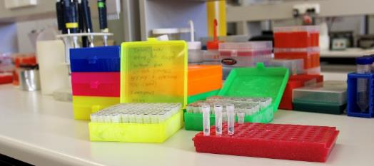
  3. **Figure 2: Processing fin clips in the lab (Photo: ARI)**
  4. **Project objectives**

Information about the genetic make-up of individuals will be used to:

* Determine how connected rivers are across south-eastern Australia, which will help inform the **appropriate spatial scale for environmental water delivery** (e.g. should rivers be managed at the river, catchment or basin scale?).
* Determine how levels of **population connectivity** are influenced by river flow conditions.
* Determine the relative influence of **local versus non-local recruitment** and how this changes in response to river flow conditions.
* Determine the **number of breeding fish** contributing to recruitment events and how this changes in response to river flow conditions.
* **Distinguish wild-born fish from stocked fish** to understand the contributions of stocking versus natural recruitment to population numbers under different river flow conditions.
* Test for **genes linked to climate, growth rate or exploratory behaviour** to inform brood stock selection for hatchery breeding programs.

## Expected outcomes

* New knowledge about the effects of environmental flows on the connectivity, recruitment dynamics and genetic health of native fish populations.
* Models to predict fish responses to flow scenarios.
* 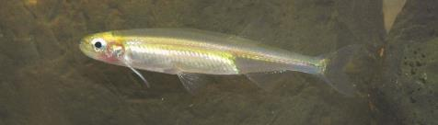Recommendations for more cost-effective delivery of environmental water to promote connectivity, genetic diversity and long-term survival of fish.

**Figure 3: Common, widespread species such as Australian Smelt are included in this project (Photo: ARI)**

**Project partners**

## This project is a collaboration between ARI, DELWP, La Trobe University, University of Melbourne, North Central Catchment Management Authority, Goulburn Broken Catchment Management Authority, South Australian Research and Development Institute, and New South Wales Department of Primary Industries.

The future potential for other collaborations

This project demonstrates the vast potential for using genomic tools to better understand fish ecology and fish responses to particular environmental conditions. We welcome further collaboration opportunities to address important knowledge gaps, including studies of range-wide population connectivity and the effects of river flows on juvenile dispersal and long-term individual- and population- level recruitment dynamics.

## Contact:

Katherine.Harrisson@delwp.vic.gov.au

|  |  |
| --- | --- |
| © The State of Victoria Department of Environment, Land, Water and Planning 2018  LogoThis work is licensed under a Creative Commons Attribution 4.0 International licence. You are free to re-use the work under that licence, on the condition that you credit the State of Victoria as author. The licence does not apply to any images, photographs or branding, including the Victorian Coat of Arms, the Victorian Government logo and the Department of Environment, Land, Water and Planning (DELWP) logo. To view a copy of this licence, visit http://creativecommons.org/licenses/by/4.0/  ISBN 978-1-76077-119-5 (print) 978-1-76077-120-1 (pdf/online/MS word)  Disclaimer  This publication may be of assistance to you but the State of Victoria and its employees do not guarantee that the publication is without flaw of any kind or is wholly appropriate for your particular purposes and therefore disclaims all liability for any error, loss or other consequence which may arise from you relying on any information in this publication. | Accessibility  If you would like to receive this publication in an alternative format, please telephone the DELWP Customer Service Centre on 136186, email [customer.service@delwp.vic.gov.au](mailto:customer.service@delwp.vic.gov.au), or via the National Relay Service on 133 677 [www.relayservice.com.au](http://www.relayservice.com.au). This document is also available on the internet at [www.delwp.vic.gov.au](http://www.delwp.vic.gov.au). |