|  |
| --- |
| Evaluating fox management strategies using a spatially explicit population model |
| L. Francis, A. Robley and B. Hradsky |
| May 2020  Updated March 2021 |

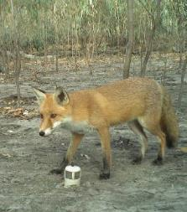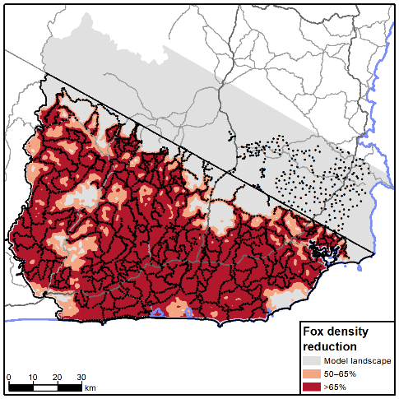

Arthur Rylah Institute for Environmental Research  
Technical Report Series No. 304

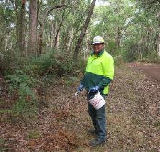

|  |  |
| --- | --- |
| |  | | --- | | Acknowledgement  We acknowledge and respect Victorian Traditional Owners as the original custodians of Victoria’s land and waters, their unique ability to care for Country and deep spiritual connection to it. We honour Elders past and present whose knowledge and wisdom has ensured the continuation of culture and traditional practices.  We are committed to genuinely partner, and meaningfully engage, with Victoria’s Traditional Owners and Aboriginal communities to support the protection of Country, the maintenance of spiritual and cultural practices and their broader aspirations in the 21st century and beyond. |   Arthur Rylah Institute for Environmental Research Department of Environment, Land, Water and Planning PO Box 137 Heidelberg, Victoria 3084 Phone (03) 9450 8600 Website. [www.ari.vic.gov.au](http://www.ari.vic.gov.au)  **Citation**. Francis, L., Robley, A. and Hradsky, B. (2020). *Evaluating fox management strategies using a spatially explicit population model*. Arthur Rylah Institute for Environmental Research Technical Report Series No. 304. Department of Environment, Land, Water and Planning, Heidelberg, Victoria.  **Front cover photo**. FoxNet density map; red fox (*Vulpes vulpes*) (DEWLP); laying fox bait (DELWP).  Logo© The State of Victoria Department of Environment, Land, Water and Planning 2020    This work is licensed under a Creative Commons Attribution 3.0 Australia licence. You are free to re-use the work under that licence, on the condition that you credit the State of Victoria as author. The licence does not apply to any images, photographs or branding, including the Victorian Coat of Arms, the Victorian Government logo, the Department of Environment, Land, Water and Planning logo and the Arthur Rylah Institute logo. To view a copy of this licence, visit [http.//creativecommons.org/licenses/by/3.0/au/deed.en](http://creativecommons.org/licenses/by/3.0/au/deed.en)  Printed by the Victorian Government  Edited by Organic Editing  ISSN 1835-3827 (print)  ISSN 1835-3835 (pdf)  ISBN 978-1-76105-474-7 (print) ISBN 978-1-76105-475-4 (pdf/online/MS word)  **Disclaimer** This publication may be of assistance to you but the State of Victoria and its employees do not guarantee that the publication is without flaw of any kind or is wholly appropriate for your particular purposes and therefore disclaims all liability for any error, loss or other consequence which may arise from you relying on any information in this publication.  Accessibility  If you would like to receive this publication in an alternative format, please telephone the DELWP Customer Service Centre on 136 186, email [customer.service@delwp.vic.gov.au](mailto:customer.service@delwp.vic.gov.au) or contact us via the National Relay Service on 133 677 or [www.relayservice.com.au](http://www.relayservice.com.au). This document is also available on the internet at [www.delwp.vic.gov.au](http://www.delwp.vic.gov.au) |

Evaluating fox management strategies using a spatially explicit population model

Lachlan Francis1, Alan Robley1 and Bronwyn Hradsky2

1Arthur Rylah Institute for Environmental Research  
123 Brown Street, Heidelberg, Victoria 3084

2Quantitative and Applied Ecology, Faculty of Science  
The University of Melbourne, Victoria 3010

Date

Arthur Rylah Institute for Environmental Research  
Technical Report Series No. 304

Cover note — March 2021 update

After the initial publishing of this technical report in May 2020, further model development in late 2020 uncovered a programming error which affected some of the projects included in this report.

Projects which had multiple sectors of baiting which occurred in the same model week were exposed to some degree of over baiting in the model; the degree of over baiting depending on the size of baiting sectors and the frequency of concurrent model baiting weeks.

The model code was subsequently updated in late 2020 to remove any potential over baiting errors and the results of these new analyses are included herewith, and a short summary table is provided directly below. The new analyses did not fundamentally change the reported outcomes and recommendations made by the original model outcomes but have been updated to provide transparency for affected programs, and to aide in any future modifications to their fox control programs.

|  |  |  |  |
| --- | --- | --- | --- |
| Project name | New fox density reduction % (original reduction) | New % of AoCI with >65% reduction (original reduction) | New % of AoCI with >20% reduction (original reduction) |
| Modelled fox control programs | | | |
| Southern Ark | 74 (83) | 37 (63) | 88 (93) |
| Otway Ark | 61 (66) | 17 (30) | 60 (65) |
| Grampians Ark | 74 (76) | 49 (56) | 95 (97) |
| Wilsons Promontory NP | 89 (89) | 64 (61) | 113 (116) |
| Little Desert (expansion) | 51 (60) | 6 (25) | 74 (89) |
| Little Desert NP | 51 (55) | <1 (<1) | 43 (51) |
| Modelled alternate fox control programs | | | |
| Little Desert (expansion) | 72 (84) | 43 (70) | 96 (97) |
| Southern Ark | 75 (84) | 38 (68) | 89 (96) |
| Otway Ark (2nd scenario) | 76 (82) | 51 (62) | 82 (85) |
| Otway Ark (1st scenario) | 68 (79) | 26 (36) | 75 (83) |
| Little Desert NP (2nd scenario) | 68 (76) | 17 (36) | 85 (97) |
| Little Desert NP (1st scenario) | 54 (59) | <1 (2) | 46 (61) |

Acknowledgements

We would like to thank the following project staff for their assistance and for providing details of fox control projects: Nelson Burand-Hicks and Sam Nicholson (Mallee Catchment Management Authority); Mick Bramwell, Scott McLean, Andrew Murray and Louise Stringer (Department of Environment, Land, Water and Planning; DELWP); Kelly Button, Dale Fuller, Matthew Hoskins, Brendan Rogers, Derek Sandow, Drew Sutton, Abigail Watkins and Zoe Wilkinson (Parks Victoria); Deanna Marshall (Trust for Nature); Rohan Bilney (New South Wales Forestry Service); and Emma Birnbaum and Jack Pascoe (Conservation Ecology Centre).

We would also like to sincerely thank Jemma Cripps, Louise Durkin, Graeme Newell and Jim Thompson (Arthur Rylah Institute for Environmental Research; ARI) for their patient support during the use of the computing resources required for this project.

The project was funded with support from the Victorian Government through its investment in the ‘Biodiversity On-ground Action’ Adaptive Learning Project and the Weeds and Pests on Public Land program, DELWP.

Contents

Summary 1

1 Introduction 3

2 Methods 5

2.1 Fox control projects 5

2.2 Fox population modelling 6

2.2.1 FoxNet 6

2.2.2 Model parameters 8

2.2.3 Calculating changes in fox density 8

2.2.4 Model sensitivity testing 8

2.2.5 Alternative scenarios 8

3 Results 9

3.1 Mallee Parks—the Cowangie connection 10

3.2 Annuello Flora and Fauna Reserve 13

3.3 Lake Tyrrell, Lake Timboram and Lalbert Creek 16

3.4 Murray Scroll Belt 20

3.5 Patchewollock State Forest 23

3.6 Lower Avoca Plains 26

3.7 Patho Plains 29

3.8 Wilsons Promontory National Park 32

3.9 Little Desert National Park 34

3.10 Little Desert Expansion 38

3.11 Glenelg Ark 41

3.12 Grampians Ark 43

3.13 Otway Ark 45

3.14 Southern Ark 49

3.15 Summary of results 52

4 Discussion 56

5 Recommendations 61

References 63

Appendices 67

Summary

Context

In April 2017, the Victorian Government released its biodiversity plan (*Protecting Victoria’s Environment – Biodiversity 2037*). Implementation of the associated on-ground actions is through the Biodiversity Response Planning (BRP) projects, including 33 Red Fox (*Vulpes vulpes*; fox) control projects across 11 geographic areas, at a cost of $4.3 million. In addition, the Weeds and Pests on Public Land (WPPL) program allocates a significant portion of its annual $3.1 million investment towards fox control projects, covering more than 1.2 million hectares. Fox control in Victoria is also implemented by Parks Victoria (Otway Ark), the Alpine Resorts Commission, the Catchment Management Authorities (through the National Landcare Program), non-government organisations (e.g. Trust for Nature), local government, and private landowners. These projects are undertaken using a range of bait types, spacing and spatial layouts, and baiting intensity and duration. However, there is limited knowledge about how differences in bait delivery influence the effectiveness of fox control, which has till now limited our ability to obtain optimal effectiveness and make strategic investment decisions.

Aims

The aim was to assess the effectiveness of various fox control strategies across a range of spatial and temporal scales, in order to improve the design of fox control projects and to help guide future investment decisions.

Methods

We selected 14 fox control projects as case studies. The projects have varying treatment area (200–800,000 ha), bait density (0.22–4.82 baits/km2), bait spatial layout (linear, perimeter, internal network), duration (3 years; ongoing), frequency of control action (single or multiple pulses of baiting, or year-round baiting) and bait replacement rates (48-hourly to 6-weekly). We applied a spatially explicit, individually based fox population model (‘FoxNet’) to assess the level of change in fox density able to be achieved by each project. We set a minimum threshold of >65% reduction in fox density over >50% of the proposed area of conservation interest (AoCI) as the level required for achieving population control of foxes. When projects failed to reach this target, we also assessed a set of project-specific alternative strategies to see whether altering control strategies could achieve effective fox control.

Results

Three of the 14 fox-baiting projects assessed (21%) met the success criteria set (>65% reduction in modelled fox density over >50% of their AoCI); this increased to 5 (36%) when alternative strategies were modelled. Successful projects were those that had:

* an area of greater than ~30,000 ha
* a network of bait stations throughout their AoCI
* baits replaced at least fortnightly
* control applied continuously.

The spatial extent of the reduction in fox density within an AoCI was not uniform across projects. Only large-scale projects that had a network of baits throughout their AoCI were able to reduce fox densities by >65% over >50% of their AoCI. Two large-scale projects that implemented the above strategies achieved reductions of >65%, but did not do so over >50% of their AoCI. This was likely due to the linear shape of their landscapes, which may have allowed higher rates of immigration, too high to be suppressed by the control program. In cases where there were additional adjacent baiting programs designed to complement the project, this tended to increase the effective area of control and improve outcomes. Fox control implemented over small areas (i.e. less than ~30,000 ha), with bait stations placed along perimeter features only (e.g. fences and tracks) and/or with infrequent or inconsistent baiting frequency were ineffective at meeting the success criteria.

Conclusions and implications

Interacting factors (including spatial scale, bait layout, bait density and timing of baiting) affect fox control success. To be effective (i.e. reduce fox density by >65% over >50% of the AoCI), fox control projects need to assess the impact of these interacting factors before embarking on control actions. In general, the AoCI needs to be >30,000 ha, baits must be deployed as a network across the area, and baits need to be replaced at least fortnightly. Spatial scale and the shape of the AoCI will influence bait station configuration and replacement rates: areas with high perimeter-to-area ratios are likely to need more closely spaced baits with more frequent replacement rates, and/or baiting extended beyond the main AoCI, although the latter strategy requires further investigation.

FoxNet is a useful tool for managers exploring the effectiveness of current and possible alternative management strategies. Here we have demonstrated its utility and capacity to provide managers with insights into the likely outcomes of their management actions.

The outcome from this work is the development of a transparent approach for quantitatively assessing current and future investment in fox control in Victoria. Using FoxNet, the effects of alternative management strategies and tools (e.g. alternative timing of baiting, or spacing and placement of baits; use of aerial baiting, trapping and fencing, or combinations of these) can be assessed. We present a set of recommended criteria that fox control project managers should apply in order to achieve adequate and lasting suppression of fox populations. In addition, we highlight information gaps that, if filled, would improve fox control outcomes.

1. Introduction

Due to Australia’s isolation over evolutionary timescales, the native faunal assemblage has evolved with no specific threat of Red Fox (*Vulpes vulpes*; fox) predation, and thus has limited adaptive strategies for avoiding it. The Australian fauna has proven to be highly susceptible to fox predation due to this predator naivety (Woinarski et al. 2015). Mammals particularly susceptible to predation by the fox are those that dwell or forage on the ground and broadly fall into the ‘critical weight range’ category of 35 g – 5.5 kg (Burbidge and McKenzie 1989; McKenzie et al. 2007; Woinarski et al. 2015). The impacts of foxes are exacerbated by the presence of feral cats (*Felis catus*), habitat fragmentation, and changed fire regimes (Woinarski et al. 2015).

The management of foxes in Victoria follows the Invasive Plants and Animals Policy Framework (IPAF) and takes an asset-focused approach (i.e. makes the assumption that they cannot be eradicated from the state but seeks to reduce their adverse effects in order to provide the greatest benefits for specific high-value assets). Fox control is also undertaken for the protection of livestock (often led by community groups), which may in some locations benefit or complement biodiversity conservation efforts (McLeod et al. 2010).

Fox control typically involves the use of lethal baiting, with uneaten baits generally being recovered after 2–4 weeks. Baiting can be supplemented with shooting, trapping and/or den fumigation (Saunders et al. 2010). Monitoring the outcomes of control programs ranges from simply recording the number of baits taken (Dexter and Meek 1998) to assessing changes in both prey and predators using robust treatment/non-treatment or before–after control-impact (BACI) designs (Robley et al. 2014).

Experimental, large-scale evaluations of population reductions from baiting programs show that intensive baiting operations can achieve high success rates (e.g. Thompson and Fleming 1994; Dexter and Meek 1998). However, the resources, duration and care that go into these operations are generally much greater than that which occurs during routine fox control operations conducted by conservation land managers (Saunders and McLeod 2007), many of which are undertaken on a relatively small landscape scale. In contrast to the results of the experimental studies cited above, assessments of actual baiting practices by conservation organisations in Australia suggest that many current baiting operations may be unlikely to achieve meaningful reductions in fox densities or impacts (Reddiex et al. 2006).

The assumption behind fox control is that a reduction in fox abundance across an area of conservation interest (AoCI) causes a reduction in the damage inflicted by foxes (Sinclair et al. 1998; Hone 1999a; Doherty and Ritchie 2017). For example, for native species at risk from fox predation, it is assumed that reducing foxes will halt their population decline and/or increase their abundance. However, the level to which fox populations or density needs to be reduced to allow native species to escape regulation by fox predation remains unknown. Fox control may reduce fox abundance, but if the reduction is inadequate for achieving population-level control (i.e. offsetting the population growth) of foxes, the effects may be mitigated by compensatory changes in fecundity and/or mortality rates (Sinclair 1997). Compensatory immigration can also significantly affect the success of short-term predator control, particularly with highly mobile species such as the fox (Doherty and Ritchie 2017). To reduce a species’ abundance, population growth must be limited (Hone 1999a). To maintain abundances at reduced levels, the higher compensatory population growth that can be generated following pest control must also be limited. Hone (1999b) estimated that a population reduction in foxes of 0.65 per year (65% reduction in density) is needed to stop population increase. However, this estimation assumes no compensatory changes in the rate of increase in response to control; nor does this figure capture the spatial nature of compensatory immigration, and it should be interpreted as a minimum threshold that needs to be exceeded to obtain a benefit.

The effectiveness of fox control at reducing fox density is related to several factors. Bait distribution patterns can be highly influenced by seasonal track access, and baits are often distributed at low densities (e.g. Gentle 2005; Reddiex et al. 2006; Carter et al. 2011; Towerton et al. 2012). Poor spatial distribution means that many poison baiting programs are likely to reach only a fraction of the resident fox population, even when coordinated across land tenures. In these situations, the removal of some foxes by baiting is likely to be almost immediately compensated for by adjustments in the home ranges of other resident foxes, or rapid incursions by foxes from nearby areas (Carter et al. 2011). The size and shape of an area can also have a significant effect on immigration rates and bait exposure rates. We propose a >65% reduction in fox density (Hone 1999b) across >50% of an AoCI as the measure for effective control of fox populations. The area of reduction proposed is an arbitrary figure that we consider to be a minimum target for areas in which biodiversity conservation is the main aim. This figure needs further investigation.

In April 2017, the Victorian Government released its biodiversity plan (*Protecting Victoria’s Environment – Biodiversity 2037*), which aims to stop the decline of the state’s native plants and animals, and to improve the natural environment so it is healthy, retains its value and is actively cared for. The Biodiversity 2037 plan contains 20-year management output targets across public and private land. It includes a target of 1.5 million hectares of invasive predator control (primarily fox and feral cat control) in priority locations. Funding for the implementation of on-ground actions is through the Biodiversity Response Planning (BRP) projects, and the Weeds and Pests on Public Land (WPPL) program. In 2019, BRP-funded projects included 33 fox control projects across 11 geographic areas, with $4.3 million dollars of investment (Victorian Government 2018). In addition, the WPPL is investing a significant portion of its $3.1 million annual funding in fox control, covering >1.2 million ha (Victorian Government 2019).

These BRP and WPPL projects are undertaken over a wide range of spatial and temporal scales, by the Department of Environment, Land, Water and Planning (DELWP), Parks Victoria, the Catchment Management Authorities, the Australian Alpine Resorts Commission, non-government organisations, and local governments. Current interventions can be divided into two broad categories:

(i) large-scale (generally >30,000 ha) multiyear projects. These generally involve ongoing and continuous (year-round) baiting, often with baits deployed across a network of internal tracks; and

(ii) small-scale (<30,000 ha) programs of limited duration (1 month – 3 years) that may or may not undertake year-round control actions (many have pulses of baiting of 4–12 weeks once or twice per year).

Baiting layouts can vary from networks of baits within an AoCI, to perimeter baiting (in which baits are placed around the outside of the AoCI), or a simple line of baits along a track or fence line.

As part of the Victorian State Government’s continuous improvement framework, funds were made available through the Adaptive Learning Project and the WPPL program for this assessment of the effectiveness of the BRP on-ground actions and in this report, we present the findings. The information gained will help guide future management and investment decisions.

The ultimate question conservation practitioners would like answered is, “Was the decline in species of conservation concern halted or reversed by the fox control program?” Answering that question is outside the scope of this Adaptive Learning Project. The penultimate question we propose to address in this report, which will provide information on the effectiveness of the management action (i.e. the control of fox populations) is:

**“What combination of control factors achieves a reduction in fox density of >65% over >50% of the area of conservation interest?”**

We used a spatially explicit, individually based population modelling framework for foxes (‘FoxNet’; Hradsky et al. 2019) and selected BRP and WPPL projects that covered a range of spatial scales and baiting strategies as case studies to answer this question. The modelling used here is a transparent and objective method of assessing the value-for-money outcome of fox control proposals that land managers and investors can apply into the future.

1. Methods
   1. Fox control projects

We selected 10 of the 33 BRP projects and four ‘Ark’ (WPPL) projects that have fox control as the main management activity. The fox control strategies employed in these projects have varied in spatial scale, timing and intensity of baiting, and in the layout of baits (Figure 1, Table 1). All 10 projects used buried toxic baits dosed with 3.5 mg of sodium monofluoroacetate (compound 1080).

Two program attributes that were considered important to assess in this study were bait layout and the timing of baiting. The spatial layout of the bait stations within the various AoCIs was classified as ‘a network’ (i.e. bait stations were generally on internal tracks and roads in a network), ‘perimeter’ (i.e. baits were laid around the outside of the AoCI) or ‘linear’ (i.e. baits were laid along a feature, e.g. fence/road within or along the edge of the AoCI). The timing of the baiting regimes was defined according to the temporal intensity of the baiting program, and regimes were classified as ‘continuous’ (i.e. baiting was consistent year-round at some scale, e.g. fortnightly, monthly, etc.) or ‘pulsed’ (i.e. baiting was only continuous between set periods, e.g. 6 weeks of baiting undertaken three times during the year).

Table 1. Fox control case study projects and their control strategies

|  |  |  |  |  |  |
| --- | --- | --- | --- | --- | --- |
| Project name | BRP project | Area of conservation interest (ha) | Bait layout | Timing | Bait replacement schedule |
| Murray–Sunset NP–South | BRP028 | 3,318 | Linear | Single pulse (4 weeks) | 48-hourly |
| Annuello FFR | BRP040 | 12,507 | Linear | Single pulse (8 weeks) | 48-hourly |
| Lake Tyrrell, Lake Timboram and Lalbert Creek | BRP049 | 11,063 | Linear | Single pulse (4 weeks) | 48-hourly |
| Murray Scroll Belt | BRP051 | 31,029 | Network | Continuous | Monthly |
| Patchewollock SF | BRP052 | 13,810 | Perimeter | Single pulse (4 weeks) | Weekly |
| Avoca Plains | BRP071 | 2,759 | Network | Continuous | Monthly |
| Patho Plains | BRP072 | 5,407 | Network | Continuous | Monthly |
| Wilsons Promontory NP | BRP082 | 6,548 | Network | Continuous | Weekly |
| Little Desert (expansion) | BRP097 | 67,206 | Network | Dual pulse (12 weeks) | Fortnightly |
| Little Desert NP | BRP111 | 94,967 | Network | Continuous, 3 pulses (9 weeks) | Fortnightly |
| Glenelg Ark | – | 87,120 | Network | Continuous | Fortnightly |
| Grampians Ark | – | 269,700 | Network | Continuous | Fortnightly |
| Otway Ark | – | 149,996 | Network | Continuous | Monthly |
| Southern Ark | – | 862,086 | Network | Continuous | 6-weekly |

FFR: Flora and Fauna Reserve; SF: State Forest; NP: National Park.

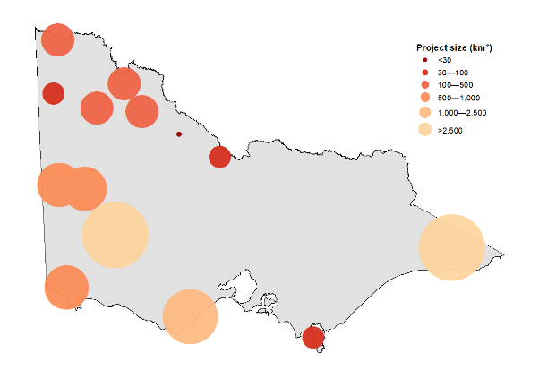

Figure 1. The location of the fox control projects assessed in this report, with an indication of their relative sizes (km2).

* 1. Fox population modelling
     1. FoxNet

We used a spatially explicit, individually based population model, ‘FoxNet’, to predict fox population density and responses to management within customised AoCIs. We incorporated parameters on dispersal and home ranges as a function of resource availability (Hradsky et al. 2019), and customised survival and reproductive parameters for south-eastern Australia (all model parameters are provided in Appendix 1).

FoxNet models foxes as mobile individuals whose behaviour is determined by their age, sex and status, and the time of year. Within the model, ‘alpha’ foxes seek to join or start their own fox-families, which establish and update a territory. Each fox-family must contain at least one alpha fox, and may also include the alpha’s mate, cubs and subordinate offspring, who share the territory. Fox-families can be characterised according to a description of the family members, the territory they hold (habitat-cells) and the productivity of their territory.

The landscape in FoxNet is divided into habitat-cells, which we defined as 1 ha in size. Each habitat-cell has a set of parameters associated with it that affect how fox-families and individual foxes behave. These include:

* *the type of habitat*, i.e. ocean, farmland or forest. One type of habitat (e.g. ocean) can be set to be unavailable to foxes if applicable, and the others have a defined level of productivity that determines how many habitat-cells a fox-family will need to acquire to establish a territory. We customised the configuration of different habitat types for each scenario;
* *cell availability*, i.e. whether the cell was available to foxes or not;
* *the cell-relative-use by individual foxes*; if a cell is owned by a fox-family, its relative use is calculated as the productivity of the habitat-cell divided by the total productivity of the fox-family’s territory. For example, in a homogeneous landscape with a territory-size of 100 ha and 1-ha habitat-cells, relative-cell-use would be 0.01. Relative-cell-use is used to scale the exposure of foxes to bait-stations with territory-size and habitat-cell productivity, and to derive the density of foxes;
* *cell productivity*, the intrinsic amount of food available to a fox in the habitat-cell during each time step. The productivity of habitat-cells in primary habitat was calculated from the size of an average fox home-range [assumed here to be 2.14 km2 (Hradsky et al. 2017)] and the daily food requirements of an adult fox (378 g per day; Lockie 1959). Productivity in secondary habitat (if applicable) depends on the ratio of the secondary to the primary habitat, but was set at 1:1 in our models as we had no *a priori* information on the differences in productivity for different habitat types;
* *the cell-relative-use by a fox family*; if a habitat-cell is owned by a fox-family, the relative-cell-use by individual foxes is calculated as the relative-cell-use multiplied by the number of foxes in the fox-family. This was used to calculate the density of foxes. For example, if four foxes shared a 100-ha territory and relative-cell-use was 0.01, relative-cell-use-foxes would be 0.01 x 4 = 0.04.

We updated our model processes at 1-week intervals (time steps). A series of processes occur consecutively at each time step, and key seasonal events [e.g. dispersal (March–April) and mating (July–September)] are linked to weeks of the year (9–21 and 27–40, respectively).

Foxes who have just become ‘dispersers’ leave their natal fox-family and move a random distance, scaled by their territory-size (Trewhella et al. 1988). ‘Disperser’ foxes explore an area set to three times the radius of an average home-range (Soulsbury et al. 2011), where they (i) are exposed to any active bait-stations and have a risk of dying; (ii) attempt to join a fox-family that lacks an ‘alpha’ fox of the appropriate sex; or (iii) try to establish a new fox-family. If unsuccessful, they remain a ‘disperser’ until the next time step, when the process is repeated.

If it is the breeding season, fox-families that contain an ‘alpha’ male and an ‘alpha’ female breed, producing a Poisson-distributed number of ‘cub’ foxes in September each year. If an ‘alpha’ fox is absent, all family-members become dispersers and attempt to join other nearby fox-families. Random background mortality of foxes occurs, based on their age. ‘Cub’ foxes belonging to fox-families without any adults die, reflecting their dependence on food provision (Baker et al. 1998). This allows baiting to affect reproductive success. Defunct fox-families (those that have no family members) are removed from the model.

In summary, at each time step, foxes age; if old enough, they disperse between March and May each year. Within fox-families, an alpha male or female that dies (either by natural causes or from baiting) is replaced by an age- and sex-appropriate subordinate from that family, if a suitable individual is available. Otherwise, the position remains vacant for a disperser to join the fox-family (see below). Fox families check their territories, and if productivity is insufficient, adults and subordinates disperse, and cubs die. This checking also enables fox families to expand and contract their territory size relative to landscape productivity.

Baits are deployed at bait stations (according to a project-defined management strategy). Foxes whose territories overlap with one or more bait stations are exposed to these baits and have a risk of dying, based on the number of baits, the size of their territory and the number of foxes in the fox-family. All baits that are not ‘eaten’ by foxes are removed after each model time step (one week). Although baits may be available to foxes for longer, degradation of 1080 may render baits non-lethal 2 weeks after deployment (Saunders et al. 2000).

FoxNet was built and run in the open-source software Netlogo (v. 6.0.4 Wilensky 1999), and models were executed using R v. 3.5.3 (R Core Team 2019) and the ‘RNetLogo’ package (Thiele et al. 2012; Thiele 2014). A detailed model overview and description of FoxNet following the Overview, Design, Details protocol (Grimm et al. 2010) is provided in Hradsky et al*.* (2019). Landscapes were built using ArcMap 10.3.1 (ESRI 2015) using Victorian Government GIS datasets (PLM25) and State boundary information from the Australian Government Open Data repository (DIIS 2018).

Models for all projects were run for 40 iterations to capture the underlying variance in fox responses. Adult fox densities were recorded and updated at each time step and were averaged across all model iterations.

* + 1. Model parameters

Life history and movement parameters, initial population density, carrying capacity and resource availability, were based on those used by Hradsky et al. (2019). Models were run with a buffer of ~30 km around the AoCI to capture >96% of dispersing female foxes and >93% of dispersing male foxes that might reach the AoCI. Input parameters were consistent across models, except for the model spatial parameters (landscape configuration, AoCI, and the spatial and temporal baiting regime for the model project).

Fox density was modelled for 10 years prior to the commencement of baiting to allow the population to stabilise, and for 10 years following the commencement of baiting across each project. Baiting was implemented for 10 years for Ark projects to demonstrate the benefit of their long-term fox control. BRP projects were run for 10 years and baited for 6 years (i.e. two times a 3-year funding cycle) to demonstrate the benefit of a second funding round, while also showing fox density recovery following the cessation of baiting.

* + 1. Calculating changes in fox density

Each project consisted of two base models: baited and unbaited. The difference in mean fox density was used to assess the success of the control strategy. For each of the 40 model iterations, fox densities within an AoCI were averaged over 13 × 13 1-ha cells or 1.69 km², approximately 80% of the area of a fox’s home range. This produced an average fox density (number per km2) for the AoCI, which was analysed to determine the percentage reduction in density [R package ‘raster’ (Hijmans et al. 2015)]. For pulsed baiting projects this assessment was made in the final month of the pulse, and for ongoing baiting operations this was taken in week 23 of model year 20 to coincide with the midpoint between population peaks (cub independence).

A snapshot in time of the spatial effect of baiting on fox density was also produced; this ‘density map’ was prepared at the same time as the percentage differences in fox density were reported, and it illustrates the regions with spatial reductions in fox density of between 50–65% and >65% of the AoCI. Spatial reduction calculations were done by contrasting the unbaited and baited scenario spatial density outputs.

* + 1. Model sensitivity testing

The number of model iterations, model run-in time (number of years to stabilise the density of an unbaited fox population), initial fox density, and bait efficacy (probability of an individual bait encounter resulting in fox mortality) were subjected to sensitivity testing to determine the optimal settings (Appendix 2). These sensitivity tests were ‘local’, and only the parameter under investigation was tested (Grimm et al. 2014). Model run-in time was tested by plotting density over time for unbaited scenarios and visually assessing when the variation in fox densities had stabilised between model years. These stabilised fox densities were used to set the initial fox density in subsequent models. The number of iterations needed to stabilise the fox population was tested by analysing spatial output results of consecutively higher numbers of model iterations, until the random variability in density between the unbaited and baited scenario was negligible. Bait efficacy was tested over different levels (0, 0.05, 0.1, 0.15, 0.2, 0.3), and over different model time steps (weekly, fortnightly, monthly).

* + 1. Alternative scenarios

Alternative scenarios were created for projects that did not reach the target reduction in fox density of >65% over >50% of the AoCI, in order to explore alternative management strategies. These alternative scenarios were created for projects by modifying the temporal and spatial scales of the baiting program. Temporal scale experiments were modelled with fortnightly bait replacement year-round and were run with the same initial spatial layout as proposed. A second experiment was run, wherever possible, with the alternative temporal baiting program but with changes to the spatial layout of baits. This involved using a network of bait stations at 1-km intervals on internal roads or tracks within the proposed area of fox control if these tracks were visible on the available spatial data layers; we note that not all these tracks may be available for projects.

1. Results

The following section describes the results of the FoxNet modelling, with each project having a stand-alone ‘fact sheet’ describing the current strategy, the model outcomes and details of any modelled alternative control strategies. A summary of the overall outcomes is presented at the end of the section.

Model results need to be considered in conjunction with the following information.

1. Unbaited fox populations fluctuate annually, with peaks in November resulting from the influx of individuals from the previous breeding season entering the population. Populations steadily decline through the year as individuals either disperse away from the modelled landscape or die, with a low point in October prior to the influx of the independent cub cohort. Fluctuations in the baited fox populations are related to the same factors as above, with the additional impact of the specific baiting operation.
2. Fox densities with baiting were considered significantly different from fox densities without baiting when the baited scenario maximum density was less than the unbaited scenario minimum density. Time series graphs of fox density for the baited and unbaited model outcomes are presented here. The peaks in these graphs illustrate the point of independence for each year’s fox cub cohort. Due to the synchronicity of this event between unbaited and baited models, it may appear that these peaks overlap, when in fact they may not.
3. Density maps have been produced to illustrate the spatial coverage of the reduced fox density. These snapshots were in most cases taken in June (coinciding with the midpoint between cub cohort independence), but on two occasions were taken at the end of a baiting pulse (marked with a dot in the time series graphs). A snapshot taken at a different time of year, e.g. September, would yield a different result, and would reflect the dynamic nature of the changes in the fox population through time. These density maps should be viewed in combination with the time series graphs. Appendix 3 shows a continuously baited program’s spatial density reductions at 4-weekly intervals, and the dynamic nature of the reductions.
4. Reductions in fox density may occur outside the AoCI, due to either baits near the edge of the AoCI or adjacent baiting regimes having an impact. The spatial reductions are reported as totals relative to the size of the AoCI, with raster cells averaged across 1.69 km²; hence, reductions can be >100% of the AoCI. When the AoCI is adjacent to the coastal outline (or other areas uninhabitable by foxes), this averaging will not cover cells adjacent to the uninhabitable cells for 600 m (6 × 1-ha cells; equivalent to half the radius of 1.69 km² used in the averaging process). This will result in some projects appearing to have some areas of the AoCI in which thre has been no reducton in densityand may also underestimate the area of >65% reduction for these projects.
5. Unless otherwise noted, reporting of results for BRP projects was made at the end of the third year (i.e. model year 13). While BRP project models were baited for 6 years to demonstrate the benefits of continuing these projects past the initial funding cycle, the focus was on investigating the current BRP strategies. Ark projects were assessed at model year 20 to reflect the ongoing nature of those projects.

**Fox control operation**

This baiting operation is a component of BRP028, Mallee Parks—the Cowangie connection, and is a single intense-pulse baiting program along a section of the southern boundary of the Murray–Sunset National Park in the north-west of Victoria (Figure 2). Baits are laid approximately every 250 m, and baiting is completed over 28 days mid-April to mid-May, with baits checked every 48 h Monday to Friday. The project aims to protect the Mallee Emu-wren (*Stipiturus mallee*) and the Lined Earless Dragon (*Tympanocryptis lineata lineata*).

**FoxNet modelling**

|  |
| --- |
| 3.1 Mallee Parks—the Cowangie connection |

FoxNet was run for 10 years with no baiting, to stabilise the fox population. Baiting began in year 11. Baiting was undertaken weekly over mid-April to mid-May (model weeks 16–19) and finished in model year 16. FoxNet is unable to model 48-hourly bait checks, with the smallest time step possible being weekly. The model predictions of the levels of fox reduction achieved may be underestimations, as the model baits are not available to foxes as frequently as in the described project.

Figure 2. The baiting layout as modelled in FoxNet, showing project bait station locations, FoxNet area of conservation interest (AoCI), model extent, and locality of project.

The AoCI (33 km2) was specified by the project as the area under which fox control is expected to have an impact.

**Results**

FoxNet modelling showed a reduction in fox density of 46% in May of model year 13 (Figure 3). Fox densities with baiting differed significantly from fox densities without baiting between May and November in years 13 to 16 but returned to pre-baited levels within 1 year.

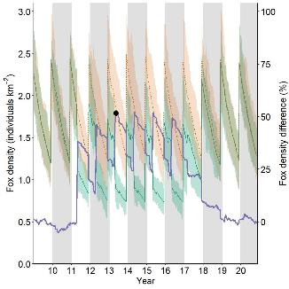Figure 3. The modelled fox densities for Mallee Parks—baited (green) and unbaited (pale red). Colour-shaded areas are modelled minimum and maximum values across all iterations. The purple line shows the percentage difference between the fox densities with and without baiting within the AoCI. The dot indicates the point in time where percentage differences were reported. Baiting first occurred in April–May of model year 11; it finished in year 16.

No areas within the AoCI were reduced by >50% by year 13.

**Alternative scenarios**

This project was also modelled with an alternative scenario. The alternative scenario maintained the linear spatial layout, but with baiting conducted fortnightly throughout the year. This alternative temporal scale scenario showed an overall reduction in fox density of 61% by May of model year 13 (Figure 4). Fox densities with baiting differed significantly from unbaited fox densities by May in year 11. Following the cessation of baiting, fox densities returned to levels that did not differ from the unbaited scenario by November in year 17.

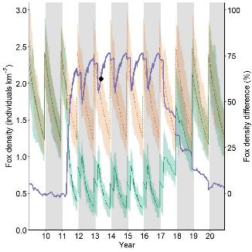Figure 4. The modelled fox densities for the alternative scenario—baited (green) and unbaited (pale red). Colour-shaded areas are modelled minimum and maximum values across all iterations. The purple line shows the percentage difference between the fox densities with and without baiting within the AoCI. The dot indicates the point in time when model outcomes were reported. Fortnightly baiting commenced in model year 11 and continued throughout the year; it finished in year 16.

Under the fortnightly baiting scenario, some small areas within the AoCI achieved 50–65% reduction in fox densities following the baiting in May year 13 (Figure 5).

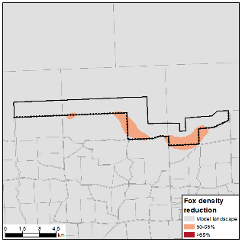Figure 5. The spatial reduction in modelled fox densities taken in May of model year 13 for the alternative scenario. The dot in Figure 4 indicates the point in time when model outcomes were reported.

**Results summary**

This project is limited by its small spatial scale and short baiting period. Maintaining bait spacing at 250 m but increasing the duration did improve the outcome (Table 2). However, it still did not achieve enough reduction in density, or wide enough spatial coverage, to halt fox population growth. This alternative strategy would come with the additional costs associated with an extra 12 bait runs throughout the year [currently 14 runs per year vs a proposed 26 runs per year (fortnightly)].

These results should be interpreted as minimum likely levels of reduction in density, because the model is unable to capture the 48-hourly bait replacement strategy used in this project. Bait-take data for this project confirms this, with some bait stations showing continuous, consecutive bait-take in time intervals shorter than those modelled here.

Table 2. The mean and percentage reduction in modelled fox densities for all management scenarios.

|  |  |  |  |
| --- | --- | --- | --- |
| Baiting program | Baiting strategy | Foxes per km2: mean (min–max) | Percentage reduction |
| Original program | Linear pulse baiting | 1.04 (0.73–1.58) | 46% |
| First alternative | Linear fortnightly baiting | 0.70 (0.52–1.07) | 61% |

|  |
| --- |
| 3.2 Annuello Flora and Fauna Reserve |

**Fox control operation**

This baiting operation is part of BRP040, Annuello and Wandown: enhancing Mallee to Murray biolinks. The fox control project undertakes a single-pulse fox baiting program along the eastern edge of the Annuello Flora and Fauna Reserve in the north-west of Victoria (Figure 6). Baits are laid approximately every 400 m, and baiting is completed over 8 weeks from early March to the end of April, with baits checked every 48 h Monday to Friday. The project aims to protect the Malleefowl (*Leipoa ocellata*) and the Bandy-bandy (*Vermicella annulata*).

**FoxNet modelling**

FoxNet was run for 10 years with no baiting, to stabilise the fox population. Baiting began in year 11. Baiting was undertaken weekly from early March to the end of April (model weeks 10 to 17) and finished in model year 16. FoxNet is unable to model 48-hourly bait checks, and the smallest time step possible is weekly. The model predictions of the levels of fox reduction achieved may be underestimations, as the model baits are not available to foxes as frequently as in the described project.

The AoCI (125 km2) was specified by the proponent as the area under which fox control is expected to have an impact.

Figure 6. The Annuello Flora and Fauna Reserve (FFR) baiting layout, as modelled in FoxNet, showing project bait station locations, alternative bait station locations, FoxNet area of conservation interest (AoCI), model extent, and locality of project.

**Results**

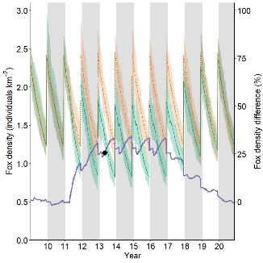FoxNet modelling showed an overall reduction in fox density of 16% by the end of April in year 13 (Figure 7). Fox densities with baiting differed significantly from fox densities without baiting briefly during year 13 and year 15.

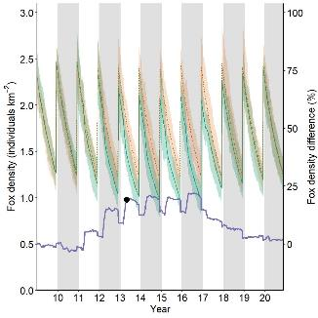Figure 7. The modelled fox densities for the Annuello FFR—baited (green) and unbaited (pale red). Colour-shaded areas are modelled minimum and maximum values across all iterations. The purple line shows the percentage difference between the fox densities with and without baiting within the AoCI. The dot indicates the point in time when model outcomes were reported. Baiting first occurred in March–April of model year 11; it finished in year 16.

No areas within the AoCI were reduced by >50% by year 13.

**Alternative scenarios**

This project was also modelled with two alternative scenarios investigating different temporal scales and spatial layouts.

**Scenario 1.** The first alternative scenario maintained the linear spatial layout (with baits spaced at 400-m intervals), but increased baiting to fortnightly throughout the year.

This alternative temporal scale scenario showed an overall reduction in fox density of approximately 24% over the AoCI (Figure 8). Fox densities with baiting differed significantly from fox densities without baiting by September in year 12. Following the cessation of baiting, fox densities returned to pre-baiting levels by May in year 17.

Figure 8. The modelled fox densities for the first alternative scenario for the Annuello FFR—baited (green) and unbaited (pale red). Colour-shaded areas are modelled minimum and maximum values across all iterations. The purple line shows the percentage difference between the fox densities with and without baiting within the AoCI. The dot indicates the point in time when model outcomes were reported. Fortnightly baiting commenced in model year 11 and continued throughout the year; it finished in year 16.

**Scenario 2.** This scenario was run with a network of bait stations on internal roads and tracks identified from available spatial layers, spaced approximately 1 km apart, with baits replaced fortnightly throughout the year. Note: more internal tracks may be available than were modelled.

This scenario showed an overall reduction in fox density of approximately 37% over the AoCI (Figure 9). Fox densities with baiting differed significantly from fox densities without baiting by October in year 11. Following the cessation of baiting, fox densities returned to levels that did not differ from those in the unbaited scenario by November in year 17.

Neither of the alternative scenarios achieved more than a 50% reduction in fox density by year 13.

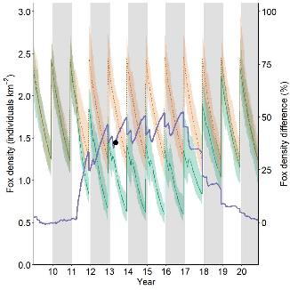Figure 9. The modelled fox densities for the second alternative scenario for the Annuello FRR—baited (green) and unbaited (pale red). Colour-shaded areas are modelled minimum and maximum values across all iterations. The purple line shows the percentage difference between the fox densities with and without baiting within the AoCI. The dot indicates the point in time when model outcomes were reported. Fortnightly baiting using a network of bait stations commenced in model year 11 and continued throughout the year; it finished in year 16.

**Results summary**

This project is limited by its spatial layout and single-pulse (although moderately intense) baiting period. While increasing the spatial coverage and the duration of the baiting did improve the outcome, none of the modelled baiting strategies achieved reductions extensive enough to stop fox population growth (Table 3).

These results should be interpreted as minimum likely levels of reduction in density, because the model is unable to capture the 48-hourly bait replacement strategy used in this project. Bait-take data for this project confirms this, with clusters of bait stations showing continuous, consecutive bait-take in time intervals shorter than those modelled here.

Table 3. The mean and percentage reduction in modelled fox densities for all Annuello FFR management scenarios.

|  |  |  |  |
| --- | --- | --- | --- |
| Baiting program | Baiting strategy | Foxes per km2: mean (min–max) | Percentage reduction |
| Original program | Linear pulse baiting | 1.6 (1.30–2.01) | 16% |
| First alternative | Linear fortnightly baiting | 1.45 (1.18–1.70) | 24% |
| Second alternative | Network, fortnightly baiting | 1.23 (0.98–1.48) | 37% |

**Fox control operation**

This project is part of BRP049, Tyrrell—preserving an ancient salina landscape, and involves a single-pulse fox baiting program along the edge of Lake Tyrrell, Lake Timboram and Lalbert Creek in the north-west of Victoria (Figure 10). The project aims to protect the Bush Stone-curlew (*Burhinus grallarius*), the Inland Carpet Python (*Morelia spilota metcalfei*) and the Lined Earless Dragon (*Tympanocryptis lineata lineata*). At the time of data collection, baits were intended to be laid approximately every 250 m and baiting was to be completed over 28 days mid-April to mid-May, with baits checked every 48 h Monday to Friday.

**FoxNet modelling**

|  |
| --- |
| 3.3 Lake Tyrrell, Lake Timboram and Lalbert Creek |

FoxNet was run for 10 years with no baiting, to stabilise the fox population. Baiting began in year 11. Baiting was undertaken weekly from mid-April to mid-May (model weeks 16–19) and finished in model year 16. The AoCI (111 km2) was specified by the proponent as the area under which fox control was expected to have an impact. The AoCI was subdivided into the two subsections: Lalbert Creek and Lake Timboram [BRP049(1)] and Lake Tyrrell [BRP049(2)] to reflect the fact they are two distinct areas.

Figure 10. The baiting layout for Lake Tyrrell, Lake Timboram and Lalbert Creek, as modelled in FoxNet, showing project bait station locations, FoxNet area of conservation interest (AoCI), model extent, and locality of project.

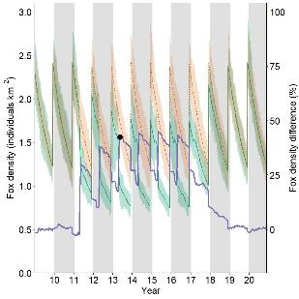FoxNet is unable to model 48-hourly bait checks, and the smallest time step possible is weekly. The model predictions of the levels of fox reduction achieved may be underestimations, because the model baits are not available to foxes as frequently as in the described project.

**Results**

Modelling showed a maximum mean reduction of 55% over Lalbert Creek and Lake Timboram by mid-May in year 13 (Figure 11), but a total reduction in density of >65% only covered 2.9% of the AoCI (Figure 11). Lake Tyrrell showed a maxiumum of 38% reduction in fox density by the same time, with no area being >50% (Figure 12).

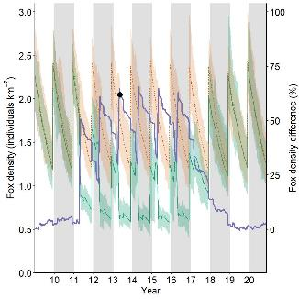Fox densities with baiting only differed from fox densities without baiting in years 12 to 16, and then only between May and November each year.

Figure 11. The modelled fox densities for Lalbert Creek and Lake Timboram—baited (green) and unbaited (pale red). Colour-shaded areas are modelled minimum and maximum values across all iterations. The purple line shows the percentage difference between the fox densities with and without baiting within the AoCI. The dot indicates the point in time when model outcomes were reported. Weekly baiting first occurred in April–May of model year 11; it finished in year 16.

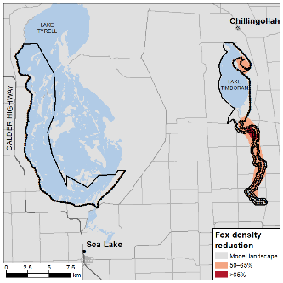Figure 12. The modelled fox densities for Lake Tyrrell—baited (green) and unbaited (pale red). Colour-shaded areas are modelled minimum and maximum values across all iterations. The purple line shows the percentage difference between the fox densities with and without baiting within the AoCI. The dot indicates the point in time when model outcomes were reported. Weekly baiting first occurred in April–May of model year 11; it finished in year 16.

Figure 13. The spatial reduction in modelled fox densities for Lake Tyrrell, and Lake Timboram/Lalbert Creek. The dot in Figure 11 and 12 indicates the point in time when model outcomes were reported.

**Alternative scenario**

This project was also modelled with an alternative scenario investigating fortnightly baiting implemented throughout the year, while maintaining the linear spatial bait layout.

This alternative temporal scale achieved a >65% reduction (maximum 70%; Figure 14) by mid-May in year 13, covering 29.3% of the AoCI (Figure 14). Lake Timboram achieved a 55% reduction in fox density by mid-May in year 13 (Figure 15).

Fox densities with baiting differed significantly from fox densities without baiting in all areas by mid-May in year 11. Following the cessation of baiting under all strategies, fox densities returned to levels that did not differ from the unbaited scenario by late year 17.

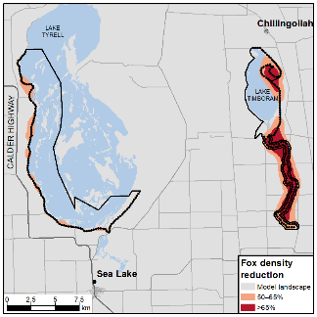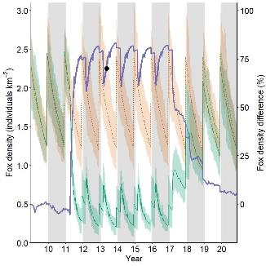Fox densities with baiting differed significantly from fox densities without baiting by May in year 11 for both areas. Following the cessation of baiting, fox densities returned to levels that did not differ from the unbaited scenario by November in year 17 at Lake Timboram and Lalbert Creek, and by July in year 18 for Lake Tyrrell.

**Figure 14. The modelled fox densities for the alternative scenario along Lake Timboram/Lalbert Creek—baited (green) and unbaited (pale red). Colour-shaded areas are modelled minimum and maximum values across all iterations. The purple line shows the percentage difference between the fox densities with and without baiting within the AoCI. The dot indicates the point in time when model outcomes were reported. Fortnightly baiting commenced in model year 11 and continued throughout the year; it finished in year 16.**

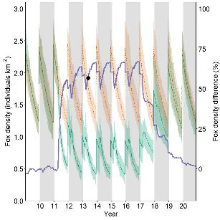 Figure 15. The modelled fox densities for the alternative scenario at Lake Tyrrell—baited (green) and unbaited (pale red). Colour-shaded areas are modelled minimum and maximum values across all iterations. The purple line shows the percentage difference between the fox densities with and without baiting within the AoCI. The dot indicates the point in time when model outcomes were reported. Fortnightly baiting commenced in model year 11 and continued throughout the year; it finished in year 16.

Figure 16. The spatial reduction in modelled fox densities for Lake Tyrrell, and Lake Timboram/Lalbert Creek alternative scenario. The dot in Figure 14 and 15 indicates the point in time when model outcomes, shown here, were reported.

**Summary**

This project is limited by its relatively narrow, spatially limited layout and short (although intense) baiting period. The alternative scenario of fortnightly baiting each year reduced fox density by up to a further 15-17% (Table 4). This would come with the additional costs associated with an extra 12 bait runs per year [14 runs currently vs 26 proposed runs per year (fortnightly)].

Bait-take data for this project showed only two bait stations had two consecutive baits taken in time intervals shorter than modelled here (i.e. less than a week), and that the baiting program did not run for as long as anticipated. Therefore, while these results should be interpreted as minimum likely levels of reduction in density for the proposed project (as the model is unable to capture the 48-h bait replacement strategy), these results are most likely overestimations, as the modelled project was twice as long as the 2019 baiting effort.

Table 4. The mean and percentage reduction in modelled fox densities for all Lake Tyrrell and Lake Timboram/Lalbert Creek management scenarios.

|  |  |  |  |
| --- | --- | --- | --- |
| Baiting program | Baiting strategy | Foxes per km2: mean (min–max) | Percentage reduction |
| BRP program—Lalbert Creek and Lake Timboram | Linear pulse baiting | 0.83 (0.50–1.51) | 55% |
| BRP program—Lake Tyrrell | Linear pulse baiting | 1.13 (0.84–1.59) | 38% |
| Alternative scenario—Lalbert Creek and Lake Timboram | Fortnightly linear baiting | 0.54 (0.30–0.77) | 70% |
| Alternative scenario—Lake Tyrrell | Fortnightly linear baiting | 0.80 (0.66–1.06) | 55% |

**Fox control operation**

This project is a component of BRP051, Protecting the Murray Scroll Belt, and is a year-round fox baiting program across a network of roads and tracks on private property in the far north-west of Victoria (Figure 17). Baiting occurs monthly. Baits are spaced on average 1.45 km apart (range 0.15–3.79 km). The project aims to protect the Giles’ Planigale (*Planigale gilesi*), the Inland Carpet Python (*Morelia spilota metcalfei*), the Eastern Hooded Scaly-foot (*Pygopus schraderi*), De Vis’s Banded Snake (*Denisonia devisi*) and the Growling Grass Frog (*Litoria raniformis*).

|  |
| --- |
| 3.4 Murray Scroll Belt |

**FoxNet modelling**

FoxNet was run for 10 years with no baiting, to stabilise the fox population. Baiting began in year 11. Baiting was undertaken monthly, year-round, and finished in model year 16.

The AoCI (309 km2) was interpreted from the proponent’s extent of management units for the property.

**Figure 17. The baiting layout as modelled in FoxNet, showing project bait station locations, FoxNet area of conservation interest (AoCI), model extent, and locality of project.**

**Results**

FoxNet modelling showed an overall reduction in fox density of 22% by June in year 13 (Figure 18), with fox densities with baiting differing significantly from fox densities without baiting by June in year 12. Following the cessation of baiting, fox densities returned to levels that did not differ from the unbaited scenario by November in year 17.

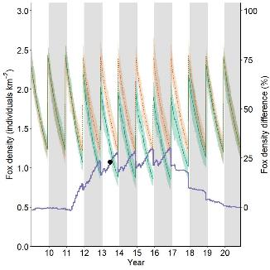The fox density was not reduced by >50% by year 13 in any area within the AoCI.

**Figure 18. The modelled fox densities for the Murray Scroll Belt—baited (green) and unbaited (pale red). Colour-shaded areas are modelled minimum and maximum values across all iterations. The purple line shows the percentage difference between the fox densities with and without baiting within the AoCI. The dot indicates the point in time when model outcomes were reported. Monthly baiting began in year 11; it finished in year 16.**

**Alternative scenarios**

This project was also modelled with an alternative scenario that maintained the spatial network of bait stations, but increased baiting to fortnightly throughout the year.

This alternative scenario showed an overall reduction in fox density of 35% over the AoCI (Figure 19). Fox densities with baiting differed significantly from fox densities without baiting by September in year 11. Following the cessation of baiting, fox densities returned to levels that did not differ from the unbaited scenario by September in year 18. A small area achieved a reduction in fox density of 50–65% in areas of high bait density (Figure 20).

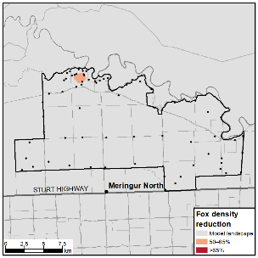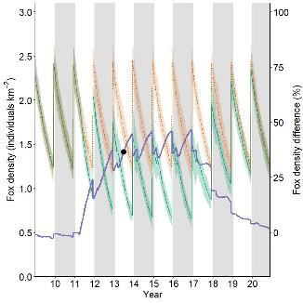**Figure 19. The modelled fox densities for the alternative model—baited (green) and unbaited (pale red). Colour-shaded areas are modelled minimum and maximum values across all iterations. The purple line shows the percentage difference between the fox densities with and without baiting within the AoCI. The dot indicates the point in time when model outcomes were reported. Fortnightly baiting commenced in model year 11; it finished in year 16.**

**Figure 20. The spatial reduction in modelled fox densities for the alternative model. The dot in Figure 19 indicates the point in time when model outcomes, shown here, were reported.**

**Results summary**

Neither the current modelled baiting strategy nor the modelled alternative were able to achieve a reduction in fox density to maintain population level control (Table 5). The relatively sparse spatial arrangement of baits is a factor that could be explored further, along with fox home-range sizes in this environment.

The alternative strategy investigated here would come with the additional costs associated with an extra 14 bait runs throughout the year [12 runs currently vs 26 proposed runs per year (fortnightly)].

**Table 5. The mean and percentage reduction in modelled fox densities for all BRP051 management scenarios.**

|  |  |  |  |
| --- | --- | --- | --- |
| Baiting program | Baiting strategy | Foxes per km2: mean (min–max) | Percentage reduction |
| Original program | Monthly network baiting | 1.32 (1.13–1.49) | 22% |
| Alternative scenario | Fortnightly network baiting | 1.11 (0.96–1.34) | 35% |

**Fox control operation**

This fox control operation is part of BRP052, Restoration and protection of Wyperfeld National Park and Patchewollock State Forest. Fox control is undertaken at Patchewollock State Forest as a single-pulse baiting program around the perimeter in the north-west of Victoria (Figure 21). The project aims to protect the Malleefowl (*Leipoa ocellata*) within the Patchewollock State Forest.

Baiting is completed weekly during a single 4-week pulse in April to coincide with other private (agricultural) baiting targeting fox dispersal.

|  |  |
| --- | --- |
| 3.5 Patchewollock State Forest |  |

**FoxNet modelling**

FoxNet was run for 10 years with no baiting, to stabilise the fox population. Baiting began in year 11. Baiting was undertaken weekly in April (model weeks 14–17) and finished in model year 16. The AoCI (138 km2) was defined as the extent of the Patchewollock State Forest.

**Figure 21. The baiting layout for Patchewollock State Forest, as modelled in FoxNet, showing project bait station locations, alternative baiting layout, FoxNet area of conservation interest (AoCI), model extent, and locality of project.**

**Results**

FoxNet modelling showed an overall reduction in fox density of approximately 15% by June in year 13 (Figure 22). However, stochastic variation in changes to fox density meant that fox densities with baiting did not differ from fox densities without baiting at any stage.

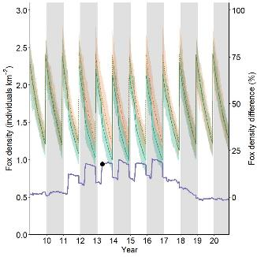**Figure 22. The modelled fox densities for Patchewollock State Forest—baited (green) and unbaited (pale red). Colour-shaded areas are modelled minimum and maximum values across all iterations. The purple line shows the percentage difference between the fox densities with and without baiting within the AoCI. The dot indicates the point in time when model outcomes were reported. Weekly baiting was undertaken in April each year; it finished in year 16.**

The fox density was not reduced by >50% by year 13 in any area within the AoCI.

**Alternative scenarios**

This project was also modelled with two alternative scenarios investigating different temporal scales and spatial layouts.

**Scenario 1**. This alternative model maintained the linear spatial layout, but increased baiting to fortnightly replacement continued throughout the year. This alternative temporal scale scenario showed a maximum reduction in fox density of 45% in April in year 13 (Figure 23). Fox densities with baiting differed significantly from fox densities without baiting by the end of April in year 11. Following the cessation of baiting, fox densities returned to levels that did not differ from the unbaited scenario by October in year 18.

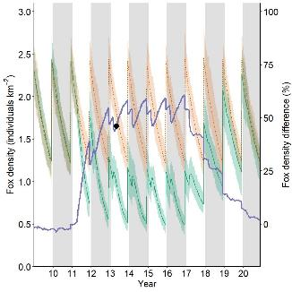**Figure 23. The modelled fox densities for the first alternative scenario for Patchewollock State Forest—baited (green) and unbaited (pale red). Colour-shaded areas are modelled minimum and maximum values across all iterations. The purple line shows the percentage difference between the fox densities with and without baiting within the AoCI. The dot indicates the point in time when model outcomes were reported. Fortnightly baiting began in year 11; it finished in year 16.**

Under scenario 1, there was no spatial coverage of reduced fox densities of >50%.

**Scenario 2**. This alternative model was run with a network of bait stations on open internal roads and tracks, spaced approximately 1 km apart, with baits replaced fortnightly throughout the year.

This model showed an overall reduction in fox density of 53% (Figure 24). Fox densities with baiting differed significantly from fox densities without baiting by July in year 11. Following the cessation of baiting, fox densities returned to levels that did not differ from the unbaited scenario by August in year 18.

Under scenario 2, a small area within the AoCI had the fox density reduced by >50% by April in year 13 (Figure 25).

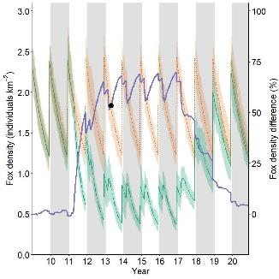**Figure 24. The modelled fox densities for the second alternative scenario for Patchewollock State Forest—baited (green) and unbaited (pale red). Colour-shaded areas are modelled minimum and maximum values across all iterations. The purple line shows the percentage difference between the fox densities with and without baiting within the AoCI. The dot indicates the point in time when model outcomes were reported. Fortnightly baiting on a network of tracks began in year 11; it finished in year 16.**

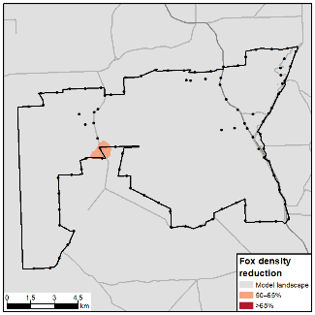

**Figure 25. The spatial reduction in modelled fox densities for the second alternative scenario for Patchewollock State Forest. The dot in Figure 24 indicates the point in time when model outcomes, shown here, were reported.Results summary**

There are potential improvements in the proposed baiting regime; however, the proponent acknowledges the lack of internal tracks at this site. The alternative scenarios of fortnightly baiting each year increased fox density reductions by a further 27% and 35%, respectively, compared with the current management strategy (Table 6). The alternative scenarios would come with the additional costs associated with an extra 22 bait runs throughout the year [4 runs per year currently vs 26 runs per year (fortnightly)].

**Table 6. The mean and percentage reduction in modelled fox densities for all Patchewollock State Forest management scenarios.**

|  |  |  |  |
| --- | --- | --- | --- |
| Baiting program | Baiting strategy | Foxes per km2: mean (min–max) | Percentage reduction |
| Original program | Perimeter pulse baiting | 1.57 (1.25–1.86) | 15% |
| First alternative | Perimeter fortnightly baiting | 1.02 (0.87–1.26) | 45% |
| Second alternative | Network fortnightly baiting | 0.86 (0.64–1.13) | 53% |

**Fox control operation**

This baiting operation is part of BRP071, Lower Avoca Plains, and is a year-round monthly fox baiting program across a network of roads and tracks on private land in the north-west of Victoria (Figure 26). Baits are spaced on average 472 m apart (range 111–1321 m). The project aims to protect the Eastern Hooded Scaly-foot (*Pygopus schraderi*), the Fat-tailed Dunnart (*Sminthopsis crassicaudata*) and the woodland bird community.

**FoxNet modelling**

|  |
| --- |
| 3.6 Lower Avoca Plains |

FoxNet was run for 10 years with no baiting, to stabilise the fox population. Baiting began in year 11. Baiting was undertaken monthly year-round and finished in model year 16. The area of conservation interest (AoCI) (28 km2) was identified as the extent of occurrence of bait stations within the landscape.

Figure 26. The baiting layout for Lower Avoca Plains, as modelled in FoxNet, showing project bait station locations, FoxNet area of conservation interest (AoCI), model extent, and locality of project.

**Results**

FoxNet modelling showed an overall reduction in fox density of 45% by year 13 (Figure 27). Fox densities with baiting differed significantly from fox densities without baiting by May in year 12. Following the cessation of baiting, fox densities returned to levels that did not differ from the unbaited scenario by June in year 17.

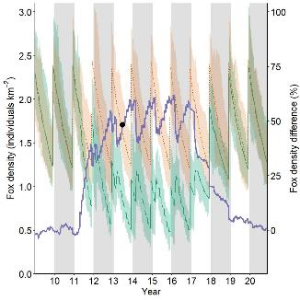Figure 27. The modelled fox densities for the Lower Avoca Plains—baited (green) and unbaited (pale red). Colour-shaded areas are modelled minimum and maximum values across all iterations. The purple line shows the percentage difference between the fox densities with and without baiting within the AoCI. The dot indicates the point in time when model outcomes were reported. Monthly baiting commenced in model year 11 as per project description; it finished in year 16.

The fox density was not reduced by >50% by year 13 in any area within the AoCI.

**Alternative scenario**

This project was also modelled with an alternative scenario that maintained the spatial network of bait stations but increased baiting to fortnightly throughout the year. Fox densities with baiting differed significantly from fox densities without baiting by August in year 11. Following the cessation of baiting, fox densities returned to levels that did not differ from the unbaited scenario by November in year 17. This alternative scenario did achieve a reduction in fox density of >50% (Figure 28); however, this was only over a small section of the AoCI (Figure 29).

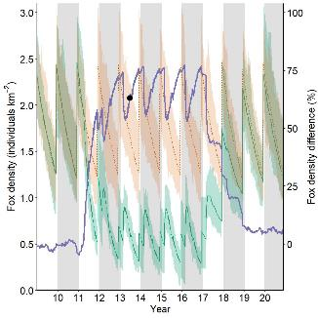Figure 28. The modelled fox densities for the alternative scenario for Lower Avoca Plains—baited (green) and unbaited (pale red). Colour-shaded areas are modelled minimum and maximum values across all iterations. The purple line shows the percentage difference between the fox densities with and without baiting within the AoCI. The dot indicates the point in time when model outcomes were reported. Fortnightly baiting commenced in model year 11 as per the project spatial description; it finished in year 16.

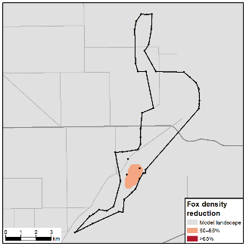

Figure 29. The spatial reduction in modelled fox densities for the alternative scenario for the Lower Avoca Plains. The dot in Figure 28 indicates the point in time when model outcomes, shown here, were reported.

**Results summary**

Neither the current modelled baiting strategy nor the modelled alternative were able to achieve enough reduction in fox density to maintain population-level control (Table 7).

The alternative strategy investigated here would come with the additional costs associated with an extra 14 bait runs throughout the year [12 runs per year currently vs 26 runs per year (fortnightly)].

Table 7. The mean and percentage reduction in modelled fox densities for all Lower Avoca Plains management scenarios.

|  |  |  |  |
| --- | --- | --- | --- |
| Baiting program | Baiting strategy | Foxes per km2: mean (min–max) | Percentage reduction |
| Original program | Monthly network baiting | 0.92 (0.63–1.42) | 45% |
| Alternative scenario | Fortnightly network baiting | 0.68 (0.47–0.88) | 60% |

|  |
| --- |
| 3.7 Patho Plains |

**Fox control operation**

This baiting operation is part of BRP072, Protecting Patho Plains, and is a year-round monthly fox baiting program across a network of roads and tracks on private land in the mid-north of Victoria (Figure 30). Baits are spaced on average 793 m apart (range 261–1578 m). The project aims to protect the Bush Stone-curlew (*Burhinus grallarius*), the Brolga (*Grus rubicunda*) and the Fat-tailed Dunnart (*Sminthopsis crassicaudata*).

**FoxNet modelling**

FoxNet was run for 10 years with no baiting, to stabilise the fox population. Baiting began in year 11. Baiting was modelled monthly year-round and finished in model year 16.

The AoCI (54 km2) was identified as the extent of occurrence of bait stations within the landscape.

Figure 30. The baiting layout for the Patho Plains, as modelled in FoxNet, showing project bait station locations, FoxNet area of conservation interest (AoCI), model extent, and locality of project.

Results

FoxNet modelling showed an overall reduction in fox density of 41% by year 13 (Figure 31). Fox densities with baiting differed significantly from fox densities without baiting by February in year 12. Following the cessation of baiting, fox densities returned to levels that did not differ from the unbaited scenario by November in year 17.

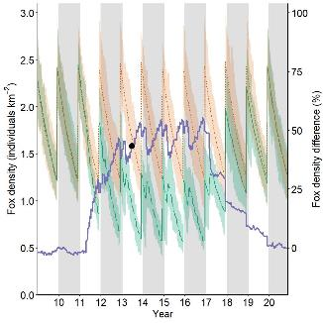Figure 31. The modelled fox densities for the Patho Plains—baited (green) and unbaited (pale red). Colour-shaded areas are modelled minimum and maximum values across all iterations. The purple line shows the percentage difference between the fox densities with and without baiting within the AoCI. The dot indicates the point in time when model outcomes were reported. Baiting commenced in model year 11 as per project description; it finished in year 16.

The fox density was not reduced by >50% by year 13 in any area within the AoCI, or at any time during the fox baiting operation.

Alternative scenario

This project was also modelled with baiting conducted fortnightly throughout the year and maintaining the spatial network of bait stations. Fox densities with baiting differed significantly from fox densities without baiting by September in year 11. Following the cessation of baiting, fox densities returned to levels that did not differ from the unbaited scenario by February in year 18. This alternative temporal scale scenario achieved an overall reduction in fox density of 56% (Figure 32); however, no specific area was predicted to have a 50–65% reduction. This is possibly due to the AoCI being too small to maintain stable home ranges entirely within its perimeter. When these variable home range locations are averaged, the impact of the baiting is diluted due to the instability between model iterations.

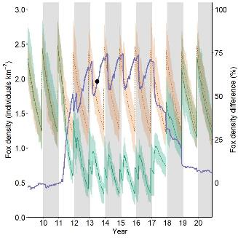Figure 32. The modelled fox densities for the alternative scenario for the Patho Plains—baited (green) and unbaited (pale red). Colour-shaded areas are modelled minimum and maximum values across all iterations. The purple line shows the percentage difference between the fox densities with and without baiting within the AoCI. The dot indicates the point in time when model outcomes were reported. Fortnightly baiting commenced in model year 11 as per project spatial description; it finished in year 16.

Results summary

Neither the modelled current management strategy nor the modelled alternative strategy resulted in a reduction in fox density of >65%. While the alternative of increasing baiting to fortnightly year-round did have a positive effect, it still was not enough to achieve the level needed to stop fox population growth (Table 8).

Table 8. The mean and percentage reduction in modelled fox densities for all Patho Plains management scenarios.

|  |  |  |  |
| --- | --- | --- | --- |
| Baiting program | Baiting strategy | Foxes per km2: mean (min–max) | Percentage reduction |
| Original program | Monthly network baiting | 1.02 (0.74–1.24) | 41% |
| Alternative scenario | Fortnightly network baiting | 0.75 (0.55–0.98) | 56% |

|  |  |
| --- | --- |
| |  | | --- | | 3.8 Wilsons Promontory National Park | |

**Fox control operation**

Project BRP082, Managing immigration of foxes into Wilsons Promontory National Park, is a year-round intense fox baiting program across a network of roads and tracks within the isthmus of the Park (Figure 33). Baits are checked weekly and replaced if taken, and all baits are replaced fortnightly. Baits are spaced on average 620 m apart (range 248–1326 m). The project aims to protect critical weight range mammals, including the Long-nosed Potoroo (*Potorous tridactylus tridactylus*), the Southern Brown Bandicoot (*Isoodon obesulus obesulus*), the New Holland Mouse (*Pseudomys novaehollandiae*), and beach nesting birds, including Hooded Plovers (*Thinornis cucullatus cucullatus*).**FoxNet modelling**

FoxNet was run for 10 years with no baiting, to stabilise the fox population. Baiting began in year 11. Baiting was undertaken weekly year-round and finished in model year 16. Although all baits were replaced fortnightly, baits that had been taken as at the weekly check were replaced, and this was interpreted as a weekly baiting regime for modelling purposes. Adjacent pulse baiting completed within Wilsons Promontory National Park by the proponent was also incorporated into the modelling.

Figure 33. The baiting layout for Wilsons Promontory National Park, as modelled in FoxNet, showing project and adjacent bait station locations, FoxNet area of conservation interest (AoCI), and locality of project.

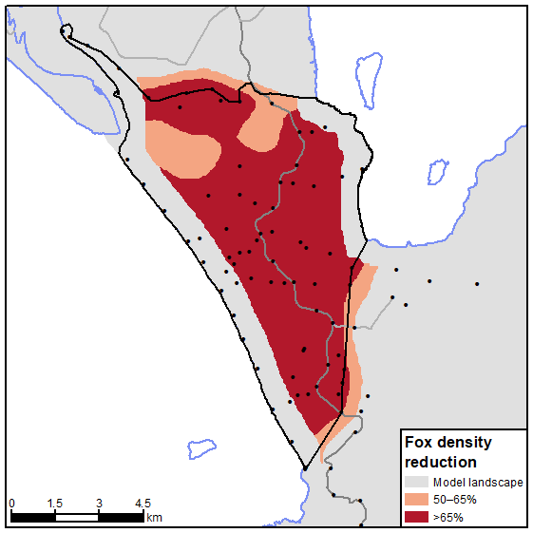The AoCI (65 km2) was identified as the extent of occurrence of BRP bait stations within the national park, bounded by the park boundaries on the northern edge.

Results

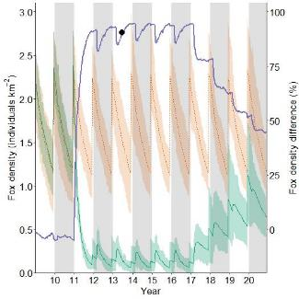FoxNet modelling showed a reduction in fox density of 89% by year 13 (Figure 34). Fox densities with baiting differed significantly from fox densities without baiting by February in year 11. Following the cessation of baiting, fox densities returned to levels that did not differ from the unbaited scenario by November in year 20.

Figure 34. The modelled fox densities for Wilsons Promontory National Park—baited (green) and unbaited (pale red). Colour-shaded areas are modelled minimum and maximum values across all iterations. The purple line shows the percentage difference between the fox densities with and without baiting within the AoCI. The dot indicates the point in time when model outcomes were reported. Weekly baiting commenced in model year 11 as per project description; it finished in year 16.

Fox density was reduced by >65% over 64% of the AoCI by June in year 13 (Figure 35). FoxNet is unable to predict density close to uninhabitable areas (e.g. ocean); in addition, the spatial averaging buffered the ocean by approximately 600 m, so this is most likely an underestimation of the area of 65% reductions.

Figure 35. The spatial reduction in modelled fox densities for Wilsons Promontory National Park. The dot in Figure 34 indicates the point in time when model outcomes, shown here, were reported.

Results summary

This program’s high bait density and intensive continuous baiting regime resulted in high fox density reductions (Table 9). Alternative modelling investigations may be able to provide insight into different temporal regimes that may reduce the overall yearly cost of the program but deliver the same results (e.g. investigate a combination of weekly, fortnightly and monthly baiting that delivers the same result).

Table 9. The mean and percentage reduction in modelled fox densities for the Wilsons Promontory National Park management scenario.

|  |  |  |  |
| --- | --- | --- | --- |
| Baiting program | Baiting strategy | Foxes per km2: mean (min–max) | Percentage reduction |
| Original program | Weekly network baiting | 0.17 (0.05–0.29) | 89% |

**Fox control operation**

The Little Desert National Park baiting operation is part of BRP111, Western Victorian woodlands, and is a large fox baiting program undertaken across a network of roads and tracks within Little Desert National Park (Figure 36). There are different temporal scales of baiting within the project. The eastern block is baited fortnightly year-round, and the central block (western section) is baited in three 9-week pulses (in autumn, late winter, and late spring). BRP111 adds to this program with an overlapping area in the centre of the AoCI (Cooack Intensify), which has a single 9-week pulse coinciding with the autumn pulse of the central block. Baits are checked fortnightly during each pulse. Private land baiting (BRP097) adjacent to Little Desert National Park was undertaken to complement the baiting within the park. BPR111 aims to protect the Silky Mouse (*Pseudomys apodemoides*), the Western Pygmy Possum (*Cercartetus concinnus*), the Little Pygmy Possum (*Cercartetus lepidus*), the Bardick (*Echiopsis curta*) and the Striped Worm Lizard (*Aprasia striolata*).

|  |
| --- |
| 3.9 Little Desert National Park |

Figure 36. The project baiting layout for the Little Desert National Park as modelled in FoxNet, showing project and adjacent bait station locations, FoxNet AoCI , model extent, and locality of project. Bait stations outside the region of interest are only modelled in alternative scenarios.

**FoxNet modelling**

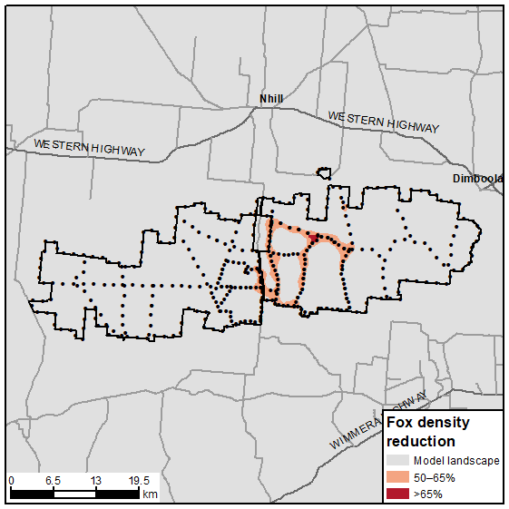FoxNet was run for 10 years with no baiting, to stabilise the fox population. Baiting began in year 11. Baiting was undertaken fortnightly year-round for the eastern block. The three pulses in the central block were undertaken fortnightly during autumn (weeks 18–24), late winter (weeks 32–38) and late spring (weeks 40–46). Cooack Intensify was baited concurrently with the autumn pulse (weeks 18–24). All baiting finished in model year 16

The AoCI (950 km2) was identified as the extent within the national park boundaries.

Results

FoxNet modelling of the entire baiting program resulted in a reduction in fox density of 51% by year 13 (Figure 37). Fox densities with baiting differed significantly from unbaited fox densities by April in year 11. Following the cessation of baiting in year 16, fox densities returned to levels that did not differ from the unbaited scenario by year 20.

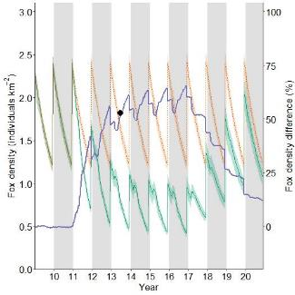Figure 37. The modelled fox densities for Little Desert National Park—baited (green) and unbaited (pale red). Baiting commenced in model year 11 as per project description; it finished in year 16. The annual population peaks show the effect of each year’s cub cohort entering the population. The purple line shows the percentage difference between the fox densities with and without baiting within the AoCI. The dot indicates the point in time when model outcomes were reported. Colour-shaded areas are modelled minimum and maximum values across all iterations.

However, modelled spatial reduction estimates of >65% taken in June in model year 13 were only achieved in one small area of high bait density in the eastern block within the Cooack Intensify section (<1% of the AoCI) (Figure 38). The Cooack Intensify section in the centre of the project did generate reductions of 50–65%.

Figure 38. The spatial reduction in modelled fox densities for Little Desert National Park. The dot in Figure 37 indicates the point in time when model outcomes, shown here, were reported.

Alternative scenario

This project was also modelled with two alternative scenarios investigating the benefits of the adjacent baiting to the program (BRP097), and with an alternative temporal scale for each program.

**Scenario 1**. This scenario maintained the spatial layout and temporal scales of baiting across blocks, and added the adjacent baiting undertaken as part of BRP097 according to its project description.

This scenario showed an overall reduction in fox density of 53% by year 13 (Figure 39). Fox densities with baiting differed significantly from fox densities without baiting by May in year 11. Following the cessation of baiting, fox densities returned towards levels that did not differ from the unbaited scenario, but were still significantly different at the end of the modelling period in year 20.

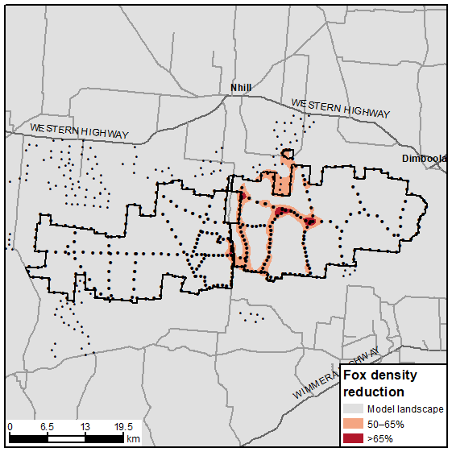Modelled spatial reduction estimates of >65% taken in June in model year 13 were achieved in small areas of high bait density in the eastern block, and near adjacent BRP097 baiting (<1% of the AoCI) (Figure 40). The Cooack intensify section in the centre of the project did generate reductions of 50–65%. The adjacent BRP097 baiting program appeared to complement this program in a small section adjacent to the central-north part of the eastern block.

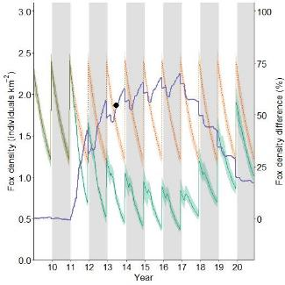Figure 39. The modelled fox densities under the alternative scenario 1—baited (green) and unbaited (pale red). Baiting commenced in model year 11 as per project spatial description with adajcent BRP097 baiting; it finished in year 16. Annual population peaks show the effect of each year’s cub cohort entering the population. The purple line shows the percentage difference between the fox densities with and without baiting within the AoCI. The dot indicates the point in time when model outcomes were reported. Colour-shaded areas are modelled minimum and maximum values across all iterations.

**Scenario 2**. This scenario maintained the spatial networks of bait stations for both projects, but increased baiting to fortnightly throughout the year for both BRP111 and the adjacent BRP097.

This alternative temporal scale scenario showed an overall reduction in fox density of 68% over the AoCI (Figure 41). Fox densities with baiting differed significantly from fox densities without baiting by January in year 11. Following the cessation of baiting, fox densities returned towards levels that did not differ from the unbaited scenario, but were still significantly different at the end of the modelling period in year 20.

Figure 40. The spatial reduction in modelled fox densities for Little Desert National Park scenario 1. The dot in Figure 39 indicates the point in time when model outcomes, shown here, were reported.

Modelled fox density spatial reduction estimates taken in June in model year 20 showed an area of 17% of the size of the AoCI had areas of >65% reduction across most areas of bait deployment (for both BRP111 and BRP097) (Figure 42).

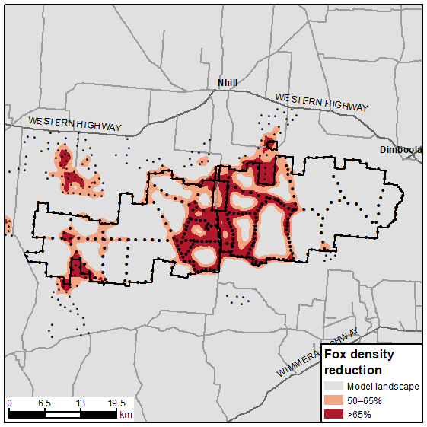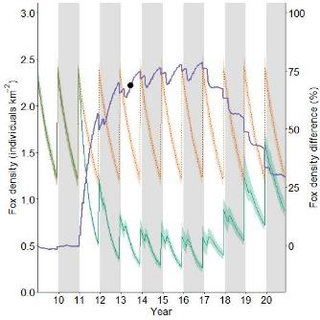Figure 41. The modelled fox densities under the alternative scenario 2—baited (green) and unbaited (pale red). Fortnightly baiting commenced in model year 11 as per project spatial description; it finished in year 16. Annual population peaks show the effect of each year’s cub cohort entering the population. The purple line shows the percentage difference between the fox densities with and without baiting within the AoCI. The dot indicates the point in time when model outcomes were reported. Colour-shaded areas are modelled minimum and maximum values across all iterations.

Figure 42. The spatial reduction in modelled fox densities for scenario 2 for Little Desert National Park. The dot in Figure 41 indicates the point in time when model outcomes, shown here, were reported.Results summary

Despite the model indicating the project could achieve a relatively large overall reduction in fox density, the areas of high reduction were limited to high bait density areas in the eastern block. This did however indicate a relatively high fox reduction across the reserve. The alternative scenario increased fox density reduction by a further 2%, and areas of high fox density reductions were extended towards the edges and into adjacent baiting areas. The second alternative scenario increased fox density reduction by 17% from the original scenario (Table 10), with large areas of high fox density reductions (Figure 42). The interesting result from the second alternative scenario was the apparent benefit of landscape-scale continuous baiting. This was apparent in the eastern block, where in all scenarios baiting was fortnightly. However, only when there was continuous additional baiting across the program were reductions in fox densities of >65% observed across the block. These reductions appeared to be on a gradual decline the further they were away from the higher bait densities in the centre of the program.

The additional reductions achieved by the alternative scenario would come with the additional costs associated with an extra 14 bait runs per year throughout the year [12 runs per year currently vs 26 runs per year (fortnightly)] for the central block, and an extra 22 runs for the Cooack Intensify section.

Table 10. The mean and percentage reduction in modelled fox densities for all Little Desert National Park management scenarios.

|  |  |  |  |
| --- | --- | --- | --- |
| Baiting program | Baiting strategy | Foxes per km2: mean (min–max) | Percentage reduction |
| Original program | Various temporal scale network baiting | 0.82 (0.71–0.94) | 55% |
| First alternative scenario | Various temporal scale network baiting (adjacent baiting included) | 0.78 (0.68–0.92) | 59% |
| Second alternative scenario | Fortnightly network baiting (adjacent baiting included) | 0.54 (0.47–0.62) | 76% |

**Fox control operation**

The BRP097 fox control project is part of the *Little* Desert landscape-scale enhancement initiative. The operation is a dual-pulse fox baiting program undertaken across a network of private land in the central-west region of Victoria (Figure 43). It is intended that baits are checked fortnightly during each 10–12-week pulse (Feb–April, Sept–Nov). The program aims to complement the adjacent fox control program within Little Desert National Park.

**FoxNet modelling**

|  |
| --- |
| 3.10 Little Desert Expansion |

FoxNet was run for 10 years with no baiting, to stabilise the fox population. Baiting began in year 11. Baiting was undertaken fortnightly during Feb–Apr (weeks 6–16) and Sept–Nov weeks (weeks 36–46) and finished in model year 16. Adjacent baiting undertaken as part of BRP111 was also included according to its project description.

The AoCI (672 km2) was identified as the extent of occurrence of bait stations within the landscape, bounded by park boundaries where applicable.

Figure 43. The baiting layout for the Little Desert (expansion), as modelled in FoxNet, showing project and adjacent bait station locations, FoxNet area of conservation interest (AoCI), model extent, and locality of project.

**Results**

Fox densities with baiting differed significantly from fox densities without baiting by March in year 11. Following the cessation of baiting, fox densities returned towards levels that did not differ from the unbaited scenario by September in year 20. FoxNet modelling showed the project achieved a reduction in fox density of 51% by year 13 (Figure 44).

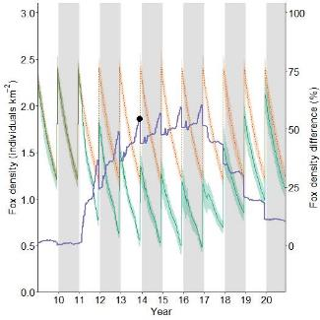Figure 44. The modelled fox densities for the Little Desert (expansion)—baited (green) and unbaited (pale red). Baiting commenced in model year 11 as per project description; it finished in year 16. Annual population peaks show the effect of each year’s cub cohort entering the population. Colour-shaded areas are modelled minimum and maximum values across all iterations. The purple line shows the percentage difference between the fox densities with and without baiting within the AoCI. The dot indicates the point in time when model outcomes were reported.

An area equivalent to 6% of the AoCI had >65% reduction in November in year 13 (Figure 45; see results for BRP111 for details of results obtained within the adjacent Little Desert National Park).

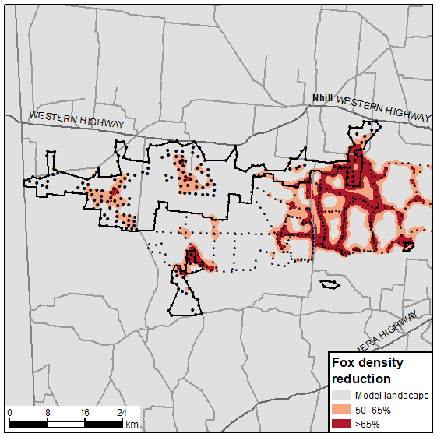Figure 45. The spatial reduction in modelled fox densities for Little Desert (expansion). The dot in Figure 44 indicates the point in time when model outcomes, shown here, were reported.

Alternative scenario

This project was also modelled with an alternative scenario investigating a different temporal scale that maintained the spatial network of bait stations. Baiting was conducted fortnightly throughout the year, for both BRP097 and the adjacent BRP111.

This alternative temporal scale scenario showed an overall reduction in fox density of 72% over the AoCI (Figure 46). Fox densities with baiting differed significantly from unbaited fox densities at the commencement of baiting from February in year 11. Following the cessation of baiting, fox densities slowly returned towards unbaited densities, but were still significantly different at the end of the modelling period in year 20.

An area equivalent to 43% of the AoCI had >65% reduction in modelled fox density in November of the alternative model year 13 (Figure 47).

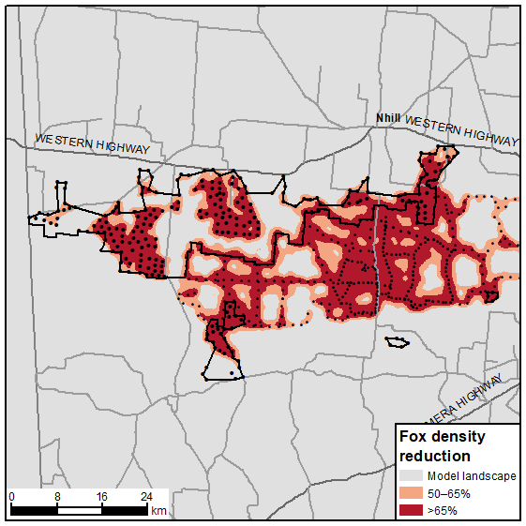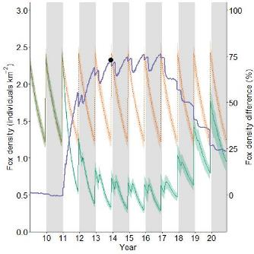Figure 46. The modelled fox densities for the alternative scenario for Little Desert (expansion)—baited (green) and unbaited (pale red). Fortnightly baiting commenced in model year 11 as per project spatial description; it finished in year 16. Annual population peaks show the effect of each year’s cub cohort entering the population. Colour-shaded areas are modelled minimum and maximum values across all iterations. The purple line shows the percentage difference between the fox densities with and without baiting within the AoCI. The dot indicates the point in time when model outcomes were reported.

Results summary

The current baiting strategy resulted in some patchy spatial coverage of reductions of >65%, even when the adjacent BRP111 Little Desert project was included. The alternative strategy of baiting fortnightly in both projects increased fox density reduction by a further 21% and increased the coverage by 37% (Table 11).

The alternative scenario would come with the additional costs associated with an extra 14 bait runs throughout the year [12 runs per year currently vs 26 runs per year (fortnightly)], which may not be a feasible undertaking for private landowners.

Table 11. The mean and percentage reduction in modelled fox densities for all Little Desert (expansion) management scenarios.

|  |  |  |  |
| --- | --- | --- | --- |
| Baiting program | Baiting strategy | Foxes per km2: mean (min–max) | Percentage reduction |
| Original program | Network pulsed baiting | 0.65 (0.49–0.83) | 51% |
| Alternative scenario | Network fortnightly baiting | 0.38 (0.29–0.48) | 72% |

Figure 47. The spatial reduction in modelled fox densities for Little Desert (expansion) scenario 1. The dot in Figure 46 indicates the point in time when model outcomes, shown here, were reported.

**Fox control operation**

The Glenelg Ark is an ongoing, year-round fox baiting program across a network of roads and tracks within public land in the south-west coastal region of Victoria (Figure 48). Baiting occurs every fortnight. Baits are spaced on average 764 m apart (range 111–1840 m).

**FoxNet modelling**

|  |
| --- |
| 3.11 Glenelg Ark |

FoxNet was run for 10 years with no baiting, to stabilise the fox population. Baiting began in year 11. Baiting was undertaken fortnightly year-round.

The AoCI (871 km2) was identified as the extent of public land within which baiting occurs.

Figure 48. The Glenelg Ark baiting layout as modelled in FoxNet; showing project bait station locations, FoxNet area of interest (AoCI), model extent, and locality of project.

**Results**

FoxNet modelling showed a reduction in fox density of 73% by year 20 (Figure 49). Fox densities with baiting became significantly different from fox densities without baiting from April in year 11.

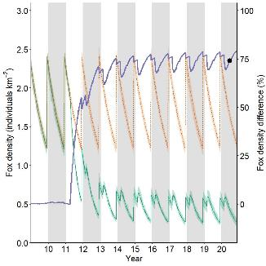Figure 49. The modelled fox densities for the Glenelg Ark program—baited (green) and unbaited (pale red). Fortnightly baiting commenced in model year 11 as per project description, and ran for the duration of the model. Annual population peaks show the effect of each year’s cub cohort entering the population. Colour-shaded areas are modelled minimum and maximum values across all iterations. The purple line shows the percentage difference between the fox densities with and without baiting within the AoCI. The dot indicates the point in time when model outcomes were reported.

Fox density was reduced by >65% over 43% of the AoCI by June in year 20 (Figure 50).

**Results summary**

The Glenelg Ark program’s high bait density and continuous fortnightly baiting regime are contributing factors to the high fox density reductions where baiting occurs. The high levels of reduction predicted at the smaller public land blocks to the east and south undoubtedly received benefits from the larger central block baiting effort (Table 12).

**Error! Reference source not found.**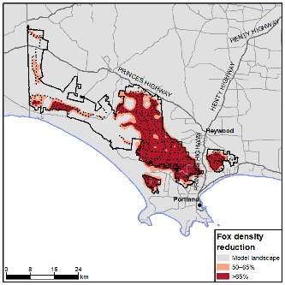

**Figure 50. Spatial reduction in modelled fox densities for the Glenelg Ark program. The dot in Figure 49 indicates the point in time when model outcomes, shown here, were reported.**

**Table 12. Mean and percentage reduction in modelled fox density for the Glenelg Ark management scenario.**

|  |  |  |  |
| --- | --- | --- | --- |
| Baiting program | Baiting strategy | Mean foxes per km2 (min–max) | Percentage reduction |
| Ark program | Fortnightly, network baiting | 0.46 (0.38–0.54) | 73% |

**Fox control operation**

The Grampians Ark is an ongoing, year-round fox baiting program across a network of roads and tracks in the central-west region of Victoria (Figure 51). Baiting within public land occurs fortnightly year-round. Baits are spaced on average 782 m apart (range 22–1286 m). Private land baiting in the south delivered by a Landcare group occurs approximately weekly in three 8-week pulses throughout the year (Feb–Apr, Jun–Aug, Sept–Nov). Private land baits are spaced on average 826 m apart (range 328–1463 m).

|  |
| --- |
| 3.12 Grampians Ark |

**FoxNet modelling**

FoxNet was run for 10 years with no baiting, to stabilise the fox population. Baiting began in year 11. Baiting was undertaken fortnightly year-round on public land. The private land baiting occurred in three 8-week pulses, during Feb–Apr (weeks 6–13), Jun–Aug (weeks 23–30) and Sept–Nov (weeks 36–43).

The AoCI (2697 km2) was bounded by public land boundaries and the extent of the private land baiting.

**Figure 51. The Grampians Ark baiting layout as modelled in FoxNet, showing project bait station locations, FoxNet area of interest (AoCI), model extent, and locality of project.**

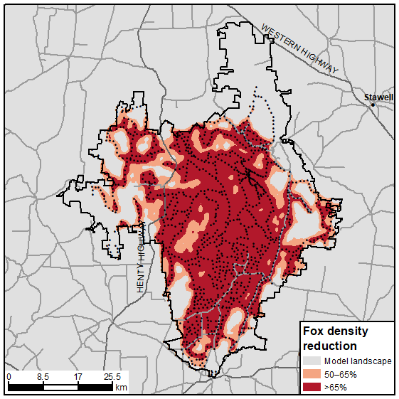**Results**

FoxNet modelling showed an overall reduction in fox density of 74% by year 20 (Figure 52). Fox densities with baiting became significantly different from fox densities without baiting February in year 11.

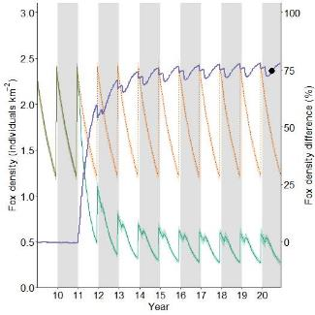**Figure 52. The modelled fox densities for the Grampians Ark program—baited (green) and unbaited (pale red). Baiting commenced in model year 11 as per project description, and ran for the duration of the model. Annual population peaks show the effect of each year’s cub cohort entering the population. Colour-shaded areas are modelled minimum and maximum values across all iterations. The purple line shows the percentage difference between the fox densities with and without baiting within the AoCI. The dot indicates the point in time when model outcomes were reported.**

Fox density was reduced by >65% over 49% of the AoCI by June in year 20 (Figure 53).

* 1. **Results summary**

The Grampians Ark program’s high bait density, continuous fortnightly baiting regime, and adjacent private baiting are contributing factors to the high fox density reductions where baiting occurs (Table 13). Alternative modelling investigations may be able to provide insight into different temporal regimes that may reduce the overall yearly cost of the program, but deliver the same results (e.g. investigate a combination of fortnightly and monthly baiting).**Figure 53. The spatial reduction in modelled fox densities for the Grampians Ark program. The dot in Figure 52 indicates the point in time when model outcomes, shown here, were reported.**

**Table 13. The mean and percentage reduction in modelled fox density for the Grampians Ark management scenario.**

|  |  |  |  |
| --- | --- | --- | --- |
| Baiting program | Baiting strategy | Mean foxes per km2 (min–max) | Percentage reduction |
| Ark program | Fortnightly, network baiting | 0.44 (0.38–0.49) | 74% |

|  |  |
| --- | --- |
| 3.13 Otway Ark |  |

**Fox control operation**

The Otway Ark is a year-round fox baiting program on Parks Victoria estate delivered across a network of roads and tracks in the south-west coastal region of Victoria (Figure 54). Baits are replaced monthly across the entire operations area. In 2019, the program increased its baiting program to include private land and state forest along the northern edge (Extension bait stations).

**FoxNet modelling**

FoxNet was run for 10 years over the model landscape with no baiting, to stabilise the fox population. Baiting began in the AoCI in year 11. Baiting was undertaken every 4 weeks across the Parks Victoria estate. The AoCI (1500 km2) was defined as the extent of the bait stations, buffered by 1 km.

Figure 54. The Otway Ark baiting layout as modelled in FoxNet, showing project bait station locations, FoxNet area of interest (AoCI), model extent, and locality of project. FoxNet modelled fox populations across the area shown in the model extent (excluding ocean). Dots: Otway Ark bait stations; triangles: extension bait stations.

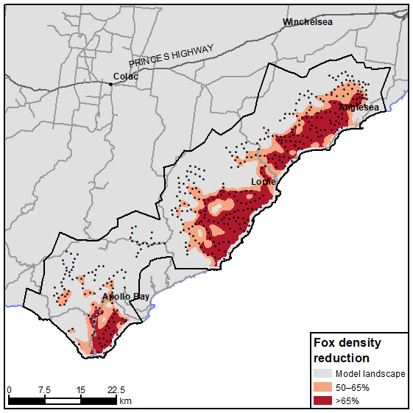**Results**

FoxNet modelling predicted an overall reduction in fox density of approximately 61% by year 20 (Figure 55). Fox densities with baiting became significantly different from fox densities without baiting, after the commencement of baiting in March in year 11.

The modelled fox density was reduced by >65% over 17% of the AoCI by June in year 20 (Figure 56).

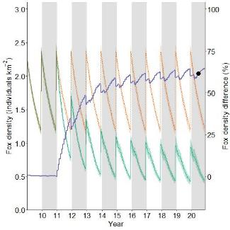Figure 55. The modelled fox densities for the Otway Ark core baiting program—baited (green) and unbaited (pale red). Colour-shaded areas are modelled minimum and maximum values across all iterations. Monthly baiting commenced in model year 11, and ran for the duration of the model. The purple line shows the percentage difference between the fox densities with and without baiting within the AoCI. The dot indicates the point in time when model outcomes were reported.

Figure 56. The spatial reduction in modelled fox densities for the Otway Ark program. The dot in Figure 55 indicates the point in time when model outcomes, shown here, were reported.

**Alternative scenario**

**Scenario 1**. This model maintained the existing baiting regime and added extensions to the baiting as proposed for 2019. Extensions to the program were initially baited weekly for the first month, before synchronising with the 4-weekly baiting of the rest of the program. This scenario showed an overall reduction in fox density of approximately 68% over the AoCI by year 20 (Figure 57) (versus 61% reduction without extensions). Fox densities with baiting became significantly different from unbaited fox densities after the commencement of baiting in March in year 11.

Modelled fox density was reduced by >65% over 26% of the AoCI by June in year 20 (Figure 58).

**Scenario 2**. This scenario maintained the existing spatial baiting regime and added the 2019 proposed baiting extensions, and all baiting was conducted fortnightly. This scenario showed an overall reduction in fox density of 76% over the AoCI by year 20 (Figure 59) (versus 68% reduction with monthly baiting). Fox densities with baiting became significantly different from unbaited fox densities at the commencement of baiting in January in year 11.

Modelled fox density was reduced by >65% over 51% of the AoCI by June in year 20 (Figure 60).

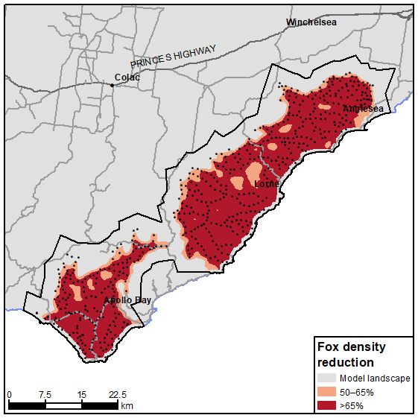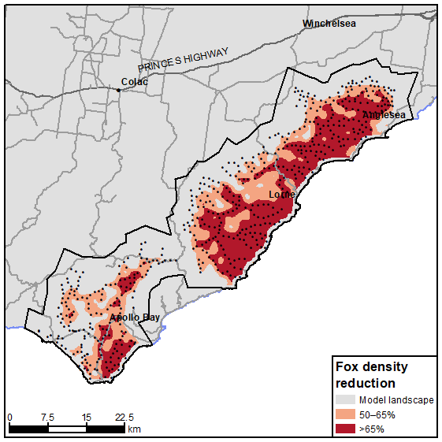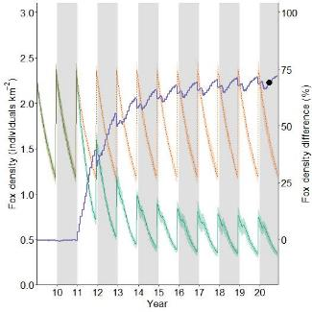Figure 57. The Otway Ark scenario 2 modelled fox densities—baited (green) and unbaited (pale red). Colour-shaded areas are modelled minimum and maximum values across all iterations. Monthly baiting commenced in model year 11 as per project description, including 2019 baiting extensions, and ran for the duration of the model. The purple line shows the percentage difference between the fox densities with and without baiting within the AoCI. The dot indicates the point in time when model outcomes were reported.

Figure 58. The spatial reduction in modelled fox densities for the first alternative model for Otway Ark. The dot in Figure 57 indicates the point in time when model outcomes, shown here, were reported.

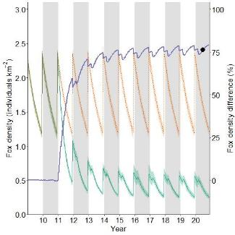Figure 59. The Otway Ark scenario 3 modelled fox densities—baited (green) and unbaited (pale red). Colour-shaded areas are modelled minimum and maximum values across all iterations. Fortnightly baiting commenced in model year 11 as per project description, including 2019 baiting extensions, and ran for the duration of the model. The purple line shows the percentage difference between the fox densities with and without baiting within the AoCI. The dot indicates the point in time when model outcomes were reported.

Figure 60. The spatial reduction in modelled fox densities for the second alternative model for the Otway Ark. The dot in Figure 59 indicates the point in time when model outcomes, shown here, were reported.

**Results summary**

The base program of monthly bait replacement without the extension baiting is predicted to have relatively limited spatial effectiveness, achieving a >65% reduction over 17% of the total AoCI (Table 14).

The addition of the extended baiting onto private land and some adjoining state forest is predicted to increase the level of reduction by 7% and increase the area over which effective reduction occurred by a further 9%.

Increasing bait replacement to fortnightly with the extension baiting is expected to increase the level of reduction compared with the original scenario by 15% and increase the area over which effective reduction occurred by a further 34%.

Table 14. The mean and percentage reduction in modelled fox densities for all Otway Ark management scenarios.

|  |  |  |  |
| --- | --- | --- | --- |
| Baiting program | Baiting strategy | Foxes per km2: mean (min–max) | Percentage reduction |
| Original program | Monthly network baiting (no extension) | 0.65 (0.55–0.76) | 61% |
| First alternative | Monthly network baiting (with extension) | 0.52 (0.44–0.59) | 68% |
| Second alternative | Fortnightly network baiting (with extension) | 0.40 (0.34–0.47) | 76% |

**Fox control operation**

|  |  |
| --- | --- |
| 3.14 Southern Ark |  |

The Southern Ark is a year-round fox baiting program across a network of roads and tracks in the far-eastern region of Victoria (Figure 61). Baits are replaced every 6 weeks across the entire region. Baits are spaced on average 690 m apart (range 3–2144 m). In addition, Parks Victoria implement wild dog baiting within the Southern Ark region, which is year-round baiting every 2 or 4 weeks depending on bait type used (with approximately a 50:50 ratio between perishable and shelf-stable baits, respectively). Baiting in NSW state forest and national parks is also undertaken. NSW national park mound baiting occurs in May–September, and NSW state forest baiting occurs every 6–8 weeks year-round. State forest baits are spaced on average 1544 m apart (range 476–3187 m).

**FoxNet modelling**

The FoxNet model landscape for Southern Ark was limited to the area east of the Snowy River (because the assumption was that the Snowy River is a barrier to fox migration) and a 30-km buffer north of the state border to allow for fox migration from the north. Subsequently, the AoCI (8621 km2) was bounded by the Snowy River in the west and the state border in the north.

Figure 61. The Southern Ark baiting layout as modelled in FoxNet; showing project bait station (dots) and adjacent NSW national park and state forest bait station locations (triangles), FoxNet area of interest (AoCI), model extent, and locality of project. All land to the west of the Snowy River was not available to foxes under the assumption that the river was a barrier to migration.

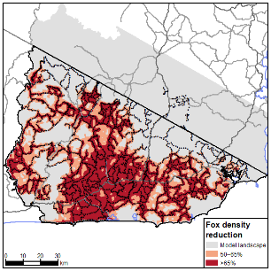FoxNet was run for 10 years with no baiting, to stabilise the fox population. Baiting began in year 11. Southern Ark baiting was undertaken every 6 weeks, with a different sector baited each model week. Parks Victoria wild dog baiting within Southern Ark was undertaken year-round for 10 years, baiting alternatively every 2 and 4 weeks (to match the ratio of the perishable and shelf-stable baits used). New South Wales (NSW) national park mound baiting was assumed to be monthly and was baited at 4-weekly intervals between model weeks 19 and 39, for 10 years.

**Results**

FoxNet modelling showed an overall reduction in fox density of 74% by year 20 (Figure 62). Fox densities with baiting became significantly different from fox densities without baiting at the commencement of baiting in January in year 11.

Modelled fox density was reduced by >65% over 37% of the AoCI by June in year 20 (Figure 63).

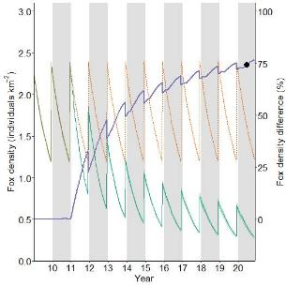 Figure 62. The modelled fox densities for the Southern Ark program—baited (green) and unbaited (pale red), including NSW national park baiting. Baiting commenced in model year 11 as per project description, and ran for the duration of the model. Annual population peaks show the effect of each year’s cub cohort entering the population. Colour-shaded areas are modelled minimum and maximum values across all iterations. The purple line shows the percentage difference between the fox densities with and without baiting within the AoCI. The dot indicates the point in time when model outcomes were reported.

Figure 63. The spatial reduction in modelled fox densities for the Southern Ark program including NSW National Park baiting. The dot in Figure 62 indicates the point in time when model outcomes, shown here, were reported.

**Alternative scenario**

An alternative scenario was also run investigating the effect of adjacent baiting in NSW state forest. The alternative scenario was run to investigate the benefits that might occur if adjacent baiting in NSW state forest was sustained over the longer term (having had inconsistent baiting in recent years).

The alternative scenario maintained the same baiting regime across all the various baiting programs, with the inclusion of the NSW state forest baiting completed year-round for 10 years in 8-weekly intervals. The alternative model showed an overall reduction in fox density of 75% over the Southern Ark AoCI (Figure 64). Fox densities with baiting became significantly different from fox densities without baiting by the commencement of baiting in January in year 11.

Modelled fox density was reduced by >65% over 38% of the AoCI by June in year 20 (Figure 65). The addition of NSW state forest marginally increased the effectiveness of the Victorian baiting effort; however, it did not extend reductions of >50% into NSW.

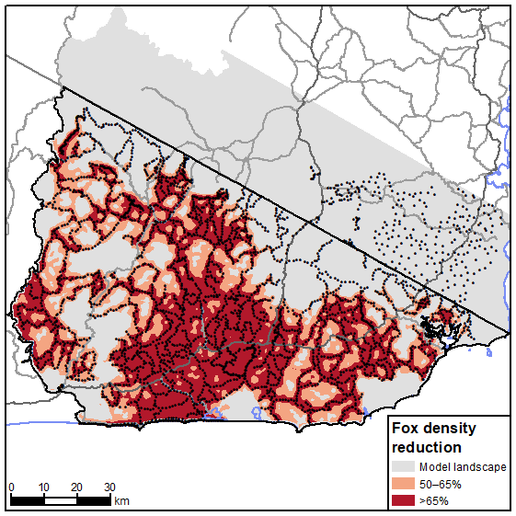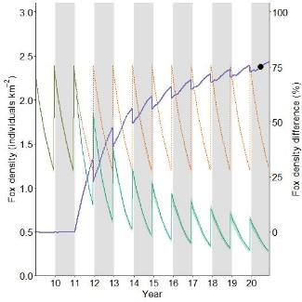Figure 64. The modelled fox densities for the alternative Southern Ark baiting scenario, including all NSW baiting—baited (green) and unbaited (pale red). Baiting commenced in model year 11 as per project description and additional NSW state forest baiting, and ran for the duration of the model. Annual population peaks show the effect of each year’s cub cohort entering the population. Colour-shaded areas are modelled minimum and maximum values across all iterations. The purple line shows the percentage difference between the fox densities with and without baiting within the AoCI. The dot indicates the point in time when model outcomes were reported.

Figure 65. The spatial reduction in modelled fox densities for the alternative Southern Ark scenario, including all adjacent NSW baiting. The dot in Figure 64 indicates the point in time when model outcomes, shown here, were reported.

**Results summary**

The Southern Ark program’s large-scale, high bait density and continuous baiting regime are contributing factors to the high fox density reductions where baiting occurs. The limited contribution from NSW baiting to the model was surprising. However, the 8-week frequency with relatively low bait density are plausible explanations for this.

Alternative modelling investigations may be able to provide insight into different temporal regimes that may reduce the overall yearly cost of the program but deliver the same results (e.g. investigate a combination of 6-week and other less frequent baiting that delivers the same result).

Summary results for all scenarios are provided in Table 15.

Table 15. The mean and percentage reduction in modelled fox densities for all Southern Ark management scenarios.

|  |  |  |  |
| --- | --- | --- | --- |
| Baiting program | Baiting strategy | Foxes per km2: mean (min–max) | Percentage reduction |
| Ark program | 6-weekly network baiting | 0.44 (0.38–0.47) | 74% |
| Alternative scenario | 6-weekly network baiting (including NSW state forest baiting) | 0.43 (0.37–0.46) | 75% |

One of the 14 projects (7%) were modelled as reaching the defined level of fox density reduction of >65% over an area >50% of the AoCI: Wilsons Promontory National Park (BRP082) (Figure 66, Table 16). The Grampians Ark (ARKGRA) project was just shy of meeting a >65% fox density reduction over >50% of the area, with a total >65% reduction of 49% (Figure 66, Table 16). Two projects achieved a >65% reduction in fox density, but not over >50% of the AoCI: Glenelg Ark (ARKGLG) and Southern Ark (ARKSTH) (Figure 66, Table 16).

|  |  |  |
| --- | --- | --- |
| |  |  | | --- | --- | | 3.15 Summary of results |  | |

These projects were generally large in spatial scale, had a network of bait stations throughout their AoCI, included frequent bait checking and changing (often weekly or fortnightly), and implemented baiting year-round. Glenelg Ark and Southern Ark did not achieve a reduction in foxes over >50% of their AoCI, despite on average reducing foxes by >65%. This is thought to be due to a combination of the linear nature of some sections in their AoCIs and the low bait density in those areas, or inaccessible areas included in the AoCI which were potentially large enough to harbour a self-sustaining fox meta-population. This combination appears to have allowed fox immigration to overcome the mortality imposed by the control effort in those areas, reducing the overall area of fox reduction to <50%.

Projects that modelling indicated did not achieve a fox reduction of >65% over >50% of their AoCIs had a combination of small size (<300 km2), linear or perimeter baiting (usually leading to low bait densities), and/or pulsed baiting, even when implemented with very frequent bait replacement regimes (Figure 66, Table 16).

Figure 66. (a) Reductions in fox density for all projects (plotted against spatial size of AoCI); (b) percentage of area over which a fox reduction of >65% was achieved (plotted against spatial size of AoCI). Fox control strategies in the grey-shaded areas in both graphs meet the criteria for success. Blue circle: multi-pulsed with continuous baiting; blue square: multi-pulsed with linear baiting; green circles: continuous baiting with network bait layout; red squares: pulsed baiting with linear bait layout; red triangle: pulsed baiting with perimeter bait layout.

Alternative modelling of (i) changing baiting strategies to include ongoing, fortnightly bait replacement, (ii) including the effect of baiting in the adjoining area, and (iii) implementing network baiting all had positive effects on project outcomes, while not always resulting in projects meeting the criteria for successful control (Figure 67; Table 17). Notably, the Otway Ark program was able to meet the criteria using alternative strategies that included an expansion of the base strategy, whilst the Little Desert (expansion) narrowly missed out on meeting the criteria.

Despite some successes, some alternative strategies modelled here had little effect on reducing fox density or on increasing the area over which this occurred for some projects.

Table 16. Results for current fox control modelling strategies. Yellow background indicates projects that meet the criteria for success.  
BRP: Biodiversity Response Planning; AoCI: area of conservation interest; NP: National Park; FFR: Flora and Fauna Reserve; SF: State Forest.

|  |  |  |  |  |  |  |
| --- | --- | --- | --- | --- | --- | --- |
| Project name | BRP Project | Baiting strategy | Fox density reduction (%) | % of AoCI with fox density reduction >65% | % of AoCI with fox density reduction >20%a | Number of years taken to reach a >65% reduction |
| Wilsons Promontory NP | BRP082 | Weekly network baiting | 89 | 64 | 113b | 1 |
| Grampians Ark | – | Fortnightly network baiting | 74 | 49 | 95 | 2 |
| Southern Ark | – | 6-weekly network baiting | 74 | 37 | 88 | 5 |
| Glenelg Ark | – | Fortnightly network baiting | 73 | 43 | 123b | 2 |
| Otway Ark | – | Fortnightly network baiting | 61 | 17 | 60 | Not achieved |
| Lake Timboram/Lalbert Creek | BRP049 (1) | Pulsed linear baiting | 56 | 2 | 64 | 4c |
| Little Desert (expansion) | BRP097 | Pulsed network baiting | 51 | 6 | 74 | Not achieved |
| Little Desert NP | BRP111 | Various temporal scales of network baiting | 51 | <1 | 43 | 6c |
| Murray Sunset NP–South | BRP028 | Pulsed linear baiting | 46 | Not achieved | 60 | Not achieved |
| Lower Avoca Plains | BRP071 | Monthly network baiting | 45 | Not achieved | 28 | Not achieved |
| Patho Plains | BRP072 | Monthly network baiting | 41 | Not achieved | 4 | Not achieved |
| Lake Tyrrell | BRP049 (2) | Pulsed linear baiting | 36 | Not achieved | 17 | Not achieved |
| Murray Scroll Belt | BRP051 | Monthly network baiting | 22 | Not achieved | 2 | Not achieved |
| Annuello FFR | BRP040 | Pulsed linear baiting | 16 | Not achieved | 22 | Not achieved |
| Patchewollock SF | BRP052 | Pulsed perimeter baiting | 15 | Not achieved | 0 | Not achieved |

aLower levels of reduction are subject to stochastic variation, resulting in unreliable estimates of reduction.

bPercentage of the area over which the % reduction in density was achieved is >100 because reductions were recorded outside the AoCI boundaries.

cBRP funding only for 3 years; project achieved >65% reduction after 4 years.

Figure 67. (a) Reductions in fox density for alternative projects (plotted against spatial size of AoCI); (b) percentage of area over which a fox reduction of >65% was achieved for alternative projects (plotted against spatial size of AoCI). Fox control strategies in the grey-shaded areas in both graphs meet the criteria for success. Green circles: continuous baiting with network bait layout; green squares: pulsed baiting with linear bait layout.

Table 17. Results for modelling of alternative project management strategies. Percentage increase in reduction and area covered from current strategies shown in brackets. Yellow background indicates projects that meet criteria for success.  
BRP: Biodiversity Response Planning; AoCI: area of conservation interest; NP: National Park; FFR: Flora and Fauna Reserve; SF: State Forest.

|  |  |  |  |  |  |  |
| --- | --- | --- | --- | --- | --- | --- |
| Project name | BRP project | Alternative baiting strategy | Fox density reduction (% increase from base) | % of AoCI with >65% reduction (% increase from base) | % of AoCI with >20% reductiona (% increase from base) | Number of years taken to reach a >65% reduction |
| Otway Ark (2nd scenario) | – | Fortnightly network baiting (with extension) | 76 (15) | 51 (34) | 82 (22) | 2 |
| Southern Ark | – | 6-weekly network baiting (including NSW state forest baiting) | 75 (1) | 38 (1) | 89 (1) | 5 |
| Little Desert (expansion) | BRP097 | Fortnightly network baiting | 72 (21) | 43 (37) | 96 (22) | 1 |
| Lake Timboram/Lalbert Creek | BRP049 (1) | Fortnightly linear baiting | 69 (13) | 27 (25) | 73 (9) | 1 |
| Otway Ark (1st scenario) | – | Monthly network baiting (with extension) | 68 (7) | 26 (9) | 75 (15) | 4 |
| Little Desert NP (2nd scenario) | BRP111 | Fortnightly network baiting (with adjacent baiting) | 68 (17) | 17 (17) | 85 (42) | 2 |
| Murray–Sunset NP–South | BRP028 | Fortnightly linear baiting | 61 (15) | Not achieved | 148b (88) | 1 |
| Lower Avoca Plains | BRP071 | Fortnightly network baiting | 60 (15) | Not achieved | 135b (107) | 2 |
| Little Desert NP (1st scenario) | BPR111 | Various temporal scales network baiting (with adjacent baiting) | 53 (2) | <1 (0.5) | 46 (3) | 4 |
| Patho Plains | BRP072 | Fortnightly network baiting | 56 (15) | Not achieved | 99b (95) | 2 |
| Lake Tyrrell | BRP049 (2) | Fortnightly linear baiting | 56 (20) | Not achieved | 48 (31) | 3 |
| Patchewollock SF (2nd scenario) | BRP052 | Fortnightly network baiting | 53 (38) | Not achieved | 81 (81) | 2 |
| Patchewollock SF (1st scenario) | BRP052 | Fortnightly baiting perimeter | 45 (30) | Not achieved | 40 (40) | Not achieved |
| Annuello FFR (2nd scenario) | BRP040 | Fortnightly network baiting | 37 (19) | Not achieved | 27 (5) | Not achieved |
| Murray Scroll Belt | BRP051 | Fortnightly network baiting | 35 (13) | Not achieved | 7 (4) | Not achieved |
| Annuello FFR (1st scenario) | BRP040 | Fortnightly linear baiting | 24 (6) | Not achieved | 25 (3) | Not achieved |

aLower levels of reduction are subject to stochastic variation, resulting in unreliable estimates of reduction.

bPercentage of the area over which the % reduction in density was achieved is >100 as reductions were recorded outside the AoCI boundaries.

1. Discussion

We investigated the level of reduction in fox density arising from different fox management strategies (varying spatial and temporal scales, bait densities and bait configurations) using a spatially explicit individually based fox population model (FoxNet; Hradsky et al. 2017) with 14 Victorian fox control projects as case studies. These projects broadly cover large-scale continuous, ongoing baiting and smaller-scale, short-term/pulsed baiting, all with a variety of bait densities and spatial configurations. We set a target reduction in fox density of >65% compared with the no-baiting density, based on population modelling by Hone (1999a), with this occurring over >50% of the AoCI being the measure of effective fox control. These criteria are suggested as the minimum reduction required for projects to be considered effective at controlling foxes, but this needs quantitative verification.

It was outside the scope of this project to investigate the link between the level of reduction in fox density and any biodiversity response arising from that reduction. This is a complex area, and there is little empirical evidence available for determining the threshold of fox density that will allow native species to overcome limitation by fox predation. However, see Sinclair et al. (1998) and Pech et al. (1992) for examples and an application of predator–prey theory that could address this issue. Examples in the literature about fox predation on reintroduced populations indicate that small numbers of foxes can quickly bring about local extinctions (Kinnear et al. 1988; Short 2009; Moseby et al. 2019), and there is uncertainty about the effectiveness of some open-system fox control measures (Lindenmayer et al. 2018), so the target threshold of fox density is likely required to be very low. Our target of >65% reduction over >50% of the area may be enough to halt fox population growth, but should be considered a minimum level for projects with the aim of biodiversity conservation.

Of the 14 projects modelled in this study, only one (Wilsons Promontory National Park) was predicted to reach the target of >65% reduction in density over >50% of the AoCI, whilst two projects were close to meeting the criteria (Southern Ark and Grampians Ark). Modelling alternative strategies (for bait deployment and replacement) for projects that were analysed as failing to reach the target reductions showed that, generally, either increasing bait density, increasing spatial coverage of baits and/or increasing the duration of the baiting would result in increased levels of reduction in fox density. However, only one additional project [Otway Ark] met the criteria for success under the alternative scenarios, with the Little Desert (expansion) project also being close to meeting the criteria. This is because, despite increasing the duration of baiting from short-term to year-round for some projects, limitations on track networks prevented bait densities being increased to a level that resulted in foxes encountering baits fast enough to reduce survival rates or counter rates of immigration. In some cases, the shape of the project area meant that reductions of >65% were achieved over the broader sections of the AoCI, but not in sections that were relatively narrow.

Modelling outcomes showed that the fox control projects that met the success criteria (or were close to meeting the criteria) were generally those that were larger than 300 km2 in area, deployed baits year-round across a network of baits spaced approximately 1 km apart, and had a spatial arrangement of baits that broadly covered the AoCI. These findings are supported by previous work that also found that ongoing baiting over large areas is much more effective than one-off programs conducted over small areas (Saunders and McLeod 2007; Newsome et al. 2014). Generally, projects that we assessed as unable to meet the criteria for success were those that were <300 km2 in scope, that had baits deployed in pulses, and in which baiting only occurred on the perimeter of the AoCI. The latter strategy was unable to achieve the target reduction in foxes, despite some projects deploying baits at 250-m intervals along the perimeter of the AoCI. Areas that had comparatively high perimeter-to-area ratios, resulting in AoCI’s with low bait densities which are more vulnerable to fox immigration from adjacent unbaited areas, were also assessed as unable to achieve the target reduction in foxes.

To highlight the requirement for the above combination of factors to be in place in order to achieve effective reduction in fox density, six projects of intermediate size (66–309 km²) that had moderate perimeter-to-area ratios were modelled. Five (Lake Tyrell, Lake Timboram/Lalbert Creek, Patchewollock SF, Annuello FFR, and Murray Scroll Belt) were predicted not to reach reductions of >65%. This was despite being at a reasonable spatial scale (potentially about 30–150 fox home ranges), although three (Lake Tyrell, Lake Timboram/Lalbert Creek, and Annuello FFR) were short-term perimeter baiting projects with a relatively sparse arrangement of baits across the AoCI due to the limitations of internal track networks. The other two were year-round network baiting projects; however, one (Patchewollock State Forest) had very sparse bait spacing, resulting in low bait density, again due to limited internal track access. The fourth (successful) project (Wilsons Promontory National Park) had in place all the criteria—year-round baiting, relatively high bait density, and a network of bait stations with broad coverage. In addition, it was bordered by water on two sides, which limited immigration, and this is likely to have been a significant factor in achieving a successful outcome.

Small spatial scale becomes an issue because small-scale projects cannot reduce foxes over a large enough area to stop compensatory immigration and fecundity. Duration (short-term or pulsed vs ongoing) is also an issue for small-scale projects; stopping control allows for rapid immigration, particularly in a highly productive environment. The combination of small-scale and short-duration baiting presents significant challenges for achieving population-level control of foxes, and limits the likely biodiversity outcomes.

Larger-scale projects can stop, or at least significantly reduce, immigration and internal compensatory fecundity, with the outer edges acting as buffers to the internal processes. Even so, short-term control over large areas or ceasing control will have the same retrograde result as for smaller-scale projects, particularly in habitat with higher underlying productivity.

Occasionally, the aim of fox control programs is short-term protection of conservation assets that are susceptible to fox predation at certain periods in their life history, e.g. freshwater turtles when nesting, Malleefowl when nesting, migratory seabirds when present (Kirkwood et al. 2000; Robley et al. 2016a), or ecosystems after significant fire events (Robley et al. 2012). While implementing fox control to protect conservation assets would seem logical, foxes are a highly mobile species (Larivière and Pasitschniak-Arts 1996; Hradsky et al. 2017) and will rapidly invade newly vacated territories following small isolated control efforts (Newsome et al. 2014). Lethal control of fox populations can induce compensatory immigration, a demographic response by foxes that can quickly negate any benefits from short-term fox control (Lieury et al. 2015). In this study, FoxNet modelling of small, isolated control programs with inconsistent baiting demonstrated an underwhelming level of reduction in fox densities being achievable by these programs. In some cases, the modelled return to densities like those of the unbaited scenario was rapid. Hradsky et al. (2019) noted that at times the short-term, modelled population recovery was somewhat slower than that observed (Thomson et al. 2000), suggesting a scope to improve model fit via experiments that explore the compensatory fecundity and immigration hypotheses (Marlow et al. 2016) (i.e. investigate potential model improvements which consider higher immigration and birth rates following modelled control programs) .

Three projects had adjacent private land baiting that effectively increased the spatial scale under fox control. Separate predictions were made for the public and private land areas, as well as for the combination of the public and private land for two of these: Little Desert National Park / Little Desert (expansion) and Otway Ark. For Little Desert National Park / Little Desert (expansion), it was only when the combined public and private land baiting program was modelled that the level of reduction was >65%, and even then it was spatially patchy. The proposed extensions in the Otway Ark project had a significant additive effect on the area over which fox density was reduced compared with the current baiting regime. This was particularly so in the southern area of baiting, where only a small number of additional bait stations had a large effect on fox densities. Increasing the spatial coverage by adding buffer zones (areas of baiting surrounding the AoCI) has been shown to be effective at reducing fox immigration into core baited areas, e.g. Thomson et al. (2000) and Hradsky et al. (2019), who used FoxNet to investigate fox densities with variously sized buffers around the AoCI.

Increasing the area over which control is implemented or adding buffer zones will, in many cases, involve baiting on private land. The same factors that are highlighted here for public land need to be considered for private land extensions. In addition, issues of motivation (livestock protection vs biodiversity), access, ability to deliver year-round control, changes in property ownership, changes in motivation (e.g. movement out of lamb and wool production), ongoing cost, clarity about who delivers baiting on the ground, sense of ownership of the baiting program by private landowners, and the capacity of the public land manager to manage an ongoing relationship with many private landowners all need to be considered prior to any extension of baiting across private land.

While the scale of the control program is important, we also found there is an interaction between bait density and spatial scale. Saunders and McLeod (2007) suggest that a bait density of 5–10 baits per km2 should be enough for fox control programs in Australia, but do not address the influence of scale and placement. Carter and Luck (2013) investigated the effect of various landscape features on bait-take in agricultural landscapes, but did not look at bait densities. Our study included projects that achieved significant levels of fox reductions with bait densities of <1 bait per km2, with networks of baits. However, these were also the largest and longest-running projects. Smaller-scale projects (<300 km2) that had higher bait densities (e.g. Avoca Plains at 1.7 baits per km2) were not predicted to reduce foxes by any significant amount, and in these a contributing factor was likely the relatively large perimeter-to-area ratio.

The spatial coverage of the modelled reduction in fox density was not uniform within or between projects that achieved a >65% reduction but was related to the spatial configuration of the baits within the AoCI, the density of the baits, and the length of the control period. Larger-scale projects with a network of bait deployment were predicted to have higher levels of spatial reduction. Promontory National Park, having extensive road and track networks, was predicted to have greater area achieving the 65% reduction level compared with Glenelg Ark, Southern Ark and Otway Ark. In contrast, despite the Little Desert project reaching >65% reduction in density by year 12, this reduction was limited to areas close to tracks and roads, and there were large areas with no track access that had no baits and were not predicted to reach even >50% levels of reduction.

Timing of fox control can influence how successfully programs reduce fox density (Lieury et al. 2015). The fox management programs in the present study that employed a pulsed baiting strategy often did so to coincide with juvenile dispersal and/or cub rearing. This is frequently the fox control style implemented in agricultural settings (Saunders and McLeod 2007). In contrast to the strategy of most pulsed programs investigated here, fox control *after* dispersal and before the birthing of the following season’s cubs (i.e. during winter) has been shown to have the greatest effect on the reduction in fox density (Rushton et al. 2006; McLeod et al. 2010; Lieury et al. 2015). This period was also shown to coincide with the time when bait uptake rates were potentially highest in south-west Western Australian forests (Dundas et al. 2014). Whilst we advocate for continuous baiting regimes, if pulsed baiting is undertaken then the timing of the pulses should align to periods where greatest efficacy can be achieved.

In deliberating on the criteria for implementing a successful baiting program, project managers need to consider labour, bait and project management costs; social licence; and opportunities to collaborate with neighbouring property managers in undertaking fox control (Saunders and McLeod 2007; Kinnear et al. 2017). We focus on baiting as the primary tool for the control of foxes over a large scale on conservation estates. In some circumstances, the use of complementary tools (e.g. trapping, shooting, fox drives, and habitat manipulation) (Saunders and McLeod 2007) may be applicable and should be considered on a case-by-case basis.

Although FoxNet was able to simulate the fox control case studies (Hradsky et al. 2019), and other individually based fox control models have provided a strong rationale for their use (Rushton et al. 2006), modelling projects are only as good as the accuracy of their input data (Coulson et al. 2001). Ecological models can help provide insight for decision-making and policy (Schmolke et al. 2010); however, if models are to be used for decision-making support, assessment of the model quality and the assumptions is critical (Schmolke et al. 2010; Grimm et al. 2014).

The model sensitivity testing undertaken in this project showed that bait efficacy (i.e. the probability of a fox encountering and then consuming a lethal bait) can impact on model outcomes, and this is an area that warrants further empirical investigation. Factors such as bait toxicity and palatability, caching of baits, the rate of non-target species’ bait-take, and underlying prey availability can all diminish the effectiveness of a poison baiting operation. Currently, FoxNet applies a uniform bait efficacy rate across all landscapes, which may lead to an overestimation of the level of reduction in fox density.

While we held fox demographic parameters constant across all projects, it is likely that there will be variation in these across regions within Victoria. For example, fox home ranges were estimated to be 0.92–3.24 km2 in forests of south-west Victoria (Robley et al. 2016b), 3–7 km2 in agricultural landscapes of Victoria (e.g. central Victorian open woodland country; Coman et al. 1991) and 9.4 km2 in a wet forest location in East Gippsland (Diment 2010). Urban landscapes within Melbourne are known to have fox home ranges of as low as 0.3–0.5 km2 (Marks and Bloomfield 1999, 2006). In habitat somewhat comparable with that of the Mallee region, Towerton et al. (2016) recorded fox home ranges of 4.2–44.62 km2 in central NSW (Dubbo). This could lead to model over or underestimates depending on the direction of the relationship between modelled and actual home ranges.

A key driver that will determine modelled project success (at reducing fox density) is the underlying productivity of the landscape (i.e. model prey availability); this determines home-range size, density, survival rate, dispersal rate, etc. The testing of the model parameters (Hradsky et al. 2019) indicated that change in fox density is particularly sensitive to home-range size. Landscape productivity is scaled by home-range size, and larger home ranges tend to be less productive, because productivity influences carrying capacity and dispersal distance. In most cases, land managers will not have information on the underlying productivity of their land. However, see Bengsen et al. (2015) for an approach to assessing home-range size based on remotely sensed productivity data, which they used to predict feral cat home-range sizes. Smaller home ranges in FoxNet would have the effect of increasing fox density and reducing bait encounter probabilities, leading to a reduction in the effectiveness of the modelled control action. In validating FoxNet, Hradsky et al. (2019) reproduced the demographic structure of two very different fox populations and determined a quantitative relationship between home-range size and fox-family density for ranges between 1.0 and 9.6 km². They also recorded the rapid population knock-down and seasonally driven recovery of a fox population following poison-baiting. Nevertheless, more empirical data on the variation in fox home-range size is needed to improve the predictive power of the modelling.

Three projects (Murray–Sunset National Park–South, Annuello State Forest, and Lake Tyrrell, Lake Timboram/Lalbert Creek) baited at 48-h intervals; however, FoxNet is limited to baiting once per week. The discrepancy between baiting intervals leaves the model scenario baited at <30% of the real-world baiting regime, which potentially could lead to an underestimation of the efficacy of these regimes. However, this would require foxes to explore their territory every 48 h and encounter a bait (or to recognise that a territory is newly vacant, explore it and encounter a bait within 48 h) to create an underestimation; this is unrealistic, so the impact is likely to be negligible. Appendix 4 provides a summary of some limitations of FoxNet and suggests approaches that could reduce these limitations.

Empirical data around the efficacy of individual baits would be valuable for improving future FoxNet modelling scenarios in Victoria. The efficacy parameter of 0.15 used in our models is scaled from the ‘evaludation’ process of Hradsky et al. (2019), but uncertainty remains about the true value. Further information on the home-range sizes and ranging behaviour of foxes in landscapes across Victoria would also improve model outcomes, particularly where large fox home ranges are to be expected. This information could also refine the habitat use parameters within the model. We chose the level of fox density reduction required to be ‘successful’ based on Hone’s (1999b) review of fox population dynamics and rates of increase. Hone (1999b) suggests that the estimated proportion of the population that is required to be removed from the population to stop maximum population growth is 65%. However, this level remains arbitrary, without empirical fox abundance and predation data to explain the mechanisms of prey population response (Hone 1999a; Kirkwood et al. 2014), and future work is needed to quantify fox density reductions that may generate a conservation outcome.

Evaluation of whether benefits to biodiversity have accrued from fox control programs, and thus whether a given management strategy is working or requires alteration, can be ascertained only through monitoring (Possingham 2001). There are two types of monitoring (Choquenot et al. 1996). ‘Operational monitoring’ (e.g. by using FoxNet) involves generating an estimate of the proportional changes in the pest population as a result of the control action. ‘Performance monitoring’ (or ‘outcome monitoring’) is an estimate of the effectiveness of the operation at protecting native biodiversity.

While FoxNet provides a transparent approach for operational monitoring, we encourage land managers to implement more direct assessments of the effectiveness of their operations in order to provide validation of the model predictions and to enable adjustments to both model inputs and control strategies. A host of monitoring and analysis methods exist; however, careful consideration needs to be given to sampling design and analysis if monitoring is to provide information that gives genuine insight into the performance of fox control programs. Land managers should seek expert advice on the best methods of obtaining robust information for their fox control program.

We have found that uncoordinated, small-scale and inconsistent fox baiting programs do not provide long-term changes in fox density, consistent with the findings of Newsome et al. (2014) and Lieury et al. (2015). In the following section, we present a set of recommendations that should be considered when planning fox control operations.

1. Recommendations

We present a set of recommendations aimed at providing guidance for land managers and funding agencies when considering fox control programs. We also recommend actions that could (i) improve the FoxNet model predictions and (ii) fill areas of uncertainty in effective fox management.

Land managers undertaking fox control are also directed to the resources below that provide details of the legislative and regulatory framework, provide background information on foxes and fox ecology, and broadly outline strategies and tools for undertaking fox control in rural and natural landscapes.

* Australian Federal Government. Centre for Invasive Species Solutions – PestSmart – European fox  
  <https://www.pestsmart.org.au/pest-animal-species/european-fox/>
* Victorian Government. Agriculture Victoria: integrated fox control for rural and natural landscapes  
  <http://agriculture.vic.gov.au/agriculture/pests-diseases-and-weeds/pest-animals/invasive-animal-management/established-invasive-animals/integrated-fox-control-for-rural-and-natural-landscapes>

|  |  |  |
| --- | --- | --- |
| **Subject** | **Recommendation** | **Description** |
| **Fox control strategies – guiding principles** | **Areas of <300 km2** – network of bait stations spaced at <500-m intervals; baits checked and replaced weekly; bait density >3–4 per km2; baiting to be continuous | Smaller areas often have large perimeter-to-area ratios, allowing fox immigration to occur rapidly. Smaller areas often only encompass a small proportion of fox home ranges. Removing these foxes allows for rapid colonisation. Baiting must be spatially and temporally intensive to counter these responses and effectively maintain lowered levels of fox abundance. |
|  | **Areas between 300 km2 and 1000 km2** – network of bait stations spaced at 1-km intervals; bait density at between 2 and 3 baits per km2; baits checked and replaced weekly or fortnightly; baiting to be continuous | The AoCI is likely to encompass the home ranges of most resident foxes. Suppressing foxes internally will be achieved by exposing all foxes to multiple baits. Suppressing growth can be achieved by exposing survivors and immigrants frequently to the probability of encountering and consuming bait. |
|  | **Areas >1000 km2** – network of bait stations spaced at 1-km intervals; bait density at >1 per km2; baits checked and replaced fortnightly to monthly; baiting to be continuous | Larger areas will encompass many fox home ranges. Suppressing foxes internally will be achieved by exposing all foxes to multiple baits. Suppressing growth can be achieved by exposing survivors and immigrants frequently to the probability of encountering and consuming bait. |
|  | **Timing** – baiting needs to be both continuous and ongoing to have the maximum probability of achieving success. | Projects that baited in pulses within a single year were assessed as failing to meet the criteria for success. Also, once baiting ceased as funding ran out, fox densities were able to return to pre-baiting levels within a few years or less. |
| **Knowledge gaps** | Validate model predictions against the outcomes of a representative selection of current fox control projects. | Validating these model outcomes (i.e. the accuracy of predicted fox population densities, along with estimates of home-range size) for representative projects would represent a significant step towards refining the proposed guidelines and would greatly assist in developing standards for fox control. |
|  | Assess individual bait encounter mortality efficacy across a range of representative habitats. | Empirical data to quantify individual bait encounter mortality efficacy would be valuable for improving future FoxNet modelling scenarios in Victoria. The efficacy parameter of 0.15 used in this project is scaled from the ‘evaludation’ process of Hradsky et al. (2019), but uncertainty remains about the true value. |
|  | Support investigations into the rate of non-target bait-take and bait loss across various ecological regions of Victoria. | Information gained will strengthen the accuracy of model predictions. |
|  | Assess underlying habitat productivity in conjunction with estimates of home-range size across a range of habitat types. | Linking productivity with home-range size will allow for more refined habitat use parameters within the model. |
|  | Use FoxNet to explore alternative baiting strategies not covered in this initial project. | While we attempted to cover a range of real-world scenarios, there was a limit to the number we could do in this project. FoxNet could be used to evaluate further possible strategies, the indicated strategies could be implemented, and the information used to improve model predictions. |
|  | Estimate fox density reductions that may generate a conservation response. | We based the level of fox density reduction required in order to be ‘successful’ on Hone’s (1999b) review of fox population dynamics and rates of increase. Hone (1999b) suggests that the estimated proportion of the population needing to be removed from the population to stop maximum population growth is 0.65 per year. However, this level remains somewhat arbitrary without empirical fox abundance and predation data needed to determine the mechanisms of prey population response (Hone 1999a; Kirkwood et al. 2014) Further investigation is needed. |

References

Baker, P.J., Robertson, C.P.J., Funk, S.M. and Harris, S. (1998). Potential fitness benefits of group living in the red fox, *Vulpes vulpes*. *Animal Behaviour* **56**, 1411–1424.

Bengsen, A.J., Algar, D., Ballard, G., Buckmaster, T., Comer S., Fleming, P.J.S., Friend, J.A., Johnston, M., McGregor, H., Moseby, K. and Zewe, F. (2015). Feral cat home-range size varies predictably with landscape productivity and population density. *Journal of Zoology* **298**, 112–120.

Burbidge, A.A. and McKenzie, N.L. (1989). Patterns in the modern decline of Western Australia’s vertebrate fauna: causes and conservation implications. *Biological Conservation* **50**, 143–198.

Carter, A. and Luck, G.W. (2013). Fox baiting in agricultural landscapes: preliminary findings on the importance of bait-site selection. *Wildlife Research* **40**, 184–195.

Carter, A., Luck, G.W. and McDonald, S.P. (2011). Fox‐baiting in agricultural landscapes in south‐eastern Australia: a case‐study appraisal and suggestions for improvement. *Ecological Management and Restoration* **12**, 214–223.

Choquenot, D., McIlroy, J. and Korn, T. (1996). *Managing Vertebrate Pests: Feral Pigs*. Australian Government Publishing Service, Canberra, ACT.

Coman, B.J., Robinson, J. and Beaumont, C. (1991). Home range, dispersal and density of red foxes (*Vulpes vulpes* L.) in central Victoria. *Wildlife Research* **18**, 215–223.

Coulson, T., Mace, G.M., Hudson, E. and Possingham, H. (2001). The use and abuse of population viability analysis. *Trends in Ecology and Evolution* **16**, 219–221.

DeAngelis, D.L. and Mooij, W.M. (2005). Individual-based modeling of ecological and evolutionary processes. *Annual Review of Ecology, Evolution, and Systematics* **36**, 147–168.

Department of Industry, Innovation and Science (DIIS). (2018)*. SA State Boundary – PSMA Administrative Boundaries*. https://data.gov.au/data/dataset/sa-state-boundary-psma-administrative-boundaries (accessed 17 April 2019).

Devenish-Nelson, E.S., Harris, S., Soulsbury, C.D., Richards, S.A. and Stephens, P.A. (2013). Demography of a carnivore, the red fox, *Vulpes vulpes*. What have we learnt from 70 years of published studies? *Oikos* **122**, 705–716.

Dexter, N. and Meek, P. (1998). An analysis of bait-take and non-target impacts during a fox-control exercise. *Wildlife Research* **25**, 147–155.

Diment, A. (2010). *Monitoring the ecological impacts of invasive predator control.* PhD thesis, University of Sydney, Sydney, NSW.

Doherty, T.S. and Ritchie, E.G. (2017). Stop jumping the gun: a call for evidence-based invasive predator management. *Conservation Letters* **10**, 15–22.

Dundas, S.J., Adams, P.J. and Fleming, P.A. (2014). First in, first served. Uptake of 1080 poison fox baits in south-west Western Australia. *Wildlife Research* **41**, 117–126.

Environmental Systems Research Institute (ESRI). (2015). *ARCMAP Desktop Release 10.3.1.* http://desktop.arcgis.com/en/arcmap/

Gentle, M. (2005). *Factors affecting the efficiency of fox baiting practices on the Central Tablelands of New South Wales*. PhD thesis, University of Canberra, Canberra, ACT.

Grimm, V., Augusiak, J., Focks, A., Frank, B.M., Gabsi, F., Johnston, A.S.A., Liu, C., Martin, B.T., Meli, M., Radchuk, V., Thorbek, P. and Railsback, S.F. (2014). Towards better modelling and decision support: documenting model development, testing, and analysis using TRACE. *Ecological Modelling* **280**, 129–139.

Grimm, V., Berger, U., DeAngelis, D.L., Polhill, J.G., Giske, J. and Railsback, S.F. (2010). The ODD protocol; a review and first update. *Ecological Modelling* **221**, 2760–2768.

Harris, S. and Smith, G.C. (1987). Demography of two urban fox (*Vulpes vulpes*) populations. *Journal of Applied Ecology* **24**, 75–86.

Hijmans, R.J., van Etten, J., Cheng, J., Mattiuzzi, M., Sumner, M., Greenberg, J.A., Lamigueiro, O.P., Bevan, A., Racine, E.B. and Shortridge, A. (2015). *raster: geographic data analysis and modeling. R package version 2.5-8*. https://cran.r-project.org/web/packages/raster/index.html

Hone, J. (1999a). Fox control and rock-wallaby population dynamics; assumptions and hypotheses. *Wildlife Research* **26**, 671–673.

Hone, J. (1999b). On rate of increase (*r*): patterns of variation in Australian mammals and the implications for wildlife management. *Journal of Applied Ecology* **36**, 709–718.

Hradsky, B.A., Kelly, L.T., Robley, A. and Wintle, B.A. (2019). FoxNet: an individual‐based model framework to support management of an invasive predator, the red fox. *Journal of Applied Ecology* **56**, 1460–1470.

Hradsky, B.A., Robley, A., Alexander, R., Ritchie, E.G., York, A. and Di Stefano, J. (2017). Human-modified habitats facilitate forest-dwelling populations of an invasive predator, *Vulpes vulpes*. *Scientific Reports* **7**, 12291.

Kinnear, J.E., Onus, M.L. and Bromilow, R.N. (1988). Fox control and rock-wallaby population dynamics. *Wildlife Research* **15**, 435–450.

Kinnear, J.E., Pentland, C., Moore, N. and Krebs, C.J. (2017). Fox control and 1080 baiting conundrums: time to prepare for a CRISPR solution. *Australian Mammalogy* **39**, 127–136.

Kirkwood, R., Dann, P. and Belvedere, M. (2000). Effects of the seasonal availability of Short-tailed Shearwaters (*Puffinus tenuirostris*) on the diet of red foxes (*Vulpes vulpes*) on Phillip Island, Victoria. *Australian Mammalogy* **22**, 87–92.

Kirkwood, R., Sutherland, D.R., Murphy, S. and Dann, P. (2014). Lessons from long-term predator control: a case study with the red fox. *Wildlife Research* **41**, 222–232.

Larivière, S. and Pasitschniak-Arts, M. (1996). *Vulpes vulpes*. *Mammalian Species* **537**, 1–11.

Lieury, N., Ruette, S., Devillard, S., Albaret, M., Drouyer, F., Baudoux, B. and Millon, A. (2015). Compensatory immigration challenges predator control: an experimental evidence-based approach improves management. *Journal of Wildlife Management* **79**, 425–434.

Lindenmayer, B.D., Wood, J., MacGregor, C., Foster, C., Scheele, B., Tulloch, A., Barton, P., Banks, S., Robinson, N., Dexter, N., O’Loughlin, S. and Legge, S. (2018). Conservation conundrums and the challenges of managing unexplained declines of multiple species. *Biological Conservation* **221**, 279–292.

Lockie, J.D. (1959). The estimation of the food of foxes. *Journal of Wildlife Management* **23**, 224–227.

Marks, C.A. and Bloomfield, T.E. (1999). Distribution and density estimates for urban foxes (*Vulpes vulpes*) in Melbourne: implications for rabies control. *Wildlife Research* **26** 763–775.

Marks, C.A. and Bloomfield, T.E. (2006). Home-range size and selection of natal den and diurnal shelter sites by urban red foxes (*Vulpes vulpes*) in Melbourne. *Wildlife Research* **33**, 339–347.

Marlow, N.J., Thomson, P.C., Rose, K. and Kok, N.E. (2016). Compensatory responses by a fox population to artificial density reduction in a rangeland area in Western Australia. *Conservation Science Western Australia* **10**, 1–10.

McIlroy, J., Saunders, G. and Hinds, L.A. (2001). The reproductive performance of female red foxes, *Vulpes vulpes*, in central-western New South Wales during and after a drought. *Canadian Journal of Zoology* **79**, 545–553.

McIntosh, D.L. (1963). Reproduction and growth of the fox in the Canberra district. *CSIRO Wildlife Research* **8**, 132–141.

McKenzie, N.L., Burbidge, A.A., Baynes, A., Brereton, R.N., Dickman, C.R., Gordon, G., Gibson, L.A., Menkhorst, P.W., Robinson, A.C., Williams, M.R. and Woinarski, J.C.Z. (2007). Analysis of factors implicated in the recent decline of Australia’s mammal fauna. *Journal of Biogeography* **34**, 597–611.

McLeod, L.J., Saunders, G.R., McLeod, S.R., Dawson, M. and van de Ven, R. (2010). The potential for participatory landscape management to reduce the impact of the red fox (*Vulpes vulpes*) on lamb production. *Wildlife Research* **37**, 695–701.

Moseby, K., Letnic, M., Blumstein, D. and West, R. (2019). Understanding predator densities for successful co‐existence of alien predators and threatened prey. *Austral Ecology* **44**, 409–419.

Newsome, T.M., Crowther, M.S. and Dickman, C.R. (2014). Rapid recolonisation by the European red fox: how effective are uncoordinated and isolated control programs? *European Journal of Wildlife Research* **60**, 749–757.

Pech, R.P., Sinclair, A.R.E., Newsome, A.E. and Catling, P.C. (1992). Limits to predator regulation of rabbits in Australia: evidence from predator-removal experiments. *Oecologia* **89**, 102–112.

Possingham, H. (2001). *The Business of Biodiversity*. Australian Conservation Foundation and Earthwatch Institute, Melbourne, Victoria.

R Core Team. (2019). *The R Project for Statistical Computing*. https://www.r-project.org/ (accessed 17 April 2019).

Reddiex, B., Forsyth, D.M., McDonald-Madden, E., Einoder, L.D., Griffioen, P.A., Chick, R.R. and Robley, A. (2006). Control of pest mammals for biodiversity protection in Australia. I. Patterns of control and monitoring. *Wildlife Research* **33**, 691–709.

Robley, A., Gormley, A.M., Forsyth, D.M. and Triggs, B. (2014). Long-term and large-scale control of the introduced red fox increases native mammal occupancy in Australian forests. *Biological Conservation* **180**, 262–269.

Robley, A., Howard, K., Lindeman, M., Cameron, R., Jardine, A. and Hiscock, D. (2016a). The effectiveness of short-term fox control in protecting a seasonally vulnerable species, the Eastern Long-necked Turtle (*Chelodina longicollis*). *Ecological Management and Restoration* **17**, 63–69.

Robley, A., Moloney, P., Moxham, C., Neave, G., Friend, G. and Fraser, I. (2016b). *The effects of interaction between planned burning and foxes on the presence of native mammals*. Arthur Rylah Institute for Environmental Research Technical Report Series No. 273. Department of Environment, Land, Water and Planning, Heidelberg, Victoria.

Robley, A., Newell, G., White, M., MacDonald, A., Sarre, S., Triggs, B. Currie, J. and Smith, S. (2012) *Strategic Red Fox control on bushfire affected public land in Victoria – Black Saturday Victoria 2009 – Natural Values Fire Recovery program.* Department of Environment and Primary Industries, East Melbourne, Victoria.

Rushton, S.P., Shirley, M.D.F., Macdonald, D.W. and Reynolds, J.C. (2006). Effects of culling fox populations at the landscape scale: a spatially explicit population modeling approach. *Journal of Wildlife Management* **70**, 1102–1110.

Saunders, G. and McLeod, L. (2007). *Improving fox management strategies in Australia*. Bureau of Rural Sciences, Canberra, ACT.

Saunders, G., McLeod, L. and Kay, B. (2000). Degradation of sodium monofluoroacetate (1080) in buried fox baits. *Wildlife Research* **27**, 129–135.

Saunders, G.R., Gentle, M.N. and Dickman, C.R. (2010). The impacts and management of foxes *Vulpes vulpes* in Australia. *Mammal Review* **40**, 181–211.

Schmolke, A., Thorbek, P., DeAngelis, D.L. and Grimm, V. (2010). Ecological models supporting environmental decision making: a strategy for the future. *Trends in Ecology & Evolution* **25**, 479–486.

Short, J. (2009). *The characteristics and success of vertebrate translocations within Australia. A final report to the Department of Agriculture, Fisheries and Forestry*, Canberra, ACT. Wildlife Research and Management, Kalamunda, Western Australia.

Sinclair, A.R.E. (1997). Fertility control of mammal pests and the conservation of endangered marsupials. *Reproduction, Fertility and Development* **9**, 1–16.

Sinclair, A.R.E., Pech, R.P., Dickman, C.R., Hik, D., Mahon, P. and Newsome, A.E. (1998). Predicting effects of predation on conservation of endangered prey. *Conservation Biology* **12**, 564–575.

Soulsbury, C.D., Iossa, G., Baker, P.J., White, P.C. and Harris, S. (2011). Behavioral and spatial analysis of extraterritorial movements in red foxes (*Vulpes vulpes*). *Journal of Mammalogy* **92**, 190–199.

Storm, G.L., Andrews, R.D., Phillips, R.L., Bishop, R.A., Siniff, D.B. and Tester, J.R. (1976). Morphology, reproduction, dispersal, and mortality of midwestern red fox populations. *Wildlife Monographs* **49**, 3–82.

Thiele, J.C. (2014). R marries NetLogo: introduction to the RNetLogo package. *Journal of Statistical Software* **58**, 1–41.

Thiele, J.C., Kurth, W. and Grimm, V. (2012). RNETLOGO. an R package for running and exploring individual-based models implemented in NETLOGO. *Methods in Ecology and Evolution* **3**, 480–483.

Thompson, J.A. and Fleming, P.J.S. (1994). Evaluation of the efficacy of 1080 poisoning of red foxes using visitation to non-toxic baits as an index of fox abundance. *Wildlife Research* **21**, 27–39.

Thomson, P.C., Marlow, N.J., Rose, K. and Kok, N.E. (2000). The effectiveness of a large-scale baiting campaign and an evaluation of a buffer zone strategy for fox control. *Wildlife Research* **27**, 465–472.

Towerton, A.L., Kavanagh, R.P., Penman, T.D. and Dickman, C.R. (2012). Recording fox baiting effort across the landscape using geographic information systems: facilitating more effective management. *Ecological Management and Restoration* **14**, 54–58.

Towerton, A.L., Kavanagh, R.P., Penman, T.D. and Dickman, C.R. (2016). Ranging behaviour and movements of the red fox in remnant forest habitats. *Wildlife Research* **43**, 492–506.

Trewhella, W.J., Harris, S. and McAllister, F.E. (1988). Dispersal distance, home-range size and population density in the red fox (*Vulpes vulpes*): a quantitative analysis. *Journal of Applied Ecology* **25**, 423–434.

Victorian Government. (2018). *Biodiversity Response Planning Projects*. Department of Environment, Land, Water and Planning. https://www.environment.vic.gov.au/biodiversity/biodiversity-response-planning (accessed 1 March 2019).

Victorian Government. (2019). *Weeds and Pests on Public Land program*. Department of Environment, Land, Water and Planning. https://www.environment.vic.gov.au/invasive-plants-and-animals/invasive-species-on-public-land/weeds-and-pests-on-public-land-program (accessed 22 Feb 2019).

Wilensky, U. (1999). *NetLogo*. https://ccl.northwestern.edu/netlogo/ (accessed 14 March 2019).

Woinarski, J.C.Z., Burbidge, A.A. and Harrison, P.L. (2015). Ongoing unraveling of a continental fauna: decline and extinction of Australian mammals since European settlement. *Proceedings of the National Academy of Sciences of the United States of America* **112**, 4531–4540.

Appendices

**Appendix 1. FoxNet model parameters**

**Table A1.1 FoxNet model parameters**

| Model parameter | Unit | Value | Reference |
| --- | --- | --- | --- |
| duration | time steps | 1040 | – |
| working-directory | – | ..\Foxnet | – |
| weeks-per-timestep | weeks | 1 | – |
| cell-dimension | ha | 100 | – |
| landscape-source | – | “import raster” | – |
| landscape-size | km² | Project specific | – |
| region-size | km² | Project specific | – |
| landscape-raster | .asc file | Project specific | – |
| uninhabitable-raster-value | integer | 0 | – |
| second-habitat-raster-value | integer | 2 | – |
| hab2.hab1 | ratio | 1 | – |
| third-habitat-raster-value | integer | 0 | – |
| hab3.hab1 | ratio | 0 | – |
| region-shape | shape file | Project specific | – |
| ***Fox parameters*** |  |  |  |
| initial-fox-density | no. per km2 | 2.2 | † |
| range-calculation | – | “1 kernel, 1 mean” | – |
| home-range-area | km² | 2.14 | (Hradsky et al. 2017) |
| kernel-percent | % | 95 | – |
| fox-mortality | – | “on” | – |
| less1y-survival | proportion | 0.39 | (Devenish-Nelson et al. 2013) |
| from1yto2y-survival | proportion | 0.65 | (Devenish-Nelson et al. 2013) |
| from2yto3y-survival | proportion | 0.92 | (Devenish-Nelson et al. 2013) |
| more3y-survival | proportion | 0.18 | (Devenish-Nelson et al. 2013) |
| cub-birth-season | week of year | 37 (occurs in September) | (McIntosh 1963; McIlroy et al. 2001) |
| number-of-cubs | no. fox per family | 3.74 | (McIlroy et al. 2001) |
| proportion-cubs-female | proportion female | 0.5 | (McIntosh 1963; McIlroy et al. 2001) |
| age-at-independence | weeks | 12 | (Baker et al. 1998) |
| dispersal-season-begins | week of year | 9 (occurs in March) | (Pech et al. 1992) |
| dispersal-season-ends | week of year | 21 (occurs in late May) | (Pech et al. 1992) |
| female-dispersers | proportion | 0.7 | (Coman et al. 1991) |
| male-dispersers | proportion | 0.999 | (Coman et al.1991) |
| ***Bait parameters*** |  |  |  |
| bait-layout | – | “custom” | – |
| bait-density | baits per km2 | “custom” | – |
| bait-layout-shape | Shape file | Project specific | – |
| bait-frequency | – | “custom*” | – |
| pr-die-if-exposed-100ha | proportion | 0.15 | ‡ |
| commence-baiting-year | year | “custom” | – |
| commence-baiting-week | week of year | “custom” | – |
| custom-bait-years | year(s) | 11-16 BRP program 11-20 Ark program | – |
| custom-bait-weeks | week(s) of year | Project specific* | – |
| ***Monitoring parameters*** |  |  |  |
| age-structure | – | “off” | – |
| density | – | “on” | – |
| family-density | – | “off” | – |
| population-structure | – | “off” | – |

†Derived from model testing to ensure the population stabilised quickly (i.e. initial density was higher than the carrying capacity of the landscape).

‡Hradsky et al. (2019) data was used to inform and subsequently scale for time step. Model sensitivity testing shows varying values can significantly affect model outcomes.

*Only projects that were baited fortnightly and checked weekly to replace taken baits were modelled as weekly projects.

**Appendix 2. Sensitivity testing of model iterations**

Sensitivity testing around the number of iterations found that 40 iterations was enough to remove any random spatial variation in predicted fox density. Progressively more iterations reduced random spatial variability (contraction of spatial reduction estimates) and its effect on the accuracy of identifying fox densities spatially (Figure A2.1). This was also validated by the mean fox densities for the model region of interest, which stabilised at 30 iterations (Figure A2.2).

|  |  |  |  |
| --- | --- | --- | --- |
|  | Unbaited | Baited | Spatial reduction |
| 15 iterations |  |  |  |
| 30 iterations |  |  |  |
| 40 iterations |  |  |  |

Figure A2.1. Iterations test spatial analysis results for 15, 30 and 40 iterations (top to bottom) and the unbaited scenario, the baited scenario and the spatial fox density reduction (left to right) results. A progressive reduction in spatial variability occurs as the number of iterations increases.

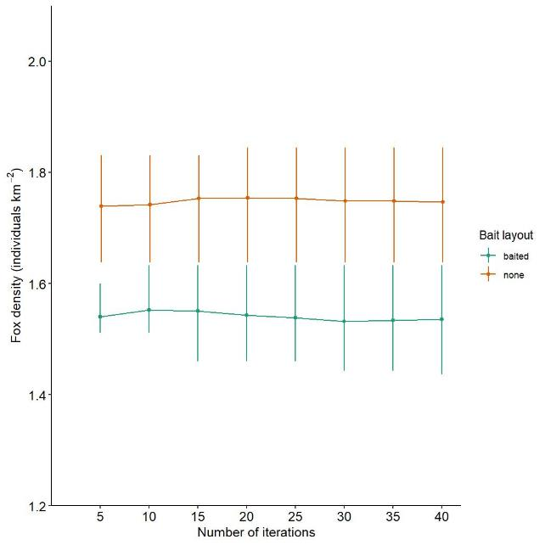Figure A2.2. FoxNet mean fox density with increasing number of scenario iterations. Mean fox density stabilised after 30 iterations. Error bars show minimum and maximum mean fox densities within iterations.

Testing for model run-in time and initial fox density showed that 10 years was enough to remove any model founding effects (to remove initial model variability), and the model fox density at initialisation of 2.2 foxes per km² is adequate (the stable model population peaks at approx. 2.2 foxes per km²) (Figure A2.3).

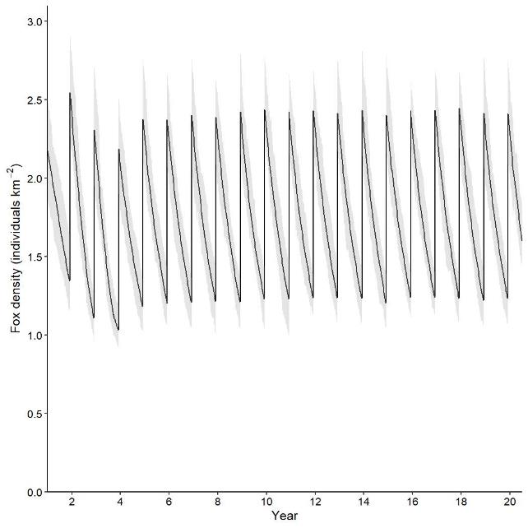Figure A2.3. Sensitivity testing for model run-in and initial fox density, showing that 10 years is a suitable run-in period to allow for founding effects to be removed, and that a model initialisation fox density of 2.2 foxes per km² is adequate. Grey-shaded areas indicate modelled minimum and maximum values across all iterations.

Bait efficacy sensitivity testing was undertaken across different levels of bait efficacy and was also undertaken at different model time-step scales. The model outputs showed that the bait efficacy model parameter (Pr-die-if-exposed-100ha) has a significant influence on model outcomes (Figure A2.4).

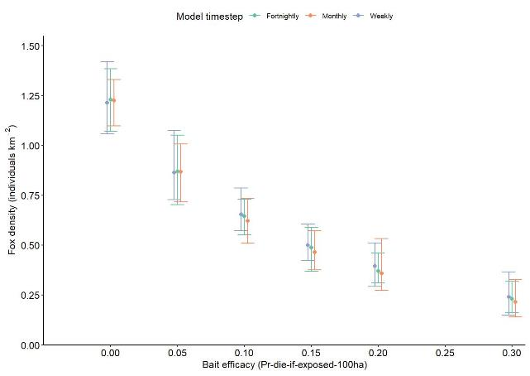Figure A2.4. Bait efficacy model parameter (Pr-die-if-exposed-100ha) sensitivity testing across different levels of efficacy and different model timestep scales, showing the significant influence different levels of bait efficacy can have on model outputs. Error bars show the minimum and maximum fox density for all iterations.

**Appendix 3. Four-weekly spatial model outcomes**

Model outcomes were reported mid-year for continuously baited programs, or after the final pulse for pulsed programs. Spatial reductions, particularly for continuously baited programs, are dynamic and vary throughout the year which is the same cycle as is seen in fox density graphs. Figure A3.1 shows the dynamic nature of a continuously baited project throughout a yearly fox cycle.

|  |  |  |
| --- | --- | --- |
|  |  |  |
|  |  |  |
|  |  |  |
|  |  |  |
|  | Figure A3.1. Year-round spatial outcomes for a continuous year-round baited program, showing the dynamic nature of reductions, with peak reductions just prior to the dispersal period. Four-weekly reductions, beginning with spatial reductions during the dispersal period (top left). | |

**Appendix 4. FoxNet model limitations**

1. **Size of home range**

Predicted fox densities tend to be more sensitive to a decrease in home-range size than an increase in home-range size, because smaller home ranges result in a denser population and less effective bait saturation. Fox home-range size is generally proportional to the level of the available resources, with smaller home ranges occurring in resource-rich habitats (Saunders and McCleod 2007). Our FoxNet modelling used a home range of 2.14 km², based on Hradsky et al. (2017). Their study was undertaken in temperate forests in southern Victoria. In habitat more closely representing the semi-arid projects in the north-west of Victoria, Towerton et al. (2016) tracked foxes in dry forests of central NSW and found fox ranges of up to 44.62 km², whereas Saunders and McCleod (2007) report home ranges varying between 3.4 and 6.1 km2.

Studies of fox home-range size and movement patterns across Victorian ecological regions would increase model accuracy.

1. **Baiting efficacy**

Currently, the model determines a probability of a fox dying per 100 ha, which scales with home-range size. The larger the home range, the lower the probability of encounter with baits. The default value of 0.3 comes from the ‘evaludated’ model of Hradsky et al. (2019), which used a fortnightly time step that was scaled to 0.15 for our weekly time-step models. In addition, some baits will not be available for the entire time step of the model, i.e. a bait may be taken by a non-target species, or become non-toxic, unpalatable or unattractive within the time step.

Incorporating a bait decay function and random removal of baits into the model is possible, but there is no reliable information currently available on these parameters. Conducting field trials under a variety of environmental conditions would provide boundaries for parameterisation of these factors.

1. **Bait replacement limited to weekly or greater**

Some projects may involve checking and replacing baits more frequently than the current minimum period allowable in the model. This discrepancy between baiting intervals could leave the model scenario baited for <30% of the time that occurs in the actual baiting regime, which potentially could lead to an underestimation of the efficacy of these regimes.

The model code could be adjusted to allow for multiple baits to be available within a time step to simulate the availability of baits per week.

1. **Fecundity**

The model population could not persist if fecundity was (unrealistically) low, even in the absence of baiting; however, increasing fecundity would have less effect, because carrying capacity is limited by the number of available territories (Hradsky et al. 2019).

1. **Timing of seasonal events**

Small discrepancies in the timing of seasonal events, such as births or dispersal (Marlow et al. 2016), or seasonal variation in mortality rates (Storm et al. 1976; Harris and Smith 1987), could cause differences between modelled fox densities and field estimates.

Information on these parameters would require detailed population studies. It may be possible to gather some of this information from shot samples, through the Victorian Fox Bounty scheme, by enlisting sporting shooters to collect samples at different times of the year. This would require the location and date of collection to be recorded and carcasses to be stored for later analysis.

1. **Fine-scale habitat use by foxes**

Bait encounters may differ between modelled baiting and real-world baiting, because generally baits were laid on roads or tracks, which may have a higher utilisation by foxes than the model could replicate. FoxNet models the probability of foxes encountering a toxic bait within their territory or potential dispersal territory relative to their overall territory size or dispersal exploration area (refer to Hradsky et al. 2019) and is currently unable to incorporate preferential fine-scale habitat use. However, the ability to model fox behaviour at fine-scale resolution would come at a significant computational efficiency cost.

1. **Demographic and seasonal stochasticity**

The spatial heterogeneity in the modelled landscapes across Victoria inevitably leads to variability in demographic parameters. Variability is considered by some to be a property intrinsic to any individually based model (DeAngelis and Mooij 2005), although this may be more important when modelling species of conservation concern. Variation in parameters can be gleaned from long-term studies, but often those long-term studies do not exist (Coulson et al. 2001). It could be argued that incorporating variation into a modelling scenario in which the mean is the main output of interest only leads to increasing the underlying variation, not changing the mean.

Hradsky et al. (2019) notes that stochastic variation is a potential inclusion in future revisions of FoxNet.

[www.delwp.vic.gov.au](http://www.delwp.vic.gov.au)

www.ari.vic.gov.au