Benefits of environmental water – The Victorian Environmental Flow Monitoring and Assessment Program
Fact sheet 1 – VEFMAP Stage 5

Managing environmental water in Victoria
‘Environmental water’ is water that is specifically allocated to protect and restore a healthy environment within rivers, the floodplain, wetlands and estuaries.

Partnership
Many agencies work together to develop and implement environmental watering programs in Victoria. This includes the Department of Environment, Land, Water and Planning (DELWP), the Victorian Environmental Water Holder (VEWH), Catchment Management Authorities (CMAs), land managers and water authorities, the Commonwealth Environmental Water Office (CEWO) and the Murray-Darling Basin Authority (MDBA).

Water is a scarce resource and it is important to use environmental water as effectively as possible. Delivery of environmental water is targeted to priority areas where significant environmental values exist.

Environmental flows achieve many ecological benefits

The Victorian Government approach - VEFMAP
DELWP, which plays a key role in overseeing the environmental watering program, established the Victorian Environmental Flows Monitoring and Assessment Program (VEFMAP) in 2005. This is a large-scale, long-term monitoring program to assess ecosystem responses to environmental watering in eight regulated rivers in Victoria. The results help inform decision-making for future environmental watering.
A 2014 review of VEFMAP recommended that Stage 5 should focus primarily on the analysis of native fish and riparian vegetation responses to environmental water.

VEFMAP Stage 5
VEFMAP Stage 5 runs from March 2015 to June 2016. It is led by the Arthur Rylah Institute (ARI), in partnership with DELWP and the University of Melbourne. A multi-agency Technical Reference Group also includes participants from the Glenelg Hopkins CMA, Goulburn-Broken CMA and independent scientists from across Australia.
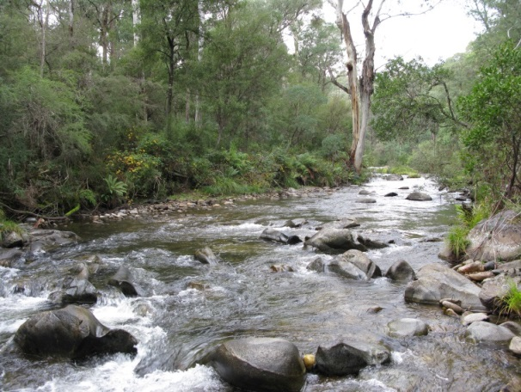
Stage 5 objectives are to:
- continue to demonstrate the ecological importance of environmental water.
- increase the effectiveness of VEFMAP’s contribution to adaptive management of environmental water, including refining our understanding of flow-biota relationships, undertaking further data analyses and developing case studies.
- plan an approach for a proposed Stage 6.
There is now an increased emphasis on:
- linking with complementary programs and data sources related to fish and vegetation response to flows.
- sharing information and results broadly with all stakeholders to highlight the benefits of environmental water.
- more targeted monitoring of specific flow events, population responses and specific sites.

Meeting stakeholders’ needs
In October 2015, ARI undertook a survey of stakeholders within CMAs, Melbourne Water and VEWH to understand their views on VEFMAP, and identify what they want and need from the program. The comprehensive feedback has provided the project team with strong guidance for an approach to deliver Stage 5 and plan a proposed Stage 6.

Key findings
The key findings of the Stage 5 analysis of VEFMAP and complementary data include that:
- VEFMAP as a large scale, long-term program, has provided valuable baseline information on fish communities to support managers. The monitoring has confirmed the threatened status of 11 native fish species, and the dominance of non-native fish species such as Carp.
- some patterns in abundance and distribution of particular native and non-native fish species are apparent. These include recovery of Murray Rainbowfish in some northern rivers, range expansions of several native coastal fish species, and some spawning responses of Carp to flooding events.

- regional case studies of Australian Grayling, Golden Perch and Silver Perch have identified ecological responses to environmental flows which can inform planning.

A final report on the Stage 5 analyses will be available by June 2016. Fact sheets are also being developed to summarise the results of the analyses, to support water managers in designing and implementing future environmental watering events.

VEFMAP Stage 6
Early planning for a proposed VEFMAP Stage 6 has commenced. There will be strong consultation with stakeholders to ensure this program meets their needs. This will involve forums with the CMAs and independent scientific input.

VEFMAP Stage 6 will focus on:
- strong science, best practice and use of an adaptive and consultative approach. It will be forward looking and apply the scientific learnings so far.
- developing a series of regional and system-specific objectives.
- developing regional approaches that are based on clear hypotheses, species-specific conceptual models and practical monitoring methods. The new approach will be highly transferable among rivers, to maximise the benefits at broad geographic scales.

