Help protect our
southern right whales

Engagement pack

Help protect our southern right whales

Endangered southern right whales return to Victoria’s coastal waters each year between May and October to give birth and raise their calves.
With the help of the whale watching community, the Department of Energy, Environment and Climate Action (DEECA) has been monitoring the population for decades. After being protected from whaling in Australian waters in 1935, the species is recovering slowly. Currently, there are only approximately 300 whales in our south-east Australian population.
Species experts have highlighted that southern right whales are vulnerable to boat strikes and disturbance right along the coast of Victoria. To help our southern right whale population recover, boat responsibly and follow three key actions:
1. WATCH OUT FOR WHALES: Stay alert, as southern right whales can be difficult to spot. These whales have no dorsal fin, so they can look like floating logs as they rest near the surface, often in shallow water close to shore.
2. SLOW DOWN TO 5 KNOTS: Within 300m of a whale, you must slow to 5 knots. It's best to travel at less than 10 knots when within 1km of whales to keep vessel noise low. Mothers and calves need rest and quiet as they communicate in whispers to avoid predators.
3. KEEP A SAFE DISTANCE: Don't go within 200m of a whale in a boat, 300m on a jet ski. Stay out of their way and avoid boxing them in. If you find yourself too close to a whale, put your engine in neutral and let them pass.
The broader community can also help protect our whales:
- Learn about our southern right whales and share this knowledge with others.
- Report disturbance to whales or unsafe boating to Crime Stoppers Victoria on 1800 333 000.
- Upload photographs and sightings of the visiting whales to the online platform, WhaleFace. The information collected will help future research and provide updates on the whales during breeding season.

Watch out for whales – awareness initiative

In the coming weeks, southern right whales will give birth and nurse their calves in waters along the Victorian coastline. It means those of us out on the water must take special care to protect them.
With funding from the Victorian Government’s Icon Species Program, the Department of Energy, Environment and Climate Action’s (DEECA) Arthur Rylah Institute and the Conservation Regulator are leading a community awareness and engagement initiative to help reduce the risk of boat strikes and disturbance to our whales.
The project has delivered a range of resources to educate our recreational boating community about the important role they play in protecting the species. We need your help spreading these important messages to your community at events, workshops, or public locations.
Enclosed in this Engagement pack is:
- Poster - seasonal boat ramp signage
- Postcard
- Sticker
- Frequently asked questions (FAQs)
- Social media post static
- Social media post video
- Newsletter article
If you would like to receive hard copies of the above printable material, please contact our project team using the details below.

Contacts
Project Lead: Dr Kasey Stamation, kasey.stamation@delwp.vic.gov.au
Arthur Rylah Institute, Collaboration and Impact: Tess McLaren, tess.mclaren@delwp.vic.gov.au

Poster – Warrnambool seasonal signage
Specs: A2 (can be printed at A3)
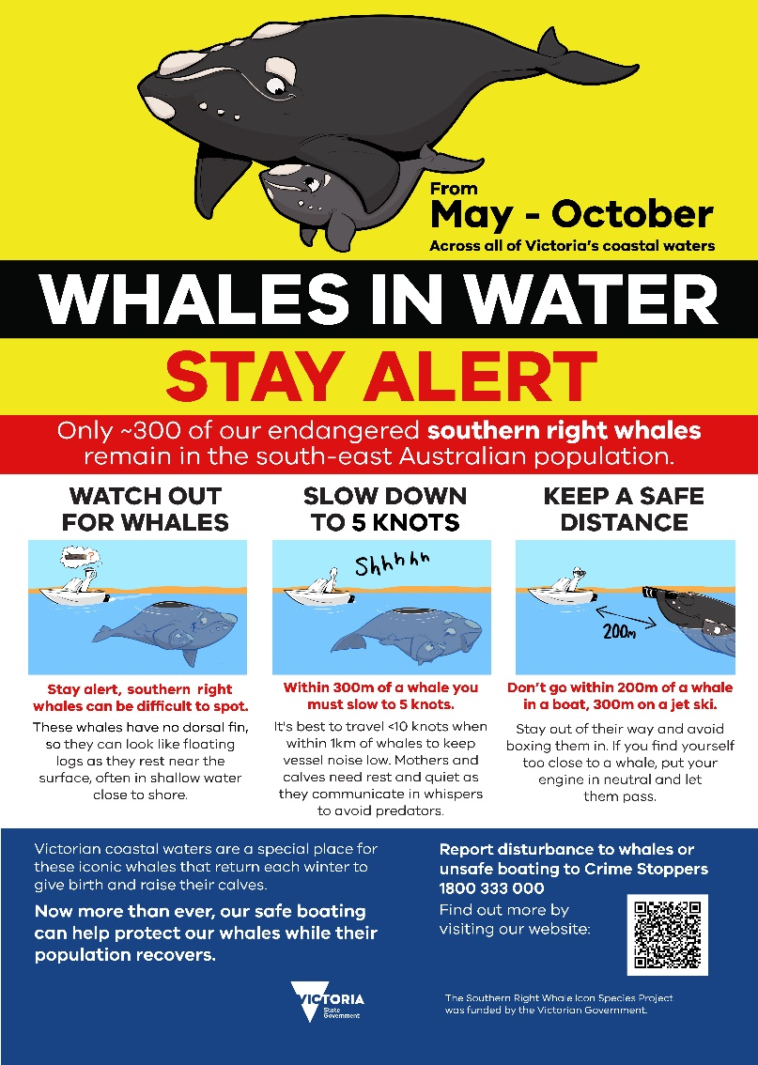

Audience: Boaters and coastal community of Warrnambool

How should it be shared?
This poster has been designed specifically for Warrnambool where locals are already familiar with the term whale nursery but need to be alert to whales present outside their regular breeding ground at Logan's Beach. This poster is not designed to be used at Logan’s Beach as separate rules apply for vessels from 1 June to 31 October. It can be displayed at retail stores or hospitality venues or provided to boating/fishing interest groups in the Warrnambool community for display. Corflute signs will be displayed at coastal boat ramps in Warrnambool between May and October to warn people that whales are in the water.
DOWNLOAD

Poster – State-wide seasonal signage
Specs: A2 (can be printed at A3)
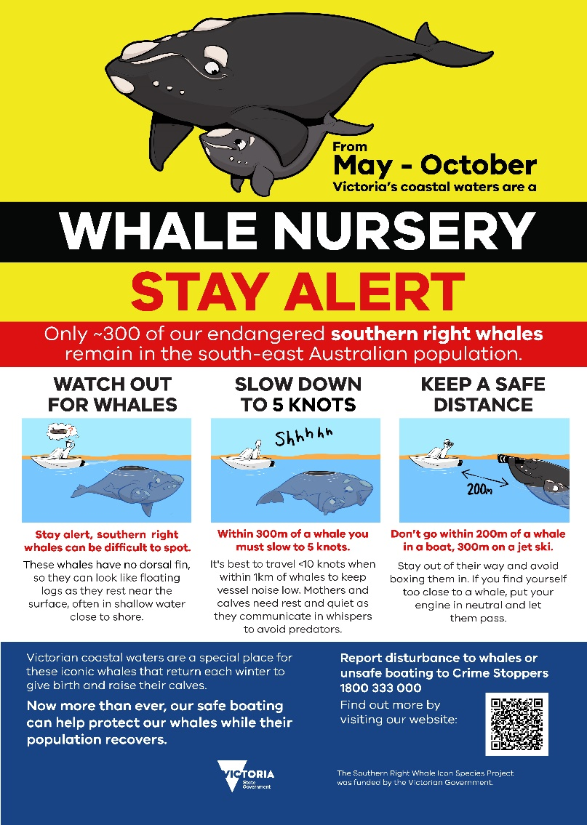

Audience: Boaters, coastal communities

How should it be shared?
This poster has been designed for display right along Victoria’s coastline. It can be displayed at retail stores or hospitality venues or provided to boating/fishing interest groups in coastal communities for display. Corflute signs will be displayed at coastal boat ramps between May and October to ensure people who use the water stay alert for whales.
DOWNLOAD

Postcard
Specs: 99mm x 210mm (1/3 A4)
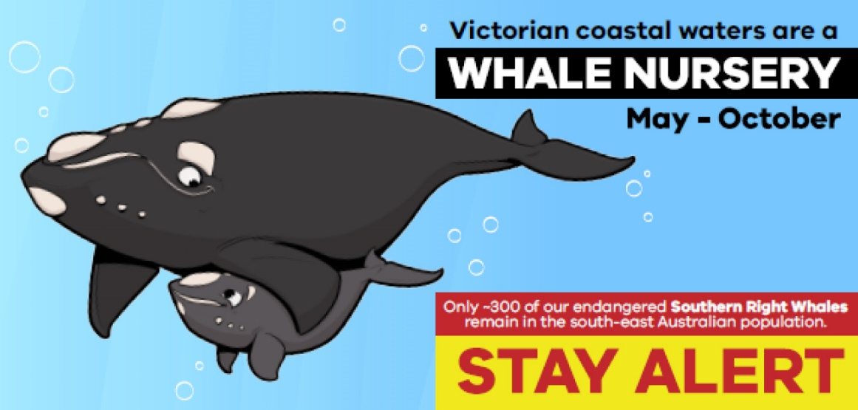
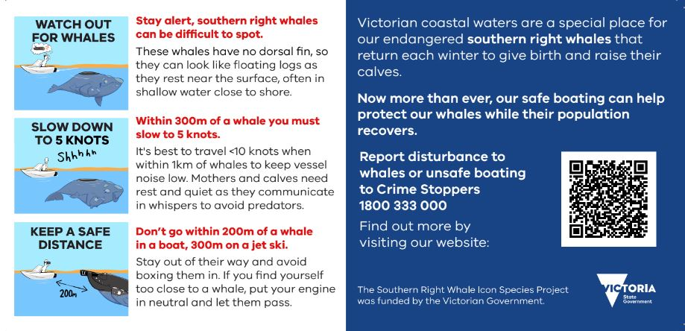

Audience: Boaters, coastal community.

How should it be shared?
This postcard can be distributed at events or workshops, supplied to retail stores or hospitality venues, or provided to boating/fishing interest groups. It has been designed for people to take and keep in their pocket the next time they go boating.
DOWNLOAD

Sticker
Specs: 85mm
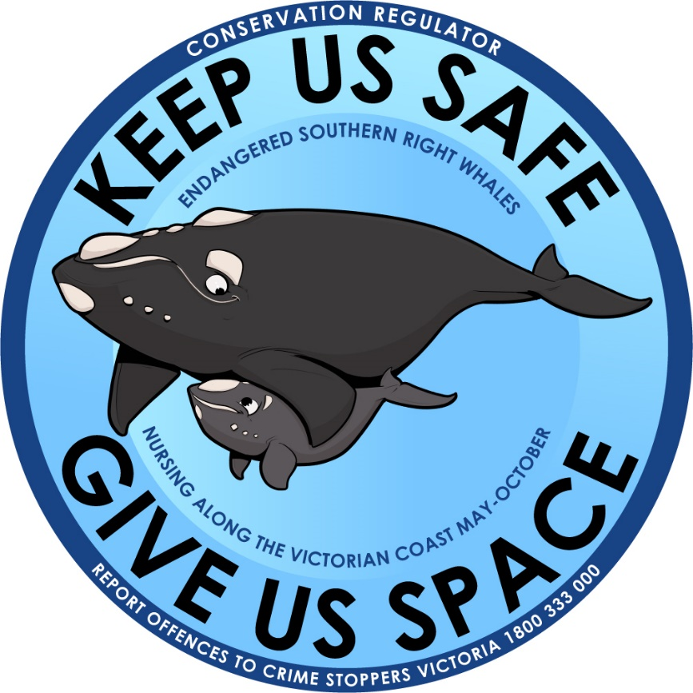

Audience: Recreational and commercial boat users, beach goers, coastal community.

How should it be shared?
This sticker can be distributed at community events, supplied to retail stores or hospitality venues, or provided to local schools and community interest groups. It has been designed for outdoor use and people stick it on their boat, vehicle, surfboard bag or beach gear.
Contact our team for your own stickers or download the design below.
DOWNLOAD

FAQs
Specs: A4 double sided
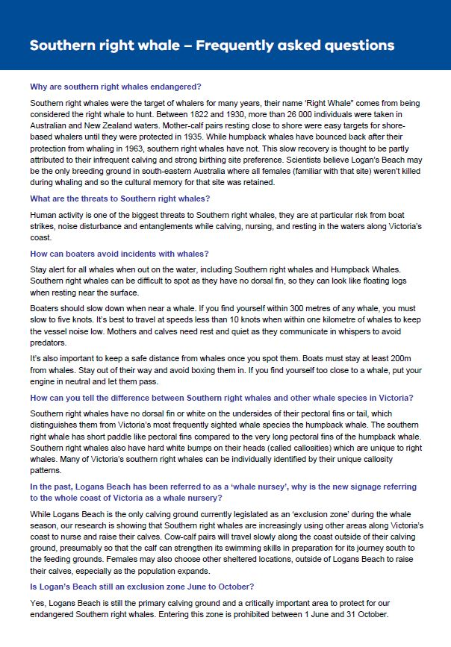

Audience: Engagement partners, coastal community.

How should it be shared?
This FAQ document can be provided to interested parties or used to inform further engagement across different platforms such as websites, media articles or educational conversations with local community or at events.
DOWNLOAD

Social media post static
Specs: 1080 x 1080
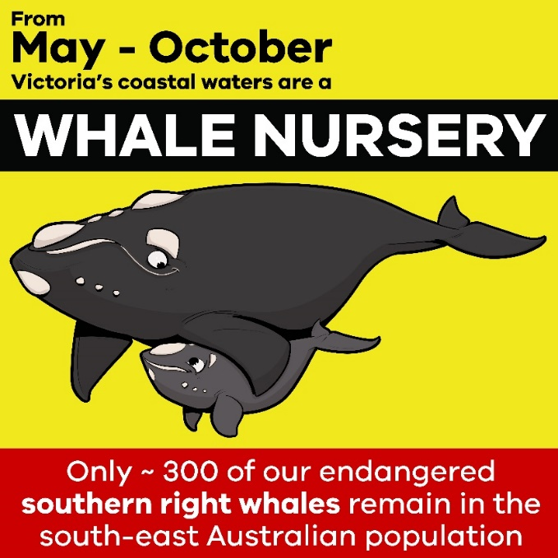

Suggested text:
Our endangered southern right whales need our help. When out on the water: Watch for whales, slow down and keep a safe distance.
Call to action: Learn more about sharing the water with whales at https://www.wildlife.vic.gov.au/our-wildlife/whales,-dolphins-and-seals/water-safety-around-marine-mammals

Audience: Coastal community

How should it be shared?
Share this image and text on your social media platforms to ensure coastal communities see the important message.
DOWNLOAD

Social media video
Specs: 44seconds, MP4, 1080 x 1080

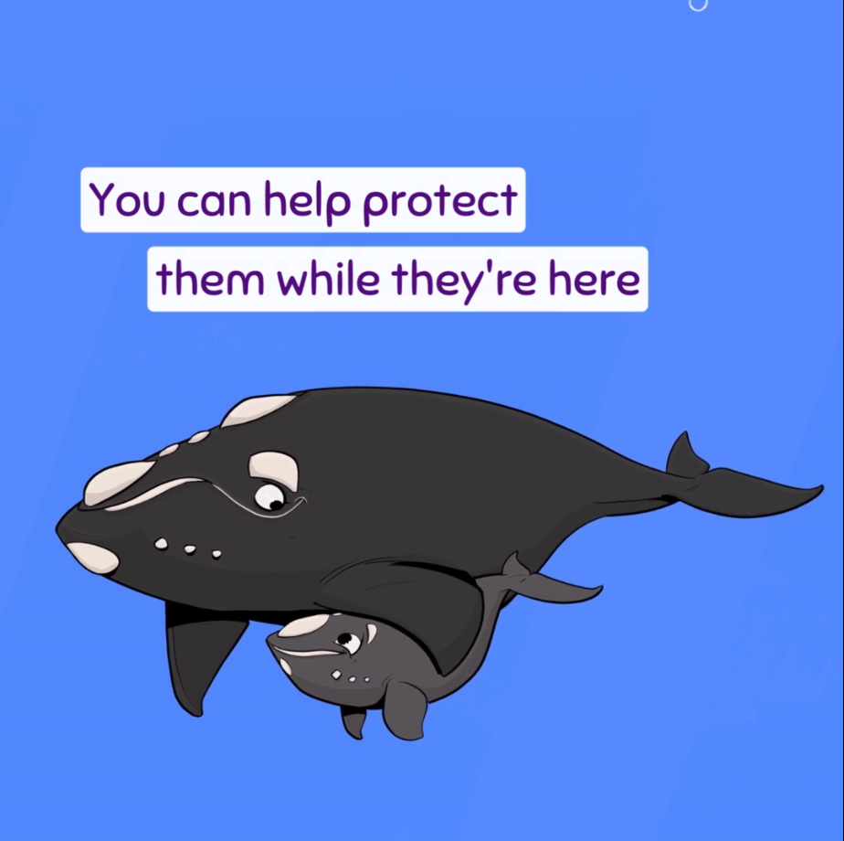

Suggested text:
Our endangered southern right whales need our help. To protect our whales when out on the water: Watch for whales, slow down and keep a safe distance.
Stay alert, these whales have no dorsal fin and can look like floating logs as mothers and calves rest near the surface, often in shallow water close to shore. Slow down to keep vessel noise low. Mothers and calves need rest and quiet as they communicate in whispers to avoid predators.
Giving our whales plenty of space keeps them safe.
Call to action: Learn more about sharing the water with whales at https://www.wildlife.vic.gov.au/our-wildlife/whales,-dolphins-and-seals/water-safety-around-marine-mammals

Audience: Coastal community.

How should it be shared?
Share this fun video and text on your social media platforms to ensure coastal communities see the important message.
DOWNLOAD

Newsletter article
Looking out for our southern right whales
Boaters are being asked to stay alert as endangered southern right whales make their way back to Victoria’s coastal waters to birth and care for their young.
With just 300 southern right whales estimated to remain in the south-eastern Australian population, the annual breeding season – from May to October – is a crucial time for the species.
Boaters play an important role in protecting these rare and magnificent creatures as disturbance and strikes from boats pose significant threats during this time.
The Department of Energy, Environment and Climate Action’s (DEECA) Arthur Rylah Institute for Environmental Research and the Conservation Regulator are urging our recreational boating community to follow three simple steps:
- WATCH OUT FOR WHALES: Stay alert, southern right whales can be difficult to spot. These whales have no dorsal fin, so they can look like floating logs as they rest near the surface, often in shallow water close to shore.
- SLOW DOWN TO 5 KNOTS: Within 300m of a whale you must slow to 5 knots. It's best to travel at speeds less than 10 knots when within 1km of whales to keep vessel noise low. Mothers and calves need rest and quiet as they communicate in whispers to avoid predators.
- KEEP A SAFE DISTANCE: Do not go within 200m of a whale in a boat, 300m on a jet ski. Stay out of their way and avoid boxing them in. If you find yourself too close to a whale, put your engine in neutral and let them pass.
The endangered species has traditionally been observed at Warrnambool's Logan’s Beach, however in recent years mothers and calves have increasingly been seen right along Victoria's coast.
Community members can contribute to whale conservation by submitting whale sightings and photos to WhaleFace.
Community sightings submitted to this platform have allowed DEECA to add new whales to the photo-identification catalogue, to track the return of calving females, and have provided crucial information about nursing, resting, and strengthening locations used by southern right whales.
To learn more about the regulations for boaters near whales, visit: https://www.wildlife.vic.gov.au/our-wildlife/whales,-dolphins-and-seals/water-safety-around-marine-mammals

Audience: Boat owners, vessel operators, broader coastal community

How should it be shared?
This article has been written for stakeholders to share in their regular newsletters or on the news sections of their websites. It is designed to engage boat owners and vessel operators to follow the important and simple steps to protect whales, and to encourage the broader community to contribute to the WhaleFace platform.
DOWNLOAD

