Abundance of deer in Victoria  Regional and statewide estimates of deer density and their impact on vegetation | Title in sentence case,  as in this example, with no more than three short lines  Subheading continues in sentence case  over two lines maximum
J.G. Cally and D.S.L. Ramsey | Initial(s). Surname1, Initial(s). Surname2,  Initial(s). Surname3 and Initial(s). Surname4
October 2023 | Month Year
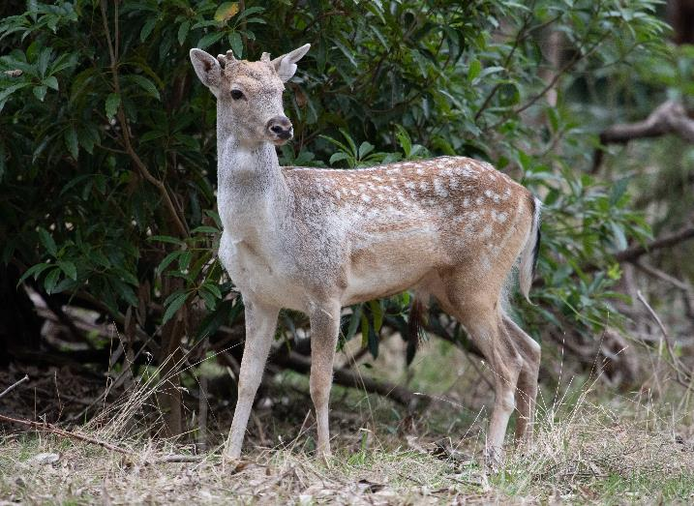

Arthur Rylah Institute for Environmental Research
Technical Report Series No. 368





Acknowledgment
We acknowledge and respect Victorian Traditional Owners as the original custodians of Victoria's land and waters, their unique ability to care for Country and deep spiritual connection to it. We honour Elders past and present whose knowledge and wisdom has ensured the continuation of culture and traditional practices.
We are committed to genuinely partner, and meaningfully engage, with Victoria's Traditional Owners and Aboriginal communities to support the protection of Country, the maintenance of spiritual and cultural practices and their broader aspirations in the 21st century and beyond.

Arthur Rylah Institute for Environmental Research
Department of Energy, Environment and Climate Action
PO Box 137
Heidelberg, Victoria 3084
Phone (03) 9450 8600
Website: www.ari.vic.gov.au
Citation: J.G. Cally, and D.S.L. Ramsey (2023). Abundance of deer in Victoria: Regional and statewide estimates of deer density and their impact on vegetation. Arthur Rylah Institute for Environmental Research Technical Report Series No. 368. Department of Energy, Environment and Climate Action, Heidelberg, Victoria.
Front cover photo: Fallow deer at Lysterfield Park (Arthur Rylah Institute).
© The State of Victoria Department of Energy, Environment and Climate Action 2023

This work is licensed under a Creative Commons Attribution 3.0 Australia licence. You are free to re-use the work under that licence, on the condition that you credit the State of Victoria as author. The licence does not apply to any images, photographs or branding, including the Victorian Coat of Arms, the Victorian Government logo, the Department of Energy, Environment and Climate Action logo and the Arthur Rylah Institute logo. To view a copy of this licence, visit http://creativecommons.org/licenses/by/3.0/au/deed.en
Edited by Fox Writing Services
ISSN 1835-3835 (pdf)
ISBN 978-1-76136-434-1 (Print)
ISBN 978-1-76136-435-8 (pdf)

Disclaimer
This publication may be of assistance to you but the State of Victoria and its employees do not guarantee that the publication is without flaw of any kind or is wholly appropriate for your particular purposes and therefore disclaims all liability for any error, loss or other consequence which may arise from you relying on any information in this publication.

Accessibility
If you would like to receive this publication in an alternative format, please telephone the DEECA Customer Service Centre on 136 186, email customer.service@delwp.vic.gov.au or contact us via the National Relay Service on 133 677 or www.relayservice.com.au. This document is also available on the internet at www.deeca.vic.gov.au

Abundance of deer in Victoria

Regional and statewide estimates of deer density and their impact on vegetation

J.G. Cally and D.S.L. Ramsey

Arthur Rylah Institute for Environmental Research
123 Brown Street, Heidelberg, Victoria 3084

Date

Arthur Rylah Institute for Environmental Research
Technical Report Series No. 368

Acknowledgements
This work was funded by Department of Energy, Environment and Climate Action (DEECA) Biodiversity Division under the Victorian Deer Control Strategy, and we thank Stefan Kaiser, Michelle Hanslow and Daryl Clune for facilitating this project. We also thank the Game Management Authority, particularly Simon Toop, for providing the funding for the targeted Hog Deer survey. We would like to thank Wildlife Unlimited, Brad Farmilo, Declan Leevers, Thomas Schneider, Luke Woodford, Dave Bryant, Emily Jordan, Rob Dabal, Khorloo Batpurev, Ellie Tsiamis and Celsey Adams for their contributions to fieldwork. Image tagging was also supported by Thomas Schneider and Luke Woodford. Finally, we would like to thank Jian Yen, Steve Sinclair, Simon Toop, Jason Flesch, and Chris Davies for providing comments and suggestions on the report.

Contents
Acknowledgements ii
Summary 1
Context: 1
Aims: 1
Methods: 1
Results: 2
Conclusions and recommendations: 2
1 Introduction 3
1.1 Objectives 4
2 Methods 5
2.1 Site selection 5
2.2 Field methods 5
Camera trap deployment 5
Deer sign searches 7
Vegetation assessment 7
2.3 Model of deer density 8
Camera detection process 8
Abundance process from camera trap counts 9
Supplementing camera data with transect detections 10
Model selection and validation 10
Prediction of deer abundance across Victoria 10
Estimating range size across Victoria 11
2.4 Effect of deer abundance on vegetation 11
3 Results 12
3.1 Detection of deer 12
Distance sampling 12
Transects 14
3.2 Deer abundance 15
Site-level estimates 15
Regional and statewide estimates 15
Drivers of abundance 20
Distribution 20
3.3 Effect of deer abundance on vegetation 24
4 Discussion 26
4.1 Deer abundance 26
4.2 Deer distribution 27
4.3 Impact on vegetation 28
4.4 Limitations and future recommendations 28
5 References 30
6 Appendix 34

Tables
Table 1. Camera deployment settings. 6
Table 2. Model selection table for deer detection. 14
Table 3. Average (mean) density estimates at the various groups of sites (according to detection patterns). SD = standard deviation. 16
Table 4a. Regional model-based estimates of deer abundance on public land in each DEECA region (SD = standard deviation; CV = coefficient of variation). 17
Table 4b. Regional design-based estimates of deer abundance on public land in each DEECA region (SD = standard deviation; CV = coefficient of variation). 18
Table A1. Descriptions of covariates used to model deer density. 35
Table A2. Australian studies that have estimated deer densities at local and regional scales. Dens = Density (deer per km²), LB = Lower bound provided by the study, UB = Upper bound provided by the study. 36
Table A3. Estimated average abundance and density of deer in reserves listed under the National Parks Act 1975 and greater than 20 km² in size. Reserves are ordered from highest estimated density to least (n = 157). 38
Table A4. Wildlife species (n=73) detected during the statewide and hog deer surveys, including the number of sites where the species was detected. 42

Figures
Figure 1. Field setup at each site used for deploying camera traps, deer sign transects and vegetation sampling. Camera locations were set at least 150 m from the nearest track/road that provided the closest access to the centroid of the sampling unit (4 km² hexagonal grid cell). 6
Figure 2. An example image showing the markers placed at set intervals from the camera location to enable distance sampling. A Sambar deer is present in this image. 7
Figure 3. Detections of deer species (camera or transects) from across Victoria. Detections of Hog deer were restricted to Gippsland. 13
Figure 4. Distance-sampling detection process for deer (group size = 1–5). Herbaceous understorey cover in the area surrounding appeared to have some impact on detection probability. 14
Figure 5. Conditional detection probabilities for the various methods of survey, across various deer densities. Camera trap detection probability was based on average deployment length (53 days), while transects were based on three transect searches. 15
Figure 6. Spatial variation in deer density (deer/km²) for (A) Sambar, (B) Fallow, (C) Red, and (D) Hog deer across Victoria. Grey area reflects area not included in predictions (i.e., not public land), and grid cells are offset by the proportion of overlapping public land. Estimates for each prediction grid cell (1km²) use the mean. 19
Figure 7. Effects of the influence of bioregions on variation in deer abundance (log-scale), with unsampled bioregions shown in grey. 21
Figure 8. Conditional effects of five covariates used in the top model. The y-axis shows the relative contribution to abundance (log-scale), and the x-axis shows the untransformed covariate values. All parameters were scaled for use within the model with square-root transformations for bare soil, nitrogen, and forest edge. Distance to pastural land was rounded up to the nearest 100 m and log transformed. 50% and 90% confidence bands are shown with dark and light purple shadings. 22
Figure 9. Estimates of the occupied range for Sambar, Fallow, Red and Hog deer across Victoria. White area reflects area not included in predictions (i.e., not public land), LCI and UCI confidence bounds refer to bootstrapped threshold confidence intervals (90%) for optimal sensitivity and specificity. 23
Figure 10. Conditional effect of deer density at sampled sites on a range of vegetation measures. Density was negatively related to (A) bare ground and (B) native woody understorey cover. Increased deer density was positively correlated with (C) native herbaceous understorey and the (F) presence of exotic species. No strong relationships were found between deer density and (D) seedlings or (E) saplings. Inner and outer shading represents 50% and 90% confidence levels, respectively. 25

Summary

Context:
Deer populations are anticipated to be increasing and widespread across Victoria. Given the range of impacts deer have on biodiversity, public safety, water quality, agriculture, and Aboriginal cultural heritage, the Victorian Deer Control Strategy (Department of Environment Land Water and Planning 2020) sought to address knowledge gaps relating to the distribution, abundance, and impacts of deer in the state. The statewide deer monitoring project was developed as a multi-year project to fill these knowledge gaps, with monitoring commencing in 2021. This report summarises the monitoring data collected to estimate statewide and regional deer distribution and abundance, as well as impacts on ecosystem health.

Aims:
The aims of this project were to:
- design and implement a statewide monitoring program to estimate the abundance of the four deer species in Victoria (Sambar, Fallow, Red and Hog), and report the resulting abundance estimates at statewide and regional scales
- undertake vegetation assessments at each monitored site to measure understory vegetation cover, seedling and sapling stem densities and canopy tree cover, to establish current measures of these ecological characteristics
- produce spatial raster layers of deer densities for each of the four deer species, that would be suitable for use in GIS software
- provide guidance on how the monitoring data could be developed to provide ecological indicators of trends in deer abundance and ecological integrity (e.g., vegetation condition), suitable for State of the Environment (SOE) reporting requirements.

Methods:
The area of Victorian public land (74,570 km²) was divided up into 4 km² hexagonal grid cells (sites), with sites selected for monitoring using a balanced acceptance sampling approach. A total of 253 sites were monitored between September 2021 and May 2023. Due to the restricted range of Hog deer, an additional 64 sites were selected in South Gippsland and Wilsons Promontory to specifically target that species.
At each site, we used various methods to detect deer. First, we deployed a camera trap by attaching it to a tree at a height of 1 m, and positioned at least 150 m from the nearest road/track. Four distance markers were set at 2.5 m, 5 m, 7.5 m, and 10 m from each camera, to enable distance sampling and therefore allow us to estimate absolute abundance at a site. Second, we supplemented camera traps with transect-based searches for deer pellets and other deer signs (e.g., pellets, footprints, rubbings, and wallows). In concert with camera-trap deployment and transect searches, we also implemented a rapid-vegetation assessment at each site. This vegetation assessment measured key structural vegetation components to assess possible impacts of deer on native flora. Transect surveys and vegetation monitoring were conducted at all statewide sites, but not the sites targeting Hog deer.
We used a multispecies hierarchical Bayesian model to integrate both the camera trap distance sampling data and the deer sign searches, to estimate the density and abundance of deer. We used a selection of environmental, climatic, and regional-based variables to predict the spatial variation in abundance/density of each deer species across public land. These gridded predictions were then summed to provide regional and state-wide estimates of deer abundance for Sambar, Fallow, Red, and Hog deer. Statewide predictions were also used to derive updated range estimates for each deer species.
We used estimates of deer density at each sampled site (summed across all four species) to investigate whether there was any relationship between deer density and our suite of six vegetation variables that were measured at each site. Specifically, we investigated whether deer density at a site influenced the cover of bare ground, native woody understorey cover, native non-woody/herbaceous understorey cover, seedling abundance, sapling abundance and/or the presence/absence of exotic plant species.

Results:
Deer were detected at 148 of the 317 camera traps across Victoria, and some form of deer sign (camera or transect) was recorded at 186 of the 317 sites. Total deer abundance on Victorian public-tenured land was 191,153 (90% CI: 146,732, 255,490). Sambar deer were the most abundant species across Victoria (123,061 [90% CI: 96,200, 157,638]), followed by Fallow (48,932 [90% CI: 29,888, 85,063]), Red (12,672 [90% CI: 4,719, 35,465]), and Hog (4,243 [90% CI: 2,121, 8,464]) deer. Within Department of Energy, Environment and Climate Action (DEECA) regions, deer density on public-tenured land was highest in Hume, followed by Barwon South West, Port Phillip, Gippsland, Grampians, and Loddon Mallee. Range estimates for deer on public land were highest for Sambar (38,582 km² [95% CI: 33,405, 40,590]), followed by Fallow (24,901 km² [95% CI: 20,666, 30,423]), Red (9,403 km² [95% CI: 2,465, 10,148]), and Hog (2,176 km² [95% CI: 1,542, 2,219]) deer.
Results from the modelling suggested that five variables influenced the spatial variation in deer abundance including bioregion, the percentage of bare soil, distance to pastural land, precipitation seasonality, and amount of forest edge surrounding a site. All deer species tended to have higher densities in closer proximity to pastural land, but this effect was stronger for Fallow and Red deer. The amount of forest edge in the landscape positively impacted the abundance for Fallow deer. It was also weakly positively associated with the abundance of Sambar and Hog deer, but negatively associated with the abundance of Red deer.
We also found evidence for relationships between deer density and several components of vegetation structure and composition. An increased density of deer was related to decreased native woody understorey cover, decreased percentage of bare soil (and conversely, increased native herbaceous understorey cover). Higher densities of deer were also related to increased probabilities of exotic plant species (weeds) being present at a site, with the presence of weeds being 1.17 [90% CI: 1.04, 1.33] times more likely for every 1 deer/km² increase in deer density.

Conclusions and recommendations:
This study provides the first estimates of the statewide and regional abundance of the four main deer species in Victoria. Consequently, these estimates provide critical baseline data on spatial variation in deer densities, and a range that can be used to target and evaluate deer management more effectively. We also provide evidence that deer may be implicated in reducing native woody understory cover and an increased probability of weed invasion.
The estimates of statewide and regional abundance of deer could provide representative data suitable for incorporation into biodiversity reporting, such as the biodiversity indicator framework (e.g., Victorian Biodiversity Index). Repeat monitoring of a subset of the sites surveyed in this study would provide the data necessary to establish statewide and regional trends in deer and possibly other wildlife species. Future work should identify the minimum subset and locations of sites that could reasonably contribute to such a framework. The recommendations arising from this report are as follows:
- spatial raster layers of deer abundance/density and range for each deer species should be used in future planning around deer management. These layers are provided as supplementary material accompanying this report
- priorities for future deer management should identify parks or reserves of high conservation significance that are at high risk of impacts from deer. Control in reserves on species range fronts may also limit the expansion of deer in Victoria. A list of parks and reserves and corresponding deer densities is provided in Table A3
- to incorporate trends in deer density into the biodiversity indicator framework, monitoring of a subset of sites should be repeated biennially. A subset of sites targeting Sambar, Fallow and Red deer distributions should be identified for future monitoring. Power analyses and simulations can help guide the selection of which sites, how many, and over what timeframe monitoring should be conducted (Andersen and Steidl 2020)
- future monitoring of deer trends should also include an assessment of vegetation condition to monitor impacts of deer. Suitable measures of potential deer impacts include native woody understory cover and presence/absence of exotic flora (weeds).

- Introduction
Four species of deer have established feral populations in Victoria: Fallow deer (Dama dama), Sambar deer (Cervus unicolor), Red deer (Cervus elaphus) and Hog deer (Axis porcinus) (Moloney et al. 2022). Globally, deer have been implicated in modifying forest ecosystems, mainly by reducing understorey biomass and species diversity, and the growth and survival of tree seedlings (Côté et al. 2004; Tanentzap et al. 2009; Barrette et al. 2014). However, the impacts of deer in Australian ecosystems are relatively poorly understood (Davis et al. 2016). Deer are also a valued game resource popular with recreational hunters, with the net economic contribution of recreational hunting to the Victorian economy valued at around $11M–$32M per year (Walshe et al. 2022). Wild deer in Victoria are likely to have adverse impacts on biodiversity, as well as public safety, water quality, agriculture, and Aboriginal cultural heritage values (Davis et al. 2016), with the impacts of deer estimated to cost the Victorian economy over $1.1 billion over the next 20 years (Walshe et al. 2022). Risks that deer pose to biodiversity include the reductions in understorey cover, species diversity (Moriarty 2004), and seedling recruitment (Davis and Coulson 2010). These impacts may negatively affect threatened flora (Forsyth and Davis 2011) and fauna under certain conditions (Pedersen et al. 2014). While the magnitude of these adverse effects on biodiversity are currently unknown, they are likely to be dependent on the density of deer at a given location, with previous studies showing that high density deer populations have a greater impact on vegetation structure (Moriarty 2004; Davis et al. 2016).
To mitigate the impacts of deer on biodiversity, safety, agriculture and cultural values, the Victorian Deer Control Strategy was released in October 2020 (Department of Environment Land Water and Planning 2020). Alongside regional deer control strategies (Peri-urban, Eastern Victoria and Western Victoria), the Deer Control Strategy will implement various methods to reduce deer abundance, with an aim to limit their impacts on native biodiversity. However, existing knowledge gaps on deer range and abundance in Victoria, and their associated impacts, may prevent control measures from being well-targeted and sufficiently evaluated. To tackle these knowledge gaps, the Victorian Deer Control Strategy provided funding to undertake an extensive statewide survey of deer to generate statewide and regional estimates of deer distribution and abundance.
Previous studies have attempted to estimate deer abundance in Australia at various point locations, and localities across eastern Australia (Amos et al. 2014; Bengsen et al. 2022). However, only one study that we are aware of has attempted to estimate deer abundance at a regional or statewide level (Lethbridge et al. 2019). This study estimated the abundance of Fallow deer across the core range of the species in Tasmania (Lethbridge et al. 2019). Various methods have been employed to measure absolute or relative estimates of deer density within Australia. These methods include aerial surveys (Amos et al. 2014; Lethbridge et al. 2019), catch-effort models from aerial control (Ramsey et al. 2023), spatial mark–resight camera trap surveys (Bengsen et al. 2022), spotlighting transects (Lethbridge et al. 2019), faecal pellet counts (Forsyth et al. 2016; Davis et al. 2017), genetic mark-recapture (Pacioni et al. 2023) and camera-trap distance sampling (CTDS) (Ramsey et al. 2019).
The abundance of deer in Victoria has been the subject of much debate, with estimates ranging from several hundred thousand to one million deer (Department of Environment Land Water and Planning 2020). This large figure (one million) appears to be an extrapolation based on the number of deer taken by recreational hunters, which was estimated to be almost 123,000 deer in 2022 (Moloney and Flesch 2023). These recreational harvest estimates are based on telephone surveys of a sample of recreational hunters undertaken several times per year (Moloney et al. 2022). However, analysis of the most recent recreational harvest surveys has indicated that the estimate of total harvest is sensitive to reporting bias, especially from respondents who report very high harvest rates (Moloney and Flesch 2023). Harvest estimates also include hunting that occurs on private land, which often makes up a large proportion (~ 50%) of the recreational take of deer.
Previous estimates of the abundance and densities of deer in Victoria have been largely based on monitoring conducted over small areas, between 2 and 15 km² (Bengsen et al. 2022; Pacioni et al. 2023). Densities of Sambar deer in these studies ranged from 0.5 to 12 deer km², while densities of fallow ranged from 0.3 to 2 deer km² and red deer ranged from 20 to 25 deer km² (Bengsen et al. 2022; Pacioni et al. 2023). Estimates of Sambar deer densities were recently derived from helicopter shooting removals from 10 national or regional parks areas in the Gippsland and North East regions of Victoria (Ramsey et al. 2023). These areas ranged from 39 km² (Mitta Mitta RP) to 1077 km² (Snowy River NP), with pre-control densities of Sambar deer ranging from 0.1 to 2.8 deer km², and a mean of 1.1 deer km² (Ramsey et al. 2023). Previous research has also used CTDS to estimate the abundance of Hog deer across their range in coastal Gippsland (Ramsey et al. 2019). Results from that study estimated an average density of 1.7 deer/km², with a total population of around 3000 deer. However, that analysis did not account for variation in the activity of hog deer, which may have resulted in abundance being underestimated. Recent studies have shown that CTDS estimates need to account for variation in activity levels (i.e., the proportion of a 24 h day when animals are active), because encounter rates with cameras are likely to vary with activity (Rowcliffe et al. 2014). Failure to account for activity using CTDS will result in estimates having negative bias (Corlatti et al. 2020). In addition, behavioural interactions of animals with camera traps or distance markers may also cause bias in density estimates (Houa et al. 2022). Hence, animal reactivity to camera traps must also be accounted for in any analysis to avoid such bias.
Here we report on a study conducted between 2021 and 2023 where deer were monitored across Victoria using a combination of camera traps and searches for deer sign (e.g., faecal pellets, footprints). This study included a robust, random sampling design to select sites to monitor deer on public land across the state (74,570 km²). At each monitored site, a rapid vegetation assessment was also undertaken to determine relationships between deer density and structural components of the vegetation there. The monitoring data collected were then used to construct baseline information on deer abundance and density at statewide and regional scales, as well as parks and reserves greater than 20 km². Such information could then be used to assess the outcomes of deer management by providing a regional context (average expected density estimates) for places where intensive management of deer occurs.
  - Objectives
- design and implement a statewide monitoring program to estimate the abundance of the four key deer species (Sambar, Fallow, Red and Hog), and report on abundance estimates at statewide and regional scales
- undertake vegetation assessments at each monitored site to measure understory vegetation cover, woody species stem densities and canopy tree cover, to establish current measures of ecological condition
- produce spatial raster layers of deer densities for each of the four key deer species that would be suitable for use in GIS software
- provide guidance on how the monitoring data collected as part of this project could be developed to provide ecological indicators of trends in deer abundance and ecological integrity (e.g., vegetation condition), suitable for State of the Environment (SOE) reporting requirements.

- Methods
  - Site selection
Sites were selected for sampling across Victorian public land using a balanced acceptance sampling (BAS) approach (Lisic and Cruze 2016). This approach improves efficiency by reducing spatial autocorrelation between selected sites, ensuring sites contribute as much unique information as possible (Foster et al. 2017). The area of Victorian public land was divided up into grid cells (hexagonal 4 km² grid cells) and a pool of 600 sites were randomly selected for survey, with 253 having surveys completed within the study period. To sample across a wide variety of habitats, we employed a local pivotal method to sample across high dimensional space with site inclusion probabilities based on latitude, longitude, tree density, recent fire history and a metric of ecological importance (strategic biodiversity values; DEECA 2023). Additionally, we incorporated knowledge on deer distributions to minimise surveying areas outside the known deer distribution (e.g., Mallee areas). Specifically, we used a convex hull area to modify the inclusion probabilities (down-weight five-fold) for grid cells that fell beyond 50 km from a deer observation in the past 10 years. The deer data was obtained from the atlas of living Australia (ALA) using the galah R package (Stevenson et al. 2022).
In addition to the 253 sites surveyed as part of the statewide program, an additional 64 sites in South Gippsland and Wilsons Promontory were also sampled. These targeted surveys were primarily for monitoring Hog deer as part of surveys funded by the Game Management Authority (GMA), and were repeat surveys of sites surveyed in 2018 (Ramsey et al. 2019). However, given that we recorded all deer species detected from these surveys, we included these surveys within our statewide analyses, leading to a total of 317 sampled sites across Victoria.
  - Field methods
In this study, we used various methods to detect deer. The use of multiple methods can improve detectability and provide more robust estimates of abundance or distribution (Gormley et al. 2011; Bowler et al. 2019; Forsyth et al. 2022). First, we used CTDS, which extends a point-transect method to estimate density of an unmarked population, given individuals within a species cannot be distinguished (Howe et al. 2017). Second, we supplemented CTDS with transect-based methods of pellet-counts and other deer signs (footprints, rubbings, and wallows). In concert with camera-trap deployment and transect searches, we also implemented a rapid-vegetation assessment at the camera location at each site. This vegetation assessment measured key structural vegetation components to measure possible impacts of deer on native flora. Transect surveys and vegetation monitoring were conducted at all statewide sites (n = 253), but not the sites targeting Hog deer (n = 64).

Camera trap deployment
We deployed Reconyx HF2X Hyperfire 2 camera traps (Reconyx, Holmen, Wisconsin, USA) at one point-location within each sampled 4 km² hexagonal grid cell. The location of the camera placement within the cell was determined by the field staff, with most cameras being placed at least 150 m from the nearest road/track and within a forested area with suitable trees for camera attachment (Figure 1).
Cameras were placed 1 m above the ground, generally facing south and secured to the tree with a python lock. The exact camera positions were selected to avoid false detections from vegetation or obscurement of animals by vegetation. In some cases, vegetation needed to be trimmed. Cameras used 32 GB Sandisk SD cards with 12 Fujitsu NiMH AA batteries. The cameras had consistent settings for all deployments, with quick and continuous shooting enabled to maximise footage of animals when they were in the frame (Table 1). Triggering of the cameras were tested using the ‘walktest’ mode before automatic activation.
To enable distance sampling, four distance markers were set at 2.5 m, 5 m, 7.5 m, and 10 m from the camera near the midpoint of the field of view (Figure 2). Reflective tape attached to star picket caps enabled the markers to be visible in both day and night-time images. Caps were attached to branches or vegetation. Cameras were left in place for an average of 53 days (range 35–248 days) across Summer, Autumn, and Spring months. See Figure A1 for a visualisation of when and how long the cameras were deployed.
Camera images were tagged with the metadata tags of species, number of individuals in the photo, distance of closest individual from the camera, and any un-natural behaviour (e.g., interaction with markers or camera) – because these may bias density estimates (Henrich et al. 2022). Data was tagged in DigiKam (DigiKam Team) or Lightroom Classic (Adobe, San Jose, California, USA) with metadata extracted using the camtrapR R package (Niedballa et al. 2016). The metadata and tags for the camera trap images were written to a postgresql database alongside site information that was collected in-field using the ProofSafe app (Proofsafe, Melbourne, Victoria, Australia).
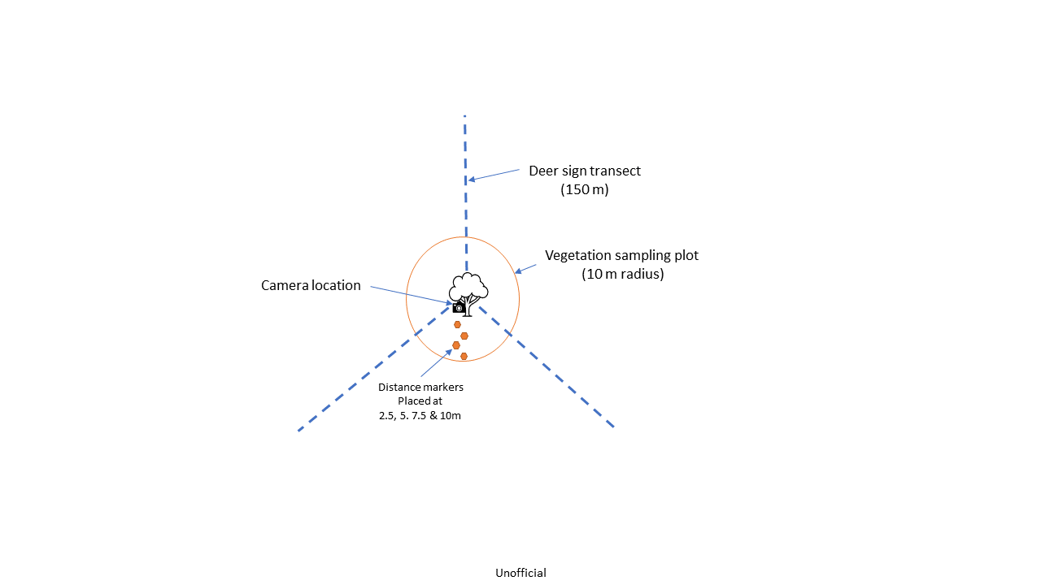
Figure 1. Field setup at each site used for deploying camera traps, deer sign transects and vegetation sampling. Camera locations were set at least 150 m from the nearest track/road that provided the closest access to the centroid of the sampling unit (4 km² hexagonal grid cell).

Table 1. Camera deployment settings.
Specification | Setting
Brand | Reconyx
Model | HF2X Hyperfire 2
Method | Motion
Number of pictures | 5
Time between pictures | Rapidfire
Motion video | Off
Quiet period | Off
Sensitivity | High

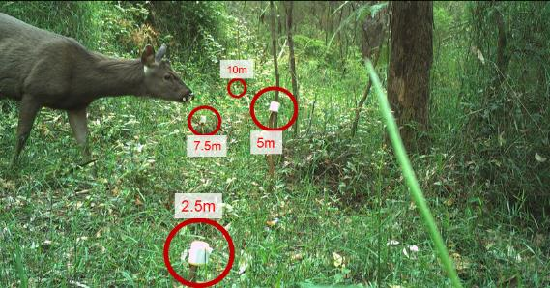
Figure 2. An example image showing the markers placed at set intervals from the camera location to enable distance sampling. A Sambar deer is present in this image.

Deer sign searches
Starting from the camera locations, three transects of 150 m in length were established at 120° separation (Figure 1). Two of the three transects were walked twice by a single observer (back and forth), while one transect was walked once by two observers. Hence, a similar survey effort was conducted for each transect, with a total of 450 m of sign surveys conducted twice at each site. The deer signs recorded along the transects were deer pellets, deer footprints, deer rubbings on trees (made by males during breeding season) and deer wallows (muddy pools made by deer). The detection of these signs is generally easy to distinguish from non-deer species (Claridge 2010). We recorded counts of the number of pellet piles, rubbings, and wallows along each transect and the presence/absence of footprints.
The recorded deer sign data (pellets, footprints, rubbings and wallows) were not identifiable to deer species. Fresh pellets can be identified to species using genetic sequencing. It is also possible to identify deer species from pellets using visual structure, but this is challenging (Claridge 2010). Given the variation in surveyors and the uncertainty in visual assignment, we instead assigned species post-hoc via a set of logical steps to minimise false detections of species outside their known range. The known range was determined by creating a kernel density estimate (KDE) of species records over the past 30 years from incidental sightings recorded in the Atlas of Living Australia (ALA). The KDE had a bandwidth determined via the normal reference distribution and was thresholded so that 99.5% of observations fell within the KDE polygon. For a given deer sign detection at a site, we assigned that observation to a given species based on the following stepwise logic:
- species seen on camera = present
- species not seen on camera and another species seen on camera = absent
- species not seen on camera and no others seen, but within KDE distribution = present
- species not seen on camera, and not within KDE distribution = absent.

Vegetation assessment
Rapid vegetation assessments were undertaken at each site. Measurements were taken in each of the four quadrants (78.5 m²) within a plot (314.1 m²), in a 10 m radius from the camera. For each quadrant, the following vegetation measures were recorded:
- understorey cover – understorey (vegetation < 2.2 m in height) cover (%) of vascular plants was visually assessed and categorised according to native woody, native non-woody/herbaceous, exotic woody, exotic non-woody/herbaceous and visible bare ground (excluding leaf litter)
- average top height – the average top height of the canopy vegetation in the quadrant was estimated to the nearest metre
- canopy cover – a visual assessment of the total canopy cover (%) of the quadrant > 2.2 m was performed
- seedling/sapling abundance – the number of seedlings (canopy species < 1 m high) and saplings (canopy species > 1 m high but < 10 cm diameter at breast height) were counted separately.
  - Model of deer density
Using the results from the camera trap surveys and transect-based surveys, we were able to model deer density and abundance at each site using a Bayesian hierarchical modelling approach (Royle et al. 2009; Delisle et al. 2023). We used a selection of informative environmental, climatic, and regional-based covariates to predict the estimated abundance/density of each deer species across 74,570 km² of public-tenured land. These gridded predictions were then summed to provide regional and statewide estimates of deer abundance for Sambar, Fallow, Red, and Hog deer. The model used in this approach allows for multiple species of deer to be modelled simultaneously, which improves the estimation of certain parameters (e.g., detection rates, daily activity, and probability of detection along transects) for less observed species (e.g., Red deer). Data analysis and models were written in R (R Core Team 2023), and STAN (Gelman et al. 2015) programming languages. Extensive supplementary details, including R and STAN code have been made available as online supplementary material (https://github.com/JustinCally/statewide-deer-analysis).

Camera detection process
The density of deer at a given site can be estimated using CTDS (Howe et al. 2017). CTDS is a modified form of distance-sampling, which allows us to infer the probability that a given individual will be detected within the survey area (area in front of the camera). This detection probability is a function of the distance of the individual from the camera, whereby detection of individuals declines with increasing distance from the camera (Howe et al. 2017). Briefly, this method assumes that cameras are deployed independently of animal locations at a site ($i$) for a period of time ($T_{i}$) and captures images for as long as an individual is present to trigger the camera. Images are then obtained at a predetermined set of instants, $t$ units of time apart (snapshot instants). Temporal effort at each camera is then calculated as $T_{i}⁄t$. Howe et al. (2017) suggested that a useful range for $t$ is 0.25 to 3 seconds, with values at the lower end being more suitable for fast-moving or rarer species. For the analysis here, we set the snapshot instants ($t)$ to 2 second intervals. If the camera covers a horizontal angle of view of $θ$ radians, then the fraction of the circle observed by the camera field of view is $θ⁄2π$. Hence, the data consist of a series of snapshot instants taken $t$ units of time apart, with an overall sampling effort at each site $i$ equal to $(θT_{i})/2πt$ (Howe et al. 2017). Estimates of density (${\hat{D}}_{i}$) follow standard point transect methods (Equation 1) (Buckland et al. 2006).
$$\begin{aligned}\begin{aligned}{\hat{D}}_{i}=\frac{C_{i}}{πw^{2} e_{i}{\hat{p}}_{i}\hat{A}}\end{aligned}\#1\end{aligned}$$
Where $C_{i}$ are the counts of the total number of deer snapshot moments at site $i$, $w$ is the maximum observation distance from the camera (truncation distance – here set to 12.5 m for all deer observed beyond the 10 m marker), ${\hat{p}}_{i}$ is the probability of detecting an individual that is within $w$ distance from the camera, $\hat{A}$ is an estimate of relative animal activity and $e_{i}$ is the overall sampling effort $(θT_{i})/2πt$.
An underlying assumption about CTDS is that the probability a deer will be available for detection at any given point location within the camera field of view is proportional to the total area of each distance bin, which increases at further distance bins (Buckland et al. 2006). However, in this study we implemented a novel method that considers group size of the detected species in the availability calculations. For larger groups, CTDS should account for the availability of the closest individual rather than the availability of all individuals. This modification in approach is due to our assumption that it is the individual within a group, which is closest to the camera that will trigger the camera trap. It follows that as group size increases, the distance between the camera and the closest individual is likely to decrease. If we assume that the triggering of the camera is dependent upon the closest individual within a group, then we must adjust our estimated availability to account for variable group sizes. If we do not adjust for group size and only use the distance to the closest individual for our distance sampling models, then we will likely underestimate the detection rate. Alternatively, if we record distances to multiple individuals in the same photo and take an average or model them independently, we will likely overestimate detection probability because individuals at further distances are only recorded because a closer individual has triggered the camera trap.
In this study, we investigated two possible detection functions (half-normal and hazard rate) that may explain how detection rates decline with increasing distances from the camera (Buckland et al. 1993). We also examined possible heterogeneity in detection rates among sites by incorporating herbaceous understorey cover as a covariate and a possible explanatory variable. Given our assumption that different species of deer will have similar likelihoods of triggering the camera at a given distance, we combined our distance sampling model across Sambar, Fallow, Red, and Hog deer. We compared detection functions/models using AIC (Burnham and Anderson 2002) in the ‘Distance’ R package (Thomas et al. 2010) and used the detection function and formula most supported by the data in our Bayesian hierarchical model for abundance.
For each site, the average estimated detection probability ${\hat{p}}_{i}$ (up to 12.5m) was then included in the model to account for imperfect detection of individual deer in the camera counts.

Abundance process from camera trap counts
The count of the number of snapshot moments of deer images at a site was modelled as a function of explanatory variables describing spatial variation in density, relative frequency of group sizes, distance-sampling detection probability, survey effort (area in front of camera multiplied by the total snapshot moments the camera was deployed for) and proportion of time within a 24-hour cycle that deer were active (Equation 2). We accounted for over-dispersion in the counts of deer by adopting a negative binomial $(NB$) model with a species-specific over-dispersion parameter $ϕ_{s}$. Using a multispecies approach, our model for estimating the counts ($C$) for a given species ($s$), site ($i$), and group size ($j$) was:
$$\begin{aligned}C_{sij} \sim NB\left(λ_{si}∙p_{si}∙A_{s}∙g_{sij}∙e_{i}, ϕ_{s}\right)\#2\end{aligned}$$
Where $λ_{si}$ is the true mean density at a site (dependent on explanatory variables). This mean density parameter is derived from a mixed-effects formulation:
$$\begin{aligned}λ_{si}=X_{i}β_{s}+ε_{sb\left(i\right)}\#3\end{aligned}$$
In Equation 3, $X_{i}$ are the variables describing spatial variation in density, derived from climatic, environmental, topographic, and soil-based variables; $β_{s}$ are the species-specific parameter estimates; and $ε_{sb\left(i\right)}$ are the spatial random effects for species $s$, which were dependent on the bioregion $b$ at site $i$. The values for the spatial variables at a camera site were estimated as the mean of the values extracted from the camera location including a 1 km buffer. Further details about the predictors investigated in this analysis is available in the appendix and supplementary material (Table A1), with additional descriptions of the predictors in our chosen model available in the results. The $g_{sij}$ are the estimated proportions for each of the $J$ group sizes ($j=1…J$) at a site, where $\sum_{j=1}^{J}{g_{sij}}=1.$We assumed that group size proportions could vary between sites, and accounted for this by modelling group size for each species with a group level intercept ($ζ_{j}$) and site-group-size level random effect (${ϵsite}_{ij}$):
$\begin{aligned}{ϵpsi}_{sij}=exp\left(ζ_{sj}+{ϵsite}_{sij}\right) \#4\end{aligned}$proportional group size $j$at a given site $i$ for species $s$ was thus given by:
$$\begin{aligned}g_{sij}= \frac{{ϵpsi}_{sij}}{sum\left({ϵpsi}_{sij}\right)}\#5\end{aligned}$$
The parameter $A_{s}$ is the estimate of deer activity, defined as the proportion of a 24-hour day that animals were active. Estimation of this parameter is required to account for availability bias, where individuals may temporarily be unavailable for detection due to changes in animal behaviour (e.g., resting) (Corlatti et al. 2020). We estimated the proportion of a 24-hour day that individual deer were active by fitting a kernel density estimate to the image capture times from each deer image (in radians). The area under the kernel density estimate was used as the estimate of $A_{s}$ (Rowcliffe et al. 2014), and was included in the Bayesian hierarchical model using an informative beta prior. Additionally, we removed snapshot moments where deer were involved in behaviour that might bias density estimates (e.g., interaction with camera/markers), which occurred in 27% of snapshot moments. Since CTDS estimates of animal density are based on encounter rates of individuals in cameras at each snapshot moment, changes in animal behaviour that affect movement rates can cause bias in density estimates (Henrich et al. 2022).

Supplementing camera data with transect detections
The data collected on the transects provided supplemental presence-absence data that could be integrated into our model to help inform likely densities at sites where cameras did not record observations of deer, but one or more deer signs were detected along the transects.
The presence-absence data were integrated into Equation 2 by adopting a Royle-Nichols model (Royle and Nichols 2003) where the frequency of detections on transects is conditional on a (latent) abundance parameter $N$. Hence, the conditional detection probability for a particular type of deer sign $u$ (e.g. deer pellet, footprint, rubbing, wallow) detected on a transect for species $s$ at site $i$ ($p_{usi}$) was conditional on the number of individuals available to be detected at the site ($N_{si}$) and the probability of detecting a particular sign type $r_{u}$ (Equation 6).
$$\begin{aligned}p_{usi}=1-{\left(1-r_{u}\right)}^{N_{si}}\#6\end{aligned}$$
Hence, the number of transects detecting deer presence for each type of sign was distributed as:
$$\begin{aligned}y_{usi}∼Binomial\left(p_{usi}, K\right)\#7\end{aligned}$$
Where $y_{usi}$ is the number of transects detecting a particular deer sign $u$ (e.g. pellet/footprint) for species $s$ at site $i$ with $K$ being the total number of transects (i.e., $K$ = 3). Since deer were sometimes detected in the camera but not detected on any transect, we also included the presence-absence of deer in the camera as another detection method. The abundance of deer at each site, was dependent on the spatial model for abundance (Equation 3) used to model the camera trap data.
$$\begin{aligned}N_{si}∼NB\left(λ_{si},\overline{ϕ}\right)\#8\end{aligned}$$
In Equation 8, the number of individuals at a site is also dependent on the over-dispersion parameter specific to the Royle-Nichols component of the model ($\overline{ϕ}$); this parameter was equal for all species and sites for this study. Linking observation processes from both the camera trap detections and observations of deer sign from transect searches to the same ecological model describing spatial variation in deer abundance should provide improved inferences on the processes driving both deer abundance and their distribution across the landscape (Bowler et al. 2019). This is because detections of deer by both observation processes were informative about deer abundance at a site. This became especially important when deer presence was detected on the transects, but no deer were detected with the cameras.

Model selection and validation
In a Bayesian context, extensive model selection and comparison becomes computationally expensive and unfeasible. Given this, following initial exploration of our suite of spatial variables, we compared six alternative models of deer abundance. These models varied in their combination of fixed and random effects. All models included covariates (or a subset) that we deemed to potentially be informative in predicting spatial variation in deer distribution and abundance. From an initial pool of 27 covariates, we checked for correlations, but no pair of covariates had a greater correlation value of 0.8. Comparison and cross-validation of these models were conducted using leave-one-out cross validation (Vehtari et al. 2020), and predictive performance. From the predictive performance of these models and the results of a range of posterior predictive checks, we chose a single model for statewide predictions.

Prediction of deer abundance across Victoria
Our model-based approach allowed us to generate estimates of deer abundance across unsampled areas (grid cells), by applying the model to any unsampled areas that had the appropriate covariates. We restricted our predictions to public land (excluding water bodies and publicly tenured land used for services and utilities). The total area of public land we generated abundance predictions for was 74,570 km², which represents 33% of the land area in Victoria. Predictions used covariate data at a 1 km² spatial resolution. One square kilometre gridded predictions across Victoria were offset by the amount of public land in the grid cell and therefore reflected the estimated abundance of deer on public land within that grid cell. Grid cells were then summed within a region and across the state to estimate regional (DEECA regions) and statewide estimates for each species. Average density estimates for DEECA regions were calculated by dividing the total abundance within the region by the area of public land in the region.
In addition to the model-based estimates of total abundance described above, we also calculated design-based estimates of total abundance for each species, for each region. Design-based estimates differ from the model-based estimates, because they are only based on the estimates of deer density at each monitored site and hence, do not rely on a model to extrapolate to all unsampled sites (grid cells). Design-based estimates assumed that monitored sites were selected using a probabilistic (e.g., random) sampling design, which was the case with the current survey. Design-based estimates can provide a useful check on model-based estimates, because they rely on a simpler set of assumptions and are free from model extrapolation error.

Estimating range size across Victoria
Using mean model predictions across Victoria, we created binary predictions of occupied and unoccupied areas for each species. To do this, we calculated an optimal abundance/density ($λ_{si}$) threshold, which was closest to perfect sensitivity and specificity (Perkins and Schisterman 2006; Robin et al. 2011). We generated 90% confidence intervals for this threshold value using 2,000 bootstrapped iterations (Robin et al. 2011). From these values, we were able to assign areas across 74,570 km² of public land as being occupied/unoccupied based on median thresholds as well as lower and upper bound thresholds.
  - Effect of deer abundance on vegetation
We used estimates of deer density from all sampled sites (summed across all four species) to investigate whether there was any relationship between deer density and our suite of six vegetation components that were measured at each site. Specifically, we investigated whether deer density at a site was related to the cover of bare ground, native woody understorey cover, native non-woody/herbaceous understorey cover, seedling abundance, sapling abundance and the presence/absence of exotic plant species. To investigate these relationships, we implemented a multivariate model with beta-distributions for cover response variables, negative-binomial distributions for seedling/sapling counts, and a Bernoulli distribution for exotic plant presence-absence. We modelled the effect of deer density on each of the above vegetation components as well as a suite of 13 (12 fixed and 1 random effect) covariates to control for a range of climatic, environmental, topographic, and microsite covariates that might impact the vegetation response variables. The covariates used alongside deer density were: annual mean temperature, temperature seasonality, minimum temperature of coldest month, annual precipitation, precipitation seasonality, soil nitrogen, time since last fire, topographic wetness index, amount of surrounding forest edge, canopy cover, canopy height, wallaby presence, and ecological vegetation class group (random effect with 19 groups). The effect of these covariates was not of direct interest in this study, but their effects should help control for variation in the response variables that is not due to the variation in deer density (e.g. the effect of climate on bare soil composition). Therefore, controlling for these effects allowed us to better isolate and understand the impact of deer density on vegetation. We implemented these multivariate models in a Bayesian framework using the ‘brms’ R package (Bürkner 2017; Bürkner 2018; Bürkner 2021).

- Results
  - Detection of deer
Following image processing and tagging, deer were detected by 148 cameras (Sambar = 104, Fallow = 30, Red = 12, Hog = 22) from 317 cameras distributed across Victoria, and some form of deer sign (camera or transect) was detected at 186 (Sambar = 135, Fallow = 58, Red = 13, Hog = 24) of the 317 sites (Figure 3).

Distance sampling
Distance sampling used pooled detections across the four species. We compared the predictive performance of four detection models (restricting to group size = 1) and found that the top performing model (according to AIC) was a hazard function with herbaceous understorey as a predictor of the shape parameter (Table 2). When this hazard function was incorporated into a Bayesian model, it provided an average detection rate for the area in front of the camera of 0.297, with an average cover of herbaceous understorey and group size = 1. Herbaceous understorey was found to have a negative relationship with the detection probability (Figure 4). Detection probability also varied according to group size. In larger groups, detection rates were higher; for instance, average estimates of detection probability increased from 0.297 for 1 individual to 0.379, 0.439, 0.485, and 0.523 for group sizes 2, 3, 4, and 5, respectively.

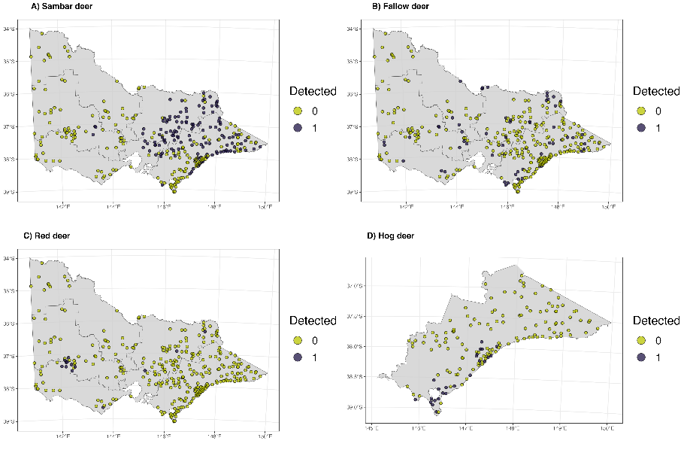
Figure 3. Detections of deer species (camera or transects) from across Victoria. Detections of Hog deer were restricted to Gippsland.

Table 2. Model selection table for deer detection.
Model | Key function | Formula | $$χ^{2} p value$$ | $$ΔAIC$$
hr1 | Hazard-rate | ~Herbaceous understory cover | 0 | 0.000
hr0 | Hazard-rate | ~1 | 0 | 3.759
hn0 | Half-normal | ~1 | 0 | 186.719
hn1 | Half-normal | ~Herbaceous understory cover | 0 | 187.700

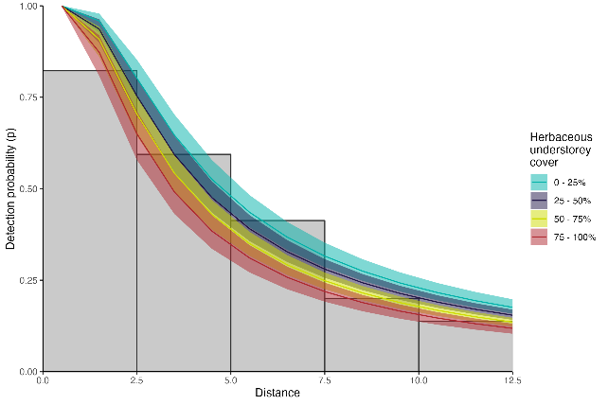
Figure 4. Distance-sampling detection process for deer (group size = 1–5). Herbaceous understorey cover in the area surrounding appeared to have some impact on detection probability.

Transects
A single camera trap was not a perfect method to detect deer when they were present at a location. Given a certain density of deer (e.g. for the numerical values presented here, assume 3 deer per km²), cameras deployed for an average period (53 days) had only slightly higher detection rates (0.73 [90% CI: 0.65, 0.81]) to finding pellets (0.71 [90% CI: 0.63, 0.78]) or footprints (0.64 [90% CI: 0.56, 0.72]) along three 150 m transects (Figure 5). Detection probability of deer via observation of rubbings was substantially lower (0.36 [90% CI: 0.29, 0.44]), and detection was near-zero for wallows (0.03 [90% CI: 0.01, 0.05]).
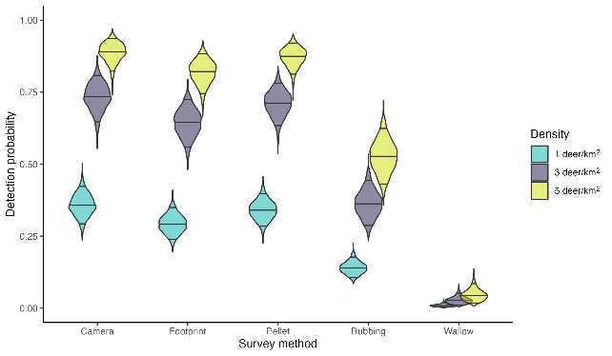
Figure 5. Conditional detection probabilities for the various methods of survey, across various deer densities. Camera trap detection probability was based on average deployment length (53 days), while transects were based on three transect searches.
  - Deer abundance

Site-level estimates
Estimated average deer density at sites varied depending on the patterns of detection at that site (Table 3). Sambar deer density estimates at sampled sites ranged from 0 to 28.31 deer/km². Fallow deer density was estimated as ranging from 0 to 23.25 deer/km². Red deer densities ranged from 0 to 6.81 deer per km², and Hog deer densities ranged from 0 to 16.90 deer/km². Table 3 shows the average density (and standard deviation) at sites for a given detection pattern (e.g. only seen on cameras).

Regional and statewide estimates
Deer were found to be widely distributed across Victoria. Across approximately 74,570 km² of public land, we estimate total deer abundance of the four species investigated in this study (Sambar, Fallow, Red and Hog) to be 191,153 (90 % CI: 146,732, 255,490) deer. Sambar deer were the most populous species across Victoria (123,061 [90% CI: 96,200, 157,638]), followed by Fallow (48,932 [90% CI: 29,888, 85,063]), Red (12,672 [90% CI: 4,71, 935,465]), and Hog (4,243 [90% CI: 2,121, 8,464]) deer. Regional estimates of abundance revealed that average densities of Sambar deer were highest in Hume, Port Phillip, and Gippsland (Table 4a). Fallow deer had highest densities in Barwon South West and Hume. Red deer were mainly concentrated in Barwon South West, and the Grampians regions. Hog deer were only detected and predicted to occur in Gippsland. Modelled regional abundance estimates are presented in Table 4a, and in Figure 6. Spatial raster layers of deer abundance for each species, which would be suitable for use in GIS software, are available at the following link: https://github.com/JustinCally/statewide-deer-analysis/tree/main/outputs/rasters.

Table 3. Average (mean) density estimates at the various groups of sites (according to detection patterns). SD = standard deviation.
Species | Detection | Number of sites | Average density (deer per km²) | SD between sites
Sambar | Not seen | 182 | 0.81 | 1.29
Sambar | Only detected on transects | 31 | 2.46 | 1.71
Sambar | Only seen on cameras | 50 | 3.34 | 4.71
Sambar | Seen on both camera and transects | 54 | 4.16 | 2.51
Fallow | Not seen | 259 | 0.52 | 1.53
Fallow | Only detected on transects | 28 | 0.97 | 1.43
Fallow | Only seen on cameras | 20 | 1.37 | 1.38
Fallow | Seen on both camera and transects | 10 | 1.89 | 1.62
Red | Not seen | 304 | 0.05 | 0.19
Red | Only detected on transects | 1 | 1.23 | NA
Red | Only seen on cameras | 5 | 1.47 | 1.48
Red | Seen on both camera and transects | 7 | 2.01 | 2.37
Hog | Not seen | 293 | 0.27 | 1.18
Hog | Only detected on transects | 2 | 2.03 | 2.71
Hog | Only seen on cameras | 22 | 3.1 | 2.39

Table 4a. Regional model-based estimates of deer abundance on public land in each DEECA region (SD = standard deviation; CV = coefficient of variation).
Species | Region | N | SD | CV | 5% | 95% | Area km² | Density (90% CI)
Sambar | Barwon South West | 139 | 277 | 1.99 | 35 | 430 | 4,745 | 0.03 (0.01, 0.09)
Sambar | Gippsland | 54,895 | 8,898 | 0.16 | 42,618 | 70,948 | 25,211 | 2.18 (1.69, 2.81)
Sambar | Grampians | 1,619 | 2,032 | 1.25 | 716 | 3,266 | 9,896 | 0.16 (0.07, 0.33)
Sambar | Hume | 59,732 | 12,360 | 0.21 | 43,334 | 82,188 | 16,890 | 3.54 (2.57, 4.87)
Sambar | Loddon Mallee | 1,094 | 1,761 | 1.61 | 460 | 2,589 | 15,597 | 0.07 (0.03, 0.17)
Sambar | Port Phillip | 5,200 | 1,334 | 0.26 | 3,367 | 7,694 | 2,231 | 2.33 (1.51, 3.45)
Sambar | Total | 123,061 | 19,657 | 0.16 | 96,200 | 157,638 | 74,570 | 1.65 (1.29, 2.11)
Fallow | Barwon South West | 10,514 | 14,091 | 1.34 | 3,049 | 31,646 | 4,745 | 2.22 (0.64, 6.67)
Fallow | Gippsland | 12,305 | 5,001 | 0.41 | 6,914 | 21,794 | 25,211 | 0.49 (0.27, 0.86)
Fallow | Grampians | 4,350 | 3,203 | 0.74 | 2,106 | 9,264 | 9,896 | 0.44 (0.21, 0.94)
Fallow | Hume | 16,021 | 5,519 | 0.34 | 9,362 | 26,721 | 16,890 | 0.95 (0.55, 1.58)
Fallow | Loddon Mallee | 3,296 | 2,198 | 0.67 | 1,384 | 7,277 | 15,597 | 0.21 (0.09, 0.47)
Fallow | Port Phillip | 1,501 | 767 | 0.51 | 761 | 2,879 | 2,231 | 0.67 (0.34, 1.29)
Fallow | Total | 48,932 | 20,900 | 0.43 | 29,888 | 85,063 | 74,570 | 0.66 (0.4, 1.14)
Red | Barwon South West | 5,645 | 8,018 | 1.42 | 1,559 | 19,399 | 4,745 | 1.19 (0.33, 4.09)
Red | Gippsland | 179 | 196 | 1.1 | 49 | 502 | 25,211 | 0.01 (CI: 0, 0.02)
Red | Grampians | 5,134 | 5,709 | 1.11 | 1,705 | 14,695 | 9,896 | 0.52 (0.17, 1.48)
Red | Hume | 1,126 | 739 | 0.66 | 420 | 2,638 | 16,890 | 0.07 (0.02, 0.16)
Red | Loddon Mallee | 103 | 1,524 | 14.83 | 1 | 794 | 15,597 | 0.01 (0, 0.05)
Red | Port Phillip | 31 | 83 | 2.67 | 5 | 103 | 2,231 | 0.01 (0, 0.05)
Red | Total | 12,672 | 12,275 | 0.97 | 4,719 | 35,465 | 74,570 | 0.17 (0.06, 0.48)
Hog | Gippsland/Total | 4,243 | 2,263 | 0.53 | 2,121 | 8,464 | 25,211 | 0.17 (0.08, 0.34)
Table 4b. Regional design-based estimates of deer abundance on public land in each DEECA region (SD = standard deviation; CV = coefficient of variation).
Species | Region | N | SD | CV | 5% | 95% | Area km² | Density
Sambar | Barwon South West | 118 | 78 | 0.66 | 37 | 383 | 4,745 | 0
Sambar | Gippsland | 45,279 | 4,131 | 0.09 | 37,878 | 54,124 | 25,211 | 2.1
Sambar | Grampians | 2,557 | 826 | 0.32 | 1,379 | 4,741 | 9,896 | 0.3
Sambar | Hume | 59,744 | 5,024 | 0.08 | 50,680 | 70,428 | 16,890 | 3.7
Sambar | Loddon Mallee | 1,710 | 309 | 0.18 | 1,204 | 2,429 | 15,597 | 0.1
Sambar | Port Phillip | 9,790 | 2,078 | 0.21 | 6,488 | 14,773 | 2,231 | 3.6
Sambar | Total | 119,198 | 6,885 | 0.06 | 106,449 | 133,474 | 74,570 | 1.9
Fallow | Barwon South West | 9,588 | 7,034 | 0.73 | 2,650 | 34,696 | 4,745 | 1.5
Fallow | Gippsland | 8,404 | 1,587 | 0.19 | 5,823 | 12,130 | 25,211 | 0.4
Fallow | Grampians | 5,166 | 1,923 | 0.37 | 2,550 | 10,465 | 9,896 | 0.6
Fallow | Hume | 13,323 | 2,289 | 0.17 | 9,537 | 18,612 | 16,890 | 0.8
Fallow | Loddon Mallee | 9,772 | 3,682 | 0.38 | 4,784 | 19,960 | 15,597 | 0.3
Fallow | Port Phillip | 1,648 | 418 | 0.25 | 1,011 | 2,688 | 2,231 | 0.6
Fallow | Total | 47,901 | 8,641 | 0.18 | 33,731 | 68,025 | 74,570 | 0.6
Red | Barwon South West | 4,017 | 1,386 | 0.34 | 2,082 | 7,751 | 4,745 | 0.6
Red | Gippsland | 129 | 38 | 0.3 | 73 | 228 | 25,211 | 0
Red | Grampians | 4,087 | 1,906 | 0.47 | 1,713 | 9,752 | 9,896 | 0.5
Red | Hume | 1,036 | 177 | 0.17 | 743 | 1,443 | 16,890 | 0.1
Red | Loddon Mallee | 247 | 196 | 0.79 | 63 | 970 | 15,597 | 0
Red | Port Phillip | 23 | 13 | 0.56 | 8 | 63 | 2,231 | 0
Red | Total | 9,539 | 2,372 | 0.25 | 5,902 | 15,416 | 74,570 | 0.2

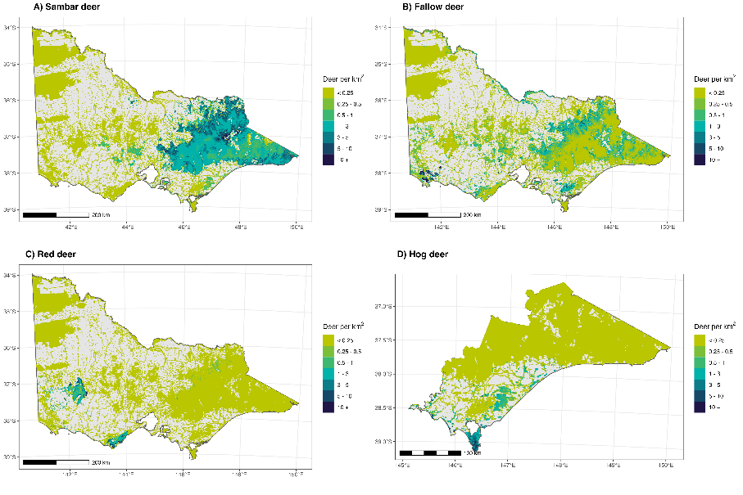
Figure 6. Spatial variation in deer density (deer/km²) for (A) Sambar, (B) Fallow, (C) Red, and (D) Hog deer across Victoria. Grey area reflects area not included in predictions (i.e., not public land), and grid cells are offset by the proportion of overlapping public land. Estimates for each prediction grid cell (1km²) use the mean.

Design-based estimates of abundance for each species and region were similar to the model-based estimates (Table 4b). Design-based statewide estimates for Sambar and Fallow deer differed from the model-based estimates by less than 5%, while the design-based estimate for Red deer was about 25% lower than the model-based estimate. No design-based estimate was possible for Hog deer because the 64 cameras placed in the species’ range used a different sampling design to that used for the statewide deer survey and, therefore, the sampling designs were not strictly comparable.

Drivers of abundance
A total of six covariates were used to model spatial variation in deer abundance across Victoria, with coefficient effects estimated separately for each species. Descriptions of these covariates are provided in Appendix Table A1. Unexplained spatial variation in abundance was modelled using bioregion as the sole random effect, and proved to be a particularly informative predictor.
We sampled 26 out of the 28 bioregions in Victoria, with the Victorian Riverina and Bridgewater the only bioregions not sampled due to the small area of public land within those bioregions (884 km²: 1.2% of public land in Victoria for both bioregions combined). For prediction purposes, we used the effects from the nearest neighbouring bioregions. Figure 7 shows the log-contribution of each bioregion to abundance estimates. The variance (standard deviation) associated with the bioregion random effect was large for Sambar (σ = 3.96, 90% CI: 2.8, 5.38), but less for Fallow (σ = 1.67, 90% CI: 0.85, 2.73). Red deer also exhibited large variance in the bioregion random effect (σ = 3.7, 90% CI: 2.48, 5.23), as did Hog deer (σ = 4.4, 90% CI: 3.11, 5.93). The larger variances for Hog, Red and Sambar deer reflect their more restricted range boundaries, whereas Fallow deer show less clear range boundaries and, therefore, less variance across the state (Figure 4).
Our top model contained five fixed-effect covariates including bare soil (estimated by remote sensing at a broad spatial scale), soil nitrogen, distance to pastural land, precipitation seasonality, and amount of forest edge within a site. Of the five fixed-effect covariates used in the top model, we found that all had non-negligible effects for one or more species (Figure 8). The direction and magnitude of these effects often varied between species (Figure 8). Bare soil had a slight positive relationship with Sambar deer abundance, a negligible effect on Fallow and Red deer abundance, and a slight negative effect on Hog deer abundance (Table 5, Figure 8). Nitrogen generally had weaker and more variable effects. The effect of nitrogen was weakly positive for Sambar and Hog deer, but weakly negative for Fallow and Red deer (Table 5, Figure 8). The effect of distance to pasture was consistently negative across all four species, which can be interpreted as a preference of deer to be ‘closer’ to pastural areas. However, the effect of this covariate varied, and was weaker for Sambar and Hog deer, and stronger for Fallow and Red deer (Table 5). Sambar deer weakly favoured areas with less seasonal variation in precipitation, with Fallow, Red, and Hog deer all showing positive relationships between precipitation seasonality and abundance. Lastly, we found that the amount of forest edge in the landscape positively impacted the abundance of Fallow deer; was weakly positively associated with the abundance of Sambar and Hog deer; and was negatively associated with the abundance of Red deer (Table 5, Figure 8).
Estimates of abundance were also dependent upon overdispersion (excess variation) in the camera counts and transect detections. Sambar ($ϕ_{1}$ = 0.114 [90 % CI: 0.093, 0.137]), Fallow ($ϕ_{2}$ = 0.021 [90 % CI: 0.015, 0.03]), Red ($ϕ_{3}$ = 0.047 [90 % CI: 0.025, 0.076]), and Hog ($ϕ_{4}$ = 0.064 [90 % CI: 0.038, 0.095]) deer all had large amounts of overdispersion (where lower values in $ϕ$ (< 1) equate to more variance). The Royle-Nichols model derived from transect-level detections/non-detections had less variance than camera count ($\overline{ϕ}$ = 0.79 [90 % CI: 0.591, 1.041]).

Distribution
We obtained a threshold distribution based on the mean abundance values for each grid cell. Our public-tenured land range estimates suggested that Sambar deer had a range of 38,582 km² [95% CI: 33,405, 40,590]. For Fallow deer, the range estimate was smaller and more variable (24,901 km² [95% CI: 20,666, 30,423]). This was similarly the case for Red deer (9,403 km² [95% CI: 2,465, 10,148]). Lastly, Hog deer had a more restricted range estimate (2,176 km² [95% CI: 1,542, 2,219]).

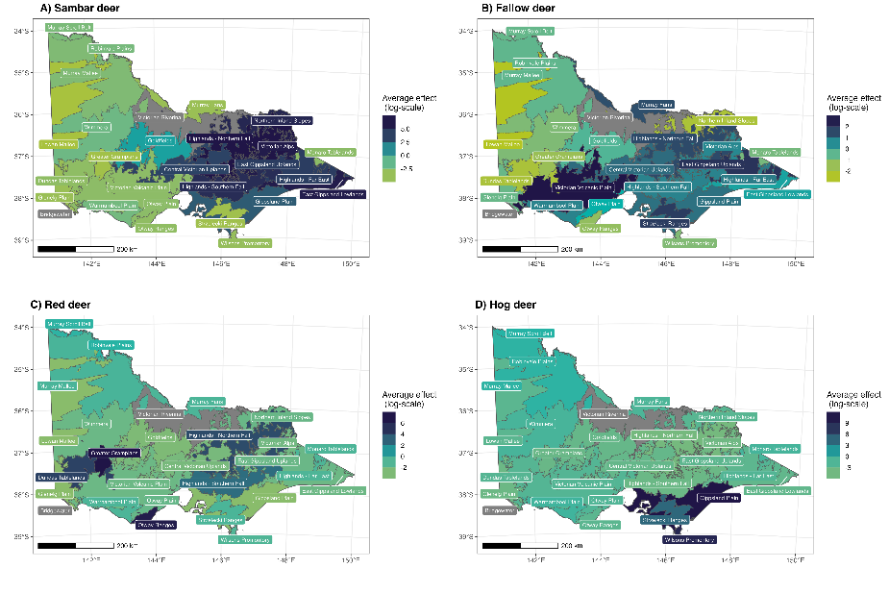
Figure 7. Effects of the influence of bioregions on variation in deer abundance (log-scale), with unsampled bioregions shown in grey.
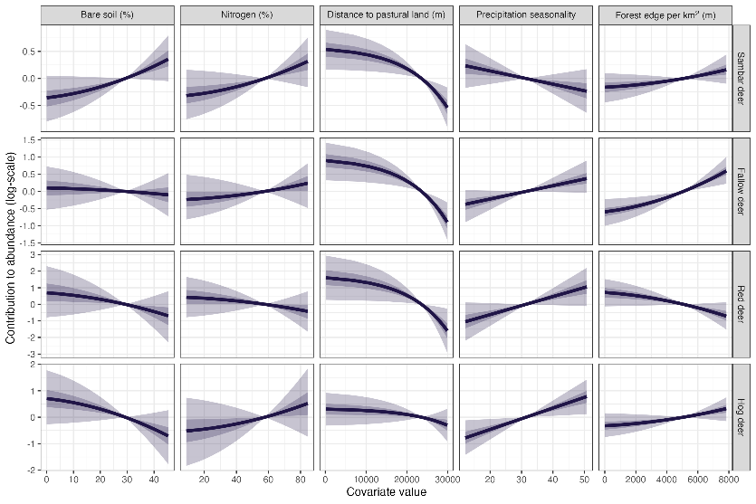
Figure 8. Conditional effects of five covariates used in the top model. The y-axis shows the relative contribution to abundance (log-scale), and the x-axis shows the untransformed covariate values. All parameters were scaled for use within the model with square-root transformations for bare soil, nitrogen, and forest edge. Distance to pastural land was rounded up to the nearest 100 m and log transformed. 50% and 90% confidence bands are shown with dark and light purple shadings.
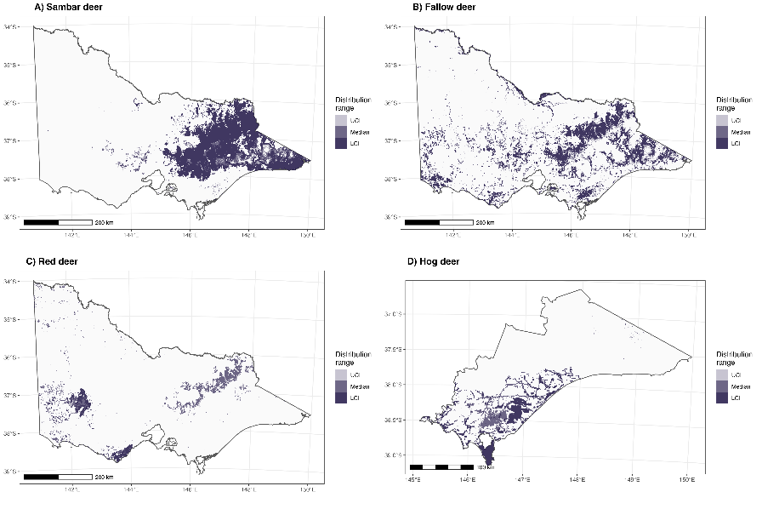
Figure 9. Estimates of the occupied range for Sambar, Fallow, Red and Hog deer across Victoria. White area reflects area not included in predictions (i.e., not public land), LCI and UCI confidence bounds refer to bootstrapped threshold confidence intervals (90%) for optimal sensitivity and specificity.

Table 5. Coefficient estimates for the drivers of species abundance. Estimates not-overlapping zero are in bold. SD = standard deviation.
Species | Covariate | Estimate | SD | 5% | 95%
Sambar deer | (Intercept) | -3.615 | 0.956 | -5.182 | -2.166
Sambar deer | Bare soil (%) | 0.368 | 0.215 | 0.023 | 0.723
Sambar deer | Nitrogen (%) | 0.313 | 0.230 | -0.079 | 0.683
Sambar deer | Distance to pastural land (m) | -0.535 | 0.189 | -0.832 | -0.221
Sambar deer | Precipitation seasonality | -0.230 | 0.208 | -0.573 | 0.122
Sambar deer | Forest edge per km² (m) | 0.166 | 0.137 | -0.057 | 0.396
Fallow deer | (Intercept) | -1.680 | 0.513 | -2.563 | -0.930
Fallow deer | Bare soil (%) | -0.103 | 0.319 | -0.630 | 0.403
Fallow deer | Nitrogen (%) | 0.220 | 0.335 | -0.359 | 0.723
Fallow deer | Distance to pastural land (m) | -0.892 | 0.278 | -1.345 | -0.432
Fallow deer | Precipitation seasonality | 0.392 | 0.239 | 0.023 | 0.799
Fallow deer | Forest edge per km² (m) | 0.607 | 0.192 | 0.288 | 0.931
Red deer | (Intercept) | -6.781 | 1.170 | -8.861 | -4.997
Red deer | Bare soil (%) | -0.725 | 0.793 | -2.013 | 0.543
Red deer | Nitrogen (%) | -0.447 | 0.635 | -1.481 | 0.628
Red deer | Distance to pastural land (m) | -1.613 | 0.683 | -2.705 | -0.482
Red deer | Precipitation seasonality | 1.049 | 0.599 | 0.052 | 2.021
Red deer | Forest edge per km² (m) | -0.699 | 0.426 | -1.386 | 0.005
Hog deer | (Intercept) | -8.297 | 1.307 | -10.503 | -6.305
Hog deer | Bare soil (%) | -0.717 | 0.512 | -1.567 | 0.120
Hog deer | Nitrogen (%) | 0.526 | 0.651 | -0.543 | 1.601
Hog deer | Distance to pastural land (m) | -0.298 | 0.312 | -0.799 | 0.222
Hog deer | Precipitation seasonality | 0.772 | 0.334 | 0.209 | 1.312
Hog deer | Forest edge per km² (m) | 0.318 | 0.231 | -0.068 | 0.690

  - Effect of deer abundance on vegetation
We found deer density to have several plausible relationships with structural vegetation components (Table 5), including negative relationships with bare ground cover (estimated at the microsite level) and native woody understorey cover, and a positive relationship with native non-woody/herbaceous understorey cover (Figure 6). We also found strong evidence suggesting that the presence of exotic weeds was more likely at sites with higher densities of deer, with weeds being 1.17 [90% CI: 1.042, 1.325] times more likely for every 1 deer/km² increase in deer density. We did not find strong relationships between deer densities and seedling or sapling counts. Relationships between environmental covariates and the six vegetation response variables were also found, but given they were not of core interest in this study, the results of these are presented only in the online supplementary material.
Table 6. Estimates of the effect of deer density on five vegetation components. Values are on the logit-scale; estimates not-overlapping zero are in bold. SD = standard deviation.
Vegetation component | Estimate | SD | 5% | 95%
Bare ground cover | -0.035 | 0.028 | -0.083 | 0.009
Native woody understorey cover | -0.046 | 0.027 | -0.089 | -0.003
Native herbaceous understorey cover | 0.064 | 0.029 | 0.017 | 0.111
Presence of seedlings | 0.053 | 0.074 | -0.067 | 0.179
Presence of saplings | -0.006 | 0.058 | -0.102 | 0.092
Presence of exotic flora | 0.149 | 0.072 | 0.035 | 0.276

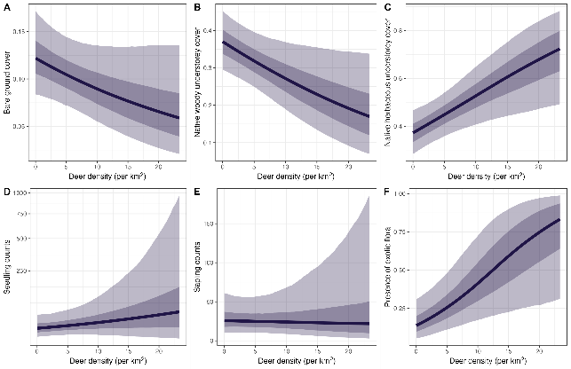
Figure 10. Conditional effect of deer density at sampled sites on a range of vegetation measures. Density was negatively related to (A) bare ground and (B) native woody understorey cover. Increased deer density was positively correlated with (C) native herbaceous understorey and the (F) presence of exotic species. No strong relationships were found between deer density and (D) seedlings or (E) saplings. Inner and outer shading represents 50% and 90% confidence levels, respectively.

- Discussion
  - Deer abundance
We modelled the density of four deer species in Victoria and estimated the abundance of these species on 74,570 km² of public land. We found deer to be widespread throughout Victoria, with large variation in densities across sites and regions. Abundance was not estimated for deer on private land, but private land may harbour a significant proportion of the deer population in Victoria (especially, Fallow, Red and Hog deer). Relationships between deer density and the presence of exotic weed species, as well reduced native woody understorey cover suggest areas of higher deer density may have detrimental outcomes for maintaining ecosystem health. We discuss this in more detail below.
There has been much contention and uncertainty regarding the abundance of deer in Victoria and Australia. Despite no studies estimating abundance of deer across Victoria, various management strategies and independent reports assume abundance to range from several hundred thousand to upwards of one million deer (Department of Environment Land Water and Planning 2020; Frontier Economics 2022). Most recent estimates of deer harvest numbers in Victoria estimate that a total of 123,376 deer were harvested in 2022, with the majority being reported as Sambar (62%), and Fallow (33%); however, these harvest estimates may also be lower (89,900) if extreme outliers in survey responses are removed (Moloney and Flesch 2023). Additionally, harvest survey results also include hunting on private land, with 39.2% of harvested deer being reported as taken exclusively on private land (Moloney and Flesch 2023), and likely only half of all harvest exclusively on publicly tenured land (Moloney and Flesch 2023).
Several studies have attempted to estimate deer density across relatively smaller areas in Victoria (Davis et al. 2017; Ramsey et al. 2019; Bengsen et al. 2022; Ramsey et al. 2023) and across Australia (Amos et al. 2014; Lethbridge et al. 2019; Bengsen et al. 2022). We find the densities in these other studies broadly comparable to the range of densities obtained in this study (Table A2). The only other large-scale study in Australia estimating deer abundance that we are aware of estimated Fallow deer densities at an average of 2.70 individuals/km² [95 % CI: 1.67, 3.71] across 19,905 km² of suitable habitat in Tasmania (Lethbridge et al. 2019). In our study, we estimated average fallow deer density across the state and within DEECA regions. In two regions estimated to have the majority of the Fallow deer population (Barwon South West and Hume), we found density estimates to be similar to those in Tasmania: with their average density (deer per km²) estimated in the Barwon South West region at 2.22 [90% CI: 0.64, 6.67], and in Hume at 0.95 [90% CI: 0.55, 1.58]. Both these regions also have significant densities of Red and Sambar deer, respectively. With regards to Sambar deer, their abundance has been previously estimated across several National Parks in eastern Victoria (Ramsey et al. 2023). Here, densities were estimated using catch-effort models for aerial control, with pre-control densities estimated by the removal model ranging from 0.1 to 2.8 deer/km² (mean 1 deer/km²) (Ramsey et al. 2023). An extensive list of studies that have estimated deer density at local and regional scales in Australia is presented in Table A2.

Drivers of deer abundance
Victorian bioregions are a landscape-level classification based on a range of climatic, environmental, and ecological attributes (Department of Energy Environment and Climate Action 2019). We found them to be influential in predicting abundance for all four species of deer. This finding likely reflects a combination of spatial clustering in populations of some deer species to some localised area that has suitable climatic and environmental conditions (e.g., Red deer in the Greater Grampians area), and an absence of certain species from other bioregions that may have suitable habitat but no dispersal pathways to population establishment (e.g., Hog deer in coastal areas of Western Victoria). For invasive species such as deer, these spatial effects may be more pronounced, because they are still expanding from original source/s and have not fully dispersed throughout their potential range.
We also found several bioclimatic and landscape variables to be informative in predicting spatial variation in deer abundance. Notably, edge/ecotone effects were generally seen across deer species where distance to pastural land and/or amount of forest edge in surrounding landscape predicted higher abundance. Proximity to pastural areas and grasslands may support higher densities of deer as those areas likely provide an abundance of preferred food sources. Previous studies have found Sambar deer abundance in the Yarra Ranges catchment to be highest in open flats, followed by forest edges and then forested areas (Bennett 2008). Our study found climate and soil composition (bare soil and nitrogen %) had variable effects on deer abundance between species. Interestingly Sambar deer had opposing relationships to precipitation seasonality and soil nitrogen in contrast to Fallow and Red deer. This finding may be suggestive of the establishment of distinct niches for Sambar, Fallow and Red deer in Victoria. Further analyses that jointly estimate abundance of deer species, while accounting for residual co-occurrence patterns may provide insight into drivers of co-occurrence of deer species (Pollock et al. 2014). This may also be extended to include a range of other herbivores recorded in this study (e.g., macropods).
  - Deer distribution
Several studies have attempted to estimate deer distribution in Victoria (Gormley et al. 2011; Forsyth et al. 2015; Forsyth et al. 2016). In 2011, occupancy models estimated the distribution of Sambar deer on public land at 32,644 km² (Gormley et al. 2011). This is less than our study estimates of the range for Sambar Deer of 38,582 km² [95% CI: 33,405, 40,590]. Updated presence-only and expert-elicitation derived range maps (Forsyth et al. 2015; Forsyth et al. 2016) produced in 2020 also estimated the range of Sambar to be higher in 2020 than in 2011, with an area on public land predicted to be 43,779 km². This estimated distribution is larger than the range estimated in this study. One possible reason for this is that our study estimates a patchier distribution for Sambar in East Gippsland. Given that our surveys exclusively took place after the 2019–20 bushfires, it is possible that their distribution has reduced in these fire-affected areas in the past couple of years; a trend that was seen shortly after the 2009 Black Saturday fires (Forsyth et al. 2012).
For Fallow deer, existing estimates (c. 2020) of range size on public land (10,259 km²) were substantially lower than our estimated range size of 24,901 km² [95% CI: 20,666, 30,423]. Similar discrepancies were found for Red deer range size, which in 2020 was estimated to be 2,630 km² compared with 9,403 km² [95% CI: 2,465, 10,148] for the current study. Estimates of the Hog deer range (c. 2016) were also smaller than those estimated here: 1,147 km² vs 2,176km² [95% CI: 1,542, 2,219]. There may be several reasons why our estimates of range size tend to be larger for Fallow, Red, and Hog deer. First, previously irregular and/or concentrated presence-only records made existing distributions patchy and isolated for Fallow and Red deer. Given our study used a random sampling design, our ability to determine occupancy in previously unsurveyed areas was improved. Second, range sizes may truly be increasing for these species. Trends in reported Fallow harvest from hunter surveys suggest more than twice as many Fallow deer were harvested annually in 2022 compared with in 2017 (Moloney and Flesch 2023), which may be partially due to range expansion (as well as increased density). Lastly, our study may have also over-estimated range size for certain species that were restricted to areas due to factors not accounted for in our model. For example, our study estimated a larger Hog deer range than previous estimates, with this range including the possibility of more inland area (north of the South Gippsland Highway) being occupied. However, some of these areas, while suitable for Hog deer, may not be occupied due to discontinuous habitat between these areas and the coastal core breeding range. In addition, wild dog predation and hunting pressure may be further restricting the range of Hog deer (Ramsey et al. 2019). Improved range estimates on public and private land and for more restricted species such as Hog and Red deer can be achieved by more intensive sampling in the peripheries of their core range.
There is concern that deer may continue to expand their range across Victoria (Department of Environment Land Water and Planning 2020). Sambar, Fallow, and Red deer may expand their ranges in the future to occupy more of their potential environmental niches (Kelly et al. 2023). However, most established species investigated in this study have previously been estimated to already be occupying most of their potential range in Australia (Sambar: 86%, Fallow: 84%, Red: 98%; Kelly et al. 2023). Alternatively, Kelly et al. (2023), estimated that Hog deer only currently occupy 6% of their potential range, and thus could be a candidate for range expansion in the future. However, these niche models (Kelly et al. 2023) are only dependent on existing presence-only records and the niche breadth of these species (especially Red and Fallow deer) may be able to adapt and expand.

  - Impact on vegetation
We found relationships between deer density and several key measures of vegetation structure and composition. Higher deer densities were negatively associated with native woody/non-herbaceous cover as well as bare ground, and positively associated with native herbaceous cover. Our results align with previous studies, where enclosure experiments found deer stripping bark, defoliating, and breaking stems of native shrubs (Keith and Pellow 2005). This behaviour can ultimately reduce plant biomass in the woody understorey layer (Bennett 2008; Davis et al. 2016). A recent study by Bennett and Greet (2023) investigating impacts of deer in the Dandenong Ranges National Park found that most sites had a high relative abundance of deer (i.e. faecal pellet index), while also having relatively low native woody understorey cover and medium-high native herbaceous understory cover, aligning with the findings from our analyses. That study found that the native species most impacted by deer included tree ferns (Cyathea/Dicksonia spp.) as well as Victorian Christmas Bush (Prostanthera lasianthos), three-veined Cassinia (Cassinia trinerva) and prickly current bush (Coprosma quadrifida). Deer impacts were found to be generally related to other environmental attributes including proximity to waterbodies, forest edges, aspect, and elevation (Bennett and Greet 2023).
The finding that higher deer density strongly related to increased probability of exotic plant presence may suggest deer as a potential vector of weed propagation. Sambar deer are known to ingest large quantities of invasive weed, such as Blackberry (Rubus fruticosus) (Forsyth and Davis 2011). These seeds may then be actively dispersed through droppings. Studies have also suggested that Sambar deer may also spread other weeds in Victoria, such as the Himalayan Honeysuckle (Leycesteria formosa) (see Davis et al. 2016a). However, the role deer play in exotic species proliferation is largely unknown (Davis et al. 2016), and may be confounded by their utilisation of forest edge habitats and pasture, where weed invasion pressure would be expected to be relatively high.

Deer in high conservation areas
Deer may pose risks to ecological integrity in a range of environments. Across Victoria, areas with high biodiversity values will often be gazetted to enable a focus on conservation (National Parks Act 1975). Using our model predictions of mean deer density across Victoria (and restricting the scope to reserves > 20 km²), we see that several significant reserves (listed under National Parks Act 1975) have high average estimated deer densities (Table A3). Cobboboonee Forest Park (86 km²), Mount Napier State Park (29 km²), Mount Stanley Scenic Reserve (27 km²), and Budj Bim National Park (86 km²) all have combined deer densities estimated as being over 10 deer per km². Total deer abundance was greatest in Victoria’s second largest national park (Alpine NP 6,624 km²), with abundance estimated at 23,422 deer, giving an average density of 3.5 deer/km². We provide Table A3 as a potentially useful resource to guide management actions across high value conservation reserves (i.e., culling targets to impede population growth). However, given the scale of our study, caution should be applied when interpreting the estimates for reserves (especially smaller reserves), as uncertainty may be high.
  - Limitations and future recommendations
We estimate deer abundance across public land in Victoria. However, a large proportion of the deer population may reside predominantly on private land, and therefore estimates of total deer numbers in Victoria would require additional surveys. Surveys on private land would come with a range of other challenges, including access, and variable habitat conditions. Other survey methods such as aerial surveys (thermal and double observer distance sampling), have previously been used to survey for Fallow deer over a broad geographic range in variable woodland habitats (Lethbridge et al. 2019), and may be more suited to surveys across Victorian private land than camera trapping. The precision of estimates in deer abundance on either public or private land could be improved by increasing survey effort; in our case, this could involve the deployment of multiple cameras at a site, within close proximity (e.g. three cameras 50 m apart). Increased use of camera traps would come with computational overheads in the form of increased time needed to process images. However, recent developments may allow for semi-automated distance calculations to be made using monocular depth estimation and depth image calibration methods (Haucke et al. 2022; Henrich et al. 2023). Such methods may also prevent behavioural interactions between animals and distance markers that can bias density estimates (Henrich et al. 2022).

Ecological indicators of deer abundance and their impact
DEECA is currently developing a biodiversity indicator framework, including the Victorian Biodiversity Index (VBX), to support state-of-the-environment reporting. The VBX and other indicators have been developed to monitor trends in biodiversity loss or restoration, including future states of biodiversity under current management actions, as well as indicators to measure trends in threatening processes, including invasive species. The work contained in this report provides baseline estimates of statewide and regional abundance of deer and their potential impacts on ecological health. To incorporate these measures into the biodiversity indicator framework, monitoring would need to be repeated periodically to establish trends in these measures over time. Combining the estimates for each deer species into a single trend would be relatively straightforward. Measures of ecological health related to deer impacts, such as native woody understory cover and weed occurrence, could also be monitored periodically and incorporated into the indicator framework. We suggest that repeat monitoring of a subset of sites surveyed in this report (e.g., biennially) would be a useful interval to establish statewide and regional trends in deer abundance and their impacts. Future work should use the existing density estimates, and their precision, to help design an ongoing deer monitoring survey (i.e., minimum number and locations of sites and their cost) that could contribute to state-of-the-environment reporting and the biodiversity indicator framework.

Non-target species abundance
An advantage of the camera-trap monitoring methods used in this study is that multiple species, besides deer, are detected in camera traps. Images of all wildlife species detected during our survey were tagged and stored in a custom-built database. Hence, it should be possible to provide density estimates for a range of these species (e.g., macropods, foxes, cats, wombats) using the same methods as applied for deer in this report, which could provide important information for state-of-the-environment reporting. A list of the major wildlife species detected during the statewide survey are provided in Table A4. Models that estimate the density of these species may be aided by a multispecies framework, which could also be applied to further investigating the impact of native browsers on the vegetation components measured here (e.g. macropod impacts on herbaceous understorey).

- References
ABARES (2021). Catchment Scale Land Use of Australia – Update December 2020. Australian Bureau of Agricultural and Resource Economics and Sciences, Canberra, ACT.
Amos, M., Baxter, G., Finch, N., Lisle, A. and Murray, P., (2014). I just want to count them! Considerations when choosing a deer population monitoring method. Wildlife Biology 20, 362–370. doi:10.2981/wlb.00080
Andersen, E.M. and Steidl, R.J. (2020). Power to detect trends in abundance within a distance sampling framework. Journal of Applied Ecology 57, 344–353. doi:10.1111/1365-2664.13529
Barrette, M., Bélanger, L., De Grandpré, L. and Ruel, J.C. (2014). Cumulative effects of chronic deer browsing and clear-cutting on regeneration processes in second-growth white spruce stands. Forest Ecology and Management 329, 69–78. doi:10.1016/j.foreco.2014.06.020
Bengsen, A.J., Forsyth, D.M., Ramsey, D.S.L., Amos, M., Brennan, M., Pople, A.R., Comte, S. and Crittle, T. (2022). Estimating deer density and abundance using spatial mark–resight models with camera trap data. Journal of Mammalogy 103, 711–722.
Bennett, A. (2008). The impacts of sambar (Cervus unicolor) in the Yarra Ranges National Park. Citeseer.
Bennett, A. and Greet, J. (2023). Deer abundance and impact monitoring in riparian zones of the Dandenong Ranges National Park. Report prepared for Parks Victoria. North Melbourne, Victoria.
Bowler, D.E., Nilsen, E.B., Bischof, R., O’Hara, R.B., Yu, T.T., Oo, T., Aung, M. and Linnell, J.D.C. (2019). Integrating data from different survey types for population monitoring of an endangered species: The case of the Eld’s deer. Scientific Reports 9, 1–14. doi:10.1038/s41598-019-44075-9
Buckland, S.T., Anderson, D.R., Burnham, K.P. and Laake, J. (1993). Distance Sampling: Estimating Abundance of Biological Populations. Chapman and Hall, London, United Kingdom.
Buckland, S.T., Summers, R.W., Borchers, D.L. and Thomas, L. (2006). Point transect sampling with traps or lures. Journal of Applied Ecology 43, 377–384.
Bürkner, P.-C. (2018). Advanced Bayesian Multilevel Modelling with the R Package brms. The R Journal 10, 395–411. doi:10.32614/RJ-2018-017
Bürkner, P.-C. (2021). Bayesian Item Response Modelling in R with brms and Stan. Journal of Statistical Software 100, 1–54. doi:10.18637/jss.v100.i05
Bürkner, P.-C. (2017). brms: An R Package for Bayesian Multilevel Models Using Stan. Journal of Statistical Software 80, 1–28. doi:10.18637/jss.v080.i01
Burnham, K.P. and Anderson D.R. (2002). Model Selection and Multimodel Inference. Springer-Verlag: New York, USA.
Claridge, A.W. (2010). Introduced Deer Field Identification Guide for the Australian Alps. Department of Environment, Climate Change and Water, Parks and Wildlife Group, Queanbeyan, New South Wales.
Corlatti, L., Sivieri, S., Sudolska, B., Giacomelli, S. and Pedrotti, L. (2020). A field test of unconventional camera trap distance sampling to estimate abundance of marmot populations. Wildlife Biology 2020, 1–11. doi:10.2981/wlb.00652
Côté, S.D., Rooney, T.P., Tremblay, J.-P., Dussault, C. and Waller, D.M. (2004). Ecological impacts of deer overabundance. Annual Review of Ecology, Evolution, and Systematics 35, 113–147.
Davis, N.E., Bennett, A., Forsyth, D.M., Bowman, D.M.J.S., Lefroy, E.C., Wood, S.W., Woolnough, A.P., West, P., Hampton, J.O. and Johnson, C.N. (2016). A systematic review of the impacts and management of introduced deer (family Cervidae) in Australia. Wildlife Research 43, 515–532. doi:10.1071/WR16148
Davis, N.E. and Coulson, G. (2010). Mammalian browse damage to revegetation plantings in a national park. Ecological Management and Restoration 11, 72–74. doi:https://doi.org/10.1111/j.1442-8903.2010.00519.x
Davis, N.E., Gordon, I.R. and Coulson, G. (2017). The influence of evolutionary history and body size on partitioning of habitat resources by mammalian herbivores in south-eastern Australia. Australian Journal of Zoology 65, 226–239. doi:10.1071/ZO16075
DEECA (2023). NaturePrint v4.0 Strategic Biodiversity Values. Available at: https://metashare.maps.vic.gov.au/geonetwork/srv/api/records/c5c5b1b2-1ec2-5bbb-af6c-6e24d0ee7655/formatters/sdm-html?root=html&output=html
DEECA (2021). Structural Vegetation (1995). Available at: https://metashare.maps.vic.gov.au/geonetwork/srv/api/records/d433599e-e517-5b5b-a75b-45bb95ad1b85/formatters/sdm-html?root=html&output=html
Delisle, Z.J., Miller, D.L. and Swihart, R.K. (2023). Modelling density surfaces of intraspecific classes using camera trap distance sampling. Methods in Ecology and Evolution. doi:10.1111/2041-210X.14093
Department of Energy Environment and Climate Action (2019). Native Vegetation - Modelled 2005 Ecological Vegetation Classes (with Bioregional Conservation Status). Available at: https://metashare.maps.vic.gov.au/geonetwork/srv/api/records/a502df15-7b90-5e96-b1a0-ba29e95558b2/formatters/sdm-html?root=html&output=html
Department of Environment Land Water and Planning (2020). Victorian Deer Control Strategy. The State of Victoria Department of Environment, Land, Water and Planning. Melbourne, Victoria.
Forsyth, D.M., Comte, S., Davis, N.E., Bengsen, A.J., Côté, S.D., Hewitt, D.G., Morellet, N. and Mysterud, A. (2022). Methodology matters when estimating deer abundance: A global systematic review and recommendations for improvements. Journal of Wildlife Management 86. doi:10.1002/jwmg.22207
Forsyth, D.M. and Davis, N.E. (2011). Diets of non-native deer in Australia estimated by macroscopic versus microhistological rumen analysis. Journal of Wildlife Management 75, 1488–1497. doi:10.1002/jwmg.179
Forsyth, D.M., Gormley, A.M., Woodford, L. and Fitzgerald, T. (2012). Effects of large-scale high-severity fire on occupancy and abundances of an invasive large mammal in south-eastern Australia. Wildlife Research 39, 555–564.
Forsyth, D.M., Stamation, K. and Woodford, L. (2016). Distributions of Fallow deer, Red deer, Hog deer and Chital deer in Victoria. Unpublished Client Report for the Biosecurity Branch. Department of Economic Development, Jobs, Transport and Resource, Heidelberg, Victoria.
Forsyth, D.M., Stamation, K. and Woodford, L. (2015). Distributions of Sambar deer, Rusa deer and Sika deer in Victoria. Unpublished Client Report for the Biosecurity Branch. Department of Economic Development, Jobs, Transport and Resource. Heidelberg, Victoria.
Foster, S.D., Hosack, G.R., Lawrence, E., Przeslawski, R., Hedge, P., Caley, M.J., Barrett, N.S., Williams, A., Li, J., Lynch, T., Dambacher, J.M., Sweatman, H.P.A. and Hayes, K.R. (2017). Spatially balanced designs that incorporate legacy sites. Methods in Ecology and Evolution 8, 1433–1442. Doi:10.1111/2041-210X.12782
Frontier Economics (2022). Counting the doe: An analysis of the economic, social and environmental cost of feral deer in Victoria. Frontier Economics Pty Ltd. Melbourne, Victoria.
Gelman, A., Lee, D. and Guo, J. (2015). Stan: A probabilistic programming Language for Bayesian inference and optimization. Journal of Educational and Behavioral Statistics 40, 530–543. doi:10.3102/1076998615606113
Gormley, A.M., Forsyth, D.M., Griffioen, P., Lindeman, M., Ramsey, D.S.L., Scroggie, M.P. and Woodford, L. (2011). Using presence-only and presence-absence data to estimate the current and potential distributions of established invasive species. Journal of Applied Ecology 48, 25–34. doi:10.1111/j.1365-2664.2010.01911.x
Guerschman, J. (2014). Fractional cover—MODIS. CSIRO algorithm. v2. CSIRO, Data Collection. http://hdl. handle. net/102.100 100, 42094.
Haucke, T., Kühl, H.S., Hoyer, J. and Steinhage, V. (2022). Overcoming the distance estimation bottleneck in estimating animal abundance with camera traps. Ecological Informatics 68, 101536. doi:https://doi.org/10.1016/j.ecoinf.2021.101536
Henrich, M., Burgueño, M., Hoyer, J., Haucke, T., Steinhage, V., Kühl, H.S. and Heurich, M. (2023). A semi-automated camera trap distance sampling approach for population density estimation. Remote Sensing in Ecology and Conservation. doi:10.1002/rse2.362
Henrich, M., Hartig, F., Dormann, C.F., Kühl, H.S., Peters, W., Franke, F., Peterka, T., Šustr, P. and Heurich, M. (2022). Deer behavior affects density estimates with camera traps, but is outweighed by spatial variability. Frontiers in Ecology and Evolution 10. Doi:10.3389/fevo.2022.881502
Houa, N.A., Cappelle, N., Bitty, E.A., Normand, E., Kablan, Y.A. and Boesch, C. (2022). Animal reactivity to camera traps and its effects on abundance estimate using distance sampling in the Taï National Park, Côte d’Ivoire. PeerJ. doi:10.7717/peerj.13510
Howe, E.J., Buckland, S.T., Després-Einspenner, M.L. and Kühl, H.S. (2017). Distance sampling with camera traps. Methods in Ecology and Evolution 8, 1558–1565. doi:10.1111/2041-210X.12790
Karger, D.N., Conrad, O., Böhner, J., Kawohl, T., Kreft. H,, Soria-Auza, R.W., Zimmermann, N.E., Linder, H.P. and Kessler, M. (2017). Climatologies at high resolution for the earth’s land surface areas. Scientific Data 4, 1–20.
Keith, D. and Pellow, B. (2005). Effects of Javan rusa deer (Cervus timorensis) on native plant species in the Jibbon-Bundeena area, Royal National Park, New South Wales. Proceedings of the Linnean Society of New South Wales, 126, pp. 99–110.
Kelly, C.L., Gordon, I.J., Schwarzkopf, L., Pintor, A., Pople, A. and Hirsch, B.T. (2023). Invasive wild deer exhibit environmental niche shifts in Australia: Where to from here? Ecology and Evolution 13. doi:10.1002/ece3.10251
Lethbridge, M.R., Stead, M.G. and Wells, C. (2019). Report of state-wide census of wild fallow deer in Tasmania project: Part A: Baseline aerial survey of fallow deer population, central and north-eastern Tasmania. Department of Primary Industries, Parks, Water and Environment. Hobart, Tasmania.
Lisic, J.J. and Cruze, N.B. (2016). Local pivotal methods for large surveys. In (Geneva). American Statistical Association. Alexandria, Virginia.
Moloney, P., Gormley, A., Toop, S., Flesch, J., Forsyth, D., Ramsey, D. and Hampton, J. (2022). Bayesian modelling reveals differences in long-term trends in the harvest of native and introduced species by recreational hunters in Australia. Wildlife Research, 1–13. doi:10.1071/WR21138
Moloney, P.D. and Flesch, J.S. (2023). Estimates of the 2022 deer harvest in Victoria: Results from surveys of Victorian Game Licence holders in 2022. Unpublished Client Report for the Game Management Authority. Arthur Rylah Institute for Environmental Research, Department of Energy, Environment and Climate Action. Heidelberg, Victoria.
Moriarty, A.J. (2004). Ecology and environmental impact of Javan rusa deer (Cervus timorensis russa) in the Royal National Park. University of Western Sydney (Australia).
Niedballa, J., Sollmann, R., Courtiol, A. and Wilting, A. (2016). camtrapR: An R package for efficient camera trap data management. Methods in Ecology and Evolution 7, 1457–1462.
O’Brien, L. (2021). slga: Data Access Tools for the Soil and Landscape Grid of Australia. Available at: https://github.com/obrl-soil/slga
Pacioni, C., Hill, E., Woodford, L., Hampton, J., Murphy, N, and Ramsey, D. (2023). The role of wild deer in the transmission of diseases of livestock. Centre for Invasive Species Solutions. Canberra, ACT.
Pedersen, S., Andreassen, H.P., Keith, D.A., Skarpe, C., Dickman, C.R., Gordon, I.J., Crowther, M.S. and McArthur, C. (2014). Relationships between native small mammals and native and introduced large herbivores. Austral Ecology 39, 236–243. doi:https://doi.org/10.1111/aec.12072
Perkins, N.J. and Schisterman, E.F. (2006). The inconsistency of ‘optimal’ cutpoints obtained using two criteria based on the receiver operating characteristic curve. American Journal of Epidemiology 163, 670–675. doi:10.1093/aje/kwj063
Pollock, L.J., Tingley, R., Morris, W.K., Golding, N., O’Hara, R.B., Parris, K.M., Vesk, P.A. and McCarthy, M.A. (2014). Understanding co-occurrence by modelling species simultaneously with a Joint Species Distribution Model (JSDM). Methods in Ecology and Evolution 5, 397–406. doi:https://doi.org/10.1111/2041-210X.12180
R Core Team (2023). R: A Language and Environment for Statistical Computing. Available at: https://www.R-project.org/
Ramsey, D.S.L., McMaster, D. and Thomas, E. (2023). The application of catch–effort models to estimate the efficacy of aerial shooting operations on sambar deer (Cervus unicolor). Wildlife Research. doi:10.1071/wr22123
Ramsey, D.S.L., Pacioni, C. and Hill, E. (2019). Abundance and population genetics of hog deer (Axis porcinus) in Victoria. Arthur Rylah Institute for Environmental Research Technical Report Series No. 303. Department of Environment. Land, Water and Planning: Heidelberg, Victoria.
Robin, X., Turck, N., Hainard, A., Tiberti, N., Lisacek, F., Sanchez, J.-C. and Müller, M. (2011). pROC: An open-source package for R and S+ to analyze and compare ROC curves. BMC bioinformatics 12, 1–8.
Rowcliffe, J.M., Kays, R., Kranstauber, B., Carbone, C. and Jansen, P.A. (2014). Quantifying levels of animal activity using camera trap data Ed D Fisher. Methods in Ecology and Evolution 5, 1170–1179. doi:10.1111/2041-210X.12278
Royle, J.A. and Nichols, J.D. (2003). Estimating abundance from repeated presence-absence data or point counts. Ecology 84, 777–790. doi:10.1890/0012-9658(2003)084[0777:EAFRPA]2.0.CO;2
Royle, J.A., Nichols, J.D., Karanth, K.U. and Gopalaswamy, A.M. (2009). A hierarchical model for estimating density in camera-trap studies. Journal of Applied Ecology 46, 118–127. doi:10.1111/j.1365-2664.2008.01578.x
Stevenson, M., Westgate, M. and Newman, P. (2022). galah: Atlas of Living Australia (ALA) Data and Resources in R. Available at: https://CRAN.R-project.org/package=galah
Tanentzap, A.J., Burrows, L.E., Lee, W.G., Nugent, G., Maxwell, J.M. and Coomes, D.A. (2009). Landscape-level vegetation recovery from herbivory: Progress after four decades of invasive red deer control. Journal of Applied Ecology 46, 1064–1072. doi:10.1111/j.1365-2664.2009.01683.x
Thomas, L., Buckland, S.T., Rexstad, E.A., Laake, J.L., Strindberg, S., Hedley, S.L., Bishop, J.R.B., Marques, T.A. and Burnham, K.P. (2010). Distance software: Design and analysis of distance sampling surveys for estimating population size. Journal of Applied Ecology 47, 5–14. doi:https://doi.org/10.1111/j.1365-2664.2009.01737.x
Vehtari, A., Gabry, J., Magnusson, M., Yao, Y., Bürkner, P.-C., Paananen, T. and Gelman, A. (2020). Loo: Efficient leave-one-out cross-validation and WAIC for Bayesian models. Available at: https://mc-stan.org/loo/
Walshe, T., Visintin, C., Ramsey, D., Kompas, T. and Wintle, B. (2022). An economic analysis of the impacts of deer in Victoria. University of Melbourne, Melbourne, Victoria.

- Appendix
Alongside this report, we provide access to a GitHub repository and linked website that documents the analyses undertaken for this study, along with embedded documentation of analysis steps and R/STAN code. The GitHub repository is available here: https://github.com/JustinCally/statewide-deer-analysis and the webpage (created from an RMarkdown) is available here: https://justincally.github.io/statewide-deer-analysis/.
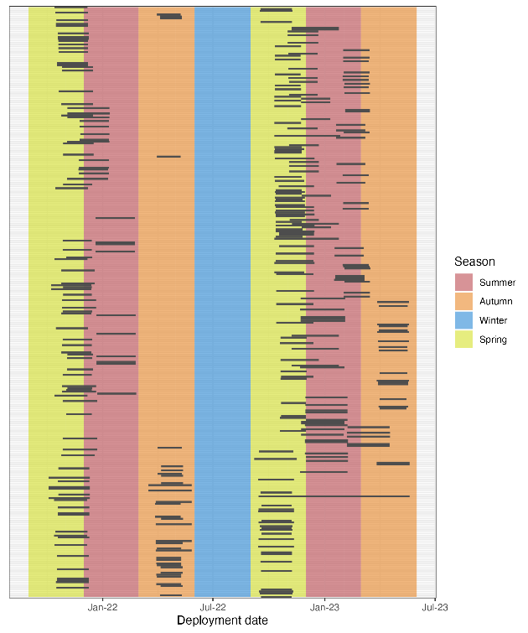
Figure A1. Deployment periods for cameras (n=317) used in this study. Grey bars represent the period (deployment to pick up) that the camera was in the field for.
Table A1. Descriptions of covariates used to model deer density.
Covariate | Description
Bioregion | A landscape-scale classification of areas in Victoria based on their climate, geomorphology, geology, soils, and vegetation (Department of Energy Environment and Climate Action 2019).
Bare soil (%) | Fractional cover of bare soil estimated from remote sensing (MODIS Nadir BRDF-Adjusted Reflectance product: MCD43A4). The combined sum of bare soil, photosynthetic vegetation and non-photosynthetic vegetation is 100% (Guerschman 2014).
Nitrogen (%) | Mass fraction of nitrogen in the topsoil (0–15 cm) by weight (O’Brien 2021).
Distance to pastural land (m) | Distance to nearest area of land that is classed as being under pastural use. Catchment scale land use data for Australia (CLUM) using The Australian Land Use and Management (ALUM) classification system was used to classify pastural areas (ABARES 2021). The following land use classes were considered as pasture:  2.1.0 Grazing native vegetation  3.2.0 Grazing modified pastures  3.2.1 Native/exotic pasture mosaic  3.2.2 Woody fodder plants  3.2.3 Pasture legumes  3.2.4 Pasture legume/grass mixtures  3.2.5 Sown grasses  4.2.0 Grazing irrigated modified pastures  4.2.1 Irrigated woody fodder plants  4.2.2 Irrigated pasture legumes  4.2.3 Irrigated legume/grass mixtures  4.2.4 Irrigated sown grasses
Precipitation seasonality | The Coefficient of Variation of precipitation across the year. That is, the standard deviation of the monthly precipitation estimates expressed as a percentage of the mean of those estimates (i.e., the annual mean). This broadly reflects how much rainfall varies throughout the year (Karger et al. 2017).
Forest edge per km² (m) | Length of forest edge within a 1 km² area. Forest cover is estimated from structural vegetation data (DEECA 2021). With forest classed as a type of open forest or woodland vegetation form.

Table A2. Australian studies that have estimated deer densities at local and regional scales. Dens = Density (deer per km²), LB = Lower bound provided by the study, UB = Upper bound provided by the study.
State | Species | Title | Study sites | Year start | Year end | Dens mean | Dens LB | Dens UB
NSW | Fallow | Estimating deer density and abundance using spatial mark-resight models with camera trap data (Bengsen et al. 2022) | Montane Woodland/Forest in Kosciuszko NP | 2017 | 2019 | 0.29 | 0.12 | 0.53
NSW | Sambar |  | Montane Forest in Kosciuszko NP | 2017 | 2019 | 0.73 | 0.33 | 1.35
NSW | Sambar |  | Montane Woodland/Forest in Kosciuszko NP | 2017 | 2019 | 2.49 | 1.67 | 3.5
NSW | Sambar |  | Wetland Reserve | 2017 | 2019 | 0.48 | 0.24 | 0.84
QLD | Red | I just want to count them! Considerations when choosing a deer population monitoring method (Amos et al. 2014) | Cressbrook Dam catchment | 2010 | 2012 | 45.75 | 39.8 | 51.7
QLD | Red |  | Cressbrook Dam catchment | 2010 | 2012 | 26.5 | 23.7 | 29.3
QLD | Red |  | Cressbrook Dam catchment | 2011 | 2011 | 26.26 | 12.92 | 53.3
QLD | Rusa | Estimating deer density and abundance using spatial mark-resight models with camera trap data (Bengsen et al. 2022) | Central Coastal QLD Woodland | 2017 | 2019 | 10.34 | 7.84 | 13.32
QLD | Rusa |  | Central Coastal QLD Woodland | 2017 | 2019 | 0.68 | 0.21 | 1.77
QLD | Rusa |  | Samsonvale Reservoir | 2017 | 2019 | 3.11 | 1.76 | 5.07
TAS | Fallow | Report of state-wide census of wild fallow deer in Tasmania project: Part A: Baseline aerial survey of fallow deer population, central and north-eastern Tasmania. (Lethbridge et al. 2019) | Northern Midlands | 2019 | 2019 | 2.7 | 1.67 | 3.71
VIC | Fallow | Estimating deer density and abundance using spatial mark-resight models with camera trap data (Bengsen et al. 2022) | Cardinia Reservoir Woodland | 2017 | 2019 | 2.09 | 1.46 | 2.92
VIC | Hog | The influence of evolutionary history and body size on partitioning of habitat resources by mammalian herbivores in south-eastern Australia (Davis et al. 2017) | Yanicke | 2003 | 2004 | 3.01 | 1.73 | 4.29
VIC | Red | Estimating deer density and abundance using spatial mark-resight models with camera trap data (Bengsen et al. 2022) | Sugarloaf Reservoir Woodland | 2017 | 2019 | 24.57 | 19.79 | 30.64
VIC | Red |  | Yan Yean Woodland | 2017 | 2019 | 19.76 | 17.58 | 22.17
VIC | Sambar | BBRR Feral Pig Survey Project | Delicknora | 2023 | 2023 | 1.7 | 1.7 | 1.7
VIC | Sambar | BBRR Feral Pig Survey Project | Wulgulmerang | 2022 | 2022 | 3.29 | 3.29 | 3.29
VIC | Sambar | BBRR Feral Pig Survey Project | Wulgulmerang | 2023 | 2023 | 6.4 | 6.4 | 6.4
VIC | Sambar | Estimating deer density and abundance using spatial mark-resight models with camera trap data (Bengsen et al. 2022) | Cardinia Reservoir Woodland | 2017 | 2019 | 11.94 | 8.44 | 16.48
VIC | Sambar |  | Yan Yean Woodland | 2017 | 2019 | 3.93 | 2.53 | 6.29
VIC | Sambar | The application of catch-effort models to estimate the efficacy of aerial shooting operations on Sambar deer (Ramsey et al. 2023) | Alpine NP - Bogong | 2020 | 2022 | 0.89 | 0.7 | 1.1
VIC | Sambar |  | Alpine NP - Eastern Alps | 2020 | 2022 | 1.4 | 1.08 | 1.76
VIC | Sambar |  | Burrowa-Pine | 2020 | 2022 | 0.4 | 0.27 | 0.56
VIC | Sambar |  | Coopracambra | 2020 | 2022 | 1.12 | 0.04 | 0.2
VIC | Sambar |  | Croajingolong NP | 2020 | 2022 | 0.61 | 0.44 | 0.81
VIC | Sambar |  | Errinundra NP | 2020 | 2022 | 0.8 | 0.58 | 1.05
VIC | Sambar |  | Mount Mitta Mitta RP | 2020 | 2022 | 0.3 | 0.14 | 0.49
VIC | Sambar |  | Mt Buffalo NP | 2020 | 2022 | 0.78 | 0.64 | 0.94
VIC | Sambar |  | Snowy River NP | 2020 | 2022 | 1.08 | 0.86 | 1.28
VIC | Sambar |  | Wabba WP | 2020 | 2022 | 1.3 | 1.02 | 1.6
VIC | Sambar | The role of wild deer in the transmission of diseases of livestock (Pacioni et al. 2023) | Gembrook | 2018 | 2020 | 5.9 | 5.7 | 6.1
VIC | Sambar |  | Kinglake | 2018 | 2020 | 6.8 | 3.7 | 10.9
VIC | Sambar |  | Willow Grove | 2018 | 2020 | 6.2 | 5.9 | 6.5

Table A3. Estimated average abundance and density of deer in reserves listed under the National Parks Act 1975 and greater than 20 km² in size. Reserves are ordered from highest estimated density to least (n = 157).
Reserve | Abundance (deer density per km²)
Reserve | Sambar | Fallow | Red | Hog | All
Cobboboonee Forest Park (86 km²) | 2 (0.02) | 2,288 (26.49) | 24 (0.28) | 0 (0) | 2,314 (26.79)
Mount Napier State Park (29 km²) | 1 (0.03) | 420 (14.29) | 1 (0.03) | 0 (0) | 422 (14.36)
Mount Stanley Scenic Reserve (27 km²) | 222 (8.08) | 70 (2.55) | 6 (0.22) | 0 (0) | 298 (10.84)
Budj Bim National Park (86 km²) | 3 (0.04) | 857 (10) | 22 (0.26) | 0 (0) | 882 (10.29)
Cathedral Range State Park (36 km²) | 237 (6.59) | 104 (2.89) | 9 (0.25) | 0 (0) | 350 (9.73)
Jarvis Creek Plateau Regional Park (25 km²) | 191 (7.59) | 35 (1.39) | 2 (0.08) | 0 (0) | 228 (9.06)
Mount Granya State Park (62 km²) | 403 (6.54) | 79 (1.28) | 7 (0.11) | 0 (0) | 489 (7.93)
Cobboboonee National Park (186 km²) | 2 (0.01) | 1,410 (7.6) | 31 (0.17) | 0 (0) | 1,443 (7.78)
Mount Mitta Mitta Regional Park (39 km²) | 279 (7.09) | 5 (0.13) | 0 (0) | 0 (0) | 284 (7.22)
Burrowa–Pine Mountain National Park (190 km²) | 1,196 (6.31) | 96 (0.51) | 7 (0.04) | 0 (0) | 1,299 (6.85)
Kurth Kiln Regional Park (35 km²) | 179 (5.17) | 52 (1.5) | 1 (0.03) | 0 (0) | 232 (6.7)
Cape Liptrap Coastal Park (44 km²) | 13 (0.3) | 85 (1.94) | 1 (0.02) | 178 (4.07) | 277 (6.33)
Kinglake National Park (231 km²) | 1,153 (4.99) | 250 (1.08) | 10 (0.04) | 0 (0) | 1,413 (6.11)
Marble Gully–Mount Tambo Nature Conservation Reserve (60 km²) | 301 (4.99) | 65 (1.08) | 1 (0.02) | 0 (0) | 367 (6.08)
Baranduda Regional Park (34 km²) | 193 (5.67) | 9 (0.26) | 0 (0) | 0 (0) | 202 (5.93)
Mount Samaria State Park (74 km²) | 272 (3.65) | 156 (2.1) | 4 (0.05) | 0 (0) | 432 (5.8)
Mount Buffalo National Park (275 km²) | 1,106 (4.03) | 432 (1.57) | 27 (0.1) | 0 (0) | 1,565 (5.7)
Warby–Ovens National Park (147 km²) | 794 (5.4) | 26 (0.18) | 1 (0.01) | 0 (0) | 821 (5.58)
Nunniong Plain Natural Features and Scenic Reserve (23 km²) | 116 (5.01) | 8 (0.35) | 0 (0) | 0 (0) | 124 (5.35)
Chiltern-Mt Pilot National Park (217 km²) | 1,118 (5.16) | 34 (0.16) | 1 (0) | 0 (0) | 1,153 (5.32)
Tarra-Bulga National Park (20 km²) | 1 (0.05) | 98 (4.83) | 0 (0) | 6 (0.3) | 105 (5.18)
Mount Wills Historic Area (88 km²) | 393 (4.49) | 57 (0.65) | 3 (0.03) | 0 (0) | 453 (5.17)
Mount Lawson State Park (134 km²) | 609 (4.56) | 56 (0.42) | 8 (0.06) | 0 (0) | 673 (5.04)
River Murray Reserve (150 km²) | 258 (1.72) | 477 (3.19) | 6 (0.04) | 0 (0) | 741 (4.95)
Dandenong Ranges National Park (35 km²) | 154 (4.36) | 20 (0.57) | 0 (0) | 0 (0) | 174 (4.92)
Lake Tyers State Park (87 km²) | 397 (4.57) | 30 (0.35) | 0 (0) | 0 (0) | 427 (4.92)
Colquhoun Regional Park (35 km²) | 153 (4.43) | 10 (0.29) | 0 (0) | 4 (0.12) | 167 (4.84)
Providence Ponds Flora and Fauna Reserve (25 km²) | 19 (0.75) | 22 (0.87) | 0 (0) | 80 (3.16) | 121 (4.77)
Shepparton Regional Park (28 km²) | 78 (2.79) | 52 (1.86) | 0 (0) | 0 (0) | 130 (4.65)
Terrick National Park (64 km²) | 267 (4.18) | 17 (0.27) | 2 (0.03) | 0 (0) | 286 (4.48)
Ewing Morass Wildlife Reserve (hunting) (68 km²) | 292 (4.28) | 13 (0.19) | 0 (0) | 0 (0) | 305 (4.47)
Macedon Regional Park (22 km²) | 45 (2.07) | 48 (2.21) | 0 (0) | 0 (0) | 93 (4.28)
Reef Hills State Park (20 km²) | 82 (4.09) | 3 (0.15) | 0 (0) | 0 (0) | 85 (4.24)
Lower Goulburn National Park (93 km²) | 3 (0.03) | 386 (4.14) | 1 (0.01) | 0 (0) | 390 (4.18)
Dawson-Murrindal Nature Conservation Reserve (32 km²) | 66 (2.07) | 66 (2.07) | 0 (0) | 0 (0) | 132 (4.14)
Port Campbell National Park (24 km²) | 4 (0.17) | 84 (3.47) | 12 (0.5) | 0 (0) | 100 (4.13)
Baw National Park (128 km²) | 495 (3.87) | 29 (0.23) | 0 (0) | 0 (0) | 524 (4.1)
Wabba Wilderness Park (194 km²) | 713 (3.68) | 71 (0.37) | 11 (0.06) | 0 (0) | 795 (4.1)
Cassilis Historic Area (44 km²) | 113 (2.58) | 66 (1.51) | 0 (0) | 0 (0) | 179 (4.09)
Brodribb Flora Reserve (28²) | 105 (3.8) | 7 (0.25) | 0 (0) | 0 (0) | 112 (4.06)
Alfred National Park (30 km²) | 102 (3.38) | 15 (0.5) | 0 (0) | 0 (0) | 117 (3.87)
Black Range State Park (117 km²) | 1 (0.01) | 23 (0.2) | 415 (3.54) | 0 (0) | 439 (3.74)
Wilsons Promontory National Park (477 km²) | 30 (0.06) | 55 (0.12) | 2 (0) | 1,694 (3.55) | 1,781 (3.74)
Lake Eildon National Park (278 km²) | 689 (2.48) | 301 (1.08) | 19 (0.07) | 0 (0) | 1,009 (3.63)
Otway Forest Park (396 km²) | 17 (0.04) | 426 (1.08) | 976 (2.47) | 0 (0) | 1,419 (3.59)
Moondarra State Park (64 km²) | 200 (3.14) | 26 (0.41) | 1 (0.02) | 1 (0.02) | 228 (3.58)
Walhalla Historic Area (26 km²) | 85 (3.31) | 6 (0.23) | 0 (0) | 0 (0) | 91 (3.55)
Alpine National Park (6624 km²) | 20,669 (3.12) | 2,632 (0.4) | 119 (0.02) | 2 (0) | 23,422 (3.54)
Cape Conran Coastal Park (116 km²) | 378 (3.26) | 29 (0.25) | 0 (0) | 0 (0) | 407 (3.52)
Yallock–Bulluk Marine & Coastal Park (32 km²) | 9 (0.28) | 16 (0.5) | 0 (0) | 86 (2.68) | 111 (3.46)
Bunyip State Park (166 km²) | 454 (2.73) | 80 (0.48) | 3 (0.02) | 27 (0.16) | 564 (3.39)
Yarra Ranges National Park (772 km²) | 2,124 (2.75) | 409 (0.53) | 12 (0.02) | 0 (0) | 2,545 (3.3)
Mitchell River National Park (144 km²) | 299 (2.08) | 168 (1.17) | 1 (0.01) | 0 (0) | 468 (3.25)
Great Otway National Park (1104 km²) | 29 (0.03) | 659 (0.6) | 2,835 (2.57) | 0 (0) | 3,523 (3.19)
Grampians National Park (1682 km²) | 7 (0) | 268 (0.16) | 4,926 (2.93) | 0 (0) | 5,201 (3.09)
Croajingolong National Park (885 km²) | 2,622 (2.96) | 107 (0.12) | 0 (0) | 0 (0) | 2,729 (3.08)
Grant Historic Area (74 km²) | 202 (2.73) | 18 (0.24) | 1 (0.01) | 0 (0) | 221 (2.98)
Mount Buangor State Park (25 km²) | 30 (1.2) | 43 (1.72) | 0 (0) | 0 (0) | 73 (2.92)
Tara Range Park (76 km²) | 131 (1.72) | 91 (1.2) | 0 (0) | 0 (0) | 222 (2.92)
Avon–Mt Hedrick Natural Features and Scenic Reserve (56 km²) | 136 (2.41) | 19 (0.34) | 2 (0.04) | 0 (0) | 157 (2.79)
Langi Ghiran State Park (30 km²) | 34 (1.12) | 49 (1.61) | 0 (0) | 0 (0) | 83 (2.73)
Stradbroke Flora and Fauna Reserve (35 km²) | 29 (0.84) | 14 (0.41) | 0 (0) | 50 (1.45) | 93 (2.69)
Mornington Peninsula National Park (27 km²) | 17 (0.63) | 54 (2.01) | 0 (0) | 0 (0) | 71 (2.65)
Lower Glenelg National Park (265 km²) | 1 (0) | 676 (2.56) | 8 (0.03) | 0 (0) | 685 (2.59)
Nooramunga State Faunal Reserve (71 km²) | 24 (0.34) | 16 (0.23) | 0 (0) | 130 (1.84) | 170 (2.41)
Holey Plains State Park (107 km²) | 88 (0.82) | 46 (0.43) | 0 (0) | 123 (1.14) | 257 (2.39)
Gunbower National Park (93 km²) | 2 (0.02) | 216 (2.32) | 1 (0.01) | 0 (0) | 219 (2.35)
Brisbane Ranges National Park (89 km²) | 133 (1.5) | 75 (0.84) | 0 (0) | 0 (0) | 208 (2.34)
Wimmera River Heritage Area Park (28 km²) | 6 (0.21) | 48 (1.72) | 10 (0.36) | 0 (0) | 64 (2.29)
Jancourt Nature Conservation Reserve (34 km²) | 4 (0.12) | 64 (1.9) | 8 (0.24) | 0 (0) | 76 (2.25)
Tallageira Nature Conservation Reserve (38 km²) | 5 (0.13) | 58 (1.55) | 18 (0.48) | 0 (0) | 81 (2.16)
Proposed Murray River Park (part) (219 km²) | 90 (0.41) | 365 (1.66) | 4 (0.02) | 0 (0) | 459 (2.09)
The Lakes National Park (24 km²) | 10 (0.42) | 7 (0.29) | 0 (0) | 32 (1.33) | 49 (2.04)
Coopracambra National Park (385 km²) | 587 (1.52) | 194 (0.5) | 1 (0) | 0 (0) | 782 (2.03)
Enfield State Park (43 km²) | 53 (1.23) | 34 (0.79) | 0 (0) | 0 (0) | 87 (2.01)
Martins Creek Nature Conservation Reserve (65 km²) | 93 (1.42) | 28 (0.43) | 0 (0) | 0 (0) | 121 (1.85)
Avon Wilderness Park (396 km²) | 681 (1.72) | 35 (0.09) | 3 (0.01) | 0 (0) | 719 (1.82)
Snowy River National Park (1147 km²) | 1,253 (1.09) | 780 (0.68) | 2 (0) | 1 (0) | 2,036 (1.78)
French Island National Park (103 km²) | 70 (0.68) | 112 (1.09) | 0 (0) | 0 (0) | 182 (1.76)
Errinundra National Park (431 km²) | 577 (1.34) | 146 (0.34) | 2 (0) | 2 (0) | 727 (1.69)
Mount Arapiles–Tooan State Park (75 km²) | 12 (0.16) | 52 (0.7) | 58 (0.78) | 0 (0) | 122 (1.64)
Mount Elizabeth Nature Conservation Reserve (52 km²) | 56 (1.07) | 28 (0.54) | 0 (0) | 0 (0) | 84 (1.61)
Lerderderg State Park (205 km²) | 219 (1.07) | 107 (0.52) | 0 (0) | 0 (0) | 326 (1.59)
Gippsland Lakes Coastal Park (178k m²) | 73 (0.41) | 51 (0.29) | 0 (0) | 147 (0.83) | 271 (1.52)
Cundare Pool (Lake Martin) Lake Reserve (28 km²) | 1 (0.04) | 36 (1.26) | 0 (0) | 0 (0) | 37 (1.3)
Hepburn Regional Park (31 km²) | 8 (0.26) | 32 (1.03) | 0 (0) | 0 (0) | 40 (1.29)
Pyrenees National Park (Proposed) (107 km²) | 53 (0.5) | 80 (0.75) | 1 (0.01) | 0 (0) | 134 (1.25)
Crawford River Regional Park (24 km²) | 0 (0) | 30 (1.24) | 0 (0) | 0 (0) | 30 (1.24)
Jack Smith Lake Wildlife Reserve (hunting) (28 km²) | 16 (0.58) | 4 (0.14) | 0 (0) | 14 (0.5) | 34 (1.22)
Murray–Kulkyne Park (45 km²) | 12 (0.26) | 39 (0.86) | 2 (0.04) | 0 (0) | 53 (1.17)
Barmah National Park (285 km²) | 4 (0.01) | 313 (1.1) | 1 (0) | 0 (0) | 318 (1.11)
Castlemaine Diggings National Heritage Park (76 km²) | 9 (0.12) | 66 (0.87) | 0 (0) | 0 (0) | 75 (0.99)
Dergholm State Park (109 km²) | 1 (0.01) | 66 (0.61) | 41 (0.38) | 0 (0) | 108 (0.99)
Jilpanger Nature Conservation Reserve (122 km²) | 20 (0.16) | 85 (0.69) | 15 (0.12) | 0 (0) | 120 (0.98)
Wilkin Flora and Fauna Reserve (32 km²) | 0 (0) | 31 (0.96) | 0 (0) | 0 (0) | 31 (0.96)
Wilsons Promontory Marine Park (54 km²) | 2 (0.04) | 2 (0.04) | 0 (0) | 44 (0.82) | 48 (0.89)
Winton Wetlands Natural Features Reserve (88 km²) | 66 (0.75) | 11 (0.13) | 0 (0) | 0 (0) | 77 (0.88)
Kings Billabong Park (22 km²) | 4 (0.18) | 15 (0.68) | 0 (0) | 0 (0) | 19 (0.87)
Maldon Historic Reserve (25 km²) | 2 (0.08) | 20 (0.79) | 0 (0) | 0 (0) | 22 (0.87)
Ararat Regional Park (37 km²) | 2 (0.05) | 26 (0.71) | 0 (0) | 0 (0) | 28 (0.76)
Pilchers Bridge Nature Conservation Reserve (22 km²) | 2 (0.09) | 14 (0.62) | 0 (0) | 0 (0) | 16 (0.71)
Nooramunga Marine and Coastal Park (231 km²) | 35 (0.15) | 19 (0.08) | 0 (0) | 97 (0.42) | 151 (0.65)
Leaghur State Park (20 km²) | 2 (0.1) | 10 (0.49) | 1 (0.05) | 0 (0) | 13 (0.64)
Lake Coleman Wildlife Reserve (hunting) (21 km²) | 8 (0.38) | 1 (0.05) | 0 (0) | 4 (0.19) | 13 (0.62)
Fryers Ridge Nature Conservation Reserve (20 km²) | 1 (0.05) | 11 (0.54) | 0 (0) | 0 (0) | 12 (0.59)
Mount Bolangum Nature Conservation Reserve (27 km²) | 2 (0.07) | 13 (0.48) | 0 (0) | 0 (0) | 15 (0.56)
Paddys Ranges State Park (20 km²) | 2 (0.1) | 9 (0.45) | 0 (0) | 0 (0) | 11 (0.55)
Yarrara Flora and Fauna Reserve (23 km²) | 2 (0.09) | 9 (0.4) | 1 (0.04) | 0 (0) | 12 (0.53)
Wychitella Nature Conservation Reserve (69 km²) | 5 (0.07) | 30 (0.43) | 0 (0) | 0 (0) | 35 (0.51)
Crosbie Nature Conservation Reserve (20 km²) | 2 (0.1) | 8 (0.4) | 0 (0) | 0 (0) | 10 (0.5)
Stuart Mill Nature Conservation Reserve (26 km²) | 2 (0.08) | 11 (0.42) | 0 (0) | 0 (0) | 13 (0.5)
Bendigo Regional Park (87 km²) | 8 (0.09) | 35 (0.4) | 0 (0) | 0 (0) | 43 (0.49)
Kooyoora State Park (115 km²) | 8 (0.07) | 47 (0.41) | 0 (0) | 0 (0) | 55 (0.48)
North Western Port Nature Conservation Reserve (21 km²) | 7 (0.34) | 3 (0.14) | 0 (0) | 0 (0) | 10 (0.48)
Dalyenong Nature Conservation Reserve (27 km²) | 2 (0.08) | 10 (0.38) | 0 (0) | 0 (0) | 12 (0.45)
Discovery Bay Coastal Park (106 km²) | 0 (0) | 42 (0.39) | 6 (0.06) | 0 (0) | 48 (0.45)
Waanyarra Nature Conservation Reserve (29 km²) | 3 (0.1) | 10 (0.35) | 0 (0) | 0 (0) | 13 (0.45)
Greater Bendigo National Park (176 km²) | 14 (0.08) | 61 (0.35) | 0 (0) | 0 (0) | 75 (0.43)
Landsborough Nature Conservation Reserve (34 km²) | 4 (0.12) | 10 (0.3) | 0 (0) | 0 (0) | 14 (0.42)
Tooloy–Lake Mundi Wildlife Reserve (hunting) (41 km²) | 0 (0) | 17 (0.41) | 0 (0) | 0 (0) | 17 (0.41)
Kara Kara National Park (140 km²) | 7 (0.05) | 46 (0.33) | 0 (0) | 0 (0) | 53 (0.38)
Koorangie Wildlife Reserve (hunting) (32 km²) | 2 (0.06) | 9 (0.28) | 1 (0.03) | 0 (0) | 12 (0.37)
Wilsons Promontory Marine National Park (156 km²) | 0 (0) | 1 (0.01) | 0 (0) | 55 (0.35) | 56 (0.36)
Heathcote–Graytown National Park (127 km²) | 8 (0.06) | 35 (0.28) | 0 (0) | 0 (0) | 43 (0.34)
Lake Corangamite Lake Reserve (252 km²) | 1 (0) | 84 (0.33) | 1 (0) | 0 (0) | 86 (0.34)
Hattah–Kulkyne National Park (501 km²) | 42 (0.08) | 109 (0.22) | 9 (0.02) | 0 (0) | 160 (0.32)
Lake Connewarre Wildlife Reserve (hunting) (37 km²) | 1 (0.03) | 10 (0.27) | 1 (0.03) | 0 (0) | 12 (0.32)
Lake Burrumbeet Lake Reserve (26 km²) | 0 (0) | 8 (0.31) | 0 (0) | 0 (0) | 8 (0.31)
Whroo Nature Conservation Reserve (22 km²) | 2 (0.09) | 5 (0.22) | 0 (0) | 0 (0) | 7 (0.31)
Lake Colac Lake Reserve (29 km²) | 0 (0) | 7 (0.24) | 0 (0) | 0 (0) | 7 (0.24)
Birdcage Flora and Fauna Reserve (26 km²) | 1 (0.04) | 5 (0.19) | 0 (0) | 0 (0) | 6 (0.23)
Lake Albacutya Park (83 km²) | 2 (0.02) | 15 (0.18) | 1 (0.01) | 0 (0) | 18 (0.22)
Corner Inlet Marine and Coastal Park (283 km²) | 8 (0.03) | 6 (0.02) | 0 (0) | 42 (0.15) | 56 (0.2)
Twelve Apostles Marine National Park (75 km²) | 1 (0.01) | 8 (0.11) | 5 (0.07) | 0 (0) | 14 (0.19)
Point Hicks Marine National Park (38 km²) | 7 (0.18) | 0 (0) | 0 (0) | 0 (0) | 7 (0.18)
French Island Marine National Park (30 km²) | 3 (0.1) | 2 (0.07) | 0 (0) | 0 (0) | 5 (0.17)
Lake Hindmarsh Lake Reserve (153 km²) | 2 (0.01) | 13 (0.08) | 7 (0.05) | 0 (0) | 22 (0.14)
Murray–Sunset National Park (6668 km²) | 217 (0.03) | 414 (0.06) | 122 (0.02) | 0 (0) | 753 (0.11)
Cape Howe Marine National Park (41 km²) | 4 (0.1) | 0 (0) | 0 (0) | 0 (0) | 4 (0.1)
Red Bluff Flora and Fauna Reserve (38 km²) | 0 (0) | 4 (0.1) | 0 (0) | 0 (0) | 4 (0.1)
Lake Gnarpurt Lake Reserve (25 km²) | 0 (0) | 2 (0.08) | 0 (0) | 0 (0) | 2 (0.08)
Little Desert National Park (1316 km²) | 5 (0) | 88 (0.07) | 11 (0.01) | 0 (0) | 104 (0.08)
Wandown Flora and Fauna Reserve (25 km²) | 1 (0.04) | 1 (0.04) | 0 (0) | 0 (0) | 2 (0.08)
Point Addis Marine National Park (44 km²) | 0 (0) | 3 (0.07) | 0 (0) | 0 (0) | 3 (0.07)
Port Phillip Heads Marine National Park (28 km²) | 1 (0.04) | 1 (0.04) | 0 (0) | 0 (0) | 2 (0.07)
Bronzewing Flora and Fauna Reserve (125 km²) | 1 (0.01) | 3 (0.02) | 2 (0.02) | 0 (0) | 6 (0.05)
Bunurong Marine National Park (20 km²) | 0 (0) | 0 (0) | 0 (0) | 1 (0.05) | 1 (0.05)
Lake Tyrrell Wildlife Reserve (hunting) (128 km²) | 1 (0.01) | 2 (0.02) | 2 (0.02) | 0 (0) | 5 (0.04)
Lake Wahpool Lake Reserve (26 km²) | 0 (0) | 1 (0.04) | 0 (0) | 0 (0) | 1 (0.04)
Paradise Flora and Fauna Reserve (24 km²) | 0 (0) | 1 (0.04) | 0 (0) | 0 (0) | 1 (0.04)
Annuello Flora and Fauna Reserve (352 km²) | 4 (0.01) | 6 (0.02) | 2 (0.01) | 0 (0) | 12 (0.03)
Big Desert Wilderness Park (1417 km²) | 1 (0) | 26 (0.02) | 1 (0) | 0 (0) | 28 (0.02)
Wathe Flora and Fauna Reserve (60 km²) | 0 (0) | 1 (0.02) | 0 (0) | 0 (0) | 1 (0.02)
Wyperfeld National Park (3600 km²) | 5 (0) | 48 (0.01) | 4 (0) | 0 (0) | 57 (0.02)
Discovery Bay Marine National Park (28 km²) | 0 (0) | 0 (0) | 0 (0) | 0 (0) | 0 (0)
Lake Timboram Flora and Fauna Reserve (25 km²) | 0 (0) | 0 (0) | 0 (0) | 0 (0) | 0 (0)
Ninety Mile Beach Marine National Park (27 km²) | 0 (0) | 0 (0) | 0 (0) | 0 (0) | 0 (0)

Table A4. Wildlife species (n=73) detected during the statewide and hog deer surveys, including the number of sites where the species was detected.
Species | Sites detected (out of 317)
Black-tailed Wallaby | 214
Eastern Grey Kangaroo | 129
Sambar deer | 104
Bare-nosed Wombat | 91
Red Fox | 90
Common Brush-tailed Possum | 80
Emu | 46
Dingo/Wild Dog | 38
Superb Lyrebird | 38
Pied Currawong | 36
Laughing Kookaburra | 35
Short-beaked Echidna | 32
Domestic Cat (feral) | 30
Fallow deer | 30
Red-necked Wallaby | 25
Ravens and Crows | 24
Hog deer | 22
Grey Currawong | 19
Australian Magpie | 18
Southern Long-nosed Bandicoot | 17
Western Grey Kangaroo | 17
Long-footed Potoroo | 16
Rabbits and Hares | 16
European Rabbit | 15
Red deer | 12
Red Wattlebird | 11
Eastern Ring-tailed Possum | 9
Koala | 9
White-winged Chough | 9
Wonga Pigeon | 9
Grey Shrike-thrush | 8
Lace Monitor | 8
Crimson Rosella | 6
Goat (feral) | 6
Australian Raven | 5
Bassian Thrush | 3
Bush Rat | 3
Common Blackbird | 3
Horse (feral) | 3
Leadbeater's Possum | 3
Magpie-lark | 3
Mountain Brush-tailed Possum | 3
Pacific Black Duck | 3
Satin Bowerbird | 3
Australian Wood Duck | 2
Black Rat | 2
Eastern Whipbird | 2
Flame Robin | 2
Long-nosed Potoroo | 2
Pig (feral) | 2
White-browed Scrubwren | 2
White-eared Honeyeater | 2
Yellow-tailed Black-Cockatoo | 2
Antechinus | 1
Australian Owlet-nightjar | 1
Black Swan | 1
Black-faced Cuckoo-shrike | 1
Brush Bronzewing | 1
Brushtail Possums | 1
Cattle (feral) | 1
Chestnut Teal | 1
Dingo and Dog (feral) | 1
Eastern Rosella | 1
Eastern Yellow Robin | 1
Galah | 1
Grey Butcherbird | 1
Grey Fantail | 1
Morepork | 1
Red Kangaroo | 1
Rufous Fantail | 1
Stubble Quail | 1
Sulphur-crested Cockatoo | 1
White-faced Heron | 1

www.deeca.vic.gov.au

www.ari.vic.gov.au

Average abundance estimates (N) are based on a trimmed mean for regional and statewide predictions. Trimming excludes the top and bottom 2.5% of values in calculating the mean.

