
Native Fish Report Card 2025
Gellibrand River
Corangamite Region

This report card summarises the 2025 Native Fish Report Card (NFRC) survey in the Gellibrand River
Sites: 9, Electrofishing + Fyke Netting

Fish found in Gellibrand River for NFRC
Target species
River Blackfish

Non-target species captured since 2017*
Large-bodied native species
Australian Grayling
Pouched Lamprey
Short-finned Eel
Short-headed Lamprey
Tupong

Small-bodied native species
Australian Smelt
Climbing Galaxias
Common Galaxias
Ornate Galaxias
Southern Pygmy Perch
Spotted Galaxias

Exotic species
Brown Trout

* These non-target species were incidentally captured during NFRC surveys since 2017 but not measured as for target species

Gellibrand River 2025
Fish Community

NFRC target species
The NFRC Program began in 2017 to monitor population dynamics of key iconic fish species that have high recreational and/or conservation values, in large rivers across Victoria. In the Gellibrand River, the target species is River Blackfish. Surveys occur in March/April each year, at seven sites from upstream of Chapple Vale to Dandos Campground on the Gellibrand River and two sites on tributaries. Backpack electrofishing is undertaken in the tributaries, whilst backpack electrofishing and fyke netting is undertaken in the Gellibrand River. The equipment used and habitats surveyed target River Blackfish, which are measured to determine their population structures. Other fish species that are incidentally captured are counted, but not measured.
Summary of key health indicators for target species in 2025
Species | Key Health Indicators
 | Recent recruitment | Multiple size classes | Mature fish present
River Blackfish | Yes | Yes | Yes

Recent recruitment means young-of-year fish

River Blackfish are a lowland species, generally found at altitudes below 200m. This species has suffered a decline in distribution and abundance across Victoria^{1,2}. The Gellibrand River was previously known as having a well-established River Blackfish population with large adults present³.

Non-target species
The non-target fish species that have been incidentally recorded in the Gellibrand River during NFRC surveys since 2017 are:

Large-bodied native species
Australian Grayling, Short-finned Eel, Short-headed Lamprey and Tupong were recorded in the 2025 survey. Of these four species, Short-finned Eel is the only species recorded in all nine NFRC surveys. Tupong have been recorded in seven of the nine NFRC surveys, Short-headed Lamprey in six, with Australian Grayling recorded in five. Australian Grayling is listed as endangered in Victoria (Flora and Fauna Guarantee Act 1988) and nationally (Environment Protection and Biodiversity Conservation Act 1999). Numbers of Australian Grayling are low in the Gellibrand River catchment and the species is rarely found. Two fish were captured in the 2025 surveys. The fish were captured at Lyness and Ganes which are at the downstream end of the sites surveyed. Previous captures in the catchment during the NFRC surveys were predominantly from the most downstream site with only one recruit captured further upstream in 2017 (at the third most downstream site) and one at Clancys (second most upstream site) in 2024. The Short-finned Eel, Short-headed Lamprey and Tupong are diadromous (migratory between salt water and fresh water) species found throughout coastal Victoria. No Pouched Lamprey were recorded in the 2025 surveys; however, they have been detected in five previous NFRC surveys. Pouched Lamprey is also a diadromous species found throughout coastal Victoria.

Small-bodied native species
Australian Smelt, Common Galaxias, Ornate Galaxias and Southern Pygmy Perch were recorded in the 2025 survey. Australian Smelt, Common Galaxias and Ornate Galaxias have been detected in all nine NFRC surveys. Australian Smelt is a common species distributed across all of Victoria. The Common Galaxias is a diadromous species found across coastal Victoria. The Ornate Galaxias is known from West Gippsland across to the Gellibrand area. Southern Pygmy Perch has been recorded in three NFRC surveys and is more common in off stream habitats such as wetlands, billabongs and lagoons. In previous NFRC surveys the Climbing Galaxias and Spotted Galaxias have been recorded, although rarely. Both are diadromous species found across coastal Victoria.

Exotic fish species
Brown Trout was the only exotic species recorded in the 2025 survey and has been detected in all nine NFRC surveys. The species is present throughout the Gellibrand River, occurring in low to moderate abundances. Brown Trout is not a dominant species in the Gellibrand River; however abundances increase higher in the catchment.

Other native fish species known from the Gellibrand River
Some fish species known to occur in the Gellibrand River have never been recorded during NFRC surveys. This includes the Flatheaded Gudgeon which is a common species across Victoria.

Other notable species
Surveys have also recorded Corrugated Mussel, Hairy Burrowing Crayfish, Platypus and Southern Victorian Spiny Crayfish.

1. Hammer et al. (2014) A multi-gene molecular assessment of cryptic biodiversity in the iconic freshwater blackfishes (Teleosti: Perchichthyidae: Gadopsis) of south-eastern Australia. Biological journal of the Linnean Society.
2. Khan et al. (2004). Habitat use and movement of river blackfish (Gadopsis marmoratus R.) in a highly modified Victorian stream, Australia. Ecology of Freshwater Fish, 13: 285–293.
3. Koehn, J. 1984. Survey of angling and recreational use of the Gellibrand River, south-western Victoria. Arthur Rylah Institute for Environmental Research Technical Report Series No. 10. Department of Conservation, Forests and Lands. Fisheries and Wildlife Service Victoria.

Gellibrand River 2025
Environmental and Management Context

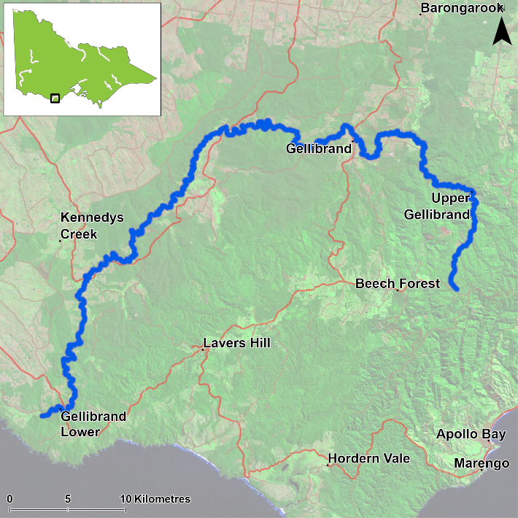
Figure 1. Map showing the section of Gellibrand River where NFRC sampling occurs

Environment
Low flow conditions were present in all nine sampling years, albeit the lowest recorded in 2025. The water was also very clear in 2025, increasing the electrofishing efficiency. Since 2021 the pH in Boggy Creek has been extremely low ranging from 4.5 to 5.4 in each of the sampling years with the lowest pH reading in the Gellibrand mainstem being 6.4 during this time. The preferred pH range for aquatic species is 6.4-8.4 ⁴. Variations in the pH of a water body can negatively affect an organism’s biochemical processes, leading to altered behaviour, functioning, growth, and even survival⁵.
However, fish have continued to be detected at the Boggy Creek site across all years. The upper sites on the Gellibrand River main stem have been experiencing increased levels of sand deposition since the NFRC surveys began.

Waterway and fisheries management efforts in the Gellibrand River
Many rehabilitation actions have occurred, and are underway, to improve the health of the Gellibrand River. These are informed by the Corangamite Waterway Strategy 2014-2022 as well as the Gellibrand River Estuary Management Plan. Actions include revegetation, weed control including large scale removal of willows, fencing of riparian areas, bank stabilisation, reintroduction of instream woody habitat, removal of migration barriers and pest control. Some fish monitoring has occurred, including related to rehabilitation efforts. The Corangamite Catchment Management Authority, DEECA and Victorian Fisheries Authority support rehabilitation and management of the Gellibrand River and its fish community.

4. U.S. EPA (2024). Causal Analysis/Diagnosis Decision Information System (CADDIS): pH. United States Environmental Protection Agency. Viewed 15 September 2025, https://www.epa.gov/caddis/ph.

5. Petheram C, Philip S, Watson I, Bruce C and Chilcott C (eds) (2024) Water resource assessment for the Victoria catchment. A report from the CSIRO Victoria River Water Resource Assessment for the National Water Grid. CSIRO, Australia.
River Blackfish

Gellibrand River, Corangamite region

Key Health Indicators
Recent recruitment Yes
Multiple size classes Yes
Mature fish present Yes

Monitoring Results
Total number of fish caught 63
Fish per 1km of waterway 33.42
Largest fish by length (cm) 52.2
Largest fish by weight (kg) 1.26
% of the catch that is legal size 33.3

Recruits, juveniles and adult River Blackfish (Gadopsis marmoratus) were recorded in the 2025 survey and have been recorded in eight of the nine years surveyed (Figure 2). Twenty-seven River Blackfish were detected in the main stem of the Gellibrand River in 2025, which is the highest so far in NFRC surveys. Previously, only low abundances of River Blackfish were detected in the mainstem (5-18 fish each year), despite seven of the nine sites being on the Gellibrand River main stem. The highest abundance of recruits was detected in 2025 (n=16), a vast increase from only two in 2024 and none in 2023 (Figure 2; Figure 3). Fifty-two percent of the River Blackfish (adults, juveniles and recruits) were recorded from Boggy Creek in 2025, although, adults, juveniles and recruits were also detected in the Gellibrand River. Most recruitment occurs in the tributaries; however, five recruits were detected in the main stem of the Gellibrand River (one at Daffys and four at Dandos). Prior to 2025, only one recruit had been recorded in the Gellibrand River (at Dandos in 2022). Additionally, three juveniles were recorded in 2025 (one at Daffys and two at Dandos), with only three juveniles previously recorded in the Gellibrand River during NFRC surveys (all at Dandos - two in 2023 and one in 2024).

The detection of the vast majority of recruits and juveniles from tributary habitats in the Gellibrand River catchment over nine years of NFRC surveys highlights the importance of these habitats for recruitment to the River Blackfish population. The presence of recruits and juveniles at the highest two Gellibrand River sites (Dandos-highest and Daffys) indicates limited recruitment is occurring at the upper end of the sites surveyed. It is unknown why abundances were lower in 2023.

Stocking
No stocking has occurred.
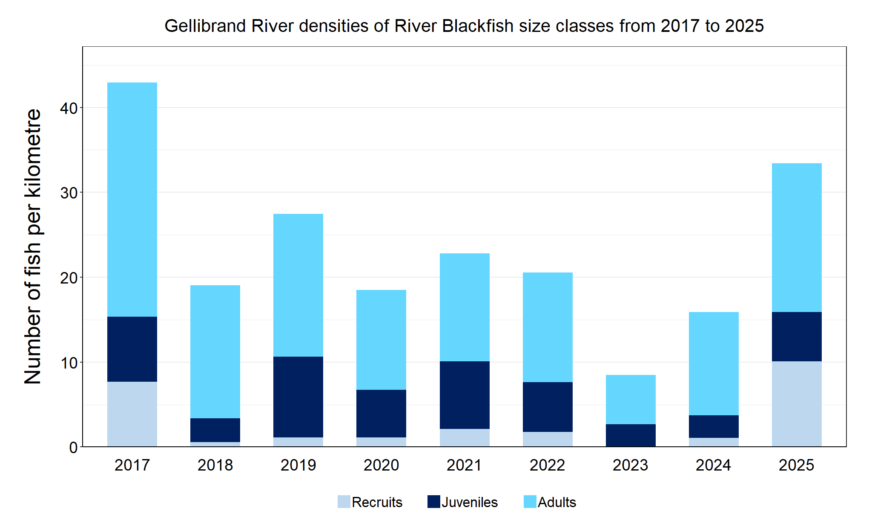Figure 2. The densities of recruits, juveniles and adult River Blackfish in the Gellibrand River from 2017 to 2025.

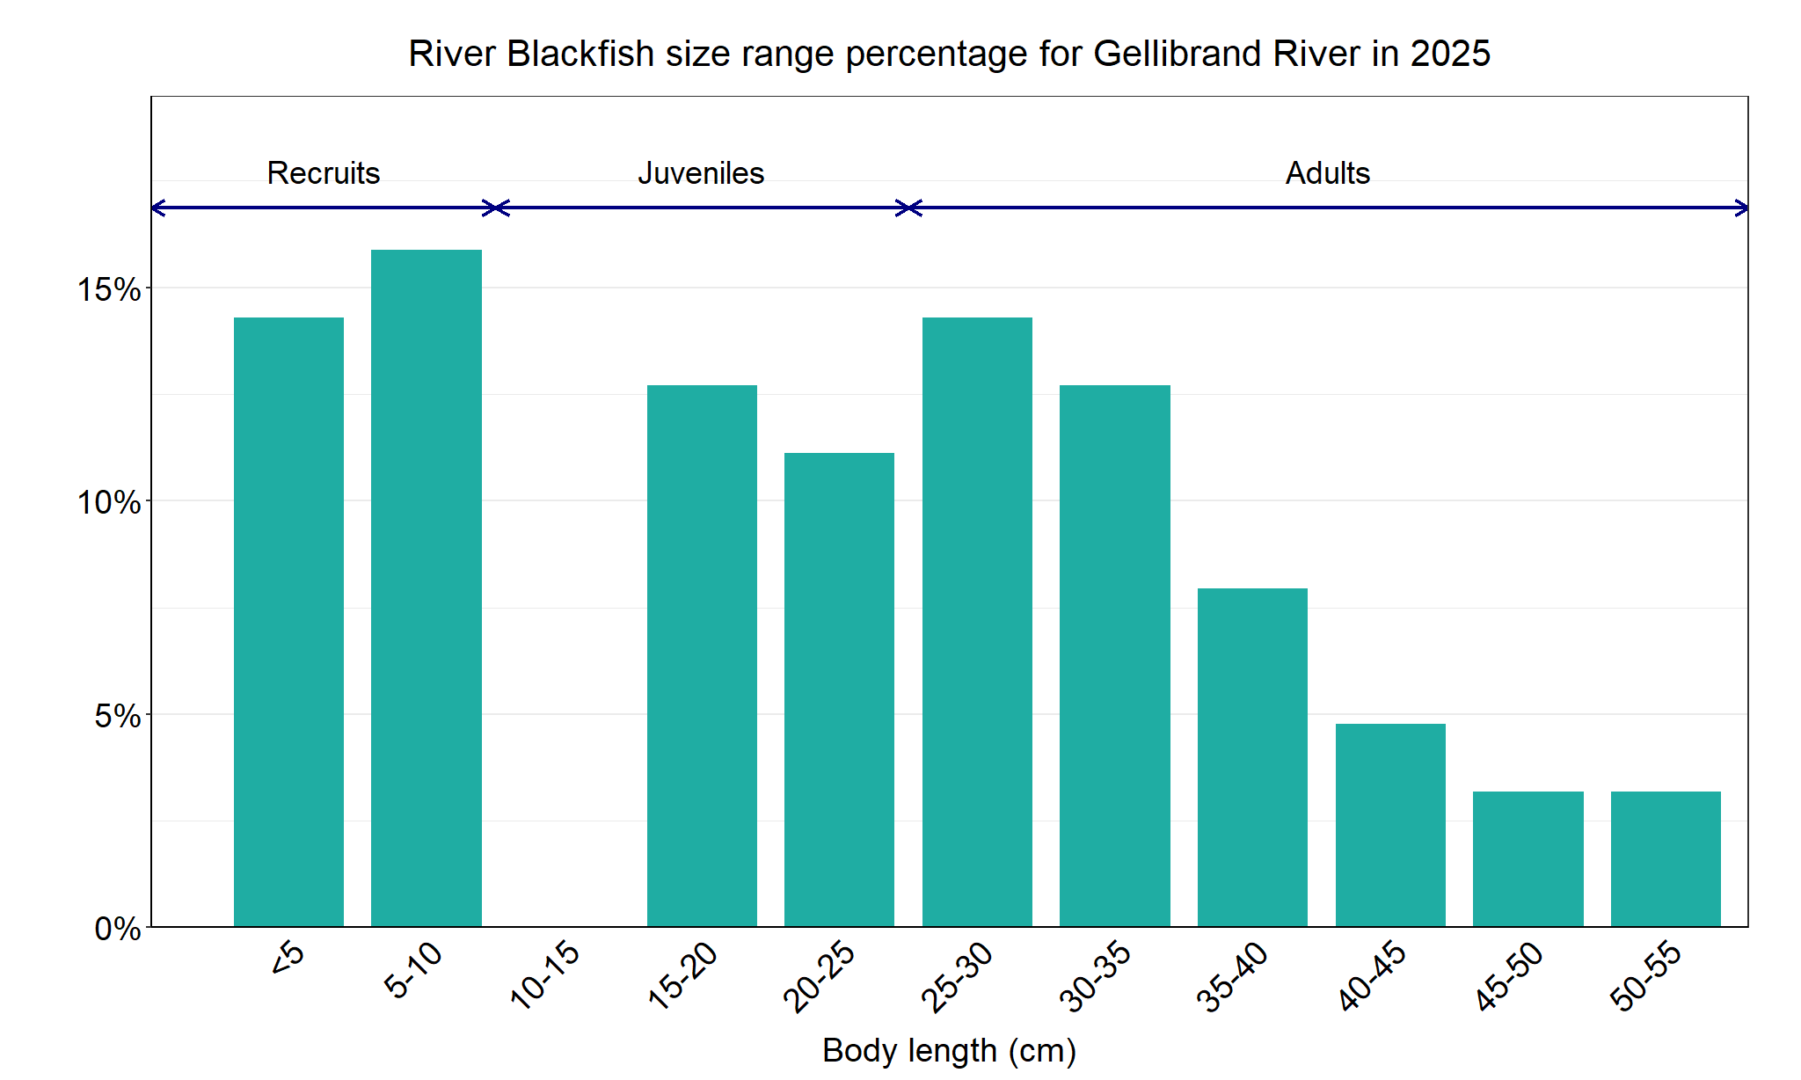Figure 3. The size range percentage of river Blackfish in the Gellibrand River in 2025.

We acknowledge and respect Victorian Traditional Owners as the original custodians of Victoria’s land and waters, their unique ability to care for Country and deep spiritual connection to it. We honour Elders past and present whose knowledge and wisdom has ensured the continuation of culture and traditional practices.

© The State of Victoria Department of Energy, Environment and Climate Action 2025. This work is licensed under a Creative Commons Attribution 4.0 International licence. To view a copy of this licence, visit creativecommons.org/licenses/by/4.0/
ISSN 2981-8990 - Online (pdf/word)

