
Native Fish Report Card 2025
Yarra River
Port Phillip Region

This report card summarises the 2025 Native Fish Report Card (NFRC) survey in the Yarra River
Sites: 11, Electrofishing

Fish found in Yarra River for NFRC
Target species
Australian Grayling
Macquarie Perch#
Murray Cod#

Non-target species recorded since 2017*
Large-bodied native species
River Blackfish
Short-finned Eel
Tupong
Australian Bass#
Barramundi#
Golden Perch#

Small-bodied native species
Australian Smelt
Common Galaxias
Flatheaded Gudgeon
Ornate Galaxias

Exotic species
Brown Trout
Common Carp
Eastern Gambusia
Goldfish
Oriental Weatherloach
Redfin
Roach

* These non-target species were incidentally captured during NFRC surveys since 2017 but not measured as for target species. # Native species translocated outside of its natural range.
Yarra River 2025
Fish Community

NFRC target species
The NFRC Program began in 2017 to monitor population dynamics of key iconic fish species that have high recreational and/or conservation values, in large rivers across Victoria. In the Yarra River, the target species are Australian Grayling, Macquarie Perch and Murray Cod. The equipment used and habitats surveyed target these species, which are measured to determine their population structures. Other fish species that are incidentally captured are counted, but not measured. Surveys occur in March/April each year, with 14 sites from upstream of Dights Falls to Yarra Glen fished in 2017-2021 and 11 sites fished from Heidelberg to Yarra Glen in 2022-2025. The Yarra River primarily uses boat electrofishing with bank-mounted electrofishing at two sites.
Summary of key health indicators for target species in 2025
Species | Key Health Indicators
 | Recent recruitment | Multiple size classes | Mature fish present
Australian Grayling* | - | - | -
Macquarie Perch | Yes | Yes | Yes
Murray Cod | Yes | Yes | Yes

Recent recruitment refers to young-of-year fish
*- cannot be determined due to low abundances

Australian Grayling were once widespread throughout coastal Victoria, including the Yarra River system. Changes to flow regimes and barriers negatively affect this species. The detection of Australian Grayling in seven of the nine years is an encouraging sign that river conditions are enabling persistence of the species. Macquarie Perch has undergone a long-term decline in abundance with populations now fragmented and absent from much of its former range. Macquarie Perch were first translocated into the Yarra catchment in 1857 and the population is now considered important genetically. The population appears to be declining; however, an increase in adults has been detected post the 2023 fishing regulation changes (when Macquarie Perch became a no-take species). Murray Cod were translocated into the Yarra River in 1857 and are now a popular recreational species. There appears to be a small self-sustaining population. The following pages have more detail about the population structures of each target species.

Non-target species
The non-target fish species that have been incidentally recorded in the Yarra River during NFRC surveys since 2017 are:

Large-bodied native species
Australian Bass, Golden Perch, River Blackfish, Short-finned Eel were recorded in the 2025 survey. Short-finned Eel is a diadromous species (migrating between freshwater and the sea) found throughout coastal Victoria and has been recorded in all nine NFRC surveys. River Blackfish is a non-migratory species and has been recorded in two of the nine NFRC surveys. River Blackfish is a lowland species, generally found at altitudes below 200 m. This species has declined in distribution and abundance across the State. Golden Perch has been recorded in seven of the nine NFRC surveys and has been translocated into the Yarra River. Australian Bass have been recorded in three of the nine NFRC surveys. Australian Bass is found in eastern coastal Victoria and has been translocated to the Yarra River. Other large-bodied species previously recorded, although rarely, in NFRC surveys are Barramundi and Tupong. While Barramundi has also been translocated to this river, it is a tropical species and thus conditions are not likely to be suitable for its survival. Tupong are a diadromous species found throughout coastal Victoria.

Small-bodied native species
Australian Smelt, Common Galaxias and Flatheaded Gudgeon were recorded in the 2025 survey. Australian Smelt and Flatheaded Gudgeon are common across Victoria with Australian Smelt recorded in all nine NFRC surveys and Flatheaded Gudgeon recorded seven times. The Common Galaxias is a diadromous species found across coastal Victoria and has been collected in all nine NFRC surveys. The Ornate Galaxias, whilst not recorded in 2025, has been recorded in two of the nine NFRC surveys (2023, 2024). Ornate Galaxias is mainly confined to coastal Victoria between Wilsons Promontory and Cape Otway. In the Yarra River, the species is widespread and patchy in the lower areas, but more common above 200 m altitude.

Exotic fish species
Common Carp, Eastern Gambusia, Goldfish, Oriental Weatherloach, Redfin and Roach were recorded in the 2025 survey. These species are generally widespread throughout the sampling reaches of the Yarra River. Common Carp, Redfin and Roach have been recorded in all nine NFRC surveys. Eastern Gambusia has been recorded in seven of the nine surveys, while Goldfish and Oriental Weatherloach have been recorded eight times. Eastern Gambusia are often detected in slower flowing habitats. Brown Trout, although not recorded in the 2025 survey has been recorded in three of the nine NFRC surveys. It is not a dominant species in the NFRC sampling area, being more abundant at higher altitudes.

Other native fish species known from the Yarra River
Some fish species known to occur in the Yarra River have never been recorded during NFRC surveys (e.g. Climbing Galaxias, Dwarf Galaxias, Spotted Galaxias, Pouched Lamprey, Short-headed Lamprey, Southern Pygmy Perch and Yarra Pygmy Perch). Climbing Galaxias, Spotted Galaxias, Pouched Lamprey and Shortheaded Lamprey are diadromous species in coastal Victoria. Climbing Galaxias and Spotted Galaxias have patchy distributions and are hard to detect using NFRC sampling methods. Pouched and Short-headed Lamprey were considered widespread but in recent times adults are rarely seen and are usually active at night. Dwarf Galaxias, Southern and Yarra Pygmy Perch are often found in offstream habitats (billabongs, wetlands and lagoons).

Other notable species
Surveys have also recorded Southern Victorian Spiny Crayfish.

Yarra River 2025
Environmental and Management Context

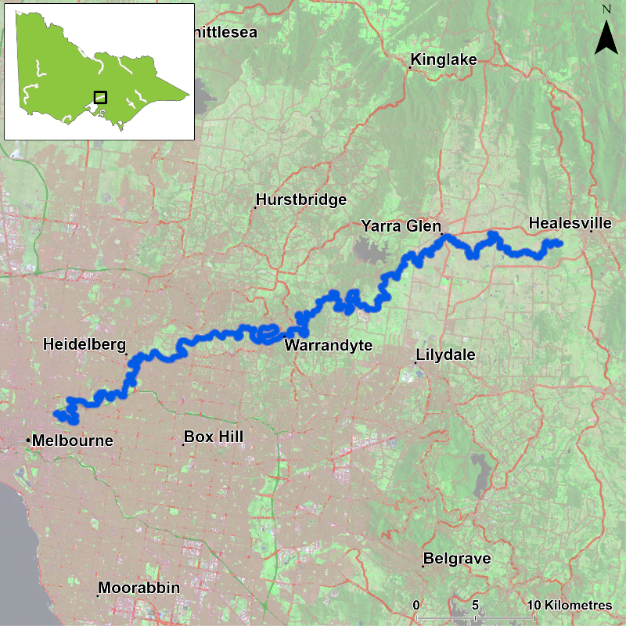
Figure 1. Map showing the section of Yarra River where NFRC sampling occurs

Environment
Low flow conditions were present in all nine sampling years, albeit slightly higher in 2018 and 2021 and slightly lower in 2022. The NFRC worked collaboratively with a Melbourne Water Macquarie Perch project with 14 sites fished from 2017-20. As the Melbourne Water Macquarie Perch project has finished, 11 sites were fished in 2022-2025.

Waterway and fisheries management efforts in the Yarra River
Many rehabilitation actions have occurred, and are underway, to improve the health of the Yarra River and its fish community. These are informed in particular by Melbourne Water’s Healthy Waterways Strategy 2018-28 and a Co-Designed Catchment Program for the Yarra Catchment. Efforts include revegetation, weed control and fencing of riparian areas, reintroduction of instream woody habitat, deliveries of water for the environment from the Yarra River Environmental Entitlement (through seasonal watering planning), removal of barriers to fish movement, pest control, threatened species breeding and translocation, management of water quality including stormwater, sewage and litter management.

Some monitoring of the fish community occurs in association with a variety of rehabilitation efforts. This includes monitoring fish responses to provision of water for the environment, the status of threatened species such as Macquarie Perch, fish monitoring in the upper Yarra River, as well as eel and eDNA monitoring. Melbourne Water also maintains an extensive network of flow and water quality monitoring across the Yarra River system. Melbourne Water, DEECA, the Victorian Environmental Water Holder and the Victorian Fisheries Authority support rehabilitation and management of the Yarra River and its fish community.

Australian Grayling

Yarra River, Port Phillip region

Key Health Indicators
Recent recruitment Cannot be determined
Multiple size classes Cannot be determined
Mature fish present Cannot be determined

Monitoring Results
Total number of fish caught 2
Fish per 1km of waterway 0.30
Largest fish by length (cm) 10.84
Largest fish by weight (kg) 0.07
% of the catch that is legal size NA #

# This species is a Protected Freshwater Species and taking or possessing is prohibited (Victorian Recreational Fishing Guide 2025)

Australian Grayling (Prototroctes maraena) is a diadromous species that has declined in distribution and abundance across its range. The species is listed as endangered in Victoria (Flora and Fauna Guarantee Act 1988) and nationally (Environment Protection and Biodiversity Conservation Act 1999). The NFRC does not expect to capture enough Australian Grayling to measure key health indicators. Rather, threatened species such as Australian Grayling are targeted for monitoring to gain a greater understanding of the current status of the populations which is essential information to inform the management of such species.

Only two Australian Grayling were captured in the 2025 survey, both being juveniles (Figure 2, Figure 3). The highest capture rates occurred in 2022 and 2023 with five fish captured in each year. Juveniles have been recorded in seven of the nine years of NFRC surveys (2018-19 and 2021-25), and are the most common size recorded in the NFRC surveys. Adults have been detected in four of the nine surveys (2018, 2021 and 2023-2024) with the highest abundance in 2023 (Figure 2; Figure 3). Recruits have only been detected in 2022 and 2023. Juveniles have been detected consistently, in seven of the nine years. The presence of recruits in 2022 and 2023 and juveniles in 2018-19 and 2021-25 (Figure 2; Figure 3) indicates stream conditions were suitable for recruits to be attracted into the system from coastal/marine waters and subsequent upstream dispersal.

Stocking
No stocking has occurred.
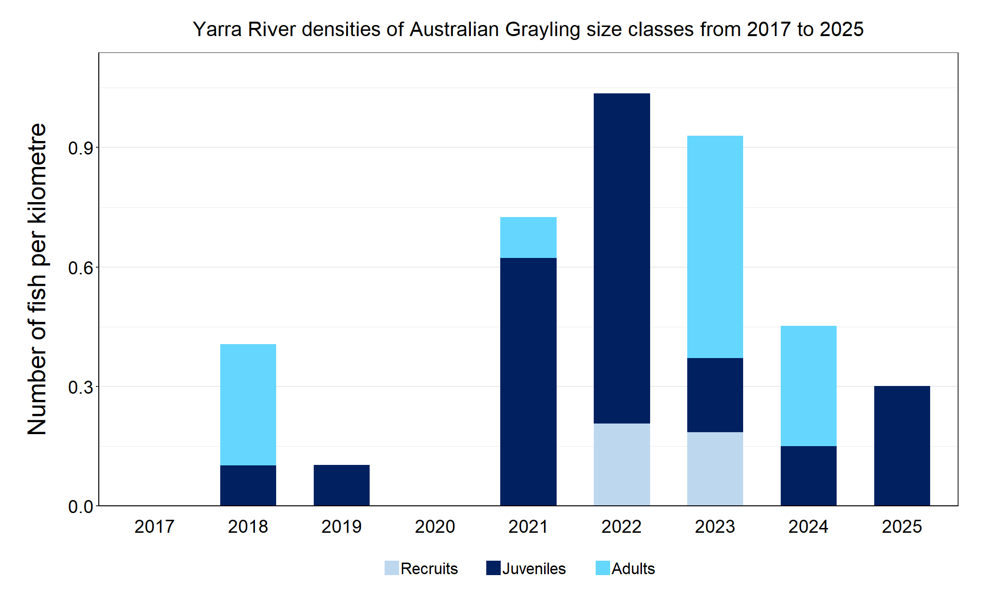
Figure 2. The densities of recruits, juveniles and adult Australian Grayling in the Yarra River from 2017 to 2025.

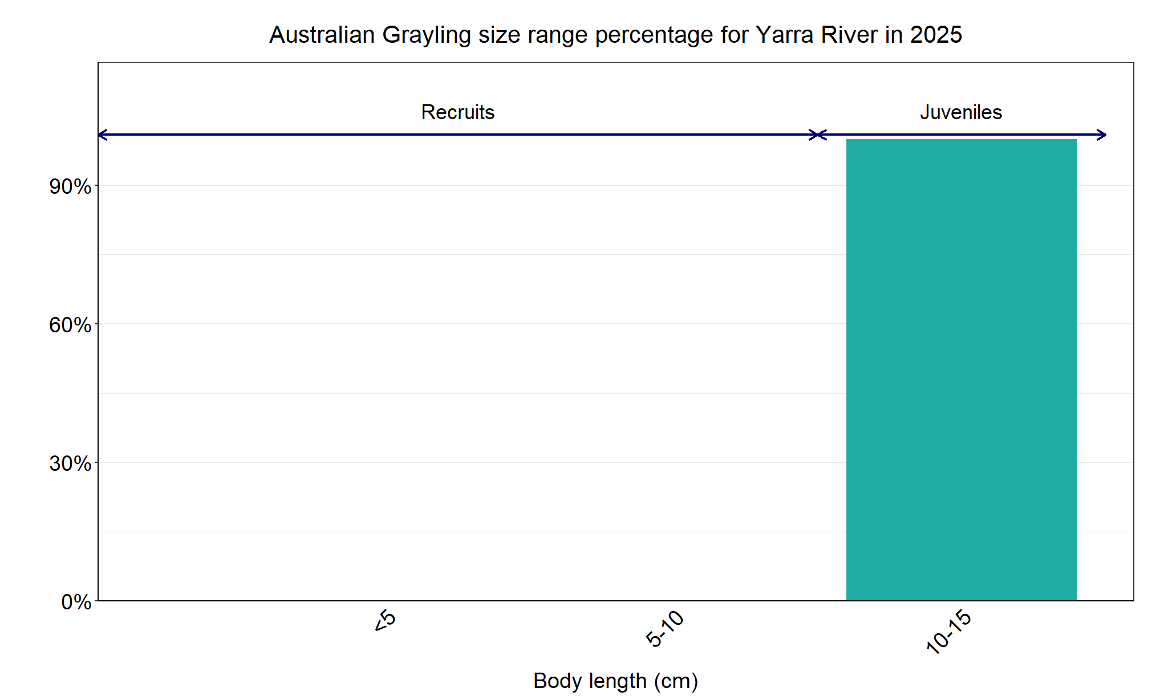
Figure 3 The size range percentage of Australian Grayling in the Yarra River in 2025.

Macquarie Perch

Yarra River, Port Phillip region

Key Health Indicators
Recent recruitment Yes
Multiple size classes Yes
Mature fish present Yes

Monitoring Results
Total number of fish caught 60
Fish per 1km of waterway 9.05
Largest fish by length (cm) 38.6
Largest fish by weight (kg) 0.98
% of the catch that is legal size NA #

# This species is a Protected Freshwater Species and taking or possessing is prohibited (Victorian Recreational Fishing Guide 2025)

Macquarie Perch (Macquaria australasica) have been translocated into this system, but the Yarra River population is considered an important population from a genetic perspective¹. Macquarie Perch are listed as endangered in Victoria (Flora and Fauna Guarantee Act 1988) and nationally (Environment Protection and Biodiversity Conservation Act 1999). Recruits, juvenile and adult Macquarie Perch were recorded in the 2025 survey. In 2025, the presence of recruits of 5-10 cm indicates successful spawning occurred in spring 2024 and successful survival to recruits in autumn 2025 (Figure 5). Prior to 2025, recruits had not been detected since 2018 (Figure 4). The Victorian fishing regulations changed Macquarie Perch to a no take species in 2023 to protect this important population. Low abundances of adults have been detected in all nine years of sampling, albeit higher between 2022 and 2025, which is an encouraging sign regarding the regulation changes. Ongoing monitoring will determine if the adult population continues to increase and leads to greater recruitment success.

Stocking
No stocking has occurred.
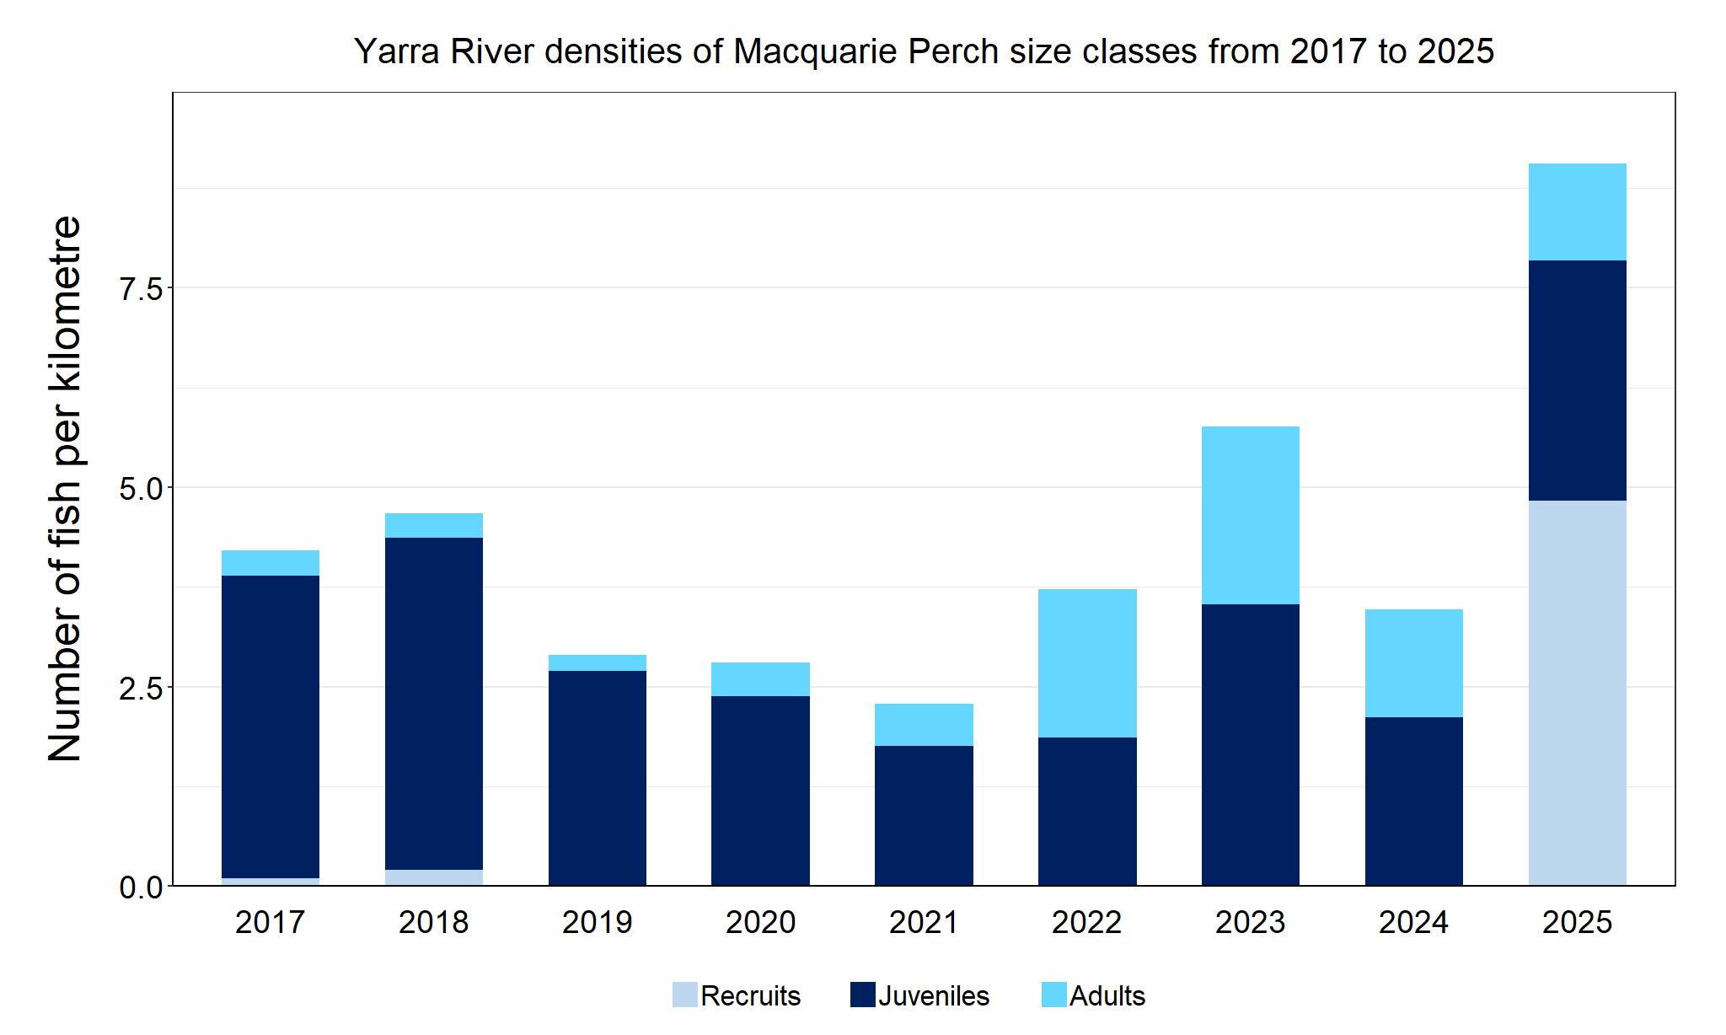
Figure 4. The densities of recruits, juveniles and adult Macquarie Perch in the Yarra River from 2017 to 2025.

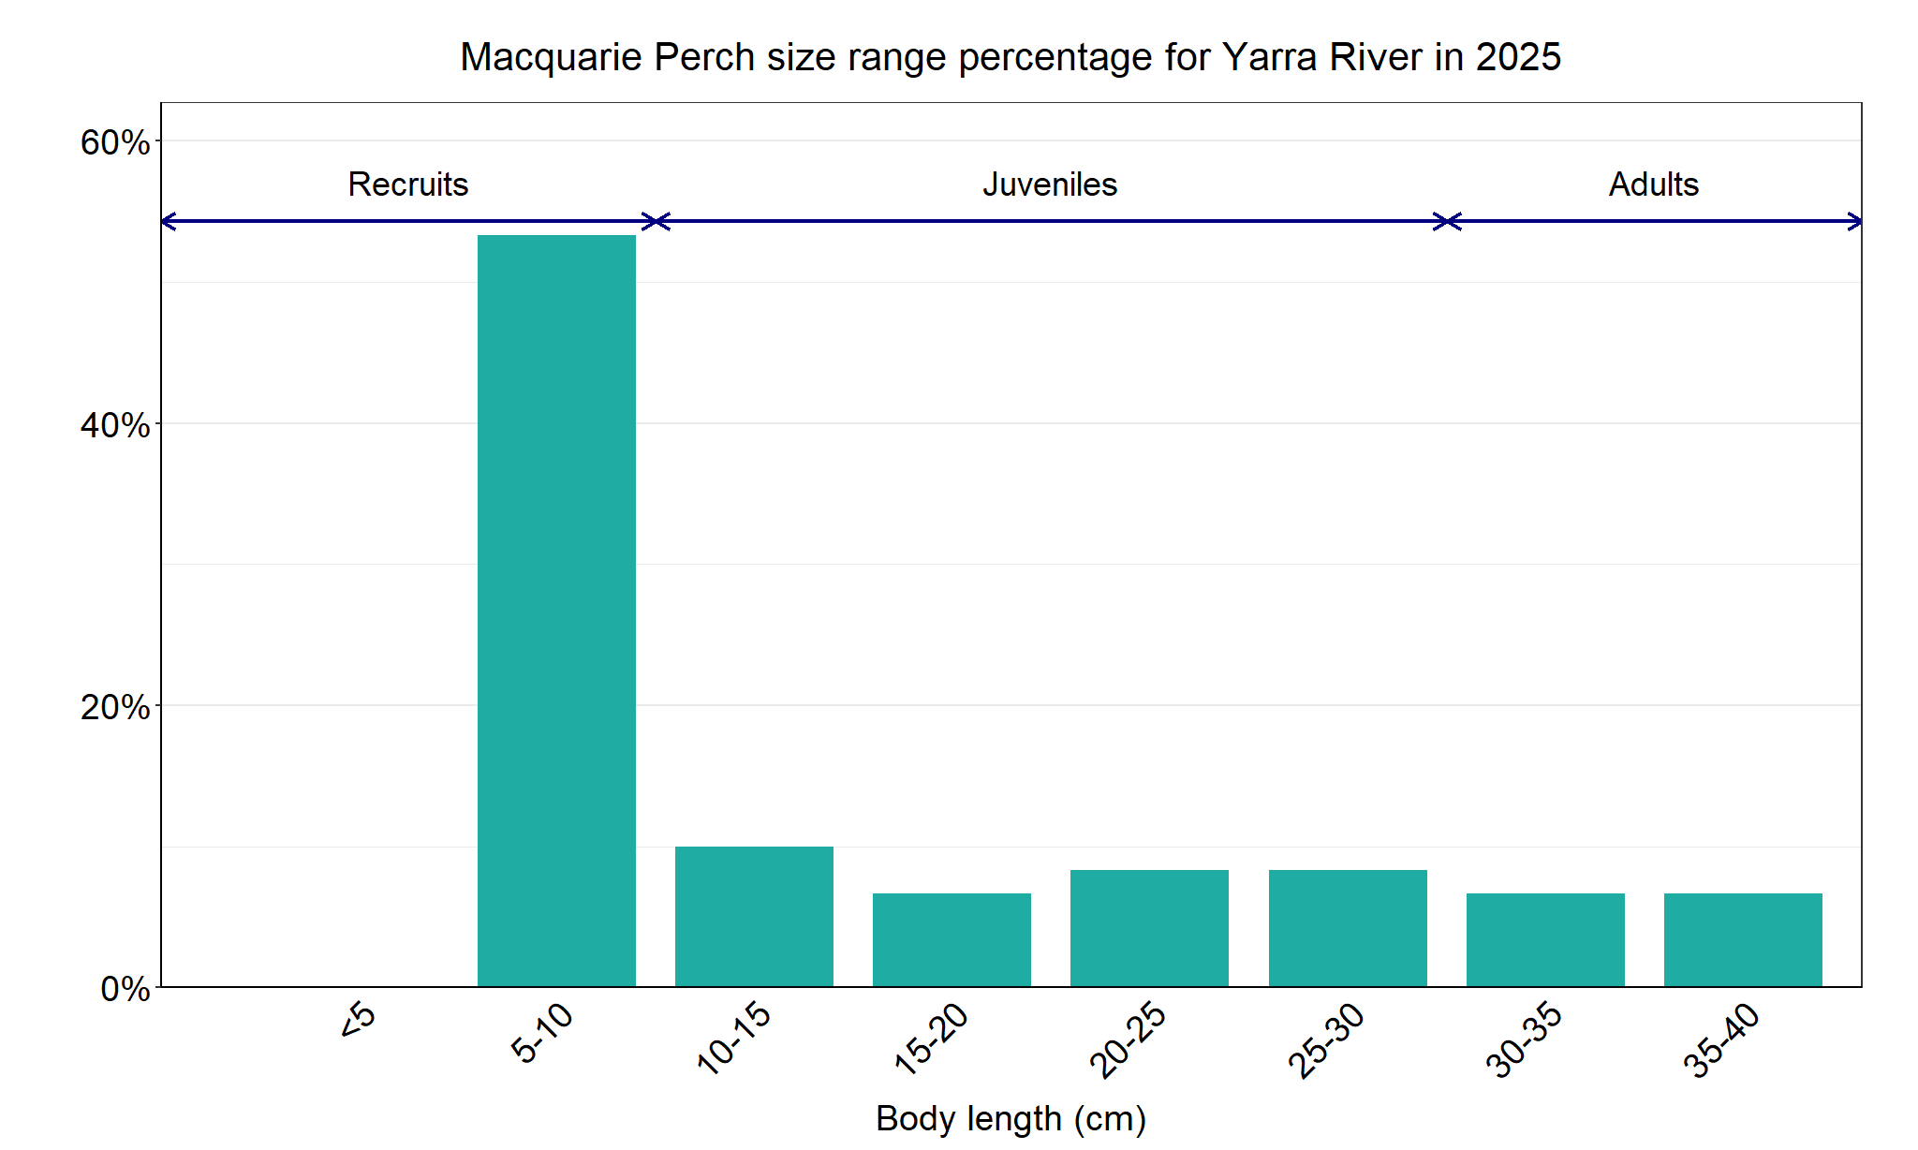
Figure 5. The size range percentage of Macquarie Perch in the Yarra River in 2025.

¹. Pavlova, A., Beheregaray, L.B., Coleman, R., Gilligan, D., Harrisson, K.A., Ingram, B.A., Kearns, J., Lamb, A.M., Lintermans, M., Lyon, J., Nguyen, T.T.T., Sasaki, M., Tonkin, Z., Yen, J.D.L., & Sunnucks, P. (2017) Severe consequences of habitat fragmentation on genetic diversity of an endangered Australian freshwater fish: a call for assisted gene flow. Evolutionary Applications 10, 531 – 550.

Murray Cod

Yarra River, Port Phillip region

Key Health Indicators
Recent recruitment Yes
Multiple size classes Yes
Mature fish present Yes

Monitoring Results
Total number of fish caught 30
Fish per 1km of waterway 4.52
Largest fish by length (cm) 74.3
Largest fish by weight (kg) 5.71
% of the catch that is legal size 3.3

Murray Cod (Maccullochella peelii) is a translocated species in the Yarra River but is classed as a key recreational species in the Yarra system. Murray Cod is listed as endangered in Victoria (Flora and Fauna Guarantee Act 1988) and vulnerable nationally (Environment Protection and Biodiversity Conservation Act 1999). Adults, juveniles and recruits were recorded in the 2025 survey (Figure 6, Figure 7). Recruits have been recorded in seven of the nine years surveyed (2017-18, 2020 and 2022-25) with the highest number of recruits detected in 2022 and 2025 (Figure 6). The number of recruits captured in 2025 was equal second highest across all the NFRC surveys, albeit lower than in 2022. The strong recruitment recorded in 2022 and 2024 is reflected in the juvenile cohort in 2025 (Figure 6). A broad size range of fish was collected in 2025 (Figure 7), however only one was an adult and no oversize Murray Cod were recorded. Although in low abundance, adults have been detected in eight of the nine years surveyed (absent in 2021). The low abundances of adults may indicate a high angling pressure.

Stocking
No stocking has occurred.

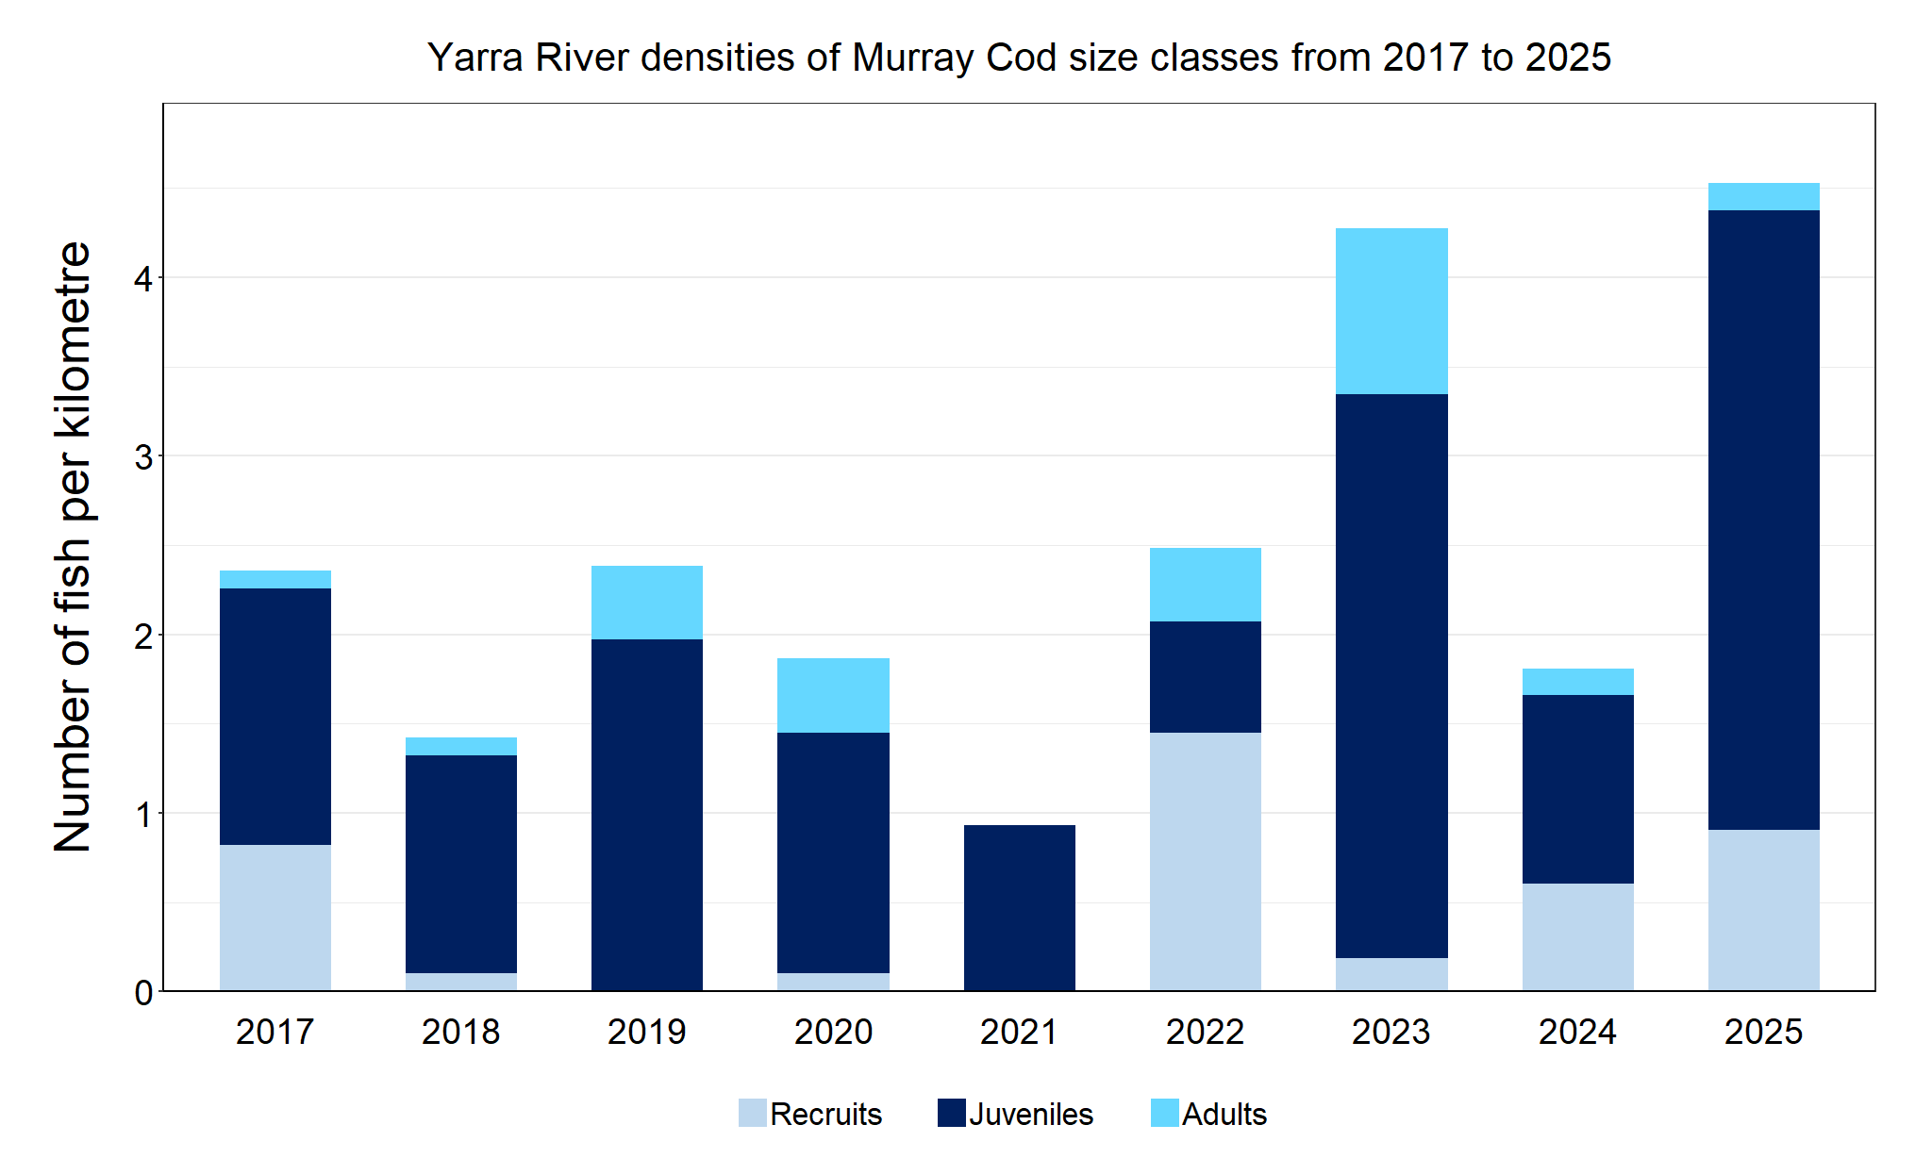
Figure 6. The densities of recruits, juveniles and adult Murray Cod in the Yarra River from 2017 to 2025.

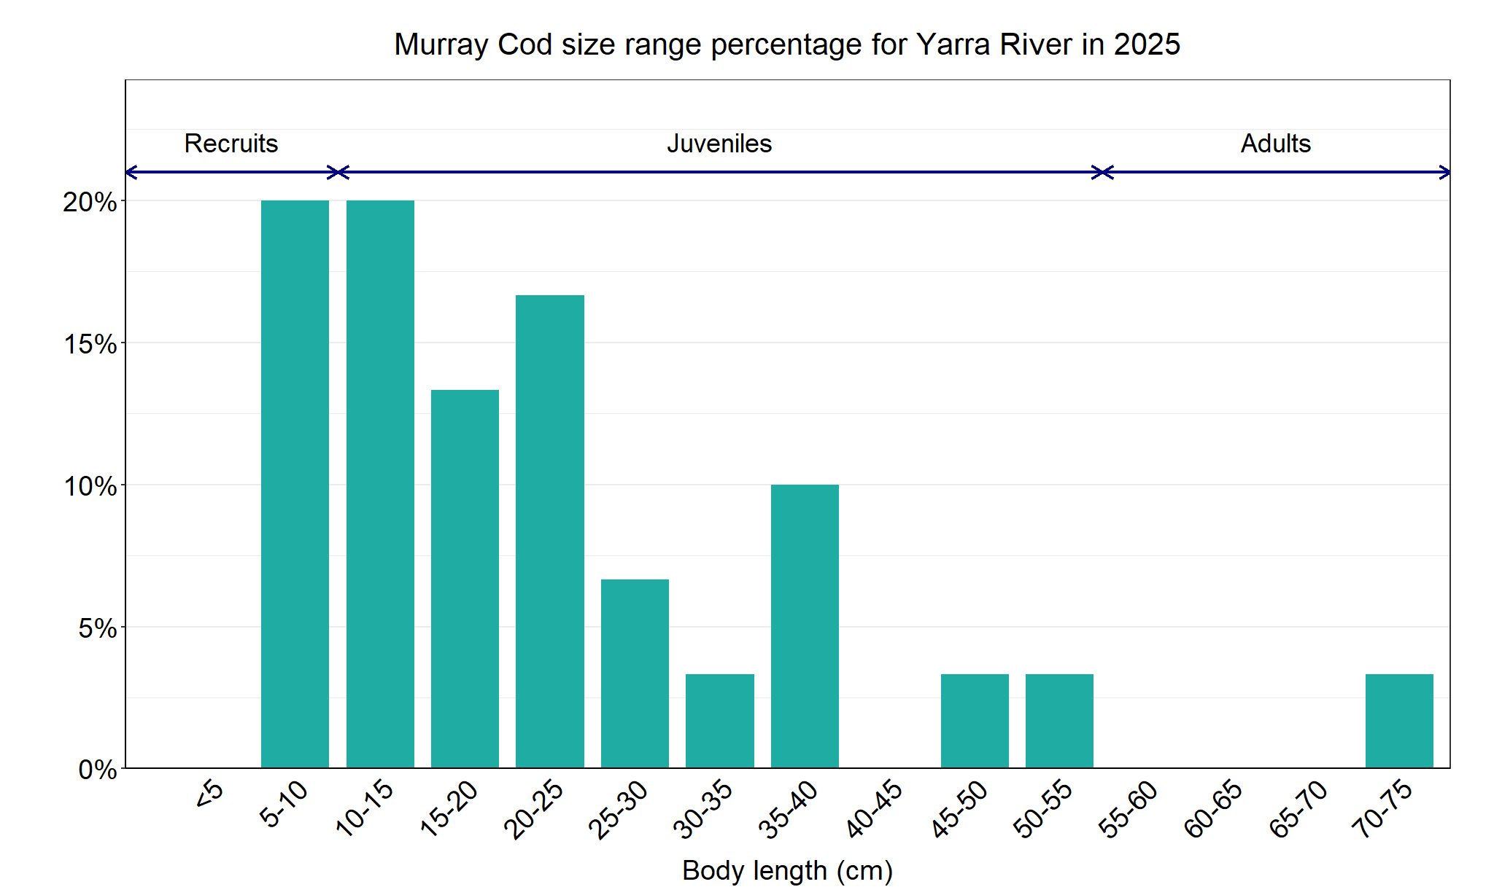
Figure 7. The size range percentage of Murray Cod in the Yarra River in 2025.

We acknowledge and respect Victorian Traditional Owners as the original custodians of Victoria’s land and waters, their unique ability to care for Country and deep spiritual connection to it. We honour Elders past and present whose knowledge and wisdom has ensured the continuation of culture and traditional practices.
© The State of Victoria Department of Energy, Environment and Climate Action 2025. This work is licensed under a Creative Commons Attribution 4.0 International licence. To view a copy of this licence, visit creativecommons.org/licenses/by/4.0/ ISSN 2981-9105 Online (pdf/word)

