|  |
| --- |
| Victorian Environmental Flows Monitoring and Assessment Program (VEFMAP) Stage 6 |
| Project Update – 2018  Southern Victorian Rivers - Fish |

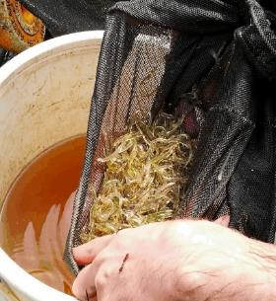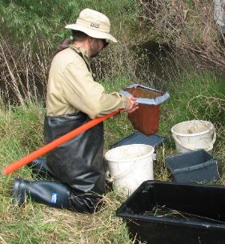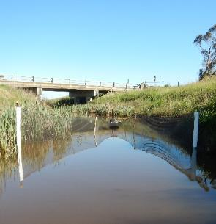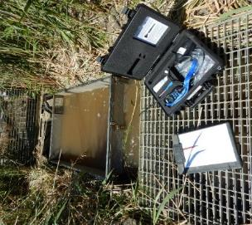

**Background**

The Victorian Environmental Flows Monitoring and Assessment Program (VEFMAP) was established by the Victorian Government in 2005 to monitor and assess ecosystem responses to environmental watering in priority rivers across Victoria. The program’s results help inform decisions for environmental watering by Victoria’s Catchment Management Authorities (CMAs), Melbourne Water and the Victorian Environmental Water Holder (VEWH). Over the past 12 years, the information collected through VEFMAP has provided valuable data and informed significant changes to the program. VEFMAP is now in its sixth stage of delivery and includes a strong focus on “intervention” or “flow event” type questions, for vegetation and fish.

**Fish Monitoring - Southern Victorian Rivers**

The core objective for fish monitoring in VEFMAP Stage 6 for coastal rivers is to examine the importance of environmental flows in promoting immigration, dispersal and subsequent recruitment of diadromous fish.

There are two key evaluation questions for fish in coastal Victorian rivers, which were developed in collaboration with CMAs.

KEQ 1 Do environmental flows enhance *immigration* of diadromous fishes in coastal streams?

KEQ 2 Do environmental flows enhance *dispersal, distribution and recruitment* of diadromous fishes in coastal streams?

**2017/18 Survey Sites and Timing**

In 2017/18, surveys were undertaken to investigate processes associated with KEQ 1 and 2 in the following sites:

* ***Immigration*** - the lower reaches of the Barwon, Bunyip, Glenelg, Tarwin and Werribee rivers and Cardinia Creek (Sept-Dec 2017).
* ***Dispersal*** - the Glenelg and Moorabool rivers (Jan-Feb 2018).
* ***Distribution and recruitment*** - the Glenelg and Thomson rivers (Feb-Mar 2018).

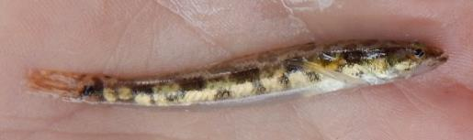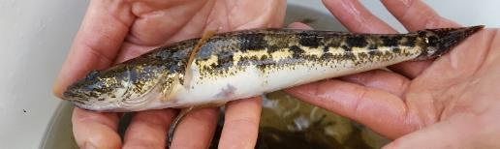

**Figure 1: A juvenile (top) and adult (bottom) Tupong (Photo: ARI)**

**Methods**

Different survey methods were used for each component of the study:

***Immigration***

* *Fyke netting* – undertaken weekly (dependent on water levels) (Oct-Dec 2017) at one site in each of the Glenelg, Tarwin and Werribee rivers and Cardinia Creek. The Bunyip River was sampled as part of a study by Melbourne Water, usually twice per week (Sept-Dec 2017).

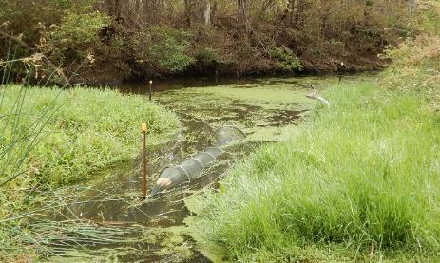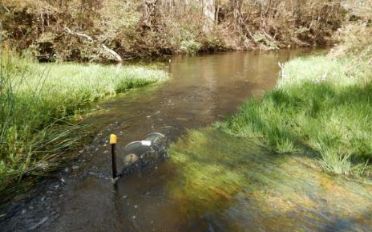

* *Fishway trapping* – undertaken weekly at the vertical-slot fishway in the Barwon River at the Barwon Barrage (Oct-Dec 2017).

All fish were identified to species, counted and a subsample of 50 fish/species measured for length. Large-bodied fish were weighed.

***Dispersal***

* *Fyke netting –* undertaken over three nights (late Jan 2018) before summer fresh releases, and over four nights (Feb 2018) during the peak of the releases. Netting was conducted at six ‘treatment’ sites on each of the lower Glenelg and Moorabool rivers and at three control sites on each of the Stokes and Barwon rivers.

All fish were identified to species, counted and a subsample of at least 20 fish/species measured for length.

***Distribution and recruitment***

* *Electrofishing –* bankmounted electrofishing was undertaken at 14 sites on the Thomson River (Feb 2018) and at eight sites on the Glenelg River (Mar 2018).

All fish were identified to species, counted and a subsample of 50 fish/species measured for length. Large-bodied fish and Tupong *Pseudaphritis urvillii*, were weighed.

**Results**

***Hydrology and environmental flow delivery***

*Immigration* - Rain events resulted in high discharge rates during September in all study waterways, except the Werribee River. There were several smaller peaks in discharge in all the study rivers during October and November due to rain events. An environmental flow release occurred in the Werribee River during early November increasing over three days to a one-day peak of 350 ML/d, then decreasing over the following seven days. This release was the first substantial discharge event during the spring of 2017.

*Dispersal* - Generally, discharge in the Glenelg River during the summer of 2018 decreased from early to late January following a rain event in late December. Two peaks in discharge occurred in February and March as a result of fresh releases that lasted around 10 days with a peak of 133 ML/d in early February and 172 ML/d in mid-March. The minimum mean daily summer baseflow between these two environmental flow releases was 77 ML/d. Discharge was usually low in the Moorabool River over summer with two pulses of around 20 ML/d resulting from rainfall events and one large pulse of 80 ML/d during mid-February due to the summer fresh release.

**Figure 2: Double-wing fyke net set in the Moorabool River monitoring the upstream movement of diadromous fishes, summer 2018: pre-fresh release (top) and during release (bottom)**

***Immigration***

Over 300,000 fish were captured in the six streams. Galaxiid species (mostly Young of Year (YOY)) comprised ~95% of the catch). Other YOY diadromous species captured included Tupong, Short-finned Eel *Anguilla australis*, Australian Grayling *Prototroctes maraena* and Australian Mudfish *Neochanna cleaveri.*

***Dispersal***

*Fyke netting*

Sampling in 2017/18 in the two river systems resulted in a catch of 787 Tupong, 2203 Common Galaxias and 465 Short-finned Eel. Over the two years of sampling, the catch rates of Tupong, small Common Galaxias (<80 mm) and small Short-finned Eel (<180 mm) moving in an upstream direction were higher (statistically significant) during fresh releases when 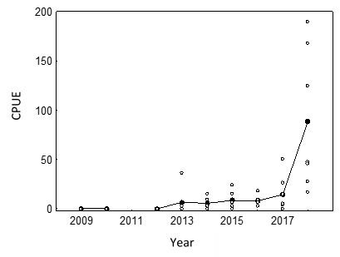compared with the pre-treatment, baseflow periods. This was observed for Tupong in both rivers, Common Galaxias in the Glenelg system and Short-finned Eel in the Moorabool system. The analyses for Common Galaxias and Short-finned Eel were restricted to one river because small individuals were rare in the other.

YOY Tupong were captured at the Sandford Weir, about 180 km from the Glenelg River mouth, demonstrating that the recent summer flow regime (enhanced connectivity by providing baseflows of around 80 ML/d and summer fresh releases) was effective in facilitating upstream dispersal.

The Stokes River experienced relatively low discharge and water velocity during sampling and it appeared YOY Tupong avoided these conditions during their upstream migration.

***Distribution and recruitment***

In the Thomson River, a total of 1480 fish from 14 species (10 native and four exotic) were captured, including five diadromous species: Short-finned Eel (n=89), Long-finned Eel *Anguilla reinhardtii* (n=14), Australian Bass *Macquaria novemaculeata* (n=4), Australian Grayling (n=11) and Tupong (n=127). Australian Smelt *Retropinna* *semoni* and *Gambusia holbrooki* were the most abundant species.

In the Glenelg River, a total of 750 fish representing 13 species (nine native and four exotic) were captured, including Common Galaxias (n=60) and Tupong (n=324). Tupong and Gambusia were the most abundant species.

The CPUE of Tupong in 2018 was the highest observed catch rate during the 10-year history of VEFMAP in the Glenelg River (Fig 3). Around half of the Tupong captured in 2018 (53%) were considered YOY fish (<~80 mm). No Tupong were captured at these sampling sites in 2009, 2010 or 2012 and the catch rates have increased through time.

**Progress to Date**

***Immigration***

Results to date indicate immigration of juvenile diadromous fish into freshwater reaches, which is the key process governing recruitment, is a complex process. The 2017 spring sampling captured hundreds of thousands of YOY galaxiids migrating into freshwater. Although two years of data is not sufficient to demonstrate responses, there is evidence indicating that this migration was linked to flow pulses in the Werribee River.

**Figure 3: Electrofishing catch-per-unit-effort (CPUE – fish per hour) of Tupong captured at sites sampled consistently in the Glenelg River, 2009 to 2018. Open circles = raw data for each site; solid circles = mean; sampling was incomplete in 2011.**

We propose that if increases in discharge attract these diadromous fish into coastal streams, a lag is expected between the flow peaks and the time when fish reach freshwater where netting is occurring; logically, this lag time should vary with the length of the estuary. The 2017 VEFMAP data supports this theory; high catch rates occurred in the larger rivers about a month after large flow peaks, whereas in shorter estuaries high catch rates occurred within a week after flow peaks. Data collected during 2018-19 will enable a more thorough examination of this relationship.

***Dispersal***

The upstream movement of Tupong, small Common Galaxias (<80 mm), and small Short-finned Eel (<180 mm) was significantly greater during summer fresh releases than during the pre-treatment, baseflow conditions, demonstrating these releases stimulate upstream movement of these species. This stimulation of upstream movement is expected to influence fish distribution within coastal rivers. Which aspect of hydrology stimulated the increased movement will be investigated following scrutiny of further hydraulic data, however, fish are likely to detect and respond to an increase in water velocity.

***Distribution and recruitment***

The relatively high catch rate of Tupong in the Thomson River follows the strong recruitment of these fish, which was first detected in 2016. This cohort, along with the 2007, 2011 and 2012 Tupong year-classes were the strongest in the history of VEFMAP. These successful year-classes were dependent upon successful spawning, immigration into freshwater, dispersal and subsequent survival.

The 2018 catch rate of Tupong in the Glenelg River was six times higher than in 2017, with over half being YOY. The flow regime in the Glenelg River over the last two years in particular has had elevated summer baseflows and freshes (often provided by environmental flow releases), which have provided excellent conditions for Tupong recruitment.

**Key Observations**

* Demonstration that summer/early autumn fresh releases in the Glenelg and Moorabool rivers stimulated the upstream movement of Tupong, small Common Galaxias, and small Short-finned Eel.
* Evidence that YOY Tupong avoid upstream migration pathways that have lower river flows.
* The most successful recruitment year for Tupong in the Glenelg River since VEFMAP sampling began in 2009. This provided an excellent chance to observe how far juvenile fish migrated. YOY Tupong were captured at the Sandford Weir, about 180 km from the river mouth, showing that the recent summer flow regime (enhanced connectivity by providing baseflows of around 80 ML/d and summer fresh releases) facilitated upstream dispersal.

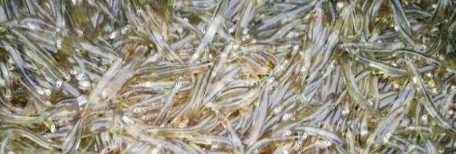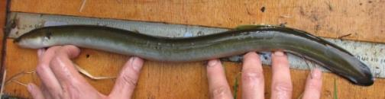

**Figure 4: a) Summer fresh releases stimulated upstream movement of small Common Galaxia and b) Short-finned Eels (Photos: ARI)**

**Flow Recommendations to Support Managers**

Whilst these results and analyses are preliminary, some patterns have emerged which have prompted particular flow recommendations to test over the next year. These are focussed at maximising immigration and upstream dispersal of juvenile diadromous fish such as Tupong, Short-finned Eel and galaxiid species by providing baseflows and freshes during summer which maintain connectivity and provide cues to movements.

**What’s next?**

***Surveys***

* Continue fyke netting and/or trapping in the Barwon, Bunyip, Tarwin and Werribee rivers and Cardinia Creek in spring and early summer 2018.
* Continue fyke netting in the Glenelg River and possibly another river to investigate the effects of various components of summer fresh releases on fish migration, and transferability of results to other systems.
* Continue annual summer population surveys in the Glenelg and Thomson rivers, and consider a third river for the electrofishing monitoring.

***Further analysis of data***

* Consider further analysis of annual fish population survey data to assess the role of flows in governing recruitment and survival of other priority species, particularly River Blackfish *Gadopsis marmoratus*.

**Further details:**

See DELWP (2018) VEFMAP Stage 6: Do environmental flows enhance immigration and dispersal of diadromous fishes in Victorian coastal rivers? 2017/18 survey results. A client report to Water and Catchments of the Department of Environment, Land, Water and Planning (DELWP).

**Acknowledgements:**

Most of this work was funded by DELWP Water and Catchments, as part of the Victorian Government’s $222 million investment to improve catchment and waterway health across regional Victoria. Melbourne Water provided funding for work in the Bunyip River as part of another project.

**Contact:**

[Zeb.Tonkin@delwp.vic.gov.au](mailto:Zeb.Tonkin@delwp.vic.gov.au), [Frank.Amtstaetter@delwp.vic.gov.au](mailto:Frank.Amtstaetter@delwp.vic.gov.au), [Wayne.Koster@delwp.vic.gov.au](mailto:Wayne.Koster@delwp.vic.gov.au) (Bunyip River surveys)

|  |  |
| --- | --- |
| © The State of Victoria Department of Environment, Land, Water and Planning 2018  LogoThis work is licensed under a Creative Commons Attribution 4.0 International licence. You are free to re-use the work under that licence, on the condition that you credit the State of Victoria as author. The licence does not apply to any images, photographs or branding, including the Victorian Coat of Arms, the Victorian Government logo and the Department of Environment, Land, Water and Planning (DELWP) logo. To view a copy of this licence, visit http://creativecommons.org/licenses/by/4.0/  ISBN 978-1-76077-302-1 (print) 978-1-76077-303-8 (pdf/online)  Disclaimer  This publication may be of assistance to you but the State of Victoria and its employees do not guarantee that the publication is without flaw of any kind or is wholly appropriate for your particular purposes and therefore disclaims all liability for any error, loss or other consequence which may arise from you relying on any information in this publication. | Accessibility  If you would like to receive this publication in an alternative format, please telephone the DELWP Customer Service Centre on 136186, email [customer.service@delwp.vic.gov.au](mailto:customer.service@delwp.vic.gov.au), or via the National Relay Service on 133 677 [www.relayservice.com.au](http://www.relayservice.com.au). https://www.ari.vic.gov.au/research/rivers-and-estuaries/assessing-benefits-of-environmental-watering |