**Mitchell River 2023**

***East Gippsland region***

**This report card summarises the 2023 Native Fish Report Card (NFRC) survey in the Mitchell River**

**Sites 11, EGCMA, Electrofishing**

**Fish found in Mitchell River for NFRC**

**Target species**

Australian Bass

Australian Grayling

**Non-target species captured since 2017\***

**Large-bodied native species**

Cox’s Gudgeon

Long-finned Eel

Pouched Lamprey

Short-finned Eel

Short-head Lamprey

Striped Gudgeon

Tupong

A further 10 species which are estuarine (see next page)

**Small-bodied native species**

Australian Smelt

Common Galaxias

Dwarf Flatheaded Gudgeon

Flatheaded Gudgeon

Flinder’s Pygmy Perch

Australian Anchovy (estuarine sp.)

Port Jackson Glassfish (estuarine sp.)

**Exotic species**

Common Carp

Goldfish

* These non-target species were incidentally captured during NFRC surveys since 2017 but not measured as for target species.  LOGOS – ARI, DEECA

**Mitchell River 2023**

**Fish Community**

**NFRC target species**

**The NFRC Program began in 2017,** **with a focus on targeting the monitoring of population dynamics of key iconic fish species that have high recreational and/or conservation values, in large rivers across Victoria. In the Mitchell River, the target species are Australian Bass and Australian Grayling. Surveys occur in February each year, at 11 sites from** **Bairnsdale to Kingswell Bridge. The Mitchell River uses Smith-root boat electrofishing, with elevated salinities at the two bottom sites requiring Grassl boat electrofishing1. The equipment and habitats surveyed are focused on these species, which are measured to determine population structures. Other fish species that are incidentally captured are recorded, but not measured to determine their population structures.**

**Summary of key health indicators for target species in 2023**

|  |  |  |  |
| --- | --- | --- | --- |
| **Species** | **Key Health Indicators** | | |
|  | Recent recruitment | Multiple size classes | Mature fish present |
| Australian Bass | Yes | Yes | Yes |
| Australian Grayling | - | - | - |

*Recent recruitment means young-of-year fish*

*\*- cannot be determined due to low abundances*

Australian Bass are close to the edge of their natural range in the Mitchell River system. Historically they occurred no further west than Wilsons Promontory. Australian Bass are an important recreational species in the Mitchell River with the population aided by stockings. Australian Grayling was once widespread throughout coastal Victoria, including the Mitchell River system. Changes to flow regimes and barriers have impacted this species. The detection of Australian Grayling in six of the seven years indicates that conditions are suitable for the population.

**Non-target species**

The non-target fish species that have been incidentally recorded in the Mitchell River during NFRC surveys since 2017 are:

**Large-bodied native species**

Other large-bodied species recorded in surveys are Black Bream, Cox’s Gudgeon, Eastern Australian Salmon, Estuary Perch, Flat-tail Mullet, Long-finned Eel, Luderick, Pouched Lamprey, River Garfish, Sand Mullet, Sea Mullet, Short-finned Eel, Short-head Lamprey, Striped Gudgeon, Tailor, Tupong and Yellow-eye Mullet. Ten of these species (Black Bream, Eastern Australian Salmon, Estuary Perch, Flat-tail Mullet, Luderick, River Garfish, Sand Mullet, Sea Mullet, Tailor and Yellow-eye Mullet) are considered as estuarine species. Long-finned and Short-finned Eel, Pouched and Short-headed Lamprey and Tupong are diadromous species found throughout coastal Victoria. Within Victoria, Cox’s Gudgeon and Striped Gudgeon are only found in coastal areas of eastern Victoria. Cox’s Gudgeon is listed as endangered under the Flora and Fauna Guarantee Act 1988 in Victoria. Cox’s Gudgeon was recorded in 2019 (the first record in the Mitchell catchment since 1982) and again in 2021 and 2022. The Striped Gudgeon was recorded in 2017 and 2018.

**Small-bodied native species**

The Australian Smelt is a common species distributed across all of Victoria. The Common Galaxias is a diadromous species found across coastal Victoria. Flatheaded Gudgeon is common across Victoria, whilst Dwarf Flatheaded Gudgeons have a more restricted distribution and a rarer. Flinder’s Pygmy Perch are often found in slow flowing areas with abundant aquatic vegetation. Both Australian Anchovy and Port Jackson Glassfish are estuarine species and are only expected to be detected at the most downstream two sites.

**Exotic fish species**

Common Carp have been detected in all sampling years and are widespread throughout the Mitchell River, with juvenile Common Carp detected as far upstream as Kingswell Bridge in 2020 and 2023. Goldfish prefer slower flowing waters and were detected in 2023.

**Other native species known from the Mitchell River**

Some fish species known to occur in the Mitchell River have never been recorded during NFRC surveys. For example, no Climbing Galaxias, Dwarf Galaxias, Mountain Galaxias or Spotted Galaxias or River Blackfish have been detected in the surveys. The Climbing and Spotted Galaxias are diadromous species occurring in coastal Victoria. The Climbing Galaxias and Spotted Galaxias have patchy distributions and are found in lowland areas but are hard to detect using NFRC sampling methodology. The Mountain Galaxias is found on both sides of the Great Dividing Range from Melbourne eastwards in Victoria. In the Mitchell River they are widespread and patchy in the lower areas, but more common in higher altitudes and are hard to detect using the NFRC sampling methodology. The Dwarf Galaxias (listed as vulnerable nationally under the Environmental Protection and Biodiversity Conservation Act 1992) are often found in offstream habitats. The River Blackfish are a lowland species, generally found at altitudes below 200 metres. This species has suffered a decline in distribution and abundance across Victoria and was historically considered to be widespread, but with a patchy distribution within the Mitchell River basin2.

**Other notable species**

Surveys have also recorded Platypus.

LOGOS – ARI, DEECA, NFRC

1. Lieschke, Jason A., Dean, Jan, C and Pickworth, Andrew 2019. Extending the Effectiveness of Electrofishing to Estuarine Habitats: Laboratory and Field Assessments. *Transactions of the American Fisheries Society*, 148:584–591.

2. Lieschke, J.A., Dodd, L., Stoessel, D., Raadik, T.A., Steelcable A., Kitchingman, A. and Ramsey, D. (2013). The status of fish populations in Victorian rivers 2004–2011 – Part A. Arthur Rylah Institute for Environmental Research Technical Report Series No. 246. Department of Environment and Primary Industries, Heidelberg, Victoria.

**Mitchell River 2023**

**Environmental and Management Context**

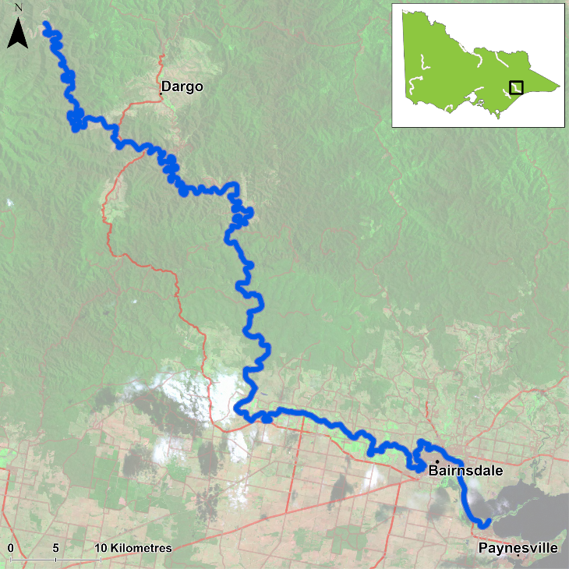

Figure 1. Map showing the section of Mitchell River where NFRC sampling occurs

**Environment**

Summer base flows were recorded in 2017­20 and 2023, with slightly higher flows in 2021 and above summer base flows in 2022. During 2020 and 2021 there was elevated turbidites due to increased sediment loads following the 2019/2020 fires. These elevated turbidities will have decreased electrofishing efficiency in those two years. The higher flows restricted access to one site, therefore only 10 sites were fished in 2022.

**River rehabilitation efforts in the Mitchell River**

Many rehabilitation actions have occurred, and are underway, to improve the health of the Mitchell River. These are informed in particular by the [East Gippsland Waterway Strategy 2014-2022](https://egcma.com.au/wp-content/uploads/2019/06/East_Gippsland_Waterway_Strategy-Final.pdf).

The [East Gippsland Catchment Management Authority](https://egcma.com.au/) continues to work closely with landholders, partner agencies and Traditional Owners to improve the health of the Mitchell River. This year the focus has been on controlling weeds, particularly willows along waterways in the catchment. This work is of particular importance following bushfires. Other works in the Mitchell River have included planting native plants, constructing stock exclusion fencing along rivers, stabilising the banks and creating more habitat for fish by reintroducing large woody habitat.

Some monitoring of the fish community has occurred including associated with rehabilitation efforts. In the upper Mitchell River catchment well above the NFRC area, there have been surveys of a suite of threatened galaxiid species as well as Forest Protection Survey Program (FPSP) surveys of fish and crayfish. The EGCMA, DEECA and VFA support rehabilitation and management of the Mitchell River and its fish community.

PHOTOS

LOGOS – ARI, DEECA, NFRC

**Australian Bass**

**Mitchell River, East Gippsland region**

**Key Health Indicators**

Recent recruitment Yes

Multiple size classes Yes

Mature fish present Yes

**Monitoring Results**

Total number of fish caught 212

Fish per 1km of waterway 31.3

Largest fish by length (cm) 41.2

Largest fish by weight (kg) 1.26

% of the catch that is legal size 16.5

**Australian Bass (*Percalates novemaculeata*) - formerly *Macquaria novemaculeata* - were collected in the highest abundances in 2023 (Figure 2). Recruits, juveniles and adults have been collected in all seven years of surveys (Figure 2). The population is dominated by recruits (which are likely from stockings), but the abundances of juveniles and adults has increased over the last three years with the highest abundance of adults detected in 2023 (Figure 2) indicating that stocked fish are surviving and reaching maturity. Even though the 2023 catch is still dominated by recruits and juveniles, there was a wide spread of fish sizes detected (Figure 3).**

**Stocking**

Ten thousand Australian Bass were stocked in 2016; 150,000 in 2017; 30,000 in 2018, 44,000 in 2019; 66,000 in 2020, 100,000 in 2021 and 67,000 in November 2022.

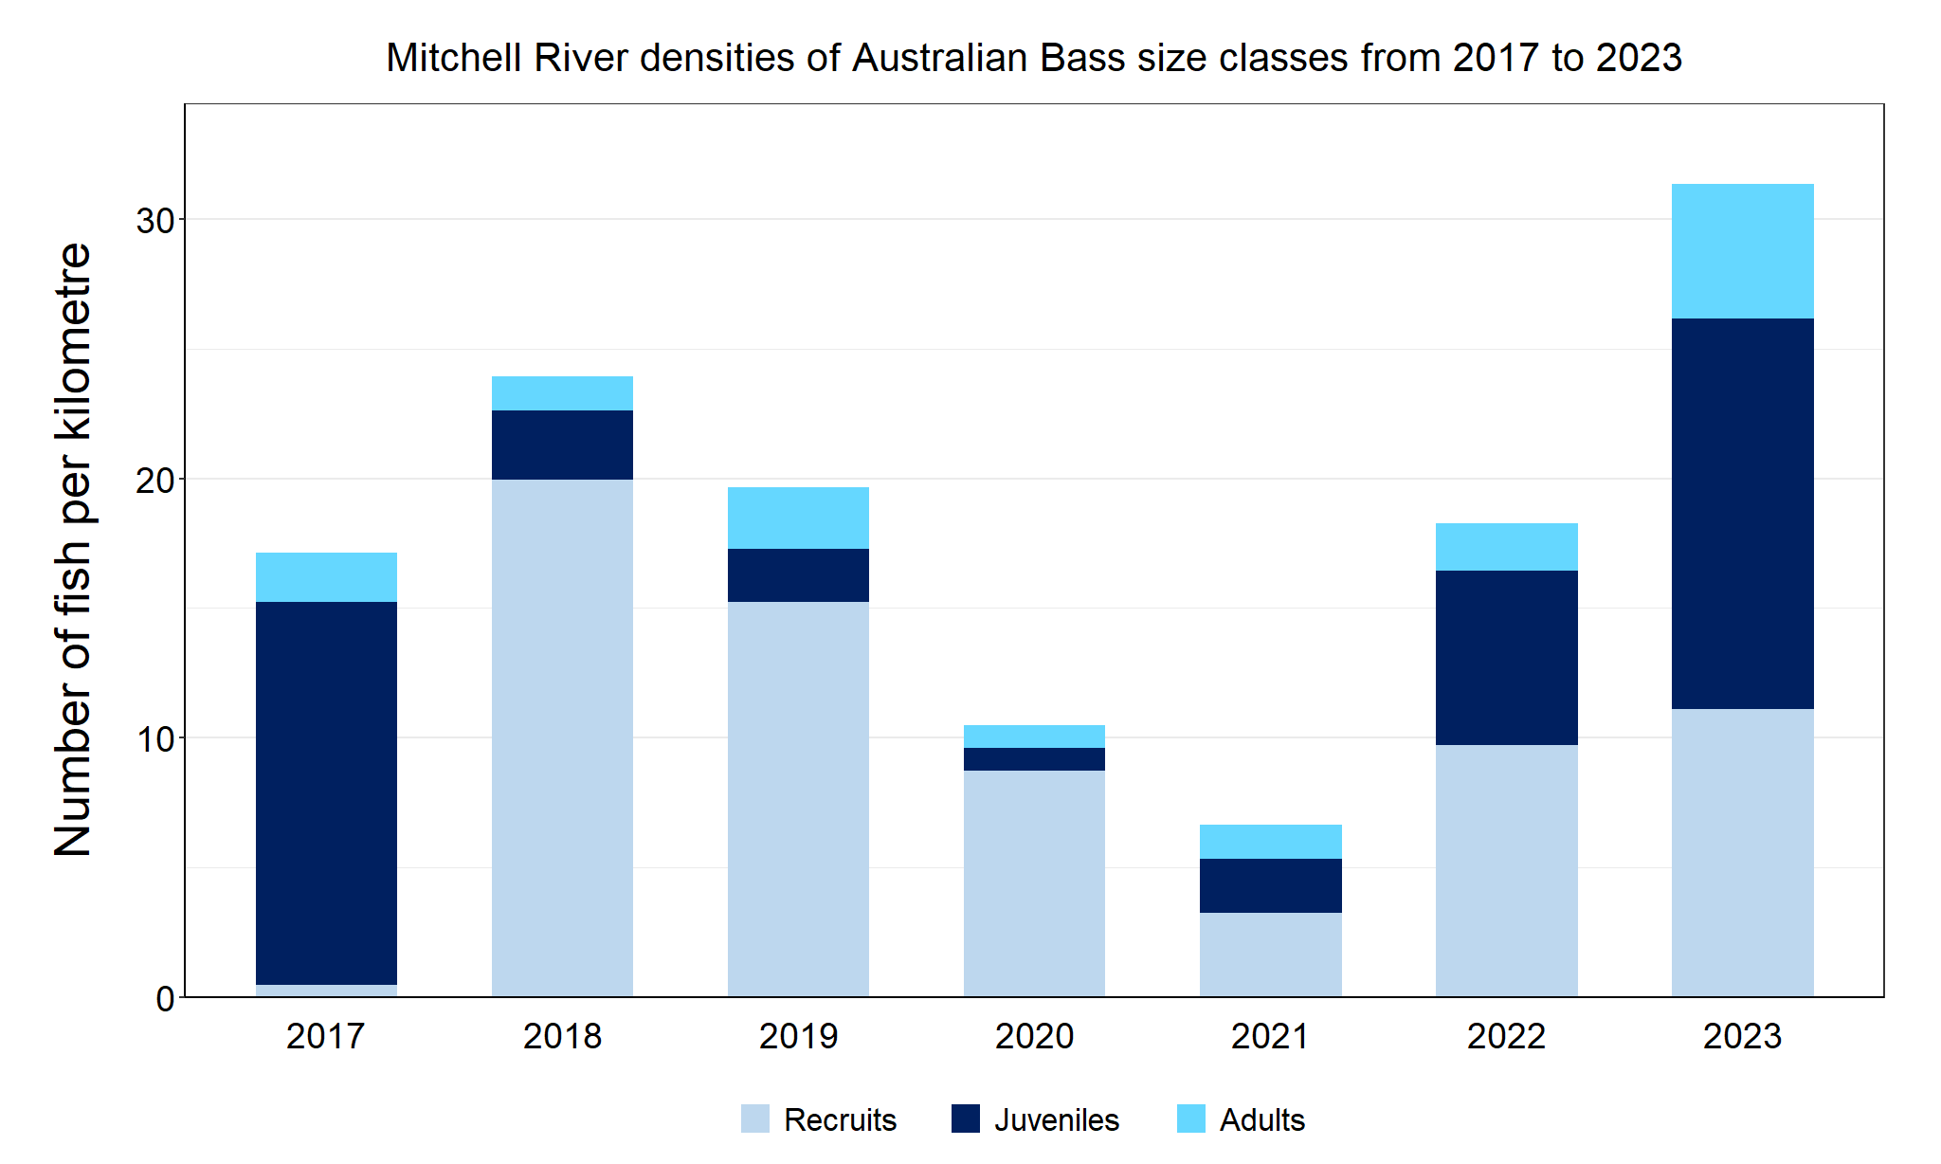

Figure 2. The densities of recruits, juveniles and adult Australian Bass in the Mitchell River from 2017 to 2023

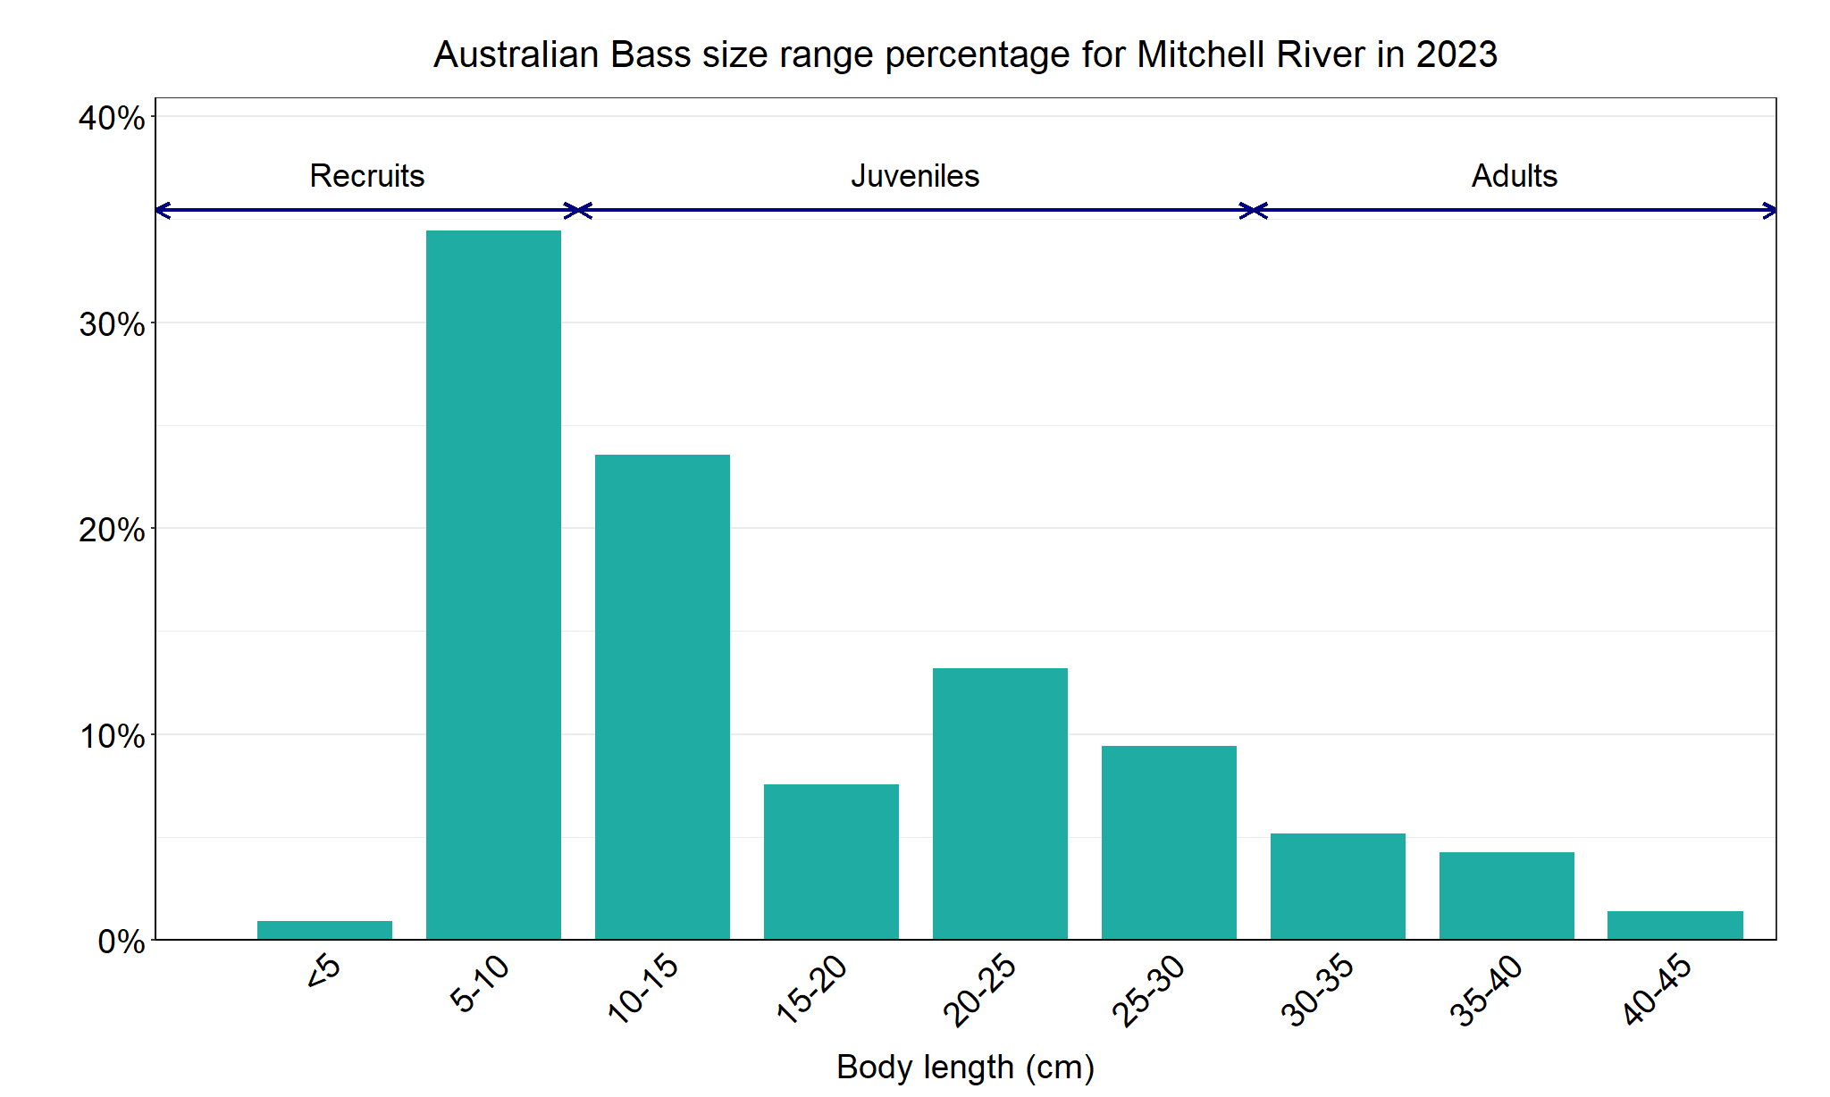

Figure 3. The size range percentage of Australian Bass in the Mitchell River in 2023

**Australian Grayling**

**Australian Grayling, East Gippsland region**

**Key Health Indicators**

Recent recruitment Cannot be determined

Multiple size classes Cannot be determined

Mature fish present Cannot be determined

**Monitoring Results**

Total number of fish caught 9

Fish per 1km of waterway 1.33

Largest fish by length (cm) 21.5

Largest fish by weight (kg) 0.08

% of the catch that is legal size NA

**Australian Grayling (*Prototroctes maraena*) is a diadromous species which has undergone declines in distribution and abundance across its range. The species is listed as endangered in Victoria (Flora and Fauna Guarantee Act 1988) and nationally (Environmental Protection and Biodiversity Act 1992). While NFRC expects to only capture low numbers of this species, the monitoring can provide a greater understanding of the current status of the populations which is essential to inform management of these species. Due to the low abundances of Australian Grayling collected during NFRC, the key health indicators cannot be determined. However, adults have been captured in 2017, 2019–21 and 2023 (Figure 4). Only adults were detected in 2023 (Figure 4; Figure 5). Low abundances of recruits were detected in 2020 and 2021, while low abundances of juveniles were detected in 2017 and 2022 (Figure 4).** **The adults collected in 2023, are likely the same year class as the juveniles detected in 2022 and recruits detected in 2021. This indicates stream conditions were suitable for recruits to be attracted into the system in spring 2020, despite elevated sediment loads following the 2019/2020 fires and that they have survived through to 2023. It is worth noting that seven adult fish were recorded in the Dargo River, a tributary of Mitchell River, as part of the Wild Trout Fisheries Management program during autumn 2019 (when no adults were collected in the Mitchell River).**

**Stocking**

No stocking has occurred.

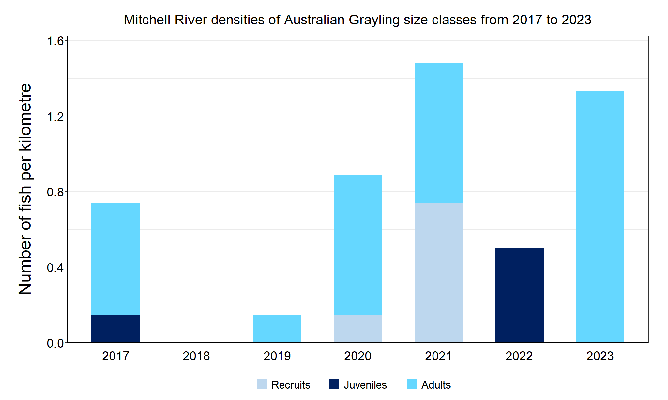

Figure 4. The densities of recruits, juveniles and adult Australian Grayling in the Mitchell River from 2017 to 2023

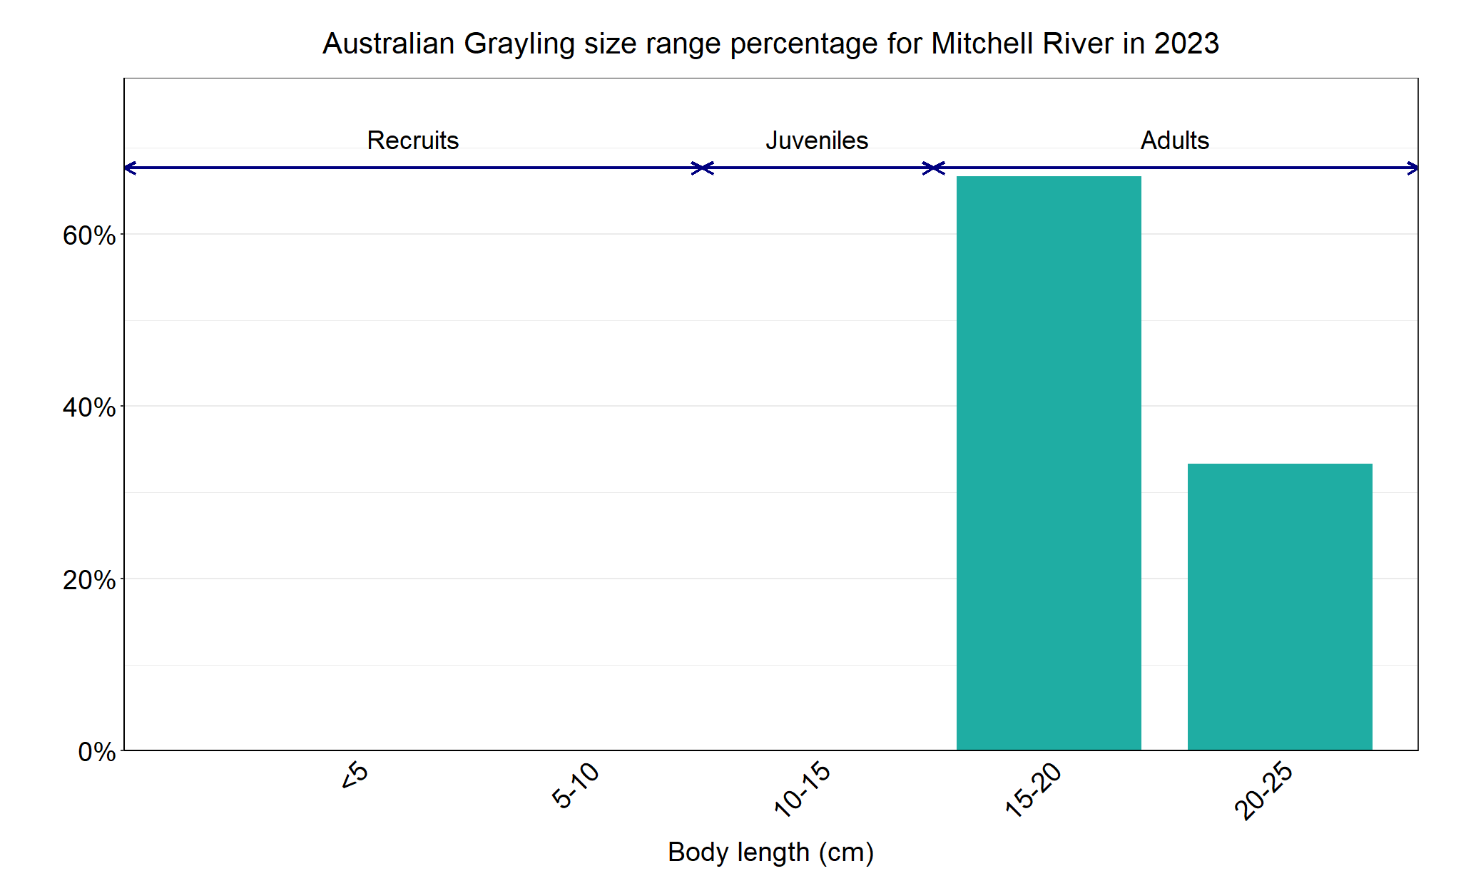

Figure 5. The size range percentage of Australian Grayling in the Mitchell River in 2023

We acknowledge and respect Victorian Traditional Owners as the original custodians of Victoria’s land and waters, their unique ability to care for Country and deep spiritual connection to it. We honour Elders past and present whose knowledge and wisdom has ensured the continuation of culture and traditional practices.

Logo© The State of Victoria Department of Energy, Environment and Climate Action 2023. This work is licensed under a Creative Commons Attribution 4.0 International licence. To view a copy of this licence, visit creativecommons.org/licenses/by/4.0/

ISSN 2981-9067 Online (pdf/word)