
Native Fish Report Card 2025
Glenelg River
Glenelg Hopkins Region

This report card summarises the 2025 Native Fish Report Card (NFRC) survey in the Glenelg River
Sites: 10, Electrofishing

Fish found in Glenelg River for NFRC
Target species
Estuary Perch
Non-target species captured since 2017*
Large-bodied native species
Australian Bass#
Australian Grayling
Black Bream
Freshwater Catfish#
Golden Perch#
Mulloway
River Blackfish
Short-finned Eel
Tupong
Yellow-eye Mullet

Small-bodied native species
Australian Smelt
Bridled Goby
Carp Gudgeon
Common Galaxias
Flatheaded Gudgeon
Southern Pygmy Perch
Tamar River Goby
Variegated Pygmy Perch

Exotic species
Common Carp
Eastern Gambusia
Goldfish
Rainbow Trout
Redfin
Tench
* These non-target species were incidentally captured during NFRC surveys since 2017 but not measured as for target species. # Native species translocated outside of its natural range.
Glenelg River 2025
Fish Community

NFRC target species
The NFRC Program began in 2017 to monitor population dynamics of key iconic fish species that have high recreational and/or conservation values, in large rivers across Victoria. In the Glenelg River, the target species is Estuary Perch. Surveys occur in February/March each year, at 10 sites from Dartmoor to Yat Nat (between Balmoral and Rocklands Reservoir). Due to access logistics two sites have not been fished since 2022. Two new sites were added into the estuary between Sapling Creek Boat ramp and Dartmoor in 2023 and were also fished in 2024 and 2025. The equipment used and habitats surveyed target Estuary Perch, which are measured to determine their population structures. Other fish species that are incidentally captured are counted, but not measured.

Summary of key health indicators for target species in 2025
Species | Key Health Indicators
 | Recent recruitment | Multiple size classes | Mature fish present
Estuary Perch | No | Yes | Yes

Recent recruitment means young-of-year fish

Estuary Perch is considered an estuarine species, which often moves into lower freshwater reaches of rivers, particularly rivers with elevated baseline salinity levels.

Non-target species
The non-target fish species that have been incidentally recorded in the Glenelg River during NFRC surveys since 2017 are:

Large-bodied native species
River Blackfish and Tupong were recorded in the 2025 survey. River Blackfish is a lowland species, generally found at altitudes below 200m. It has declined in distribution and abundance across the State^{1,2}, however, numerous fish have been detected in the Glenelg River (ARI unpublished data). Tupong is a diadromous (migratory between salt water and fresh water) species found throughout coastal Victoria. Two estuarine species (Black Bream and Yellow-eye Mullet) were recorded in the 2025 surveys. Black Bream has been recorded in all nine NFRC surveys, whilst Yellow-eye Mullet has been recorded in five. These estuarine species are only expected to be recorded from Dartmoor and into the estuary. An Australian Bass was also captured in the 2025 surveys. Australian Bass is native to coastal systems in eastern Victoria and has been translocated into the Glenelg system. Other species recorded in previous NFRC surveys are Australian Grayling, Freshwater Catfish, Golden Perch, Mulloway and Short-finned Eel. One Australian Grayling was collected in 2019 and another in 2021. These are only the second and third records of this species in the Glenelg River system; the other confirmed record was 126 years ago. This species is listed as endangered in Victoria (Flora and Fauna Guarantee Act 1988) and nationally (Environment Protection and Biodiversity Conservation Act 1999). Mulloway were captured in 2023 and 2024 in the Glenelg estuary. Both Golden Perch and Freshwater Catfish are species native to the Murray-Darling Basin which have been translocated into the Glenelg system.

Small-bodied native species
Australian Smelt, Common Galaxias, Flatheaded Gudgeon and Southern Pygmy Perch were recorded in the 2025 survey. Australian Smelt, Flatheaded Gudgeon and Common Galaxias have been recorded in all nine NFRC surveys. Australian Smelt and Flatheaded Gudgeon are common across the state. The Common Galaxias is a diadromous species common across coastal Victoria. Southern Pygmy Perch has been recorded in four of the NFRC surveys. Bridled Goby, an estuarine species, was recorded from 2023 to 2025. Tamar River Goby, also an estuarine species was recorded in 2024. Both goby species have restricted distributions (to the two estuarine sites downstream of Dartmoor). Variegated Pygmy Perch has been recorded in seven NFRC surveys, although absent in 2024 and 2025. This species is listed as endangered in Victoria (Flora and Fauna Guarantee Act 1988). Carp Gudgeon, a species translocated into the Glenelg system, has previously been recorded in four of the NFRC surveys. It is a lowland species and is hard to detect via boat electrofishing.

Exotic fish species
Common Carp, Eastern Gambusia, Goldfish, Redfin and Tench were detected in the 2025 survey and have been detected in all nine NFRC surveys. Common Carp, Eastern Gambusia, Goldfish and Redfin are widely distributed across survey sites but are more likely detected and more abundant further upstream. Tench has only been detected in low abundances during NFRC surveys. Small Carp (young-of-year) were detected at most sites in 2019. In all other NFRC surveys, the presence of juvenile Carp has been restricted at the upper sites indicating spawning in these areas is occurring consistently. Rainbow Trout has been recorded in five NFRC surveys and is restricted in distribution to the Warrock area.

Other native species known from the Glenelg River
Other fish species are known to occur in the Glenelg River that have never been recorded in NFRC surveys (e.g. Climbing Galaxias, Little Galaxias, Obscure Galaxias, Spotted Galaxias, Pouched Lamprey and Short-headed Lamprey). Both Climbing Galaxias and Spotted Galaxias historically had patchy distributions within the Glenelg River system and are hard to detect using the NFRC sampling methods. Both lamprey species also had patchy distributions historically. Obscure Galaxias are hard to detect using the NFRC sampling methods. Little Galaxias are normally found in lower altitude areas but are found in the Glenelg River upstream of Rocklands Reservoir.

Other notable species
Surveys have also recorded Eastern Long-necked Turtles, Glenelg Spiny Crayfish, Platypus and Yabbies.

^{1.}Khan et al. (2004). Habitat use and movement of river blackfish (Gadopsis marmoratus R.) in a highly modified Victorian stream, Australia. Ecology of Freshwater Fish, 13: 285–293.
^{2.} Hammer et al. (2014) A multi-gene molecular assessment of cryptic biodiversity in the iconic freshwater blackfishes (Teleosti: Perchichthyidae: Gadopsis) of south-eastern Australia. Biological journal of the Linnean Society.

Glenelg River 2025
Environmental and Management Context

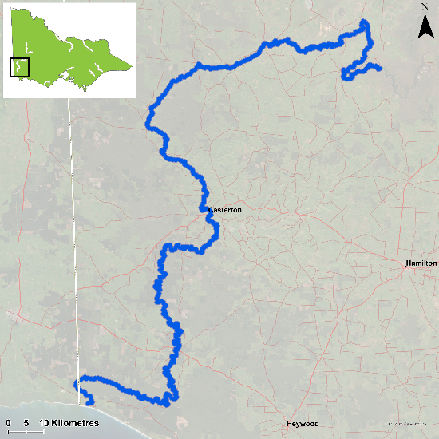
Figure 1. Map showing the section of Glenelg River where NFRC sampling occurs

Environment
Low flow conditions were present in all nine sampling seasons, albeit the lowest in 2025. Two sites were not fished between 2022-2025 due to limitations in access and these have been replaced with two new estuarine sites from 2023 onwards. It is expected the addition of the two new estuarine sites will increase the abundance of Estuary Perch detected during sampling.

Waterway and fisheries management efforts in the Glenelg River
Many rehabilitation actions have occurred, and are underway, to improve the health of the Glenelg River. These are informed by the Glenelg Hopkins Waterway Strategy 2014-2022 and the Glenelg River Restoration Program. Actions include revegetation, weed control and fencing of riparian areas, reintroduction of instream woody habitat, allocations of water for the environment, removal of migration barriers and pest control. There are a range of fish monitoring programs related to these management efforts. The Glenelg Hopkins Catchment Management Authority, DEECA, Victorian Environmental Water Holder and Victorian Fisheries Authority support rehabilitation and management of the Glenelg River and its fish community.

Estuary Perch

Glenelg River, Glenelg Hopkins region

Key Health Indicators
Recent recruitment No
Multiple size classes Yes
Mature fish present Yes

Monitoring Results
Total number of fish caught 130
Fish per 1km of waterway 16.06
Largest fish by length (cm) 45
Largest fish by weight (kg) 1.4
% of the catch that is legal size 80

Estuary Perch (Percalates colonorum - formerly Macquaria colonorum) is an estuarine species that can inhabit the lower freshwater reaches of streams. Within the Glenelg River, the species moves further inland than other rivers in Victoria. No Estuary Perch have been detected as far upstream as Balmoral, but sites have been included this far upstream to monitor the potential for further expansion in range, as the species seems to be slowly moving further upstream (based on previous surveys). The abundance of Estuary Perch in 2025 was similar to 2023, albeit lower than 2024 (Figure 2). There was an increase in the number of adults captured in the 2025 survey, likely reflecting strong juvenile year classes of 2023 and 2024 reaching maturity (Figure 3). This may be the result of strong juvenile year classes in 2023 and 2024 maturing. The increase in numbers from 2023 onwards coinciding with the addition of two new estuarine sites is not unexpected, as Estuary Perch are largely an estuarine species. These new sites are expected to continue to be surveyed into the future. Multiple size classes, including mature and juvenile fish, were captured in all nine years, with a small number of young-of-year fish also detected in 2018. This is an indication that conditions in the Glenelg River are supporting spawning, recruitment, and survival of this species throughout its lifecycle and providing good, ongoing angling opportunities.

Stocking
No stocking has occurred.
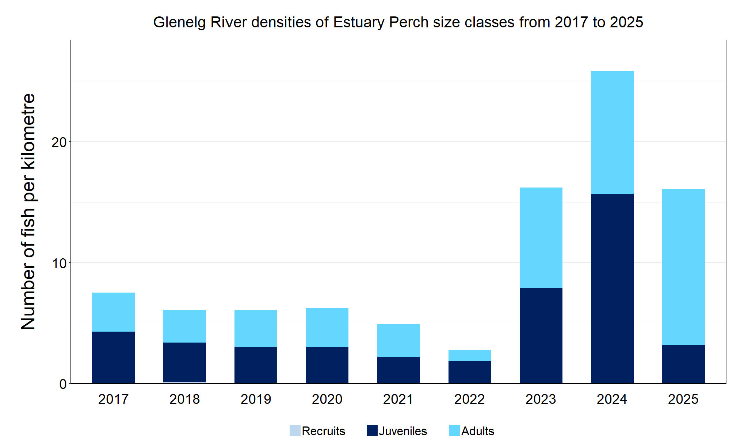
Figure 2. The densities of recruits, juveniles and adult Estuary Perch in the Glenelg River from 2017 to 2025.

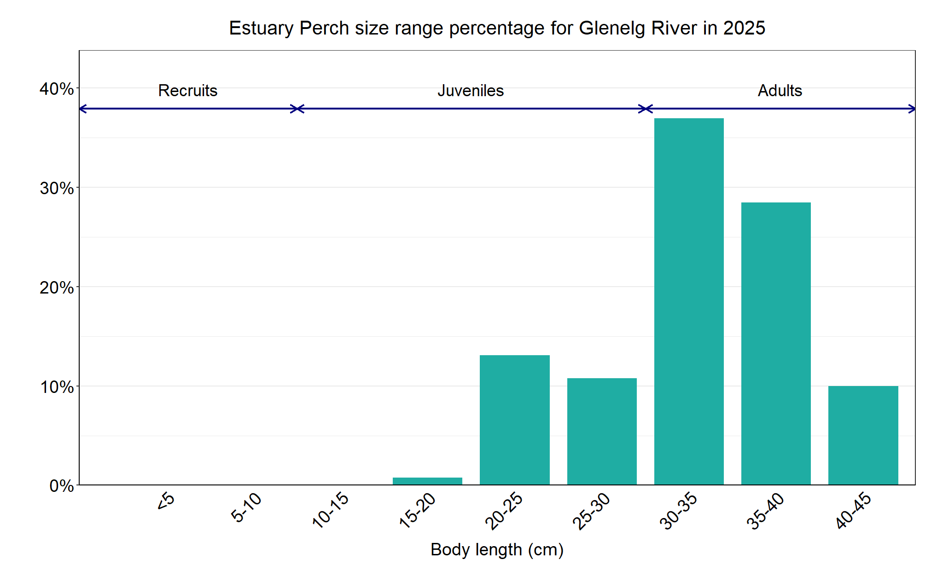
Figure 3. The size range percentage of Estuary Perch in the Glenelg River in 2025.

We acknowledge and respect Victorian Traditional Owners as the original custodians of Victoria’s land and waters, their unique ability to care for Country and deep spiritual connection to it. We honour Elders past and present whose knowledge and wisdom has ensured the continuation of culture and traditional practices.

© The State of Victoria Department of Energy, Environment and Climate Action 2025. This work is licensed under a Creative Commons Attribution 4.0 International licence. To view a copy of this licence, visit creativecommons.org/licenses/by/4.0/
ISSN 2981-9008 Online (pdf/word)

