
Native Fish Report Card 2025
Mitchell River
East Gippsland Region

This report card summarises the 2025 Native Fish Report Card (NFRC) survey in the Mitchell River
Sites: 11, Electrofishing

Fish found in Mitchell River for NFRC
Target species
Australian Bass
Australian Grayling
Non-target species captured since 2017*
Large-bodied native species
Cox’s Gudgeon
Long-finned Eel
Pouched Lamprey
Short-finned Eel
Short-headed Lamprey
Striped Gudgeon
Tupong
A further 10 species which are estuarine (see next page)

Small-bodied native species
Australian Anchovy
Australian Smelt
Common Galaxias
Dwarf Flatheaded Gudgeon
Flatheaded Gudgeon
Flinder’s Pygmy Perch
Port Jackson Glassfish
Tamar River Goby

Exotic species
Brown Trout
Common Carp
Goldfish

* These non-target species were incidentally captured during NFRC surveys since 2017 but not measured as for target species.
Mitchell River 2025
Fish Community

NFRC target species
The NFRC Program began in 2017 to monitor population dynamics of key iconic fish species that have high recreational and/or conservation values, in large rivers across Victoria.
In the Mitchell River, the target species are Australian Bass and Australian Grayling. The equipment used and habitats surveyed target these species, which are measured to determine their population structures. Other fish species that are incidentally captured are counted, but not measured. Surveys occur in February each year, at 11 sites from Bairnsdale to Kingswell Bridge. One site on the upper Mitchell River was unable to be fished in 2022 and 2024 due to higher flows restricting access. Surveys on the Mitchell River use Smith-Root boat electrofishing at most sites, with elevated salinities at the two bottom sites requiring Grassl boat electrofishing¹.

Summary of key health indicators for target species in 2025
Species | Key Health Indicators
 | Recent recruitment | Multiple size classes | Mature fish present
Australian Bass | No | Yes | Yes
Australian Grayling* | - | - | -

Recent recruitment means young-of-year fish
*- cannot be determined due to low abundances

Australian Bass are close to the edge of their natural range in the Mitchell River system. Historically they occurred no further west than Wilsons Promontory. Australian Bass are an important recreational species in the Mitchell River with the population aided by stockings. Australian Grayling was once widespread throughout coastal Victoria, including the Mitchell River system. Changes to flow regimes and addition of barriers have negatively affected this species.

Non-target species
The non-target fish species that have been incidentally recorded in the Mitchell River during NFRC surveys since 2017 are:

Large-bodied native species
Cox’s Gudgeon, Long-finned Eel, Short-finned Eel and Tupong were recorded in the 2025 survey. Long-finned Eel, Short-finned Eel and Tupong have been recorded in all nine NFRC surveys, while Cox’s Gudgeon has been recorded in five. The Pouched Lamprey (twice), Short-headed Lamprey (three times) and Striped Gudgeon (twice), have also been recorded in previous NFRC surveys. Six estuarine species (Black Bream, Estuary Perch, Luderick, River Garfish, Sand Mullet and Sea Mullet) were also recorded in the 2025 survey. Other large-bodied estuarine species previously recorded in NFRC surveys are Eastern Australian Salmon, Flat-tail Mullet, Tailor and Yellow-eye Mullet. All ten estuarine species are restricted to the lowest Mitchell River site (Bairnsdale) and Clifton Creek. Long-finned and Short-finned Eel, Pouched and Short-headed Lamprey and Tupong are diadromous species found throughout coastal Victoria. Cox’s and Striped Gudgeon are only found in coastal areas of eastern Victoria. Cox’s Gudgeon is listed as endangered under the Flora and Fauna Guarantee Act 1988 in Victoria. It was recorded in 2019 (the first record in the Mitchell catchment since 1982), 2021, 2022, 2024 and 2025.

Small-bodied native species
Australian Smelt, Common Galaxias and Flatheaded Gudgeon were recorded in the 2025 survey, with Australian Smelt and Common Galaxias recorded in all nine NFRC surveys and Flatheaded Gudgeon in eight. Australian Smelt and Flatheaded Gudgeon are common species distributed across all of Victoria. The Common Galaxias is a diadromous species found in coastal Victoria. Port Jackson Glassfish, an estuarine species, was also recorded in 2025, the fourth time in NFRC surveys, but the first time since 2019. This species is only expected to be detected at the lowest Mitchell River site (Bairnsdale) and Clifton Creek. Other species recorded in previous NFRC surveys are Dwarf Flatheaded Gudgeon and Flinder’s Pygmy Perch (listed as vulnerable in Victoria under the Flora and Fauna Guarantee Act 1988) which have a more restricted distribution and are rarer. Additionally, two estuarine species, Australian Anchovy (once) and Tamar River Goby (once) are only expected to be detected at the lowest Mitchell River site (Bairnsdale) and Clifton Creek.

Exotic fish species
Common Carp and Brown Trout were recorded in the 2025 survey. Common Carp have been detected in all nine NFRC surveys. It is widespread throughout the Mitchell River, with juveniles detected as far upstream as Kingswell Bridge in 2020 and 2023. Brown Trout were recorded for the first time in 2025. Brown Trout are a cool water species and were detected in the two highest sites in the Wonnangatta River. Goldfish was recorded in the 2023 NFRC surveys. It prefers slower flowing waters and was detected at Bairnsdale, the lowest site on the Mitchell River mainstem.

Other native species known from the Mitchell River
Some fish species known to occur in the Mitchell River have never been recorded during NFRC surveys (e.g. Climbing Galaxias, Dwarf Galaxias, Mountain Galaxias, Spotted Galaxias, River Blackfish). The Climbing and Spotted Galaxias are diadromous species occurring in coastal Victoria. They have patchy distributions, in lowland areas, but are hard to detect using NFRC sampling methods. The Mountain Galaxias occurs on both sides of the Great Dividing Range from Melbourne eastwards in Victoria. In the Mitchell River it is widespread and patchy in the lower areas, but more common at higher altitudes and is hard to detect using the NFRC sampling methods. The Dwarf Galaxias (listed as vulnerable nationally under the Environment Protection and Biodiversity Conservation Act 1992) is often found in offstream habitats. River Blackfish is a lowland species, generally found at altitudes below 200m. This species has declined in distribution and abundance across Victoria. It was historically considered to be widespread, but with a patchy distribution in the Mitchell River basin².

Other notable species
Surveys have also recorded Eastern Long-necked Turtles, Easten School Prawn and Platypus.

1. Lieschke, Jason A., Dean, Jan, C and Pickworth, Andrew 2019. Extending the Effectiveness of Electrofishing to Estuarine Habitats: Laboratory and Field Assessments. Transactions of the American Fisheries Society, 148:584–591.
2. Lieschke, J.A., Dodd, L., Stoessel, D., Raadik, T.A., Steelcable A., Kitchingman, A. and Ramsey, D. (2013). The status of fish populations in Victorian rivers 2004–2011 – Part A. Arthur Rylah Institute for Environmental Research Technical Report Series No. 246. Department of Environment and Primary Industries, Heidelberg, Victoria.

Mitchell River 2025
Environmental and Management Context

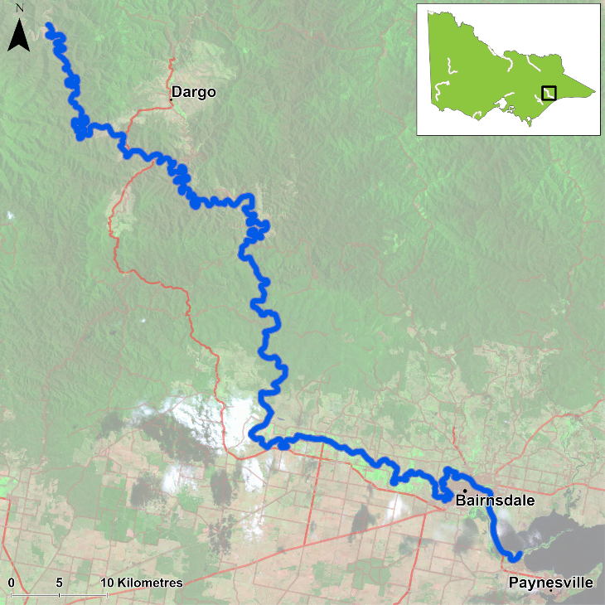
Figure 1. Map showing the section of Mitchell River where NFRC sampling occurs

Environment
Summer base flows were recorded in 2017-20, 2023 and 2025, with slightly higher flows in 2021 and above summer base flows in 2022 and 2024. During 2020 and 2021 turbidity was elevated at sites due to increased sediment loads following the 2019/2020 fires. The elevated turbidity decreased electrofishing efficiency in those two years. Higher flows restricted access to one site, therefore only 10 sites were fished in 2022 and 2024.

Waterway and fisheries management efforts in the Mitchell River
On ground projects continue to be delivered to improve the health of the Mitchell River. These activities are contributing to the long term goals for rehabilitation of the Mitchell River, particularly in its lower reaches.

The East Gippsland Catchment Management Authority (EGCMA) continues to work closely with landholders, partner agencies and Traditional Owners to deliver improvements to the health of the Mitchell River. This year the focus has been on continuing to replace willows with native plants along the river, supported by constructing stock exclusion fencing, stabilising the banks and creating more habitat for fish by reintroducing large woody habitat. Works have continued in the upper reaches to control weeds, particularly willows along waterways, preventing their spread downstream.

Some monitoring of the fish community has occurred including in relation to associated rehabilitation efforts. In the upper Mitchell River catchment well above the NFRC area, there have been surveys of a suite of threatened galaxiid species as well as Forest Protection Survey Program (FPSP) surveys of fish and crayfish. The EGCMA, DEECA and the Victorian Fisheries Authority support rehabilitation and management of the Mitchell River and its fish community.

Australian Bass

Mitchell River, East Gippsland region

Key Health Indicators
Recent recruitment No
Multiple size classes Yes
Mature fish present Yes

Monitoring Results
Total number of fish caught 114
Fish per 1km of waterway 16.9
Largest fish by length (cm) 46.8
Largest fish by weight (kg) 1.56
% of the catch that is legal size 50.8

Australian Bass (Percalates novemaculeata) - formerly Macquaria novemaculeata – have been collected in all nine NFRC surveys. Abundance of Australian Bass in the 2025 survey was lower than in 2024 and lower than the peak found in 2023. The abundance of adults however has increased since 2020 (Figure 2). Adults and juveniles have been detected in all nine years of NFRC sampling (Figure 2, Figure 3). No recruits were detected in 2025 for the first time (Figure 2, Figure 3). Australian Bass are close to the edge of their natural range in the Mitchell River system and are likely to have limited natural recruitment. The recruits detected in 2024 are likely from the stocking in November 2023. No Australian Bass were stocked in 2024 or early 2025, therefore it is not unexpected that no recruits were detected in 2025.

Stocking
Ten thousand Australian Bass were stocked in 2016; 150,000 in 2017; 30,000 in 2018; 44,000 in 2019; 66,000 in 2020; 100,000 in 2021; 67,000 in 2022 and 100,000 in 2023. No Australian Bass were stocked in 2024 or early 2025.

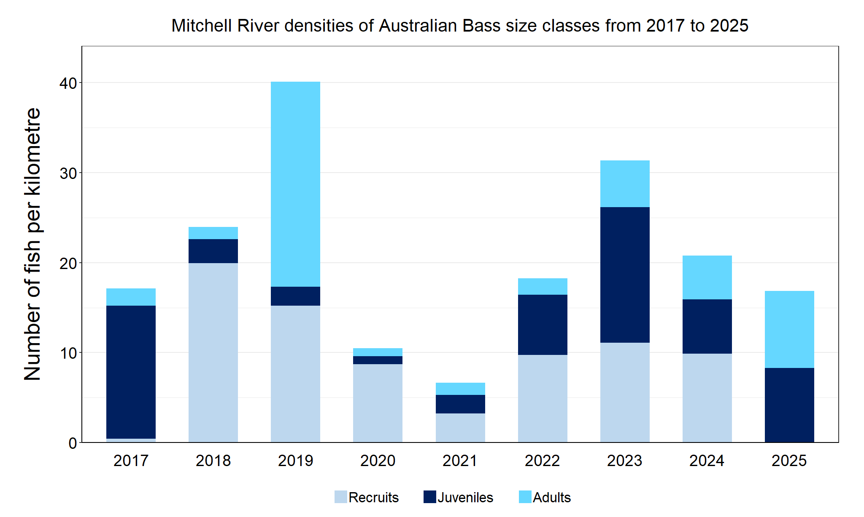
Figure 2. The densities of recruits, juveniles and adult Australian Bass in the Mitchell River from 2017 to 2025

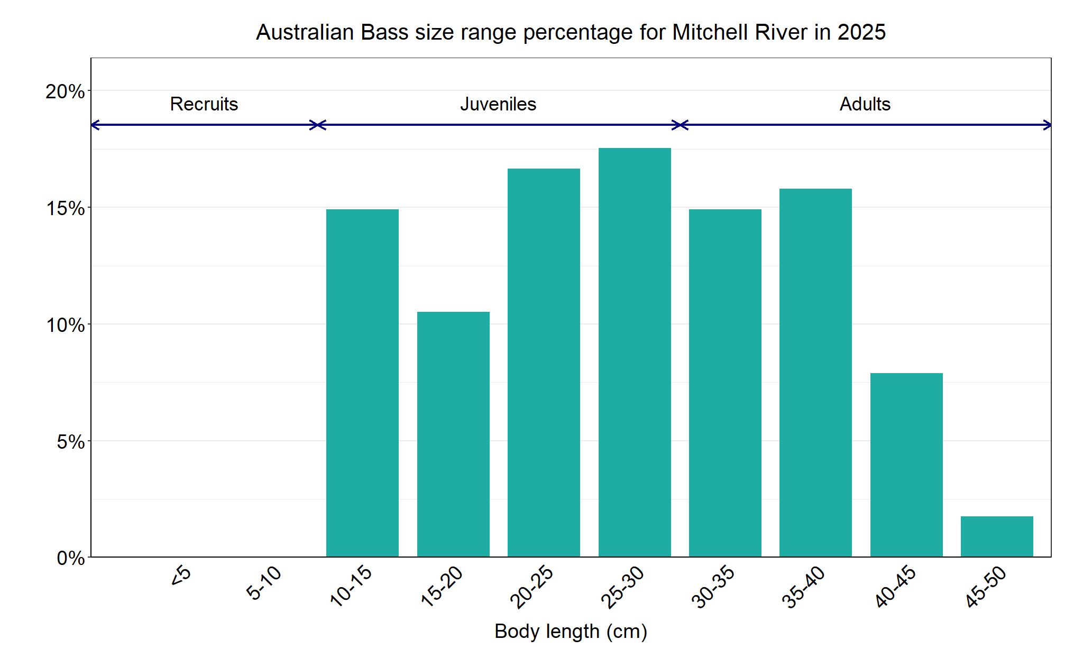
Figure 3. The size range percentage of Australian Bass in the Mitchell River in 2025

Australian Grayling

Mitchell River, East Gippsland region

Key Health Indicators
Recent recruitment Cannot be determined
Multiple size classes Cannot be determined
Mature fish present Cannot be determined

Monitoring Results
Total number of fish caught 14
Fish per 1km of waterway 2.07
Largest fish by length (cm) 23.9
Largest fish by weight (kg) 0.14
% of the catch that is legal size NA#

# This species is a Protected Freshwater Species and taking or possessing is prohibited (Victorian Recreational Fishing Guide 2025).

Australian Grayling (Prototroctes maraena) is a diadromous species which has undergone declines in distribution and abundance across its range. The species is listed as endangered in Victoria (Flora and Fauna Guarantee Act 1988) and nationally (Environment Protection and Biodiversity Act 1999). While NFRC expects to only capture low numbers of this species, the monitoring can provide a greater understanding of the current status of the populations which is essential to inform management of these species. Due to the low abundances of Australian Grayling collected during NFRC, the key health indicators cannot be determined.
The highest abundance of Australian Grayling was detected in the 2025 survey compared to all NFRC surveys, with recruits, juveniles and adults detected (Figure 4, Figure 5). This is the first time all three life stages have been detected in the same sampling year during NFRC surveys. Adults have been captured in seven of the nine years of NFRC surveys (2017, 2019–21 and 2023-25) (Figure 4), while juveniles have been detected in four (2017, 2022 and 2024-25) (Figure 4). Recruits were detected for the third time in 2025, previously being detected in 2020 and 2021 (Figure 4). This would suggest stream conditions were suitable for recruits to be attracted into the system in spring 2024. This is the first time since spring 2019 and spring 2020 that recruits have been detected in the Mitchell River. The presence of juveniles in 2024, indicates that recruits entered the system in 2022, but were not detected in the surveys in 2023. The continued presence of adult Australian Grayling indicates conditions continue to be favourable for the survival of this species in the Mitchell River.

Stocking
No stocking has occurred.
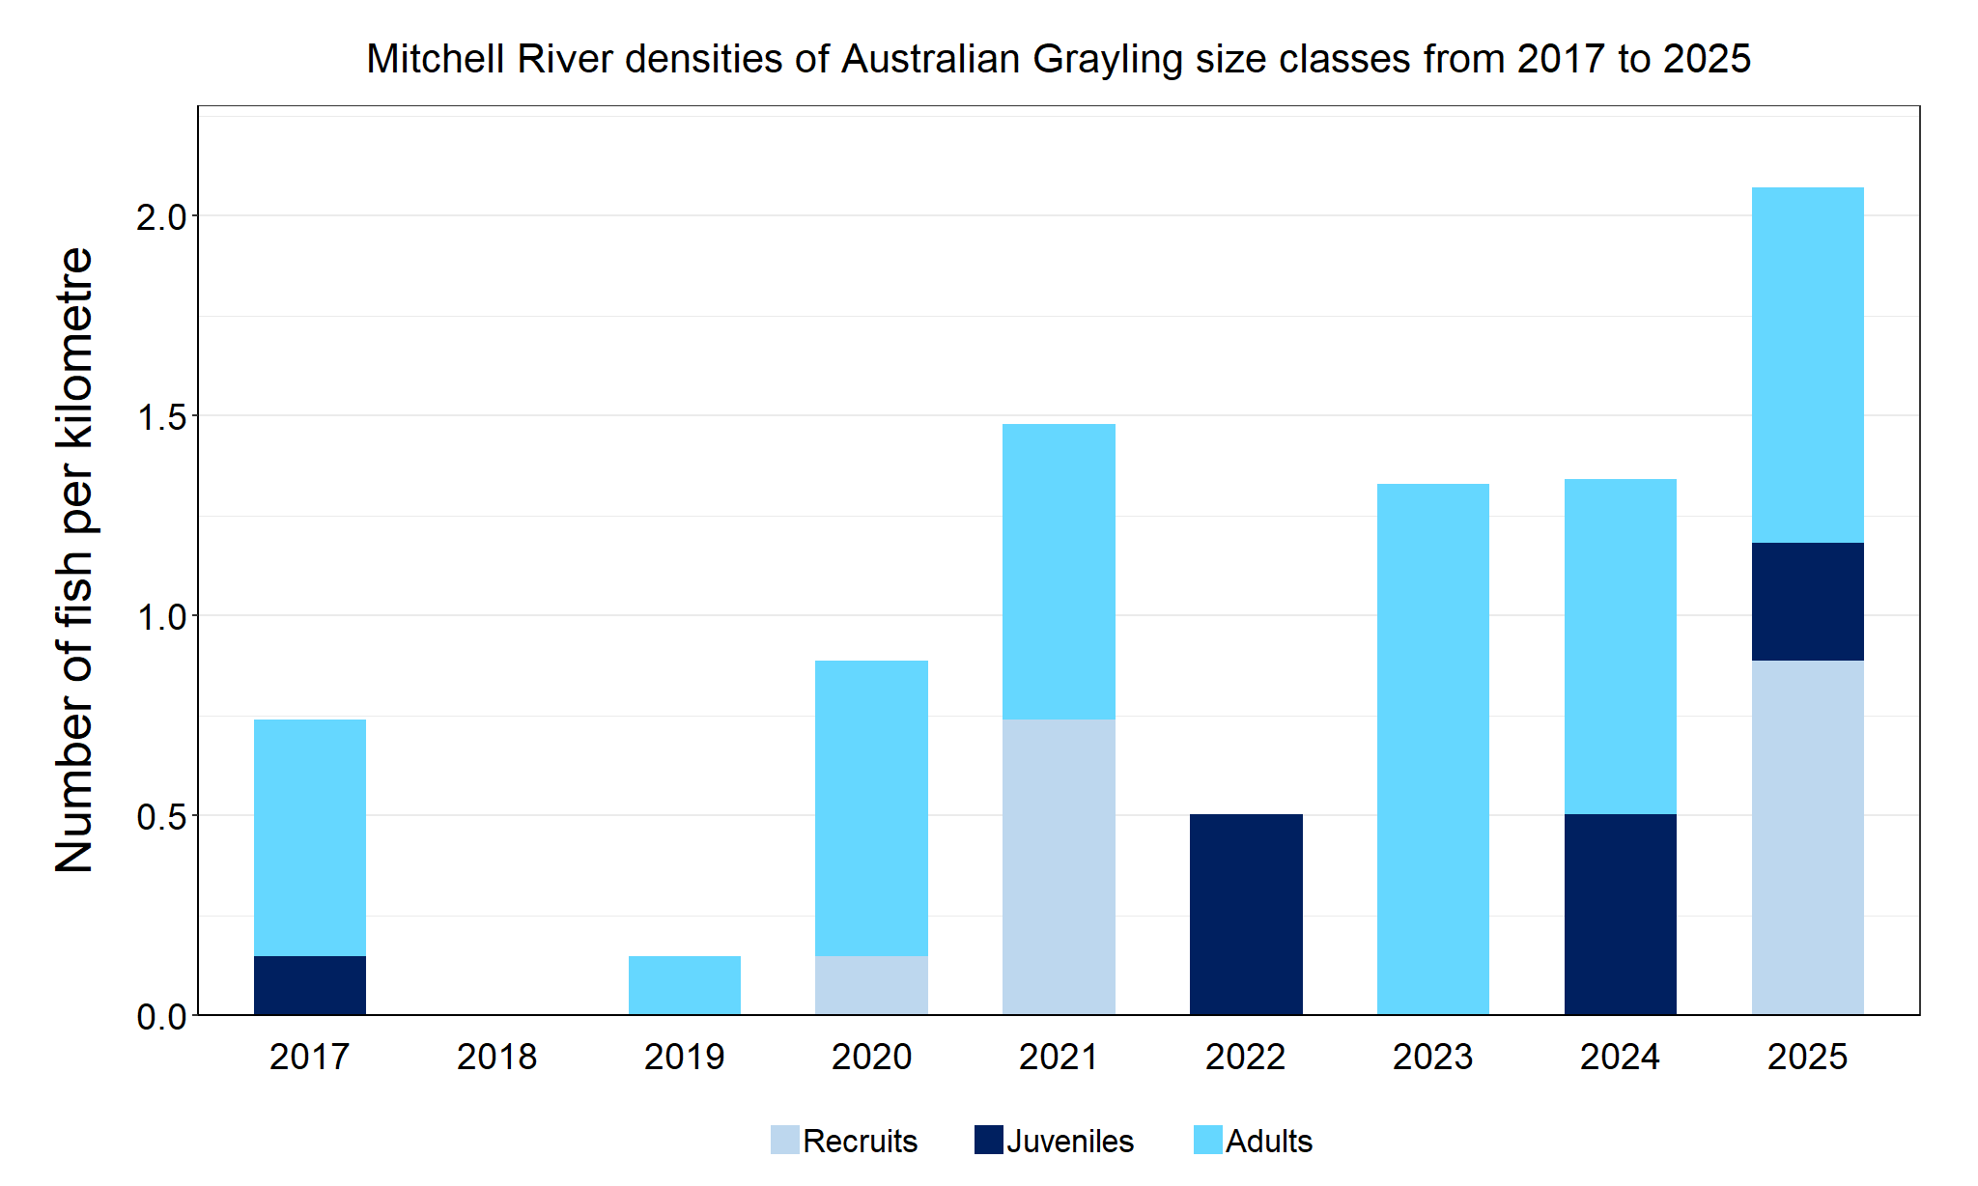
Figure 4. The densities of recruits, juveniles and adult Australian Grayling in the Mitchell River from 2017 to 2025

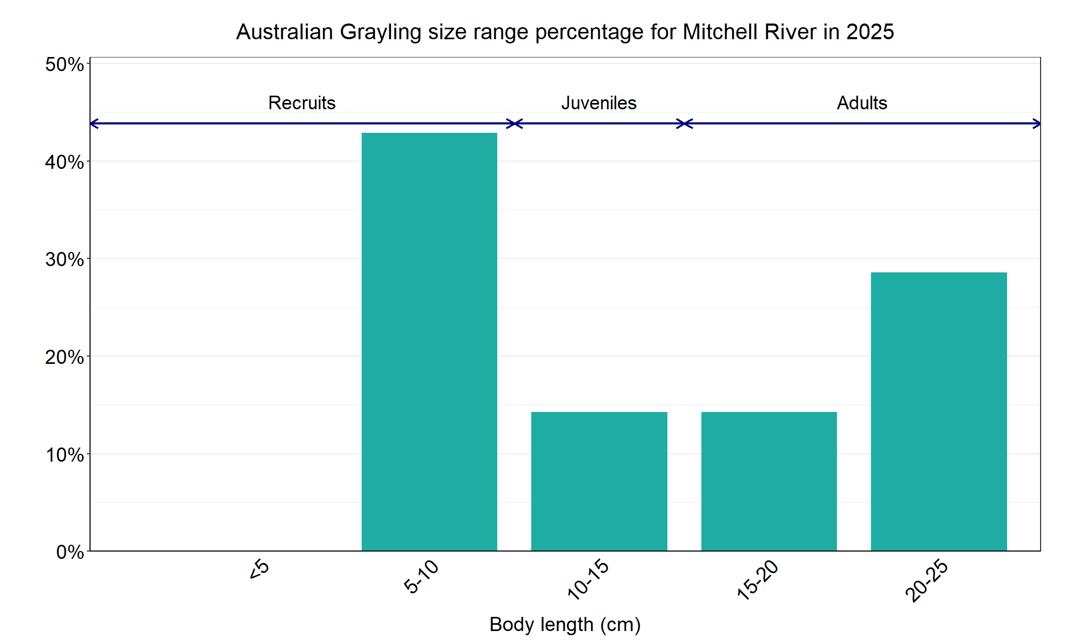
Figure 5. The size range percentage of Australian Grayling in the Mitchell River in 2025

We acknowledge and respect Victorian Traditional Owners as the original custodians of Victoria’s land and waters, their unique ability to care for Country and deep spiritual connection to it. We honour Elders past and present whose knowledge and wisdom has ensured the continuation of culture and traditional practices.
© The State of Victoria Department of Energy, Environment and Climate Action 2025. This work is licensed under a Creative Commons Attribution 4.0 International licence. To view a copy of this licence, visit creativecommons.org/licenses/by/4.0/ ISSN 2981-9067 Online (pdf/word)

