
Aquatic Quarterly Update Influence
Autumn 2026

About Us
The Applied Aquatic Ecology section generates and shares knowledge, through world-class, applied, ecological research. This research supports and guides sustainable ecosystem policy and management to ensure healthy, resilient ecosystems. We work collaboratively with national, state and local agencies, research institutes, universities, interest groups and the community.
Our focus:
- To undertake high quality, relevant ecological research.
- To interpret research outcomes and communicate these effectively to key stakeholders.
- To guide and support sustainable ecosystem policy and management.

This update provides four examples of projects that support waterway management.

They provide an overview of:
- an extensive study (integrating otolith and genomic data) providing the strongest evidence to date on the long-term fate of stocked Golden Perch in a large, connected freshwater system.
- how reinstating very low-flow regimes (allowing riverbed exposure for at least two weeks in late summer or autumn) can effectively stimulate recruitment of flood-tolerant and certain aquatic plants.
- a novel study showing that environmental flows can enhance fishway functionality, delivering greater ecological benefit than fishways alone.
- a nursery experiment showing that riparian plants are more resilient to seasonal inundation than terrestrial plants, particularly during spring and under short summer flooding.

www.ari.vic.gov.au Sign up to any of ARI’s communications at ari.vic.gov.au/ari-updates
Stocking strategies to protect genetic diversity and enhance recovery outcomes for Golden Perch
Issue: Golden Perch (Macquaria ambigua), a species of immense cultural and recreational value, is a mobile, long-lived freshwater fish in Australia’s Murray–Darling Basin (MDB). In some areas it is heavily reliant on hatchery stocking to support species’ persistence and/or recreational fisheries (Figure 1). Managers currently lack evidence on how stocked fish disperse, survive and mix with wild populations over decades. This gap limits the ability to refine stocking strategies and assess genetic risks of stocking (e.g. reduced diversity or unintended mixing of distinct lineages) which may undermine long-term population resilience.
Action: The potential genetic effects of stocking on the natural populations of Golden Perch in the MDB was explored using a combination of:
- otolith (earbone) chemistry and otolith age data to identify stocked individuals according to their natal origin.
- genomic data to assess genetic structure, diversity among stocked and wild fish and the prevalence of close kin across the basin and over time.

This dual approach determined:
- whether fish were wild born or hatchery stocked
- where they recruited, and
- temporal patterns in dispersal and genetic structure.
Sampling was conducted across all major river basins to gain insights into how stocking influences populations over multiple decades. This large dataset brought together samples from many large Commonwealth and State fish monitoring projects including Flow-MER, The Living Murray and the former VEFMAP (Victorian Environmental Flows Monitoring and Assessment Program).
Results: The analyses revealed that:
- stocked fish persisted in the system for many years and contributed to both local and distant populations, indicating substantial movement across the basin.
- in some areas, stocked individuals made up a notable proportion of sampled fish, while in others, wild recruitment dominated. Areas where stocked fish dominated tended to be relatively isolated due to the presence of artificial barriers to movement.
- otolith analyses confirmed recruitment locations, while genomic data detected subtle but important changes in genetic structure linked to stocking history.
- the species’ high mobility facilitated widespread mixing, meaning stocking influences were detectable far from original release points.
- importantly, genetically distinct lineages were not homogenised, suggesting that previous stockings had not yet eroded key population structure. It was however apparent that active management of stocking is needed to mitigate this risk.
Outcome: The study provides managers with the strongest evidence to date on the long-term fate of stocked fish in a large, connected freshwater system. By demonstrating how stocked and wild individuals interact over decades, the research supports more targeted, basin-wide stocking strategies that protect genetic diversity and enhance recovery outcomes.
It is important that breeding and stocking programs are modified to place a greater emphasis on the genetic diversity and effective population size of stocked fish, whilst continuing to implement management strategies that promote in situ recruitment and connectivity (e.g. habitat protection and restoration, removal of barriers, provision of environmental water). Such an approach is likely to have positive outcomes for the evolutionary resilience of wild Golden Perch.
Revised stocking strategies should aim to:
- increase genetic diversity in hatchery broodstock
- minimize release of closely related fish
- incorporate context-specific approaches based on river connectivity and natural recruitment.
The study underlines the importance of integrated monitoring, using both otolith and genomic data, to guide adaptive, genetic-aware stocking management. By tailoring practices to local population structure and connectivity, agencies can better promote the long-term viability of Golden Perch while supporting fisheries.
Funder: This work was supported by Australian Research Council, La Trobe University, the University of Melbourne and Goulburn-Broken Catchment Management Authority. See Harrisson et al. (2025) for further details of funding support.
ARI contact: Dr Zeb Tonkin, ARI
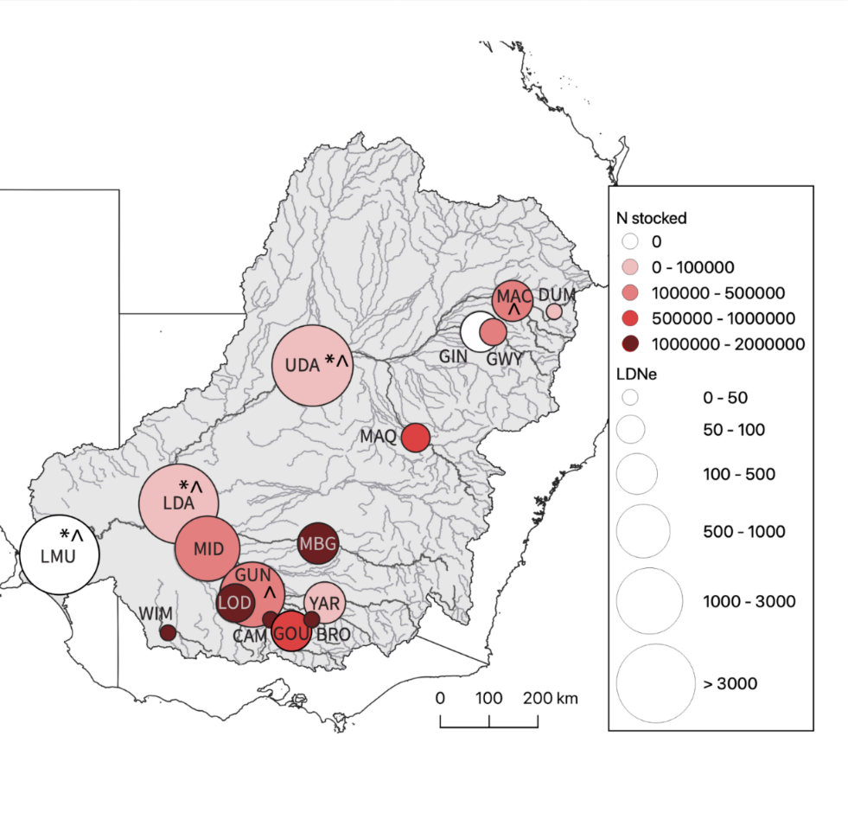
Harrisson et al. (2025) Otolith and genomic data reveal temporal insights into stocking across a large river basin in a mobile, long-lived Australian freshwater fish species. Molecular Ecology
Figure 1. Colour scale represents the number of Golden Perch stocked directly into the sampled reach from 1990 to 2019 (i.e., intensity of stocking). Size of the circle represents the effective population size (Ne), which is expected to reflect genetic diversity and adaptive potential of populations. Infinite estimates of Ne (likely indicative of very large population sizes and low rates of genetic drift) are marked with *. Ne estimates where upper confidence intervals of Ne estimates spanned infinity are marked with ^."

Managing low flows in rivers to enhance recruitment of instream plants

Issue: Many environmental flow planning frameworks include key objectives for riparian and instream vegetation. Most vegetation needs are met by elevated flows from environmental flows or natural flows, but some aspects of recruitment require low flows. Regulated lowland rivers now often lack natural warm-season low flows, resulting in persistent riverbed inundation. This constant inundation of the riverbed suppresses the recruitment of riparian and some instream vegetation, particularly flood-tolerant and aquatic species. This means that objectives might not be met in some waterways. In the regulated Campaspe River downstream of Lake Eppalock, post-regulation flows rarely drop below 50 ML/day, which is unlike the pre-regulation period when flows sometimes fell below 10 ML/day in late summer and autumn. This permanence may inhibit germination and establishment of riverbed vegetation that relies on sediment exposure.
Action: A low-flow field experiment was carried out in early May 2022. Flows were gradually reduced from 50 ML/day to 15–20 ML/day over one week, maintained for two weeks, and then ramped back up over another two weeks, totaling a 36-day experiment. Paired plots at high-elevation (exposed) and low-elevation (inundated) positions were established across eight sites, and surveyed at three timepoints (at Week 0, Week 2 and Week 6) (Figure 2).

A concurrent ex-situ nursery experiment was also carried out. This experiment used sediment samples from the field site plots in three treatments: long exposure (exposed throughout the experiment), short exposure (two weeks) followed by inundation, and continuous inundation over 22 weeks.

Results: The field experiment found that:
- a two-week exposure was sufficient to trigger germination of thousands of flood-tolerant riverine species, whereas aquatic plants responded minimally and terrestrial species were rare.
- seedlings that emerged tolerated early re-inundation, but prolonged submersion reduced survival for non-aquatic plants.
The nursery experiment mirrored these results:
- short and long exposure treatments led to higher seedling counts from aquatic and flood-tolerant groups, while continuous inundation resulted in few recruits.

Outcome: The study demonstrated that reinstating very low-flows in regulated flow regimes—allowing riverbed exposure for at least two weeks during late summer or autumn—can effectively stimulate the recruitment of flood-tolerant and certain aquatic plants species. However, survival post-germination depends on timely re-inundation. While these very low-flows pose potential risks to some aquatic fauna and water quality management, the benefits for reinstating natural biotic processes are potentially substantial. As such, environmental water planning where objectives include recruitment of instream vegetation should consider incorporating warm-season low-flow pulses.

Next step: Subsequent studies are underway to assess the effectiveness of instream revegetation where flow management cannot be used to facilitate natural recruitment, as well as studies to better understand recruitment processes for aquatic plants.

Funder: The former VEFMAP (Victorian Environmental Flows Monitoring and Assessment Program), DEECA Water and Catchments.

ARI contact: Dr Chris Jones, ARI

Jones et al. (2025) Managing river low flows to enhance instream vegetation recruitment. Environmental Management.
Figure 2. Counts of seedlings across all sites in the field at Week 0 (start of the low-flow period), Week 2 (end of the low-flow period), and Week 6 (one month after end), for the three plant groups (aquatic, flood-tolerant and terrestrial) and the two plot exposure treatments inundated, short exposure). The y-axis is log scaled to improve data visibility. Boxplots show the median and the range between the first and third quartiles of the data, the whiskers extend up to 1.5× the interquartile range.

Environmental flows increase fish movement and improve fishway performance
Issue: Fishways and environmental flows both commonly aim to enhance instream connectivity and fish movement, however the combined benefits of these management interventions are rarely evaluated or reported on, despite the costs of implementing the flow and fishway interventions.
Action: Fish movement responses to environmental flows were examined across multiple fishways in two regulated lowland river systems (Broken Creek and the lower Loddon River). Fish movement was assessed using fishway trapping and PIT (Passive Integrated Transponder) tag detections. Fishway hydraulics (i.e. turbulence, water velocity and discharge) were modelled under low, medium and high discharge conditions. Environmental flows were delivered as seasonal “freshes” which aim to raise river levels, stimulate fish movement, and enhance river connectivity. This work assessed which fish species used fishways, how their movement changed with river discharge, and how flow-driven changes in fishway hydraulics influenced fish movement, increased movement frequency and species diversity.
Results: Increasing river discharge driven largely by environmental flows substantially increased fish movement across all fishways, particularly during spring when water temperatures were rising. Fish movement was greater during medium to large flow events.
- Large-bodied native fish species (e.g. Murray Cod and Golden Perch) showed strong river discharge-related increases in fishway use (up to 20-fold for Murray Cod in Broken Creek).
- Small-bodied native fish species (e.g. Australian Smelt, Carp Gudgeon) responded even more dramatically, with movement increasing by 30- to 140-fold during high-flow events.
- Higher flows raised tailwater levels and partially drowned-out low-level fishways, reducing turbulence and headloss (loss of hydraulic energy) by ~50%, creating more favourable hydraulic conditions for small fish.
- Alien species (e.g. Common Carp, Oriental Weatherloach and Goldfish) also moved more during high flows. This highlights the need to integrate pest management with river connectivity restoration.
Outcome: This study showed that increased stream discharge driven primarily by environmental flows enhanced fishway functionality, delivering greater ecological benefit than fishways alone. By improving hydraulic conditions and aligning flow timing with biological cues, managed flows enable a wider range of species and size classes to move through regulated rivers. These findings support coordinated investment in flows and fishway design/operation to maximise connectivity outcomes in highly regulated rivers.
A conceptual model was also developed which details the hydraulic interplay between environmental flow magnitude and river height, fishway performance, fish size class movement and the likely fish movement pathways to simplify and visualise these relationships (Figure 3). This model effectively demonstrates how the degree of connectedness within regulated waterways fluctuates for fishes, even after fishways have been constructed, and environmental flows delivered.
Funder: The former VEFMAP (Victorian Environmental Flows Monitoring and Assessment Program), DEECA Water and Catchments, University of Melbourne, Goulburn-Broken Catchment Management Authority and the Murray-Darling Basin Authority.
ARI contact: Dr Matt Jones, ARI
Jones et al. (2025) More than the sum of their parts – Environmental flows increase fish movement and fishway functionality. Ecological Engineering.
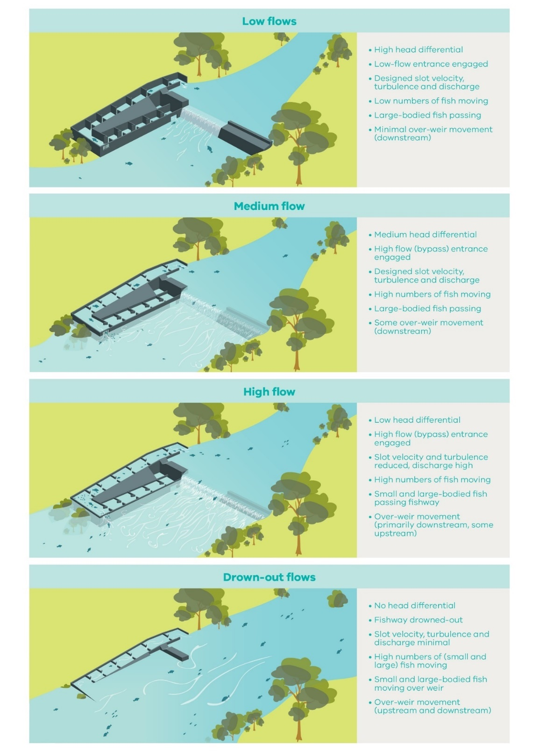
Figure 3. Conceptual model of a low-level (e.g., <3m high) fixed-crest weir and fishway and how fish passage is influenced by increasing river discharge. Note the flow induced changes could occur from natural flow events or environmental flows.

Spring inundation can mimic natural flows to benefit riparian plant growth

Issue: River regulation has altered the timing, duration and frequency of inundation in many Australian rivers, fundamentally changing riparian vegetation dynamics. These changes often favour terrestrial plants over native riparian plants, reducing ecosystem function and management outcomes associated with environmental flows. While inundation is known to influence plant growth and reproduction, there is limited experimental evidence on how different seasons and flood durations affect riparian versus terrestrial plant groups (which are often the objective of delivered flows). This limits the ability of water managers to design environmental flows that most efficiently and effectively support targeted vegetation objectives.
Action: The study experimentally tested the effects of seasonal inundation on plant performance using four riparian species (a mix of sedges and rushes) and four terrestrial grass species common to regulated rivers in southern Australia. Plants were exposed to three inundation treatments (no inundation, short inundation of one week, and long inundation of four weeks) during spring and summer. Survival, growth, flowering, seed production and seed viability were measured to assess both health and reproductive responses. This controlled approach enabled direct comparison of plant group responses across seasons and inundation durations relevant to environmental flow delivery.

Results: In spring, long inundation reduced survival and growth of terrestrial grasses, while riparian species showed consistently high survival and relatively stable growth across all treatments (Figure 4). Spring inundation often delayed or reduced flowering and seed production in both plant groups. During summer, terrestrial grasses again showed reduced survival and growth under inundation. In contrast, riparian species generally performed best under short summer inundation, with some evidence of enhanced reproduction. Notably, summer inundation promoted reproduction in Juncus amabilis (Hollow Rush) while seed viability showed few consistent treatment effects across species or seasons.

Outcome: This work provided clear evidence that seasonal inundation delivered by environmental flows not only supports riparian plant growth compared to terrestrial species but also that spring and summer environmental flows benefit riparian plant reproduction relative to terrestrial species.

The results provide clear, experimentally based guidance for water managers to use in environmental flow design. This work supports the use of seasonally targeted flows to promote riparian vegetation outcomes in regulated rivers. Environmental flows in spring and short events in summer are likely to promote riparian vegetation in regulated rivers.

Next steps: Verifying these responses in controlled conditions is a very important step and can allow us to assess plant responses to a range of flow conditions in a single year. We now need to validate how these responses occur in field conditions of Victorian waterways to see how the natural setting may influence outcomes.

Funder: The former VEFMAP (Victorian Environmental Flows Monitoring and Assessment Program), DEECA Water and Catchments, with support from the University of Melbourne.

ARI contact: Dr Chris Jones, ARI

Wijepala et al. (2025) Effects of seasonal inundation on riparian plant growth and reproduction. River Research and Applications.

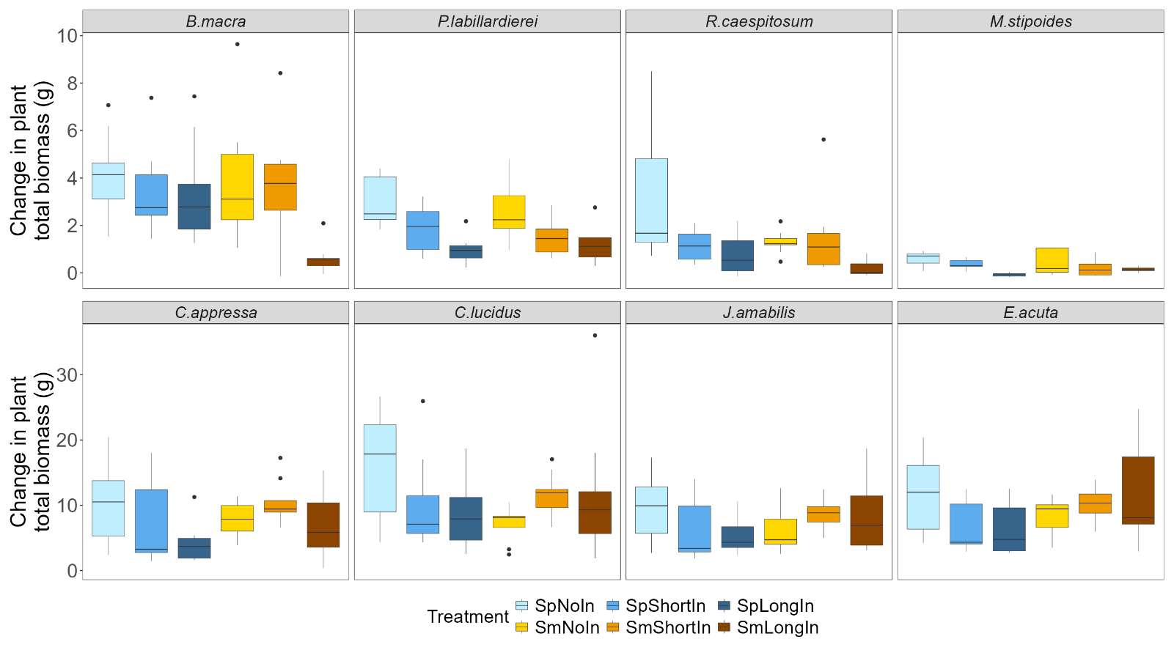
Figure 4. Change in plant biomass by species during the experiment for the different treatments (NoIn = no inundation, ShortIn = short inundation, LongIn = long inundation) in spring (Sp) and summer (Sm). N.B. different y-axes
values in the top (terrestrial plants) and bottom (riparian
plants) rows.

© The State of Victoria Department of Energy, Environment and Climate Action This work is licensed under a Creative Commons Attribution 4.0 International licence. To view a copy of this licence, visit http://creativecommons.org/licenses/by/4.0/ ISSN 2653-8334 Online (pdf/word)

