Gellibrand River 2022
Corangamite region

This report card summarises the 2022 Native Fish Report Card (NFRC) survey in the Gellibrand River
Sites 8, CCMA, Electrofishing, Fyke Netting

Fish found in Gellibrand River for NFRC
Target species
River Blackfish

Non-target species captured since 2017*
Large-bodied native species
Australian Grayling
Short-finned Eel
Tupong

Small-bodied native species
Australian Smelt
Climbing Galaxias
Common Galaxias
Ornate Mountain Galaxias
Pouched Lamprey
Short-headed Lamprey
Southern Pygmy Perch
Spotted Galaxias

Exotic species
Brown Trout

* These non-target species were incidentally captured during NFRC surveys since 2017 but not measured as for target species

LOGOS – ARI, DELWP

Gellibrand River 2022
Fish Community

NFRC target species
The NFRC Program began in 2017, with a focus on targeting the monitoring of population dynamics of key iconic fish species that have high recreational and/or conservation values, in large rivers across Victoria. In the Gellibrand River, the target species is River Blackfish. Surveys occur in March/April each year, at six sites from upstream of Chapple Vale to Dandos Campground on the Gellibrand River and two sites on tributaries. Backpack electrofishing and fyke netting is undertaken in the Gellibrand River, whilst the backpack electrofishing only occurs in the tributaries. The equipment and habitats surveyed are focused on the River Blackfish, which are measured to determine population structures. Other fish species that are incidentally captured are recorded, but not measured to determine their population structures.
Summary of key health indicators for target species in 2022
Species | Key Health Indicators
 | Recent recruitment | Multiple size classes | Mature fish present
River Blackfish | Yes | Yes | Yes

Recent recruitment means young-of-year fish

River Blackfish are a lowland species, generally found at altitudes below 200 metres. This species has suffered a decline in distribution and abundance across Victoria¹. The Gellibrand River was previously known as having a well-established River Blackfish population with large adults present².

Non-target species
The non-target fish species that have been incidentally recorded in the Gellibrand River during NFRC surveys since 2017 are:

Large-bodied native species
Other large-bodied species recorded in surveys are Australian Grayling, Short-finned Eel and Tupong. Numbers of Australian Grayling are low in the Gellibrand River catchment and the species is rarely found. Records from the NFRC are only the third (2017), fourth (2018) and fifth (2019) confirmed records of this species in this river. Australian Grayling have been found at the most downstream site on three occasions during NFRC surveys, with only one other detection recorded. The Short-finned Eel and Tupong are diadromous (migratory between salt water and fresh water) species found throughout coastal Victoria.

Small-bodied native species
The Australian Smelt is a common species distributed across all of Victoria. The Common Galaxias, Climbing Galaxias and Spotted Galaxias as well as Pouched Lamprey and Short-headed Lamprey are diadromous species found across coastal Victoria. The Ornate Mountain Galaxias is known from West Gippsland across to the Gellibrand area. Southern Pygmy Perch are more common in offstream habitats such as wetlands, billabongs and lagoons.

Exotic fish species
Brown Trout are present throughout the Gellibrand River occurring in low to moderate abundances, however they are not a dominant species.

Other native fish species known from the Gellibrand River
Some fish species known to occur in the Gellibrand River have never been recorded during NFRC surveys. This includes the Flatheaded Gudgeon which is a common species across Victoria.

Other notable species
Surveys have also recorded Southern Victorian Spiny Crayfish and Platypus.

LOGOS – ARI, DELWP, NFRC

1. Khan MT, Khan TA, Wilson ME 2004. Habitat use and movement of river blackfish (Gadopsis marmoratus R.) in a highly modified Victorian stream, Australia. Ecology of Freshwater Fish, 13: 285–293.
2. Koehn, J. 1984. Survey of angling and recreational use of the Gellibrand River, south-western Victoria. Arthur Rylah Institute for Environmental Research Technical Report Series No. 10. Department of Conservation, Forests and Lands. Fisheries and Wildlife Service Victoria.

Gellibrand River 2022
Environmental and Management Context

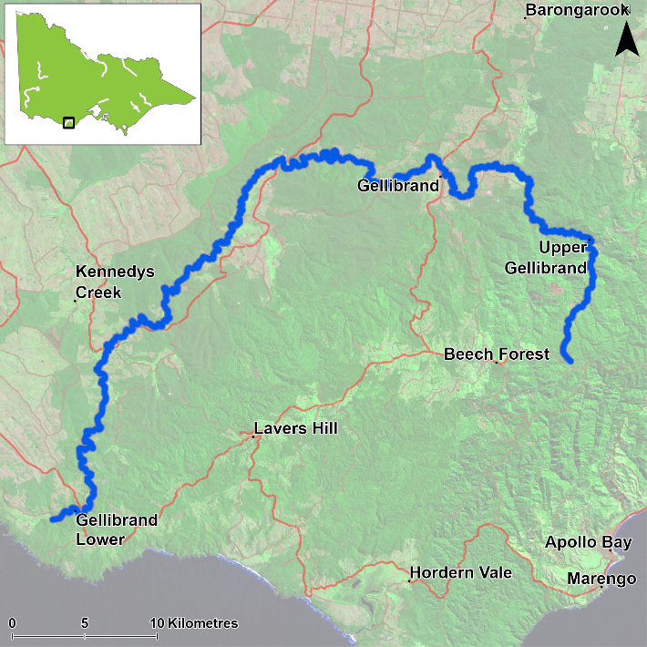
Figure 1. Map showing the section of Gellibrand River where NFRC sampling occurs

Environment
Low flow conditions were present in all six sampling seasons. The tributaries were extremely low in 2022. Only seven of the eight sites were surveyed in 2022 due to access issues and one site was only partially electrofished due to water being too deep to wade. Both the partially fished site and the site not surveyed were on the Gellibrand main stem.

River rehabilitation efforts in the Gellibrand River
Many rehabilitation actions have occurred, and are underway, to improve the health of the Gellibrand River. These are informed by the Corangamite Waterway Strategy 2014-2022 as well as an Estuary Management Plan. Actions include revegetation, weed control including large scale removal of Willows, fencing of riparian areas, bank stabilisation, reintroduction of instream woody habitat, removal of migration barriers and pest control. Some fish monitoring has occurred, including related to rehabilitation efforts. The Corangamite Catchment Management Authority, DELWP and VFA support rehabilitation and management of the Gellibrand River and its fish community.

PHOTOS
LOGOS – ARI, DELWP, NFRC

River Blackfish

Gellibrand River, Corangamite region

Key Health Indicators
Recent recruitment Yes
Multiple size classes Yes
Mature fish present Yes

Monitoring Results
Total number of fish caught 35
Fish per 1km of waterway 20.53
Largest fish by length (cm) 46.1
Largest fish by weight (kg) 0.9
% of the catch that is legal size 40

Recruits, juveniles and adult River Blackfish (Gadopsis marmoratus) have been recorded in all six years of surveys (Figure 4, Figure 5). Until 2022, all young-of-year River Blackfish were found in the two tributary sites of the Gellibrand River, not the mainstem. One young-of-year River Blackfish was recorded in the mainstem in 2022. Aside from this one recruit, the Gellibrand mainstem only has adult fish, highlighting the potential importance of tributary habitats for the population in Gellibrand River catchment. Only low abundances of River Blackfish were detected in the mainstem (6-18 fish each year, despite six of the eight sites being on the mainstem). Aside from the recruit detected at the most upstream site in 2022, two other individuals were recorded. This is unusual as River Blackfish had not been detected at this site since 2017.

Stocking
No stocking has occurred.
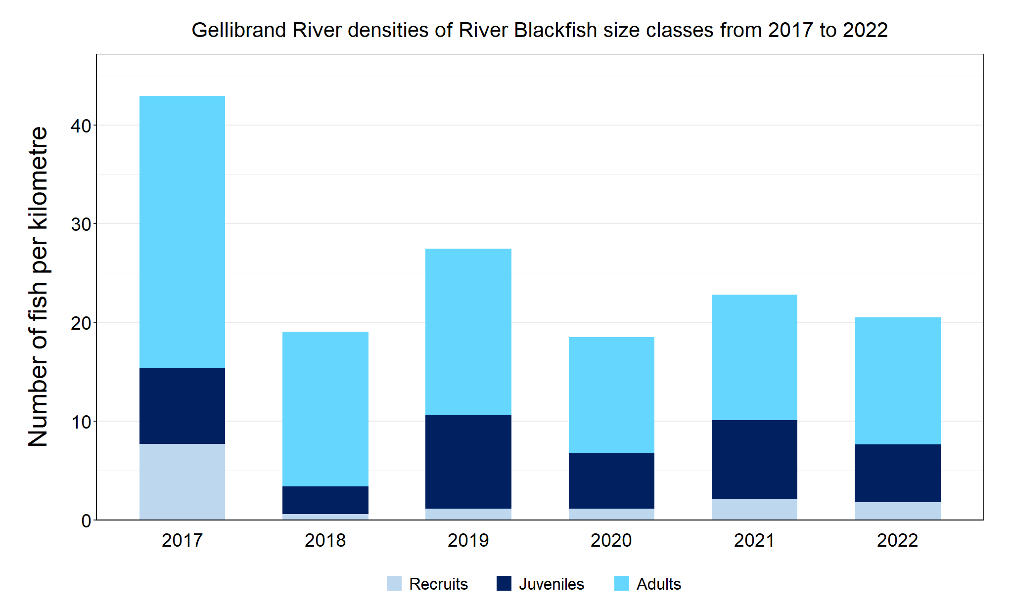
Figure 2. The densities of recruits, juveniles and adult River Blackfish in the Gellibrand River from 2017 to 2022

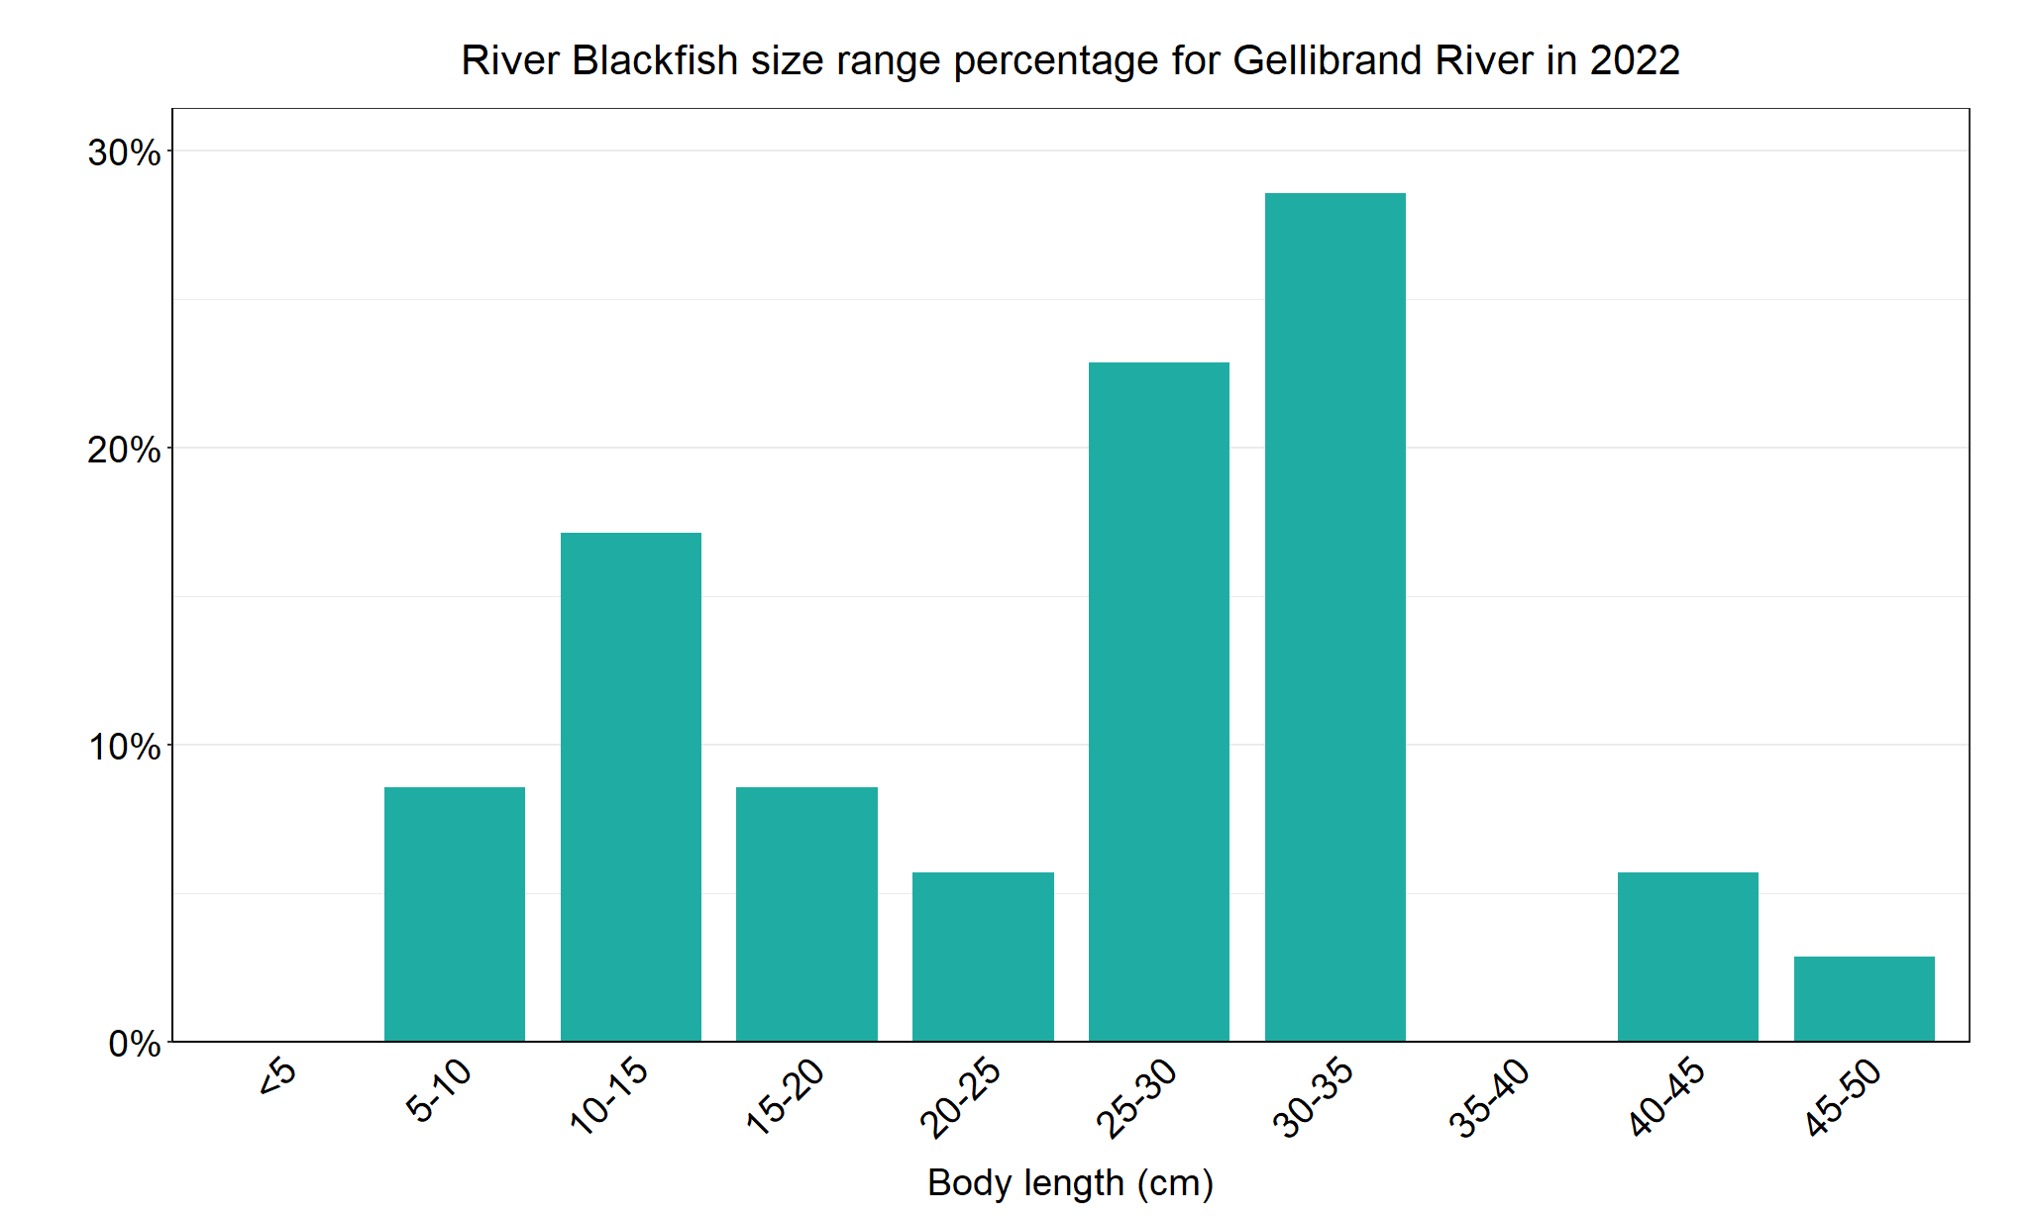
Figure 3. The size range percentage of river Blackfish in the Gellibrand River in 2022

We acknowledge and respect Victorian Traditional Owners as the original custodians of Victoria’s land and waters, their unique ability to care for Country and deep spiritual connection to it. We honour Elders past and present whose knowledge and wisdom has ensured the continuation of culture and traditional practices.

