**Wimmera River 2023**

***Wimmera region***

**This report card summarises the 2023 Native Fish Report Card (NFRC) survey in the Wimmera River**

**Sites 8, Electrofishing**

**Fish found in Wimmera River for NFRC**

**Target species**

Freshwater Catfish

Golden Perch

**Non-target species captured since 2017\***

**Large-bodied native species**

Silver Perch

**Small-bodied native species**

Australian Smelt

Common Galaxias

Carp Gudgeon

Flatheaded Gudgeon

**Exotic species**

Common Carp

Eastern Gambusia

Goldfish

Redfin

Roach

* These non-target species were incidentally captured during NFRC surveys since 2017 but not measured as for target species

*LOGOS – ARI, DEECA*

**Wimmera River 2023**

**Fish Community**

**NFRC target species**

**The NFRC Program began in 2017,** **with a focus on targeting the monitoring of population dynamics of key iconic fish species that have high recreational and/or conservation values, in large rivers across Victoria. In the Wimmera River, the target species are Freshwater Catfish and Golden Perch. Surveys occur in January-March each year, at eight sites from** **Gross Bridge at Drung Drung to just upstream Lake Hindmarsh, Jeparit. The equipment and habitats surveyed are focused on these species, which are measured to determine population structures. Other fish species that are incidentally captured are recorded, but not measured to determine their population structures.**

**Summary of key health indicators for target species in 2023**

|  |  |  |  |
| --- | --- | --- | --- |
| **Species** | **Key Health Indicators** | | |
|  | Recent recruitment | Multiple size classes | Mature fish present |
| Freshwater Catfish | - | - | - |
| Golden Perch | Yes | Yes | Yes |

*Recent recruitment means young-of-year fish*

*\*- cannot be determined due to low abundances*

Both Freshwater Catfish and Golden Perch are considered translocated populations in the Wimmera River.

**Non-target species**

The non-target fish species that have been incidentally recorded in the Wimmera River during NFRC surveys since 2017 are:

**Large-bodied native species**

Other large-bodied native species recorded in fish surveys are Murray Cod and Silver Perch. Both Murray Cod and Silver Perch are considered a translocated species in the Wimmera River. Small numbers (5,000- 15,000) of Murray cod were stocked annually between 1997 and 2004 and 10,000 in 2022 and 10,000 in February 2023. Silver Perch have been stocked annually since 1997 with numbers stocked increasing recently from less than 20,000 pre 2020 to 50,000 in 2020 and 2021 and 100,000 in 2022 and 161,000 in March 2023.

**Small-bodied native species**

Some of the small-bodied species recorded within the Wimmera River include Australian Smelt and Flatheaded Gudgeon. Carp Gudgeon are a lowland species and are more common in slower flowing habitats, often hard to detect via boat electrofishing. The Common Galaxias is considered a translocated species and is likely to have entered the system via water transfers from the Glenelg River system.

**Exotic fish species**

Common Carp, Eastern Gambusia, Goldfish and Redfin are widely distributed across sampling sites, and have been detected in all sampling years. Roach were detected in 2018 and this is the first confirmed record of this species in the Wimmera River system.

**Other native species known from the Wimmera River**

Some fish species known to occur in the Wimmera River have never been recorded during NFRC surveys. For example, no Obscure Galaxias, River Blackfish and Southern Pygmy Perch have been detected in the surveys. Southern Pygmy Perch are more common in offstream habitats such as billabongs, wetlands and lagoons. Southern Pygmy Perch and River Blackfish are still present is the Wimmera River system upstream of the areas where NFRC surveys occur. Obscure Galaxias are difficult to detect using the NFRC sampling methods.

**Other notable species**

Surveys have also recorded Yabbies and Eastern Long-necked Turtles.

LOGOS – ARI, DEECA, NFRC

**Wimmera River 2023**

**Environmental and Management Context**

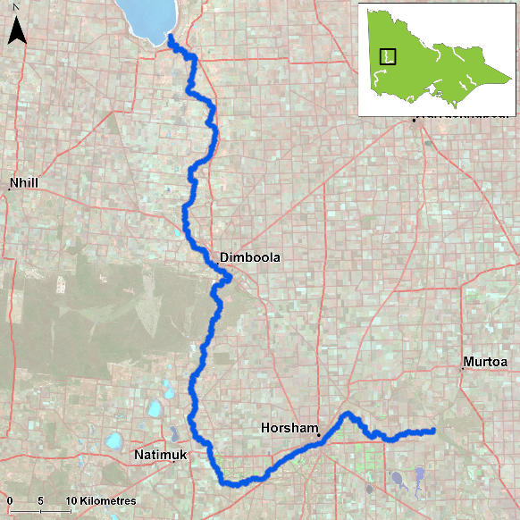

Figure 1. Map showing the section of Wimmera River where NFRC sampling occurs

**Environment**

Low flow conditions were present in all seven sampling seasons.

**River rehabilitation efforts in the Wimmera River**

Many rehabilitation actions have occurred, and are underway, to improve the health of the Wimmera River and its fish community.

The WCMA collaborated with the Arthur Rylah Institute to produce the 2022 Wimmera Native Fish Management Plan. The plan’s principal objectives are to guide strategic management, environmental flow regimes, cost-effective investment and recovery of native fish communities in the region. The overarching vision of the plan is that “*The waterways of the Wimmera River catchment have abundant and diverse native fish populations than enhance the region’s environmental, cultural and socio-economic values*.”

Water in the Wimmera catchment after extensive 2022 flows has provided opportunities to progress implementation of this plan. Options for enhanced management of native fish in the Wimmera system are being investigated.

A range of activities to improve river and fish health are also informed by the Wimmera Waterway Strategy 2014-2022. These include actions to improve water quality, manage erosion and sedimentation, improve riparian habitats through revegetation, weed control and fencing of riparian areas, installation of fish habitat and angler access platforms, allocations of water for the environment, fish stockings and control of Carp.

Some monitoring of the fish community occurs including as part of the Victorian Environmental Flows Monitoring and Assessment Program ([VEFMAP](https://www.ari.vic.gov.au/research/rivers-and-estuaries/assessing-benefits-of-water-for-the-environment)). The [Wimmera Catchment Management Authority](https://wcma.vic.gov.au/), DEECA and VFA support rehabilitation and management of the Wimmera River and its fish community.

PHOTOS LOGOS – ARI, DEECA, NFRC

**Golden Perch**

**Wimmera River, Wimmera region**

**Key Health Indicators**

Recent recruitment Yes

Multiple size classes Yes

Mature fish present Yes

**Monitoring Results**

Total number of fish caught 49

Fish per 1km of waterway 4.46

Largest fish by length (cm) 50.9

Largest fish by weight (kg) 2.31

% of the catch that is legal size 91.8

**All Golden Perch (*Macquaria ambigua*) in the Wimmera River are a result of stockings1. Abundances of Golden Perch have been variable within the Wimmera system, with the lowest abundances recorded in 2020 (Figure 2). Since 2020, abundances have increased each year with the highest abundances detected in 2023 (Figure 2). The sampling methodology included fyke nets and electrofishing in 2017-19, but electrofishing only from 2020-23. Recruits were detected in 2018 and 2019 (Figure 2) via fyke netting and by electrofishing in 2022 and 2023. Recruits of this species are difficult to catch using electrofishing sampling methods and detections via electrofishing in 2022 and 2023 may indicate higher survival of stocking in those years. Juveniles and adults have been recorded in all seven sampling years, though the population is dominated by adult fish. A higher proportion of juveniles were detected in 2021 sampling (Figure 2). Although recruits and juveniles were detected in 2023, their abundances were low (Figure 3).**

**Stocking**

Eighty thousand Golden Perch were stocked in 2016; 110,000 in 2017; 150,000 in 2019; 80,000 in 2020; 100,000 in 2021 and 167,000 in 2022 and 170,000 in March 2023.

1 Trueman, W.T., 2012. True Tales of the Trout Cod: River Histories of the Murray–Darling Basin. Chapter 22, Wimmera & Avoca River Catchments. MDBA Publication, (07/12).

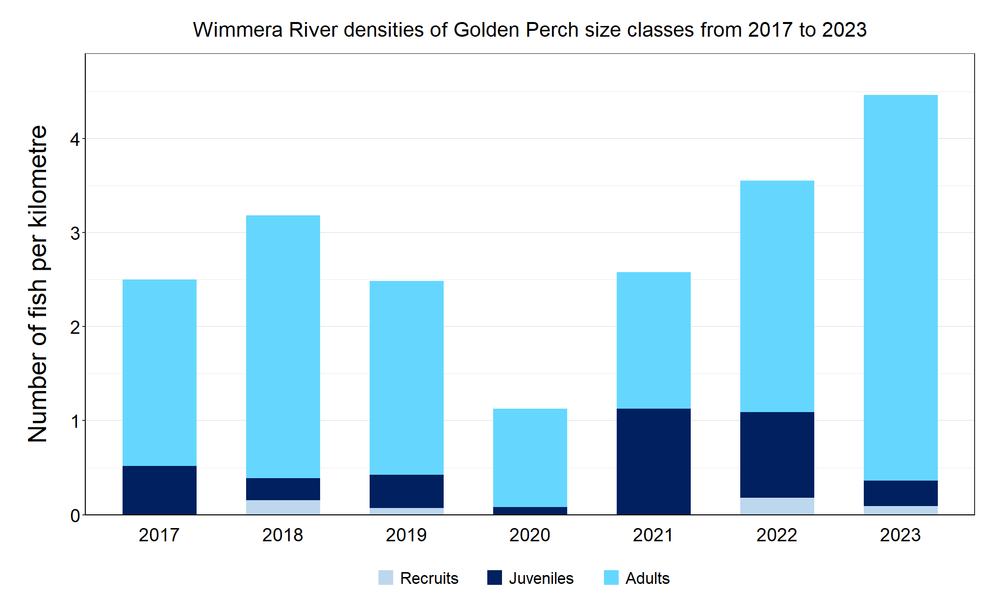

Figure 2. The densities of recruits, juveniles and adult Golden Perch in the Wimmera River from 2017 to 2023

Figure 3. The size range percentage of Golden Perch in the Wimmera River in 2023

**Freshwater Catfish**

**Wimmera River, Wimmera region**

**Key Health Indicators**

Recent recruitment Cannot be determined

Multiple size classes Cannot be determined

Mature fish present Cannot be determined

**Monitoring Results**

Total number of fish caught 4

Fish per 1km of waterway 0.36

Largest fish by length (cm) 45.4

Largest fish by weight (kg) 0.96

% of the catch that is legal size 100

**The NFRC does not expect to capture enough Freshwater Catfish to measure key health indicators. However, collecting data for translocated species including Freshwater Catfish allows a greater understanding of the current status of the populations providing essential information to the management on this species. Although low numbers of Freshwater Catfish were caught in all seven years of sampling, there has been a mix of recruits (2017-19), juveniles (2017 and 2021) and adults (2018-23) (Figure 4). In 2023, the second highest abundances were detected (Figure 4), though all were adults (Figure 4; Figure 5). The sampling methods included fyke nets and electrofishing in 2017­19, but electrofishing only from 2020­23. Recruits of this species are difficult to catch using electrofishing sampling methods with recruits primarily detected via fyke netting. Only a single recruit was detected via electrofishing in 2019.**

**Stocking**

No stocking has occurred.

Figure 4. The densities of recruits, juveniles and adult Freshwater Catfish in the Wimmera River from 2017 to 2023

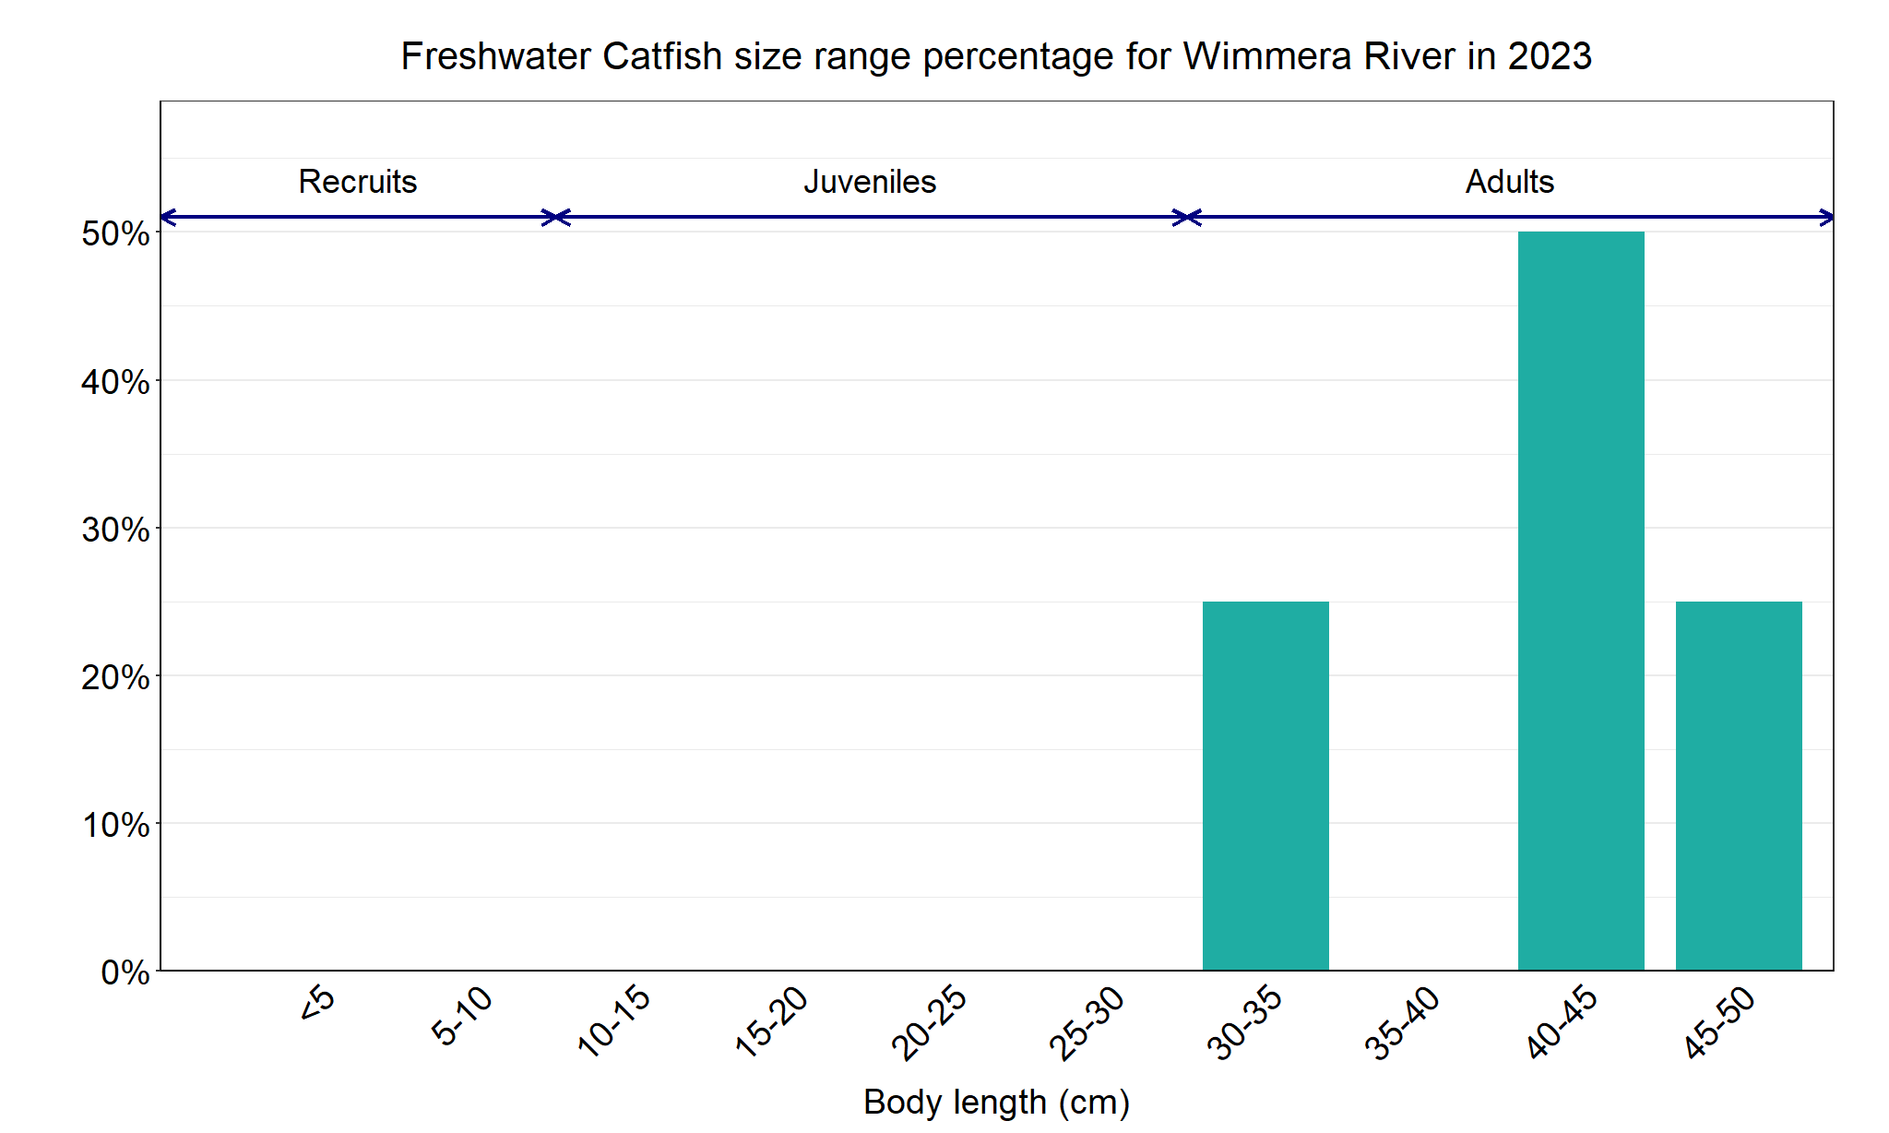

Figure 5. The size range percentage of Freshwater Catfish in the Wimmera River in 2023

We acknowledge and respect Victorian Traditional Owners as the original custodians of Victoria’s land and waters, their unique ability to care for Country and deep spiritual connection to it. We honour Elders past and present whose knowledge and wisdom has ensured the continuation of culture and traditional practices.

Logo© The State of Victoria Department of Energy, Environment and Climate Action 2023. This work is licensed under a Creative Commons Attribution 4.0 International licence. To view a copy of this licence, visit creativecommons.org/licenses/by/4.0/

ISSN 2981-9091 Online (pdf/word)