|  |
| --- |
| Victorian Environmental Flows Monitoring and Assessment Program (VEFMAP) Stage 6 |
| Project Fact Sheet – 2018  Monitoring aquatic flora and fauna in three **Wimmera River tributaries** |

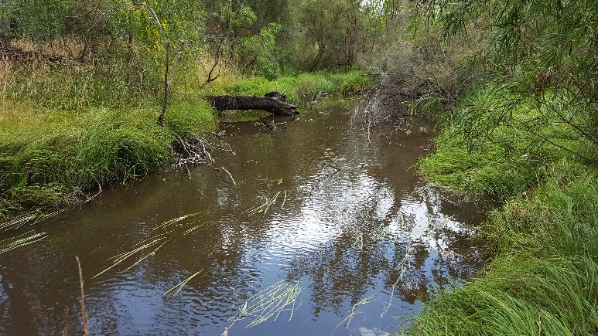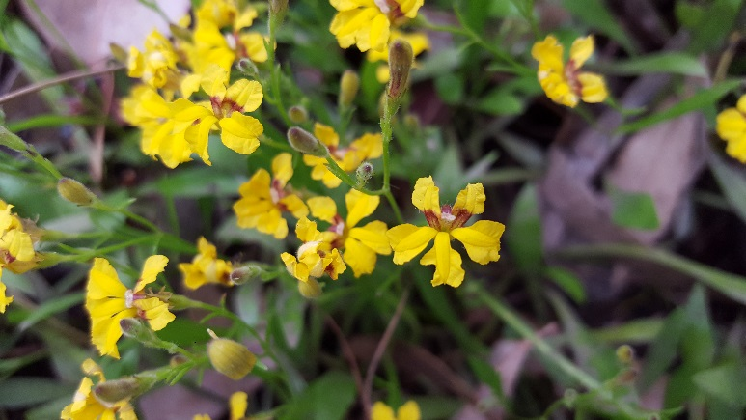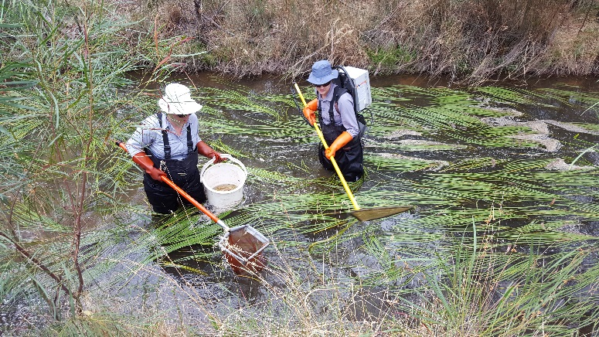

* 1. **VEFMAP Stage 6**

The Victorian Environmental Flows Monitoring and Assessment Program (VEFMAP) is now in its sixth stage of delivery. VEFMAP Stage 6 will run from 2016 to 2020, funded through the Victorian government’s $222 million investment in waterway and catchment health. VEFMAP Stage 6 focusses on ‘intervention’ or ‘event-based’ monitoring of fish and vegetation responses to flows and incorporates data from previous VEFMAP stages.

* 1. **Vegetation Objectives**

The vegetation objectives aim to measure vegetation responses to environmental flows, i.e. plant growth, survival, and recruitment. The monitoring approach has been substantially modified from previous stages of the program and is focussing on individual flow events in individual waterways to detect short-term responses to environmental water delivery. A longer-term understanding will be gained by repeated short-term assessments and by using data from previous stages of VEFMAP. Importantly, these vegetation responses will be considered in relation to other factors that may influence flow responses, such as grazing, rainfall, soil properties and season (see program overview for details, DELWP 2017a).

* 1. **Fish Objectives**

The core objective for fish is to examine the importance of environmental flows in promoting population growth and the rehabilitation of native fish populations via dispersal, colonisation, recruitment and survival.

* 1. **2017/18 Monitoring in the Wimmera**

Rather than survey the relatively stable flows on the Wimmera River itself, surveys were conducted on three of the Wimmera River tributaries: MacKenzie River, Burnt Creek and Mount William Creek. These waterways are regulated and occur below water storage reservoirs in the Grampians area at Lake Lonsdale and Wartook Reservoir. The waterways have different channel forms and flow regimes, but their climatic conditions are similar. The MacKenzie River and Burnt Creek have two distinct reaches: upper and lower (separated by weirs), while the Mount William Creek is more uniform.

*Vegetation*

Twelve sites were surveyed for vegetation, four on each of the waterways (Figure 1). For the MacKenzie River and Burnt Creek, two sites were located in each of the upper and lower reaches.

*Fish*

Twenty-eight sites were surveyed for fish including 10 each for the MacKenzie River and Burnt Creek, and eight sites in the lower Mount William Creek (Figure 1). These sites corresponded with the 12 vegetation sites. For the MacKenzie River and Burnt Creek, five sites were located in each of the upper and lower reaches.

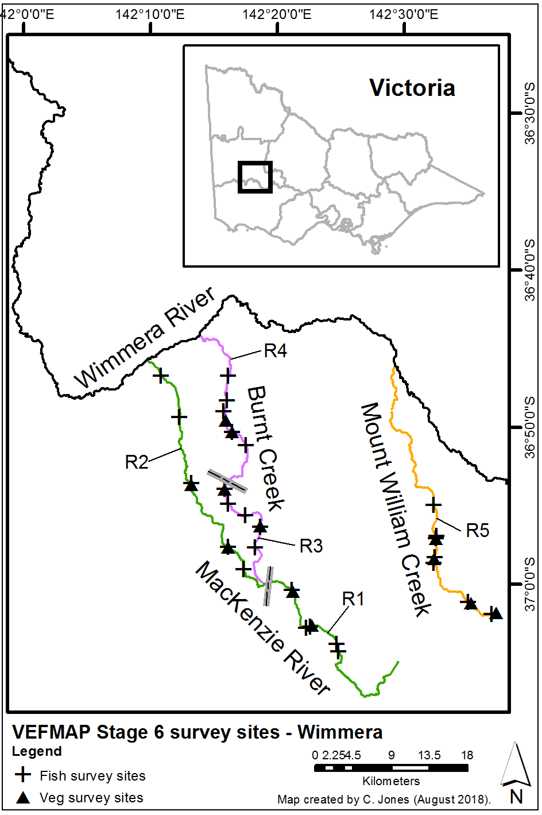

**Figure 1 – Map of survey sites on the MacKenzie River, Burnt Creek and Mount William Creek. Reaches are labelled R1-5 and are separated by grey lines.**

* 1. **Survey timing and hydrology**

The additional focus on short-term responses to individual flow events in VEFMAP Stage 6 requires repeated surveys close together. The survey timing is shown in relation to stream flows in Figures 2, 3 and 4.

*Vegetation*

Three surveys were carried out at sites, roughly corresponding to spring, summer and autumn periods.

*Fish*

For fish, the sampling design specified two surveys: late spring and late autumn, enabling an overall assessment of the fish population along with an assessment of recruitment and survival following the summer low flow period.

The MacKenzie River and the upper Burnt Creek received elevated flows in early spring 2017 (Figures 2 and 3), while the Mount William Creek received elevated flows in late spring (Figure 4). The lower Burnt Creek flows were not regularly monitored, as this waterway reach receives the least amount of water of those surveyed. Flows were observed for the lower Burnt Creek in spring 2017 but there was no flow from December 2017 through to April 2018. Survey timing was aimed to occur either prior to, or after, significant flow events, but the overlapping flow periods meant that some surveys occurred during flows events.

The spring flows in each waterway consisted of an extended period of elevated baseflows (which exceeded one month in duration), which included a series of brief high peaks lasting less than a week. Flow levels during these events inundated the banks but, in most cases, did not spill over the bank.

Each waterway had at least some period of no flow (cease to flow). The Mount William creek had a longer cease to flow duration than the others, apart from the lower Burnt Creek, which has the longest cease to flow duration.

Rainfall in Horsham, slightly north of the three waterways, was low over the summer months, apart from two peak rainfall events at the end of spring that had minor influences on stream flow (Figure 5).

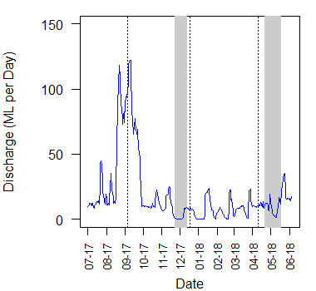

**Figure 2 – River flow discharge recorded on the MacKenzie River at MacKenzie Creek Reserve (lower reach) in 2017/18 and timing for the three vegetation surveys (dotted lines) and two fish surveys (grey bars).**

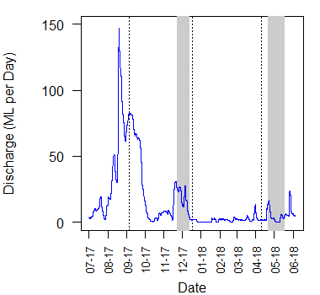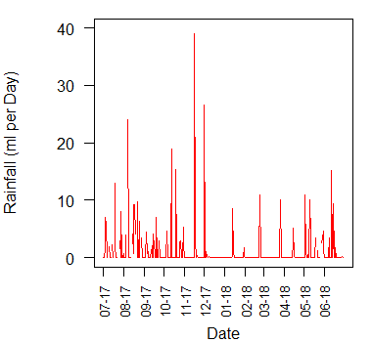

**Figure 3 – River flow discharge recorded on the Burnt Creek at Wonwondah Gauge (upper reach) in 2017/18 and timing for the three vegetation surveys (dotted lines) and two fish surveys (grey bars).**

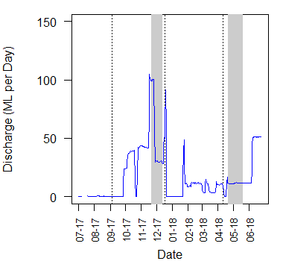

**Figure 4 – River flow discharge recorded on the Mount William Creek at Roses Gap Rd in 2017/18 and timing for the three vegetation surveys (dotted lines) and two fish surveys (grey bars).**

**Figure 5 – Daily rainfall recorded at Horsham in 2017/18.**

* 1. **Methods**

Survey methods are outlined in detail in VEFMAP Stage 6 Part B: Monitoring design and sampling methods (DELWP 2017b). Broadly, the surveys include a wide range of methods, including:

* Vegetation - fine-scale vegetation measurements, broad-scale mapping and tree canopy assessments,
* Soil moisture and hydrology assessments,
* Fish - backpack or bank mounted electrofishing.
  1. **Survey observations: Vegetation**

The first vegetation surveys were conducted during peak flows on the MacKenzie River and upper Burnt Creek. This meant that water levels were elevated, and visibility of instream vegetation and the lower bank was reduced. Despite this reduced visibility, it was possible to appropriately survey the sites and assess species identity and abundance.

Flows in Mount William Creek were not peaking at this time and accessibility was ideal for surveys. During spring the upper banks were commonly dominated by exotic pasture grass species and herbaceous weeds such as Oxalis (Figure 6).

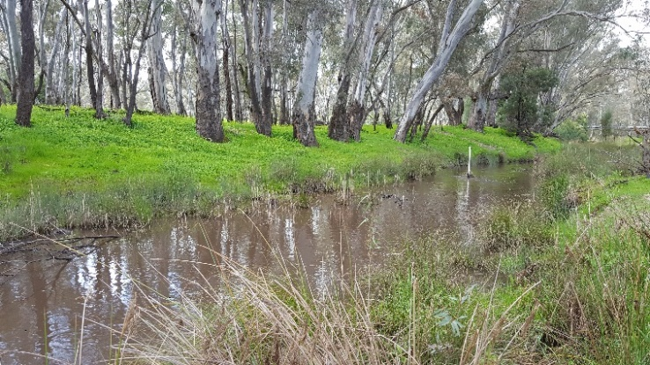**Figure 6 – Exotic plants high on the bank of the Mount William Creek and a narrow line of native sedges and rushes on the waterline in spring 2017.**

By the end of spring, the fringing and instream vegetation in wetter sites showed rapid growth, whereas the lower Burnt Creek had started to dry and plants higher on the bank were already showing signs of stress.

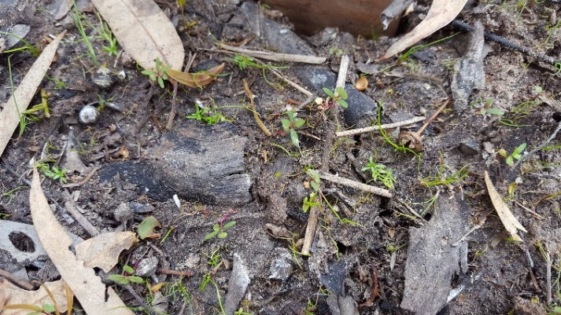Large numbers of plant recruits were observed in December, following germination of seed after the spring flow events, as the saturated soil was exposed to sunlight (Figure 7). However, on the lower Burnt Creek, most of these plants died during the dry summer conditions with no stream flow.

**Figure 7 – Germination on the bank of the Burnt Creek in December 2017 following spring flows.**

While much of the upper river bank vegetation had senesced over summer, the instream vegetation at sites where flows continued had increased in abundance by April (Figure 8). Recruitment of aquatic and fringing species was also apparent on the water margins where water levels were low enough for access to light but the soil moisture was high.

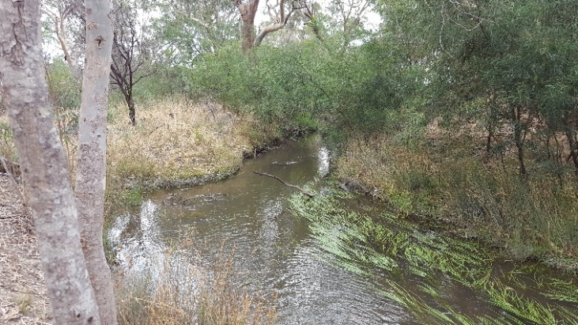**Figure 8 – Increasing abundance of Water Ribbons on the Mackenzie River (April 2018).**

* 1. **Soil moisture and hydrology**

Six soil moisture recording probes are installed on the banks of the tributaries, two on each. The probes record soil moisture and temperature at different depths continuously through time. The results inform how changes in flow influence the soil moisture in the bank that can be accessed by vegetation.

In addition to the flow data collected at permanent gauging stations, pressure loggers were installed in each waterway to measure the water level change. The level data will show how the levels change for different flows and how long different parts of the bank are inundated.

The soil is generally wetter deeper in the soil and drier at the surface. Rainfall typically influences the shallow soil layers only, while flows in some cases can increase the soil moisture deeper down. On the lower Burnt Creek, where flows ceased by December 2017, the soil moisture level declined rapidly in all depths until flows were released again in April 2018 (Figure 9). The lack of soil moisture was evident in the vegetation on the bank, which was highly stressed compared to the same species at wetter sites.

In contrast, on the lower MacKenzie River where the stream did not dry over summer, the soil moisture level remained high (Figure 10).

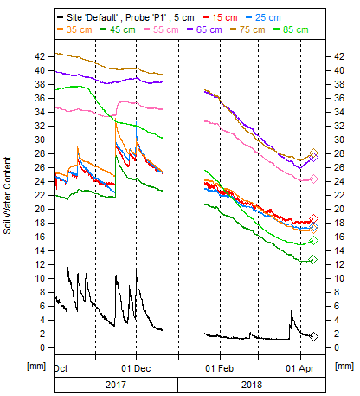

**Figure 9 – Soil moisture monitoring on the lower Burnt Creek. Each line colour is a different depth in the soil, where the black line (shallowest) is driest.**

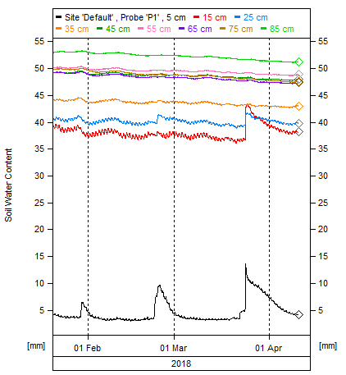

**Figure 10 – Soil moisture monitoring lower MacKenzie River. Each line colour is a different depth in the soil, where the black line (shallowest) is driest.**

* 1. **Survey observations: Fish**

The surveys showed clear differences in fish community composition and abundance across the reaches. For reaches subject to more permanent flows (and reduced cease-to-flow periods), such as the MacKenzie River and upper Burnt Creek, there was a general trend of the fish community being dominated by the native species Southern Pygmy Perch and Obscure Galaxias (Figure 11A,D). These species also successfully recruited during spring 2017 in the MacKenzie River (upper and lower reaches) and the upper Burnt Creek, with their greatest numbers found at sites where instream aquatic vegetation was abundant (Figure 12).

For reaches subject to higher cease-to-flow periods, the dominant fish species were the exotic Carp and Redfin and the native Flat-headed Gudgeon (Mount William Creek and lower Burnt Creek; Figure 11). River Blackfish were also recorded for the first time in several years in the MacKenzie River (upper reach) and Mount William Creek.

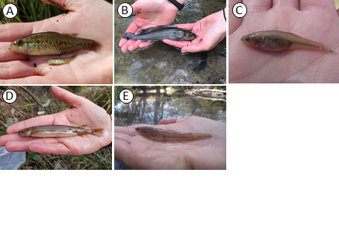

**Figure 11 – Native fish species captured during surveys of MacKenzie River, Burnt Creek and Mount William Creek: (A) Southern Pygmy Perch; (B) River Blackfish; (C) Carp Gudgeon; (D) Obscure Galaxias and (E) Flat-headed Gudgeon.**

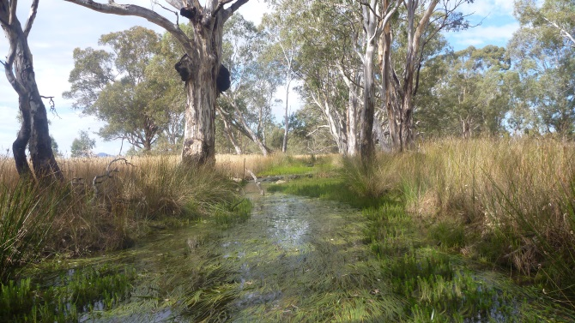

**Figure 12 –The upper Burnt Creek with dense Water Ribbons and Water Milfoil which helped sustain a high abundance of Southern Pygmy Perch.**

There were differences in the abundance of native fish between the seasons (Figure 13). In spring 2017, the lower Burnt Creek was reduced to a series of isolated pools where water quality was poor (i.e. very low dissolved oxygen concentrations) and very few fish were collected (largely exotic species). The cease-to-flow period extended into summer, resulting in many of these pools drying out. Importantly, the survey results indicate that native fish such as Southern Pygmy Perch can rapidly recolonise areas previously affected by the drought (i.e. lower reach of MacKenzie River). Successful recruitment and establishment however, is reliant on maintaining refugia throughout the summer (as were not available in the lower Burnt Creek).

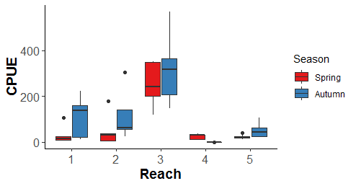

**Figure 13 – Catch per unit effort (CPUE) of native fish in Reach 1 (upper MacKenzie River); Reach 2 (lower MacKenzie River); Reach 3 (upper Burnt Creek); Reach 4 (lower Burnt Creek); and Reach 5 (lower Mount William Creek) during spring 2017 and autumn 2018.**

**Summary**

Using multiple methods and surveying at regular intervals to directly address the monitoring objectives, VEFMAP Stage 6 has so far successfully evaluated vegetation and fish responses to flows. By conducting some surveys at the same sites, we will also be able to evaluate the relationship between fish and vegetation in relation to flows, i.e. which flows, or flow regimes, benefit one or both groups, and how does vegetation influence fish populations.

Environmental flows are being delivered on three tributaries of the Wimmera River to deliver benefits to a wide range of flora and fauna. Waterway managers are working closely with researchers, waterway authorities and a range of other stakeholders to manage flow deliveries as effectively as possible for the environment and other water users. Flows delivered at the right time, magnitude and duration can be beneficial to fish and to vegetation on the river banks, in the channel and beyond the channel. Flows delivered at non-ideal times or sizes may have detrimental effects on vegetation, but the native riparian vegetation is mostly very tolerant of variable flow conditions. Lack of flow (cease to flow) over summer is a significant challenge for fish, particularly if refuge pools go dry or become inhabitable. However, flow management has supported the recovery of fish populations since the millennium drought.

* 1. **Collaboration**

VEFMAP Stage 6 includes many collaborations between DELWP staff, waterway managers and authorities, academics and students.

* 1. **Future work**

The fish surveys in these waterways have been completed for this stage of the program and the data are being analysed. Vegetation surveys will be conducted again at the same sites in 2018/19 to continue data collection for evaluation of the Wimmera system, as well as in comparison to other systems. Soil moisture and hydrology monitoring will continue at the existing sites through 2018/19. Additional evaluation is currently underway and will be shared upon completion.

* 1. **References**

DELWP (2017a) VEFMAP Stage 6 Part A: Program context and rationale. A report by Arthur Rylah Institute for Environmental Research and Integrated Water and Catchments Division, Department of Environment, Land, Water and Planning.

## DELWP (2017b) VEFMAP Stage 6 Part B: Program design and monitoring methods. A report by Arthur Rylah Institute for Environmental Research and Integrated Water and Catchments Division, Department of Environment, Land, Water and Planning, Victoria.

## Contact Joanne.Sharley@delwp.vic.gov.au (fish),

Chris.Jones@delwp.vic.gov.au (vegetation),

FletcherG@wcma.vic.gov.au (WCMA)

|  |  |
| --- | --- |
| © The State of Victoria Department of Environment, Land, Water and Planning 2018  LogoThis work is licensed under a Creative Commons Attribution 4.0 International licence. You are free to re-use the work under that licence, on the condition that you credit the State of Victoria as author. The licence does not apply to any images, photographs or branding, including the Victorian Coat of Arms, the Victorian Government logo and the Department of Environment, Land, Water and Planning (DELWP) logo. To view a copy of this licence, visit http://creativecommons.org/licenses/by/4.0/  ISBN978-1-76077-358-8 (print), 978-1-76077-359-5 (pdf/online/MS word)  Disclaimer  This publication may be of assistance to you but the State of Victoria and its employees do not guarantee that the publication is without flaw of any kind or is wholly appropriate for your particular purposes and therefore disclaims all liability for any error, loss or other consequence which may arise from you relying on any information in this publication. | Accessibility  If you would like to receive this publication in an alternative format, please telephone the DELWP Customer Service Centre on 136186, email [customer.service@delwp.vic.gov.au](mailto:customer.service@delwp.vic.gov.au), or via the National Relay Service on 133 677 [www.relayservice.com.au](http://www.relayservice.com.au). This document is also available on the internet at https://www.ari.vic.gov.au/research/rivers-and-estuaries/assessing-benefits-of-environmental-watering |