DELWP Science Reference Panel
  - Dr Marta Yebra (Australian National University)

Space mission specialist joins science panel

Marta Yebra is a mission specialist at the Australian National University’s Institute of Space. She is also a Senior Lecturer in Environment and Engineering at ANU and one of the seven members of DELWP’s new Scientific Reference Panel.
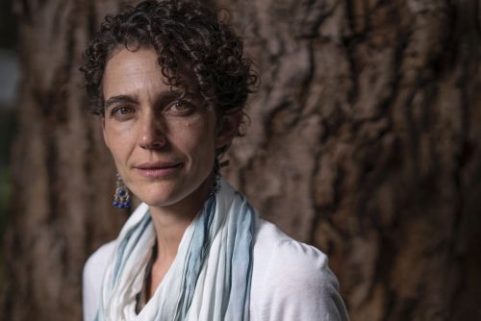
The panel convened late last year by the Department of Environment, Land, Water and Planning (DELWP) provides guidance and independent advice about how DELWP delivers its science.

So, what does a Mission Specialist at the Institute for Space do?

‘I look at how observation of the Earth, using satellites, can be used practically to inform decisions and policymaking; such as land management, for example,’ says Marta.

InSpace supports the Australian Space Agency, which was established less than two years ago.

Most of Marta’s research focuses on using remote sensing data (which uses ground sensors and sensors onboard aircrafts or satellites). A key example is applying this information to manage bushfires, before they begin. ‘We get information from satellites about moisture content in bushland and the amount of fuel available, to better understand fire danger and behaviour.’

Marta’s work, particularly the Bushfire and Natural Hazards project she leads, has been used in modelling ahead of fire seasons. ‘Information from my research group indicated that this past fire season was going to be very bad, with landscapes across the South East coast of Australia extremely dry due to drought, with even tree canopies completely dry or dead.’

This information is used by several agencies to schedule planned burns so they can happen safely. It was also used this year in fire behaviour models to see how fires could spread.

Based in Canberra, much of Marta’s input to the panel will be done remotely. While she still hopes to visit Melbourne to attend some panel meetings in person, so far, bushfires and coronavirus (COVID 19) have prevented that from happening.

Marta is excited about her appointment to the panel. ‘I really like to do applied science and provide a guide on the best ways science can be used,’ she says. ‘It’s very healthy to have people outside an organisation, with the relevant knowledge and expertise, to broadly look how things are working and give advice on where improvements can be made.‘

