# Developing an eDNA reference library for aquatic and semi-aquatic vegetation





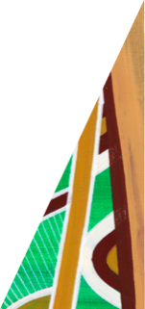

*eDNA can be used effectively to monitor aquatic plant presence*

## Key Messages

* Aquatic and semi-aquatic plants are important but can be difficult to survey
* Environmental DNA (eDNA) may be an effective tool for rapid assessments of species presence
* We increased the DNA reference library for Victorian plants and validated its uses

Fact Sheet July 2025

[deeca.vic.gov.au](https://delwpvicgovau.sharepoint.com/Users/fionadurante/Downloads/deeca.vic.gov.au)

## Background

Aquatic and semi-aquatic vegetation are an important ecological component of waterways and wetlands due to their many functional roles including habitat provision for a range of plant and animal species. However, monitoring aquatic and semi-aquatic vegetation using traditional field survey methods can be challenging, slow and costly due to low visibility, access difficulty and the often patchy nature of aquatic plant distributions.

The growing research field of environmental DNA (eDNA) monitoring may provide a solution for rapid surveys of aquatic vegetation occurrence and diversity. However, there is a lack of genetic reference material for aquatic plant species, particularly for those that occur outside of the Melbourne urban area. Trials are also required to determine the effectiveness of eDNA sampling for identifying plants to species level, accuracy and sensitivity of detections, and resolving application strengths and limitations.

This project had two aims: firstly, to expand the reference library for aquatic and semi-aquatic plants in Victoria by collecting reference material for species found in regional Victoria; and secondly, to collect water samples from wetlands and waterways to determine whether the DNA of aquatic and species can be detected through metabarcoding analysis.

## Methods

### Sample collection and analysis

In 2023 and 2024, we collected water samples from eleven sites on waterways and wetlands in regional Victoria (Table 1). Samples were collected by passing water through a disc filter, with a preservative added on-site to reduce DNA degradation. Two replicates were collected at each site, and we noted whether any of our target species were present. We also collected tissue samples from 25 aquatic and semi-aquatic plant species from a range of locations (Figure 1, Table 2). All samples were collected opportunistically during fieldwork for other projects. All tissue and water samples were analysed by EnviroDNA.

### Plant reference material sequencing

Plant samples were sequenced at the ITS2, rbcLa and trnL gene regions in order to identify the most suitable assay for species resolution. Resulting sequences were incorporated into the EnviroDNA reference library. ITS2 had the highest resolution to the species level and was used for the water sample metabarcoding analysis.

Figure 1: Collecting a tissue sample of Common Swamp Wallaby-grass (*Amphibromus nervosus*) from Doctors Swamp.

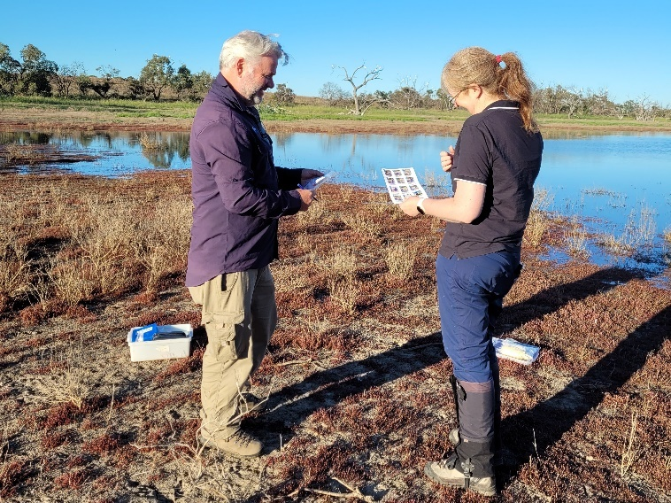

Figure 2: Collecting a tissue sample of Red Water-milfoil (*Myriophyllum verrucosum*) and a water sample from a small unnamed wetland at Hattah.

### Water sample metabarcoding analysis

Two rounds of PCR were used on the DNA extracted from the filters: firstly using gene-specific primers to amplify the target region, and secondly adding sequencing adapters and unique barcodes. DNA sequences were clustered into Operational Taxonomic Units (OTUs). Taxonomic assignment was performed by comparing OTU clusters against a reference sequence database that included species from existing reference material and the new reference material collected in this project. Manual vetting was conducted for species that could not be adequately resolved.

**Table 1: Water sample locations and the number of plant taxa detected (across the two water sample replicates collected per site).**

|  |  |  |
| --- | --- | --- |
| **CMA region** | **Wetland or waterway** | **No. taxa detected** |
| Corangamite | Reedy Lake: Site 1  Reedy Lake: Site 2  Moorabool River: Site 1  Moorabool River: Site 2 | 7  2  9  23 |
| Goulburn-Broken | Black Swamp | 6 |
| Mallee | Hattah (unnamed wetland; Figure 2)  Nyah wetland: Site 1  Nyah wetland: Site 2  Vinifera wetland | 4  3  5  11 |
| West Gippsland | Macalister River  Heyfield Racecourse Dam | 37  7 |

## Results

### Plant reference material sequencing

Of the 25 reference species we collected, 15 were resolved to the level of species and seven to the level genus when using one or more of the three plant barcodes (ITS2, rbcLa, trnL) (Table 2). Three species (the two species of *Amphibromus* and *Ottelia ovalifolia*) could not be resolved to any level of identification.

The ITS2 marker was the most effective with reference sequencing successful for 16 unique taxa (15 of which resolved to the species level). The trnL marker was less successful, with sequences obtained for nine taxa and several of these resolving only to genus level. The rbcLa marker was successful for only six taxa, with all species identified to genus only.

**Table 2: Species for which tissue samples were collected to expand Victoria’s DNA reference library and the level of identification based on ITS2, rbcLa and trnL barcodes.**

Bold indicates that the species’ DNA was detected in water samples (with number of detections in brackets). Blue text are species resolved to genus level only; red text are species that could not be resolved with any of the three assays.

|  |  |
| --- | --- |
| **Family** | **Species** |
| Alismataceae | *Damasonium minus* |
| Apiaceae | *Lilaeopsis polyantha* |
| Characeae | *Characeae* sp*.* |
| *Nitella* sp*.* |
| Cyperaceae | *Bolboschoenus caldwellii* |
| Haloragaceae | *Myriophyllum crispatum* |
| *Myriophyllum pappillosum* |
| *Myriophyllum salsugineum* |
| ***Myriophyllum simulans (1)*** |
| ***Myriophyllum verrucosum (3)*** |
| Hydrocharitaceae | *Elodea canadensis* |
| *Ottelia ovalifolia* |
| *Vallisneria australis* |
| Juncaginaceae | *Triglochin striata* |
| Menyanthaceae | *Nymphoides crenata* |
| Montiaceae | ***Montia australasica (2)*** |
| Phrymaceae | ***Thyridia repens*** |
| Poaceae | *Amphibromus fluitans* |
| *Amphibromus nervosus* |
| Potamogetonaceae | *Potamogeton cheesemanii* |
| ***Potamogeton crispus (3)*** |
| *Potamogeton sulcatus* |
| ***Stuckenia pectinata (2)*** |
| Ranunculaceae | ***Ranunculus amphitrichus (3)*** |
| *Ranunculus inundatus* |

### Water sample metabarcoding analysis

81 separate plant taxa were detected in the water samples. Of these, 36 plant species from 17 families were resolved to species level. A broad range of functional plant types were detected including terrestrial, aquatic and semi-aquatic species. A range of structural types including trees, shrubs, forbs and grasses were also detected.

The species identified included seven of the reference species we collected for this project (Table 2), along with others already included in the reference library. The reference library was biased towards terrestrial or riparian plants, not aquatic or semi-aquatic plants, and included several introduced species.

The most frequently detected taxa (resolved to varying taxonomic levels) were *Eucalyptus* sp., Myrtales, and *Persicaria* sp. with the most common species level taxa being *Eucalyptus camaldulensis*, the River Red Gum.

When target species were observed at a wetland or river where metabarcoding samples were collected, those species were always detected using eDNA. For example, the unnamed wetland at Hattah contained *M. verrucosum* growing on the wetland margins (Figure 2), which was detected in the water sample. This suggests that true positive records are reliably recorded when the species is in close proximity to the sample site.

Similarly, *R. amphitrichus* and *Montia australasica* were observed in one of the Moorabool River locations (Figure 3); both of which were detected in the water samples. These two species were not detected at the Moorabool River site 3 km downstream where those species were absent. This suggests that false positives at a site caused by plant material drifting downstream but not occurring locally may not be problematic. Conversely, this also suggests that samples in flowing systems may need to be very close to the plant locations to ensure detection using the approach applied in this study.

Overall, more taxa were detected in our water samples collected from rivers compared to wetlands, noting that only three collections were from rivers, and all were in southern Victoria. The river sites typically had abundant instream and riparian plant populations, so it is unclear whether this effect is dictated by the number of species in or near the sample site.

Lower volumes of water were filtered at wetland sites due to higher turbidity blocking the filter more quickly. Although all target species were detected in the current study, filtering smaller volumes increases the risk of some species going undetected. To decrease this risk mechanical water pumps that can filter larger water volumes can be used in turbid conditions.

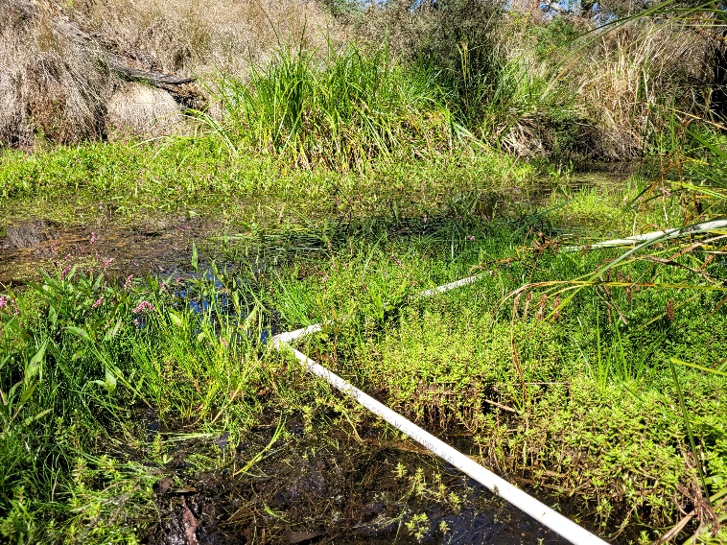

Figure 3: Aquatic and semi-aquatic plants in the Moorabool River sample site.

## Next Steps

Aquatic and semi-aquatic plants can be reliably detected using eDNA metabarcoding from river and wetland water samples. However, there were many plants detected that could only be resolved to genus or family level, so monitoring programs must consider their target species and whether using an eDNA approach is suitable.

There are also many aquatic and semi-aquatic species that are not included in reference lists, so new reference material to increase the library of species would improve the effectiveness of eDNA monitoring.

Effective application of using eDNA for monitoring will require clear protocols and understanding of the limitations for different monitoring needs. Currently, these limitations are not fully understood. For example, it is unknown how detection rates vary with the size of plant populations, water quality, size of the wetland or river, and distance between the plant source and the location of the water sample collection site (in wetlands and rivers). These uncertainties need to be addressed to improve the utility of eDNA as a monitoring tool.

**Acknowledgements:** thanks to Sally Kenny, Bryan Mole, Dylan Osler, Ana Backstrom, and Ben Vasic for collecting samples, and Di Crowther for assistance with equipment. This project was funded through the Arthur Rylah Institute Capability Fund.

**For further information contact Chris Jones (**[**chris.jones@deeca.vic.gov.au**](mailto:chris.jones@deeca.vic.gov.au)**) or Lyndsey Vivian (lyndsey.vivian@deeca.vic.gov.au)**

Banner Photos on front page: Black Swamp (left) and Moodie Swamp (right)

Accessibility

If you would like to receive this publication in an alternative format, please telephone the DEECA Customer Service Centre on 136186, email [customer.service@delwp.vic.gov.au](mailto:customer.service@delwp.vic.gov.au), or via the National Relay Service on 133 677 [www.relayservice.com.au](http://www.relayservice.com.au).

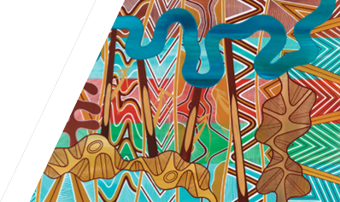

We acknowledge Victorian Traditional Owners and their Elders past and present as the original custodians of Victoria’s land and waters and commit to genuinely partnering with them and Victoria’s Aboriginal community to progress their aspirations.

**ISBN** 978-1-76176-576-6 **(pdf/online/MS word)**

Accessibility

If you would like to receive this publication in an alternative format, please telephone the DEECA Customer Service Centre on 136186, email [customer.service@delwp.vic.gov.au](mailto:customer.service@delwp.vic.gov.au), or via the National Relay Service on 133 677 [www.relayservice.com.au](http://www.relayservice.com.au).

© The State of Victoria Department of Energy, Environment and Climate Action July 2025

Logo

Accessibility

If you would like to receive this publication in an alternative format, please telephone the DEECA Customer Service Centre on 136186, email [customer.service@delwp.vic.gov.au](mailto:customer.service@delwp.vic.gov.au), or via the National Relay Service on 133 677 [www.relayservice.com.au](http://www.relayservice.com.au).

© The State of Victoria Department of Energy, Environment and Climate Action July 2024

Logo

Accessibility

If you would like to receive this publication in an alternative format, please telephone the DEECA Customer Service Centre on 136186, email [customer.service@delwp.vic.gov.au](mailto:customer.service@delwp.vic.gov.au), or via the National Relay Service on 133 677 [www.relayservice.com.au](http://www.relayservice.com.au).

This work is licensed under a Creative Commons Attribution 4.0 International

licence. To view a copy of this licence, visit

creative commons.org/licenses/by/4.0/