
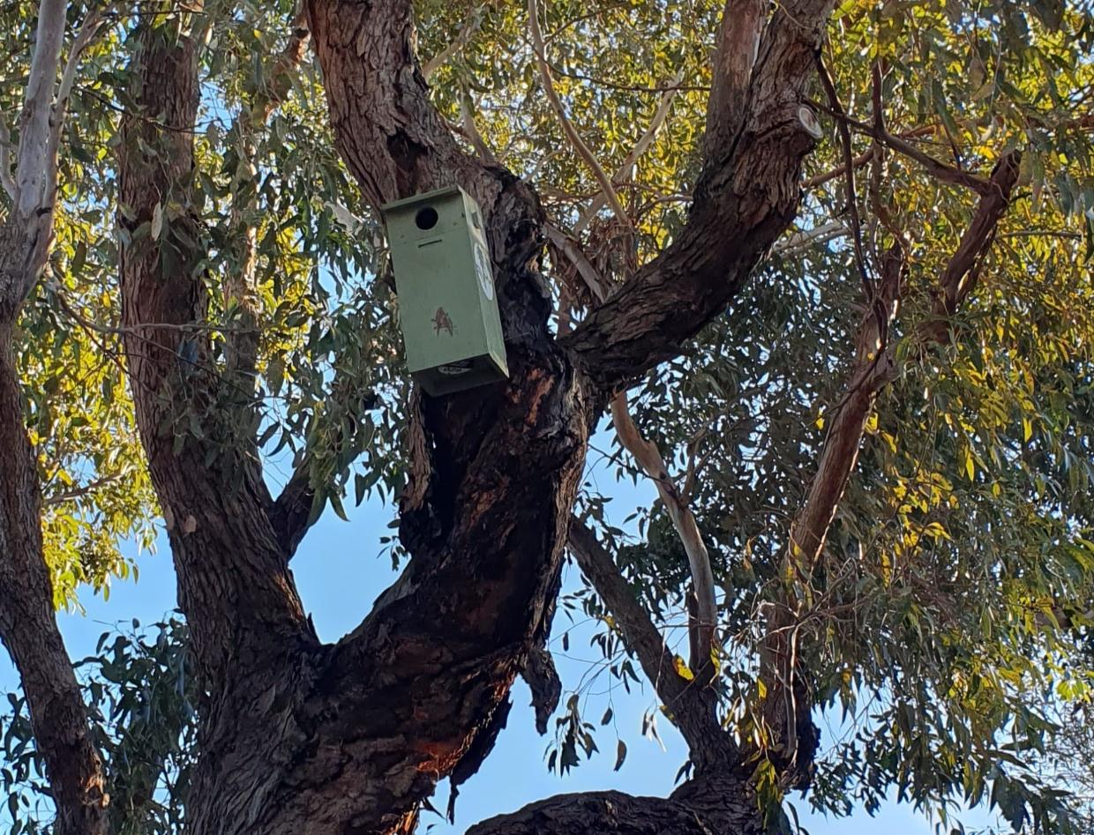

Arthur Rylah Institute for Environmental Research

Published Report for the City of Port Phillip
Nest box review and management plan
Danks Street Biolink, City of Port Phillip
P.V. Macak and P.E. Lentini
June 2025



Acknowledgements
This project was funded by the City of Port Phillip under the Greening Port Phillip program, and we thank Meg Taylor, Emily Lin and Shane Hall for facilitating this funding and providing helpful information and advice. Amanda Bush and Steve Griffiths provided helpful comments and suggestions on an earlier draft. Common and scientific names for fauna follows the Victorian Biodiversity Atlas.
Arthur Rylah Institute for Environmental Research
Department of Energy, Environment and Climate Action
PO Box 137, Heidelberg, Victoria 3084
Phone (03) 9450 8600
Website: www.ari.vic.gov.au
Citation: Macak, P.V. and Lentini, P.E. (2025). Nest box review and management plan: Danks Street Biolink, City of Port Phillip. Arthur Rylah Institute for Environmental Research Published Report for the City of Port Phillip. Department of Energy, Environment and Climate Action, Heidelberg, Victoria.
Front cover photo: Nest box installed within the Danks Street Biolink (Pia Lentini).
ISBN 978-1-76176-348-9 (pdf/online/MS word)

We acknowledge and respect Victorian Traditional Owners as the original custodians of Victoria’s land and waters, their unique ability to care for Country and deep spiritual connection to it.
We honour Elders past and present whose knowledge and wisdom
has ensured the continuation of culture and traditional practices.
DEECA is committed to genuinely partnering with Victorian Traditional Owners and Victoria’s Aboriginal community to progress their aspirations.
© The State of Victoria Department of Energy, Environment and Climate Action June 2025.
Creative Commons
This work is licensed under a Creative Commons Attribution 4.0 International licence, visit the Creative Commons website (http://creativecommons.org/licenses/by/4.0/).
You are free to re-use the work under that licence, on the condition that you credit the State of Victoria as author. The licence does not apply to any images, photographs or branding, including the Victorian Coat of Arms, and the Victorian Government, the Department and the ARI logos.
Disclaimer
This publication may be of assistance to you but the State of Victoria and its employees do not guarantee that the publication is without flaw of any kind or is wholly appropriate for your particular purposes and therefore disclaims all liability for any error, loss or other consequence which may arise from you relying on any information in this publication.
Accessibility
To receive this document in an alternative format, phone the Customer Service Centre on 136 186, email customer.service@deeca.vic.gov.au, or contact National Relay Service on 133 677. Available at DEECA website (www.deeca.vic.gov.au).

Nest box review and management plan

Danks Street Biolink, City of Port Phillip

Phoebe V. Macak and Pia E. Lentini

Arthur Rylah Institute for Environmental Research
Department of Energy, Environment and Climate Action
123 Brown Street, Heidelberg, Victoria 3084

Date

Arthur Rylah Institute for Environmental Research
Published Report for the City of Port Phillip

Contents
Summary 1
1 Introduction 2
1.1 Danks Street Biolink nest box review and management plan 2
2 Danks Street Biolink 3
3 Hollow-using fauna and the Danks Street Biolink 4
3.1 Design considerations for artificial hollows targeting native fauna 4
3.2 Hollow-using species potentially occurring within Danks Street Biolink 5
4 Danks Street Biolink nest box audit 8
4.1 Site visit 8
4.2 Nest box details 8
4.3 Nest box condition and signs of occupancy 10
4.4 Accessibility 11
4.5 Potential issues 11
5 Nest box management plan 15
5.1 Baseline occupancy/condition check 15
5.2 Changes to current nest box placement 15
5.3 Type of nest boxes 15
5.4 Occupancy monitoring and recording 16
5.5 Animal care and ethics 18
5.6 Maintenance of nest boxes and dealing with pest species 18
5.7 Alternative artificial hollows 18
5.8 Future considerations 19
6 Conclusion 20
References 21
Appendix 23

Tables
Table 1. Hollow-using or hollow-dependent mammal species occurring within 5 km of the Danks Street Biolink. 5
Table 2. Hollow-using or hollow-dependent bird species occurring within 5 km of the Danks Street Biolink. 6
Table 3. Danks Street Biolink nest box details 12
Table 4. Birds and mammals that may use the Danks Street Biolink nest boxes 16
Table 5. Options for professional and community-based monitoring of nest boxes and surrounds 17
Table 6. Alternative options for artificial hollows 19

Figures
Figure 1. Location of the Danks Street Biolink 3
Figure 2. Street view of the Danks Street Biolink 3
Figure 3. Location of nest boxes installed along the Danks Street Biolink 9
Figure 4. Types of nest boxes installed along the Danks Street Biolink 10

Summary
Context:
The City of Port Phillip (CoPP) is a highly urbanised council area in Melbourne’s inner south. From 2019 the 1.3 km Danks Street Biolink was established along a wide median strip to support biodiversity. This involved planting a wide range of vegetation during various stages to 2024 and included community input and participation. In addition, 32 nest boxes targeting local fauna including parrots and bats were installed in some of the established trees along the Biolink. However, in the absence of a maintenance or monitoring program it was unclear what their current condition was, and whether or not they were being used. To support their Greening Port Phillip program, CoPP commissioned a review of the nest boxes, including identifying local fauna likely to benefit, and development of a nest box management plan to guide their ongoing management, which was to include community participation.
Nest box review:
Forty-one hollow-using or hollow-dependent species that are also known to use nest boxes were identified as occurring within 5 km of the Danks Street Biolink. These included common and widespread insectivorous bats, possums, ducks, kookaburras, cockatoos, lorikeets and rosellas, as well as some rare and threatened species.
Twenty-nine nest boxes of three designs were found during an on-site ground-based audit: six designed for insectivorous bats, eighteen designed for small parrots, and five designed for large parrots. Most boxes were in good condition, though there were few obvious signs of use, such as wear around entrances. Current designs are considered to potentially be suitable for most local fauna, although some species may favour more specialised designs.
Nest box management plan:
To establish baseline information on nest box condition and occupancy, and commence a basic monitoring and maintenance schedule based on the objective of providing nesting or denning habitat for local birds and bats the following is recommended:
- Conduct an initial occupancy check for presence or signs of use by fauna and inspect for damage. Record details in a purpose-built database that will also provide for ongoing monitoring. Plan for ongoing condition checks and maintenance (ideally every 12 months).
- Adjust or reposition select nest boxes to ensure they are >5 m above ground level to deter ground-based predators, are adequately shaded and pointing in a variety of cardinal directions.
- Increase the variety of nest box designs to cater for those species that require dimensions or features that are not currently available.
- Implement a monitoring program (2-4 checks a year) using methods easily and safely conducted by community members to encourage participation, consistent data collation and minimal disturbance to fauna:
  - Use a pole camera to check inside boxes.
  - Observe nest box entrances from ground-level for fauna entering or exiting.
  - Provide a simple but standardised data entry form for recording results, making sure that each box has a unique identifier to link to monitoring information.
- Periodically review management plan to consider:
  - The objectives of the nest boxes.
  - The success of the nest boxes in providing nesting/denning habitat for target fauna.
  - How to address unoccupied boxes (update, remove).
  - How to address boxes occupied by pest species (e.g. Common Mynas, European Honey Bees).
  - The sustainability of the plan e.g. in terms of community participation, budget.

- Introduction
The City of Port Phillip (CoPP) is in Melbourne’s inner south, and fully or partially encompasses 12 suburbs over an area of 21 km². It includes 11 km of the foreshore of Port Phillip Bay and the large parkland area of Albert Park Lake (the latter managed by Parks Victoria). A highly urbanised environment, the CoPP comprises retail, manufacturing, entertainment and leisure precincts, over 52,000 households, open spaces, parklands, public transport infrastructure, and bike and walking paths (CoPP 2024a).
The value of biodiversity is recognised and supported within the CoPP through numerous activities and projects implemented via programs such as the Greening Port Phillip program and the Urban Forest Strategy (CoPP 2024b). This includes the 1.3 km long Danks Street Biolink, situated parallel to and about 250 m from Port Melbourne Beach in the central-western part of the CoPP. The Biolink was created to improve habitat and support biodiversity, particularly local bird species, and involved establishing vegetation along the central median strip during various stages between 2019-2024. Community involvement and input, including volunteer ornithologists, was a key component.
As part of the original design, 32 timber nest boxes targeting local fauna including parrots and bats were installed in some of the existing established, mature trees along the Biolink. However, in the absence of a maintenance or monitoring program it was unclear what their current condition was, and whether or not they were being used. Nest boxes, and other types of artificial or introduced cavities, are typically installed to provide habitat for hollow-dependant fauna, especially in areas where natural hollows may be in short supply (Beyer and Goldingay 2006, Harley 2006, Rueegger 2017). Designs of these structures vary widely depending on the ecological requirements of the species they are targeting, but a wide variety of fauna have been documented using them including birds, bats, arboreal marsupials, monitor lizards and frogs (Lindenmayer et al. 2009, Lindenmayer et al. 2017, Goldingay et al. 2015, Rueegger 2016). To prolong the life of nest boxes, condition checks and follow-up maintenance is required to ensure that attachment methods remain in place and are not causing damage to the tree(s), that boxes retain structural integrity and have not been damaged by vandals or fauna, and that they have not become occupied by insects such as ants or European Honey Bees (Lindenmayer et al. 2009, Lindenmayer et al. 2017) or introduced birds such as Common Mynas (Harper et al. 2005) that exclude target species. Monitoring their use by fauna will also enable an assessment of their success in providing habitat.
  - Danks Street Biolink nest box review and management plan
To support their Greening Port Phillip program, CoPP engaged the Arthur Rylah Institute for Environmental Research of the Victorian Department of Energy, Environment and Climate Action (DEECA) to review the Danks Street Biolink nest boxes and provide advice on their ongoing management.
This report contains advice on the following:
- A review of the nest boxes within the Danks Street Biolink to:
  - Confirm their location, number and type (i.e. target fauna).
  - Identify local fauna species that may use the boxes, and provide advice on a process that can be followed to identify species for other, similar projects.
  - Consider whether additional nest boxes or other types of artificial hollows (e.g. carved cavities) should be installed.
- A nest box management plan, including:
  - A baseline audit.
  - Advice on ongoing monitoring and maintenance.
  - Suggestions for community involvement in monitoring.
  - Additional future considerations.

- Danks Street Biolink
The Danks Street Biolink (mid-point 144.9501324°E -37.8464887°S) is situated within Melbourne’s CoPP, along the centre median strip of Danks Street from Esplanade East, Port Melbourne at its northwest end, to Mills Street, Albert Park at its southeast end (Figure 1). It is about 250 m from the Port Phillip Bay foreshore and at its southeast end, about 700 m from the edge of Albert Park Lake parkland area.
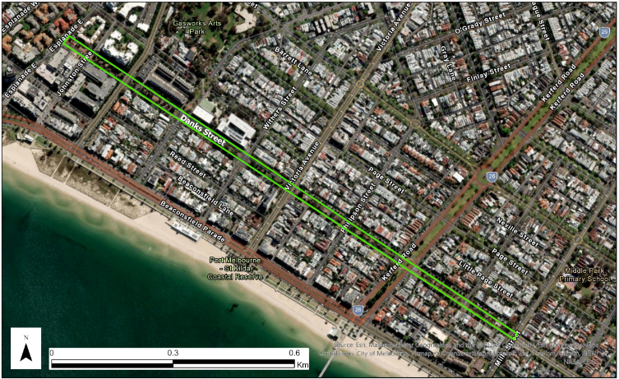
Figure 1. Location of the Danks Street Biolink
Location of the Danks Street Biolink (outlined in bright green) within the City of Port Phillip.
Creation of the Biolink began in 2019 with the aim to improve habitat and support biodiversity. With community involvement, CoPP has since undertaken numerous plantings, including trees, shrubs and grasses, and has installed bird baths, nesting boxes and hollow logs amongst established mature trees (Figure 2). There are also walking paths, benches, sculptures and playgrounds at various points along its length. Residential houses and apartments largely border the one-way roads on each side of the Biolink, as well as Albert Park College and a few commercial buildings.
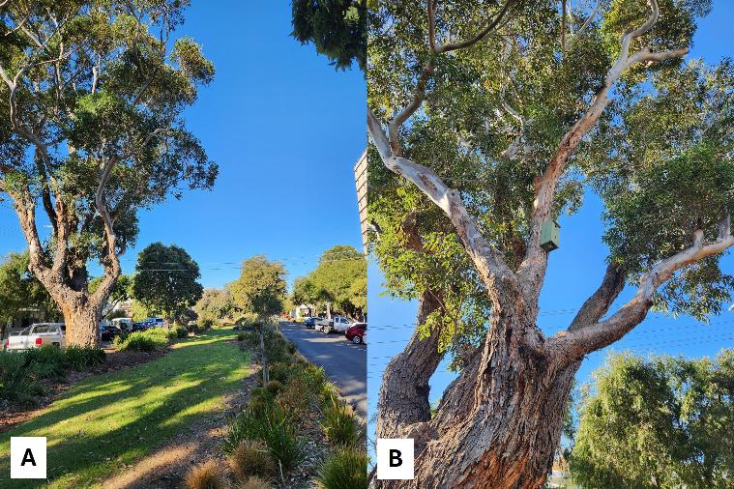
Figure 2. Street view of the Danks Street Biolink
A) A section of the Danks Street Biolink showing an established large mature tree with lawn and groundcover plantings; B) A nest box in one of the many Southern Mahogany trees along the Biolink.
- Hollow-using fauna and the Danks Street Biolink
  - Design considerations for artificial hollows targeting native fauna
Hollow-using native fauna typically found in urban areas includes lorikeets, rosellas, cockatoos and other parrots, as well as owls, insectivorous bats and possums. However, urban environments, by their character, typically lack high densities of hollow-bearing trees. Artificial hollows offer an alternative site for nesting, breeding, denning and shelter when natural hollows are lacking or have been reduced (Beyer and Goldingay 2006, Harley 2006, Rueegger 2017). It is worth noting that there are limitations to the effectiveness of artificial hollows due to factors such as their shorter lifespan and greater variation in internal temperatures compared to natural hollows (Griffiths et al. 2018).
The design of artificial hollows, including nest boxes, can vary widely to suit different species and their ecological requirements (e.g. Beyer and Goldingay 2006, Callan et al. 2023, Griffiths et al. 2018a, Knight and Leck 2023, Strain et al. 2021). This includes overall cavity size, shape, and entrance size and position. In general, many species will use artificial hollows where the entrance is only just large enough for them to fit, to avoid larger competitors or predators. For example, insectivorous microbats typically use nest boxes with a downwards-pointing entrance slit that is only 1.2 – 2 cm wide. Bat boxes also include a landing plate that allows the bats to “launch”, and material or grooves inside that they can hang from (Rueegger 2016, and see https://www.ausbats.org.au/install-a-microbat-house.html). Likewise, boxes designed for Wood Ducks typically include an exit that is accessible for ducklings to launch from (e.g. see https://nestboxtales.com/nest-box-designs/wood-duck/). Some species, such as the Leadbeater’s Possum, require cavities with a small entrance diameter but a large internal space, which allows them to build large, complex nests (McComb et al. 2022). However, many of the common species that typically occupy Melbourne’s urban areas are less fussy, more hardy, and can make use of boxes of a variety of shapes and designs.
Another important consideration is the microclimate that artificial hollows provide, that is, how hot and/or humid the environment is for occupants. Nest boxes that are most commonly installed around Melbourne (including those at Danks Street) are frequently constructed from a single sheet of marine ply, which has very poor insulating properties. These boxes can get very hot in summer, and very cold in winter, an issue that can be exacerbated based on box’s colour, extent of tree canopy cover, and the cardinal direction that it is facing. For example, Griffiths et al. (2017) found that plywood nest boxes painted dark green, and which were facing west, reached temperatures of up to 53°C, which was 18.3°C hotter than boxes painted light-green and facing south. These conditions can have serious implications for species at their physiological limits. Better-insulated artificial hollows, including those constructed from alternative materials, hollowed logs that are capped and attached to trees, or cavities carved directly into trees (‘chainsaw hollows’) have all been shown to provide more stable microclimates (Griffiths et al. 2018a, Griffiths et al. 2022, McComb et al. 2022).
Nest boxes attached to trees are conspicuous structures, which may be targeted by both native and non-native predators (Threlfall et al. 2013, Stojanovic et al. 2019). In urban areas free-roaming cats are of particular concern, given they have been recorded targeting nest boxes (McComb et al. 2018), are capable tree climbers, and hollow-dependent wildlife are frequently brought into care due to cat attack. For this reason, boxes (or other hollow substitutes) should be installed at least 5–6 m above ground, out of the reach of cats. Other pest species, such as introduced birds or bees can also occupy boxes and thereby exclude native fauna, but the degree to which this is an issue varies greatly between projects (Goldingay et al. 2020, Lindenmayer et al. 2016) and can, to some extent, be avoided through regular maintenance.
Even in cases where nest boxes have been carefully designed with the requirements of specific species in mind, taking into account all of the above considerations, there is no guarantee that those species will use them. There is a variety of potential reasons for nest boxes to remain unoccupied, for example, there may be ample suitable natural cavities in the surrounding area, or perhaps the target species requires a diversity of hollow types across the year, or they may not be present in the immediate area. Installed nest boxes may not attract fauna for design-based reasons e.g. a lack of adequate insulation (Harper et al. 2005). There is still much uncertainty around precise natural hollow requirements for native fauna and how that translates to a nest box design and its subsequent use.
The ultimate success of nest boxes in supporting native fauna will remain unknown unless these structures are regularly monitored for use. How often monitoring occurs will depend on the overall goals of the nest box program, which may range from simply providing potential habitat for local native fauna, to increasing the breeding success of specific species. However, implementing a monitoring program (including data management) is a time and financial commitment. Involving local community members in nest box monitoring can provide opportunities for connecting people with nature, improving relationships between local councils and residents, and helping shape and achieve biodiversity outcomes. Considerations such as safety for both people and fauna during monitoring are important to address (Waudby et al. 2022). For example, ensuring community members only use ground-based rather than at-height monitoring techniques and stay clear of roadways.
  - Hollow-using species potentially occurring within Danks Street Biolink
Forty-one hollow-using or hollow-dependent native species known to use nest boxes were identified as occurring within 5 km of the Danks Street Biolink (Table 1 and Table 2). This included 11 mammals (all nocturnal) and 30 birds (27 diurnal and 3 nocturnal).
This was based on collating species lists and records from the following sources: the Victorian Biodiversity Atlas (VBA), Atlas of Living Australia (ALA), iNaturalist and results from informal surveys conducted nearby by community members.
The list was compiled using the following process:
- A species list summarised from records contained within the VBA was obtained as a GIS shapefile from the ‘Victorian Biodiversity Atlas fauna records (unrestricted) for sites with high spatial accuracy’ layer (DEECA 2024).
- The above shapefile was imported into a GIS application and clipped using a 5 km radius circle around the mid-point (144.9501324°E -37.8464887°S) of the Danks Street Biolink.
- The resultant species list was filtered to extract known hollow-using birds and mammals (e.g. Gibbons and Lindenmayer 2002) and cross-checked using records within the same area from the ALA, iNaturalist, and unpublished information. The list was also supplemented to include bat species that are known to occupy the area and use artificial hollows based on past research (Caryl et al. 2016, Griffiths et al. 2018b), and the compiled ‘Batmap’ resource (ABS 2025). Vagrants, rare sightings close to the edge of the search area and introduced species were excluded.

Table 1. Hollow-using or hollow-dependent mammal species occurring within 5 km of the Danks Street Biolink.
This list does not include introduced species or vagrants. All of these species are nocturnal. Period of use is based on the peak season that each species usually uses hollows, which is often linked to nesting, noting that there is limited information available for some species.
Common name | Scientific name | Period of use | Notes
White-striped Free-tailed Bat | Austronomus australis | Autumn
Gould's Wattled Bat | Chalinolobus gouldii | Year-round
Chocolate Wattled Bat | Chalinolobus morio | Occasional use only
Lesser Long-eared Bat | Nyctophilus geoffroyi | Occasional use only | Has only been recorded using boxes in NSW, not Vic
Ride's Free-tailed Bat | Ozimops ridei | Occasional use only
Kreft’s Glider | Petaurus breviceps | Year-round | Unlikely to be present near Danks Street
Eastern Ring-tailed Possum | Pseudocheirus peregrinus | Year-round | Also constructs nests (dreys) in dense foliage to den
Eastern Broad-nosed Bat | Scotorepens orion | Year-round
Common Brush-tailed Possum | Trichosurus vulpecula | Year-round | Uses a variety of structures to den
Large Forest Bat | Vespadelus darlingtoni | Year-round
Little Forest Bat | Vespadelus vulturnus | Occasional use only

Table 2. Hollow-using or hollow-dependent bird species occurring within 5 km of the Danks Street Biolink.
This list does not include introduced species or vagrants. All bird species are diurnal species except for three owl species (including the Boobook). Period of use is based on the peak season that each species usually uses hollows, which is often linked to nesting, noting that there is limited information available for some species.
Common name | Scientific name | Period of use | Notes
Chestnut Teal | Anas castanea | Winter-Summer | Breeding season may be extended
Grey Teal | Anas gracilis | Spring
Pacific Black Duck | Anas superciliosa | Spring
Sulphur-crested Cockatoo | Cacatua galerita | Winter-Summer
Little Corella | Cacatua sanguinea | Spring
Long-billed Corella | Cacatua tenuirostris | Spring
Yellow-tailed Black-Cockatoo | Calyptorhynchus funereus | Spring-Summer, or Autumn
Australian Wood Duck | Chenonetta jubata | Winter-Summer
Grey Shrike-thrush | Colluricincla harmonica | Spring
Laughing Kookaburra | Dacelo novaeguineae | Spring
Galah | Eolophus roseicapilla | Winter-Spring
Musk Lorikeet | Glossopsitta concinna | Spring, Autumn
Swift Parrot* | Lathamus discolor | NA | Only use nest boxes when breeding which occurs in Tasmania
Pink-eared Duck | Malacorhynchus membranaceus | Spring-Summer
Southern Boobook | Ninox boobook | Year-round
Powerful Owl^ | Ninox strenua | Winter
Striated Pardalote | Pardalotus striatus | Spring-Summer
Purple-crowned Lorikeet | Parvipsitta porphyrocephala | Spring
Little Lorikeet | Parvipsitta pusilla | Winter-Spring
Fairy Martin | Petrochelidon ariel | Occasional use only | Relatively few records in area
Tree Martin | Petrochelidon nigricans | Year-round | Relatively few records in area
Flame Robin | Petroica phoenicea | Spring-Summer
Crimson Rosella | Platycercus elegans | Spring-Summer
Eastern Rosella | Platycercus eximius | Spring-Summer
Red-rumped Parrot | Psephotus haematonotus | Spring-Summer
Australian Shelduck | Tadorna tadornoides | Spring
Sacred Kingfisher | Todiramphus sanctus | Spring-Summer
Rainbow Lorikeet | Trichoglossus moluccanus | Spring
Barn Owl | Tyto alba | Only during nesting which may occur any time of year | One record in area only
* Listed under the Flora and Fauna Guarantee Act (FFG 1988) and the Environment Protection and Biodiversity Conservation Act (EPBC 1999) as Critically Endangered.
^ Listed (FFG 1988) as Vulnerable
Although the 41 species in Table 1 and Table 2 are all known to use tree hollows, some are dependent on them for denning year-round (e.g. Kreft’s Glider), some rely on hollows only to lay their eggs and rear young (e.g. lorikeets, rosella, corellas, and cockatoos) while others use a wide variety of other structures as well (e.g. Grey Shrike-thrush) (Marchant et al. 1990-2006. Menkhorst 1995). Eastern Ring-tailed Possums and Common Brush-tailed Possums may den in other places such as dreys (nests constructed in dense foliage) and roof spaces respectively.
Introduced species that use nest boxes have also been recorded in the area including Common Starlings, Common Mynas, and European Honey Bees.

- Danks Street Biolink nest box audit
  - Site visit
To confirm the location of the current nest boxes and collect basic information about them, the Danks Street Biolink was visited on 20th May 2025. Based on nest box tree locations supplied by CoPP and a visual search, an assessment from ground level was conducted with the following details recorded: type/size of box, aspect of entrance, signs of use (e.g. chew marks around entrances), signs of wear or damage, condition of attachment (including any signs of damage to the tree), estimated height of box, bark characteristics, general size and maturity of tree, extent/density of canopy cover, and the presence of dead branches or obvious hollows. Coordinates were recorded for each nest box on a GPS unit (Appendix Table A1). Accessibility to nest boxes was noted in terms of community members being able to easily check occupancy using a pole camera or burrow scope.
  - Nest box details
The nest boxes were spread over a 1.14 km stretch of the Biolink between Pickles Street and Mills Street, Albert Park (Figure 3). A total of 29 nest boxes were found in 25 trees (Table 3). Boxes were individually numbered with clear labels from 001 to 032 and ran sequentially from the northwestern end of the Biolink to the southeastern end. Six of the installed boxes were of designs targeted at insectivorous bats and twenty-three for parrots (FauNature, Magill). The parrot boxes were of two sizes: small (18 boxes, designed for lorikeets) and large (five boxes, designed for Galahs and cockatoos) (Figure 4).
Boxes with numbers 016, 025, and 031 were not located. It is unclear whether these three boxes were missed during the audit (considered unlikely) or had fallen/been removed since installation. Most of the boxes were distributed individually (i.e. one per tree), with two trees containing two bat boxes each, and one tree containing three nest boxes (two bat and one small parrot box).
Boxes had been attached to tree trunks or main vertical branches with two strands of wire. Wire was threaded through the top and bottom of each box and around the tree trunk or a major branch. Most of the wire was covered with tubing apart from a short length on each side of the box. One side of each wire was a zig-zag shape (Figure 4D) similar to the Habisure system recommended by Franks and Franks (2003), which is designed to expand as the tree grows to avoid the wire pulling too tightly and cutting into the tree trunk or branch. Boxes were installed from an estimated 4–7.5 m above the ground, noting this was a visual approximation made from ground level rather than a precise measurement. While boxes were pointing in various cardinal directions, all parrot boxes pointed to the south/south-east, and all bat boxes to the west or north-west.
Most of the trees containing the nest boxes were alive with good canopy coverage, with few or no dead branches. No obvious hollows were observed, but on two trees a potential hollow entrance was seen. In each of these cases, it was not possible to confirm whether a full hollow had formed or not.
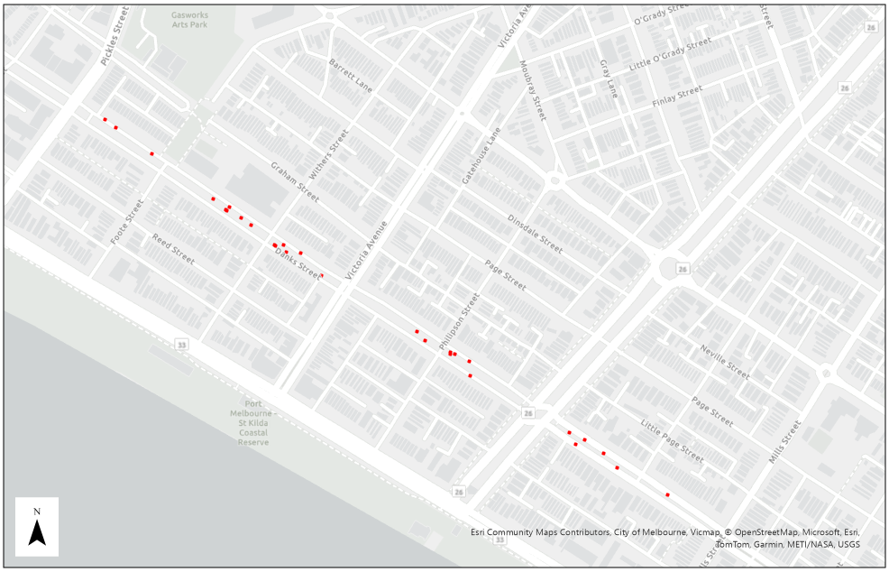
Figure 3. Location of nest boxes installed along the Danks Street Biolink
Nest boxes are indicated by red dots; note that several boxes may be installed on a single tree.
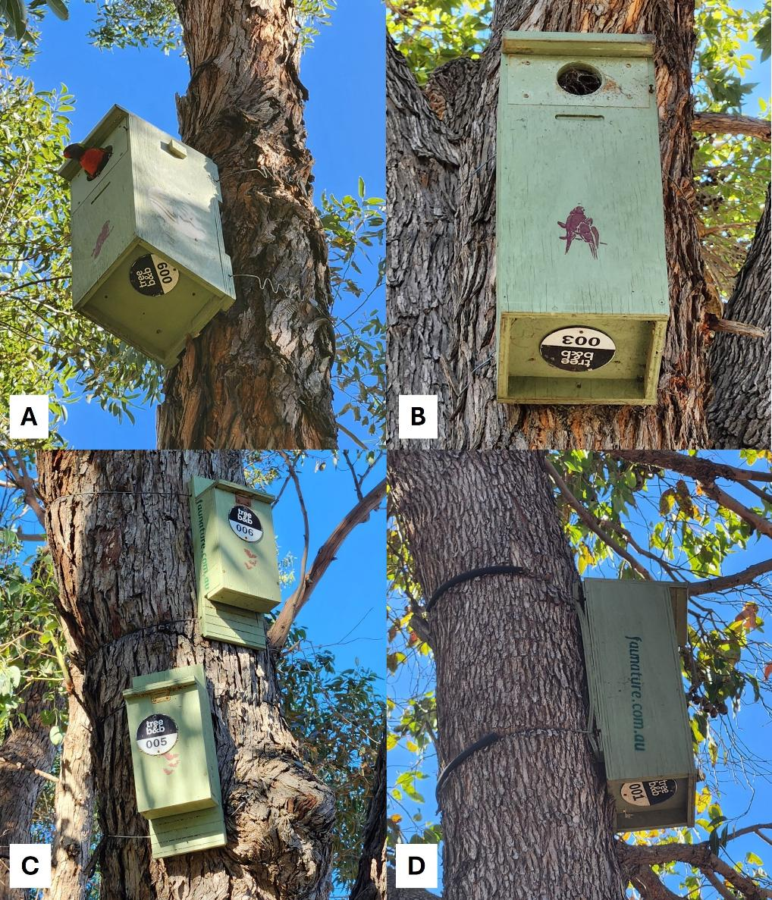
Figure 4. Types of nest boxes installed along the Danks Street Biolink
A) A large parrot box with a Rainbow Lorikeet perched at the entrance, showing the zig-zag wiring attachment; B) a small parrot box, in this case the entrance is covered over by a web and has adjacent discolouration/minor marks; C) two bat boxes installed in the same tree; D) side view of a small parrot nest box showing the back coming away where the wire is attached.
  - Nest box condition and signs of occupancy
Most of the nest boxes appeared to be in good condition (externally) with no major damage observed. For a small number (six) of boxes, the back panel was beginning to split from the main body of the box where the wire was attached. The wire of nearly half the boxes was pressing into the outer bark layer of the tree – the extent of this ranged from slightly pressing to appearing to cut more deeply. From ground level it was not possible to assess whether the wire had cut into the cambium (tree tissue) layer immediately beneath the bark.
During the site visit a Rainbow Lorikeet was observed briefly entering and then perching (facing outwards) on the entrance of a large parrot box (Figure 4A). One small parrot box was seemingly being used by ants – with a line of ants observed to be leading from the trunk of the tree into the nest box entrance.
Although there was some discoloration and minor marks around the entrances of eight of the parrot boxes (e.g. Figure 4B), it was difficult to ascertain whether this indicated that animals had entered the boxes or was the result of weathering. Three of the parrot boxes and one bat box had spider webs partially or wholly covering the entrance (e.g. Figure 4B), indicating that they were not currently being used by mammals or birds.
  - Accessibility
It was believed that nest box occupancy could be checked from the ground (e.g. by community members) using a pole camera (or a burrow scope attached to a pole), although protruding branches may make it difficult to manoeuvre the camera for a clear view into some of the boxes. In general, box entrances were easily visible from the ground. Some of the boxes were positioned on trees such that they were very close to the edge of the adjacent road which would require extra care by observers.
  - Potential issues
Several of the boxes were relatively low to the ground (4-4.5 m) which may increase the likelihood of cats investigating them and lead to predation events.
All the bat boxes were on the northern to western side of trees. Insectivorous bats are known to use multiple den sites and their thermal needs change over the year. The current positioning of the bat boxes may limit their suitability in this regard. In addition, two of the bat boxes were installed in a dead tree with no canopy cover, such that they were highly exposed to daily sunshine (and potentially high internal temperatures) and predators.

Table 3. Danks Street Biolink nest box details
Details were collected during a site visit on the 20th May 2025. Box labels are as observed on site; Tree asset numbers were provided by CoPP; Tree species are as follows: Lemon Scented Gum Corymbia citriodora, Red flowering Gum Corymbia ficifolia, River Red Gum Eucalyptus camaldulensis, Southern Mahogany Eucalyptus botryoides, Box type as according fauNature; Aspect is direction boxes were facing (SE = south-east, NW = north-west, N = north, S = south, E = east, W = west); Heights were visually estimated from ground level.
Box label | Tree asset # | Tree species | Box type | Aspect | Box/wire attachment condition | Signs of use | Estimated box height (m) | Notes
001 | 1160347 | Corymbia ficifolia | Parrot - small | SE | Back of box split at top and bottom where wire attached; wire pressing into bark | Discolouration around entrance with minor possible chew/scratch marks | 4.5 | Box set relatively low
002 | 1196261 | Eucalyptus botryoides | Parrot – large | SE | No box damage apparent; wire pressing into bark | Discolouration around entrance with minor possible chew/scratch marks | 5.5
003 | 1160355 | Corymbia ficifolia | Parrot - large | SE | Back of box split at top and bottom where wire attached; wire pressing into bark; top wire snapped on one side | Web covering entire entrance | 4.5 | Box set relatively low
004 | 1160300 | Corymbia citriodora | Parrot - small | SE | No box damage apparent; bark caught under wire but not obviously digging into trunk | Possible minor chew/scratch marks | 6.5 | Clear plastic collar around lower trunk
005 | 1160303 | Eucalyptus botryoides | Bat | NW | No box damage apparent; wire pressing into bark | No obvious signs of use | 5 | Box set relatively low
006 | 1160303 | Eucalyptus botryoides | Bat | W | No box damage apparent; wire pressing into bark | Web covering entire entrance | 5.5
007 | 1160303 | Eucalyptus botryoides | Parrot - small |  | No box damage apparent | No obvious signs of use | 7
008 | 1160304 | Eucalyptus botryoides | Parrot - small | SE | No box damage apparent; wire pressing into bark | Web covering entire entrance; minor possible chew/scratch marks | 4.5 | Box set relatively low
009 | 1160305 | Eucalyptus botryoides | Parrot - large | E | No box damage apparent; wire pressing into bark | Rainbow Lorikeet was observed entering box, then briefly perching at entrance | 7
010 | 1160306 | Corymbia ficifolia (dead) | Bat | W | No box damage apparent | No obvious signs of use | 4.5 | Box set relatively low; no canopy
011 | 1160306 | Corymbia ficifolia (dead) | Bat | NW | No box damage apparent | No obvious signs of use | 5 | Box set relatively low; no canopy
012 | NA |  | Parrot - small | S | Back of box split at top and bottom where wire attached | No obvious signs of use | 7
013 | 1160308 | Corymbia ficifolia | Parrot - small | SE | No box damage apparent | No obvious signs of use | 5 | Box set relatively low
014 | 1160310 | Eucalyptus botryoides | Parrot - small | SE | No box damage apparent; wire pressing into bark | No obvious signs of use | 6 | May be difficult to access with a pole camera due to protruding branches
015 | 1160314 | Eucalyptus botryoides | Parrot - small | E | No box damage apparent | No obvious signs of use | 4 | Box set relatively low
017 | 1160264 | Eucalyptus botryoides | Parrot - small | E | No box damage apparent | No obvious signs of use | 7 | Box slightly pointing towards ground
018 | 1160265 | Eucalyptus botryoides | Parrot - small | SE | No box damage apparent | Discolouration around entrance with minor possible chew/scratch marks | 7.5 | May be difficult to safely access with a pole camera due to height and proximity to road
019 | 1160770 | Eucalyptus botryoides | Bat | N | No box damage apparent | No obvious signs of use | 5.5
020 | 1160770 | Eucalyptus botryoides | Bat | NW | No box damage apparent; wire pressing into bark | No obvious signs of use | 5 | Box set relatively low
021 | 1160771 | Eucalyptus botryoides | Parrot - small | S | No box damage apparent | No obvious signs of use | 5.5
022 | 1160772 | Eucalyptus botryoides | Parrot - large | S | No box damage apparent; wire pressing into bark | No obvious signs of use | 6.5
023 | 1160773 | Eucalyptus botryoides | Parrot - small | SE | No box damage apparent; wire pressing into bark | Web partially covering entrance, discolouration with minor possible chew/scratch marks | 5.5 | May be difficult to safely access with a pole camera due to proximity to road
024 | 1196287 | Eucalyptus botryoides | Parrot - small |  | Back of box split at bottom where wire attached; wire pressing into bark | Web partially covering entrance; no obvious signs of use | 4 | Box set relatively low
026 | NA |  | Parrot - small | SE | No box damage apparent; wire pressing into bark | Discolouration around entrance with minor possible chew/scratch marks | 4.5 | May be difficult to safely access with a pole camera due to proximity to road; Box set relatively low
027 | 1159182 | Eucalyptus botryoides | Parrot - large | SE | No box damage apparent | Discolouration around entrance with minor possible chew/scratch marks | 6
028 | 1159183 | Eucalyptus camaldulensis | Parrot - small | S | Back of box split at bottom where wire attached; wire pressing into bark | No obvious signs of use | 4.5 | Box angled slightly upwards; Box set relatively low
029 | 1185575 | Eucalyptus botryoides | Parrot - small | E | No box damage apparent | No obvious signs of use | 6.5
030 | 1159184 | Eucalyptus botryoides | Parrot - small | SE | No box damage apparent | No obvious signs of use | 4.5 | May be difficult to access with a pole camera due to protruding branches; Box set relatively low
032 | 1159187 | Eucalyptus botryoides | Parrot - small | SE | Back of box split at top where wire attached; wire pressing into bark | Discolouration around entrance with minor possible chew/scratch marks, ants seen entering box | 5 | Box set relatively low

- Nest box management plan
This management plan covers establishing baseline information on nest box condition and occupancy and provides a basic monitoring and maintenance schedule. It is recommended that the plan be periodically reviewed depending on nest box occupancy and overall objectives.
  - Baseline occupancy/condition check
Given the Danks Street nest boxes have not been closely examined since being installed, a thorough check of their condition and occupancy (or signs thereof) will provide a recorded baseline for their ongoing management. The outcomes of this initial inspection will inform next steps. This first step should be conducted by an experienced arborist, or an ecologist with appropriate working at heights / ropes qualifications. This may be scheduled to coincide with regular tree health checks.
- Conduct a daytime occupancy check to determine a) whether any animals are present in the boxes, b) whether there are any signs of occupancy e.g. formed nests, leaves. This could be done via a quick check under the box lid or using a pole camera in the first instance.
- Inspect each nest box and attachment mechanism for damage. Assess whether the attachment wiring is cutting into the bark such that tree health may be compromised and replace if necessary. If an unoccupied nest box is damaged or unstable such that it will no longer provide adequate shelter for fauna either repair, replace or remove the box altogether.
- Record details of nest box locations and type, and occupancy and condition checks in a purpose-designed nest box database (e.g. Access database or SQL server) or an Excel spreadsheet that enables individual boxes with associated CoPP tree asset numbers, to be linked to occupancy monitoring.
  - Changes to current nest box placement
Our audit identified several nest boxes that are currently in positions that are either highly exposed to the sun, are sitting at an angle that may expose the interior to rain or are at a height that may increase the likelihood of cat predation (Table 3). Re-positioning such boxes may improve their suitability and attractiveness to fauna.
- Bat boxes 010 and 011 are currently attached to a dead tree with no shade; installing these on a live tree with a canopy will provide shade in summer.
- Repositioning bat boxes so they collectively face a variety of cardinal directions will ensure there is a range of internal temperatures available throughout the year. This is important because female insectivorous bats require warmer temperatures during the breeding season (spring/summer) to aid gestation and milk production, but at other times of year cooler daytime temperatures help bats maintain torpor (a form of hibernation) and reduce energy requirements. Bats also regularly switch roosts every few days, presumably to avoid predators and a build-up of parasites (Churchill 2008) so require a network of available roost sites to meet their ecological requirements.
- Ensuring nest boxes are at least 5 m above the ground will help deter ground-based predators such as cats, which may be a particular issue given the urban setting. Predator guards such as tree collars or entrance covers will also decrease predation risk (Bailey and Bonter 2017).
  - Type of nest boxes
Currently installed nest boxes are designed to target both small and large parrot species, and also insectivorous bats, but may potentially be used by many of the other nest box using species recorded in the area, including possums (Table 4). However, the dimensions of nest boxes can affect which species use them. Nest boxes targeting small-sized birds such as robins and pardalotes, or medium-sized birds like ducks and kookaburras, are typically constructed with different dimensions to those currently installed, catering to different nesting requirements, and often include a perch or a platform. Although ducks have been recorded using hollows some way from water bodies, they usually nest nearby to facilitate access for ducklings and may therefore be unlikely to use nest boxes in Danks Street.
- Increasing the variety of nest box designs would expand the range of nesting and denning features available, catering for a greater number of species (e.g. possums or small birds).
- Some species would be difficult to cater for due to their low occurrence in the area, and very occasional documented use of nest boxes e.g. Fairy Martins, or very specific requirements e.g. owls. It is unlikely to be worth targeting such species.
Another element to consider is the attachment mechanism of nest boxes. Attachment is often by wire encased in PVC tubing with zig-zag shape (e.g. Figure 4A) to allow for tree growth without cutting into the bark or cambium. Screws with expanders that sit between the tree and the box are also an option, although this involves drilling into the tree itself.
Table 4. Birds and mammals that may use the Danks Street Biolink nest boxes
The three types of nest boxes currently installed along the Biolink, and bird and mammal species which may use them. Potential species based on presence records within 5 km of the Biolink.
Parrot box (small) | Parrot box (large) | Bat
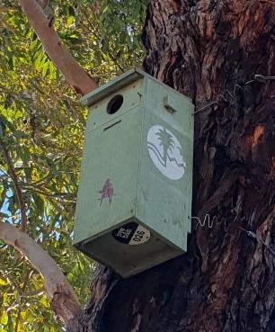 | 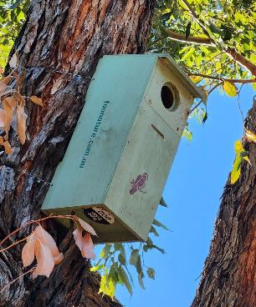 | 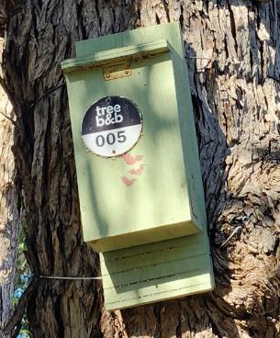
Lorikeets  Red-rumped Parrot  Common Brush-tailed Possum | Corellas  Cockatoos  Galahs  Rosellas | Gould’s Wattle Bat  White-striped Free-tailed Bat  Large Forest Bat
  - Occupancy monitoring and recording
An ongoing monitoring program will provide valuable information on usage and local fauna. The frequency and timing of nest box occupancy checks depends on the overall purpose of the installed boxes, which also needs to be balanced with minimising disturbance to fauna. In addition, the level of community involvement and volunteer management needs to be considered.
For the general objective of providing nesting/denning habitat, where success is measured by boxes being occupied by native fauna, checking boxes two to four times a year will provide an indication of their use. This will capture intermittent use including where boxes are only used for nesting and raising young (where nesting material may still be present), although care must be taken not to disturb fauna (e.g. avoid physically looking into boxes during this time if possible). If it is not possible to check boxes several times per year, monitoring could be targeted during one or more of the following periods in order of priority: 1) spring, 2) late summer, 3) autumn, and 4) late winter. Winter checks may be useful to capture nest-building activities, to highlight which boxes might be occupied during subsequent periods when young are being raised. If boxes are being checked when there is the possibility of the presence of young (chicks, pups, or joeys), tell-tale signs such as adult birds regularly entering and exiting, or appearing agitated by the presence of people (e.g. making alarm calls, swooping), can help indicate which boxes should be avoided.
There are several options for monitoring both the occupancy of the boxes, as well as investigating what fauna are using the surrounding areas (see Table 5). Methods to check occupancy include physically looking into the box, monitoring remotely with cameras, or making observations from ground level. Physical inspection can involve having an observer, who is qualified to work at heights, briefly lift the lid and directly look in, or using a pole camera to look through the entrance. The latter method will cause less disturbance to animals, can be done from ground level and allows photos to be taken remotely. Components for pole cameras can be mixed and matched to suit factors such as height of boxes and budget. Another option is to install a wireless camera into nest boxes. These can be accessed remotely, although setting up the necessary equipment (batteries or solar panel, Wi-Fi receiver) in a public area and ensuring its security may be challenging. Boxes, and other artificial hollows are also sometimes monitored using heat-motion triggered cameras (‘camera traps’), mounted to a nearby tree and pointing at the box entrance to record individuals coming and going (see McComb et al. 2018 or Rueegger 2017), for example). However, these units can be expensive (typically ranging in cost from approximately $200 – $900) and are vulnerable to theft and vandalism, so would not be recommended for an urban setting such as Danks Street.
Ground-based methods could include observing entrances for fauna entering or exiting during the day (e.g. for diurnal birds), or at dusk for emerging nocturnal fauna (‘stag watching’) including with a thermal or a “night vision” (infrared) camera. Thermal cameras pointed at nest boxes may allow observers to detect heat signatures emitted by animals, indicating their presence inside. This will be particularly apparent during colder times of the year, when there is greatest contrast between ambient temperatures and the heat generated by the occupant. Thermal cameras range from more expensive stand-alone devices, which are sometimes available to members of the public for loan from libraries, to units or adaptors that can be mounted to smart phones. However, the species using a box typically can’t be determined from a heat signature alone, so this method may only provide an indication of occupancy. Other observational records (diurnal bird point counts, stag watches of known hollows, and acoustic surveys using bat detectors) will help identify what hollow-using species of birds and mammals are present in the area that might not be using the boxes. Stag watches can be conducted with binoculars alone, and/or paired with thermal cameras, while bat detectors can be purchased as standalone units or as smart phone adaptors.
Table 5. Options for professional and community-based monitoring of nest boxes and surrounds
Cost is indicated by $ (cheapest), $$ (in between the cheapest and most expensive) or $$$ (most expensive) and is relative.
Monitoring approach | Nocturnal species | Diurnal species | Suitable for community | Can assess box occupancy? | Cost | Considerations
Physical inspection (i.e. lifting box lid) | Y | Y | N  (requires working at heights) | Y | $$$ (contractors) | Night-time checks may be required for diurnal species  May disturb inhabitants
Ground-based checks  (pole camera) | Y | Y | Y | Y | $ | As above
Cameras installed in-, or pointed at-, boxes | Y | Y | N (though can review collected images) | Y | $$$ | Vulnerable to theft/vandalism  Require professional installation and maintenance  Minimal disturbance
Stag watching | Y | N | Y | Y | $ | To be conducted at dusk, time consuming
Thermal cameras | Y | Y | Y | Y | $$  (initial outlay) | Night-time checks may be required for diurnal species
Point counts (birds) | N | Y | Y | N | $ | Likely being conducted anyway
Bat detectors | Y | N | Y | N | $$  (initial outlay) | Species identification difficult

Recording the results of nest box monitoring according to a standardised protocol will ensure consistent and useful information is collected and stored. Designing data sheets or forms (hard-copy or electronic) that are clear and simple to fill out on-site and follow a logical flow of observations as they are collected, will help ensure all relevant information is included. A specifically designed electronic database that enables nest box information to be easily extracted, summarised and linked through multiple monitoring events is recommended.
Regular occupancy checks should include recording the following data categories:
- Date, time, box number, location
- Tree species (and tree asset number)
- Name of observer(s)
- Condition of box
- Signs of occupancy
  - Species if present (and number of individuals) if easily observed
  - Formed nests
  - Other signs e.g. feathers, leaves, scats, scratches
  - Animal care and ethics
It is preferrable to monitor nest boxes using methods that cause as little disturbance to any resident fauna as possible, especially when young are present. This includes minimising noise and movement, using a red filter on camera lights or only exposing the inside of boxes to white light for a short time, and ceasing if any animals become distressed. Lifting a lid or using a camera to check a nest box does not require a permit, however handling native animals requires authorisation under the Wildlife Act 1975 (though this doesn’t apply to introduced species) and may also require approval from an established Animal Ethics Committee. If planning to trap or handle native animals as part of a nest box program, obtaining advice from the Conservation Regular is advised (https://www.vic.gov.au/conservation-regulator).
  - Maintenance of nest boxes and dealing with pest species
Regularly checking the condition of nest boxes (at least every 12 months) and follow-up maintenance if required will help prolong their life. This will allow any issues to be identified and recorded including if boxes become infested with bees or ants (to the point that other fauna cannot use them) or are being used by invasive species such as Common Mynas. Once a pest species becomes established, their removal from nest boxes can be difficult. In the case of birds such as Common Myna, this may require physical removal of nests or controlling the animals themselves (e.g. trapping and euthanising individuals). Strategies for dealing with pest species should be part of a management plan; advice regarding control can be sought from Agriculture Victoria.
  - Alternative artificial hollows
There are many alternative options for providing artificial hollows, in addition to the plywood-type nest boxes currently installed at Dank Street. However, costs and maintenance requirements for these can vary greatly (summarised in Table 6). While some of the more expensive options, such as carved cavities, more closely mimic the properties of natural hollows and provide stable microclimates (Griffiths et al. 2028), in general cheaper options can also adequately meet the needs of common species found in urban areas. If community monitoring is also a high priority, it is worth bearing in mind that log hollows and carved cavities may be less accessible. All types of artificial hollows can become infested with pests, but these can be harder to evict from carved cavities. Carved hollows can also flood during high rainfall events if not installed with care to ensure adequate drainage. In short, there is no one, “best” type of artificial hollow, it depends on program budgets and objectives and target species. In many cases a trial-and-error type approach may be best, i.e. installing two or more hollow types, designed for different target species, ensuring they provide a diversity of conditions, and monitor to see what works. If a situation arises where installed hollows remain unoccupied (as may be the case for Danks Street), then it is likely worthwhile testing some additional alternatives.
Table 6. Alternative options for artificial hollows
Cost is indicated by $ (cheapest), $$ (moderate cost) or $$$ (most expensive) and is relative.
Hollow type | Cost | Maintenance requirements | Accessible for monitoring | Thermal properties | Other considerations
Plywood boxes | $ | Frequent (6- months) | Y | Poor | -
3D printed or insulated boxes, constructed from thick hard-wearing wood | $$ | Annual | Y | Good | -
Log hollows | $$ | Annual | Possibly (depending on design) | Good | Less conspicuous than nest boxes
Carved cavities | $$$ | Every few years | N (except stag watch / physical check) | Excellent | Potential safety risks, not suitable for some tree species or for small trees

  - Future considerations
Given that the nest boxes were installed approximately five years prior to our assessment, if they are not presently occupied and there are no signs of recent use this may indicate:
- Potential resident species are finding suitable hollows (natural or artificial) elsewhere.
- Nest boxes are not attractive/suitable.
- Potential resident species are not using the Danks Street Biolink.
Although the number or size of natural hollows along the Biolink is unknown, there were none in the trees where nest boxes are currently installed, and it is likely to be a long-term limiting factor for local fauna. Adjusting and/or moving some of the boxes and replacing a sub-set to provide options with better insulation, and an increased diversity of designs, would provide a baseline from which to begin a formal nest box program. In any case, points to consider include:
- Clearly define the purpose of the program (e.g. what does success or failure look like?) including which species to target.
- If boxes remain unoccupied consider whether to replace with updated or better-insulated designs, replace with different designs (i.e. different target species), or remove altogether.
- Consider budget, effort to monitor, likelihood of community involvement.
- After implementing a monitoring program review regularly to reassess.

- Conclusion
Most of the hollow-using and hollow-dependant bird and mammal species that have been recorded near the Danks Street Biolink are common and widespread. While many of these species will potentially use the nest boxes currently installed along the Danks Street Biolink, some species may benefit from designs that include additional features or are different dimensions.
To cater for a wider range of species with the aim of providing nesting/denning habitat we recommend the following steps:
- Conduct an initial occupancy and condition check.
- For those nest boxes that are unoccupied and have no signs of recent occupancy, consider replacing a subset:
  - Constructed from materials with highly insulative properties.
  - Include a wider range of designs to target species such as small birds and kookaburras.
- Implement a monitoring program designed around community involvement:
  - Include a range of techniques to detect fauna in boxes including pole cameras, thermal cameras, and direct observation (day/night).
  - Provide a simple data collection form to capture standardised monitoring details that can be entered into an electronic recording system (e.g. database).
  - Complement with other surveys to determine the presence of nest box-using fauna along the Biolink (e.g. diurnal bird counts).
- Review monitoring results after two years to consider impact of nest boxes:
  - Are target fauna using them?
  - Are pest species using them?
  - Is community involvement at the desired level?
  - Is the nest box program sustainable?

Nest boxes can successfully provide habitat for a range of fauna, particularly within a highly modified urban environment. The implementation of a monitoring program can have multiple benefits for community members but also provide valuable information on wildlife in urban areas and their use of nest boxes.

References
ABS (2025). BatMap. Australasian Bat Society. https://www.ausbats.org.au/batmap.html. (accessed 13 June 2025)
Bailey, R. L., and Bonter, D. N. (2017). Predator guards on nest boxes improve nesting success of birds. Wildlife Society Bulletin 41, 434–441.
Beyer, G.L. and Goldingay, R.L. (2006). The value of nest boxes in the research and management of Australian hollow-using arboreal marsupials. Wildlife Research 33(3), 161-174.
Callan, M.N., Johnson, A. and Watson, D.M. (2023). Influence of nest box design on internal microclimate: Comparisons of plastic prototypes. Austral Ecology 48(2), 374-387.
Caryl, F.M., Lumsden, L.F., van der Ree, R. and Wintle, B.A. (2016). Functional responses of insectivorous bats to increasing housing density support ‘land‐sparing’rather than ‘land‐sharing’urban growth strategies. Journal of Applied Ecology 53(1),191-201.
Churchill, S (2008). Australian Bats. 2nd edition. Allen and Unwin, Sydney, NSW.
CoPP (2024a). Annual report 2023/24. City of Port Phillip, St Kilda, Victoria.
CoPP (2024b). Urban Forest Strategy 2024 to 2040. Healthy biodiverse, connected. City of Port Phillip, St Kilda, Victoria.
DEECA (2024). Victorian Biodiversity Atlas fauna records (unrestricted) for sites with high spatial accuracy. Department of Energy, Environment, & Climate Action, Melbourne, Victoria. https://datashare.maps.vic.gov.au/search?q=uuid%3D84b924b3-e115-58d9-b707-2920143051f7 (accessed 13 June 2025)
Franks, A. and Franks, S. (2003). Nest Boxes for Wildlife. Bloomings Books, Melbourne, Victoria
Gibbons, P. and Lindenmayer, D. (2003). Tree hollows and wildlife conservation in Australia. CSIRO Publishing, Collingwood, Victoria.
Goldingay, R.L., Rueegger, N.N., Grimson, M.J. and Taylor, B.D. (2015). Specific nest box designs can improve habitat restoration for cavity‐dependent arboreal mammals. Restoration Ecology 23(4), 482-490.
Goldingay, R.L., Rohweder, D. and Taylor, B.D. (2020). Nest box contentions: are nest boxes used by the species they target? Ecological Management & Restoration 21(2), 115-122.
Griffiths, S.R., Rowland, J.A., Briscoe, N.J., Lentini, P.E., Handasyde, K.A., Lumsden, L.F. and Robert, K.A. (2017). Surface reflectance drives nest box temperature profiles and thermal suitability for target wildlife. PLoS One 12(5), e0176951.
Griffiths, S.R., Lentini, P.E., Semmens, K., Watson, S.J., Lumsden, L.F. and Robert, K.A. (2018a). Chainsaw-carved cavities better mimic the thermal properties of natural tree hollows than nest boxes and log hollows. Forests 9(5), 235.
Griffiths, S.R., Lumsden, L.F., Bender, R., Irvine, R., Godinho, L.N., Visintin, C., Eastick, D.L., Robert, K.A. and Lentini, P.E. (2018b). Long-term monitoring suggests bat boxes may alter local bat community structure. Australian Mammalogy 41(2), 273-278.
Griffiths, S.R., Robert, K.A. and Jones, C.S. (2022). Chainsaw hollows carved into live trees provide well insulated supplementary shelters for wildlife during extreme heat. Wildlife Research 49, 596–609.
Harley, D.K. (2006). A role for nest boxes in the conservation of Leadbeater’s possum (Gymnobelideus leadbeateri). Wildlife Research 33(5), 385-395.
Harper, M.J., McCarthy, M.A. and van der Ree, R. (2005). The use of nest boxes in urban natural vegetation remnants by vertebrate fauna. Wildlife Research 32(6), 509-516.
Knight, A.R. and Leck, J. L. (2023). Evaluation of habitat recovery for hollow-dependent fauna – regional-scale solutions for long term resilience. Report for North Coast Regional Landcare. Gulbali Report 2. Charles Sturt University, Port Macquarie, NSW.
Lindenmayer, D.B., Welsh, A., Donnelly, C., Crane, M., Michael, D., Macgregor, C., McBurney, L., Montague-Drake, R. and Gibbons, P. (2009). Are nest boxes a viable alternative source of cavities for hollow-dependent animals? Long-term monitoring of nest box occupancy, pest use and attrition. Biological Conservation 142(1), 33-42.
Lindenmayer, D., Crane, M., Blanchard, W., Okada, S. and Montague-Drake, R. (2016). Do nest boxes in restored woodlands promote the conservation of hollow-dependent fauna? Restoration Ecology 24, 244–251.
Lindenmayer, D.B., Crane, M., Evans, M.C., Maron, M., Gibbons, P., Bekessy, S. and Blanchard, W. (2017). The anatomy of a failed offset. Biological conservation 210, 286-292.
Marchant, S., Higgins, P.J., Davies, S.J.J.F., Peter, J.M., Steele, W.K. and Cowling, S.J. (eds.) (1990-2006). Handbook of Australian, New Zealand and Antartctic Birds. Volume 1 to 7. Oxford University Press, Melbourne, Victoria
Maziarz, M., Broughton, R.K. and Wesołowski, T. (2017). Microclimate in tree cavities and nest-boxes: Implications for hole-nesting birds. Forest Ecology and Management 389, 306-313.
McComb, L.B., Lentini, P.E., Harley, D.K., Lumsden, L.F., Antrobus, J.S., Eyre, A.C. and Briscoe, N.J. (2018). Feral cat predation on Leadbeater’s possum (Gymnobelideus leadbeateri) and observations of arboreal hunting at nest boxes. Australian Mammalogy 41(2), 262-265.
McComb, L.B., Lentini, P.E., Harley, D.K.P., Lumsden, L.F., Eyre, A.C. and Briscoe, N.J. (2022). Climate and behaviour influence thermal suitability of artificial hollows for a critically endangered mammal. Animal Conservation 25(3), 401-413.
Menkhorst, P.W. (ed.) (1995). Mammals of Victoria: distribution, ecology and conservation. Oxford University Press, Melbourne, Victoria
Rueegger, N. (2016). Bat boxes—a review of their use and application, past, present and future. Acta Chiropterologica 18(1), 279-299.
Rueegger, N. (2017). Artificial tree hollow creation for cavity-using wildlife–Trialling an alternative method to that of nest boxes. Forest Ecology and Management 405, 404-412.
Strain, C., Jones, C.S., Griffiths, S.R. and Clarke, R.H. (2021). Spout hollow nest boxes provide a drier and less stable microclimate than natural hollows. Conservation science and practice 3(6), e416.
Stojanovic, D., Eyles, S., Cook, H., Alves, F., Webb, M. and Heinsohn, R. (2019). Photosensitive automated doors to exclude small nocturnal predators from nest boxes. Animal Conservation 22(3), 297-301.
Threlfall, C., Law, B. and Banks, P.B. (2013). Odour cues influence predation risk at artificial bat roosts in urban bushland. Biology letters 9(3), 20121144.
Waudby, H.P., Kerr, G.D., Roger, E., Gill, M.J., Petit, S. and Douglas, T.K. (2022). Citizen science and education. In: Smith, B.P., Waudby, H.P., Alberthsen, C. and Hampton, J.O. (Eds) Wildlife research in Australia, practical and applied methods, pp. 201-209. CSIRO, Clayton South, Victoria.

Appendix
Table A1. Coordinates of the Danks Street Biolink nest boxes
Box label | Coordinate (Latitude Longitude)
001 | S37.84395 E144.94546
002 | S37.84406 E144.94565
003 | S37.84441 E144.94625
004 | S37.84500 E144.94727
005 | S37.84511 E144.94756
006 | S37.84515 E144.94750
007 | S37.84515 E144.94751
008 | S37.84526 E144.94774
009 | S37.84535 E144.94792
010 | S37.84563 E144.94832
011 | S37.84561 E144.94832
012 | S37.84561 E144.94846
013 | S37.84571 E144.94851
014 | S37.84572 E144.94875
015 | S37.84602 E144.94910
017 | S37.84676 E144.95071
018 | S37.84689 E144.95084
019 | S37.84704 E144.95127
020 | S37.84707 E144.95126
021 | S37.84707 E144.95134
022 | S37.84717 E144.95158
023 | S37.84735 E144.95159
026 | S37.84811 E144.95325
027 | S37.84827 E144.95336
028 | S37.84821 E144.95352
029 | S37.84840 E144.95383
030 | S37.84857 E144.95405
032 | S37.84894 E144.95491

www.deeca.vic.gov.au

www.ari.vic.gov.au

