
Native Fish Report Card 2025
Ovens River
North East Region

This report card summarises the 2025 Native Fish Report Card (NFRC) survey in the Ovens River
Sites: 12, Electrofishing

Fish found in Ovens River for NFRC
Target species
Golden Perch
Macquarie Perch
Murray Cod
Trout Cod
Non-target species captured since 2017*
Large-bodied native species
Bony Bream
River Blackfish
Two-spined Blackfish

Small-bodied native species
Australian Smelt
Carp Gudgeon
Flatheaded Gudgeon
Obscure Galaxias
Southern Pygmy Perch
Unspecked Hardyhead

Exotic species
Brown Trout
Common Carp
Eastern Gambusia
Goldfish
Oriental Weatherloach
Rainbow Trout
Redfin

* These non-target species were incidentally captured during NFRC surveys since 2017 but not measured as for target species
Ovens River 2025
Fish Community

NFRC target species
The NFRC Program began in 2017 to monitor population dynamics of key iconic fish species that have high recreational and/or conservation values, in large rivers across Victoria. In the Ovens River, the target species are Golden Perch, Macquarie Perch, Murray Cod and Trout Cod. Surveys occur in March/April each year, at 12 sites from just downstream of Porepunkah to the junction with Lake Mulwala (Boorhaman North). The equipment used and habitats surveyed target these species, which are measured to determine their population structures. Other fish species that are incidentally captured are counted, but not measured.

Summary of key health indicators for target species in 2025
Species | Key Health Indicators
 | Recent recruitment | Multiple size classes | Mature fish present
Golden Perch | No | No | Yes
Macquarie Perch | Yes | Yes | Yes
Murray Cod | Yes | Yes | Yes
Trout Cod | Yes | Yes | Yes

Both Macquarie Perch and Trout Cod were historically abundant in the lower and mid Ovens River, but experienced dramatic declines until they were considered locally extinct. The status of both species has improved in recent times. Overall, the Ovens River appears to be maintaining healthy Murray Cod and Trout Cod populations. Golden Perch are historically rare upstream of Wangaratta, while low numbers of adults are consistently found downstream. An integrated program for the recovery of Macquarie Perch is showing encouraging results. As the section surveyed is downstream of the cooler waters preferred by trout, large abundances of trout species are not expected in the NFRC surveys.

Non-target species
The non-target fish species that have been incidentally recorded in the Ovens River during NFRC surveys since 2017 are:

Large-bodied native species
River Blackfish and Two-spined Blackfish were recorded in the 2025 survey, with River Blackfish recorded in all nine NFRC survey. River Blackfish, a lowland species generally found at altitudes below 200m, is more frequently recorded upstream of Wangaratta. It is rarely recorded at the top site towards Porepunkah. This species has declined in distribution and abundance across Victoria¹. Two-spined Blackfish is only found at the top few sites monitored in the Ovens River. The species typically occurs above 200m altitude, with few records down to 180m altitude (this correlates to around Whorouly in the Ovens River system).
Bony Bream, caught once in the 2024 survey, is a lowland species found across the Murray-Darling Basin and is intolerant of cold water.

Small-bodied native species
Australian Smelt, Flatheaded Gudgeon and Carp Gudgeon were recorded in the 2025 survey. Australian Smelt have been recorded in all nine NFRC surveys, Flatheaded Gudgeon in six and Carp Gudgeon in two (2017 and 2018). Flatheaded Gudgeon and Australian Smelt are common and widespread throughout the Murray-Darling Basin. Carp Gudgeon is a lowland species and not expected to be recorded above 200m altitude. The species is more common in slower flowing habitats, especially downstream of Wangaratta. The Obscure Galaxias has been recorded twice during NFRC surveys and is normally found in lowland areas up to 260m altitude. Southern Pygmy Perch was recorded for the first time in NFRC surveys in 2024. It is often more common in offstream habitats such as billabongs, wetlands and lagoons. Unspecked Hardyhead has previously been recorded in six of the nine NFRC surveys. It is a lowland species only found in the lower regions of tributaries of the Murray River and is not expected to be found at the upper sites.

Exotic fish species
Common Carp, Eastern Gambusia and Goldfish were the only exotic species recorded in the 2025 survey. Common Carp has been recorded every year during NFRC surveys, and is widely distributed across sampling sites, though lower in abundances towards Porepunkah. Goldfish, recorded six times and Eastern Gambusia, recorded five times, are more common in the slower flowing waters. Redfin, previously recorded three times, are also distributed throughout the system, but in lower abundances. Three species, Brown Trout (recorded in 2023), Oriental Weatherloach (recorded in 2017) and Rainbow Trout (recorded in 2022) have all only been recorded in one NFRC survey. Oriental Weatherloach is increasing in distribution and abundance and found in slower flowing areas, often in silt substrate. This species often disperses during floods. Brown Trout and Rainbow Trout are cool water species and have only been detected upstream of Wangaratta. This is not unexpected after the cool and wet spring summers of 2021/22 and 2022/23.

Other native fish species known from the Ovens River
Some fish species known to occur in the Ovens River have never been recorded during NFRC surveys and for some species this is likely due to their habitats not being surveyed. For example, no Flatheaded Galaxias or Silver Perch have been recorded. Flatheaded Galaxias is often more common in offstream habitats such as billabongs, wetlands and lagoons. Historically Silver Perch has been recorded to up to 140m altitude and has experienced dramatic declines across its range.

Other notable species
Surveys have also recorded Murray Crayfish, Yabbies, Eastern Long-necked Turtles and Platypus.

¹ Hammer et al. (2014) A multi-gene molecular assessment of cryptic biodiversity in the iconic freshwater blackfishes (Teleosti: Perchichthyidae: Gadopsis) of south-eastern Australia. Biological journal of the Linnean Society.

Ovens River 2025
Environmental and Management Context

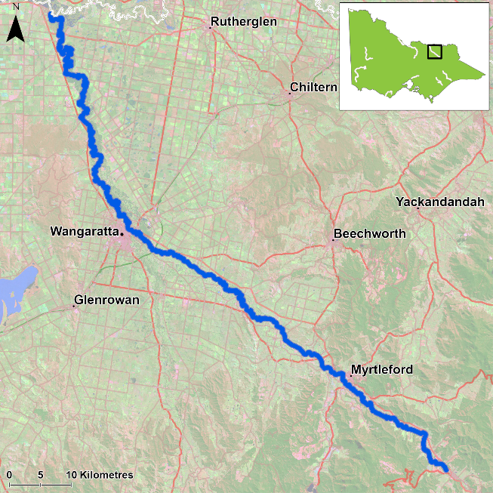
Figure 1. Map showing the section of Ovens River where NFRC sampling occurs

Environment
In 2025, river flows were the lowest recorded across all NFRC surveys. Low flows were also recorded from 2017-19 and 2024, with higher flows encountered in the 2020-23 sampling events. The higher flows present in 2020-23 impacted the sampling efficiency, especially for small-bodied species or small individuals of large-bodied species. The 2020-23 survey results are therefore likely lower than comparable sampling conditions in 2017-19 and 2024-25.

Waterway and fisheries management efforts in the Ovens River
Many rehabilitation actions have occurred, and are underway, to improve the health of the Ovens River and its suite of large-bodied native fish species including Murray Cod, Trout Cod, Golden Perch and Macquarie Perch. These are informed by the North East Waterway Strategy 2014-22. In particular, since 2008, there has been a large scale coordinated effort by many government agencies and the community to protect and plant native streamside vegetation, install instream woody habitat and fishways to improve fish passage, and remove Carp. These efforts include the Demonstration Reach program and targeted monitoring for Macquarie Perch and Trout Cod, as well as reintroduction and recovery efforts. The North East Catchment Management Authority, DEECA and the Victorian Fisheries Authority support rehabilitation and management of the Ovens River and its fish community.

Golden Perch

Ovens River, North East region

Key Health Indicators
Recent recruitment No
Multiple size classes No
Mature fish present Yes

Monitoring Results
Total number of fish caught 21
Fish per 1km of waterway 2.56
Largest fish by length (cm) 48.2
Largest fish by weight (kg) 2.33
% of the catch that is legal size 100

Low abundances of Golden Perch (Macquaria ambigua) have been recorded each year during NFRC surveys, although abundances in 2023, 2024 and 2025 were over double the next highest year (2021) (Figure 2). In the 2025 survey, Golden Perch were generally evenly distributed between the eight most downstream sites between Tarrawingee and Boorhaman North. No Golden Perch have been recorded upstream of the Tarrawingee site. Only adults were recorded in 2025 (Figure 2; Figure 3). The fate of Golden Perch stocked in recent years is unclear. Recruits of this species are difficult to catch using this sampling methodology of electrofishing and none have been detected during the nine years of sampling (Figure 2; Figure 3). Adult Golden Perch have only been recorded upstream of Wangaratta in 2021–25. The large flooding of 2022 may have led to fish immigrating into and dispersing up the system from the Murray River and Lake Mulwala.

Stocking
In 2016 no Golden Perch were stocked; 30,000 were stocked in 2017; 50,293 in 2018; 51,000 in 2019; 54,000 in 2020; 50,000 in 2021; 54,000 in 2022; 50,000 in 2023; 31,900 in 2024 and 19,000 in 2025 (after NFRC surveys).
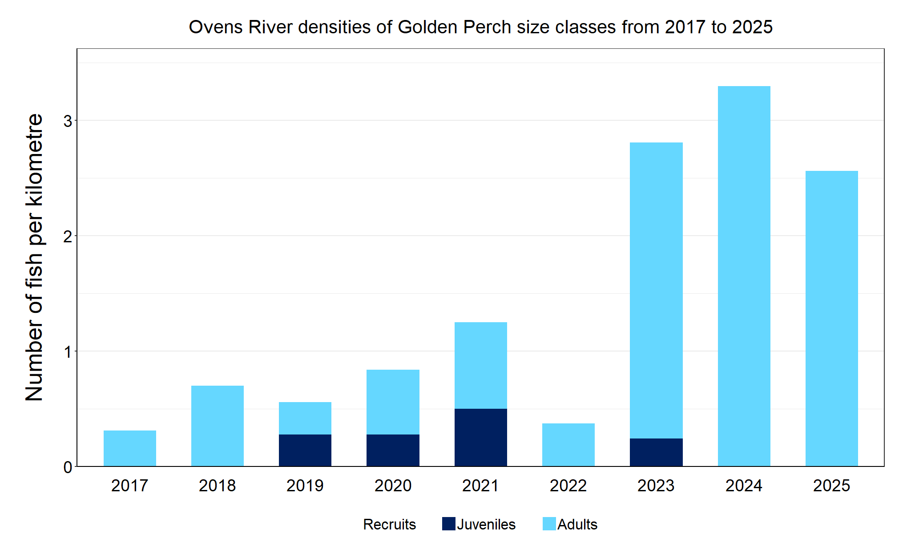
Figure 2. The densities of recruits, juveniles and adult Golden Perch in the Ovens River from 2017 to 2025.

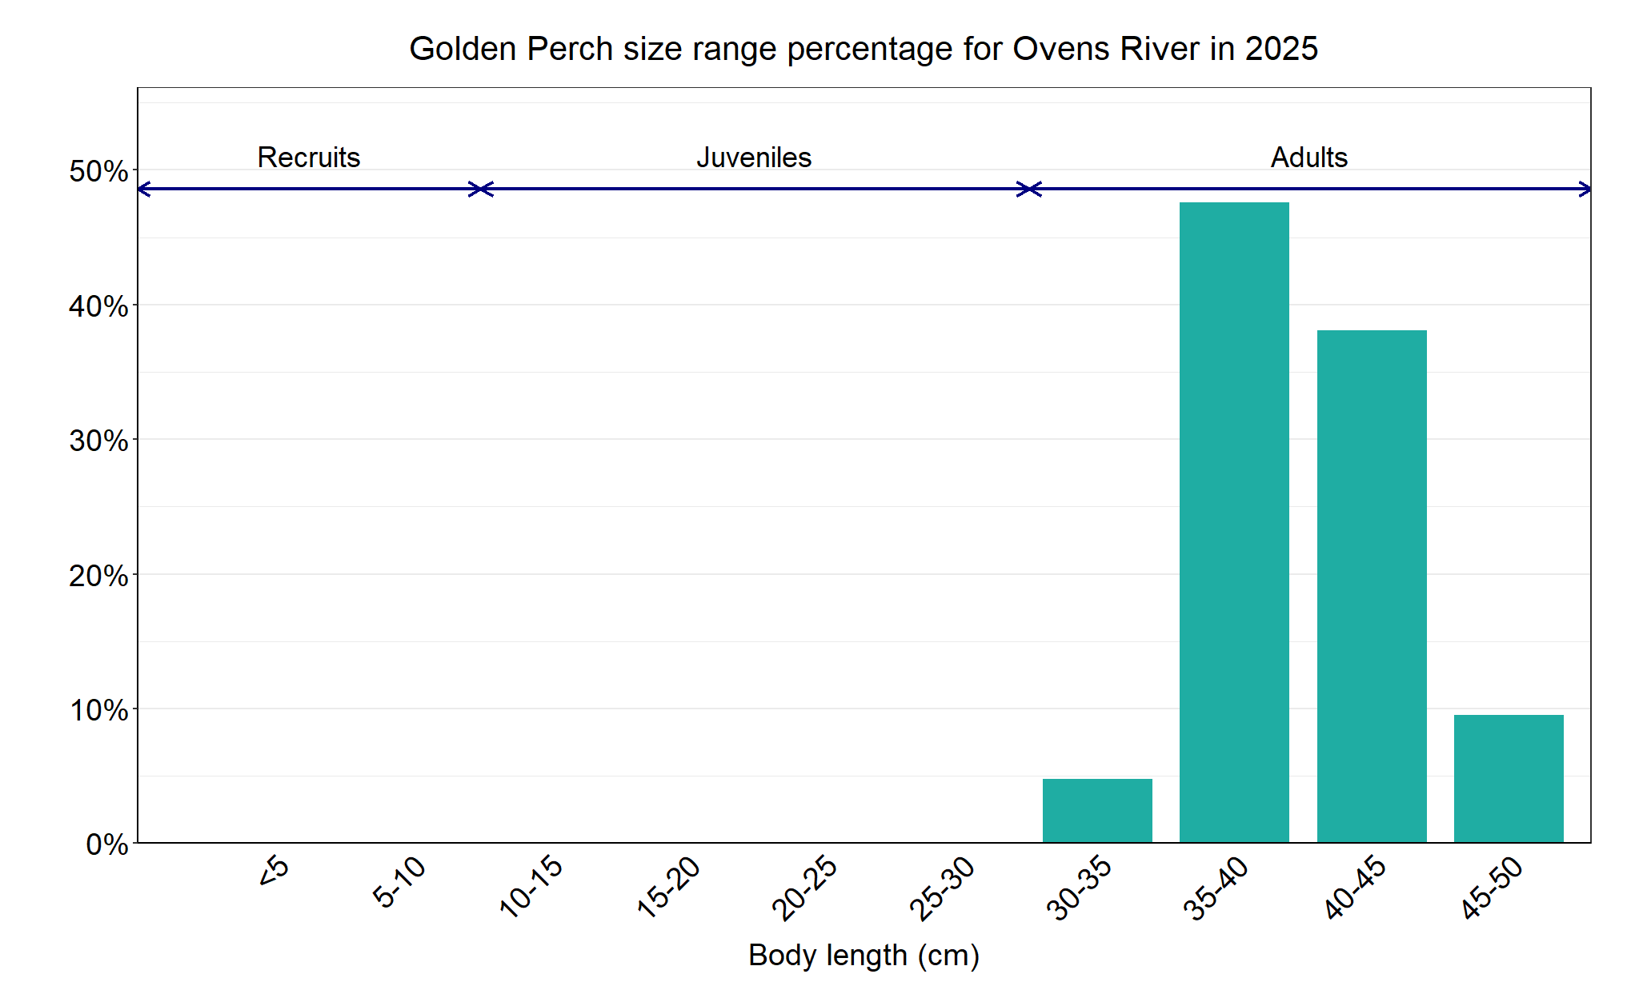
Figure 3. The size range percentage of Golden Perch in the Ovens River in 2025.

Macquarie Perch

Ovens River, North East region

Key Health Indicators
Recent recruitment Yes
Multiple size classes Yes
Mature fish present Yes

Monitoring Results
Total number of fish caught 150
Fish per 1km of waterway 18.29
Largest fish by length (cm) 38.8
Largest fish by weight (kg) 1.05
% of the catch that is legal size NA#

# This species is a Protected Freshwater Species and taking or possessing is prohibited (Victorian Recreational Fishing Guide 2025)

Most Macquarie Perch (Macquaria australasica) recorded during each year of NFRC surveys have been juveniles (Figure 4; Figure 5), with recruitment recorded in all years except 2021. A large increase of adult fish was detected in 2023 and 2024, indicating the fish are surviving to maturity (Figure 4). The highest abundance of juveniles was detected in the 2025 survey, but it is unknown if these are stocked fish or from wild breeding.
In the 2025 survey, Macquarie Perch were collected from eight sites from Apex Park in Wangaratta to Porepunkah. No Macquarie Perch were detected downstream of Wangaratta. In 2023 the first detections of Macquarie Perch were recorded downstream of Wangaratta; two juveniles and one recruit were recorded from three separate sites. Future monitoring will determine if Macquarie Perch continues to extend its range downstream and if past management actions to establish a population with natural recruitment have been successful. Given the species is long-lived and has undergone population crashes shortly after establishment in other areas², continued monitoring is critical to track the success of the establishment of this species in the Ovens system.

Stocking
Stocking of fingerlings started in the Ovens River in 2011, and translocations from Lake Dartmouth started in 2014. Stockings relevant to NFRC survey areas include: 6400 fingerlings and 62 adult fish (ex-broodfish) into the Ovens River in 2016; 8300 fingerlings and 675 translocated fish in 2017; 15,000 fingerlings, 10 adult broodfish and 474 translocated fish in 2018 (following NFRC surveys); 7500 fingerlings in 2019; 700 fingerlings in 2020; 32,000 fingerlings in 2021; 40,000 fingerlings in 2022; 10,500 in 2023; 10,000 in 2024 and 10,000 in January 2025. In addition, 15,300 Macquarie Perch fingerlings have been stocked into the King River in 2022; 4,950 in 2023; 25,050 in 2024 and 10,000 in 2025. All translocations involved a range of sizes from young-of-year to adults.
²Lintermans et al. (2013) The rise and fall of a translocated population of the endangered Macquarie Perch Macquaria australasica in south-eastern Australia. Marine and Freshwater Research 64(9): 838.
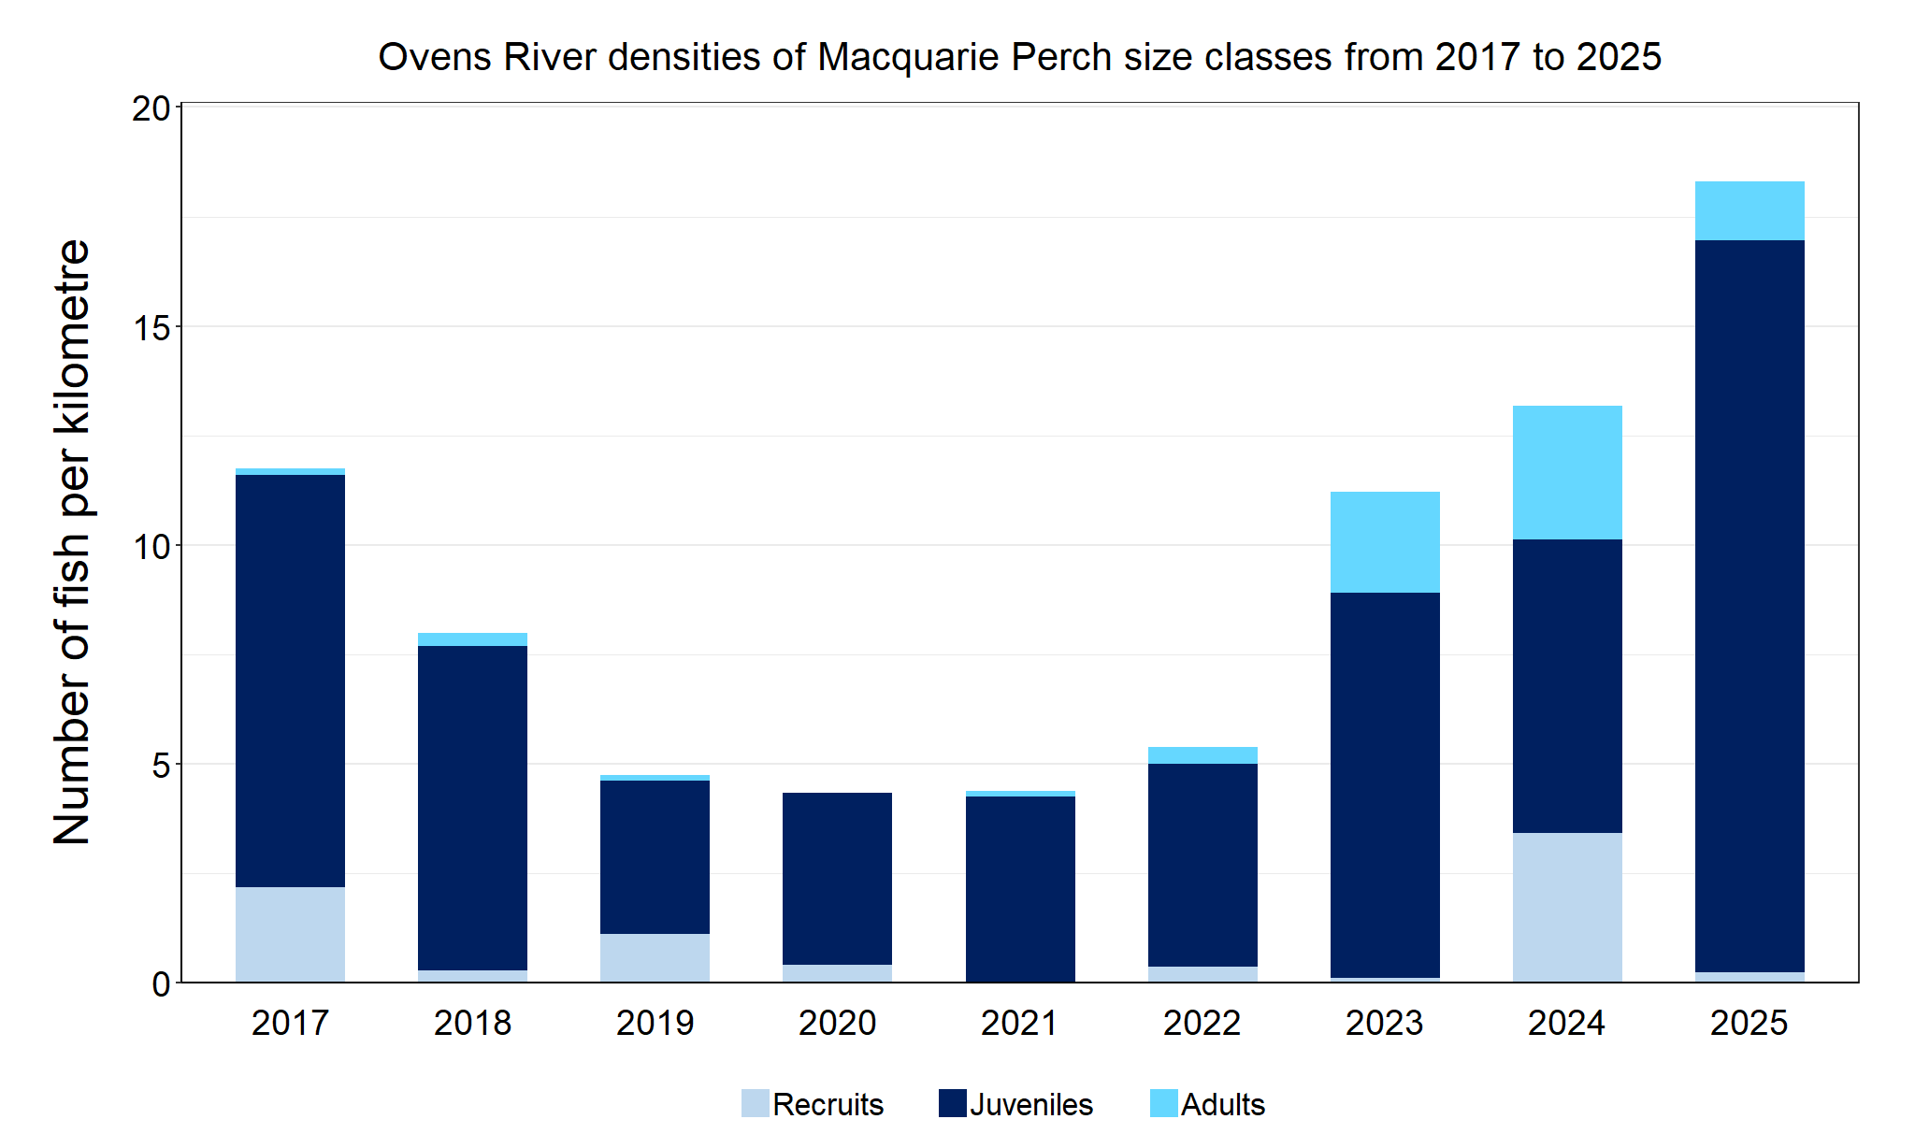
Figure 4. The densities of recruits, juveniles and adult Macquarie Perch in the Ovens River from 2017 to 2025.

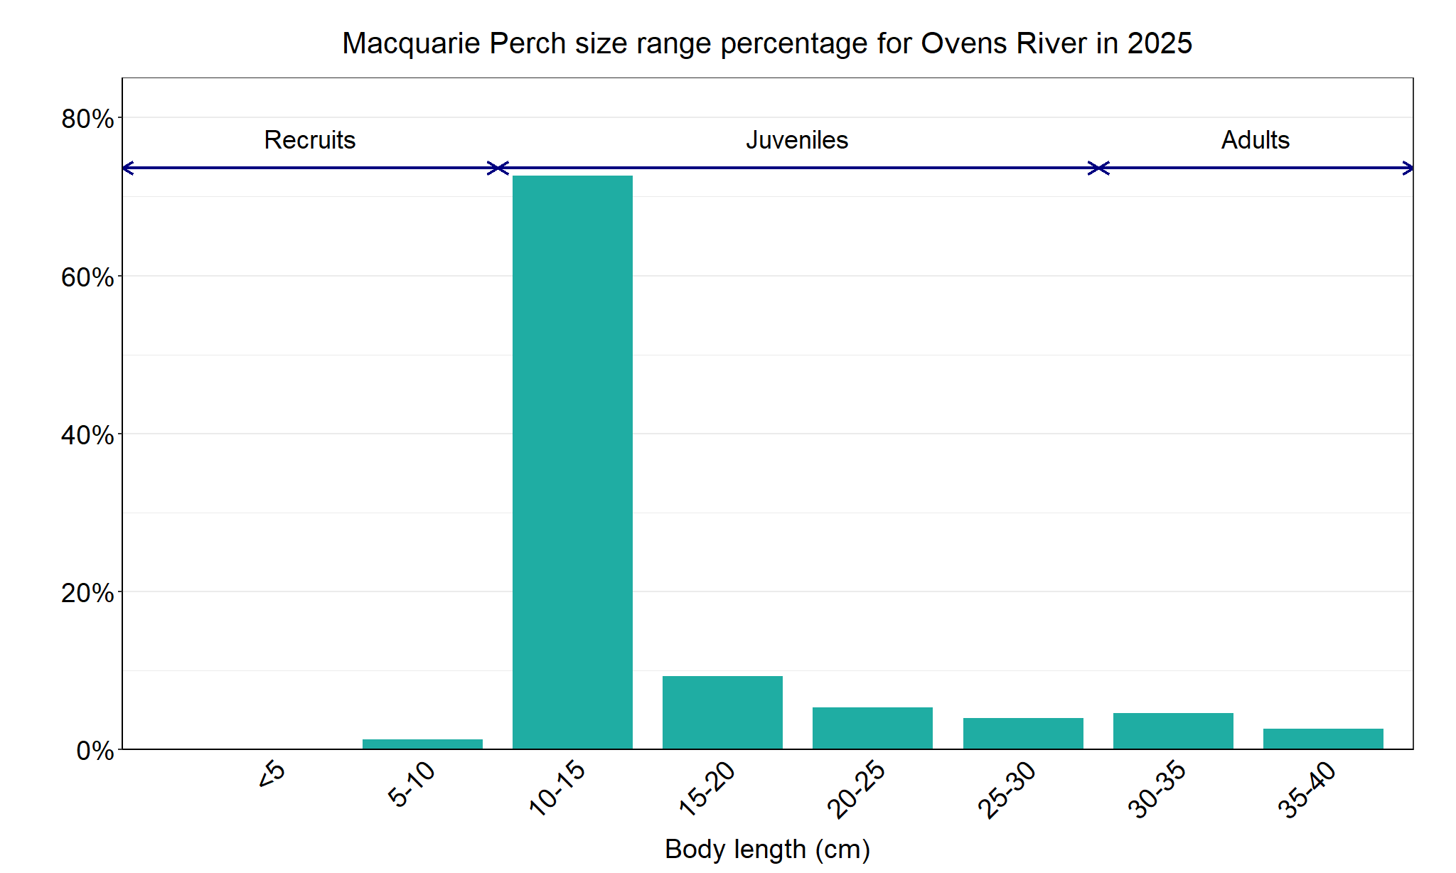
Figure 5. The size range percentage of Macquarie Perch in the Ovens River in 2025.

Murray Cod

Ovens River, North East region

Key Health Indicators
Recent recruitment Yes
Multiple size classes Yes
Mature fish present Yes

Monitoring Results
Total number of fish caught 185
Fish per 1km of waterway 22.56
Largest fish by length (cm) 98.0
Largest fish by weight (kg) 17.35
% of the catch that is legal size 25

Multiple size classes of Murray Cod (Maccullochella peelii), including adults, juveniles and recruits have been caught in all nine NFRC surveys, including in the 2025 survey (Figure 6). An increase in Murray Cod recruits (5-15cm) captured in 2025 (Figure 7) could possibly be linked to lower river flows at the time of sampling resulting in greater fishing efficiency for smaller size classes. Murray Cod were detected at every site surveyed in 2025. As no Murray Cod stocking occurs in the Ovens River, it is likely that a large proportion of Murray Cod recorded are natural recruits. The abundances of Murray Cod, evidence of annual recruitment, and wide range of size classes including large adults indicate that the population is healthy in the system. This is supported by the fact that the Ovens River had the highest number of fish per kilometre surveyed compared to the other NFRC rivers that targeted Murray Cod (Goulburn, Gunbower and Lindsay-Mullaroo).

Stocking
No stocking has occurred in the area surveyed post 1990.

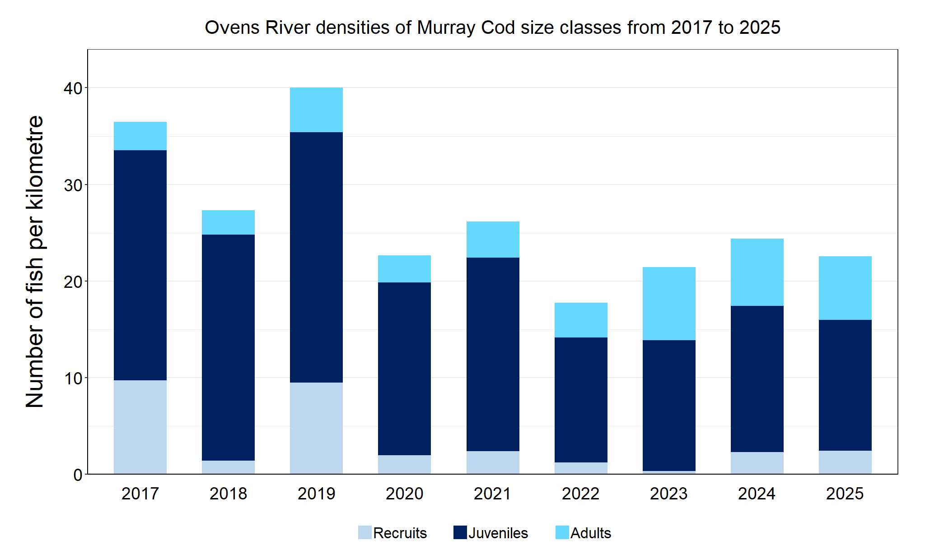
Figure 6. The densities of recruits, juveniles and adult Murray Cod in the Ovens River from 2017 to 2025.

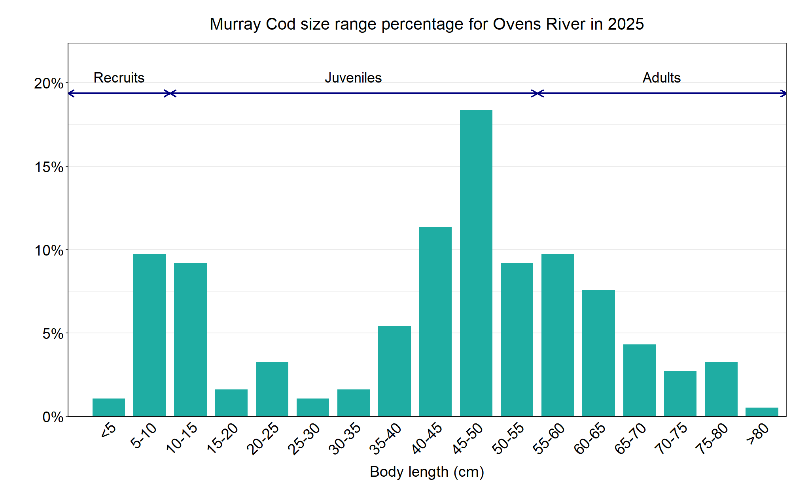
Figure 7. The size range percentage of Murray Cod in the Ovens River in 2025.

Trout Cod

Ovens River, North East region

Key Health Indicators
Recent recruitment Yes
Multiple size classes Yes
Mature fish present Yes

Monitoring Results
Total number of fish caught 82
Fish per 1km of waterway 10
Largest fish by length (cm) 56.2
Largest fish by weight (kg) 2.01
% of the catch that is legal size NA#

# This species is a Protected Freshwater Species and taking or possessing is prohibited (Victorian Recreational Fishing Guide 2025)

The abundance of Trout Cod (Maccullochella macquariensis) in the 2025 survey was the second highest recorded in the nine years of NFRC surveys (Figure 8). A wide size range of fish was recorded in 2025 with most fish being juveniles (Figure 9). The lower abundance of fish recorded in 2020 correlated with higher flows and associated high turbidity which would have reduced the likelihood of capturing fish. The wide size range and detection of recruits (seven of nine years), juveniles (all nine years) and adults (all nine years) indicate that conditions in the Ovens River are supporting the recruitment and survival of this species throughout its lifecycle.

Stocking
No Trout Cod stocking has occurred in the Ovens River system since 2006, however 15,000 fingerlings were stocked into the King River in January 2024 and 30,000 in December 2024.

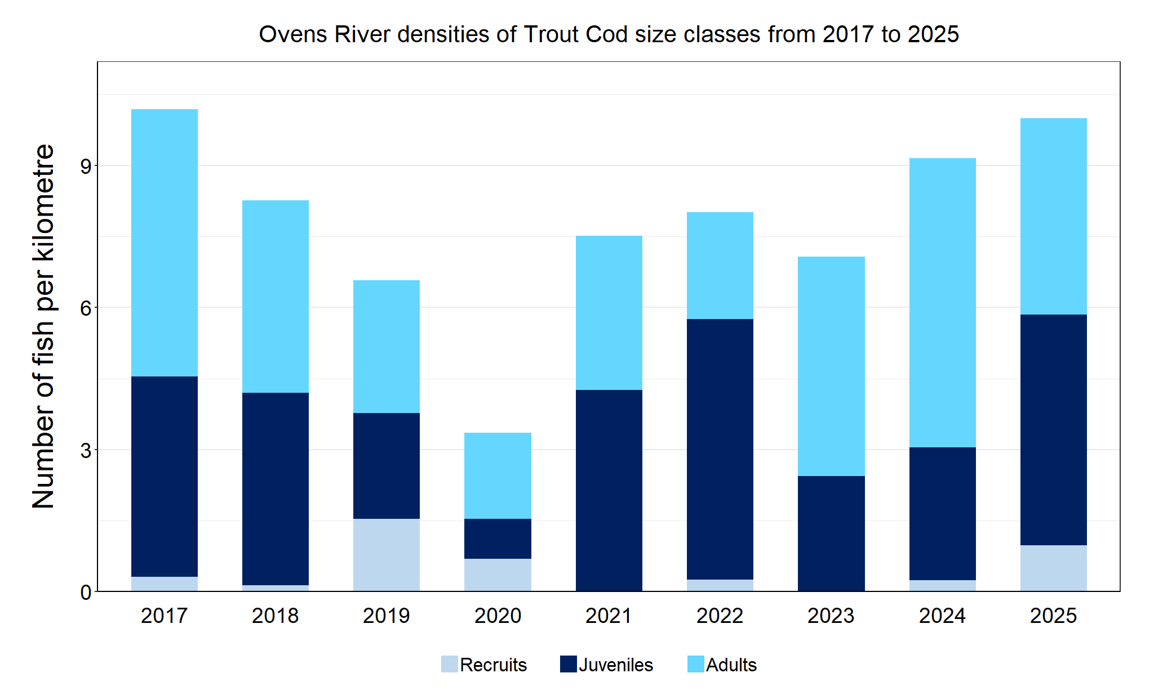
Figure 8. The densities of recruits, juveniles and adult Trout Cod in the Ovens River from 2017 to 2025.

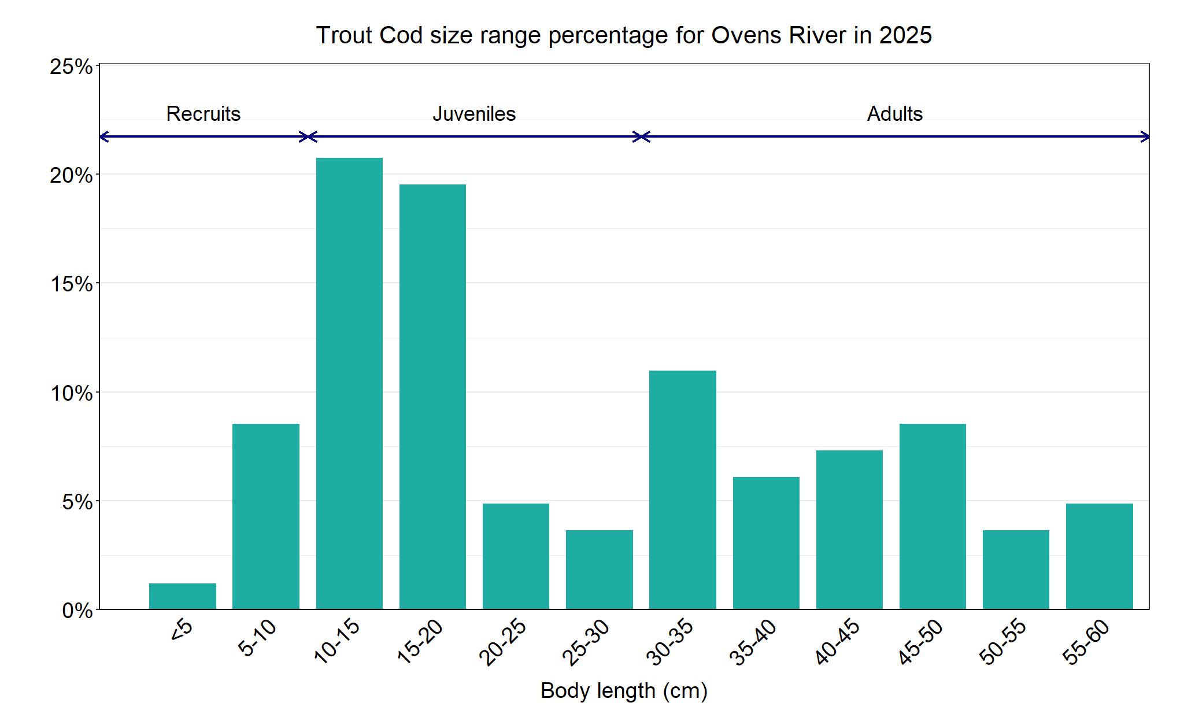
Figure 9. The size range percentage of Trout Cod in the Ovens River in 2025.

We acknowledge and respect Victorian Traditional Owners as the original custodians of Victoria’s land and waters, their unique ability to care for Country and deep spiritual connection to it. We honour Elders past and present whose knowledge and wisdom has ensured the continuation of culture and traditional practices.
© The State of Victoria Department of Energy, Environment and Climate Action 2025. This work is licensed under a Creative Commons Attribution 4.0 International licence. To view a copy of this licence, visit creativecommons.org/licenses/by/4.0/ ISSN 2981-9075 Online (pdf/word)

