|  |
| --- |
| Impacts of Rabbits in Wetlands |
| Fact Sheet 1 |

## Victorian distribution and habitats

Wild Rabbits occur throughout Victoria in a range of habitats from subalpine to stony deserts and subtropical grasslands to wet coastal plains. They are particularly abundant in Mediterranean-type climates, but not usually in dense forests, black soil plains or above 1600 m elevation1.

Soils are a major factor influencing local and regional distribution. Rabbits prefer well-drained deep soils and warrens are more prevalent on lower slopes and flats which are usually areas that are highly productive in terms of pasture2. Rabbit densities are greatest in non-arable rough country including creeks and river banks, erosion gullies, rocky outcrops and forest-grassland interfaces3. Wetlands are particularly well suited for Rabbits due to suitable soils for warren construction. Many significant Victorian wetlands and adjacent habitats have been impacted by Rabbits, including the Kerang Lakes, Winton wetlands, Hattah-Kulkyne Lakes, Phillip Island wetlands, Cheetham wetlands and urban wetlands in the Yarra basin.

## Recruitment and mortality

Does (female Rabbits) can reproduce at any time of the year, if food is available and the territorial breeding groups are led by a dominant pair. Breeding is only absent in hot summers. Gestation lasts 1 month with about four or five kittens per litter. A female may produce five or six litters per year. Kittens remain in the nest for 3-4 weeks drinking milk from the doe. Kittens can become sexually mature at 4 months old and Rabbits can live for up to 6 or 7 years but 1-2 years is a more typical lifespan. Annual survival of adults is about 50% and only 3-5% of kittens survive to breed2. Natural mortality rates are high but variable, caused by illness (including myxomatosis and Rabbit haemorrhagic disease virus (RHDV), formerly known as calicivirus) and from predators (e.g. Feral Cats, Foxes, Dingoes and avian raptors). Increased genetic resistance by Rabbits to myxomatosis and RHDV has lessened their effectiveness over time4.

## Diet

Rabbits are highly resilient to harsh environmental conditions, including extended periods of poor nutrition. As herbivores, Rabbits eat a wide variety of plants, including: green grass, herbs, young seedlings, pastures, roots and crops. Rabbits can often graze plants to ground level and they eat up to one-third of their body weight per day. Even at moderate densities (e.g. five Rabbits per ha) they can remove half the pasture produced in an average year in Australia’s arid-zone5. Rabbits gain moisture from their food and do not need access to water, except in semi-arid areas. They pass hard droppings, usually from eating plant stalks, or they pass soft droppings which are often re-eaten to maximize nutrient uptake.

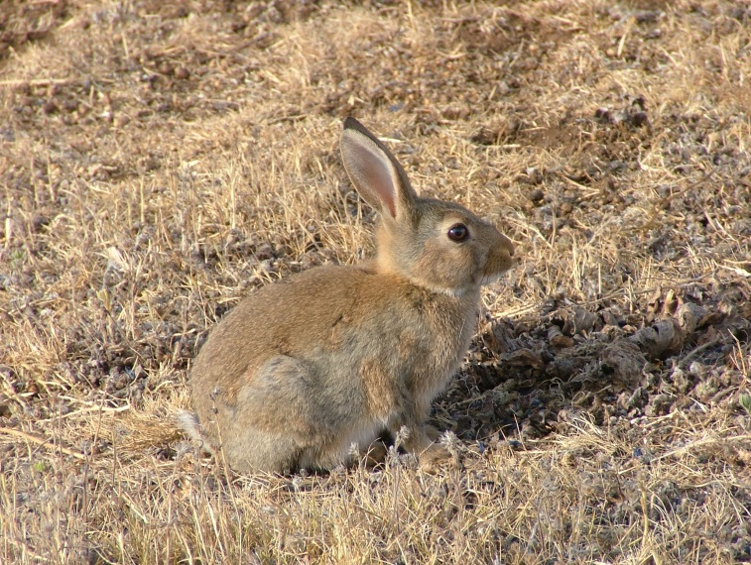

Figure 1: The environmental and economic impacts of Rabbits in Australia are significant (Photo: Department of Economic Development, Jobs, Transport and Resources).

## Rabbit warrens

Rabbits live in a series of burrows called warrens, which may have multiple entrances, and are a key to their success. Warrens provide a place to rear young, hide from predators, avoid temperature extremes, and also enable Rabbits to live in open areas such as grasslands and pasture. Where there is abundant surface cover Rabbits may also live above ground. Warrens take years or even decades to build and tend to be inherited by female Rabbits.

## Home range and dispersal

The centre of Rabbit activity is the warren system. The size of an individual Rabbit’s home range is influenced by population density, season, feed availability, sex, age, and surface cover. Male home ranges are typically larger than females. When food is not limited most Rabbits graze within 300 m from the warren. When food is scarce, Rabbits routinely move 800 m or sometimes 1500 m. Young Rabbits (i.e. 1-2 months old) can disperse up to 20 km and these are often males. The recolonization of warrens that have been ripped is strongly influenced by both the distance to, and size of, neighbouring active warrens6. Rabbits appear to prefer to recolonise larger warrens compared to smaller ones.

|  |  |
| --- | --- |
| Common Name | Scientific Name |
| Drooping sheoak | *Allocasuarina verticillata* |
| Sweet bursaria | *Bursaria spinosa* |
| Belah | *Casuarina pauper* |
| Umbrella wattle | *Acacia ligulata* |
| Golden wattle | *Acacia pycnantha* |
| Hopbush | *Dodonaea viscosa* |
| Buloke | *Allocasuarina luehmannii* |
| Manna gum | *Eucalyptus viminalis* |
| White cypress | *Callitris glaucophylla* |
| Cassias | *Cassia* spp. |
| Ti-tree | *Melaleuca halmaturorum* |

Table 1. A selection of native plants upon which Rabbits have major impacts.

Impacts

The impact of Rabbits on the Australian environment has been disastrous. Rabbits compete with native wildlife for food and shelter and nationally impact 73 species of fauna, 260 listed plants species and nine endangered ecological communities7. Ecological changes linked with high Rabbit numbers have been blamed for the disappearance of threatened native species such as bandicoots, bettongs, bilbies and quolls, and for putting many other species under stress.

The economic impact of Rabbits is enormous; with >$206 million in annual production losses to the pastoral and agricultural sectors, five times greater the losses than from wild dogs and almost ten times greater than the losses caused by foxes and mice 7,8,9,10.

## Impacts on wetlands

Wetlands are particularly sensitive to Rabbit impacts due to their inherent high flora and fauna biodiversity values, their elevated deep soils and more limited Rabbit management opportunities relative to agricultural land. The damage Rabbits cause to wetlands is particularly severe because they:

* preferentially graze on native versus exotic plants
* encourage the growth of weeds
* disturb riparian soils
* contribute to runoff and water quality impacts
* can degrade the cultural value of wetlands2.

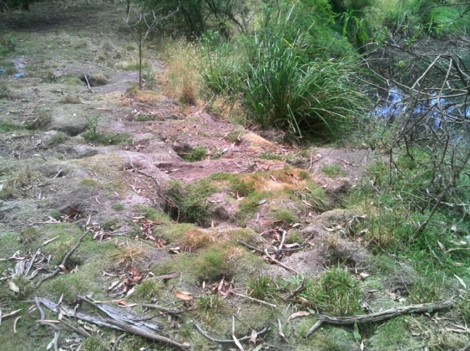

Figure 2: A Rabbit warren on a wetland margin causing soil and vegetation disturbance (Photo: Ivor Stuart).

## Impacts on native plants

Rabbits impact on native plants by ringbarking, grazing and browsing, and preventing regeneration of seedlings. They selectively graze on native vegetation and can prevent seedlings from regenerating contributing to landscape degradation. As little as one Rabbit per hectare can prevent many sensitive tree species from regenerating. Rabbits preferentially graze on native vegetation versus exotic plants, thereby increasing weed abundance and damaging ecosystem function11. There is very strong experimental evidence which quantifies the impacts of Rabbits on a variety of native plants. Rabbits have a major impact on native plants and even at low densities can completely remove seedlings of palatable species and significantly damage non-palatable species (Table 1)(12-16). Native vegetation is then often replaced by noxious weeds.

Recent information suggests that Rabbits contribute to a significant loss of carbon storage in above-and-below ground woody biomass17. In wetland environments, even at very low densities where Rabbits are barely noticeable to conservation managers, their effect on palatable plant species can still be severe and there can be widespread impacts and damage to ecosystem function15.

Much of the Victorian work on vegetation impacts of Rabbits has been in the arid and semi-arid habitats of north western Victoria. There has also been long-term research in the temperate Werribee River catchment16. This research work indicates that, for some seedling species, there may be no safe Rabbit density. The impact of Rabbits on wetland plants is poorly known and requires targeted research.

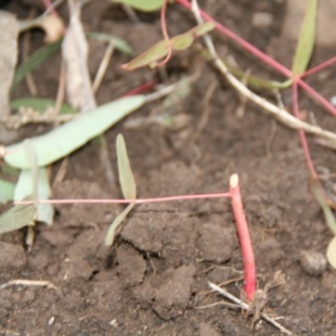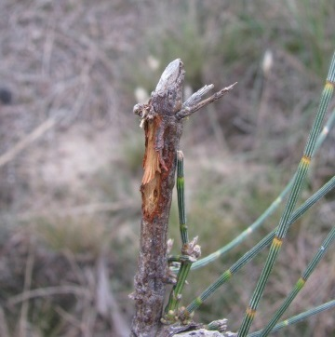

Figure 3: Rabbits can have a major impact on the survival of many native plants (Photo: Ivor Stuart).

## Density thresholds and plant impacts

For sensitive vegetation, Rabbit densities as low as 0.5 Rabbits/ha can reduce regeneration prospects by >50%14,18. This means that it only takes one Rabbit per two football field sized paddocks to affect many native species. For slow growing species, such as mulga or highly palatable species, such as sheoak and buloke there is a high likelihood that these will become extinct throughout their range if Rabbits continue to prevent regeneration of seedlings15,19.

|  |
| --- |
| For managers, defining an acceptable Rabbit density based on their impact threshold e.g.   * <3 Rabbits/ha for non-sensitve species and * <1 Rabbit/ha for palatable species   provides a very important guide for setting both a clear objective for Rabbit control and a recovery vision for the landscape. |

## Vectors for spread and growth of weeds

There is strong evidence that warren areas seasonally support the growth of dense patches of weeds, such as horehound, nettles, and thistles20. Rabbits routinely feed away from the warrens and on their return bring a wide variety of seeds back to the nutrient rich, warren areas for cultivation. The intense grazing around the warren areas removes the more desirable plant species and allows the less palatable weed species to flourish. Weed covered warrens can then provide a source for the spread of weeds into the surrounding areas.

## Impacts on soil

Construction of warrens is an ongoing process which leads to extensive and sustained soil disturbance, especially along river banks and wetland margins20,21. The ideal location for warrens are along elevated, well drained, deep sandy or granitic soils situated adjacent to floodplains, wetlands or watercourses where green forage persists for longer periods or responds quickly to rain2. Soil depth, hardness and permeability to water are major factors that determine the suitability of the substrate for burrowing2. Deep, friable, elevated, sandy soils are optimal for burrowing. Soils with high clay content are not suitable for warrens as they are too wet in winter causing significant mortalities in newborns through hypothermia and drowning3. New burrows are not readily constructed when Rabbit numbers increase.

In good years, Rabbits tend to expand existing warren systems rather than build new warrens22. In the absence of warrens Rabbits can also exist above ground where there is abundant surface harbour. Fallen timber or logs, rocks, dense thickets of native scrub or woody weeds and heaps of debris create ideal shelter for Rabbits.

## Impacts on water quality

There is strong anecdotal evidence that Rabbits impact on water quality by disturbing soil in catchment areas. Persistent high grazing pressure from Rabbits removes ground cover to expose the soil surface to wind and water erosion resulting in increased run-off and silting of waterways and reservoirs23. The extent that Rabbits contribute to wetland siltation and eutrophication is unknown but riparian habitats are among the most susceptible to Rabbit damage through overgrazing that leads to erosion2.

## Impacts on cultural value of wetlands

Wetlands can be sites of great cultural significance and without effective Rabbit control native vegetation and animals which rely on these habitats cannot be expected to recover24. Within 30 years of the Rabbits' arrival, important totemic animals like Rabbit bandicoots disappeared, leaving the people not only short of traditional game but also culturally bereft25. However, with restoration of degraded wetland ecosystems there are direct biodiversity benefits with population increases in native herbivores, such as wombats15. In combination, recovery of flora and fauna biodiversity, especially in wetlands, can contribute to the well-being of rural and regional communities17,26.

## Climate change

Climate change may exacerbate the impacts of pest animals in some areas and reduce them in others. For Rabbits, increasing temperatures may reduce their abundance in semi-arid zones due to declines in reproduction as these areas become hotter and more arid27. However, climate change may also reduce ecosystem resilience and alter seasonally food limited environments to advantage Rabbits in other areas28.

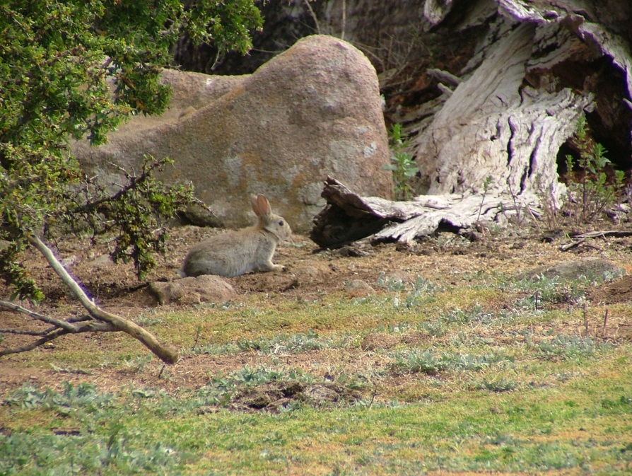

Figure 4: Rabbits occur throughout Victoria in a range of habitats (Photo: Department of Economic Development, Jobs, Transport and Resources).

## References

1. Menkhorst, P.W. (1995). Mammals of Victoria: Distribution, Ecology and Conservation. Oxford University Press, Melbourne.

2. Williams, K., et al. (1995). Managing vertebrate pests: rabbits. Australian Government Publishing Service, Canberra, ACT, Australia.

3. Myers, K., et al. (1995). The Rabbit in Australia. In: Thompson, H.V. and King, C.M. (eds). The European Rabbit – The history and biology of a successful colonizer. Oxford University Press, pp. 158-200.

4. Mutze, G., et al. (2015). Recovery of South Australian rabbit populations from the impact of rabbit haemorrhagic disease. *Wildlife Research* **41**, 552-559.

5. Cooke, B.D. (2015). Daily food intake of free-ranging wild rabbits in semiarid South Australia. *Wildlife Research* **41**, 141-148.

6. Ramsey, D. S. L. et al. (2014). Recolonisation of rabbit warrens following coordinated ripping programs in Victoria, south-eastern Australia. *Wildlife Research* **41**, 46-55.

7. Commonwealth of Australia (2015). Draft Background document to the Threat abatement plan for competition and land degradation by rabbits. Department of the Environment.

8. Department of Primary Industries (2012). Established Invasive Animals. Training manual. Published by the Department of Primary Industries Biosecurity Victoria Division, November 2012. The State of Victoria 2012.

9. Cooke, B., et al. (2013). The economic benefits of the biological control of rabbits in Australia, 1950–2011. *Australian Economic History Review* **53**, 91-107.

10. Gong, W. et al. (2009). The economic impacts of vertebrate pests in Australia, Invasive Animals Cooperative Research Centre Canberra.

11. Parker, J.D., et al. (2006). Opposing effects of native and exotic herbivores on plant invasions. *Science* **311**, 1459-1461.

12. Cooke, B.D. (1987). The effects of rabbit grazing on regeneration of sheoaks, *Allocasuarina verticillata*, and saltwater ti-trees, *Melaleuca halmaturorum*, in the Coorong National Park, South Australia. *Australian Journal of Ecology* **13**, 11–20.

13. Denham, A.J. and Auld, T.D. (2004) Survival and recruitment of seedlings and suckers of trees and shrubs of the Australian arid zone following habitat management and the outbreak of Rabbit Calicivirus Disease (RCD). *Austral Ecology* **29**, 585–99.

14. Cooke, B.D. (2008). Rabbits: A threat to conservation and natural resource management. How to rapidly assess a rabbit problem and take action. Available at: (<http://www.feral.org.au/wp-content/uploads/2010/03/BRS_Rabbit_Booklet_lr.pdf>).

15. Bird, P., et al. (2012). Damage caused by low-density exotic herbivore populations: the impact of introduced European rabbits on marsupial herbivores and *Allocasuarina* and *Bursaria* seedling survival in Australian coastal shrubland. *Biological Invasions* **14**, 743–755.

16. Forsyth, D. M., et al. (2015). Density-dependent effects of a widespread invasive herbivore on tree survival and biomass during reforestation. *Ecosphere* **6**, 71.

17. Bengsen, A. and Cox, T. (2012). The role of rabbit and other invasive herbivore control in reducing Australia’s greenhouse gas emissions. Pest Smart Toolkit publication. Invasive Animal Cooperative Research Centre, Canberra, Australia.

18. Cooke, B.D. (2012). Planning landscape-scale rabbit control, PestSmart Toolkit publication, Invasive Animals Cooperative Research Centre, Canberra, Australia.

19. Mutze, G. et al. (2008). Geographic and seasonal variation in the impact of rabbit haemorrhagic disease on European rabbits, *Oryctolagus cuniculus*, and rabbit damage in Australia, in: C. Alves, N.F.a.K.H. (Ed.), Lagomorph Biology: Evolution, Ecology and Conservation. Springer-Verlag, Berlin, pp. 279-293.

20. Eldridge D. J. and Simpson R. (2002). Rabbit (*Oryctolagus cuniculu*s L.) impacts on vegetation and soils, and implicationsfor management of wooded rangelands. *Basic and Applied Ecology* **3**, 19–29.

21. Eldridge, D.J. and Myers, C.A. (2001). The impact of warrens of the European rabbit (*Oryctolagus cuniculus* L.) on soil and ecological processes in a semi-arid Australian woodland. *Journal of Arid Environments* **47**, 325-337.

22. Parer, I. (1977). The population ecology of the wild rabbit *Oryctolagus cuniculus* (L.) in a Mediterranean- type climate in New South Wales. *Australian Wildlife Research* **4**, 171–205.

23. Eldridge, D. J., et al. (2006). Short-term vegetation and soil responses to mechanical destruction of rabbit (*Oryctolagus cuniculus* L.) warrens in an Australian box woodland. *Restoration Ecology* **14**, 50–59.

24. McPhee, S. R., and K. L. Butler. (2010). Long-term impact of coordinated warren ripping programmes on rabbit populations. *Wildlife Research* **37**, 68–75.

25. Cooke, B.D. (2015). Effects of Pastoralism and Rabbits on the Economy and Culture of the Diyari People of North Eastern South Australia. Australian Economic History Review.

26. Cooke, B.D. (2014). Australia’s war against rabbits. The RHDV story. CSIRO publishing.

27. Pavey, C.R. and Bastin, G. (2014). Australian rangelands and climate change - invasive animals. Ninti One Limited and CSIRO, Alice Springs.

28. Latham, A. D. M., et al. (2015). Climate change turns up the heat on vertebrate pest control. *Biological Invasions* **17**, 2821-2829.

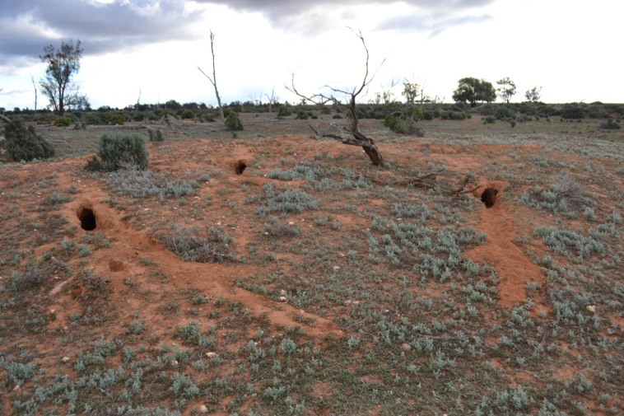

Figure 5: A Rabbit warren has caused significant soil and vegetation disturbance (Photo: Ivor Stuart).

Websites

Department of Economic Development, Jobs, Transport and Resources - <http://agriculture.vic.gov.au/agriculture/pests-diseases-and-weeds/pest-animals/a-z-of-pest-animals/european-rabbit>

Invasive Animal CRC -

[http://www.pestsmart.org.au/pest-animal-species/european-rabbit/](http://www.pestsmart.org.au/pest-animal-species/european-rabbit/ )

|  |  |
| --- | --- |
| © The State of Victoria Department of Environment, Land, Water and Planning 2017  LogoThis work is licensed under a Creative Commons Attribution 4.0 International licence. You are free to re-use the work under that licence, on the condition that you credit the State of Victoria as author. The licence does not apply to any images, photographs or branding, including the Victorian Coat of Arms, the Victorian Government logo and the Department of Environment, Land, Water and Planning (DELWP) logo. To view a copy of this licence, visit http://creativecommons.org/licenses/by/4.0/  ISBN 978-1-76047-418-8 (print)  ISBN 978-1-76047-419-5 (pdf)  Disclaimer  This publication may be of assistance to you but the State of Victoria and its employees do not guarantee that the publication is without flaw of any kind or is wholly appropriate for your particular purposes and therefore disclaims all liability for any error, loss or other consequence which may arise from you relying on any information in this publication. | Accessibility  If you would like to receive this publication in an alternative format, please telephone the DELWP Customer Service Centre on 136186, email [customer.service@delwp.vic.gov.au](mailto:customer.service@delwp.vic.gov.au) or via the National Relay Service on 133 677 [www.relayservice.com.au](http://www.relayservice.com.au). This document is also available on the internet at [www.delwp.vic.gov.au](http://www.delwp.vic.gov.au). |