
Native Fish Report Card 2025
Lower Goulburn River
Goulburn Broken Region

This report card summarises the 2025 Native Fish Report Card (NFRC) survey in the Lower Goulburn River
Sites: 11, Electrofishing

Fish found in Lower Goulburn River for NFRC
Target species
Golden Perch
Murray Cod
Silver Perch
Trout Cod

Non-target species captured since 2017*
Large-bodied native species
Bony Bream
River Blackfish

Small-bodied native species
Australian Smelt
Carp Gudgeon
Flatheaded Gudgeon
Murray-Darling Rainbowfish
Unspecked Hardyhead

Exotic species
Common Carp
Eastern Gambusia
Goldfish
Oriental Weatherloach
Redfin
Roach

* These non-target species were incidentally captured during NFRC surveys since 2017 but not measured as for target species

Lower Goulburn River 2025
Fish Community

NFRC target species
The NFRC Program began in 2017 to monitor population dynamics of key iconic fish species that have high recreational and/or conservation values, in large rivers across Victoria. In the Goulburn River, the target species are Murray Cod, Golden Perch, Silver Perch and Trout Cod. The equipment used and habitats surveyed target these species, which are measured to determine their population structures. Other fish species that are incidentally captured are counted, but not measured.
Surveys occur in April/May each year, at 11 sites from just downstream of Lake Nagambie (Goulburn Weir) to upstream of the junction with the Murray River (Sun Valley). The timing of the surveys coincides with reduced flows immediately following the irrigation season, when the target species are most easily captured.
Summary of key health indicators for target species in 2025
Species | Key Health Indicators
 | Recent recruitment | Multiple size classes | Mature fish present
Golden Perch | No | Yes | Yes
Murray Cod | Yes | Yes | Yes
Silver Perch* | - | - | -
Trout Cod | No | Yes | Yes

Recent recruitment means young-of-year fish
*- cannot be determined due to low abundances

Both Silver Perch and Trout Cod were historically abundant in the lower and mid Goulburn River, with Silver Perch historically abundant up to the Nagambie area and Trout Cod present upstream of the Lake Eildon confluence. These species have experienced dramatic declines across their range, reflected in their classification as threatened species nationally under the Environment Protection and Biodiversity Conservation Act 1999. Recently, within the Goulburn River the population status of both species has improved, with Trout Cod now having a self-sustaining population downstream of Lake Nagambie and Silver Perch present, although in lower densities. Overall, the Goulburn River appears to be maintaining healthy populations of Golden Perch, Murray Cod and Trout Cod. The following pages have more detail about the population structures of each target species.

Non-target species
The non-target fish species that have been incidentally recorded in the lower Goulburn River during NFRC surveys since 2017 are:

Large-bodied native species
No non-target large-bodied native species were captured in the 2025 survey. Bony Bream has only been recorded in three of the nine NFRC surveys, and is a lowland species only expected to be found in the lower Goulburn River. It is found in lowland rivers across the Murray-Darling Basin and is intolerant of cold water. River Blackfish has been recorded in five of the nine NFRC surveys and is a lowland species, generally found at altitudes below 200 m. This species has declined in distribution and abundance across the State. It has low abundance in this section of the Goulburn River and has only been recorded near Murchison.

Small-bodied native species
Australian Smelt, Carp Gudgeon, Flatheaded Gudgeon and Murray-Darling Rainbowfish were recorded in the 2025 survey. Australian Smelt, Carp Gudgeon and Flatheaded Gudgeon are expected to be widespread throughout the Goulburn River and more broadly within the Murray-Darling Basin. Murray-Darling Rainbowfish has been recorded in all nine NFRC surveys. It was historically present to 130 m altitude in the Goulburn River system. While once widespread in the Murray-Darling Basin, its range has become more restricted. The species now has a patchy distribution and is listed under the Flora and Fauna Guarantee Act 1988 in Victoria. Previous NFRC surveys have also recorded Unspecked Hardyhead, a common widespread species throughout the Goulburn River and more broadly within the Murray-Darling Basin.
Exotic fish species
Common Carp, Goldfish and Roach were recorded in the 2025 survey. Common Carp, widely distributed in the Goulburn River, have been recorded in all nine NFRC surveys and were recorded in high abundances in 2025. Roach, encountered for the first time during NFRC surveys in 2024, are more common in the Goulburn River upstream of Goulburn Weir to Lake Eildon. Redfin, Eastern Gambusia and Oriental Weatherloach have been previously recorded in NFRC surveys. Redfin are widely distributed, albeit in low abundances and have only been recorded in 2023 and 2024. Eastern Gambusia are more common in the slower flowing waters and have been recorded in three of the nine NFRC surveys. Oriental Weatherloach, first recorded in 2020, are increasing in distribution and abundance and are found in slower flowing areas, often in silt substrate. Oriental Weatherloach often disperse during floods.

Other native fish species known from the lower Goulburn River
Some fish species known to occur in the Goulburn system have never been recorded during NFRC surveys (e.g. Freshwater Catfish, Flatheaded Galaxias, Obscure Galaxias and Southern Pygmy Perch). The two galaxiid species are hard to detect using the NFRC sampling method. Flatheaded Galaxias, Freshwater Catfish and Southern Pygmy Perch are more frequently found in offstream habitats such as billabongs, wetlands and lagoons within the Goulburn system.
Other notable species
NFRC surveys have also recorded Murray Crayfish, Yabbies and turtle species.

Environmental and Management Context

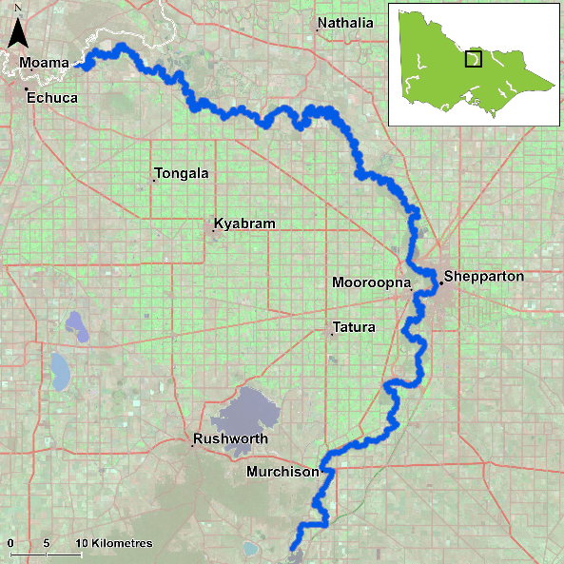
Figure 1. Map showing the section of lower Goulburn River where NFRC sampling occurs

Environment
Stream flow was marginally higher in 2018 and 2020-22 when compared to 2017, 2019 and 2023-25, due to water management (i.e. Inter Valley Transfers) and this may have decreased electrofishing efficiency in those years. During the 2020 and 2021 surveys there was elevated turbidity following earlier flooding, which also further decreased electrofishing efficiency for all species.

Waterway and fisheries management efforts in the lower Goulburn River
Many rehabilitation actions have occurred, and are underway, to improve the health of the Goulburn River and its fish community. These include revegetation, weed control and fencing of riparian areas, reintroduction of instream woody habitat, allocations of water for the environment, rubbish removal, and fish stockings. Regular monitoring of the fish community has occurred for over 10 years. Fish monitoring programs include Flow-MER (fish theme) and environmental flow assessments. Recent work has focused on the role of flows for spawning of Golden Perch and Silver Perch using drift net surveys, as well as links between flows and movements of these species using telemetry techniques. The Goulburn-Broken Catchment Management Authority, DEECA, Victorian Environmental Water Holder, Victorian Fisheries Authority and Yorta Yorta Nation Aboriginal Corporation support rehabilitation and management of the Goulburn River and its fish community.

Golden Perch

Lower Goulburn River, Goulburn Broken region

Key Health Indicators
Recent recruitment No
Multiple size classes Yes
Mature fish present Yes

Monitoring Results
Total number of fish caught 59
Fish per 1km of waterway 4.09
Largest fish by length (cm) 52.6
Largest fish by weight (kg) 2.7
% of the catch that is legal size 90

Adult Golden Perch (Macquaria ambigua) have been detected in all years of sampling and a large proportion of Golden Perch collected have been adults (Figure 2), including 90% in 2025 (Figure 3). Juveniles have been recorded in eight of the nine years of sampling, being absent in 2020 (Figure 2). Lower abundances recorded between 2020 and 2022 were likely caused, at least partly, by high flows and associated high turbidity reducing the likelihood of capturing fish. It is possible that the higher flows that resulted in flooding in 2016 and 2022 provided immigration events for Golden Perch from the Murray River, resulting in the highest abundances detected in 2017 and 2023 (Figure 2). Recruits of this species are difficult to catch using the NFRC survey method and none have been detected in all nine years of sampling (Figure 2). It is worth noting that other monitoring surveys have shown that Golden Perch recruitment is low or often zero in the Goulburn River, with less than 20% spawned locally, over 60% were stocked and 20% were migrants into the system¹. This indicates that natural immigration of adults as well as stocking is maintaining a large proportion of the Golden Perch population within the Goulburn River.

Stocking
Fifty-thousand Golden Perch were stocked in 2016; 44,000 in 2017; 59,000 in 2018; 89,950 in 2019; 61,000 in 2020; 115,000 in 2021; 150,000 in 2023 and 100,000 in 2024. These fish were released downstream of Lake Nagambie (where NFRC surveys occur) and does not take into account stockings outside of this area. No Golden Perch were stocked in 2022 or early 2025.
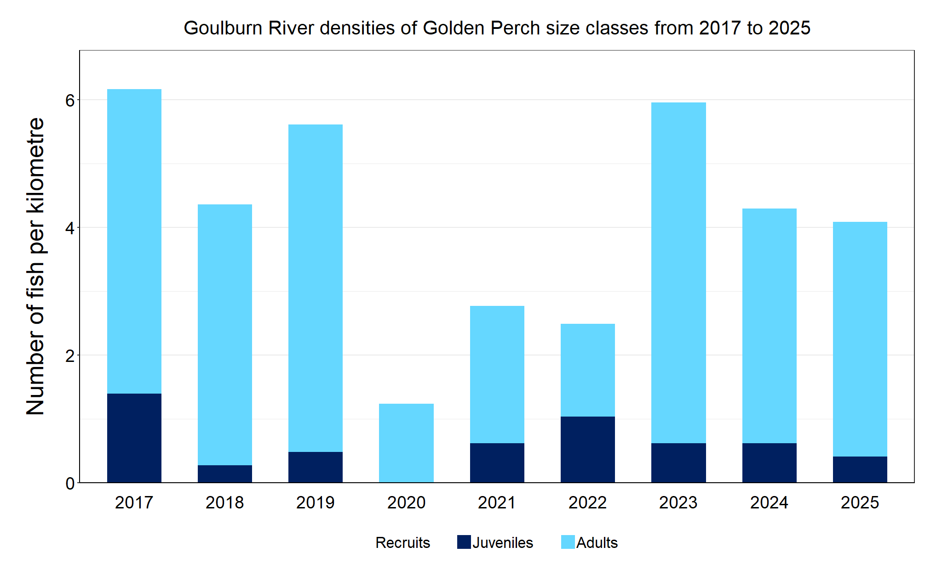
Figure 2. The densities of recruits, juveniles and adult Golden Perch for NFRC surveys in the Goulburn River from 2017 to 2025

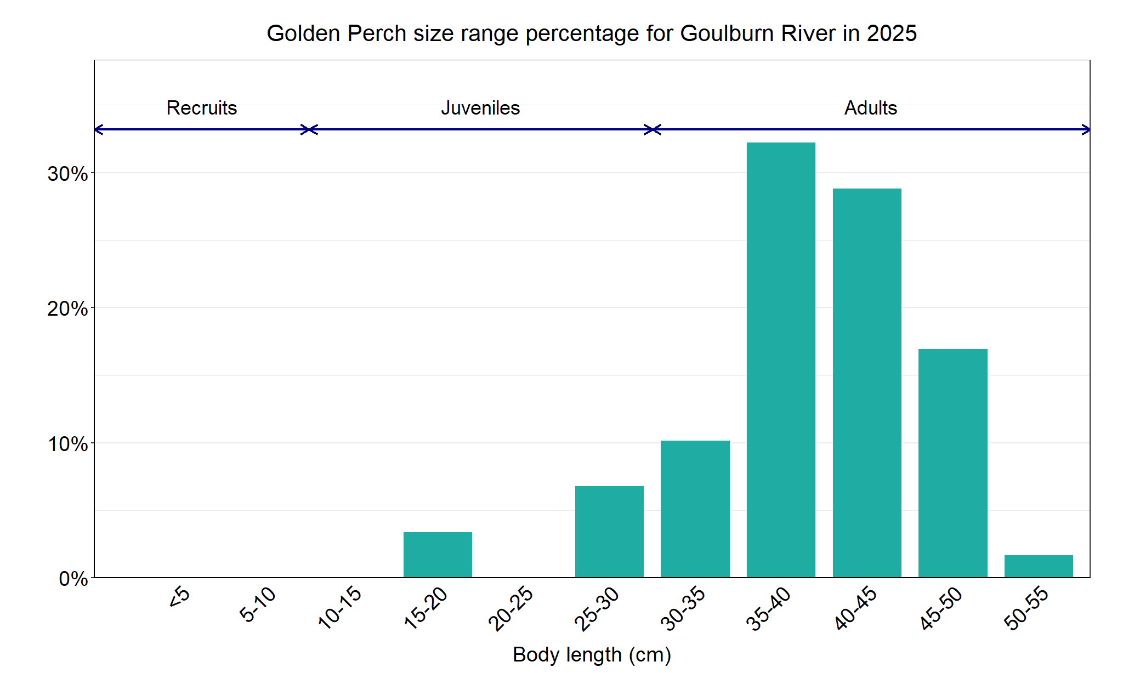
Figure 3. The size range percentage of Golden Perch measured from the Goulburn River during NFRC surveys in 2025

1. Tonkin, Z., Kitchingman, A., Ingram, B., Lieschke, J., Koster, W., Lyon, J., Lutz, M. and Pavlova, A. (2019). Smarter stocking: a synthesis of existing data to assess native fish stocking success in Victorian rivers. Unpublished Client Report for the Victorian Fisheries Authority. Arthur Rylah Institute for Environmental Research, Department of Environment, Land, Water and Planning, Heidelberg, Victoria.

Murray Cod

Lower Goulburn River, Goulburn Broken region

Key Health Indicators
Recent recruitment Yes
Multiple size classes Yes
Mature fish present Yes

Monitoring Results
Total number of fish caught 60
Fish per 1km of waterway 4.16
Largest fish by length (cm) 88
Largest fish by weight (kg) 13.4
% of the catch that is legal size 15

Relatively low numbers of Murray Cod (Maccullochella peelii) were captured in the 2025 survey (Figure 4), although a small increase from 2024 was recorded. Multiple size classes including adult, juvenile and recruits have been recorded in all nine NFRC surveys (Figure 4). A wide range of sizes was captured in the 2025 survey, however, they predominantly consisted of 45-55cm fish (Figure 5). Over 21% were adult fish, either legal size or above in 2025. The lower abundances of Murray Cod in 2020 and 2021 correlate with higher flows and associated high turbidity reducing the likelihood of capturing fish. Low abundances recorded in 2024 and 2025 could be related to a low dissolved oxygen event in the downstream reaches of the Goulburn in January 2024, however, no mass fish mortality was reported.
A large proportion of Murray Cod in the Goulburn River are from wild spawning. An otolith* study showed that all Murray Cod from the 2016/17 and 2017/18 year classes, and most fish (65%) from the 2018/19 year class were spawned in the river². Similarly, Murray Cod collected from the Goulburn River for the Long-Term Intervention Monitoring project (otoliths collected in 2016 and 2017) showed most were wild fish³. This indicates that stocked Murray Cod are making a very small contribution to the Murray Cod population in the Goulburn River.

Stocking
In 2016, 54,000 Murray Cod were stocked; 102,000 in 2017; 50,000 in 2017; 40,000 in 2018; 21,000 in 2019; 96,000 in 2020; 17,000 in 2021; 50,000 in 2022 and 4250 in 2025. No stockings occurred in 2023 or 2024. These stockings occurred below Lake Nagambie (where NFRC surveys occur).

*Otoliths are fish earbones
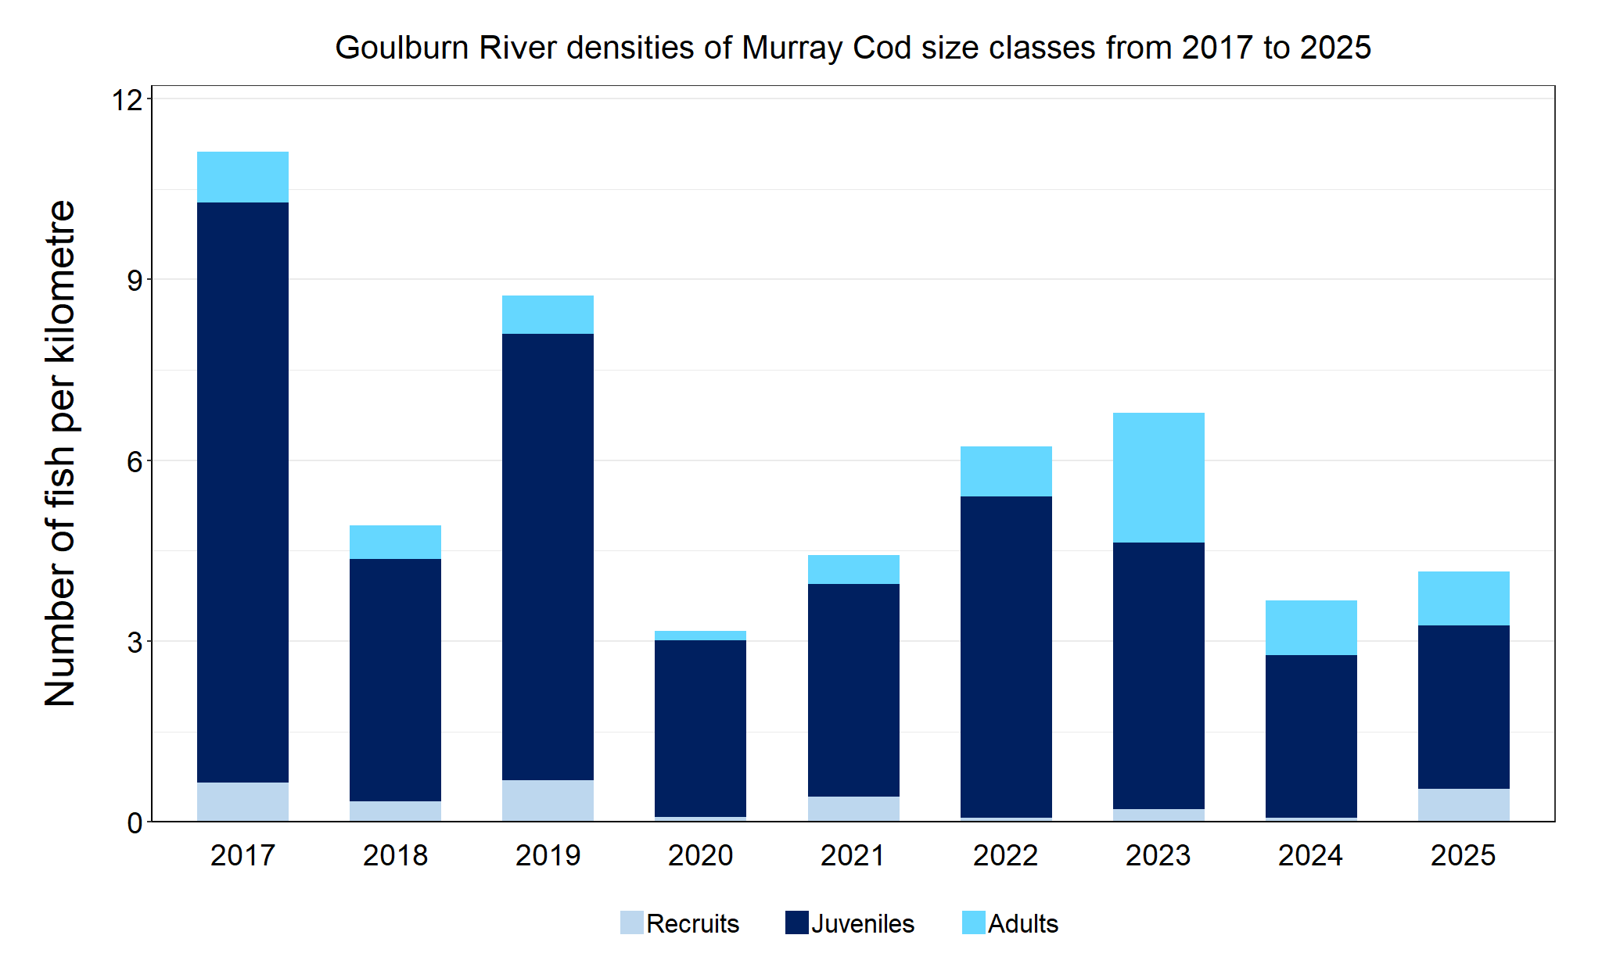
Figure 4. The densities of recruits, juveniles and adult Murray Cod in the Goulburn River from 2017 to 2025

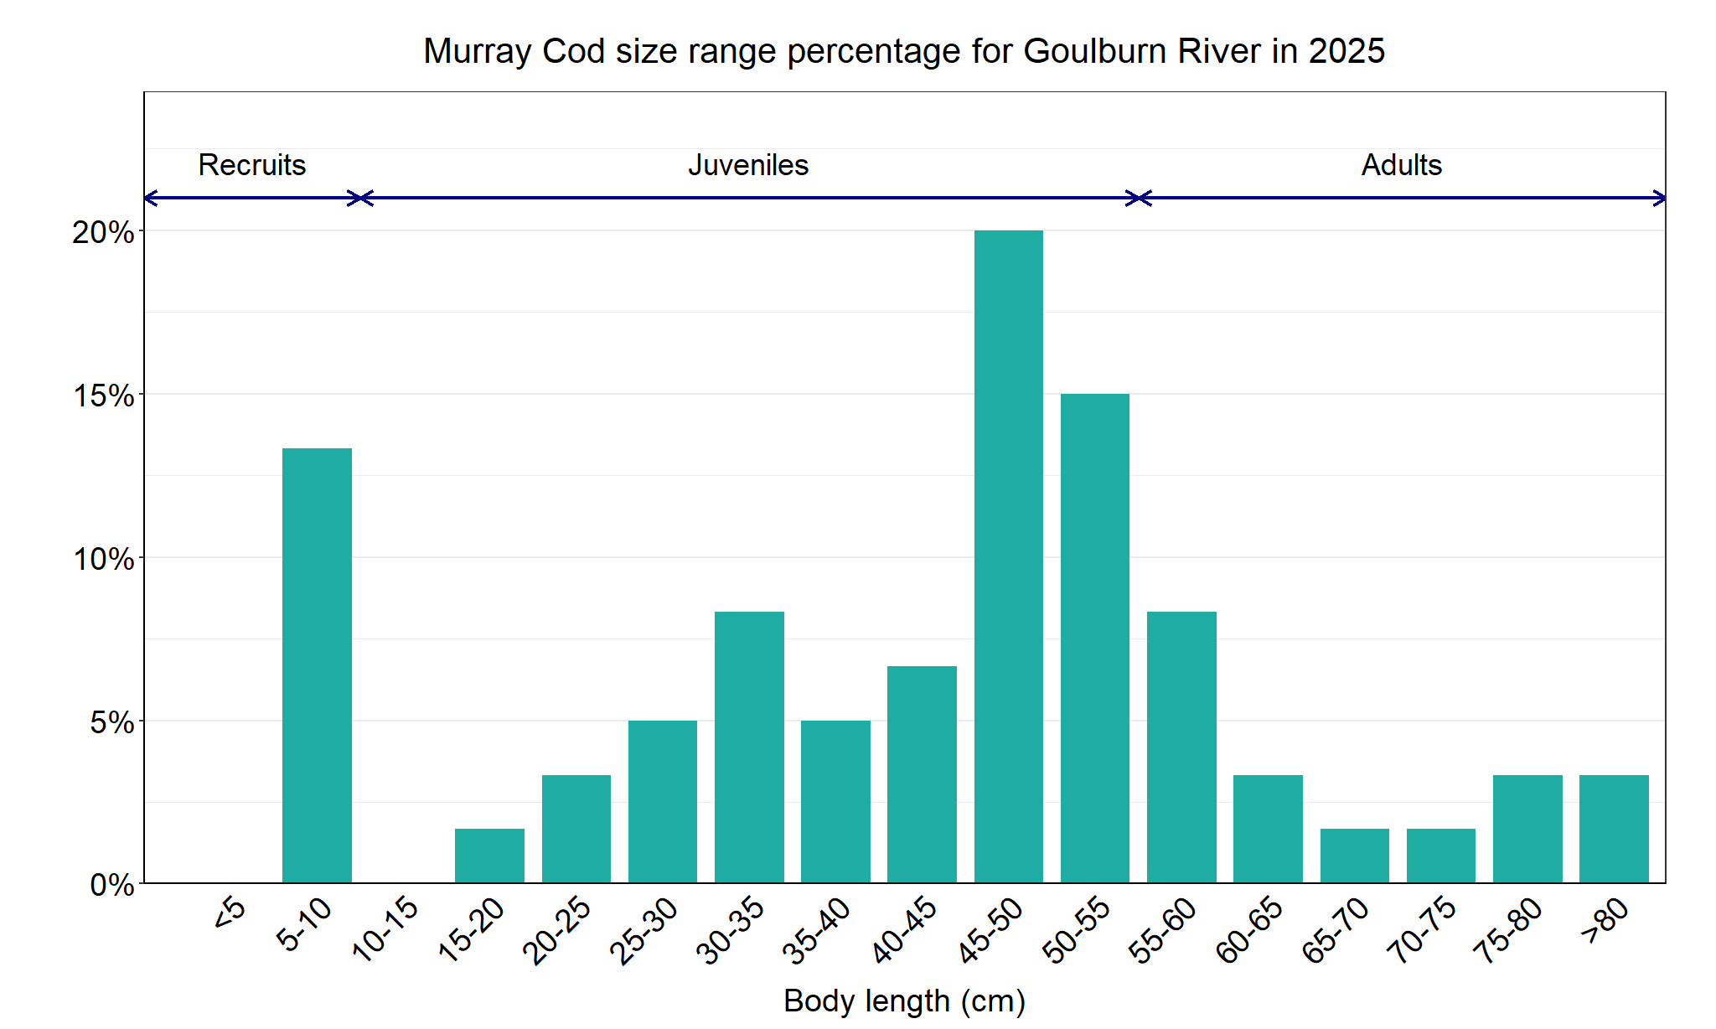
Figure 5. The size range percentage of Murray Cod in the Goulburn River in 2025

2. Harris, A., Tonkin, Z., Moloney, P., and Woodhead, J. (2020). Using Otolith Microchemistry to Assign Natal Origin to Juvenile Murray Cod. Unpublished Client Report for Water and Catchments, Department of Environment, Land, Water and Planning. Arthur Rylah Institute for Environmental Research, Department of Environment, Land, Water and Planning, Heidelberg, Victoria.

3. Tonkin, Z., Kitchingman, A., Ingram, B., Lieschke, J., Koster, W., Lyon, J., Lutz, M. and Pavlova, A. (2019). Smarter stocking: a synthesis of existing data to assess native fish stocking success in Victorian rivers. Unpublished Client Report for the Victorian Fisheries Authority. Arthur Rylah Institute for Environmental Research, Department of Environment, Land, Water and Planning, Heidelberg, Victoria.

Silver Perch

Lower Goulburn River, Goulburn Broken region

Key Health Indicators
Recent recruitment Cannot be determined
Multiple size classes Cannot be determined
Mature fish present Cannot be determined

Monitoring Results
Total number of fish caught 7
Fish per 1km of waterway 0.48
Largest fish by length (cm) 36.3
Largest fish by weight (kg) 0.63
% of the catch that is legal size NA#

# This species is a Protected Freshwater Species and taking or possessing is prohibited (Victorian Recreational Fishing Guide 2025).

The natural range of Silver Perch (Bidyanus bidyanus) includes most of the Murray-Darling Basin, excluding the cool, higher altitude upper reaches of streams. Within the Goulburn River, Silver Perch were historically abundant up to the Nagambie area. Cold water pollution, river regulation and barriers are all factors that have negatively affected Silver Perch populations, and all of these are relevant to the Goulburn River. The NFRC does not expect to capture enough Silver Perch to measure key health indicators. However, collecting data for non-recreational species including threatened species such as Silver Perch, allows for a greater understanding of the current status of the populations providing essential information to the management of these species.

Five adult and two juvenile Silver Perch were captured during the 2025 survey. Low abundances of Silver Perch have been detected in all nine years with juveniles and adults captured in six of the nine years (Figure 6; Figure 7). Only adults were captured in 2020, 2021 and 2024 (Figure 6). Recruits of this species are difficult to catch using the NFRC sampling method and none have been detected in all nine years of sampling. Silver Perch recruitment is low or often zero in the Goulburn River, with 90% of the population classified as migrants (unpublished report for GBCMA).

Stocking
No stocking has occurred.
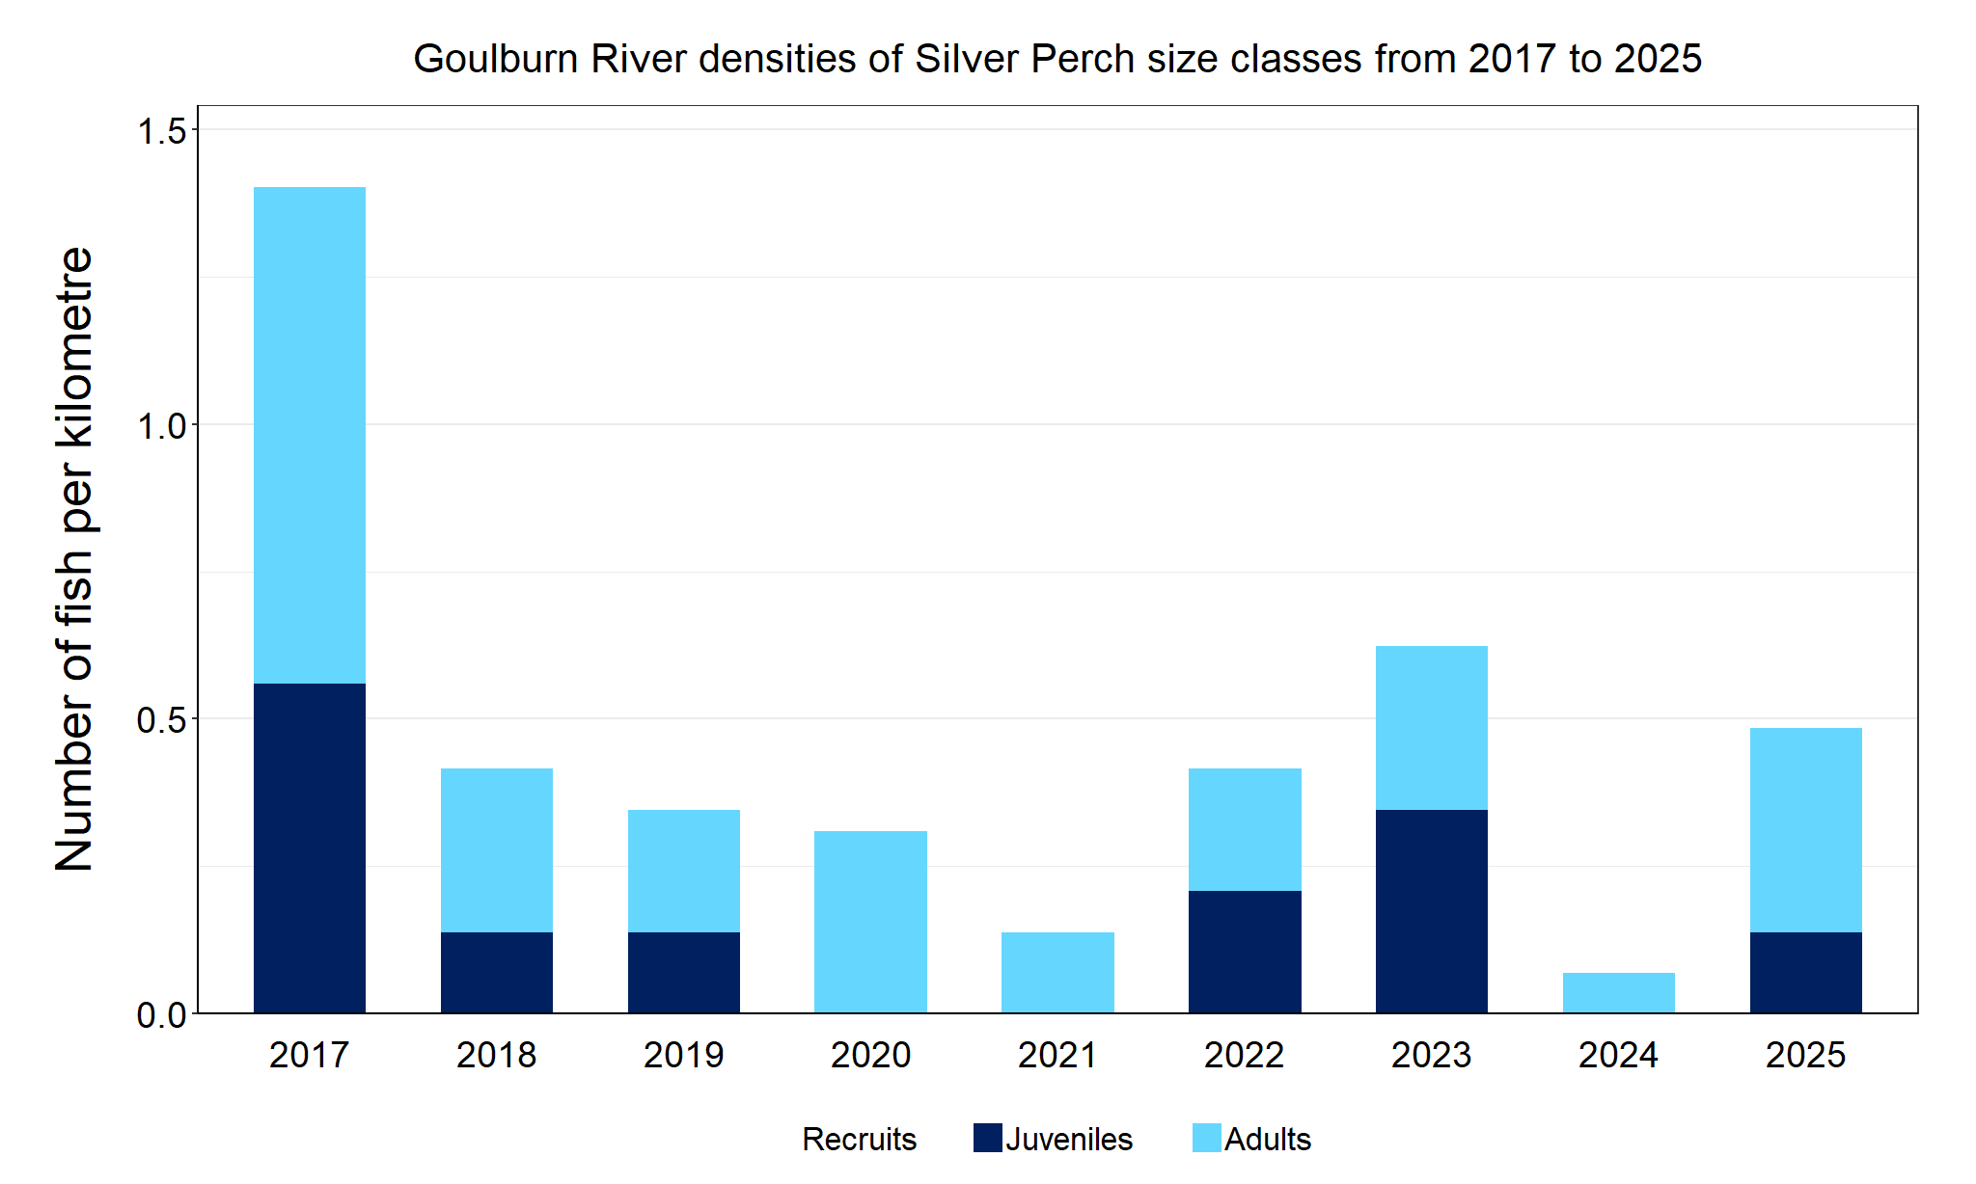
Figure 6. The densities of recruits, juveniles and adult Silver Perch in the Goulburn River from 2017 to 2025

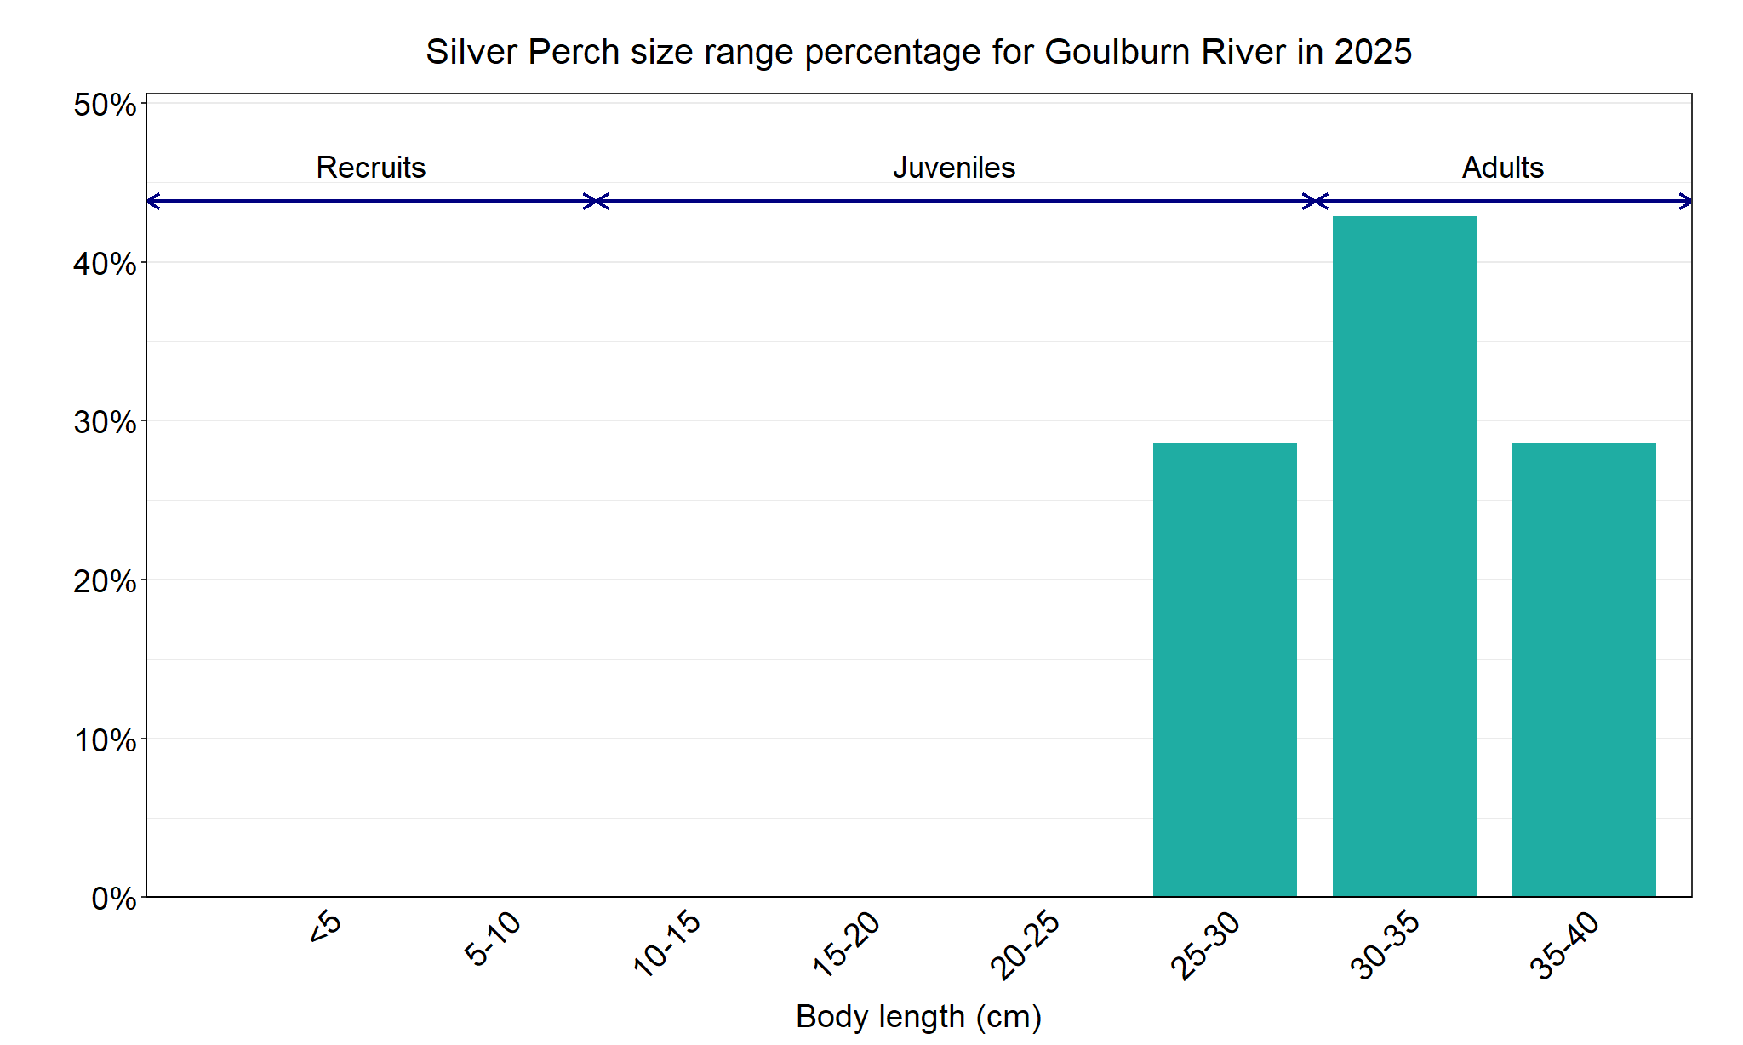
Figure 7. The size range percentage of Silver Perch in the Goulburn River in 2025

Trout Cod

Lower Goulburn River, Goulburn Broken region

Key Health Indicators
Recent recruitment No
Multiple size classes Yes
Mature fish present Yes

Monitoring Results
Total number of fish caught 29
Fish per 1km of waterway 2.01
Largest fish by length (cm) 48
Largest fish by weight (kg) 1.18
% of the catch that is legal size NA#

# This species is a Protected Freshwater Species and taking or possessing is prohibited (Victorian Recreational Fishing Guide 2025).

Trout Cod (Maccullochella macquariensis) were absent in surveys downstream of Lake Nagambie from 1982–1983³, with low numbers detected in 2003-04⁴ and low numbers persisting since then⁵. Abundance of Trout Cod recorded in 2025 were similar to 2024, after being recorded in much higher densities in 2023 (Figure 8). Only adults and juveniles were detected in the 2025 survey (Figure 8, Figure 9). The proportion of adult fish to juvenile fish in 2025 was similar to 2023 and 2024 (Figure 8). Recruits have only been detected in 2018-20 but juveniles and adults have been recorded every year (Figure 8). Trout Cod captured in 2025 ranged from 15-48 cm in length (i.e. juveniles and adults). Very few Trout Cod have been caught downstream of Shepparton, indicating a restricted distribution between Shepparton and Lake Nagambie. This is consistent with other research, including the Long-Term Intervention Monitoring program/Flow-MER⁶. Prior to 2022, both the Flow-MER and NFRC had caught relatively few Trout Cod downstream of Shepparton. However, in recent years both programs have recorded increased abundances and from a greater number of sites. The whole of Murray River monitoring program (River Murray Channel Monitoring Plan⁷) also recorded Trout Cod down to Swan Hill in 2022, indicating Trout Cod dispersing throughout 2021 and early 2022.

Stocking
There has been no stocking below Lake Nagambie (where NFRC surveys occur) since 1997. Between 1993 and 1997, a total of 58,500 Trout Cod were stocked below Lake Nagambie.

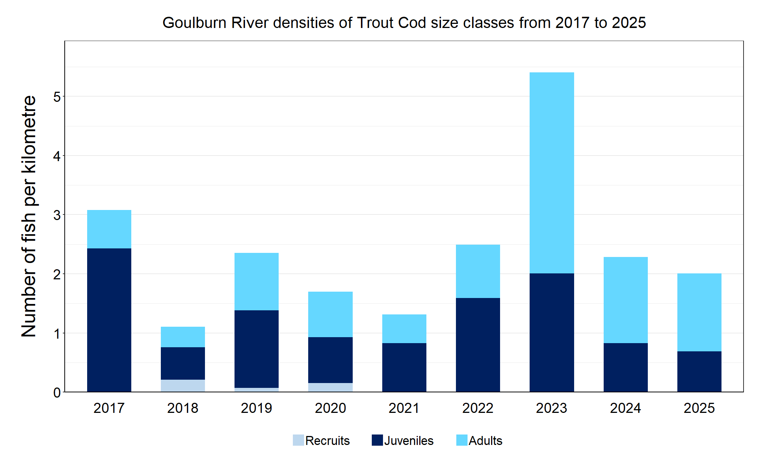
Figure 8. The densities of recruits, juveniles and adult Trout Cod in the Goulburn River from 2017 to 2025

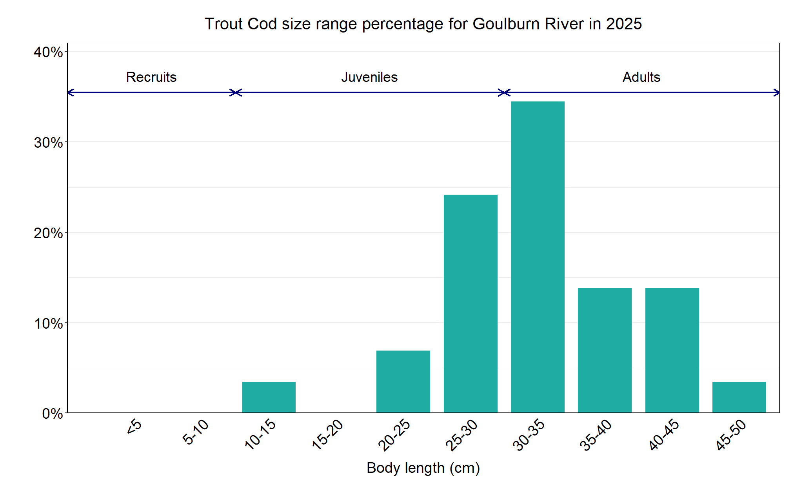
Figure 9. The size range percentage of Trout Cod in the Goulburn River in 2025

³ Brumley et al. (1987). Revision of the conservation status of several species of warmwater native fish after surveys of selected sites in northern Victoria. (1982–1984). Technical Report Series No. 33. Arthur Rylah Institute for Environmental Research, Department of Conservation, Forests and Lands, Shepparton, Victoria.

⁴ Koster et al. (2012) Status of fish populations in the lower Goulburn River (2003-2012). Arthur Rylah Institute for Environmental Research Unpublished Client Report for Goulburn Broken Catchment Management Authority, Department of Sustainability and Environment, Heidelberg, Victoria.

5. Webb et al. (2021). Commonwealth Environmental Water Office Long Term Intervention Monitoring Project Goulburn River Selected Area Scientific Report 2020-21.

6. Bovill et al. (2023). Commonwealth Environmental Water Office Monitoring, Evaluation and Research Project Goulburn River Selected Area Scientific Report 2023-24.

⁷ River Murray Channel Monitoring Plan. The Department of Agriculture, the Environment and Water, through its Commonwealth Environmental Water Office (CEWO), on behalf of River Murray jurisdictions (via the Southern Connected Basin Environment Watering Committee), has agreed to engage a consortium team, led by CSIRO, to implement the River Murray Channel Monitoring Plan

We acknowledge and respect Victorian Traditional Owners as the original custodians of Victoria’s land and waters, their unique ability to care for Country and deep spiritual connection to it. We honour Elders past and present whose knowledge and wisdom has ensured the continuation of culture and traditional practices.

© The State of Victoria Department of Energy, Environment and Climate Action 2025. This work is licensed under a Creative Commons Attribution 4.0 International licence. To view a copy of this licence, visit creativecommons.org/licenses/by/4.0/
ISSN 2981-9016 Online (pdf/word)

