**Gunbower Creek 2023**

***North Central region***

**This report card summarises the 2023 Native Fish Report Card (NFRC) survey in the Gunbower Creek**

**Sites 11, Electrofishing**

**Fish found in Gunbower Creek for NFRC**

**Target species**

Golden Perch

Murray Cod

Silver Perch

Trout Cod

**Non-target species captured since 2017\***

**Large-bodied native species**

Bony Bream

**Small-bodied native species**

Australian Smelt

Carp Gudgeon sp.

Flatheaded Gudgeon

Murray-Darling Rainbowfish

Unspecked Hardyhead

**Exotic species**

Common Carp

Eastern Gambusia

Goldfish

Redfin

* These non-target species were incidentally captured during NFRC surveys since 2017 but not measured as for target species

LOGOS – ARI, DEECA

**Gunbower Creek 2023**

**Fish Community**

**NFRC target species**

**The NFRC Program began in 2017,** **with a focus on targeting the monitoring of population dynamics of key iconic fish species that have high recreational and/or conservation values, in large rivers across Victoria. In the Gunbower Creek, the target species are Golden Perch, Murray Cod, Silver Perch and Trout Cod. Surveys occur in April/May each year, at 11 sites from the offtake with the Murray River upstream of Torrumbarry to the junction of the Murray River at Koondrook. The equipment and habitats surveyed are focused on these species, which are measured to determine population structures. Other fish species that are incidentally captured are recorded, but not measured to determine their population structures.**

**Summary of key health indicators for target species in 2023**

|  |  |  |  |
| --- | --- | --- | --- |
| **Species** | **Key Health Indicators** | | |
|  | Recent recruitment | Multiple size classes | Mature fish present |
| Golden Perch | No | Yes | Yes |
| Murray Cod | No | Yes | Yes |
| Silver Perch | - | - | - |
| Trout Cod | - | - | - |

*Recent recruitment means young-of-year fish*

*\*- cannot be determined due to low abundances*

Silver Perch were historically abundant throughout Gunbower Creek, while Trout Cod were rare downstream of Torrumbarry on the Murray River system. Both of these species have experienced dramatic declines across their range. The Yarrawonga population of Trout Cod was shown to have extended downstream from Barmah to Gunbower Island in 20121. Trout Cod were then captured in 2014, with NFRC sampling detecting this species in six of the seven sampling years from 2017, although in low densities. Silver Perch are also present in low densities. Overall, the Gunbower Creek appears to be maintaining healthy populations of Golden Perch and particularly Murray Cod.

**Non-target species**

The non-target fish species that have been incidentally recorded in the Goulburn River during NFRC surveys since 2017 are:

**Large-bodied native species**

Other large-bodied species recorded in fish surveys include Bony Bream. Bony Bream are a lowland species across the Murray-Darling Basin which are intolerant of cold water and likely to be restricted to the lower Gunbower Creek (downstream of Koondrook). It is unlikely this species would be detected upstream of the barrier at Koondrook, although a new fishway installed in 2021 may assist fish passage to areas upstream of Koondrook.

**Small-bodied native species**

The small-bodied species Australian Smelt, Carp Gudgeon, Flatheaded Gudgeon, and Unspecked Hardyhead are common and are expected to be widespread throughout the Gunbower Creek and more broadly within the Murray-Darling Basin. Murray-Darling Rainbowfish are common and widespread in the Gunbower Creek. Once widespread in the Murray-Darling Basin, this species now has a patchy distribution and a restricted range and is considered threatened in Victoria.

**Exotic fish species**

Common Carp and Goldfish are widely distributed across sampling sites, with Eastern Gambusia more common in the slower flowing waters. Redfin are also distributed throughout, but in lower abundances.

**Other native species known from Gunbower Creek**

Some fish species known to occur in the Gunbower Creek system have never been recorded during NFRC surveys. For example, no Flatheaded Galaxias or Freshwater Catfish have been detected in the surveys, but these species are more common in offstream habitats (such as billabongs, lagoons and wetlands), with Freshwater Catfish detected in permanent offstream habitats regularly by The Living Murray surveys. No Obscure Galaxias have been recorded during the surveys. No Southern Pygmy Perch have been recorded during the NFRC surveys and this species has been absent from the Gunbower Creek system for over 30 years. These species outlined above are hard to detect using the NFRC sampling methodology.

**Other notable species**

Surveys have also recorded Rakali, Yabbies and Turtle species.

LOGOS – ARI, DEECA, NFRC

1. Douglas, J, Hunt, T and Trueman, W. (2012). Confirmed records of the endangered Trout Cod Maccullochella macquariensis from the Murray River at Gunbower Island, Victoria. [Victorian Naturalist](https://www.researchgate.net/journal/Victorian-Naturalist-0042-5184) 129(4):152-155.

**Gunbower Creek 2023**

**Environmental and Management Context**

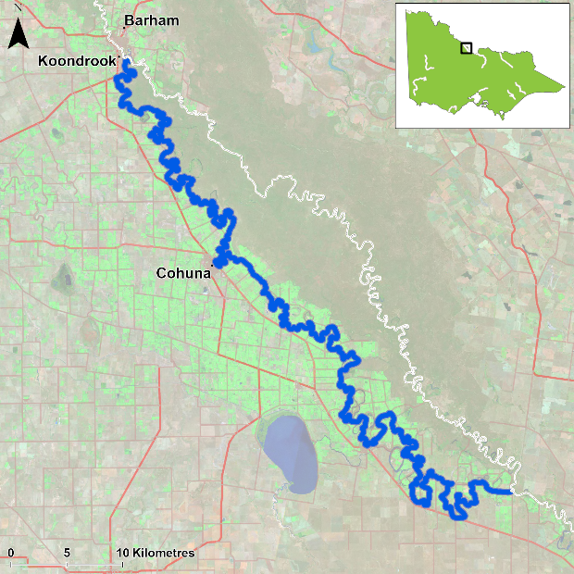

Figure 1. Map showing the section of Gunbower Creek where NFRC sampling occurs

**Environment**

Stream flow was consistent for the majority of Gunbower Creek from 2017 to 2023. However, at the time of sampling, the two sites downstream of Koondrook had fluctuating heights, with heights particularly low in 2018, 2019, 2020, 2022 and 2023. Therefore, in 2018, 2021-23, these sites were fished later in autumn, when water levels had increased slightly. In 2022, water levels were extremely low downstream of Koondrook whilst the fishway was being built. Only one of the sites was therefore surveyed in that year. In 2023, sampling the closest site downstream of Koondrook Weir was further delayed until late June due to river heights and logistics and was higher than previous samplings due to backing up from the flooding Murray River.

**River rehabilitation efforts in the Gunbower Creek**

Many rehabilitation actions have occurred, and are underway, to improve the health of the Gunbower Creek and its fish community. These are informed by the North Central Waterway Strategy 2014-22 and in particular by the Native Fish Recovery Plan – Gunbower and lower Loddon. Actions include allocations of water for the environment, increasing connectivity by establishing fishways at Koondrook and Cohuna to improve fish passage, fish screens to prevent loss of fish to irrigation channels and pumps, protection and revegetation of riparian areas, investigating options to control Carp, and reintroduction of threatened species including Southern Pygmy Perch into two wetlands (Black Charlie and Reedy lagoons) and River Blackfish into flowing water habitats.

There are a range of fish monitoring efforts related to the rehabilitation efforts above. These include the Victorian Environmental Flow Monitoring and Assessment Program ([VEFMAP](https://www.ari.vic.gov.au/research/rivers-and-estuaries/assessing-benefits-of-water-for-the-environment)) and The Living Murray program. The [North Central Catchment Management Authority](http://www.nccma.vic.gov.au/), DEECA and VFA support rehabilitation and management of the Gunbower Creek and its fish community.

PHOTOS

LOGOS – ARI, DEECA, NFRC

**Golden Perch**

**Gunbower Creek, North Central Region**

**Key Health Indicators**

Recent recruitment No

Multiple size classes Yes

Mature fish present Yes

**Monitoring Results**

Total number of fish caught 32

Fish per 1km of waterway 2.12

Largest fish by length (cm) 53.3

Largest fish by weight (kg) 3.18

% of the catch that is legal size 93.8

**The abundance of Golden Perch (*Macquaria ambigua*) was high in 2023 relative to the previous six years of sampling. High catch rates were also observed in 2017 and 2021. High abundances in 2017 were due to more fish being captured at the two sites downstream of Koondrook Weir compared to other years when water levels were exceptionally low at these sites. Juveniles have been present in all years, with recruits only detected in 2019 (Figure 2). It is unlikely that these are natural recruits, as the creek has many barriers which would limit spawning opportunities and egg/larval survival. A large proportion (94%) of Golden Perch collected in 2023 were adults (Figure 3). This indicates conditions in the system are suitable for recruits and juvenile survival and for maintaining adult Golden Perch populations. The population has likely been maintained by stockings. The construction of the Koondrook fishway in 2021 should allow Golden Perch to access areas further upstream in the Gunbower Creek system.** **A blackwater event occurred in late 2022 with dead Golden Perch recorded. Rescues were undertaken, with fish either transported out of the Gunbower Creek system or taken to the Arcadia fish hatchery and some subsequently returned to the creek when water quality improved, prior to NFRC sampling. Based on the abundances detected in 2023 compared to previous sampling events, it appears the blackwater event in Gunbower Creek did not impact the Golden Perch population heavily.**

**Stocking**

Golden Perch were stocked into Gunbower Creek for the first time in 2016. Twenty thousand Golden Perch were stocked in 2016; 40,500 in 2017; 200,000 in early 2018; 70,000 in 2019; 70,000 in 2020; 70,000 in 2021; 65,000 in 2022. No Golden Perch have been stocked in the first half of 2023.

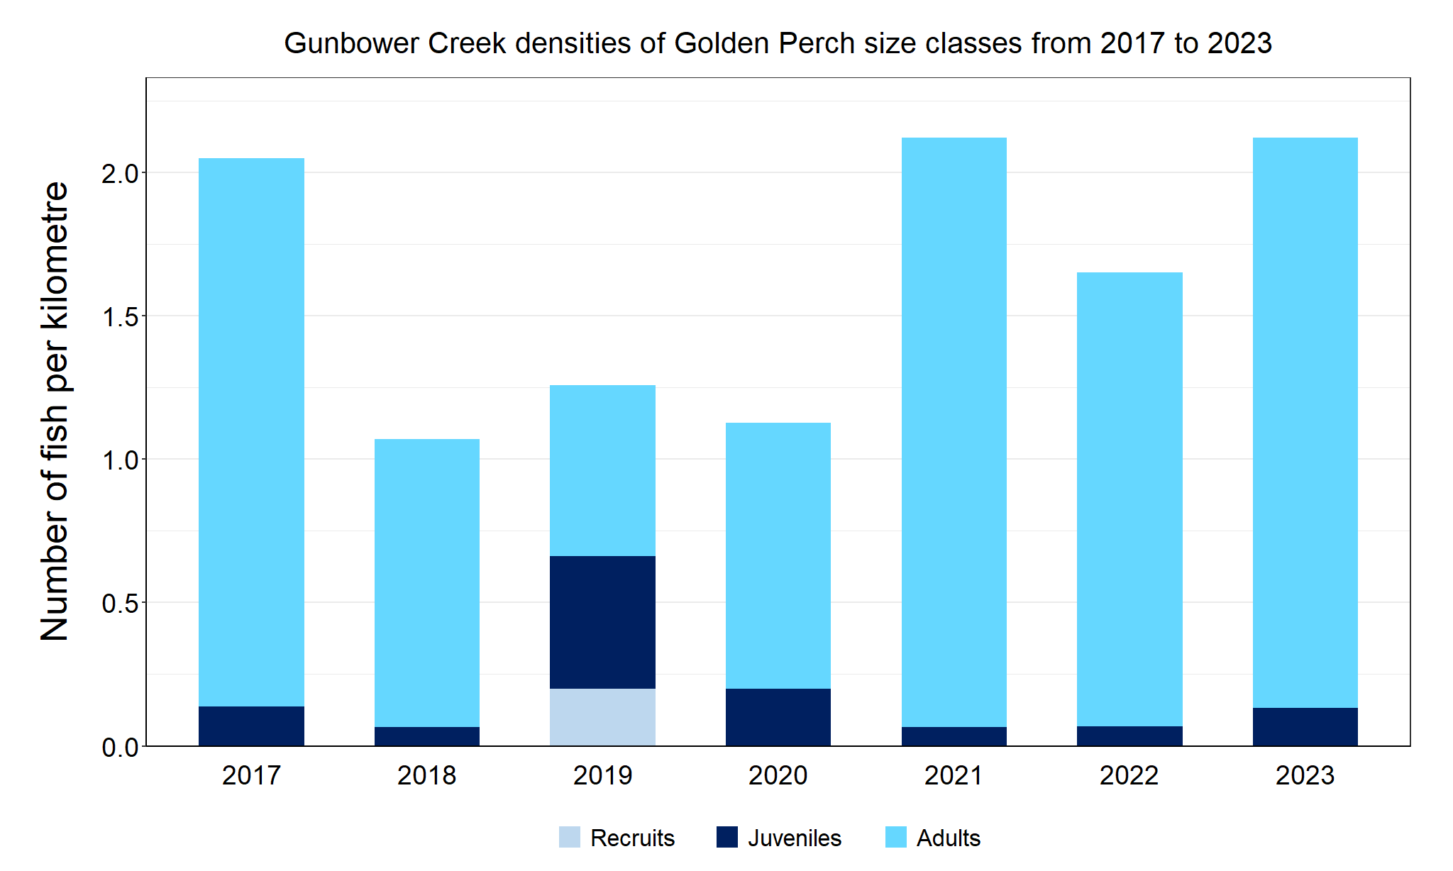

Figure 2. The densities of recruits, juveniles and adult Golden Perch in Gunbower Creek from 2017 to 2023

Figure 3. The size range percentage of Golden Perch in Gunbower Creek in 2023

**Murray Cod**

**Gunbower Creek, North Central region**

**Key Health Indicators**

Recent recruitment No

Multiple size classes Yes

Mature fish present Yes

**Monitoring Results**

Total number of fish caught 40

Fish per 1km of waterway 2.65

Largest fish by length (cm) 100.2

Largest fish by weight (kg) 16.2

% of the catch that is legal size 60

**The Murray Cod (*Maccullochella peelii*) population was lowest in 2022 and 2023 and has been reducing in size since 2019 (Figure 4). Multiple size classes including adult and young-of-year fish were caught in all seven years, except 2023 when no recruitment was detected. The 2023 size range percentage shows very low abundances of Murray Cod less than 40 cm (Figure 5). A blackwater event occurred in late 2022 (during Murray Cod breeding season) with dead Murray Cod recorded. It is unknown if the juveniles were impacted at higher rates than other size classes. Rescues were undertaken, with some fish either transported out of the Gunbower Creek system or taken to the Arcadia fish hatchery and some subsequently returned to the creek when water quality improved, prior to NFRC sampling. Since 2014, water for the environment has been delivered to Gunbower Creek to reduce water level fluctuations during the breeding period for Murray Cod to enhance egg and larval survival, to maintain winter base flows2 and to enhance survival of juvenile fish over winter. Monitoring indicates that the provision of water for the environment is enhancing the survival of young-of-year fish, irrespective of them being stocked or being from natural recruitment. The lack of recruitment detected in 2023 is likely due to the blackwater event.**

**Stocking**

Twenty thousand Murray Cod were stocked in 2016; 55,000 in 2017; 150,000 in 2018; 115,690 in 2020 (of which 65,000 were in December); 60,000 in 2022 and 60,000 in February 2023. Murray Cod stocking started in 2001, with 20,000 stocked in most years until 2016. The exceptions to this are: 120,000 in 2012 and 80,000 in 2014. No Murray Cod were stocked in 2019.

Figure 4. The densities of recruits, juveniles and adult Murray Cod in Gunbower Creek from 2017 to 2023

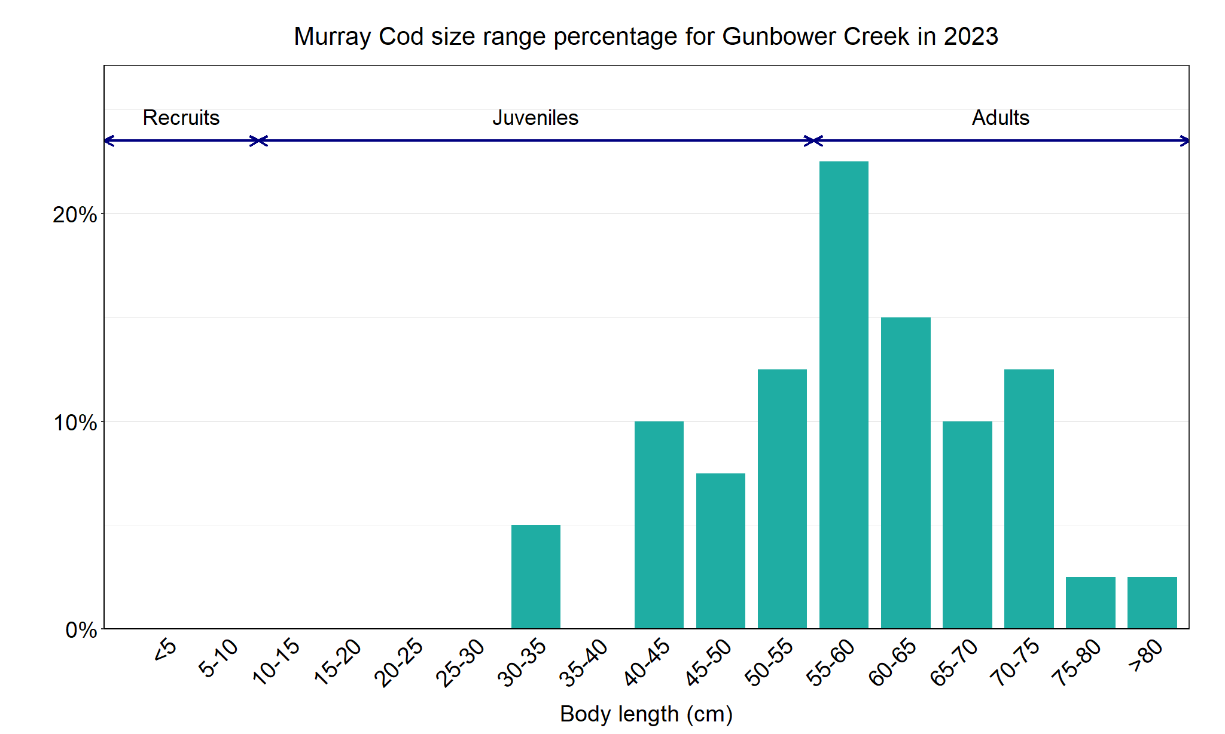

Figure 5. The size range percentage of Murray Cod in Gunbower Creek in 2023

2. Stuart et al. (2019). From an irrigation system to an ecological asset: adding environmental flows establishes recovery of a threatened fish species. *Marine and Freshwater Research*: **70 (9)**, 1295-1306.

**Silver Perch**

**Gunbower Creek, North Central region**

**Key Health Indicators**

Recent recruitment Cannot be determined

Multiple size classes Cannot be determined

Mature fish present Cannot be determined

**Monitoring Results**

Total number of fish caught 14

Fish per 1km of waterway 0.93

Largest fish by length (cm) 46.2

Largest fish by weight (kg) 1.51

% of the catch that is legal size NA

**The natural range of Silver Perch (*Bidyanus bidyanus*) includes most of the Murray-Darling Basin, excluding the cool, higher altitude upper reaches of streams. River regulation and barriers have all impacted Silver Perch populations, with these prevalent in Gunbower Creek. The NFRC does not expect to capture enough Silver Perch to measure key health indictors. However, by collecting data for non-recreational species including threatened species such as Silver Perch, it will allow a greater understanding of the current status of the populations providing essential information to the management on these species. Low abundances of Silver Perch have been detected in all seven years with the highest abundances detected in 2023 (Figure 6). However, due to the low abundances of Silver Perch collected during NFRC, the key health indicators cannot be measured. The Silver Perch detected were predominantly adults (Figure 6; Figure 7). Juveniles were only detected in 2017, 2022 and 2023. Recruits of this species are difficult to catch using this sampling methodology and none have been detected in all seven years of sampling. Silver Perch are unlikely to successfully spawn in Gunbower Creek due to the many barriers to fish movement. There was an accumulation of juvenile Silver Perch at the Koondrook fishway during construction (Lieschke unpublished data). The construction of the Koondrook fishway in 2021 should allow juvenile and adult Silver Perch to access areas further upstream within the Gunbower Creek system. A blackwater event occurred in late 2022.** **Rescues were undertaken, with fish either transported out of the Gunbower Creek system or taken to the Arcadia fish hatchery and some subsequently returned to the creek when water quality improved, prior to NFRC sampling. Due to low numbers being captured prior to 2023, it cannot be determined if the blackwater event in late 2022 has impacted the Silver Perch population.**

**Stocking**

No stocking has occurred.

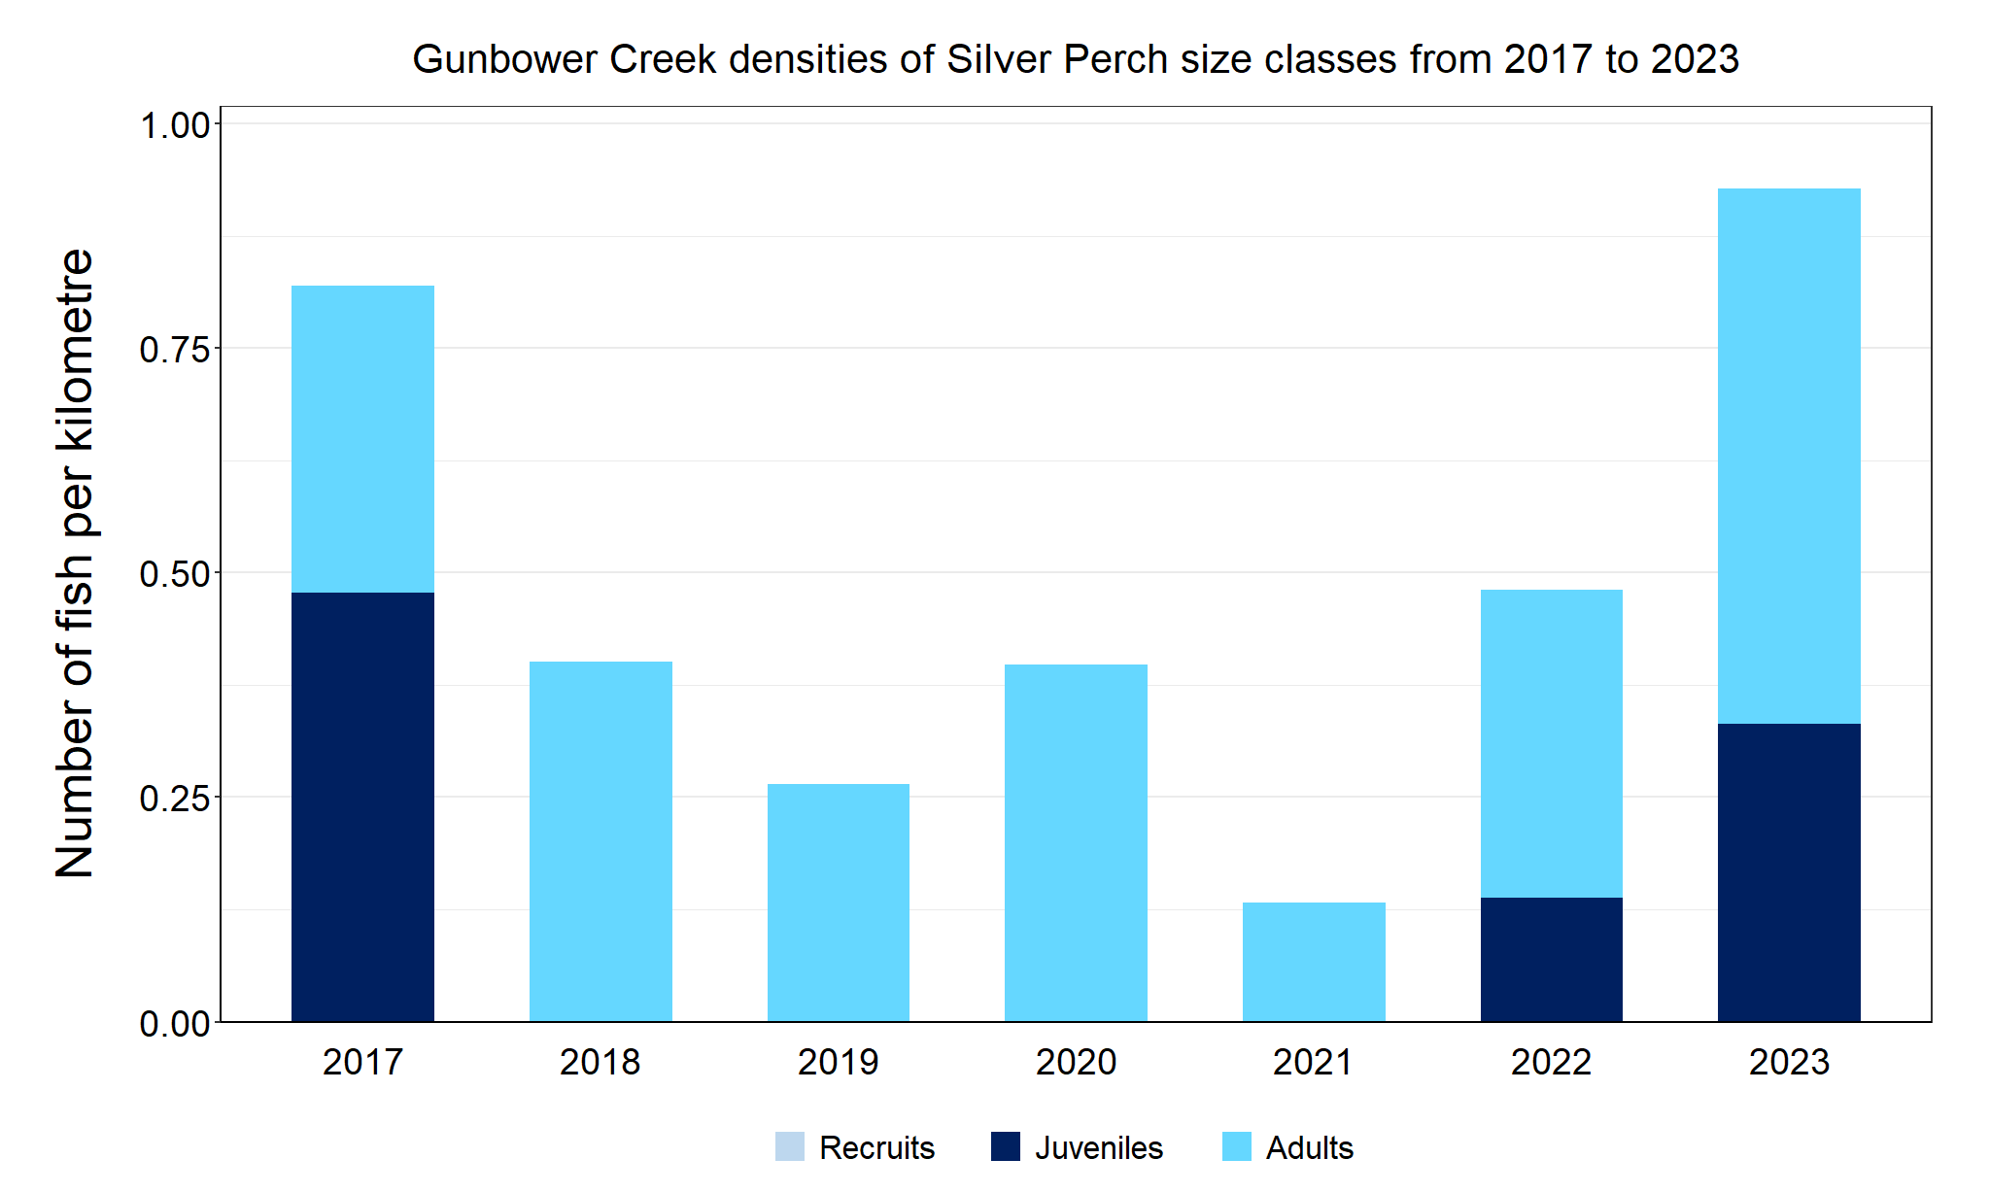

Figure 6. The densities of recruits, juveniles and adult Silver Perch in Gunbower Creek from 2017 to 2023

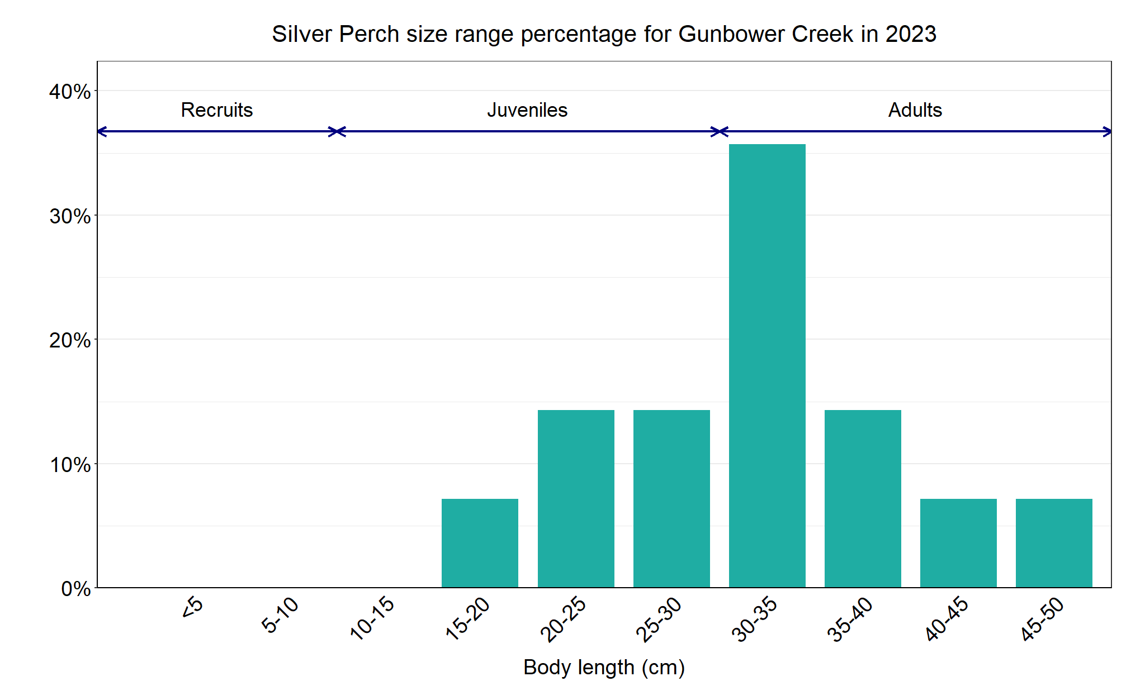

Figure 7. The size range percentage of Golden Perch in Gunbower Creek in 2023

**Trout Cod**

**Gunbower Creek, North Central region**

**Key Health Indicators**

Recent recruitment Cannot be determined

Multiple size classes Cannot be determined

Mature fish present Cannot be determined

**Monitoring Results**

Total number of fish caught 1

Fish per 1km of waterway 0.07

Largest fish by length (cm) 40.0

Largest fish by weight (kg) 0.85

% of the catch that is legal size NA

**The natural range of Trout Cod included Gunbower Creek, but the species was absent in this area from the 1980s. The NFRC does not expect to capture enough Trout Cod to measure key health indictors. However, by collecting data for non-recreational species including threatened species such as Trout Cod, it will allow a greater understanding of the current status of the populations providing essential information to the management on these species. Due to the low abundances of Trout Cod collected during NFRC the key health indicators cannot be measured. Trout Cod was first detected again in Gunbower Creek**1 **in 2012 and have regularly been recorded since then, albeit in low abundances. Trout Cod have been recorded in six of the seven years of NFRC sampling (Figure 8). No recruits have been detected in NFRC sampling, and juveniles have only been detected in 2017 and 2021 (Figure 9). Only a single adult was recorded in 2023 (Figure 9). This indicates that Trout Cod are persisting in Gunbower Creek, but it is uncertain if they are breeding. It is possible that larvae or recruits enter the system via the national channel inlet upstream of Torrumbarry Weir. Monitoring during Koondrook and Cohuna fishway installations in 2021 captured juvenile Trout Cod (in higher abundances than NFRC sampling) immediately downstream of the weirs - potentially accumulating, which indicates a barrier to fish passage. The construction of the Koondrook fishway in 2021 should allow Trout Cod to access areas further upstream in the Gunbower Creek system.** **A blackwater event occurred in late 2022. Rescues were undertaken, with fish either transported out of the Gunbower Creek system or taken to the Arcadia fish hatchery and some subsequently returned to the creek when water quality improved, prior to NFRC sampling. Due to low numbers being captured prior to 2023, it cannot be determined if the blackwater event in late 2022 has impacted the Trout Cod population.**

**Stocking**

No stocking has occurred.

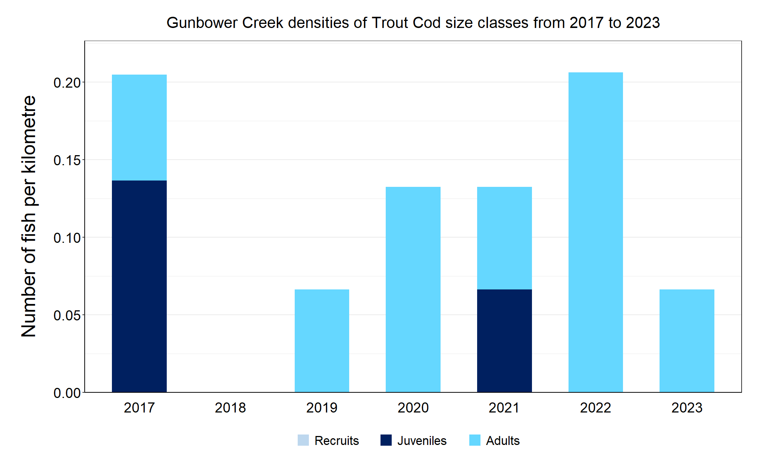

Figure 8. The densities of recruits, juveniles and adult Trout Cod in Gunbower Creek from 2017 to 2023

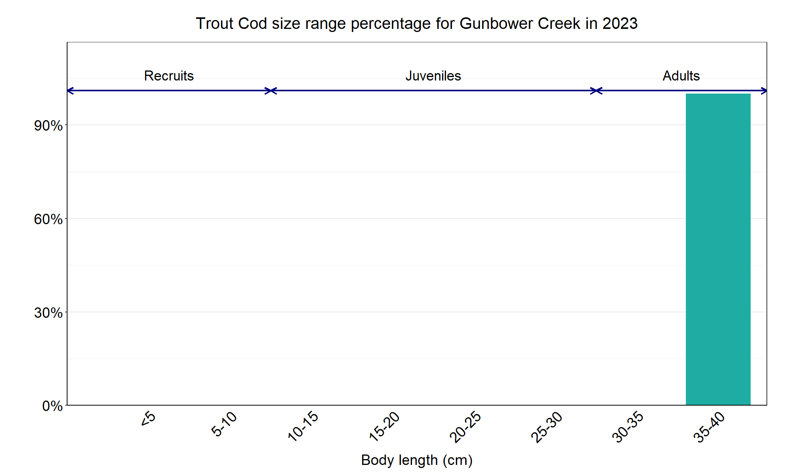

Figure 9. The size range percentage of Trout Cod in Gunbower Creek in 2023

3 River Murray Channel Monitoring Plan. The Department of Agriculture, the Environment and Water, through its Commonwealth Environmental Water Office (CEWO), on behalf of River Murray jurisdictions (via the Southern Connected Basin Environment Watering Committee), has agreed to engage a consortium team, led by CSIRO, to implement the River Murray Channel Monitoring Plan

We acknowledge and respect Victorian Traditional Owners as the original custodians of Victoria’s land and waters, their unique ability to care for Country and deep spiritual connection to it. We honour Elders past and present whose knowledge and wisdom has ensured the continuation of culture and traditional practices.

Logo*© The State of Victoria Department of Energy, Environment and Climate Action 2023. This work is licensed under a Creative Commons Attribution 4.0 International licence. To view a copy of this licence, visit creativecommons.org/licenses/by/4.0/*

*ISSN 2981-9032 Online (pdf/word)*