Guidelines for monitoring deer populations

Practical methods for undertaking deer surveys

J.G. Cally and D.S.L. Ramsey

April 2025
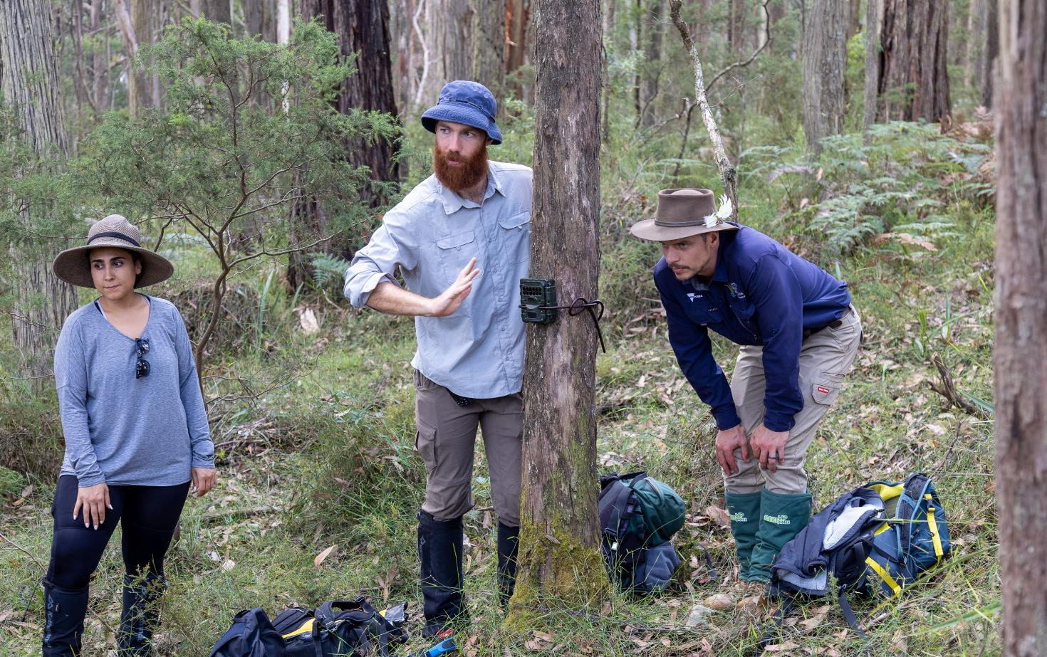

Arthur Rylah Institute for Environmental Research
Technical Report Series No. 378





Acknowledgment
We acknowledge and respect Victorian Traditional Owners as the original custodians of Victoria's land and waters, their unique ability to care for Country and deep spiritual connection to it. We honour Elders past and present whose knowledge and wisdom has ensured the continuation of culture and traditional practices.
We are committed to genuinely partner, and meaningfully engage, with Victoria's Traditional Owners and Aboriginal communities to support the protection of Country, the maintenance of spiritual and cultural practices and their broader aspirations in the 21st century and beyond.

Arthur Rylah Institute for Environmental Research
Department of Energy, Environment and Climate Action
PO Box 137
Heidelberg, Victoria 3084
Phone (03) 9450 8600
Website: www.ari.vic.gov.au
Citation: Cally, J.G. and Ramsey, D.S.L. (2025). Guidelines for monitoring deer populations: Practical methods for undertaking deer surveys. Arthur Rylah Institute for Environmental Research Technical Report Series No. 378. Department of Energy, Environment and Climate Action, Heidelberg, Victoria.
Front cover photo: ARI staff deploying a camera trap for deer – Nick Esser, Parks Victoria.
© The State of Victoria Department of Energy, Environment and Climate Action 2025

This work is licensed under a Creative Commons Attribution 3.0 Australia licence. You are free to re-use the work under that licence, on the condition that you credit the State of Victoria as author. The licence does not apply to any images, photographs or branding, including the Victorian Coat of Arms, the Victorian Government logo, the Department of Energy, Environment and Climate Action logo and the Arthur Rylah Institute logo. To view a copy of this licence, visit http://creativecommons.org/licenses/by/3.0/au/deed.en
Edited by Fox Writing Services
ISSN 1835-3827 (print)
ISSN 1835-3835 (pdf)
ISBN 978-1-76136-655-0 (pdf)

Disclaimer
This publication may be of assistance to you but the State of Victoria and its employees do not guarantee that the publication is without flaw of any kind or is wholly appropriate for your particular purposes and therefore disclaims all liability for any error, loss or other consequence which may arise from you relying on any information in this publication.

Accessibility
If you would like to receive this publication in an alternative format, please telephone the DEECA Customer Service Centre on 136 186, email customer.service@delwp.vic.gov.au or contact us via the National Relay Service on 133 677 or www.relayservice.com.au. This document is also available on the internet at www.deeca.vic.gov.au

Guidelines for monitoring deer populations

Practical methods for undertaking deer surveys

J. G. Cally¹ and D. S. L. Ramsey¹

¹Arthur Rylah Institute for Environmental Research
123 Brown Street, Heidelberg, Victoria 3084

Date

Arthur Rylah Institute for Environmental Research
Technical Report Series No. 378

Acknowledgements
We would like to thank Michelle Hanslow (DEECA) and Peter Kambouris (DEECA) for facilitating funding for this project. Belinda Cant (DEECA), Michelle Hanslow (DEECA), Luke Woodford (Arthur Rylah Institute), Jenny Nelson (Arthur Rylah Institute) and Michael Scroggie (Arthur Rylah Institute) provided valuable suggestions on drafts of this report. Luke Woodford and Jemma Cripps (Arthur Rylah Institute) were authors of the Digikam tagging guide in the Appendix.

Contents
Acknowledgements iv
Summary 1
1 Glossary 2
2 Flowchart 4
3 Introduction 6
4 Designing a monitoring protocol 7
4.1 What are my management objectives? 7
4.2 Where should I monitor? 7
4.3 What monitoring methods should I use? 8
4.4 Site selection and survey effort 10
5 Monitoring methods 12
5.1 Camera trap surveys 12
Camera models 12
Camera settings 12
Camera deployments 13
Camera retrieval 14
Photo storage 15
Photo tagging 15
5.1.1 Camera trap presence-absence 15
5.1.2 Camera trap relative abundance index (CT-RAI) 16
5.1.3 Camera trap distance sampling (CTDS) 16
5.1.4 Camera trap spatially explicit capture-recapture (CT-SECR) 19
5.2 Pedestrian sign counts 21
5.2.1 Transect searches 23
5.2.2 Pellet counts 23
5.2.3 Pellet genetic mark-recapture 24
5.3 Aerial direct counts 25
5.3.1 Aerial double observer counts 25
5.3.2 Aerial distance sampling 25
5.3.3 UAV and thermal aerial counts 26
6 References 30
Appendix 33
Protocol for tagging species identification from camera trap images using digiKam 33

Tables
Table 1. Methods recommended in this document and the type of information they can provide. After Forsyth et al. (2022) 9
Table 2. ARI camera and deployment settings used for statewide deer monitoring. 13
Table 3. The advantages and disadvantages of different methods that use camera traps. 20
Table 4. Considerations for UAV deer surveys and how they may improve the analysis or mitigate bias, and alter costs to projects. 28

Figures
Figure 1. Unconditional detection probabilities for the various methods of survey, across various deer densities (low = 1 deer per km², medium = 3 deer per km² and high = 5 deer per km²). Camera trap detection probability is based on average deployment length (7.5 weeks/53 days); while transects used to detect footprints, pellets, rubbings and wallows are based on 3 x 150 m bidirectional transect searches (Cally and Ramsey 2023). 10
Figure 2. Camera trap distance sampling can use various techniques to estimate the distance of animals in front of the camera. (A) distance markers or (B) reference images can be used to manually ‘tag’ a distance bin of an animal when reviewing photos. Alternatively, semi-automated distance-sampling can use reference images (B), to compute a (C) depth estimate and calculate the distance to an animal (not exclusively deer) (Haucke et al. 2022; Henrich et al. 2023). 18
Figure 3. Deer signs can be searched for along transects. Surveyors can confirm the presence of deer by detecting (A) pellets, (B) footprints, (C) antler rubbings, and (D) wallows. 22
Figure 4. Sighting poles are used to place detected animals into distance categories from the aircraft (photo credit – Mark Lethbridge, Ecoknowledge). 26

Summary
Several species of deer (Sambar, Fallow, Red and Hog) have widespread established ranges across Victoria. Deer are valued as a recreational hunting resource, but they can also negatively impact biodiversity and agriculture. Techniques for monitoring and estimating deer populations are needed for targeted control measures and evaluating the effect of control on reducing deer abundance. While surveys for deer have been undertaken at statewide and regional scales (Cally and Ramsey 2023); abundance and trend estimate at the local scale will be more thorough and precise if targeted monitoring is conducted at that scale. Here we provide a comprehensive guide to the current recommended techniques that can be used to effectively monitor deer.
These guidelines are targeted at a wide audience from research groups to land managers and local organisations undertaking deer control programs. We introduce a range of methods that vary in their technical complexity and quantitative (analysis) skills required.
Here we provide synthesised guidelines for how to (i) select a monitoring protocol, (ii) implement one or more of the methods, and lastly (iii) use, and analyse the data from the monitoring procedure.
We provide extensive descriptions of methods that can be used to estimate the occupancy, relative abundance, or absolute abundance of deer within an area. The advantages and disadvantages of various methods are also compared.
Accompanying this report is an online site-selection tool/app that can be used to help sample an area for a method such as camera trapping (https://arisci.shinyapps.io/deersim/). In addition, this technical report has been condensed into a companion “glovebox guide” (Cally and Ramsey 2025) which describes how to implement less technical monitoring methods (e.g. pellet searches and camera trap relative abundance index).

- Glossary
Term | Definition
Absolute abundance | A measure of how many individuals there are of a given species in an area (abundance). The abundance is given in units of total individuals.
(Absolute) Density | The density is the measure of individuals (abundance), divided by the total area that those individuals occupy. For example, if there is an abundance of 100 deer in 10 km² then the density is 100/10 = 10 deer per km².
Relative abundance | A (relative) measure of how many individuals there are of a given species in an area (abundance). Unlike absolute abundance, where the measure is the number of individuals, relative abundance is measured using a population index, which has units that are particular to the type of measurement. For example, a camera trap relative abundance index can be measured as the number of deer encounters per day while a deer pellet index can be measured as the number of pellets per km of transect searched. The use of population indices allows relative comparisons about where or when deer may be higher or lower by comparing indices taken at different locations or times, but they cannot be used to measure absolute abundance (total number of deer in the area).
Occupancy | Occupancy is a measure of the probability a given species is present at a location. Estimates of occupancy are usually dependent upon measuring the presence or absence of a species at site.
Precision: | Precision is a description of how variable measurements or estimates are. For example, an estimate that there are between 90-110 deer in a reserve is more precise than an estimate that there are between 50 – 150 deer in that area. Higher precision estimates can thus lead to greater confidence in the conclusions drawn from the data.
Bias | Bias is a distortion of a measurement or estimate that can often lead to misrepresentation of the true situation. For example, certain methods may be prone to either negative or positive bias, which result in underestimated or overestimated abundance or occupancy estimates. A typical situation that may lead to bias in estimates is monitoring that deliberately targets sites known to be visited by deer, which may distort estimates of deer abundance for an area.
Harvest Data | Data that originates from operations and activity relating to the killing of deer as a result of recreational hunting or deer control operations. Harvest data can include a broad range of data including the precise GPS points of kills and track logs of terrestrial or aerial shooters. Harvest data can also include reported summaries from hunters or control teams of how many deer were killed in a given area or timeframe.
Pedestrian Direct Counts | Data from sightings of deer made by human observers when on foot, including through the assisted use of thermal scopes.
Vehicular Direct Counts | Data from sightings of deer made by human observers when in vehicles, including through the assisted use of thermal scopes.
Random sampling | The process for selecting sites or places to monitor deer (i.e. camera or transect locations). A random sample for an area can be undertaken by listing all possible sites within an area (i.e. camera or transect locations) and then randomly selecting a subset to sample. Random sampling ensures that estimates of relative or absolute abundance for the monitored area are unbiased.
Systematic sampling | An alternative to random sampling. A systematic sample is taken by selecting a random starting point for the first site and then selecting subsequent sites to give an even distribution of sites across the monitored area. For example, a systematic sample using 20 cameras could be undertaken by randomly selecting the first site and then placing the remaining cameras in a ‘grid’ pattern (i.e. 4 rows of 5 cameras at 1 km spacing). If the starting point for the grid is selected randomly, estimates of relative or absolute abundance should be unbiased.
Statistical power | Power is the probability that a statistical test correctly detects an effect when there is one. Data and methods that have high statistical power can thus be more confidently relied on to determine whether there is a true effect of a given control method or a true difference in abundance between areas/sites.
Simulations | Statistical simulations are often conducted to estimate the expected distribution of data that will be generated from surveys. Simulations can be valuable in determining sample size, sample effort and sample frequency (i.e., how many sites should be sampled, how intensively should they be surveyed, and how frequently should they be surveyed).
Covariates | Covariates are a broad term given to data in an analysis that may impact the response variable being measured. For example, when analysing what determines where deer are in high abundance covariate may include data such as elevation, distance to pasture and rainfall patterns.
False positive (Type-I error) | A result that wrongly indicates that something is present. In the context of deer monitoring, a false positive may be a survey that suggests deer are present at a site, when in fact they are not.
False negative (Type-II error) | A result that wrongly indicates that something is absent. In the context of deer monitoring, a false negative may be a survey that suggests deer are not present at a site, when in fact they are.
Royle-Nichols Model | A statistical method to generate estimates of relative abundance from a series of repeated presence-absence observations (Royle and Nichols 2003). Underpinning this method is the assumption that as the abundance increases the probability of detecting an individual during a survey/observation event increase.
Occupancy analysis accounting for imperfect detection | Estimating occupancy from presence-absence data can consider ‘repeat surveys’, such as sequential nights of camera trap deployment or multiple transects a site. When using repeat surveys, analyses can jointly estimate detection probability alongside occupancy probability. In doing so, occupancy estimates are safeguarded against false negative errors (imperfect detection).
Availability | The probability an animal is present and ‘available’ to be detected. Availability may depend upon how much an animal moves in and out of a survey site (spatial availability), as well as how much time an animal spends hiding or resting (temporal availability), and cannot be detected by a certain method (e.g. camera trap)
Detectability | The probability an animal that is present and ‘available’ is detected by a certain method in the given conditions. For example, the detectability of a deer that walks in front of the camera at 7 metres might be 50%. Failure to detect an animal that is actually present gives rise to false negative errors (imperfect detection).
- Flowchart
The following four flowcharts are provided as a tool to guide the selection of appropriate monitoring methods, based on the management objectives and an understanding of the habitat and species being surveyed. In this flowchart, RAI refers to ‘relative abundance index’, DS refers to ‘distance sampling’, and SECR refers to ‘spatially-explicit capture-recapture’

RAI refers to ‘relative abundance index’.
SECR refers to Spatially Explicit Capture-Recapture.

- Introduction
Four species of deer have established wild populations in Victoria (Cally and Ramsey 2023): Sambar deer (Cervus unicolor), Fallow deer (Dama dama), Red deer (Cervus elaphus) and Hog deer (Axis porcinus). Deer are a valued game resource in Victoria, with 48,000 licenced deer hunters in the state. However, control programs also take place on public and private land in Victoria to minimise the impact of deer on various environmental and economic assets.
Deer may have a range of adverse impacts on natural environments (Davis et al. 2016). A reduction in floral species diversity, seedling recruitment and shrub cover, and increased weed invasion are all likely consequences of deer populations establishing in new areas (Davis and Coulson 2010; Forsyth and Davis 2011). Deer are also estimated to be responsible for extensive economic impacts; with the impact on Victoria’s economy over the next 20 years estimated at over $1.1 billion. Preventing the expansion in range and/or abundance of these invasive species is likely to be an important action to protect biodiversity, public safety, water quality, agriculture, and Aboriginal cultural heritage values.
Collecting data to determine deer presence or abundance can help target where and sometimes how to control deer. This data can also provide a baseline to evaluate the effects of deer control. Additionally, methods to monitor deer can be used alongside deer control operations with surveys helping determine the effectiveness of control efforts. Hence, monitoring can provide critical information to help guide future management of deer populations.
There are numerous methods to monitor deer populations (Forsyth et al. 2022). These methods can provide data such as an estimate of absolute deer abundance (population size), relative abundance (e.g. high density, low density), and presence/absence (e.g. probability of occupancy). Monitoring methods will differ in their cost, complexity, resource requirements, suitability across environments, and the richness of information they provide.
This document has been formulated to provide a wide range of options to researchers, land managers and local community groups to undertake monitoring that is scientifically valid. These guidelines provide conceptual guidance to help navigate key steps in selecting and establishing a monitoring regime to ensure the monitoring is fit-for-purpose and provides useful data to management goals. Additionally, we provide extensive details of currently recommended and tested methods that can be used to monitor deer across Victoria; this includes the use of camera traps, searches for deer sign/activity and aerial surveys. The technical knowledge and skills needed will vary substantially across methods and thus it is important users understand the technical and analytic requirements of methods and the data they generate before undertaking surveys. In addition, this technical report has been condensed into a companion “glovebox guide” which describes how to implement several monitoring methods in a more condensed document (Cally and Ramsey 2025).
- Designing a monitoring protocol
It is essential that the data collected for a monitoring program provides adequate information to help answer the management question(s) and can help achieve or evaluate management objectives.
A management question can be as simple as, ‘How many deer are in this location?’ This requires an abundance estimate. Alternatively, ‘Does the number of deer change when we do some amount of control?’ This requires us to measure the effect of control, which could be measured using a relative abundance index (RAI).
Where the effect of a management intervention is small, we will need greater sampling intensity to detect it. Sometimes project budgets don’t allow for adequate sampling intensity to answer the question conclusively. In these cases, careful thought is needed about what questions can be answered using the information that can be collected within the scope of the available budget.
The flowchart provided in Section 2 can help select an appropriate method based on the purpose and conditions of the monitoring.
  - What are my management objectives?
The first step in designing a monitoring protocol is to decide on the objectives of monitoring. For example, monitoring could be conducted to gather background information (baseline data) that would then be used as input for other objectives. Another example might be to estimate the effectiveness of deer control, in which case, monitoring should be conducted both before and after deer control. The effectiveness of deer control might also be measured by monitoring environmental features that deer impact (e.g. a rare plant species). In cases where land managers are concerned with the impact of deer on a certain environmental asset, arguably it is best to monitor the condition of that asset in addition to or instead of deer abundance. In some cases, the objectives require estimation of abundance, and in others presence-absence information is appropriate. While monitoring objectives are usually self-evident, they are often routinely ignored in monitoring design making the results or estimates unusable.
Examples of management objectives could be to:
- prevent the incursion of deer into an area
- determine the efficacy of a deer control method (e.g. aerial shooting or ground shooting)
- reduce the population size of deer in an area to reduce impacts.
Under different management objectives, the approach taken to monitoring and the information needed will differ (Flowchart A). For instance, when the goal is to prevent the incursion of deer, then monitoring methods that provide simple ‘presence/absence’ data are sufficient (Flowchart B). Alternatively, objectives that seek to determine the efficacy of a control method would require multiple surveys (before and after). They would also likely need to obtain richer datasets that provide relative abundance (Flowchart C) or absolute abundance (Flowchart D). When the goal is to reduce the population size of deer in an area, estimates of absolute abundance may be the most suitable option so that population size can be used to compare against baseline data elsewhere.
  - Where should I monitor?
The second step in monitoring design is to decide on the target population and geographic extent of sampling (i.e. the study area). Within the study area, sampling sites should often be selected randomly or systematically with a random start (see step four) and the geographic boundary determined.
When selecting an area to monitor, it is important to understand two key principles: (1) sample sites can only be drawn from the extent of the study area; and (2) those samples are only representative of the extent of the area they are drawn from. The study area then defines the population for which we can make statistical inferences (estimates of abundances, trends, or presence of deer) (Skalski 1994; Thompson et al. 1998). Importantly, predictions and conclusions should only be drawn about the population within the area surveyed. Practically, this means if you are only drawing samples from within a given area (e.g. Kinglake National Park), you cannot use the results to predict what is happening outside that area (e.g. Alpine National Park).
In practice, the study area will most likely be a tenured land parcel (e.g. a specific national park or conservation reserve). For studies over larger areas (e.g. a management region), then extents may be a subset to include areas that would realistically contain deer or are accessible (e.g. land that has some level of tree cover or publicly accessible land). As a potentially useful resource, the expected range and abundance of Sambar, Fallow, Red, and Hog deer (Cally and Ramsey 2023) can be accessed through DEECA’s spatial Datashare.
  - What monitoring methods should I use?
Step three entails deciding what type of technique and measure will be used for monitoring. Numerous methods exist for surveying deer and estimating deer density/abundance. A recent review (Forsyth et al. 2022) found that the most common methods for estimating the density of deer across the world (from 3,870 estimates) were:
- pedestrian sign (track or faecal) counts
- pedestrian direct counts
- vehicular direct counts
- aerial direct counts (including UAVs/drones)
- motion‐sensitive cameras (camera traps)
- harvest data.
Estimates obtained using these methods will generally vary in their precision, bias, the habitats they can be used in (e.g. aerial counts can be difficult in areas of high canopy cover), cost, and suitability to varying densities of populations (see Table 1 in Forsyth et al. (2022)) and Figure 1. New technologies have made certain methods (e.g. motion-sensitive cameras and drones) increasingly popular (Forsyth et al. 2022). In these guidelines, we describe pedestrian sign counts, aerial direct counts, and motion-sensitive cameras (hereafter camera traps).
We have excluded pedestrian direct counts, vehicular direct counts, and harvest data because we believe these techniques are not widely applicable or reliable for monitoring deer in Victoria, especially in areas with low deer density and dense forest cover.
Where harvest data (the number of deer removed though shooting) is obtained accurately through control efforts, then catch-effort modelling techniques can be used to analyse the population trends. These techniques have previously been applied in Victoria during aerial control programs (Ramsey et al. 2023). We have not included the use of harvest data in these guidelines. Users undertaking control operations and simultaneously wanting to estimate deer abundance should follow methods from Ramsey et al. 2023.
Section 5 extensively details the methods of the different monitoring techniques, and the flowcharts in Section 2 provide a flowchart for choosing an appropriate method based on the conditions and goals of the project.

Table 1. Methods recommended in this document and the type of information they can provide. After Forsyth et al. (2022)
Key method | Method subtype | Data type | Environmental conditions | Cost
Camera trap | Camera trap distance sampling (CTDS) | Absolute abundance | Suitable in areas with no-to-high levels of tree cover¹, and must have accessible terrain¹ to walk to camera trap location | Medium-high
Camera trap | Camera trap spatial mark-recapture (CT-SECR) | Absolute abundance |  | Medium-high
Camera trap | Camera trap relative abundance index (CT-RAI) | Relative abundance |  | Medium
Camera trap | Camera trap presence-absence | Presence-absence |  | Medium
Pedestrian sign counts | Transect searches | Presence-absence | Suitable in areas with no-to-high levels of tree cover, and must have accessible terrain to walk to count pellets | Low
Pedestrian sign counts | Pellet counts | Relative abundance or Absolute abundance |  | Low
Pedestrian sign counts | Pellet genetic mark-recapture | Absolute abundance |  | Medium-high
Aerial direct counts | Manned aerial mark-recapture distance sampling | Absolute abundance | Suitable in areas with no-to-medium tree cover, can be conducted in very inaccessible/rugged terrain | High
Aerial direct counts | Unmanned aerial counts | Absolute abundance | Suitable in areas with no-to-medium tree cover, can be conducted in very somewhat inaccessible terrain but the distance UAVs can fly will be limited in rough topography | High
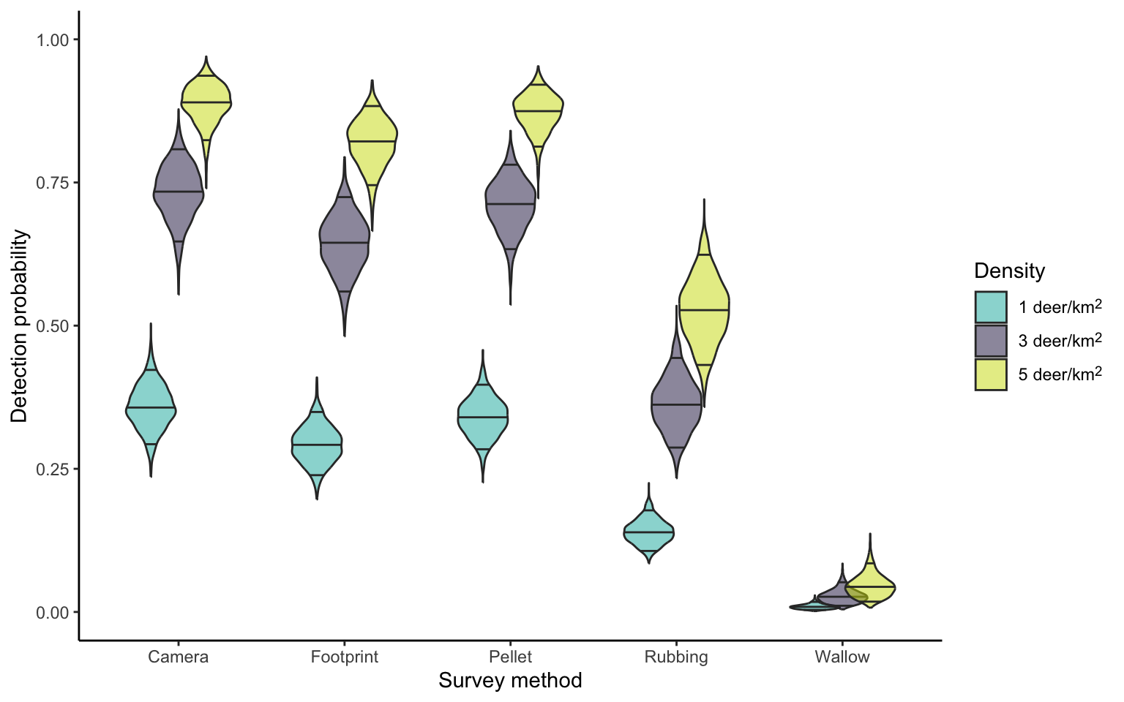
Figure 1. Unconditional detection probabilities for the various methods of survey, across various deer densities (low = 1 deer per km², medium = 3 deer per km² and high = 5 deer per km²). Camera trap detection probability is based on average deployment length (7.5 weeks/53 days); while transects used to detect footprints, pellets, rubbings and wallows are based on 3 x 150 m bidirectional transect searches (Cally and Ramsey 2023).

  - Site selection and survey effort
Step four determines the location and number of sampling sites (sample size) and the survey effort (e.g. how long to leave camera traps out for, or how long transects searching for deer sign are). Sites (e.g. camera trap locations or deer-sign transects) are selected from within the study area and should be representative of the study area/extent.
Non-random site selection (i.e. sites chosen in specific locations) may result in biased estimates of abundance, and the measures of precision will be unreliable. Random site selection (see accompanying online app) will provide unbiased estimates but could result in variable results due to consistent differences between sites (Thompson et al. 1998). Another alternative for site selection is the systematic placement of sites, with a random starting location. Systematic placement can be useful for ensuring good coverage of the area but may still have substantial variance associated with estimates if sample size is inadequate. The accompanying app (https://arisci.shinyapps.io/deersim/) can help select sites within an area. In some cases, stratification may improve the sampling design, whereby samples are drawn from distinct ‘strata’ such that enough samples are obtained from each strata of interest. An example of stratification may be to draw equal random samples from vegetation types such as rainforest, open woodlands and closed wet forests.
Site selection and survey effort will depend on the purpose of the monitoring (in fulfilling management objectives) and the desired precision of the abundance estimate or the ability to detect changes in abundance/occupancy over time. Frameworks have previously been created for designing monitoring programs to optimise survey efforts, such that changes to occupancy can be detected over time (Southwell et al. 2019). Power analyses and simulations can help optimise sampling design given fixed costs. You may need to seek expert advice about how to use these site selection methods, as there is no single rule that can be applied to all cases.
The number of sites and samples at each site (effort) depends on budget and the desired precision of estimates or statistical power to detect effects (trends, responses to control etc). High sample sizes generally reduce the influence of background variation and therefore increase precision or the ability to detect an effect. A statistician can use previous studies and statistical methods to work out the sample size needed to answer a particular question. In the absence of any baseline data, a statistician may determine the optimal amount of sampling effort by a method called Monte-Carlo simulation where the performance of various survey designs is assessed against simulated populations with known characteristics (i.e. density and spatial variation) (e.g. Scroggie et al. 2017).

The precision of estimates of occupancy or relative abundance (e.g. deer encounters on a camera trap per day) is usually measured by the standard deviation, but a more useful measure is the relative standard deviation, also called the coefficient of variation (CV). The coefficient of variation is calculated simply as
$$CV=\frac{SD}{Estimate}$$
Where $Estimate$ refers to the mean estimate of deer occupancy or relative abundance (e.g. 2.3 camera trap encounters per day) and $SD$ is the standard deviation of the mean estimate. A good rule of thumb is to undertake enough sampling effort to obtain a CV 0.3 (Robson and Regier 1964). The accompanying app (https://arisci.shinyapps.io/deersim/) can help select an adequate number of sites using different sampling methods (random or systematic) and sampling efforts within an area to obtain an adequate CV. To use the app to determine a sample size big enough to get precise estimates of relative abundance (CV < 0.3), select your area and run the simulation with between 20 and 40 sites at a starting point. If your CV is estimated to be above 0.3, add more sites and repeat the process until CV drops below 0.3.

Additional consideration should also be made to the spatial clustering of sites. If sites are close together, they will not be independent. While most modelling methods may account for non-independence through spatial random effects, you will need to determine whether your analysis technique assumes independence.
- Monitoring methods
  - Camera trap surveys
Camera traps are becoming an increasingly common way to survey for deer (Forsyth et al. 2022). Camera traps can be used to estimate abundance and occupancy (Cally and Ramsey 2023; Bengsen et al. 2022). They can operate remotely for long periods, provide robust evidence of presence (Figure 1), are relatively quick and simple to set up and can provide extensive information about a target and non-target species that can help estimate abundance and occupancy.
Below we provide information about which cameras to use, how to program them and then how to deploy them. We also provide further guidelines relating to how to deploy camera traps to be suitable for various types of analyses (e.g. camera trap distance sampling). We have also developed an online app to accompany these guidelines that can help with survey design for camera trapping (https://arisci.shinyapps.io/deersim/). This app can help select the number and locations of the sites to survey to achieve a desired level of precision in camera trap relative abundance index.
Table 3 compares camera trap methods and their respective advantages and disadvantages. Note that 4G enabled cameras are rapidly becoming more common for use in the management of invasive species. Such cameras can be paired with cloud-based platforms that use machine-learning models to identify species and notify land managers in near-real-time. While such tools may be useful in helping land managers to respond quickly to incursions of invasive species or alter control operations, they are not essential for estimating occupancy or abundance.

Camera models
Several brands and models of camera traps can be used to survey deer.
Brands and models vary in cost, sensitivity, programmability, longevity, and image/video quality. ARI exclusively used Reconyx Hyperfire 2 HF2X camera traps for a recent statewide survey of deer (Cally and Ramsey 2023). This model provided a suitable balance between cost, reliability and image quality, but other models and brands may have been equally as effective.
For consistency in camera sensitivity across a project, we recommend using the same or similar models of cameras; otherwise, potential differences between models should be accounted for during analyses using more complex statistical models. Within the context of camera trapping, sensitivity refers to the amount of movement/thermal signature required to trigger the camera. A high sensitivity will allow more frequent capture of smaller animals, or animals further away; but also, may lead to more false detections (e.g. triggered by leaves blowing in the wind).
For these guidelines, we will refer to the programmable settings of a Reconyx Hyperfire 2 HF2X. However, these settings should be equally applicable across other Reconyx models, such as the cellular Reconyx Hyperfire 2 HF2XC, the slightly more customizable Reconyx Hyperfire 2 HP2X and the older Hyperfire 1 range (e.g. HC500, HC600, and PC900).
Any camera used should be able to operate nocturnally with covert infrared flashes. Camera traps with white flash (e.g. Reconyx Hyperfire 2 HP2W) are not recommended as the flash may startle deer; species identification of deer is possible from black-and-white nocturnal photos taken using infrared flash.

Camera settings
When choosing the programmable settings for a camera trap, the main goal is to reduce the number of photos with no animal in them (false positive) and reduce the number of times an animal has entered the field of view, and the camera has not fired (false negative).
Often, we may tolerate modest levels of false positives (false triggers) as they marginally increase processing time and storage costs. On the other hand, high rates of false negatives may have severe impacts on the accuracy of analyses and conclusions as cameras fail to detect deer that are present.
We also want to ensure that photos are taken rapidly enough and for long enough to give us the best chance of positively identifying the animal that triggered the photo. The programmable settings that were used in the recent statewide surveys for deer (Cally and Ramsey 2023) are shown in Table 2.
When setting the camera, users should ensure that the date and time are correctly set, and the type of batteries used are correctly entered when prompted (e.g. NiMH).
Users can also ‘geotag’ the camera deployment with latitude and longitude during camera programming; however, this is not necessary if the camera location is stored on other data sheets/apps.
A 32GB SD card can usually record 40,000 – 50,000 photographs on the HF2X, with this threshold only likely to be hit when excessive false triggers occur (although this will depend on the duration of the deployment).
Good-quality rechargeable batteries should allow continuous operation for at least three months.
Table 2. ARI camera and deployment settings used for statewide deer monitoring.
Type | Specification | Selection
Camera Settings | Brand | Reconyx
Camera Settings | Model | HF2X Hyperfire 2
Camera Settings | Method | Motion
Camera Settings | Number of pictures | 5
Camera Settings | Time between pictures | Rapidfire
Camera Settings | Motion video | Off
Camera Settings | Quiet period | Off
Camera Settings | Sensitivity | High
Camera Settings | SD card | 32 GB Sandisk SD
Camera Settings | Batteries | 12 Rechargeable Fujitsu NiMH AA (1900 mAh)
Deployment Settings | Camera height | 1 metre above ground
Deployment Settings | Camera angle | Horizontal to match slope
Deployment Settings | Camera bearing | South-facing or as-close to as possible
Deployment Settings | Camera slope | Flat or gentle slope (if possible)

Camera deployments
Camera deployment should be consistent across sites. The number of sites can be determined by using our accompanying app (https://arisci.shinyapps.io/deersim/) or more technically complex simulations. The number of cameras being deployed will depend upon budget, area being surveyed, acceptable level of precision and underlying expected density of deer (i.e., if deer are very scarce, more cameras will likely be needed than in cases where deer are very common). Camera height, angle, bearing, and slope should be the same across sites, and obstructing vegetation should be minimised at each site (see Table 2). Using the settings in Table 2 should optimise the probability of detecting deer up to 12.5 m away from the cameras. Below we provide the detailed steps you should take when deploying a camera trap to monitor deer:
- Check the camera has charged batteries and a blank SD card before walking into the site. Numbering/labelling the SD card can be a good strategy to ensure the photos can be correctly matched up to the site location. To minimise theft, camera deployments should not be visible from the road (e.g. 100+ m).
- Note that if cameras are deployed to target microhabitats where you think deer will be more active (e.g. at a wallow), then estimates of abundance will be biased. Therefore, cameras should be deployed randomly without specifically targeting microhabitats where you expect deer to be more active. That is unless you are only interested in monitoring deer use of those microhabitats.
- At an approximate location you plan to deploy your camera, find a suitable tree to mount the camera on. In treeless landscapes, cameras will need to be mounted to stakes/posts, which you will need to bring to the site. The tree you mount the camera on should be sturdy enough to avoid being swayed under strong winds, but not too large so that straps/python locks cannot wrap around the tree (e.g. DBH between 50 cm – 1.5 m).
- Ideally, cameras should be orientated southward to avoid glare from the sun, and where possible on a flat or gentle slope.
- Once a suitable tree and orientation are chosen, ensure that there is good visibility in front of the camera (up to 12.5 m). In certain environments, pruning of vegetation and moving debris will be required (e.g. areas with recent fires usually have dense understorey). Vegetation in the field of view that may sway/move in the wind can cause excessive false detections and block the view of the animal triggering the camera.
- Secure the camera to the chosen tree 1 m above the ground and try and align the angle to match the angle of the slope. Cameras can be attached with straps, or python locks (or both) to minimise theft.
- Test the camera is functioning and able to detect motion up to 10 m by using the ‘walktest’ function (Reconyx models); this mode flashes a red light when motion is detected (but does not take a photo). Based on the feedback from the ‘walktest’, you may need to slightly angle the camera up/down/left/right, this can be easily done by wedging a small stick behind the camera. Alternatively, if the ‘walktest’ mode is not available for your camera, you may need to check sensitivity by arming the camera, taking test photos, and then viewing them with an SD card viewer/laptop/handheld digital camera before finally arming/deploying the camera.
- Once you are content with the results/feedback from the ‘walktest’, you can exit the field of view of the camera. Reconyx cameras will automatically arm after several minutes of no detections when operating under the ‘walktest’ mode. This is useful as it means you do not have to open the camera trap and ‘arm’ it manually, which could knock out the alignment of the camera.
- Additional covariates in the detection or activity of deer can be recorded on a separate data sheet at this point for use in the analyses (e.g. woody understorey cover, and other structural vegetation properties).
Before you leave the location, make sure that data regarding the deployment has been recorded. Importantly the date/time and the location (latitude/longitude) should be recorded on data sheets/apps and GPS devices. Data can be recorded on paper field sheets or phone/tablet applications such as Survey123 (https://survey123.arcgis.com), or ProofSafe (http://www.proofsafe.com.au), the latter of which is used by ARI to record data during most wildlife ecology fieldwork. At a minimum, it is paramount that you can at least record the data spatially and temporally by matching the camera’s SD card data with geographic coordinates.

Camera retrieval
We recommend cameras be left out on site for between six and twelve weeks. This ensures a higher likelihood of detection if deer are present.
In sites with medium to high densities of deer present, it is more likely that you will detect at least one deer during a deployment. However, in areas where deer density is lower (e.g. 1 deer per km²), the likelihood of detecting at least one deer will be lower (Cally and Ramsey 2023; Figure 1).
Cameras should be deployed for the same duration at each site in a study. If not, you must account for varying deployment durations during analysis.
The process for retrieving cameras is relatively simple:
- Attend the camera location, switch off the camera (press ‘okay’ first if using any Reconyx camera) and unmount it from the tree or stake. If the camera was secured using a Python lock, make sure you have the correct key/combination.
- Record the date-time of retrieval and other valuable information (e.g. camera condition).

Photo storage
Camera trap surveys come with a burden of storage costs for images and/or videos.
For many analyses, data can be extracted from image metadata (e.g. date-time and species tags), tabularised and then analysed; with the original photos no longer required. For instance, at ARI, a database has been created to store image metadata, and associate camera trap deployment details (e.g. where, and when).
However, when extracting metadata, certain information may not be tagged and extracted from the images (e.g. distance, sex, age) initially and the images may have wider uses after the original project (e.g. studies on other species or use of images to train image recognition software). Therefore, images must be stored in a structured, secure, and accessible format for future needs.
Cloud-based or local server/hard-drives may be used to store images.
An ideal directory structure allows for easy navigation through survey periods and sites. An example structure for a survey across two repeat survey iterations (seasons/years), three sites, and each site having two cameras may look like the following:
Deer-Project-|
|-Iteration-1-|
| |- SiteA -|
| |- SiteB -|
| |- SiteC -|
| | |- Cam1 -|
| | |- Cam2 -|
| | | |- IMG01.jpg
| | | |- IMG02.jpg
|-Iteration-2-|
Data can also be stored and tagged using third-party cloud and image recognition tools such as Wildlife Insights (https://www.wildlifeinsights.org). Subscriptions to such platforms may reduce storage and image processing burdens for large datasets.

Photo tagging
If using manual species tagging protocols (as opposed to trained automated tools such as Wildlife Insights or MegaDetector), users can use software such as Digikam, ExifTool, or Lightroom to tag photos with species, distance, group size and other important information. Programs that combine machine-learning and manual tagging and validation such as TimeLapse2 and EcoAssist can also be used.
Guidelines for this tagging process in Digikam have been included as supplementary material (Appendix). This tagging process has been used by ARI, other DEECA staff, consultancies and the Forest Protection Survey Program (FPSP) for a variety of camera trap surveys.
    - Camera trap presence-absence
In its simplest form camera trap data can be used to construct simple presence-absence information at a locality. Obtaining presence-absence data from camera trap photos would simply involve summarising which sites had photos of deer and which did not. The use of this method could be used to:
- Determine the species of deer present after discovering deer sign at a site
- Investigating whether deer now occupy a locality of interest (that they didn’t before)
- Investigating whether deer still occupy an area after control efforts.
While the observation of deer on a camera trap confirms the presence of deer at that location; it should be remembered that an ‘absence’ record does not necessarily mean that species is not present; just that it was not detected. The non-detection may be due to various factors related to the camera sensitivity, amount of obscuring vegetation in front of the camera, camera operating duration, camera angle, microhabitat, as well as the density and availability of deer at that location. In cases where deer density is low (< 1 deer per km²), it is more likely that there will be no photos of deer when the cameras are set-up as previously described for 53 days (Figure 1). Thus, survey effort (deployment duration) or the number of cameras deployed will likely need to be higher for low density populations, than high density populations to ensure good detectability.
To circumvent issues regarding non-detections being falsely ascribed as an “absence” (false negatives), we would recommend the use of occupancy analyses that account for imperfect detection (MacKenzie et al. 2002). These methods can be employed by analysing the camera trap data as a series of repeat daily observation periods; essentially delineating the data as daily presence-absence data. From this information you will be able to calculate the probability of occupancy (presence) at a site, as well as the detection probability for each given observation period (day), if the deer is present at a site. Occupancy analyses accounting for imperfect detection require statistical skills and understanding. Existing software to help conduct these analyses for camera trap data in the R programming language includes the ‘camtrapR’ and ‘unmarked’ R packages (Fiske and Chandler 2011; Niedballa et al. 2016).
    - Camera trap relative abundance index (CT-RAI)
In some cases, absolute abundance estimates may not be essential or cost-effective for monitoring; such cases might be when you wish to compare the relative abundance of deer pre- and post- control. A relative abundance index (RAI) can be a useful alternative because they are easy to calculate (encounters per day) and linearly correlate with absolute abundance (Palmer et al. 2018).
Programs that want to locate deer ‘hotspots’ within a management area, or determine if control impacts deer abundance, could use measures of relative abundance.
To have the necessary information to calculate a camera trap RAI (CT-RAI), camera traps should be deployed as previously described.
For each camera trap deployment, the relative abundance index can be calculated by dividing the total encounters of species by the deployment duration (e.g. days). In many cases, animals will not be solitary and photos with multiple individuals should be multiplied by the number of individuals in the photo. The resulting RAI metric in this case would be the average ‘encounters per day’.
Sequential photos can be grouped into ‘encounter’ periods (e.g. within 10 minutes of each other), to avoid inflated counts of CT-RAI when many photos are taken of a single animal within a short space of time. The CT-RAI at a site can be calculated as:
CT-RAI = total number of encounters/days the camera was deployed
The average relative abundance within an area/survey block can be calculated as the mean CT-RAI across cameras for a given survey period (sum of each site/survey CT-RAI divided by the number of site/surveys). The variation associated with this calculation can be obtained from determining the coefficient of variation (CV):
CV = standard deviation (CT-RAI) / mean (CT-RAI)
CT-RAI can be used to monitor the change in relative abundance of deer over time (possibly due to some control measure). You may need to seek statistical advice to help with this calculationCamera trap distance sampling (CTDS)
    - Camera trap distance sampling (CTDS)
CTDS is a method to estimate the absolute abundance of terrestrial species (Howe et al. 2017). It is a variation on conventional distance sampling at a point (Thomas et al. 2010). The method allows density/abundance estimates to be made without individual recognition (as is needed with spatially explicit capture-recapture). CTDS is able to calculate absolute abundance and density by taking into account the probability a deer will be detected at varying distances from the camera, therefore the total number of unobserved individuals can be accounted for, leading to an estimate of a ‘true’ total abundance. This method is more technical than the previously discussed CT-RAI, and we recommend this method is implemented with the assistance of a statistician.
For CTDS to be possible, each snapshot moment (usually a second time period) of the target species must also be assigned a distance from the camera; the distance recorded alongside the species can be a continuous point value (e.g. 5.5 m), or a pre-defined binned value (e.g. 5 – 7.5 m). For this to be possible, the images being analysed need to allow for a distance value to be assigned to any given individual within the photo. There are currently three methods that could be used: distance markers, reference images and semi-automated distance sampling. We discuss the processes for implementing these methods below.

Distance markers
The distance of animals in photos can be estimated by placing markers in the field of view of the camera at known distances (Figure 2A). Animals can then be assigned to a ‘bin’ depending on which two markers the animal is between. For deer, we have previously used four distance markers (2.5 m, 5 m, 7.5 m, and 10 m), which provide five distance bins (0 – 2.5 m, 2.5 – 5 m, 5 – 7.5 m, 7.5 – 10 m, and 10 m +).
Markers are placed at the correct distance by laying out a tape measure 10 m from the camera tree. The markers used are a post cap with reflective tape attached to a stick, post, or vegetation at the given distances.
Distance marker caps can often be knocked off the vegetation or post they are placed on by animals or wind. To avoid this, caps can be attached to the posts/sticks using a screw. Sometimes, however, they can be entirely knocked over.
It should also be noted that the marker caps should be somewhat staggered down the centre of the field of view so that the camera has a clear line of sight to all markers. Furthermore, the distance marker at 2.5 m needs to be high enough (e.g. 75 cm) to be seen by the camera, as the ground 2.5 m in front of the camera may not be within the field of view of a camera placed at 1 m height (Figure 2A).
When tagging images for species, images should also be tagged for distance, equating to the bin (0 – 2.5 m, 2.5 – 5 m, 5 – 7.5 m, 7.5 – 10 m, and 10 m +). They should also be tagged for the number of individuals in the photo (i.e. group size > 1). In cases where there are multiple individuals in the photo, the distance to the closest individual should be taken. Each photo of the target species will then have three metadata tags: species, number of individuals, and distance to the closest individual.
This method can be biased if animals interact with the markers (Henrich et al. 2022). In doing so, the animals will stay in the sampling area longer than they normally would. To correct for this bias then, an additional metadata tag should be recorded. A ‘behaviour’ recording behaviours like ‘marker interaction’ or ‘camera interaction’ can help identify photos that contain abnormal behaviour and therefore should be filtered out from the analysis.
This method is relatively easy to perform in the field and usually only adds 5 minutes to the deployment process at low cost (given the markers are relatively cheap). However, additional time is required when tagging photos to tag for distance.

Reference images
An alternative method for determining the distance of animals from the camera is to process the images using reference images taken during the set-up of the camera (Figure 2B). Reference images would be taken during set-up at varying distances from the camera (e.g. 2.5 m, 5 m, 7.5 m, 10 m), meaning the camera should be armed and take photos during this process. Then when tagging images of species, distance is binned based on inspection of where the animal is placed relative to these reference images. Reference images could also be taken with four distance markers set up and then subsequently taken down before commencing the sampling period.

Semi-automated distance sampling
Note that we have not thoroughly tested this semi-automated approach and as such would not recommend it without undertaking adequate tests and trials. However, given the rapidly evolving advancements and use of machine learning in ecology, we anticipate this method will have more usage and support in future.
Semi-automated distance sampling is a novel method that uses reference images (as set up above) alongside machine learning and monocular depth (distance) estimation software (Haucke et al. 2022; Henrich et al. 2023). For this automated process to occur, several calibration steps at each site need to occur. At least two reference photos need to be taken (but four are often more suitable) at a known distance with clear objects (Figure 2B). The photos then need to be masked using image processing software so that the calibration images are black and white photos, with the object at the known reference distance (e.g. 3 m) being white, and the rest of the photo black. This software (Henrich et al. 2023) will then automatically detect animals within photos and estimate their distance based on the calibration photos (Figure 2C).
This method could have several advantages over manual distance estimation using markers. First, by avoiding the use of markers you restrict the bias in abundance estimates due to deer interacting with markers (however camera interaction is still possible). Second, the software will automatically tag distance and identify animals (although not currently trained to a species identification). This may speed up processing time as only the species name will need to be tagged for the identified subset of photos that have animals detected. Third, given the output of distance is on a continuous scale, more flexibility in binning data is possible during analyses.
However, this approach is not currently used widely over distance markers or reference images, because it requires some additional editing of calibration photos using image editing software (such as Photoshop); this may take more time than manual tagging if very few or no target species are detected at that site. Processing lots of photos is computationally expensive, and although the software can be run without supervision, the process may require the use of multiple GPUS (graphics processing units)/computers for hours or days. The software used for this process is open-source and may not have had extensive testing under all conditions. This could mean that there may be undiscovered challenges. Finally, the calibration process can be conducted using various methods and parameters within the software, and therefore estimated distances may vary for a given photo depending on how the software was calibrated.

Analysing CTDS data
Obtaining estimates of density/abundance from CTDS requires statistical expertise and familiarity with statistical coding languages (e.g. R). Existing methods have been published to help guide users of this method through the analysis: https://examples.distancesampling.org/Distance-cameratraps/camera-distill.html (Howe et al. 2017). The advanced application of these methods has been documented for the statewide estimation of deer abundance in Victoria: https://justincally.github.io/statewide-deer-analysis/ (Cally and Ramsey 2023).

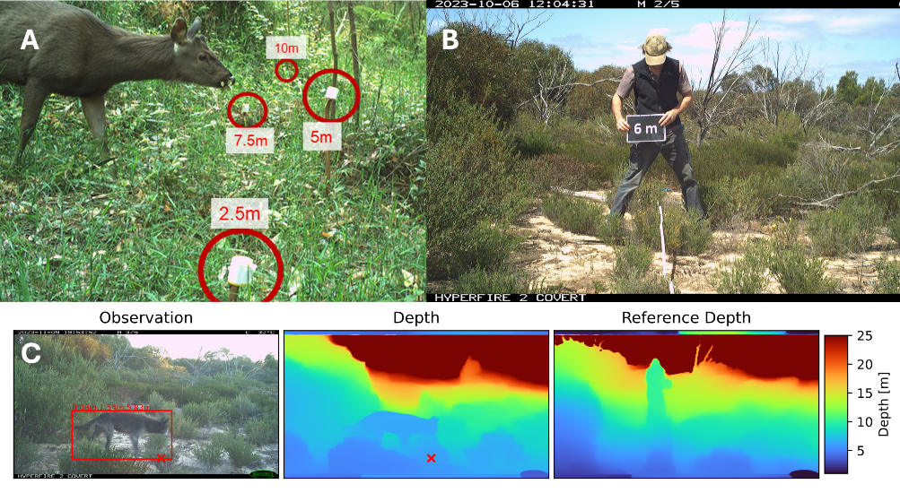
Figure 2. Camera trap distance sampling can use various techniques to estimate the distance of animals in front of the camera. (A) distance markers or (B) reference images can be used to manually ‘tag’ a distance bin of an animal when reviewing photos. Alternatively, semi-automated distance-sampling can use reference images (B), to compute a (C) depth estimate and calculate the distance to an animal (not exclusively deer) (Haucke et al. 2022; Henrich et al. 2023).

    - Camera trap spatially explicit capture-recapture (CT-SECR)
Spatially explicit capture-recapture with camera traps can estimate deer density using repeated capture of a recognisable deer individual. It is best used in smaller areas, where a closely spaced array of cameras can be placed.
CT-SECR has been used to estimate deer at several locations (study areas: 2.8 – 14.6 km² in size) in Australia (Bengsen et al. 2022).
CT-SECR relies on at least some deer being individually recognisable from images. The method also requires some of these individually recognised deer to be detected in multiple cameras (i.e. recaptures). CT-SECR can be used to estimate density at locations when cameras can be deployed relatively close to one another (e.g. 300 – 800 m), allowing for a given individual to be detected at multiple cameras.
As a guideline, camera spacing should be 0.5–0.8 of the home-range radius for best performance (Ramsey et al. 2015). If for instance a deer home range size is 4 km² (this is likely to vary depending on species, habitat, age and sex; e.g. Amos et al. (2022)), then cameras should be placed 560 m – 900 m apart.
Ideally, cameras should be spaced equally apart (e.g. in a rectangular, or triangular array); however, restrictions in terrain accessibility may lead to arrays being less regular.
Several further recommendations for CT-SECR deployment for deer in Australia are made by Bengsen et al. (2022), with a key requirement being at least 30 cameras to be spaced at 500–1,000 m and set for a minimum of 90 days; although simulations before undertaking surveys will likely help guide the camera spacing, duration and numbers.
To conduct CT-SECR, cameras can be deployed following the general guidelines discussed above. While distance is not explicitly required for SECR models, previous studies estimating deer density in Australia have used a marker 6 m in front of the camera to create a standardised detection zone, with identifications only being made for images within 0 – 6 m. This process tries to standardise detection at each given camera across the camera array. Considering this, a marker at 6 m can be deployed to follow this process, or distance can also be estimated using the semi-automated approach discussed above.
During the tagging of photos, the following variables need to be recorded (Bengsen et al. 2022):
  - Species.
  - Minimum number of deer that passed through the 6-m detection zone during the encounter (10 minute period) (if using a standardised detection zone).
  - Minimum number of deer within the entire field of view.
  - The individual identification codes for deer that could be unambiguously recognised as distinct individuals within the detection zone.
Encounters can be classified in various ways. Previously, ‘encounters’ have been classed as consecutive photos within 10 minutes of the previous photo of those species.
To identify given individuals from a camera trap, it is recommended to use natural markings on the deer (e.g. scarring, antler characteristics) and avoid ambiguous markings to assign a unique identification (Bengsen et al. 2022).
Unfortunately, most individuals can’t be individually recognised with any certainty. Previous studies estimated the ratio of marked to unmarked detections at 0.03 to 0.28 (Bengsen et al. 2022). Methods to analyse data that consist of both individually identifiable and unidentifiable detections have been developed to overcome the inability to individually identify all deer (Rich et al. 2014; Forsyth et al. 2019). These include extensions where only a fraction of the individuals that can be identified are in the data (Augustine et al. 2018). These methods have also been applied to monitoring data consisting of deer pellet searches, where genetic approaches have been used to identify individuals from DNA in faecal pellets (Augustine et al. 2019).
Multi-season CT-SECR surveys are also able to estimate demographic changes and can be used for population viability analyses (Duľa et al. 2021).

Analysing CT-SECR data
Obtaining estimates of density/abundance from CT-SECR requires statistical expertise and familiarity with statistical coding languages (e.g. R). Published methods exist for these analyses (Bengsen et al. 2022). Additionally, an R package (‘secr’) provides tools for statisticians/data analysts to more easily follow the methods (Efford 2024).
Table 3. The advantages and disadvantages of different methods that use camera traps.
Method | Advantages | Disadvantages
Camera Trap Presence-Absence | + Easy to implement in the field  + Simple analyses (without accounting for imperfect detection) is possible  + Only camera traps required | - Unable to estimate absolute abundance at a site  - Might not be sensitive enough in detecting changes to population size
Camera Trap RAI | + Easy to implement in the field  + Easy to analyse  + Only camera traps required  + Can track relative abundance and get direction and relative magnitude of change in abundance over time | - Unable to estimate absolute abundance at a site  - Does not account for imperfect detection
Camera Trap Distance Sampling (with markers) | + Easy to implement in the field  + Distance-markers relatively cheap and easy to use.  + Able to be used to estimate absolute density/abundance | - Advanced analysis required  - Animals may interact with markers, which may bias results  - Markers may fall or attachments may be knocked off if not firmly fixed
Camera Trap Distance Sampling (with reference images) | + Easy to implement in the field  + Animal staying time is less likely to be biased (no marker interaction)  + Able to be used to estimate absolute density/abundance | - Advanced analysis required  - Tagging images will require comparing the image of the animal to multiple reference photos so may be time consuming
Camera Trap Distance Sampling (semi-automated) | + Easy to implement in the field  + Animal staying time is less likely to be biased (no marker interaction)  + Able to be used to estimate absolute density/abundance  + Can filter out false detections automatically  + Can be time-saving if sites have thousands of images | - Advanced analysis required  - Calibration of images require processing using image-editing software (e.g. photoshop)  - Software is relatively new and not used or tested widely  - Results may differ depending on the calibration settings and methods used in the software
Camera Trap SECR | + Easy to implement in the field  + Able to be used to estimate absolute density/abundance  + Useful if study area is relatively small (e.g. a closed water catchment reserve)  + Able to estimate home-range size  + Demography and population viability can be analysed if multiple years of surveys take place | - Advanced analysis required  - Identification of individuals may be difficult and bias the results if not confident  - Ideally requires relatively closely-spaced cameras in an array, which would then require more resources (cameras) for surveys over a larger area.
  - Pedestrian sign counts
Pedestrian sign counts can be cheaper and less equipment-intensive than camera traps, as well as being able to be used in a wide variety of environments. However, they do require observer training and sufficient time to walk transects.
Deer can be difficult to observe where they are in low densities. Their cryptic behaviour, use of heavily forested areas, and crepuscular/nocturnal activity mean that direct counts of deer from walked transects may often be unsuccessful.
In Australia, direct counts from vehicles with spotlights have been used to survey for Fallow deer (Lethbridge et al. 2019), and transects walked during daylight hours have been used to conduct distance sampling (Amos et al. 2014). However, in many Victorian environments, we do not recommend direct counts as an efficient method to estimate deer abundance, unless in very homogenous and open areas, where they are more easily seen (e.g. alpine grasslands or farmlands). In forests and woodlands, deer would not be easily observed as there will be more obscuring vegetation and because they easily scare, this limits the ability to make distance measurements.
While direct observations of deer along transects remain challenging; detecting deer signs along transects or in pre-defined plots/quadrats will likely yield more data. Signs of deer presence (e.g. faecal pellets, footprints, rubbings, wallows) are usually distinguishable from other species (although feral goats may have similar scats and prints) but are more challenging to differentiate between deer species (Claridge 2010).
The handbook ‘Introduced Deer Field Identification Guide for the Australian Alps’ (Claridge 2010) is a key resource in understanding the appearance of deer pellets, footprints, rubbing and wallows. Figure 3 shows what each of these four deer signs look like in the field.

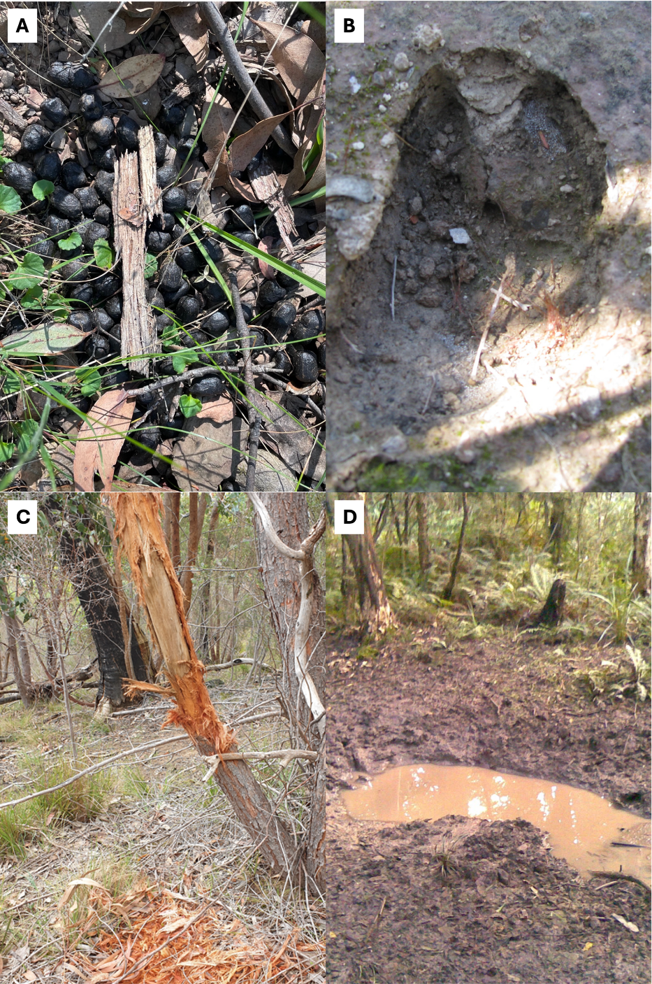
Figure 3. Deer signs can be searched for along transects. Surveyors can confirm the presence of deer by detecting (A) pellets, (B) footprints, (C) antler rubbings, and (D) wallows.
    - Transect searches
Transect searches are a simple method involving walking a defined length, noting sightings of live or dead deer, tree-rubbings, tracks, cast antlers, wallows, footprints and faecal pellets. This method can provide estimates of relative abundance or occupancy.
Transect searches for deer signs have been successfully used in Victoria to help estimate the occupancy of Sambar deer (Gormley et al. 2011) and the abundance of Sambar, Fallow, Red, and Hog deer (Cally and Ramsey 2023).
By themselves, transect searches cannot be used to estimate absolute abundance, but they can provide estimates of occupancy or even relative abundance.
For this method, survey effort can be controlled by (i) the length of the transect/s at a site, (ii) the number of transects at a site, and (iii) the number of observers/times the transect is walked. We generally recommend that survey effort is consistent across sites; however, variations can be accounted for in the analysis if recorded.
Sign transects that are subjectively located to follow a route more likely used by deer (e.g. along a watercourse or a trail) may have a higher likelihood of detecting deer. However, this type of monitoring should only be used to determine deer presence in an area. If unbiased estimates of occupancy or relative abundance are required, then systematic placement of straight transects (with a random start point) will yield more robust results.
Along the transect, any sign of deer can be noted: sightings of live or dead deer, tree-rubbings, tracks, cast antlers, wallows and faecal pellets (Gormley et al. 2011).
Previous studies have shown a single transect of 400 m has a detection probability of 0.75 for Sambar deer (Gormley et al. 2011), with three independent transects of 150 m (total = 450 m) walked back and forth (out and back along a single transect) also having a combined high detection probability when deer were present (Cally and Ramsey 2023); see Figure 1. Tri-point transects at 0°, 120° and at 240° from your coordinate, can measure occupancy and relative abundance with 90%+ detection probability (if deer are present).
Deer signs can be either recorded as a binary variable for each type of sign along the transect (e.g. pellet – YES, footprint – NO, rubbing – NO, wallow – YES), or as a count along the transect (e.g. pellet – 3 mounds, footprint – 0, rubbing – 0, wallow – 1).
It is advised that unless combined with other methods, multiple transects should be walked at each site for each survey to provide multiple observation events. Previous studies found three transects (150 m in length) walked bi-directionally from a centre point to be an efficient yet thorough way to survey deer. In an area with a low-medium density of deer (3 per km²), the combined detection probability of these transects was 93.5% (Cally and Ramsey 2023).
To analyse data from transects, simple presence-absence summaries for each site can be compiled to show which sites/transects detected deer and which did not. Alternatively, the amount of sign on each transect (e.g. counts of pellet groups, footprints or rubbings) can be used to estimate relative abundance (e.g. number of signs per km of transect).
When multiple transects are walked, presence-absence summaries can also be used to estimate deer occupancy and relative abundance accounting for imperfect detection. A Royle-Nichols (RN) model can be implemented to relate detection frequency to relative abundance (Royle and Nichols 2003). Alternatively, occupancy can be estimated with various other approaches (MacKenzie et al. 2002). Occupancy analyses that account for imperfect detection can use software such as the ‘unmarked’ R package. Some level of statistical expertise is required to undertake these more complex analyses.
    - Pellet counts
Faecal pellet counts have been used to estimate absolute deer abundance in Victoria (Davis et al. 2017). The density of individuals can be inferred by considering the density of pellets/pellet groups, the rate of pellet production by the deer and the longevity of the pellets before decay.
To estimate relative abundance an existing set of guidelines/field manual has been created for use in jointly assessing relative deer density and vegetation impacts (Bennett et al. 2022). We highly recommend following these guidelines if the objectives are to conduct deer surveys and assess their impacts on native vegetation. The methods for this survey method are available here: https://osf.io/8tpj2/ (Bennett et al. 2022). Here, relative abundance is calculated as deer faecal pellet counts per m² (FPC/m²). For deer, faecal pellet groups (≥ 6 pellets) can also be counted instead of individual pellets to estimate density (Smith 1964).
Surveys for pellets follow the methodology of Bailey and Putman (1981), however these methods have been adapted and slightly changed for various studies (Bennett et al. 2022; Davis et al. 2017). These methods sample small plots along a transect but in some areas/habitats then a larger plot may be sampled (e.g. area around an alpine bog). Users can broadly follow these methods but should consider appropriate sampling effort (e.g. transect length, plot frequency and plot size). Broadly pellet counts follow the following steps:
- For a sampling unit, a transect with a random bearing and length of 100 m+ is set.
- At 10+ equally spaced locations along the transect, a plot of a given radius (e.g. 3 m) is established. Ensure that plots do not overlap. Larger plots will increase sampling effort but take longer to complete. Previous plot sizes for Hog deer used a 3 m plot radius (for 100 m-long transects) in Summer and a 5.64 m plot radius (for 200 m-long transects) in Spring, with plot size modified to optimise efficiency and minimise zero counts across seasons (Davis et al. 2017). Alternatively, surveys in forested environments (primarily for Sambar deer) have used a plot with a radius of 1m for 30 survey plots along a 150m transect (Bennett et al. 2022).
- Search plots for pellets. Vegetation can be pushed aside. However, avoid disturbing leaf litter except when a deer pellet is visible, and you are searching for additional pellets in the group.
- If pellet groups are found, ensure they are deer pellets by consulting field guides (Claridge 2010). Pellet size and shape may be able to aid deer species identification if it is known that multiple species of deer occupy the survey area (e.g. Fallow and Sambar deer). However, if species confirmation is needed, then genetic swabs of the pellets can also be taken.
- Remove pellets from plots. By removing pellets from the plot, the accumulation of new pellets can be used if repeat surveys of the plots are required (e.g. before and after deer control, monitoring annual changes in abundance).
Pellet counts can then be used to model absolute abundance if the rate of pellet production and the rate of pellet decay is known (Davis et al. 2017). Pellet production and decay rates will likely require additional research and estimation for a given species and environment. Alternatively, pellet counts as described can provide measures of relative abundance that are related to absolute abundance (Forsyth et al. 2007), which may be sufficient for meeting most management objectives.
    - Pellet genetic mark-recapture
The pellet count method above can also be used to estimate deer abundance using genetic mark-recapture techniques (Pacioni et al. 2022). This involves collecting deer pellets and conducting DNA sampling to detect both the deer species, and to identify individual deer (i.e. DNA fingerprinting). Repeated detection of the same individual in multiple faecal pellet samples is equivalent to recapture of a marked individual in classical mark-recapture studies.
Pale pellets, or pellets with a hard crust, fissures or mould growing on them are not sampled, because they are usually too old to recover usable genetic material.
During pellet collection, sterile procedures must be used so that pellets do not become contaminated with genetic material from other pellets.
To obtain potential re-captures of individual deer, the area should be subject to a systematic search (e.g. transects) recording the location of both the transect and any sampled pellets.
Multiple detections of the same individual in different locations within the study area (recaptures) can be used in a spatial capture-recapture analysis, with pellet detection dependent on the amount of search effort expended (Henk et al. 2022). For this method, geneticists should be involved in project design and analysis.
  - Aerial direct counts
Aerial direct counts are likely to be more fruitful than pedestrian or vehicle direct counts as they can cover a large area and may often provide better vantage points for detection than ground-based surveys (Forsyth et al. 2022). Aerial surveys of deer can be conducted from a helicopter, fixed-wing aircraft or UAV (uncrewed aerial vehicle). However, helicopters are proving to be a more flexible option, because they allow surveys to be conducted at lower altitudes and in areas with higher tree cover (Forsyth et al. 2022).
Aerial surveys may be difficult to conduct in heavily forested and rough terrain due to challenges in aircraft mobility and the obscurement of animals by dense vegetation.
Aerial surveys can be conducted via
- crewed aerial double observer counts
- crewed aerial distance sampling
- UAV and thermal aerial counts.
UAV surveys are often conducted with the aid of deep learning models/artificial intelligence to automate the detection of deer (Kellenberger et al. 2018). Alternatively, video footage from UAVs is scanned manually and the number of deer detections counted.
Aerial surveys will require specialist equipment and permits and are best suited to larger-scale surveys (> 3000 ha) (e.g. Lethbridge et al. 2019).
    - Aerial double observer counts
Aerial direct counts are likely to be more fruitful than pedestrian or vehicle direct counts as they can cover a large area and may often provide better vantage points for detection than ground-based surveys (Forsyth et al. 2022). Aerial surveys of deer can be conducted from a helicopter, fixed-wing aircraft or UAV (uncrewed aerial vehicle). However, helicopters are proving to be a more flexible option, because they allow surveys to be conducted at lower altitudes and in areas with higher tree cover (Forsyth et al. 2022).
Aerial surveys may be difficult to conduct in heavily forested and rough terrain due to challenges in aircraft mobility and the obscurement of animals by dense vegetation.
Aerial surveys can be conducted via
- crewed aerial double observer counts
- crewed aerial distance sampling
- UAV and thermal aerial counts.
UAV surveys are often conducted with the aid of deep learning models/artificial intelligence to automate the detection of deer (Kellenberger et al. 2018). Alternatively, video footage from UAVs is scanned manually and the number of deer detections counted.
Aerial surveys will require specialist equipment and permits and are best suited to larger-scale surveys (> 3000 ha) (e.g. Lethbridge et al. 2019).
    - Aerial distance sampling
If the terrain being monitored is relatively flat and open, then distance sampling (i.e. recording of distance to each detected deer group) can be employed.
Unlike double-observer counts, conventional distance sampling only requires a single observer. However, in practice, it is usual to use two observers, one on either side of the aircraft, so that a wider transect can be monitored.
To enable aerial distance sampling, sighting poles are mounted on the aircraft to help divide up the visual area for surveyors into zones for distance sampling (Figure 4). The standard zones are 0–20 m, 20–40 m, 40–70 m, 70–100 m, and 100–150 m (Lethbridge et al. 2019).
An alternative to conventional distance sampling uses two observers on each side of the aircraft to enable double-observer distance sampling, which is a combination of double observer counts and distance sampling (also called mark-recapture distance sampling – MRDS). MRDS is often more robust than single observer (conventional) distance sampling or counts within a defined strip-width but is usually only feasible on larger aircraft that can comfortably sit four people behind the pilot.
Double-observer distance sampling becomes especially useful when detection probability along the transect (directly under the helicopter) is imperfect; this may be the case if the aircraft can obscure some animals that are on the transect line.
Surveys also require the use of experienced observers, with previous studies using observers generally with more than 200 hours of experience (Lethbridge et al. 2019).
The capability to conduct these surveys is not widespread in Victoria and Australia, with EcoKnowledge as the primary provider for many crewed aerial surveys: https://ecoknowledgeau.weebly.com/aerial-surveys.html as well as the NSW Department of Primary Industries.
This method has been used to estimate deer abundance in Tasmania (Lethbridge et al. 2019), and in Kosciuszko, alongside horse populations (NSWOEH 2023).
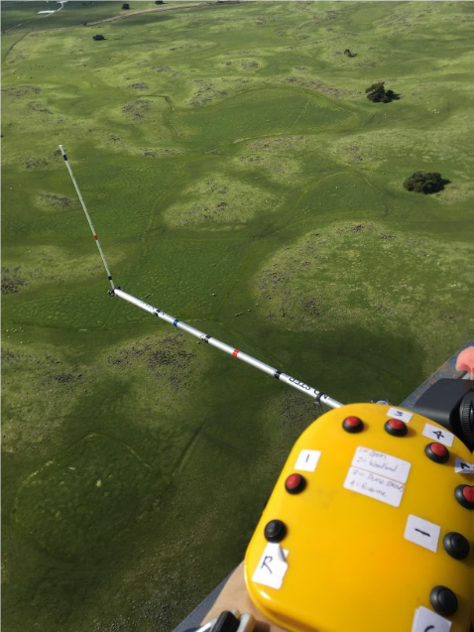\
Figure 4. Sighting poles are used to place detected animals into distance categories from the aircraft (photo credit – Mark Lethbridge, Ecoknowledge).

    - UAV and thermal aerial counts
UAVs (often drones) are rapidly becoming adopted as a tool to survey wildlife. They can be useful in conducting surveys in low to medium forested habitat and can be less costly than crewed aerial surveys (helicopter or fixed-wing aircraft). Aerial surveys using UAVs are often conducted by flying structured and relatively closely spaced transects, with thermal imagery/videos being taken throughout. UAVs can often be equipped to operate in both day and night conditions; with the latter requiring use of thermal cameras. Trained models or observers are then used to process the imagery to highlight the locations of the animals. Additionally, artificial intelligence models automatically detect target species from photo/video footage (Kellenberger et al. 2018), which can reduce manual labour workload and costs by up to 84% (Sudholz et al. 2022).
UAV surveys have been shown to provide similar but more efficient density estimates than those derived from pellet counts (McMahon et al. 2022). Unfortunately, if drones are used to conduct only one round of transects then estimating abundance can be prone to undercounting bias. This is because estimating the detection probability is difficult with only one survey or one round of applying manual observers or models to detect animals in the UAV footage. This is unlike many crewed aerial surveys, where at least two observers independently record observations; allowing for an estimation of detectability. However, imperfect detection probability as well as spatiotemporal availability (the degree of movement in and out of the transect survey area between surveys) can be accounted for (Brack et al. 2023).
UAV technology and methods are rapidly evolving, and we expect changes to operating procedures and tools in the future.
Specialised skills and equipment are needed for undertaking UAV surveys, so they are often contracted to specialists. As such, methods applied may be subject to operational and environmental conditions such as the total area surveyed and resources available. Inclement weather, logistical planning and permits may be key barriers for UAV surveys.
Table 4 provides some monitoring options using UAV systems and evaluates their relative precision and bias.

Table 4. Considerations for UAV deer surveys and how they may improve the analysis or mitigate bias, and alter costs to projects.
Method component | Description | Benefit of inclusion | Bias | Effect on cost
Repeat surveys | Undertaking repeat surveys (e.g. on consecutive nights or at different times of the day) can be used to increase survey effort over a fixed area. Flying complete transects North-South and then East-West in the same session may also be considered repeat surveys. | By undertaking repeat surveys, precision is likely to improve. It is possible to estimate temporal availability and/or detection probability. In cases where the counts of individuals vary between surveys, it is likely that either animals have moved in and out of the survey area or were not able to be detected in the survey area (e.g. are hiding) in a proportion of the surveys. If repeat surveys are undertaken in quick succession, it is less likely differences in counts are due to temporal availability, because it is less likely animals have moved out of the area. | If only repeat surveys instead of use of multiple observers) are conducted and variation between counts is used to estimate detection probability, then temporal availability (animals moving in and out of the survey area) will not be estimated and density estimates will likely be larger than reality. This can be mitigated by flying the repeat transects in quick succession.  Alternatively, if density is estimated from the average counts of the repeat surveys, it may be that density is underestimated, because for each survey, detection probability is not perfect. | Repeat surveys would increase costs
Observer type | Trained artificial intelligence models or human observers can be used to detect deer from UAV footage. | The use of one observer type over the other depends on resources available and accuracy of methods. Larger projects and surveys may consider the use of AI more beneficial than smaller studies that require less time from human observers. Contractors often provide identification of species (via AI or observers) alongside their flight surveys. When multiple deer species are present it is unknown how well thermal UAV footage would perform on identifying deer to species-level. | A single observer or AI model may have positive or negative bias in detecting deer (non-equal rate of false positives and negatives). Without the use of multiple observers or detection methods, it is difficult to evaluate direction and magnitude of bias. A previous study of Rusa deer found that AI detected between 66% and 100% of those detected from manual observers (Sudholz et al. 2022), suggesting use of AI may negatively bias counts if unaccounted for. | Use of AI may reduce costs of footage processing by 84% (Sudholz et al. 2022). However, initial investment in these models is required.
Multiple observers | Either two observers reviewing footage (that are blinded to one another) can review footage or one manual observer and one AI processing model or two AI processing models. | Multiple observers allow for detection probability to be estimated via a mark-recapture model. This assumes that not all individuals will be seen by each observer. Accounting for this source of undercounting bias will likely make estimates more accurate. If one of the observers is an AI model, the manual observer will also provide understanding of how well the AI model performs. | Use of multiple observers should minimise negative bias because detection probability can be estimated. Positive bias may be increased if false positives occur and are not accounted for. | Use of multiple observers will increase costs. However, additional precision gained from multiple observers may allow less sites to be surveyed to obtain population estimates (Brack et al. 2023).
Flight time | Nocturnal or dawn/dusk are possible for deer. | Optimal flying time will likely depend on temperature, because in warmer months, thermal signatures are difficult to detect. Activity of deer appears to peak around dawn/dusk. Flying in natural light (dawn/dusk) can also allow for high-definition footage to be recorded that may be helpful in confirming species identification. | If conditions are sub-optimal for flying, then detection rates may decrease, leading to a negative bias in abundance estimates. | There may be slight differences in cost with nocturnal versus dawn/dusk due to contractor costs and accessibility to locations at those times.

- References
Amos M, Baxter G, Finch N, Lisle A, Murray P (2014). ‘i just want to count them! Considerations when choosing a deer population monitoring method’. Wildlife Biology 20, 362–370. doi:10.2981/wlb.00080
Amos M, Pople A, Brennan M, Sheil D, Kimber M, Cathcart A (2022). Home ranges of rusa deer (Cervus timorensis) in a subtropical peri-urban environment in South East Queensland. Australian Mammalogy. doi:10.1071/AM21052
Augustine BC, Royle JA, Kelly MJ, Satter CB, Alonso RS, Boydston EE, Crooks KR (2018). Spatial capture–recapture with partial identity: An application to camera traps. The Annals of Applied Statistics 12, 67–95. doi:10.1214/17-AOAS1091
Augustine BC, Royle JA, Murphy SM, Chandler RB, Cox JJ, Kelly MJ (2019). Spatial capture–recapture for categorically marked populations with an application to genetic capture–recapture. Ecosphere 10, e02627. doi:https://doi.org/10.1002/ecs2.2627
Bailey RE, Putman RJ (1981). Estimation of Fallow Deer (Dama dama) Populations from Faecal Accumulation.
Bengsen AJ, Forsyth DM, Ramsey DSL, Amos M, Brennan M, Pople AR, Comte S, Crittle T (2022). Estimating deer density and abundance using spatial mark–resight models with camera trap data. Journal of Mammalogy 103, 711–722.
Bennett A, Fedrigo M, Greet J (2022). A field method for rapidly assessing deer density and impacts in forested ecosystems. Ecological Management and Restoration 23, 81–88. doi:10.1111/emr.12518
Brack I V., Kindel A, de Oliveira LFB, Lahoz-Monfort JJ (2023). Optimally designing drone-based surveys for wildlife abundance estimation with N-mixture models. Methods in Ecology and Evolution 14, 898–910. doi:10.1111/2041-210X.14054
Cally JG, Ramsey DSL (2023). Abundance of deer in Victoria: Regional and statewide estimates of deer density and their impact on vegetation. Arthur Rylah Institute for Environmental Research Technical Report Series No. 368. Department of Energy, Environment and Climate Action, Heidelberg, Victoria. Available at: www.ari.vic.gov.au
Cally JG, Ramsey DSL (2025). Guidelines for monitoring deer populations: A glovebox guide for practitioners. Arthur Rylah Institute for Environmental Research, Department of Energy, Environment and Climate Action, Heidelberg, Victoria.
Claridge AW (2010). ‘Introduced Deer Field Identification Guide for the Australian Alps’. (Department of Environment, Climate Change and Water, Parks and Wildlife Group: Queanbeyan, New South Wales)
Davis NE, Bennett A, Forsyth DM, Bowman DMJS, Lefroy EC, Wood SW, Woolnough AP, West P, Hampton JO, Johnson CN (2016). A systematic review of the impacts and management of introduced deer (family Cervidae) in Australia. Wildlife Research 43, 515–532. doi:10.1071/WR16148
Davis NE, Coulson G (2010). Mammalian browse damage to revegetation plantings in a national park. Ecological Management & Restoration 11, 72–74. doi:https://doi.org/10.1111/j.1442-8903.2010.00519.x
Davis NE, Gordon IR, Coulson G (2017). The influence of evolutionary history and body size on partitioning of habitat resources by mammalian herbivores in south-eastern Australia. Australian Journal of Zoology 65, 226–239. doi:10.1071/ZO16075
Duľa M, Bojda M, Chabanne DBH, Drengubiak P, Hrdý Ľ, Krojerová-Prokešová J, Kubala J, Labuda J, Marčáková L, Oliveira T, Smolko P, Váňa M, Kutal M (2021). Multi-seasonal systematic camera-trapping reveals fluctuating densities and high turnover rates of Carpathian lynx on the western edge of its native range. Scientific Reports 11. doi:10.1038/s41598-021-88348-8
Efford M (2024). secr: Spatially explicit capture-recapture models. Available at: https://CRAN.R-project.org/package=secr
Fiske I, Chandler R (2011). Unmarked: an R package for fitting hierarchical models of wildlife occurrence and abundance. Journal of statistical software 43, 1–23.
Forsyth DM, Barker RJ, Morris G, Scroggie MP (2007). Modeling the Relationship Between Fecal Pellet Indices and Deer Density. The Journal of Wildlife Management 71, 964–970. doi:10.2193/2005-695
Forsyth DM, Comte S, Davis NE, Bengsen AJ, Côté SD, Hewitt DG, Morellet N, Mysterud A (2022). Methodology matters when estimating deer abundance: a global systematic review and recommendations for improvements. Journal of Wildlife Management 86. doi:10.1002/jwmg.22207
Forsyth DM, Davis NE (2011). Diets of Non-Native Deer in Australia Estimated by Macroscopic Versus Microhistological Rumen Analysis. Journal of Wildlife Management 75, 1488–1497. doi:10.1002/jwmg.179
Forsyth DM, Ramsey DSL, Woodford LP (2019). Estimating abundances, densities, and interspecific associations in a carnivore community. The Journal of Wildlife Management 83, 1090–1102. doi:https://doi.org/10.1002/jwmg.21675
Gormley AM, Forsyth DM, Griffioen P, Lindeman M, Ramsey DSL, Scroggie MP, Woodford L (2011). Using presence-only and presence-absence data to estimate the current and potential distributions of established invasive species. Journal of Applied Ecology 48, 25–34. doi:10.1111/j.1365-2664.2010.01911.x
Haucke T, Kühl HS, Hoyer J, Steinhage V (2022). Overcoming the distance estimation bottleneck in estimating animal abundance with camera traps. Ecological Informatics 68, 101536. doi:https://doi.org/10.1016/j.ecoinf.2021.101536
Henk M, Hilson C, Bean WT, Barton DC, Gunther MS (2022). Noninvasive genetic sampling with a spatial capture-recapture analysis to estimate abundance of Roosevelt elk. The Journal of Wildlife Management 86, e22294. doi:https://doi.org/10.1002/jwmg.22294
Henrich M, Burgueño M, Hoyer J, Haucke T, Steinhage V, Kühl HS, Heurich M (2023). A semi-automated camera trap distance sampling approach for population density estimation. Remote Sensing in Ecology and Conservation. doi:10.1002/rse2.362
Henrich M, Hartig F, Dormann CF, Kühl HS, Peters W, Franke F, Peterka T, Šustr P, Heurich M (2022). Deer Behavior Affects Density Estimates With Camera Traps, but Is Outweighed by Spatial Variability. Frontiers in Ecology and Evolution 10. doi:10.3389/fevo.2022.881502
Howe EJ, Buckland ST, Després-Einspenner ML, Kühl HS (2017). Distance sampling with camera traps. Methods in Ecology and Evolution 8, 1558–1565. doi:10.1111/2041-210X.12790
Kellenberger B, Marcos D, Tuia D (2018). Detecting mammals in UAV images: Best practices to address a substantially imbalanced dataset with deep learning. Remote Sensing of Environment 216, 139–153. doi:10.1016/j.rse.2018.06.028
Lethbridge MR, Stead MG, Wells C (2019). Report of state-wide census of wild fallow deer in Tasmania project: Part A: Baseline aerial survey of fallow deer population, central and north-eastern Tasmania.
MacKenzie DI, Nichols JD, Lachman GB, Droege S, Andrew Royle J, Langtimm CA (2002). Estimating site occupancy rates when detection probabilities are less than one. Ecology 83, 2248–2255. doi:https://doi.org/10.1890/0012-9658(2002)083[2248:ESORWD]2.0.CO;2
Mcmahon MC, Ditmer MA, Forester JD (2022). Comparing unmanned aerial systems with conventional methodology for surveying a wild white-tailed deer population. Wildlife Research 49, 54–65. doi:10.1071/WR20204
Niedballa J, Sollmann R, Courtiol A, Wilting A (2016). camtrapR: an R package for efficient camera trap data management. Methods in Ecology and Evolution 7, 1457–1462.
NSWOEH (2023). A survey of the wild horse population in Kosciuszko National Park, October 2023. Available at: https://www.environment.nsw.gov.au/research-and-publications/publications-search/a-survey-of-the-wild-horse-population-in-kosciuszko-national-park-october-2023 [accessed 8 April 2024]
Palmer MS, Swanson A, Kosmala M, Arnold T, Packer C (2018). Evaluating relative abundance indices for terrestrial herbivores from large-scale camera trap surveys. African Journal of Ecology 56, 791–803. doi:10.1111/aje.12566
Ramsey DSL, Caley PA, Robley A (2015). Estimating population density from presence–absence data using a spatially explicit model. The Journal of Wildlife Management 79, 491–499. doi:https://doi.org/10.1002/jwmg.851
Ramsey DSL, McMaster D, Thomas E (2023). The application of catch–effort models to estimate the efficacy of aerial shooting operations on sambar deer (Cervus unicolor). Wildlife Research. doi:10.1071/wr22123
Rich LN, Kelly MJ, Sollmann R, Noss AJ, Maffei L, Arispe RL, Paviolo A, De Angelo CD, Di Blanco YE, Di Bitetti MS (2014). Comparing capture-recapture, mark-resight, and spatial mark-resight models for estimating puma densities via camera traps. Journal of Mammalogy 95, 382–391. doi:10.1644/13-MAMM-A-126
Royle JA, Nichols JD (2003). Estimating abundance from repeated presence-absence data or point counts. Ecology 84, 777–790. doi:10.1890/0012-9658(2003)084[0777:EAFRPA]2.0.CO;2
Scroggie MP, Moloney PD, Ramsey DSL (2017). Design of an aerial survey to estimate the abundance of kangaroos in Victoria. Arthur Rylah Institute for Environmental Research Technical Report No. 280. Department of Environment, Land, Water and Planning, Heidelberg, Victoria.
Skalski JR (1994). Estimating Wildlife Populations Based on Incomplete Area Surveys. Wildlife Society Bulletin 22, 192–203.
Smith AD (1964). Defecation Rates of Mule Deer. The Journal of Wildlife Management 28, 435–444. doi:10.2307/3798195
Southwell DM, Einoder LD, Lahoz-Monfort JJ, Fisher A, Gillespie GR, Wintle BA (2019). Spatially explicit power analysis for detecting occupancy trends for multiple species. Ecological Applications 29, e01950. doi:https://doi.org/10.1002/eap.1950
Sudholz A, Denman S, Pople A, Brennan M, Amos M, Hamilton G (2022). A comparison of manual and automated detection of rusa deer (Rusa timorensis) from RPAS-derived thermal imagery. Wildlife Research 49, 46–53. doi:10.1071/WR20169
Thomas L, Buckland ST, Rexstad EA, Laake JL, Strindberg S, Hedley SL, Bishop JRB, Marques TA, Burnham KP (2010). Distance software: design and analysis of distance sampling surveys for estimating population size. Journal of Applied Ecology 47, 5–14. doi:https://doi.org/10.1111/j.1365-2664.2009.01737.x
Thompson WL, White GC, Gowan C (1998). ‘Monitoring Vertebrate Populations’ 1st ed. (Academic Press)

Appendix

Protocol for tagging species identification from camera trap images using digiKam
Version 2, 20/6/2023
Luke Woodford, Jemma Cripps (V1)
DEECA – Arthur Rylah Institute

Purpose
- A method is needed to consistently and efficiently process remote camera data collected during general camera trap surveys. Species data will be used to improve our knowledge of detection probabilities and population densities using the modified distance sampling method. Data will be analysed by ARI using the CamtrapR package in R.
- This document describes the method using digiKam as the software for image tagging. digiKam is compatible with the camptrapR package. Metadata tags can be assigned to images in image management software such as digiKam. They are saved in the image metadata automatically. Metadata tagging can be used to assign custom tags to images, e.g. species identification, number of individuals on images.

Part 1: Setting up digiKam for the first time
- Download digiKam at https://www.digikam.org/download/
- Install digiKam. Open access will be required. Currently it is best to store the files directly on: C:\Data\digiKam (not ‘Program Files’).
- digiKam needs to write metadata tags into image metadata, not into .xmp sidecar files. Its behaviour can be configured. Here’s how to set up digiKam:
- If installing for the first time, it will ask you to make a few settings when you first start the program. When asked ‘Configure Metadata Storage to Files’, set ‘Add Information to Files’ instead of the default ‘Do Nothing’.
- If digiKam was installed already, go to ‘Settings’, then ‘Configure digiKam’. There, select ‘Metadata’ on the left and, in the tab ‘Behaviour’, make sure that ‘Image tags’ is checked in the box titled ‘Write This Information to the Metadata’.
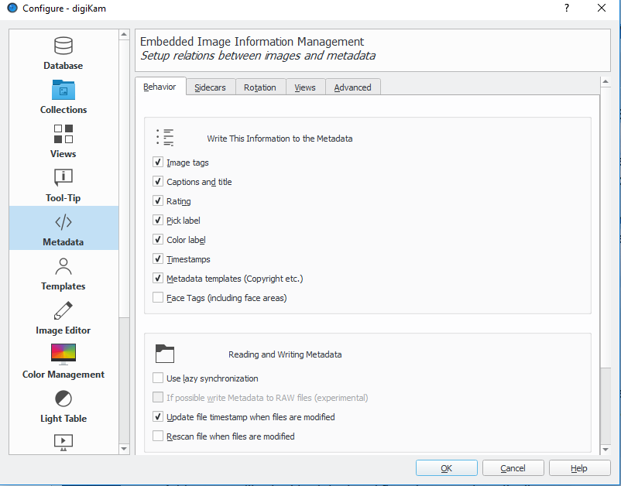
- In the ‘Sidecars’ tab, in the box ‘Reading and Writing Metadata’, make sure that both ‘Read from sidecar files’ and ‘Write to sidecar files’ are unchecked. Also uncheck the box ‘Update file timestamp when files are modified’.
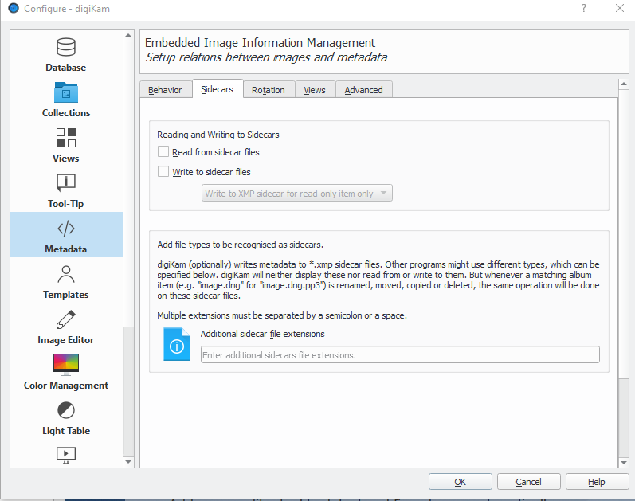
- Also in ‘Settings’, ‘Configure digiKam’ – make sure your Collections Settings are set to the folder where your images are stored. Click on ‘Collections’ on the left, and then ‘Add Collection’ to ‘Local Collections’.
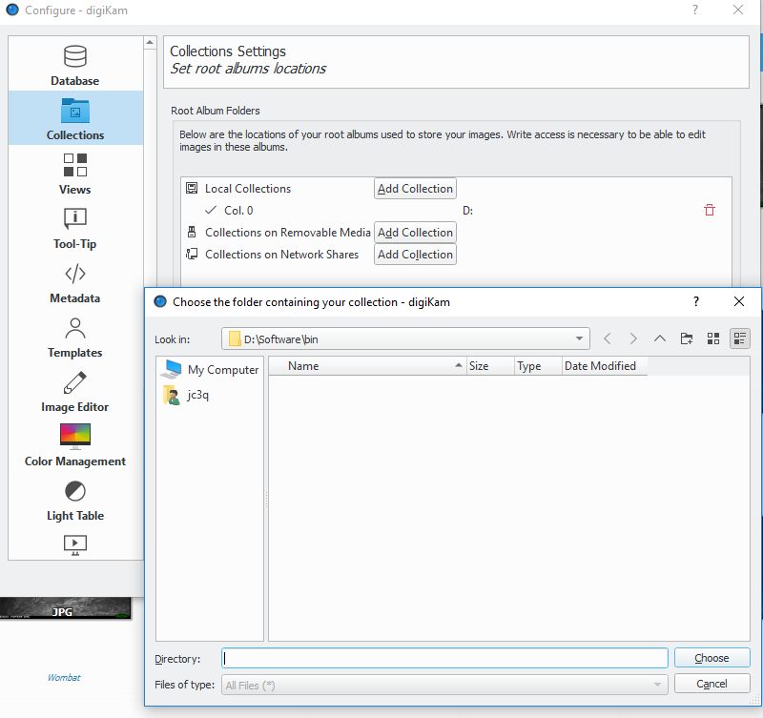
- This process may take some time (e.g. overnight sometimes) for the digiKam software to connect to your folder at its location, depending on the size of the image data. This is normal. Once it has connected, you will see the data folders listed in the ‘Albums’ windowpane on the left hand side.

Part 2: Metadata tag structure and tagging images
- Before assigning metadata tags, users need to set up a hierarchical tag structure for the tagging to be compatible with camtrapR. This structure is customisable and can be expanded as needed. In digiKam, this is done in the Tag Manager. Here’s some examples:
  - Species
    - SpeciesA
    - SpeciesB
  - Individual
    - Male1
    - Male2
    - Female1
    - Unknown
  - Multiples
    - 1 (if no tag is made for multiples we assume 1)
    - 2
    - 3
  - Behaviour
    - Sitting
    - Feeding
    - Mating
    - Fighting
    - Moving
    - CameraInteraction
    - MarkerInteraction
- If the project requires distance sampling bin tags (using the distance markers)
- Distance (meters)
- 0 – 2.5
- 2.5 – 5
- 5 – 7.5
- 7.5 – 10
- 10+

- If available, request an image is provided with the correct tags for the project. This can be named ‘project name_species_tags.jpg’ or similar. This must be in the same folder path as the photos you are planning to tag.
NOTE: This image is tagged with all the possible species tags and already structured in a hierarchical way. Tags will therefore be automatically recognised in Tag Manager. This will ensure consistency in tag use between contractors tagging images. Ensure scientific names are used to align with VBA data requirements, e.g.:
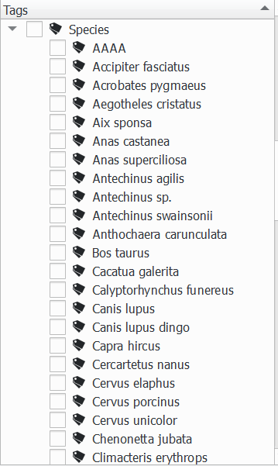
For a list of species tags, see VBA taxa list: https://discover.data.vic.gov.au/dataset/victorian-biodiversity-atlas-vba-taxa-list

Table A1. Explanations for use of method tags.
Tag | Explanation
AAA | Images taken during the camera setup.
IDX | There is an animal visible, but it’s not possible to identify it  (e.g. you can only see a furry blur or a tail).  These images will be excluded from further analysis.
NIL | There is no animal present (e.g. wind trigger).  These images will be excluded from further analysis.
XXX | This is an identifiable animal, and I think it’s a particular species, but I’m not 100% confident.  These images are to be reviewed by one or more experts before analysis and either confirmed (i.e. XXX tag removed) or changed to IDX.  An XXX tag should always be accompanied by a species tag, never on its own:  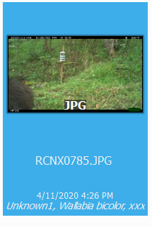  (Note – the tag ‘Unknown1’ refers to the sex. See below.)
ZZZ | Images taken when the camera was retrieved.

- In the ‘Album’ pane (left), select a single camera deployment folder at a time. (Note: if you select a higher-order folder, you’ll see all the related subfolders as thumbnails).
- Make sure that the ‘Captions’ tab is selected in the right pane. Select the tab named ‘Tags’.
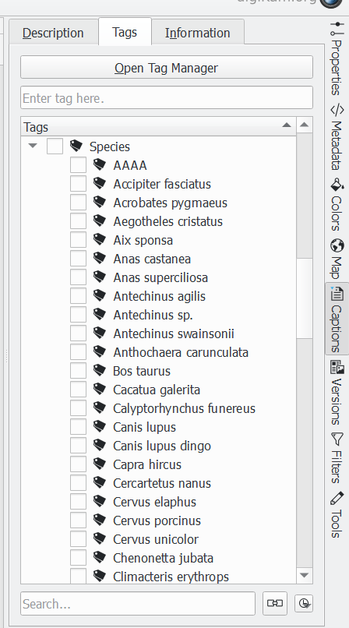
- In the thumbnail pane (centre), click on the first image. Now you can use the arrow keys (on the keyboard) to efficiently move through the images in sequence.
- Start by applying the ‘camera deployment’ tag (i.e. when the camera was set up initially), which is ‘AAA’, to the first images. Click on the first thumbnail.
- Hold down the ‘Shift’ key on your keyboard and click on the last photo corresponding to deployment. This should highlight all the relevant images (12 in the case below):
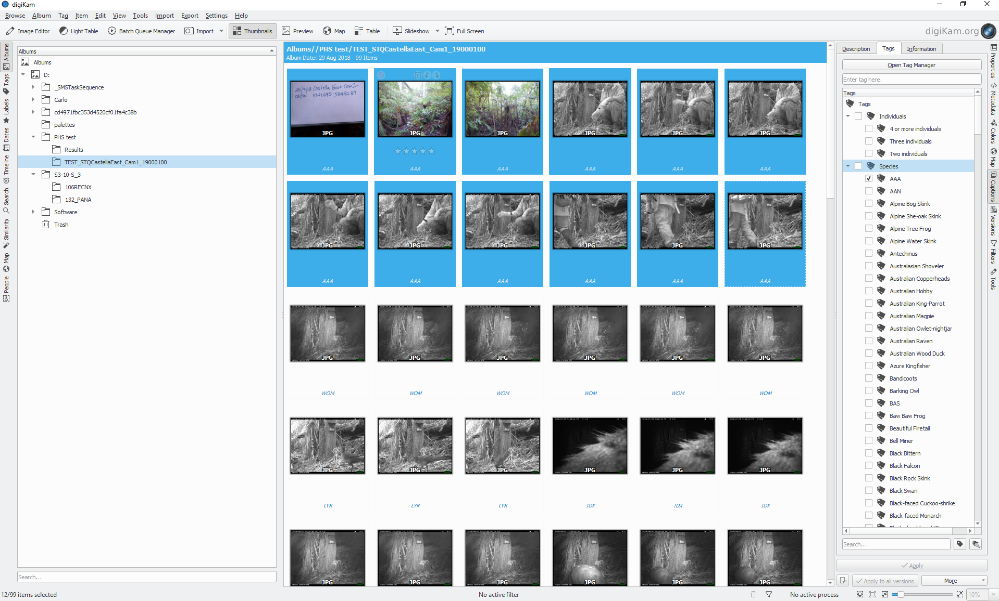
- In the tag pane, tick the ‘AAA’ tag:
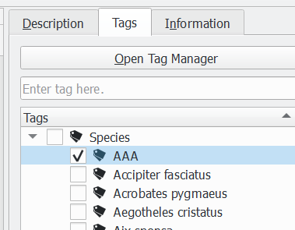
- After a short delay (or longer if applying a tag to many images), you should see that the tags are applied to the selected thumbnails. Do not tick the tag column headings (e.g. ‘Species’).
- Continue to move through the images using the arrow keys, adding species tags to each image, or cluster of images (using ‘Shift’ to batch process).
- Multiple tags can be applied to a single image, either if more than one species is visible, more than two individuals are present, or using the ‘XXX’ tag to denote an identification that needs confirmation.
- Tags should be applied consistently to all images from a single trigger event. Using camera settings as per the particular project guidelines (often batches of five images per trigger event), this means tagging images in those batches of five. For example, if the first image from a trigger is clearly a Mountain Brushtail, the next image only shows the animal leaving camera and couldn’t be identified to species based on that image alone, and the next image is empty, tag all three images as ‘Trichosurus cunninghami’ (not ‘Trichosurus cunninghami’, ‘IDX’, and ’NIL’ in that order).
- There is also a ‘behaviour’ tag heading. This should be self-explanatory and each tag with the appropriate behaviour should be tagged for each individual (see below).
- The sex of each individual animal should also be tagged if known. If the sex is unknown, then use the tag in the ‘individuals’ heading - ‘unknown 1’.
Tagging multiple individuals
- The number of individuals should also be tagged if it is more than one animal in the frame. This is in the ‘multiples’ tag heading.
- If two animals are in the frame and so the multiples – ‘2’ tag is ticked, then you can add the tags for the sex ‘male1’ and ‘unknown1’ if you are sure one is a male but are unsure of the other animal in the frame, e.g.:
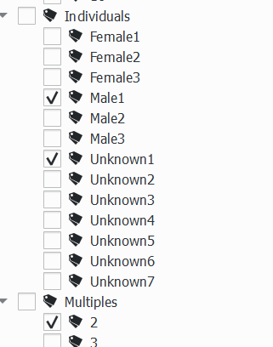
- All images should be tagged with at least one tag, regardless of what’s visible or not.
- If you make a mistake, just select the images and untick the wrong tag, then tick the correct one. Then click Apply.
- If an animal is present over a sequence of several consecutive trigger events, and the species identification can only be distinguished in some photos or some trigger events, but you can confidently infer the species identification across the whole series of photos, then tag the whole series with the species identification.
- An example of a tagged image without the distance markers is below:
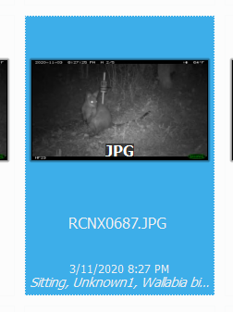
Tagging images that are using distance sampling bins
- This is effectively the same process as described before. However, each individual image will need to have the distance bin tagged for that particular image. This is unlike the simpler species only tagging – which groups batches of three or five images.
- There will likely be five bins measured in meters: 0–2.5, 2.5–5, 5–7.5, 7.5–10 and 10+. Animals may move across to different bin categories during the sequence of images. This is why each image will need to be tagged individually. However, if an animal doesn’t move across the bins it can be batch tagged.
- If there are multiple animals in the frame at different distance bins, then you will need to check as for the example from the figure below; Multiples ‘3’ (if it is three animals) and then the sex of the individuals (‘male1’, ‘female1’ and ‘unknown1’) and then the three distance bins that they are within in each frame, and which species they are (for example kangaroos are often in mobs and will require the images to be examined and tags checked in detail).
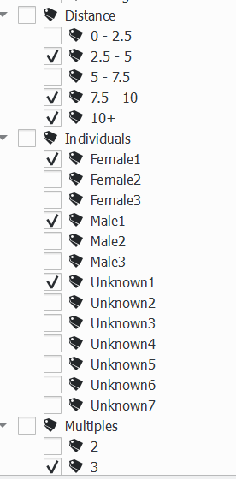

Part 3: Review your work
After completing tagging of all relevant deployments, search all folders for untagged images.
- In the toolbar on the right side of the screen, click on the tab called ‘Filters’.
- Tick the box at the bottom labelled Images without tags. This will select any images that have been missed in the tagging process.
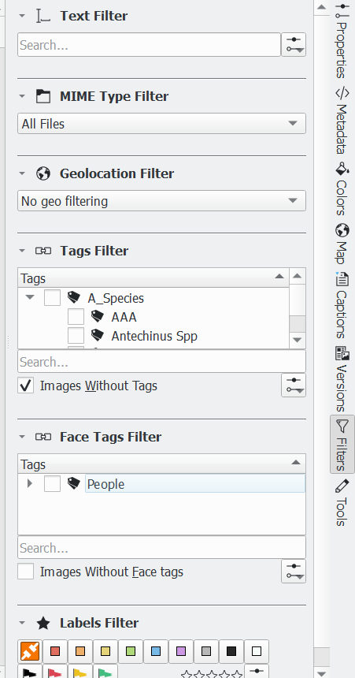
Review your own ‘XXX’ tags
- This time, use the Search tab on the toolbar on the left hand side of the screen.
- Type in the keyword ‘XXX’ to find all images tagged with this label.
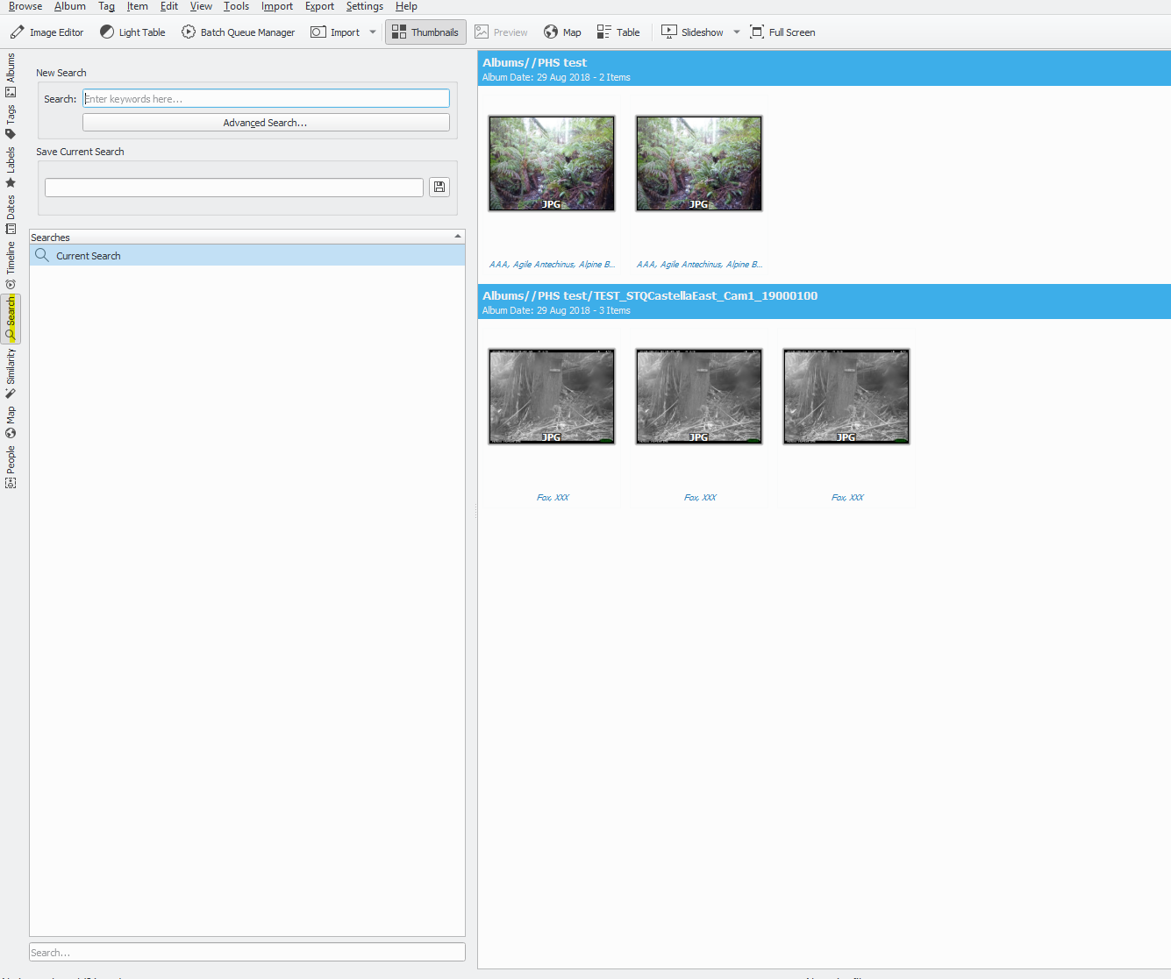
- Review these images and make sure each ‘XXX’ tag also has a species tag (as per Table 1 guidance).
- Review these decisions if required (remove the ‘XXX’ if you’re now confident of the species identification) or keep them for later expert review.
Part 4: Expert review of ‘XXX’ tags
This should be performed by a person with appropriate identification skills and taxonomic expertise, before final results are uploaded or exported for storage and analysis.
- Filter to view all ‘XXX’ tags as per the process above.
- Review each image and either
  - (i) remove the ‘XXX’ tag to confirm the current species identification, or
  - (ii) change to another species and remove the ‘XXX’ tag, or
  - (iii) remove both the ‘XXX’ and species tag, and replace with ‘IDX’.
- Once done, there should be no remaining ‘XXX’ tags, and no more visible thumbnails.

www.deeca.vic.gov.au

www.ari.vic.gov.au

Tree cover reflects how visible the ground is from aerial viewpoints. Open woodlands would usually be low-medium tree cover and tall wet forests would be high tree cover. Accessible terrain usually means areas that can be navigated around on foot; very steep and densely vegetated areas are somewhat inaccessible.
Requires estimation of pellet decomposition rates or a calibrated relationship between faecal pellets and measured density.

