
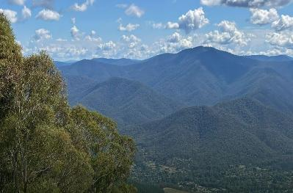
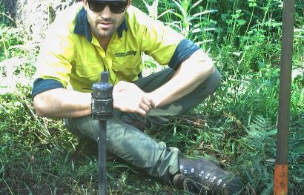

Arthur Rylah Institute for Environmental Research Technical Report Series No. 388
Barry Mountains Ark – 2024 Update
Managing the Great Dividing Range Long-footed Potoroo population

A. Robley, J. Thomson, E. Wemyss, L. Woodford and G. Melgaard

June 2025

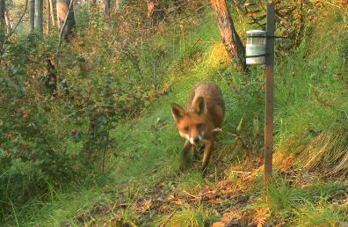
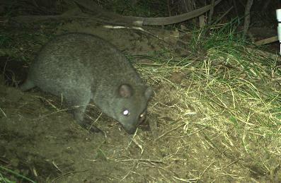


Arthur Rylah Institute for Environmental Research
Department of Energy, Environment and Climate Action
PO Box 137, Heidelberg, Victoria 3084
Phone (03) 9450 8600
Website: www.ari.vic.gov.au
Citation: Robley, A., Thomson, J., Wemyss, E., Woodford, L. and Melgaard, G. (2024). Barry Mountains Ark — 2024 Update. Managing the Great Dividing Range Long-footed Potoroo population. Arthur Rylah Institute for Environmental Research Technical Report Series No. 388. Department of Energy, Environment and Climate Action, Heidelberg, Victoria.
Front cover photo: Clockwise: Barry Mountains (Buckland Valley); DEECA staff setting cameras (DEECA), Red Fox (DEECA); Long-footed Potoroo (DEECA).
Edited by Fox Writing Services
ISBN 978-1-76176-114-0 (pdf/online/MS word)
ISSN 1835-3827 (print)
ISSN 1835-3835 (pdf))


We acknowledge and respect Victorian Traditional Owners as the original custodians of Victoria’s land and waters, their unique ability to care for Country and deep spiritual connection to it.
We honour Elders past and present whose knowledge and wisdom
has ensured the continuation of culture and traditional practices.
DEECA is committed to genuinely partnering with Victorian Traditional Owners and Victoria’s Aboriginal community to progress their aspirations.
© The State of Victoria Department of Energy, Environment and Climate Action June 2025.
Creative Commons
This work is licensed under a Creative Commons Attribution 4.0 International licence, visit the Creative Commons website (http://creativecommons.org/licenses/by/4.0/).
You are free to re-use the work under that licence, on the condition that you credit the State of Victoria as author. The licence does not apply to any images, photographs or branding, including the Victorian Coat of Arms, and the Victorian Government, the Department and the ARI logos.
Disclaimer
This publication may be of assistance to you, but the State of Victoria and its employees do not guarantee that the publication is without flaw of any kind or is wholly appropriate for your particular purposes and therefore disclaims all liability for any error, loss or other consequence which may arise from you relying on any information in this publication.
Accessibility
To receive this document in an alternative format, phone the Customer Service Centre on 136 186, email customer.service@delwp.vic.gov.au, or contact National Relay Service on 133 677. Available at DEECA website (www.deeca.vic.gov.au).
.

Barry Mountains Ark – 2024 Update

Managing the Great Dividing Range Long-footed Potoroo population

Alan Robley, Jim Thomson, Elizabeth Wemyss¹, Luke Woodford and Gavin Melgaard²

Arthur Rylah Institute for Environmental Research
Department of Energy, Environment and Climate Action
123 Brown Street, Heidelberg, Victoria 3084
¹, Department of Energy, Environment and Climate Action, Regions, Environment, Climate Action and First Peoples Division, Hume Region,
1 McKoy Street, Wodonga VIC 3689
² Department of Energy, Environment and Climate Action, Bushfire and Forest Services, Hume Region,
5340 Great Alpine Rd, Ovens VIC 3738

Date

Arthur Rylah Institute for Environmental Research
Technical Report Series No. 388

Acknowledgements
This project was funded through the Victorian Government Bushfire Biodiversity Response and Recovery (BBRR) program (supporting Victoria’s bushfire-impacted wildlife and biodiversity), the Weeds and Pests on Public Land Program, and Parks Victoria. This funding was supported by the Australian Government's Bushfire Recovery Program for Wildlife and Their Habitat package.
Field work for the 2020–2024 sampling was undertaken by:
Jerry Alexander, Travis Applegarth, Maddy Barker, Geoff Beach, Nathan Beach, Corey Bosley, Brett Bouker, Bec Briody, Irene Brouwer, Nick Buckley, Mick Cafe, Laura Coverdale, Kylie Croucher, Kaustuv Dahal, Diana Dogan, Justine Dungan, Brendan Fraser, Casey Hawkey, Matt Hicks, Alex Huggins, Carol Jadraque, Glen Johnson, Pennie Keenes, Lachlan King, Steve LeBrun, Dan Littlewood, Ella Loeffler, Vanessa Lucy, Damien McMaster, Gavin Melgaard, Mark Notman, James O'Shea, Joe Paterson, Daniel Pendavingh, Keith Primrose, Dylan Pritchard, Jane Roots, Josh Russo, Greg Scott, Monique Semmens, Nikki Sigmund, Ben Staker, Amy Stephens, Rhiannon Stute, Emily Voogt, Elizabeth Wemyss, Matt Whitney, Lydia Wilson and Blair Yates from the Department of Energy, Environment and Climate Action.
Hannah Clemen, Jim Craven, Lili Donaldson, Remi Flynn-Lindsay, Zoey Godfrey, Thomas Grounds, Noah Honeysett, Craig Hore, Alex Jennings, Tim Northy, Steph Riley and Tomas Sanchez from Parks Victoria.
Darren Detez, Tom Griffiths, Skye Hunter, Jack Hyatt, Shane Monk and Lucas Russell from Taungurung Land and Waters Council. Lochlann Allen, Blair McCallum, Veronika Munar, Bronte Munro, Aiden O’Dempsey, Jack Schenk and Daphne Tripodi from BIIK Environmental.
Volunteers, University students, PhD Candidates and their supervisors Matthew Lincoln and Charlie Pascoe; Mikala Hackett (Myrtleford P-12); Christine Brazier, Ben Collins and Stephen Hart (Charles Sturt University); Aviya Naccarella (Deakin University); Emily McIntyre (Monash University) and Camille Truong (Royal Botanic Gardens).
Rachael Bartlett and Willow Bourke from Wildlife Unlimited. The 2007–2009 field sampling was undertaken by Ryan Chick, Katie Howard, Micaela Jemison, Ruth Lennie, Phoebe Macak, Dan Purdey, Manieka Reid, and Steve Coulson, Amie Douglas, Rena Gabrov, Laura Owen and Heidi Snow (Wildlife Unlimited). This component was led by Lindy Lumsden, with contributions from Jerry Alexander, Charlie Pascoe and Michael Scroggie. Funding was provided from the (then) Department of Sustainability and Environment, the (then) Department of the Environment and Water Resources, and Parks Victoria.
Earlier drafts of this report were improved by Carol Jadraque.

Contents
Acknowledgements ii
Summary 6
1 Introduction 8
2 Methods 9
2.1 Study Area 9
2.2 The Expansion fox control program 2021–2024 10
2.3 Detecting native and introduced species 10
2.3.1 Data collection 10
2.4 Statistical analysis 12
2.4.1 Occupancy modelling 12
2.4.2 Spatial and temporal trend in occupancy 14
2.4.3 Naïve occupancy of native species 14
3 Results 15
3.1 Long-footed Potoroo occupancy 15
3.2 Long-nosed Bandicoot occupancy 18
3.3 Superb Lyrebird 18
3.4 Fox occupancy 20
3.5 Feral cat occupancy 22
4 Summary 23
4.1 Conclusion 24
Appendices 25
References 34

Tables
Table 1. Summary of camera trap survey effort and numbers (proportions) of Long-footed Potoroo, fox and feral cat detections from 2007 to 2024. 12

Figures
Figure 1. Map of the Barry Mountains Ark area. 9
Figure 2. The locations of baited tracks and roads used for the control of foxes in the Barry Mountains Ark program. 10
Figure 3. Locations of cameras used to survey changes in Long-footed Potoroo occupancy 2007–2024. 11
Figure 4. Estimated occupancy of Long-footed Potoroo in the Core and Expansion baiting zones in all surveyed years since 2007. 15
Figure 5. Estimated partial relationship between the probability of Long-footed Potoroo occurrence and modelled habitat suitability. 16
Figure 6. Estimated partial relationship between the probability of Long-footed Potoroo occupancy and time since fire, assuming average habitat quality (HDM value = 60) and FAPAR value (68). 16
Figure 7. Estimated relationships between the probability of Long-footed Potoroo occupancy and the mean fraction of absorbed photosynthetically available radiation (FAPAR) at baited (orange) and unbaited (grey) sites, assuming average habitat quality (HDM value = 60) and time since fire (6.3 years). 17
Figure 8. Predicted Long-footed Potoroo occupancy (probability of occurrence) across the study region based on HDM value, time-since-fire, mean annual FAPAR value, and baiting intensity. Predictions are derived from Model 2B in Table 2 (which included spatial and temporal random effects). 17
Figure 9. Estimated occupancy (mean probability of occurrence) of Long-nosed Bandicoot in the Core and Expansion baiting zones in all surveyed years since 2020. 18
Figure 10. Estimated occupancy (mean probability of occurrence) of Superb Lyrebird in the Core and Expansion baiting zones in all surveyed years since 2020. 18
Figure 11. Estimated relationship between the probability of Superb Lyrebird occurrence and modelled habitat suitability. 19
Figure 12. Estimated relationship between the probability of Superb Lyrebird occurrence and time since fire. 19
Figure 13. Estimated relationship between the probability of Superb Lyrebird occurrence and one-year mean FAPAR value. 20
Figure 14. Estimated occupancy (mean probability of occurrence) of foxes in the Core and Expansion baiting zones in all surveyed years since 2007. 20
Figure 15. Estimated partial relationship between the probability of fox occurrence and the mean fraction of absorbed photosynthetically available radiation (FAPAR) at baited (orange) and unbaited (grey). 21
Figure 16. Estimated occupancy (mean probability of occurrence) of feral cats in the Core and Expansion baiting zones in all surveyed years since 2007. 22

Glossary
Occupancy = the average probability of occurrence and is equivalent to the expected proportion of sites at which the species (ever) occurs within a season. Occupancy is a landscape-scale metric indicating the proportion of all sites at which the species occurs.
For foxes and cats, the proportion of sites visited by animals (i.e., the proportion of sites at which the species ever occurs) is interpreted as their ‘occupancy’. Arguably, this is a measure of their activity across the landscape (i.e. the occurrence of a predator at a site indicates predatory activity).
Occurrence = species is present (occurs) at a site for some or all the survey season (the spring of a given year). Occurrence is a site-scale metric indicating whether the species occurs at a particular site.
FAPAR = The fraction of absorbed photosynthetically active radiation (estimated by satellite remote sensing at 300m resolution and averaged over the 12 months prior to camera deployment) characterises the energy absorption capacity of vegetation canopy. It is a physiological variable describing the vegetation structure and related material and energy exchange processes and is an important parameter for estimating the net primary production of terrestrial ecosystem using a remote sensing–based method. Low values may indicate canopy disturbance (e.g., fire, harvesting) or plant resource limitation (e.g., drought).
Habitat Distribution Model (HDM) = HDMs are statistical or machine-learning models that relate the occurrence of a species to underlying, mapped habitat variables allowing prediction of occurrence in space and time. Specifically, 26 explanatory variables are used for the modelling; three versions of models were built using different sets of explanatory variables.

Summary
Context:
This report updates previous research detailing the Barry Mountains Ark fox control and Long-footed Potoroo response (Robley et al. 2023) by adding an additional year (2024) of monitoring data and updating the results of the ongoing monitoring program. This information will aid land managers and policy makers to make informed, evidence-based decisions on the future of Long-footed Potoroos in this landscape.
The Long-footed Potoroo (Potorous longipes) is found in two isolated populations: East Gippsland/ southeastern New South Wales and northeastern Victoria.
The northeastern Victorian population, known as the "Great Dividing Range population," is located around the Barry Mountains. This species is listed as Endangered under both the Environment Protection and Biodiversity Conservation Act 1999 (Cth) and the Victorian Flora and Fauna Guarantee Act 1988 due to its limited range, low population density, vulnerability to predators like the Red Fox (Vulpes vulpes), inappropriate fire regimes and climate change.
A Red Fox (Vulpes vulpes) control program began in 2004, focusing on a Core baiting zone in the Barry Mountains (45,000 ha) and continued until 2021, despite disruptions from weather and wildfires in 2006 and 2019/2020 and conflicts with recreational hunters. In 2021, the program expanded to cover approximately 229,000 ha, now referred to as the Barry Mountains Ark, encompassing both the Core and Expansion zones.
Aims:
The aims of this report are to:
- Update the results of the trends in Long-footed Potoroo occupancy (proportion of sites occupied) from 2007 to 2024 in the Barry Mountains region.
- Assess the impacts of fire, feral predators (foxes and feral cats) and fox baiting on Long-footed Potoroo occupancy in the Barry Mountains region.
- Assess the trends in fox and feral cat populations.
- Assess the initial changes in occurrence of a range of native species first detected during surveys in 2020–2024.
Methods:
Camera traps have previously been deployed to gather data on Long-footed Potoroos, other native species, foxes, and feral cats during two distinct sampling periods: 2007–2009 and 2020–2023, with an additional year of data (2024) being added to this report. Each camera location was categorised into one of two fox baiting zones: Core (baited since 2007) or Expansion (baited since December 2021).
Hierarchical Bayesian models were employed to analyse the combined camera survey data, investigating trends in Long-footed Potoroo occupancy and relationships between potoroo occupancy and factors such as fire history, habitat quality, productivity of vegetation, fox baiting and proxy measures of predator density.
The Long-footed Potoroo data consisted of detection histories from 210 camera trap locations from 2007–2009 and 381 from 2020–2024. Several variables were included in models, including fire history and fire severity for the 2019/2020 fires, an existing Habitat Distribution Model (HDM) served as an indicator of overall habitat suitability, and the fraction of absorbed photosynthetically active radiation (FAPAR) was utilised to characterise vegetation canopy's energy absorption capacity and represents underlying forest productivity. Predictions of fox densities for the Core and Expansion areas were derived, using individually based, spatially explicit population modelling.
Results:
Long-footed Potoroo occupancy is positively associated with HDM values, increasing time since fire higher plant productivity and canopy density as represented by FAPAR values in baited areas and the duration of fox baiting. Occupancy rates are higher in the Core baiting zone (~ 9-fold increase) compared to the Expansion zone, with both areas experiencing increasing occupancy rates over time (23% and 18% p.a., respectively).
The spatial and temporal landscape model indicated that there has been a 6-fold increase in the estimated area of Long-footed Potoroo occupancy since 2008, with a negative relationship with predicted fox density and positive relationships with HDM, time-since fire and FAPAR.
Updated results show a continuing and further trend in declining fox occurrence, areas (Core baiting zone –20% p.a.; Expansion baiting zone –12% p.a.) while there is no detectable change in feral cats.
Long-nosed Bandicoot occurrence has increased significantly since 2003; however, modelled covariates showed no significant relationship to this change. Superb Lyrebird occupancy was higher in the Core zone than the Expansion zone throughout the 2020-2024 period, with no consistent temporal trend. There was evidence that Superb Lyrebird occurrence increased with increasing time since fire and increasing Long-footed Potoroo-HDM, but the relationship with FAPAR values was highly uncertain.
Seventy-one native species were detected on camera traps between 2020 and 2024. Naïve occupancy estimates (not considering detection probabilities) indicated that the rates of occurrence of several native species had increased from 2020 to 2024. Assessment of the drivers for these changes was outside the scope of this study, so further investigation is suggested.
Conclusions and Implications:
Long-footed Potoroos continue to increase in response to fox control and time since fire underscoring the need to maintain the current management program.
The results again highlight the intricate response of native species to the reduction of introduced predators, emphasizing the necessity of long-term implementation of effective fox control supported by monitoring of key variables such as habitat suitability, productivity, fire history and predator dynamics for understanding Long-footed Potoroo occupancy patterns. It also highlights the need to continually review the model inputs and update variable selection to improve our understanding of the population drivers and dynamics.
Sustained, landscape-scale fox control is crucial in achieving and preserving the biodiversity gains made to date. Despite the reduction in fox abundance due to ongoing fox control in the Barry Mountains, foxes persist in the landscape, posing a continued threat to Long-footed Potoroos and other vulnerable native species. While the presence of feral cats did not have a demonstrable influence of Long-footed Potoroo occurrence, likely due to limitations in the camera trapping design, further investigation is needed in the Barry Mountains to better understand the impact of feral cats on Long-footed Potoroos and other native species.

- Introduction
In the mesic forests of south-eastern Australia, the decline of mammal species has been significant, with numerous terrestrial species experiencing substantial reductions since European settlement (Bilney et al. 2010; Woinarski et al. 2014). Among the affected species is the endangered Long-footed Potoroo (Potorous longipes), which is threatened by restricted distribution, low population density and predation by introduced Red Fox (Vulpes vulpes; “foxes”) and feral cats (Felis catus), inappropriate fire regimes and climate change (Brereton et al. 1995).
First described in the late 1960s (Seebeck and Johnston 1980), the Long-footed Potoroo is known from two disjunct populations in East Gippsland/south-eastern New South Wales and north-eastern Victoria (the study area for this report)/the Great Dividing Range (Jones and Johnson 1997). To support conservation efforts, a fox baiting program commenced in 2004 in the Barry Mountains, covering a substantial portion of the potoroo's known range in this area (Robley et al. 2005). However, disruptions, including conflicts with hound hunters and logistical challenges, impacted program implementation. Additionally, large-scale bushfires in 2003, 2006/2007 (Lumsden et al. 2012), and 2019/2020 extensively affected the potoroo's habitat.
A project initiated in 2004 to assess the potoroo population's status revealed that fox baiting had a positive impact on potoroo occupancy, particularly in unburnt or lightly scorched areas (Lumsden et al. 2012). In 2019, a survey was conducted to evaluate the potoroo population's status in relation to the fox control program. Population models predicted favourable outcomes under an expanded fox baiting strategy, indicating lower extinction risks for potoroos (DELWP 2022). Consequently, an expanded baiting program (Barry Mountains Ark) has been implemented from 2021-2024, aiming to further reduce fox densities and safeguard potoroo habitat.
Occupancy modelling using data from 2007–2009 and 2020–2024 indicates a positive trend in potoroo occupancy across the Barry Mountains and has identified the importance of forest productivity, the impacts of fire, feral predators and fox baiting on potoroo presence in the Barry Mountains region. These findings offer valuable insights for public land managers, providing measurable targets for conservation actions and guiding future management plans for the Long-footed Potoroo and other species vulnerable to fox predation in the Barry Mountains.
This report updates previous research on the Barry Mountains fox control operation and the Long-footed Potoroo monitoring program (Robley et al. 2023) by adding an additional year worth of data (2024) and exploring the influence of additional variables in the associated models. For detailed background and information on methods refer to Robley et al (2023).
- Methods
Detailed descriptions of the study area and methods can be found in Robley et al. (2023). These are briefly summarised here.
  - Study Area
The study area, centred on the Barry Mountains in northeastern Victoria's Great Dividing Range region, spans approximately 229,000 hectares and includes Abbeyard, Mount Selwyn, Mount Cobbler, the Buckland Valley, Demon Ridge, and parts of the old Wonnangatta Station areas (Figure 1). The Ark boundaries were delineated based on the Habitat Distribution Model for Long-footed Potoroos (HDM; Liu et al. 2013), inclusion of both fire-affected and unburnt areas from the 2019/2020 fires and alignment with the proposed Expansion zone footprint.
The Ark area experienced significant wildfires in 2003 and 2006/2007 and partial burning, with varying severity, in the 2019/2020 fires (Figure 1).
Internally, the study area was divided into five management zones, four within State Forests and one within Parks Victoria estate (Figure 1). These zones delineate operational areas for the planned Barry Mountains Ark fox control operations, as detailed in section 2.2.
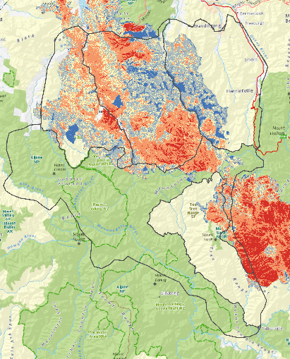
Figure 1. Map of the Barry Mountains Ark area.
Internal divisions indicate the location of the four State Forest zones (yellow background) and the Alpine National Park zone (green background). The map also shows the severity of the burn [red (severe) to light blue (unburnt within the fire footprint)] and the area burnt in the 2019/2020 Ovens Fire Complex.

  - The Expansion fox control program 2021–2024
A detailed description of the Barry Mountains Ark program has been provided by DELWP (2021). Here we summarise the main characteristics of the program:
Between 2004 and 2019, baiting was undertaken year-round in the Core baiting zone within the Alpine National Park (Figure 2); the Expansion baiting strategy commenced in December 2021. It includes the Alpine National Park and a small section of State Forest in the Tea-Tree Range is being baited year-round with baits checked and replaced monthly. In areas above 900 metres, baits are removed, and baiting is generally ceased in June/July or when snow conditions or other access factors dictate. In State Forest, bait is laid continuously from December to March inclusive only (i.e. outside deer-hunting season) and baiting is generally ceased above 900 metres due to snow conditions or other access factors. Baits are checked and replaced monthly.
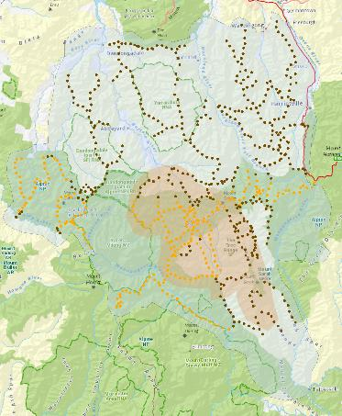
Figure 2. The locations of baited tracks and roads used for the control of foxes in the Barry Mountains Ark program.
Tan area = Core baiting zone (2004–2009); pale-blue area = Expansion baiting zone (December 2021–2024); brown dots indicate stations mostly in State Forest, operated predominantly outside the April–November deer-hunting season, access permitting; orange dots indicate stations mostly in the Alpine National Park, operated all year round, access permitting.
  - Detecting native and introduced species
For a full description of the methods and analytical approach refer to Robley et al. (2023). These are briefly summarised below.
    - Data collection
Camera trapping was conducted over two periods, from 2007 to 2009 (Lumsden et al. 2012; Lumsden et al. unpublished data) and from 2020 to 2024, to gather data on the presence of Long-footed Potoroos, other native species, foxes, and feral cats. Cameras were positioned approximately 30 centimetres above ground, facing south, and equipped with mammal lures to attract the target species. Initially deployed as part of a 5-year project assessing the potoroo population, the camera trapping aimed to investigate distribution patterns, assess population status, and evaluate the impact of bushfires and predator control.
Sampling was stratified across various habitat types, with sites selected randomly within and outside the known distribution of the species in the Great Dividing Range area. In the 2007-2009 period, 271 sites were sampled, with 210 within the study boundary. In October 2020, 120 camera trap sites were established at a subset of the 2007-2009 locations using Reconyx cameras (models PC900 and HP2X, Reconyx Inc., WI USA). Surveys were undertaken in October 2021 (n = 138), October 2022 (n = 123), October 2023 (n = 125), and October 2024 (n = 132) (Table 1, Figure 3). The number of cameras varied each year, as additional camera sites were added to improve estimates, or some cameras failed to operate or were stolen. (Figure 3).
The combined camera survey data from both periods were analysed to assess Long-footed Potoroo occupancy (MacKenzie et al. 2017) trends and investigate the impacts of fire, feral predators and fox baiting in the Barry Mountains region. Fire history was derived from fire history overlays and severity models, while a Habitat Distribution Model was developed to assess habitat suitability. The analysis included data from both Core and Expansion baiting zones, allowing for comparisons before and after baiting programs and between different baiting zones.
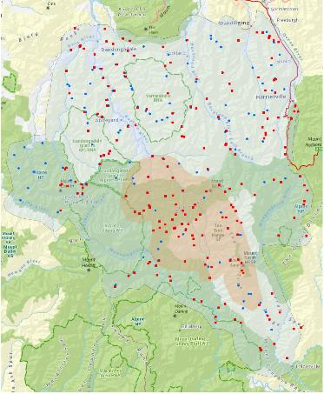
Figure 3. Locations of cameras used to survey changes in Long-footed Potoroo occupancy 2007–2024.
Tan shading: Core baiting zone; pale-blue shading: Expansion baiting zone. Red squares: camera locations 2007–2009; blue dots: camera locations 2020–2024. Note, some camera locations were the same in all years.

Table 1. Summary of camera trap survey effort and numbers (proportions) of Long-footed Potoroo, fox and feral cat detections from 2007 to 2024.
Year | Treatment zone | Sites | Long-footed Potoroo detections | Fox detections | Feral cat detections | Mean HDM value | Mean time since fire
2007 | Core | 7 | 2 (0.29) | 0 (0.00) | 2 (0.29) | 68 | 0
2007 | Expansion | 35 | 2 (0.06) | 8 (0.23) | 7 (0.2) | 54 | 3
2008 | Core | 33 | 10 (0.30) | 2 (0.06) | 8 (0.24) | 70 | 1
2008 | Expansion | 60 | 6 (0.10) | 8 (0.13) | 10 (0.17) | 42 | 4
2009 | Core | 17 | 7 (0.41) | 3 (0.18) | 0 (0.00) | 59 | 3
2009 | Expansion | 58 | 8 (0.14) | 7 (0.12) | 9 (0.16) | 47 | 3
2020 | Core | 33 | 17 (0.52) | 1 (0.03) | 6 (0.18) | 69 | 10
2020 | Expansion | 87 | 17 (0.20) | 0 (0.00) | 11 (0.13) | 61 | 4
2021 | Core | 37 | 26 (0.70) | 1 (0.03) | 14 (0.36) | 70 | 11
2021 | Expansion | 100 | 26 (0.26) | 9 (0.09) | 19 (0.19) | 56 | 6
2022 | Core | 36 | 27 (0.75) | 0 (0.00) | 6 (0.17) | 70 | 12
2022 | Expansion | 88 | 21 (0.24) | 5 (0.06) | 20 (0.23) | 57 | 7
2023 | Core | 40 | 28 (0.70) | 1 (0.03) | 10 (0.25) | 68 | 14
2023 | Expansion | 95 | 34 (0.36) | 3 (0.03) | 19 (0.20) | 57 | 8
2024 | Core | 40 | 33 (0.82) | 0 (0.00) | 13 (0.32) | 69 | 15
2024 | Expansion | 92 | 40 (0.43) | 9 (0.10) | 18 (0.20) | 58 | 9
2007–2009* | All | 70.0 | 11.7 (0.17) | 9.3 (0.13) | 12 (0.17) | 52 | 3
2020–2024* | All | 129.8 | 53.8 (0.41) | 7.0 (0.05) | 27.2 (0.21) | 61 | 8
HDM: Habitat Distribution Model. Values for mean HDM and mean time since fire are for sampled sites.
  - Statistical analysis
Here we present updated results for the statistical models presented in Robley et al 2023, which estimate temporal trends and occupancy-covariate relationships for five species of interest: Long-footed Potoroo, Long-nosed Bandicoot, Superb Lyrebird, foxes and feral cats. All trend and best-supported covariate models presented in Robley et al 2023 were re-fitted with data up to 2024 (see Robley et al. 2023 for a full description of the modelling methods, including Bayesian model selection, to identify ‘best-supported’ covariate models).
For Long-footed Potoroos, we fitted an additional covariate model, using a continuous measure of baiting intensity, which allowed us to map predicted occupancy probabilities across the study area through time. Details are provided below in the Results section.
    - Occupancy modelling
The study employed the Occupancy Model Framework of MacKenzie et al. (2017) to analyse the distribution of Long-footed Potoroos and two feral predators, foxes and feral cats, while accounting for imperfect detection. This framework estimates both the probability of species occurrence (presence) and the probability of detecting a species when present (detectability), based on observed detection histories from repeated surveys.
Occurrence and detectability can be influenced by various factors and modelled as functions of covariates. Detectability estimates assume "closure", meaning species do not move in or out of sites within a survey season (duration of camera deployment). When this assumption is violated, occupancy models estimate the probability of site visitation within a season and the probability of detecting a species at a visited site, termed the "detection rate."
For Long-footed Potoroos, we assumed population closure, interpreting occupancy as the proportion of sites occupied for the duration of the survey period. For foxes and feral cats, closure was not assumed, interpreting occupancy as the proportion of sites visited during the survey period. The term "occurrence" indicates the species was present for some (foxes and feral cats) or all (Long-footed Potoroo) of the annual spring survey.
Model structure
We used camera traps in two fox baiting “treatment” zones: the Core baiting zone (baited since 2004) or the Expansion baiting zone (baited since December 2021 only) to monitor the presence of Long-footed Potoroos, foxes and feral cats.
First, we fitted a basic model to look for trends over time, comparing species occupancy between the Core and Expansion zones and to estimate the trends in occupancy within zones. To test for a change in trend, following the expansion of baiting in 2021, the basic trend model allowed for a change in any trend after 2021 (i.e. after baiting commenced) within the Expansion zone.
In the previous analysis (Robley et al. 2023), we used Bayesian variable selection (O’Hara and Sillanpää 2009) to identify the best predictors of Long-footed Potoroo presence/occupancy from a set of candidate variables related to habitat quality, fire and predators. Variables with strong support as predictors $(\operatorname{Pr}\left(β_{n}≠0\right)>0.75)$ were included in a full occupancy model (Best-supported Model) that included a detectability sub model to estimate the effects of those variables, while accounting for imperfection detection. Finally, best supported variables were added to the basic trend model to estimate trends that incorporated any significant covariates.
This report updates the ‘best’ model’ from this previous analysis. All occupancy models (basic trend and best) included site, area and year random effects terms to account for the repeated sampling of sites among years and to capture spatial and temporal patterns not captured by covariates or linear trend terms.
Detectability submodels
We assumed that the likelihood of detecting Long-footed Potoroos, foxes and feral cats remained consistent within each survey period but could change over longer timeframes and across different locations, due to various environmental and methodological factors. For Long-footed Potoroos, we considered that factors affecting their presence could also affect how easily they were detected. We included time, treatment zone, and any habitat (e.g. HDM value) or predator-related (e.g. fox presence) variable identified as a predictor of occupancy as potential influences on detectability. Additionally, we incorporated a binary indicator for the survey periods (2007-2009), to allow for differences in methods between survey periods and the number of cameras used, as these factors could affect detection rates. However, for foxes and feral cats, we only included variables related to survey periods and the number of cameras, as their detections were too sporadic to draw meaningful conclusions about other influences on detection rates.
Model fitting
All models were fitted by Markov chain Monte Carlo (MCMC) methods using WinBUGS software (Spiegelhalter et al. 2003), with Lunn et al.’s (2008) reversible jump Markov Chain Monte Carlo (RJMCMC) add-on (used for variable selection). Note that the RJMCMC add-on requires use of the probit link function for binary response variables (Lunn et al. 2008). To improve modelling fitting, all continuous variables were standardised to have a zero mean (except time, which was centred on 2020) and unit standard deviation. Posterior distributions were estimated from 20,000 MCMC iterations after 5000 iteration burn-in periods. Adequate MCMC convergence and mixing were confirmed by inspection of MCMC chain histories and R-hat statistics (Spiegelhalter et al. 2003). Posterior predictive checks (Gelman et al. 2000) were used to confirm that fitted models could plausibly generate data with the same structure as the observed data.
Odds ratios
Conditional odds ratios (ORs) provide a way to compare the likelihood of an outcome, such as the presence of Long-footed Potoroos, across different groups or levels of covariates. We aimed to understand how the likelihood of Long-footed Potoroos occurring varied over time periods, spatial areas (Core vs Expansion zones), management actions (fox baiting) and environmental gradients (HDM values, FAPAR, time-since fire). ORs are useful for quantifying the effect of a variable on probabilities. For instance, if 'p1' represents the probability of occurrence in the Core zone (e.g. 0.4) and 'p0' in the Expansion zone (0.1), the odds ratio (OR) is calculated as [p1 / (1 – p1)] / [p0 / (1 – p0)] (e.g. (0.4/0.6)/(0.1/0.9)=0.67/.0.11)= 6.09. Conditional ORs control for other factors in the model, allowing us to estimate the relative impact of specific variables. They help us understand how occupancy changes over time or across different values of a continuous predictor.
    - Spatial and temporal trend in occupancy
To visualise the spatial-temporal trends in Long-footed Potoroo occupancy, we refitted the best-supported covariate model in a landscape model substituting the binary ‘baited within 1 km’ predictor, with a continuous measure of baiting intensity derived from FoxNet predictions of fox density under the baseline and expansion fox baiting scenarios (Francis et al, 2020). The FoxNet density predictions assume 20 years of baiting but are used here as a measure of the intensity of baiting within the landscape, rather than as predictions of fox density per se. FoxNet predictions were averaged over 3.6 km² focal windows at 100m resolution. When FoxNet density predictions were used in the model instead of the binary baited/unbaited variable, the interaction term with FAPAR values was close to zero and highly uncertain. Removing the interaction improved MCMC mixing and model fit, so we present results of the additive occupancy model with fixed effects for HDM value, log (Time-Since-Fire), mean annual FAPAR, and FoxNet density, and random effects for site, baiting zone, and year (see Robley et al. 2023 for hierarchical model structure). We used the posterior mean estimates of all model parameters, excluding ‘site’ random effects, to map predicted occupancy probabilities in each year at 75m resolution. Annual time-since fire rasters were derived from fire-history polygons, rasterized to the same extent and resolution as the HDM. Annual FAPAR (300 m resolution), bait intensity (100 m resolution) and baiting zone layers (polygons) were projected (and rasterized if necessary) and resampled to match the HDM extent and resolution.
    - Naïve occupancy of native species
Naïve occupancy provides a quick, simple summary of the proportions of sites where various species were detected but will underestimate true occupancy rates as actual detection rates will always be less than perfect.
Naïve occupancy is calculated as the proportion of sites where a species is detected without adjusting for undetected presence. We calculated naïve occupancies for various native species detected on camera between 2020 and 2024. A more thorough examination of this data, allowing for imperfect detection could be used in the future to explore changes in occupancy rates of other native species in the study area, including the influences of foxes and feral cats and other habitat and management variables such as time since fire or other predictor variables. Such as analysis is beyond the scope of the current report.
- Results
  - Long-footed Potoroo occupancy
The basic trend model indicates that Long-footed Potoroo occupancy was higher in the Core baiting zone (a 9-fold increase in the odds of occurring) compared to the Expansion baiting zone throughout both survey periods and increased with time in both areas (Figure 4, Table A1-A). The estimated annual trends in occupancy were slightly higher in the Core zone (23% increase p.a.) compared with the Expansion zone (18% increase p.a.) (Figure 4,Table A1-A), however trend estimates are relatively uncertain, with no substantive evidence that trends differ between zones. There was no substantive evidence of a change in trend in the Expansion zone after baiting commenced in December 2021 (Table A1-A).
Long-footed Potoroo occupancy increased with increasing HDM value (Figure 5, Table A1-B1) and increasing time since fire (Figure 6, Table A1-B1). Potoroo occupancy also increased with increasing FAPAR values, but only among baited sites (Figure 7, Table A1-B1). There was no relation between Long-footed Potoroo occupancy and FAPAR values among un-baited sites (Figure 7, Table A1-B1).
The model implies that HDM values explain some of the difference in mean occupancy between Core and Expansion zones and some of the long-term increases in occupancy among surveyed sites in both zones (~3-fold increase in Core Zone; ~11-fold increase in Expansions zone) (Table A2; surveys since 2020 have targeted higher HDM value sites, Figure A1) but cannot explain all the observed spatial and temporal variation in occupancy.
The time-since-fire effect predicts increasing trends in both zones but predicts greater long-term increases in the Core zone (11-fold increase) and greater short-term increases in the Expansion zone (6-fold increase) (Table A2). This difference reflects the fact that much of the Expansion zone was burnt in the 2019/20 fires (Figure A2).
The FAPAR x Baiting interaction predicts long term increases in potoroo occurrence in both Core (6-fold increase) and Expansion zones (7-fold increase) (Table A2), associated with long term increases in mean FAPAR values and, especially for the Expansion Zone, an increase in the proportion of sites baited. The substantial increase in the proportion of sites baited in the Expansion Zone post 2021, combined with a small increase in FAPAR values, is predicted to nearly double the odds of potoroo occupancy from 2020 to 2024 (Table A2). In the Core Zone, shorter term (2024 vs 2020) effects of FAPAR x Baiting interaction are predicted to be negative because 2024 FAPAR values are lower than 2020 values, and the proportion of sites baited is only marginally higher (Figure A3 and A4, Table A2).
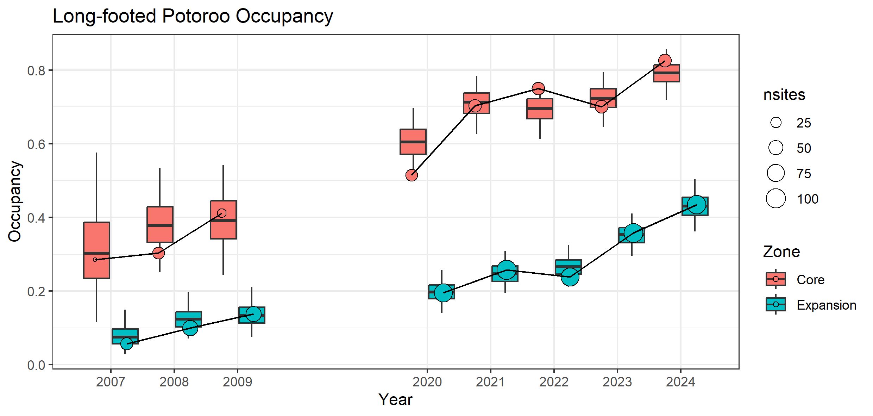
Figure 4. Estimated occupancy of Long-footed Potoroo in the Core and Expansion baiting zones in all surveyed years since 2007.
Boxplots show posterior distributions of the estimated occupancy within each year, derived from the Basic Trend Model with random spatial and temporal effects. Points show raw proportions of surveyed sites with at least one Long-footed Potoroo detection (naïve occupancy). Naïve occupancy (raw counts) may differ from model estimates of actual occupancy [because of imperfect detection and because model estimates tend towards long-term means (or trends) within spatial zones]. nsites = number of sites.
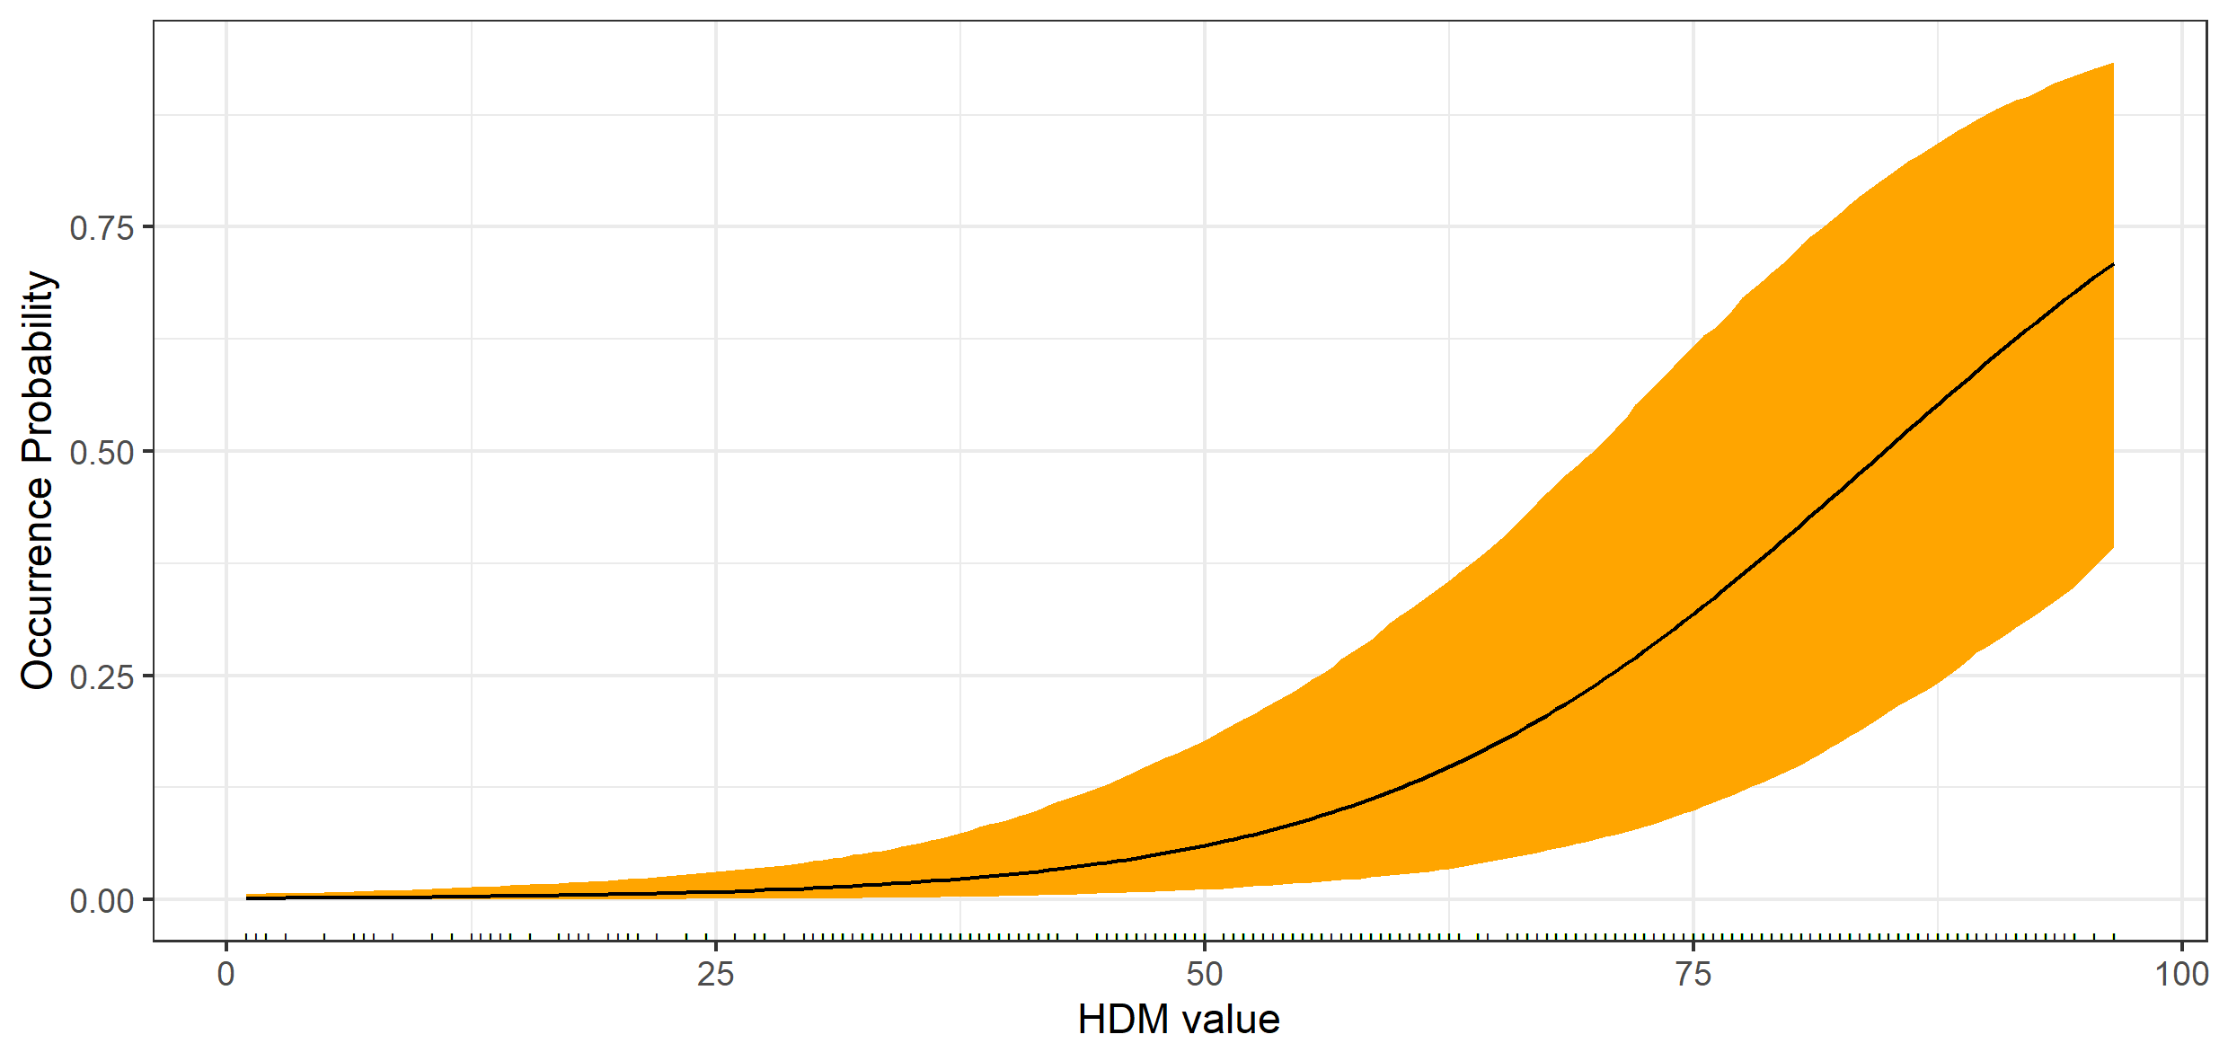
Figure 5. Estimated partial relationship between the probability of Long-footed Potoroo occurrence and modelled habitat suitability.
Black line shows posterior mean occurrence probability; orange band extends to the 95% credible interval. The fitted relationship is derived from the best supported model (Table 2B) and assumes time since fire (6.3 years), number of years of baiting (4.2 years) and FAPAR (68) are held constant at their means. HDM: Habitat Distribution Model.

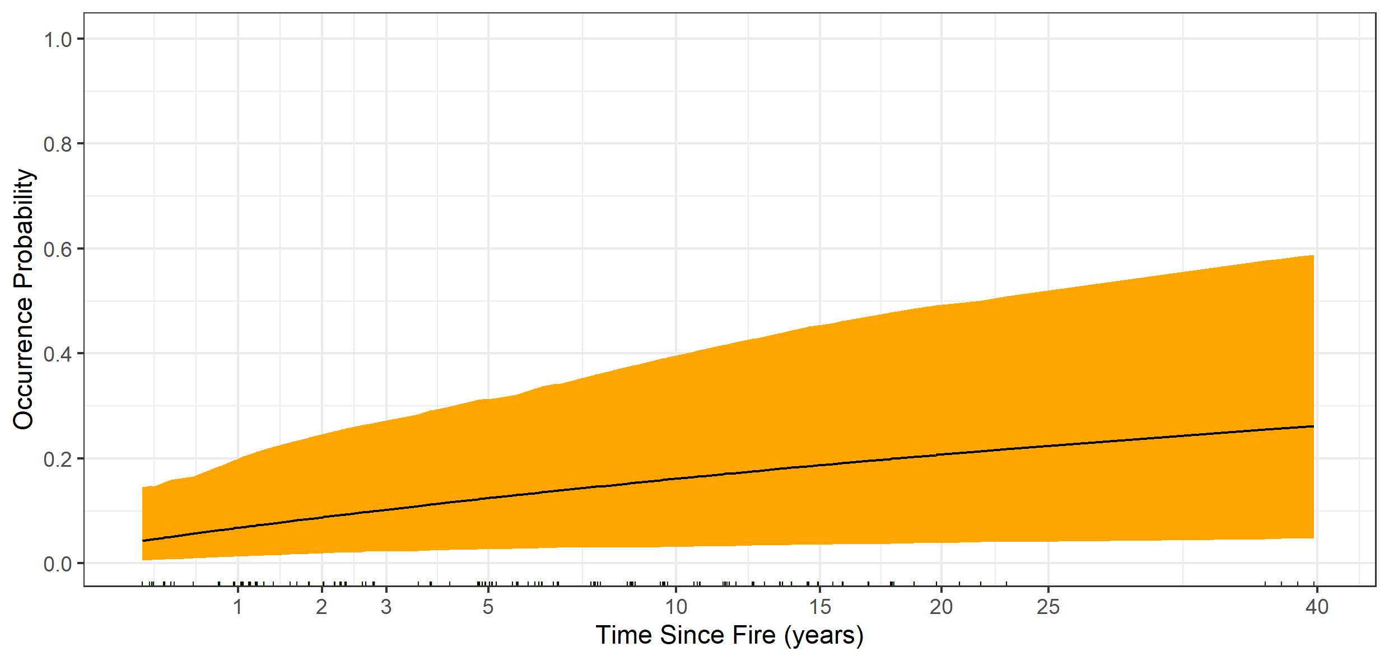
Figure 6. Estimated partial relationship between the probability of Long-footed Potoroo occupancy and time since fire, assuming average habitat quality (HDM value = 60) and FAPAR value (68).
The fitted relationship is derived from the best supported model (Table 2B). HDM: Habitat Distribution Model.
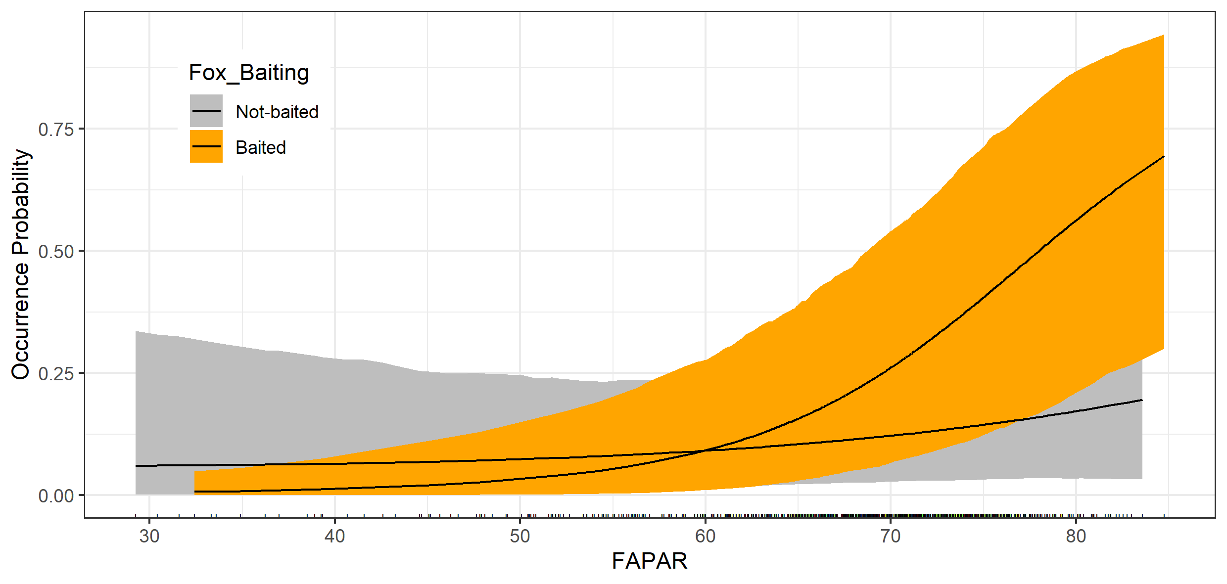
Figure 7. Estimated relationships between the probability of Long-footed Potoroo occupancy and the mean fraction of absorbed photosynthetically available radiation (FAPAR) at baited (orange) and unbaited (grey) sites, assuming average habitat quality (HDM value = 60) and time since fire (6.3 years).
FAPAR was averaged over the 12 months prior to camera retrieval and measured at 300 m resolution (values taken from the pixel containing trap coordinates). HDM: Habitat Distribution Model.

The landscape model showed a negative relationship between long-footed Potoroos occurrence and predicted fox density and positive relationships with HDM, time-since fire and FAPAR (Table A1-B2). Figure 8 presents a visual representation of the spatial and temporal trends in Long-footed Potoroo occupancy from 2007 to 2024, using the landscape model. The modelled area is divided into pixels with a 75m resolution and covers an area of 481,694 ha. Summing the probabilities of occurrence across pixels in each year allows us to estimate the predicted area occupied and to determine the percentage change from year to year. To allow for the fact that 2007 had relatively few camera sites (47) we have compared the change in predicted area occupied between 2008 (99 camera sites, 15,484 ha) to 2024 (130 camera sites, 96,679 ha), which is a 6-fold increase in the estimated area of Long-footed Potoroo occupancy since 2008.
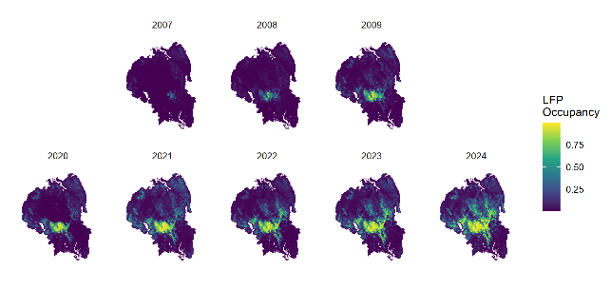
Figure 8. Predicted Long-footed Potoroo occupancy (probability of occurrence) across the study region based on HDM value, time-since-fire, mean annual FAPAR value, and baiting intensity. Predictions are derived from Model 2B in Table 2 (which included spatial and temporal random effects).
  - Long-nosed Bandicoot occupancy
Long-nosed Bandicoot occupancy has increased in both Core and Expansion zones since 2020 (data not available prior to 2020), with a substantial increase in 2023 (Figure 9, Table A3). The covariates that had support as predictors of Long nosed Bandicoot occurrence previously had weaker, and more uncertain, effects in the updated model and explain little, if any, of the temporal trends.
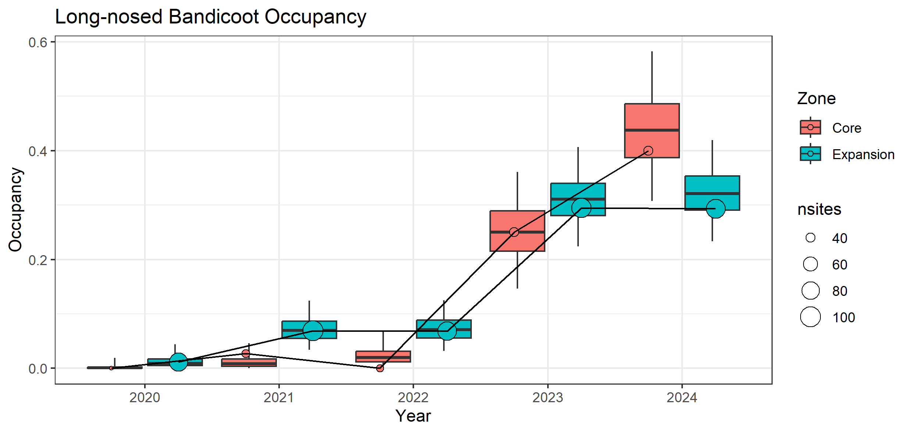
Figure 9. Estimated occupancy (mean probability of occurrence) of Long-nosed Bandicoot in the Core and Expansion baiting zones in all surveyed years since 2020.
  - Superb Lyrebird
Superb Lyrebird occupancy was higher in the Core zone than the Expansion throughout the 2020-2024 period, with no consistent temporal trend (Figure 10, Table A4). There was evidence that Superb Lyrebird occurrence increased with increasing time-since-fire and increasing LFP-HDM but the relationship with FAPAR values was highly uncertain (Figures 11 – 13, Table A4).
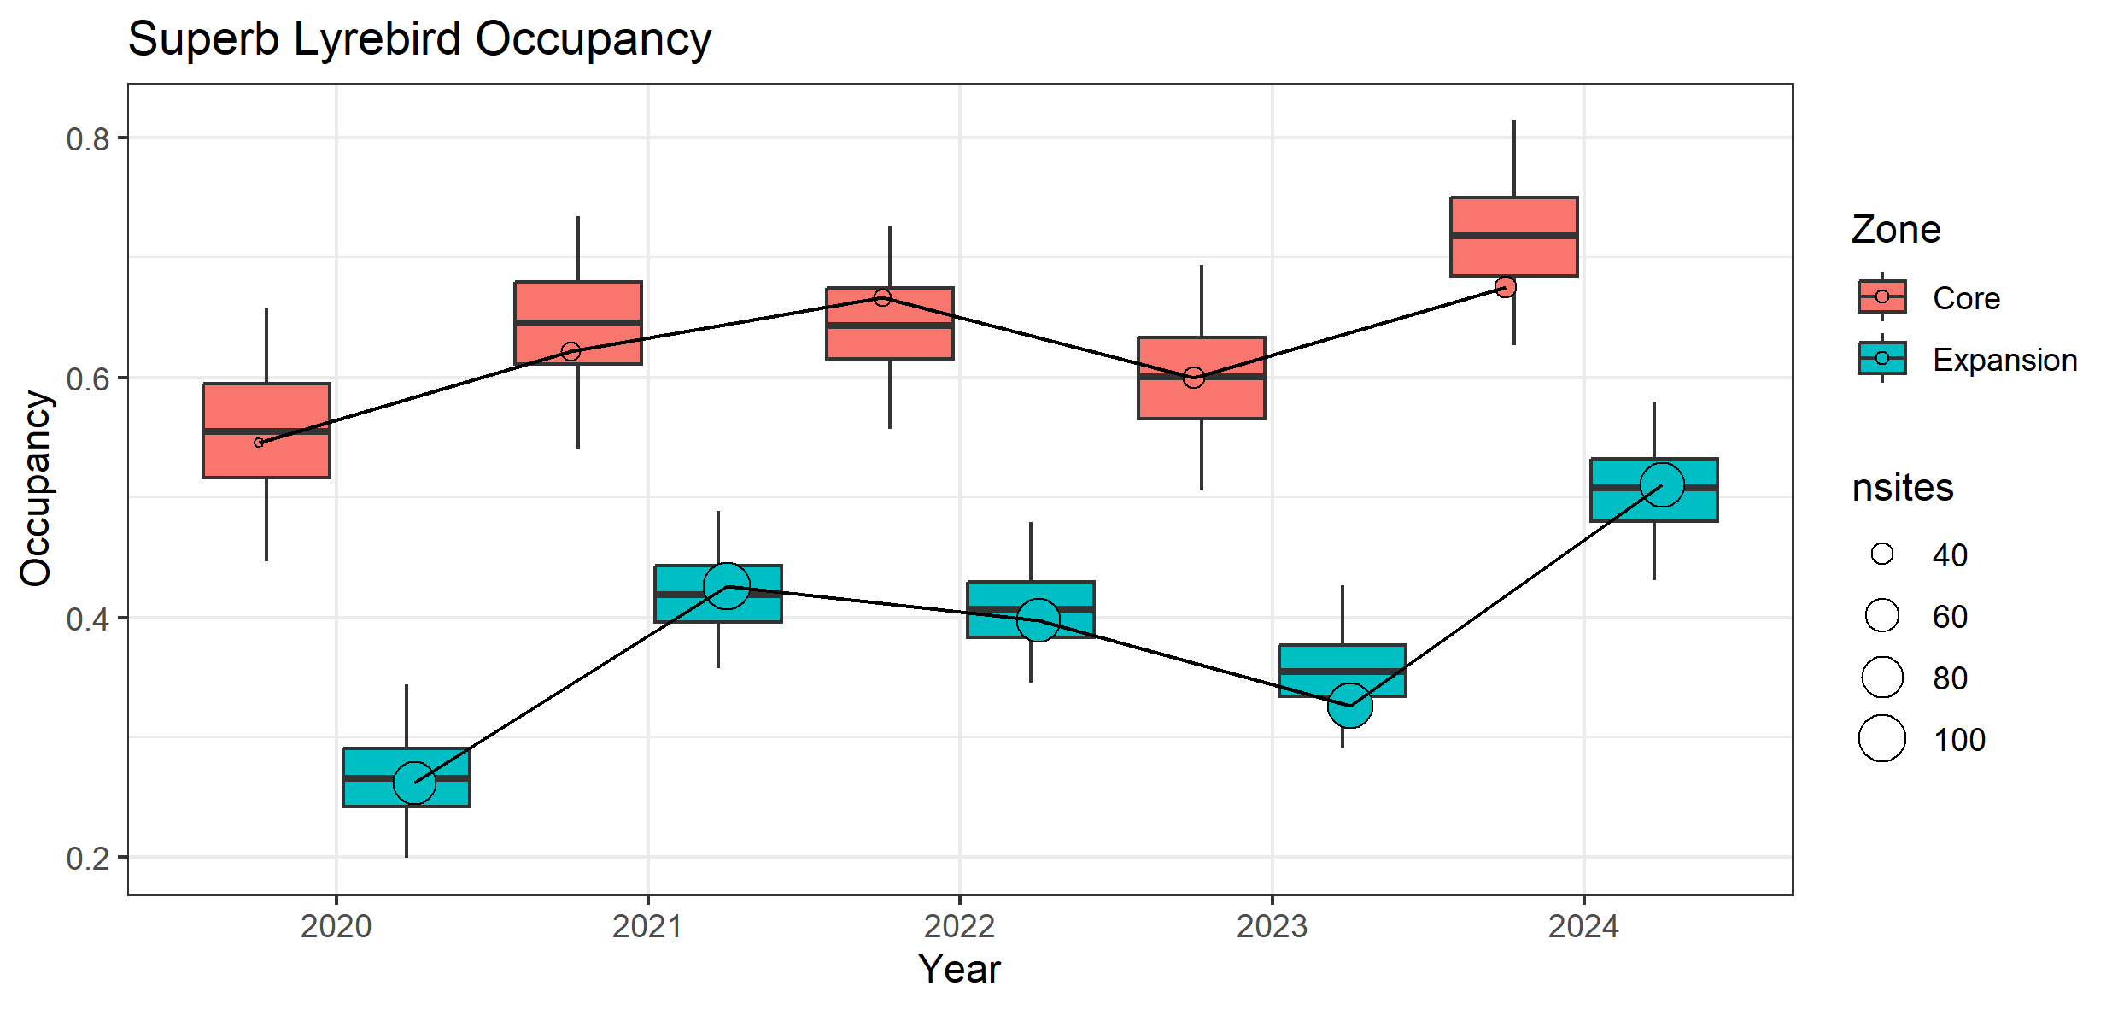
Figure 10. Estimated occupancy (mean probability of occurrence) of Superb Lyrebird in the Core and Expansion baiting zones in all surveyed years since 2020.
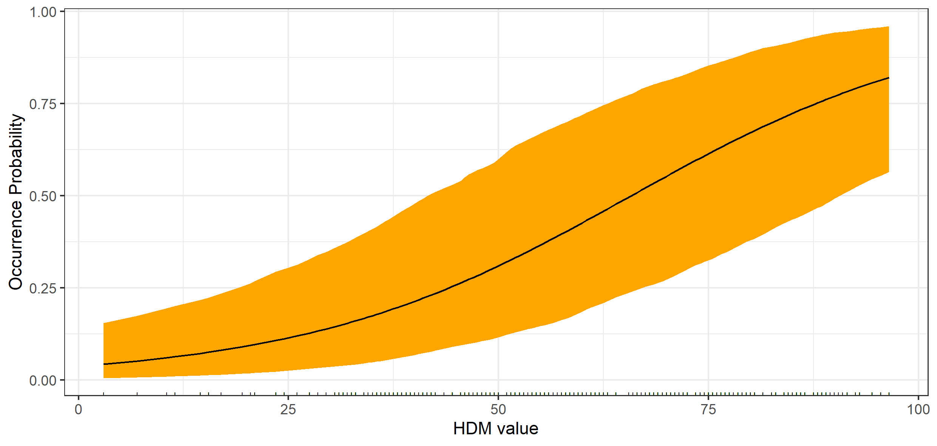
Figure 11. Estimated relationship between the probability of Superb Lyrebird occurrence and modelled habitat suitability.
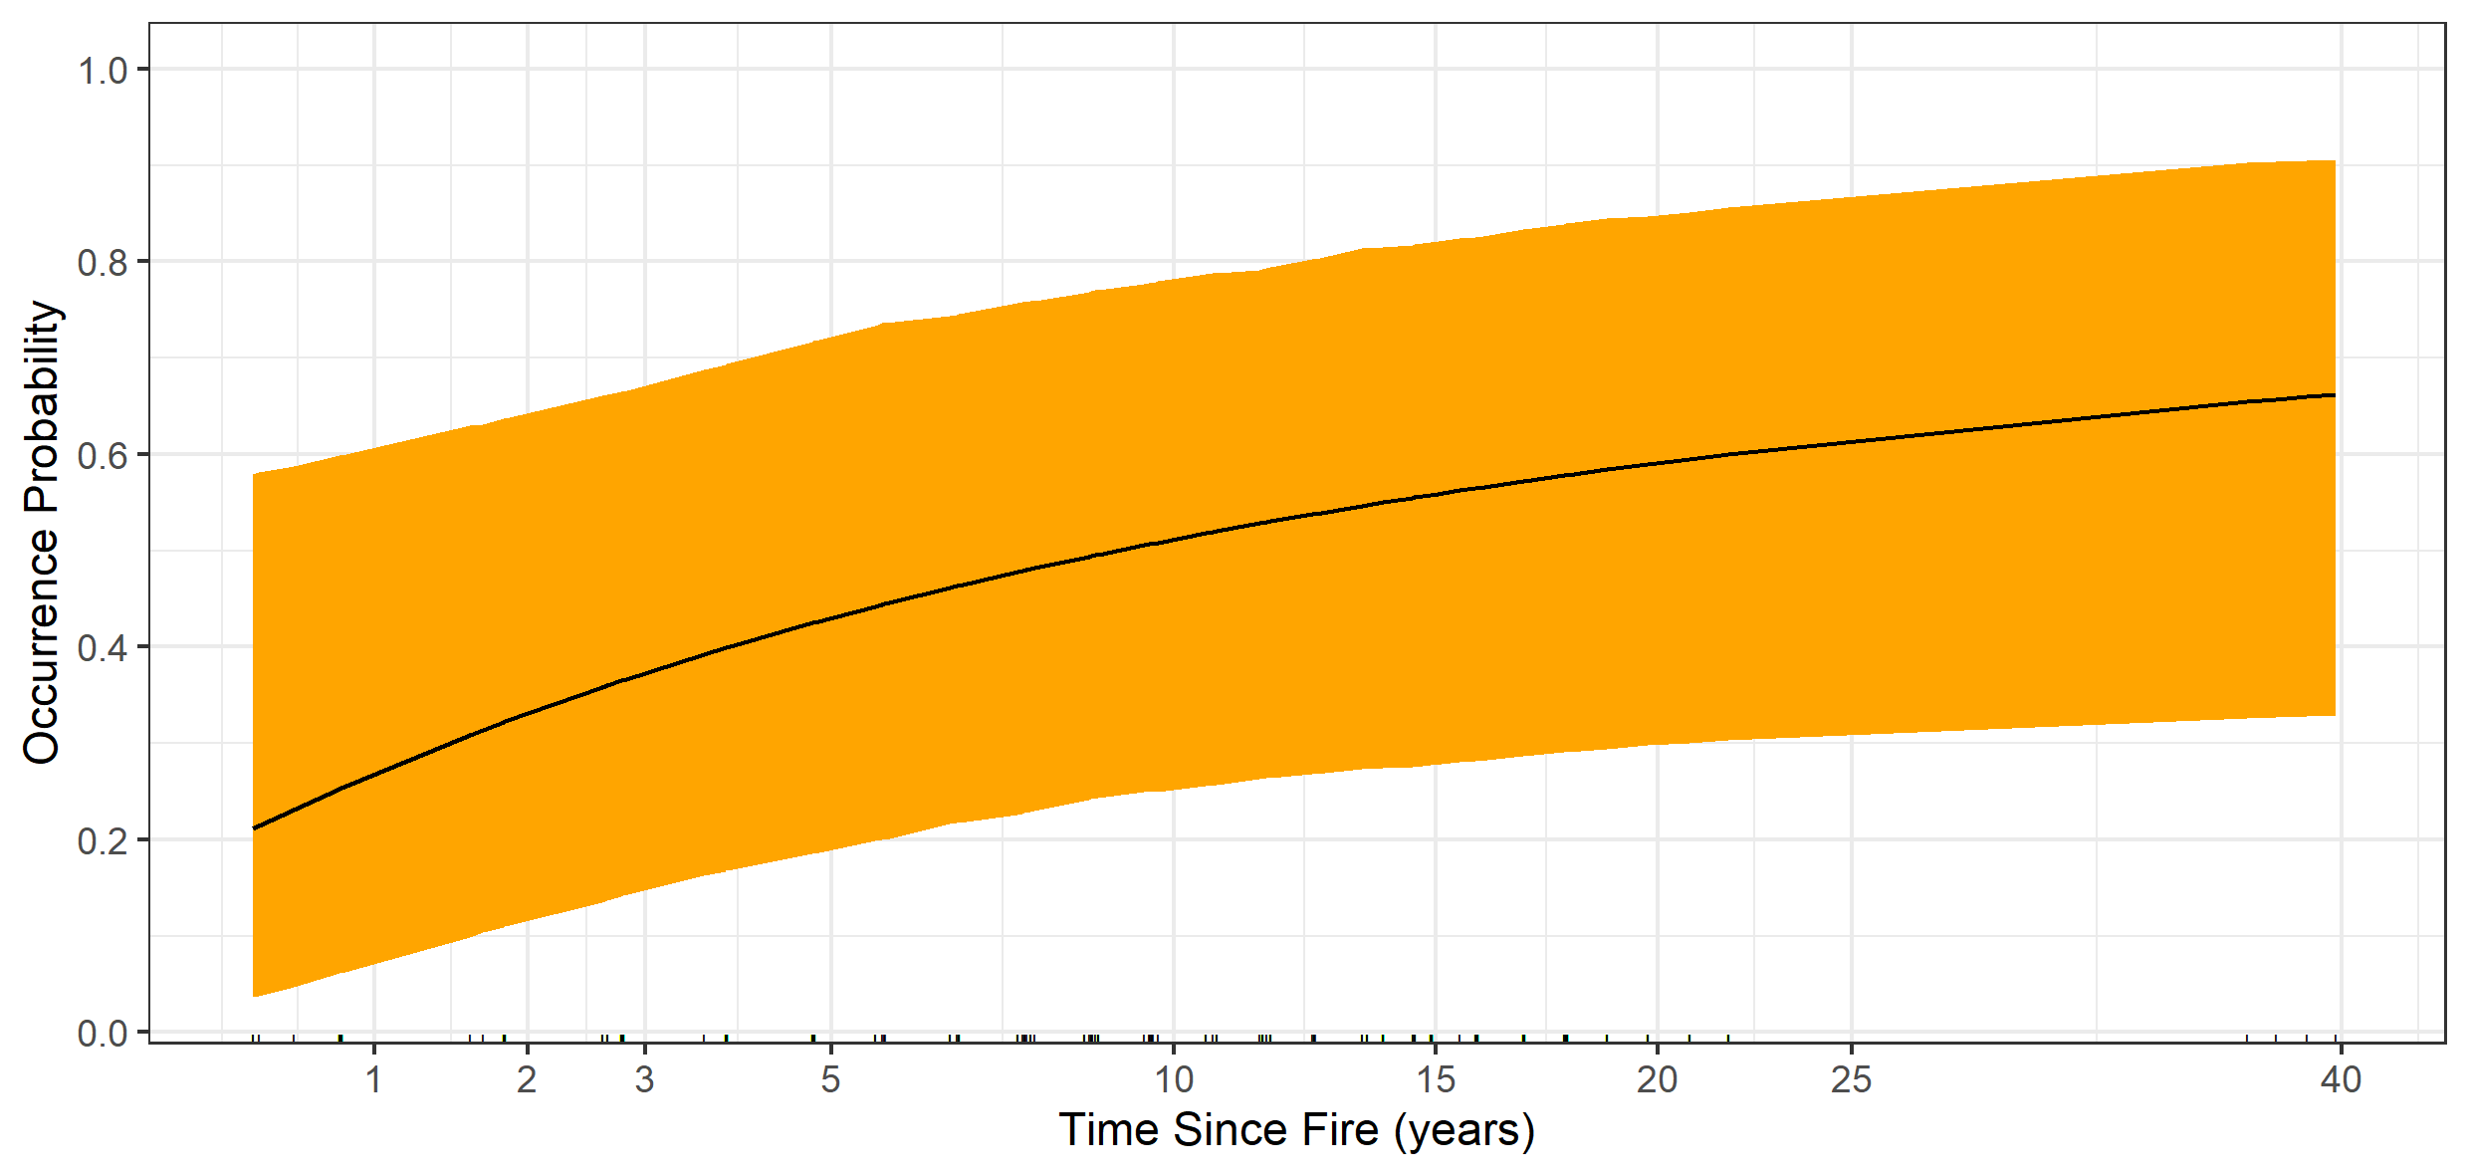
Figure 12. Estimated relationship between the probability of Superb Lyrebird occurrence and time since fire.
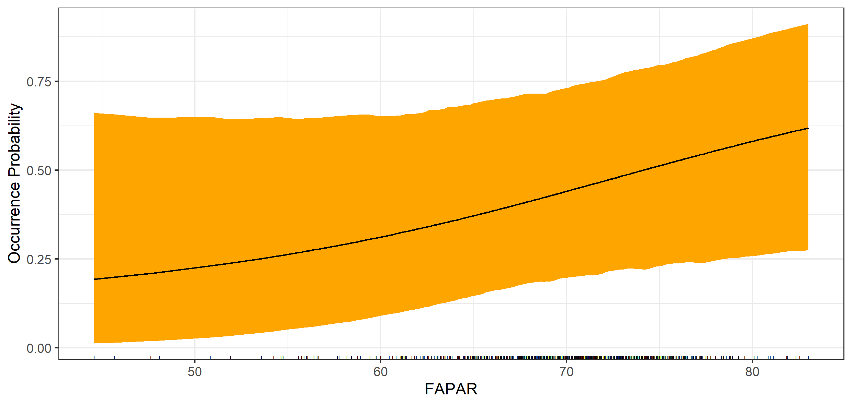
Figure 13. Estimated relationship between the probability of Superb Lyrebird occurrence and one-year mean FAPAR value.
  - Fox occupancy
Fox occurrence was lower (had lower visitation rates) in the Core baiting zone than in the Expansion zone (Table A5). There was evidence of declines in fox occurrence in both areas [Core baiting zone trend = –20% (–33%, -5%) p.a.; Expansion baiting zone trend = –12% (–21%, -3%) p.a.)] (Figure 14, Table A5).
Fox occurrence declined with increasing FAPAR values, with a stronger FAPAR effect among baited sites than among unbaited sites (Figure 15, Table A5).

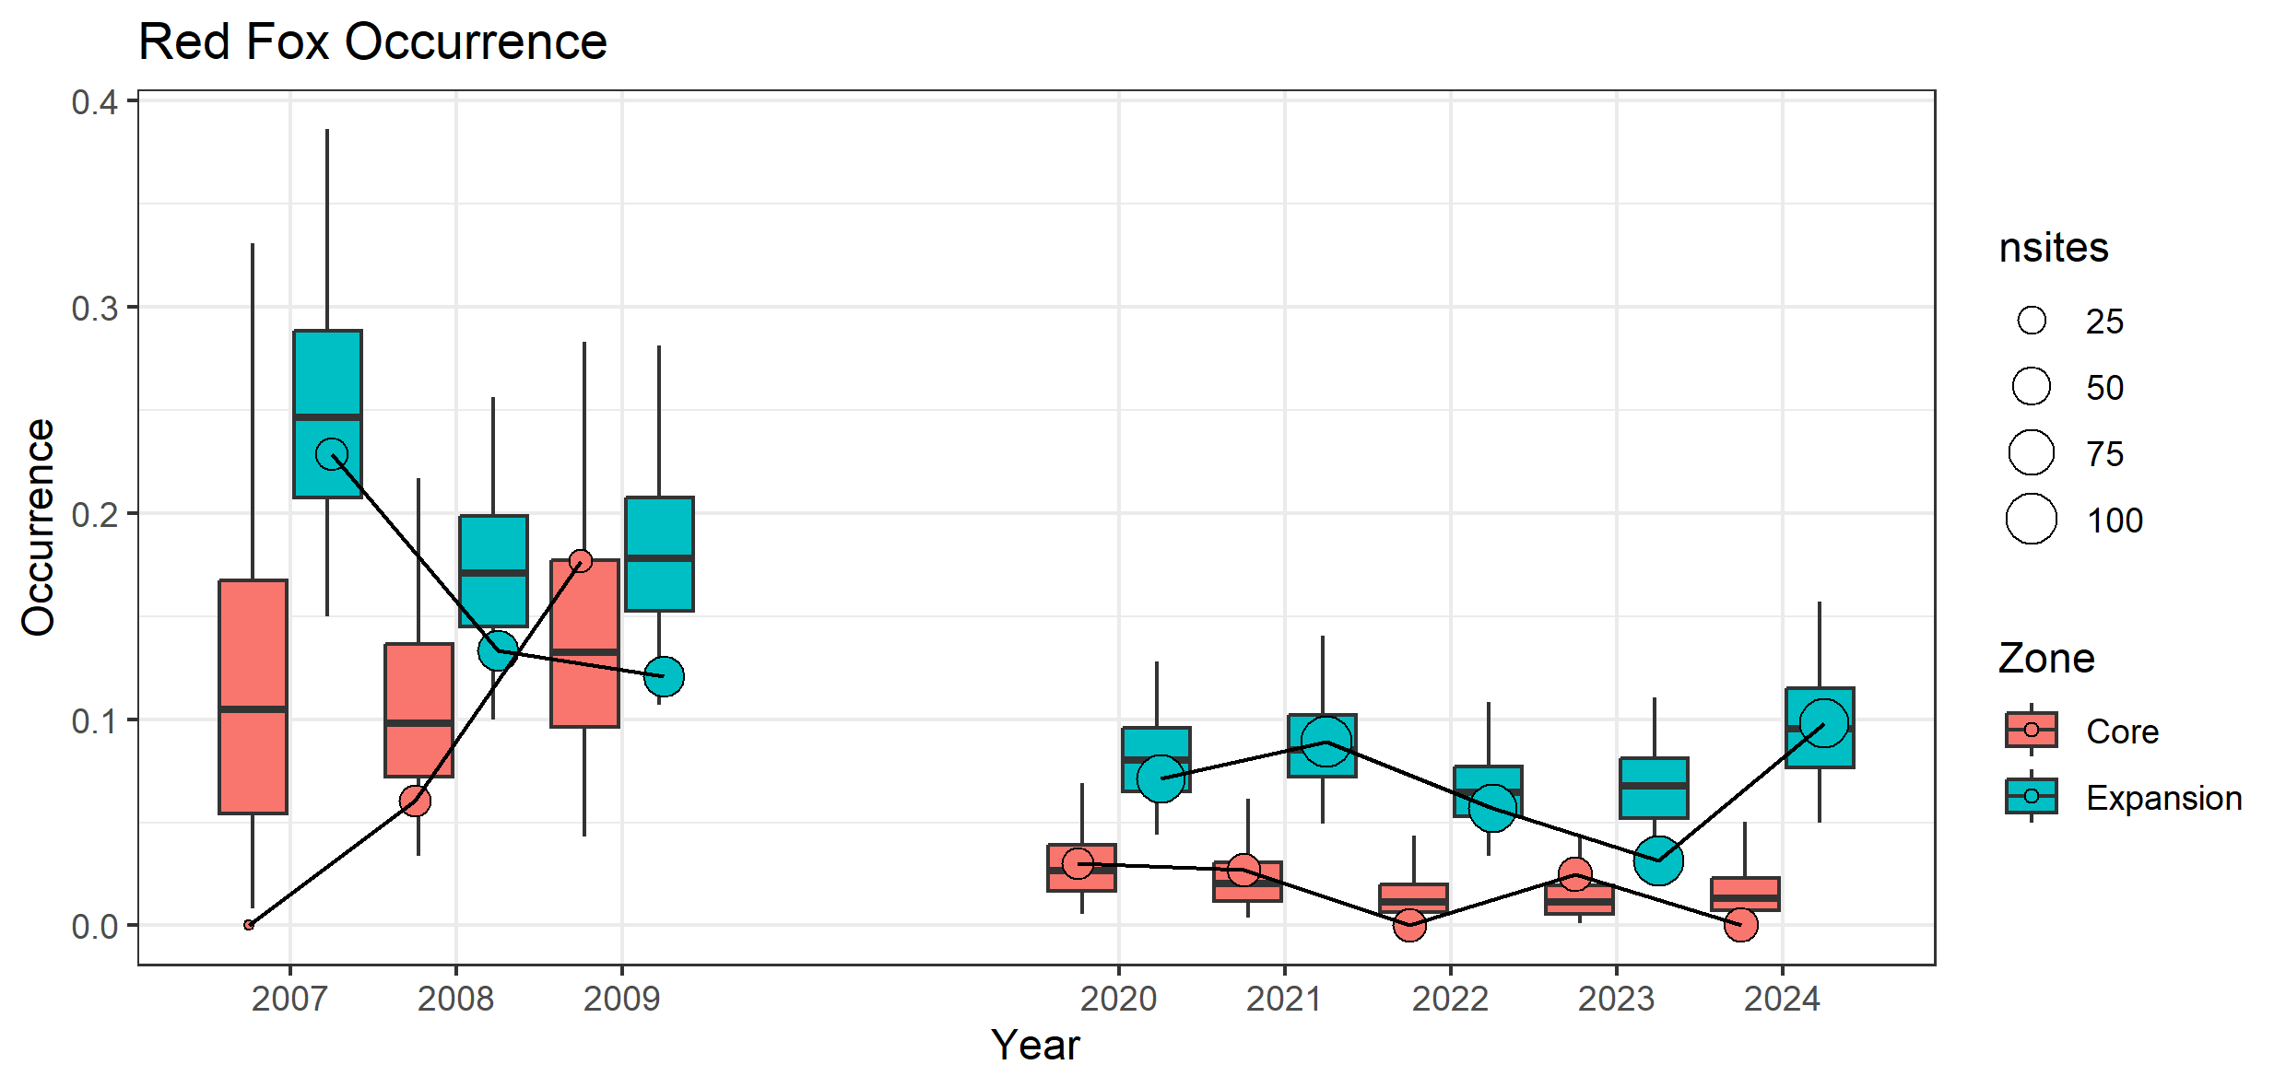
Figure 14. Estimated occupancy (mean probability of occurrence) of foxes in the Core and Expansion baiting zones in all surveyed years since 2007.
Boxplots show the posterior distributions of the estimated occupancies within each year, derived from the Basic trend model with random spatial and temporal effects. Note that for foxes, we interpreted occupancy as being indicated by the proportion of sites visited. The data points/circles show the raw proportions of surveyed sites with at least one fox detection (naïve occupancy). Naïve occupancy may differ from the model estimates because of low and highly uncertain detection probabilities (which for foxes, are affected by visitation rates) and because model estimates tend towards long-term means (or trends) within spatial zones. nsites = number of sites.
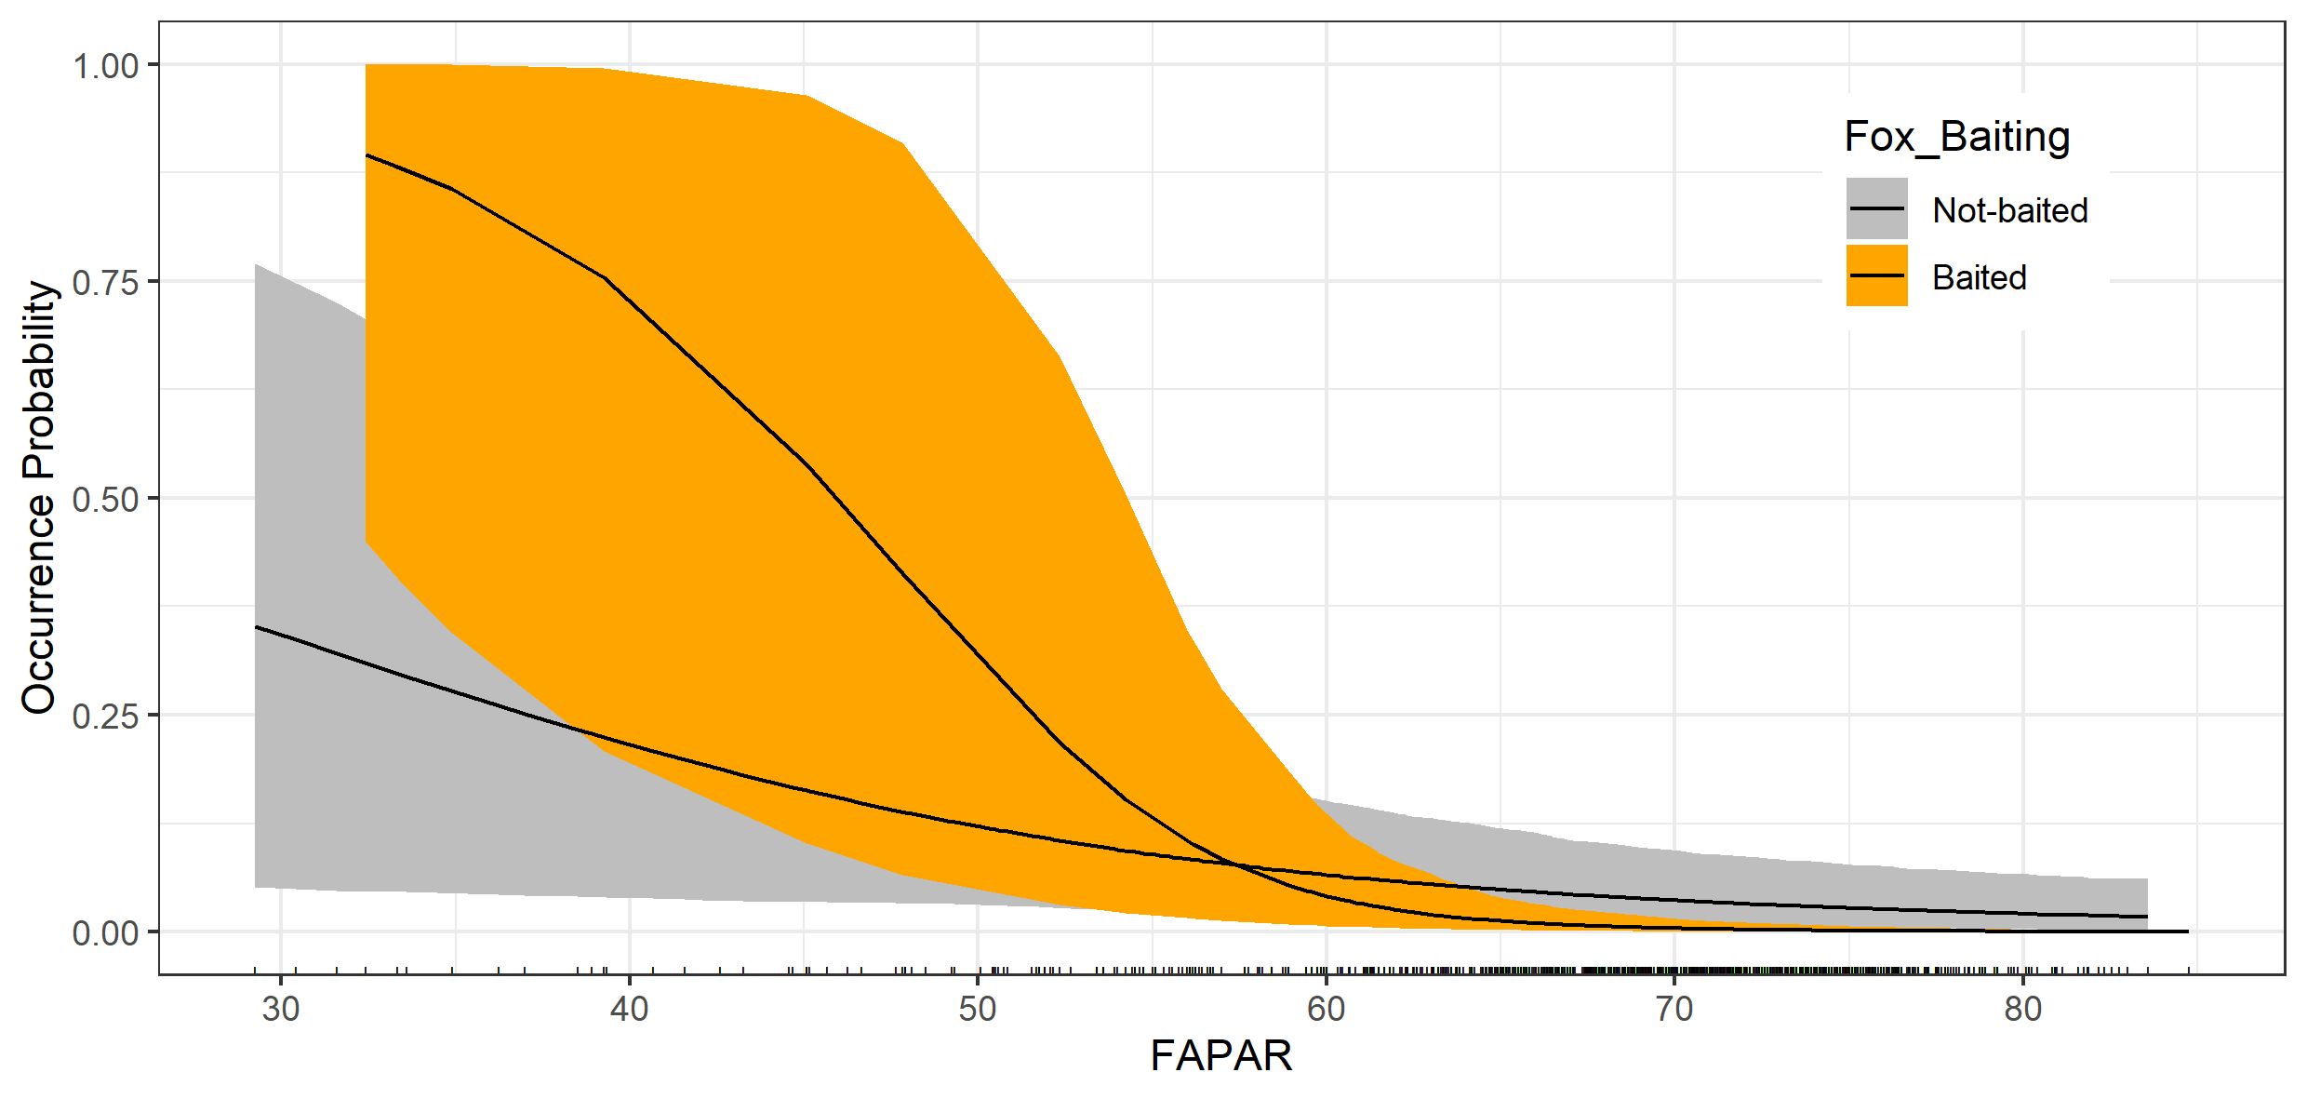
Figure 15. Estimated partial relationship between the probability of fox occurrence and the mean fraction of absorbed photosynthetically available radiation (FAPAR) at baited (orange) and unbaited (grey).
FAPAR was averaged over the 12 months prior to camera retrieval and measured at 300 m resolution (values taken from the pixel containing trap coordinates). Note the large uncertainties, and overlapping credible intervals, at FAPAR values below 65: the negative effect of baiting on fox occurrence is only evident at high FAPAR values (>70). There is insufficient data at low FAPAR values to make meaningful comparisons between baited and unbaited sites.
  - Feral cat occupancy
There was no substantive difference in feral cat occurrence between baiting zones, and no consistent trends in cat occurrence in either zone (Figure 16, Table A6). No variables had support as predictors of feral cat occurrence in the variable selection model.
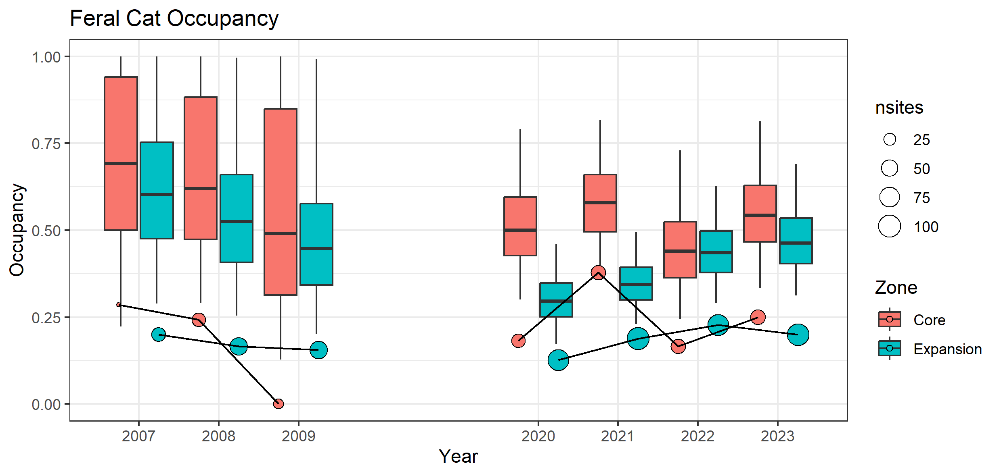
Figure 16. Estimated occupancy (mean probability of occurrence) of feral cats in the Core and Expansion baiting zones in all surveyed years since 2007.
Boxplots show posterior distributions of the estimated feral cat occupancy within each year, derived from the Basic trend model with random spatial and temporal effects. Note that for cats, we define occupancy as the proportion of sites visited. Data points/circles show the raw proportions of the surveyed sites with at least one cat detection (naïve occupancy). Naïve occupancy may differ from model estimates because of low and highly uncertain detection probabilities (which, for cats, are affected by visitation rates) and because model estimates tend towards long-term means (or trends) within spatial zones. nsites = number of sites.

- Summary
Seventeen years since fox control began in the Core zone and four years after it commenced in the Expansion zone, there is good evidence that Long-footed Potoroos have significantly increased the number of sites at which they are found and expanded the area over which they occur. The increases in occupancy can largely be explained by the length of time since the last fire (the longer the period the higher the chance of Long-footed Potoroos occurring there) and the interaction between habitat productivity (the surrogate variable – FAPAR representing plant productivity and/or density) and the ongoing fox baiting (good habitat + fox control = more sites occupied). There are at least two plausible explanations for the observed interaction, 1) the response of Long-footed Potoroos to increases in underlying plant productivity or cover is dependent on fox density, with Potoroo preferences for high FAPAR sites only expressed when fox densities are low, or 2) FAPAR is relatively unimportant to Long-footed Potoroos, but they are more likely to occur where fox densities are low, and fox densities are lowest in high FAPAR value, baited sites. The negative relationship between fox occurrence and FAPAR and negative FAPAR x Baited interaction in the fox occupancy model supports the second explanation (fox densities are lower in high FAPAR sites, and especially low in baited-high-FAPAR sites) but does not preclude the former. Regardless of the interaction between fox bating and FAPAR, results indicate that the expansion of fox baiting in 2021 has contributed to a substantial increase in the prevalence of Long-footed Potoroo within the Expansion Zone.
We have taken FAPAR to be a representation of underlying plant productivity, it may however be confounded with vegetation structure. To disentangle this plausible relationship, site specific habitat and vegetation structural variables could be used to separate out the role of habitat from productivity. Alternatively, more detailed structural remotely sensed data might be available from light detecting and ranging (LiDAR) data, e.g. Hawbaker et al. (2009) used this to assess forest vegetation structure and biomass. We recommend collecting more detailed vegetation structural data as part of the next monitoring round. In addition, during exploratory analysis of the most recent data, there was some indication that the relationships with Long-footed Potoroo occurrence and HDM values and other predictors is becoming less certain, but it needs more data and / or a more complex analyses to make any reliable inferences.
Ecological systems are complex and understanding the importance of a range of variables on the response of species to management interventions is challenging. Interactions between variables introduce further complexity as the relationship between variables is not straightforward or additive. Instead, the effect of one variable on the outcome depends on the level of another variable, e.g., the importance of FAPAR and baiting.
Previous analysis of the camera trap data provided naïve occupancy estimates for the Long-nosed Bandicoot and Superb Lyrebird which showed potential positive responses to reduced fox abundance. While Long-nosed Bandicoots have increased markedly in both the Core and expansion zones in both 2023 and 2024, compared to previous years, none of the predictor variables shed light on the drivers of this response. Similar increases have been observed in the Southern Ark landscape over the same period (Cally 2024, unpublished). Superb Lyrebird occurrence remains significantly higher in the Core Zone, with no detectable trend in either zone. Although no detectable response to baiting was observed, long-term fox control has been shown to positively influence Lyrebird activity (Claridge et al. 2010). The camera trap survey methods collect data on a wide range of native species that could potentially respond to reductions in fox density. A multi-species, hierarchical occupancy modelling framework could be applied to these data, to provide insights into the response of a wide range of species to fox baiting operations.
There is good evidence that fox baiting is associated with declines in fox occurrence (activity). Fox occurrence was lower on average in baited sites and declined with increasing FAPAR value in both baited and unbaited sites but declined more rapidly with FAPAR in baited sites. That is, foxes were least likely to occur at (visit) baited sites with high FAPAR sites.
The negative relationship between fox occurrence and FAPAR could arise spuriously if foxes were less detectable, when present, in high value FAPAR sites. Unfortunately, with the data available, there is no way to separate detectability per se from the probability of a site being visited. Movement data from tracking individuals would be required. However, it is doubtful that foxes would be less likely to be captured by a camera trap when they visited a site with high FAPAR values than when they visited a site with lower values.
With ongoing baiting, we expect fox densities to continue to decline in the Core and Expansion zones. If fox densities decline further in the Barry Mountains area, we can clarify the influence of foxes on the apparent habitat preferences of Long-footed Potoroo by assessing whether the relationships between Long-footed Potoroo occupancy and habitat variables (HDM, FAPAR, time-since-fire) change as fox densities decline.
We demonstrated a decreasing temporal trend in the occurrence of foxes across both zones, with a slightly stronger rate of decline in the Core zone, as might be expected given the longer duration of fox control in that area. Although baiting in the Core zone has been irregular, with continuous baiting from 2004 to 2009, followed by reduced baiting until 2021, and then continuous baiting again. Despite these fluctuations, fox occurrence was approximately 80% lower at Core baited sites compared to Expansion unbaited sites. In contrast, the Expansion zone's baiting program covers a larger area but is not continuous throughout the year, particularly in State Forests. While the spatial model predicted a substantial reduction in fox density with a continuous baiting program (Robley et al. 2023), the actual pulsed baiting strategy may not be as effective, potentially allowing for immigration and compensatory recruitment among fox populations.
No significant difference in feral cat occupancy was found between the Core and Expansion zones, possibly due to the low feral cat detection rate, which could be attributed to various factors such as lure preference or active exclusion from fox-occupied sites.
  - Conclusion
This study highlights that native species responses to reductions in an introduced predator have complex outcomes. It highlights the importance of monitoring plausible influential variables such as habitat suitability, productivity, fire history and changes in predators over the long-term to understand Long-footed Potoroo occupancy dynamics.
This study also reinforces the need to maintain landscape scale, long-term fox control to achieve and maintain biodiversity gains. While the current Barry Mountains fox control has reduced fox abundance, foxes are still present in the landscape. Cessation of fox control would allow the fox population to recover, increasing the impacts on Long-footed Potoroos and other native species at risk from fox predation.
The role of feral cats in significantly impacting Australia’s biodiversity has been widely researched (Hamer et al. 2020). While we have not been able to detect a significant number of feral cats (due most likely to the current camera trapping design), it has been shown that densities of feral cats in wet or productive forests can be very high (Rees et al. 2019). There is also some evidence that feral cats can increase in areas with reduced fox abundance (Rees et al. 2023). More work is required in the Barry Mountains to determine the relative influence of feral cats on Long-footed Potoroos and other native species.
These updated results highlight the importance of both the need to continue the landscape scale fox control program but also the value of the monitoring, which identified features important to the ongoing persistence and expansion of the Long-footed Potoroo Great Dividing Range population.

Appendices
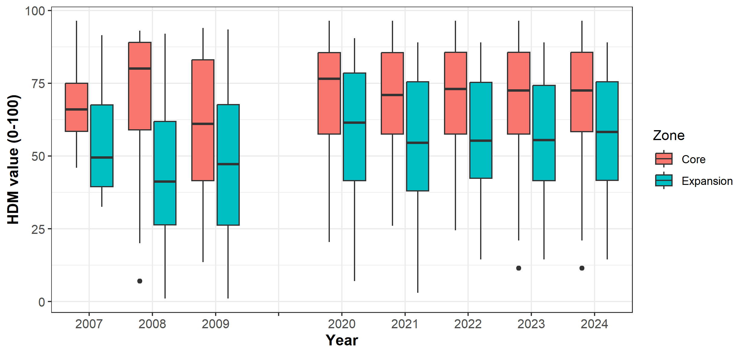
Figure A1. Distribution of Habitat Distribution Model (HDM) values among camera locations within Core and Expansion zones in each survey year. Note the HDM is a static model (average long-term habitat suitability); variation among years is related to spatial differences in the location of camera sites.
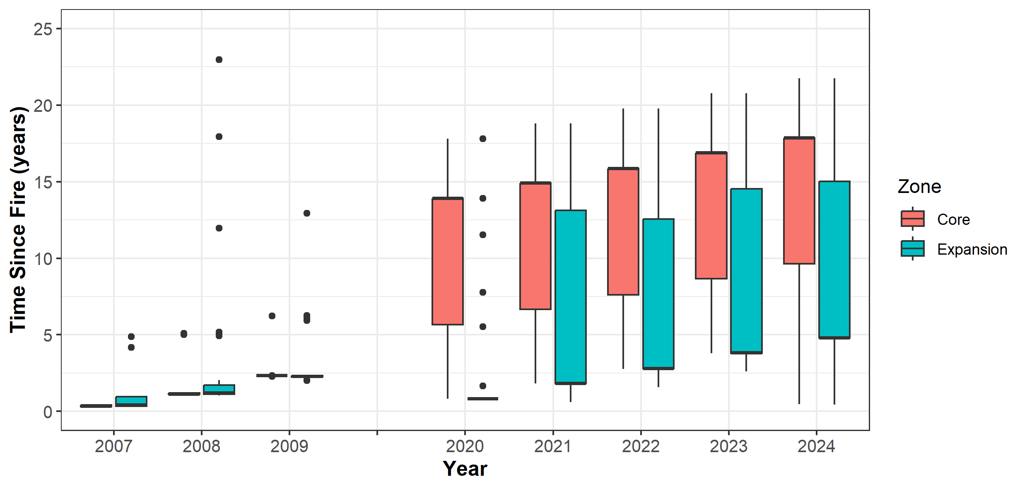
Figure A2. Distribution of Time-Since-Fire values among camera locations within Core and Expansion zones in each survey year. Six outliers, comprising a maximum of 1 site per year, with Time-Since-Fire > 25 years are not shown.
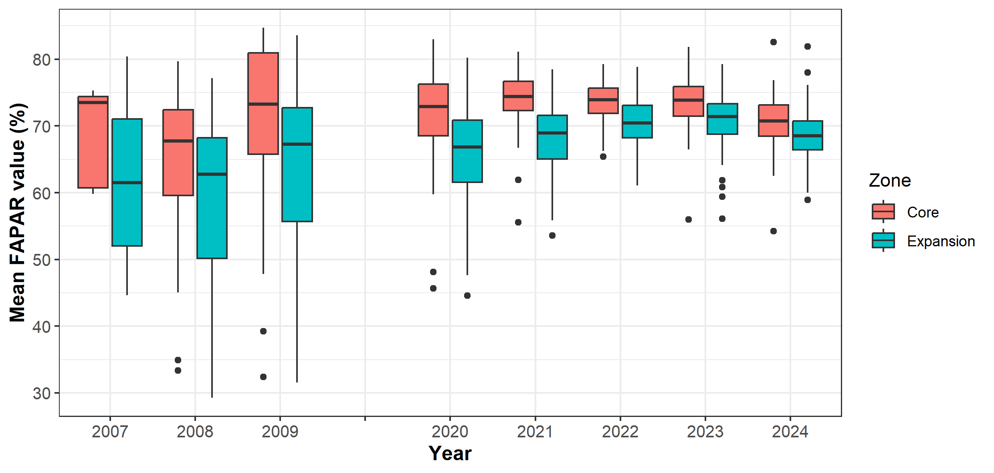
Figure A3. Distribution of mean annual FAPAR values among camera-trap locations within Core and Expansion zones in each survey year. FAPAR = fraction of absorbed photosynthetically available radiation; a measure of photosynthetic activity that reflects canopy density and plant productivity.

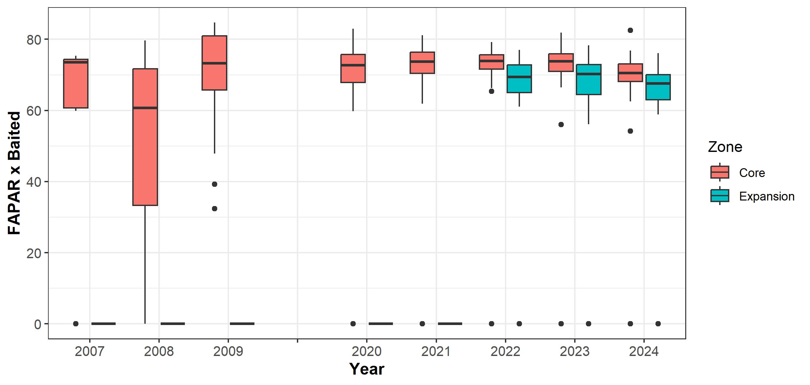
Figure A4. Distribution of the product of mean annual FAPAR values and the binary Baited (within 1km of camera) variable among camera-trap locations within Core and Expansion zones in each survey year. FAPAR = fraction of absorbed photosynthetically available radiation; a measure of photosynthetic activity that reflects canopy density and plant productivity.
Table A1. Parameter estimates (posterior means and 95% credible intervals) and corresponding conditional odds ratios for three models of Long-footed Potoroo occupancy: Basic Trend Model, Best-supported Model (based on Bayesian variable selection), and Conditional Trend Model (trends conditioned on supported predictors for all years).
Parameter | Estimate  (95% CI) | ¹Odds ratio  (95% CI) | Interpretation
- A: Basic trend model
Occupancy - Core v Exp | 2.13  (1.17, 3. 20) | 8.50  (3.22, 24.5) | - Occupancy higher in Core than Expansion  - (~9-fold higher odds in Core in 2020)
- Trend in Core | 0.21  (0.08, 0.34) | 1.23  (1.08, 1.40) | - Positive trend in occupancy in Core zone  - (23% p.a. increase in odds of occurrence)
- Trend in Exp | 0.17  (0.07, 0.29) | 1.18  (1.07, 1.34) | - Positive trend in occupancy in Expansion zone (18% p.a. increase in odds of occurrence)
- Difference between Core and Exp | 0.03  (-0.07, 0.15) | 1.03  (0.93, 1.28) | - No clear difference in trends between Core and Expansion
- Change after baiting in Exp | 0.38  (-0.19, 0.83) | 1.46  (0.83, 2.30) | - No clear change in Expansion zone trend after 2021.
- B1: Best-supported model
- Difference between baited & unbaited | 0.82  (-0.02, 1.70) | 2.27  (0.98,5.47) | - No difference in Long-footed Potoroo occurrence b/w baited and unbaited sites at the mean FAPAR value
- HDM | 1.91  (1.41, 2.63) | 6.75  (5.47, 25.8) | - Positive relationship between Long-footed Potoroo occurrence and HDM value
- Time since fire | 0.52  (0.11, 0.97) | 1.68  (1.12, 2.64) | - Positive relationship between Long-footed Potoroo occurrence and time-since-fire
- FAPAR and baited sites | 1.18  (0.48, 1.96) | 3.25  (1.62, 7.1) | - Positive relationship between Long-footed Potoroo occurrence and FAPAR among baited sites
- FAPAR and unbaited sites | 0.32  (-0.02, 1.70) | 1.38  (0.76, 2.53) | - No relationship between Long-footed Potoroo occurrence and FAPAR among unbaited sites
- B2: Landscape model
Modelled fox density | -0.64  (-1.03, -0.25) | - | Negative relationship between Long-footed Potoroo occurrence and predicted fox density (i.e. positive rel. with baiting intensity)
HDM | 1.42  (1.03,1.08) | - | Positive relationship between Long-footed Potoroo occurrence and HDM value
Time since fire | 0.23  (-0.01, 0.48) | - | Positive relationship between Long-footed Potoroo occurrence and time-since-fire (high uncertainty)
FAPAR | 0.61  (0.23, 0.99) | - | Positive relationship between Long-footed Potoroo occurrence and FAPAR
- C: Conditional trend model
- Trend in Core | 0.08  (-0.02,0.18) | 1.08  (0.82,1.19) | - No trend in occupancy in Core zone after accounting for best-supported predictors
- Trend in Exp | 0.06  (-0.01,0.16) | 1.06  (0.99,1.17) | - No trend in occupancy in Expansion zone after accounting for best-supported predictors

CI = credible interval; p.a. = per annum; HDM: Habitat Distribution Model.
¹Conditional Odds Ratios (OR) are a way to compare the chances of a particular outcome (e.g., the occurrence of Long-footed Potoroo) between two different groups (e.g., the Core vs the Expansion zone). We want to understand how the chances of Long-footed Potoroo occurring differ between these two groups. To calculate the OR, we look at the probabilities of that event happening in both groups. For example, we can call the probability of Long-footed Potoroo occurring in the Core zone "p1", and the probability in the Expansion zone "p0". The formula for the Conditional Odds Ratio is: OR = [p1 / (1-p1)] / [p0 / (1-p0)]. We assume all other factors (like different predictors or random spatial variations) are kept constant. To see how the odds change over time for the time variable comparison, we compare the odds occurrence at time t+1 year relative to time t. So, the proportional change from year t to year t+1 is expressed as (ORt-1). For the continuous predictors, the variables can take different values, e.g., HDM values; we can use the OR to understand the impact of changing these values, for example, if one site has an HDM value of "x" and another with a slightly different value "x+σ_x" (where σ_x is the standard deviation of x); the ORx gives us the ratio of odds at these two sites. ORx-1 tells us the proportional change in odds associated with a change in the value of x equivalent to one standard deviation. The Conditional Odds Ratios help us compare the chances of something happening between different groups, times, or varying values of a specific variable. They give us insights into how one situation compares to another while considering other relevant factors.
Table A2. Conditional odds ratios for the expected changes in Long-footed Potoroo occupancy associated with long term (2020-24 mean vs 2007-2009 means) and recent (2024 vs 2020) changes in predictor variables.
Variable (units) | Core zone |  |  |  | Expansion zone
 | Long-term  (2020-24 v 2007-09) |  | Recent  (2024 v 2020) |  | Long-term  (2020-24 v 2007-09) |  | Recent  (2024 v 2020)
 | Δ_{L} | OR (95% CI) | Δ_{S} | OR (95% CI) | Δ_{L} | OR (95% CI) | Δ_{S} | OR (95%CI)
HDM value  (0-100) | 2.6 | 1.24  (1.16, 1.35) | -0.35 | 0.97  (0.96, 0.98) | 10.8 | 2.52  (1.91, 3.48) | -2.7 | 0.80  (0.73, 0.85)
Time-since-Fire (years) | 11.1 | 2.54  (1.17, 5.78) | 4.6 | 1.32  (1.04, 1.69) | 2.8 | 1.47  (1.06, 2.06) | 6.1 | 2.11  (1.11, 4.07)
FAPAR (0-100)  x Baiting (0/1) | 6.0  0.09 | 2.39  (1.47, 4.22) | -1.2  0.07 | 0.79  (0.63, 0.96) | 7.0  0.5 | 1.61  (1.13, 2.36) | 2.4  0.8 | 1.90  (1.01, 3.54)
Odds Ratios are derived from effect sizes estimated in the Best-supported Model and give the expected proportional change in the odds of occupancy associated with the observed mean changes in each variable (or product of variables in the case of the FAPAR x Baiting interaction). Δ = change in the mean value of each variable over long (Δ_{L}) and short (Δ_{S}) time frames.
Table A3. Parameter estimates (posterior mean and 95% Credible Intervals) and corresponding conditional odds ratios for Long-nosed Bandicoot basic trend, best supported model and covariate-adjusted models.
Parameter | Estimate  (95% CI) | Odds Ratio  (95% CI) | Interpretation
A: Basic Trend Model
- Occupancy - Core v Exp | -2.37  (-5.99, -0.50) | 0.04  (0.01, 0.08) | Long-nosed Bandicoot occurrence lower in Core zone in 2020
- Trend in Core | 3.83  (2.24, 6.27) | 46.1  (9.40, 528) | Positive trend in Core zone  (very high uncertainty)
- Trend in Exp | 1.89  (0.60, 3.79) | 6.62  (1.82, 44.3) | Positive trend in Expansion zone (very high uncertainty)
- Difference between Core and Exp | -0.98  (-4.32, 1.26) | 0.38  (0.01, 3.52) | No difference in trends between Core and Expansion zones
 | - B: Covariate Model
 | - Difference between baited and unbaited with TSF | 0.20  (-0.61, 1.11) | 1.22  (0.54, 3.03) | No substantive difference in bandicoot occurrence between baited and unbated sites at mean time-since-fire (4.8 years)
 | - Time since fire and baited sites | 0.51  (-0.02, 1.10) | 1.67  (0.98, 3.00) | No or weakly-positive association between bandicoot occurrence and time-since-fire at baited sites.
 | - Time since fire and unbaited sites | 0.08  (-0.65, 0.83) | 1.08  (0.52, 2.29) | No association between bandicoot occurrence and time-since-fire at un-baited sites.
 | - C: Conditional Trends
- Trend in Core |  | 3.80  (1.95, 7.04) | 44.7  (7.03, 1141) | Positive trend in Core zone after controlling for covariates (very high uncertainty)
- Trend in Exp |  | 1.55  (-0.18, 3.56) | 4.71  (0.84, 35.2) | Marginally positive trend in Expansion zone after controlling for covariates (very high uncertainty)

Table A4. Parameter estimates (posterior mean and 95% Credible Intervals) and corresponding conditional odds ratios for Superb Lyrebird models).
Parameter | Estimate  (95% CI) | Odds Ratio  (95% CI) | Interpretation
- Occupancy - Core v Exp | 1.73  (0.17, 3.51) | 5.64  (1.19, 33.4) | Superb Lyrebird occurrence higher in Core zone
- Trend in Core | 0.13  (-1. 48, 1.54) | 1.14  (0.23, 4.66) | No trend in occurrence in Core zone (high uncertainty)
- Trend in Exp | 0.57  (-0.98, 1.75) | 1.77  (0.38, 5.75) | No trend in occupancy in Expansion zone (high uncertainty)
- Difference between Core and Exp | 0.44  (-0.52, 1.48) | 1.55  (0.59, 4.26) | No difference in trends in occurrence between Core and Expansion zones
- B: Covariate Model
- FAPAR | 0.34  (-0.11, 0.80) | 1.40  (0.90, 2.23) | Weak positive relationship between Superb Lyrebird occurrence and FAPAR
- HDM | 1.13  (0.69, 1.65) | 3.10  (1.99, 5.21) | Positive relationship between Superb Lyrebird occurrence and LFP-HDM value
- Time since fire | 0.54  (0.03, 1.06) | 1.72  (1.03, 2.89) | Positive relationship between Superb Lyrebird occurrence and time-since-fire

Table A5. Parameter estimates (posterior mean and 95% credible intervals) and corresponding conditional odds ratios for three models for foxes: Basic trend model, Best-supported model (based on Bayesian variable selection), and covariate-adjusted trends (trends not explained by supported predictors).
Parameter | Estimate  (95% CI) | Odds ratio¹  (95% CI) | Interpretation
A: Basic Trend Model
- Occupancy - Core v Exp | -1.95  (-3.54, -0.46) | 0.14  (0.03, 0.63) | Fox occurrence lower in Core zone than Expansion zone (82% lower odds in Core)
- Trend in Core | -0.22  (-0.39, -0.05) | 0.80  (0.67, 0.95) | Negative trend (-22% p.a.) in occurrence in the Core zone
- Trend in Exp | -0.13  (-0.24, -0.03) | 0.88  (0.79, 0.97) | Negative trend (-13% p.a.) in occurrence in the Expansion zone
- Difference between Core and Exp | 0.09  (-0.07, 0.26) | 1.09  (0.93, 1.29) | No clear difference in trends in occurrence between Core and Expansion zones
- Change after baiting in Exp | 0.24  (-0.43, 1.10) | 1.27  (0.65, 3.00) | No clear change in Expansion zone trend after 2021.
B: Best-supported Model²
- Difference between baited & unbaited | -2.12  (-3.39, -0.98) | 0.12  (0.03, 0.38) | Fox occurrence lower at baited sites (90% lower at mean FAPAR value).
- FAPAR and baited sites | -2.03  (-31 -1.15) | 0.13  (0.04, 0.32) | Fox occurrence declines sharply with increasing FAPAR¹ value among baited sites.
- FAPAR and unbaited sites | -0.55  (-1.05, -0.11) | 0.58  (0.35, 0.90) | Fox occurrence declines with increasing FAPAR¹ value among unbaited sites.
C: Conditional Trend Model
- Trend in Core | -0.04  (-0.26, 0.20) | 0.96  (0.77,1.22) | No residual trend in Core zone after controlling for FAPAR and Baiting
- Trend in Exp | -0.04  (-0.16, 0.08) | 0.94  (0.85, 1.08) | No residual trend in Expansion zone after controlling for FAPAR and Baiting
¹Conditional Odds Ratios (OR) are a way to compare the chances of a particular outcome (e.g., the occurrence of foxes) between two different groups (e.g., the Core vs the Expansion zone). We want to understand how the chances of foxes occurring differ between these two groups. To calculate the OR, we look at the probabilities of that event happening in both groups. For example, we can call the probability of foxes occurring in the Core zone "p1", and the probability in the Expansion zone "p0". The formula for the Conditional Odds Ratio is: OR = [p1 / (1-p1)] / [p0 / (1-p0)]. We assume all other factors (like different predictors or random spatial variations) are kept constant. For the continuous predictors, the variables can take different values, e.g., HDM values; we can use the OR to understand the impact of changing these values, for example, if one site has an HDM value of "x" and another with a slightly different value "x+σ_x" (where σ_x is the standard deviation of x); the ORx gives us the ratio of odds at these two sites. ORx-1 tells us the proportional change in odds associated with a change in the value of x equivalent to one standard deviation. The Conditional Odds Ratios help us compare the chances of something happening between different groups, times, or varying values of a specific variable. They give us insights into how one situation compares to another while considering other relevant factors.
²The interaction term was not supported in the variable selection model (Table A2) but was estimated with the full occupancy model accounting for detectability, and temporal and spatial structures in the data, to confirm the lack of interaction. The estimates for $β_{baited}$ and $β_{H}$ reported here are for the model with no interaction ($β_{B×H}=0$).
Table A6. Parameter estimates (posterior means and 95% credible intervals) and corresponding conditional odds ratios for the feral cats: Basic trend model for all years.
Parameter | Estimate  (95% CI) |  | Odds ratio  (95% CI) | Interpretation
- Occupancy - Core v Exp |  | 0.93  (-0.01, 2.05) | 3.86  (0.79, 38.45) | No substantive difference in cat occurrence between Core and Expansion zones
- Trend in Core |  | 0.05  (-1.13, 0.21) | 1.05  (0.88, 1.23) | No trend in occurrence in Core zone
- Trend in Exp |  | -0.01  (-0.17, 0.11) | 0.99  (0.84, 1.11) | No trend in occurrence in Expansion zone
- Difference between Core and Exp |  | -0.06  (-0.23, 0.12) | 0.94  (0.79, 1.12) | No difference in trends in occurrence between Core and Expansion zones
- Change after baiting in Exp |  | 0.42  (-0.16, 1.23) | 1.52  (0.85, 3.42) | No clear change in Expansion zone trend after 2021.
CI = credible interval.

References
Bilney, R.J., Cooke, R. and White, J.G. (2010). Underestimated and severe: small mammal decline from the forests of south-eastern Australia since European settlement, as revealed by a top-order predator. Biological Conservation 143, 52–59.
Brereton, R., Bennett, S. and Mansergh, I. (1995). Enhanced greenhouse climate change and its potential effects on selected fauna of south-eastern Australia: a trend analysis. Biological Conservation 72, 339–354.
Claridge, A.W., Cunningham, R.B., Catling, P.C., Reid, A.M. (2010).Trends in the activity levels of forest-dwelling vertebrate fauna against a background of intensive baiting for foxes. Forest Ecology and Management 260, 822-832,
DELWP (2021). Fox control management plan for the protection of Long-footed Potoroo: Great Dividing Range (Barry Mountains). Department of Environment, Land, Water and Planning, Melbourne, Victoria.
DELWP (2022). Managing the Great Dividing Range Long-footed Potoroo population. Fact Sheet. Department of Environment, Land, Water and Planning, Melbourne, Victoria.
Francis, L., Robley, A. and Hradsky, B. (2020). Evaluating fox management strategies using a spatially explicit population model. Arthur Rylah Institute for Environmental Research Technical Report Series No. 304. Department of Environment, Land, Water and Planning, Heidelberg, Victoria.
Gelman, A., Goegebeur, Y., Tuerlinckx, F. and Van Mechelen, I. (2000). Diagnostic checks for discrete data regression models using posterior predictive simulations. Journal of the Royal Statistical Society: Series C (Applied Statistics) 49, 247–268.
Hawbaker, T.J., N.S. Keuler, A.A. Lesak, T. Gobakken, K. Contrucci, and V.C. Radeloff (2009). Improved estimates of forest vegetation structure and biomass with a LiDAR-optimized sampling design, Journal of Geophysics Research 114, G00E04, doi:10.1029/2008JG000870 (accessed June 2024).
Hamer, R.P., Gardiner, R.Z., Proft, K.M., Johnson, C.N., Jones, M.E. (2020). A triple threat: high population density, high foraging intensity and flexible habitat preferences explain high impact of feral cats on prey. Proceeding of the Royal Society. B 288: 20201194. https://doi.org/10.1098/rspb.2020.1194
Jackson, S.M., Groves, C.P., Flemming, P.J.S., Aplin, K.P., Eldridge, M.D.B., Gonzalez, A. and Helgen, K.M. (2017). The wayward dog: is the Australian native dog or dingo a distinct species? Zootaxa 4317, 201–224. doi:org/10.11646/zootaxa.4317.2.1
Jackson, S.M., Fleming, P.J.S., Eldridge, M.D.B., Ingleby, S., Flannery, T.F., Johnson, R.N., Cooper, S.J.B., Mitchell, K.J., Souili, T., Cooper, A., Wilson, D.E. and Helgen, K.M. (2019). The dogma of dingoes – taxonomic status of the dingo: a reply to Smith et al. Zootaxa 4564, 198–212.
Jones, N. and Johnson, G.A. (1997). The Long-footed Potoroo in the north-eastern Victorian Alps: 1995–96 survey report. Flora and Fauna Technical Report No. 147. Department of Natural Resources and Environment, Melbourne, Victoria.
Liu, C., White, M., Newell, G. and Griffioen, P. (2013). Species distribution modelling for conservation planning in Victoria, Australia. Ecological Modelling 249, 68–74.
Lumsden, L., Chick, R., Scroggie, M., Howard, K., Woodford, L., Douglas, A., Alexander, J. and Pascoe, C. (2012). Assessing management strategies and wildfire impact on Long-footed Potoroos in the Great Dividing Range area of Victoria. 4th Progress Report. Arthur Rylah Institute for Environmental Research Unpublished Report. Department of Sustainability and Environment, Heidelberg, Victoria.
Lunn, D.J., Best, N. and Whittaker, J. (2008). Generic reversible jump MCMC using graphical models. Statistics and Computing 19, 395. doi:10.1007/s11222-008-9100-0
MacKenzie, D.I., Nicols, J.D., Royle, J.A., Pollock, K.H., Bailey, L.L. and Hines, J.E. (2017). Occupancy Estimation and Modeling. Inferring Patterns and Dynamics of Species Occurrence. Elsevier, San Diego, California, USA.
O’Hara, R.R. and Sillanpää, M.J. (2009). A review of Bayesian variable selection methods: what, how and which. Bayesian Analysis 4, 85–117. doi:org/10.1214/09-BA403
Rees, M.W., Pascoe, J.H., Wintle, B.A., Le Pla, M., Birnbaum, E.K. and Hradsky, B.A. (2019). Unexpectedly high densities of feral cats in a rugged temperate forest. Biological Conservation, 239 108287.
Rees, M.W., Pascoe, J.H., Le Pla, M., Robley, A., Birnbaum, E.K., Wintle, B. and Hradsky, B.A. (2023). Mesopredator release among invasive predators: controlling red foxes can increase feral cat densities and alter their behaviour. Journal of Applied Ecology 60, 1100–1114. doi:10.1111/1365-2664.14402
Robley, A. (2022). Managing the Great Dividing Range Long-footed Potoroo population – Fact Sheet. Arthur Rylah Institute for Environmental Research, Department of Environment Land, Water and Planning, Heidelberg, Victoria.
Robley, A., Moloney, P.D. and Le Duc, E. (2023). Glenelg Ark—2022 monitoring and evaluation update. Arthur Rylah Institute for Environmental Research Technical Report Series No. 358. Department of Energy, Environment and Climate Action, Heidelberg, Victoria.
Robley, A., Scroggie, M., Chick, R., Gillespie, G., Alexander, J., Wentworth, A., Purdey, D., Bush, A. and Miles, J. (2005). Assessing management strategies and wildfire impact on Long-footed Potoroos in North East Victoria. Progress Report 1: Results from the 2004/05 predator control and Long-footed Potoroo monitoring program. Unpublished report. Department of Sustainability and Environment, Heidelberg, Victoria.
Seebeck, J.H. and Johnston, P.G. (1980). Potorous longipes (Marsupialia: Macropodidae); a new species from eastern Victoria. Australian Journal of Zoology 28, 119–134.
Spiegelhalter, D., Thomas, A., Best, N. and Lunn, D. (2003). WinBUGS user manual. Version 1.4. https://www.mrc-bsu.cam.ac.uk/wp-content/uploads/manual14.pdf .(accessed April 2023).
Woinarski, J.C.Z., Burbidge, A.A. and Harrison, P.L. (2014). The Action Plan for Australian Mammals 2012. CSIRO Publishing, Melbourne, Victoria.

www.deeca.vic.gov.au

www.ari.vic.gov.au

Note that foxes and feral cats have large home ranges (2–5 km²) (Roshier and Carter 2021) relative to the scale of the Long-footed Potoroo camera trap spacing: detection of foxes and feral cats at a particular Long-footed Potoroo camera trap indicates the proportion of sites visited by foxes and feral cats, i.e., the occurrence (see the Glossary for further definition).

