Lindsay River/Mullaroo Creek (Lindsay River system) 2022
Mallee region

This report card summarises the 2022 Native Fish Report Card (NFRC) survey in the Lindsay River system
Sites 10, MCMA, Electrofishing

Fish found in Lindsay River system for NFRC
Target species
Golden Perch
Murray Cod
Silver Perch

Non-target species captured since 2017*
Large-bodied native species
Bony Bream
Freshwater Catfish

Small-bodied native species
Australian Smelt
Carp Gudgeon
Flatheaded Gudgeon
Murray-Darling Rainbowfish
Unspecked Hardyhead

Exotic species
Common Carp
Eastern Gambusia
Goldfish
Redfin

* These non-target species were incidentally captured during NFRC surveys since 2017 but not measured as for target species

LOGOS – ARI, DELWP

Lindsay River system 2022
Fish Community

NFRC target species
The NFRC Program began in 2017 with a focus on targeting the monitoring of population dynamics of key iconic fish species that have high recreational and/or conservation values, in large rivers across Victoria. In the Lindsay River system, the target species are Golden Perch, Murray Cod and Silver Perch. Surveys occur in March each year, at 10 sites from the Mullaroo offtake with the Murray River upstream of weir seven to the junction of the Lindsay and Murray rivers. The equipment and habitats surveyed are focused on these species, which are measured to determine population structures. Other fish species that are incidentally captured are recorded, but not measured to determine their population structures, except Freshwater Catfish which are also captured, measured and weighed.

Species | Key Health Indicators
 | Recent recruitment | Multiple size classes | Mature fish present
Golden Perch | Yes | Yes | Yes
Murray Cod | No | Yes | Yes
Silver Perch | - | - | -

Recent recruitment means young-of-year fish
*- cannot be determined due to low abundances
Silver Perch were historically abundant throughout the Lindsay River system but have experienced dramatic declines across their range. Silver Perch are present in low densities. Overall, the Lindsay River system appears to be maintaining healthy populations of Golden Perch with the Murray Cod population recovering following the 2016 blackwater event.

Non-target species
The non-target fish species that have been incidentally recorded in the Lindsay River system during NFRC surveys since 2017 are:

Large-bodied native species
Other large-bodied species recorded in surveys are Bony Bream and Freshwater Catfish. Bony Bream which are cold water intolerant are common in the lower Murray-Darling Basin, including the Lindsay River system. The species is often in higher abundances in slower flowing habitats. Freshwater Catfish are a lowland species, generally found at altitudes below 200 metres. This species has suffered a decline in distribution and abundance across Victoria. Low abundances of Freshwater Catfish have been recorded from 2018 onwards. In 2021, young-of-year were collected for the first time during NFRC surveys.

Small-bodied native species
The small-bodied species Australian Smelt, Carp Gudgeon, Flatheaded Gudgeon and Unspecked Hardyhead are common and are expected to be widespread throughout the Lindsay River system and more broadly within the Murray-Darling Basin. Murray-Darling Rainbowfish are common throughout the Lindsay River system. This species was once widespread in the Murray-Darling Basin, and now has a patchy distribution and a restricted range and is considered threatened in Victoria.

Exotic fish species
Common Carp and Goldfish are widely distributed across sampling sites. Eastern Gambusia are not as widely distributed and are more likely to be collected in the slower flowing waters. Redfin are also distributed throughout, but in low abundances.

Other native species known from the Lindsay River system
There is a range of other species historically known from this system, although they have not been detected for many decades.

Other notable species
Surveys have also recorded Yabbies and Turtle species.

LOGOS – ARI, DELWP, NFRC

Lindsay River system 2022
Environmental and Management Context

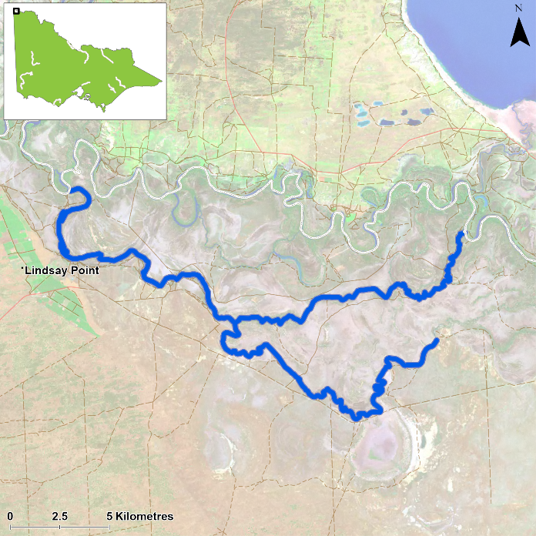
Figure 1. Map showing the section of Lindsay River and Mullaroo Creek where NFRC sampling occurs

Environment
A blackwater event impacted the fish population in late 2016. Generally, stream flows were similar during the autumn sampling periods in 2017 to 2022. Prior to 2022 surveys, the Murray River has had varying levels of connectivity with the upper Lindsay River since the 2016 flood. As such, the upstream reaches of the Lindsay River (above the Mullaroo Creek junction) have generally experienced lower flows and water levels since 2017. Working collaboratively with a The Living Murray (TLM) Project, the number of sites fished and used in the analysis has varied with 12 sites fished in 2017, 13 in 2018- 2020 and ten sites in 2021 and 2022. Sites were surveyed between 22 and 24 March 2022 by an electrofishing boat. The water turbidity levels were much higher in 2022, which likely reduced the efficiency of the electrofishing surveys.

River rehabilitation efforts in the Lindsay River
A range of rehabilitation actions to improve the health of the Lyndsey River system and its fish community, have been identified within the Mallee Waterway Strategy 2014-2022. The core current focus involves allocation of water for the environment and improving fish passage. Since 2006, fish monitoring has occurred for the Lindsay, Mulcra, Wallpolla Islands, as part of The Living Murray Program. The Mallee Catchment Management Authority, DELWP and VFA support rehabilitation and management of the Lindsay River and its fish community.

PHOTOS
LOGOS – ARI, DELWP, NFRC

Golden Perch

Lindsay River system, Mallee region

Key Health Indicators
Recent recruitment Yes
Multiple size classes Yes
Mature fish present Yes

Monitoring Results
Total number of fish caught 21
Fish per 1km of waterway 1.74
Largest fish by length (cm) 44.03
Largest fish by weight (kg) 1.38
% of the catch that is legal size 76.2

The abundance of Golden Perch (Macquaria ambigua) appears to have decreased after higher abundances were recorded in 2017 and 2018, particularly in the Lindsay River (Figure 4). It is likely that the 2016 floods attracted Golden Perch into the system, with abundances in the upper Lindsay system (above the Mullaroo Creek junction) being highest in 2017 and decreasing as this part of the system has reduced flows. Abundances were lower in 2022 than previous years, which likely reflects the high turbidity levels during surveys which will decrease survey efficiency. In addition, the higher proportion of juveniles in 2017 were also in the upper Lindsay River.
A large proportion of Golden Perch collected are adults (Figures 4, 5) with 76% adults in 2022 (Figure 4). Recruits were detected for the first time in 2022 in the Lindsay River system (Figures 4, 5). The Victorian Murray Floodplain Restoration Program (VMFRP) found Golden Perch recruits in the Lindsay River and in wetlands in the Lindsay River system in 2022 (VMFRP unpublished data). Overall, there is a consistently productive Golden Perch population.

Stocking
No stocking has occurred.

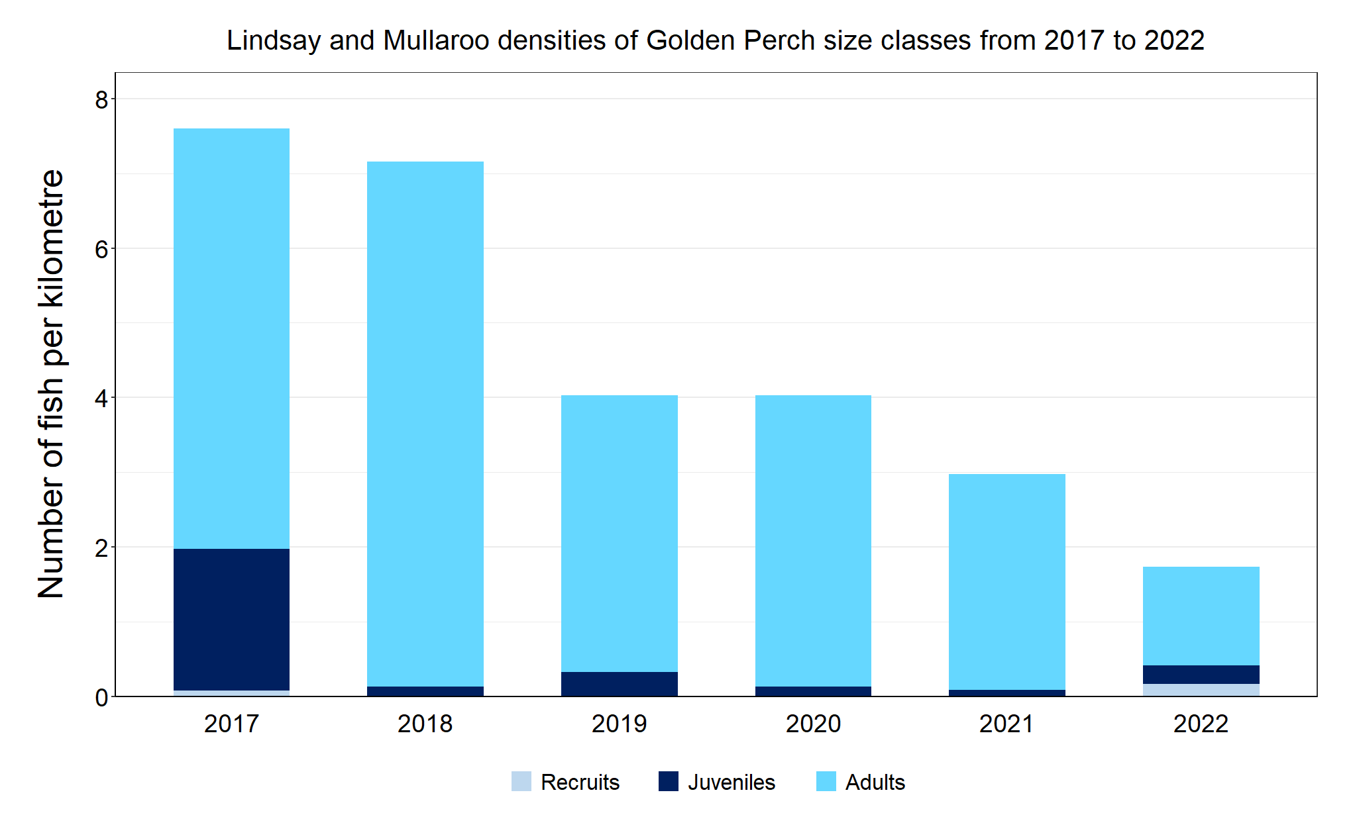
Figure 4. The densities of recruits, juveniles and adult Golden Perch in the Lindsay River system from 2017 to 2022

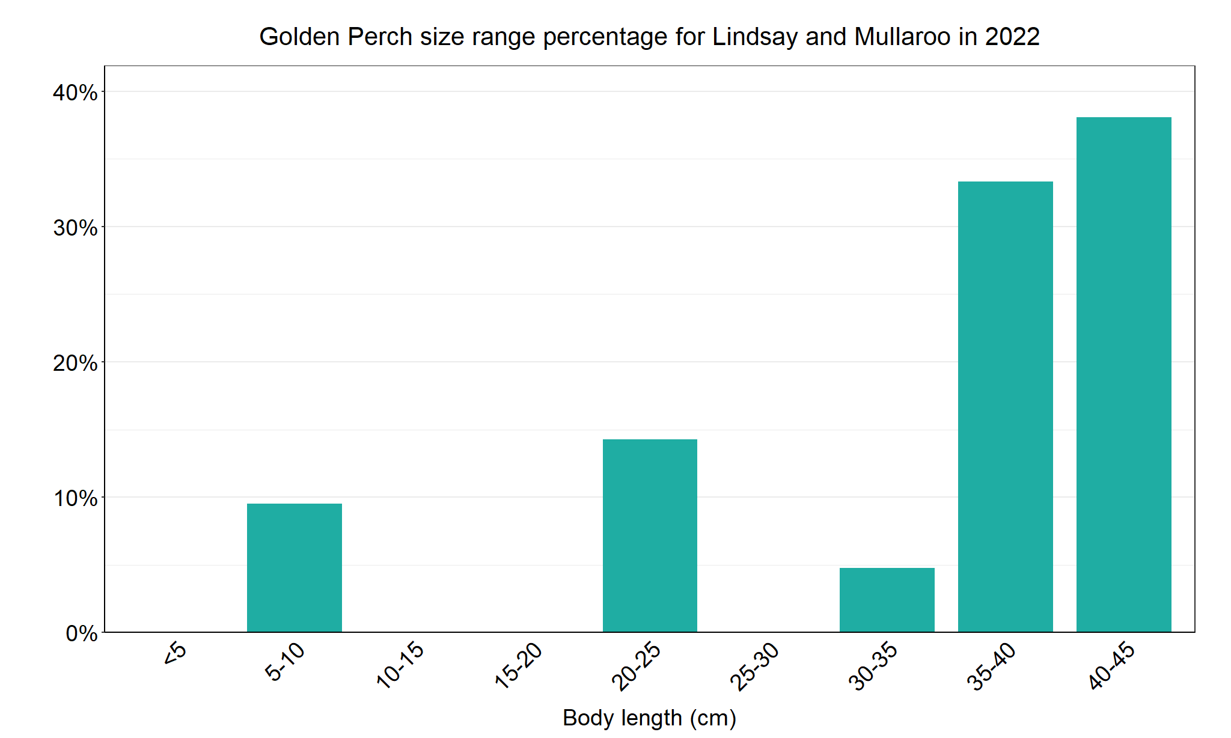
Figure 5. The size range percentage of Golden Perch in the Lindsay River system in 2022

Murray Cod

Lindsay River system, Mallee region

Key Health Indicators
Recent recruitment No
Multiple size classes Yes
Mature fish present Yes

Monitoring Results
Total number of fish caught 34
Fish per 1km of waterway 2.82
Largest fish by length (cm) 113
Largest fish by weight (kg) 29
% of the catch that is legal size 29.4

The abundance of Murray Cod (Maccullochella peelii) in the Lindsay River system declined dramatically following the 2016 blackwater event either through emigration or mortality¹. Murray Cod have subsequently increased from 2017 (where no Murray Cod were captured at NFRC sites, although one juvenile was captured during The Living Murray survey (unpublished data) (Figure 4).
The abundance of Murray Cod (Maccullochella peelii) in the Lindsay River system declined dramatically following the 2016 blackwater event either through emigration or mortality1. Only one Murray Cod was captured in 2017, with abundances increasing from 2018 to 2020 before declining in 2021 and further declining in 2022 (Figure 6). The decreases in abundances in 2021 and 2022 are largely from the juvenile range. In 2022, there was also higher turbidity levels which decrease survey efficiency. The highest abundances of adults collected were in 2021 and 2022, indicative of fish growing following the 2017 spawning event. In 2020, where Murray Cod were aged, the 2017 spawning made up approximately 50% of Murray Cod in the system2. From 2018 to 2022 multiple size classes including mature and young-of-year fish have been recorded, except for 2022 where no recruits were recorded (Figure 6). The NFRC has set maximum size thresholds for recruits for Murray Cod across all priority rivers as 10cm (based on previous research). In the Lindsay River system in 2018 approximately 71% of fish captured were 90–150mm TL, representative of young-of-year fish spawned in spring 2017 (a subsample was aged by otoliths*), indicating a faster growth rate following the blackwater event². As a result, the abundance of recruits is most likely under-represented in Figures 6 and 7. The 10-15cm fish in 2022 (Figure 6) may be a recruit from 2021 spawnings; either way Murray Cod recruitment decreased in 2022. A single Murray Cod was recorded from the Lindsay River in 2022, the first in six years of NFRC sampling. It is unknown if this was from wild spawning or from the stockings in 2021. Overall, the Murray Cod is showing a strong recovery.

Stocking
Twenty-seven thousand Murray Cod were stocked into the Lindsay River in March 2021. Note this stocking occurred after the 2021 surveys.

*Otoliths are fish earbones

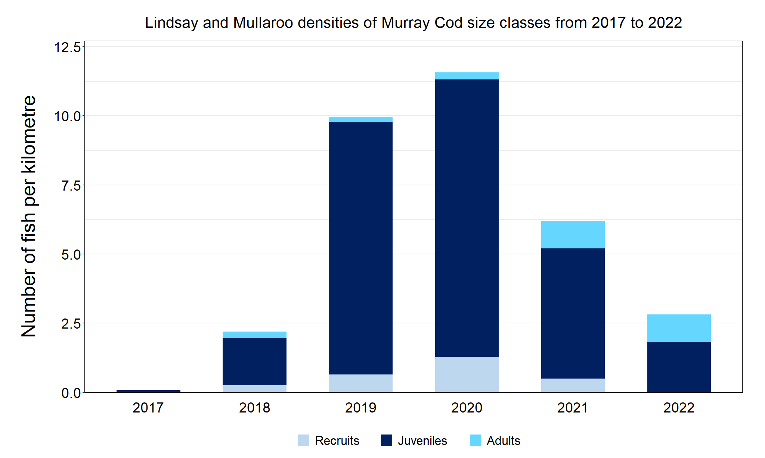
Figure 6. The densities of recruits, juveniles and adult Murray Cod in the Lindsay River system from 2017 to 2022
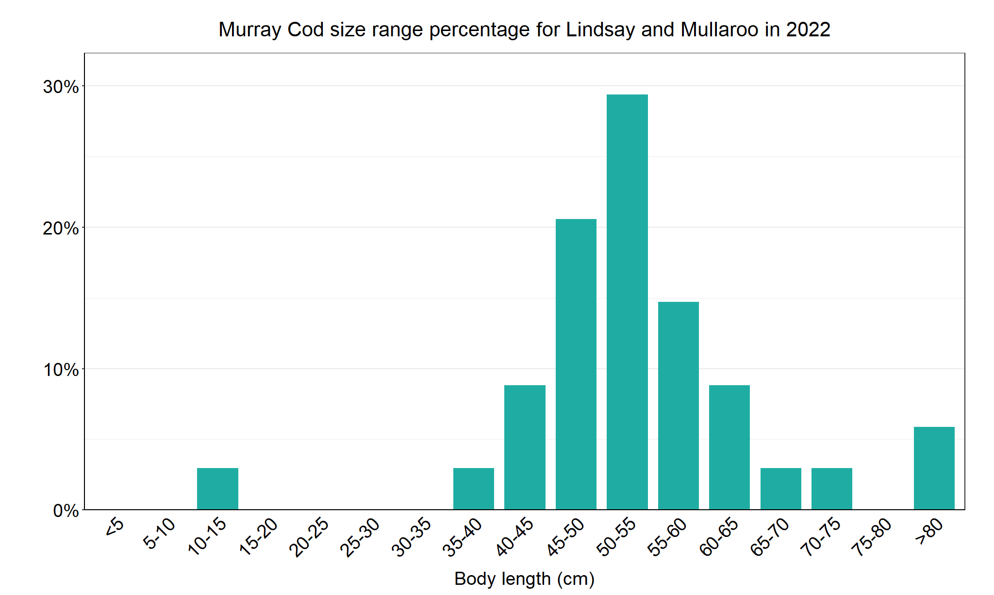
Figure 7. The size range percentage of Murray Cod in the Lindsay River system in 2022

1. Tonkin, Z., O’Mahony, J., McMaster, D., Raymond, S., Moloney, P. and Lyon, J. (2017). Fish movement in the Lindsay and Mulcra Island anabranch systems: 2017 Progress report. Unpublished Client Report for the Mallee Catchment Management Authority. Arthur Rylah Institute for Environmental Research. Department of Environment, Energy, Environment and Climate Change Group, Heidelberg, Victoria.

2. Tonkin, Z., O’Mahony, J., Kitchingman, A., Moloney, P., Raymond, S., Hackett, G., and J. Lyon (2020). Murray cod movement and population structure in the Lindsay Island anabranch system: 2020 Report. Unpublished Client Report for the Mallee Catchment Management Authority. Arthur Rylah Institute for Environmental Research, Department of Environment, Land, Water and Planning, Heidelberg, Victoria.

Silver Perch

Lindsay River system, Mallee region

Key Health Indicators
Recent recruitment Cannot be determined
Multiple size classes Cannot be determined
Mature fish present Cannot be determined

Monitoring Results
Total number of fish caught 8
Fish per 1km of waterway 0.66
Largest fish by length (cm) 34.3
Largest fish by weight (kg) 0.5
% of the catch that is legal size NA

The natural range of Silver Perch (Bidyanus bidyanus) includes most of the Murray-Darling Basin, excluding the cool, higher altitude upper reaches of streams. River regulation and barriers have been listed as factors impacting Silver Perch populations, with these relevant to the Lindsay River system. While the NFRC only expects to capture low numbers of this species, the monitoring can provide a greater understanding of the current status of the populations which is essential to inform management of the species. Due to the low abundances of Silver Perch collected during NFRC the key health indicators cannot be measured. Low abundances of Silver Perch have been detected in all six years (Figure 8). The Silver Perch detected are a mixture of recruits (2020), juveniles (2017, 2019, 2021 and 2022) and adults (2018-2022 (Figures 8 and 9)). Recruits of this species are difficult to catch using this sampling methodology, with recruits only detected in 2020, indicative of spawning success in 2019.

Stocking
No stocking has occurred.

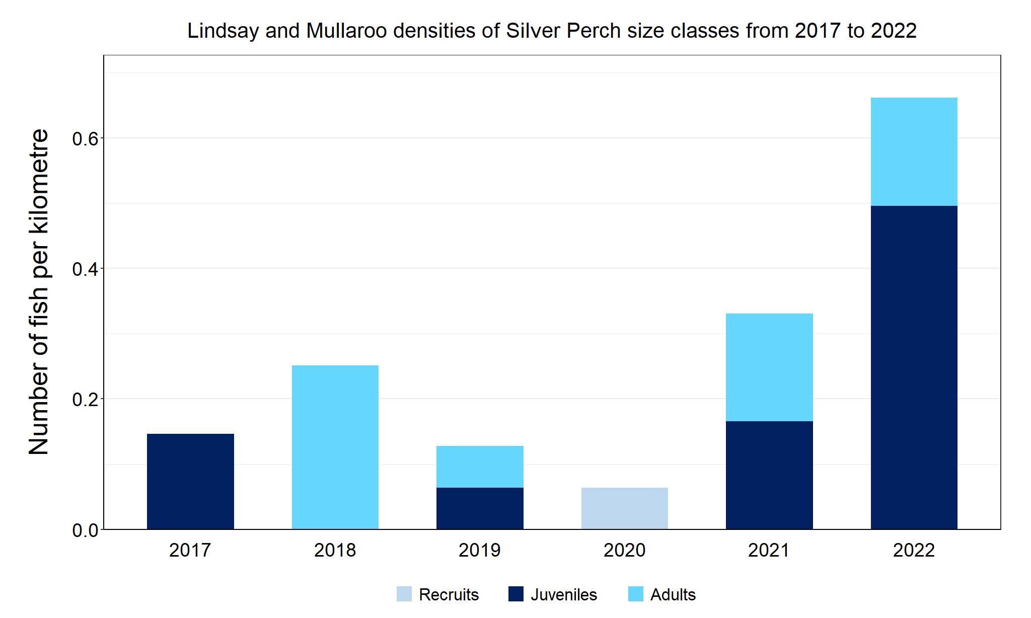
Figure 8. The densities of recruits, juveniles and adult Silver Perch in the Lindsay River system from 2017 to 2022

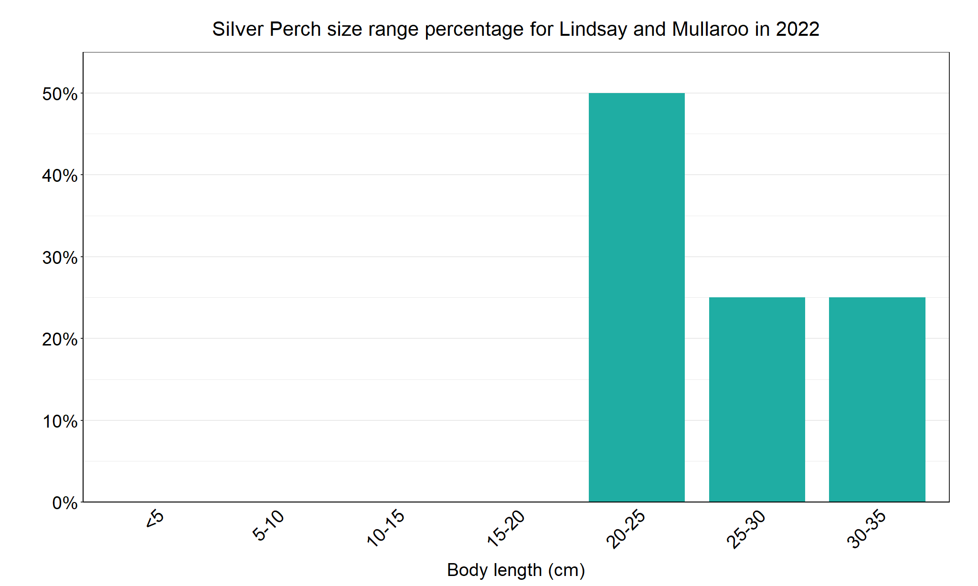
Figure 9. The size range percentage of Silver Perch in the Lindsay River system in 2022

We acknowledge and respect Victorian Traditional Owners as the original custodians of Victoria’s land and waters, their unique ability to care for Country and deep spiritual connection to it. We honour Elders past and present whose knowledge and wisdom has ensured the continuation of culture and traditional practices.

