**Gellibrand River 2023**

***Corangamite region***

**This report card summarises the 2023 Native Fish Report Card (NFRC) survey in the Gellibrand River**

**Sites 8, CCMA, Electrofishing, Fyke Netting**

**Fish found in Gellibrand River for NFRC**

**Target species**

River Blackfish

**Non-target species captured since 2017\***

**Large-bodied native species**

Australian Grayling

Short-finned Eel

Tupong

**Small-bodied native species**

Australian Smelt

Climbing Galaxias

Common Galaxias

Ornate Mountain Galaxias

Pouched Lamprey

Short-headed Lamprey

Southern Pygmy Perch

Spotted Galaxias

**Exotic species**

Brown Trout

* These non-target species were incidentally captured during NFRC surveys since 2017 but not measured as for target species

LOGOS – ARI, DEECA

**Gellibrand River 2023**

**Fish Community**

**NFRC target species**

**The NFRC Program began in 2017, with a focus on targeting the monitoring of population dynamics of key iconic fish species that have high recreational and/or conservation values, in large rivers across Victoria. In the Gellibrand River, the target species is River Blackfish. Surveys occur in March/April each year, at six sites from upstream of Chapple Vale to Dandos Campground on the Gellibrand River and two sites on tributaries. Backpack electrofishing and fyke netting is undertaken in the Gellibrand River, whilst the backpack electrofishing only occurs in the tributaries. The equipment and habitats surveyed are focused on the River Blackfish, which are measured to determine population structures. Other fish species that are incidentally captured are recorded, but not measured to determine their population structures.**

**Summary of key health indicators for target species in 2023**

|  |  |  |  |
| --- | --- | --- | --- |
| **Species** | **Key Health Indicators** | | |
|  | Recent recruitment | Multiple size classes | Mature fish present |
| River Blackfish | No | Yes | Yes |

*Recent recruitment means young-of-year fish*

River Blackfish are a lowland species, generally found at altitudes below 200 metres. This species has suffered a decline in distribution and abundance across Victoria1. The Gellibrand River was previously known as having a well-established River Blackfish population with large adults present2.

**Non-target species**

The non-target fish species that have been incidentally recorded in the Gellibrand River during NFRC surveys since 2017 are:

**Large-bodied native species**

Other large-bodied species recorded in surveys are Australian Grayling, Short-finned Eel and Tupong. Numbers of Australian Grayling are low in the Gellibrand River catchment and the species is rarely found. Records from the NFRC are only the third (2017), fourth (2018) and fifth (2019) confirmed records of this species in this river. Australian Grayling have been found at the most downstream site on three occasions during NFRC surveys, with only one other detection recorded. The Short-finned Eel and Tupong are diadromous (migratory between salt water and fresh water) species found throughout coastal Victoria.

**Small-bodied native species**

The Australian Smelt is a common species distributed across all of Victoria. The Common Galaxias, Climbing Galaxias and Spotted Galaxias as well as Pouched Lamprey and Short-headed Lamprey are diadromous species found across coastal Victoria. The Ornate Mountain Galaxias is known from West Gippsland across to the Gellibrand area. Southern Pygmy Perch are more common in offstream habitats such as wetlands, billabongs and lagoons.

**Exotic fish species**

Brown Trout are present throughout the Gellibrand River occurring in low to moderate abundances, however they are not a dominant species.

**Other native fish species known from the Gellibrand River**

Some fish species known to occur in the Gellibrand River have never been recorded during NFRC surveys. This includes the Flatheaded Gudgeon which is a common species across Victoria.

**Other notable species**

Surveys have also recorded Southern Victorian Spiny Crayfish and Platypus.

LOGOS – ARI, DEECA, NFRC

1. Khan MT, Khan TA, Wilson ME 2004. Habitat use and movement of river blackfish (Gadopsis marmoratus R.) in a highly modified Victorian stream, Australia. *Ecology of Freshwater Fish,* 13: 285–293.

2. Koehn, J. 1984. Survey of angling and recreational use of the Gellibrand River, south-western Victoria. Arthur Rylah Institute for Environmental Research Technical Report Series No. 10. Department of Conservation, Forests and Lands. Fisheries and Wildlife Service Victoria.

**Gellibrand River 2023**

**Environmental and Management Context**

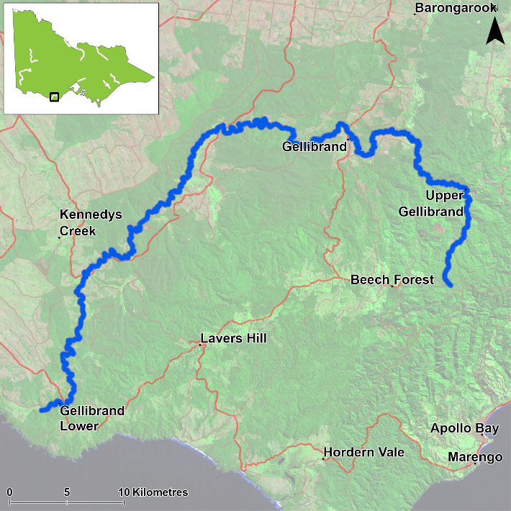

Figure 1. Map showing the section of Gellibrand River where NFRC sampling occurs

**Environment**

Low flow conditions were present in all seven sampling seasons. The tributaries were extremely low in 2022. In 2022 and 2023 the pH was extremely low in Boggy Creek. Only seven of the eight sites were surveyed in 2022 due to access issues and one site was only partially electrofished due to water being too deep to wade. Both the partially fished site and the site not surveyed in 2022 were on the Gellibrand main stem. All sites were surveyed in 2023.

**River rehabilitation efforts in the Gellibrand River**

Many rehabilitation actions have occurred, and are underway, to improve the health of the Gellibrand River. These are informed by the [Corangamite Waterway Strategy 2014-2022](https://issuu.com/gsdm/docs/waterway_strategy_2014-22) as well as an Estuary Management Plan. Actions include revegetation, weed control including large scale removal of Willows, fencing of riparian areas, bank stabilisation, reintroduction of instream woody habitat, removal of migration barriers and pest control. Some fish monitoring has occurred, including related to rehabilitation efforts. The [Corangamite Catchment Management Authority](https://ccma.vic.gov.au/), DEECA and VFA support rehabilitation and management of the Gellibrand River and its fish community.

PHOTOS

LOGOS – ARI, DEECA, NFRC

**River Blackfish**

**Gellibrand River, Corangamite region**

**Key Health Indicators**

Recent recruitment No

Multiple size classes Yes

Mature fish present Yes

**Monitoring Results**

Total number of fish caught 16

Fish per 1km of waterway 8.49

Largest fish by length (cm) 41.0

Largest fish by weight (kg) 0.56

% of the catch that is legal size 37.5

**Recruits, juveniles and adult River Blackfish (*Gadopsis marmoratus*) have been recorded in six of the seven years surveyed (Figure 2); no recruits were detected in 2023 (Figure 2; Figure 3). Only one recruit (in 2022) and two juveniles (in 2023) have been detected at main stem sites of the Gellibrand River during this project. Only low abundances of River Blackfish were detected in the mainstem (5-18 fish each year), despite six of the eight sites being on the mainstem. This highlights the potential importance of tributary habitats for recruitment to the population in the Gellibrand River catchment. In 2023, the abundances of River Blackfish were notably lower than previous years, with a large proportion attributable to a decrease in abundances detected in the tributaries (all size classes) (Figure 2). The reasons for a lack of observed recruitment and lower abundances detected in the tributaries in 2023 are unclear and need further investigation.**

**Stocking**

No stocking has occurred.

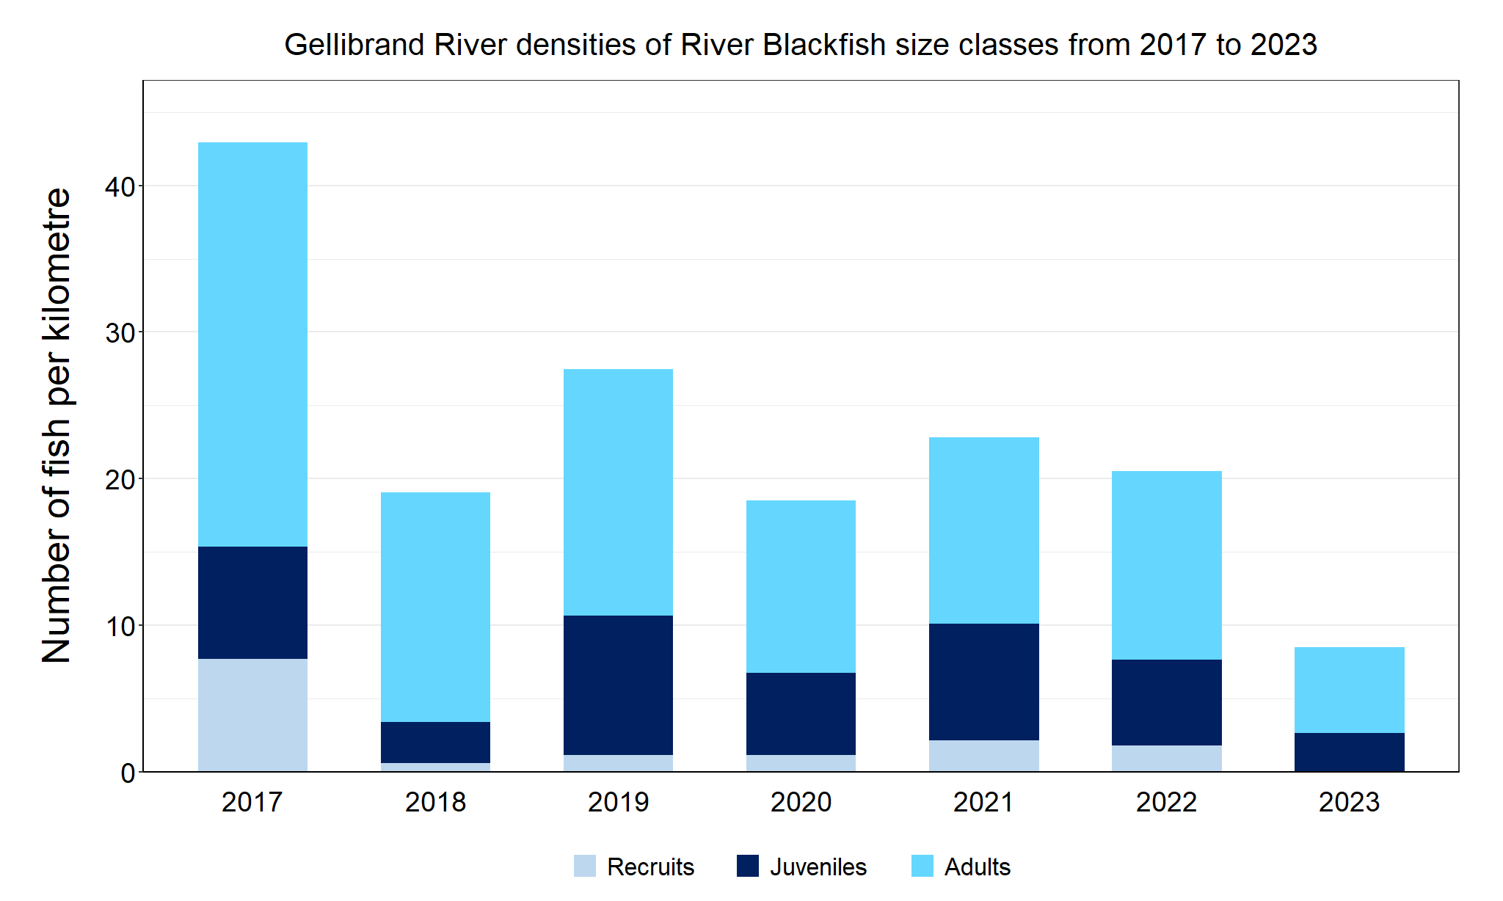

Figure 2. The densities of recruits, juveniles and adult River Blackfish in the Gellibrand River from 2017 to 2023

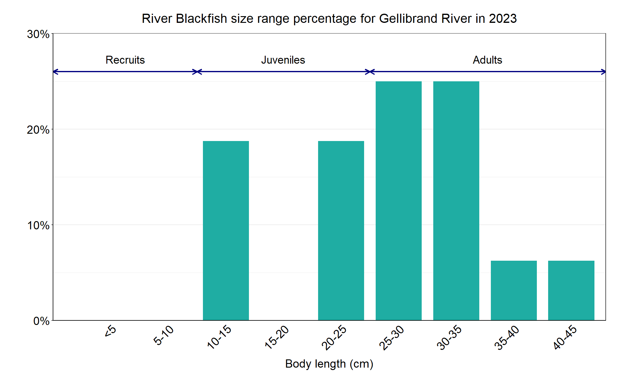

Figure 3. The size range percentage of river Blackfish in the Gellibrand River in 2023

We acknowledge and respect Victorian Traditional Owners as the original custodians of Victoria’s land and waters, their unique ability to care for Country and deep spiritual connection to it. We honour Elders past and present whose knowledge and wisdom has ensured the continuation of culture and traditional practices.

Logo*© The State of Victoria Department of Energy, Environment and Climate Action 2023. This work is licensed under a Creative Commons Attribution 4.0 International licence. To view a copy of this licence, visit creativecommons.org/licenses/by/4.0/*

*ISSN 2981-8990 - Online (pdf/word)*